Ameloblastic transformation of a treated odontogenic keratocyst: A rare case report

Abstract:
Odontogenic keratocyst (OKC) is a developmental cyst of odontogenic origin that develops from residual dental lamina. It is characterized by aggressive growth behavior and a high tendency for recurrence. Transformation of its epithelial lining into benign or malignant lesions is uncommon. In contrast, ameloblastoma is a true odontogenic tumor derived from enamel organ–like tissue and lacks differentiation sufficient for enamel production. Ameloblastomatous change arising within an OKC is exceedingly rare, and such cases are classified as combined or hybrid odontogenic lesions.
In this report, we describe a rare case involving a 40-year-old female who had undergone surgical treatment for an odontogenic keratocyst in the left posterior mandible four years earlier and subsequently presented with a recurrent swelling at the same location. Provisionally, it was diagnosed as a case of recurrent OKC, but on histopathological examination it was revealed as follicular ameloblastoma. This article highlights importance of accurate diagnosis of such lesions, for careful management and prevention of recurrence.
Keywords: Odontogenic keratocyst, ameloblastoma, recurrent OKC, Hybrid odontogenic lesions, Nevoid basal cell carcinoma syndrome.

1. INTRODUCTION: -
“Odontogenic keratocyst is developmental odontogenic cyst and the term odontogenic keratocyst was first used by Philipsen in 1956. Pindborg and Hansen in 1963 described its essential features”.^{[1]} It is believed that it arises from remnants of dental lamina epithelium and constitutes 8 to 11 % of all odontogenic cysts. Lining epithelium of OKC produces huge amount of keratin. It shows unique features like aggressive behavior, high recurrence rate, anteroposterior growth and sometimes may be associated with Nevoid Basal Cell Carcinoma Syndrome (NBCCS).^{[2]} Based on clinical behavior, “in 1967 Toller suggested that OKC may be regarded as benign neoplasm than cyst. In 2005 WHO reclassified OKC as Keratocystic Odontogenic Tumor (KCOT)”.^{[3]} Based on genetic and molecular studies, there were not enough reports to justify change in classification.^{[1]} Hence, again in 2017 WHO classification, it is classified back as cyst and in 2022 WHO classification it maintained its position as cyst only.^{[4]}
“Ameloblastoma is a benign neoplasm of odontogenic epithelium which represents 11-13 % of all odontogenic tumors.^{[5]} It has a locally aggressive growth pattern; about 70% of cases undergo malignant transformation, and up to 2% metastasize to other sites”.^{[18]}
Ameloblastomatous transformation from epithelial remnants of treated OKC is an extremely rare occurrence.^{[7]} This case report highlights such kind of transformation in patient who was treated for OKC 4 years back and got diagnosed with ameloblastoma at same site after 4 years.

2. CASE REPORT: -
Clinical Findings
A 40 years old female reported to department with chief complaint of swelling in lower left back region of jaw since 15 days. Her past medical history and habit history were non-significant. While her past dental history revealed similar swelling and its treatment at same site 4 years back. Patient had previous reports, cytopathological and histopathological evaluation gave odontogenic keratocyst as her final diagnosis. For that she had undergone surgical enucleation of cystic lining followed by reconstruction of surgical defect 4 years back.
An extraoral examination showed diffuse swelling in left mandibular body & submandibular region. No gross facial asymmetry was seen. On palpation the swelling was firm to hard in consistency, afebrile and tender. No palpable lymph nodes were present (Fig. 1a). An intraoral examination showed swelling extending from alveolar process from missing 33 to 38 teeth region with obliteration of buccal and lingual vestibule. Grade I mobile 31, 32 were present (Fig. 1b). Based on clinical features and previous history, provisional diagnosis was given as recurrent OKC.
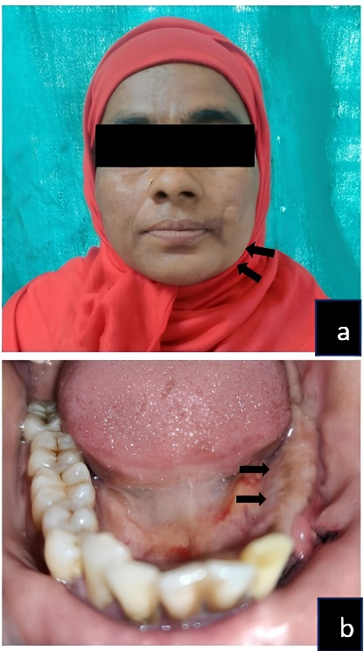
Fig.1a) Extraoral image showing diffuse swelling. b) Intraoral image showing obliteration of buccal and lingual vestibule.

Diagnostic Assessment
For radiological evaluation, CBCT was done. Curved planar reconstruction showed an osteolytic lesion in left mandible with reconstruction plates extending from 32 to 38 teeth region (Fig. 2a). Axial section revealed well-defined radiolucency with septa and perforation of buccal and lingual cortical plates, with maximum anteroposterior dimension of 45.5 mm (Fig. 2b). In Sagittal section scalloped radiolucency and external root resorption of 32 was seen (Fig. 2c & d). Coronal section showed same septate radiolucency with maximum superoinferior dimension of 18.2 mm (Fig. 2e).
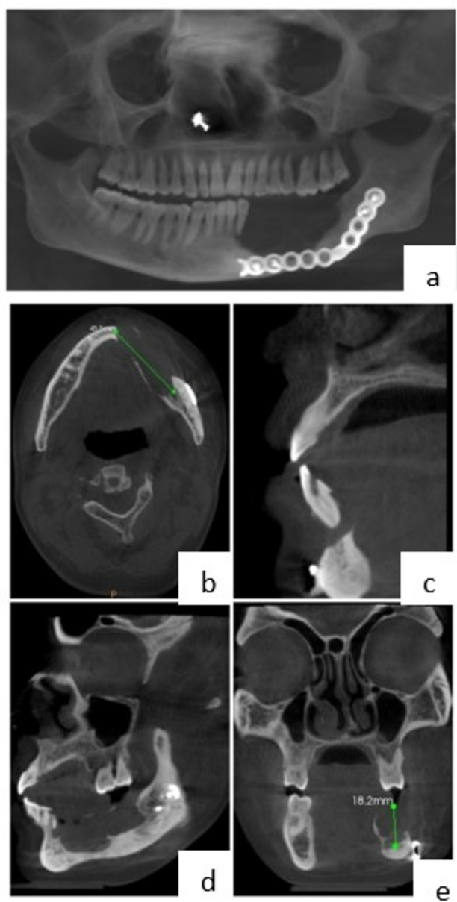
Fig.2a) Curved planar reconstruction showing osteolytic lesion. b) Axial section showing perforation of buccal and lingual cortical plates with maximum anteroposterior dimension of 45.5 mm. (c and d) Sagittal section showing external root resorption of 32 and scalloped radiolucency. e) Coronal section showing septate radiolucency with maximum supero-inferior dimension of 18.2 mm.

Biopsy was done. Histopathology report showed epithelial lining of non-keratinized, stratified, squamous epithelium with varying degree of proliferation. Connective tissue wall was thick and fibrocellular. It showed numerous ameloblastomatous islands consisting of peripheral tall columnar cells and central loosely arranged stellate reticulum like cells. These islands were arranged in the form of sheets and strands. Moderate to severe degree of chronic inflammatory cells were evident throughout the stroma (Fig. 3). Overall features were suggestive of ameloblastoma. Based on these findings histopathological diagnosis was given as follicular ameloblastoma and final diagnosis was given as follicular ameloblastoma transformed from epithelial remnant of OKC.
Surgical Intervention
After final diagnosis segmental resection of ameloblastoma with continuity defect and its reconstruction was done.
Follow-Up
The patient did not give follow-up.

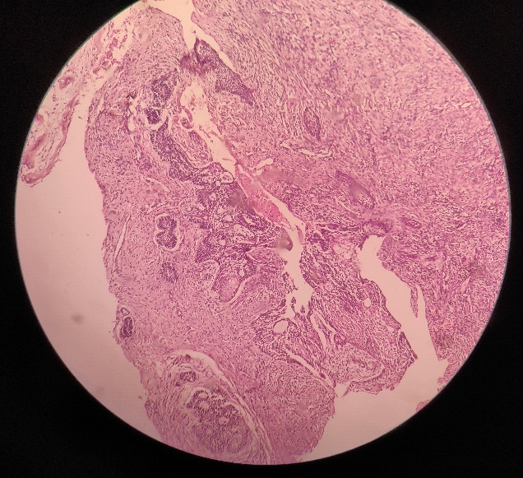
Fig. 3 Image Showing ameloblastomatous islands - red arrows,
connective tissue – green arrow.

3. DISCUSSION: -
“Ameloblastomatous transformation from epithelial remnants of OKC is an extremely rare case, such lesions are referred as combined or hybrid odontogenic lesions”.^{[7]} Literature search showed only 10 cases of ameloblastoma originating from OKC, excluding current case. These are listed in table 1.
“This type of transformation is more prevalent in Nevoid Basal Cell Carcinoma Syndrome (NBCCS) and stated that ameloblastoma is more prevalent in NBCCS”.^{[6]} But there were no syndromic associations observed in the cases reported by Kakarantza-Angelopoulou, Nicolatou, Ogunsalu et al., Geng et al., Neuman et al., Metehan Keskin et al., V Manoj Kumar et al. and Sachiko Yamasaki et al. Similarly, there is no syndromic association seen in our case also.
“Combined odontogenic lesions of jaw are complex cases and they can be misdiagnosed. Hence, correct diagnosis is of utmost importance for successful management and good prognosis”.^{[7]} Histopathology and immunohistochemistry play an important role in correct diagnosis. Immunohistochemical tumor marker like “calretinin” is specific to ameloblastomatous cells can be used to distinguish between cyst and tumor. “Immunohistochemical markers such as “Ki-67” and “PCNA (proliferating cell nuclear antigen)” can be used to indicate prognosis in terms of clinical prognosis, aggressive potential and biological behavior”.^{[14]} In our case immunohistochemistry was not done.
The pathogenesis behind the conversion of a treated odontogenic keratocyst (OKC) into an ameloblastoma upon recurrence is not fully understood, but several possible mechanisms have been proposed, like residual epithelial cells, chronic inflammatory changes, genetic mutations, and epithelial-mesenchymal interactions. OKCs originate from remnants of the dental lamina or basal cells of the oral epithelium, which share histological similarities with ameloblastoma. In some cases, remnant epithelial cells left behind after OKC treatment may undergo neoplastic transformation into an ameloblastoma upon recurrence.^{[7]} Recurrence of OKC is often accompanied by chronic inflammation due to incomplete removal, previous surgical trauma, or secondary infection. Inflammatory mediators (e.g., cytokines, growth factors) may induce proliferation and dysplastic changes in the residual odontogenic epithelium, leading to the development of an ameloblastoma.^{[15]} Molecular and genetic factors, particularly mutations in the PTCH1 gene, commonly found in nevoid basal cell carcinoma syndrome (Gorlin syndrome)-associated OKCs have been implicated in this process. The PTCH1 gene is part of the Hedgehog signaling pathway, and its mutations are associated with both OKCs and ameloblastoma. These mutations may contribute to the neoplastic transformation observed in recurrent cases.^{[13]}
The transformation of odontogenic keratocyst (OKC) into ameloblastoma upon recurrence could be influenced by epithelial-mesenchymal interactions (EMI). In normal tooth development, the interaction between odontogenic epithelium and ectomesenchyme triggers the differentiation of ameloblasts (enamel-forming cells). This interaction is mediated by growth factors such as BMP (Bone Morphogenetic Proteins), FGF (Fibroblast Growth Factor), SHH (Sonic Hedgehog), and WNT signaling. If remnants of dental lamina or odontogenic epithelium persist after OKC treatment, these cells may still respond to mesenchymal signals, leading to abnormal proliferation and transformation into an ameloblastoma. ^{[13, 15-17]}
Proper surgical excision with marginal resection rather than simple curettage may reduce the risk of such transformation.

Table 1. Existing Literature on OKC transformation to Ameloblastoma
Sr. No. | Author’s Name | Publication Year | No. of cases | Age | Sex | Site | Clinical Feature | Radiological Feature
1. | Brannon RB et al.[8] | 1977 | 2 | NS | NS | NS | NS | NS
2. | Kakarantza angelopoulou and  Nicolatou  [9] | 1990990 | 2 | NS | NS | NS | NS | NS
3. | Ogunsalu C  et al.[10] | 2007 | 1 | 27 | NS | Anterior mandible | Painless swelling in Rt. Mandible, Numbness in ant. mandible | Well defined, corticated, unilocular RL from 45 to 34, resorption of roots
4. | Geng N et al.[11] | 2012 | 1 | 38 | F | Posterior left maxilla | Painless swelling in left maxilla for 3 years | Ill defined, multilocular RL from Premolar to tuberosity.
5. | Neumann AN et al.[12] | 2015 | 1 | 17 | F | Left ramus molar area | NS | NS
6. | Metehan Keskin et al.[7] | 2020 | 1 | 22 | M | Angle & ramus of left mandible | E/O swelling of left ramus of mandible for 2 months | Large RL lesion of left mandible involving whole ramus, 2nd molar and impacted third molar
7. | V. Manoj Kumar et al.[6] | 2021 | 1 | 60 | M | Anterior mandible | E/O swelling in anterior mandible | Large sized well-defined RL with multiple septae and bicortical expansion.
8. | Sachiko Yamasaki et al.[13] | 2024 | 1 | 26 | M | Right maxilla | I/O swelling obliterating buccal vestibule extends from 13 to 16. | Well-defined unilocular RL extending from 13 to 16
9. | Present Case | 2025 | 1 | 40 | F | Left posterior mandible | I/O swelling extending from 33 to 38 edentulous region with obliteration of buccal & lingual vestibule. | Well-defined multilocular RL

*NS – Not Specified

4. CONCLUSION:
This case report highlights the rare occurrence of ameloblastomatous transformation from treated OKC. Considering this possibility, regular follow-up of OKC cases is necessary. Also, further research and accumulation of such cases is essential to understand mechanism of such transformations.

Consent
As per international standards or university standards, patient(s) written consent has been collected and preserved by the author(s).

Disclaimer (Artificial intelligence)
Option 1:
Author(s) hereby declare that NO generative AI technologies such as Large Language Models (ChatGPT, COPILOT, etc.) and text-to-image generators have been used during the writing or editing of this manuscript.

References: -
- Sivapathasundharam, B. (2020). Cysts of orofacial region. In B. Sivapathasundharam (Ed.), Shafer’s Textbook of Oral Pathology (9th ed.). Elsevier Health Sciences. https://www.elsevier.com/books/shafers-textbook-of-oral-pathology/sivapathasundharam/978-81-312-5545-2
- Neville, B. W. (2007). Update on current trends in oral and maxillofacial pathology. Head and Neck Pathology, 1(1), 75-80. https://doi.org/10.1007/s12105-007-0007-4
- Chen, P., Liu, B., Wei, B., & Yu, S. (2022). The clinicopathological features and treatments of odontogenic keratocysts. American Journal of Cancer Research, 12(7), 3479-3485. https://www.ncbi.nlm.nih.gov/pmc/articles/PMC9360231/
- Soluk-Tekkesin, M., & Wright, J. M. (2022). The World Health Organization Classification of Odontogenic Lesions: A Summary of the Changes of the 2022 (5th) Edition. Turk Patoloji Derg, 38(2), 168-184. https://doi.org/10.5146/tjpath.2022.01573
- Figueiredo, N. R., Dinkar, A. D., Meena, M., Satoskar, S., & Khorate, M. (2014). Ameloblastoma: A clinicoradiographic and histopathologic correlation of 11 cases seen in Goa during 2008-2012. Contemporary Clinical Dentistry, 5(2), 160-165. https://doi.org/10.4103/0976-237X.132305
- Kumar, V. M., Chakravarthy, A., Sathyanarayanan, R., Raghu, K., & Reddy, C. D. (2022). Hybrid Ameloblastoma Arising from a Treated Odontogenic Keratocyst of the Mandible: A Case Report With Literature Review. Indian Journal of Otolaryngology and Head & Neck Surgery, 74(Suppl 3), 6180-6188. https://doi.org/10.1007/s12070-021-02889-y
- Keskin, M., Özkan, N., Akbulut, N., & Bereket, M. C. (2020). Odontogenic Keratocyst with Ameloblastomatous Transformation: A Rare Case Report. Journal of Clinical and Diagnostic Research, 14(4), ZD10-ZD13. https://doi.org/10.7860/JCDR/2020/43336.13636
- Brannon, R. B. (1977). The odontogenic keratocyst. A clinicopathologic study of 312 cases. Part II. Histologic features. Oral Surgery, Oral Medicine, Oral Pathology, 43(2), 233-255. https://doi.org/10.1016/0030-4220(77)90161-x.
- Kakarantza-Angelopoulou, E., & Nicolatou, O. (1990). Odontogenic keratocysts: clinicopathologic study of 87 cases. Journal of Oral and Maxillofacial Surgery, 48(6), 593-599. https://doi.org/10.1016/s0278-2391(10)80472-0
- Ogunsalu, C., Daisley, H., Kamta, A., Kanhai, D., Mankee, M., & Maharaj, A. (2007). Odontogenic keratocyst in Jamaica: A review of five new cases and five instances of recurrence together with comparative analyses of four treatment modalities. West Indian Medical Journal, 56(1), 90-95. https://doi.org/10.1590/s0043-31442007000100017
- Geng, N., Lv, D., Chen, Q. M., Zhu, Z. Y., Wu, R. Q., He, Z. X., & Chen, Y. (2012). Solid variant of keratocystic odontogenic tumor with ameloblastomatous transformation: A case report and review of the literature. Oral Surgery, Oral Medicine, Oral Pathology, Oral Radiology, 114(2), 223-229. https://doi.org/10.1016/j.oooo.2011.11.023
- Neuman, A. N., Montague, L., Cohen, D., Islam, N., & Bhattacharyya, I. (2015). Report of Two Cases of Combined Odontogenic Tumors: Ameloblastoma with Odontogenic Keratocyst and Ameloblastic Fibroma with Calcifying Odontogenic Cyst. Head and Neck Pathology, 9(3), 417-420. https://doi.org/10.1007/s12105-014-0601-1
- Yamasaki, S., Shintani, T., Ando, T., Miyauchi, M., & Yanamoto, S. (2024). Transformation of an odontogenic keratocyst into a solid variant of odontogenic keratocyst/keratoameloblastoma during long-term follow-up: A case report. Molecular Medicine Reports, 29(3), 44. https://doi.org/10.3892/mmr.2024.13168
- Jeyaraj, P. (2019). The dilemma of extensive unilocular radiolucent lesions of the jaws - value of immunohistochemistry as a diagnostic marker and prognostic Indicator. Annals of Diagnostic Pathology, 40, 105-135. https://doi.org/10.1016/j.anndiagpath.2019.04.007
- Kotrashetti, S. M., John, S., Kotrashetti, V., Mishra, R., & Panday, S. (2025). From innocuous to aggressive: A case of odontogenic keratocyst transforming to unicystic ameloblastoma. Cureus, 17(2). https://doi.org/10.7759/cureus.78806
- Ghazi, N., Saghravanian, N., Mirhashemi, M., & Abedini Ardakani, A. (2023). Evaluation of tenascin expression in ameloblastoma, odontogenic keratocyst, and dentigerous cyst by immunohistochemistry. Advanced Biomedical Research, 12, 66. https://doi.org/10.4103/abr.abr_131_21
- Balic, A., & Thesleff, I. (2015). Tissue Interactions Regulating Tooth Development and Renewal. Craniofacial Development (pp. 157–186). https://doi.org/10.1016/bs.ctdb.2015.07.006
- Effiom OA, Ogundana OM, Akinshipo AO, Akintoye SO. Ameloblastoma: current etiopathological concepts and management. Oral Dis. 2018;24(3):307-16. doi:10.1111/odi.12646.

