A RARE CLINICAL VARIANT OF PERIPHERAL OSSIFYING FIBROMA IN A 9- YEAR-OLD CHILD

ABSTRACT
Peripheral ossifying fibroma (POF) is a focal exuberant nonneoplastic gingival overgrowth in the oral cavity and is a rare entity in children. The clinical presentation often mimics fibroma but can also resemble lipoma, peripheral giant cell granuloma, pyogenic granuloma or even peripheral ameloblastoma.The usual presentation is in the second and third decades of life, with the peak age being 29 years¹⁴. This is a case report of a 9-year-old girl, who presented with a chief complaint of rapidly growing, pedunculated growth of tissue on the palatal aspect between the maxillary central incisors. An excisional biopsy was performed, and histopathological study confirmed the diagnosis of Peripheral Ossifying Fibroma (POF). No recurrence was observed during the one-year follow-up period. Failure to accurately diagnose this lesion could result in improper treatment and potentially poorer outcomes.
Keywords: Peripheral Ossifying Fibroma in children, Peripheral Cementifying Fibroma, Ossifying Fibrous Epulis, Calcifying Fibrous Epulis, Peripheral Fibroma.
INTRODUCTION
Peripheral ossifying fibroma is one among the exophytic gingival lesions of the oral cavity. This lesion has been described in the literature under various terminologies, including peripheral cementifying fibroma, ossifying fibrous epulis, calcifying fibrous epulis, and peripheral fibroma with calcification reflecting the diversity in its histopathological characteristics¹. The lesion can develop as a response to irritants like dental plaque, calculus, microorganisms, overhanging restorations and other factors^{3,10}. However, it is more commonly seen in young adults with a predilection for females. About 60% of these tumors occur in the maxilla, with over 50% of maxillary tumors originating from the interdental papillae of incisors and canines^{3,} ⁴.
The clinical presentation of the lesion is a well-demarcated, pedunculated/sessile lesion with a firm consistency. Although the lesion typically matches the color of the oral mucosa, it can occasionally appear red and in rare cases, may present with ulcerations. Investigations include radiographs and histopathological examination, the latter being the gold standard. Treatment involves surgical excision, along with management of local irritants through scaling and repair of overhanging restorations. The lesion is quite notorious for its recurrence with a rate of 16 -20%⁵.
CASE REPORT
A 9-year-old female child reported to the Department of Pedodontics and Preventive Dentistry with a chief complaint of swelling in the upper front tooth region since 2 weeks. History revealed that the lesion was small when it was noticed initially, following which there was a rapid increase in the size of the lesion over a period of 2 weeks. There was no recent history of trauma or appliance wear. The child appeared healthy and there was no relevant medical history. Intraorally there was a well-defined pedunculated, firm, non-tender, non fluctuant soft tissue growth of dimension 2cm x 1cm x 0.5 cm located over the incisive papilla, and labially extending into the area between the maxillary central incisors (Fig 1,2). Regional lymph nodes were non-palpable.
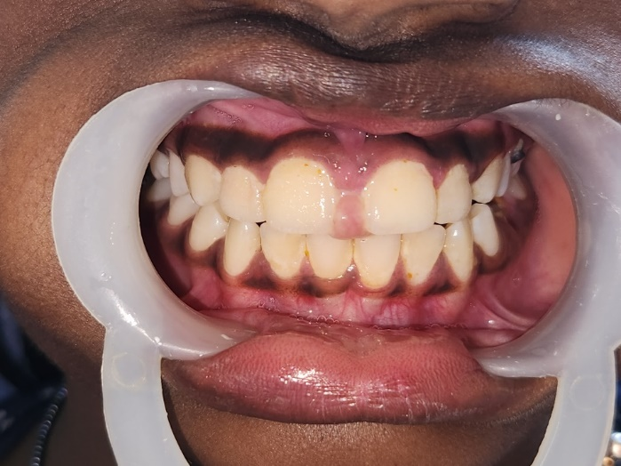
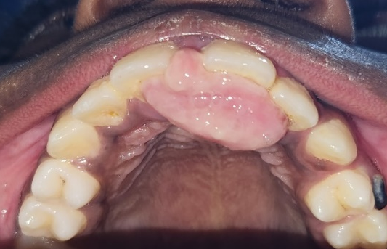

Fig 1: Preoperative view
Fig 2: Preoperative occlusal view

The color of the lesion was consistent with the surrounding gingiva, featuring an erythematous base with bleeding on probing. The adjacent teeth were non-mobile and imprints of the lower incisors were seen on the outer surface of the lesion. IOPAR of 11 and 21 region showed no relevant findings. The lesion's rapid progression and aggressiveness, coupled with the absence of an apparent cause, elevated the diagnostic complexity. Hence, a CBCT image of the maxillary anterior region was advised, which revealed erosion of the palatal bone with perforations of the buccal and lingual cortical plates (Fig 3).
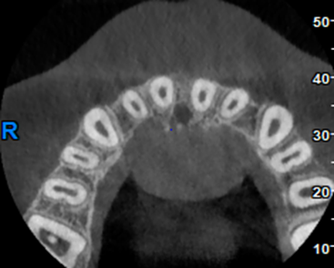
Fig 3: CBCT Image Showing Erosion Of Bone
Based on the clinical and radiographic appearance a malignant lesion was suspected. Following informed consent, an excisional biopsy was scheduled. After local anesthesia, the lesion was tied with a 3-0 silk suture material just above the pedunculated base facilitating better access for excision with a No. 15 blade (Fig 4). The lesion was excised by making a V-shaped incision down to the periosteum (Fig 5), following which sutures were placed using 3-0 silk. The specimen was sent for histopathological evaluation and a thorough full mouth oral prophylaxis was done after a period of 1 week (Fig 6). Patient was reviewed at one week, one month, three months, and six months.

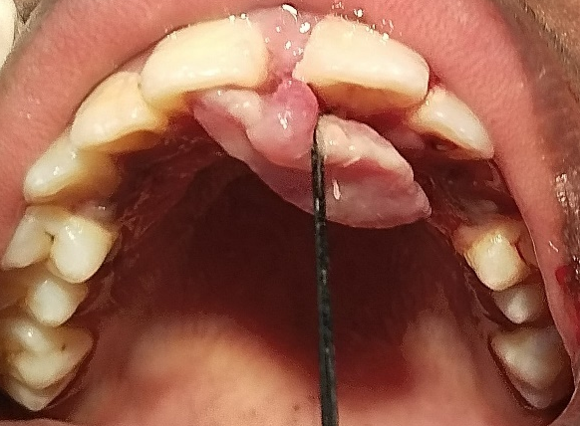
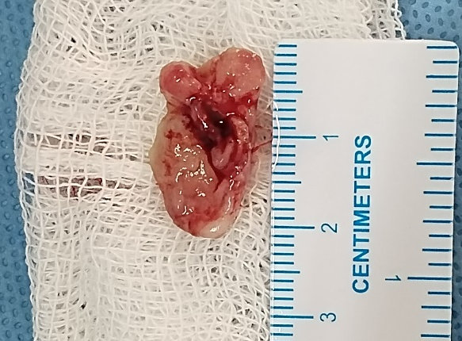

Fig 5: Excised lesion
Fig 4: Silk tie placed at the base

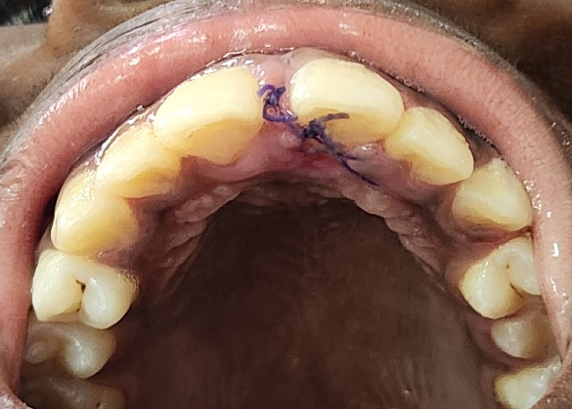

Fig 6: One week follow up

Differential Diagnosis: Fibroma, Lipoma, Peripheral Giant Cell Granuloma, Pyogenic Granuloma, And Even Peripheral Ameloblastoma
HISTOPATHOLOGY REPORT:
Histopathological study showed serial sections of H & E stained soft tissue bits with a hyperplastic parakeratinised stratified squamous epithelium overlying a dense collagenous connective tissue stroma. Within the hyper cellular connective tissue stroma proliferating fibroblasts and osteoblasts were noted. Numerous foci of basophilic calcifications resembling osteoid were also observed. Dense and diffuse collection of inflammatory cells chiefly composed of lymphocytes and plasma cells were noted. Numerous forming, formed and dilated blood vessels were seen. Endothelial cell proliferation was also observed. The deeper portion of the tissue showed ulceration with fibrin and collections of PMNLs. These findings confirmed the diagnosis of peripheral ossifying fibroma (Fig 7).
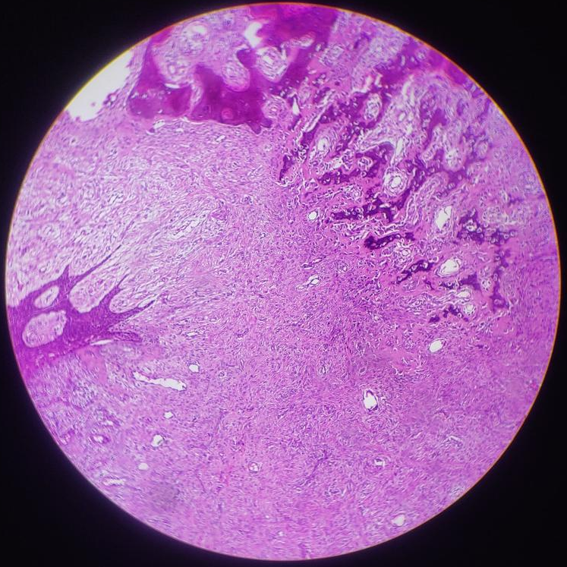
3
2
1
Fig 7: 1.Osteoid trabeculae 2. Blood vessels 3.Proliferating mesenchymal cells

DISCUSSION
Peripheral ossifying fibroma is a benign soft tissue lesion, exclusive to the gingiva and quite prone to recur, with a rate of 8% after surgical removal¹². Many authors consider it as a reactive lesion rather than a true neoplasm^{6,15}. Although believed to arise from the periodontal ligament there is some consensus on its gingival origin. However, the lesion's proximity to tooth-bearing areas, the anatomical relationship between the periodontal ligament and the gingiva, as well as the presence of oxytalan fibers within the calcified matrix on histopathological examination provide support for its origin from the periodontal ligament. Clinical presentation of the lesion is characteristic but not pathognomic¹. They often resemble other exophytic lesions like fibroma, lipoma, peripheral giant cell granuloma, pyogenic granuloma, and even peripheral ameloblastoma⁷. However, the lesion has a predilection for the maxillary anterior region often involving the interdental papilla². Peripheral ossifying fibromas are slow-growing lesions however some of them behave aggressively with changes in the underlying cortical bone⁸. The aggressive nature of the lesion in this patient led us to overdiagnose the lesion initially. The aggressive variant of the lesion presents a paradox: it is typically associated with children, yet its actual occurrence in this demographic is rare. Histopathology is the gold standard when it comes to diagnosis. The lesion can be distinguished from other gingival lesions by the presence of osteoid/cementum-like substance which is often found as clusters^{9,13}. The management of the lesion involves surgical excision and removal of local irritants¹². It is important to ensure that the incision is extended deep to the periosteum and periodontal ligament area to minimize the risk of recurrence. Though the procedure is relatively simple it can be quite challenging when it is performed on a young child as it was with this patient. We were able to manage the child effectively and efficiently by utilizing non-pharmacological behavior management techniques and placement of a silk tie at the base of the growth which aided in its prompt and smooth removal.
CONCLUSION
Surgical excision of the lesion is the treatment of choice for peripheral ossifying fibroma which can be a traumatic experience, especially for a young child. Therefore every attempt should be made to prevent such lesions which are believed to occur as a reaction to local irritants. Maintaining proper oral hygiene and timely dental visits are the key.

Consent
As per international standards, parental written consent has been collected and preserved by the author(s).
Disclaimer (Artificial intelligence)
Option 1:
Author(s) hereby declare that NO generative AI technologies such as Large Language Models (ChatGPT, COPILOT, etc.) and text-to-image generators have been used during the writing or editing of this manuscript.
Option 2:
Author(s) hereby declare that generative AI technologies such as Large Language Models, etc. have been used during the writing or editing of manuscripts. This explanation will include the name, version, model, and source of the generative AI technology and as well as all input prompts provided to the generative AI technology
Details of the AI usage are given below:
1.
2.
3.

AUTHORS CONTRIBUSION
This work was carried out in collaboration among all authors. All authors read and approved the final manuscript

REFERENCE
- Shafer WG, Hine MK, Levy BM. A Textbook of Oral Pathology. 7th ed. Philadelphia: W.B. Saunders Company; 1974.
- Kenney JN, Kaugars GE, Abbey LM. Comparison between the peripheral ossifying fibroma and peripheral odontogenic fibroma. Journal of oral and maxillofacial surgery. 1989 Apr 1;47(4):378-82.
- Rallan M, Pathivada L, Rallan NS, Grover N. Peripheral ossifying fibroma. Case Reports. 2013 May 18;2013:bcr2013009010.
- Xavier SA. Peripheral ossifying fibroma: a case report. Cureus. 2024 May 6;16(5).
- Gardner DG. The peripheral odontogenic fibroma: an attempt at clarification. Oral Surgery, Oral Medicine, Oral Pathology. 1982 Jul 1;54(1):40-8.
- An SY, Kim CM, Sung CH, Kim CH. Peripheral ossifying fibroma arising from the maxillary bucco-palatal gingiva in an elderly male patient: a rare case report. Journal of the Korean Association of Oral and Maxillofacial Surgeons. 2024 Oct 31;50(5):292-6.
- Banerjee S, Pal TK. Localized gingival overgrowths: A report of six cases. Contemporary clinical dentistry. 2017 Oct 1;8(4):667-71.
- Eversole LR, Leider AS, Nelson K. Ossifying fibroma: a clinicopathologic study of sixty-four cases. Oral surgery, oral medicine, oral pathology. 1985 Nov 1;60(5):505-11.
- Mergoni G, Meleti M, Magnolo S, Giovannacci I, Corcione L, Vescovi P. Peripheral ossifying fibroma: a clinicopathologic study of 27 cases and review of the literature with emphasis on histomorphologic features. Journal of Indian Society of Periodontology. 2015 Jan 1;19(1):83-7.
- Shaji NE, Vundela RR, Mahurkar P, Karuppiah M, Setty J. Recurrent Peripheral Ossifying Fibroma in a Child: A Case Report. Asian Journal of Pediatric Research. 2025 May 24;15(5):29-35.
- Cuisia ZE, Brannon RB. Peripheral ossifying fibroma--a clinical evaluation of 134 pediatric cases. Pediatric dentistry. 2001 May 1;23(3):245-8.
- Siddiqui M, Juneja A, Sultan A, Popli DB. Peripheral Ossifying Fibroma in a 5-year-old Female Patient: A Rare Case Report. Archives of Medicine and Health Sciences. 2025 May 1;13(2):296-9.
- Cavalcante IL, da Silva Barros CC, Cruz VM, Cunha JL, Leão LC, Ribeiro RR, Turatti E, de Andrade BA, Cavalcante RB. Peripheral ossifying fibroma: A 20-year retrospective study with focus on clinical and morphological features. Medicina Oral, Patología Oral y Cirugía Bucal. 2022 Jun 19;27(5):e460.
- Poonacha KS, Shigli AL, Shirol D. Peripheral ossifying fibroma: A clinical report. Contemporary clinical dentistry. 2010 Jan 1;1(1):54-6.
- Delbem AC, Cunha RF, Silva JZ, Soubhia AM. Peripheral cemento-ossifying fibroma in child. A follow-up of 4 years. Report of a case. European Journal of Dentistry. 2008 Apr;2(02):134-7.

