Assessment of DNA Methylation Levels in Saccharum officinarum L. Under Traffic-Related Abiotic Stress

ABSTRACT

The continuously growing population and the increase in the number of vehicles, the emissions from vehicles result in that spread of smog and dust, contributing to air pollution. This has various negative impacts, especially on crops growing alongside roadways. Air pollution linked to transportation has emerged as a potentially deadly concern. Our study offers a summary of how vehicle emissions of smog and dust can affect crops. The primary objective of this study is to examine the effects of potential toxic abiotic stress caused by traffic-related air pollution on the quality of DNA methylation in crops, while also investigating the extent of health risks associated with the toxicological impact on crops. A comparative study of the concentrations of potential toxic abiotic agents (ppm) in crop soil, mature leaves, and the edible parts of mature plants was conducted. The locations selected included a very high dusting traffic road, a high dusting traffic road at a distance of 500 meters, a low dust traffic road at a distance of 1000 meters, and a control site at 1500 meters away. The potential toxic abiotic agents assessed were arsenic (As), cadmium (Cd), copper (Cu), mercury (Hg), lead (Pb), nickel (Ni), zinc (Zn), and chromium (Cr). Statistical evaluation of the samples from these sites indicated concentrations (ppm) of potential toxic abiotic agents with P values of 0.001, 0.004, and 0.0002 (where P < 0.05 is regarded as highly significant and very highly significant).

Keywords: Saccharum officinarum L., Toxic chemo stress, Heavy Metals Toxicity, DNA methylation

- INTRODUCTION

Air pollution caused by traffic is one of the major environmental challenges facing both urban and rural areas. The daily rise in population and vehicles leads to the distressing impact of vehicle emissions and dust being released into the environment, resulting in air pollution. This has detrimental effects, especially when it interacts with crops growing alongside the roads. Pollution from transportation has emerged as a potentially life-threatening dilemma. It reduces the lifespan of living organisms, leads to various health issues, and increases the incidence of premature deaths among humans, plants, and animals (Aliyar et al., 2020). One of the most significant environmental issues is air pollution. Air contamination poses a serious health risk, primarily due to high traffic volumes. Unlike other environmental problems, the air pollution caused by transportation is largely influenced by natural factors, making it particularly challenging to address. It harms and endangers the health of people, animals, and plants in areas with high traffic volumes. However, roadside trees and vegetation greatly enhance air filtration, thereby helping to reduce environmental pollution (Hashad et al., 2023). This study provides a detailed account of the adverse effects that harmful air pollutants have on crop vegetation. Phytochemical analyses reveal that crop quality varies significantly between contaminated areas and those unaffected by pollution (Singh et al., 2023). The toxic air pollution poses a significant health risk; this research examined its impact on agricultural vegetation near traffic sources (Singh et al., 2023). The complex phytochemical composition in multi-plant systems was assessed using traditional methods for determining concentrations in sample analyses (Singh and Sharma, 2024). Comparative data on phytochemical aspects reveal notable differences in crops between sites affected by road traffic and control locations (Singh et al., 2024). The assessment concentrated on identifying harmful toxic substances in crops that could have stemmed from air pollution caused by vehicles (Singh et al., 2025). This study investigated the harmful toxicological impacts of air pollutants emitted by vehicles on Sugarcane. The findings suggest that these pollutants can have detrimental effects on plant health and growth, highlighting a significant environmental concern (Singh et al., 2025).
Heavy metals are introduced into environments from both natural and anthropogenic sources. They explain that these metals are highly reactive, toxic even at low concentrations, can enter soils and groundwater, bioaccumulate in food webs, and persist in the environment long after the initial pollution event has ceased (Gall et al., 2015) The intake of food crops affected by either direct dust deposition from the air onto plant surfaces or through the transfer of soil components into plant tissue poses considerable health hazards to humans, alongside those emerging from natural sources. According to Franca et al. (2017), particulate matter (PM) released by automobiles and industries eventually builds up in the air and soil. Potential toxic agent contamination is mostly caused by coal-fired and fuel. The abiotic stress is produced by industry and automobile fumes, and many causes are the main sources of contamination agents, based on the findings of an analysis of the main components. Given their intimate connections to many health issues, research on soil contaminants and their origins is essential. (Rai, 2012 & Sun M, et al., 2022). Crops absorb abiotic agents in many forms, which can differ depending on any toxic agents, from soil pores (McLaughlin et al., 2010). HM bio speciation might also differ depending on the food crop. The crop parts of several daily foods, including many vegetables, absorb HMs in varying amounts. The vegetables grew in decreasing order of the abiotic agent’s bioaccumulation in legume crops. Given that there were any, all of the veggies were highly likely to pose serious health concerns when consumed.
The main significant components in the absorption and movement of toxic abiotic agents are part of the plant. The plant root anatomy, particularly the environmental adaptation of a root, determines whether metals can enter. Because of radial oxygen loss, for instance, zinc uptake in mangrove parts negatively impacted their natural adaptation (Zhou et al., 2016). A detailed analysis of the processes behind leaf uptake of abiotic agents is also needed for managing health issues. Numerous studies on the topic have shown that adsorption to tissues was the main mechanism by which the crop absorbed the through its leaves. Abiotic substance is transported from the root system to the plant's vegetation portions by the vascular tissue loading mechanism, whereas leaf transport is carried out by the phloem vascular system. Compared to foliar translocation, the root uptake mechanism of abiotic agents’ uptake in flora has been researched more (Shahid et al., 2017). Nanotechnology is being applied in many areas, such as agriculture, medicine, energy, and nature, which results in the uncontrollable release of nanoparticles and associated harmful metals. There are environmental effects from this. Food crops should be assessed for nanotoxicity since they may have detrimental effects on living health and DNA methylation (Xiong et al., 2017). A comprehensive understanding of the pathways and mechanisms through which HMs endanger fauna health through the consumption of crops enables the adoption of appropriate strategies to manage and mitigate heavy metals for the benefit of people. Thus, this section covers the various mechanisms that contribute to metal routes, their negative impacts, and the phytochemical and molecular stress tolerance systems of agricultural plants (Oves et al., 2012) (Fig. 1).
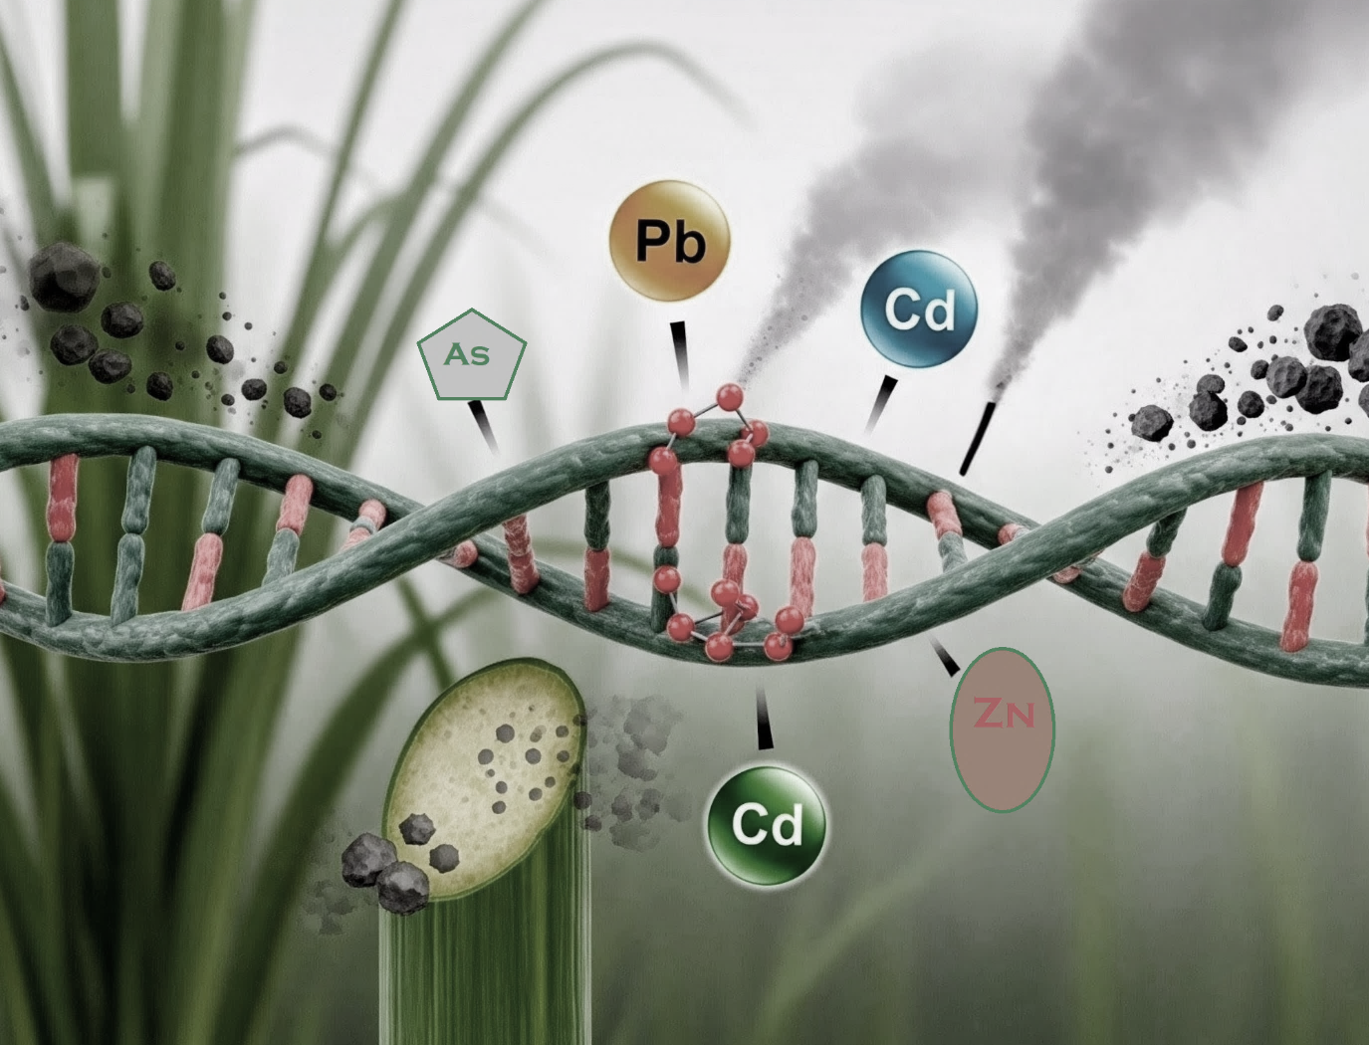
Fig. 1. Overview of DNA Methylation
1.1 Effects of toxic abiotic agents on the risk to fauna health: -
Those exposed to high levels of air contamination experience the symptoms in different degrees of intensity (Kloog et al., 2013). Therefore, as both types of effects often depend on dosage, nature conditions, and individual sensitivity, they are covered in this section along with general concerns about the more common short- and long-term health effects. Symptoms range from mild discomfort, like multiple problems, and heart and lung problems. Brief exposure to air contamination can also cause lightheadedness, nausea, and headaches. In addition to aggravating these problems, prolonged exposure to the pollutants can harm the neurological, reproductive, and respiratory systems and raise the chance of cancer and, in extreme circumstances, death. For years or perhaps a lifetime, the long-term, chronic consequences might persist and ultimately cause death. According to Nakano et al. (2013), the long-term toxicity of some air pollutants can also result in a variety of malignancies. Respiratory diseases are directly linked to breathing in air pollution, as was previously stated. These pollutants will enter the airways and congregate in the cells. The pollutant component, along with its source and dosage, should be linked to the harm to the target cells. The season, time of year, country, and geography all have a big influence on health results. Given the previously described characteristics and a longer exposure period to the pollutant, long-term health impacts should be anticipated. The abiotic contamination can cause significant injury to the respiratory system. Furthermore, the likelihood is higher if a respiratory disease such as asthma already exists. There is a greater chance of long-term consequences for those who are in a predisposed state. It is possible to notice changes in voice after acute exposure to toxins that have contaminated the trachea. Morbidity and mortality are increased by chronic obstructive pulmonary disease, which is brought on by air pollution. Long-term effects from traffic, industrial air contamination, and fuel combustion are the primary sources of chronic obstructive pulmonary disease risk (Jiang et al., 2016). Numerous cardiovascular effects have been connected to exposure to air pollution. Heart function may be impacted by the alterations in blood cells brought on by prolonged exposure.
1.2 Effects of toxic abiotic agents on the risk to flora health: -
The most common environmental contaminants are heavy metals, which include chromium, lead, arsenic, mercury, and cadmium. The non-biodegradable components harm crop health and productivity when HMs build up to hazardous levels in agricultural soils. The occurrence and bioavailability of heavy metal ions in the soil solution, crop type, growth conditions, and developmental stage, the toxicity of the specific elements involved, the physical and chemical characteristics of the soil, and the chemistry of the soil rhizosphere all influence how harmful HMs are to crops. In addition to impeding molecular and metabolic processes, HMs can alter the normal structure and function of cellular components. These factors affect the bioavailability of heavy metal elements in soil solutions, as well as their absorption, translocation, and bioaccumulation in crop plants. The HM elements directly or indirectly interfere with physiological, biochemical, and molecular processes in plants (Rashid et al., 2023).
According to earlier research, abiotic agents in food flora undergo intracellular compartmentalization, physiochemical changes, and molecular homeostasis (Yang et al., 2018). In the end, HMs can increase their phytotoxic terms and prevent crop plants from growing by causing nucleic strand breaks, molecular factors, and genetic damage. The food chain and human health are closely related to all those physiochemical and genetic alterations in flora. Additionally, heavy metals negatively impact many growth phases, especially germination and seedlings, and produce significant physiological alterations. The germination-related protein profiles, enzymes such as α-amylases, proteases, phosphatases and DNA methylation are negatively impacted by heavy metals. For instance, heavy metals blocked the chloroplast's PSII, decreased the amount of starch, limited the amount of nutrients, and caused the accumulation of proline and heat shock proteins (Seneviratne et al., 2019). The impacts of abiotic agents on food crop seed growth have primarily been examined in rice, with cadmium being one of the most researched pollutants. Multimetal toxicity in food crops has, however, received little attention in studies. When it came to detrimental impacts on biomass and physio response, it was discovered that of the three elements, abiotic was the most toxic to flora, exhibiting the lowest phytotoxicity (Gao et al., 2022).
Tree growth close to polluted areas showed in the quality of several chemical and molecular disturbances, the harmful effects of air pollution from automobiles and harmful pollutants on agricultural plants. There are clear disparities in tree quality between contaminated and non-polluted locations based on assessments of different chemical compounds (Luo 2024). The intricate connection between abiotic stress and flora, as well as the chemical and molecular terms reactions of flora, is examined. The research also explores the adaptive processes that allow plants to respond to the stress caused by heavy metals. In order to effectively combat the harmful effects of toxic heavy metals, mitigating techniques are crucial. Additionally, the need for cutting-edge technologies and international cooperation in protecting crops from hazardous pollution is also emphasized (Asiminicesei et al., 2024).
This research primarily focuses on evaluating the impact of potential toxic abiotic stress from traffic air pollution on the quality of DNA methylation status in Saccharum officinarum L.
- MATERIAL AND METHODS
2.1 Research site: -
Hapur is located in the northwest region of Hapur (U.P.), which is between latitudes 28.730579 and 77.775879, and has a humid climate that is influenced by the monsoon, resulting in hot summers and chilly winters (Joshi and Swami 2007). Brajnathpur is located near NH-235 in Hapur district. Near NH-235, in Brajnathpur, samples were studied (Fig. 2).
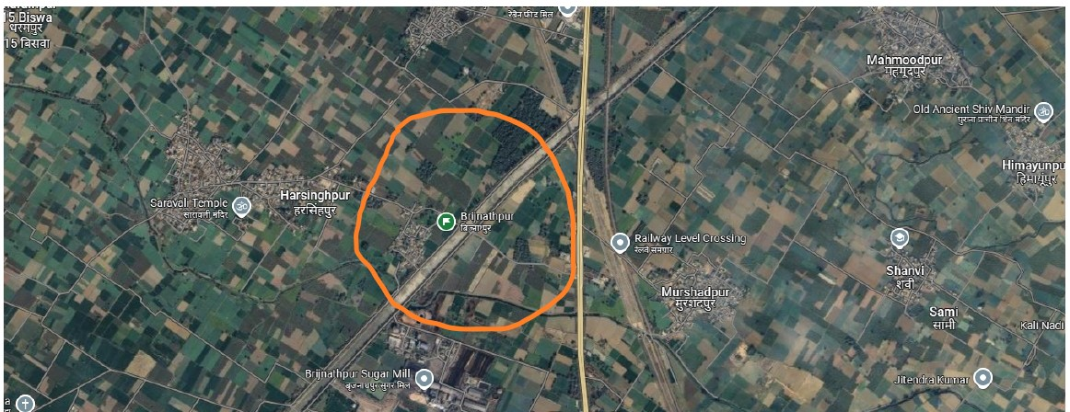
Fig. 2: The samples were studied, as shown in the Brajnathpur map.
2.2 Getting the samples of the crop: -
At Brajnathpur, sites along NH-235 were selected for sampling. The chosen sites are several farms near roads with traffic, and without road air pollution sites. Saccharum officinarum L. was selected as the crop species for this investigation. The Department of Botany at Chaudhary Charan Singh University, in Meerut, Uttar Pradesh, India, verified and authenticated the taxonomic identity of crop samples using the assigned sample numbers, Bot/PB/260. Samples were collected from soil, mature leaves, and mature edible components to evaluate the influence of traffic air pollution caused by the transport system.
2.3 Accumulation of harmful toxic heavy metal substances analysis: -
2.3.1 Preparation of soil samples for detrimental, harmful, toxic heavy metal substances evaluation: -
The moisture content of the soil samples was eliminated by air-drying them. The specimens were smashed using a dry, sanitized pestle and mortar after they had dried, and then they were finely filtered over a 2 mm screen. Three-gram soil samples that had been sieved were weighed and digested using a solution of 3.5 milliliters of concentrated nitric acid (HNO₃), 10 milliliters of concentrated hydrochloric acid (HCl). After being kept unheated overnight beneath the switch-on fume closet, the mixes were heated for two hours at 104°C the next day. A 100 ml volumetric flask was filled with DW after the digested sample had been filtered through a filter paper with a Whatman No. 42 filter. The solution was transferred into sampling vials to perform an analysis. The harmful toxic heavy metal substance concentrations (ppm) of multi-abiotic agents in soil samples were then measured using the Perk-Elmer A Analyst (A.A.S) (Singh et al., 1999).
2.3.2 Preparation of crop samples for detrimental harmful toxic heavy metal substances evaluation: -
Fresh crop samples, including mature leaf and mature edible parts, were separated and dried entirely at a hot air tool set at seventy °C for 48 hrs. before being weighed using a digital electronic scale. In a mechanical grinder, the dried crop samples were ground into a fine powder in order to perform heavy metal analysis. One gram of each sample (mature leaves and mature edible part) was placed in a 150-milliliter conical flask, and 15 milliliters of a di-acid mixture (Nitric acid, HNO₃, Perchloric acid, HClO₄) was added for the first breakdown. Next, the concoction was permitted to stand for the entire night. Following the partial breakdown of the materials, conical flasks were heated on a hot plate to complete the digestion process. Following digestion and filtering of the materials using Whatman No. 42 filter paper, the last vol. was adjusted to 50 ml in volumetric flasks and washed with (D.W). For the well-digested, filtered, and diluted samples, the harmful toxic heavy metal substance concentrations (ppm) of multi-abiotic agents were determined using an Atomic Absorption Spectroscopy (AAS) in compliance with the protocol (Singh et al., 1999).
2.4 DNA extraction of crop samples: -
The technique outlined by Sika et al., (2015) was used to isolate the DNA. 50 mg of the dried powder leaf sample was dissolved, in short, to homogenize in 1200 µL of buffer for extraction (0.5 M Sodium chloride, 1% % SDS). After the homogenate was centrifuged at 13,500 rpm for four minutes at room temperature, the supernatant was removed. For five minutes, the quality liquid was placed on ice after being reconstituted with an equivalent volume of isopropanol. After centrifuging the mixture once more for four minutes at room temperature at 13,500 rpm, the supernatant was extracted. Then, DNA pellet was centrifuged at 13,500 rpm for two minutes at ambient temperature and resuspended with 70% ethanol. After a period of air drying, the DNA pellet was dissolved in distilled water. A spectrophotometer was used to measure the genomic DNA, which was then kept at 20°C.
2.4.1 DNA methylation: -
A commercial Enzyme-Linked Immunosorbent Assay based kit (5Mc DNA Enzyme-Linked Immunosorbent Assay Kit (Zymo Research, D5326)) was used to determine the global DNA methylation profile in accordance with the manufacturer’s instructions. In short, two hundred ng of calibrators and genomic DNA were denatured for 5 minutes at 98°C after being adjusted to one hundred µL using a 5-Mc coating buffer. Samples were, after all, put on ice right away. After being denatured, the samples of DNA were placed incubator on the well strips for one hour at thirty-seven °C. Following the incubation period, 200 µL of the five Mc Enzyme-Linked Immunosorbent Assay buffer was used to wash every well three times. Following the reaction, each well was filled with 100 ml of the antibody mixture another one-hour incubation was carried out. Every well was cleaned using 200 ml of 5Mc ELISA buffer after the incubation period. After adding one hundred microliters of Horse Reddish Peroxidase (HRP) developer to initiate colour development, the response was examined using a spectrophotometer in 30 to 60 minutes. The colour development was assessed using a microplate spectrophotometer (Multiscan-GO, Thermo Scientific) at an absorbance of 405 nm. The standard curve was produced by calibrators using a known methylation profile.
2.5 Statistical Analysis: -
A single-factor ANOVA (analysis of variance) was performed to analyze various sample groups. According to Gomez (1984), the specified methodology, the values of P = 0.001, 0. 004, and 0.0002 (P < 0.05 is considered highly significant and very highly significant).
- RESULTS
3.1 Accumulation of potentially dangerous toxic heavy metal substances in soil: -
Throughout the observation period, concentrations (ppm) of potentially dangerous toxic heavy metal substances for example, arsenic (As), cadmium (Cd), copper (Cu), mercury (Hg), lead (Pb), nickel (Ni), zinc (Zn), and chromium (Cr) were found in the soil at the following sites: very high dusting traffic road, high dusting traffic road 500 meters distance, low dust traffic road 1000 meters distance, and control 1500 meters distance. There was a notable variation in the concentrations (ppm) of these potentially dangerous toxic heavy metal substances across the multisite, according to the overall concentrations (ppm) values for arsenic (0.29 > 0.20 > 0.18 > 0.16 ±), cadmium (0.34 > 0.26 > 0.24 > 0.21 ±), chromium (0.47 > 0.37 > 0.34 > 0.31 ±), copper (0.52 > 0.40 > 0.37 > 0.34 ±), lead (0.44 > 0.31 > 0.28 > 0.25 ±), mercury (0.32 > 0.25 > 0.23 > 0.20 ±), nickel (0.56 > 0.43 > 0.41 > 0.38 ±), and zinc (0.42 > 0.31 > 0.29 > 0.26 ±) at show fig 3. The observation of the statistical analysis shows that the amount of potentially dangerous toxic heavy metal substances (ppm) varied between the multisite by P=0.004 (P<0.05 is regarded as highly significance). In Fig. 4, potentially dangerous toxic heavy metal substances statistical mean values varied from (0.42 > 0.31 > 0.29 > 0.26 ±) at the very high dusting traffic road, high dusting traffic road 500 meters, low dusting traffic road 1000 meters, and control 1500 meters.

Fig. 3: Levels of concentrations (ppm) of potentially dangerous toxic heavy metal substances in soil at sites of very high dusting traffic road, high dusting traffic road 500 meters distance, low dust traffic road 1000 meters distance, and control 1500 meters distance.

Fig. 4: Levels of mean value of potentially dangerous toxic heavy metal substances in soil at sites of very high dusting traffic road, high dusting traffic road 500 meters distance, low dust traffic road 1000 meters distance, and control 1500 meters distance.
3.2 Evaluation of DNA methylation: -
During the observation period, the DNA methylation status was detected in the mature leaf at the sites of the very high dusting traffic road, high dusting traffic road 500 meters distance, low dust traffic road 1000 meters distance, and control 1500 meters distance. At the sites with very high dusting traffic roads, high dusting traffic roads at a 500-meter distance, low dust traffic roads at a 1000-meter distance, and control at a 1500-meter distance, the DNA methylation status ranged differently in fig. 5. According to observation, the major DNA methylation status was arranged in descending order 1 month: (35.02 > 30.06 > 25.08 > 22.04 ± in very high dusting traffic road, high dusting traffic road 500 meters, low dusting traffic road 1000 meters, and control 1500 meters), 2 month: (43.04 > 37.08 > 32.07 > 29.04 ± in very high dusting traffic road, high dusting traffic road 500 meters, low dusting traffic road 1000 meters, and control 1500 meters), 4 month: (50.02 > 45.03 > 40.06 > 36.04 ± in very high dusting traffic road, high dusting traffic road 500 meters, low dusting traffic road 1000 meters, and control 1500 meters), 6 month: (54.04 > 49.06 > 44.03 > 39.02 ± in very high dusting traffic road, high dusting traffic road 500 meters, low dusting traffic road 1000 meters, and control 1500 meters). The observation of the statistical analysis shows that the amount of DNA methylation status varied between the multisites by P=0.004 (P<0.05 is regarded as highly significant). In Fig. 6, DNA methylation status statistical total mean values varied from (45.05 > 40.04 > 35.03 > 31.05 ±) at the very high dusting traffic road, high dusting traffic road 500 meters, low dusting traffic road 1000 meters, and control 1500 meters.
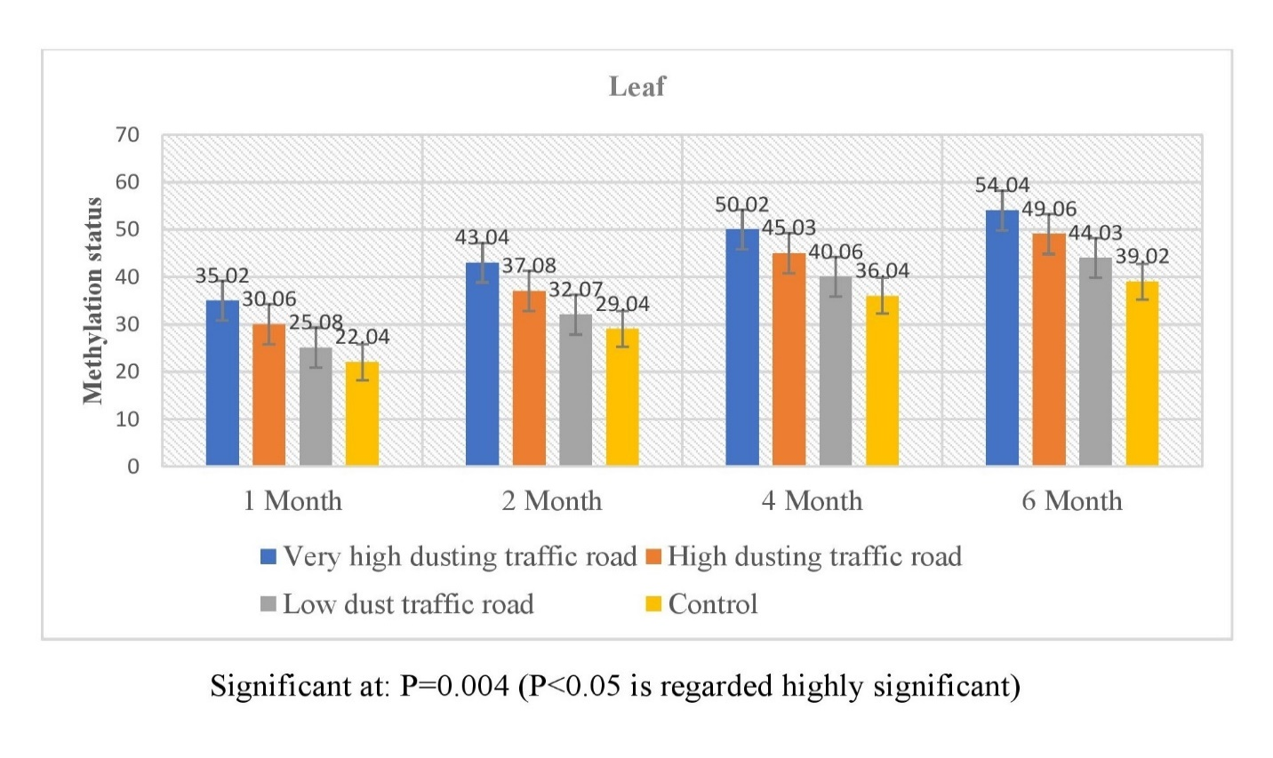Fig. 5: The levels of DNA methylation status in the leaf at the sites of the very high dusting traffic road, high dusting traffic road 500 meters distance, low dust traffic road 1000 meters distance, and control 1500 meters distance.
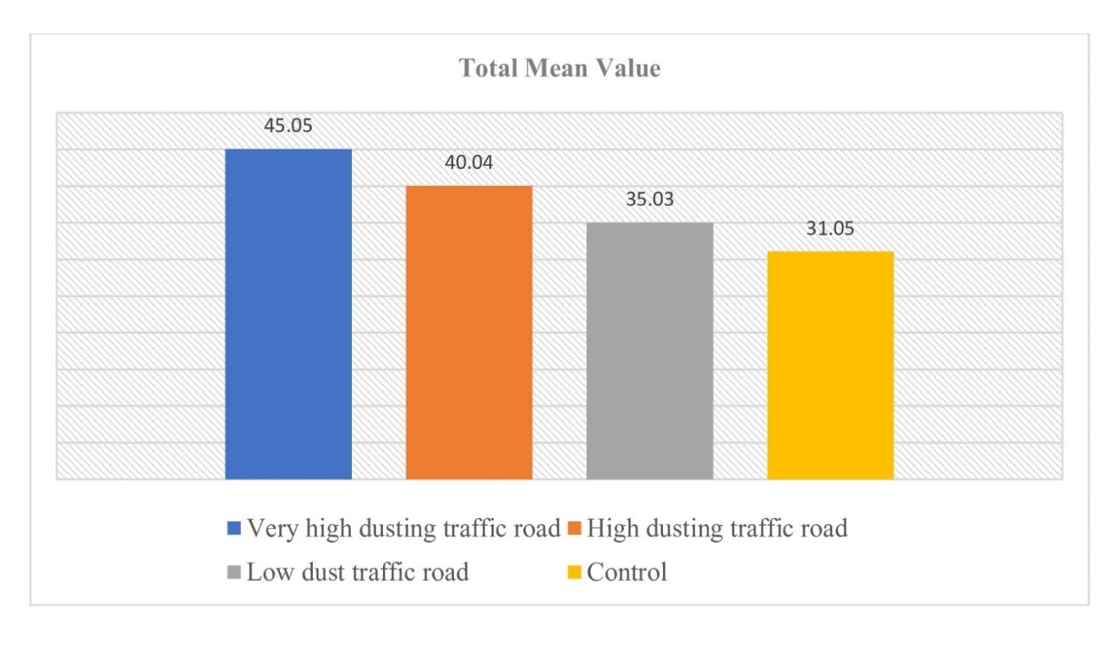
Fig. 6: Levels of total mean value of DNA methylation status in the leaf at sites of very high dusting traffic road, high dusting traffic road 500 meters distance, low dust traffic road 1000 meters distance, and control 1500 meters distance.
4. DISCUSSION
The potential toxic abiotic stress was assessed at both the farm and the control site located away from the road with traffic. The observation period indicated that the sites adjacent to the roadway showed the highest levels of potential toxic HMs, while the sites away from traffic exhibited the lowest levels. The air quality measurements recorded at the site with traffic were found to exceed those at the site without traffic. Statistical analysis revealed that the concentrations of potentially harmful toxic heavy metals (ppm) differed significantly between the multiple locations, with a p-value of 0.004, indicating a high level of significance (P<0.05). In soil samples, the average values of potentially hazardous heavy metal substances ranged from (0.42 > 0.31 > 0.29 > 0.26 ±) at the very high traffic dusting road, the high dusting traffic road 500 meters away, the low dusting traffic road 1000 meters away, and the control site 1500 meters away. The results of the statistical analysis indicate that the levels of potentially harmful toxic heavy metal substances (ppm) differed among the various sites with P=0.001 (P<0.05 is considered highly significant). In the samples of mature leaves, the average values of potentially dangerous toxic heavy metal substances ranged from (0.51 > 0.42 > 0.37 > 0.30 ±) at the very high dusting traffic road, the high dusting traffic road 500 meters away, the low dusting traffic road 1000 meters away, and the control site 1500 meters away. The results of the statistical analysis indicate that the levels of potentially harmful toxic heavy metal substances (ppm) differed among the various sites, with a P-value of 0.0002 (P<0.05 considered highly significant). In the mature edible portions, the average values of potentially harmful toxic heavy metals ranged from (0.49 > 0.37 > 0.32 > 0.26 ±) at the site with very high traffic dust, the high traffic dust road at 500 meters, the low traffic dust road at 1000 meters, and the control site at 1500 meters. Additionally, DNA methylation status was observed in the mature leaves at locations with very high traffic dust, the high traffic dust road at a distance of 500 meters, the low traffic dust road at 1000 meters, and the control site at 1500 meters. At the sites with very high dusting traffic roads, high dusting traffic roads at a 500-meter distance, low dust traffic roads at a 1000-meter distance, and control at a 1500-meter distance, the DNA methylation status ranged differently. According to finding, the major DNA methylation status was arranged in descending order 1 month: (35.02 > 30.06 > 25.08 > 22.04 ± in very high dusting traffic road, high dusting traffic road 500 meters, low dusting traffic road 1000 meters, and control 1500 meters), 2 month: (43.04 > 37.08 > 32.07 > 29.04 ± in very high dusting traffic road, high dusting traffic road 500 meters, low dusting traffic road 1000 meters, and control 1500 meters), 4 month: (50.02 > 45.03 > 40.06 > 36.04 ± in very high dusting traffic road, high dusting traffic road 500 meters, low dusting traffic road 1000 meters, and control 1500 meters), 6 month: (54.04 > 49.06 > 44.03 > 39.02 ± in very high dusting traffic road, high dusting traffic road 500 meters, low dusting traffic road 1000 meters, and control 1500 meters). The finding of the statistical analysis show that the amount of DNA methylation status varied between the multisite by P=0.004 (P 40.04 > 35.03 > 31.05 ±) at the very high dusting traffic road, high dusting traffic road 500 meters, low dusting traffic road 1000 meters, and control 1500 meters. The DNA methylation rate was high in traffic road sites, and the DNA methylation rate was low in the control site. A change of epigenetic marker from such a record data can be seen by changing. The abiotic stress can be detected by the change of epigenetic markers (Sun M, et al., 2022). The change of epigenetic markers can cause reduced growth of cytosine methylation present in the base of DNA molecules. This was the cause of the traffic-related toxic air quality and potentially dangerous toxic heavy metal substances, which were observed to differ between the control site and the farm near the traffic road.
The data was evaluated using the ANOVA test, and differences were evaluated at (p < 0.05. In plants and soils, the levels of abiotic agents were multi-amount, respectively, according to the investigation's findings. Vehicle emissions were shown to be a contributing factor in the significant metal load found in the soil and plants along the roadsides (Olajumoke and Ojo 2020). A survey was conducted to find out how many abiotic agents were present in soil and other crops that were cultivated next to the road. Additionally, the molecular effects of these metals on the crop were assessed. From Millat Road in Faisalabad, a sample of dust, soil, and plants was collected. Samples were collected at four different points that were (10, 30, and 60 meters) from the road. The distance between each site was five kilometers. Therefore, as. The road became farther away, and the quantities of abiotic agents on dust, soil, and maize decreased (P ≥ 5). The higher quantities (HMs) of dust, soil, and flora (10 meters) from the road were abiotic agents in plants. Likewise, maize plants growing by the road showed slower chemical and molecular reactions and greater metal concentrations (Malik 2022). The necessity for transportation and rapidly expanding manufacturing has resulted in environmental degradation, especially from heavy metals. Planning effective methods to stop this rising pollution would be made easier with efficient monitoring. We investigated the epigenetic modifications in the plant species in this regard in order to track the environmental stressors brought on by the buildup of hazardous organic chemicals and heavy metals. It is hypothesized that DNAm (DNA methylation) signatures could be used as an alternative monitoring method to investigate environmental pollution since they reflect changes in the surrounding environment. Two distinct geographic areas were used to gather the vegetative form in the forest region (FS), and the other was close to the major road (MR). In MR and FS, the DNAm rate was 10.41±2.009 and 23.37±2.94, respectively (P <0.005). The contaminants associated with traffic were the sole difference between the two samples. Accordingly, the findings imply that car pollution causes epigenetic modifications in plant species, specifically DNA methylation, and may be a useful biomarker for determining the risk of pollution from vehicle traffic (Cicekliyurt and Yayintas 2022). Potential processes that could account for these findings include the following abiotic activities that modify the nature of methylation to facilitate assimilation of novel stressors. The nature of methylation is the most well-understood mechanism among epigenetic controls, particularly about the C (cytosine) base, which resides at particular regions within the DNA molecule. Cytosine methylation is linked to numerous genetic processes, such as molecular and genetic parameters, according to the body of current literature (Chandana et al., 2022 & Song et al., 2024). As previously mentioned, the various types typically exhibit inherited characteristics diversity at DNA methylation bases in conjunction with an evolutionary process when exposed to abiotic agents (Laanen et al., 2021). The accumulation of more abiotic agents is advantageous for monitoring purposes but not for bioremediation. DNA methylation may be a biomarker that assesses toxicity evaluations, according to multiple lines of research. Nevertheless, no research was done on the potential connection between plants' DNA methylation state and biomonitoring. In this investigation, we looked at the impact of transportation pollution and anthropogenic sources on nature DNA methylation levels in any part collected from pertinent locations. Our data's findings unequivocally demonstrate that pollution causes epigenetic changes, and the risk level may be assessed using global methylation status (Papadia et al., 2020). The effective absorbance of contaminants and reflection of metal levels in plants are strong markers of long-term pollution mitigation and management. The contamination status is assessed using the plants accumulated metal composition; nevertheless, these facts are all the culmination of overall findings from many times (Mahapatra et al., 2019). The primary claim is that statistical average values of these dangerous, toxic abiotic agents were arranged in descending order across the various areas. Assessing the degree of pollution and health risks related to multi-HMs in three frequently consumed vegetables close to any highway is the purpose of this article. This implies that common anthropogenic sources of these components include car emissions, commercial trash, filling stations, and agriculture (Salam et al., 2024).
Numerous studies have examined the correlation between DNA methylation and different heavy metal stressors in crops. We have found several differential DNA methylation marker sites under various toxic stress conditions in rice (Feng et al., 2016). The examination of DNA methylation and heavy metal stress in crops in comparison to the data available for crops. Heavy metal stress in crops results in DNA methylation variations (Ding et al., 2014).
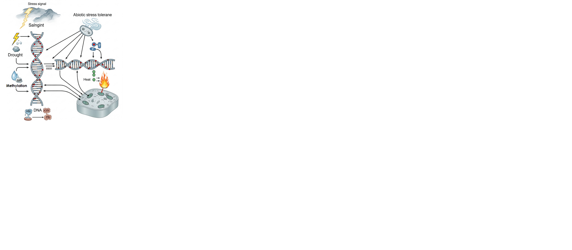

Fig. 7: Abiotic stress tolerance and DNA methylation

The literature mentioned above leads one to the conclusion that DNA methylation changes in a variety of plant genomes can also be brought on by heavy metal stress. The figure contrast to drought stress, heavy metal stress seems to have a stronger and more noticeable impact on epigenetic continuity (Reichard and Puga 2010 & Sun M, et al., 2022). Along with Pb, zinc also alters the promoters of many genes and significantly alters DNA methylation patterns in maize, which leads to alterations in gene expression (Galati et al., 2021).
5. CONCLUSION
According to this study, specific toxic heavy metals negatively impact the crop species S. officinarum L. Air pollution from transportation has emerged as a potentially life-threatening concern. This study highlights the significant risks that toxic HM pollutants from excessive vehicle emissions pose to environmental and wildlife health. In crops located near heavily trafficked areas, a high rate of DNA methylation was observed, while those growing farther away showed a lower rate. The data regarding DNA methylation fluctuated, indicating changes in epigenetics. Alterations in epigenetics can signal the presence of abiotic stress. Cytosine found in the structure of DNA can contribute to a reduction in the levels of methylation. The recorded data indicating potentially hazardous concentrations of toxic HMs and gases at a heavily trafficked site, compared to a site without traffic, revealed that the farm adjacent to the trafficked area had higher levels of these dangerous substances. Due to the presence of pits near the trafficked site that fill with water when it rains, the smog produced by passing vehicles mixes with the water in these pits. When a pit is filled with water, it becomes toxic, and this contaminated water seeps into the farm. As a result, the soil on the farm becomes toxic. The observations show that crops absorb these pollutants through their root systems and leaf stomata and that concentrations of these pollutants are significantly greater in crops that are situated close to dust-impacted, traffic-polluted locations than in control regions that are farther away from traffic sources. This was the cause of the traffic air pollution, which was observed to differ between the control site and the farm near the with-traffic site. The elevated levels of harmful HMs in these crops act as toxic agents that negatively affect plant health and pose significant threats to both plant and animal life. Additionally, the accumulation of these toxins in parts of edible crops presents considerable health hazards to humans, while crops meant for animal feed also play a role in the introduction of these contaminants, disrupting the health systems of livestock.
6. FUTURE SCOPE
A record of both qualitative and quantitative data is also included in this study. This information may be crucial for identifying the precise impacts of emissions on various crop species and for enhancing our comprehension of those effects. This could lead to additional research using data from these findings. Such studies could assist in assessing the environmental risks posed by vehicle air pollution. This can involve specific research utilizing molecular data derived from these sources. This kind of information reveals alterations in epigenetics. Changes in epigenetics can indicate abiotic stress. The status level of DNA methylation can be used to assess pollution. DNA methylation serves as a biomarker, reflecting environmental pollution at the molecular level. Air pollution caused by transportation has emerged as a serious threat to health. Various effective strategies have been implemented to lessen air pollution from traffic. These strategies include establishing roadside vegetation, constructing dust barriers along roads, encouraging the adoption of electric vehicles, supporting the use of compressed natural gas (CNG) vehicles, decreasing the total number of vehicles, promoting vehicle usage only when necessary, employing genetic technology, utilizing greenhouses for crop production, and planting crops at greater distances from major roadways.

7. DISCLAIMER (ARTIFICIAL INTELLIGENCE)
Author(s) hereby declares that NO generative AI technologies such as Large Language Models (ChatGPT, COPILOT, etc) and text-to-image generators have been used during writing or editing of this manuscript.
8. COMPETING INTERESTS
Authors have declared that no competing interests exist

9. REFERENCES
- Aliyar, Z. B., Shafiei, A. B., Seyedi, N., Rezapour, S., & Moghanjugi, S. M. (2020). Effect of traffic-induced air pollution on seed germination of Arizona Cypress (Cupressus arizonica Green) and Black Pine (Pinus nigra Arnold). Urban Forestry & Urban Greening, 55, 126841. https://doi.org/10.1016/j.ufug.2020.126841
- Asiminicesei, D.-M., Fertu, D. I., & Gavrilescu, M. (2024). Impact of Heavy Metal Pollution in the Environment on the Metabolic Profile of Medicinal Plants and Their Therapeutic Potential. Plants, 13(6), 913. https://doi.org/10.3390/plants13060913
- Chandana, B. S., Mahto, R. K., Singh, R. K., Ford, R., Vaghefi, N., Gupta, S. K., Yadav, H. K., Manohar, M., & Kumar, R. (2022). Epigenomics as potential tools for enhancing magnitude of breeding approaches for developing climate resilient chickpea. Frontiers in Genetics, 13, 900253. https://doi.org/10.3389/fgene.2022.900253
- Cicekliyurt, M. M. H., & Yayintas, O. T. (2022). DNA methylation in bryophytes as a biomarker for monitoring environmental pollution. Indian Journal of Experimental Biology (IJEB), 60(11), 870-874. https://doi.org/10.56042/ijeb.v60i11.54255
- Ding, H., Gao, J., Qin, C., Ma, H., Huang, H., Song, P., Luo, X., Lin, H., Shen, Y., Pan, G., & Zhang, Z. (2014). The dynamics of DNA methylation in maize roots under Pb stress. International Journal of Molecular Sciences, 15(12), 23537-23554. https://doi.org/10.3390/ijms151223537
- Feng, S. J., Liu, X. S., Tao, H., Tan, S. K., Chu, S. S., Oono, Y., & Yang, Z. M. (2016). Variation of DNA methylation patterns associated with gene expression in rice (Oryza sativa) exposed to cadmium. Plant, Cell & Environment. https://doi.org/10.1111/pce.12793
- França, F. C. S. S., Albuuerque, A. M. A., Almeida, A. C., Silveira, P. B., Filho, C. A., Hazin, C. A., & Honorato, E. V. (2017). Heavy metals deposited in the culture of lettuce (Lactuca sativa L.) by the influence of vehicular traffic in Pernambuco. Brazil. Food Chemistry, 215, 171-176. https://doi.org/10.1016/j.foodchem.2016.07.168
- Galati, S., Gullì, M., Giannelli, G., Furini, A., DalCorso, G., Fragni, R., Buschini, A., & Visioli, G. (2021). Heavy metals modulate DNA compaction and methylation at CpG sites in the metal hyperaccumulator Arabidopsis halleri. Environmental and Molecular Mutagenesis. https://doi.org/10.1002/em.22421
- Gall, J. E., Boyd, R. S., & Rajakaruna, N. (2015). Transfer of heavy metals through terrestrial food webs: a review. Environmental monitoring and assessment. https://doi.org/10.1007/s10661-015-4436-3
- Gao, Y., Duan, Z., Zhang, L., Sun, D., & Li, X. (2022). The status and research progress of cadmium pollution in rice (Oryza sativa L.) and wheat (Triticum aestivum L.) cropping systems in China: A critical review. Toxics, 10(12), 794. https://doi.org/10.3390/toxics10120794
- Gomez, K. A., & Gomez, A. A. (1984). Statistical procedures for agricultural research. John Wiley & Sons. https://books.google.com/books/about/Statistical_Procedures_for_Agricultural.html?id=2_4eAAAAMAAJ
- Hashad, K. N., Yang, B., Gallagher, J., Baldauf, R. W., Deshmukh, P., & Zhang, K. M. (2023). Impact of roadside conifers vegetation growth on air pollution mitigation. Landscape and Urban Planning, 229, 104594. https://doi.org/10.1016/j.landurbplan.2022.104594
- Jiang, X. Q., Mei, X. D., & Feng, D. (2016). Air pollution and chronic airway diseases: what should people know and do?. Journal of Thoracic Disease, 8(1), E31-E40. https://doi.org/10.3978/j.issn.2072-1439.2015.11.50
- Joshi, P. C., & Swami, A. (2007). Physiological responses of some tree species under roadside automobile pollution stress around city of Haridwar, India. The Environmentalist, 27(3), 365-374. https://doi.org/10.1007/s10669-007-9049-0
- Kloog, I., Ridgway, B., Koutrakis, P., Coull, B. A., & Schwartz, J. D. (2013). Long- and short-term exposure to PM2.5 and mortality: Using novel exposure models. Epidemiology, 24(4), 555-561. https://doi.org/10.1097/EDE.0b013e318294beaa
- Laanen, P., Saenen, E., Mysara, M., Van de Walle, J., Van Hees, M., Nauts, R., Van Nieuwerburgh, F., Voorspoels, S., Jacobs, G., Cuypers, A., & Horemans, N. (2021). Changes in DNA methylation in Arabidopsis thaliana plants exposed over multiple generations to gamma radiation. Frontiers in Plant Science, 12, 611783. https://doi.org/10.3389/fpls.2021.611783
- Luo, N. (2024). Methods for controlling heavy metals in environmental soils based on artificial neural networks. Scientific Reports, 14(1), 2563. https://doi.org/10.1038/s41598-024-52869-9
- Mahapatra, B., Dhal, N. K., Dash, A. K., Panda, B. P., Panigrahi, K. C. S., & Pradhan, A. (2019). Perspective of mitigating atmospheric heavy metal pollution: using mosses as biomonitoring and indicator organism. Environmental Science and Pollution Research. https://doi.org/10.1007/s11356-019-06270-z
- Malik, F. (2022). Assessing heavy metal contamination impact in maize growing along the roadside. Pakistan Journal of Agriculture, Agricultural Engineering and Veterinary Sciences, 38(1), 7-14. https://doi.org/10.47432/2022.38.1.2
- McLaughlin, M., Smolders, E. A. A., Degryse, F., & Rietra, R. P. J. J. (2011). Uptake of metals from soil into vegetables - Chapter 8. In F. A. Swartjes (Ed.), Dealing with contaminated sites: From theory towards practical application (pp. 325-367). https://doi.org/10.1007/978-90-481-9757-6_8
- Nakano, T., & Otsuki, T. (2013). Environmental air pollutants and the risk of cancer. Gan to kagaku ryoho. Cancer & chemotherapy, 40(11), 1441-1445. https://pubmed.ncbi.nlm.nih.gov/24231697/
- Olajumoke, E. T., & Ojo, F. P. (2020). Quantifying vehicular heavy metal deposits on roadside soil and vegetation along Akure-Ilesa express road, South-Western Nigeria. GSC Biological and Pharmaceutical Sciences, 12(1), 054-61. https://doi.org/10.30574/gscbps.2020.12.1.0186
- Oves, M., Khan, M. S., Zaidi, A., & Ahmad, E. (2012). Soil contamination, nutritive value, and human health risk assessment of heavy metals: An overview. In A. Zaidi, P. A. Wani, & M. S. Khan (Eds.), Toxicity of heavy metals to legumes and bioremediation (pp. 1-27). Springer. https://doi.org/10.1007/978-3-7091-0730-0_1
- Papadia, P., Barozzi, F., Migoni, D., Rojas, M., Fanizzi, F. P., & Di Sansebastiano, G.-P. (2020). Aquatic mosses as adaptable bio-filters for heavy metal removal from contaminated water. International Journal of Molecular Sciences, 21(13), 4769. https://doi.org/10.3390/ijms21134769
- Rai, P. K. (2012). An eco-sustainable green approach for heavy metals management: two case studies of developing industrial region. Environmental Monitoring and Assessment, 184(1), 421-448. https://doi.org/10.1007/s10661-011-1978-x
- Rashid, A., Schutte, B. J., Ulery, A., Deyholos, M. K., Sanogo, S., Lehnhoff, E. A., & Beck, L. (2023). Heavy metal contamination in agricultural soil: environmental pollutants affecting crop health. Agronomy, 13(6), 1521. https://doi.org/10.3390/agronomy13061521
- Reichard, J. F., & Puga, A. (2010). Effects of arsenic exposure on DNA methylation and epigenetic gene regulation. Epigenomics. https://doi.org/10.2217/epi.09.45
- Salam, M. A., Akhter, S., Nur-E-Alam, M., Islam, M. S., Dewanjee, S., Siddique, M. A. B., Chakraborty, T. K., & Prakash, V. (2025). Assessment of Heavy Metal Contamination and Health Risk Associated with Cultivated Vegetables along Dhaka-Mymensingh Highway, Bangladesh. Biological Trace Element Research, 203(2), 1162-1174. https://doi.org/10.1007/s12011-024-04200-w
- Seneviratne, M., Rajakaruna, N., Rizwan, M., Madawala, H. M. S. P., Ok, Y. S., & Vithanage, M. (2019). Heavy metal-induced oxidative stress on seed germination and seedling development: a critical review. Environmental Geochemistry and Health, 41(4), 1813-1831. https://doi.org/10.1007/s10653-017-0005-8
- Shahid, M., Dumat, C., Khalid, S., Schreck, E., Xiong, T., & Niazi, N. K. (2017). Foliar heavy metal uptake, toxicity and detoxification in plants: A comparison of foliar and root metal uptake. Journal of hazardous materials, 325, 36-58. https://doi.org/10.1016/j.jhazmat.2016.11.063
- Singh, D., & Sharma, M. K. (2024). Evaluation of Qualitative and Quantitative Phytochemical Constituents in Saccharum officinarum L. Exposed to Roadside Traffic-Derived Ambient Air Pollution. International Journal of Biochemistry Research & Review, 33(5), 33-46. https://doi.org/10.9734/ijbcrr/2024/v33i5874
- Singh, D., Chhonkar, P. K., & Pandey, R. N. (1999). Soil plant water analysis: a methods manual. IARI, New Delhi, 80-82.
- Singh, D., Garg, A. K., & Sharma, M. K. (2025). Evaluation of potential harmful toxic heavy metals in Saccharum officinarum L. due to air contamination from roadside vehicle exposure. Annals of Plant and Soil Research, 27(1), 60-69. https://doi.org/10.47815/apsr.2025.10436
- Singh, D., Garg, A. K., & Sharma, M. K. (2025). Quantitative assessment of potentially toxic heavy metals in (Solanum tuberosum L.) In relation to vehicular-derived atmospheric pollutants. Annals of Plant and Soil Research, 27(2), 206-217.
- Singh, D., Sharma, M. K., & Singh, M. (2023). Assessment of Physical and Biochemical Qualities of Solanum tuberosum L. Under Roadside Traffic Polluted Area. Current Agriculture Research Journal, 11(3), 1013-1022 https://doi.org/10.12944/CARJ.11.3.29
- Singh, D., Sharma, M. K., Kumar, P., & Vashistha, H. (2024). A study on Effect of Ambient Air Pollution from Roadside Traffic on Qualitative and Quantitative Phytochemical Constituents of Solanum tuberosum L. International Journal of Plant & Soil Science, 36(6), 695-708. https://doi.org/10.9734/ijpss/2024/v36i64674
- Singh, D., Singh, I., & Sharma, M. K. (2023). Assessment of Growth Rate and Photosynthetic Pigments of Saccharum officinarum L. Plantlet under Polluted Area. Biological Forum–An International Journal, 15(5), 725-730. https://researchtrend.net/bfij/BF%2015(5)%20725-730%20(2023).pdf
- Song J, Zhang X, Jones T, Wang ML, Ming R. Identification of male sterility-related genes in Saccharum officinarum and Saccharum spontaneum. Plant Reproduction. 2024 Dec;37(4):489-506. https://doi.org/10.1007/s00497-024-00503-z
- Sun, M., Yang, Z., Liu, L., & Duan, L. (2022). DNA Methylation in Plant Responses and Adaption to Abiotic Stresses. International Journal of Molecular Sciences, 23(13), 6910. https://doi.org/10.3390/ijms23136910
- Xiong, T., Dumat, C., Dappe, V., Vezin, H., Schreck, E., Shahid, M., Pierart, A., & Sobanska, S. (2017). Copper oxide nanoparticle foliar uptake, phytotoxicity, and consequences for sustainable urban agriculture. Environmental Science & Technology https://doi.org/10.1021/acs.est.6b05546
- Yang, Y., Chang, A. C., Wang, M., Chen, W., & Peng, C. (2018). Assessing cadmium exposure risks of vegetables with plant uptake factor and soil property. Environmental Pollution, 238, 263-269. https://doi.org/10.1016/j.envpol.2018.02.059
- Zhou, H., Yang, W.-T., Zhou, X., Liu, L., Gu, J.-F., Wang, W.-L., Zou, J.-L., Tian, T., Peng, P.-Q., & Liao, B.-H. (2016). Accumulation of Heavy Metals in Vegetable Species Planted in Contaminated Soils and the Health Risk Assessment. International Journal of Environmental Research and Public Health. https://doi.org/10.3390/ijerph13030289

