Original Research Article
Assessment of Soil Fertility Status in Gomati and South Tripura District, Tripura, India

ABSTRACT
Aims: Geo-referencing of the important physico-chemical and nutrient parameters of Gomati and South Tripura is the prime objective of this study.
Study Design: Random sampling followed by laboratory tests of important properties of soil were derived to conduct a cross-sectional survey of soil fertility.
Place and Duration of Study: This experiment was carried out in Gomati and South Tripura districts of Tripura, India. The entire work was commenced at the College of Agriculture, Tripura during November, 2024 to June 2025.
Methodology: Using random sampling method, geo-referenced soil samples (0-15 cm depth) were collected followed by dried (air-drying), sieved (2 mm) and inspected with regard to texture, bulk density, water-holding capacity, soil penetration, pH, electrical conductivity, soil organic carbon and available N, P₂O₅, K₂O, Ca+Mg, S and CEC using standard methods of analysis. Correlation analysis and descriptive statistics were carried out. Inverse Distance Weighting (IDW), the special interpolation technique has been used for predicting the values of non-sampled periphery of the sampled locations.
Results: Primarily most soil textured as sandy loam with bulk density ranging within 1.10-1.60 mg m⁻³; pH was ranged extremely acidic to strongly acidic (4.14-5.70) and Organic carbon ranged from 0.45-2.65%. Available nutrients were diversified: Nitrogen (87.81-225.79 kg ha⁻¹), Phosphate (7.70-43.63 kg ha⁻¹), Potash (60.58-451.89 kg ha⁻¹), Calcium & Magnesium (157.01-753.67 kg ha⁻¹) and Sulphur (0.07-18.92 kg ha⁻¹) but CEC had a mean of 12.29-20.84 cmol kg⁻¹. The correlation coefficient is closely related between SOC and available N (r = 0.574) and between CEC and Ca+Mg (r = 0.999).
Conclusion: Gomati and South Tripura are mostly made up of sands and loam soils that are highly acidic with lower availability of nitrogen, phosphate, calcium, magnesium and sulphur; but possess medium CEC due to moderate to high SOC levels. Sustainable crop production in these districts can be advocated to be done using soil acidity-tolerant legumes, site-specific nutrient management and GIS-based mapping of soil fertility.
Keywords: Acidic soils; Geo-referenced sampling; Soil physico-chemical properties; IDW; Tripura
1. INTRODUCTION
The basic prerequisite to develop a soil information system (SIS) is to have big datasets. The present day information system of any resources requires physical existence in terms of latitude and longitude, exact referencing can only be possible with GIS and the geo-referenced soil information system (GeoSIS) can be projected (Saleh et al., 2023). Tripura is one of the advance states of North East India and the datasets of its soil has been prepared and stored with National Bureau of Soil Survey & land Use Planning during past decade without use of new surveying techniques like Global Positioning System (GPS) and Geographic Information System (GIS).
Soil fertility evaluation is the ‘fundamental decision making tool’ for efficiently planning a specific land use system (Havlin et al., 2010). Soil testing offers information about nutrient status-availability, which is a precursor to make fertilizer recommendations for sustainable crop productivity. Soil analysis comprises physical features (texture, bulk density, water holding capacity and so on) as well as chemical properties (pH, SOC, available macronutrients and so on), which are required for long-term soil management (Patil et al., 2010). According to Wilding & Lin (2006) soil contains various amounts of air, water, minerals, organic materials, untold numbers of creatures and other elements that are necessary for life. The availability of nutrients to growing crop plants as well as the total amount of nutrients present disturbs the overall crop growth and development (Shreekanth et al., 2018). Therefore, systematically regular examination is very important for the sufficiency of major, secondary and micronutrients as well as nutrient deficits. Therefore, the data from soil tests should be most accurate, collected from reliable authentic sources of information on the availability of plant nutrients and how to modify fertilizer recommendations for different crops. For the purpose of creating thematic soil fertility maps, the old database has been privileged to collect soil samples using GPS (Mishra et al., 2016). Soil fertility is assessed using the physical and chemical parameters: BD, water holding capacity, texture, penetration, slope, pH, Soil Organic Carbon, available nitrogen (N), phosphate (P₂O₅), potash (K₂O), Calcium (Ca), Magnesium (Mg) and Sulphur (S). For the aforementioned fertility indicators, the average weighted data from topsoil samples taken at depths ranging from 0 to 15 cm (Khaki et al., 2017) are considered for preparing fertility mapping of Gomati and South Tripura District and suggesting best cropping pattern along with management of soil for the yield sustainability of this mild sub-tropical climatic zone.
2. MATERIALS AND METHODS
2.1 Site Description
The present investigation was conducted in the Gomati and South Tripura district which is situated between latitude 22°75′ to 23°50′ North and longitude 91°20′ to 91°50′ East (Table 1; Figure 1). The existing crops in the districts are rice, seasonal vegetables in plain-low lying regions along with riverbeds; rubber, tea, cashew nut etc. plantation in areas having less than 33% slope and forests in high altitude with >33% slope. The day temperature hovers around 30.8 °C while night temperature is 19.4 °C for most of November, often dropping to 12 °C during January. Monsoon is expected to occur & extend in June-September with average annual rainfall distribution of 1851 mm in Gomati and 2869 mm in South Tripura. The temperature varies from 38.4 °C to 4.3 °C.
Table 1: Location of Soil samples collected from Gomati and South Tripura
Sl. No. | District | Range | Beat Name | Latitude | Longitude
S₁ | Gumati | Amarpur | Bampur | 23.55658 | 91.63606
S₂ | Gumati | Ampi | Dhanlekha | 23.67377 | 91.62537
S₃ | Gumati | Karbook | Bairagi Dokan | 23.38958 | 91.76004
S₄ | Gumati | Silachari | Suknachari | 23.20871 | 91.78044
S₅ | Gumati | Udaipur | Paratia | 23.45346 | 91.49557
S₆ | Gumati | Udaipur | Udaipur | 23.55232 | 91.45794
S₇ | Gomati | Silachari | Ghorakappa | 23.16618 | 91.72865
S₈ | South | Kakulia | Manirambari | 23.22483 | 91.51569
S₉ | South | Bankul | Bankul | 23.11821 | 91.69498
S₁₀ | South | Satchand | Manu Bazar | 23.04284 | 91.66868
S₁₁ | South | Rajnagar | Anandapur WL | 23.19595 | 91.36649
S₁₂ | South | Rangamura | Nidaya WL | 23.30189 | 91.33939
S₁₃ | South | Bankul | Rupaichari | 23.04575 | 91.72915
S₁₄ | South | Abhoya WL | Maicherra WL | 23.30785 | 91.48072

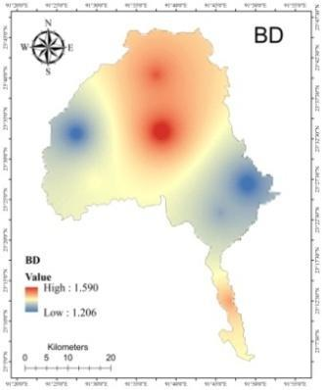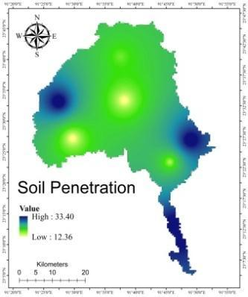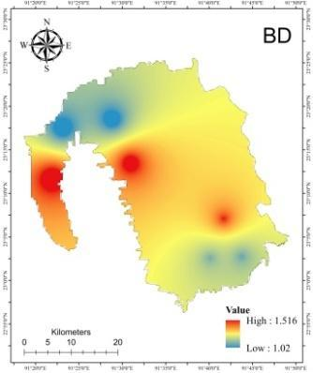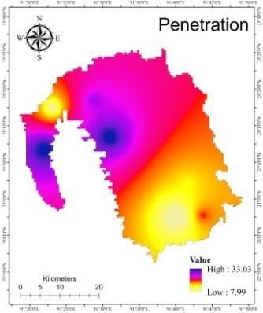
(a) (a) (b) (b)
Figure 1: Spatial variability of Bulk density and penetration of (a) Gomati and (b) South Tripura
2.2 Soil Sampling and Analysis
Sampling (0-15 cm depth) was conducted during November, 2024 following recommended methods and stored in the polythene bag. The samples were collected along with the geo-coordinates and recorded from each location by using a global positioning system (GPS) tool. Samples were dried at room temperature and pulverized with a wooden roll on wooden plank followed by sieved at 2 mm. Then, soil samples that had been homogenized were placed in marking-cloth bags for further analysis to determine the physico-chemical properties of the soil. The standard protocols for the analysing parameters are tabulated in table 2.
Table 2: Procedure used for physico-chemical analysis of soil
Sl. No. | Properties | Method applied | References
a) Physical Properties
1 | Particle size analysis | International Pipette method | Black (1965)
2 | Bulk Density (BD) | Core sampler | Black (1965)
3 | Water Holding Capacity (WHC) | Keen Raczkowski Box | Black (1965)
4 | Soil penetration (N value) | SPT method | Selvam (2020)
b) Chemical Properties
1 | Soil reaction (pH) | pH meter | Jackson et al. (1973)
2 | Electrical Conductivity (dS m⁻¹) | EC bridge | Jackson et al. (1973)
3 | Organic Carbon (%) | Wet oxidation method | Walkley & Black (1934)
c) Available nutrient
1 | Available N (kg ha⁻¹) | Alkaline KMnO₄ method | Subbiah & Asija (1956)
2 | Available P (kg ha⁻¹) | Bray & Kurz Method | Bray & Kurz (1945)
3 | Available K (kg ha⁻¹) | Ammonium acetate method | Hanway & Heidel (1952)
4 | Available Ca+Mg (kg ha⁻¹) | EDTA Method | Cheng & Bray (1951)
5 | Available S (kg ha⁻¹) | Calcium chloride method | Chesnin & Yien (1950)
6 | Cation Exchange Capacity (CEC) | Ammonium acetate method | Lewis (1949)

2.3 Statistical Analysis
The techniques modelled by Snedecor and Cochran’s (1967) are found suitable for doing this simple statistical analysis. These analyses included common statistical algorithms viz. maximum, minimum, mean, coefficient of variation and correlation. The Coefficient variation was determined by using formula:
C.V. = Standard Deviation Mean × 100
And the correlation coefficient was determined by using the formula:
$r=\frac{n\left(\sum{}xy\right)-\left(\sum{}x\right)\left(\sum{}y\right)}{\sqrt{\left[n\sum{}x^{2}-{\left(\sum{}x\right)}^{2}\right]\left[n\sum{}y^{2}-{\left(\sum{}y\right)}^{2}\right]}}$
Where,
r = Correlation coefficient
SP (xy) = Sum product of x, y variables
SS (x) = Sum of square of x variable
SS (y) = Sum of square of y variable.
3. RESULTS AND DISCUSSION
3.1 Physical Properties
In both Gomati and South Tripura, the sand, silt and clay content of samples ranged from 8-61, 5-63 and 4-47 (Table 3) respectively following no definite trend. The bulk density (BD) ranged from 1.10 to 1.60 mg m⁻³; whereas water holding capacity was mostly at nearly in the optimum range. The ratio of Sand-Silt-clay reflected most sites were sandy loam type. The CV value of BD, WHC and Sand were in acceptable range and reflected the basic parent soil type of the study area (Gökbulak & Özcan, 2008). Topographical variability affected the formation and range of silt and clay, reflected at a higher range of CV value (Khan et al., 2013). The BD exhibited positive significant correlation (r = 0.662**) with sand; whereas silt and clay are negatively correlated (r = -0.644*). A similar result was experienced by Wang et al. (2024).
Table 3: Physical properties of soils of Gomati and South Tripura
Sl. No. | Beat Name | BD  (mg m⁻³) | Water Holding Capacity (%) | Soil Penetration (N value) | Sand (%) | Silt (%) | Clay (%)
S₁ | Bampur | 1.60 | 37.00 | 12 | 60 | 5 | 35
S₂ | Dhanlekha | 1.50 | 47.54 | 17 | 52 | 44 | 4
S₃ | Bairagi Dokan | 1.30 | 76.00 | 15 | 54 | 41 | 5
S₄ | Suknachari | 1.45 | 45.00 | 34 | 51 | 39 | 10
S₅ | Paratia | 1.39 | 65.00 | 12 | 47 | 34 | 19
S₆ | Udaipur | 1.21 | 33.00 | 32 | 37 | 31 | 32
S₇ | Ghorakappa | 1.20 | 76.00 | 32 | 56 | 39 | 5
S₈ | Manirambari | 1.51 | 65.21 | 34 | 61 | 35 | 4
S₉ | Bankul | 1.43 | 76.45 | 18 | 49 | 11 | 40
S₁₀ | Manu Bazar | 1.22 | 67.45 | 7 | 42 | 42 | 16
S₁₁ | Anandapur WL | 1.54 | 71.00 | 34 | 48 | 41 | 11
S₁₂ | Nidaya WL | 1.10 | 73.76 | 12 | 8 | 63 | 29
S₁₃ | Rupaichari | 1.21 | 43.34 | 23 | 44 | 9 | 47
S₁₄ | Maicherra WL | 1.11 | 54.23 | 27 | 41 | 49 | 10
 | SD | 0.16 | 14.99 | 9.54 | 12.61 | 15.54 | 14.21
 | mean | 1.26 | 56.40 | 21.24 | 44.17 | 34.50 | 18.75
 | CV | 12.79 | 26.57 | 44.90 | 28.55 | 45.03 | 75.80

3.2 Chemical Properties
The pH range of sampling area ranges from 4.14 to 5.70 with a mean value of 4.59 (Table 4). The result indicated extremely acidic pH with a safe limit of electrical conductivity in the entire study area. Intensive rainfall followed by erosion and leaching and or percolation were the reasons for acidity and low EC (Makineci et al., 2015). EC is negatively correlated with available N (r = -0.690**) due to the effect of low pH on nutrient dynamics where high acidity limits the availability of NH₄⁺ even when EC is elevated (Kim & Park, 2024). The level of organic carbon from 0.45 to 2.65 existed in the study area which covered exhaustive farming to virgin or forest or plantation area (Kaushik et al., 2018). Tripura is second highest in rubber production in India and the age of the rubber field might be responsible for high range of SOC at Manirambari, Dhanlekha, Maicherra WL areas. SOC was lower in young plantations but gradually increased with rubber plantation age as equivalent with natural forest (Nguyen et al., 2020).
3.3 Nutrient Status
The soil in the research region unveiled the range of available nitrogen content, spanning from 37.63 to 225.79 kg ha⁻¹, while mean value is 137.98 kg ha⁻¹ (Table 4). Among the sites, the highest level (225.79 kg ha⁻¹) was found at no. S₈ Manirambari which also reflected the highest range of 2.65% SOC. Dense rubber cultivation along with synthetic fertilisation might be the reason for this result as observed by Jin et al. (2024). The universal truth of positive correlation between SOC and available N was re-established in such acidic soil representing the responses of Bharteey et al. (2023). The wide variations of available P2O5 (7.70 to 43.63 kg ha⁻¹) with mean value of 22.31, resulted in higher CV (44.34) and positive correlation with pH. Suknachari (7.70 kg ha⁻¹) reflected lowest P2O5 with a pH level of 4.30. This established the truth of negative relation between acidity and available P2O5 (Bharteey et al., 2017). The status of available potassium ranged from 60.58-451.89 kg ha⁻¹, having a mean value of 173.93 kg ha⁻¹. No. S₈ Kakulia has the maximum potassium content, while No. S₅ Paratia has the lowest potassium content. 57% of the soil samples had medium, 28% low and 14% had high potassium content. Such a trend in hilly high rainfall subtropical areas had been controlled by SOC and potassium buffering capacity took the lead role on availability of potash (Gautam et al., 2023; Grando et al., 2025). The range of available Ca+Mg was 157.01 to 753.67 kg ha⁻¹ having a mean value of 441.47. This range existed in the lower range of Ca+Mg as per the limit proposed by Tisdale et al. (1995). Subtropical climate with high rainfall might be the reason for low base saturation as also observed by Grando et al. (2025). Also the range of available S (0.07 to 18.92 kg ha⁻¹) also existed at lower range might be due to parent soil characteristics along with high rainfall. Paul and Mukhopadhyay (2015) proved that organic S is the most predominant fraction of S and occurs as a major native S reserve. CEC ranges from 12.29 to 20.84 cmol(p+) kg⁻¹ where the mean value is 15.66 cmol(p+) kg⁻¹. Only Maicherra WL no. S₁₄ reflected lower range and rest areas represented medium range of CEC with CV value of 13.72. CEC was significantly correlated with Ca+Mg (r = 0.999**) as re-assessed by Grando et al. (2025) (Table 5).
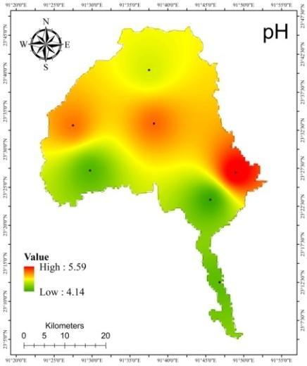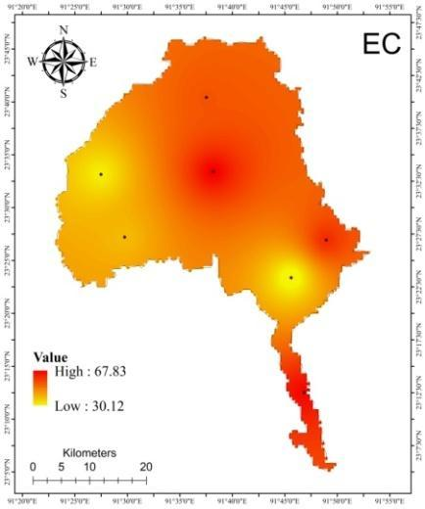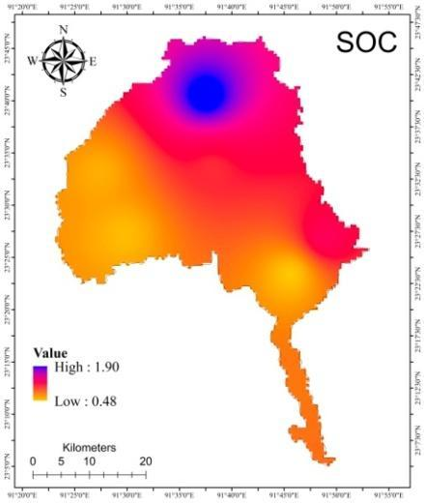
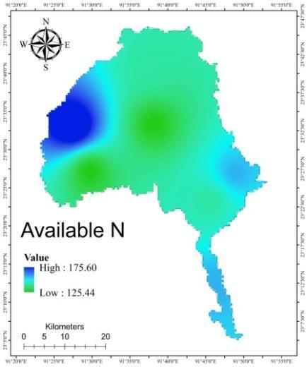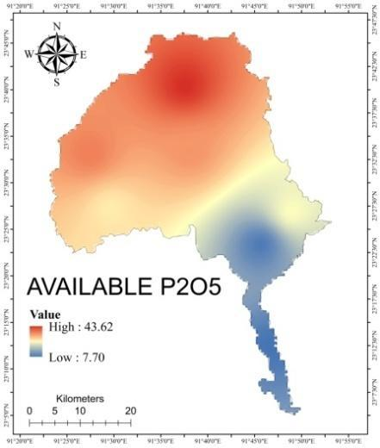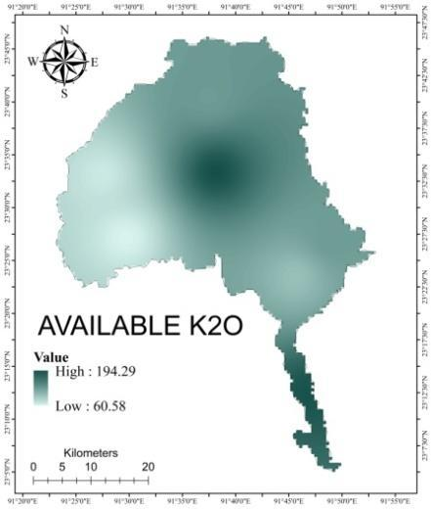
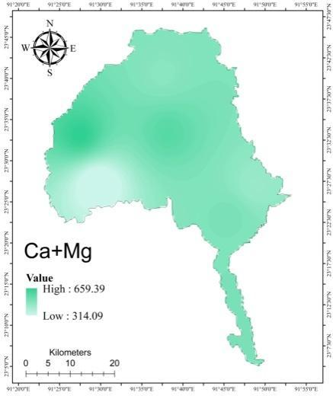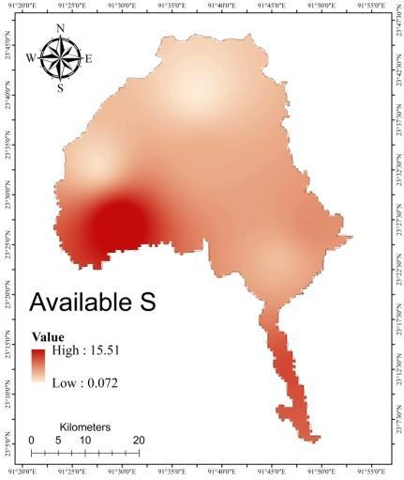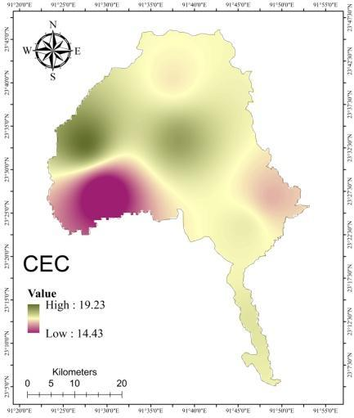
Figure 2: Spatial variability maps of pH, EC, SOC, available N, P₂O₅, K₂O, Ca+Mg, S & CEC of Gomati
Among various geostatistical analytical tools, Inverse Distance Weighting (IDW) is most common and this technique is used for creating maps of the physico-chemical properties of Gomati and South Tripura districts, depicted as figures 2 and figure 3, respectively.
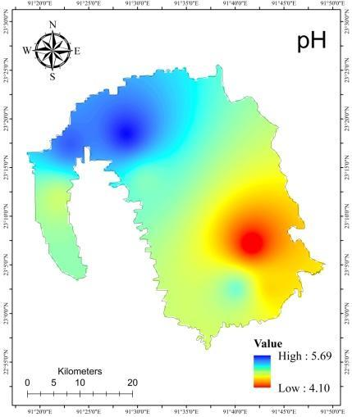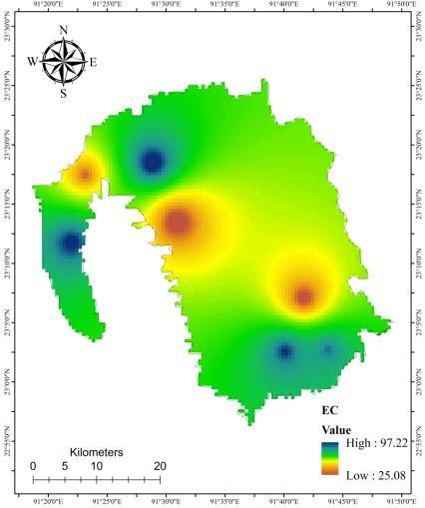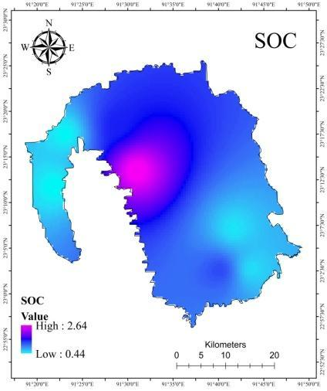
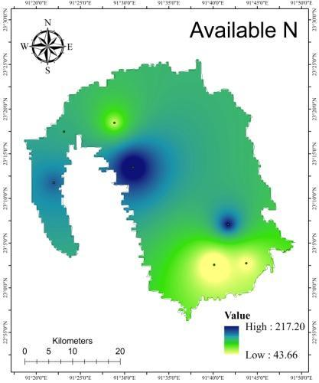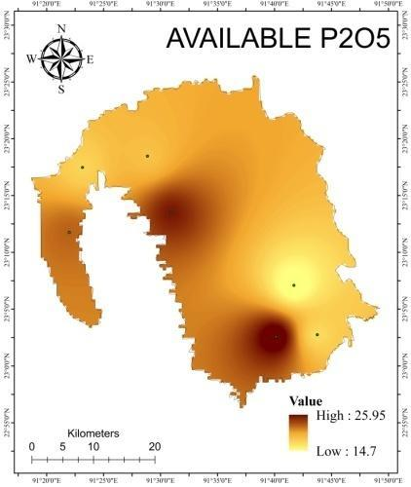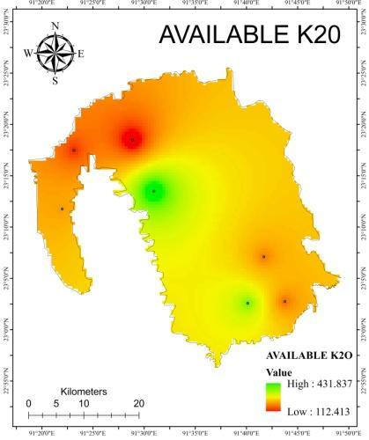
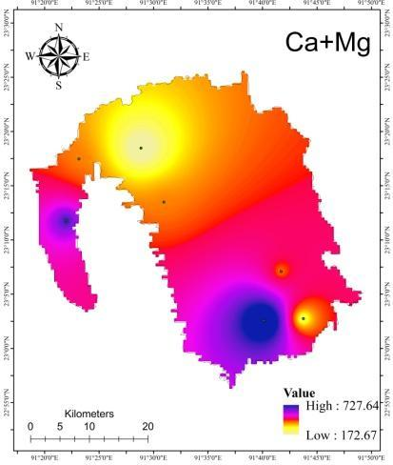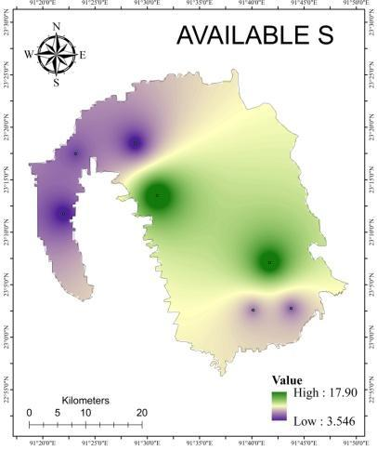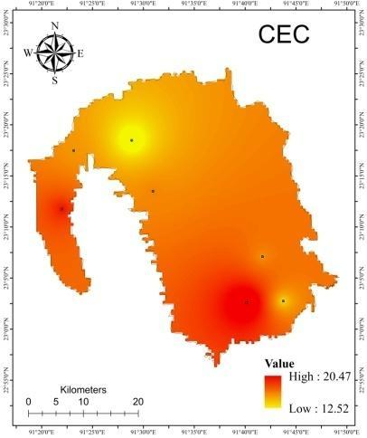
Figure 3: Spatial variability maps of pH, EC, SOC, available N, P₂O₅, K₂O, Ca+Mg, S & CEC of South Tripura

Table 4: Chemical and nutrient properties of analytical soil samples
Sl. No. | Beat Name | EC  (µS cm⁻¹) | pH | SOC % | Avail. N  (kg ha⁻¹) | Avail. P₂O₅  (kg ha⁻¹) | Avail. K₂O  (kg ha⁻¹) | Avail. (Ca+Mg)  (kg ha⁻¹) | Avail. S  (kg ha⁻¹) | CEC  (cmol kg⁻¹)
S₁ | Bampur | 67.90 | 5.20 | 0.98 | 125.44 | 34.66 | 194.32 | 596.65 | 4.17 | 18.51
S₂ | Dhanlekha | 55.90 | 4.70 | 1.91 | 137.98 | 43.63 | 125.43 | 502.45 | 0.07 | 17.12
S₃ | Bairagi Dokan | 29.90 | 4.14 | 0.49 | 137.98 | 8.62 | 97.29 | 533.85 | 3.21 | 17.52
S₄ | Suknachari | 66.70 | 4.30 | 0.78 | 150.53 | 7.70 | 191.13 | 533.85 | 9.68 | 17.63
S₅ | Paratia | 41.50 | 4.26 | 0.53 | 125.44 | 27.38 | 60.58 | 314.03 | 15.52 | 14.43
S₆ | Udaipur | 34.00 | 5.17 | 0.59 | 175.62 | 36.62 | 67.50 | 659.46 | 1.00 | 19.23
S₇ | Ghorakappa | 61.90 | 5.60 | 1.17 | 150.53 | 25.28 | 125.43 | 471.04 | 5.92 | 16.68
S₈ | Manirambari | 20.80 | 5.06 | 2.65 | 225.79 | 24.24 | 451.89 | 376.83 | 18.92 | 15.75
S₉ | Bankul | 28.70 | 4.10 | 0.55 | 188.16 | 14.72 | 196.82 | 376.83 | 17.30 | 15.46
S₁₀ | Manu Bazar | 88.90 | 5.10 | 1.25 | 37.63 | 25.97 | 330.33 | 753.67 | 6.57 | 20.84
S₁₁ | Anandapur WL | 93.40 | 4.88 | 0.45 | 163.07 | 21.99 | 217.12 | 533.85 | 3.55 | 17.66
S₁₂ | Nidaya WL | 38.70 | 5.54 | 0.47 | 137.98 | 17.72 | 161.28 | 376.83 | 5.42 | 15.42
S₁₃ | Rupaichari | 81.70 | 4.62 | 0.59 | 75.26 | 17.46 | 188.39 | 282.63 | 5.92 | 14.14
S₁₄ | Maicherra WL | 100.20 | 5.70 | 1.44 | 87.81 | 18.70 | 99.64 | 157.01 | 3.12 | 12.29
 | SD | 25.35 | 0.53 | 0.63 | 45.84 | 9.89 | 101.80 | 153.12 | 5.77 | 2.15
 | mean | 55.70 | 4.59 | 0.96 | 137.09 | 22.31 | 173.93 | 441.47 | 7.08 | 15.66
 | CV | 45.51 | 11.45 | 65.15 | 33.44 | 44.34 | 58.53 | 34.68 | 81.52 | 13.72

Table 5: Correlation between physico-chemical and nutrient properties of Gomati and South Tripura
Pearson Correlations
 | BD | WHC | N value | Sand | Silt | Clay | EC | pH | SOC | N | P₂O₅ | K₂O | Ca+Mg | S | CEC
BD | 1 | -0.144 | 0.093 | 0.662** | -0.416 | -0.133 | -0.134 | -0.445 | 0.228 | 0.454 | 0.234 | 0.325 | 0.241 | 0.283 | 0.256
WHC |  | 1 | -0.163 | -0.103 | 0.38 | -0.324 | -0.21 | -0.083 | -0.079 | 0.141 | -0.438 | 0.174 | -0.148 | 0.371 | -0.137
N value |  |  | 1 | 0.26 | 0.047 | -0.283 | 0.07 | 0.163 | 0.206 | 0.531 | -0.129 | 0.114 | -0.132 | 0.036 | -0.125
Sand |  |  |  | 1 | -0.507 | -0.334 | -0.009 | -0.33 | 0.407 | 0.242 | 0.121 | 0.24 | 0.14 | 0.234 | 0.152
Silt |  |  |  |  | 1 | -0.644* | 0.044 | 0.362 | 0.138 | -0.05 | -0.098 | -0.091 | -0.031 | -0.254 | -0.036
Clay |  |  |  |  |  | 1 | -0.04 | -0.102 | -0.513 | -0.161 | 0.000 | -0.113 | -0.09 | 0.07 | -0.095
EC |  |  |  |  |  |  | 1 | 0.343 | -0.055 | -0.690** | -0.001 | -0.01 | -0.012 | -0.451 | -0.013
pH |  |  |  |  |  |  |  | 1 | 0.315 | -0.159 | 0.332 | 0.08 | -0.043 | -0.38 | -0.038
SOC |  |  |  |  |  |  |  |  | 1 | 0.192 | 0.372 | 0.574* | -0.084 | 0.194 | -0.052
N |  |  |  |  |  |  |  |  |  | 1 | 0.013 | 0.162 | -0.041 | 0.407 | -0.032
P2O5 |  |  |  |  |  |  |  |  |  |  | 1 | -0.079 | 0.306 | -0.309 | 0.298
K2O |  |  |  |  |  |  |  |  |  |  |  | 1 | 0.165 | 0.481 | 0.218
Ca+Mg |  |  |  |  |  |  |  |  |  |  |  |  | 1 | -0.319 | 0.999**
S |  |  |  |  |  |  |  |  |  |  |  |  |  | 1 | -0.29
CEC |  |  |  |  |  |  |  |  |  |  |  |  |  |  | 1
**Correlation is significant at the 0.01 level (2-tailed).
*Correlation is significant at the 0.05 level (2-tailed).

4. CONCLUSION
It can be concluded that Gomati and South Tripura district soil can be classified as sandy loam and clay loam with an extreme to strongly acidic pH. 50% soil samples had high organic carbon, 28% medium, 22% low and 100% low available nitrogen, phosphate, calcium sulphur and magnesium. All the sites reflected medium CEC range due to higher levels of SOC. Intensive plantation as well as rice-fellow cropping pattern in this region created such a result. Considering soil textural classes, policy makers can introduce acidic soil suitable leguminous crops in rice-fellow cropping pattern. Application of crop specific bio-fertilizer will increase the productivity and make additional return to the farmers. Soil mapping using GIS may generate an idea about the soil fertility state and it could be very useful for fertilizer management for a specific area simply by applying previously analyzed soil data, leading to site-specific smart nutrient management. At plantation sites at least 2-tier cropping systems like Sal/Segun-black pepper, Sal-pineapple etc. can be established to uplift socio-economic status of the forest dwellers.
Consent (where applicable): Not applicable as no personal data were involved in this study.
Ethical Approval (where applicable): Not applicable. Soil sampling and analysis were carried out with permission and support from the Forest Department, Government of Tripura under the SCATFORM, JICA project.

COMPETING INTERESTS DISCLAIMER:
Authors have declared that they have no known competing financial interests OR non-financial interests OR personal relationships that could have appeared to influence the work reported in this paper.
Author(s) hereby declare that NO generative AI technologies such as Large Language Models (ChatGPT, COPILOT, etc.) and text-to-image generators have been used during the writing or editing of this manuscript.

Disclaimer (Artificial intelligence)
Option 1:
Author(s) hereby declare that NO generative AI technologies such as Large Language Models (ChatGPT, COPILOT, etc.) and text-to-image generators have been used during the writing or editing of this manuscript.
Option 2:
Author(s) hereby declare that generative AI technologies such as Large Language Models, etc. have been used during the writing or editing of manuscripts. This explanation will include the name, version, model, and source of the generative AI technology and as well as all input prompts provided to the generative AI technology
Details of the AI usage are given below:
- NO ARTIFICIAL INTELLIGENCE SUPPORT WAS TAKEN TO WRITE THIS MANUSCRIPT.
2.
3.

6. REFERENCES
- Bharteey, P. K., Singh, Y. V., Sharma Sukirtee, P. K., Kumar, M., & Rai, A. K. (2017). Available Macro Nutrient Status and their Relationship with Soil Physico-Chemical Properties of Mirzapur District of Uttar- Pradesh, India. International Journal of Current Microbiology and Applied Sciences, 6(7), 2829-2837. https://doi.org/10.20546/ijcmas.2017.607.394
- Bharteey, P. K., Deka, B., Dutta, M., Goswami, J., & Saikia, R. (2023). Geospatial variability of soil physico-chemical properties of Moridhal watershed in Dhemaji district of Assam, India using remote sensing and GIS. Annals of Plant and Soil Research, 25(1), 99-109. https://doi.org/10.47815/apsr.2023.10242
- Black, C. A. (Ed.). (1965). Methods of Soil Analysis: Part 1 Physical and Mineralogical Properties, Including Statistics of Measurement and Sampling. American Society of Agronomy. https://doi.org/10.2134/agronmonogr9.1
- Bray, R. H., & Kurtz, L. T. (1945). Determination of total, organic, and available forms of phosphorus in soils. Soil Science, 59, 39-45. https://doi.org/10.1097/00010694-194501000-00006
- Cheng, K. L., & Bray, R. H. (1951). Determination of calcium and magnesium in soil and plant material. Soil Science, 72(6), 449-458. https://doi.org/10.1097/00010694-195112000-00005
- Chesnin, L., & Yien, C. H. (1951). Turbidimetric determination of available sulfates. Soil Science Society of America Journal, 15, 149-151. https://doi.org/10.2136/sssaj1951.036159950015000C0032x
- Gökbulak, F., & Özcan, M. (2008). Hydro-physical properties of soils developed from different parent materials. Geoderma, 145(3-4), 376-380. https://doi.org/10.1016/j.geoderma.2008.04.006
- Gautam, M.K., Sharma, S., Kumar, A., Kumar, S., Jayant, H., Sachan, R. & Kumar, M. (2023). Assessment of Soil Fertility Status under the Barren Land Soil of the Central Plain Zone of Uttar Pradesh, India”. International Journal of Environment and Climate Change 13 (10):483–490. https://doi.org/10.9734/ijecc/2023/v13i102672.
- Grando, D. L., Martins, C. G., Deponti, L. P., Rodrigues, M. L., Mumbach, G. L., Schmitt, D. E., Moterle, D. F., Tiecher, T. L., Garlet, L. P., Dunker, L. S., Papalia, D. G., & Brunetto, G. (2025). Potassium buffer capacity in subtropical soils with high organic matter content. Revista Sociedade Brasileira de Ciência do Solo (Brazilian Society of Soil Science), 49, e0240201. https://doi.org/10.36783/18069657rbcs20240201
- Hanway, J.J. & Heidel, H. (1952). Soil analysis methods as used in Iowa state college soil testing laboratory. Iowa Agriculture, 57, 1-31.
- Havlin, H.L., Beaton, J.D., Tisdale, S.L. & Nelson, W.L. (2010). Soil fertility and fertilizers: An introduction to nutrient management (7th edition). PHI Learning Private Limited, New Delhi. India. p. 516.
- Jackson, M. L. (1973). Soil Chemical Analysis. Prentice Hall of India, Pvt. Ltd.
- Jin, D., Cha, Z., Li, J., Huang, Y., Yang, H., Liu, H., Luo, W., & Lin, Q. (2024). Reinforcing nitrogen nutrition through partial substitution with organic nitrogen enhances the properties of natural rubber. Forests, 15(11), 1897. https://doi.org/10.3390/f15111897
- Kaushik, U., Raj, D., Rani, P., & Bhardwaj, K.K. (2018). Effect of cultivation on organic carbon pools and nutrient availability in soil under different land use system: A review. International Journal of Current Microbiology and Applied Sciences. https://doi.org/10.20546/ijcmas.2018.708.180
- Khaki, B. D., Honarjoo, N., Davatgar, N., Jalalian, A., & Golsefidi, H. T. (2017). Assessment of two soil fertility indexes to evaluate paddy fields for rice cultivation. Sustainability, 9(8), 1299. https://doi.org/10.3390/su9081299
- Khan, F., Hayat, Z., Ahmad, W., Ramzan, M., Shah, Z., Sharif, M., Mian, I. A., & Hanif, M. (2013). Effect of slope position on physico-chemical properties of eroded soil. *Soil Environment*, *32*(1), 22-28. https://www.researchgate.net/publication/259295824_Effect_of_slope_position_on_physico-chemical_properties_of_eroded_soil
- Kim, H. N., & Park, J. H. (2024). Monitoring of soil EC for the prediction of soil nutrient regime under different soil water and organic matter contents. Applied Biological Chemistry. https://doi.org/10.1186/s13765-023-00849-4
- Lewis, D.R. (1949). Analytical data on reference clay materials. Section 3, Base-Exchange Data, Reference Clay Minerals. A.P.I. Research Project 49, Preliminary Report No. 7, Columbia University, New York. p. 91.
- Makineci, E., Demir, M., & Kartaloglu, M. (2015). Acidity (pH) and electrical conductivity changes in runoff water from ditches of paved and unpaved forest roads. Baltic Forestry, 21(1), 170-175. https://www.balticforestry.mi.lt/bf/PDF_Articles/2015-21[1]/Acidity%20and%20Electrical%20Conductivity%20Changes%20in%20Runoff%20Water%20from%20Ditches%20of%20Paved%20and%20Unpaved%20Forest%20Roads.pdf
- Mishra, A., Das, D., Saren, S., & Dey, P. (2016). GPS and GIS based soil fertility maps of Nayagarh district, Odisha. Annals of Plant and Soil Research, 18(1), 23-28. http://www.gkvsociety.com/index.php
- Nguyen, T. T., Do, T. T., Harper, R., Pham, T. T., Linh, T. V. K., Le, T. S., Thanh, L. B., & Giap, N. X. (2020). Soil health impacts of rubber farming: The implication of conversion of degraded natural forests into monoculture plantations. Agriculture, 10(8), 357. https://doi.org/10.3390/agriculture10080357
- Patil, P. L., Kuligod, V. B., Gundlur, S. S., Katti, J., Nagaral, I. N., Shikrashetti, P., Geetanjali, H. M., & Dasog, G. S. (2016). Soil fertility mapping in Dindur sub-watershed of Karnataka for site specific recommendations. Journal of the Indian Society of Soil Science, 64(4), 381-390. https://doi.org/10.5958/0974-0228.2016.00050.5
- Paul, S. C., & Mukhopadhyay, P. K. (2015). Distribution and Availability of Sulphur in some Terai Soils under Subtropical Zone of Eastern India. International Journal of Agriculture, Environment and Biotechnology, 8(2), 347-357. https://doi.org/10.5958/2230-732X.2015.00043.1
- Saleh, T. M., Jubeir, A. R., & Al-Tememe, M. S. O. (2023). The role of Geographic Information Systems (GIS) in soil surveying and classification. IOP Conference Series Earth and Environmental Science, 1158(2), 022028. https://doi.org/10.1088/1755-1315/1158/2/022028
- Selvam, S., Mukundan, M., & Alagirisamy, S. (2020). Standard Penetration Test (SPT) Pitfalls and Improvements. In C. N. V. S. Reddy (Ed.), Ground Characterization and Foundations: Proceedings of Indian Geotechnical Conference 2020 Volume 1 (pp. 391-400). Springer Singapore. https://doi.org/10.1007/978-981-16-3383-6_35
- Shreekanth, S., Anita, E.K., Rekha, M.V., Champa, B.V., & Nagaraja, M.S. (2018). Secondary and micronutrient status in soils of grape orchards of Vijayapura Taluka in Northern Karnataka, India. International Journal of Current Microbiology and Applied Sciences, 7(5), 1393-1401. https://doi.org/10.20546/ijcmas.2018.705.165
- Snedecor, G.W. & Cochran, W.G. (1967). Statistical Methods (6th Edition). Iowa State University Press, Ames. Iowa, USA. p. 593.
- Subbiah, B.V., & Asija, G.L. (1956). A rapid procedure for the estimation of available nitrogen in soils. Current Science, 25, 259-260.
- Tisdale, S.L., Nelson, W.L., Beaton, J.D. & Havlin, J.L. (1995). Soil Fertility and Fertilizers (5th Edition). Prentice-Hall of India, New Delhi. p. 684.
- Walkley, A., & Black, I. A. (1934). An examination of the Degtjareff method for determining soil organic matter and a proposed modification of the chromic acid titration method. Soil Science, 37(1), 29–38. https://doi.org/10.1097/00010694-193401000-00003
- Wang, X., Sun, H., Wang, C., Liu, J., Guo, Z., Gao, L., Ma, H., Yuan, Z., Yao, C. & Pan, X. (2024). Predicting the soil bulk density using a new spectral PTF based on intact samples. Geoderma, 449, 117005. DOI: https://doi.org/10.1016/j.geoderma.2024.117005
- Wilding, L. P., & Lin, H. (2006). Advancing the frontiers of soil science towards a geoscience. Geoderma, 131(3-4), 257-274. https://doi.org/10.1016/j.geoderma.2005.03.028

