Original Research Article

Multivariate Selection of High-Performing Green Gram Accessions Based on Yield and Component Traits

.
ABSTRACT

The present study was undertaken to evaluate eleven green gram (Vigna radiata (L.) Wilczek) accessions to identify superior genotypes based on yield and key yield-associated traits. Significant genotypic correlations were observed between yield per plant and number of pods per plant, number of primary branches, number of clusters per plant, and pod length. Path coefficient analysis revealed that number of pods per plant and pod length exerted strong positive and direct effects on yield indicating their values as primary selection criteria. Superior accessions were identified by integrating yield performance with favourable trait expression. Results obtained from the two approaches were almost comparable. Among the different multivariate approaches examined for constructing a selection index, the PCA biplot proved particularly effective for visualizing trait relationships and discriminating high-performing accessions. The findings provide a practical framework for trait-based selection in green gram improvement programs.

Keywords: Principal component analysis, selection index, PCA biplot, high performing accessions

1. INTRODUCTION

Green gram [Vigna radiata (L.) Wilczek], known as mungbean, is believed to have originated in India and Central Asia. The crop is characterized by a short growth cycle, which makes it highly adaptable to diverse agro-ecological conditions and suitable for multiple cropping systems. Nutritionally, green gram is an excellent source of plant-based protein, containing approximately 24.0% crude protein, 1.0% fat, and 62% carbohydrates, providing approximately 334 kcal per 100 g. It is also a good source of minerals and vitamins with 140 mg calcium, 8.4 mg iron, 280 mg phosphorus, 0.47 mg thiamine (B1), 0.39 mg riboflavin (B2), and 2.0 mg niacin per 100 g of green gram (Chongre et al., 2019). In addition to its nutritional value, green gram contributes significantly to soil health through symbiotic nitrogen fixation with Rhizobium species.

In India, green gram is the third most important pulse crop after pigeon pea and chickpea. During 2023-24, 15.93 lakh hectares of land were under green gram cultivation (Jat et al., 2024). The primary green gram producing states are Rajasthan, Karnataka, Maharashtra, Odisha, Madhya Pradesh and Gujarat (Green gram outlook, 2024). Enhancement of productivity requires the availability and adoption of high-yielding accessions suited to local production systems.
.
As the yield of a crop is a complex quantitative trait, direct selection for yield alone is often inefficient. Yield associated traits with higher heritability and strong direct effects offer a more effective basis for selection. In this context, the present study was undertaken to identify superior green gram accessions by integrating yield performance with key yield-contributing traits.

2. material and methods

2.1 Experimental design and treatments

The experiment was conducted in the Experimental Field of Department of Plant Breeding and Genetics, College of Agriculture, Vellanikkara, Kerala Agricultural University, Thrissur, Kerala (10°32’11’’N and 76°16’43’’E and 97m above mean sea level) during June to August, 2024. The experimental material comprised of 11 accessions of green gram viz., IC 394380, IC 394640, IC 392930, IC 247820, IC 224780, Pusa M 2142, CO8, CO6, TM 96, Virat and IC 393910. The experiment was laid out in randomized complete block design with three replications. Line sowing was adopted within each block with a spacing of 30 x 10 cm and standard agronomic practices were adopted.

2.2 Data collection

Observations were recorded on twelve traits viz., days to 50 per cent flowering, days to maturity, plant height, number of primary branches per plant, number of secondary branches per plant, number of clusters per plant, number of pods per cluster, number of pods per plant, number of seeds per pod, pod length, 100 seed weight and yield per plant.

2.3 Statistical analysis

Genotypic correlations were estimated, and traits showing significant correlation with yield were further subjected to path coefficient analysis using variability package in R Studio version 4.2.2. Principal component analysis (PCA) was carried out using yield and traits correlated with yield using KAU GRAPES (Gopinath et al., 2021). Superior accessions were selected based on yield and yield-associated traits using the methods of Arunachalam and Bandyopadhyay (1984) and the PCA-based approach.

2.3.1 Arunachalam and Bandyopadhyay method (1984)

In Arunachalam and Bandyopadhyay (1984) method, accessions were grouped post hoc ANOVA into statistically distinct classes. Scores were assigned to each accession such that those in the highest class for a given character received a score of one, those in the next class received a score of two, and those in the lowest class received the highest score for that character. These scores were then standardized by dividing each by the total number of groups for that trait to ensure that the maximum possible standardized score did not exceed 1. The scores across the traits were summed to obtain a total score for each accession. Accessions were then ranked in ascending order, wherein the accession with the lowest score was considered the best performer (Prabhu et al., 1990).

2.3.2 Principal Component Analysis (PCA) based method

For PCA based method, only PCs with eigen values greater than 0.5 were considered. Score for each accession for a particular trait was calculated as the sum of the products of phenotypic value of that trait and their respective modified weights from the PCs. Modified weights were obtained as the product of loading value of each character in the concerned PC and its eigenvalue. Total score of each accession was calculated by summing the scores of yield and yield associated traits. Accessions were arranged in descending order based on total score and accession with the highest total score was considered superior.

3. results and discussion

3.1 Identification of yield contributing traits

Yield per plant exhibited significant genotypic correlation (Fig 1) with the number of pods per plant, pod length, number of primary branches, and number of clusters per plant. These findings are in agreement with earlier reports of Sandhiya and Saravanan (2018); Asari et al. (2019); Shakeer et al. (2022) ; Nalajala et al. (2023) and Mohanty et al. (2024). Traits which exhibited significant correlation with yield were further subjected to path analysis (Fig 2) to know the yield contributing traits and effects of individual traits on yield.

Positive and direct effect on yield per plant were exerted by number of pods per plant and pod length, whereas positive and indirect effect was exercised by number of pods per plant, number of clusters per plant, pod length, number of primary branches. Mohanty et al. (2024); Kamble et al. (2023) and Harsh et al. (2024) had reported similar results in green gram. Traits that displayed significant correlation with yield were further subjected to path coefficient analysis (Fig. 2) to determine their direct and indirect contributions to yield.

Number of pods per plant and pod length exerted positive direct effects on yield per plant, indicating their importance as primary determinants of yield. Positive indirect effects on yield were contributed by number of pods per plant, number of clusters per plant, pod length, and number of primary branches. Similar observations have been reported in green gram by Mohanty et al. (2024), Kamble et al. (2023), and Harsh et al. (2024).

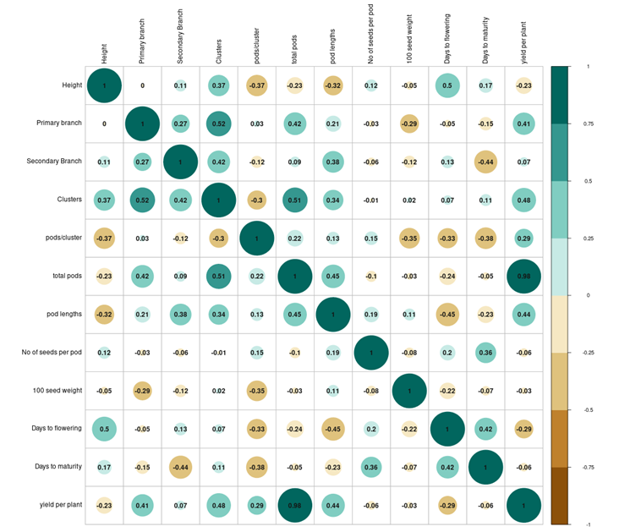

Fig. 1. Correlogram exhibiting association between yield and agronomic traits in 11 green gram accessions

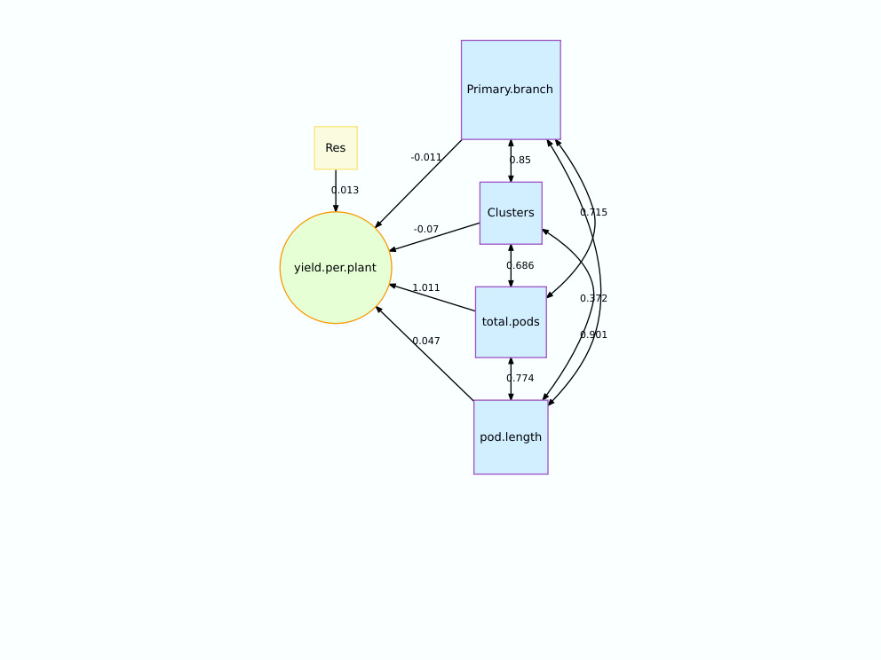
Fig. 2. Path diagram representing the direct and indirect effects of four yield correlated traits in 11 green gram accessions

3.2 Selection of superior accessions using the Arunachalam and Bandyopadhyay method

IC394640 ranked as the best among the evaluated accessions with a total score of 6, followed by IC 394380 with a score of 22 as depicted in Table 1. Accession Pusa M 2142 was the least performing accession with a score of 55. Accession IC394640 recorded the highest value among the evaluated accessions in yield and yield correlated traits, except in pod length. On the other hand, Pusa M 2142 was included in the lowest statistical group in all the above traits. Released varieties Virat and TM96 were in fourth and sixth positions, while CO6 and CO8 were in eighth and ninth positions, respectively.

Shibana and Jalaja (2019) evaluated ten garlic genotypes for their yield using the Arunachalam and Bandyopadhyay method. Similarly, Sivasankarreddy et al. (2024) identified five top-performing lines in brinjal using this approach from a total of twenty genotypes. Shilpa et al. (2024) identified six testers and four lines from parental genotypes in marigold based on this scoring.

Table 1: Trait scores, total score, and ranking of green gram accessions using the Arunachalam and Bandyopadhyay (1984) method

Sl.No. | Accession | Number of clusters per plant | Pod length | Number of Primary branches | Number of pods per plant | Yield per plant | Total score | Rank
1 | CO6 | 5 | 7 | 5 | 9 | 10 | 36 | 8
2 | CO8 | 8 | 4 | 7 | 10 | 9 | 38 | 9
3 | IC224780 | 9 | 9 | 4 | 5 | 5 | 32 | 7
4 | IC247820 | 10 | 1 | 9 | 2 | 2 | 24 | 3
5 | IC392930 | 7 | 8 | 8 | 8 | 8 | 39 | 10
6 | IC393910 | 4 | 6 | 3 | 6 | 6 | 25 | 5
7 | IC394380 | 2 | 10 | 2 | 4 | 4 | 22 | 2
8 | IC394640 | 1 | 2 | 1 | 1 | 1 | 6 | 1
9 | Pusa M 2142 | 11 | 11 | 11 | 11 | 11 | 55 | 11
10 | TM96 | 6 | 3 | 6 | 7 | 7 | 29 | 6
11 | Virat | 3 | 5 | 10 | 3 | 3 | 24 | 4

3.3 Selection of superior accessions using PCA

In the present study, first three principal components (PCs) recorded eigenvalues greater than 0.5, and together they accounted for 94.67 per cent of the total variation. Following Arunachalam and Bandyopadhyay method, IC 394640 with a total score of 113.66 was selected as the best accession. This accession belonged to the statistically highest group for the evaluated characters except for pod length, and consequently, it registered the highest score in PCA analysis for all traits except for pod length. Accession IC 247820 and Virat ranked second and third, with total scores of 101.24 and 99.65,respectively. Consistent with the results of Arunachalam and Bandyopadhyay's (1984) method, Pusa M 2142 with a total score of 48.34 emerged as the most undesirable accession in the PCA method too (Table 2).

PCA has been effectively used in several crops for genotype selection. Sinha et al. (2019) applied PCA to identify superior inbred lines in maize. Suma et al. (2025) used PCA approach to identify 55 superior genotypes from a total of 553 okra accessions. Wambi et al. (2025) also used PCA to identify lodging resistant maize genotypes.

Table 2 : Trait scores, total score, and ranking of green gram accessions using PCA
Sl.No. | Accession | Number of pods per plant | Pod length | Number of clusters per plant | Number of Primary branches | Yield per plant | Total score | Rank
1 | IC392930 | 28.22 | 13.44 | 11.15 | 10.05 | 8.53 | 71.39 | 8
2 | IC394640 | 52.04 | 14.74 | 17.06 | 10.96 | 18.87 | 113.66 | 1
3 | TM96 | 31.48 | 14.60 | 12.24 | 10.05 | 9.58 | 77.96 | 7
4 | IC224780 | 38.43 | 13.28 | 10.06 | 10.28 | 12.97 | 85.01 | 5
5 | CO8 | 21.41 | 13.96 | 10.28 | 10.05 | 6.86 | 62.56 | 10
6 | CO6 | 24.81 | 13.78 | 12.90 | 10.05 | 5.29 | 66.83 | 9
7 | IC247820 | 48.49 | 15.28 | 10.06 | 9.82 | 17.59 | 101.24 | 2
8 | IC394380 | 41.83 | 13.14 | 14.87 | 10.96 | 14.23 | 95.03 | 4
9 | IC393910 | 34.46 | 13.81 | 13.12 | 10.51 | 11.39 | 83.28 | 6
10 | Virat | 46.22 | 13.96 | 13.99 | 9.59 | 15.88 | 99.65 | 3
11 | Pusa M 2142 | 16.73 | 12.13 | 8.31 | 7.54 | 3.63 | 48.34 | 11

3.4 Interpretation from PCA biplot

First two PCs collectively explained 83.76 per cent of variability (Fig.3). Traits such as number of pods per plant and yield per plant had the highest loading values in PC1 and most of the variability explained by PC1 was contributed by these traits. Similarly, number of clusters per plant, number of primary branches, and pod length had highest loading value in PC 2. Since the first two PCs explained the major proportion of variation, the biplot allowed easy identification of superior accessions in the present study. Accessions positioned towards the right side were superior, whereas accessions located at the left side were inferior. In other words, accessions towards the positive side of PC1 and away from the origin were superior, and those towards the negative side were inferior.

An additional advantage of biplot is that it provides clear information on desirable features of a superior accession and the specific traits contributing to it. For example, the superiority of IC 247820 was mainly contributed by pod length, followed by yield and number of pods per plant. Similarly, the superiority of IC394380 was attributed to its higher number of clusters per plant and number of primary branches per plant, as this accession belonged to the second highest statistical class for above traits and registered high PCA based scores. In addition to highlighting positive attributes, the biplot also reveals undesirable characteristics. Although, Virat ranked third overall, it performed poorly for the number of primary branches per plant. It was the second last poor performer in that trait, and obviously, it aligned away from number of primary branches in the biplot. Thus biplots help for easy identification of superior accessions, as well as suitable trait donors for breeding programmes.
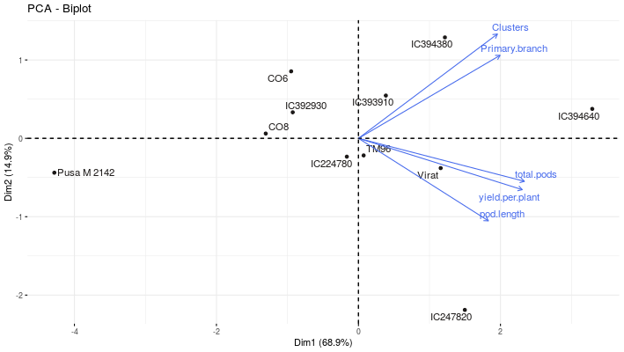
Fig. 3. PCA biplot of yield and yield associated traits in 11 green gram accessions

3.5 Comparative evaluation of the different selection methods

From the selection methods tested, it can be inferred that the results obtained from Arunachalam and Bandyopadhyay (1984) scoring and PCA based selection were largely similar (Table 3). Both approaches identified IC 394640 as the best performing accession and Pusa M 2142 as the poorest performer. Although both methods facilitated evaluation of genotypes for multiple traits, each had distinct strengths and limitations.

The Arunachalam and Bandyopadhyay method is based on post hoc ANOVA statistical groupings, whereas the PCA based selection uses actual phenotypic values multiplies by modified weights derived from PC’s. In PCA method, biplot allows for easy identification of accessions with desirable trait combinations. The Arunachalam and Bandyopadhyay method relies on mean performance is effective when traits differ significantly across genotypes but it does not account for inter trait correlations. Another advantage of this method is that the varying levels of error variance across traits are naturally accounted for through the application of DMRT. Besides this, the use of logically derived, standardised scores ensures a scale independent assessment of the relative potential of different accessions across all characters (Prabhu et al., 1990). In contrast, the PCA method covers maximum variability through dimensional reduction but may undervalue biologically important traits that contribute low variance, thus introducing a degree of subjectivity in interpretation. Unlike the Arunachalam method, PCA based scoring method is found to exhibit scale dependent changes.

Both the selection methods are free from economic weights and artificial index values, allowing straight forward computations and avoiding biases associated with subjective economic weights. However, neither approaches gives special weightage for any particular traits such as yield. In the present study, we used yield as well as traits genotypically correlated with yield for selection. Htwe et al. (2020) and Wambi et al. (2025) also included traits correlated with yield for making their selection index. Among the traits studied, number of pods per plant had the strongest correlation with yield and exerted the strongest direct influence on yield. Despite this, all traits were given equal weightage in the current study. A selection method that assigns higher priority to traits with strong direct effects on yield would be more advantageous and may improve the efficiency of accession identification.

Table 3: Comparative evaluation of two different selection methods for ranking green gram accessions
Sl.No. | Accession | Rank in Arunachalam and Bandyopadhyay method | Rank in PCA based method
1 | IC394640 | 1 | 1
2 | IC394380 | 2 | 4
3 | IC247820 | 3 | 2
4 | Virat | 4 | 3
5 | IC393910 | 5 | 6
6 | TM96 | 6 | 7
7 | IC224780 | 7 | 5
8 | CO6 | 8 | 9
9 | CO8 | 9 | 10
10 | IC392930 | 10 | 8
11 | PusaM2142 | 11 | 11

4. Conclusion

The present study demonstrates that both the Arunachalam and Bandyopadhyay (1984) scoring method and the PCA-based selection approach are effective tools for identifying superior green gram accessions using multiple yield-related traits. The two methods produced highly congruent results, consistently identifying IC 394640 as the best-performing accession and Pusa M 2142 as the poorest. When the first two principal components captured most of the total variation, the PCA biplot provided a clear visual framework for discerning superior accessions and understanding the specific traits contributing to their performance. The study also highlights the importance of yield-contributing traits, particularly number of pods per plant and pod length, in guiding selection decisions. Overall, the findings support the integration of multivariate approaches in green gram improvement programs, both for selecting superior accessions and for identifying promising trait donors for breeding.

COMPETING INTERESTS DISCLAIMER:
Authors have declared that they have no known competing financial interests OR non-financial interests OR personal relationships that could have appeared to influence the work reported in this paper.

Disclaimer (Artificial intelligence)
Option 1:
Author(s) hereby declare that NO generative AI technologies such as Large Language Models (ChatGPT, COPILOT, etc.) and text-to-image generators have been used during the writing or editing of this manuscript.
Option 2:
Author(s) hereby declare that generative AI technologies such as Large Language Models, etc. have been used during the writing or editing of manuscripts. This explanation will include the name, version, model, and source of the generative AI technology and as well as all input prompts provided to the generative AI technology
Details of the AI usage are given below:
1.
2.
3.

References

Arunachalam, V. and Bandyopadhyay, A. (1984). A method to make decisions jointly on a number of dependent characters. Indian Journal of Genetics and Plant Breeding, 44(3): 419-424. ISSN 0019-5200 https://repository.ias.ac.in/89378/1/54p.pdf
Asari, T., Patel, B. N., Patel, R., Patil, G. B., & Solanki, C. (2019). Genetic Variability, Correlation and Path Coefficient Analysis of Yield and Yield Contributing Characters in Mung Bean [Vigna radiata (L.) Wilczek]. International Journal of Chemical Studies, 7(4), 383-387. https://www.chemijournal.com/archives/2019/vol7issue4/PartF/7-4-10-700.pdf
Chongre, S., Mondal, R., Biswas, S., Munshi, A., Mondal, R. and Pramanick, M. (2019). Effect of liquid manure on growth and yield of summer green gram (Vigna radiata L. Wilczek). Current Journal of Applied Science and Technology, 38(6), pp.1-7.https://doi.org/10.9734/cjast/2019/v38i630460.
Gopinath, P. P., Parsad, R., Joseph, B., & S., A. V. (2021). grapesAgri1: Collection of Shiny Apps for Data Analysis in Agriculture. Journal of Open Source Software, 6(63), 3437. https://doi.org/10.21105/joss.03437
Agricultural Market Intelligence Centre, PJTSAU. (2024). Greengram Outlook. https://pjtsau.edu.in/agri-marketing-intelligence.html
Htwe, N. M., Aye, M. Y. I. N. T., & Thu, C. N. (2020). Selection Index for Yield and Yield Contributing Traits in Improved Rice Genotypes. International Journal of Environmental and Rural Development, 11(2), 86. https://doi.org/10.32205/ijerd.11.2_86
Jat, R., Tzudir, L., Kumari, S., Surotsala, K., Awomi, K., Gohain, T., Nongmaithem, D., Yadav, R., Merentoshi, M., & Pavan, S. (2024). Performance of green gram Vigna radiata (L.) Wilczek as influenced by integrated nutrient management under rainfed conditions. Annals of Plant and Soil Research, 26(4), 745-750. https://doi.org/10.47815/apsr.2024.10426
Kamble, S. S., Patil, D. K., Rathod, V. B., & Gite, V. K. (2023). Correlation and path analysis for yield and yield contributing characters in greengram (Vigna radiata (L.) Wilczek). The Pharma Innovation Journal, 12(12), 841-844. https://www.thepharmajournal.com/archives/2023/vol12issue12/PartL/12-12-10-999.pdf
Mohanty, A. A., Kar, R. K., Pradhan, B., Mishra, T. K., Das, S., Dash, A. P., Lenka, B., Pradhan, H., Sahu, D., Behera, C., Mishra, A., & Maity, G. (2024). Correlation and path analysis for quantitative traits in greengram. Ecology Environment and Conservation, 30(1), 67-71. http://www.envirobiotechjournals.com/journal_details.php?jid=3
Nalajala, S., Muniyandi, S.J., & Manjunath, P. (2023). Principal component analysis of quantitative and qualitative traits in sixty mung bean (Vigna radiata L. Wilczek) genotypes. International Journal of Bio-resource and Stress Management, 14(4), 643-651. https://doi.org/10.23910/1.2023.3354
Prabhu, K. V., Arunachalam, V., & Bandyopadhyay, A. (1990). Nonparametric approach to multitrait selection for yield in groundnut (Arachis hypogaea L.). Theoretical and Applied Genetics, 80(2), 223-227. https://doi.org/10.1007/BF00223740
Shibana, S.N. and Jalaja, S.M. (2019). Comparative evaluation of garlic (Allium sativum L.) genotypes in Kanthalloor, Idukki, Kerala, India. International Journal of Current Microbiology and Applied Sciences, 8(4), pp.798-803. https://doi.org/10.20546/ijcmas.2019.804.088
Sandhiya, V., & Saravanan, S. (2018). Genetic variability and correlation studies in greengram (Vigna radiata L. Wilczek). Electronic Journal of Plant Breeding, 9(3), 1094-1099. https://doi.org/10.5958/0975-928X.2018.00136.9
Shakeer, S., Lal, G. M., Varma, V. C., & Saikumar, S. (2022). Correlation and Path Coefficiant Analysis for Quantitative Traits in Greengram [Vigna radiata (L.) Wilczek]. International Journal of Environment and Climate Change, 12(11), 3683-3692. https://doi.org/10.9734/ijecc/2022/v12i111418
Shilpa, P., Sreelatha, U., Minimol, J. S., Sankar, M., & Suma, A. (2024). Utilisation of GMS lines for production of heterotic bacterial wilt resistant hybrids in Tagetes spp. Journal of Horticultural Sciences, 19(1). https://doi.org/10.24154/jhs.v19i1.2114
Sinha, S. K., Singh, R., Tiwari, J., & Thakur, D. (2019). Utilization of principal component analysis in determining selection criteria and selection of superior and diverse inbred lines in maize (Zea mays L.). Journal of Pharmacognosy and Phytochemistry, 8(2S), 671-676. https://www.journalofpharmacognosyandphytochemistry.com/
Sivasankarreddy, K., Joseph, J., & Thirumalaisamy, P.P. (2024). Organoleptic profiling for demand led breeding of eggplant (Solanum melongena L.) suitable for Kerala market. Electronic Journal of Plant Breeding, 15(3), 621-631. https://doi.org/10.37992/2024.1503.081
Suma, A., John, K. J., Latha, M., Thirumalaisamy, P. P., Venkatesan, K., Neeraja, P., Gopinath, P. P., Gangopadhyay, K. K., Pandey, C. D., Pandey, S., Singh, P. K., & Singh, G. P. (2025). Exploring the genetic potential of cultivated genepool of okra from National Genebank, India. Genetic Resources and Crop Evolution. https://doi.org/10.1007/s10722-025-02470-4
Wambi, W., Makumbi, D., Asea, G., Zeleke, H., Bruce, A. Y., Wakgari, M., Kwemoi, D. B., & Prasanna, B. M. (2025). Use of multi-trait principal component selection index to identify fall armyworm (Spodoptera frugiperda) resistant maize genotypes. Frontiers in Plant Science, 16, 1544010. https://doi.org/10.3389/fpls.2025.1544010

