Original Research Article
Spectrum of action of a natural total herbicide based on cocoa juice and papaya leaf extract on a fallow plot in Daloa, Côte d’Ivoire
Abstract
Aims: The general objective of this study was to evaluate the efficacy and spectrum of action of a bioherbicide based on cocoa juice and papaya leaf extract as a sustainable alternative to glyphosate.
Study Design: The experiment design was a block of Fisher with four repetitions.
Place and Duration of Study: The study was carried out on a fallow land in Daloa Department, Central Western Côte d’Ivoire, from April to June 2025.
Methodology: Treatments applied to the study design were five doses of the tested bioherbicide (16.6 l/ha, 11.08 l/ha, 8.33l/ha, 5.55 l/ha, 2.78 l/ha, and 8 l/ha), an untreated plot and a glyphosate dose (8 l/ha). Their efficacy was assessed every two weeks using C.E.B. scale.
Results: The applied methodology revealed that the tested biological herbicide is as effective as glyphosate at the dose of 16.6 l/ha with a weed mortality rate around 93% and killed all the weed species on the study site except one: Spermacoce verticillata. However, weed vegetation resumption took place from the 45th day after the implementation of the essay.
Conclusion: The use of the local plant extracts appears to be a promising alternative to glyphosate, better suited to small producers. Its application to Spermacoce verticillata at different life stages may allow to detect if there are stages of development when this species can be controlled.
Key words : Bioherbicides, Theobroma cacao juice, Carica payaya leaf extract, glyphosate, weeds, sustainable agriculture

1. Introduction
Weed management poses a significant challenge to global agricultural productivity, as weeds can cause yield losses averaging up to 34% in major crops, depending on the type and agroecological conditions (Oerke, 2006). To address this, modern agriculture relies heavily on synthetic chemical herbicides, which account for nearly 40% of the global pesticide market (Zimdahl, 2018).
This has generated environmental concerns due to the harmful impacts of herbicides on biodiversity and human health (Duke and Powles, 2008). Indeed, over the years, certain herbicides have been criticized for their high toxicity and detrimental effects on ecosystems and health (Goulson, 2013). This is the case with glyphosate, the world's best-selling active ingredient (with an estimated market value of €27 billion), classified as a possible carcinogen by the International Agency for Research on Cancer (IARC, 2015). However, farmers continue to use conventional chemical herbicides, despite their potential dangers to the environment and human health (Heap, 2014).
In response to this problem, local plants known for their phytotoxic effects could provide a natural solution. Their extracts, readily available in agricultural areas, can inhibit the germination or growth of certain weeds (Adeoye et al., 2014; Eze & Gill, 2020).
The ojective of this study is to evaluate the efficacy and spectrum of action of a total natural herbicide based on cocoa juice and papaya leaf extract under real-world conditions on a fallow field in Daloa.
2. Materials & Methods
2.1. Study Site
This research was conducted in the Daloa department. The bioherbicide (Herbibo) was tested on a three-year-old fallow plot located in Tazibouo University, a district of Daloa (at a north latitude of 6°55’10’’ and a west longitude of 6°25’30’’). The entire protocol was correctly applied to ensure the reliability of the results (Gomez & Gomez, 1984).
2.2. Floristic Survey
Floristic and phytosociological inventories were carried out before and after the implementation of the trial. The aim was to determine the floristic list and the abundance/dominance of weeds at the different observation periods. During the assessment of weed cover in the plots, each weed species was assigned a weed cover score according to the C.E.B. scale modified by Marnotte (1984) shown in Table 1.
Table 1: Weed rating scale
Note | Comments
1 | 1% recovery rate (rare)
2 | 7% coverage (≤ 1 individual/m2)
3 | 15% coverage (> 1 individual/m2)
4 | 30% recovery
5 | 50% recovery
6 | 70% recovery
7 | 85 % recovery
8 | 93% recovery
9 | 100% recovery

2.3. Trial Setup
The experimental design used in this study was a Fisher block design: a randomized complete block (Figure 1). It comprised four (4) replicates. Each block consisted of seven treatments: five doses of the tested bioherbicide, one dose of the reference product (R), glyphosate, and one untreated plot, the control (TM).
The area of elementary plots was 30 m² (6 m x 5 m). The distance between two adjacent blocks was 2 m, and the distance between two adjacent plots within the same block was 1 m.
Herbicides were applied using a knapsack sprayer with constant pressure and a flat fan nozzle. The spray volume was determined based on 200 L/ha. The application rates of the tested bioherbicide, Herbibo, were 16.6, 11.08, 8.33l, 5.55, and 2,78 l/ha respectively (Table 2).
Block 4
Block 3
Block 1
Block 2
R | T2 | T4 | T5 | T1 | T3 | TM
R | T1 | T3 | T5 | T4 | TM | T2
T1 | R | T3 | TM | T5 | T2 | T5
T3 | T5 | T2 | T4 | T1 | TM | R
Figure 1 : Diagram of the experimental setup
Table 2: Dosage of used herbicides
Objects | Products | Dose/ha | Surface  m² | Quantity of product in ml | Porridge for 1 elementary plot
T1 | HERBIBO | 16,6l/ha | 30m² | 50 | 2500 ml
T2 | HERBIBO | 11,08l/ha | 30m² | 33,25 | 2500 ml
T3 | HERBIBO | 8,33l/ha | 30m² | 25 | 2500 ml
T4 | HERBIBO | 5,55 l/ha | 30m² | 16,65 | 2500 ml
T5 | HERBIBO | 2,78 l/ha | 30m² | 8,42 | 2500 ml
R | LADABA 480 SL | 8 l/ha | 30m² | 24 | 2500 ml
TM | - | - | 30m² | - | 2500 ml

2.4. Herbicide effectiveness rating
The bioherbicide's efficacy was assessed every two weeks using the C.E.B. scale modified by Marnotte (1984). The trial was conducted on a three-year-old fallow field. The product applications (herbicide applications) were carried out on this fallow field. The C.E.B. scale is presented in Table 3. A weed is considered well controlled if the herbicide efficacy score is equal to or greater than 7.

2.5. Specific richness
Species richness was assessed to highlight the diversity within the analyzed ecosystem. In reality, assessing species richness involves counting all the identified species in a plot, without considering their number.
Table 3 : C.E.B scale for rating herbicide efficacy modified by Marnotte et al. (1984)
Note Destroyed Meaning of the note
Biomass %
1 1 No effectiveness
2 7 Very low effectiveness
3 15 Limited effectiveness
4 30 Poor efficiency
5 50 Effectiveness reduced by 50%
6 70 Moderate effectiveness
7 85 Acceptable effectiveness
8 93 Good efficiency
9 100 Perfect efficiency

2.6. Floral composition
Weeds were identified using the following floras: tropical weeds (Merlier and Montégut, 1982), Adventrop: weeds of the Sudan-Sahel region (Le Bourgeois and Merlier, 1993), and weeds in rice cultivation in West Africa. The floristic composition aims to highlight the distinctive features of the analyzed flora. This includes, in particular, details on families, genera, and biological types. The research conducted by Aké-Assi (1984) formed the basis of these lists.
2.7. Biological Types
The biological type of a species encompasses all the anatomical and morphological structures that define its vegetative system, thus distinguishing its appearance and environment. Biological types have been determined according to the plants' adaptation to winter. The terminology used for this research is based on the work of Raunkier (1934), modified by Aubréville (1965) to correspond to tropical regions. Thus, we distinguish between Chamaephytes (Ch), Hemicryptophytes (H), Therophytes (Th), Nanophanerophytes (np), and Mesophanerophytes (mp).
2.8. Data Analysis
The raw data collected were entered using Microsoft Excel 2013. Subsequently, all this information was subjected to statistical analysis using the R software. ANOVA tests were therefore performed to evaluate the efficacy of the biological herbicide compared to the reference herbicide. In cases where a significant difference was found at the 5% level, Tukey's test was used to determine the different homogeneity classes.
3. Results
3.1. Weed flora before the herbicide trial
At the time of the herbicide trial, the flora of the study site comprised 25 species belonging to 20 genera and 10 families. This flora consisted of 5 monocots and 20 dicots (Table 4). The most represented genera were Desmodium (three species), Cassia (two species), Digitaria (two species), and Sida (two species). The most abundant families (Table 4) were Fabaceae (36%), Poaceae (20%), Malvaceae (12%), and Asteraceae (8%). Based on abundance-dominance scores, the most abundant species at the study site were Sida acuta, Digitaria gayana, and Sporobolus pyramidalis. Their abundance/dominance scores ranged from 6 to 7 (Table 4).
Table 4: List of species identified on the experimental plot
Botanical classes | Families | Species | AD
Dicotyledons | Asteraceae | Chromolaena odorata | 2
Dicotyledons | Asteraceae | Synedrella nodiflora | 2
Dicotyledons | Convolvulaceae | Ipomoea bifolia | 3
Dicotyledons | Euphorbiaceae | Croton hirtus | 4
Dicotyledons | Fabaceae | Centrosema pubescens | 2
Dicotyledons | Fabaceae | Cassia fistula | 3
Dicotyledons | Fabaceae | Cassia obtusifolia, | 1
Dicotyledons | Fabaceae | Calopogonium mucunoides | 2
Dicotyledons | Fabaceae | Desmodium adscendens | 1
Dicotyledons | Fabaceae | Desmodium triforum | 1
Dicotyledons | Fabaceae | Desmodium velutinum | 1
Dicotyledons | Fabaceae | Mezoneuron benthamianum | 2
Dicotyledons | Fabaceae | Mimosa pudica | 3
Dicotyledons | Lamiaceae | Clerodendrum volubile | 2
Dicotyledons | Malvaceae | Sida acuta | 6
Dicotyledons | Malvaceae | Sida urens | 1
Dicotyledons | Malvaceae | Abutilon mauritianum | 5
Dicotyledons | Meliaceae | Azadirachta indica | 1
Dicotyledons | Moraceae | Ficus exasperata | 1
Dicotyledons | Rubiaceae | Spermacose latifoia | 3
Monocotyledons | Poaceae | Digitaria gayana | 6
Monocotyledons | Poaceae | Digitaria horizontalis | 1
Monocotyledons | Poaceae | Leptochloa Chinensis | 3
Monocotyledons | Poaceae | Panicum maximum | 2
Monocotyledons | Poaceae | Sporobolus pyramidalis | 7
AD = Abundance/Dominance

3.2. Biological types of weeds
After data analyzing, five biological types were identified across our experimental site. These were : Hemicryptophytes, Chamaephytes, Nanophanerophytes, Therophytes, and Mesophanerophytes. Hemicryptophytes and Chamaephytes were the most numerous (Figure 2).

Figure 2 : Spectrum of biological types
3.3. Morphological types of weeds
Morphological types refer to the different forms of plants. This concerns weed species inventoried in their natural environment. The graph shows that the majority of weeds are herbaceous plants, representing 72% of the inventoried species. These are followed by shrubs and bushes (16%) and lianas (12%) (Figure 3).

Figure 3 : Distribution of morphological types of the weed flora
3.4. General weed growth 15 days after the herbicide trial
Figure 4 shows the results of the observations, 15 days after the implementation of the herbicide trial. At this time, acceptable control of the weed population was observed only at a dose of 16,6l/ha of the bioherbicide (T1) with an efficacy rating of 7, representing 85% of the destroyed biomass (Figure 5).
d
d
a
a
b
d
d
Figure 4 : Treatment efficacy 15 days after the start of the trial
Treatments with the same letter are not significantly different.
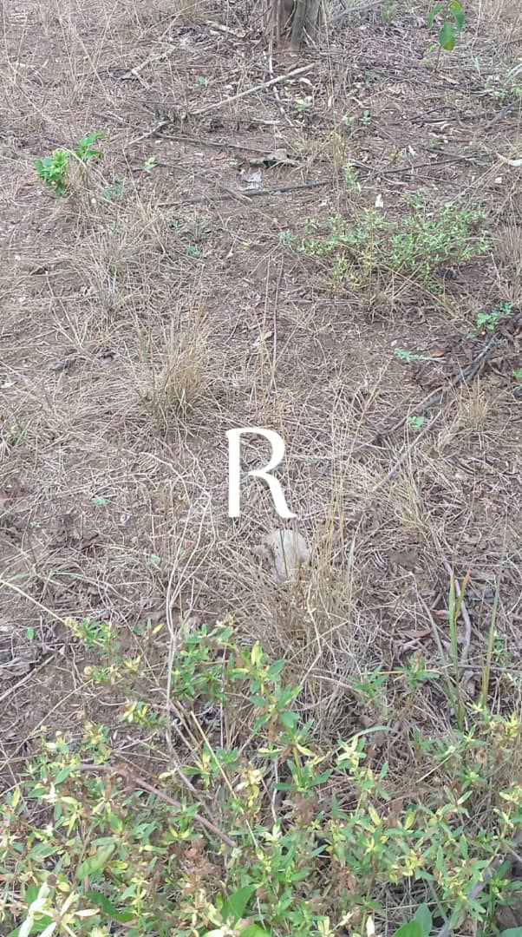 | 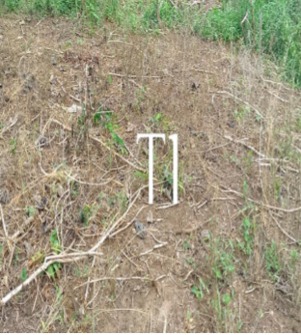
A B
Figure 5 : Effects of treatments R (A) and T1 (B), 15 days after the start of the herbicide trial
3.5. General weed growth 30 days after the herbicide trial
Thirty (30) days after the implementation of the efficacy test of the tested biological herbicide, the analysis of variance shows a significant difference between the different treatments in terms of weed infestation levels in the individual plots (Figure 6). The classification of means from the Turkey test reveals five distinct groups. Treatments R and T1 constitute the groups with the highest efficacies. These treatments have efficacy scores of 8 (Figure 6). In contrast, the efficacy scores of the other doses of the tested biological herbicide are below the acceptable efficacy threshold (Figure 6).
d
a
e
d
c
a
Figure 6 : Efficacité des traitements 30 jours après la mise en place de l’essai
Treatments with the same letter are not significantly different.
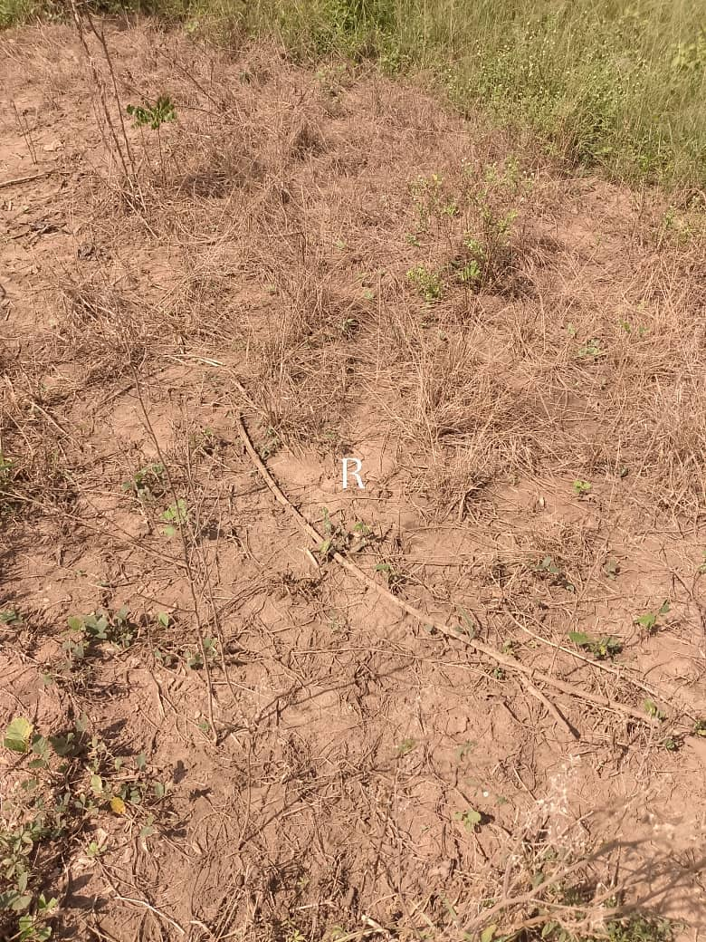 | 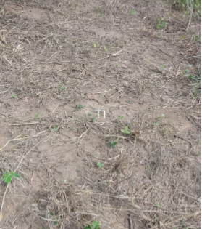
Figure 7 : Effects of treatments R and T1, 30 days after the start of the herbicide trial

3.6. General weed growth 45 days after the herbicide trial
The results of the observations on day 45 after treatment are presented in Figure 8. Analysis of variance shows a significant difference in weed infestation levels between the treatments applied to the plots. The Turkey test reveals five distinct treatment classes. Treatment R yielded the highest efficacy score, while treatments T4 and T5 had the lowest efficacy scores after the control treatment TM.
However, at this time, the efficacy scores for all treatments were below 7. This indicates that, at that point, none of the applied treatments were effective (Figure 7).
b
a
de
de
bc
a
e
Figure 7 : Treatment efficacy 45 days after the start of the trial
Treatments with the same letter are not significantly different.
3.7. General weed growth 60 days after the herbicide trial
Sixty (60) days after the start of the trial, analysis of the observation results indicates a significant difference between the treated and control plots. The Turkey test shows four distinct treatment groups. However, none of the treatments applied to the individual plots had an efficacy score higher than 7 (Figure 8).
cd
cd
c
d
b
a
a
Figure 8 : Treatment efficacy 60 days after the start of the trial
Treatments with the same letter are not significantly different.
3.8. Spectrum of action of the bioherbicide tested on the experimental plot
The spectrum of action of a herbicide describes the range of plant species that this herbicide can control. During the study, the tested bioherbicide eliminated 24 of the 25 weeds identified on the fallow plot at its effective range of 16.6 L/ha. The only weed that escaped its control was Spermacoce verticillata (Rubiaceae).
Botanical classes | Families | Species
Dicotyledons | Asteraceae | Chromolaena odorata
Dicotyledons | Asteraceae | Synedrella nodiflora
Dicotyledons | Convolvulaceae | Ipomoea bifolia
Dicotyledons | Euphorbiaceae | Croton hirtus
Dicotyledons | Fabaceae | Centrosema pubescens
Dicotyledons | Fabaceae | Cassia fistula,
Dicotyledons | Fabaceae | Cassia obtusifolia,
Dicotyledons | Fabaceae | Calopogonium mucunoides,
Dicotyledons | Fabaceae | Desmodium adscendens,
Dicotyledons | Fabaceae | Desmodium triforum,
Dicotyledons | Fabaceae | Desmodium velutinum,
Dicotyledons | Fabaceae | Mezoneuron benthamianum,
Dicotyledons | Fabaceae | Mimosa pudica
Dicotyledons | Lamiaceae | Clerodendrum volubile
Dicotyledons | Malvaceae | Sida acuta,
Dicotyledons | Malvaceae | Sida urens,
Dicotyledons | Malvaceae | Abutilon mauritianum
Dicotyledons | Meliaceae | Azadirachta indica
Dicotyledons | Moraceae | Ficus exasperata
Monocotyledons | Poaceae | Digitaria gayana,
Monocotyledons | Poaceae | Digitaria horizontalis,
Monocotyledons | Poaceae | Leptochloa Chinensis,
Monocotyledons | Poaceae | Panicum maximum,
Monocotyledons | Poaceae | Sporobolus pyramidalis
Table 5: Spectrum of action of the biological herbicide tested on the experimental plot
4. Discussion
This research has allowed us to compile a detailed inventory of the weed species present at the experimental site. The floral diversity is illustrated by 25 weed species, distributed among 20 genera and 10 families. Our findings differ from those of Konan et al. (2020), who studied the same area and identified 194 species and 80 genera, classified into 27 families. This discrepancy may stem from the fact that our work was conducted at a plot level, unlike the authors who examined a regional scale.
The most represented families in our study are the Fabaceae, Poaceae, and Malvaceae. We note that our results are similar to those of Boraud (2000) and Maillet (1981). Their strong presence is explained by their ability to adapt to different environments. Traore et al. (2018) confirm that. This observation indicates that the most dominant families are those capable of thriving in diverse environments and cropping systems.
Furthermore, a high proportion of dicotyledons (80%) was observed at our study site. Mangara (2010) and Le Bourgeois (1993) noted similar results in their respective studies. Indeed, the majority of weeds in African tropical regions are dicotyledons. The dominance of dicotyledons was also reported in the research of Boraud (2000) on sugarcane crops, Mangara et al. (2008) on pineapples, and Kouakou (2016) on maize crops.
The most prevalent biological categories at our analysis site were hemicryptophytes and chamaephytes. Together, these two categories constitute almost half of the identified weeds. Several studies have indicated that most weeds belong to these two biological categories (Touré, 2009; Kouakou, 2016). The fact that the plot is an open space favors the growth of these categories. As they are heliophilous, their development is also observed in open environments. Generally, initial plot preparation interventions facilitate the establishment and growth of hemicryptophytes and chamaephytes (Ipou Ipou, 2005; Kouakou, 2016). The presence of shrubs in a given plot can often indicate a natural ecological dynamic or a change in human behavior. Their appearance could signify an ecological transition towards a wooded state in the absence of any intervention, or result from a disturbance that facilitated their establishment. The herbaceous morphology of weed species, representing 72%, is also expected in tropical agricultural systems (FAO, 2023). The high proportion of herbaceous species observed in agricultural and peri-urban plots, as in our study in Daloa, can be explained by various ecological and functional mechanisms associated with land use, ecosystem disturbances, and the adaptation strategies of weed species.
We observed the effectiveness of bioherbicide treatments at a dose of 16,6l/ha, with a progressive decrease in abundance/dominance (AD) during this study. These results are consistent with those of Zhang et al. (2023), who indicate that bioherbicides based on natural extracts generally act more slowly and systemically than chemical herbicides. In our study, only treatment T1 (16,6l/ha) and treatment R (glyphosate) achieved an efficacy equal to or greater than 7 on the C.E.B scale. This efficacy reflects a progressive reduction in weeds after application, with visible effects between the 15th and 30th days post-treatment.
The bioherbicide and glyphosate demonstrated efficacy (93% weed mortality rate); the T1 treatment yielded good results in terms of weed mortality. Partial regrowth was then observed 45 and 60 days post-treatment. This trend confirms the findings of Marnotte (1984), who indicated that the efficacy of natural herbicides is often similar to that of chemical products in the short term, but that reinfestation can occur rapidly if biomass is low or if the product lacks a prolonged residual effect.
At a dose of 16.6 L/ha, the tested biological herbicide is almost as effective as the reference synthetic herbicide, glyphosate. This is consistent with the findings of Rinando et al. (2002). Regarding bioherbicides, it is noted that efficacy can fluctuate depending on the applied dose and the sensitivity of the unwanted species. The mortality rate, based on the standardized C.E.B method according to Marnotte (1984), shows significant elimination of unwanted plants after treatment, even though regrowth appears 45 days later, particularly in the form of young seedlings. This phenomenon stems from the ability of annual species to regenerate rapidly and the persistence of the seed bank in the soil, as also reported by Chauhan and Johnson (2010).
The study demonstrates that the tested bioherbicide has an initial efficacy comparable to that of glyphosate. This aligns with the observations of Dayan (2014), who emphasize that bioherbicides, while promising for reducing the use of synthetic chemicals, often require repeated applications and integration with other management methods for sustainable control of unwanted plants.
The only weed that escaped control by the tested bioherbicide was Spermacoce verticillata. This resistance may be linked to the fact that the individuals of this species were mature at the time of bioherbicide application. Indeed, Fadin et al. (2018) noted the failure of glyphosate to control Spermacoce verticillata in several Brazilian States but demonstrated its susceptibility to glyphosate at the juvenile stage.
Conclusion
This study evaluated the efficacy of a total bioherbicide against weeds in a fallow field in Daloa compared to a reference herbicide (glyphosate). The results showed that the weed flora of this fallow field comprised 25 species, 20 genera, and 10 families, dominated by Fabaceae, Poaceae, and Malvaceae. The predominance of dicotyledons and heliophilous biological types such as hemicryptophytes and chamaephytes was also noted. From a phytosanitary perspective, the results revealed the effectiveness of the tested total bioherbicide on all weed species except Spermacoce verticillata, with peak efficacy 30 days after treatment, although residual activity was short-lived. The bioherbicide thus appears as a credible alternative to glyphosate in a strategy to reduce chemical inputs. To further explore these results and consider sustainable weed management, it is necessary to combine the bioherbicide with other cultural control methods (mulching, crop rotation, green manure, etc.) in an integrated approach, evaluate the effect of treatments over several growing cycles to observe the evolution of the weed flora and the dynamics of the seed bank, compare the cost-effectiveness of the bioherbicide treatment against the chemical herbicide "glyphosate" in order to guide farmers in their choices, and apply it at different life stages of Spermacoce verticillata to verify its susceptibility to the bioherbicide at given stages of its life.
DISCLAIMER (ARTIFICIAL INTELLIGENCE)
Author(s) hereby declare that NO generative AI technologies such as Large Language Models (ChatGPT, COPILOT, etc.) and text-to-image generators have been used during the writing or editing of this manuscript.

References
- Adeoye, D. O., Olaniyan, G. O., & Ajayi A. M. (2014). Allelopathic effects of Carica papaya leaf extract on the growth of certain selected weeds. Journal of Research in Biology, 4(7), 1450–1457.
- Aké-Assi, L.1984. Flora of the Ivory Coast: a descriptive and biogeographical study with some ethnobotanical notes. Doctoral thesis, Faculty of Science and Technology, University of Cocody, Abidjan, Ivory Coast.1206p.
- Aubréville, A. (1965). The dense Australian rainforests and their conifers. Bois et Forêts des Tropiques, 104, 3–16. https://doi.org/10.19182/bft1965.104.a18943
- Boraud, N. K. M., 2000. Floristic and phytoecological study of weeds in sustainable complexes. Specialization thesis,UFR Biosciences université cocody, Abidjan (côte d’ivoire),18p.
- Chauhan, B. S., & Mahajan, G. (2021). Weed management in agriculture: new approaches. Springer, 29(9), 913–922.
- International Agency for Research on Cancer. (2015). IARC Monographs Volume 112: Some Organophosphate Insecticides and Herbicides. IARC Monographs on the Evaluation of Carcinogenic Risks to Humans. https://monographs.iarc.who.int/news-events/volume-112/
- Dayan, F. E., & Duke, S. O. (2014). Natural compounds as next-generation herbicides. Plant Physiology, 166(3), 1090–1105. https://doi.org/10.1104/pp.114.239061
- Duke, S. O. (2018). The history and current status of glyphosate. Pest Management Science, 74(5), 1027–1034. https://doi.org/10.1002/ps.4652
- Eze, J. M., & Gill, L. S. (2020). Phytotoxic effects of Carica papaya L. leaf extract on weed species. Nigerian Journal of Botany, 33(2), 312–320.
- FAO, ITPS, GSBI, CDB et CE. (2021). State of knowledge on soil biodiversity - Current state, challenges and potential, Summary for decision-makers. https://doi.org/10.4060/cb1929fr
- Fadin, D. A., Tornisielo, V. L., Barroso, A. A. M., Ramos, S., Dos Reis, F. C., & Monquero, P. A. (2018). Absorption and translocation of glyphosate in Spermacoce verticillata and alternative herbicide control. Weed Research. https://doi.org/10.1111/wre.12329
- Gomez, K. A., & Gomez, A. A. (1984). Statistical procedures for agricultural research. John Wiley & Sons. https://books.google.com/books/about/Statistical_Procedures_for_Agricultural_R.html?id=124xAAAAMAAJ
- Goulson, D. (2013). An overview of the environmental risks posed by neonicotinoid insecticides. Journal of Applied Ecology, 50(4), 977–987. https://doi.org/10.1111/1365-2664.12111
- Heap, I. (2014). Global perspective of herbicide-resistant weeds. Pest Management Science, 70(9), 1306–1315. https://doi.org/10.1002/ps.3696
- Ipou Ipou. 2005. Biology and ecology of Euphorbia heterophylla L. (Euphorbiaceae) in cotton cultivation, in northern Ivory Coast. Doctoral thesis, Felix Houphouët-Boigny University, Cocody, Abidjan; Ivory Coast; 191p.
- Chauhan, B. S., & Johnson, D. E. (2010). The role of seed ecology in improving weed management strategies in the tropics. Advances in Agronomy, 105, 221–262. https://doi.org/10.1016/S0065-2113(10)05006-6
- Konan, A., Sylla, M., Touré, A., & Soro, D. (2021). Floristic diversity and major weeds of corn cultivation in the Haut-Sassandra region, in the center-west of Côte d'Ivoire. International Journal of Innovation and Scientific Research, 53(2), 116-122. http://www.ijisr.issr-journals.org/abstract.php?article=IJISR-20-362-01
- Kouakou, N. J. (2017). Relative importance of weeds in maize crops; impact of Rottboellia cochinchinensis (Loureiro) W. Clayton (Poaceae) sur la production du maïs (Zea mays L.) à M'Bahiakro au Centre-Est de la Côte d'Ivoire. (Phd thesis, Félix Houphouët-Boigny University).
- Le Bourgeois, T. (1993). *Weeds in cotton rotation in Northern Cameroon (Africa). Habitat amplitude and infestation rate; phenological* [Doctoral thesis, University of Montpellier II Science and Technology of Languedoc]. https://agritrop.cirad.fr/315711/
- Le Bourgeois, T., & Merlier, H. (1995). Adventrop. Weeds of Sudanian-Sahelian Africa. CIRAD-CA. https://agritrop.cirad.fr/326208/
- Maillet, J. (1981). Evolution of weed flora in the Montpellier region under the pressure of agricultural techniques. DDI.USTL Thesis, Montpellier, 200p.
- Mangara, A., N'Da Adopo, A. A., Boraud, M. K. N., Kobenan, K., Lejoly, J., & Traoré, D. (2008). Inventory of weed flora in pineapple (Ananas comosus (L.) Merr.) cultivation in the locality of Bonoua in lower Ivory Coast. Agronomie Africaine, 20(1), 23-53. https://doi.org/10.4314/aga.v20i1.1733
- Mangara A., 2010. Weeds in pineapple crops: Ananas comosus (L.) Merr. (Bromeliaceae), in the localities of Anguédédou, Bonoua, and N'douci, in Lower Ivory Coast: Inventory and control trials: Doctoral thesis of Université de Cocody-Abidjan 207pp
- Marnotte, P. (1984). In Weeds in tropical environments: knowledge and control methods (pp. 261–271). Eds. M. Déat & P. Marnotte. Bouaké : SOAM.
- Merlier, H., & Montegut, J. (1982). Tropical weeds. Flora at seedling and adult stages of 123 African or pantropical species. Ministry of External Relations. https://agritrop.cirad.fr/380155/
- Raunkiaer, C. (1934). The life forms of plants and statistical plant geography. Oxford University Press. https://www.cabidigitallibrary.org/doi/10.5555/19340300000
- Rinando, A. (2002). Comparative study of the effect of various treatments on the sensitivity of weeds to bioherbicides. Weed Science, 50(3), 138–145.
- Oerke, E. C. (2006). Crop losses to pests. The Journal of Agricultural Science, 144(1), 31-43. https://doi.org/10.1017/S0021859605005708
- Touré, A. (2009). Infestation dynamics of the Sanaimbo classified forest in the sub-prefecture of Tiéméléhro (Ivory Coast) by weeds from surrounding agroecosystems and their uses by local populations. Doctoral thesis of Université de cocody Abidjan, Côte d’Ivoire, 205p.
- Veer, V., & Gopalakrishnan, R. (Eds.). (2016). Herbal Insecticides, Repellents and Biomedicines: Effectiveness and Commercialization. Springer India. https://doi.org/10.1007/978-81-322-2704-5
- Zimdahl, R. L. (2018). Fundamentals of weed science (5th ed.). Academic Press. https://www.elsevier.com/books/fundamentals-of-weed-science/zimdahl/978-0-12-811143-7

