Assessing the Impact of Urban Land Use Change on Soil Water driven Erosion Risk: A Case Study of the Gourou Watershed, Abidjan, Côte d’Ivoire
Abstract
Vegetation cover is a crucial factor in the evolution of soil erosion, as its presence can slow it down or its absence can exacerbate it. Combating erosion risk requires knowledge of land cover types in a given region to best target erosion control measures. With this in mind, the general objective of this study is to demonstrate This study examined the impact of vegetation cover dynamics on the risk of soil water erosion, using the Gourou watershed in southern Côte d'Ivoire as a case study. Landsat satellite images of the Gourou watershed were processed, and the Revised Universal Soil Equation (RUSLE) was used to spatially map soil loss within the study area. The results show a dominance of buildings and bare soils which occupy 70% of the landscape of the Gourou watershed in 2020. This spatial analysis allowed us to determine the extent of water erosion in the study area, with a distribution showing an average ranging from 556.77 t/ha/year to 633.46 t/ha/year and a percentage of highly vulnerable areas ranging from 38.95% in 2002 to 50.03% in 2020. The entire surface of the watershed would therefore be highly affected by the phenomenon of water erosion. A more advanced or more severe degradation of the vegetation cover would be detrimental to this region which already suffers from disasters such as flooding by accumulation of runoff water caused by the inability of soils to infiltrate and the silting up of drainage canals caused by soil loss and the drainage of solid waste by water towards the canals.

Keywords: water erosion, Gourou watershed, RUSLE, vegetation cover dynamics, degradation.
1. INTRODUCTION
Rapid urbanization and climate change exacerbate soil erosion globally, threatening ecosystem services and sustainable development. However, current predictive studies on future soil erosion often lack comprehensive consideration of the interactions between land use and climate change (Ma et al., 2025). Soil erosion is a natural phenomenon that, at different spatial and temporal scales, degrades, modifies, and shapes terrestrial environments. It represents a global environmental problem, seriously hindering sustainable development (Khaoula & Sihem, 2021). Land use/land cover (LULC) change has been a focus in socio-environmental research in recent years. Changes in land use are recognized as a significant factor and a crucial driver of global environmental change, with alterations in land use and land cover being strongly linked to soil erosion. Land use influences the runoff and sediment transport processes, and thus the soil erosion process, by altering surface morphology (Guo et al., 2024). In West Africa in general, the uncontrolled exploitation of forest ecosystems for agricultural and urbanization purposes leads to strong dynamics in land cover and land use (N'go et al., 2018). Human activities developing in these environments sometimes guide the intensity of the soil erosion process, either by protecting the soils or, more commonly, by promoting erosive action (N'go et al., 2018). Indeed, rapid landscape changes under the influence of population pressure and climate change have contributed to increased exposure of land to runoff and, consequently, to soil degradation through erosion (Heusch, 1970; Al Karkouri et al., 2000; Naimi et al., 2002; Briak et al., 2016). Modern agricultural practices, such as deep plowing and the use of heavy machinery, further disturb soil structures, reducing their stability and increasing erosion risk. Moreover, the rapid process of urbanization is accompanied by extensive construction activities, including the development of roads, residential areas, and industrial zones. These activities typically remove vegetation cover, increase impervious surface area, and alter natural surface hydrological processes, which can lead to changes in SE patterns. Overall, LUCCs directly influence the risk and intensity of SE by altering surface cover, topographical conditions, and hydrological processes (Guo et al., 2024). Since the late 1960s, these anthropogenic impacts have been compounded by an increase in climate variability in certain West African countries, such as Côte d'Ivoire, whose economic capital is Abidjan. The city of Abidjan, where the Gourou watershed is located, has vegetation that suffers the adverse effects of its rapid spatial expansion linked to the population explosion and the industrial and commercial activities of the Abidjan district (Béligné, 1994; Hauhouot, 2002). In addition to the pressure exerted on Abidjan's vegetation, the city is constantly subjected to rainfall that could contribute to soil erosion. Thus, the present study aims to general objective of analyzing the impact of vegetation cover dynamics on the risk of soil water erosion will be examined using the Gourou watershed as a case study. Specifically, the aim will be (1) to determine the spatio-temporal dynamics of vegetation cover from 2002 to 2020 and (2) to estimate soil losses at every point within the watershed.
2. MATERIALS AND METHODS
2.1. Presentation of the study area
The Gourou watershed, covering an area of 27.5 km², is located in southern Côte d'Ivoire, in the Abidjan District (Figure 1) . It straddles several municipalities, including Abobo, Adjamé, Attécoubé, and Cocody. The entire watershed is now urbanized, extending to the minor beds of the thalwegs, with uncontrolled development. The watershed has a transitional equatorial climate (Attiéen climate), characterized by four distinct seasons differentiated by rainfall patterns, although there are no significant temperature variations. Average monthly rainfall ranges from 25 to 354 mm, with a peak in June, the wettest month of the year at 354 mm. The Gourou watershed has a relatively flat surface upstream in the Abobo-Gare area, but exhibits moderately deep gullies further downstream.
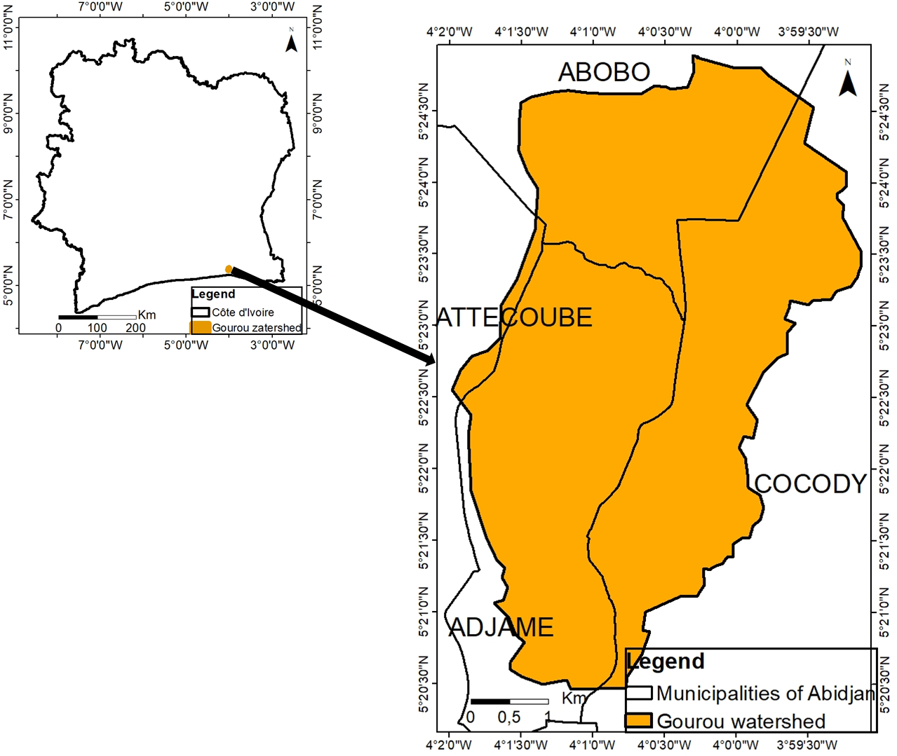
Fig. 1 . Location map of the Gourou watershed in Côte d’Ivoire
2.2. Data and software used
The data used in this study are of three types: satellite data, rainfall data, and soil data. For the satellite data, Landsat images covering the Gourou watershed were obtained from ETM + and OLI sensors, with a medium resolution (30m) and dating from 2002 and 2020 respectively. These images were acquired from the US Geological Survey ( USGS ) portal. The rainfall data used are from the years 2000 to 2020 for the city of Abidjan. This data was provided by the Société d'Exploitation et de Développement Aéroportuaire, Aéronautique et Météorologue (SODEXAM). The FAO's World Soil Database was downloaded from http://www.iiasa.ac.at/Research/LUC/External-World-soil-database/HTML/. This database consists of an Access file containing important information on soil types worldwide and a digital world map showing the different soil type units. This database was used to determine soil erodibility (the K factor).
Excel was used to organize and analyze climate data. It also enabled the calculation of certain parameters for the RUSLE model . Envi 4.7 software was used for the digital processing of satellite images. ArcGIS version 10.4.1 was used to create the various land cover maps.
2.3. Land cover mapping from 2002 to 2020
Digital image processing began with the extraction of the entire scene's study area using ENVI 4.7 software. After extracting the study area, we performed color composites, using 4/5/3 band combinations for the Landsat 7 image and 5/6/4 for the Landsat 8 image, as these combinations offer the best discrimination between land cover types (Chatelain, 1996; Girard & Girard, 1999; Oszwald , 2005). Based on the 2020 color composite image, points were selected according to their hue. Field missions were conducted to identify the classes corresponding to the areas marked on the color composite. Following these field missions, based on the similarity of hues, and therefore reflectances, the initially identified points were grouped into three land cover classes. These are : (i) low-lying areas/cultivated land , (ii) buildings and bare soil, and (iii) parks and gardens. A supervised classification using the maximum likelihood algorithm was performed on these classes (Brou et al., 2005). The quality of the classifications was assessed using the Kappa coefficient obtained from the confusion matrix (Girard & Girard, 1999). A classification is considered accepted when the Kappa coefficient is greater than 0.61 (Landis & Koch, 1977).
2.4. Analysis of the spatio-temporal dynamics that occurred in vegetation cover from 2002 to 2020
To assess overall gains and losses over the period considered, changes in surface area were calculated between different dates based on the formula established by ( Toyi et al. , 2013) .

Tg = [(S 2 - S 1) / S 1] x 100 Equation 1
Tg = rate of change (%).
S ₁ = Area of the class at time t ₁ ; S ₂ = Area of the class at time t ₂ (t ₂ > t ₁ ).
In a second step, we assessed the changes that occurred within each land cover unit considered individually. This analysis was carried out by calculating the rate of change (Tc), or average annual rate of spatial expansion, commonly used in land cover change studies ( FAO, 1996 ). The analysis of the rate of change values shows that positive values indicate "progression" and Negative values indicate "regression". Values close to zero indicate that the class is relatively "stable".
These rates of change are calculated using the following equation:
Tc = [(S ₂ / S ₁ ) ^{1/t} – 1] x 100 Equation 2
With: Tc = overall rate of change (%); t = Number of years between the two dates.

2.5. Estimation of soil losses
The application of the Universal Soil Loss Equation ( USLE ) by Wishmeier & Smith (1978) , through its integration into a GIS, enabled the spatial mapping of areas vulnerable to water erosion in the watershed under study. This mapping was performed by estimating the various parameters of the equation, including the R factor, the K factor, the LS factor, the land cover factor, and the P factor (Figure 2). The use of USLE for establishing and quantifying the water erosion rate of soils in the Gourou watershed is justified by its simplicity and its easy integration into a GIS. It has been used by numerous authors for this purpose, including Desmet & Govers (1996) and Prasuhn. et al. (2013). Given that the Wischmeier & Smith (1978) model (USLE) was designed for a local scale to assess soil losses from sheet erosion and runoff, its application for a regional assessment requires some modifications (Sùri et al., 2002). Thus, the regional-scale soil erosion risk model is defined without the soil conservation factor (P), which is often considered invariant for regional assessments (P = 1) (N'go, 2015). Finally, soil loss maps were created by integrating the various soil loss parameters in ArcMap . Subsequently, these parameters were combined to obtain the soil loss map for the study area using its "Raster Calculator " tool. The classification adopted is the soil loss tolerance classification reported by Sadiki et al . (2004) . It assumes that, on average, agricultural soils can tolerate soil losses of up to 7.41 t/ha/yr while still allowing for a high level of agricultural production. When yields exceed 20 t/ha/year, losses are significant and soils become severely degraded, which can harm agricultural production (N'go, 2015). Soil loss is estimated using the following equation:
$A=R*K*LS*C*P$Equation 3
With :
A: the average annual soil loss.
R: the rainfall erosivity factor.
K: the soil erodibility factor.
LS: the topographic factor (slope length).
C: factor of vegetation cover and cultivation practices.
P: the factor of conservation practices.
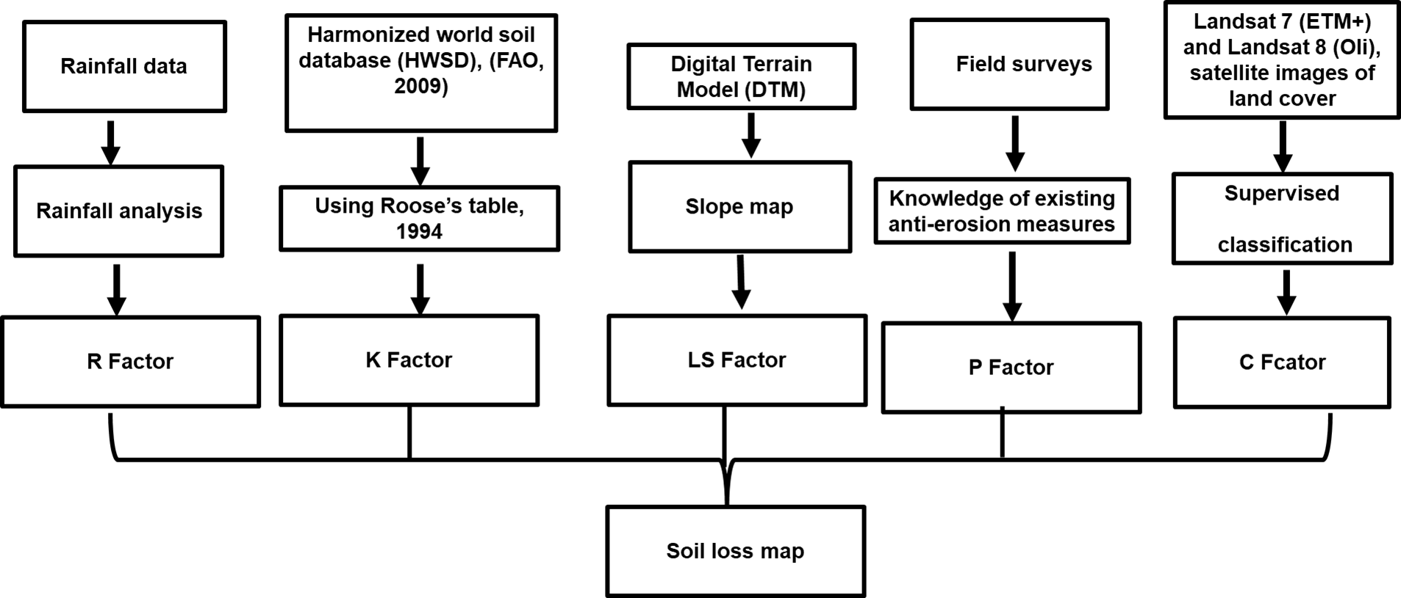
Fig.2 . Steps in mapping water erosion hazard on the watershed

3. RESULTS AND DISCUSSION
3.1. Results
3.1.1. Land cover maps of the 2002 and 2020 images
Digital processing of multispectral images enabled the creation of land cover maps for the Gourou watershed in 2002 and 2020 (Figure 3). Three land cover classes emerged from these maps: low-lying areas/cultivated land, parks and gardens, and built-up areas and bare soil. The images were well classified, with Kappa coefficients of 0.97 and 0.99 for 2002 and 2020, respectively. Visually, the landscape of the Gourou watershed in both 2002 and 2020 was dominated by built-up areas and bare soil.
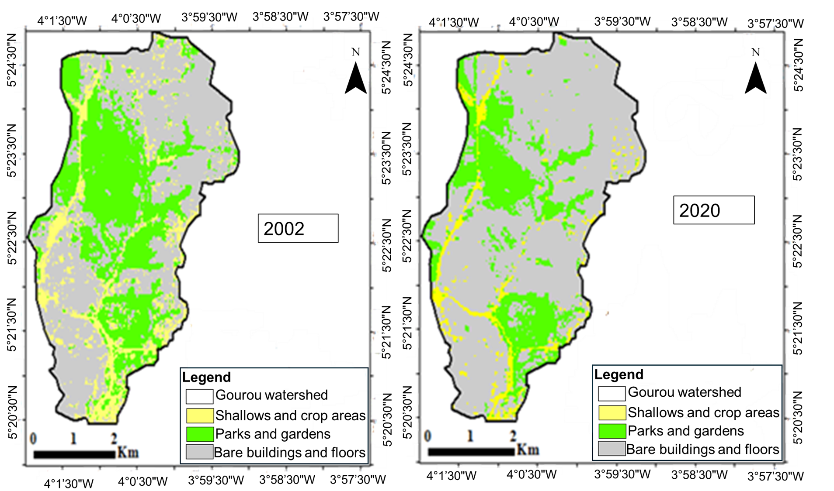
Fig. 3 . Land use maps of the Gourou watershed in 2002 and 2020

3.1.2. Land use dynamics in the Gourou watershed from 2002 to 2020
3.1.2.1. Evolution of land cover areas and types in the catchment area of Gourou
In 2002, the areas of different land cover types varied (Figure 4). Buildings and bare land, which were predominant, occupied 51% of the Gourou watershed, or 13.48 km² (Figure 4). Lowlands and cultivated areas accounted for 14% of the Gourou watershed, or 3.81 km². Parks and gardens represented 9.17 km², or 35% of the total area.
In 2020, buildings and bare ground occupy approximately 71% of the total area of the study zone. Lowlands and cultivated areas cover 6% of the basin, park and garden class 23% with respective areas of 18.79 km² and 1.71 and 5.96 km² (Figure 4).

Fig. 4 . Proportion of land cover classes in the Gourou watershed in 2002 and 2020
3.1.2.2. Rate of change in land cover areas from 2002 to 2020
During the study period, parks and gardens experienced a 35.01% decrease in area, or 2.37% per year (Figure 5). The same trend was observed for the Lowlands and Cultivated Areas class, which saw a 55.12% decrease in area between 2002 and 2020. Conversely, built-up areas and bare land increased in area during the study period. In fact, the surface area of built-up areas and bare land increased by 1.86% between 2002 and 2020 (Figure 5).

Fig. 5 . Annual rate of change (AC) and global rate of change (GRT) of land cover in the Gourou watershed from 2020 to 2002
3.1.3. Soil loss in the study area
The estimation of soil loss is done through different factors which are: R (rainfall erosivity factor), K (soil erodibility factor), LS (topographic factor, length and slope of the slope), C (vegetation cover and cultivation practices factor) and P (conservation practices factor), each of these factors has been estimated.
These estimates give us LS factor values ranging from 0 to 79.73 (Figure 6). The study area is thus comprised mainly of the total area of gentle slopes (52%), representing an area of 13.79 km². Average LS factor values represent 27% of the study area, corresponding to an area of 7 km². Average, high, and very high LS values represent 16% and 5% of the study area, corresponding to 4.21 and 1.41 km², respectively (Figure 6).
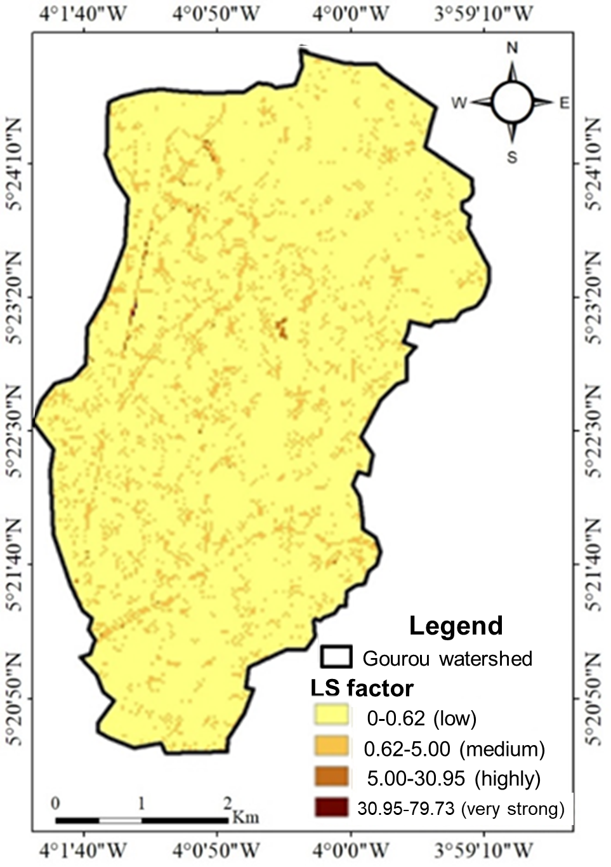
Fig. 6. Distribution map of the LS factor in the study area
Regarding the K factor, it was estimated by extracting the study area from the FAO World Soil Map using ArcMap. This extraction provided cartographic units for the different soil types. These soil type values are associated with proportions of sand, silt, clay, and organic carbon. From the organic carbon, we obtained the proportion of organic matter and the soil textures of the study area. Based on these different parameters, the K factor was assigned to each mapping unit. Thus, the K factor values are 0.20 th /ha/MJ/mm and 0.26 th /ha/MJ/mm with a land cover of 75.58% and 24.41% respectively of the study area (Figure 7).
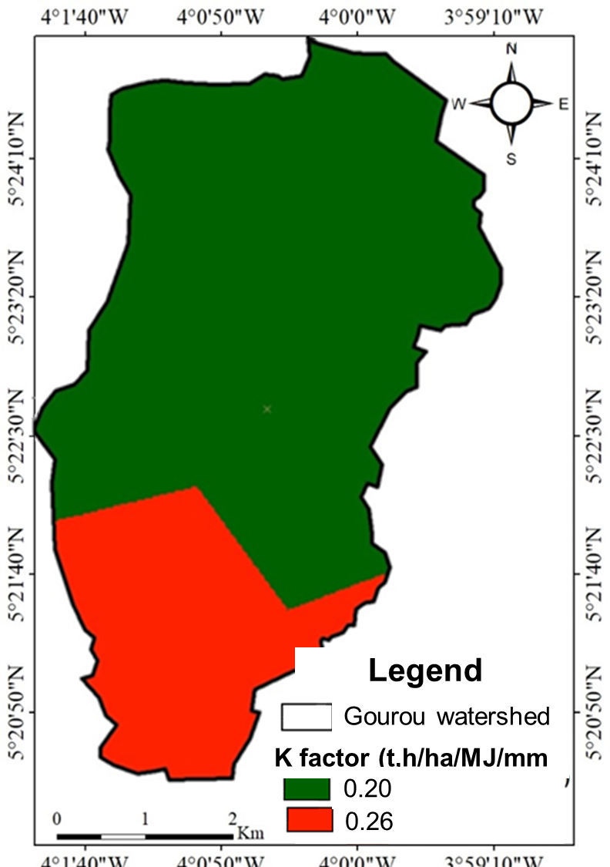
Fig. 7. Distribution map of the values of K factor
Regarding the C factor in the study area, we obtained values ranging from 0.05 to 0.8 (Figure 8). Lowlands and cultivated areas have a C factor of 0.050, while parks and gardens have a C factor of 0.090, and buildings and bare soils have a C factor of 0.80. Integrating the C factor into the GIS yielded R factor values ranging from 961 to 1001 MJ.mm/ha.hr.yr. (Figure 9). This variation is gradual from east to west and from north to south.

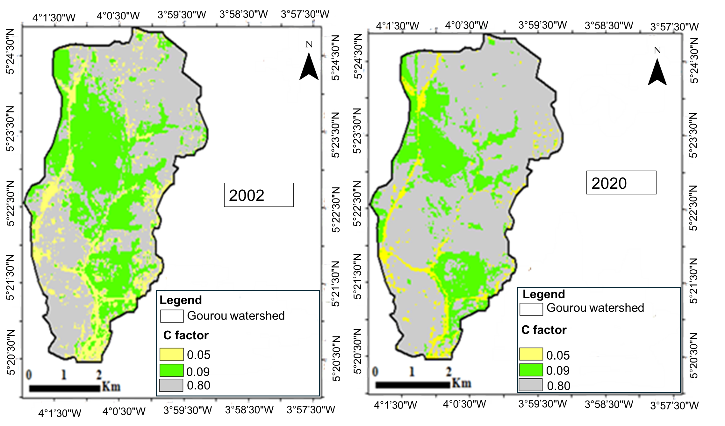
Fig. 8 . Variation in the value of C factor in the study area between 2002 and 2020

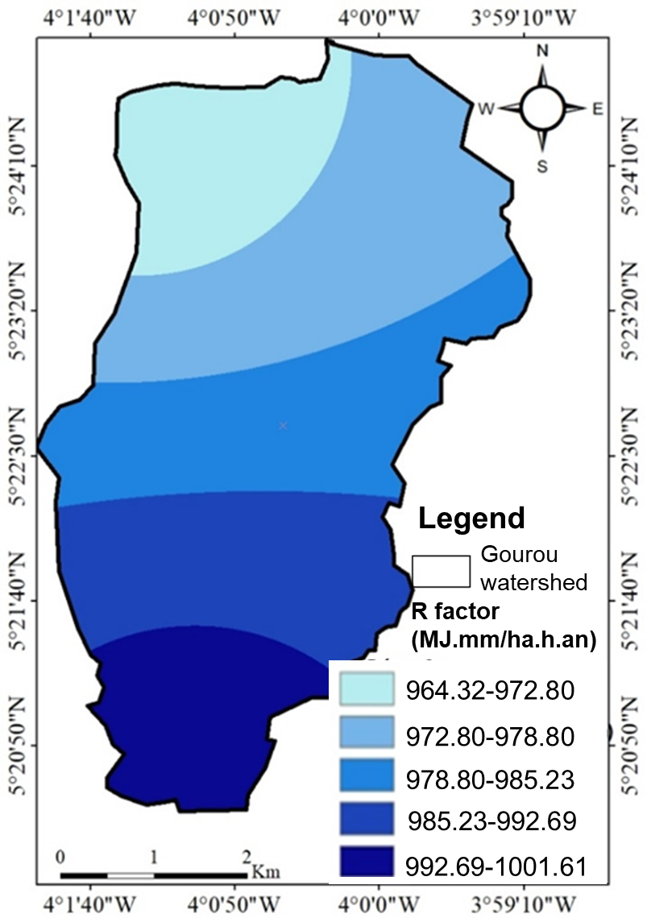
Fig. 9. Variation of the R factor in the study area
The integration of all these factors into the RUSLE model yielded soil loss values ranging from 0 to 1423.31 t/ha/year for 2002 and from 0 to 1582.28 t/ha/year for 2020. The areas least susceptible to erosion, which comprised 61.32% of the study area in 2002, increased to 49.96% in 2020. This reflects a shift in areas highly vulnerable to erosion and an increase in erosion from 38.95% to 50.03% between 2002 and 2020. Average soil losses increased from 556.778 t/ha/year to 633.46 t/ha/year over the period from 2002 to 2020. Total annual soil losses over the same period were 1,473,213.42 t/year in 2002 and 1,676,135.16 t/year in 2020, representing an increase of approximately 1.5% (Table 1). The losses are concentrated in the southwest and northeast of the basin, which are the most urbanized areas (Figure 10).
Table 1. Soil loss rates in the Gourou watershed in 2002 and 2020
Year | Average soil losses (t/ha/year) | Total annual soil losses (t/year)
2002 | 556.77 | 1473213.42
2020 | 633.46 | 1676135.16

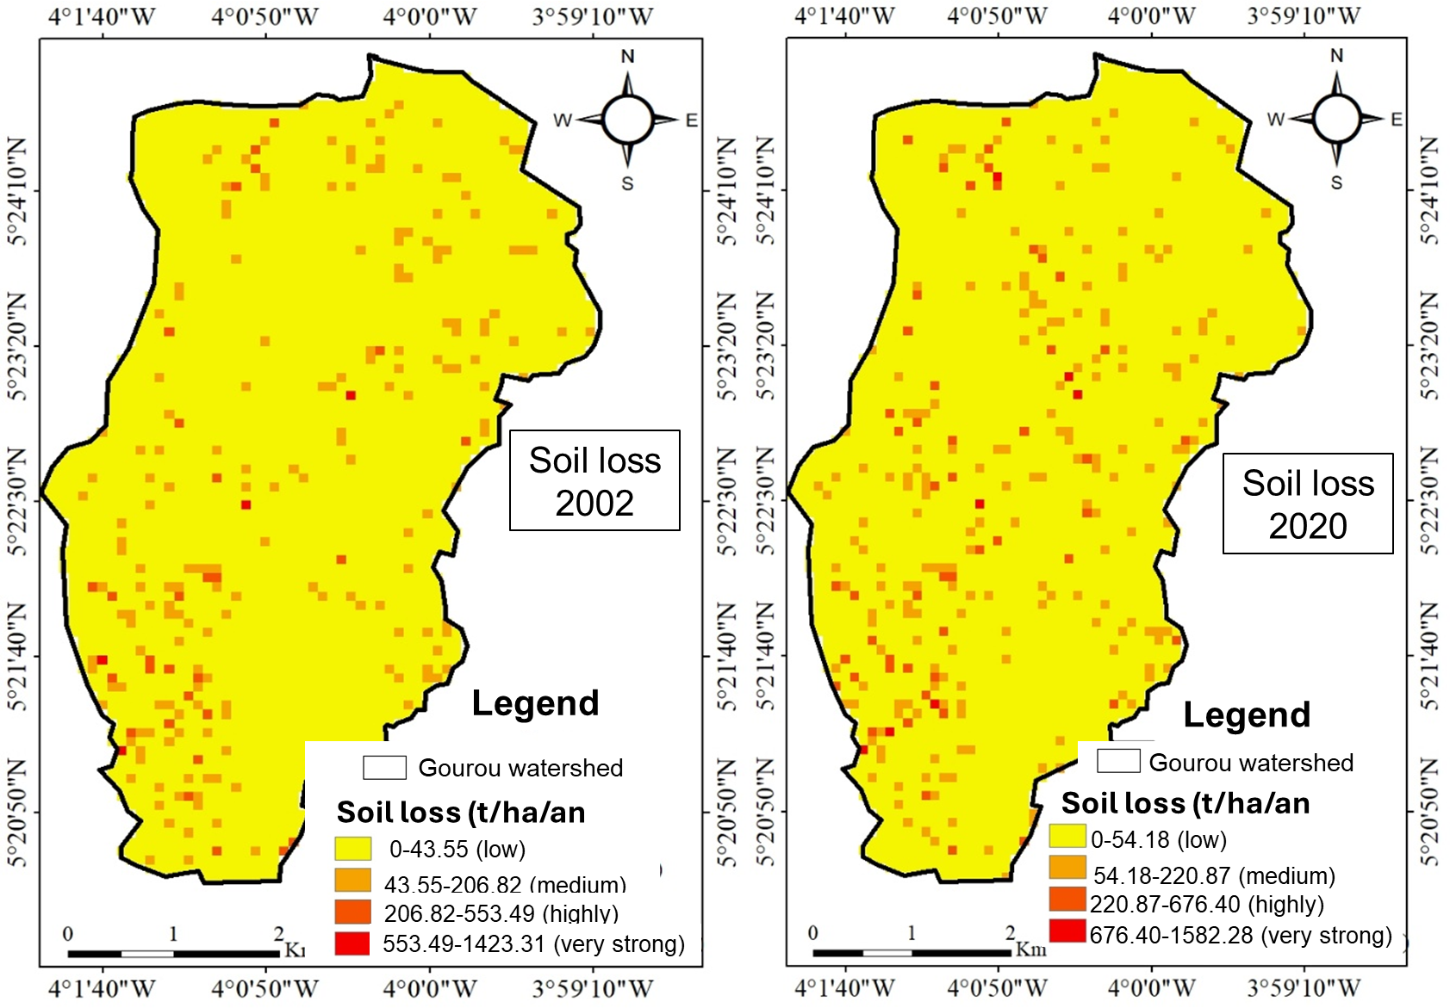
Fig. 10. Evolution of soil loss in the Gourou catchment from 2002 to 2020
3.2 . DISCUSSION
Land cover was analyzed using spatial analysis tools within a GIS. This approach has already been used by some authors ( Meledje , 2016 ; N'go et al ., 2018) to characterize land cover, delineate forested areas, and estimate soil loss. The overall accuracy and classification kappa coefficients obtained are above 80%, indicating good image classification ( Congalton , 1991 ). The land cover results indicate that the studied area was more than 51% covered by artificial formations in 2002 and 71% in 2020. Indeed, the analysis of land cover dynamics between 2002 and 2020 in the Gourou watershed shows a significant decline in parks and gardens, as well as in low-lying areas and cultivated land in 2020, in favor of buildings and bare soil. This rapid conversion of parks and gardens, low-lying areas, and agricultural land into buildings and bare soil within 18 years could be attributed to the strong population growth experienced by the city of Abidjan. Indeed, the gradual increase in population density will lead to a need for housing. A study conducted by Sako et al . (2013) on the impact of urbanization on the conservation of Banco National Park in Abidjan showed a 7% increase in buildings within this protected forest area in 1998. Furthermore, this conversion of vegetated areas into buildings could be explained by the population displacement during the 2002 socio-political crisis, which saw a large mass of the population migrate to the south of the country.
The quantification of soil loss indicates an average soil loss ranging from 556.77 t/ha/yr in 2002 to 633.46 t/ha/yr in 2020. According to the findings of Wall et al. (1954) , the study area is experiencing very high erosion. Areas with high erosion rates are located on steep slopes and with bare or built-up soil. This assertion is supported by Meledje (2016) , who states that lower soil losses are associated with dense cover such as forests, while the highest values are attributed to bare soils. The high soil losses recorded in the study area could be explained by its high level of urbanization, which reduces infiltration and intensifies the impact of rainfall on the soil, allowing rainwater to easily erode topsoil layers. Numerous scientific studies highlight the role of vegetation cover in combating erosion ( El Hage Hassan et al ., 2016 ). Indeed, vegetation protects the soil surface from the effect of raindrops, slows the speed of runoff, and maintains good porosity at the soil surface, making it more resistant to erosion (Roose , 1996; Zhou et al ., 2008).
Erosion is not solely due to the absence of vegetation cover. The cumulative effects of soil and climate conditions, the disappearance of vegetation on fragile soils, rugged topography, and the lack of erosion control measures all contribute to erosion. All these factors must be considered to explain the spatial distribution of erosion.
4. CONCLUSION
Analysis of land cover dynamics between 2002 and 2020 showed that the basin is primarily occupied by human settlements, namely habitats and bare soils, which cover more than 70% of the study area. Vegetation cover declined by 35% between 2002 and 2020 due to human activities, specifically the rapid urbanization of the basin. Soil loss quantification indicates very high soil erosion, with an erosion rate ranging from 1,473,213.42 t/year in 2002 to 1,676,135.16 t/year in 2020. The average erosion rate varies between 556.77 t/ha/year and 633.46 t/ha/year. Thus, a more advanced or more severe degradation of the vegetation cover would be detrimental to this region which already suffers from disasters such as flooding by accumulation of runoff water caused by the inability of soils to infiltrate and the silting up of drainage canals caused by soil loss and the drainage of solid waste by water towards the canals.

Disclaimer (Artificial intelligence)
Option 1:
Author(s) hereby declare that NO generative AI technologies such as Large Language Models (ChatGPT, COPILOT, etc.) and text-to-image generators have been used during the writing or editing of this manuscript.
Option 2:
Author(s) hereby declare that generative AI technologies such as Large Language Models, etc. have been used during the writing or editing of manuscripts. This explanation will include the name, version, model, and source of the generative AI technology and as well as all input prompts provided to the generative AI technology
Details of the AI usage are given below:
1.
2.
3.

REFERENCES
- Al Karkouri, J., Roose, E., Laouina, A. & Sabir, M (2000). Surface condition, infiltration and erosion risks in the Beni Boufrah valley . Bulletin - Réseau Erosion , 20, 342-356.
- Béligné, V. (1994), Study of the state of the natural environment of Banco National Park. Recommendations for its protection and management. WWF-Abidjan, Pp-47.
- Briak, H., Moussadek, R., Aboumaria, K. & Mrabet, R (2016). Assessing sediment yield in Kalaya gauged watershed ( Northern Morocco) using GIS and SWAT model. International Soil and Water Conservation Research , 4, 177-185. https://doi.org/10.1016/j.iswcr.2016.08.002
- Brou Yao, T., Oszwald, J., Bigot, S. & Eric, S. (2005). Risks of deforestation in the permanent state domain in Côte d'Ivoire: what future for these last forest massifs? Remote Sensing, 5 (1-2-3). 263-275.
- Chatelain, C (1996). Possibilities of applying high-resolution satellite imagery to the study of vegetation transformations in forested Côte d’Ivoire. Doctoral thesis in life sciences, Faculties of Medicine and Science, University of Geneva, Geneva (Switzerland), pp-206.
- Congalton, GR. (1991). A Review of Assessing the Accuracy of Classifications of Remotely Sensed Data. Remote Sensing of Environment , 46, 35-37. https://doi.org/10.1016/0034-4257(91)90048-B
- Desmet PJJ., & Govers, G. (1996). A GIS procedure for automatically calculating the USLE LS factor on topographically complex landscape units . Journal of Soil and Water Conservation , 51(5), 427-433. https://doi.org/10.1080/00224561.1996.12457102
- El Hage Hassan, H., Touchard, L., Ardillier -Carras, F., & Faour G. (2016). Erosion control and agricultural development in the Bekaa plain (Lebanon). Mappmonde , 117, 1-17. http://mappemonde.mgm.fr/articles/art15104.html
- FAO. (1996). Forest resources Assessment 1990 - Survey of tropical forest cover studies of change processes . FAO Forestry Paper 130, Food and Agriculture Organization of the United Nations, Rome, Italy. Available from http://www.fao.org/docrep/007/w0015e/w0015e00.htm . Accessed July 2024.
- Girard, MC., & Girard, CM. (1999). Remote sensing data processing. Dunod, Paris (France), Pp-529. https://doi.org/10.1201/9780203741917
- Hauhouot, A., 2002, Development, Planning, Regionalization in Côte d’Ivoire. EDUCI , Pp-364.
- Heusch, B. (1970). Erosion of the Pre-Rif. A quantitative study of water erosion in the marl hills of the western Pre-Rif. Annales Recherches Forestières du Maroc , 12, 1-176. https://horizon.documentation.ird.fr/exl-doc/pleins_textes/pleins_textes_7/horizon/fdi_010056569.pdf
- Khaoula, K., & Siheme, J. (2021). Evaluation of water erosion in the watersheds of the semi-arid zone of Tunisia with the RUSLE and MUSLE models coupled with a Geographic Information System. Cahiers Agricultures , 30, 1-7.
- Landis, JR., & Koch, GG. (1977). The Measurement of Observer Agreement for Categorical Data. Biometrics, 33, 159-174. https://doi.org/10.2307/2529310
- Meledje, N. (2016). Modeling of hydrological dynamics and sediment flux in the Ayame1 hydroelectric dam lake. Doctoral thesis in Environmental Science and Management. Nangui Abrogoua University , Abidjan (Côte D'Ivoire), Pp-267.
- Naimi, M., Tayaa, M., Ouziz, S., Choukr-llah, R. & Kerby, M. (2002). Gullying in the Nakhla watershed , western, Morocco. Erosion Network Bulletin , 21, 232-243. https://beep.ird.fr/collect/bassinve/index/assoc/NANMI_M._2002.dir/NANMI_M._2002.pdf
- N'go, AY., Kouadio, AZ., Deguy, JPA., Hien, AS., Goula, ABT. & Savané, I. (2018). Influence of land cover dynamics on the amount of soil loss south of the Sassandra watershed (Côte d'Ivoire), International Journal of Advanced Research , 6(4), 830-838. https://doi.org/10.21474/IJAR01/6918
- N'go, YA. (2015). Hydrology and dynamics of land surface conditions in southwestern Côte d'Ivoire: impacts and drivers of degradation. Doctoral thesis in Environmental Science and Management. Nangui Abrogoua University , Abidjan, Côte d'Ivoire. 220 pp.
- Oszwald, J. (2005). Dynamics of agroforestry formations in Côte d'Ivoire (from the 1980s to the 2000s): Monitoring by remote sensing and development of a mapping approach. Doctoral thesis in Geography . University of Science and Technology of Lille, Lille (France). Pp-304.
- Prasuhn, A., Liniger, H., Gisler, S., Herweg, K., Candinas, A. & Clément, JP. (2013). HAS highresolution soil erosion risk map of Switzerland as strategic policy support system. Land use policy, 32, 281 - 29 https://doi.org/10.1016/j.landusepol.2012.11.006
- Roose, E. (1996). Methods for measuring soil surface conditions, roughness, and other characteristics that can aid in field diagnosis of runoff and erosion risks, particularly on cultivated mountain slopes. Erosion Network Bulletin , 16, 87-97. https://horizon.documentation.ird.fr/exl-doc/pleins_textes/pleins_textes_7/b_fdi_45/010009063.pdf
- Sadiki, A., Bouhlassa , S., Auajjar , J., Faleh , A. & Macaire, JJ . (2004). Use of a GIS for the assessment and mapping of erosion risks by the Universal Soil Loss Equation in the Eastern Rif (Morocco): case of the Boussouab wadi catchment , Bulletin of the Scientific Institute, Rabat, Earth Sciences section , 26, 69-79. https://www.researchgate.net/publication/262799307_Utilisation_d%27un_SIG_dans_la_cartographie_et_l%27evaluation_des_risques_d%27erosionExemple_le_bassin_versant_de_l%27oued_Boussouab_Rif_oriental
- Sako, NG., Beltrando, GL., Atta, HD., N'Da, T. & Brou. (2013). Forest dynamics and urban pressure in Banco National Park (Abidjan, Côte d'Ivoire). Environmental Controversies , (13)2, 1-23. https://doi.org/10.4000/vertigo.14127
- Sùri, M., Cebecauer, T., Hofierka, J. & Fulajtár, E. (2002). Soil erosion assessment of Slovakia at a regional scale using GIS. Ekológia (Bratislava) , 21, 404-422. https://www.uke.sav.sk/index.php?id=377
- Toyi, MS, Barima, YSS., Mama, A., André, M., Bastin, JF., De Cannière, C. et al. (2013). Tree Plantation Will Not Compensate Natural Woody Vegetation Cover Loss in the Atlantic Department of Southern Benin. Tropicultura, 31, 62 70. https://hdl.handle.net/2268/160471
- Wall, JM, Krider, MM, Krewson, CF, Eddy, CR, Willaman, JJ, Corell, DS & Gentry, HS (1954). Steroidal sapogenins VII. Survey of plants for steroi -dal sapogenins and others constitute . Journal of the American Pharmacists Associations, 63, 1-7. https://doi.org/10.1002/jps.3030430102
- Wishmeier, W.H. & Smith, D. (1978). Predicting rainfall erosion losses, a guide to conservation planning. Agriculture Handbook, 537, 1-58.
- Zhou, P., Luukkanen, O., Tokola, T. & Nieminen, J. (2008). Effect of vegetation cover on soil erosion in a mountainous watershed. Catena, 75: 319-325. https://doi.org/10.1016/j.catena.2008.07.010
- Guo, Z., Yan, Z., He, R., Yang, H., Ci, H., & Wang, R. (2024). Impacts of Land Use Conversion on Soil Erosion in the Urban Agglomeration on the Northern Slopes of the Tianshan Mountains. Land, 13(4), 550.
- Ma, D., Peng, S., & Lin, Z. (2025). Towards a more comprehensive scenario analysis: Response of soil erosion to future land use and climate change in the Central Yunnan Urban Agglomeration, China. Journal of Environmental Management, 376, 124523.
- Guo, J., Chen, J., & Qi, S. (2024). Impact of Land Use/Cover Change on Soil Erosion and Future Simulations in Hainan Island, China. Water, 16(18), 2654.

