Soil Contamination by Heavy Metals and Pesticides: A Critical Review of Toxicological Mechanisms, Sustainable Remediation Strategies, and One Health Implications

.
ABSTRACT

Soil contamination by heavy metals and pesticides remains a persistent global challenge with far-reaching consequences for agricultural productivity, ecosystem stability, and human health. Despite extensive research, existing studies remain fragmented across soil science, toxicology, and environmental health, limiting efforts to integrate soil nutrient status, contaminant dynamics, and their implications for plant stress, food-web integrity, and environmental well-being. This review provides a critical and multidisciplinary synthesis of current knowledge on soil profiling, contaminant fate, toxicological mechanisms, and sustainable remediation technologies, emphasizing their relevance for sustainable agriculture and One Health.
A transparent, structured literature search across Scopus, Web of Science, and PubMed identified 412 eligible articles published up to 2024. Key contaminants – including Cd, Pb, As, Cr(VI), and major pesticide groups such as organophosphates, organochlorines, carbamates, and pyrethroids – are examined with emphasis on persistence and biochemical pathways of toxicity, including oxidative stress, disruption, genotoxicity, and microbiome dysbiosis. A comparative evaluation of remediation strategies – phytoremediation, biochar amendments, nanomaterials, microbial degradation, and physico-chemical approaches – assesses their efficiencies, constraints, scalability, and environmental trade-offs, with particular emphasis on green chemistry innovations and biochar-based interventions that enhance field-level applicability.
By integrating soil toxicology within a One Health and planetary health framework, the review delineates mechanistic connections between soil pollutants, plant dysfunction, food-chain transfer, ecosystem degradation and adverse human health outcomes. The scientific novelty lies in its unified perspective, linking soil nutrient profiling, phytotoxicity, ecosystem services, and health interdependencies, and in proposing a conceptual model that synthesizes chemical, biological, and ecological insights to guide sustainability-driven soil restoration. Key research priorities include developing multi-contaminant exposure models, validating remediation strategies under long-term field conditions, and harmonizing global regulation of agrochemical residues. Overall, this review underscores the environmental significance of re-envisioning soil as a central determinant of sustainable agriculture and public health, highlighting the urgent need for integrated, cross-sectoral remediation and management strategies.

Aim: The secondary research aims to :
(1) consolidate current understanding of soil nutrient composition, contamination pathways, and implications for plant and ecosystem health;
(2) examine toxicological profiles of major pollutants – particularly heavy metals and pesticides – with emphasis on persistence, bioavailability, and ecological consequences; and
(3) evaluate recent advances in biological, chemical, and green chemistry-based remediation within a One Health framework, highlighting the need for integrative, sustainable approaches to soil restoration.

Objectives: The review aims to conceptualize and critically evaluate advancements in soil nutrient dynamics, pollutant toxicology, and remediation strategies, with emphasis on heavy metals and pesticides. It integrates soil ecological processes, plant stress responses, environmental toxicology, and human health within a unified One Health perspective.
Specific objectives include:
(1) synthesizing physicochemical and biological foundations of soil fertility and contamination;
(2) assessing toxicological pathways of heavy metals and pesticides and their ecological implications;
(3) evaluating sustainable mitigation strategies – bioremediation, phytoremediation, biochar amendments, and green chemistry approaches; and
(4) identifying knowledge gaps to guide sustainable agricultural systems.
Study Design and Methodology: This review employs a focused yet transparent evidence-mapping approach – short of a holistic protocol but still structured and traceable under PRISMA – to integrate soil profiling, contaminant toxicology, and sustainable remediation within a One Health framework. Through a targeted literature search using defined inclusion criteria and multidisciplinary keywords, the review critically evaluates soil nutrient dynamics, toxicological pathways of heavy metals and pesticides, and emerging mitigation strategies while identifying key knowledge gaps relevant to sustainable agroecosystem management.
Results: Soil functions as a complex biogeochemical system whose fertility, nutrient cycling, and ecosystem services depend on the interplay between organic matter, microbial communities, and physicochemical properties across soil horizons. Anthropogenic pressures – industrial emissions, mining, waste disposal, agrochemicals, and excessive fertilization – introduce heavy metals and pesticides that disrupt nutrient dynamics, degrade soil structure, impair microbial processes, and trigger plant physiological stress. Evidence demonstrates that agrochemical overuse destabilizes soil microbial ecology and nutrient–microbe interactions, causing contamination, reduced biodiversity, nutrient imbalance, and increased risks to food security and environmental quality. Integrating these findings reveals that soil health is tightly linked to contaminant behaviour, plant–soil interactions, and ecosystem resilience, emphasizing the need for sustainable management and remediation strategies to preserve soil-based ecosystem services.
Conclusion: Heavy metal and pesticide contamination undermines soil functioning, plant productivity, ecosystem stability, and public health, reaffirming that soil integrity is a core component of “the One Health” continuum. Evidence indicates that while physicochemical remediation offers rapid mitigation, biologically driven and green-chemistry approaches – such as biochar, phytoremediation, and microbial degradation – provide more sustainable, scalable, and ecologically restorative solutions. Advancing soil health and sustainable agriculture requires interdisciplinary collaboration, long-term field research, integrated contaminant modeling, and globally harmonized regulatory frameworks to safeguard ecosystems, food security, and human well-being.
The Environmental Significance: The idea is to conceptualize the agricultural soil profile for its nutrient content as well as contaminants, implications on plant stress management, food web or the health of humans and the environment, and highlight through a critical review the importance of research into remediation of pollutants, with a special focus on nexus approaches in soil, sustainable agriculture practices and the “one-health.”

The Scientific Novelty: The novelty lies in its integrated and multidisciplinary approach to understanding soil pollution, toxicological profiling, and remediation of heavy metal and pesticide contamination within the framework of sustainable agriculture and the “One Health” concept. Unlike conventional reviews focusing narrowly on either contaminants or remediation techniques, this work holistically connects soil nutrient profiling, phytotoxicity mechanisms, ecosystem services, and human-environmental health interlinkages. It uniquely emphasizes cross-sectional roles of green chemistry and biochar-based strategies, advancing practical farm-field applications. By synthesizing chemical, biological, and ecological insights, the study pioneers a unified conceptual model for soil restoration and sustainability-driven remediation.
This review offers an integrated One Health assessment of heavy metal and pesticide contamination in agricultural soils, combining mechanistic toxicology, a comparative critical evaluation of remediation technologies, and a planetary health perspective to identify cross-sectoral knowledge gaps and sustainability priorities.

Keywords: Soil contamination; heavy metals; pesticides; toxicology; phyto(remediation); soil microbiome; one health; environmental sustainability.

1. INTRODUCTION

Soil is a foundational ecological resource supporting global food systems and terrestrial biodiversity. Its physical, chemical, and biological properties regulate nutrient cycling, plant productivity, and ecosystem stability, thereby positioning soil health at the core of the “One Health” paradigm linking plant, animal, environmental, and human well-being (Mumford et al., 2023; Hill et al., 2024; Banerjee & van der Heijden, 2023) through only sustained ecosystem services (Shaikh & Shaikh, 2025). Often regarded as the “skin of the Earth,” soil is a dynamic matrix of minerals, organic matter, air, water, and microorganisms that regulate essential biogeochemical processes, with the rhizosphere microbiome particularly critical for nutrient cycling and biological nitrogen fixation (Philippot et al., 2024). Maintaining balanced interactions among soil physicochemical properties, microbial communities, and environmental factors is therefore vital for ecological resilience and human survival (Kalavathy, 2004). However, anthropogenic activities including industrial emissions, mining, waste disposal, and intensive agrochemical use – have accelerated the accumulation of heavy metals and pesticides – the major contaminants – in agricultural soils. These pollutants threaten soil fertility, disrupt microbial communities, impair plant physiological processes, and pose increasing risks to environmental and human health.
Although micronutrients like Zn, Cu, and Fe are essential at trace levels, their accumulation beyond threshold concentrations leads to phytotoxicity and human health risks (Nieboer & Richardson, 1980). Their persistence, bioaccumulation, and biomagnification make understanding their environmental behaviour and toxic mechanisms crucial for risk assessment and remediation. Pesticides likewise represent a dominant contamination source, with herbicides comprising nearly half of global use (Atwood & Paisley, 2017). Varying chemical classes – organochlorines (OCPs), organophosphates (Ops), carbamates, and pyrethroids – exert distinct modes of action (Yadav & Devi, 2017; Raffa & Chiampo, 2021; Kim et al., 2017), yet all function as xenobiotics capable of disrupting soil microbiota, nutrient turnover, and biodiversity, raising concerns for ecological stability and food safety (Faruque Ahmad et al., 2024). Consequently, research and regulatory attention has intensified around pesticide fate, life cycles, and soil quality standards (Zhang & Li, 2023; Schwarz et al., 2022).
Global initiatives highlight the urgency of confronting soil degradation. The Global Status of Soil Pollution report, developed by the Food and Agriculture Organization of the United Nations FAO’s the Intergovernmental Technical Panel on Soils (ITPS) with the United Nations Environment Programme (UNEP), calls for coordinated scientific action within the UN Decade on Ecosystem Restoration (2021–2030) (FAO & UNEP, 2021; UNGA Resolution 73/284, 2019), emphasizing soil organic matter conservation, microbial diversity preservation, and restoration of fertility through sustainable management. Yet current literature remains fragmented across soil science, toxicology, and environmental health, often addressing soil properties, nutrient profiles, or pollutants in isolation and giving limited attention to how soil contamination connects directly to One Health. This review responds to these gaps by integrating knowledge on soil profiling, nutrient dynamics, pollutant toxicity, and remediation strategies, underscoring links among soil processes, plant stress physiology, food safety, ecosystem stability, and human well-being.
The aims of this review are therefore to:
(1) consolidate current understanding of soil nutrient composition, contamination pathways, and implications for plant and ecosystem health;
(2) examine toxicological profiles of major pollutants – particularly heavy metals and pesticides – with emphasis on persistence, bioavailability, and ecological consequences; and
(3) evaluate recent advances in biological, chemical, and green chemistry-based remediation within a One Health framework, highlighting the need for integrative, sustainable approaches to soil restoration.

This review addresses existing fragmentation in the literature by integrating soil nutrient profiling, mechanistic toxicology, remediation science, and One Health concepts. It offers a consolidated framework for understanding how soil contamination affects plant, ecosystem, and human health, and evaluates sustainable remediation strategies that support long-term agricultural resilience.

2. STUDY DESIGN AND PRISMA-ALIGNED METHODOLOGY
Building upon the conceptual foundations introduced earlier – particularly the need to integrate soil profiling, toxicological assessment, and sustainable remediation within a One Health framework – this review adopts a structured, transparent methodology for identifying, screening, and synthesizing relevant scientific evidence. Although not a holistic review, the process follows PRISMA-aligned steps, including identification, screening, eligibility assessment, and inclusion (Figure 1).

2.1 Objectives
The review aims to conceptualize and critically evaluate advancements in soil nutrient dynamics, pollutant toxicology, and remediation strategies, with particular emphasis on heavy metals and pesticides. It integrates soil ecological processes, plant stress responses, environmental toxicology, and human health into a unified One Health perspective. The specific objectives are to:
- Synthesize physicochemical and biological foundations of soil fertility and contamination.
- Assess toxicological pathways of heavy metals and pesticides and their ecological implications.
- Evaluate sustainable mitigation strategies – including bioremediation, phytoremediation, biochar amendments, and green chemistry approaches.
- Identify knowledge gaps to guide sustainable agricultural systems and One Health-oriented soil management.

2.2 Literature Search and Data Collection Strategy
A structured literature search was conducted across Scopus, Web of Science, PubMed, and Google Scholar, incorporating peer-reviewed articles, review papers, book chapters, technical documents, and international reports (FAO, UNEP, WHO). This approach ensured comprehensive coverage of soil science, toxicology, agricultural sustainability, and One Health domain.
2.2.1 Search Terms
Keywords and Boolean combinations targeted soil profiling, contaminants, toxicology, remediation, and One Health, including:
- “soil contamination” AND “heavy metals”
- “pesticides” AND “soil microbiota”
- “soil profile” OR “nutrient dynamics”
- “toxicological profiling” AND “agricultural soils”
- “phytotoxicity” AND “heavy metals”
- “bioremediation” OR “phytoremediation”
- “biochar” AND “soil amendment”
- “One Health” AND “soil pollution”

2.2.2 Time Frame
Studies published up to 2024 were prioritized, with select 2025 studies included to ensure relevant and up-to-date coverage. Foundational works such as Nieboer & Richardson (1980) and Jensen (1907) were included for their historical and conceptual significance.

2.3 Inclusion and Exclusion Criteria
Inclusion criteria encompassed:
- Peer-reviewed studies on heavy metals, pesticides, soil microbes, nutrient dynamics, or remediation
- Research describing mechanistic toxicology, ecological impacts, or sustainable agricultural practices
- Mechanistic or applied insights into soil–plant–microbe interactions
- International agency reports (FAO, UNEP, WHO)
Exclusion criteria included:
- Non-peer-reviewed or non-scientific material
- Studies unrelated to soil systems or lacking contaminant relevance
- Articles without adequate methodological transparency

2.4 Screening and Selection
The search yielded approximately 1,200 records. After title and abstract screening, 587 publications remained. Full-text evaluation narrowed this to 412 eligible studies, from which 123 thematically relevant papers were reviewed in depth. A final set of 65 high-quality studies was selected for comparative synthesis. This curated selection reflects the interdisciplinary scope of soil science, toxicology, ecological resilience, and environmental health.
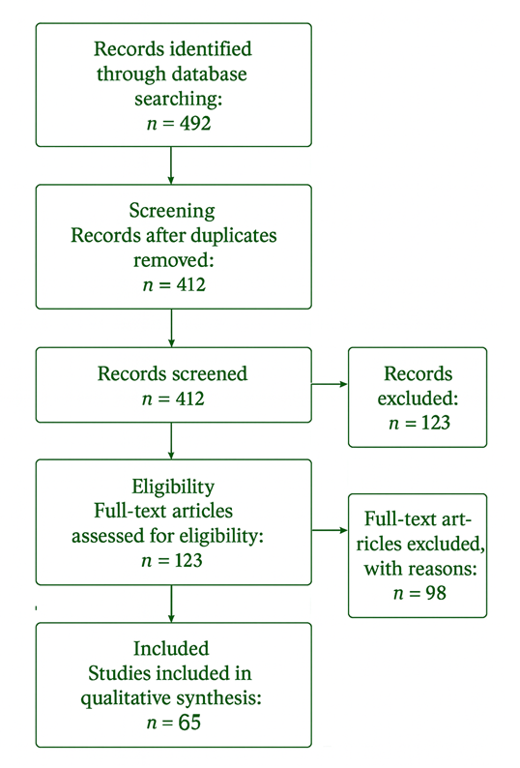
Fig. 1. PRISMA Flowchart

2.5 Analytical Approach
A thematic analytical framework guided the synthesis of included studies, focusing on:
- Soil profiling, nutrient dynamics, and physicochemical properties
- Contaminant behaviour, including chemical characteristics, fate, mobility, and bioavailability
- Mechanistic toxicological pathways affecting plants, soil microbiota, animals, and humans
- Ecological disruptions such as plant stress, microbial dysfunction, and ecosystem impairment
- Remediation strategies, evaluated for efficiencies, constraints, scalability, ecological compatibility, and sustainability
- Alignment with the One Health framework, emphasizing interconnected plant, ecosystem, and human health outcomes
This integrated approach identifies converging scientific themes and persistent gaps, underscoring the central role of soil profiling (Figure 2) in interpreting nutrient availability, soil fertility, contaminant dynamics, and the design of sustainable remediation strategies. Ultimately, the methodological framework supports a cross-sectoral understanding of how contaminated soils influence plant defenses, food safety, ecosystem services, and human health.
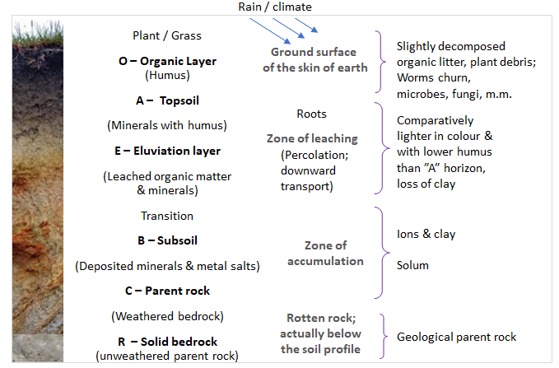
Fig. 2. A soil profile (shown on the wall of a gully) consisting of distinct soil horizons.
3. RESULTS AND DISCUSSION
Building on the methodological foundations outlined in Section 2, this section presents a critical synthesis of the results, emphasizing that soil must be understood not merely as a physical substrate but as a multifunctional ecological system. Its physicochemical properties, biological components, and nutrient dynamics collectively sustain terrestrial life and underpin ecosystem services. Soil fertility – defined by its capacity to supply essential nutrients, support root development, and maintain microbial and biochemical functions – remains central to agricultural productivity and ecosystem stability. Accordingly, the soil profile provides the framework for interpreting nutrient availability, pollutant behaviour, and plant–soil interactions, forming the basis for the integrated analysis of heavy metal and pesticide contamination, their ecological impacts, and implications for sustainable remediation strategies.

3.1 Soil as a Biogeochemical and Ecological System
Agroecosystems comprise communities of plants and animals interacting with modified chemical and physical environments to produce food, fibre, and fuel (EC / Grizzetti et al., 2018). Within these systems, soil acts as a dynamic, heterogeneous matrix of minerals, organic matter, water, gases, and microorganisms. Pedology and edaphology highlight how soil classification and soil–organism interactions together shape nutrient distribution, pollutant mobility, and microbial ecology. Historical observations of soil horizonation (Schelling, 1970) and assessments of intra-horizon variability (Hartemink et al., 2020) underscore the role of spatial heterogeneity.
The soil microbiome – especially rhizosphere communities – plays a critical role in nitrogen cycling, carbon turnover, soil structure, and ecosystem resilience. Beneficial microbial networks, therefore, must remain intact when applying agricultural interventions or remediation strategies (Philippot et al., 2024).

3.2 Nutrient Cycling, Soil Organic Matter, and Microbial Function
Although nitrogen is abundant atmospherically, plants depend on biological nitrogen fixation mediated by Rhizobium, Azolla–cyanobacteria associations, and Azotobacter spp. (Shridhar, 2012). Soil organic matter (SOM), a small but essential fraction of the soil matrix, regulates microbial metabolism, nutrient retention, moisture capacity, and soil structure, making SOM maintenance fundamental to long-term productivity.
Anthropogenic pressures – including unsustainable land use, mining, industrial emissions, and waste disposal – introduce heavy metals and metalloids into agricultural soils (Alloway, 1995), altering nutrient dynamics, impairing microbial processes, and disrupting soil physicochemical properties. Fertilizers are routinely applied to correct nutrient deficiencies (Figure 3), yet Soil Organic Carbon (SOC) depletion due to improper fertilization remains problematic. Moderate fertilizer application enhances yields, whereas excessive inputs reduce fertility and long-term productivity (Allam et al., 2022).
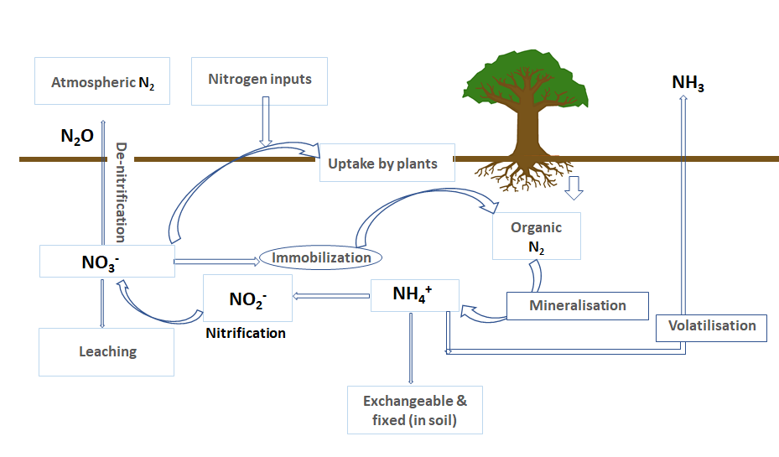

Fig. 3 Nutrients and nitrogen cycle.

Nitrate, the primary assimilated form of nitrogen, is highly soluble and prone to leaching and runoff (Figure 4). Phosphorus, the second most limiting nutrient for crops (Shen et al., 2011), enters soils via fertilizers, organic manure, and sewage sludge (Figure 5). Under certain conditions, it becomes mobile, contributing to eutrophication of freshwater and marine systems (Schroder et al., 2010; Shaikh et al., 2013).
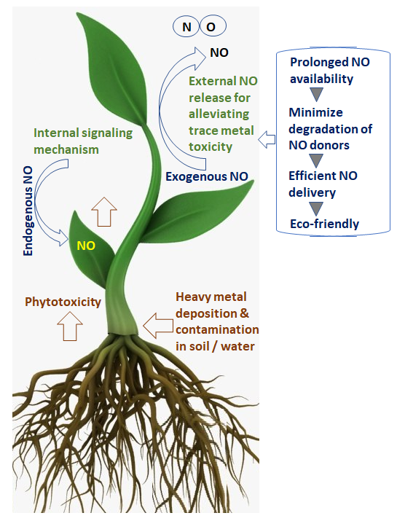

Fig. 4 Nitric oxide and the alleviation of HM phytotoxicity.
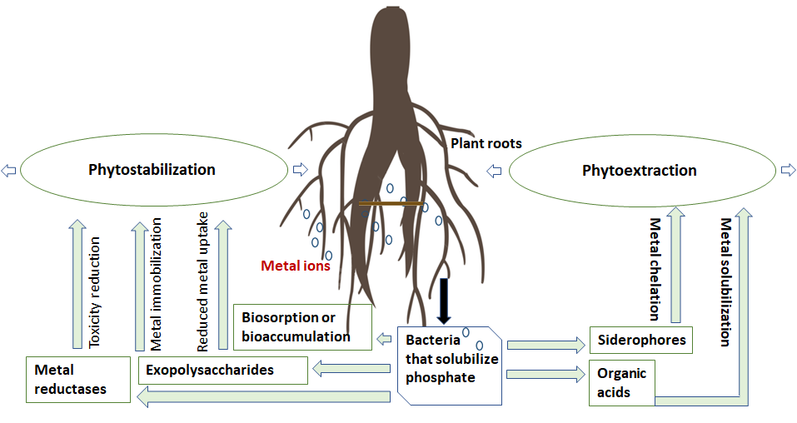
Fig. 5 Phosphate solubilizing bacteria (Ahmad, M. 2015).
Industrial emissions, mining, waste disposal, and agrochemical use have substantially increased Cr, Cd, Zn, Cu, Pb, Al, As, and Hg concentrations in soils, imposing severe environmental, ecological, and economic consequences (Figure 6).
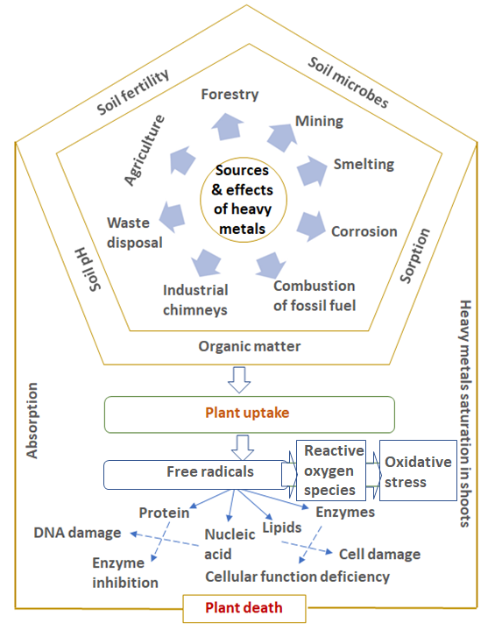
Fig. 6 Sources, mechanism and effects of heavy metal toxicity in plants.

3.3 Agrochemical Inputs, Soil Pollution, and Microbial Disruption
Modern agriculture’s reliance on pesticides and fertilizers often neglects long-term ecological effects. Pesticides, inherently xenobiotic, disrupt beneficial soil microbiota, diminish pollinators, and raise food safety concerns (Faruque Ahmad et al., 2024). These impacts have encouraged researchers to support regulatory agencies in defining pesticide life cycles, soil quality standards, and environmental thresholds (Zhang & Li, 2023; Schwarz et al., 2022).
While pesticides remain essential for crop protection, their excessive use causes soil contamination, nutrient imbalance, and structural degradation. Global assessments by the FAO and UNEP emphasize the need for sustainable soil management, microbial conservation, and restoration of SOM (FAO & UNEP, 2021). The Global Status of Soil Pollution report reinforces the importance of prevention and remediation under the UN Decade on Ecosystem Restoration (2021–2030) (UNGA Resolution 73/284, 2019).

3.4 Integrative Understanding of Soil Function and Contamination
Collectively, these observations highlight soil as a complex biogeochemical system whose ecological services depend on nutrient balance, organic matter, and microbial communities. Heavy metals, pesticides, industrial wastes, and inappropriate fertilizer use disrupt soil fertility, plant stress physiology, biodiversity, and food security. Understanding these dynamics is essential for designing integrated remediation strategies that restore soil function while preserving ecosystem services.
This integrative perspective underpins the subsequent sections, which analyse nutrient dynamics, contaminant toxicology, and remediation strategies, emphasizing their relevance to agricultural sustainability, environmental health, and the One Health framework.

4. Soil Profile and Nutrient–Soil Interactions
Building on the integrative understanding of soil structure and ecosystem services discussed in Section 3, a focused examination of the soil profile is essential for contextualizing nutrient availability, contaminant mobility, microbial activity, and plant–soil interactions. The vertical arrangement of soil horizons, shaped by pedogenic processes, governs cation exchange capacity, metal sorption, organic matter turnover, and root distribution – factors that directly determine how heavy metals and pesticides behave within the soil matrix.

4.1 Structure of the Soil Profile and Its Functional Importance
The classical horizons O, A, E, B, C, and R represent layers with distinct physical, chemical, and biological properties. Early soil cartography (Schelling, 1970) and contemporary analyses (Hartemink et al., 2020) illustrate substantial intra- and inter-horizon variability, emphasizing that soil is not a uniform medium.
The A horizon, rich in organic matter, underpins nutrient uptake, microbial colonization, and contaminant interactions, whereas the B horizon often serves as a zone of accumulation for metals, clay, and humic substances. This heterogeneity influences water infiltration, root penetration, redox gradients, and sorption–desorption processes. Understanding these horizon-specific dynamics is therefore critical for predicting pollutant transport, assessing bioavailability, and selecting remediation strategies.

4.2 Nutrient Dynamics and Soil Fertility
Soil fertility results from interactions among organic matter, minerals, microbial communities, and nutrient transformations. Although nitrogen is abundant in the atmosphere, plants rely on biological nitrogen fixation by rhizobacteria, cyanobacteria, and diazotrophs such as Azotobacter (Shridhar, 2012). SOM, though a small portion of total soil mass, regulates nutrient retention, water-holding capacity, and aggregation, while its decomposition products – including humic and fulvic acids – bind heavy metals, reducing toxicity and controlling bioavailability.

4.3 Factors Regulating Nutrient Availability and Soil Quality
Nutrient mobility is shaped by soil pH, redox potential, clay mineralogy, ionic strength, microbial biomass, and competing contaminants. Excessive or imbalanced fertilization alters microbial structure, disrupts nutrient cycling, and may induce soil acidification or salinization.
Anthropogenic inputs – including industrial emissions, mining residues, sewage sludge, and agrochemicals – introduce heavy metals and synthetic pollutants into agricultural soils (Alloway, 1995). These contaminants compete with essential nutrients, inhibit microbial nitrogen fixation, impair root enzymatic activity, and induce oxidative stress in plants.

4.4 Agrochemicals and the Disruption of Soil Nutrient–Microbe Balance
Although fertilizers and pesticides remain integral to modern agriculture, their misuse can destabilize soil nutrient–microbe interactions. Pesticides, being xenobiotic, suppress beneficial microbes, reduce enzymatic activity, and interfere with nutrient cycling (Faruque Ahmad et al., 2024). Their persistence – well documented across organochlorines, organophosphates, carbamates, and pyrethroids (Yadav & Devi, 2017; Raffa & Chiampo, 2021; Kim et al., 2017) – modifies soil chemistry and cation exchange behaviour, also influencing heavy‐metal sorption. Growing concerns have prompted refinement of pesticide guidelines and soil quality standards (Zhang & Li, 2023; Schwarz et al., 2022).

4.5 Implications for Soil Contaminant Behavior
The physicochemical properties of each horizon determine pollutant partitioning, transformation, and movement. Clay-rich B horizons promote metal adsorption; SOM-rich A horizons enhance pesticide sorption while enabling biodegradation; fluctuating redox conditions can mobilize Fe, Mn, and As; and soil moisture and microbial activity control agrochemical degradation pathways.
Thus, nutrient–soil interactions are inseparable from contaminant dynamics, as the soil profile ultimately dictates pollutant persistence, root and microbial exposure, and pathways into the food chain.

5. Heavy Metals, Pesticides, and Their Toxicological Mechanisms
Building on the nutrient–soil interactions described in Section 4, heavy metals and pesticides represent two dominant contaminant classes that disrupt soil biochemical processes, plant physiology, microbial communities, and broader ecological and human health pathways. Their persistence, bioavailability, and capacity for food-chain accumulation make them among the most consequential pollutants. Although widely reported in soils, their mechanistic toxicological effects require integrated interpretation to understand how contamination impairs soil function, agricultural productivity, and One Health outcomes.

5.1 Heavy Metals: Sources, Persistence, and Environmental Behaviour
Heavy metals enter agricultural soils through multiple pathways, including mining effluents, industrial emissions, sewage sludge, agrochemical residues, and atmospheric deposition (Alloway, 1995). Their persistence in soils reflects their non-degradable nature, with environmental fate and bioavailability strongly influenced by soil pH, redox potential, clay mineralogy, organic matter content, and the presence of competing ions. While essential micronutrients such as Zn, Cu, and Fe are required for plant and microbial metabolism, they become toxic when concentrations exceed critical thresholds (Nieboer & Richardson, 1980). In contrast, non-essential metals, including Cd, Pb, and Hg, exhibit toxicity even at trace levels, posing significant risks to soil health, plant productivity, and food chain safety. The accumulation of heavy metals in plants thus poses potential human health risks through contaminated soils (Ibrahim & Selim, 2018) and also through vegetables (; Kaushik et al., 2025).

5.1.1 Mechanisms of Heavy Metal Toxicity in Plants
Heavy metals interfere with plant processes through:
• Oxidative stress, with Cd, Pb, and Cr (VI) promoting Reactive Oxygen Species (ROS) accumulation and damaging cellular components.
• Photosynthetic impairment, disrupting chlorophyll synthesis and electron transport.
• Root growth inhibition, disturbing cell division, elongation, and nutrient uptake.
• Nutrient imbalances, limiting Ca, Mg, Fe, and Zn uptake.
• Microbial disruption, inhibiting enzymes, nitrogen fixation, and beneficial microbial populations.
These mechanisms underpin the ecological and food-chain consequences of metal contamination.

5.2 Pesticides: Classification, Environmental Persistence, and Soil Interactions
Pesticides vary widely in chemical structures and modes of action, with fate determined by adsorption–desorption processes, pH, organic matter, and microbial degradation. Major groups include organochlorines, organophosphates, carbamates, and pyrethroids (Yadav & Devi, 2017; Raffa & Chiampo, 2021; Kim et al., 2017). Dichloro-Diphenyl-Trichloroethane (DDT) remains a classic example of environmental persistence and bioaccumulation (Figure 7).
Carbamates, derived from organic carbamic acid structures, include widely used compounds such as carbaryl (Figure 8) (Zacharia & Tano, 2011). Mechanistically, carbamates and organophosphates share toxicity patterns through acetylcholinesterase inhibition (Silberman & Taylor, 2023).

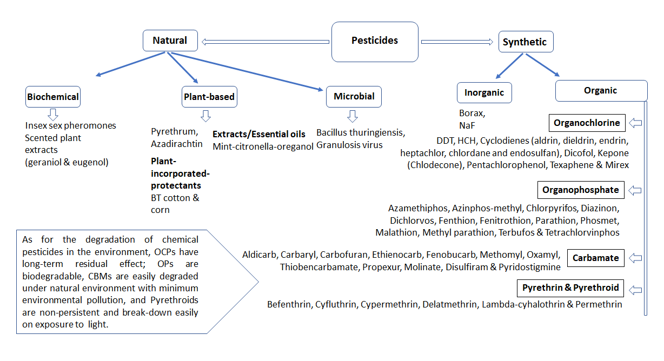
Fig. 7 Classification and examples of pesticides.

Name | Mode of action | Mechanism | Target diseases
Tebuconazole | Systemic | Inhibits sterol biosynthesis (C14-demethylation) | Leaf spots, Rusts
Propiconazole | Systemic | Inhibits sterol biosynthesis | Leaf spots, Powdery mildew
Hexaconazole | Systemic | Inhibits sterol biosynthesis | Sheath blight, Rusts
Difenoconazole | Systemic | Inhibits sterol biosynthesis | Anthracnose, Powdery mildew
Azoxystrobin | Systemic, Translaminar | Inhibits sterol biosynthesis | Blast, Downy mildew
Trifloxystrobin | Systemic, Contact | Inhibits mitochondrial electron transport (cytochrome b) | Rusts, Powdery mildew
Kresoxim-methyl | Systemic | Inhibits mitochondrial respiration | Powdery mildew, Rusts
Boscalid | Systemic | Inhibits mitochondrial respiration | Botrytis, Alternaria
Fluxapyroxad | Systemic | Inhibits succinate dehydrogenase | Powdery mildew, Leaf spots
Penthiopyrad | Systemic | Inhibits succinate dehydrogenase | Leaf spots, Blights
Mancozeb | Contact | Inhibits succinate dehydrogenase | Leaf spots, Blights
Zineb | Contact | Multi-site activity affecting enzyme systems | Downy mildew, Leaf spots
Thiram | Contact | Multi-site activity affecting enzyme systems | Seed-borne diseases
Captan | Contact | Multi-site activity affecting enzyme systems | Fruit rots, Leaf spots
Myclobutanil | Systemic | Multi-site activity affecting enzyme systems | Powdery mildew, Leaf spots
Triadimefon | Systemic | Inhibits sterol biosynthesis | Rusts, Powdery mildew
Cymoxanil | Translaminar | Inhibits sterol biosynthesis | Downy mildew, Late blight
Metalaxyl | Systemic | Inhibits RNA synthesis | Downy mildew, Late blight
Mefenoxam | Systemic | Inhibits RNA synthesis | Pythium, Downy mildew
Chlorothalonil | Contact | Inhibits RNA synthesis | Leaf spots, Blights
Fosetyl-AI | Systemic | Multi-site activity affecting fungal enzymes | Downy mildew, Phytophthora
Carbendazim | Systemic | Disrupts fungal metabolism | Leaf spots, Blights
Thiophanate-methyl | Systemic | Inhibits microtubule assembly | Powdery mildew, Leaf spots
Pyrimethanil | Systemic | Inhibits methionine biosynthesis | Botrytis, Anthracnose
Neem oil | Contact | Disrupts fungal reproduction | Powdery mildew, Leaf spots
Table 1. Application of fungicides: Classification based on mode of action and mechanism.

5.2.1 Mechanisms of Pesticide Toxicity in Plants and Soil Microbes
Key toxicological effects include:
• Acetylcholinesterase inhibition, affecting soil fauna and non-target insects.
• Membrane damage, altering cellular ion exchange.
• Oxidative imbalance, with ROS-induced lipid and protein damage.
• Soil microbial dysbiosis, reducing abundance, diversity, and nutrient-cycling capacity (Faruque Ahmad et al., 2024).
• Altered nutrient cycling, disrupting nitrification, phosphate solubilization, and carbon turnover.
These mechanisms compromise soil fertility, plant health, and food safety.

5.3 Interactions Between Heavy Metals and Pesticides in Soil
Co-contamination is common and produces synergistic effects:
• Competitive sorption on clay and organic matter.
• Altered bioavailability, with pesticides modifying soil pH/redox conditions and metals inhibiting pesticide degradation.
• Synergistic toxicity, exacerbating oxidative stress and impairing detoxification.
• Microbial impacts, reducing richness and inhibiting nutrient-cycling enzymes.
Such interactions highlight the need for mitigation strategies addressing multiple pollutants.

5.4 Food Chain Transfer and One Health Implications
Heavy metals and pesticides affect One Health by linking soil pollution to plant, animal, and human outcomes:
• Bioaccumulation of Cd, Pb, and As in edible plant tissues.
• Pesticide residue persistence in food crops and animal feed.
• Microbiome disruption, compromising rhizosphere health and plant resilience (Philippot et al., 2024).
• Human health impacts, including neurological damage, endocrine disruption, renal injury, carcinogenicity, and immunotoxicity.
• Ecosystem effects, impairing soil fauna, pollinators, and decomposers.
These pathways demonstrate that soil contamination is both an environmental and public health concern.

5.5 Toward Sustainable Mitigation: The Need for Mechanistic Understanding
Mechanistic insights into toxicity are essential for designing effective remediation. The persistence of heavy metals, stability of many pesticides, and synergistic effects of co-contamination necessitate scalable, ecologically compatible remediation solutions. The next section examines biological, physico-chemical, and green chemistry-based remediation approaches, assessing their efficiencies, limitations, and relevance to restoring soil function within a One Health framework.

6. Remediation Technologies – Comparative Critical Evaluation
Remediating contaminated agricultural soils requires understanding the scientific basis of each technology alongside their advantages, limitations, scalability, and environmental trade-offs. Because heavy metals and many pesticides persist in soils, remediation must reduce contaminant loads while restoring soil ecological functioning, sustaining crop productivity, and aligning with One Health principles.

6.1 Scientific Principles of Major Remediation Technologies
6.1.1 Physico-Chemical Approaches
Physico-chemical methods – soil washing, immobilization/stabilization, solidification, electrokinetic remediation, and thermal vitrification – primarily rely on desorption, solubilization, or structural transformation of pollutants. Soil washing uses surfactants, chelators, or acidic agents to extract metals and organics, while stabilization binds contaminants within mineral matrices to reduce mobility. Electrokinetic remediation, effective in fine-textured soils, mobilizes metals such as Cd, Pb, Zn, Cr (VI), and As under applied electric fields. Although efficient, these approaches can substantially alter soil chemistry and disturb microbial equilibria.

6.1.2 Biological Approaches
Biological remediation – including microbial degradation, phytoremediation, rhizofiltration, bioaugmentation, and biostimulation – leverages natural ecological processes. Microorganisms transform pesticides via oxidative, reductive, or hydrolytic pathways (Chia et al., 2024), while hyperaccumulator plants extract or immobilize metals over successive growth cycles. Amendments such as compost, organic matter, or biosurfactants enhance native microbial activity and pollutant degradation.

6.1.3 Green Chemistry and Integrated Approaches
Green chemistry approaches incorporate biochar amendments, nanomaterials, engineered enzymes, and hydrogel systems. Biochar improves cation exchange capacity, immobilizes metals, and enhances soil structure, while nano-enabled phytoremediation increases root uptake and detoxification potential (Dhanapal et al., 2024). These strategies are valued for low energy requirements, reduced secondary pollution, and suitability for long-term soil health restoration.

6.2 Advantages and Limitations
Physico-Chemical Methods
Advantages:
• Rapid and efficient, particularly at high contamination levels.
• Applicable to both organic and inorganic pollutants.
• Suitable for industrial hotspots and acute contamination events.
Limitations:
• High operational and energy costs.
• Generation of secondary waste requiring safe disposal.
• Potential alteration of soil physicochemical properties.
• Limited feasibility in large-scale agricultural contexts.

Biological Methods
Advantages:
• Environmentally sustainable and cost-effective.
• Enhance SOM and microbial biodiversity.
• Support long-term ecological restoration.
• Integrate well with agroecological and organic systems.
Limitations:
• Slower than physico-chemical techniques.
• Sensitive to climate, soil properties, and plant traits.
• Low biomass of hyperaccumulators constrains extraction efficiency.
• Less effective in severely contaminated soils.

Biochar and Green Chemistry Approaches
Advantages:
• Improve soil structure, pH regulation, and carbon sequestration.
• Facilitate metal immobilization while supporting crops.
• Promote microbial-mediated remediation.
• Align with circular bioeconomy, converting waste to value.
Limitations:
• Efficacy depends on feedstock type and pyrolysis temperature.
• Over-application may disrupt nutrient balance.
• Limited long-term field validation.

Previous studies from Iraq show that absence of early monitoring has escalated public health risks in polluted sites, as Pollution Load Index (PLI) values were not assessed in time (Al-Mashhadi & Alabadi, 2023). Another studies by Alain, T. K., et al. (2025) and Derra, M., et al. (2024) significantly advance understanding of environmental metal contamination in Korsimoro, Burkina Faso. Alain et al. (2025) demonstrate that agricultural soils in market gardening sites exhibit notable heavy metal accumulation, with quantified health risks for exposed populations. Derra et al. (2024) specifically shows that trace metal concentrations in the Korsimoro dam exceed recommended thresholds, indicating potential ecological and human health hazards. Together, these works highlight the need for continuous environmental monitoring and mitigation strategies to protect water and soil resources in the region. Thus, the findings suggest that due to long-term accumulation and persistence of heavy metals, affected areas require urgent intervention (Figure 9) to prevent further ecological degradation, reduced agricultural productivity, diminished crop quality, and increased human health disorders.

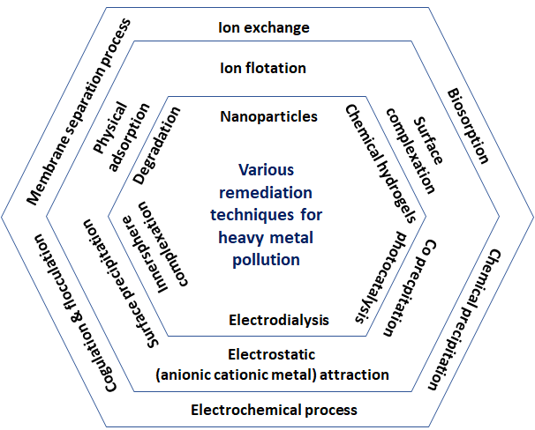
Fig. 8 Various different remediation techniques for heavy metal pollution.

6.3 Scalability and Cost Considerations
• Large-scale agriculture: Biological and biochar-based methods are most feasible, offering low cost and minimal disruption.
• Localized hotspots: Soil washing, thermal treatments, and electrokinetics provide high efficiency but require significant capital.
• Low-resource regions: Phytoremediation and organic amendments (manure, compost, crop residues) remain accessible and affordable.
• Industrial–agricultural interfaces: Hybrid approaches – physico-chemical remediation for hotspots combined with phytoremediation for surrounding areas -optimize recovery.
Cost-effectiveness varies by contaminant: metals require long-term immobilization, whereas pesticides benefit from microbial and enzymatic degradation pathways.

6.4 Environmental Trade-Offs
A comprehensive evaluation includes potential ecological side effects:
• Physico-chemical treatments may induce soil acidification, organic matter loss, and microbial decline.
• Phytoremediation risks contaminant concentration in plant biomass, requiring secure disposal.
• Nanomaterial use necessitates monitoring of nano-toxicity and trophic impacts.
• Improperly produced biochar may contain polyaromatic hydrocarbons.
• Microbial remediation may generate by-products with uncertain long-term ecological effects.
These considerations emphasize the need for integrated, ecosystem-aligned remediation strategies that maintain soil functionality, biodiversity, and agricultural resilience.

7. Integrating Soil Pollution with the One Health Framework
7.1 Mechanistic Exposure Pathways Linking Soil to Human and Environmental Health
The One Health framework provides a mechanistic lens linking soil contamination with plant dysfunction, ecosystem disruption, and human disease.

7.1.1 Soil–Plant–Food Chain Transfer
Heavy metals such as Cd, Pb, and As readily enter roots, accumulate in edible tissues, and persist through trophic levels. Persistent pesticides, including OCPs and certain herbicides, follow similar bioaccumulation trajectories.

7.1.2 Impacts on the Soil Microbiome and Rhizosphere Health
Microbiome dysbiosis induced by metals or xenobiotic pesticides suppresses nitrogen fixation, disrupts beneficial microbes and enzyme systems, and heightens plant vulnerability to stress.

7.1.3 Ecotoxicological Feedback Loops
Contaminants affect soil fauna, pollinators, and decomposers, weakening nutrient cycling and organic matter turnover.

7.1.4 Human Exposure Pathways
Exposure occurs via contaminated food, inhalation of dust, polluted groundwater, and occupational handling. These pathways contribute to carcinogenicity, neurotoxicity, endocrine disruption, and cardiometabolic disorders (Rusin et al., 2021; Popescu et al., 2024).

7.2 Planetary Health and Sustainable Agriculture Alignment
Integrating remediation with One Health emphasizes soil as a regulator of nutrient cycles, biodiversity, and food security, and positions soil contamination as a planetary boundary threat. Climate change intensifies contaminant mobility, redox shifts, and pesticide volatilization. Consequently, remediation must align with climate adaptation, biodiversity conservation, and sustainable food-system transitions. This interdependence underscores soils as foundational to ecosystem integrity and human well-being.

8. Future Directions and Knowledge Gaps
8.1 Multicontaminant and Co-Exposure Models
Most remediation studies examine pollutants individually, although agricultural soils often contain metals, pesticides, microplastics, and pharmaceuticals. Integrated models are required to predict synergistic and antagonistic effects.

8.2 Long-Term Field Validation
Key technologies – biochar, nanomaterials, enzymatic remediation – lack long-term field trials assessing durability, safety, and agronomic performance across diverse climates.

8.3 Soil Microbiome–Centered Remediation
The soil microbiome remains under integrated in remediation design. Metagenomic, metabolomic, and systems-level tools are needed to harness microbiome-driven detoxification.

8.4 Harmonized Regulatory Frameworks
Inconsistent residue limits and monitoring protocols across nations hinder effective soil and food safety governance. Harmonized standards and integrated risk assessments are essential.

8.5 Scalable Green Chemistry Approaches
Biochar, biodegradable nanopolymers, biosurfactants, and enzyme biocatalysts require further development to increase scalability, affordability, and agricultural compatibility.

8.6 Climate–Pollution Interactions
Shifts in rainfall, temperature, and soil moisture will influence contaminant mobility and degradation. Improved predictive models are needed for future climate scenarios.

8.7 Research Enterprise, Policy, and Practice
Jacquet et al. (2022) advocate a paradigm shift toward pesticide-free agriculture. The European Commission (2023) provides a comprehensive IPM “toolbox” with ~1,300 examples aligned with eight Integrated Pest Management (IPM) principles. Given persistent risks from hazardous fungicides (Table 1), remediation must remain agronomically viable and environmentally sustainable (Ball et al., 2018; Jacobson et al., 2024). The One Health framework is therefore central, linking healthy soils, crops, food, and ecosystems (Figure 10).

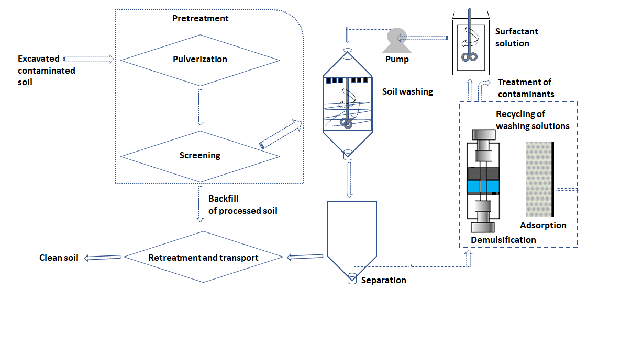

Fig. 9 Schematic design of soil washing (including the remediation example using surfactants, bioreports, etc. (RoyChowdhury et al., 2018 and Arfasa, G.F. et al. 2022).

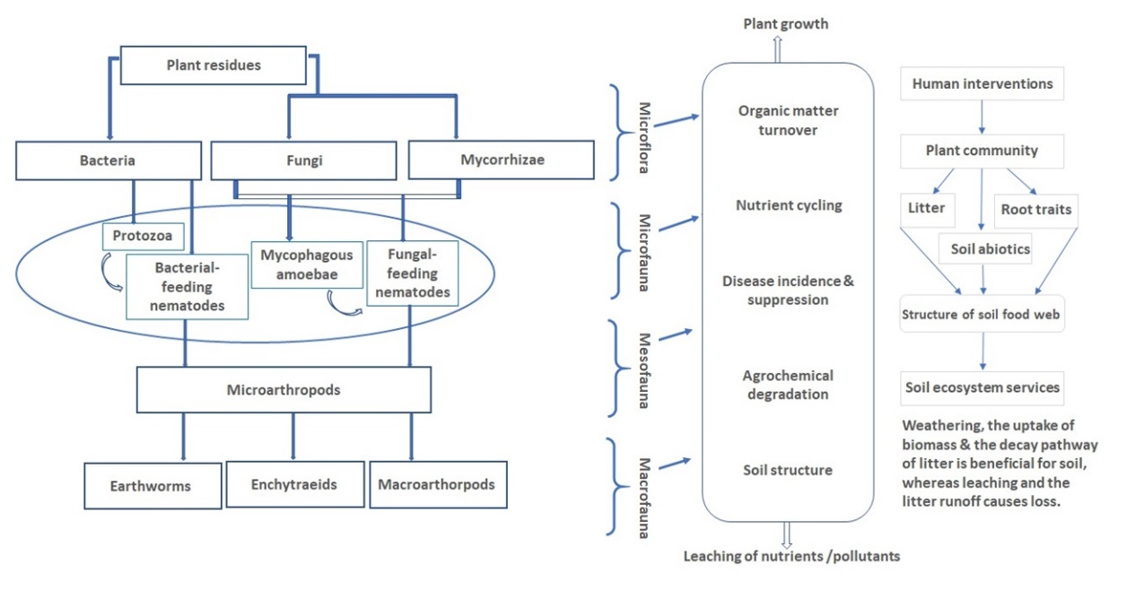
Fig. 10 Soil food web: Structure and pathways for nutrients.
Our earlier work demonstrated that excessive nutrient inputs trigger eutrophication via runoff into irrigation canal systems (Shaikh et al., 2013) (Figures 11 and 12).

Fig. 11 | Photograph of eutrophicated canal (called nala in the local language) which was later abandoned after the Purna dam was modified (Shaikh et al., 2013).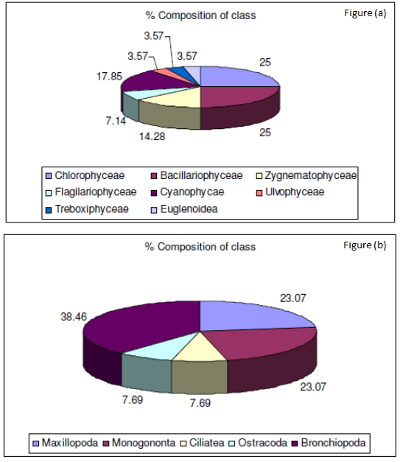
Fig. 12 (a) Percentage composition of phytoplankton in the eutrophicated study area
(b) Percentage composition of zooplankton in the study area (Shaikh, I.R. et al. 2013 Author copyright: isca.in)

The Science of the One Health Approach
The One Health (OH) framework recognizes the interdependence of environmental, plant, animal, and human health (Kahn, 2017). Established conceptually after the 2003 SARS pandemic, OH fosters collaboration among medical, veterinary, ecological, and agricultural sciences to address zoonoses, pollution, climate change, and plant disease. Sustainable agriculture operationalizes OH by reducing biodiversity loss, improving environmental quality, and enhancing food safety.
Advancing OH requires interdisciplinary collaboration. Seminal work on zoonotic transmission (Mackenzie & Jeggo, 2019; Mackenzie et al., 2014; Mubareka et al., 2023) and the COVID-19 pandemic illustrate the urgency of this integrative approach. Plant diseases can also influence human well-being (Al-Sadi & Abdullah, 2017), with evidence showing cross-kingdom pathogen transfer (Kim, 2020) and human-mediated plant viral dispersal (Ranawaka et al., 2020). Microbiomes further connect plant, animal, and human health (Kahn, 2017; Trinh et al., 2018), and soil pollution remains a major global driver of environmental degradation (Steffan et al., 2020). Climate-related stressors, such as extreme heat in the Arabian Peninsula, further destabilize OH balances (The Lancet Series on One Health and Global Health Security, 2023).
Global momentum for OH continues to grow (Brown et al., 2024; Gibbs, 2014; Destoumieux-Garzón et al., 2018). The OH paradigm now features prominently in major scientific journals (Nature Communications, 2023; Nature, 2025), and a dedicated OH journal has recently been launched (Zhou & Tanner, 2022; DOAJ, 2022). International institutions WOAH, FAO, UNEP, WHO are increasingly integrating OH into ecosystem and public-health policy (WOAH, 2023; FAO/UNEP/WHO/WOAH, 2024). Banerjee and van der Heijden (2023) further highlight soil microbiomes as central to OH, affirming soil as a core pillar of ecological and human well-being.

9. Conclusion
Soil contamination by heavy metals and pesticides is a multidimensional environmental challenge with critical consequences for plant productivity, ecosystem stability, food-chain integrity, and human health. This review shows that soil health is inseparable from the broader One Health continuum. Mechanistic evidence demonstrates that contaminants disrupt plant physiology, alter microbial ecology, and threaten biodiversity and public health through multiple exposure pathways.
A synthesis of remediation technologies indicates that sustainable, scalable, and biologically compatible strategies are urgently needed. While physico-chemical methods offer rapid decontamination, biological and green chemistry approaches – biochar amendments, phytoremediation, microbial degradation, and nano-enabled methods – provide longer-term ecological restoration aligned with sustainable agriculture.
Addressing current gaps demands interdisciplinary collaboration, integrated multi-contaminant models, long-term field research, and harmonized global regulatory frameworks. Safeguarding soil health is therefore central to food security, environmental sustainability, and public health. Framed within One Health, soil remediation becomes a transformative pathway for strengthening ecosystem resilience and protecting the well-being of current and future generations.

10. Future Scope
Addressing heavy metal contamination and excessive pesticide use is essential for ensuring food security in a growing global population. Although plants possess innate stress-response mechanisms, farmers must understand the environmental and physiological impacts of pollutants from agrochemicals, industry, and unsustainable land use. Awareness at the grassroots level remains essential for reducing environmental and health risks.
Scientific research continues to inform policy on permissible pollutant thresholds and risk assessment, ensuring that soil toxicology, remediation, and sustainable agriculture remain central to environmental management. Prevention remains preferable to remediation, yet innovation in field-applicable mitigation strategies is vital for achieving sustainability goals consistent with One Health principles.

This manuscript serves as a comprehensive resource for environmental and agricultural researchers, synthesizing evidence on soil nutrient dynamics, contamination, plant stress responses, and mitigation strategies through a One Health lens. Multidisciplinary collaboration remains crucial for advancing sustainable agricultural practices (Kahn, 2017; Mackenzie & Jeggo, 2019; Mackenzie et al., 2014).
Among remediation strategies, biochar is a cost-effective amendment for alleviating environmental stress (Foyer et al., 2016). It mitigates abiotic stressors (salinity, UV radiation, temperature extremes, heavy metals) and biotic pressures (pathogens, pests, fungi, nematodes), while enhancing soil fertility, microbial activity, cation exchange capacity, and reducing contaminant bioavailability through adsorption, ion exchange, co-precipitation, and surface complexation (Hasnain et al., 2023). Empirical studies demonstrate its ability to improve soil quality and reduce trace metal accumulation in cadmium-contaminated rice paddies (Xia et al., 2024; Priya et al., 2023; Xu et al., 2019; Tian et al., 2025), and to immobilize Zn, Pb, and Cd in switchgrass and poultry litter-derived biochar, lowering accumulation in ryegrass (Antonangelo et al., 2023). Biochar also enhances carbon sequestration and modulates greenhouse gas emissions (Zhang, 2015; Qi, 2023), while microbial bioremediation continues to show high efficacy.
Established remediation methods – soil washing, solidification, electrokinetic treatment, chemical stabilization, and phytoremediation – remain important, though biological and plant-based approaches offer sustainable long-term potential (Liu et al., 2018; Xu et al., 2019; Kim et al., 2022; Selvi et al., 2019). Prioritizing phytoremediation with responsible plant disposal is essential to prevent secondary pollution (Hu et al., 2023).

This review highlights the need to identify contamination sources, evaluate toxicological impacts, and link them to ecosystem and human health. Soil serves as a cornerstone of the One Health paradigm, reinforcing that human well-being is fundamentally tied to the health of plants, animals, and the environment (Banerjee & van der Heijden, 2023). Ultimately, healthy soils underpin ecological stability, agricultural productivity, and human health (Emikpe et al., 2024).
Future research must advance sustainable agriculture as a multidimensional framework integrating environmental protection, biodiversity conservation, plant and animal health, and human well-being. One Health offers the scientific foundation for evaluating risks posed by agrochemicals, microorganisms, plant pathogens, and infectious diseases, supported by comprehensive monitoring, life-cycle assessments, and strong environmental–health risk analyses.
Responding to the consequences of anthropogenic activities – especially soil pollution – requires production-appropriate agricultural practices that protect soil, water, and air, particularly under climate change, land degradation, and declining fertility. Green chemistry provides a unifying discipline for bridging agricultural innovation with sustainability (Shaikh et al., 2013; Shaikh & Shaikh, 2018; Shaikh, 2014). Innovations in green chemistry and sustainable engineering will be central to restoring degraded soils, minimizing pollution, and enhancing resource efficiency.
Although the present study provides scientific insights, its broader impact extends to societal transformation. Building resilient, knowledge-based communities and equitable food systems will require holistic approaches grounded in environmental stewardship, social justice, and sustainable livelihoods.

Competing interests
The authors declare that there are no conflicts of interest or competing financial interests associated with this work.

COMPETING INTERESTS DISCLAIMER:
Authors have declared that they have no known competing financial interests OR non-financial interests OR personal relationships that could have appeared to influence the work reported in this paper.
Disclaimer (Artificial intelligence)
Option 1:
Author(s) hereby declare that NO generative AI technologies such as Large Language Models (ChatGPT, COPILOT, etc.) and text-to-image generators have been used during the writing or editing of this manuscript.
Option 2:
Author(s) hereby declare that generative AI technologies such as Large Language Models, etc. have been used during the writing or editing of manuscripts. This explanation will include the name, version, model, and source of the generative AI technology and as well as all input prompts provided to the generative AI technology
Details of the AI usage are given below:
1.
2.
3.

References

- Ahmad, M. (2015). Phosphate-solubilizing bacteria-assisted phytoremediation of metalliferous soils: a review. 3 Biotech 5, 111–121. . https://doi.org/10.1007/s13205-014-0206-0

- Alain, T. K., Ouattara, A., Sawadogo, B., & Kaboré, A. (2025). Heavy Metal Pollution of Agricultural Soils and Health Implications at Korsimoro Market Gardening Sites. Current Journal of Applied Science and Technology, 44(9), 29–41.https://doi.org/10.9734/cjast/2025/v44i94602

- Allam, M., Radicetti, E., Quintarelli, V., Petroselli, V., Marinari, S., & Mancinelli, R. (2022). Influence of Organic and Mineral Fertilizers on Soil Organic Carbon and Crop Productivity under Different Tillage Systems: A Meta-Analysis. Agriculture, 12(4), 464. https://doi.org/10.3390/agriculture12040464

- Alloway B.J., Heavy Metals in Soils, Blackie Academic and Professional, Glasgow, UK (1995). https://doi.org/10.1007/978-94-011-1344-1V

- Al-Mashhadi, Mortada Jabr Hussein and Luma Abdalalah Sagban Alabadi 2023 Study and Evaluation of Soil Contamination with some Heavy Metals According to International Standards for Pollution IOP Conf. Ser.: Earth Environ. Sci. 1213 012107 DOI 10.1088/1755-1315/1213/1/012107 Published under licence by IOP Publishing Ltd IOP Conference Series: Earth and Environmental Science, Volume 1213, 4th International Agricultural Conference (IAC-2023) 10/01/2023 - 11/01/2023 Mosul, Iraq. https://doi.org/10.1088/1755-1315/1213/1/012107

- Arfasa, G.F., Cobbina, S.J., Ampofo, A. (2022). Remediation Technologies for Polluted Sites: Review, J.Env.Earth Sci. 12(12), www.iiste.org https://doi.org/10.7176/JEES/12-12-02

- Al-Sadi, Abdullah M.. Impact of Plant Diseases on Human Health. International Journal of Nutrition, Pharmacology, Neurological Diseases 7(2):p 21-22, Apr–Jun 2017. https://doi.org/10.4103/ijnpnd.ijnpnd_24_17

- Atwood, D. and Paisley-Jones, C. (2017) Pesticides Industry Sales and Usage. 2008-2012 Market Estimates. Biological and Economic Analysis Division, Office of Pesticide Programs | Office of Chemical Safety and Pollution Prevention, U.S. Environmental Protection Agency Washington, DC, USA. Retrived on 2014-12-12. https://www.epa.gov/pesticides/pesticides-industry-sales-and-usage-2008-2012-market-estimates

- Ball BC, Hargreaves PR, Watson CA. A framework of connections between soil and people can help improve sustainability of the food system and soil functions. Ambio. 2018 Apr;47(3):269-283. https://doi.org/10.1007/s13280-017-0965-z

- Banerjee, S., van der Heijden, M.G.A. (2023). Soil microbiomes and one health. Nat Rev Microbiol 21, 6–20 (2023). https://doi.org/10.1038/s41579-022-00779-w

- Brown, H. L., Pursley, I. G., Horton, D. L., Pinchbeck, G. L., Léger, A., & Halliday, J. E. B. (2024). One health: a structured review and commentary on trends and themes. One Health Outlook, 6, 17. https://doi.org/10.1186/s42522-024-00111-x

- Chia, R. S., Abdullah, N., & Rosli, R. (2024). Microbial pathways for the degradation of pesticides in agricultural soils: Mechanistic insights and biotechnological advancements. Environmental Pollution, 335, 122940.https://doi.org/10.1016/j.envpol.2023.122940

- Derra, M., Ouedraogo, H., Sawadogo, B., & Zongo, D. (2024). Evaluation of the Degree of Pollution in Trace Metal Elements (TME) of the Dam in the Rural Commune of Korsimoro, Burkina Faso. Asian Journal of Physical and Chemical Sciences, 12(1), 1–9. https://doi.org/10.9734/ajopacs/2024/v12i1215

- Destoumieux-Garzón, D., Mavingui, P., Boetsch, G., Boissier, J., Darriet, F., Duboz, P., Fritsch, C., Giraudoux, P., Le Roux, F., Morand, S., Paillard, C., Pontier, D., Sueur, C., & Voituron, Y. (2018). The One Health concept: 10 years old and a long road ahead. Frontiers in Veterinary Science, 5, 14. https://doi.org/10.3389/fvets.2018.00014

- Dhanapal, A., Sharma, N., & Gupta, R. (2024). Nano-enabled phytoremediation of contaminated soils: Current trends, mechanisms, and environmental considerations. Journal of Hazardous Materials, 456, 131089. https://doi.org/10.1016/j.jhazmat.2023.131089

- DOAJ on new journal (2015). https://doaj.org/article/75de618e757b4690bb1a87071d646bf4

- European Commission, Directorate-General for Agriculture and Rural Development. (2023). Farmer’s toolbox for integrated pest management. Publications Office of the European Union. https://doi.org/10.2762/457165

- European Commission: Directorate-General for Environment, Grizzetti, B., Teller, A., Maes, J., Orgiazzi, A., Erhard, M., Loffler, P., Petersen, J., Czúcz, B., Kovacevic, V., Paracchini, M., Bastrup-Birk, A., Christiansen, T., Zulian, G., Somma, F., Condé, S., Abdul Malak, D., Marin, A., Mauri, A., ...Biala, K., (2018). Mapping and assessment of ecosystems and their services: an analytical framework for mapping and assessment of ecosystem condition in EU: discussion paper, Publications Office. https://doi.org/10.2779/055584

- European Commission: Directorate-General for Environment, Mapping and assessment of ecosystems and their services – An analytical framework for mapping and assessment of ecosystem condition in EU – Discussion paper, Publications Office of the European Union, 2018, https://doi.org/10.2779/055584

- FAO & UNEP. (2021). Global assessment of soil pollution: Report. Food and Agriculture Organization of the United Nations. https://doi.org/10.4060/cb4894en .

- FAO/UNEP/WHO/WOAH (quadripartite) 2024 https://iris.who.int/bitstream/handle/10665/375700/9789240106208-eng.pdf

- Faruque Ahmad MD., Fakhruddin Ali Ahmad, Abdulrahman A. Alsayegh, Md. Zeyaullah, Abdullah M. AlShahrani, Khursheed Muzammil, Abdullah Ali Saati, Shadma Wahab, Ehab Y. Elbendary, Nahla Kambal, Mohamed H. Abdelrahman, Sohail Hussain, Pesticides impacts on human health and the environment with their mechanisms of action and possible countermeasures, 2024, Heliyon, Volume 10, Issue 7, 2024, e29128, https://doi.org/10.1016/j.heliyon.2024.e29128 .

- Foyer C.H., Rasool B., Davey J.W., Hancock R.D. Cross-tolerance to biotic and abiotic stresses in plants: A focus on resistance to aphid infestation. J. Exp. Bot. 2016;67:2025–2037. https://doi.org/10.1093/jxb/erw079

- Gibbs, E. P. J. The evolution of One Health: a decade of progress and challenges for the future. Vet. Rec. 174, 85–91 (2014). https://doi.org/10.1136/vr.g143

- Hartemink, A. E., Zhang, Y., Bockheim, J. G., Curi, N., Silva, S. H. G., Grauer-Gray, J., Lowe, D. J., & Krasilnikov, P. (2020). Soil horizon variation: a review. Advances in Agronomy, 160, 125–185. https://doi.org/10.1016/bs.agron.2019.10.003

- Hasnain, M., Munir, N., Abideen, Z., Zulfiqar, F., Koyro, H. W., El-Naggar, A., Caçador, I., Duarte, B., Rinklebe, J., & Yong, J. W. H. (2023). Biochar-plant interaction and detoxification strategies under abiotic stresses for achieving agricultural resilience: A critical review. Ecotoxicology and Environmental Safety, 249, 114408. https://doi.org/10.1016/j.ecoenv.2022.114408

- Hill, R., Stentiford, G. D., Walker, D. I., et al. (2024). Realising a global One Health disease surveillance approach: Insights from wastewater and beyond. Nature Communications, 15, 5324. https://doi.org/10.1038/s41467-024-49417-4

- Ibrahim, H. M., & Selim, N. M. M. (2018). Soil Pollution Enhances the Accumulation of Heavy Metals in Plants. Asian Journal of Advances in Agricultural Research, 6(2), 1–8. https://doi.org/10.9734/AJAAR/2018/40409

- Kaushik, R. R. P., Kumar, V., Bhartiya, H. D., Dhaka, A., & Ahirwar, G. K. (2025). A Systematic Review of Heavy Metal Contamination and Human Health Risk Assessment in Soils and Vegetables of Jhansi, Bundelkhand Region, India. International Journal of Plant & Soil Science, 37(11), 55–64.https://doi.org/10.9734/ijpss/2025/v37i115823

- Jacobson, A., Guth, N., Stone, Z., Desmarteau, D., and Brain, R. (2024), Inventory and review of existing agricultural best management practices for pesticides inthe US (2024). ACS Agric. Sci. Technol. 2024, 4, 5, 567–579. https://doi.org/10.1021/acsagscitech.3c00588

- Jacquet, F., Jeuffroy, M. H., Jouan, J., et al. (2022). Pesticide-free agriculture as a new paradigm for research. Agronomy for Sustainable Development, 42, 8. https://doi.org/10.1007/s13593-021-00742-8

- Jensen G.H., Toxic limits and stimulation effects of some salts and poisons on wheat, Botanical Gazette, 43, 11–44 (1907). https://www.jstor.org/stable/2465863?seq=1

- Kahn LH. Antimicrobial resistance: a One Health perspective. Trans R Soc Trop Med Hyg. 2017 Jun 1;111(6):255-260. doi: 10.1093/trstmh/trx050. PMID: 29044373. 168. Trinh, P., Zaneveld, J. R., Safranek, S. & Rabinowitz, P. M. One health relationships between human, animal, and environmental microbiomes: a mini-review. Front. Public Health 6, 1–9 (2018). https://doi.org/10.3389/fpubh.2018.00235

- Kahn LH. Perspective: The one-health way. Nature. 2017 Mar 29;543(7647):S47. https://doi.org/10.1038/543S47a

- Kalavathy, S. (2004). The Multidisciplinary nature of environmental studies. Environ. Stud, 1, 1-13. 6.

- Kim JS, Yoon SJ, Park YJ, Kim SY, Ryu CM. Crossing the kingdom border: Human diseases caused by plant pathogens. Environ Microbiol. 2020 Jul;22(7):2485-2495. https://doi.org/10.1111/1462-2920.15028

- Kim, K.-H., Kabir, E. & Jahan, S.A. (2017). Exposure to pesticides and the associated human health effects. Science of The Total Environment, 575: 525–535. https://doi.org/10.1016/j.scitotenv.2016.09.009

- The Lancet Series on One Health and Global Health Securit 2023 https://www.thelancet.com/series/one-health-and-global-health-security

- Mackenzie, J. S., & Jeggo, M. (2019). The one health approach—Why is it so important? Tropical Medicine and Infectious Diseases, 4(2), 88. https://doi.org/10.3390/tropicalmed4020088 https://doi.org/10.3390/tropicalmed4020088

- Mackenzie, J. S., McKinnon, M., & Jeggo, M. (2014). One health: From concept to practice. In J. S. Mackenzie, M. Jeggo, P. Daszak, & J. A. Richt (Eds.), Confronting emerging zoonoses: The One Health paradigm (pp. 163–189). Springer. https://doi.org/10.1007/978-4-431-55120-1_8

- Mubareka, S., Amuasi, J., Banerjee, A., Carabin, H., Jack, J. C., Jardine, C., Jaroszewicz, B., Keefe, G., Kotwa, J., Kutz, S., McGregor, D., Mease, A., Nicholson, L., Nowak, K., Pickering, B., Reed, M. G., Saint-Charles, J., Simonienko, K., Smith, T., Weese, J. S., & Parmley, E. J. (2023). Strengthening a One Health approach to emerging zoonoses. FACETS, 8, 1–64. https://doi.org/10.1139/facets-2021-0190

- Mumford, E. L., Martinez, D. J., Tyance-Hassell, K., Cook, A., Hansen, G. R., Labonté, R., Mazet, J. A. K., Mumford, E. C., Rizzo, D. M., Togami, E., Vreedzaam, A., & Parrish-Sprowl, J. (2022). Evolution and expansion of the One Health approach to promote sustainable and resilient health and well-being: A call to action. Frontiers in Public Health, 10, 1056459. https://doi.org/10.3389/fpubh.2022.1056459

- Nieboer, E., & Richardson, D. H. S. (1980). The replacement of the nondescript term “heavy metals” by a biologically and chemically significant classification of metal ions. Environmental Pollution Series B, Chemical and Physical, 1(1), 3–26. https://doi.org/10.1016/0143-148X(80)90017-8

- Nature Research. (2025). One Health. Nature Research Intelligence. Retrieved December 4, 2025, from https://www.nature.com/research-intelligence/one-health
- Journal Nature Communications (2023). Promoting the science of One Health. Nat Commun 14, 4735 (2023). https://doi.org/10.1038/s41467-023-40293-y

- Philippot, L., Chenu, C., Kappler, A. et al. The interplay between microbial communities and soil properties. Nat Rev Microbiol 22, 226–239 (2024). https://doi.org/10.1038/s41579-023-00980-5

- Raffa CM, Chiampo F. Bioremediation of Agricultural Soils Polluted with Pesticides: A Review. Bioengineering (Basel). 2021 Jul 2;8(7):92. https://doi.org/10.3390/bioengineering8070092

- Ranawaka, B., Hayashi, S., Waterhouse, P. M., & de Felippes, F. F. (2020). Homo sapiens: The superspreader of plant viral diseases. Viruses, 12(12), 1462. https://doi.org/10.3390/v12121462

- RoyChowdhury, A., Datta, R., & Sarkar, D. (2018). Heavy Metal Pollution and Remediation. Green Chemistry: An Inclusive Approach, 359-373. https://doi.org/10.1016/B978-0-12-809270-5.00015-7

- Schelling, J. (1970). Soil genesis, soil classification and soil survey. Geoderma 4: 165-193. https://doi.org/10.1016/0016-7061(70)90002-9

- Schwarz, E., Khurana, S., Chakrawal, A., Chavez Rodriguez, L., Wirsching, J., Streck, T., Manzoni, S., Thullner, M., & Pag, H. (2022). Spatial control of microbial pesticide degradation in soil: A model-based scenario analysis. Environmental Science & Technology, 56(20), 14427–14438. https://doi.org/10.1021/acs.est.2c03397

- Shaikh, Isak R. (2014). Development of Some Eco-Efficient and Selective Chemical Processes and Products Using Sustainable and Green Chemistry Approaches, Ph.D. thesis. https://shodhgangotri.inflibnet.ac.in:8443/jspui/bitstream/20.500.14146/3557/1/01_title.pdf

- Shaikh, I. R. & Shaikh, P. R. (2025). Restorative Mitigation of Contaminated Soil for Ecosystem Services: Influences from Research Enterprise and Sustainable Development Goals. https://egusphere.copernicus.org/preprints/2025/egusphere-2025-271/

- Shaikh, Isak R. and Shaikh, Alamgir A. (2018) Development of Some Eco-Efficient and Selective Chemical Processes and Products Using Sustainable and Green Chemistry Approaches. Drug Designing & Intellectual Properties International Journal, 2(4), 236-244. https://doi.org/10.32474/DDIPIJ.2018.02.000145

- Shaikh, Isak R., Shaikh, P.R., Shaikh, R.A., and Shaikh, A.A. (2013). Phytotoxic effects of Heavy metals (Cr, Cd, Mn and Zn) on Wheat (Triticum aestivum L.) Seed Germination and Seedlings growth in Black Cotton Soil of Nanded, India Research Journal of Chemical Sciences, Vol. 3(6), 14-23. https://www.isca.in/rjcs/Archives/v3/i6/3.ISCA-RJCS-2013-061.pdf

- Schroder JJ, Cordell D, Smit AL and Rosemarin A. (2010). Sustainable Use of Phosphorus, Report 357, Plant Research Institute & Stockholm Environment Institute, EU Tender ENV.B.1/ETU/2009/0025,October 2010. https://library.wur.nl/WebQuery/wurpubs/fulltext/wurpubs_full_text_report_357.pdf

- Shen, J., Yuan, L., Zhang, J., Li, H., Bai, Z., Chen, X., Zhang, W., & Zhang, F. (2011). Phosphorus dynamics: From soil to plant. Plant Physiology, 156(3), 997–1005. https://doi.org/10.1104/pp.111.175232

- Shen, J., & Schwarz, S. (2023). Introducing One Health Advances: a new journal connecting the dots for global health. One Health Advances, 1(1), 1. https://doi.org/10.1186/s44280-023-00011-1

- Promoting the science of One Health. (2023). *Nature Communications*, *14*, 4735. https://doi.org/10.1038/s41467-023-40293-y

- Shridhar, B.S. 2012. Nitrogen fixing microorganisms. International Journal of Microbiological Research, 3(1): 46–52. https://doi.org/10.5829/idosi.ijmr.2012.3.1.61103

- Silberman J, Taylor A. Carbamate Toxicity. 2023 May 1. In: StatPearls [Internet]. Treasure Island (FL): StatPearls Publishing; 2025 Jan–. PMID: 29489157. https://www.ncbi.nlm.nih.gov/books/NBK482183/

- Steffan JJ, Derby JA, Brevik EC. Soil pathogens that may potentially cause pandemics, including severe acute respiratory syndrome (SARS) coronaviruses. Curr Opin Environ Sci Health. 2020 Oct;17:35-40. https://doi.org/10.1016/j.coesh.2020.08.005

- Trinh, P., Zaneveld, J. R., Safranek, S. & Rabinowitz, P. M. One health relationships between human, animal, and environmental microbiomes: a mini-review. Front. Public Health 6, 1–9 (2018). https://doi.org/10.3389/fpubh.2018.00235

- Xiao-Nong Zhou, Marcel Tanner, Science in One Health: A new journal with a new approach, Science in One Health, Volume 1, 100001, https://doi.org/10.1016/j.soh.2022.100001

- UNGA (2019). Resolution 73/284. United Nations Decade on Ecosystem Restoration (2021–2030). https://undocs.org/pdf?symbol=en/A/RES/73/284

- WOAH, World Organisation for Animal Health. (2023). Quadripartite call to action for One Health for a safer world. https://www.woah.org/en/quadripartite-call-to-action-for-one-health-for-a-safer-world/

- Yadav, I. C., & Devi, N. L. (2017). Pesticides classification and its impact on human and environment. In A. Kumar (Ed.), Environmental Science and Engineering (Vol. 6, pp. 140–158). Studium Press LLC.

- Zacharia, J. T. & Tano, J. (2011). Identity, Physical and Chemical Properties of Pesticides. InTech. doi: 10.5772/17513 https://doi.org/10.5772/17513

- Zhang X. and Li, Z. (2023) Generalizable consistency of soil quality standards for pesticides: Modeling perspectives, Soil & Environmental Health, Volume 1, Issue 3, 2023, 100031, ISSN 2949-9194 https://doi.org/10.1016/j.seh.2023.100031

- Zhou, X.-N., & Tanner, M. (2022). Science in One Health: A new journal with a new approach. Science in One Health, 1, 100001. https://doi.org/10.1016/j.soh.2022.100001

