Field and Multi-locational study on efficacy of native Entomopathogenic nematodes (Heterorhabditis bacteriophora Poinar) against termite (Odontotermes obesus Rambur) in Assam, India

Abstract
Entomopathogenic nematodes (EPNs) are one of the important biocontrol agents against various insect pests. The effects of different doses and time of application of Entomopathogenic nematode (Heterorhabditis bacteriophora Poinar) were evaluated under field condition against termite(Odontotermes obesus Rambur).At 5.0×10⁹ IJs/mound, three-time application at one month interval as soil drenching method were required to cause 60.6 % mortality of O. obesus. Results showed that sequential application of EPN is effective than one time application. The effective dose was further evaluated in three multi-locational trials under different agro-climatic regions of Assam. Results showed that 61.6%, 61.3% and 60.6% mortality of O.obesus was due to the three times application of H.bacteriophora at the dose of 5.0×10⁹ IJs/mound in AAU-HRS Kahikuchi, AAU-SMAPRS Buralikson and AAU-ZRS Diphu, respectively. Both workers and soldiers of O. obesus cadavers had higher progeny production of H.bacteriophora with high persistence in mound soil.
Key words: Biocontrol agent, Entomopathogenic nematodes (EPNs), Efficacy, Mound, Odontotermes obesus, Soil drenching method, Termite.
Introduction
“Termites (Order Isoptera) are cellulophagous and eusocial insects found throughout the world and are a perpetual economic problem” (Eggleton, 2000).”Termite colonies contain three principal castes: workers (pseudergates), soldiers, and reproductives (king, queen, alates or swarmers). A termite mound is the most familiar form of termite nest. Termites cause huge financial losses every year in agriculture, forestry, and urban situations” (Krishna and Grimaldi, 2003). “Besides infesting wild plant species, termites cause major damage to various crops such as wheat, maize, sugarcane, paddy, cotton, groundnut, soybean and tea” (Rajagopal, 2002;Roy et al.,2020). “Economic losses due to termite in India have been estimated around 35.12 million US$” (Joshi et al., 2005). “In India 300 species of termite have been recorded and pestilence (in ecosystems) is caused by 35 species” (Verma et al., 2009). Among all the species, Odontotermes obesus Rambur (Blattodea: Termitidae) is commonly found species which build both subterranean and epigeal nests (Mahapatro and Chatterjee, 2018) and inflicts damage on ground timber and standing trees (Sunitha and Miranda, 2011; Rasib et al., 2014). “Most termite management practices are focused on total elimination of termite population rather than sustaining their population. Common methods for controlling these termites are the application of termiticides” (Woodrow et al., 2006; Quarcoo et al.,2010). Queen removal, breaking up termite galleries, crop rotation, and application of wood ash or burning with straw, application of plant insecticides are some of the management practices. “Among the diverse potential alternatives available for termite management, the use of microbes is gaining prominence” (Grace, 2003;
Grace et al.,2009). Biocontrol agents like predators, parasitoids and pathogens have been tested to suppress termite populations (Sindhu et al., 2011). However, reproductive and nymphs of subterranean termites are present in nests near or below ground level, out of reach of some of the bio-control agents (use of predators, parasitoids and pathogens). Entomopathogenic nematodes (EPNs), Steinernema spp. and Heterorhabditis spp. can be applied as a bio-control agent against termite colonies. These EPNs have been recognized as potential bio-control agent against most of the soil dwelling pests (Gaugler and Kaya, 1990; Burnell and Stock, 2000). “Apart from being environmentally safe, the use of EPN in pest control in general, and in termite control in particular, is rapid, sustainable, cost effective, and easy to apply” (Koppenhöfer et al., 2020). Moreover, IJs can find host actively or passively and are compatible with many pesticides (Smart, 1995). “Termites live and forage in habitats that are moist, cool, and without direct sunlight. These environmental conditions are ideal for the survival and movement of entomopathogenic nematodes, and, therefore, provide the basis for the interest in their role in control of termites. The infective juveniles (IJs) of EPNs are soil dwelling and obligate parasites of insects” (Kaya and Gaugler, 1993). “Once IJs locate a possible host in the soil environment, they penetrate the host hemolymph through natural openings such as mouth, anus, and spiracle or directly through the integument” (Lewis et al., 2006). “Having penetrated the host, the nematodes release the bacteria (Xenorhabdus spp. in Steinernema spp. and Photorhabdus spp. in Heterorhabditis spp.) into the host hemolymph that cause septicemia and death of the insect. The nematode feeds on the proliferating bacteria and two or three cycles of reproduction occur in the host prior to emergence of infective stages” (Adams et al., 2006). “Certain species of nematodes although effective in laboratory control is often quite variable under field conditions” (Wang et al., 2002; Gutema et al.,2025). This is because soil moisture and soil type appear to limit the nematode’s ability to move in the soil and locate termites (Poinar and Georgis, 1989). Reports of the use of entomopathogenic nematodes to control under field condition are very few or have been limited to laboratory conditions (Devi et al., 2018; Bhairavi et al., 2021). Therefore, field studies were conducted for two consecutive years to check the efficacy of a native isolate of EPNs, Heterorhabditis bacteriophora Poinar and the effective dose was evaluated in three multi-locational trials.
Materials and Methods
Source of Entomopathogenic nematodes
EPN, H. bacteriophora Poinar previously recovered from the District Majuli were used in this study (Devi et al.,2016). “The EPNs were reared in vivo on the last instar larvae of Galleria mellonella Linnaeus (Lepidoptera: Pyralidae) under laboratory conditions. The larvae of G.mellonella were obtained from the Department of Entomology, AAU, Jorhat. The last larval stage of this insect was used to maintain and propagate the nematodes throughout the entire period of time in this study. G.mellonella were multiplied in glass jars at 28± 2ºC, 60% RH, with an artificial diet” described by Metwally et al., (2012). The harvested IJs were kept at 10-12°C for experiments for less than a week before they were applied in the experiment. Before use, they were allowed to warm up to room temperature (25 ±1°C) for 2 h. Also, their viability for motion was confirmed using dissecting microscope.
Field trial
Field trials were conducted to evaluate the efficacy of H.bacteriophora against O.obesus during 2021-2022 and 2022-2023 in various agro-ecosystems located in the district Jorhat. The multi-locational trials were conducted with the best treatment with H.bacteriophora along with control in three districts of Assam having different agro-climatic condition. These are AAU-HRS Kahikuchi (district Kamrup), AAU-ZRS Diphu (district Karbi Anglong) and AAU-SMAPRS Buralikson (district Golaghat) during 2023-2024.
The agricultural fields were naturally infected with the termite pest (Odontotermis obesus Rambur). No natural colonization of the termite nests by EPNs was detected after baiting (G. mellonella) soil samples from the nests. Experiments were performed on O.obesus with mounds or a central nest structure. In preliminary assays, it was observed that O.obesus colonies were able to reconstruct an aboveground nest within one month after its demolition. So, the aboveground nests were first pulled down before the application of treatment regardless of the nest size. H. bacteriophora were used in the field trials carried out in the rainy season. Treatment (EPN) was applied over the demolished surface. Six treatments were compared:T₁:2.5×10⁹IJs/mound (One time application), T₂:2.5×10⁹ IJs/mound (Two times , one month interval) ,T₃:2.5×10⁹ IJs/mound (Three times, one month interval) ,T₄:5.0×10⁹ IJs/mound (One time application) ,T₅:5.0×10⁹ IJs/mound (Two times ,one month interval) ,T₆:5.0×10⁹IJs/mound (Three times, one month interval) and (T₇) untreated control. The nematodes were applied with different doses using a manual sprayer as a soil drench. Sterilized water alone was added to the untreated control. The trial was conducted in a randomized complete block design with three replications. Soil drenching was done with the required dose of EPNs.
Three parameters viz. Mortality of different life stages of termites, Progeny production of nematode inside their host, nematode persistence in the nests were recorded.
Mortality of different life stages of termites
Seven days after application of last treatment, the top nests made by O.obesus were broken to collect the dead insects. Samples of 250 g each were collected from four corners as well as from the middle of the nest. Samples were collected in plastic containers, mixed properly, and transferred to the laboratory. From the mixer, 250g of samples were taken for observation. Dead individuals of worker and soldiers were separated and counted. Dead insects were dissected for presence of nematodes.
Progeny production of nematode inside their host
To assess progeny production, the dead insects were rinsed and transferred to White traps in 2.2-cm diam. plates lined with a filter paper, individually and incubated at room temperature (25±1°C) for 10 days. The total number of emerging IJs from each insect was determined.
Nematode persistence
Nematode persistence in the nest area was assessed by randomly taking soil samples composed of 3 cores (0-15 cm depth) from each treated nest 30 days after last treatment (application). The three soil core samples were individually baited with 10 last instar G. mellonella larvae and kept at room temperature (25±1°C) for one week. Then, dead larvae (%) were recorded daily from the fifth day to the seventh. Cadavers were dissected to confirm EPN infection.
Statistical analysis
Prior to analysis, all data were corrected for the mortality rate of the control group using Abbott’s formula (Abbott, 1925; Fleming and Retnakam, 1985). To stabilize the variance of means, mortality percentages were arcsine transformed and subjected to one way ANOVA (OPSTAT) to test for significant differences among treatment means (Sheoran et al.,1998). The 5% level of probability was used in all statistical tests. Combined ANOVA for all the observations was obtained by pooling individual ANOVA in two years field data after significant difference was observed.
Results and Discussion
Pool analysis of data of two years of field experiments, it was observed that H.bacteriophora caused a significant mortality of O.obesus as compared to control (Table1). Insect mortality was found to be increased with increasing doses and frequency of application. There was a significant difference with other treatments in mean mortality (60.6 %) of O.obesus when application was done at the dose of 5.0×10⁹ IJs/mound three times at one month interval. High virulence and ability to search and locate host in cryptic habitats of H.bacteriophora is one important characteristic required for the successful biological control of a pest.
Amarasinghe and Hominick (1993) reported “complete control within 60-95 days when Heterorhabditis sp. was applied at high concentrations (8000 IJs/ml) directly into the galleries of Glyptotermes dilatatus Bugnion & Popoff in tea plantations”. “Similarly, G.dilatatus was successfully controlled within 2-3 months in tea plantations on Sri Lanka with Heterorhabditis sp. with a dose of 4000 and 8000 ml nematode suspension in doses of 40 and 30 ml per tea bush, respectively” (Danthanarayana and Vitarana,1987). “A field study testing the efficacy of Steinernema carpocapsae (Weiser) at 1x10⁷ per m² in pasture land against foraging workers of Reticulitermes tibialisdocumented that the entire colony of termites should be treated rather than feeding sites” (Epsky and Capinera,1988). “Coptotermes formosanus Shiraki (97.9% mortality) with S. feltiae (Filipjev) Wouts, Mráček, Gerdin & Bedding at the concentration of 1,500,000 IJs per nest demonstrated the effectiveness in field colonies” (Wu et al.,1991). Wilson-Rich et al., (2007) showed that “S.carpocapsae cause dose dependent mortality of the dampwood termite (Zootermopsis angusticollis Hagen) where both nymphs and soldiers significantly alter the frequency and duration of several behavioral acts during and after exposure to S. carpocapsae. In our experiments it was observed that there was a significant difference in the treatments for the mortality of workers (10.6-31.9 %) as well as soldiers (8.6-28.0%) of O.obesus.” “Similar laboratory results showed that after 4 days of exposure of infectives juveniles of H.indica Poinar, Karunakar & David to Coptotermes vastator worker and soldiers, worker mortality was more than soldiers” (Mankowski et al., 2005). Wagutu et al.,(2017) also demonstrated that C.formosanus workers were more susceptible than soldiers to S.karii Waturu, Hunt & Reid.
Perusal of data from the Table 2, it was observed that, H.bacteriophora reproduced well in workers and soldiers of O.obesus. The level of progeny production did not varied significantly between doses. However, it was found to be higher progeny production of H.bacteriophora (1282-1850 and 1280-1860) at higher dose (5.0×10⁹ IJs/mound) with three time application. The larger size of either worker or soldiers of O.obesus enabled the higher number of IJ /insect whereas the small soldiers and workers of O.obesus produced the fewest number of IJ /insect. This is in agreement with findings of Blinova and Ivanova (1987) and Flanders et al. (1996), who demonstrated that IJ yield is proportional to host size. “H.bacteriophora penetrated and successfully established in soldiers as well as workers. Progeny production or multiplication is an essential character for EPN populations to increase their chance for getting established in the insect environment” (Phan et al., 2005; Griffin, 2012). In samples collected at 30 days after last application of EPNs, mortality of G.mellonella larvae (6.2-39.8%) was observed due to the presence of H.bacteriophora in soil samples (Table 2). Koppenhofer et al., (1997) and Susurluk and Ehlers (2008) stated that the number of infected larvae found by sampling was related to the number of nematodes that were present in the soil after application of nematodes.
On farm multi-locational trials constitute technology verification experiments wherein bioefficacy of native EPN species, H.bacteriophora were tested in different agro-ecological conditions. Results showed that 61.6% mortality of O.obesus was due to the three times soil drenching of H.bacteriophora at the dose of 5.0×10⁹ IJs/mound in AAU-HRS Kahikuchi (Table 3; Fig.1). Mauldin and Beal (1989), and Georgis et al., (2006) also insisted on sequential application instead of simultaneous application of EPN for better efficacy of EPNs. Progeny production was as high as 1478±4.70 with higher field persistence (Table 3). Al-Zaidawiet al., (2020) demonstrated 43.6 % mortality of subterranean termite, Microcerotermes diversus Silvestri by application of native strain of H. bacteriophora under field condition. In AAU-ZRS Diphu, O.obesus mortality was 60.6% with 1478±3.65 progeny production and high persistence (Table 4; Fig 2). Similar results obtained from AAU-SMAPRS Buralikson where O.obesus mortality was 61.3% with 1478±3.65 progeny production and high persistence (Table5; Fig 3). Following a bait station with naturally infested D. sissoo plants, O.obesus mortality caused by S. Carpocapsae (58.46%), H. bacteriophora (45.45%) and H. indica (32.39%) at a concentration of1000 IJs/cm² (Aslam et al., 2023). “Successful nematode establishment in the larvae implies a potential for recycling of EPNs in the host environment, thereby increasing the control potential” (Zadji et al.,2014). Baimey et al.,(2015) applied H. sonorensis (Azohoue2) infected G. mellonella larvae to the underground populations of Macrotermes bellicosus with 63.2% mortality where soil temperature was as high as 35°C. “Termite workers and soldiers might come across EPNs in soil when foraging, or when de-winged reproductive burrow into soil to establish initial colonies” (Baïmeyetal.,2017; Labaude and Griffin,2018).
Conclusion
Based on the field results as well as on farm multi-locational trial it is confirmed that the native isolate of EPNs, H. bacteriophora is virulent to O.obesus and possess the characteristics needed to create an epizootic within the mound i.e., to self-replicate, disperse and reach secondary cycling within the termites. Three time application of H. bacteriophora at one month interval could able to cause mortality as high as 61.6% with successful persistence may support the hypothesis that biological control for termites only works with inundative methods where most of the nest is accessible for treatments and sequential instead of simultaneous application of EPN is effective.
DISCLAIMER (ARTIFICIAL INTELLIGENCE)
Author hereby declare that NO generative AI technologies such as Large Language Models (ChatGPT, COPILOT, etc) and text-to-image generators have been used during writing or editing of this manuscript.
COMPETING INTERESTS DISCLAIMER:
Authors have declared that they have no known competing financial interests OR non-financial interests OR personal relationships that could have appeared to influence the work reported in this paper.
REFERENCES
Abbott, W.S. 1925. A method of computing the effectiveness of an insecticide. Journal of Economic Entomology , 18(2), 265-267. https://doi.org/10.1093/jee/18.2.265a
Adams, B.J., Fodor, A., Koppenhofer, H.S., Stackebrandt, E., Stock, S.P. and Klein, M.G. 2006. Biodiversity and systematics of nematode-bacterium entomopathogens. Biological Control. 37(1): 32-49.https://doi.org/10.1016/j.biocontrol.2005.11.008
Al-Zaidawi, J.B., Karimi, J., Moghadam, EM. 2020. Entomopathogenic nematodes as potential biological control agents of Subterranean termite, Microcerotermes diversus (Blattodea: Termitidae) in Iraq. Environmental Entomology. 49(2): 412-421. https://doi.org/10.1093/ee/nvaa014
Amarasinghe LD. and Hominick WM.1993. Efficacy of entomopathogenic nematodes to control up-country live-wood termite. Sri Lanka Journal of Tea Science. 62:16-24.
Aslam, A., Chi, D.F., Abbasi, A., and Arshad.M. 2023. Biocontrol potential of Entomopathogenic nematodes against Odontotermis obesus (Blattodea: Termitidae) under laboratory and field conditions. Forests. 14(3),580.https://doi.org/10.3390/f14030580.
Baimey, H., Zadji, L., Afouda,L.,. Moens, M. and Decraemer. W. 2015. Influence of pesticides, soil temperature and moisture on entomopathogenic nematodes from southern Benin and control of underground termite nest populations. Nematology. 17(9): 1057-1069. https://doi.org/10.1163/15685411-00002923.
Baïmey, H., Zadji, L., Afouda, L., Fanou, A., Kotchofa, R., and Decraemer, W. 2017. Searching for better methodologies for successful control of termites using entomopathogenic nematodes. In: Nematology-Concepts, Diagnosis and Control; Mohammad Manjur Shah and Mohammad Mahamood (Eds.) Intech: London, UK. doi: 10.5772/intechopen.69861.
Bhairavi, K.S., Bhattacharyya, B., Devi, G., Bhagawati, S., Das, P.P.G., Devi, E.B., and Manpoong, N.S. 2021. Evaluation of two native entomopathogenic nematodes against Odontotermes obesus (Rambur)(Isoptera: Termitidae) and Agrotis ipsilon (Hufnagel) (Lepidoptera: Noctuidae). Egyptian Journal of Biological Pest Control , 31, 111.
Blinova, S. L., & Ivanova, E. S. (1990). Culturing the nematode-bacterial complex of Neoaplectana carpocapsae in insects. In Helminths of insects (pp. 13-21). Brill.
Burnell, A.M. and Stock, P.S. 2000. Heterorhabditis, Steinernema and their bacterial symbionts-lethal pathogens of insects. Nematology. 2: 31-42.
Danthanarayana, W. and Vitarana, S. I., 1987.Control of the live-wood tea termite Glyptotermes dilatatus using Heterorhabditis Sp. (Nemat.). Agriculture, Ecosystems & Environment. 19(4):333–342. https://doi.org/10.1016/0167-8809(87)90060-0.
Devi, G., Bhattacharyya, B., Mishra, H and Nath, DJ. 2018. Rearing of two entomopathogenic nematodes, Heterorhabditis bacteriophora Poinar and Steinernema sp. in termite (Odontotermes obesus Ramb.) Applied Biological Research. 20(1): 77-81.DOI:10.5958/0974-4517.2018.00009.5
Devi, G., Mishra, H., Bhattacharyya, B. and Nath, D.J. 2016. Occurrence of entomopathogenic nematode (Rhabditida: Heterorhabditidae, Steinernematidae) in white grub infested areas of Majuli, Assam, India. Journal of Biopesticides. 9(2):148-156.DOI:10.57182/jbiopestic.9.2.148-156.
Eggleton P.2000. Global patterns of termite diversity. In: Termites: evolution, sociality, symbioses, ecology. Abe T, Bignell DE, Higashi M (Eds). Kluwer, Dordrecht, pp. 25-51.
Epsky, ND. and Capinera, JL. 1988. Efficacy of the entomogenous nematode Steinernema feltiae against a subterranean termite, Reticulitermes tibialis (Isoptera, Rhinotermitidae). Journal of Economic Entomology. 81(5): 1313-1317. DOI: 10.1093/jee/81.5.1313
Flanders, K.L., Miller, J.M. and Shields, EJ.1996. In vitro production of Heterorhabditis bacteriophora Oswego’ (Rhabditida: Heterorhabditidae), a potential biological control agent for soil inhabiting insects in temperate regions. Journal of Economic Entomology. 89(2): 373-380. https://doi.org/10.1093/jee/89.2.373
Fleming, R. and Retnakam, A. 1985. Evaluating single treatment data using Abbott’s formula with reference to insecticides. Journal of Economic Entomology .78: 1179-1181. https: //doi. Org /10. 1093 /jee/78.6.1179.
Gaugler, R., and Kaya, HK. 1990. Entomopathogenic nematodes in Biological Control.CRC Press.365 pp.
Georgis, R., Koppenhofer, A.M., Lacey, L.A., Belair, G., Duncan, L.W., Grewal, P.S., Samish, M., Tan, L., Torr, P., van Tol, R.W.H.M. 2006. Successes and failures in the use of parasitic nematodes for pest control. Biological Control. 38(1):103-123. https://doi.org/10.1016/j.biocontrol.2005.11.005
Grace, J.K. 2003. Approaches to biological control of termites. Sociobiology, 41(1):115-121.
Grace,J.K., Woodrow, R.J. and Oshiro, R.J. 2009. Expansive gallery systems of one piece termites (Isoptera: Kalotermitidae). Sociobiology. 54(1):37-44.
Griffin, C.T. 2012. Perspectives on the behavior of entomopathogenic nematodes from dispersal to reproduction: Traits contributing to nematode fitness and biocontrol efficacy. Journal of Nematology.44(2):177-184.PMID: 23482343.
Gutema B.A., Achlehum D.M., Edosa T.T., Feyisa B, Yimer F, and Dinka TD.2025. Evaluation of entomopathogenic nematode isolates against subterranean termites under laboratory and field. F1000 Research. 12:1601. https://doi.org/10.12688/f1000research.138237.3.
Joshi P.K., Singh N.P., Singh N.N., Gerpacio R.V, Pingali P.L.2005. Maize in India: production systems, constraints, and research priorities. DF CIMMYT, Mexico, p 22.
Kaya, H.K. and Gaugler, R. 1993. Entomopathogenic Nematodes. Annual Review of Entomology. 38:181-206. https:// doi.org/ 10.1146/ annurev. en.38. 010193.001145.
Koppenhofer, A.M., Baur, M.E., Stock, S.P., Choo, H.Y., Chinnarsri, B. and Kaya, H.K.1997. Survival of entomopathogenic nematodes within host cadavers in dry soil. Applied Soil Ecology. 6(3): 231-240. Doi:10.1016/S0929-1393(97)00018-8
Koppenhöfer, A.M., Shapiro-Ilan, D.I., &Hiltpold. I. (2020). Entomopathogenic nematodes in sustainable food production. Frontiers in Sustainable Food Systems, 4 , 125, 10.3389/fsufs.2020.00125
Krishna, K., and Grimaldi, D.A. 2003. The first cretaceous Rhinotermitidae (Isoptera): a new species, genus, and subfamily in Burmese Amber. American Museum Novitates, 3390, 1-10.
Labaude, S. and Griffin, C.T. 2018. Transmission success of entomopathogenic nematodes used in pest control. Insects. 9(2):72 doi: 10.3390 /insects9020072.
Lewis, E.E., Campbell, J., Griffin, C., Kaya, H. and Peters, A. 2006. Behavioral ecology of entomopathogenic nematodes. Biological Control. 38(1):66-79. https://doi.org/10.1016/j.biocontrol.2005.11.007
Mahapatro, G. K., & Chatterjee, D. (2018). Termites as structural pest: Status in Indian Scenario. Proceedings of the National Academy of Sciences, India Section B: Biological Sciences, 88(3), 977-994.
Mankowski, M.E., Kaya, H.K., Grace, J.K. and Sipes, B.S. 2005. Differential susceptibility of subterranean termite castes to entomopathogenic nematodes. Biocontrol Science and Technology. 15: 367-377. 10.1080/09583150400016951
Mauldin, J.K. and Beal R.H. 1989. Entomogenous nematodes for control of subterranean termites, Reticulitermes spp. (Isoptera: Rhinotermitidae). Journal of Economic Entomology. 82(6): 1638-1642. https://doi.org/10.1093/jee/82.6.1638.
Metwally, H.M.S., Hafez, G.A., Hussein, M.A., Hussein, M.A., Salem, H.A. and Saleh,M.M.E. 2012. Low cost artificial diet for rearing the greater wax moth, Galleria mellonella L.(Lepidoptera: Pyralidae) as host for entomopathogenic nematodes. Egyptian Journal of Biological Pest Control. 22(1):15-17.
Phan, K.L., Tirry, L., and Moens, M. 2005. Pathogenic potential of six isolates of entomopathogenic nematodes (Rhabditida: Steinernematidae) from Vietnam. Biocontrol. 50: 477-491. https://doi.org/10.1007/s10526-004-6122-1
Poinar, GO. Jr.,and Georgis, R. 1989. Biological control of social insects with nematodes. In:A.R. Leslie and R.L. Metcalf (Eds.), Integrated pest management for turfgrass and ornamentals. U.S. Environmental Protection Agency, Washinton D. C.
Quarcoo, F.Y., Appel, A.G.,a nd Ping Hu, X. 2010.Effects of indoxacarb concentration and exposure time on onset of abnormal behaviors, morbundity, and death in eastern subterranean termite (Isoptera: Rhinotermitidae). Journal of Economic Entomology , 103(3): 762-769.doi:10.1603/EC09345.
Rajagopal, D. 2002. Economically important termite species in India. Sociobiology. 40(1):33-46.
Rasib, K.Z., Ashraf, H., and Afzal, M. 2014. Feeding preferences of Odontotermesobesus (Rambur) (Isoptera: Termitidae) on different commercial and non-commercial woods from Lahore, Pakistan, under laboratory and field conditions. Zoology and Ecology , 24(4): 369-379. https://doi.org/10.1080/21658005.2014.972044.
Roy, S., Barooah, A.K., Ahmed, K.Z., Baruah, R.D., Prasad, A.K. and Mukhopadhyay, A. 2020. Impact of climate change on tea pest status in northeast India and effective plans for mitigation. Acta EcologicaSinica 40(6):432-442.doi:10.1016/j.chnaes.2019.08.003.
Sheoran,O.P., Tonk, D.S.,Kaushik,L.S., Hasija,R.C. and Pannu, R.S. 1998.Statistical software package for Agricultural research workers. Recent Advances in information theory, Statistics & Computer Applications by D.S.Hooda & R.C. Hasija, Department of Mathematics Statistics, CCS HAU, Hisar .
Sindhu, S.S., Rakshiya, Y.S., and Verma M.K.2011. Biological control of termites by antagonistic soil microorganisms. Bioaugmentation, Biostimulation and Biocontrol, Soil Biology ,Vol 108, A. Singh, N Parmar, R Kuhad. (eds.), Springer, Berlin, Heidelberg. pp.261-309. DOI 10.1007/978-3-642-19769-7_12
Smart Jr. G.C. 1995. Entomopathogenic nematodes for the biological control of insects. Journal of Nematology. 27(4S): 529-534.PMCID: PMC2619649
Sunitha, S., and Miranda, M.T.P. 2011. Population dynamics of termites with special reference to Odontotermesobesus (Desneux). Asian Journal of Animal Science , 6(1):43-45.ISSN: 0973-4791.
Susurluk, I.A. and Ehlers, R.U. 2008. Comparison of some characterizations of recovered from soil and newly fermented entomopathogenic nematode, Heterorhabditis bacteriophora. Journal of Biological and Environmental Sciences. 2(6):65-71. https://dergipark.org.tr/tr/download/article-file/497815
Verma, M., Sharma, S., and Prasad, R. 2009. Biological alternatives for termite control: A review. International Biodeterioration and Biodegragradation 63(8): 959-972. https://doi.org/10.1016/j.ibiod.2009.05.009.
Wagutu, G.K., Kang’ethe, L.N., and Waturu, C.N. 2017. Efficacy of entomopathogenic nematode (Steinernemakarii) in control of termites (Coptorermesformosanus) Journal of Agriculture, Science and Technology. 18(1): 55-64.https://ojs.jkuat.ac.ke/index.php/JAGST/article/view/20
Wang, C., Powell, J.E., and Nguyen, K. 2002. Laboratory Evaluations of Four Entomopathogenic Nematodes for Control of Subterranean Termites (Isoptera: Rhinotermitidae). Environmental Entomology.31(2):381-387, https://doi.org/10.1603/0046-225X-31.2.381.
Wilson-Rich, N., Stuart, R.J.,and Rosengaus R.B. 2007. Susceptibility and behavioral responses of the dampwood termite Zootermopsis angusticollis to the entomopathogenic nematode Steinernema carpocapsae. Journal of Invertebrate Pathology. 95(1), 17-25. https: //doi.org /10.1016/ j.jip. 2006. 11.004.
Woodrow, R.J., Grace, J.K. and Oshiro, R.J. 2006. Comparison of localized injections of spinosad and selected insecticides for the control of Cryptotermes brevis (Isoptera: Kalotermitidae) in naturally infested structurally mesocosms. Journal of Economic Entomology. 99(4): 1354-1362. https://doi.org/10.1603/0022-0493-99.4.1354
Wu, H.J., Wang, Z.N., Ou, C.F., Tsai, R.S., and Chow, Y.S. 1991. Susceptibility of two formosan termites to the entomogenous nematode, Steinernema feltiae Filipjev. Bulletin of the Institute of Zoology, Academia Sinica,30(1):31-39.
Zadji, L., Baimey, H., Afouda, L., Moens, M., and Decraemer, W. 2014. Characterization of biocontrol traits of heterorhabditid entomopathogenic nematode isolates from South Benin targeting the termite pest Macrotermes bellicosus. BioControl .59 (3):333-344.https://doi.org/10.1007/s10526-014-9568-9

Table.1 Mortality of Odontotermes obesus by Heterorhabditis bacteriophora
(Pooled, 2021-2022 & 2022-2023)
Treatments | Observations (Av. of 3 replications)
Treatments | Mortality (%) of caste of termites
Treatments | Worker | Soldier | Total
T1:2.5×10⁹ IJs/mound  (One time application) | 10.65e | 8.65^{d} | 19.75e
T2:2.5×10⁹ IJs/mound  (Two times, one month interval) | 12.25de | 10.15^{cd} | 22.90e
T3:2.5×10⁹ IJs/mound  (Three times, one month interval) | 14.95^{cd} | 11.85^{c} | 27.35^{d}
T4:5.0×10⁹ IJs/mound  (One time application) | 18.35^{c} | 15.05^{b} | 34.10^{c}
T5:5.0×10⁹ IJs/mound  (Two times, one month interval) | 23.55^{b} | 18.85^{b} | 43.35^{b}
T6:5.0×10⁹ IJs/mound  (Three times, one month interval) | 31.90ª | 28.00ª | 60.60ª
T7: Control | 2.00^{f} | 2.00^{f} | 4.00^{f}
CD(0.05) | 3.52 | 2.96 | 4.30

Table 2. Progeny production and persistence of Heterorhabditis bacteriophora against Odontotermes obesus ((Pooled, 2021-2022 & 2022-2023)
Treatments | Observations (Av. of 3 replications)
Treatments | Progeny production of nematode inside their host (mean± SE) |  | Persistence of the nematodes in the nests  Insect  (Galleria mellonella ) mortality(%)
Treatments | Worker | Soldier
T1:2.5×10⁹ IJs/mound  (One time application) | 1260-1500 | 1240-1500 | 6.20e
T2:2.5×10⁹ IJs/mound  (Two times, one month interval) | 1230-1530 | 1250-1530 | 11.50de
T3:2.5×10⁹ IJs/mound  (Three times, one month interval) | 1240-1580 | 1280-1580 | 20.30^{cd}
T4:5.0×10⁹ IJs/mound  (One time application) | 1242-1560 | 1260-1580 | 22.92^{b}
T5:5.0×10⁹ IJs/mound  (Two times, one month interval) | 1240-1690 | 1280-1720 | 31.56^{ab}
T6:5.0×10⁹ IJs/mound  (Three times, one month interval) | 1282-1850 | 1280-1860 | 39.80ª
T7: Control |  |  | 4.3e
CD(0.05) |  |  | 8.20

Table.3. Progeny production and persistence of Heterorhabditis bacteriophora and mortality per cent of Odontotermes obesus at AAU-HRS Kahikuchi
Treatments | Observations (Av. of 3 replications)
Treatments | Mortality (%) of caste of termites |  |  | Progeny production of nematode inside their host  (mean± SE) |  | Persistence of the nematodes in the nests  Insect mortality(%)  (Galleria mellonella)
Treatments | Worker | Soldier | Total | Worker | Soldier
T1:5.0×10⁹ IJs/mound  ( Three times ,  one month interval) | 33.0 | 28.6 | 61.6 | 1272-1580  (1460±3.60) | 1290-1592  (1478±4.70) | 43.8
T0: Control | 2.0 | 2.0 | 4.0
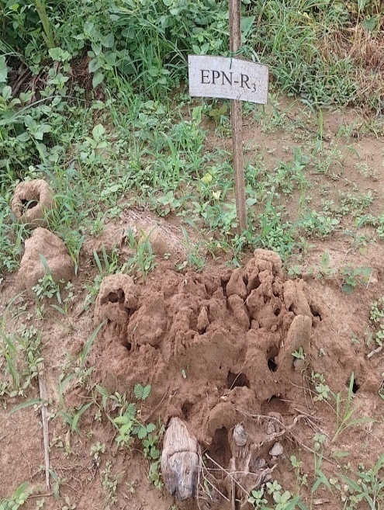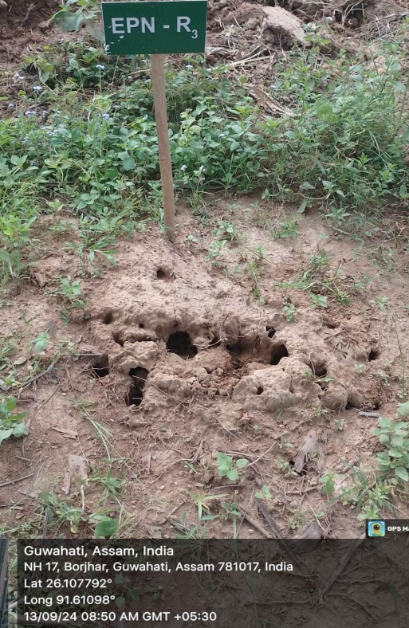
Fig.1. Termite mound after application of H.bacteriophora in AAU-HRS Kahikuchi
Table.4. Progeny production and persistence of Heterorhabditis bacteriophora and mortality per cent of Odontotermes obesus at AAU-ZRS Diphu
Treatments | Observations (Av. of 3 replications)
Treatments | Mortality (%) of caste of termites |  |  | Progeny production of nematode inside their host  (mean± SE) |  | Persistence of the nematodes in the nests  Insect mortality(%)  (Galleria mellonella)
Treatments | Worker | Soldier | Total | Worker | Soldier
T1:5.0×10⁹ IJs/mound  ( Three times ,  one month interval) | 33.3 | 27.3 | 60.6 | 1282-1590  (1478±3.65) | 1280-1580  (1460±4.72) | 45.0
T0: Control | 2.0 | 1.0 | 3.0

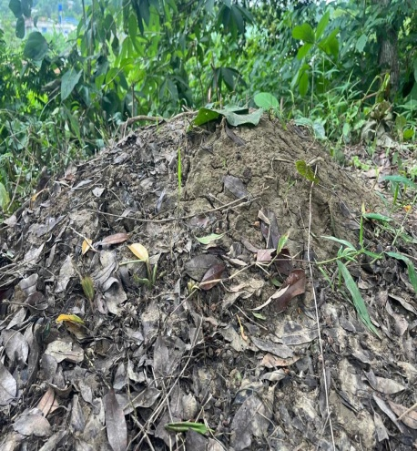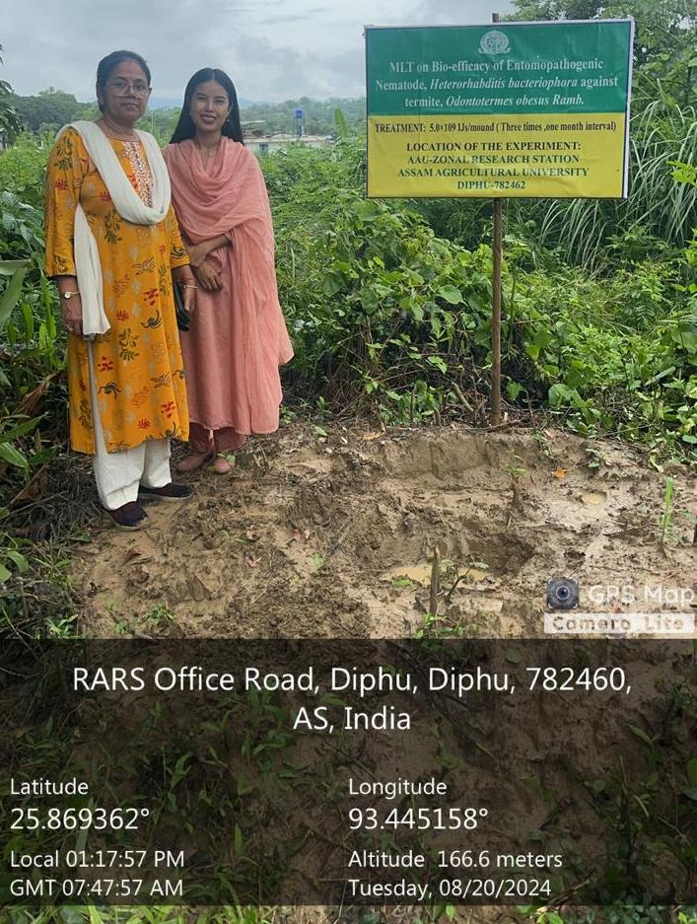
Fig.2.Termite mound after application of H.bacteriophora in Diphu

Table.5. Progeny production and persistence of Heterorhabditis bacteriophora and mortality per cent of Odontotermes obesus at AAU-SMAPRS Buralikson
Treatments | Observations (Av. of 3 replications)
Treatments | Mortality (%) of caste of termites |  |  | Progeny production of nematode inside their host  (mean± SE) |  | Persistence of the nematodes in the nests  Insect mortality(%)  (Galleria mellonella)
Treatments | Worker | Soldier | Total | Worker | Soldier
T1:5.0×10⁹ IJs/mound  ( Three times ,  one month interval) | 35.3 | 26.0 | 61.3 | 1272-1594  (1478±3.65) | 1290-1586  (1470±4.75) | 48.0
T0: Control | 2.0 | 2.0 | 4.0

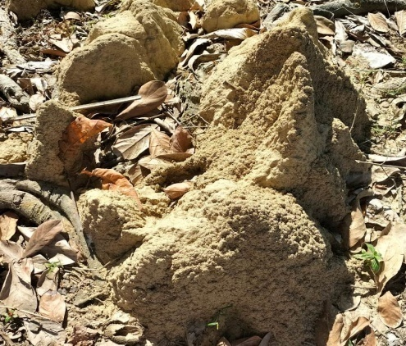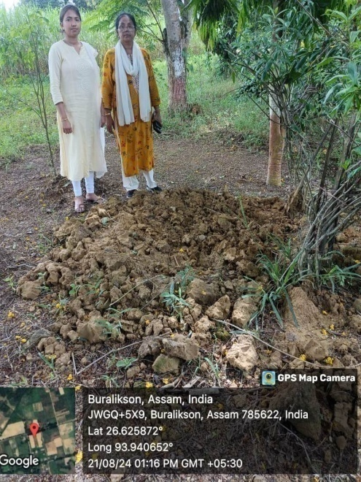
Fig.3. Termite mound after application of H.bacteriophora in AAU-SMAPRS Buralikson

