A Case report on Oculocutaneous albinism

ABSTRACT

Aims: Understanding the epidemiology, pathophysiology, clinical manifestations, causative mutations and management of oculocutaneous albinism by reporting a case of a 7-year-old child affected by this disease

Study design: Case report.

Case report: 7-year-old child presenting oculocutaneous albinism who presented for an ophthalmology consultation due to a profound decrease in visual acuity, associated with nystagmus and photophobia that had been progressing since early childhood

Discussion and literature review: We will comprehensively examine all aspects of oculocutaneous albinism by reviewing the literature on its epidemiology, pathophysiology, clinical manifestations, differential diagnosis, treatment, and prognosis.

Conclusion: Advances in molecular diagnostics have significantly enhanced the detection of causative mutations, enabling improved clinical management and genetic counseling.
Emerging therapeutic approaches, including pharmacological interventions, offer promising avenues for correcting pigmentation defects.

Key words: oculocutaneous albinism, genetic, paediatric, molecular diagnostics

1. INTRODUCTION

Oculocutaneous albinism (OCA) is a heterogeneous group of autosomal recessive diseases caused by mutations in the genes responsible for melanin biosynthesis (1).
It presents as a pattern of generalized hypopigmentation involving both skin/skin appendages and ocular manifestations (2).

Although rare, the severity of this condition lies in its predisposition to skin cancers due to increased sensitivity to UV radiation and a reserved visual functional prognosis. (3)(4)(5)
Based on the phenotypic variations and the corresponding molecular abnormalities of this condition, several forms can be defined; there are four major forms of OCA (1,2,3,4) and three minor forms of OCA (5,6,7).

Among these major forms, OCA 1 and 2 are the most common(6).
It should be noted that several unclassified forms of OCA may also occur, whose mechanisms remain to be elucidated—such as those that, in addition to skin and ocular lesions, are associated with deafness due to a lack of embryological pigmentation of the inner ear.(7)

2. CASE Presentation

The reported case concerns a 7-year-old child who presented for an ophthalmology consultation due to a profound decrease in visual acuity, associated with nystagmus and photophobia that had been progressing since early childhood and was affecting both quality of life and schooling.
History revealed parental consanguinity but no similar cases in the family. General examination revealed growth retardation, with a weight of 17 kg.
Cutaneous and mucosal examination found generalized hypopigmentation of the skin and phanera (silvery hair and eyelashes), with the presence of café-au-lait spots on the right forearm.
During the ophthalmologic examination, uncorrected visual acuity was "counts fingers at near," improving to a weak 1/10 (both eyes) with full optical correction. Refraction was +3.00(-0.50 at 180) in the right eye and +2.00(-0.57 at 170) in the left eye.
Color vision normal?? Intraocular pressure could not be measured with Goldman tonometer or air-puff due to nystagmus; therefore, digital palpation was performed and found to be normal. Examination of the anterior segment found a clear cornea, good anterior chamber, clear lens (both eyes), and a hypopigmented iris with stage II iris transillumination on slit-lamp examination.
Examination of the ocular adnexa revealed a conjugate horizontal pendular nystagmus without a rapid phase in the primary gaze, which remained horizontal when looking upward.
This nystagmus increased with lateral gaze and when the patient was presented with highly detailed images. It was dampened with near vision, with lateral head tilting (null point position), and with monocular vision; these eye movements ceased when the eyes were closed.
Examination of the lacrimal apparatus, eyelids, and conjunctivae was unremarkable.
Fundus examination found diffuse retinal hypopigmentation, predominantly at the posterior pole, with a total absence of the foveal reflex. The optic disc was pale, small, and irregular in outline, and the retina was flat. Macular OCT revealed bilateral foveal hypoplasia; in the right eye, central macular thickness was normal (229 μm) but per-foveal thickness was significantly decreased.
In the left eye, both central macular thickness (174 μm) and per-foveal thickness were decreased.
Papillary OCT showed papillary hypoplasia with atrophy of the retinal nerve fiber layer affecting the superior and inferior quadrants of the right eye.
VEP was not performed due to lack of equipment;
Complete blood count was normal for all three cell lines.
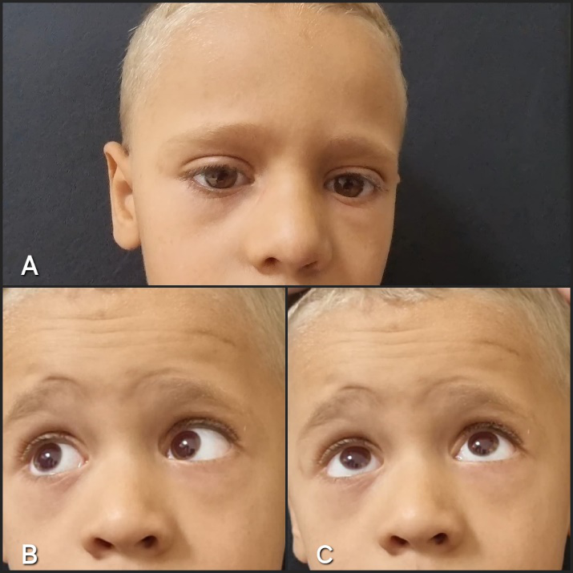
Figure 1(A,B,C): conjugate horizontal pendular nystagmus accentuated when looking upward, on lateral gaze, and when the patient is presented with highly detailed images
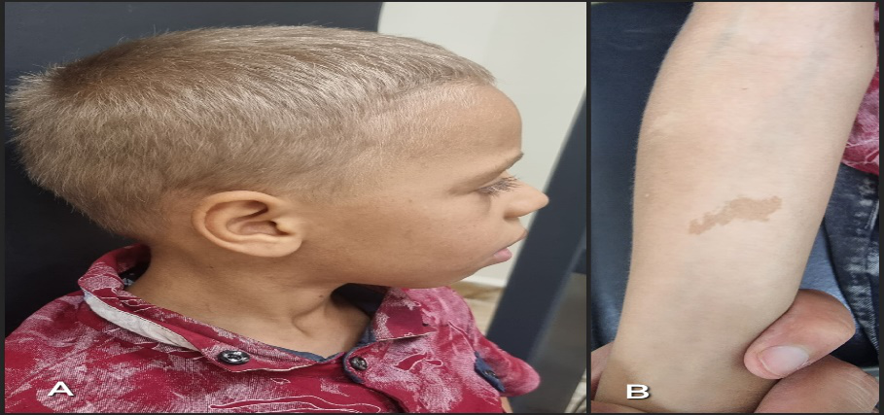
Figure 2 A: generalized hypopigmentation of the skin and phanera (silvery hair and eyelashes), B: presence of café-au-lait spots on the right forearm.
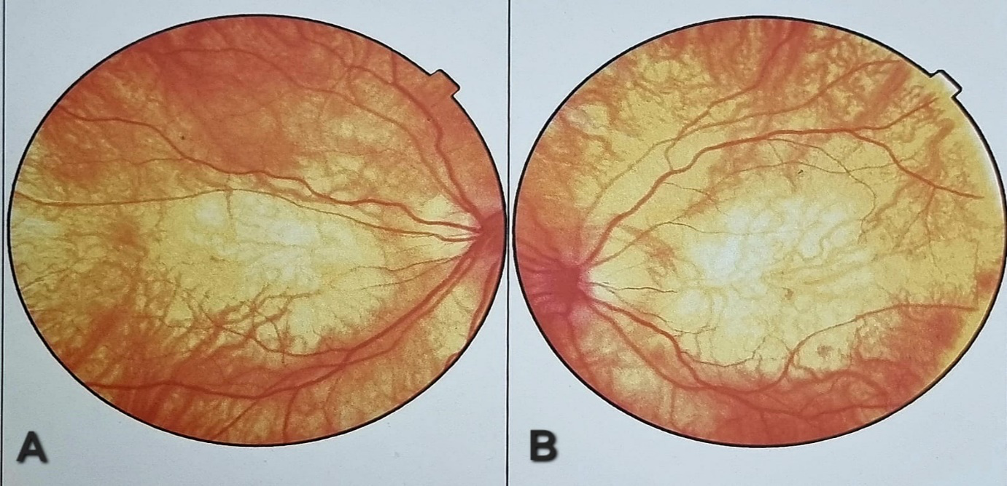 Figure 3(A,B): diffuse retinal hypopigmentation predominantly at the posterior pole with a total absence of a foveal reflex; the optic disc is pale, small, and irregular in outline

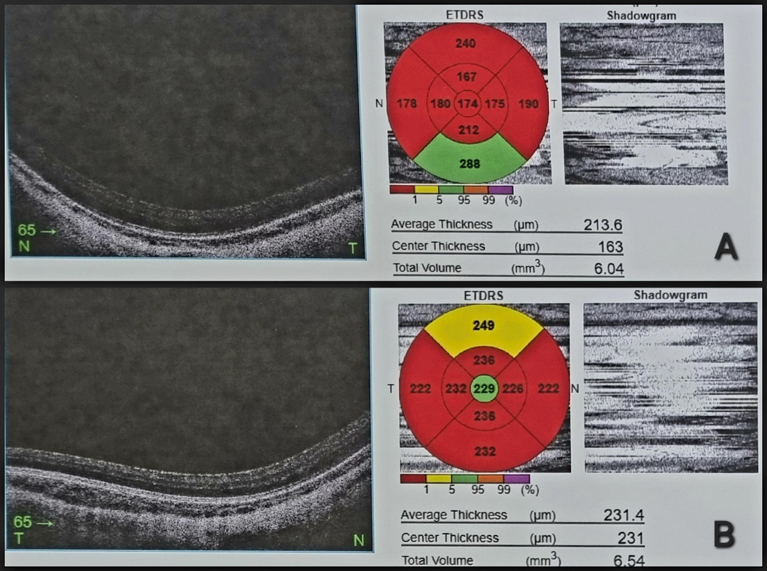
Figure 4: macular OCT showing bilateral foveal hypoplasia

3. literature review AND DIScussion

3.2 Epidemiology:

Albinism is a ubiquitous condition affecting people of all ethnic backgrounds, with an incidence of about one in 17,000 individuals regardless of the type of albinism, with a high prevalence in Africa, mainly due to increased consanguinity.
The prevalence of different forms of albinism varies considerably around the world.
Generally, two major types (OCA1 and OCA2) are the most common; however, OCA1 remains the most severe form and is characterized by a complete lack of melanin pigment in the skin, hair, and eyes, while OCA2 generally has a better prognosis because pigmentation can develop as the child grows

3.2 Physiopathology:

Albinism is attributed to a defect in the melanin synthesis pathway, resulting in reduced formation of this pigment(12).
OCA is not due to a quantitative or structural abnormality of melanocytes, but rather to defective activity of tyrosinase(13).
The four types, OCA1, OCA2, OCA3, and OCA4, are due to mutations in: tyrosinase, the OCA2 gene (formerly known as the P gene), tyrosinase-related protein (TYRP), and a membrane-associated transport protein (MATP), respectively, all of which are located at different loci.(14)(15)

3.3 Clinical manifestations:

Ocular manifestations encompass a broad spectrum of symptoms, varying in degree according to the type of OCA. Thus, commonly observed are: reduced visual acuity, generally not exceeding 2/10, high refractive errors, dyschromatopsia or even achromatopsia, congenital nystagmus, sometimes strabismus, amblyopia, and finally photophobia.(16) Iris hypopigmentation, revealed by iris transillumination, is often observed during biomicroscopic examination.(17) Fundoscopic examination may raise suspicion of foveal hypoplasia, optic nerve hypoplasia confirmed later by OCT, as well as hypopigmentation of the RPE. Sometimes, retinal vascular anomalies may be seen, such as wide outgoing angles of the optic nerve head and vessels encroaching on the central area of the macula.(18)
Increased decussation of optic fibers remains one of the disease's hallmarks, characterized by excessive crossing of temporal fibers in the optic chiasm, which can lead to a positive angle kappa, strabismus, and reduced stereoscopic vision. This abnormal crossing of fibers can be demonstrated by monocular visual evoked potentials(19). It is important to note that only the association of a positive angle kappa with congenital nystagmus should prompt the practitioner to consider and then search for other signs of OCA.
Cutaneous manifestations present as generalized hypopigmentation of the skin and skin appendages of varying intensity, manifesting in severe forms as pink skin and snow-white hair, eyelashes, and eyebrows. In milder forms, some degree of pigmentation may appear with growth, particularly in type 2 forms of oculocutaneous albinism.
This hypopigmentation results in a higher risk of skin diseases related to UV exposure, notably skin cancers(20), as well as other manifestations such as the appearance of freckles, nevi, and lentigines, whose impact is mainly aesthetic.
Certain forms associated with OCA (syndromic forms) have been described, such as HERMANSKI-PUDLAK syndrome, whose clinical picture includes signs of OCA as well as platelet storage disorders manifesting as bleeding after minor trauma(21). CHEDIAK-HIGASHI syndrome combines, in addition to the signs of oculocutaneous albinism, immunodeficiency and neurological impairment.(22)

3.4 The differential diagnosis

The differential diagnosis is made with other pathologies whose ophthalmological manifestations mimic those of non-syndromic oculocutaneous albinism and ocular albinism(23): in particular, pathologies linked to the X chromosome(24) and others with autosomal dominant and autosomal recessive transmission (Achromatopsia, Leber’s congenital amaurosis, autosomal congenital stationary night blindness, etc.)(25).

3.4 Treatment

Since it is a genetic disease, albinism remains incurable. Treatment focuses on ophthalmological and dermatological monitoring, as well as hygienic and dietary measures(8):
- Eye care: ophthalmological assessment within the first few months of life, regular ophthalmological examinations, optical correction of refractive errors to achieve optimal visual acuity and reduce the angle of strabismus, functional amblyotherapy, ocular physiotherapy, wearing tinted glasses in the case of debilitating photophobia, respecting abnormal postures that provide visual comfort, and only considering oculomotor surgery in a mature child with disabling torticollis, and finally, support for learning—with aids and special attention in the classroom (high-contrast reading materials, printed texts and worksheets, large-scale display settings on computers, among others)—which helps overcome learning difficulties associated with visual impairments.(16)
- Dermatological care: advice on the prevention of actinic lesions (photoprotection) and an annual clinical evaluation to screen for precancerous and cancerous skin lesions is recommended. Interventions such as liquid nitrogen application, topical chemotherapy, curettage, electrocautery, and surgery are performed if necessary.(20)
It should be noted that there are some potential therapies such as Nitisinone, aminoglycosides, and gene therapies, but these remain in the clinical study phase.(26)

3.4 Prognosis:

The life expectancy of the population affected by non-syndromic OCA is like that of the general population(8); however, there is an increased risk of mortality due to skin cancer. (20)
Overall, the visual prognosis remains guarded(16), in regions with economic challenges, albinism is often associated with significant stigma, resulting in discrimination, persecution, and even violence against those who have it. Sadly, some individuals with albinism have been murdered because their organs are in high demand on the black market. People with albinism have intelligence levels comparable to the general population. However, they might experience delays in visual development, which, if not promptly addressed, can lead to educational challenges. Furthermore, issues with self-esteem and social isolation can lead to feelings of loneliness and depression. There is also a higher prevalence of attention deficit disorder among those with albinism. (27)

4. Conclusion

Oculocutaneous albinism (OCA) is a genetically diverse disorder characterized by hypopigmentation of the skin, hair, and eyes, primarily due to mutations in multiple pigmentation genes (OCA1–4).
This condition substantially impairs visual function and elevates the risk of ultraviolet-induced damage, particularly in regions with high prevalence such as Africa.
Advances in molecular diagnostics have significantly enhanced the detection of causative mutations, enabling improved clinical management and genetic counseling.
Emerging therapeutic approaches, including pharmacological interventions, offer promising avenues for correcting pigmentation defects.
Continued research and the implementation of tailored public health strategies are critical to reducing the visual and dermatological complications associated with OCA and improving the quality of life for affected individuals.

Consent

All authors declare that written informed consent was obtained from the patient's family for publication of this case report and accompanying images.

Disclaimer (Artificial intelligence)
Author(s) hereby declare that generative AI technologies (PaperPal) have been used during the writing or editing of manuscripts for the translation of the paper from French to English.
No prompts were used to write the original manuscript nor the translated manuscript
Details of the AI usage are given below:
1. translation

References

- MSD Manuals. (2024). Albinism. MSD Manuals Professional Version. Retrieved from https://www.msdmanuals.com/professional/dermatologic-disorders/pigmentation-disorders/albinism

- MSD Manuals. (2024). Albinism. Topic : Symptoms and Signs of Albinism MSD Manuals Professional Version. Retrieved from https://www.msdmanuals.com/professional/dermatologic-disorders/pigmentation-disorders/albinism

- Oculocutaneous albinism - Genetics – MedlinePlus https://medlineplus.gov/genetics/condition/oculocutaneous-albinism/

- HAS / PNDS Albinisme (France) https://www.has-sante.fr/upload/docs/application/pdf/2019-10/pnds_albinisme14juillet_2019-10-11_16-18-32_87.pdf

- Atlas of Genetics & Cytogenetics / “Oculocutaneous Albinism” https://doi.org/10.4267/2042/62945

- Rapport SFO 2017 : l’Albinisme oculocutané chapitre 17 Pathologie rétinienne dégénérative et/ou héréditaire Coordonné par C. Hamel , G. Le Meur, I . Meunier, https://www.em-consulte.com/em/SFO/2017/file_10001.html

- Grønskov K, Ek J, Brondum-Nielsen K. Oculocutaneous albinism. Orphanet J Rare Dis. 2007 Nov 2;2:43. doi: 10.1186/1750-1172-2-43. PMID: 17980020; PMCID: PMC2211462.

- King RA, Creel DJ. Oculocutaneous albinism. In: Adam MP, Mirzaa GM, et al. (eds). GeneReviews®. University of Washington, Seattle; 1999-2024..

- Patricia M. Lund, Retha Gaigher, A health intervention programme for children with albinism at a special school in South Africa, Health Education Research, Volume 17, Issue 3, June 2002, Pages 365 372, https://doi.org/10.1093/her/17.3.365

- Rooryck C, Morice-Picard F, Elçioglu NH, Lacombe D, Taieb A, Arveiler B. Molecular diagnosis of oculocutaneous albinism: new mutations in the OCA1–4 genes and practical aspects. Pigment Cell Melanoma Res. 2008;21(5):583-587. https://doi.org/10.1111/j.1755-148X.2008.00496.x

- Thomas MG, Zippin J, Brooks BP. Oculocutaneous Albinism and Ocular Albinism Overview. 2023 Apr 13. In: Adam MP, Bick S, Mirzaa GM, et al., editors. GeneReviews® [Internet]. Seattle (WA): University of Washington, Seattle; 1993-2025. Available from: https://www.ncbi.nlm.nih.gov/books/NBK590568/

- Oetting WS, King RA. Molecular basis of albinism: mutations and polymorphisms of pigmentation genes associated with albinism. Hum Mutat. 1999;13(2):99-115. https://doi.org/10.1002/(SICI)1098-1004(1999)13:2%3C99::AID-HUMU2%3E3.0.CO;2-C

- King RA, Pietsch J, Fryer JP, Savage S, Brott MJ, Russell-Eggitt I, Summers CG, Oetting WS. Tyrosinase gene mutations in oculocutaneous albinism 1 (OCA1): definition of the phenotype. Hum Genet. 2003;113(6):502-513. https://doi.org/10.1007/s00439-003-0998-1

- Grønskov K, Ek J, Brondum-Nielsen K. Oculocutaneous albinism. Orphanet J Rare Dis. 2007;2:43. https://doi.org/10.1186/1750-1172-2-43

- Rooryck C, Morice-Picard F, Elçioglu NH, Lacombe D, Taieb A, Arveiler B. Molecular diagnosis of oculocutaneous albinism: new mutations in the OCA1–4 genes and practical aspects. Pigment Cell Melanoma Res. 2008;21(5):583-587. https://doi.org/10.1111/j.1755-148X.2008.00496.x

- Summers CG. Albinism: classification, clinical characteristics, and recent findings. Optom Vis Sci. 2009;86(6):659-662. https://doi.org/10.1097/OPX.0b013e3181a5254c

- Fulton, A. B., & Yang, P. (2022). Visual Impairment in infants and young children. In Albert and Jakobiec's Principles and Practice of Ophthalmology (pp. 6691-6714). Cham: Springer International Publishing.

- McCafferty BK, Wilk MA, McAllister JT, Stepien KE, Dubis AM, Summers CG, Carroll J. Clinical insights into foveal morphology in albinism. J Pediatr Ophthalmol Strabismus. 2015;52(3):167-172. https://doi.org/10.3928/01913913-20150427-06

- Hoffmann MB, Tolhurst DJ, Moore AT, Morland AB. Organization of the visual cortex in human albinism. J Neurosci. 2003;23(26):8921-8930. https://doi.org/10.1523/JNEUROSCI.23-26-08921.2003
- Lund PM, Taylor JS. Lack of adequate sun protection for children with oculocutaneous albinism in South Africa. BMC Public Health. 2008;8:225. https://doi.org/10.1186/1471-2458-8-225

- Huizing M, Malicdan MC, Wang JA, Pri-Chen H, Hess RA, Fischer R, Gahl WA. Hermansky-Pudlak syndrome: Mutation update. Hum Mutat. 2020;41(3):543-580 https://doi.org/10.1002/humu.23968

- Introne W, Boissy RE, Gahl WA. Clinical, molecular, and cell biological aspects of Chediak-Higashi syndrome. Mol Genet Metab. 1999;68(2):283-303. https://doi.org/10.1006/mgme.1999.2927

- Scheinfeld, Noah S. "Syndromic albinism: a review of genetics and phenotypes." Dermatology Online Journal 9.5 (2003). https://doi.org/10.5070/D30fb7f671

- Charles SJ, Green JS, Grant JW, Yates JR, Moore AT. Clinical features of affected males with X linked ocular albinism. Br J Ophthalmol. 1993;77(4):222-227. https://doi.org/10.1136/bjo.77.4.222

- Federico JR, Krishnamurthy K. Albinism. [Updated 2023 Aug 14]. In: StatPearls [Internet]. Treasure Island (FL): StatPearls Publishing; 2025 Jan-. Available from: https://www.ncbi.nlm.nih.gov/books/NBK519018/

- Onojafe IF, Adams DR, Simeonov DR, Zhang J, Chan CC, Bernardini IM, Brilliant MH, et al. Nitisinone improves eye and skin pigmentation defects in a mouse model of oculocutaneous albinism. J Clin Invest. 2011;121(10):3914-3923. https://doi.org/10.1172/JCI59372

- Thomas MG, Zippin J, Brooks BP. Oculocutaneous Albinism and Ocular Albinism Overview. 2023 Apr 13. In: Adam MP, Bick S, Mirzaa GM, et al., editors. GeneReviews® [Internet]. Seattle (WA): University of Washington, Seattle; 1993-2025. Available from: https://www.ncbi.nlm.nih.gov/books/NBK590568/

