Climate-Vegetation-Fire Interactions in Guinea: A Remote Sensing Perspective

ABSTRACT
Guinea republic is characterized by a wide range of climates from humid coastal zones to savannas and forest massifs, with ecosystems whose dynamics are closely linked to rainfall variability. This study aims to integrate satellite-based rainfall (CHIRPS), vegetation dynamics (MODIS NDVI), and fire occurrence (AVHRR-LTDR burned area) to investigate climate–vegetation–fire interactions in Guinea, a region characterized by limited ground-based observations. The datasets considered were recorded during 2010-2018 period. To reach the goals the seasonal climatology, standardized anomalies, and correlation analysis were adopted. The results reveal a marked seasonal cycle: fires peak during the dry season when rainfall and NDVI are low, while the wet season promotes vegetation regrowth and reduces fires. A lag between rainfall peaks and the NDVI response was observed, attributable to cloud cover and soil moisture storage. Over the interannual period (2010-2018), NDVI shows a significant upward trend, fires decrease slightly, and rainfall shows no clear trend. Correlations between rainfall, vegetation, and fires are weak to moderate, suggesting the complementary influence of anthropogenic factors. This study highlights the importance of satellite data for monitoring Guinean ecosystems and demonstrates that rainfall variability plays a central role in vegetation dynamics and fire occurrence. Overall, it provides an initial quantitative framework for ecosystem monitoring and fire-risk assessment using remote sensing. The findings of the research may be helpful for decision-makers of the region for doing the needful to prioritize safeguarding of natural resources related to vegetation and forest under climate change effects.

Key words: NDVI, MODDIS, CHIRPS, Rainfall, wildfires, climate dynamics, Guinea

- INTRODUCTION
Guinea, located in West Africa, exhibits a wide range of climates and ecosystems, from the humid coastal zone to the Sudanian-Guinean savanna and the southeastern forest massifs (Barry et al., 2018). This spatio-temporal variability of rainfall affects strongly environmental processes and ecosystem dynamics. As demonstrated in West Africa by several studies, rainfall variations directly determine water availability, biomass growth, and the sensitivity of landscapes to hydrological disturbances (Nicholson, 2013; Sylla et al., 2018). This is particularly true in Guinea, where the marked rainfall gradients between the humid Lower Guinea and the drier Upper Guinea play a crucial role in shaping ecosystems.
NDVI data is argued as a key indicator of how vegetation responds to climate fluctuations (Meena et al., 2021; Arpitha et al., 2024). NDVI is generally used to assess plant vigor, vegetation density, and photosynthetic activity, which are directly related to water availability and climatic seasons (Kueshi et al., 2023; Anyamba and Tucker, 2012). In Guinea, the vegetation density is clearly related to seasons as follows: strong vegetative activity during the monsoon and a weakening during the dry season, particularly pronounced in savanna areas. Thus, understanding the interactions between rainfall and vegetation status is essential for assessing the resilience of ecosystems to climate disturbances. Furthermore, in West Africa, wildfires or widespread represent another major driver of ecosystem transformation. They result from a combination of climatic conditions, biomass availability, and human practices such as agricultural slash-and-burn (Archibald et al., 2013; Giglio et al., 2018). In Guinea, fires are particularly frequent during the dry season, when desiccated vegetation becomes highly flammable. Savanna regions, such as Upper and Middle Guinea, are the most affected by this situation, which impacts ecological regeneration and sometimes contributes to soil degradation (Joseph, 2024). Therefore, understanding the relationship between moisture, biomass, and fire occurrence is therefore a strategic challenge for the sustainable management of natural resources.

To better understand Guinea's hydro-ecological dynamics within a climate change context the coupling of rainfall, vegetation, and fire in a single analysis is necessary. Ground-based climatological data remain limited in Guinea due to the small number of operational meteorological stations and temporal discontinuities in the datasets. Thus, the integration of satellite products such as CHIRPS for rainfall (Funk et al., 2015), MODIS for NDVI (Didan, 2015), and MCD64A1 for fires (Giglio et al., 2020; Elias 2024) offers a unique opportunity to obtain a comprehensive, continuous, and objective view of ecosystem evolution. This multi-source approach is necessary to characterize the relationships between climate, vegetation, and fires, identify vulnerable areas, and provide essential information for environmental management, land-use planning, and natural hazard reduction in Guinea. Thus, this study aims to integrate satellite-based rainfall (CHIRPS), vegetation dynamics (MODIS NDVI), and fire occurrence (AVHRR-LTDR burned area) to investigate climate–vegetation–fire interactions in Guinea, a region characterized by limited ground-based observations. The study data and methods will be explained in the next section, which will be followed by the presentation of the results and a discussion. Finally, the conclusions and suggesting avenues for future research will be highlighted.
- MATERIALS AND METHODS
MATERIALS
STUDY AREA DESCRIPTION
Guinea, located in West Africa along the Atlantic coast, is bordered by Guinea-Bissau, Senegal, Mali, Côte d'Ivoire, Liberia, and Sierra Leone. Its strategic geographic position gives the country a notable climatic and ecological diversity. Extending approximately between 7°N and 13°N latitude and 7°W and 15°W longitude, Guinea's territory has a length that allows for significant variations in climatic conditions, from the coast to the interior (Figure 1). Guinea is subdivided into four major natural regions: Lower Guinea, Middle Guinea, Upper Guinea, and Forest Guinea. The map shows these regions using distinct colors: light blue for Lower Guinea, yellow for Middle Guinea, brown for Upper Guinea, and green for Forest Guinea (Figure 1). This organization reflects both administrative distinctions and significant geographical, climatic, and ecological variations. According to Diallo (2018), “the territorial divisions in Guinea allow for better management of natural resources and facilitate the study of climate-environment interactions”. Lower Guinea, along the Atlantic coast, is characterized by plains and a humid climate, while Middle Guinea, in the center, consists of plateaus with moderate relief. Upper Guinea, in the east, features savannas and high plateaus with a drier climate, while Forest Guinea, in the southeast, is dominated by dense forests and a humid equatorial climate. These regional variations strongly influence rainfall distribution, vegetation cover, and agricultural activities. As argued by Diallo (2018), “the diversity of Guinean landscapes is intimately linked to climatic variations and local agricultural potential”.
Regional distinctions are crucial for planning development, managing natural resources, and organizing agriculture and environmental conservation. According to Keita (2017), "a detailed knowledge of Guinean territory is essential for guiding sustainable development and resource management policies."

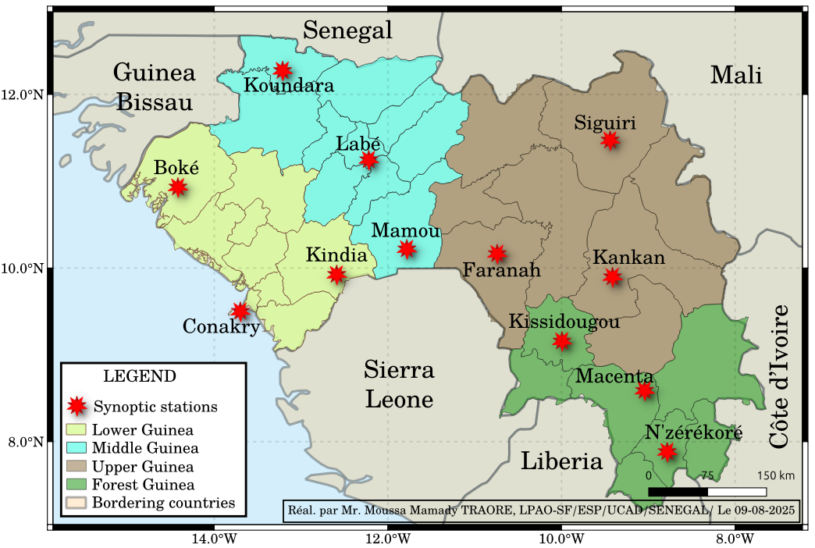
Fig. 1. Map of the Guinea republic
DATA AND DATA DESCRIPTION
In this work, the following datasets were used:
CHIRPS RAINFALL DATA
CHIRPS (Climate Hazards Group InfraRed Precipitation with Station data) product, version 2.0, with a spatial resolution of 0.05° (approximately 5 km), mainly the daily precipitation data was used. This dataset covers the period from 1981 to the present and combines in-situ observations with infrared satellite data and climatological reanalysis to produce reliable global precipitation estimates. CHIRPS is particularly valued for monitoring precipitation in tropical regions with low meteorological station density, such as sub-Saharan Africa. In West Africa, where meteorological observations are often limited or discontinuous, CHIRPS provides a robust alternative for studying rainfall trends, characterizing extreme events, or assessing interannual and seasonal variability in rainfall (Funk et al., 2015).

AVHRR OBSERVATIONS: VEGETATION FIRES (AVHRR-LTDR BURNED AREA GRID V1.1)
The ESA Fire_cci project's AVHRR-LTDR Burned Area Grid v1.1 dataset provides monthly information on burned areas worldwide from 2010 to 2018 (0.25° × 0.25° resolution). The data, in NetCDF format, include burned area, standard error, and the fraction of burnable and observed area. They are derived from daily AVHRR observations and processed using spectral indices and a random forest model calibrated to NASA's MCD64A1 product. This dataset is intended for studying fire trends, ecological and climate modeling, and assessing impacts on ecosystems.
NORMALIZED DIFFERENCE VEGETATION INDEX (NDVI)
The NDVI is a widely used indicator for assessing the state and dynamics of vegetation using satellite data (Dagnachew et al., 2020). It is calculated from near-infrared (NIR) and red (RED) reflectance using the following formula:

$NDVI=\frac{NIR-RED}{NIR+RED}$ (1)

where NIR denotes reflectance in the near-infrared and RED reflectance in the visible red (Tucker, 1979). NDVI values ​​vary between -1 and +1: values ​​close to zero or negative indicate non-vegetated surfaces (water, clouds, bare soil), while high positive values ​​reflect dense and active vegetation.
In this study, NDVI data is extracted from MODIS (Moderate Resolution Imaging Spectroradiometer) products, available at a spatial resolution of 250 m and a temporal frequency of 16 days (Didan, 2015). The period covered extends from 2010 to 2018, allowing the analysis of interannual and seasonal variability in vegetation cover in Guinea. The integration of the wildfire, NDVI, and rainfall datasets enables the precise analysis of regional climate dynamics, particularly in climate-prone areas such as Guinea.

METHODS
MONTHLY CLIMATOLOGY
Monthly climatological averages over a nine-year period for each of the studied climatic parameters, namely NDVI, rainfall, and wildfires are computed. These averages served as the basis for constructing seasonal climatological graphs to represent the annual cycles of each parameter. This analysis facilitates the identification of the main local climatic seasons as well as periods of overlap or lag between bushfire activity, NDVI evolution, and atmospheric humidity. This approach provides a deeper understanding of the climatic factors controlling the seasonal variability of NDVI and rainfall.
INTERANNUAL ANALYSIS
The interannual analysis was performed by calculating, for each year, the annual precipitation as well as the annual means of NDVI and wildfires. The resulting time series were then standardized by calculating standardized anomalies (Z-scores), according to the formula:
$Z=\frac{X-μ}{σ}$ (2)
where X is the annual value, μ the mean, and σ the standard deviation over the period. These anomalies were represented as bar charts to facilitate visual interpretation.
To assess the evolution of climatic parameters over time, a trend analysis was performed using a simple linear regression of the type Y = aX + b, where Y represents the studied variable (standardized anomaly) and X the corresponding year. The slope obtained is used to estimate the direction and intensity of the trend, while the statistical significancy was tested by the p value through student’s t test (with a significance threshold of 5%).
CORRELATION ANALYSIS
To examine the relationships between the different climatic variables the correlation analysis was performed by using Pearson's correlation coefficients. Three pairs of the studied variables were analyzed: thermal interactions, NDVI, and rainfall in the studied context. The statistical was then assessed using the p-value, with a threshold of 0.05.
- RESULTS AND DISCUSSION
RESULTS
MONTHLY CLIMATOLOGY
Figure 2 indicates a highly contrasting seasonal dynamic between rainfall (CHIRPS), vegetation activity (NDVI), and biomass fires. At the beginning of the year (January-February), low rainfall is accompanied by high fire activity and a low NDVI. These conditions reflect a dry environment that promotes vegetation flammability and limits its growth. With the arrival of the first rains during March and April, soil moisture increases rapidly, leading to a marked decrease in vegetation fires. Simultaneously, the NDVI stabilizes and then begins a slight increase, indicating a gradual resumption of photosynthesis and biomass.
July-August is identified as the "heart of the season" because this period coincides with the maximum rainfall. Abundant precipitation creates favorable water conditions for vegetation development, although the NDVI response shows a slight lag. Indeed, a minimum NDVI is observed during this period despite the rainfall peak, which can be explained by heavy cloud cover limiting photosynthetically active radiation, or by nutrient leaching due to intense rainfall. This phase shifting between rainfall and plant response is characteristic of tropical environments, where vegetation reacts more to cumulative soil moisture than to instantaneous rainfall. At the end of the wet season (September-October), the decrease in rainfall leads to a drop in soil moisture. The vegetation, having accumulated biomass during the preceding months, then reaches its maximum NDVI values. When the dry season returns (November–December), the drying of the biomass promotes the resumption of wildfires. This transition period shows a simultaneous increase in NDVI (reflecting the remaining biomass) and fires, with a direct consequence of the decrease in moisture. In January, when conditions become extremely dry, the fires again reach their maximum intensity, marking the beginning of a new seasonal cycle.
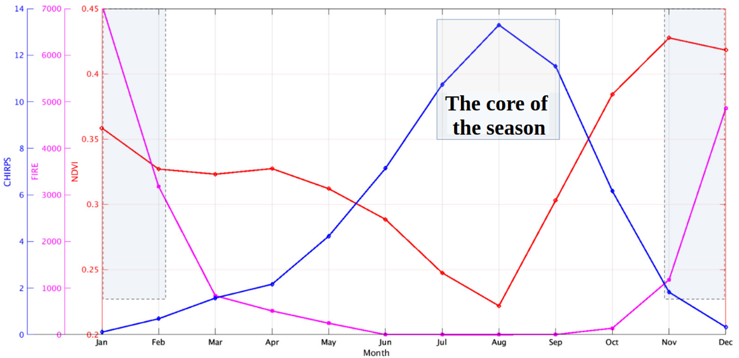
Fig. 2. Monthly climatology of climatic parameters over the period 2010-2018, including precipitation (CHIRPS, in blue), vegetation activity (NDVI, in red) and the occurrence of biomass fires (magenta curve)

STANDARDIZED ANOMALIES OF CLIMATE VARIABLES
Figure 3 presents the interannual anomalies in Guinea over the period 2010-2018 of the NDVI, burned area (ISSB) and standardized rainfall (IPS). Figure 3a shows the standardized anomalies of the NDVI
in Guinea between 2010 and 2018. Red bars represent below-average values, indicating less dense or stressed vegetation, while blue bars indicate more abundant than normal vegetation. The black dashed line trend is positive (Trend = 0.3019) with a p-value of 0.0476, meaning that the observed increase is statistically significant at the 5% level. Vegetation in Guinea showed a slight overall improvement over the study period, despite significant interannual variations.
Figure 3b shows the anomalies in the burned area (ISSB). Magenta bars represent burned areas above normal, and cyan bars represent burned areas below normal. The overall trend is negative (Trend = -0.2510), but with a p-value of 0.1753, thus, the decrease is not statistically significant. Therefore, there are no significant year-to-year variations, with burning peaks in 2013 and a sharp decrease in 2018, likely reflecting changes in agricultural practices or local climatic conditions. Figure 3c illustrates the standardized precipitation anomalies (SPAs). Green bars represent above-average precipitation, and red bars represent below-average precipitation. The linear trend is very weak and negative (Trend = -0.0186) with a p-value of 0.7545, indicating that precipitation did not show significant variation over the study period. The anomalies are therefore dominated by interannual fluctuations, notably droughts in 2011, 2013, and 2015, and surpluses in 2012 and 2017.
The combined analysis of these three panels suggests that vegetation (NDVI) in Guinea has increased slightly despite variability in rainfall and burning. The weak correlation between rainfall anomalies and burned area indicates that other factors, such as land management, land use, and agricultural practices, strongly influence vegetation status. Finally, the significant interannual variations show that ecological dynamics in Guinea are sensitive to specific events such as droughts, excess rainfall, and fires, highlighting the importance of regular monitoring and appropriate environmental management measures.
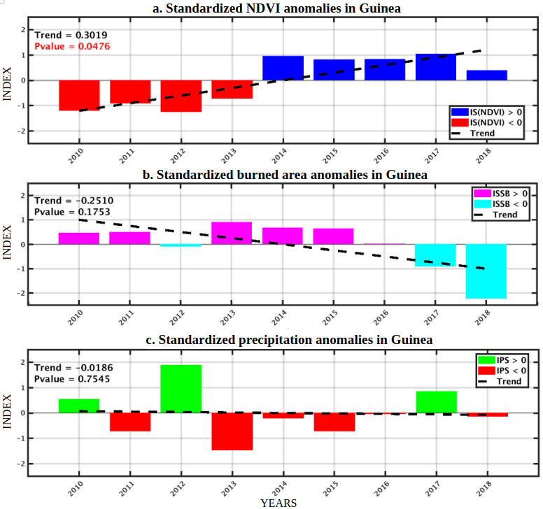
Fig. 3. Interannual anomalies in Guinea over the period 2010-2018 of the NDVI (Normalized Difference Vegetation Index), burned area (ISSB) and standardized rainfall (IPS).
CORRELATION BETWEEN RAINFALL, BUSHFIRES, AND NDVI
Figure 4 presents a correlation matrix and histograms showing the relationships between three variables: burned area (FIRE), rainfall (PRECIP), and the NDVI vegetation index in Guinea. The histograms on the diagonal show the distribution of each variable. The burned area varies mainly around 4000-4500 units, rainfall is concentrated around 0.65-0.75 (normalized values), and the NDVI is between 0.32 and 0.45, indicating moderately dense vegetation over the study period. The scatter plots in the off-diagonal cells show the pairwise relationships with a linear regression line. The correlation between FIRE and PRECIP is negative (-0.34), indicating that higher rainfall is associated with a reduction in burned area, which is consistent with the inhibitory effect of humidity on fires (Figure 4). The correlation between FIRE and NDVI is also negative (-0.29), suggesting that areas with more burning tend to have less dense vegetation. Finally, the correlation between PRECIP and NDVI is moderately negative (-0.20), which may reflect complex interactions where extreme rainfall does not necessarily lead to a high NDVI, due to other limiting factors such as land management or burning.
Overall, these results show that vegetation dynamics in Guinea are strongly influenced by burned area and, to a lesser extent, by rainfall. The negative correlations highlight that agricultural slash-and-burn practices or natural fires have a direct impact on vegetation density (Figure 4). Furthermore, the weak correlation between PRECIP and NDVI suggests that rainfall alone is insufficient to explain vegetation variability; the interactions between climate and human activities must be considered. This finding is essential for the sustainable management of ecosystems and fire risk prevention in Guinea.

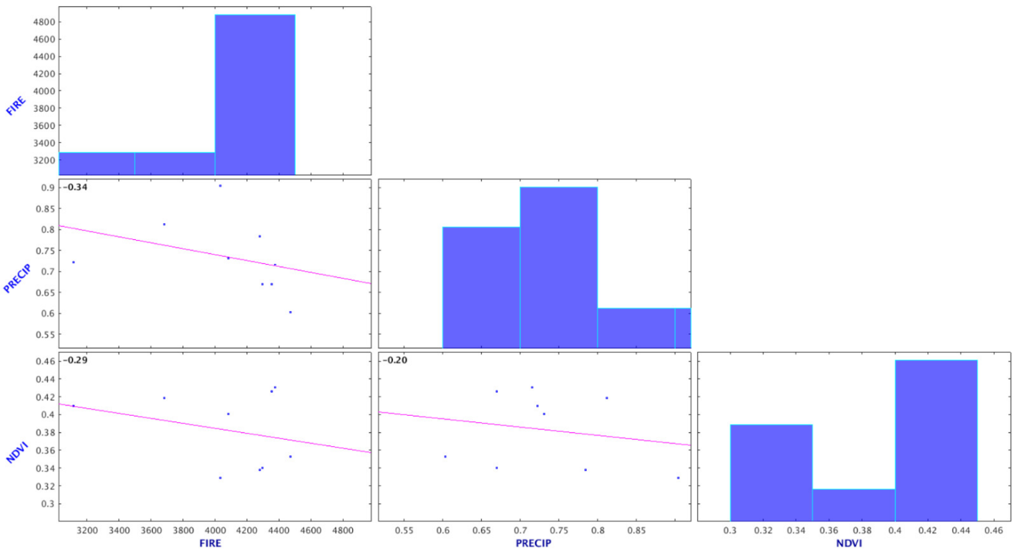

Figure 4 : Correlations between NDVI (Normalized Difference Vegetation Index), burned area (FIRE) and standardized rainfall (PRECIP) in Guinea over the period 2010-2018.
Discussion
The monthly climatological results highlight a strong seasonal dynamic structured by the alternation between dry and wet seasons, characteristic of tropical environments in West Africa. The observed correlation between increased rainfall and decreased vegetation fires confirms the crucial role of humidity in limiting biomass flammability, consistent with the work of Giglio et al. (2018) and Bowman et al. (2009), which emphasizes the sensitivity of savanna fires to hydrometeorological variations. The observed lag between the rainfall peak and the later NDVI response also corresponds to the observations of Tucker et al. (2005) and Nicholson (2013), according to whom vegetation reacts more strongly to cumulative soil moisture than to instantaneous rainfall. This ecological inertia reflects the importance of water recharge, light availability, and biophysical processes related to plant growth.
Documented interannual variability shows a significant increase in NDVI during the period 2010-2018, despite the absence of a significant trend in rainfall. This result is consistent with the findings of Anyamba and Tucker (2005), which highlighted a progressive improvement in Sahelian vegetation despite rainfall patterns marked by high variability. This partial dissociation between NDVI and rainfall suggests that other factors (such as land-use changes, agricultural practices, or socio-environmental dynamics) influence biomass production in Guinea. Furthermore, the non-significant decrease in burned areas can be explained by local adjustments in fire management, as observed in the Guinean savannas by Laris (2011), where the frequency and intensity of burning vary according to agricultural and pastoral practices. Thus, the combination of climatic variations and anthropogenic dynamics appears to structure the country's recent ecological trajectory.
Correlation analyses confirm that burned area is a major factor influencing vegetation dynamics, as shown by the negative relationships between FIRE–NDVI and FIRE–PRECIP. These results are consistent with the observations of Archibald et al. (2010), which found that savanna fires play a crucial role in controlling biomass and plant regeneration cycles. The weak relationship between rainfall and NDVI, while counterintuitive, reflects the complexity of tropical ecosystems where water availability, human pressure, and vegetation cover structure interact simultaneously (Nicholson, 2018). This confirms that rainfall is only one factor among others in explaining the spatial and temporal variability of vegetation in Guinea. In this context, understanding the interactions between climate, fire, and biomass dynamics appears essential for better anticipating environmental risks, improving sustainable landscape management, and guiding fire prevention policies.
- CONCLUSION
This research work aimed to integrate satellite-based rainfall (CHIRPS), vegetation dynamics (MODIS NDVI), and fire occurrence (AVHRR-LTDR burned area) to investigate climate–vegetation–fire interactions in Guinea, a region characterized by limited ground-based observations. From this work, the following conclusions can be drawn: (1) seasonal dynamics in Guinea are strongly structured by the alternation between dry and wet seasons; (2) rainfall, NDVI, and biomass fires follow a coherent annual cycle in which increased humidity progressively reduces fires and promotes vegetation growth. The observed lag between peak rainfall and the maximum NDVI response underscores the fundamental role of soil moisture and cumulative environmental conditions in biomass growth. This dynamic confirms that eco-climatic processes are expressed according to vegetation-specific inertias, independent of instantaneous rainfall variability; (3) Interannual analysis reveals a gradual improvement in vegetation despite significant fluctuations in rainfall and burned areas. The low rainfall trend indicates that other factors, particularly land use and local practices, strongly influence ecological dynamics. Negative correlations between fires and vegetation confirm that fires remain a determining factor in the spatial distribution of vegetation cover. (4) These results highlight the complex interactions between climate, biomass, and human pressures, and underscore the need for continuous monitoring of these variables to better understand the evolution of Guinean ecosystems. Overall, the use of seasonal climatology, standardized anomalies, and correlation analysis provides an initial quantitative framework for ecosystem monitoring and fire-risk assessment using remote sensing. The findings particularly the concentration of fires during the dry season, the delayed NDVI response to rainfall, and the indication of anthropogenic influences offer practical insights for landscape management and climate-related disaster mitigation.
One of the limitations of this study is the use of standard methods to assess the relationship between climate and natural system variables, which are assumed to be governed by nonlinear processes. This is why our future work should focus on the using of the fractal theories for a more detailed analysis of the interactions between climate, vegetation, and human dynamics by integrating more detailed spatial data and multi-scale approaches. Moreover, the use of sophisticated predictive models as machine learning or deep learning to predict climate–vegetation–fire interactions in Guinea will be investigated deeply for a better understanding of the mechanisms that control biomass and fire variability.
Disclaimer (Artificial intelligence)
Option 1:
Author(s) hereby declare that NO generative AI technologies such as Large Language Models (ChatGPT, COPILOT, etc.) and text-to-image generators have been used during the writing or editing of this manuscript.
Option 2:
Author(s) hereby declare that generative AI technologies such as Large Language Models, etc. have been used during the writing or editing of manuscripts. This explanation will include the name, version, model, and source of the generative AI technology and as well as all input prompts provided to the generative AI technology
Details of the AI usage are given below:
1.
2.
3.

REFERENCES
- Anyamba, A., & Tucker, C.J. (2012). Analysis of NDVI and Vegetation Dynamics in Africa. Remote Sensing of Environment.
- Anyamba; A., Tucker, C.J, (2005). Analysis of Sahelian vegetation dynamics using NOAA-AVHRR NDVI data from 1981 to 2003. Journal of Arid Environments 63(3):596-614DOI:10.1016/j.jaridenv.2005.03.007
- Archibald, S., et al. (2013). Defining pyromes and global syndromes of fire regimes. PNAS.
- ARCHIBALD, Sally, SCHOLES, Robert J., ROY, David P., et al. Southern African fire regimes as revealed by remote sensing. International Journal of Wildland Fire, 2010, vol. 19, no 7, p. 861-878.
- Arpitha, G.A., Choodarathnakara, A.L. & Sinchana, G.S (2024). Landslides: A Review from the Southern Western Ghats of India. Jour. Geol. Soc. India (2024) 100 (10) : 1443-1456 https://doi.org/10.17491/jgsi/2024/173999
- Barry M. B., D. Badiane, M. Diakhaté, S. M. Sall, H. Senghor and T. N. Millimono (2018). Variability and predictability of bush fire in Guinea on inter-annual and multi-year timescales based on NDVIMODIS datasets analysis. African Journal of Environmental Science and Technology. Vol. 12(12), pp. 514-522, December 2018. DOI: 10.5897/AJEST2018.2562
- Dagnachew, M., Kebede, A., Moges, A. & Abebe, A. (2020). Effects of climate variability on normalized difference vegetation index (NDVI) in the Gojeb River catchment, Omo-Gibe Basin, Ethiopia. Adv. Meteorol. 2020, 8263246. https://doi.org/10.1155/
- Diallo, F. B. (2018). Simulations multi-échelles de la saisonnalité des vagues de chaleur et des pluies de mousson en Afrique de l'Ouest (Doctoral dissertation, Sorbonne Université).
- Didan, K. (2015). MOD13Q1 MODIS Vegetation Index Product User Guide.
- Elias Nkiaka, Gloria Chinwendu Okafor. Changesin climate, vegetation coverand vegetation composition affect runoff generation in the Gulfof Guinea Basin.. Hydrological Processes. 2024; 38(3), e15124. https://doi.org/10.1002/hyp.15124
- Funk, C., et al. (2015). The Climate Hazards Infrared Precipitation with Stations (CHIRPS). Scientific Data.
- Giglio, L., Boschetti, L., Roy, D. P., Humber, M. L., & Justice, C. O. (2018). The Collection 6 MODIS burned area mapping algorithm. Remote Sensing of Environment. Volume 217, , Pages 72-85. https://doi.org/10.1016/j.rse.2018.08.005
- Giglio, L., et al. (2018). Active fire and burned area detection from MODIS. Remote Sensing of Environment.
- Giglio, L., et al. (2020). MCD64A1 Burned Area Product User Guide.
- Herrmann, S. M., Anyamba, A., & Tucker, C. J. (2005). Recent trends in vegetation dynamics in the African Sahel and their relationship to climate. Global Environmental Change. Volume 15, Issue 4, December 2005, Pages 394-404. https://doi.org/10.1016/j.gloenvcha.2005.08.004
- Joseph O. Ogutu, Gundula S. Bartzke, Sabyasachi Mukhopadhyay, Holly T. Dublin, Jully S. Senteu, David Gikungu, Isaiah Obara, Hans-Peter Piepho. Trends and cycles in rainfall, temperature, NDVI, IOD and SOI in the Mara-Serengeti: Insights for biodiversity conservation. PLOS CLIMATE. Published: October 2, 2024. https://doi.org/10.1371/journal.pclm.0000388
- Keita, M. M., Taverne, B., Sy Savané, S., March, L., Doukoure, M., Sow, M. S., ... & Delaporte, E. (2017). Depressive symptoms among survivors of Ebola virus disease in Conakry (Guinea): preliminary results of the PostEboGui cohort. BMC psychiatry, 17(1), 127.
- Kueshi S., D., Raymond A. K., Rikiatu H., Mohammed Y. Said, Md. Mijanur Rahman (2023). Towards understanding the environmental and climatic changes and its contribution to the spread of wildfires in Ghana using remote sensing tools and machine learning. International Journal of Digital Earth Volume 16, - Issue 1. https://doi.org/10.1080/17538947.2023.2197263
- Laris, P. (2011). Humanizing Savanna Fire Regimes: Transitioning from Fire-Resistant to Fire-Sensitive Landscapes in West Africa. The Professional Geographer. September 2011Annals of the Association of American Geographers 101(5):1067-1088DOI:10.1080/00045608.2011.560063
- Meena, S.R., Ghorbanzadeh, O., van Westen, C.J., Nachappa, T. G., Blaschke, T., Singh, R.P. & Sarkar, R. (2021). Rapid mapping of landslides in the Western Ghats (India) triggered by 2018 extreme monsoon rainfall using a deep learning approach. Landslides, v.18(5), pp.1937–1950. https://doi.org/10.1007/s10346-020-01602-4.
- Nicholson S.E. (2013) The West African Sahel: A Review of Recent Studies on the Rainfall Regime and Its Interannual Variability. ISRN Meteorology, 2013, Article ID: 453521.https://doi.org/10.1155/2013/453521
- Sharon E. Nicholson. The West African Sahel: A Review of Recent Studies on theRainfall Regime and Its Interannual Variability. Hindawi Publishing Volume 2013, Article ID 453521, 32 pageshttp://dx.doi.org/10.1155/2013/453521
- Sylla M.B., Jeremy S. Pal , Aissatou Faye, Kangbeni Dimobe & Harald Kunstmann (2018). Climate change to severely impact West African basin scale irrigation in 2°C and 1.5°C global warming scenarios. SCIENTIFIC RePortS, 8:1439, DOI:10.1038/s41598-018-32736-0
- Sylla, M.B., et al. (2016). Climate change over West Africa: impact on rainfall and temperature extremes. Climate Dynamics.

