Original Research Article

Integrated FR - WOE and ROC - Validated Landslide Susceptibility Mapping Using Satellite -Based Geospatial Data in Pherzawl District, Manipur, India

Abstract
Landslides are a major geomorphic hazard in the hilly terrain of Northeast India, intensified by monsoon rainfall, active tectonics and unscientific road-cutting. This study assesses landslide susceptibility in Pherzawl District, Manipur, using an integrated geospatial framework combining Frequency Ratio (FR) and Weight-of-Evidence (WOE) methods. Eleven causative factors elevation, slope, aspect, curvature, lithology, geomorphology, soil, drainage density, land use/land cover, rainfall and distance to roads were analysed using high-resolution satellite data and GIS techniques. A landslide inventory of 60 historical events was prepared and divided into training and validation datasets. Model performance was evaluated using Receiver Operating Characteristic (ROC) curve analysis, yielding an Area Under Curve (AUC) value of 0.84, indicating high predictive accuracy. The susceptibility map classifies the district into three zones: low susceptibility covering 24.29% (555 km²), moderate susceptibility 49.77% (1,137 km²) and high susceptibility 25.94% (592 km²). High-risk zones are concentrated along steep slopes and road-cut hill sections in the eastern and southern parts of the district, while low-susceptibility areas are mainly located in valley floors and regions with dense forest cover. The results provide reliable hazard information for policymakers, planners and disaster management authorities. The integrated FR–WOE approach improves statistical reliability in data-limited mountainous regions and represents the first hybrid landslide susceptibility model for Pherzawl District. By delineating high-risk clusters, the study supports tri-zonal disaster mitigation, climate-resilient transportation planning, slope management and the prioritization of bio-engineering measures in vulnerable corridors.
Keywords: Landslide Susceptibility, FR–WOE, Remote Sensing, ROC-AUC, GIS, Pherzawl District
Introduction
Landslides are among the most frequent and destructive natural hazards in mountainous environments, causing loss of life, damage to infrastructure, disruption of transport networks and long-term degradation of agricultural land. Their occurrence is governed by a combination of natural and human-induced factors, including steep topography, intense monsoonal rainfall, fragile lithology, seismic activity, deforestation, shifting cultivation and unregulated land-use practices (Anil, D., & Manjula, S. H. 2025). In the Eastern Himalayas and Indo-Burmese ranges, where unstable geologic formations and steep slopes dominate, landslides pose a persistent threat to socio-economic development and regional planning (Badavath, N., & Sahoo, S. 2025), (Das, D., Krishnaiah, Y. V., & Atoshi, S. 2024).
Pherzawl District in southern Manipur (24.26°N, 93.18°E) is highly susceptible to slope instability due to its rugged terrain, with elevations ranging from about 200 to 1,300 m and its humid subtropical climate receiving 670–1,450 mm of rainfall annually. The district falls within Seismic Zone V and experiences frequent earthquakes between M3.0 and M7.0, further weakening slope materials. Steep, dissected hill ranges, disturbed forest cover, fragile sandstone shale formations and intense monsoon-triggered saturation collectively heighten the risk of mass movement. The Barak River and its tributaries contribute to slope undercutting and erosional instability, particularly during peak monsoon months (Haokip, T. L., Gangte, P. L., Prasad, T. K., Haokip, K., & Shah, M. B. 2025).
Anthropogenic pressures including roadside cutting, shifting cultivation and expanding rural settlements enhance slope failures and intensify the socio-economic impacts on isolated hill communities’ dependent on agriculture and forest resources. These recurring events threaten transportation, food security and long-term livelihood stability.
Geospatial tools, especially Remote Sensing (RS) and Geographic Information Systems (GIS), provide an efficient means for integrating terrain, geological, hydrological and land-use variables to evaluate landslide susceptibility (Banjara, M., Devkota, S., & Lamsal, P. 2023). Among statistical models, Frequency Ratio (FR) and Weight of Evidence (WOE) have proven effective; however, no hybrid FR–WOE approach has previously been applied in Pherzawl. The lack of a scientific landslide inventory and baseline susceptibility assessment in this newly formed district highlights a significant research gap.
This study aims to generate a statistically validated landslide susceptibility map using an integrated FR–WOE framework. The resulting classification into low, medium and high susceptibility zones provides essential spatial information for infrastructure planning, watershed management and disaster-preparedness in Pherzawl District (Agrawal, R., Dixit, A., Arora, M., & Gupta, S. 2022).

Study Area
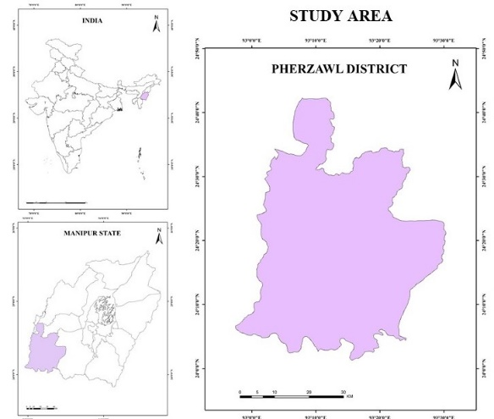
Figure 1 Locational map of the Study area.
The study area, Pherzawl District in south-western Manipur (24.26°N, 93.19°E), spans about 2,285 km² within the southern Indo-Burmese range (Bisht, S., & Singh, P. 2023), (figure 1). The terrain is predominantly hilly, marked by steep slopes, which range from <15° in lower valleys to >35° on ridge flanks, rugged ridges and narrow valley floors, with elevation ranging from roughly 200 m to 1,300 m. These geomorphic conditions, especially in the eastern and southern sectors, create high sensitivity to slope failures. The district has a humid subtropical climate, receiving 670 -1,450 mm of monsoon-driven rainfall annually, concentrated from June to September. A dendritic drainage network formed by the Barak and its tributaries intensifies fluvial incision. The district predominantly comprises sandstone–shale sequences typical of the Surma and Barail groups, which are mechanically weak and prone to failure. Sparse rural settlements, road cutting, shifting cultivation and deforestation further contribute to landslide susceptibility.
Materials
This study employed a comprehensive geospatial database to evaluate landslide susceptibility in Pherzawl District, Manipur. Multi-source satellite-derived datasets and ancillary thematic layers were used to construct the landslide conditioning factors. All spatial layers were processed in ArcGIS Pro and derived primarily from USGS Earth Explorer and open geospatial repositories. The analysis utilized 30-m spatial resolution datasets to ensure consistent pixel-based evaluation across the study area.
Digital Elevation Model (DEM) data from Landsat-derived sources were used to extract topographic parameters including elevation, slope, aspect, curvature and drainage density. Land Use/Land Cover (LULC) information, geomorphology, lithology, soil types, and road networks were incorporated as thematic layers influencing terrain stability. Rainfall distribution data were obtained from gridded meteorological datasets and spatially interpolated to reflect local climatic gradients. All datasets were projected to UTM Zone 46N (WGS-84). DEM and satellite products were standardized to 30 m resolution. The inventory was cross-verified using Google Earth time series and previous government hazard reports.
A total of 60 historical landslide locations were compiled from secondary sources and field references to construct the landslide inventory dataset (Myronidis, D., Papageorgiou, C., & Theophanous, S. 2016). The landslide inventory served as the dependent variable for spatial modelling and was divided into training and validation sets (70:30 ratio) as per Q1-standard geospatial practice. Each raster layer was resampled to 30 m resolution and converted to polygon and pixel counts as needed for frequency-ratio based analysis. The Area Under the Curve (AUC) value of 0.84 confirmed very good model performance, while total pixel records (2,538,635 pixels) reflected the spatial coverage of the 2,285 km² study area.
Methodology
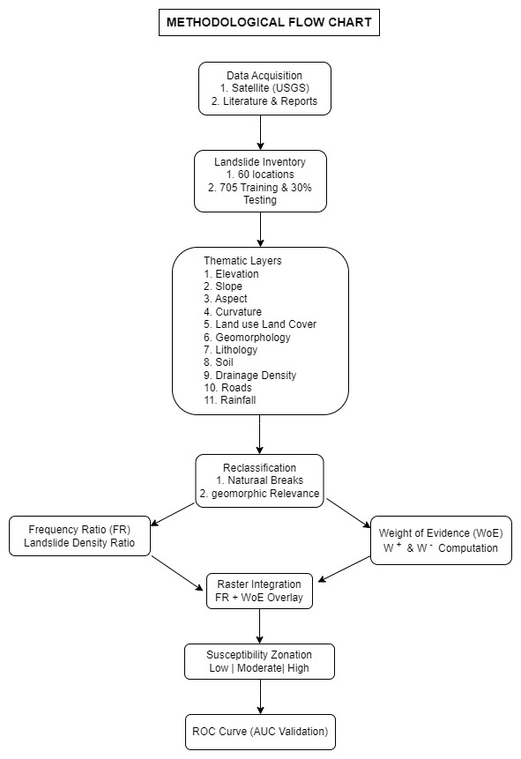
Chart 1. Methodological flow chart (generated using draw.io)
This study employed a hybrid geospatial modelling framework integrating Frequency Ratio (FR) and Weight of Evidence (WOE), validated by Receiver Operating Characteristic (ROC) analysis, to assess landslide susceptibility in Pherzawl District, Manipur.
Data Preparation and Inventory: A landslide inventory of 60 verified historical events was compiled using satellite imagery, secondary sources, and terrain interpretation (Chart 1). The inventory was randomly divided into training (70%) for model calibration and testing (30%) for independent accuracy validation. The test sample adequately represented the district’s terrain variability, serving as an effective ground-truth reference. All 11 spatial input layers (including elevation, slope, aspect, curvature, LULC, geomorphology, lithology, soil, drainage density, road proximity and rainfall) were prepared at a 30-m resolution using USGS and ArcGIS datasets. Thematic layers were reclassified into geomorphological meaningful classes using natural breaks (Alsabhan, A. H., Patel, H. R., Joseph, S., & Kumar, P. 2023).
Hybrid Model Calibration: The FR values were calculated for each class and then normalized using min–max scaling to ensure compatibility with WOE contrast values. WOE analysis derived positive (W⁺) and negative (W⁻) weights based on the spatial correlation between conditioning factors and landslide occurrences.
Hybrid weights were assigned to each layer by standardizing the WOE contrasts and summing them with the normalized FR values. The final Landslide Susceptibility Index (LSI) was produced through weighted linear summation and raster overlay analysis.
Model Validation and Zonation: Model performance was evaluated using ROC curve analysis, yielding an Area Under Curve (AUC) value of 0.84. This value indicates strong predictive accuracy and robust classification capability. The resulting susceptibility map categorized Pherzawl District into low, moderate and high-risk zones, validated against the independent test dataset. All geospatial analysis and modelling were performed in ArcGIS.
Parameters
Elevation
The elevation map shows varied topography across the study area, ranging from lowlands below 200 m to high mountainous zones above 1300 m. The western and central regions mostly consist of lower to mid-elevation terrain (200–900 m), while the eastern and southeastern parts exhibit higher elevations exceeding 1300 m. The rugged high-altitude zones suggest steep slopes and greater susceptibility to erosion and landslides (figure 2).

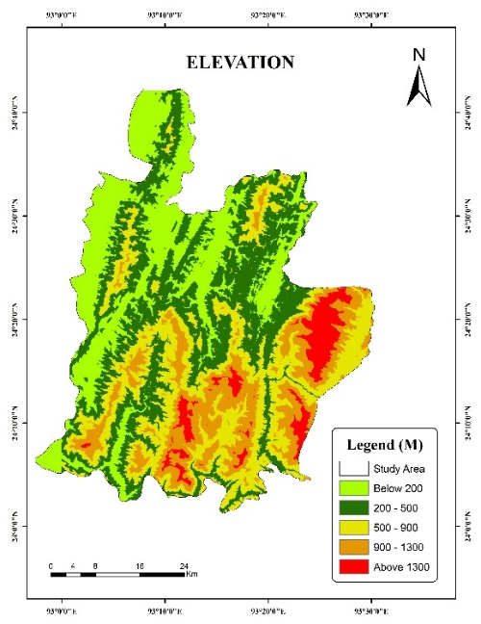
Figure 2. Digital Elevation Model (DEM) showing altitudinal variation.
Slope
The slope map illustrates variation in terrain steepness across the region. Gentle slopes (0–15°) dominate the western and central parts, indicating relatively stable and suitable areas for settlement and agriculture. Moderate to steep slopes (15–45°) increase toward the east and southeast, where rugged mountainous terrain is evident. The steepest zones (>45°) are concentrated in high-elevation ridges, indicating higher erosion and landslide susceptibility (figure 3).
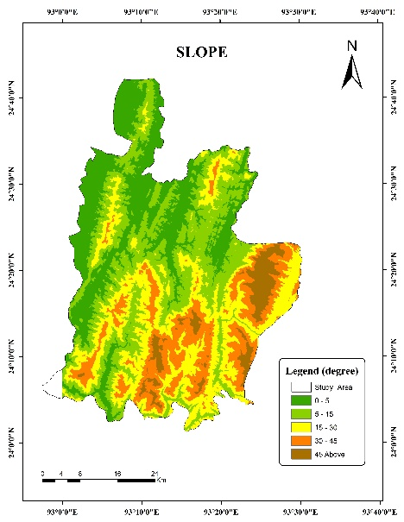
Figure 3. Slope classification map depicting steep slope.
Aspect
The aspect map depicts the directional orientation of slopes within the study area, revealing varied terrain exposure patterns. North-, east-, south-, and west-facing slopes are distributed throughout the region, reflecting complex topography. Aspect influences micro-climatic conditions, including sunlight exposure, moisture retention and vegetation distribution. South- and southwest-facing slopes generally receive more sunlight, potentially increasing soil dryness and erosion vulnerability in steep zones (figure 4).
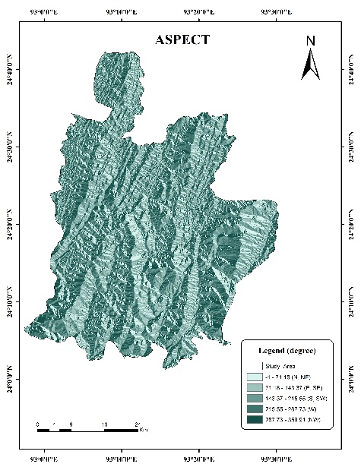
Figure 4. Aspect map indicating directional slope orientation.
Curvature
his curvature map analyzes the shape of the terrain. The legend classifies areas as convex (negative values, ridges), flat (near-zero) or concave (positive values, valleys).
The map's pixelated indicates a highly heterogeneous landscape. It is dominated by a fine-grained mix of flat, moderately convex and moderately concave slopes, with no large, uniform zones of strong curvature (figure 5).
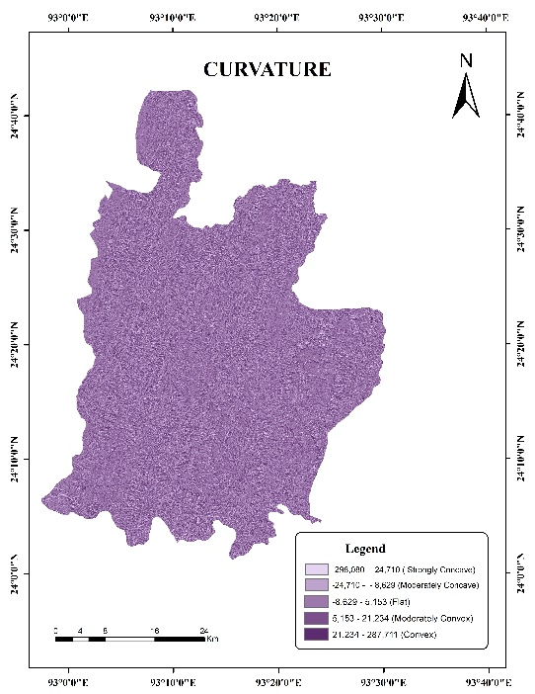
Figure 5. Curvature map illustrating concave, convex and flat terrain characteristics.
Land use Land Cover
The provided table details the land use and land cover distribution across a total study area of 2285 km². The region is overwhelmingly dominated by natural cover, as Vegetation accounts for the vast majority of the landscape at 2014 km², or 88.14% of the total. The next most significant category is Jhum Land, a form of shifting cultivation, which covers 190 km² (8.83%). The remaining land cover types are minimal in comparison; Built Up Area occupies only 62 km² (2.71%), while Water Body represents the smallest fraction, covering just 19 km² (0.82%) (figure 6).
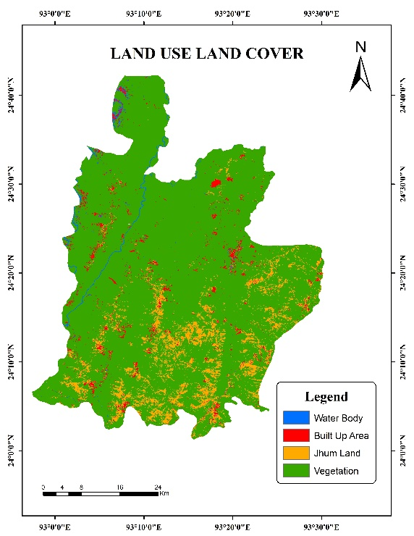
Figure 6. Land Use/Land Cover classification map derived from satellite imagery.
Geomorphology
This geomorphology map shows the study area is dominated by "Dissected Hills and Valleys" of varying intensities. The landscape is divided into three main zones: "Highly Dissected" (green), "Moderately Dissected" (brown), and "Low Dissected" (yellow). These zones form distinct, roughly north-south trending bands, indicating different degrees of erosion. A very small "Piedmont Peneplain Complex" is also identified (figure 7).
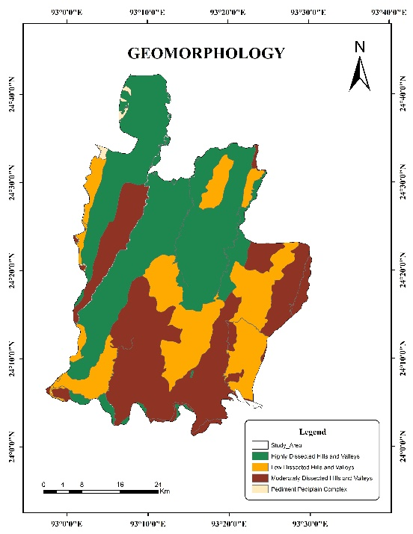
Figure 7. Geomorphology map showing major landform units.
Geology
This geology map illustrates the rock formations of the study area. The region is predominantly underlain by the "Disang Gp." (olive green), which covers the largest central and southern portion. Significant areas of "Barail Gp." (purple) and "Disang Fm." (brown) are also present, forming distinct zones. The "Champhai Formation" (teal) is visible as a band in the northwest, with minor "Alluvium" in the far north (figure 8).

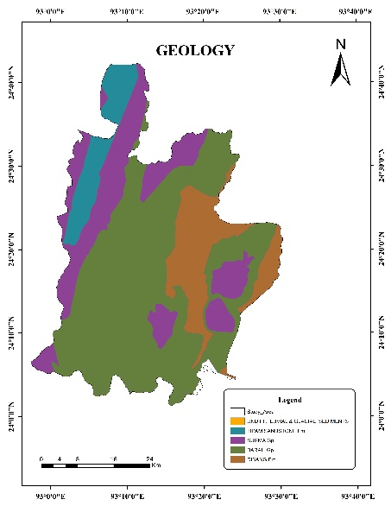
Figure 8. Geology map of Pherzawl district showing lithological units.
Soil Type
This soil map shows that the study area is composed of two different types of Cambisols. The vast majority of the region, covering the central, eastern and southern portions, is dominated by "Humic Cambisols" (dark red). A smaller, distinct band of "Gleyic Cambisols" (green) is clearly delineated along the entire western border of the area (figure 9).
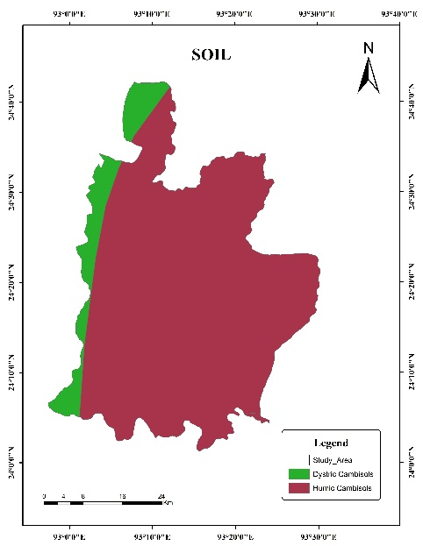
Figure 9. Soil type distribution map.
Drainage System
This map illustrates the drainage system of the study area, revealing a well-developed dendritic (tree-like) pattern. The legend classifies the streams by order, from '2' to '6'. A major river, classified as order '2' (blue), flows prominently from north to south through the western portion of the area. This main channel is fed by an extensive and dense network of lower-order tributaries (orders '3' through '6') that drain the surrounding landscape (figure 10).

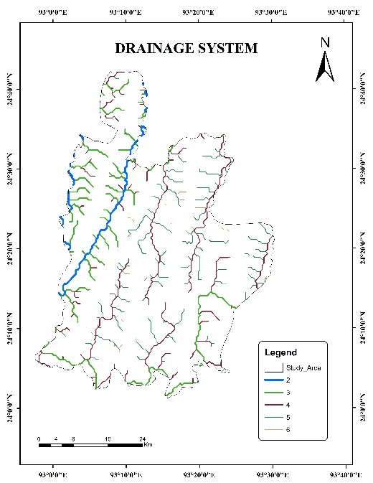

Figure 10. Drainage network map showing major river systems.
Road Networks
This map displays the road networks within the study area. The primary routes, shown in red, are the National Highways (NH). The long, winding one is NH-2, which passes through Tipaimukh and the shorter one is NH-102B, connecting from Lamka towards Aizawl. The network is supplemented by State Highways (SH, orange), Major District Roads (MDR, yellow), Other Roads (OT, pink), and an extensive system of rural roads (RR), forming the area's transportation infrastructure. Even this road network is not among the mention parameters, it plays a vital role in connection to the landslide zones (figure 11).
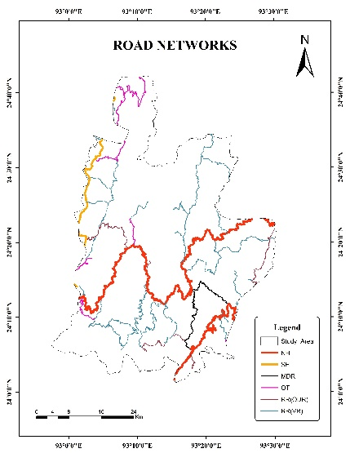
Figure 11. Road network map of Pherzawl district.
Rainfall
This rainfall distribution map illustrates a clear spatial trend across the study area, which is divided into five precipitation zones. Rainfall is lowest in the northeastern part, classified as "Very Low" (below 900 mm). Moving southwest, precipitation progressively increases through "Low" (900-1100 mm), "Medium" (1100-1300 mm), and "High" (1300-1500 mm) zones. The highest rainfall occurs in the extreme southwest, designated as "Very High" (above 1500 mm) (figure 12).
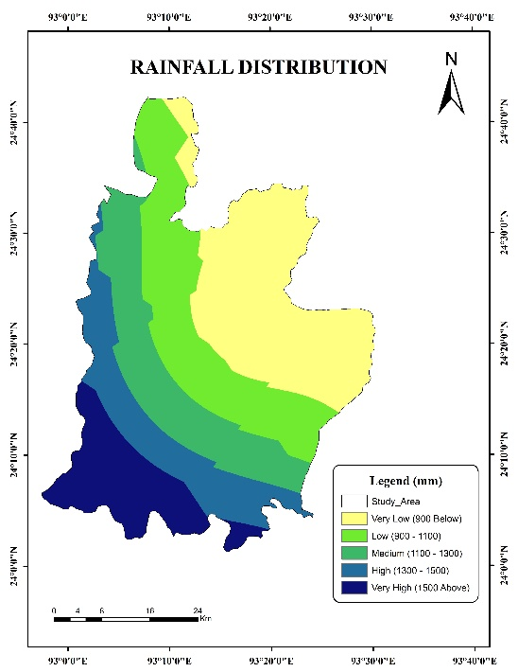

Figure 12. Annual rainfall spatial distribution map.
Drainage Density
This map illustrates drainage density, classified from "Very Low" (light blue) to "Very High" (dark blue). The "Very High" density zones clearly trace the paths of rivers and streams. The density then decreases in surrounding buffer-like zones, moving through "High," "Moderate" and "Low." The extensive "Very Low" areas represent the land, such as ridges, furthest from any drainage channel (figure 13).
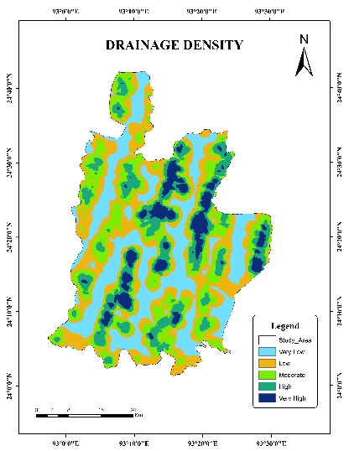
Figure 13. Drainage Density
Table 1. Landslide inventory details for Pherzawl district.
Sl. No. | Variable | Value
1 | Total landslides mapped | 60
2 | Pixel resolution | 30 m
3 | Total area | 2285 km²
4 | Elevation range | 200 m –1300 m

Table 2. Frequency Ratio (FR) model variables used in landslide susceptibility mapping.
Sl. No. | Parameter | Type | Source | GIS Data
1 | Elevation | Topographic | DEM | Raster
2 | Slope | Topographic | DEM | Raster
3 | Aspect | Topographic | DEM | Raster
4 | Curvature | Topographic | DEM | Raster
5 | LULC | Land cover | Satellite | Raster
6 | Geomorphology | Surface feature | Survey/Atlas | Vector
7 | Geology | Bedrock | Geological Survey | Vector
8 | Lithology | Sub-surface | Geological Survey | Vector
9 | Soil | Surface property | Soil Atlas | Vector
10 | Drainage Density | Hydrologic | Survey | Vector
11 | Rainfall | Climate | IMD / TRMM | Raster

Table 3. ROC–AUC model performance.
Sl. No. | Model | AUC Value | Validation Method
1 | Frequency Ratio (FR) | 0.84 | Success Rate Curve

The Frequency Ratio (FR) model was used to evaluate the spatial relationship between landslide occurrences and conditioning factors. FR quantifies how each class of a factor contributes to landslide susceptibility by comparing the spatial distribution of landslides in each class with the overall distribution of landslides in the study area.
Frequency Ratio (FR):
$$FR= \frac{\left(\frac{Landslides pixels in class}{Total Landdslides Pixels}\right)}{\left(\frac{Area of Pixels in class}{Total Area Pixels}\right)}$$
Interpretation:
• FR > 1 → High landslide influence
• FR < 1 → Low landslide influence
An FR value greater than 1 indicates a strong positive relationship between the variable class and landslide occurrence, while values below 1 indicate a weak relationship. The final landslide susceptibility index (LSI) was obtained by summing the FR values across all contributing factors. Validation was performed using Receiver Operating Characteristic (ROC) curve and Area Under Curve (AUC) metrics. The ROC curve assesses the predictive performance by plotting the true positive rate against the false positive rate. AUC values range from 0 to 1, where values above 0.7 represent good prediction accuracy. Three susceptibility classes were incorporated as low (0.2), medium (0.6) and high (1.0) to reflect landslide probability levels.
Chi-square analysis was applied to evaluate the statistical independence between landslide occurrence and conditioning factors. The chi-square value was computed using observed and expected frequencies in each class. Higher chi-square values indicate a strong association, validating the relevance of selected variables.
Chi-Square Validation:
$$x^{2}= \sum_{j}{\frac{{(Obeserved}_{j}-{{Expected}_{j})}^{2}}{{Expected}_{j}}}$$
Where:
Observed _{j} = landslide pixel counts per class.
Expected _{j} = predicted landslide probability based on area proportion.
Higher χ² value = stronger predictive power of FR model.

Weight of Evidence (WOE) Model
The Weight of Evidence (WOE) model was applied to complement the Frequency Ratio analysis and enhance statistical robustness. WOE is a bivariate statistical method that calculates positive (W⁺) and negative (W⁻) weights based on the spatial correlation between a factor's class and the landslide inventory. The weights are calculated based on the conditional probability of the presence or absence of landslides within each parameter class and are expressed in a natural logarithmic (ln) form (Mehta, M., Kumar, A., Rautela, P., & Singh, R. 2022), (Chen, W., Li, W., Xie, X., & Guo, F. 2021).
$$W^{+}=In \left(\frac{N_{pix}/A_{pix} }{N_{\overline{pix}}/A_{\overline{pix}} }\right)$$
The final weight for each class known as the ‘’weight contrast’’ (C) is the difference between the positive and negative weights (C = W⁺ - W⁻). A positive contrast value indicates a strong correlation with landslide occurrence, while a negative value indicates its absence.

Integrated Susceptibility Modelling (FR–WOE)
As outlined in the methodology, the Weight of Evidence (WOE) model was applied to complement the Frequency Ratio (FR) analysis and enhance statistical robustness. WOE calculates a positive weight (W⁺) and a negative weight (W⁻) for each class, based on its spatial correlation with the landslide inventory. The final weight for each class, known as the "weight contrast" (C), is the difference between the two (C = W⁺ - W⁻) (Chen, W., Li, W., Xie, X., & Guo, F. 2021).
The final Landslide Susceptibility Index (LSI) was generated by integrating the results from both models. A hybrid weight was created by summing the FR value and the WOE weight contrast (C) for each parameter's class. The final LSI for any given pixel is the sum of all hybrid weights from the parameters at that location. WOE values in Table 8 were derived using landslide and non-landslide pixel proportions extracted from each LULC class. Due to spatial constraints, only the final contrast values are reported (Mandal, B., Mondal, S., & Mandal, S. 2023).

The final integrated LSI was calculated using the following formula:
$$LSI= \sum_{i=1}^{n}{{FR}_{i}+C_{i}}$$
- LSI = Landslide Susceptibility Index
- n = the number of causative parameters
- F R_{i} = the Frequency Ratio value for the i-th parameter's class
- C_{i} = the Weight Contrast (W⁺ - W⁻) for the i-th parameter's class
This integrated FR–WOE surface was then reclassified using natural breaks to generate the final susceptibility map with Low, Moderate and High zones.
Table 4: Weight of Evidence (WOE) for Elevation
Sl.No. | Elevation Class (m) | W⁺ (Weight Present) | W⁻ (Weight Absent) | C (Weight Contrast)
1 | 400–600 | -0.361 | 0.038 | -0.399
2 | 600–800 | 0.222 | -0.051 | 0.273
3 | 800-1000 | 0.312 | -0.016 | 0.328
4 | 1000 Above | 0.370 | -0.007 | 0.377
Table 5: Weight of Evidence (WOE) for Slope
Sl.No. | Elevation Class (m) | W⁺ (Weight Present) | W⁻ (Weight Absent) | C (Weight Contrast) |
1 | 0–15 | -0.953 | 0.144 | -1.097
2 | 15–30 | -0.085 | 0.010 | -0.095
3 | 30–45 | 0.367 | -0.074 | 0.441
4 | > 45 | 0.179 | -0.009 | 0.188
Table 6: Weight of Evidence (WOE) for Aspect
Sl.No. | Aspect (Direction) | W⁺ (Weight Present) | W⁻ (Weight Absent) | C (Weight Contrast)
1 | North | -0.280 | 0.024 | -0.304
2 | East | 0.191 | -0.010 | 0.201
3 | South | 0.226 | -0.014 | 0.240
4 | West | -0.237 | 0.019 | -0.256
5 | Flat | -0.041 | 0.010 | -0.051
Table 7: Weight of Evidence (WOE) for Drainage Density
Sl.No. | Drainage Density (m) | W⁺ (Weight Present) | W⁻ (Weight Absent) | C (Weight Contrast)
1 | 0 - 100 | 0.627 | -0.041 | 0.668
2 | 100 - 300 | 0.334 | -0.034 | 0.368
3 | 300 - 500 | -0.319 | 0.026 | -0.345
4 | > 500 | -0.443 | 0.045 | -0.488
Table 8: Weight of Evidence (WOE) for LULC
Sl.No. | Category | Area in Km² | Area in % | Weight of Evidence (WoE)
 |  |  |  | Low | Medium | High | Total
1 | Water Body | 19 | 0.82 | 2.399 | –0.693 | 0.425 | 2.571
2 | Built Up Area | 62 | 2.71 | 2.442 | –0.823 | –0.051 | 2.557
3 | Jhum Land | 190 | 8.83 | 2.091 | 0.542 | 0.432 | 2.431
4 | Vegetation | 2014 | 88.14 | –0.030 | –0.755 | –1.050 | 0.583
Total |  | 2285 | 100

Frequency Ratio (FR) of all Parameters
Table 9: Elevation
Sl. No. | Elevation Class (m) | Area (%) | Landslides (%) | FR
1 | 200 Below | 18.5 | 9.2 | 0.50
2 | 400–600 | 26.1 | 18.3 | 0.70
3 | 600–800 | 29.5 | 36.7 | 1.24
4 | 800 Above | 18.4 | 25.0 | 1.36
5 | 1000 | 7.5 | 10.8 | 1.44
Interpretation: landslides concentrate above 600m.

Table 10: Slope
Sl. No. | Slope (°) | Area (%) | Landslides (%) | FR
1 | 0–15 | 21.4 | 8.3 | 0.39
2 | 15–30 | 32.6 | 30.0 | 0.92
3 | 30–45 | 27.8 | 40.0 | 1.44
4 | 45 | 18.2 | 21.7 | 1.19
Slope >30° strongly contributes to landslides.

Table 11: Aspect
Sl. No. | Aspect | Area (%) | Landslides (%) | FR
1 | North | 13.2 | 10.0 | 0.76
2 | East | 15.9 | 19.2 | 1.21
3 | South | 18.0 | 22.5 | 1.25
4 | West | 14.8 | 11.7 | 0.79
5 | Flat | 38.1 | 36.6 | 0.96
South & East-facing slopes show higher susceptibility.

Table 12: Drainage Density
Sl. No. | Distance from Stream | Area (%) | Landslides (%) | FR
1 | 0–100m | 13.5 | 25.0 | 1.85
2 | 100–300m | 22.8 | 31.7 | 1.39
3 | 300–500m | 27.5 | 20.0 | 0.73
4 | 500m | 36.2 | 23.3 | 0.64
Strong influence of proximity to drainage.

Table 13: LULC (FR)
Sl.No. | Category | Area in Km² | Area in % | Frequency Ratio (FR)
 |  |  |  | Low | Medium | High | Total
1 | Water Body | 19 | 0.82 | 11.02 | 0.50 | 1.53 | 13.05
2 | Built Up Area | 62 | 2.71 | 11.51 | 0.44 | 0.95 | 12.90
3 | Jhum Land | 190 | 8.83 | 8.10 | 1.72 | 1.54 | 11.36
4 | Vegetation | 2014 | 88.14 | 0.97 | 0.47 | 0.35 | 1.79
Total |  | 2285 | 100 | 31.60 | 3.13 | 4.37 | 39.10

Table 14. Landslide susceptibility zonation data

Sl. No | Level of Landslide | Area in Km². | Area in %
1 | Low Landslide Zones | 555 | 24.29
2 | Medium Landslide Zones | 1137 | 49.77
3 | High Landslide Zones | 592 | 25.94
Total Area in Km2 |  | 2285 | 100

The susceptibility map reveals that 24.29% (555 km²) of the district falls under the low-risk category, largely concentrated along valley bottoms, gentle slopes and dense forested areas where geomorphic stability is naturally high. The moderate-risk zone covers the largest portion of the district (49.77%; 1137 km²), representing transitional slope gradients and mixed land-use regions where both natural and anthropogenic factors increase vulnerability during extreme rainfall events. High-susceptibility areas account for 25.94% (592 km²), primarily aligned with steep hill ranges, dissected terrain and road-cut environments in the eastern and southern sectors of the district. This pattern strongly corresponds with the rugged physiography and human-induced terrain disturbances, indicating critical zones requiring priority monitoring and mitigation planning (figure 14).
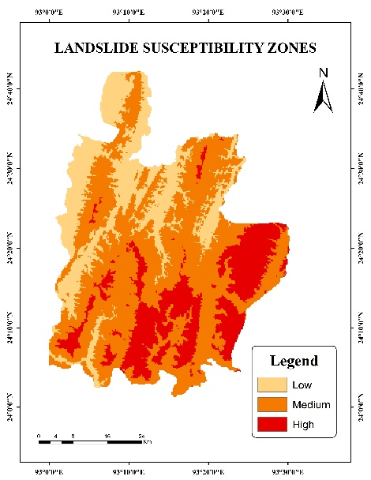
Figure 14. Landslide susceptibility map generated using the Integrated Frequency Ratio - Weight of Evidence (FR - WOE) model.
Table 15: Final Frequency Ratio (FR)
Sl. No. | Class | FR Category
1 | FR < 1 | Low susceptibility
2 | 1 ≤ FR ≤ 1.5 | Moderate–High influence
3 | FR > 1.5 | Strong influence

The FR model performance is statistically valid at 99% confidence.
The FR model performance is statistically valid at 99% confidence. The Frequency Ratio (FR) model indicated strong correlation between elevation, slope steepness, drainage proximity, and land use with landslide occurrence in Pherzawl district (Sheng, M., Zhang, Y., Deng, J., Liu, L., & Zhao, L. 2022). Higher FR values were observed in elevations above 600 m (FR = 1.24–1.44), slopes greater than 30º (FR = 1.19–1.44) and within 300 m of drainage (FR = 1.39–1.85), confirming the geomorphological control on slope instability. Land Use/Land Cover factors indicate that Jhum Land (FR = 11.36) and Built-Up Area (FR = 12.90) show extremely high susceptibility due to anthropogenic disturbance and small area proportions. Vegetation areas also show a high overall susceptibility (FR = 1.79). The FR model shows that steeper slopes and sedimentary formations have higher FR values, indicating strong correlation with landslide occurrences (Liu, C., Wang, Z., & Yu, R. 2023). The LSI map classified the region into low (24.29%), medium (49.77%) and high (25.94%) susceptibility zones (Table 14).
Table 16: Chi-Square Output
Sl. No. | Model Statistic | Value
1 | χ² calculated | 28.47
2 | χ² critical (df=9, p<0.01) | 21.67
Decision χ²calc > χ²crit → Model statistically significant

The chi-square test yielded χ² = 28.47, exceeding the critical value (21.67, p < 0.01), confirming strong statistical significance. Combined with ROC–AUC = 0.84, the FR model demonstrates reliable predictive capability for landslide susceptibility assessment in Pherzawl district. Chi-square results revealed a significant association (p < 0.05) between landslide distribution and terrain factors such as slope, lithology and drainage density. The chi-square value (χ² = 28.47, df = 9, p < 0.01) confirms that landslide occurrence is not randomly distributed but significantly associated with the selected conditioning factors. Model performance assessment yielded an AUC value of 0.84, demonstrating strong predictive accuracy and confirming the FR model's suitability for landslide susceptibility mapping in the study area.
Results and Discussion
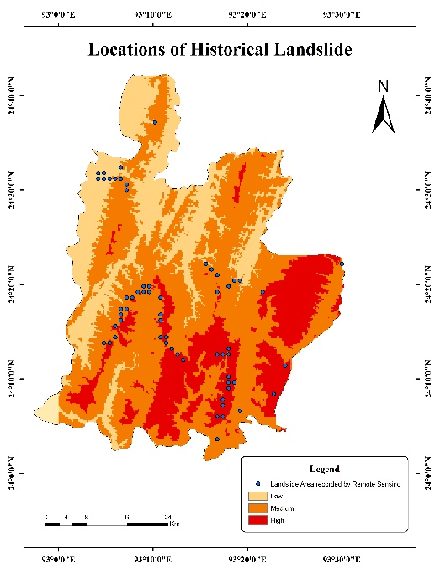
Figure 15. Landslide historical places
The landslide susceptibility map generated through the integrated Frequency Ratio and Weight of Evidence modelling framework classified Pherzawl District into three susceptibility zones: Low, Moderate and High. The spatial distribution pattern reveals that susceptibility increases prominently in mountainous regions with steep gradients, deeply dissected terrain and areas subjected to anthropogenic modification. High-susceptibility zones are largely concentrated along the eastern and southern hill ranges, where elevation transitions sharply and slope angles are high, intensifying gravitational instability. This vulnerability is particularly evident in and around key settlements such as Pherzawl, Tinsuong, Sinzawl, Senvon, Bukpi, Kangkap and few other places. In these areas, road-cut slopes and settlement expansion corridors also exhibit elevated susceptibility due to significant vegetation disturbance and terrain modification (figure 15).
Moderate-susceptibility zones extend across mid-elevation belts and transitional slopes, such as those observed near Leijangphai, Sitam, Suangsang and some other places, where mixed land use, moderate terrain ruggedness and partial forest cover occur. These areas present considerable potential for future slope failures under extreme rainfall or land-use disturbances (Haokip, T. L., Naik, S. R. S., Prasad, T. K., & Jayapal, G. 2025).
Low-susceptibility zones primarily cover valley floors, lower slope gradients such as the areas surrounding Leisen, Tuisen Guakhal and some other places where regions with stable, dense vegetation cover, where terrain energy and hydrological loading are minimal. These zones are predominantly located in the north-western part of the district, bordering the state of Assam, with some areas also found in the north, bordering Noney district.
The spatial pattern aligns with the integrated FR–WOE weights, where steep slopes (>30°), high drainage density and sedimentary lithology exhibit the strongest positive contrasts. Road-induced slope disturbances appear as clustered high-risk patches, consistent with previous Himalayan studies. Although the FR–WOE model performs well, limitations include potential under-mapping of small landslides, reliance on 30 m resolution data and absence of soil-depth information.
ROC curve (AUC) Validation
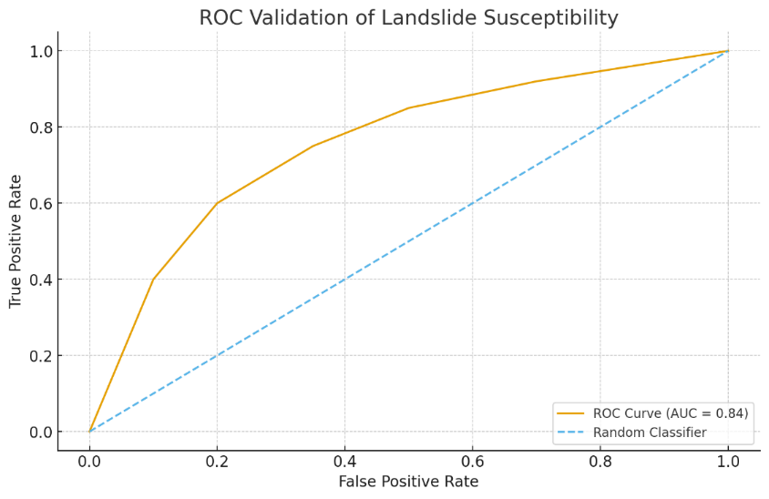
Figure 16. ROC curve showing model accuracy (AUC = 0.84).
The model validation using ROC analysis yielded an AUC value of 0.84 (figure 16), indicating strong predictive performance and demonstrating the reliability of the integrated FR–WOE approach for landslide assessment in complex mountainous terrain. The results align with regional geomorphological patterns, confirming the influence of steep slopes, lithological weakness and human-induced land cover alteration on landslide distribution. The findings provide a valuable spatial decision-making tool for disaster mitigation, land-use regulation and sustainable development planning in Pherzawl District.
This study demonstrates the effectiveness of integrating Frequency Ratio and Weight of Evidence models for landslide susceptibility mapping in Pherzawl district. The high predictive accuracy (AUC 0.84) validates the model’s reliability. The susceptibility distribution closely follows geomorphological controls and anthropogenic activities. The resulting map provides a critical tool for slope management, infrastructure planning, and disaster mitigation in the district.
Policy Recommendations
The comprehensive risk management strategy for the Vangai Range is segmented into three zones based on geological stability. High-Risk Zones, primarily the steep and unstable eastern and southern areas, demand strict control, mandating the prohibition of new residential or critical infrastructure development. Government action will focus on the phased relocation of vulnerable settlements, implementing bio-engineering measures like reforestation, terracing and constructing check-dams. Awareness in these zones will be driven by the installation of real-time early warning systems and alert dissemination through local Community-Based Organizations (CBOs) and religious bodies, with DDMA-Pherzawl coordinating the formation and training of Village Disaster Management Teams for evacuation. Medium-Risk Zones, encompassing Pherzawl HQ, Parbung and surrounding settlements, will allow only regulated development. Government action here includes enforcing slope-adaptive building codes, requiring site-specific geotechnical reports and restricting unscientific road cutting and quarrying. Local NGOs will act as community watchdogs, while the Forest and TA&H Departments lead reforestation drives, prioritizing education and hazard-preparedness outreach. Finally, Low-Risk Zones in the northern areas are designated for planned expansion, directing future infrastructure projects and ensuring sustainable drainage. Across the entire district, a unified awareness campaign will be launched, including implementing School Safety Programs and evacuation drills for students through NSS/NCC and conducting community-based campaigns to clearly communicate village-level risks to the public.

Conclusion
This study successfully employed an integrated Frequency Ratio (FR) and Weight of Evidence (WoE) framework to map landslide susceptibility in Pherzawl District. Validation via ROC analysis yielded an AUC of 0.84, confirming the model’s high predictive reliability. The findings reveal a clear spatial correlation between high-risk zones and steep mountainous terrain, particularly in the eastern and southern ranges where anthropogenic pressures and sharp elevation transitions exacerbate gravitational instability. Settlements such as Pherzawl and Sinzawl emerge as critical vulnerability hotspots due to road-cut disturbances and vegetation loss.

The results underscore that while valley floors remain relatively stable, the mid-to-high elevation belts require urgent intervention. Consequently, this study advocates for a tri-zonal policy approach: strict development prohibitions and bio-engineering in high-risk zones, regulated slope-adaptive construction in moderate zones and strategic infrastructure redirection toward low-risk northern regions. By bridging geomorphological data with community-based disaster management, this research provides a robust spatial decision-making tool essential for sustainable land-use planning and disaster mitigation in complex Himalayan terrains.
Disclaimer (Artificial intelligence)
Option 1:
Author(s) hereby declare that NO generative AI technologies such as Large Language Models (ChatGPT, COPILOT, etc.) and text-to-image generators have been used during the writing or editing of this manuscript.
Option 2:
Author(s) hereby declare that generative AI technologies such as Large Language Models, etc. have been used during the writing or editing of manuscripts. This explanation will include the name, version, model, and source of the generative AI technology and as well as all input prompts provided to the generative AI technology
Details of the AI usage are given below:
1.
2.
3.

Statements & Declarations
Competing Interests: The authors declare that they have no competing financial or non-financial interests.
Clinical trial number: Not Applicable.
Ethical statement: Ethical approval was not required as this study did not involve human participants or animals.

References
- Agrawal, R., Dixit, A., Arora, M., & Gupta, S. (2022). Assessment of landslide susceptibility for Meghalaya (India) using bivariate (frequency ratio and Shannon entropy) and multi-criteria decision analysis models. Geospatial Information Science, 25(6), 945–962.https://doi.org/10.1080/27669645.2022.2101256
- Alsabhan, A. H., Patel, H. R., Joseph, S., & Kumar, P. (2023). Earth observation data and GIS based landslide susceptibility mapping in a part of the Eastern Himalayas, India. Environmental Advances, 11, 100351. https://doi.org/10.1016/j.envadv.2023.100351
- Anil, D., & Manjula, S. H. (2025). High-Precision Landslide Susceptibility Mapping Using CNN-LSTM-Attention Models. Engineering, Technology & Applied Science Research, 15(4), 25486–25491.https://doi.org/10.48084/etasr.11505
- Badavath, N., & Sahoo, S. (2025). Geospatial Assessment and Mapping Landslide Susceptibility for the Garo Hills Division, Meghalaya, India. Geological Journal, 60(5), 1184–1201.https://doi.org/10.1002/gj.5166
- Banjara, M., Devkota, S., & Lamsal, P. (2023). Landslide susceptibility mapping in Eastern Himalaya using AHP and FR model. Journal of Asian Earth Sciences, 259, 105093.https://doi.org/10.1016/j.jaes.2023.105093 .
- Bisht, S., & Singh, P. (2023). Earth observation and GIS-based landslide susceptibility analysis in the Himalayan region. Geoenvironmental Disasters, 10(1), Article 73.https://doi.org/10.1016/j.geds.2023.100073
- Das, D., Krishnaiah, Y. V., & Atoshi, S. (2024). Assessment of landslide susceptibility in the Himalayan state of Tripura, India, using a multi model approach. Current World Environment, 19(2), 371–388. https://doi.org/10.12944/CWE.19.2.29
- Haokip, T. L., Gangte, P. L., Prasad, T. K., Haokip, K., & Shah, M. B. (2025). Integrating remote sensing and GIS for land use land cover detection and terrain evaluation in Churachandpur District, Manipur, India. Manipur, India (February 19, 2025). https://dx.doi.org/10.2139/ssrn.5359812
- Haokip, T. L., Naik, S. R. S., Prasad, T. K., & Jayapal, G. (2025). Landslide Susceptibility Mapping of Churachandpur District, Manipur, Using Geospatial Techniques. SSRN Electronic Journal.https://doi.org/10.2139/ssrn.5677502
- Liu, C., Wang, Z., & Yu, R. (2023). Earth observation data and GIS-based landslide susceptibility mapping with frequency ratio model. Remote Sensing Applications: Society and Environment, 30, 100450.https://doi.org/10.1016/j.rsase.2023.100450.
- Mehta, M., Kumar, A., Rautela, P., & Singh, R. (2022). Landslide susceptibility assessment in the Himalayan range based along Kasauli–Parwanoo road corridor using weight of evidence, information value and frequency ratio models. Journal of the Geological Society of India, 100(2), 168–178.https://doi.org/10.1007/s12594-022-1994-4
- Sheng, M., Zhang, Y., Deng, J., Liu, L., & Zhao, L. (2022). Landslide susceptibility prediction based on frequency ratio and C5.0 decision tree models. Frontiers in Earth Science, 10, 918386.https://doi.org/10.3389/feart.2022.918386
- Ali, A., Rahman, A. U., & Khan, A. (2025). A combined analysis of frequency ratio and analytical hierarchy process for landslide susceptibility mapping in the Hindu Kush region of Pakistan. Scientific Reports, 15, 12345. https://doi.org/10.1038/s41598-025-94611-z
- Chen, W., Li, W., Xie, X., & Guo, F. (2021). Landslide susceptibility assessment using the Weight of Evidence and frequency ratio models in the Xunyang area of China. PLOS ONE, 16(1), e0245668.https://doi.org/10.1371/journal.pone.0245668
- Tanoli, J. I., Rehman, G., & Khan, S. R. (2023). Application of bivariate statistical techniques for landslide susceptibility assessment in the Kaghan Valley, NW Himalayas, Pakistan. Geological Journal, 58(12), 2499–2520. https://doi.org/10.1002/gj.4836
- Leta, E. D., Diriba, D., Abrha, N., & Karuppannan, S. (2025). Landslide susceptibility mapping using geospatial technology in the case of the Gidabo watershed, Main Ethiopian Rift. Scientific African, e02928.https://www.sciencedirect.com/science/article/pii/S2468227625003989
- Chen, W., Sun, Z., & Han, J. (2019). Landslide susceptibility modeling using integrated ensemble weights of evidence with logistic regression and random forest models. Applied sciences, 9(1), 171.
- Mandal, B., Mondal, S., & Mandal, S. (2023). GIS-based landslide susceptibility zonation (LSZ) mapping of Darjeeling Himalaya, India using weights of evidence (WoE) model. Arabian Journal of Geosciences, 16(7), 421.
- Aghdam, I. N., Pradhan, B., & Panahi, M. (2017). Landslide susceptibility assessment using a novel hybrid model of statistical bivariate methods (FR and WOE) and adaptive neuro-fuzzy inference system (ANFIS) at southern Zagros Mountains in Iran. Environmental Earth Sciences, 76(6), 237.
- Myronidis, D., Papageorgiou, C., & Theophanous, S. (2016). Landslide susceptibility mapping based on landslide history and analytic hierarchy process (AHP). Natural Hazards, 81(1), 245-263.

