Original Research Article

Comparative Analysis of Carbon Emissions from Trawl Fisheries in India within a Global Framework

ABSTRACT
This study compares the carbon footprint of trawler operations in India with that of other global regions and explores key management and technological interventions to reduce emissions. The research aims to quantify emissions from Indian trawl fisheries, particularly those using bottom-contact gears, and compare these with emissions from trawlers in the Mediterranean, Europe, North America, and Oceania. Secondary data on fuel consumption and greenhouse gas emissions were collected from published assessments of trawlers operating in Kerala and along India’s northwest coast, as well as global datasets. Emission intensities, initially reported in kilograms of CO₂ equivalents per tonne of fish (kg CO₂ eq t⁻¹ fish), were converted to kilograms per kilogram of fish (kg CO₂ eq kg⁻¹ fish) for consistent comparison. The findings reveal that bottom-contact gears, such as otter and beam trawls, generate significantly higher emissions per unit of catch compared to mid-water or pelagic trawls. This is primarily due to greater fuel consumption and the release of carbon from disturbed seabed sediments. In India, large multi-day trawlers emit more CO₂ per kilogram of fish than smaller, single-day vessels, showing a positive correlation between vessel size, engine power, and carbon intensity. Optimizing vessel speed, downsizing engines, and adopting energy-efficient harvesting technologies could reduce emissions by 20-40%. Innovations like pulse trawling, selective gear, and AI-based monitoring also offer promising pathways for reducing emissions. Despite the lower carbon footprint of trawl-caught fish compared to many terrestrial animal proteins, bottom trawling remains one of the most carbon-intensive fishing methods when accounting for seafloor disturbance. The study underscores the need for harmonized data, particularly in India, to better understand and mitigate the carbon impacts of global fisheries.
Keywords: Carbon footprint; Trawl fisheries; Fuel consumption; Life-cycle assessment

- Introduction
Marine fisheries contribute a small but non-negligible fraction of global greenhouse-gas emissions: recent estimates suggest they account for roughly 4 % of food-production emissions and about 0.5 % of total anthropogenic emissions (Zhang et al., 2024). Among fishing methods, trawling which includes bottom-contact gears (e.g., otter and beam trawls) and mid-water or pelagic gearsstands out for its high energy demands. Trawlers rely on powerful engines to tow heavy nets over long distances, making fuel combustion the primary source of greenhouse gases (Lutz et al. 2022; Markager et al., 2021).. Beyond direct fuel use, bottom trawling physically disturbs seabed sediments. Recent modelling studies show that 55–60 % of the CO₂ released into the water column by such disturbance is emitted to the atmosphere within seven to nine years. This intensive energy use results in significant greenhouse gas emissions, primarily carbon dioxide (CO₂), nitrous oxide (N₂O), and methane (CH₄), contributing substantially to the sector’s carbon footprint. Additionally, bottom trawling disturbs carbon stored in marine sediments, potentially releasing more CO₂ into the water column, further exacerbating its climate impact (OSPAR Commission, 2024). Due to its ecological effects and contribution to climate change, trawling has received increasing scrutiny (Watling & Norse 1998; Pérez Roda et al. 2019; Tyedmers 2004; Sala et al. 2022). Previous studies have demonstrated that the energy demand of trawling is roughly fifteen times higher than that of purse seining (Sainsbury 1971), underscoring the need for targeted mitigation measures. Several frameworks, such as Life Cycle Assessment (LCA), have been developed to evaluate the climate impacts of fisheries, quantifying emissions from fuel combustion, vessel construction, and gear manufacture (Ziegler & Valentinsson 2008; Ravi et al. 2020). Recent global studies by Parker et al. (2018) and Hilborn et al. (2023) have shown that demersal (bottom) fisheries account for a disproportionate share of carbon emissions, primarily due to the high fuel demands of bottom trawling. In India, emissions from trawl fisheries have been estimated for specific fleets (Sayana & Remesan 2020; Devi et al. 2021), but there has been a lack of comprehensive synthesis and comparison with global data. The existing research has largely focused on isolated case studies without harmonizing emission units for broader comparisons. This gap in the literature highlights the need for a more systematic approach to understanding and addressing the carbon footprint of Indian trawl fisheries within a global framework. This study addresses this gap by harmonizing emission units and exploring how Indian trawl fleets compare to those operating in other regions. By integrating emissions data from both India and global fleets, this research aims to provide a clearer understanding of the carbon impact of trawl fisheries and identify potential mitigation strategies to reduce emissions across diverse trawl operations.
- Materials and Methods

2.1 Data Sources
This comparative analysis relies exclusively on published secondary data. Fuel consumption and carbon emissions were compiled for three fleets in the Mediterranean single-boat bottom otter trawlers (OTB), mid-water pair trawlers (PTM) and Rapido beam trawlers (TBB) and for bottom and pelagic trawlers operating in Europe, North America and Oceania (Hilborn et al. 2023). Emissions data for Indian trawlers were taken from assessments of vessels operating out of Munambam and Cochin harbours in Kerala between 2014 and 2016 (Sayana & Remesan 2020) and from surveys of trawlers along the north-west coast (Devi et al. 2021). Carbon emissions from the global fishing sector in 2011 were obtained from Parker et al. (2018). Units reported as million tonnes of CO₂ equivalents (Mt CO₂-eq) were converted to kilograms (kg CO₂-eq) by multiplying by 10⁹. Emission intensities expressed as kilogram CO₂ per tonne of fish (kg CO₂ t⁻¹ fish) were converted to kg CO₂ kg⁻¹ fish by dividing by 1000 to allow direct comparison across fleets. The resulting dataset enables qualitative comparisons of carbon intensity among gear types and regions. (Figure 1)

2.2 Data Processing
To enable comparison, emission intensities reported as kilograms of CO₂ per tonne of fish were converted to kilograms per kilogram (dividing by 1,000), and totals expressed in million tonnes were converted to kilograms. Vessel categories were grouped into comparable classes (e.g., multi-day large, multi-day medium, single-day). The harmonised data were collated into a single dataset recording gear type, vessel size, region, and emission intensity.

2.3 Comparative Approach
Given the heterogeneity of the source studies, the analysis uses descriptive comparisons rather than statistical meta-analysis. We compare carbon intensities across gear types (bottom vs. pelagic trawls), vessel sizes and regions. Emissions from Indian fleets are positioned relative to Mediterranean and North Atlantic benchmarks to highlight differences and similarities. No new measurements were taken; uncertainties from the original studies are acknowledged.
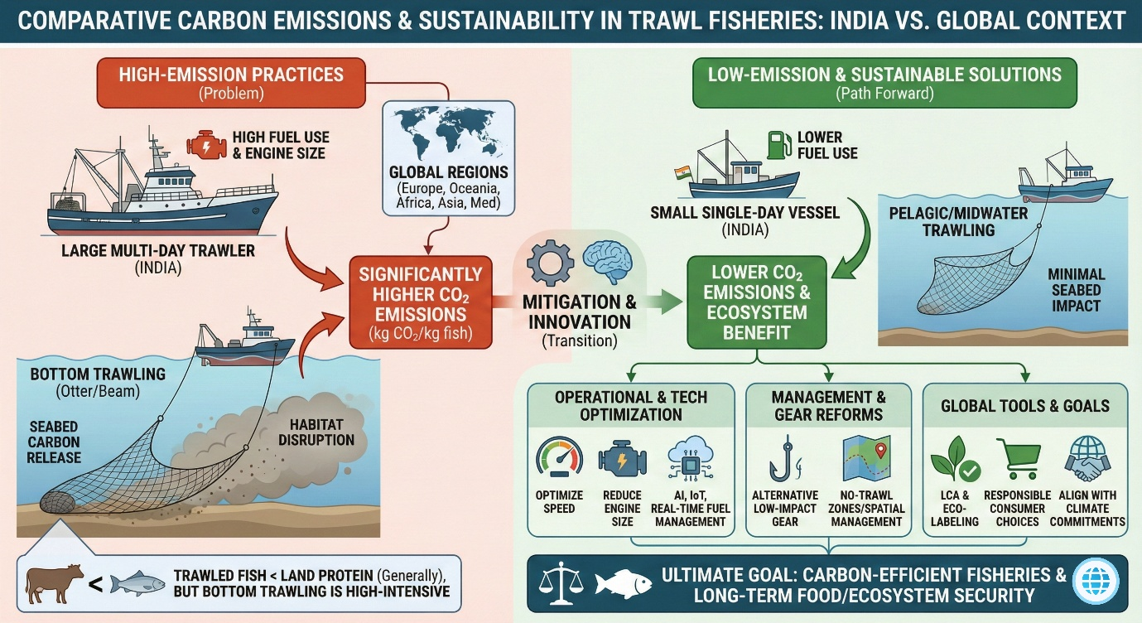

Figure:1 Pictorial Representation of comparative analysis

3. Results and Discussion

3.1 Global carbon emissions and the role of demersal fisheries

On a global scale, carbon emissions from motorised fishing fleets are several orders of magnitude higher than those from non-motorised fleets (Figure 2). When expressed in a common unit, emissions from motorised fleets in 2011 exceeded those of non-motorised fleets by several billion kilograms of CO₂ equivalents, as reported by Parker et al. (2018). Demersal fisheries were identified as a major contributor to these emissions because the capture of demersal species typically involves continuous bottom trawling, a highly fuel-intensive activity. The resulting CO₂ emissions reflect not only the energy required to tow heavy fishing gear but also the disturbance and resuspension of carbon stored in seabed sediments. These findings emphasize that the climate impact of trawling cannot be assessed solely on the basis of catch volume; rather, fishing gear type and its interaction with the seafloor are critical drivers of carbon intensity (Figure 3).

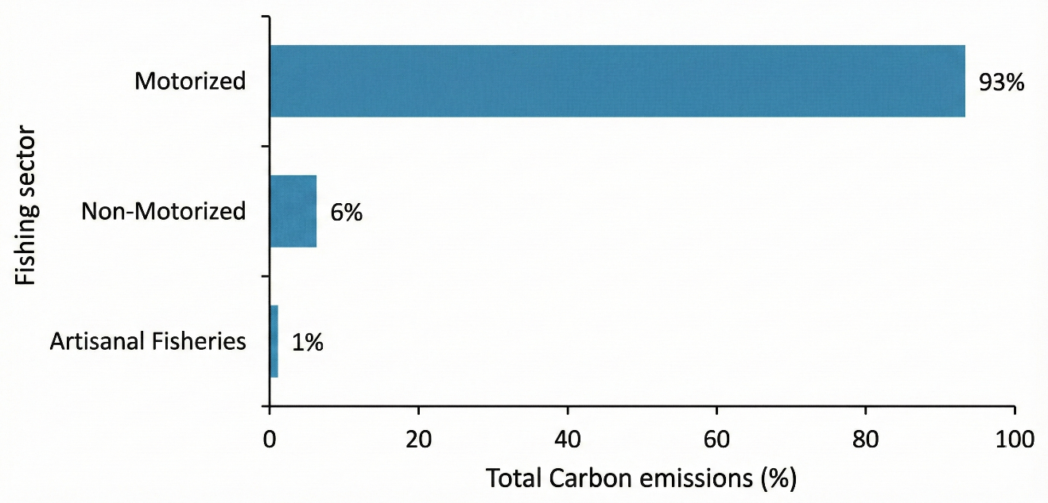

Figure:2 Global caebon emission from fishing

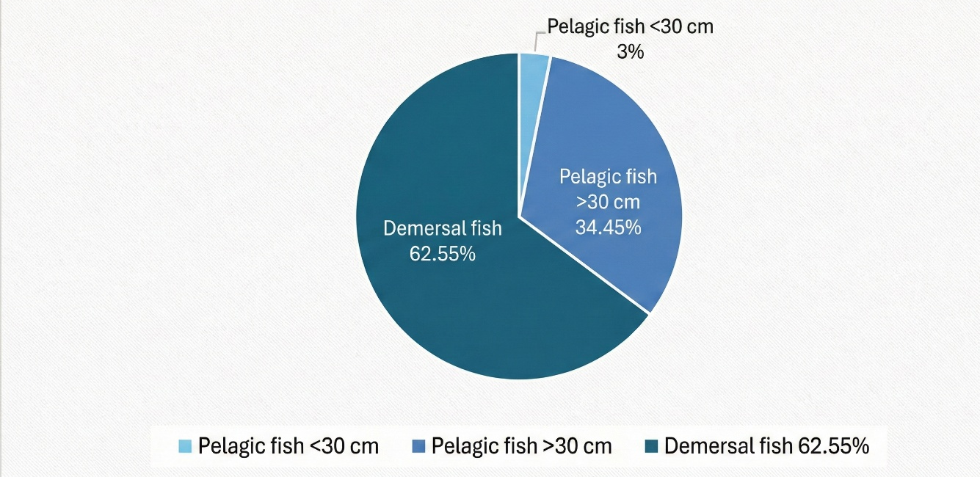

Figure:3 Global caebon emission from fishing areas

3.2 Mediterranean fleets: bottom versus mid-water gears
A comparison of Mediterranean trawl fleets illustrates the influence of gear type on emissions. Sala et al. (2022) measured emission intensities for three gear types: OTB and TBB (both bottom-contact gears) and PTM (a mid-water pair trawl). The original study reported emissions in kg CO₂ t⁻¹ fish. To harmonise units, those values are converted here to kg CO₂ kg⁻¹ fish by dividing by 1 000. After conversion, bottom-contact gears exhibited values roughly an order of magnitude greater than the mid-water gear. For example, if an OTB emitted 600 kg CO₂ per tonne of fish (original units), this corresponds to 0.6 kg CO₂ per kilogram of fish. In contrast, a PTM emitting 150 kg CO₂ per tonne equates to 0.15 kg CO₂ per kilogram. The discrepancy reflects the greater fuel requirements of bottom trawling and the additional CO₂ released from disturbed sediments. Consequently, bottom trawling in the Mediterranean likely has a higher carbon footprint per kilogram of fish than mid-water trawling, despite similar catch rates (Figure 4).
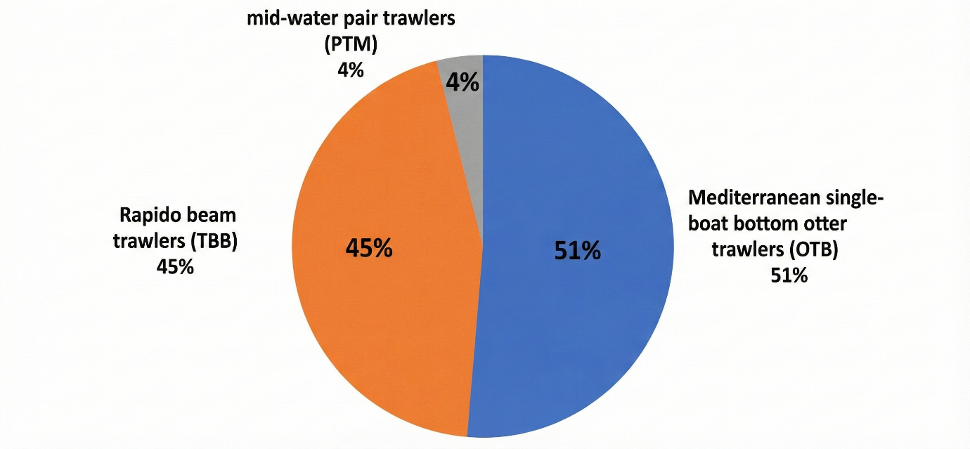
Figure:4 Average carbon footprint of single boat bottom otter trawler (OTB), Midwater pai trawler (PTM), and Rapido beam trawler (TBB) in Mediterranean fishing

3.3 Cross-regional comparisons: bottom versus pelagic trawlers

Emission data synthesised for trawlers operating across Europe, North America and Oceania indicate clear differences between bottom and pelagic trawl fisheries (Hilborn et al., 2023). When standardised as kg CO₂ kg⁻¹ of fish landed, bottom trawlers consistently showed higher carbon intensities than pelagic trawlers across all regions examined. Although data for African and Asian fleets were limited, the available evidence still revealed the same trend of elevated emissions from bottom trawlers compared to pelagic trawlers. These results align with conclusions drawn from Mediterranean fisheries, reinforcing that bottom trawling is more carbon intensive than mid-water or pelagic trawling, largely due to higher fuel requirements and the added impact of seafloor disturbance (Figure 5).

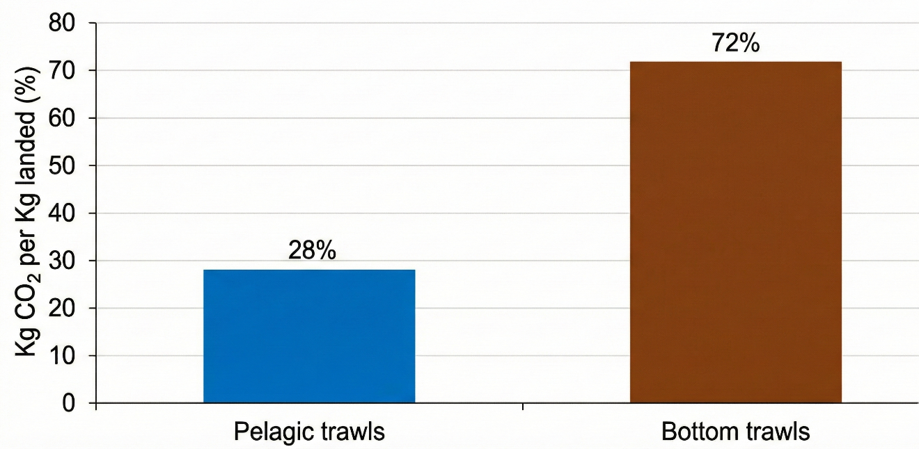

Figure:5 Carbon emission from bottom and pelagic trawler in Europe, North America, Oceania, Africa and Asia

3.4 Indian case studies: vessel size and carbon intensity
Data from Kerala and north-west India reveal strong correlations between vessel size and carbon emissions per unit catch. Sayana and Remesan (2020) documented emissions from trawlers operating out of the Kerala coast. After converting emissions to kg CO₂ kg⁻¹ fish, the authors found that very large trawlers had significantly higher carbon footprints than smaller vessels (Figure 6). Similarly, Devi et al. (2021) evaluated multi-day large (MDL), multi-day medium (MDM) and single-day (SD) trawlers along the north-west coast. Carbon intensities were highest for MDL trawlers, intermediate for MDM trawlers and lowest for SD trawlers. These patterns arise because larger vessels typically use high-powered engines and travel longer distances at greater speeds, resulting in higher fuel consumption. The results suggest that reducing vessel size or engine capacity and optimising trip length could yield significant emissions reductions for Indian trawler fleets (Figure 7).
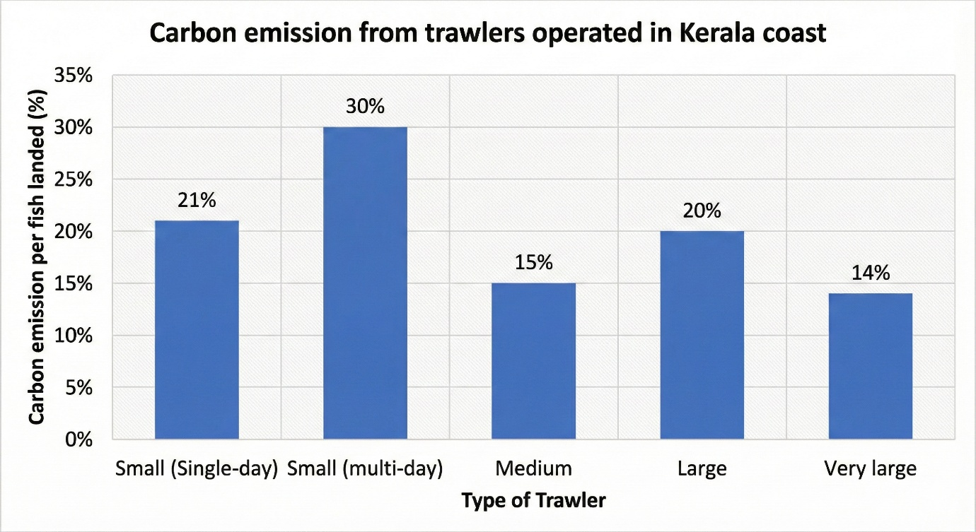
Figure:6 Carbon emission from trawlers operated in kerala coast
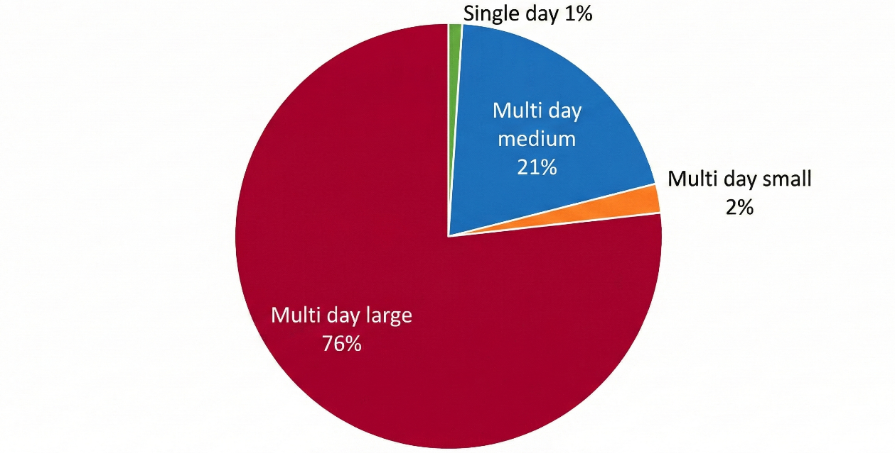
Figure:7 Carbon emission from trawlers operated in North-West coast of India

3.5 Carbon footprint of trawled fish compared with other proteins
Bottom trawling is carbon intensive relative to other fishing methods, its carbon footprint remains lower than that of many terrestrial animal proteins. Sandström et al. (2018) showed that beef, lamb and farmed fish have substantially higher carbon footprints per kilogram of edible product than wild-caught fish. Munoz et al. (2023) compared fuel-based emissions from bottom trawlers with those from pork, lamb and beef. When only fuel combustion is considered, trawl-caught fish emit less CO₂ per kilogram than most land-based meats. However, when the release of carbon from disturbed seabed sediments is included, bottom-trawled fish become the animal protein with the highest CO₂ footprint in the comparison. Even the most efficient bottom trawling fleets exhibit higher emissions per kilogram of food produced than mid-water trawling or many other animal proteins. These findings emphasise the need to reduce seafloor contact in bottom trawling to lower both fuel consumption and sediment-derived emissions.

3.6 Mitigation strategies and management considerations
3.6.1. Improving operational efficiency. Reducing engine revolutions per minute (rpm) by 10–20 % can lead to fuel savings of 20–40 % (Gulbrandsen, 2012). Operating vessels at their economic cruising speeds, installing appropriately sized engines and carrying out preventive maintenance such as cleaning or replacing engine components are low-cost measures that can effectively reduce emissions without requiring major changes to fishing practices. The adoption of energy-efficient harvesting technologies tailored to specific target species can further enhance fuel savings. In the present analysis, implementation of such measures could substantially lower kg CO₂ kg⁻¹ of fish across both Indian and global fishing fleets.
3.6.2. Alternative gears and gear modifications. Switching from bottom trawls to pots, longlines or bottom seines can reduce seafloor impact and fuel consumption. However, these alternatives may not be economically or operationally viable for all target species (Suuronen et al. 2012). For example, pots and longlines work well for cod and sablefish in Alaska but may not be suitable for flatfish or scallops. Nonetheless, gear innovations show promise: electric pulse trawls and illuminated trawls encourage fish to lift off the seabed, reducing both bottom contact and fuel use (Soetaert et al. 2015; Lomeli et al. 2021). Pulse trawling has been shown to reduce mortality of benthic megafauna and lower discards compared with traditional tickler-chain trawls (ICES 2018; Bergman & Meesters 2020). Despite subsequent regulatory bans in some jurisdictions, continued research and refinement of such technologies could provide viable low-impact alternatives in the future.
3.6.3. Spatial management and bycatch reduction. Effective management of trawl fisheries must balance environmental, social and economic objectives. Spatial measures such as no-trawl zones protect vulnerable habitats (e.g. coral reefs, sponge beds and nurseries), while move-on rules combined with tradable quotas can reduce unwanted bycatch (Groenbaek et al. 2023). Territorial use rights and area-based management strategies have shown that focusing effort on dense aggregations of target species increases catch efficiency and reduces the benthic footprint (Bloor et al. 2021). Technologies such as turtle-excluder devices and marine-mammal exclusion devices have drastically reduced bycatch of protected species (Magnuson et al. 1990; Hamilton & Baker 2015), but adoption remains limited due to perceived inconvenience and cost (Suuronen 2022). Broader uptake of these devices would further reduce the collateral impacts of trawling and potentially improve fuel efficiency by reducing gear resistance.
3.6.4. Smart technologies and life-cycle assessments. Recent advances in artificial intelligence (AI), the Internet of Things (IoT) and remote sensing allow real-time monitoring of vessel movements, fuel consumption and bycatch hotspots. AI-based analyses can classify fishing behaviours, optimise routes and improve safety (Cheng et al. 2023). Life-cycle assessment (LCA) tools help identify emission hotspots across gear types and regions, providing the basis for eco-labelling schemes that inform consumers and reward low-impact practices (Ravi et al. 2020). Harmonised LCA studies across different fisheries—and the incorporation of sediment-disturbance emissions—are essential for guiding sustainable dietary choices and policy interventions.

4. Conclusion

This study presents a comparative overview of the carbon emissions from trawl fisheries in India in a global context in light of key differences between regional practices and the very determinants of emissions. The results show that trawling, specifically bottom contact trawls such as otter and beam trawls, is one of the most energy intensive fishing techniques and has carbon footprints from fuel use and release of carbon dioxide from disturbed seabed sediments. In the Indian context, the larger multi-day trawlers have significantly higher levels of carbon emissions per kilogram of fish in comparison with the smaller, single-day vessels, thus highlighting the role of vessel size, engine power, and operational efficiency in the emission outcomes. The comparative assessment of Indian trawl fisheries with those of the rest of the world operating in the Mediterranean, Europe, North America, and Oceania indicates that bottom-contact trawling always has higher carbon intensities than pelagic trawling. This pattern identifies the central importance of gear type and seafloor disturbance as key drivers of carbon emissions in the sector. Furthermore, despite the comparatively lower carbon footprint of trawl caught fish compared to other animal proteins, carbon intensity of bottom trawling is a significant environmental concern, especially considering the impact of seafloor disturbance. Several mitigation strategies have been identified to limit emissions from trawl fisheries. These include improvements to operational efficiency with measures like lowering engine revolutions per minute, vessel speed optimisation, engine down sizing and energy efficient technologies. In addition, innovative gear technologies such as pulse trawling and AI-based monitoring systems - show potential for further emission reductions by minimising fuel consumption and reducing the seafloor impact. In addition, spatial management approaches and bycatch reduction technologies could not only enhance the sustainability of trawl fisheries but also contribute to fuel efficiency and lower carbon footprints. In conclusion, the present study highlights the need for standardized data on carbon emissions from trawl fisheries especially in the Indian context to enable more accurate assessments of their climatic impact and to guide future mitigation efforts. By adopting technological innovations, optimizing operational practices, and implementing targeted management strategies, the carbon footprint of trawl fisheries can be significantly reduced, contributing to the overall goal of reducing the environmental impacts of global fisheries. Further work and collaborations are essential to refine these strategies and ensure their effective implementation in diverse fisheries.

5. Future Scope
The findings highlight several avenues for future work:
- Technological innovations. Development of lightweight, low-resistance trawl designs that minimise seafloor contact; wider adoption of selective gear (e.g. pots, longlines, pulse trawls) to reduce fuel use and bycatch; and exploration of hybrid or electric propulsion systems and renewable fuels.
- Integration of smart technologies. Deployment of AI, IoT and remote-sensing tools for optimising fishing routes, reducing idle time and monitoring fuel use, bycatch and benthic impacts in real time.
- Ecosystem-based and spatial management. Expansion of no-trawl zones in ecologically sensitive habitats; implementation of territorial use rights and area-based management to concentrate effort on dense stocks while limiting habitat damage.
- Policy and market incentives. Strengthening eco-labelling and carbon-footprint labelling to reward sustainable practices and enable low-impact consumer choices; creating carbon credit schemes and financial incentives for fleets adopting fuel-efficient technologies and reduced-impact gear; and fostering international cooperation to harmonise carbon-reduction standards in fisheries.
- Socio-economic transitions. Providing subsidies, training and risk-sharing mechanisms to help fishers transition to alternative gear; diversifying livelihood options for coastal communities to reduce dependence on high-impact bottom trawling.
- Research and LCA. Expanding life-cycle assessments across regions and gear types; conducting comparative studies of carbon footprints across fisheries, aquaculture and terrestrial proteins to guide sustainable diet transitions; and monitoring benthic carbon release under varying trawling intensities to refine climate-impact estimates.
- Global food security and climate synergies. Integrating fisheries research with climate-change adaptation strategies to ensure the resilience of marine food systems and exploring low-carbon seafood and plant-based alternatives as complementary strategies to reduce protein-related emissions.
Disclaimer (Artificial intelligence)
Author(s) hereby declare that NO generative AI technologies such as Large Language Models (ChatGPT, COPILOT, etc.) and text-to-image generators have been used during the writing or editing of this manuscript.
6. References
Bergman, M. J., & Meesters, E. H. (2020). First indications for reduced mortality of non-target invertebrate benthic megafauna after pulse beam trawling. ICES Journal of Marine Science, 77(2), 846–857. https://doi.org/10.1093/icesjms/fsz250
Bloor, I. S. M., Duncan, P. F., Dignan, S. P., Emmerson, J. A., Beard, D., Gell, F. R., McHarg, K., & Kaiser, M. J. (2021). Boom not bust: Cooperative management as a mechanism for improving the commercial efficiency and environmental outcomes of regional scallop fisheries. Marine Policy, 132, 104649. https://doi.org/10.1016/j.marpol.2021.104649
Cheng, X., Zhang, F., Chen, X., & Wang, J. (2023). Application of artificial intelligence in the study of fishing vessel behavior. Fishes, 8(10), 516. https://doi.org/10.3390/fishes8100516
Devi, M. S., Xavier, K. M., Singh, A. S., Edwin, L., Singh, V. V., & Shenoy, L. (2021). Environmental pressure of active fishing method: A study on carbon emission by trawlers from north-west Indian coast. Marine Policy, 127, 104453. https://doi.org/10.1016/j.marpol.2021.104453
Gilman, E., Perez Roda, A., Huntington, T., Kennelly, S., Suuronen, P., Chaloupka, M., & Medley, P. (2020). Benchmarking global fisheries discards. Scientific Reports, 10, 14017. https://doi.org/10.1038/s41598-020-63695-w
Grønbæk, L., Lindroos, M., Munro, G., Pintassilgo, P., & Turris, B. (2023). The avoidance of unwanted catch and cooperation: The case of the British Columbia groundfish trawl fishery. ICES Journal of Marine Science, 80(3), 483–491. https://doi.org/10.1093/icesjms/fsac005
Gulbrandsen, O. (2012). Fuel savings for small fishing vessels – A manual. FAO, Rome. https://www.fao.org/4/i2461e/i2461e.pdf
Hamilton, S., & Baker, G. B. (2015). Review of research and assessments on the efficacy of sea lion exclusion devices in reducing the incidental mortality of New Zealand sea lions Phocarctos hookeri in the Auckland Islands squid trawl fishery. Fisheries Research, 161, 200–206. https://doi.org/10.1016/j.fishres.2014.07.010
Hilborn, R., Amoroso, R., Collie, J., Hiddink, J. G., Kaiser, M. J., Mazor, T., McConnaughey, R. A., Parma, A. M., Pitcher, C. R., Sciberras, M., & Suuronen, P. (2023). Evaluating the sustainability and environmental impacts of trawling compared to other food production systems. ICES Journal of Marine Science, 80(6), 1567–1579. https://doi.org/10.1093/icesjms/fsad115
ICES. (2018). Report of the Working Group on Electric Trawling (WGELECTRA). ICES Report WGELECTRA 2018. https://doi.org/10.17895/ices.pub.8160
Lomeli, M. J., Wakefield, W. W., Herrmann, B., Dykstra, C. L., Simeon, A., Rudy, D. M., & Planas, J. V. (2020). Use of artificial illumination to reduce Pacific halibut bycatch in a U.S. West Coast groundfish bottom trawl. Fisheries Research, 233, 105737. https://doi.org/10.1016/j.fishres.2020.105737
National Research Council. (1990). Decline of the sea turtles: Causes and prevention. National Academies Press. https://doi.org/10.17226/1536
Muñoz, M., Reul, A., Guijarro, B., & Hidalgo, M. (2023). Carbon footprint, economic benefits and sustainable fishing: Lessons for the future from the Western Mediterranean. Science of the Total Environment, 865, 160783. https://doi.org/10.1016/j.scitotenv.2022.160783
Parker, R. W. R., Blanchard, J. L., Gardner, C., Green, B. S., Hartmann, K., Tyedmers, P. H., & Watson, R. A. (2018). Fuel use and greenhouse gas emissions of world fisheries. Nature Climate Change, 8(4), 333-337. https://doi.org/10.1038/s41558-018-0117-x
Ravi, R., Das, P. H., & Edwin, L. (2020). Life cycle assessment-based identification of environmental hotspots in commercial trawl fisheries of Kerala and mitigation strategies. International Journal of Life Cycle Assessment, 25(10), 1952–1966. https://doi.org/10.1007/s11367-020-01774-4
Sainsbury, J. C. (1971). Commercial fishing methods. Fishing News (Books) Ltd.
Sala, A., Damalas, D., Labanchi, L., Martinsohn, J., Moro, F., Sabatella, R., & Notti, E. (2022). Energy audit and carbon footprint in trawl fisheries. Scientific Data, 9(1), 428. https://doi.org/10.1038/s41597-022-01478-0
Sandström, V., Valin, H., Krisztin, T., Havlík, P., Herrero, M., & Kastner, T. (2018). The role of trade in the greenhouse gas footprints of EU diets. Global Food Security, 19, 48–55. https://doi.org/10.1016/j.gfs.2018.08.007
Sayana, K. A., & Remesan, M. P. (2020). Assessment of fuel consumption rate of mechanised trawlers in Kerala, South India. Agro-Economist, 7(1), 51–56. https://agroeconomistjournal.com/
Soetaert, M., Decostere, A., Polet, H., Verschueren, B., & Chiers, K. (2015). Electrotrawling: a promising alternative fishing technique warranting further exploration. Fish and Fisheries, 16(1), 104–124. https://doi.org/10.1111/faf.12047 .
Suuronen, P. (2022). Understanding perspectives and barriers that affect fishers’ responses to bycatch reduction technologies. ICES Journal of Marine Science, 79(3), 1015–1023. https://doi.org/10.1093/icesjms/fsac045
Suuronen, P., Chopin, F., Glass, C., Løkkeborg, S., Matsushita, Y., Queirolo, D., & Rihan, D. (2012). Low impact and fuel efficient fishing: Looking beyond the horizon. Fisheries Research, 119–120, 135–146. https://doi.org/10.1016/j.fishres.2011.12.009
Tyedmers, P. (2004). Fisheries and energy use. In C. J. Cleveland (Ed.), Encyclopedia of energy (Vol. 2, pp. 683–693). Elsevier. https://www.elsevier.com/books/encyclopedia-of-energy/cleveland/978-0-12-176480-7
Watling, L. (2013). Deep-sea trawling must be banned. Nature, 501(7465), 7. https://doi.org/10.1038/501007a
Ziegler, F., & Valentinsson, D. (2008). Environmental life cycle assessment of Norway lobster (Nephrops norvegicus) caught along the Swedish west coast by creels and conventional trawls—LCA methodology with case study. International Journal of Life Cycle Assessment. https://doi.org/10.1007/s11367-008-0002-8
Zhang, Z., Liu, H., Jin, J., Zhu, X., Han, D. and Xie, S., 2024. Towards a low-carbon footprint: Current status and prospects for aquaculture. Water Biology and Security, 3(4), p.100290. https://doi.org/10.1016/j.watbs.2024.100290
OSPAR Commission. (2024). Investigating the effects of mobile bottom fishing on benthic carbon processing and storage: a systematic review protocol. Systematic Review Protocol.​
Lutz, S. J., Heyl, T., & Moustaka-Gouni, M. (2022). The impact of mobile demersal fishing on carbon storage in seabed sediments. Biological Conservation, 269, 109567.​
Markager, S., Andersen, J. H., Carstensen, J., et al. (2021). Physical disturbance by bottom trawling suspends particulate matter and alters biogeochemical processes on and near the seafloor. Frontiers in Marine Science, 8, 683331. https://doi.org/10.3389/fmars.2021.683331​

