“Effects of Indoor Air Pollution and Practical Mitigation through Architectural Elements and Indoor Plants: A Review”
Abstract
Indoor air pollution is the term used to describe the amount of contaminants that is dust,dirt or gasses in the inside air of a house or building.It is not very simple to leave with allergies, asthma or any kind of symptoms related to pollutants. To control these symptoms, one must continually consider the quality of the air he/she inhales. Indoor air quality is much more of an issue when anyone lives in an apartment rather than an individual house. Due to the presence of common walls, lack of cross ventilation, poor building layout and improper installation of architectural units like proper window size, window types, building orientation, window to flooring area ratio, shading, atrium, etc. In apartments, ventilation becomes improper. Contaminants might gather in a small area and may affect the health of inmates exposed to them. Due to an increasing concern on effect of indoor air pollution on helth this topic had been undertaken with the objectives of the inside air contaminants and their effect on health ,to maximize natural ventilation through (ACP) and different architectural elements and role of indoor plants to reduce indoor air pollution.this objectives are addressed with the help of the collected information from secondary data. A fine structured approach has been followed for the selection of authentic sources for this review. The objective of the review was initially defined. From the scholarly database available online are used for systematic searches. The articles are categorized and summarized according to the objectives. The articles from the reputed journals are prioritized for data authentication and included in the article. This research articl will help the researcher from the field of interior design, architecture, house owners and the person who is searching for a new house.
Keywords; Indoor Air Quality, Air changes per hour (ACH), Sick building syndrome (SBS), Architectural elements, Indoor plants.
Introduction
The presence of undesired components in the air (indoor/outdoor) degrades its quality and disrupts its normal composition and chemistry is characterized as air pollution ¹. Chemical, biological, and physical contamination of interior air are all considered forms of indoor air pollution. It may result in adverse health effects ². US Environmental Protection Agency ³ stated a description. It says : “Indoor Air Quality (IAQ) refers to the air quality within and around buildings and structures, especially as it relates to the health and comfort of building occupants”. Number of people devote ninty percent and more of their time inside the house, if the pollutant level of indoor air is more than that of outdoors it affects their health ⁴. Sick building syndrome (SBS) is a problem caused by a decline in fresh air exchange in modern structures. When it comes to living in an apartment, indoor air quality becomes an even larger concern. Particularly the low-price apartments in developing countries are poorly ventilated due to the presence of common walls between two flats that obstructs cross ventilation, poor building layout or plans to build more flats in a limited space, the inappropriate orientation of the building due to lack of open space and improper installation of architectural units like balcony, proper window positioning, wing wall, atrium, wind tower, etc. Because of so many constraints, as discussed, it is also very difficult to make major changes to the structure of the apartment to make it a well-ventilated house. Therefore due to the lack of proper air movement in the apartments, more concentrated irritants or pollutants are deposited in the indoor space and all of these lead to health risks. This becomes more intensified when inmates are suffering from asthma or allergies. The severity of the air quality problems can be reduced up to a certain extent by following some methodologies, but it cannot be removed entirely. This means we have to be vigilant about where we live and the way we manage the air we breathe. The living time duration and the air quality requirement are different for different people inside a house. Some people spend a significant portion of their time indoors like the homemaker, old aged parents and small children, others do not. Some persons require a higher amount of fresh air for breathing those who are suffering from asthma and allergy. In the early years of exposure, people may not be sensitive to IAQ (indoor air quality) issues, but as exposure increases over time, sensitization can develop. The degree to which human needs are addressed may be used to describe the indoor air quality. If few individuals complain about the air quality and there is little risk to their health, it is said to be of good quality.According to the EPA(Environmental protection Agency), indoor air may be up to five times more contaminated than outside air ⁵. The World Health Organization found that air quality has a significant effect on health in one of their investigations. It is mentioned that polluted indoor air-breathing may create severe health issues without any indicating signs ⁶ . Commonly the quality or quantity of air circulating through the apartments cannot be controlled, as it is particularly challenging to get optimum ventilation in the apartments since many of them have ventilation systems that exchange air between every unit in the complex.
Methodology :
In this review article, a systemetic seach strategies was developed for the complete coverage of objective based output. To achive the objectives of the indoor air pollutants sources and their impact on occupant health, to maximize the natural ventilation through different architectural elements and the role of indoor plants to reduce indoor air pollution. The objectives wise litreture were searched from scholarly database available online and the data were compailed and summerise according to the article’s objectives.

The problem faced by poor indoor air quality (IAQ).
Problems with indoor air quality can be caused by a variety of factors, including a building's construction materials, furnishings, activities inside the structure, the outside environment, combustion emissions from the kitchen, and the building's occupants. A few significant interior environment related factors include insufficient temperature, humidity, poor air circulation, and problems with the ventilation system, among others. Contaminants include chemicals, dust, mould or fungi, bacteria, gases, vapours, odours, and inadequate outdoor air intake can pollute the interior air. These indoor air pollutants, such as carbon dioxide (CO2) from cooking, cigarette smoke, perfume, and body odour, are gathered from building inhabitants 7. The internal air can also be infectious by building materials like dust, fiberglass, asbestos, gases, including formaldehyde, etc, and also from the fumes, vapours, and odours that come from the off-gas emissions from paint, carpeting, and furniture8. The internal air may become toxic for the inmates because of the combining different solvents, insecticides, disinfectants, glues, and volatile organic compounds (VOCs) etc with fresh air. Additionally, carpets, textiles, and foam chair cushions create dust and mites, which might affect health of the peoples.From the damp areas and stagnant water, microbial contaminants such as fungi, molds and bacteria are formed. These microorganisms cause severe health problems in winter when the atmosphere is dry which inducing to dry and crack skin. The microorganisms enter through the cracked skin and create infections. An adequate increase in humidity in the winter season may solve this issue. In winter, usually, the relative humidity is under 10-20 percent. With the help of the humidification process, the relative humidity may increase up to 20–30 percent, which may be advantageous according to the REHVA guidance paper 9. Higher than 30 percent of relative humidity may not provide any extra advantages, rather it may raise the hazards associated with moisture condensation. Ozone is also an indoor air contaminant that is produced from photocopiers, electric motors, and electrostatic air cleaners, etc. Acute exposure to O3 impairs pulmonary function, reduces exercise tolerance, and inflames the airways in both healthy and those with pre-existing airway illness (ie, asthma, chronic obstructive pulmonary disease)10. Around 3.8 million individuals die prematurely each year as a result of indoor air pollution. Pneumonia is responsible for 27% of these 3.8 million fatalities. 18% of people suffer from stroke issues. Ischemic heart disease affects 27% of the population. 20% of people suffer from COPD (chronic obstructive pulmonary disease). Lung cancer affects 8% of the population6. It is difficult to measure indoor air quality because of the non-availability of proper standards or metrics and unaware of what constitutes a favorable IAQ. Even at very low concentrations, indoor pollutants can have an effect on people's health and wellbeing.The vast spectrum of health effects linked to indoor pollution exposures, as well as the reality that different persons are affected differently by the same pollutant. Indoor air pollution has been established to have significant health impacts on long term and short term besis, and it is considered to be the cause of 4.3 million deaths per year 11. There are a variety of causes that might cause indoor air pollution. Some of which are easily identifiable but many more that go unnoticed. Poor indoor air quality contributes significantly to worldwide health concerns and results in multimillion-dollar losses. Currently, no single physical-chemical method can efficiently solve all difficulties.¹²
Table 1 given below is the summary of many studies which was published by various authors containing the impact of indoor air pollutants on the health of the inmate present in the polluted indoor air environment.
Table-1: Indoor air pollutants and its impact on health.
Pollutant | Health risk | Sources | Accepted levels | Studies by
Radon | lungs cancer | Underlying soil gas, rocks and soils, construction materials, water, and airtightness of the building's .  Radon can get into buildings through gaps around pipes or cables, floor or wall fractures, microscopic pores in hollow-block walls, cavity walls, or sumps or drains. | 300 Bq/m3 - International Commission on Radiological Protection (ICRP)  100 Bq/m3-World Health Organization (WHO) .  200 Becquerels per cubic metre (200 B/m³)- | ¹³, ¹⁴, ¹⁵
methane and carbon dioxide | Asphyxiation | Gases from Landfill and Waste Sites | Methane- 1,000 ppm (0.1 percent)  CO₂₋ not more then 600 ppm. | ¹⁶
Carbon monoxide (CO) | Increases the risk of lung cancer and causes irritation and discomfort of the mucous membranes of the eyes, nose, and throat.  prevents the blood from carrying oxygen to the heart, brain, and other organs.  Additionally, cardiovascular illness, behavioral impairment, headaches, weariness, and impaired reflexes can all be caused by CO exposure, as can effects on fetuses' and newborns. | From wood stoves, penetration of combustion gases from garages, and environmental cigarette smoke. From coal and kerosene heaters. | 50 (ppm) parts of air (55 mg/m3)- Occupational Safety and Health Administration (OSHA)  35 ppm (40 mg/m³) -- National Institute for Occupational Safety and Health (NIOSH)  25 ppm (29 mg/m³) as a TWA for a normal 8-hour work a day. - American Conference of Governmental Industrial Hygienists (ACGIH) | ¹⁷, ¹⁸, ¹⁹
Nitrogen dioxide (NOx). | Respiratory system damage, asthma, respiratory infections, chronic obstructive pulmonary disease, cerebrovascular and neurodegenerative illnesses, and signs of attention deficit hyperactivity disorder (ADHD). | fossil fuel combustion at high temperatures, gas kitchen equipment, and unvented home water heaters. | 13–62 μg/m³ indoors, 27–36 μg/m³ at the workplace  180–2500 μg/m³ gas cooking and heating- in European and North America homes  (43–81 μg/m³) - in Asia. | ², ²⁰, ²¹, ²²
formaldehyde | Eye irritation, burning in the eyes, nose, and throat, coughing, wheezing, nausea, and watery eyes are all symptoms of this human carcinogen. | Building materials and household products.  It is used in glues and adhesives, permanent-press textiles, paper product coatings, pressed-wood products including particleboard, plywood, and fiberboard, as well as glues and insulating materials.  Fuel-burning devices that don't have vents, such kerosene heaters, gas stoves, and wood stoves, can release smoke from cigarettes. | 0.1 ppm (100 ppb) - indoor air level | ², ²³
Trichloroethene | Effects on the CNS, reproductive system, immunological system, and may have an impact on a pregnant woman's ability to carry a child. neuro-, hepato-,and/or nephrotoxicity, human carcinogen, systemic sclerosis and pulmonary veno-occlusive disease. | Paint, building materials, furniture, fabricated metals, adhesive solvents, and dry cleaning. | 25ppm (135mg/m3) - work environments.  25-50ppm (135-270μg/m3) - general environment. | ²⁴, ²⁵, ²⁶, ²⁷
ssTotal VOC (TVOC) other than formaldehyde | Inflammation of the nose, mouth, and eyes  nausea, improper coordination of body and mind, and headaches,  damage to the central nervous system, liver, and kidneys. | Wood preservatives ,paints, paint strippers, and other solvents, cleaners, , mothballs, air fresheners and automotive items, building meterials, pesticides, furniture, copiers, printers, carbonless copy paper, correction fluids,permanent markers and glues. | < 0.3 mg/m³⁻ Low  0.3 to 0.5 mg/m³⁻ Acceptable  0.5 to 1 mg/m³ -Marginal  1 to 3 mg/m³ -High | ¹⁰
Humidity | Asthma and bronchitis are prevalent, there is a feeling of dryness and irritation on the skin and mucous membranes, and there is excessive perspiration. | Weather conditions, Moist areas, air condition | 30 to 50%,-For indoors is when the outside temperature is > 20°F and <30% of relative humidity. | ²⁸, ²⁹, ⁹
micro-organisms(mold, bacteria, viruses and fungi) | Humidifier fever, allergic and hypersensitive reactions, weakened immune systems. Asthma, rhinitis and lung diseases, PM2.5 microorganisms cause a rise in cardiac disease, death, and diabetes mellitus. | Moisture, ventilation, furniture, people, animals, and plants, as well as construction materials used for building décor and air conditioning systems. | 103 CFU m^{–3} -Residence  102 CFU m^{–3 -} Office | ³⁰, ¹⁰
Pesticides | Malignant Tumour, Genetic changes, blood and nerve disorders, Endocrine Disruption, Reproductive effects. | Consumer products, dust from outside. used indoors against insects. | Use pesticide products in accordance with the manufacturer's application and ventilation guidelines. | ²⁶, ³¹
Lead | The foetal nervous system is impacted by lead toxicity, which also causes brain swelling, memory loss, and muscle and joint pain, learning disabilities, hyperactivity, and even mental retardation. | Batteries, radiators, painted surfaces, waste incinerators, anwaste waterways all suffer wear and tear. | 50 µg/m³ - workplace (8-hour)  30 µg/m3 -for more than 30 days per year. | ³²
Hydrocarbons | Oxidative stress, innate and adaptive immune systems are responsible for inflammation. malfunction of the epithelium and endothelium, constriction of the smooth muscles, improper lung development and Nervous system dysfunction and tumour. | Smoking cigarettes, using other organic materials as fossil fuels, and incomplete coal combustion ,close to busy roads or in the vicinity of petrol filling stations. | Total particle mass-20–30% | ¹⁰, ³³

Apartments often have fewer windows than individual homes, lack of cross-ventilation due to common walls, or widow in one wall only, nowadays almost every apartment has sliding windows which allow only 50% of airflow than the actual size of the window which increases the possibility of inadequate air circulation. This may indicate that there is no natural air movement in addition to having fewer air vents. To keep the temperature at a reasonable level and to avoid accumulation of dust and mold, free-flowing air is a crucial element of healthy air. Humidity makes the air sluggish, which traps the dust particles (along with other air pollutants). Small flats frequently contain linked bathrooms and laundry facilities, as well as bathrooms without windows. It can be particularly difficult to maintain these "wet rooms" to dry and mold and mildew-free when they are near to one another. A healthy air environment depends on several variables. By taking care of different components, proper air circulation can be achieved.
Ways to Improve the indoor air quality
Although inmates won't be able to completely eradicate all the indoor pollutants but it is important to know various factors that cause indoor air pollution. So that it will help to decide what safety measures to take. The air quality can be improved by three basic strategies; one is (i) Source Monitoring, then (ii) Imroved ventilation through ACH (Air changes per hour), and (iii) Imroved ventilation through the introduction of architectural elements in design and finally by cleaning the air.
i. Source Monitoring
The best way to improve indoor air quality is typically to reduce or remove specific sources of pollution. It is possible to cover or enclose some sources, such as asbestos-containing ones, while modifying others, such gas stoves, to produce fewer emissions. Another less expensive method of preserving indoor air quality is source management.Understanding emission processes, obtaining emissions data relevant in manufacturers' product development, and data valuable for architects and others who pick building materials and other items that are sources of indoor air pollution are all necessary for effective source management.
ii. Improve ventilation through (ACH).
A properly ventilated room can be optimized to potentially reduce infection risk to occupants and it can be possible only by improving air changes per hour (ACH). The majority of research on infectious disease and particle transmission has focused on ACH and how ACH acts as a dilution factor for potential infectious agents. The rate at which interior air is replaced by outside air is known as the air exchange rate. A minimum of 15 cubic feet per minute (cfm) per person is received in the home, however air changes are 0.35 per hour.In order to achieve an acceptable IAQ for people living there while limiting detrimental health effects, residential constructions must have minimum ventilation rates.34 The movement of things in rooms, such as people or doors, has an impact on the distribution of contaminants in indoor air as well. It must be emphasized that determining an air change rate (ACR) for a structure is a difficult and expensive task. Tracer gas can also be used to assess the success of pollution clearance. The air change rate is usually calculated by looking at how rapidly tracer gas concentrations in a room decline once the source of the gas emissions is turned off or removed. The greater the gas concentration decay rate, the faster it decays. Insufficient air change rates lead to increased air humidity and carbon dioxide concentrations. A typical metric for measuring the effectiveness of ventilation and the quality of indoor air is air-exchange efficiency (AEE) . In a residential building according to its utility for different rooms different ACH is provided by the Indian standard code 35. A minimum of three air changes per hour should be delivered in living areas
and bedrooms. To remove the steam, heat, smell, and fumes produced during cooking and to prevent an excessive rise in temperature and humidity, a large amount of air is required. However, a minimum rate of ventilation of about six air changes per hour is required in a kitchen where cooking is done for a family of not more than five people.The study by Koenig says that the majority of the dangerous substances found in tobacco smoke are also present in solid fuel smoke. Additionally, it has been connected to a number of illnesses, including as lung cancer in women exposed to coal smoke, respiratory infections in children, and COPD in women. ³⁶
After usage, restrooms and water closets should be well ventilated, with the equivalent of six air changes per hour being given. Because the length of occupation of like passages, and lobbies, are so brief, no particular precautions are required. To remove the transmission of air-borne diseases also the recent SARS-CoV-2 we need 4 to 6 air changes per hour in the indoor space like retail shops, homes if guests are visiting, classrooms, etc. A graph below shows in (Fig-1), Air changes per hour (ACH) and the amount of time needed to remove airborne contaminants, according to efficiency.³⁷ .
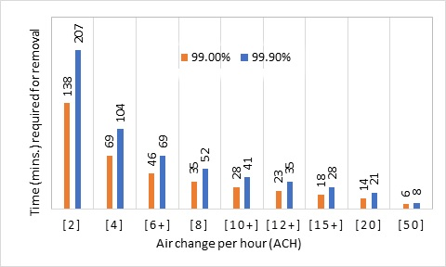
Fig-1 Air changes per hour (ACH) and the amount of time needed to effectively remove airborne contaminants. Environmental Infection Control in Healthcare Facilities: Guidelines (2003)
This graph is clearly showing that at 2 ACH, it takes 138 minutes for the removal of 99% airborne contaminant and 207 minutes is needed for removing 99.9% of contaminant. At 4 ACH, to remove 99% airborne contaminant, the time needed is 69 minutes and to remove 99.9%, 104 minutes is needed. Similarly at 6 ACH, for removal of 99% and 99.9% the time needed is 46 and 69 minutes respectively and so on. In the above graph it is mentioned that as the air change per hour increases, the time required for removal of airborne-contaminant decreases i.e. at 8 ACH, to remove 99%, 35 mins time is required and for the removal of 99.9% polluted air, 52 minutes is required and so on.
Table 2: .Architectural elements and their use to maximise natural ventilation
Architectural eliments | Image | Characteristic | Studies by
Window size, type and configuration | 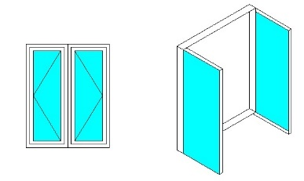 | Casement windows are the best for getting the most airflow possible. They consist of a single, fully opening sash. It can efficiently direct and manage breezes , which can exhaust stale indoor air by using the entire window opening.The wind passed through the window at an angle between 0° and 45°, which produced the best results. The maximum rates were attained when the wind travelled obliquely in the (45°) direction while construction. When the wind is 90 degrees parallel to the openings, the performance is the lowest because the interior airflow is moving at a lower velocity. Good ventilation can be encouraged by windows facing south, however velocity reduces as outlet window size or area increases in comparison to inlet window. | ³⁸
Window to floor ratio (WFR) | 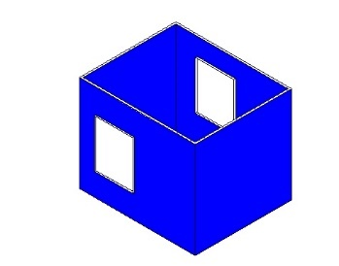 | The total window area should be less than 25 percent of the total floor area of the house. | ³⁹
Wing walls | 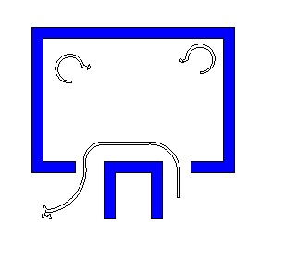 | The provision of a balcony with wing walls can be a façade design alternative to improve indoor ventilation and possibly reduce energy consumption in buildings. wing wall of the window height is sufficient for achieving 80 % of the inlet velocity achievable with a full-height wing wall and inverted ‘L’ configuration increase 9% in average inlet velocity. | ⁴⁰
Shading | 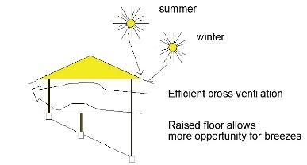 | Adding shade to the tops of apertures, particularly on the east and west sides improves the ventilation of the house. | ⁴¹
Building orientation | 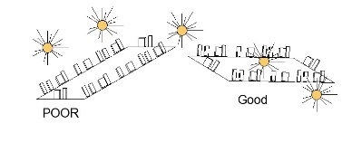 | The building should be placed so that it faces the direction of the dominant wind and sun angles. | ²⁹
Size of apertures and windows | 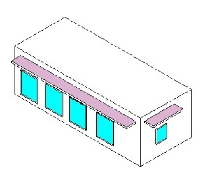 | On the east and west sides, which get twice as much radiation as the north-south elevations, openings and windows should be kept modest | ⁴²
Form and shape of architectural plan | 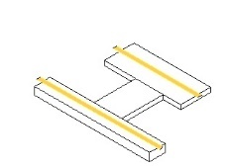 | Longitudinal ends of the buildings should be as small as practicable and parallel to the east-west axis. | ⁴³
Corridors | 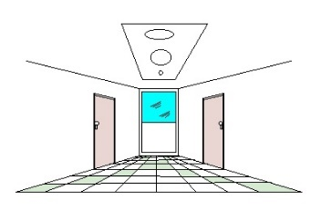 | Corridors are an example of an architectural element that connects isolated interior spaces to the outside environment to enable cross ventilation in buildings.Corridors are important for directing and distributing airflow into different portions of a structure. | ⁴⁰
Dome roof |  | A spherical structure is more energy-efficient than a typical cubic structure in terms of heating and cooling needs.  As a result, a dome home has 30% less surface area than a box house of comparable size, which results in 1/3 less heat transfer to and from its surroundings and 30% less cooling expense. | ³⁹
Balconies | 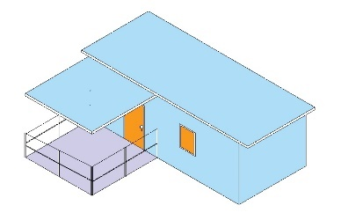 | The addition of an open balcony to single-sided ventilation enhances the ventilation performance. | ³⁹
Wind tower | 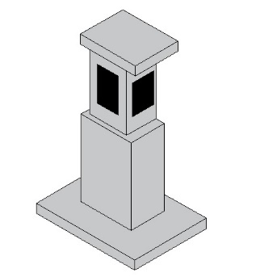 | Wind towers can reduce the amount of electricity consumed to offer thermal comfort throughout the summer months, particularly during peak hours. | ⁴⁴
Wall grooves | 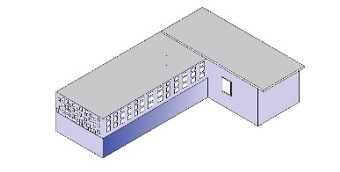 | Improved natural ventilation in buildings is made possible by the use of wall grooves in home design. | ⁴⁴
Atrium | 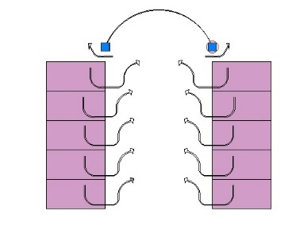 | By linking the story outlet to the external via a tall atrium, ventilation in stories with low ceiling heights is frequently improved. | ⁴⁵
Vegetation surrounding the building. | 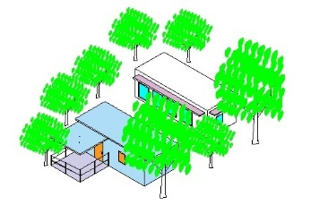 | By strategically planting in the landscape to direct breezes, air can be sent into the building to cool it. | ⁴¹

Indoor air plant is a promising economical solution for cleaning the air naturally
Densely inhabited regions that stretch for kilometers from metropolitan centers have replaced much of nature's beautiful charm by introducing the plants in the interior. This visual pollution has an impact on all of us and makes us create a closer relationship with nature. We spend around 90% of our time indoors ⁴⁶.
Interior plants are an excellent method to create appealing and relaxing environments while also improving our overall well-being. Furthermore, houseplants may be a relaxing activity that also helps to filter the air in our homes. Indoor plants not only convert CO₂ to oxygen but also trap and absorb a variety of contaminants ⁴⁷. Plants are another approach to lower CO₂ levels in interior surroundings. As part of their natural life process, plants photosynthesize in surroundings with sufficient light and heat. For photosynthesis, they absorb CO₂ from the environment through their stomas. As a result, they consume CO₂ for photosynthesis, resulting in a decrease in CO₂ levels in the environment. When the climate is conducive to plant development, plants produce oxygen and absorb CO2 ¹⁰. A study in a space stations on plants to clean the air in was done and found that common greenery plants were resulting to lower levels of many indoor pollutants, such as carbon monoxide and formaldehyde, in asmall enclosed test chambers. The majority of the reduction in pollutants was caused by bacteria that was growing on plant roots ⁴⁷. Many indoor air contaminants, such as ozone, toluene, and benzene, are removed by plants, according to a study ⁴. In indoor areas,.Some people worry that inside plants would raise relative humidity too high, although this is unlikely: as relative humidity rises, the rate of water loss from the plant slows down because water does not evaporate as quickly at high humidity ¹⁰.
Even in the middle of the room, many meters away from the plants, diposition of particulate matter is reduced by 20% after adding plants to the exterior of the building or rooms. Self-watering pots contained the plants, this types of poted plant surface become quite dusty and dry as water is not added to the plant directly. Studies showing that indoor plants were associated to reduced dust in such conditions ¹. Depending on the frequency, plants can absorb, reflect, or diffuse, sound. Plants have been demonstrated to reduce noise under certain circumstances. Plants were shown to be the most effective in reducing high-frequency noises in rooms with hard floors, with an effect equivalent to that of adding a carpet.Houseplants have been dubbed "nature's life support system" by NASA, and they play a crucial role in improving indoor air quality. They take in not just carbon dioxide from the air, but also CO2-binding particles. Furthermore, it has been revealed that soil microorganisms may remove volatile organic compounds from the air ⁴. Table -2 represents different house plants that remove different pollutants present in the indoor environment.
Table-3: Indoor plants help in removing indoor air pollutants.
Name of the indoor plants. | image of the indoor plants. | Pollutant Remove | Studies by
Boston fern. (Nephrolepis exaltata) | 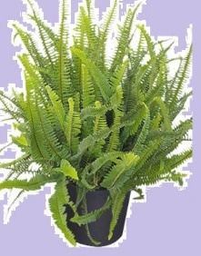 | Releases an abundant amount of moisture into the air. Remove Formaldehyde, Toluene, xylene, benzene and formaldehyde. | ⁴⁸, ⁴⁹
Areca palm. (butterfly palm), Dypsis lutescens |  | Releases an abundant amount of moisture into the air. Remove Formaldehyde, Toluene and xylene, benzene and formaldehyde. | ⁵⁰
Bamboo palm, Chamadorea elegans or C. erumpens | 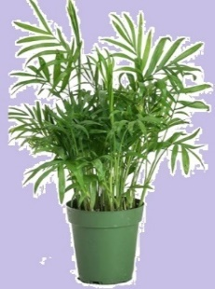 | Releases an abundant amount of moisture into the air. Remove Formaldehyde, Toluene and xylene, benzene and formaldehyde. | ⁵¹
Dwarf date palm. (Phoenix roebelenii) | 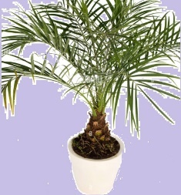 | Trichloroethylene. | ⁵², ⁵³
English ivy (Hedera helix) | 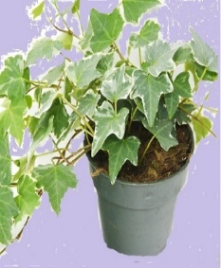 | Benzene, Formaldehyde, Toluene and xylene, Ammonia and Hydrocarbon. | ¹⁰
Spider plant (Chlorophytum comosum) | 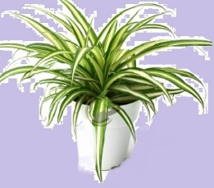 | Ozone, Toluene and xylene, Formaldehyde, Hydrocarbon | ⁵⁴, ⁵⁵
(Epipremnum aureum) |  | Benzene, Toluene and xylene, Formaldehyde, Trichloroethylene and carbon monoxide. | ⁵⁶
Chinese Evergreen (Aglaonema modestum) | 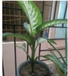 | Formaldehyde and benzene | ⁵⁷
Gerbera Daisy or Gerbera jamesonii |  | Benzene | ⁵⁸
Dragon Tree or Dracaena marginata | 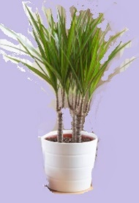 | Xylene, trichloroethylene, and formaldehyde. | ⁵⁹, ⁶⁰
Mother-in-Law's Tongue or Sansevieria trifasciata 'Laurentii' |  | Formaldehyde, xylene and nitrogen oxides | ⁶¹
Pot Mum (Chrysanthemum morifolium) |  | Benzene, formaldehyde, benzene and xylene. | ⁶²
Peace Lily (Spathiphyllum 'Mauna Loa') |  | Formaldehyde and carbon monoxide. | ¹⁰, ⁶³
Mass Cane/Corn Plant (Dracaena fragrans 'Massangeana') |  | Formaldehyde | ⁶⁴
Rubber Tree (Ficus elastica) |  | Carbon dioxide | ⁴⁷
Lemon Button Fern Nephrolepis cordifolia | 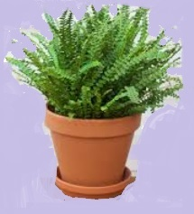 | Formaldehyde, xylene, and toluene  combats winter dryness by raising indoor humidity | ⁵³
Philodendron (Philodendron hederaceum) | 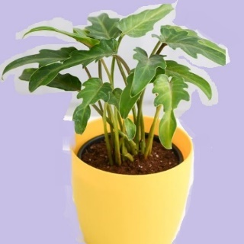 | Formaldehyde | ⁵²
Parlor Palm (Chamaedorea elegans) | 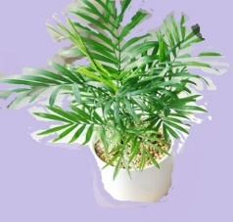 | Benzene and trichloroethylene | ⁵²
Aloe vera (Aloe barbadensis Miller) |  | Benzene and formaldehyde | ⁶⁵
Broad Lady Palm (Rhapis excelsa) | 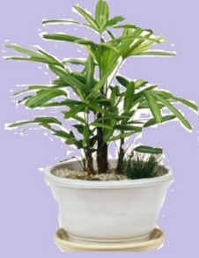 | Nitrogen oxide, ammonia, xylene and toluene, benzene, formaldehyde. | ⁶⁶
Fittonia 'Frankie' (Fittonia argyroneura) | 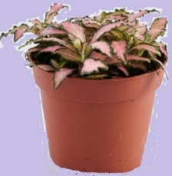 | Benzene,toluene and trichloroethylene. | ⁶⁷
Ficus (Ficus benjamina) | 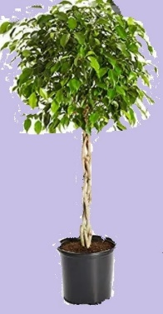 | Xylene and formaldehyde. | ⁵
Flamingo Lily (Anthurium andraeanum) | 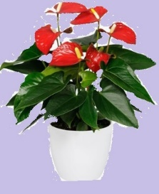 | formaldehyde , toluene, ammonia, and xylene. | ⁵³

Some plants are more effective than others at eliminating VOCs. However, none of the plants can operate when the effects of a large environment are taken into consideration.where as, some study concluded that potted plants provide only limited whole room air quality improvement. And Indoor plants are suggested as a passive method for enhancing indoor air quality studied by Omed A etal⁶⁸ However,research finding concluded even in a small flat, some of the houseplants truly enhance the quality of air, something only the most committed plant enthusiasts can do. ⁶⁹ VOCs might be removed from an airtight laboratory setting using houseplants. On the other hand, A house, is not a sealed tight chamber⁷⁰ Numerous scientific research has been conducted on the interactions between humans and plants, both indoors and outdoors. There are numorus advantages of indoor air plans which includes improved air quality, stress level decreased, recovery from sickness is accelerated, mental weariness is reduced, and productivity is increased.
Conclusion:
It is difficult to modifaiy the door window confugaration for ventilation and indoor pollutant mitigation in flats of an apartment due to its predesigned plan. However, minor architectural elemental modification and specific indoor plant position can greatly improve the ventilation and mitigation of indoor pollutants. In this review article, basically data are collected from various research article and summerized according to the two objectives. The comprehensive conclusion of the article given as follows.
- There are different factors which causes problems in indoor air qualities like building meterials,furnishings,activities inside and outside the buildings ,combustion emmitions from the kitchen,interior environment like temperature,humidity,poor air circulation ,contaminants and indoor air pollutants.
- This article suggeated that numbers of different pollutants present in indoor air leades to mild or severe health complications on different organs of the body of the members who live in the indoor environments with these pollutants for a long time.
- To ensure appropriate IAQ for human occupants, it is advised that the minimum air changes each hour should not be less than 0.35 cubic feet and not more than 15 cubic feet per minute per person.
- Some architectural elements allow better air flow and natural ventilation.Among all window types casement window which opens at 0 to 45 degree give best air flow, Balcony with wing walls ,shading to the east and west side of the apertures, lage opening at west and east side in form of window,corridors,dome roof and balcony.
- Many research has shown that indoor plants clean the pollutants of indoor space, vitalize our mental health, improve our physical health, and make our indoor a safer place to live.
Ethical issues
No human-subjects research is reported, and no ethical issues are apparent. The review uses secondary literature only.
Disclaimer (Artificial intelligence)
Author(s) hereby declare that NO generative AI technologies such as Large Language Models (ChatGPT, COPILOT, etc.) and text-to-image generators have been used during the writing or editing of this manuscript.

References
1. Chauhan P, Rawat M, P G. Role of Plants in Indoor Air Remediation. International Journal of Engineering Technology Science and Research. 2017;4(9)756.
2. Yin H, Liu C, Zhang L, Li A, Ma Z. Measurement and evaluation of indoor air quality in naturally ventilated residential buildings. J Indoor Built Environment. 2019;28(10):1307-1323.
3. da Graça GC, Linden P. Ten questions about natural ventilation of non-domestic buildings. J Building Environment. 2016;107:263-273.
4. Jung C, Awad J. Improving the IAQ for learning efficiency with indoor plants in university classrooms in Ajman, United Arab Emirates. J Buildings. 2021;11(7):289.
5. Kim H-H, Park J-W, Yang J-Y, et al. Evaluating the relative health of residents in newly built apartment houses according to the presence of indoor plants. J Journal of the Japanese Society for Horticultural Science. 2010;79(2):200-206.
6. WHO Fs. Household Air Pollution and Health. WHO Media Centre, https://wwwwhoint/news-room/fact-sheets/detail/household-air-pollution-and-health. 2014;
7. Spengler JD, Chen Q. Indoor air quality factors in designing a healthy building. J Annual Review of Energy the Environment. 2000;25(1):567-600.
8. Wargocki P. The effects of ventilation in homes on health. J International Journal of Ventilation. 2013;12(2):101-118.
9. Schuit M, Ratnesar-Shumate S, Yolitz J, et al. Airborne SARS-CoV-2 is rapidly inactivated by simulated sunlight. J The Journal of infectious diseases. 2020;222(4):564-571.
10. Han K-T, Ruan L-W. Effects of indoor plants on air quality: A systematic review. J Environmental Science Pollution Research. 2020;27(14):16019-16051.
11. Escombe AR, Oeser CC, Gilman RH, et al. Natural ventilation for the prevention of airborne contagion. J PLoS medicine. 2007;4(2):e68.
12. González-Martín J, Kraakman NJR, Pérez C, Lebrero R, Muñoz R. A state–of–the-art review on indoor air pollution and strategies for indoor air pollution control. J Chemosphere. 2021;262:128-376.
13. Radan M, Dianat M, Badavi M, Mard SA, Bayati V, Goudarzi G. Gallic acid protects particulate matter (PM10) triggers cardiac oxidative stress and inflammation causing heart adverse events in rats. J Environmental Science Pollution Research. 2019;26(18):18200-18207.
14. Mansouri Z, Dianat M, Radan M, Badavi M. Ellagic acid ameliorates lung inflammation and heart oxidative stress in elastase-induced emphysema model in rat. J Inflammation. 2020;43(3):1143-1156.
15. Dianat M, Radan M, Badavi M, Mard SA, Bayati V, Ahmadizadeh M. Crocin attenuates cigarette smoke-induced lung injury and cardiac dysfunction by anti-oxidative effects: the role of Nrf2 antioxidant system in preventing oxidative stress. J Respiratory research. 2018;19(1):1-20.
16. European Commission JRC. Indoor air quality and its impact on man. total volatile organic compounds (TVOC) in indoor air quality investigations, Publications Office. 1997;
17. Raub JA, Mathieu-Nolf M, Hampson NB, Thom SR. Carbon monoxide poisoning—a public health perspective. J Toxicology. 2000;145(1):1-14.
18. Fierro MA, O’Rourke MK, Burgess JL. Adverse health effects of exposure to ambient carbon monoxide. J University of Arizona Report. 2001;
19. Levy RJ. Carbon monoxide pollution and neurodevelopment: a public health concern. J Neurotoxicology and teratology. 2015;49:31-40.
20. Chen T-M, Kuschner WG, Gokhale J, Shofer S. Outdoor air pollution: nitrogen dioxide, sulfur dioxide, and carbon monoxide health effects. J The American journal of the medical sciences. 2007;333(4):249-256.
21. Erisman J, Schaap M. The need for ammonia abatement with respect to secondary PM reductions in Europe. J Environmental Pollution. 2004;129(1):159-163.
22. Brentrup F, Küsters J, Lammel J, Kuhlmann H. Methods to estimate on-field nitrogen emissions from crop production as an input to LCA studies in the agricultural sector. J The international journal of life cycle assessment. 2000;5(6):349-357.
23. Hoskins JA. Health effects due to indoor air pollution. Survival and Sustainability. Springer; 2010:665-676.
24. Kaneko T, Wang P-Y, Sato A. Assessment of the health effects of trichloroethylene. J Industrial Health. 1997;35(3):301-324.
25. Chiu WA, Caldwell JC, Keshava N, Scott CS. Key scientific issues in the health risk assessment of trichloroethylene. J Environmental health perspectives. 2006;114(9):1445-1449.
26. Scott CS, Cogliano VJ. Trichloroethylene health risks--state of the science. J Environmental health perspectives. 2000;108(suppl 2):159-160.
27. Caldwell JC, Keshava N. Key issues in the modes of action and effects of trichloroethylene metabolites for liver and kidney tumorigenesis. J Environmental Health Perspectives. 2006;114(9):1457-1463.
28. Kong D, Liu H, Wu Y, Li B, Wei S, Yuan M. Effects of indoor humidity on building occupants’ thermal comfort and evidence in terms of climate adaptation. J Building Environment. 2019;155:298-307.
29. Dash M, Chakraborthy M. Bio Climatic Analysis of Bhubaneswar-An Investigation to Arrive Human Comfort through Natural Ventilation. International Journal of Scientific and Research Publications. 2016;6(5):4.
30. Chen H, Du R, Ren W, Zhang S, Du P, Zhang Y. The microbial activity in PM2. 5 in indoor air: as an index of air quality level. J Aerosol Air Quality Research. 2021;21(2):200101.
31. Radan M, Dianat M, Badavi M, Mard SA, Bayati V, Ahmadizadeh M. The Association of Cigarette Smoke Exposure with lung cellular toxicity and oxidative stress: the protective role of Crocin. J Inflammation. 2020;43(1):135-145.
32. Zuraimi M, Tham K, Chew F, Ooi P. The effect of ventilation strategies of child care centers on indoor air quality and respiratory health of children in Singapore. J Indoor air. 2007;17(4):317-327.
33. Chiu WA, Jinot J, Scott CS, et al. Human health effects of trichloroethylene: key findings and scientific issues. J Environmental health perspectives. 2013;121(3):303-311.
34. Silva AS, Ghisi E, Lamberts R, Environment. Performance evaluation of long-term thermal comfort indices in building simulation according to ASHRAE Standard 55. J Building
2016;102:95-115.
35. Aflaki A, Hirbodi K, Mahyuddin N, Yaghoubi M, Esfandiari M. Improving the air change rate in high-rise buildings through a transom ventilation panel: A case study. J Building Environment. 2019;147:35-49.
36. Koenig JQ. Health Effects of Indoor Air Pollution. J Health Effects of Ambient Air Pollution: How safe is the air we breathe? 2000:195-212.
37. Chinn RY, Sehulster L. Guidelines for environmental infection control in health-care facilities: recommendations of CDC and Healthcare Infection Control Practices Advisory Committee (HICPAC). report. Morbidity and mortality weekly report. 2003;53
38. Nalamwar MR. Effect of Windows Sizes on Air Circulation inside Building using CFD Simulation. 2017:
39. Soleimani Z, Calautit JK, Hughes BR. Computational analysis of natural ventilation flows in geodesic dome building in hot climates. J Computation. 2016;4(3):31.
40. Ghadikolaei FM, Ossen DR, Mohamed MF. Effects of wing wall at the balcony on the natural ventilation performance in medium-rise residential buildings. J Journal of Building Engineering. 2020;31:101316.
41. Perini K, Pérez G. Ventilative cooling and urban vegetation. Innovations in Ventilative Cooling. Springer; 2021:213-234.
42. Yin W, Zhang G, Yang W, Wang X. Natural ventilation potential model considering solution multiplicity, window opening percentage, air velocity and humidity in China. J Building Environment. 2010;45(2):338-344.
43. Lomas KJ. Architectural design of an advanced naturally ventilated building form. J Energy Buildings. 2007;39(2):166-181.
44. Sudhakar K, Winderl M, Priya SS. Net-zero building designs in hot and humid climates: A state-of-art. J Case Studies in Thermal Engineering. 2019;13:100400.
45. Holford JM, Hunt GR. Fundamental atrium design for natural ventilation. J Building environment. 2003;38(3):409-426.
46. Claudio L. Planting healthier indoor air. National Institute of Environmental Health Sciences; 2011.
47. Cetin M, Sevik H. Measuring the Impact of Selected Plants on Indoor CO 2 Concentrations. J Polish Journal of Environmental Studies. 2016;25(3)
48. Wolverton BC, Wolverton JD. Plants and soil microorganisms: removal of formaldehyde, xylene, and ammonia from the indoor environment. J Journal of the Mississippi Academy of Sciences
1993;38(2):11-15.
49. Armijos-Moya T, de Visser P, Ottelé M, van den Dobbelsteen A, Bluyssen PM. Air cleaning performance of two species of potted plants and different substrates. J Applied Sciences. 2021;12(1):284.
50. Kobayashi KD, Kaufman AJ, Griffis J, McConnell J. Using houseplants to clean indoor air. Ornamentals and Flowers,Honolulu (HI): University of Hawaii 2007:7 p.
51. Pipal A, Kumar A, Jan R, Taneja A. Role of plants in removing indoor air pollutants. Chemistry of phytopotentials: health, energy and environmental perspectives. Springer; 2012:319-321.
52. Claudio L. Planting healthier indoor air. National Institute of Environmental Health Sciences; 2011.
53. Kokogiannakis G, Cooper P. Evaluating the environmental performance of indoor plants in buildings. 14th International Conference of International Building Performance Simulation AssociationIndia: IIIT Hyderabad. 2015; In V. Rai Khare & G. Chaudhary (Eds.), : (Proceedings of BS2015):712-719.
54. Wolverton BC, McDonald RC, Watkins E. Foliage plants for removing indoor air pollutants from energy-efficient homes. J Economic Botany. 1984;38(2):224-228.
55. Papinchak HL, Holcomb EJ, Best TO, Decoteau DR. Effectiveness of houseplants in reducing the indoor air pollutant ozone. J HortTechnology. 2009;19(2):286-290.
56. NATH DSK. Common Indoor Plants to Purify Indoor Air Pollution in Assam, India: a Review. J ENVIRONMENT CONSERVATION, CHALLENGES THREATS CONSERVATION OF BIODIVERSITY 2022;2:123.
57. Kyi LL. STUDY ON SOME OXYGEN BOMB PLANTS FOR INDOOR AIR POLLUTION ABATEMENT. 3 rd Myanmar Korea Conference Research Journal. 2020;3:395-402.
58. Sharma P, Toma P, Chapadgaonkar SS. Phytoremediation of indoor pollution-a mini review. J World Journal of Pharmaceutical Research. 2019;8(7):2136-2143.
59. Tarran J, Torpy F, Burchett M. Use of living pot-plants to cleanse indoor air–research review. 2007:249-256.
60. Liu F, Yan L, Meng X, Zhang C. A review on indoor green plants employed to improve indoor environment. J Journal of Building Engineering
2022;53:104542.
61. Garg KS, Pal M, Jain K, Garg AJJoGBV. SOME INDOOR PLANTS AND THEIR ROLE IN REDUCING INDOOR POLLUTION. 2021;10(3):8430-8439.
62. Aydogan A, Montoya LD. Formaldehyde removal by common indoor plant species and various growing media. J Atmospheric environment. 2011;45(16):2675-2682.
63. Begum K, Gopinath R. Development of Step-Wise Ranking for Indoor Plants as Indoor Air Pollutant Purifiers. J Austin Environ Sci. 2017;2(1):1018.
64. de Visser P. Air purification by house plants: a literature survey. Research output of Wageningen University & Research staff. 2017; (Report / WPR 695) ( 19)
65. Sriprapat W, Suksabye P, Areephak S, et al. Uptake of toluene and ethylbenzene by plants: removal of volatile indoor air contaminants. J Ecotoxicology. 2014;102:147-151.
66. Wolverton BC, Wolverton JD. Plants and soil microorganisms: removal of formaldehyde, xylene, and ammonia from the indoor environment. J Journal of the Mississippi Academy of Sciences. 1993;38(2):11-15.
67. Kulkarni RS, Dixit SA. Impact of Green Walls on Indoor Air Quality in Corporate Offices. J ECS Transactions. 2022;107(1):3705.
68. Abbass OA, Sailor DJ, Gall ET. Effectiveness of indoor plants for passive removal of indoor ozone. Building and Environment. 2017/07/01/ 2017;119:62-70. doi:https://doi.org/10.1016/j.buildenv.2017.04.007
69. Cummings BE, Waring MS, epidemiology e. Potted plants do not improve indoor air quality: a review and analysis of reported VOC removal efficiencies. J Journal of exposure science. 2020;30(2):253-261.
70. McPherson EG, Herrington LP, Heisler GM, Buildings. Impacts of vegetation on residential heating and cooling. J Energy
1988;12(1):41-51.

