Multivariate analyses of climate-resilient traits for in situ conservation of black pepper (Piper nigrum L.) diversity in Kerala

ABSTRACT

Aims: This study is undertaken for the comprehensive multivariate assessment of drought-adaptive morpho-physiological diversity in black pepper landraces from Kerala
Study design: Survey-based evaluation of morpho-physiological traits at natural drought stress.
Place and Duration of Study: The investigation was carried out over major black pepper-growing regions of Kerala, India—the main centre of diversity for P. nigrum, situated in the southern Western Ghats. The trait measurements were recorded in situ under farmer-field conditions during the peak drought period of the study year (March–May 2023 & 2024).
Methodology: A total of 62 black pepper genotypes collected from diverse agro-ecological units of Kerala were evaluated for key morphophysiological traits, including specific leaf area, relative water content, leaf thickness, stomatal density, epicuticular wax content, and other leaf morphological features. Variability in traits was quantified by the coefficient of variation, and inter-genotypic differences were assessed to capture the adaptive responses to moisture deficit. Hierarchical cluster analysis, heatmap-based grouping and Principle Component Analysis (PCA) were performed to resolve genetic groupings and identify drought-resilient genotypes. The PCA loading and cos² values were used to determine which traits contributed most strongly to the overall variance.
Results: The highest variability was observed for specific leaf area, with a coefficient of variation (CV) of 0.55, while relative water content exhibited the lowest variability, with a CV of 0.03. Strong inter-genotypic differentiation in epicuticular wax deposition and stomatal density reflects varied adaptive strategies to drought. Hierarchical clustering grouped the genotypes into two major groups, while heatmap clustering identified 42 drought-tolerant genotypes characterized by reduced specific leaf area, lower stomatal density, increased leaf thickness, and enhanced epicuticular wax content. PCA extracted three principal components which explained 71.81% of the total variance; PC1 represented key physiological drought-adaptive traits. Nine genotypes, namely G-44, G-61, G-38, G-50, G-56, G-32, G-54, G-36, and G-48, recorded high cos² values (>0.75) and clustered with thick leaves with high wax content and low specific leaf area, thus confirming superior drought resilience.
Conclusion: Leaf thickness, epicuticular wax deposition and high relative water content emerged as the strongest positive indicators of drought tolerance, whereas high specific leaf area and increased stomatal density signified susceptibility. This study underlines substantial unused adaptive diversity in the black pepper germplasm of Kerala and supplies basic information necessary for focused on-farm conservation, climate-resilient breeding and long-term management of genetic resources.

Keywords: Principal Component Analysis, Western Ghats, Stomatal density, Leaf thickness, Epicuticular wax

1. INTRODUCTION

Plant genetic resources (PGRs) represent the biological foundation of agriculture worldwide and hold the key to attaining long-term food and livelihood security. The crops originating in their primary and secondary centres of diversity often show profound divergence from their wild relatives due to natural selection, ecological adaptation, and domestication-driven selection. Global exchange and use of PGRs for desirable traits like yield improvement, nutritional enhancement, and stress tolerance emphasize the need for systematic germplasm collection, characterization, and conservation (Singh et al., 2020). Traditional farming communities have played a vital role in maintaining landrace diversity, which embodies unique adaptive attributes engendered by local environments and cultural preferences (Maxted et al., 2020; Puneeth et al., 2024). Against this background, in situ and ex situ complementary approaches are imperative; on-farm conservation retains the actual evolutionary processes in farmers' fields, whereas the gene bank collections are largely static in nature (Veteläinen et al., 2009; CGIAR, 2019).
Black pepper (Piper nigrum L.) is one of the most valued spices in international trade and a crop of great economic importance, native to the southern Western Ghats of India (Khan et al., 2021; Varghese et al., 2024). Kerala is the primary centre of diversity, harbouring a rich array of landraces and farmer-selected cultivars with significant variation in morphological, physiological, and quality traits underpinning their adaptive resilience to fluctuating environmental conditions (Reshma et al., 2022). Over the past few decades, however, this diversity has undergone rapid genetic erosion driven by widespread replacement of traditional landraces with high-yielding varieties, habitat loss, degradation of wild populations, and changes in land-use patterns. Systematic on-farm surveys across AEUs of Kerala are thus imperative to document, conserve, and effectively utilize the remaining genetic wealth of black pepper.
Black pepper production is estimated to be approximately 850,000 tonnes for 2023, with Vietnam, Brazil, Indonesia, and India as the major producers (FAOSTAT, 2025; IPC, 2025). India remains one of the largest producers, accounting for about 60,000–65,000 tonnes annually, and national productivity, about 300–450 kg ha, is much lower than the productivity of other major producing countries (Spices Board, 2025). The crop is cultivated in Kerala, Karnataka, Tamil Nadu, Assam, Meghalaya, Arunachal Pradesh, Mizoram, and the Andaman & Nicobar Islands, and historically, Kerala accounted for the largest area and production share of pepper in the country (DASD, 2023). Despite its high export value and strong domestic demand, the major constraints to pepper cultivation in India are ageing plantations, decline in soil fertility, increasing incidence of pests and diseases, shortage of labour, and multiple climate-induced stresses. These have resulted in stagnation of yields and reduction of area under the crop in several traditional belts in recent years (DASD, 2023; Spices Board, 2025). Nevertheless, black pepper continues to be an important livelihood source for smallholder farmers, and the sustained efforts in germplasm conservation, development of resilient varieties, and improved agro-management practices are essential to improve national productivity and ensure sustainability.
Among the several production constraints, drought stress is considered one of the most severe abiotic factors that limit black pepper yield in particular, as the crop is predominantly rainfed and demands 2,000 to 3,000 mm of well-distributed annual rainfall to optimize growth and reproduction (Ambrozim et al., 2022; Yudiyanto et al., 2014). Even slight soil moisture deficits have an adverse impact on vine vigor, spike initiation, and berry development, and prolonged drought leads to substantial vine mortality (Rao, 2016). Identification and deployment of genotypes tolerant to drought assume great significance in sustaining productivity, as well as conserving adaptive genetic diversity, with the increasing occurrence of early summer droughts and rainfall irregularity under a changing climate. Key morphological and physiological attributes such as specific leaf area, stomatal density, leaf thickness, and epicuticular wax load are central to drought adaptation and demonstrate marked variability among black pepper genotypes (Thankamani and Ashokan, 2002; Reshma et al., 2024). Mobilizing the variability in this trait through the systematic characterization of on-farm diversity for the development of climate-resilient cultivars can help accomplish targeted conservation strategies in the black pepper-growing tracts of Kerala.
Among the main abiotic stresses, heat and drought are two important ones that strongly influence black pepper plant growth and productivity, and their impacts have been increasing under changing climatic conditions. In response to water deficit, plants develop a suite of adaptive morphological and physiological strategies, including xeromorphic features such as a thicker, wax-enriched cuticular layer that restricts transpiration, reduced stomatal size and density, thicker palisade tissues, higher trichome density, smaller and thicker leaves, and enhanced vascular development (Ullah et al., 2017a; Iqbal et al., 2013). Other drought-responsive mechanisms commonly observed in plants include increased epicuticular wax deposition, reduction in leaf area, leaf rolling, modification of leaf angle to minimize radiation load and transpiration, and fine-tuning of stomatal regulation to optimize water use under stress. It is very fundamental to understand how these traits are expressed and integrated in black pepper under field conditions to identify truly resilient genotypes (Bibi et al., 2021).

Multivariate approaches, especially cluster analysis and principal component analysis, have emerged as powerful methods for dissecting stress adaptation by identifying key discriminatory traits and classifying genotypes based on integrated morpho-physiological responses. Though abundant diversity exists in black pepper, comprehensive multivariate in situ assessments of germplasm for drought resilience have been few in Kerala. The present study conducts a multivariate assessment of 62 black pepper genotypes from Kerala to identify climate-resilient genotypes and key adaptive traits associated with drought tolerance. Such findings are expected to provide essential insights for strengthening on-farm conservation strategies and to support the development of resilient genetic resources for future black pepper improvement programmes.

2. Materials and methods

Study area
The study was conducted across major black pepper–growing agro-ecological units (AEUS) of Kerala, India (AEU-2, AEU-3, AEU-9, AEU-10, AEU-12, AEU-14, AEU-17, AEU-19 and AEU-20; Figure 1). Kerala spans ~8°18′–12°48′ N and 74°52′–77°22′ E and exhibits pronounced climatic and altitudinal gradients from coastal plains to high ranges. Mean annual rainfall for the state is ~3,000 mm, delivered mainly during the Southwest (June–September) and Northeast (October–December) monsoon, creating a recurrent moisture-deficit period from January to May. mean annual temperatures range from ~17.5–21.5°c in the high ranges to ~25.5–29.5°c in coastal and midland zones, with peak inland temperatures of 33–40°c in March–April; relative humidity typically varies from ~70–95% in the monsoon to ~45–60% in drier months (CWRDM, 2011). Sampling and field measurements were timed to coincide with the peak pre-monsoon moisture stress (March–May) to capture natural drought responses in situ.

Soils and prevailing edaphic conditions

The major physiographic and ecological gradients of Kerala are reflected in the soils across these sampled Agro-ecological units. The Northern coastal plains and the Onattukara sandy plains have deep sandy to sandy-loam soils that are moderately supplied with organic carbon and have a low to medium water retention capacity. Inland, the South-central and North-central laterites consist of well-drained lateritic loams of generally moderate fertility with relatively low available moisture. Red laterite and loam soils dominate the Southern and central foot hills and Attappady hills with higher clay content and with more organic matter. Contrasting with these are the Southern high hills, Marayoor hills, and Wayanad central plateau, which have shallow to moderately deep hill soils enriched with organic carbon and are influenced by cooler temperatures and higher rainfall.

Experimental measurements

Morpho-physiological attributes were assessed employing standardized methodologies. Leaf area was measured by the graph paper method, while leaf thickness was determined using a digital Vernier calliper. Stomatal density was evaluated by microscopic examination of epidermal impressions prepared with thermocol in xylene mixture. Epicuticular wax quantification was performed gravimetrically after chloroform extraction from the leaf surface. Specific leaf area (SLA) was calculated as the ratio of leaf area to dry leaf mass. All measurements were standardized by sampling the fully expanded fourth leaf on the lateral branch. Additional metrics, including lateral branch length, number of nodes, leaf length, leaf width, leaf angle and petiole length were recorded. ​​
Statistical analysis
Multivariate statistical techniques were employed to elucidate trait variation among the 62 black pepper genotypes. Hierarchical clustering, utilizing Euclidean distance and Ward’s linkage method, was performed to classify genotypes based on morpho-physiological trait similarity. Principal component analysis (PCA) was conducted on standardized data matrices to identify principal sources of variability and to extract key traits contributing to genotype differentiation.
3. results and discussion

Variation in morphological and physiological traits

In the present study, among all evaluated black pepper genotypes, SLA exhibited the highest variability (CV = 0.55), whereas relative water content (RWC) showed the lowest variability (CV = 0.03) (Table 2). Significant genetic variability was observed in growth-related morphological traits, such as the number of nodes and lateral branch length, while leaf parameters, including leaf length, leaf width, petiole length, leaf area, and leaf thickness, displayed only moderate variation. Physiological traits, particularly epicuticular wax content and stomatal density, exhibited relatively higher variability, reflecting the differential adaptive capacities of the genotypes to their respective environmental conditions. In contrast, relative water content showed the least variation, suggesting a largely conserved physiological response among genotypes under field conditions. This pattern of variability highlights the underlying genetic diversity and the differing adaptive potential within the black pepper germplasm, offering valuable insights for breeding programmes aimed at developing stress-tolerant and high-yielding varieties.

SLA, the inverse of leaf mass per area (Poorter et al., 2009), is a fundamental ecological trait closely associated with photosynthetic capacity (Xiong et al., 2016). Variation in SLA arises from differences in leaf density and thickness (Witkowski and Lamont, 1991) and responds to environmental factors such as nutrient and moisture availability, light intensity and temperature (Niinemets, 1997; Poorter et al., 2009). Additional factors, including light quality, UV-B radiation, carbon dioxide concentration, ozone exposure, water stress, salinity and soil conditions further influence the balance between leaf area and dry mass, thereby affecting SLA (Tian et al., 2016). The strong drought-adaptive variation observed in black pepper in our study aligns with findings from Theertha et al. (2023), who similarly reported that black pepper populations maintain substantial physiological diversity. Moreover, variation in the performance of black pepper genotypes across lowland and high-altitude regions reflects inherent genetic differences as well as the influence of local environmental conditions (Sainamole et al., 2002). Consistent with these observations, the variability in quantitative traits recorded in our investigation appears to be shaped by the combined effects of genetic diversity and environmental factors.

Grouping of black pepper genotypes based on cluster analysis

Hierarchical cluster analysis (HCA) using Ward's D2 linkage and Euclidean distance on 62 black pepper genotypes revealed two major genetic clusters (Figure 2), with Cluster I showing high intracluster similarity and Cluster II displaying greater heterogeneity, consistent with patterns observed in pepper germplasm evaluations. Such clustering reflects underlying genetic divergence shaped by regional adaptation in Kerala's agro-ecological units, where smaller homogeneous groups likely stem from shared ancestry or farmer selection, while larger diverse clusters capture broader variability essential for breeding (Constantino et al., 2020; Wimalarathna et al., 2024). The optimal cluster number was validated using the elbow plot of within cluster sum of squares (Figure 3). Theertha et al. (2023) also reported similar clustering patterns and detected two distinct tolerant and susceptible groups through Unweighted Pair Group Method with Arithmetic Mean (UPGMA) clustering based on morpho-physiological traits.

Heatmap clustering (Figure 4) of morpho-physiological susceptibility indices further refined drought-response groups and identified four highly susceptible genotypes in Cluster I, together with Sub-clusters I (16 intermediate genotypes) and II (42 tolerant genotypes), falling within Cluster II. Genotypes falling within Cluster I demonstrated higher SLA, stomatal density and leaf angle characteristics contributing to high transpiration rates and susceptibility to water deficit, as observed in black pepper and other tropical perennials (Chen et al., 2022). By contrast, genotypes within Sub-cluster II converged on drought-avoidance attributes of reduced SLA, low stomatal density, increased leaf thickness, and greater epicuticular wax, features favouring enhanced water-use efficiency and characteristic of xeromorphic adaptations in stress-prone environments (Ferreira et al., 2024; Ilkay et al., 2024; Fernando et al., 2025). The partial adaptations were reflected in the set of moderate relative water contents and wax levels, suggesting an optimum balance suited to variable moisture regimes typical of farmer fields. Leaf size traits such as length, area and petiole showed variation among groups but did not affect tolerance, emphasizing that in black pepper, dimensional traits have no role in drought tolerance under field conditions. These findings bring Sub-cluster II into focus as an important reservoir for on-farm conservation and breeding, providing donors for climate-resilient varieties against the erratic rainfall in Kerala. The integration of HCA with heatmap validation using elbow plots strengthens genotype prioritization for P. nigrum improvement programs targeting drought tolerance.

Principal component analysis (PCA)

PCA reduced the dimensionality of 12 morpho-physiological traits recorded for 62 black pepper genotypes, retaining three components with eigenvalues >1 (Table 3), which cumulatively explained 71.81% of the total variance, and the individual PCs accounted for 34.75% (PC1), 24.68% (PC2), and 12.39% (PC3) (Figure 5). This capture of variance by the leading PCs is in agreement with the trend observed with the application of PCA in P. nigrum germplasm, where 2-5 PCs explain 70-86% in drought-related morphological, physiological, and yield traits under Kerala conditions (Ravindran et al., 1997; Theertha et al., 2023; Reshma et al., 2024).

PC1 and PC2 together explained 59.43% of the total variation, representing the primary axes of differentiation among black pepper genotypes. PC1 accounted for 34.75% of the variance and was predominantly influenced by physiological and leaf- related traits, with the largest loadings observed for specific leaf area (–0.44), stomatal density (–0.45), leaf thickness (0.43), epicuticular wax (0.43), and relative water content (0.35) (Table 4). Contribution analysis of PC1 revealed that stomatal density (20.41%), SLA (19.57%), epicuticular wax (18.11%) and leaf thickness (18.48%) were the major traits explaining variance in this component (Table 5). The contrasting signs associated with SLA and stomatal density (negative) versus leaf thickness and epicuticular wax (positive) indicate that PC1 effectively distinguishes genotypes that have thin leaves, high specific leaf area and high stomatal density, which are features linked to a more acquisitive and drought-susceptible strategy. In contrast, PC1 differentiates these from genotypes that possess thick leaves, greater wax deposition and higher relative water content, traits indicative of drought adaptation. PC2 accounted for 24.68% of the variation and mainly captured the variation in leaf size and shape. Leaf area (0.49), leaf width (0.48), leaf length (0.42) and petiole length (0.35) had high positive loadings on PC2. Lateral branch length and number of nodes showed negative loadings on PC2 (–0.22 and –0.33, respectively). The percentage contribution analysis confirms that leaf width (23.12%), leaf area (23.95%), and leaf length (17.71%) were the primary contributors to the second principal component. Therefore, PC2 discriminates genotypes characterized by expansive leaf laminae and longer petioles from those with a more compact canopy architecture, indicated by shorter lateral branches and fewer nodes. Jayarathna et al. (2016) also reported a strong and consistent association between leaf area and leaf width. PC3 accounted for 12.39% of the total variation and was mainly associated with morphological traits. Lateral branch length and number of nodes exhibited the highest positive loadings on PC3, contributing approximately 47.30% and 30.52% to the variance explained by this component, respectively. Consequently, PC3 primarily reflects inter-genotypic differences in plant architecture and vegetative vigour, highlighting variation in canopy structure and branching patterns among the evaluated black pepper genotypes. Correlation analyses between variables and PCs supported the loading-based interpretations (Table 6). This pattern is in accordance with Theertha et al. (2023), who similarly reported that leaf structural and stomatal traits are the major contributors to PC1 in distinguishing drought-tolerant from susceptible groups. The negative association between wax content and stomatal density observed in our dataset further supports their findings, reinforcing that increased epicuticular wax deposition coupled with reduced stomatal frequency represents a key physiological mechanism underpinning drought tolerance in black pepper.

The PCA variable plot (Figure 6) clearly resolved genotypes into distinct groups that reflect the underlying physiological and morphological axes. Genotypes positioned on the negative side of PC1 are characterized by greater leaf thickness, higher epicuticular wax content and increased RWC, but lower SLA and stomatal density, which are interpreted as traits associated with drought adaptation. In contrast, genotypes on the positive side of PC1 exhibit higher SLA, increased stomatal density and larger leaf size. These traits are indicative of a vigorous but drought-susceptible phenotype. The second principal component, PC2, further separates genotypes based on leaf size and canopy compactness. Genotypes with high cos² values in the scatter plot (Figure 7), indicating strong representation on these principal axes, included 38 genotypes, among which nine genotypes (G-44, G-61, G-38, G-50, G-56, G-32, G-54, G-36 and G-48) were classified as highly drought-resilient due to cos² values exceeding 0.75.

The PCA biplot (Figure 8) demonstrated that drought‐tolerant genotypes were primarily positioned on the negative side of PC1, where epicuticular wax content, leaf thickness and RWC showed strong negative loadings. Genotypes such as G-44, G-61, G-38, G-50, G-56, G-32, G-54, G-36 and G-48 clustered closest to these trait vectors, confirming that these physiological and anatomical traits are the major contributors to their drought resilience. Malek et al. (2021) noted that analysis of the principal contributing traits represented in the biplot of the first two principal components allows for effective differentiation of genotypes.

Drought-adaptive traits showed clear ecological gradients across the sampled regions. The genotypes from the drier and warmer zones, like the Northern Coastal Plains, Onattukara Sandy Plains, Attappady Hills and parts of the Wayanad Central Plateau, consistently showed xeromorphic features in the form of reduced SLA, lower stomatal density, thicker leaves and higher epicuticular wax, which would enhance their water-use efficiency under moisture deficit. The accessions from the cooler and more humid regions, like the Southern High Hills, Marayoor Hills and southern foothills, tended to show larger leaf laminae, higher SLA and lower wax content, reflecting their investment in growth rather than avoidance of stress. PCA further reinforced these ecological patterns by identifying nine drought-resilient genotypes (G-44, G-61, G-38, G-50, G-56, G-32, G-54, G-36, G-48), which mostly belonged to AEUs associated with pronounced pre-monsoon dryness, shallow hill soils and high diurnal temperature fluctuations, providing a strong ecological basis for the evolution and maintenance of drought-adaptive traits. The concordance between field-observed characters (thick leaves, high wax, high RWC, compact canopies) and their placement on the drought-tolerant side of PC1 coupled with the clustering of high-SLA, shade-adapted foothill types on the drought susceptible side, aptly showed the clear geographical structuring of drought tolerance within Kerala’s black pepper germplasm. Variation captured by the principal components reflects inherent genetic divergence shaped by long-term farmer selection, diverse agro-ecological niches and contrasting microclimatic pressures. By distilling this complexity into a few biologically meaningful axes, PCA provided a robust framework for identifying functionally drought-resilient genotypes, guiding their use in breeding, germplasm conservation and the development of climate-resilient black pepper cultivars.

Table 1. Genotype and Location (Taluk, District)

Genotype | AEU | District | Plant age (yrs) | Cropping system | Management level | Key trait noted in farmer field
G-1 | Northern Coastal Plains | Malappuram | 8 | Mixed cropping | Irrigated, organic inputs | Bold berries; drought-susceptible
G-2 | Northern Coastal Plains | Malappuram | 7 | Monocrop | Irrigated, fertilized | Vigorous vine; drought-susceptible
G-3 | Northern Coastal Plains | Kozhikode | 12 | Monocrop | Rainfed | Regular bearing; nematode-tolerant
G-4 | Northern Coastal Plains | Kozhikode | 15 | Mixed with coconut | Rainfed | Long spikes; quick-wilt susceptible
G-5 | Onattukara Sandy Plains | Kollam | 9 | Homestead | Irrigated | Long spikes; drought-tolerant
G-6 | Onattukara Sandy Plains | Kollam | 9 | Mixed with rubber | Rainfed | High bulk density; drought-susceptible
G-7 | Onattukara Sandy Plains | Alappuzha | 15 | Mixed cropping | Rainfed | Bold berries; nematode-susceptible
G-8 | Onattukara Sandy Plains | Alappuzha | 12 | Mixed cropping | Irrigated | Bold berries; drought-susceptible
G-9 | Onattukara Sandy Plains | Kollam | 15 | Homestead | Irrigated | Drought-tolerant
G-10 | South Central Laterites | Thiruvananthapuram | 13 | Homestead | Rainfed | Highly pungent; drought-tolerant
G-11 | South Central Laterites | Thiruvananthapuram | 8 | Mixed cropping | Irrigated | Pungent; drought-tolerant
G-12 | South Central Laterites | Thiruvananthapuram | 6 | Ancillary to tea | Rainfed | Dark foliage
G-13 | South Central Laterites | Kottayam | 11 | Mixed cropping | Irrigated | Bold berries; anthracnose-susceptible
G-14 | South Central Laterites | Kottayam | 14 | Homestead | Irrigated | High yield
G-15 | South Central Laterites | Kottayam | 17 | Homestead | Irrigated | High yield; quick-wilt tolerant
G-16 | South Central Laterites | Kollam | 8 | Homestead | Irrigated | Shade tolerant; drought-tolerant
G-17 | South Central Laterites | Thiruvananthapuram | - | Wild | - | Large leaves; drought-susceptible
G-18 | North Central Laterites | Palakkad | 15 | Mixed cropping | Irrigated | Bold berries; quick-wilt tolerant
G-19 | North Central Laterites | Palakkad | 10 | Mixed cropping | Irrigated | Drought & quick-wilt tolerant
G-20 | Southern and Central Foot Hills | Idukki | 5 | Mixed cropping | Low input | Performs well under open conditions
G-21 | Southern and Central Foot Hills | Idukki | 15 | Homestead | Rainfed | Regular bearing
G-22 | Southern and Central Foot Hills | Idukki | 15 | Mixed with cardamom | Rainfed | Suitable for high altitudes
G-23 | Southern and Central Foot Hills | Idukki | 12 | Mixed cropping | Rainfed | Highly pungent; drought-tolerant
G-24 | Southern and Central Foot Hills | Idukki | 5 | Homestead | Irrigated | High spiking intensity
G-25 | Southern and Central Foot Hills | Idukki | 6 | Monocrop | Irrigated | Vigorous vine
G-26 | Southern and Central Foot Hills | Idukki | 6 | Monocrop | Rainfed | Drought-tolerant
G-27 | Southern and Central Foot Hills | Idukki | 10 | Monocrop | Irrigated | High spiking intensity
G-28 | Southern and Central Foot Hills | Idukki | 17 | Mixed with cocoa | Rainfed | Bold berries
G-29 | Southern and Central Foot Hills | Idukki | 10 | Homestead | Irrigated | Bold berries; quick-wilt tolerant
G-30 | Southern and Central Foot Hills | Idukki | 7 | Monocrop | Low input | Dark green foliage
G-31 | Southern and Central Foot Hills | Thiruvananthapuram | — | Wild | - | Persistent stigma
G-32 | Southern and Central Foot Hills | Kottayam | 6 | Monocrop | Irrigated | Long spikes; drought-tolerant
G-33 | Southern and Central Foot Hills | Idukki | 5 | Mixed cropping | Irrigated | High yield; sh
G-34 | Southern High Hills | Idukki | 10 | Monocrop | Rainfed | Bold berries; nematode-resistant
G-35 | Southern High Hills | Idukki | 8 | Monocrop | Rainfed | High dry recovery
G-36 | Southern High Hills | Idukki | 7 | Monocrop | Irrigated | Thick leaves; drought-tolerant
G-37 | Southern High Hills | Idukki | 7 | Homestead | Rainfed | Bold berries; drought-tolerant
G-38 | Southern High Hills | Idukki | 6 | Mixed cropping | Low input | Thick leaves; drought-tolerant
G-39 | Southern High Hills | Idukki | 7 | Monocrop | Low input | High dry recovery
G-40 | Southern High Hills | Idukki | 10 | Monocrop | Low input | Shade tolerant
G-41 | Southern High Hills | Idukki | 10 | Mixed cropping | Low input | High spiking
G-42 | Southern High Hills | Idukki | 8 | Monocrop | Low input | Lemon-scented leaves
G-43 | Southern High Hills | Idukki | 10 | Monocrop | Low input | High yield; drought-tolerant
G-44 | Southern High Hills | Idukki | 7 | Monocrop | Low input | Drought-tolerant; large leaves
G-45 | Southern High Hills | Idukki | 6 | Monocrop | Low input | High yield; drought-tolerant
G-46 | Southern High Hills | Idukki | 5 | Mixed cropping | Low input | High yield
G-47 | Southern High Hills | Idukki | 6 | Monocrop | Low input | High dry recovery
G-48 | Marayoor Hills | Idukki | 8 | Homestead | Rainfed | High yield; drought-tolerant
G-49 | Marayoor Hills | Idukki | 7 | Mixed with cardamom | Rainfed | Bold berries
G-50 | Marayoor Hills | Idukki | 7 | Mixed with cardamom | Rainfed | Thick leaves; drought-tolerant
G-51 | Attappady Hills | Palakkad | 8 | Mixed cropping | Rainfed | Bold berries
G-52 | Attappady Hills | Palakkad | 7 | Monocrop | Low input | High yield
G-53 | Attappady Hills | Palakkad | 11 | Monocrop | Low input | Highly pungent
G-54 | Attappady Hills | Palakkad | 6 | Mixed cropping | Irrigated | High dry recovery
G-55 | Wayanad Central Plateau | Wayanad | 14–16 | Mixed with coffee | Rainfed | Bold berries; wilt & nematode tolerant
G-56 | Wayanad Central Plateau | Wayanad | 9 | Monocrop | Rainfed | High yield
G-57 | Wayanad Central Plateau | Wayanad | 6 | Mixed with cocoa | Irrigated | Close setting
G-58 | Wayanad Central Plateau | Wayanad | 20 | Mixed with cocoa | Irrigated | High dry recovery
G-59 | Wayanad Central Plateau | Wayanad | 12 | Mixed with coconut | Rainfed | High dry recovery
G-60 | Wayanad Central Plateau | Wayanad | 15 | Mixed with coconut | Rainfed | Drought-susceptible
G-61 | Wayanad Central Plateau | Wayanad | 8 | Monocrop | Irrigated | High yield; drought-tolerant
G-62 | Wayanad Central Plateau | Wayanad | 7 | Monocrop | Irrigated | Vigorous; drought-tolerant

Table 2. Summary of minimum, maximum, mean, standard deviation and coefficient of variation for morpho-physiological traits in black pepper

Parameter | Minimum | Maximum | Mean | Standard deviation | Coefficient of variation
Number of nodes | 2.62 | 40.81 | 19.07 | 9.34 | 0.49
Lateral branch length (cm) | 15.26 | 73.55 | 36.45 | 11.46 | 0.31
Leaf length (cm) | 7.53 | 18.52 | 12.69 | 2.89 | 0.23
Leaf width (cm) | 4.67 | 15.43 | 7.48 | 2.09 | 0.28
Petiole length (cm) | 0.38 | 3.93 | 1.70 | 0.77 | 0.45
Leaf area (cm²) | 33.67 | 173.82 | 84.23 | 29.24 | 0.35
Leaf thickness (mm) | 0.15 | 0.76 | 0.39 | 0.14 | 0.36
Specific leaf area (cm²g⁻¹) | 84.93 | 480.33 | 200.46 | 110.20 | 0.55
Relative water content (%) | 83.35 | 94.97 | 89.90 | 2.70 | 0.03
Epicuticular wax (mg 10cm⁻²) | 0.13 | 0.72 | 0.39 | 0.14 | 0.37
Leaf angle (°) | 93.33 | 155.00 | 115.48 | 16.90 | 0.15
Stomatal density (mm⁻²) | 23.33 | 126.67 | 68.18 | 30.00 | 0.44

Table 3. Eigenvalues and percentage of variance explained by the principal components

Principal component analysis | Eigen value | Percentage of variance | Cumulative percentage of variance
PC1 | 4.17 | 34.75 | 34.749
PC2 | 2.961 | 24.68 | 59.43
PC3 | 1.486 | 12.39 | 71.814
PC4 | 0.927 | 7.726 | 79.54
PC5 | 0.71 | 5.92 | 85.46
PC6 | 0.574 | 4.781 | 90.241
PC7 | 0.425 | 3.54 | 93.781
PC8 | 0.242 | 2.018 | 95.799
PC9 | 0.173 | 1.445 | 97.244
PC10 | 0.135 | 1.128 | 98.372
PC11 | 0.114 | 0.951 | 99.324
PC12 | 0.081 | 0.676 | 100

Table 4. Loadings of morpho-physiological variables on the first three principal components

Variable | PC1 | PC2 | PC3
Number of nodes | 0.10 | –0.33 | 0.55
Lateral branch length (cm) | 0.07 | –0.22 | 0.69
Leaf length (cm) | –0.06 | 0.42 | 0.24
Leaf width (cm) | –0.06 | 0.48 | 0.19
Petiole length (cm) | –0.06 | 0.35 | 0.22
Leaf area (cm2) | –0.16 | 0.49 | 0.14
Leaf thickness (mm) | 0.43 | 0.10 | –0.04
Specific leaf area (cm²g⁻¹) | –0.44 | 0.03 | –0.04
Relative water content (%) | 0.35 | 0.19 | –0.06
Epicuticular wax (mg 10cm⁻²) | 0.43 | 0.15 | 0.12
Leaf angle (°) | –0.24 | –0.02 | 0.18
Stomatal density (mm⁻²) | –0.45 | –0.08 | 0.06

Table 5. Percentage contribution of morpho-physiological traits to the first three principal components
Variable | PC1 | PC2 | PC3
Number of nodes | 1.05 | 10.87 | 30.52
Lateral branch length (cm) | 0.48 | 4.91 | 47.30
Leaf length (cm) | 0.36 | 17.71 | 5.74
Leaf width (cm) | 0.31 | 23.11 | 3.72
Petiole length (cm) | 0.32 | 12.05 | 5.00
Leaf area (cm2) | 2.58 | 23.95 | 2.03
Leaf thickness (mm) | 18.48 | 0.91 | 0.20
Specific leaf area (cm²g⁻¹) | 19.57 | 0.07 | 0.13
Relative water content (%) | 12.56 | 3.54 | 0.32
Epicuticular wax (mg 10cm⁻²) | 18.11 | 2.27 | 1.34
Leaf angle (°) | 5.78 | 0.04 | 3.39
Stomatal density (mm⁻²) | 20.41 | 0.57 | 0.31

Table 6. Correlation coefficients of morpho-physiological traits with the first three principal components
Variables | PC1 | PC2 | PC3
Number of nodes | –0.21 | –0.57 | 0.67
Lateral branch length (cm) | –0.14 | –0.38 | 0.84
Leaf length (cm) | 0.12 | 0.72 | 0.29
Leaf width (cm) | 0.11 | 0.83 | 0.24
Petiole length (cm) | 0.12 | 0.60 | 0.27
Leaf area (cm2) | 0.33 | 0.84 | 0.17
Leaf thickness (mm) | –0.88 | 0.17 | –0.05
Specific leaf area (cm²g-1) | 0.90 | 0.05 | –0.04
Relative water content (%) | –0.72 | 0.32 | –0.07
Epicuticular wax (mg 10cm⁻²) | –0.87 | 0.26 | 0.14
Leaf angle (°) | 0.49 | –0.04 | 0.22
Stomatal density (mm⁻²) | 0.92 | –0.13 | 0.07

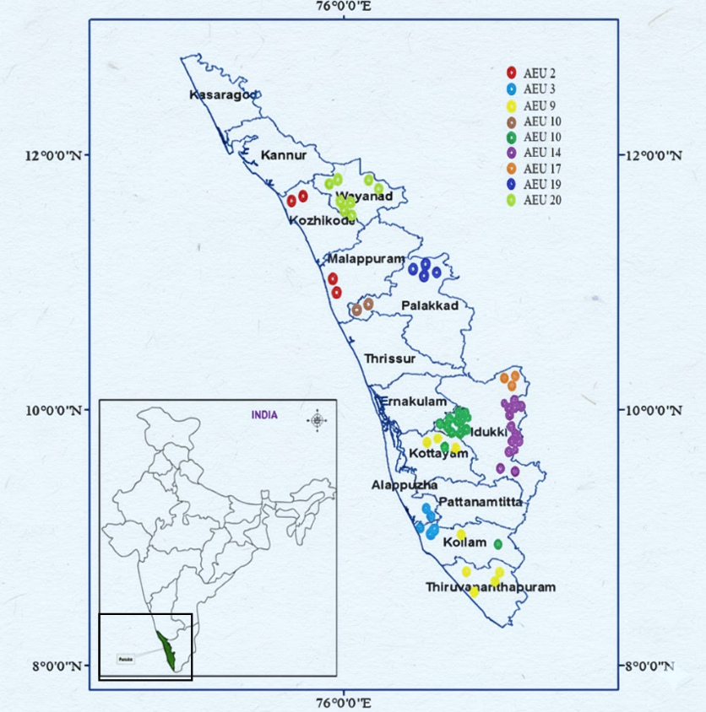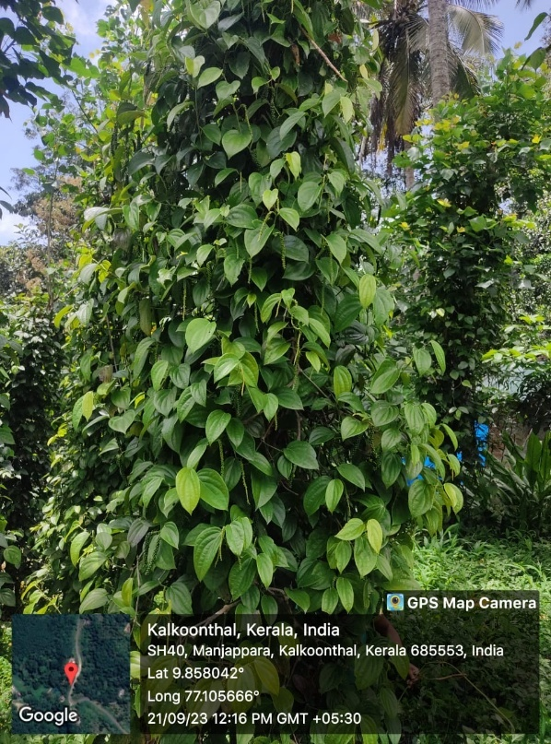

Figure 1. Study location and representative field view of black pepper in Kerala, India
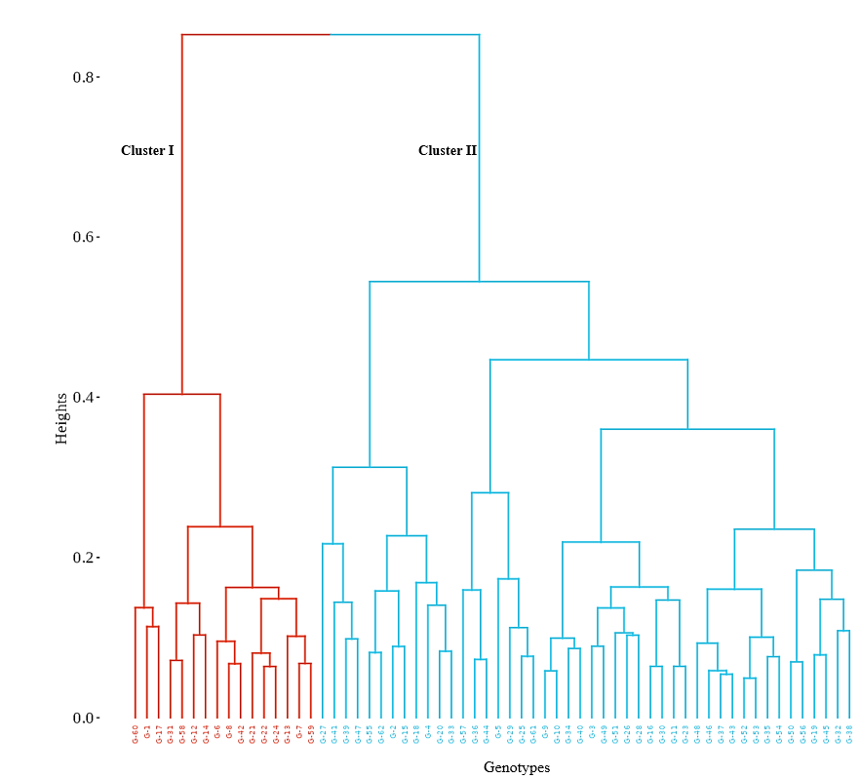
Figure 2. Hierarchical cluster dendrogram of black pepper genotypes grouping based on morpho-physiological variation

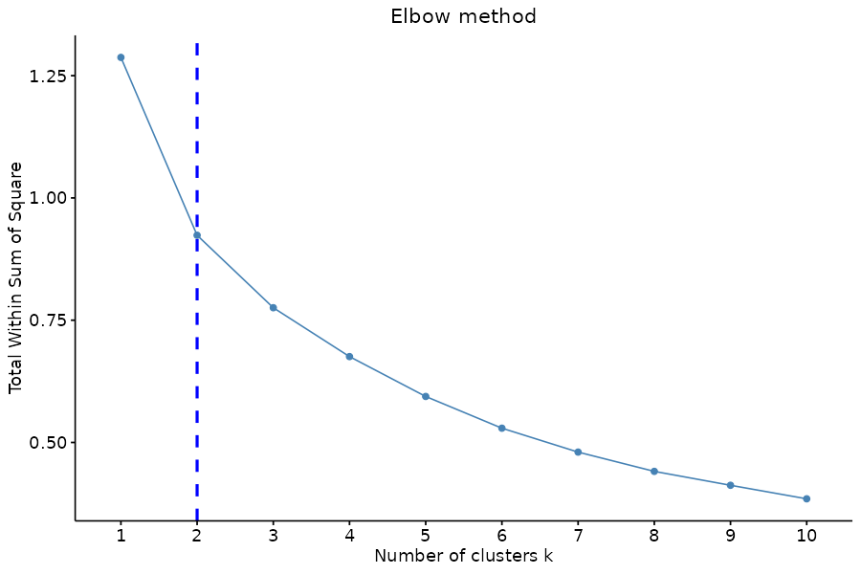
Figure 3. Elbow method showing ideal cluster size

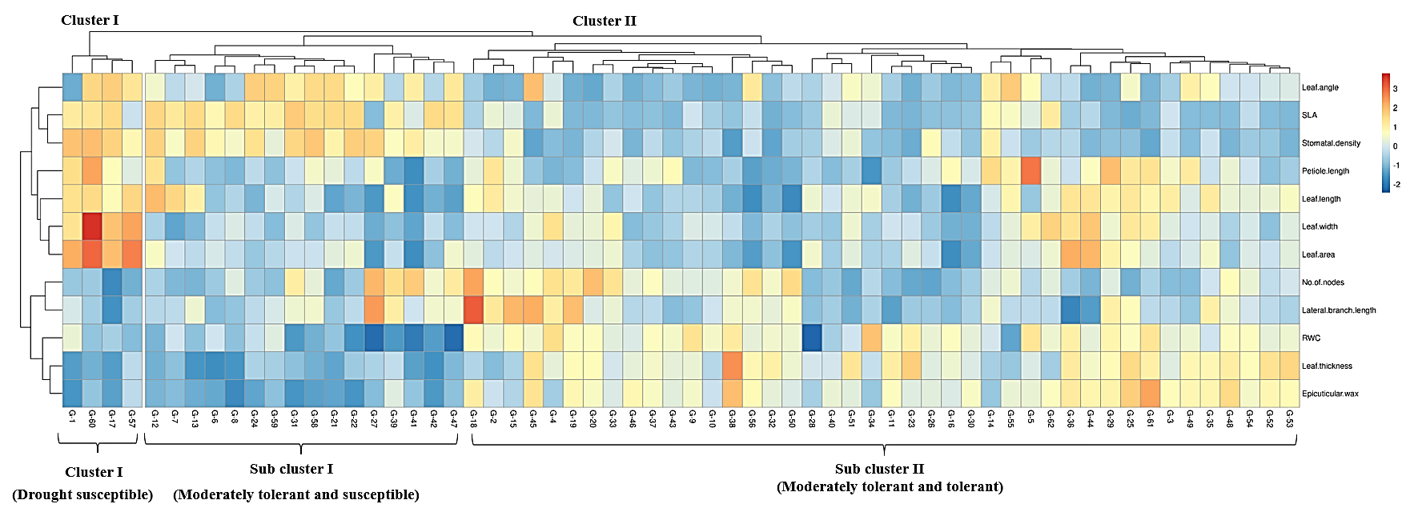

Figure 4. Heatmap and hierarchical clustering of 62 black pepper genotypes evaluated in farmers’ field conditions based on morphological and physiological traits. Colours represent z-score–transformed values of the measured traits

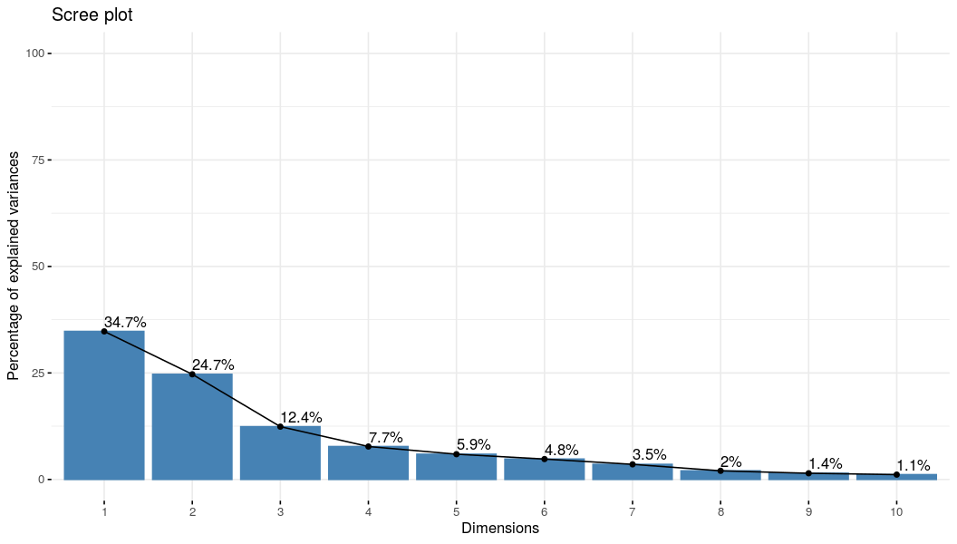
Figure 5. Scree plot showing variance explained by principal components
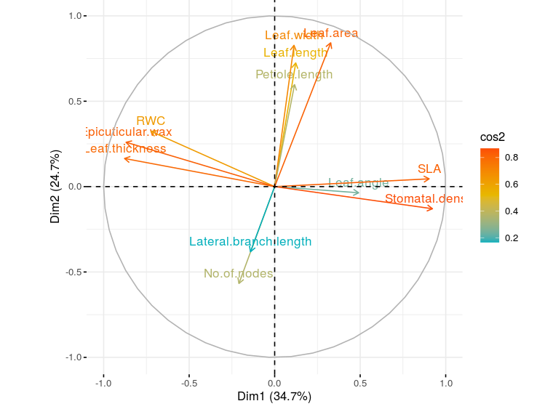
Figure 6. Variable plot of PCA displaying trait associations with drought adaptation
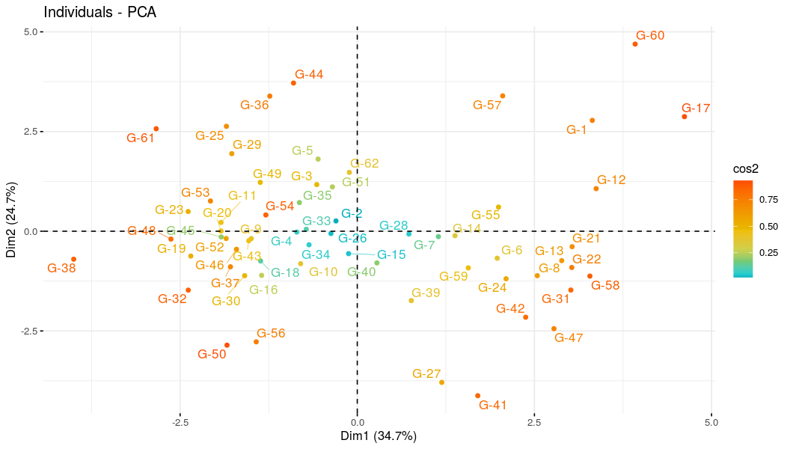
Figure 7. Distribution of black genotypes on PC1 and PC2 based on morphological and physiological traits

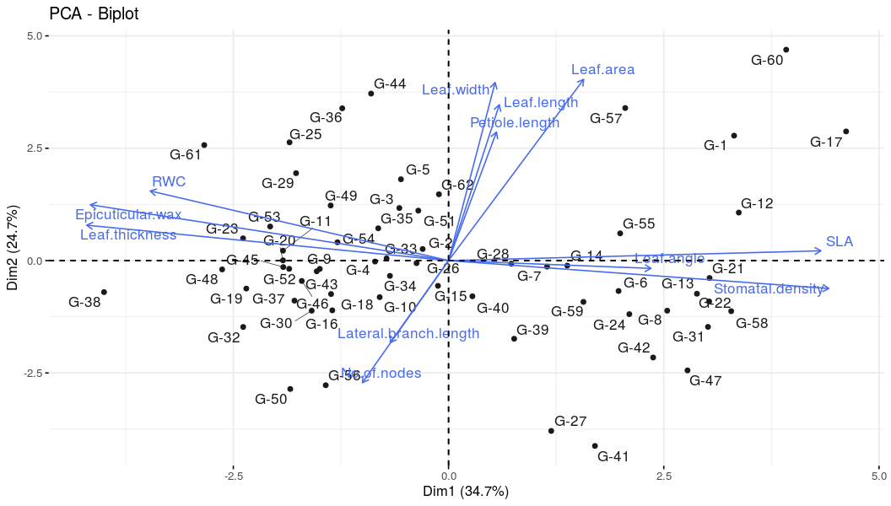
Figure 8. Biplot showing the distribution of black genotypes on PC1 and PC2 based on morphological and physiological traits

4. Conclusion

This study demonstrates that Kerala’s black pepper germplasm harbours significant morpho-physiological diversity that The study unearthed considerable morpho-physiological variability in black pepper germplasm of Kerala, which allowed clear discrimination of drought-resilient and susceptible genotypes. Multivariate analyses identified a consistent set of highly resilient accessions (G-44, G-61, G-38, G-50, G-56, G-32, G-54, G-36 and G-48) possessing adaptive xeromorphic traits and maintaining better water status under field drought. These findings provide useful candidates for climate-resilient breeding and emphasize the importance of continued germplasm conservation to safeguard adaptive diversity.

AI tools used: No

References

Ambrozim, C. S., Medici, L. O., da Cruz, E. S., Abreu, J. F. G., & de Carvalho, D. F. (2022). Physiological response of black pepper (Piper nigrum L.) to deficit irrigation. Revista Ciência Agronômica, 53, 1–10. https://doi.org/10.5935/1806-6690.20220002
Bibi, S., Noshad, A., & Khan, A. (2021). Role of epicuticular wax in the regulation of plant growth and health as measured by spectral indices. International Journal of Remote Sensing, 42(9), 3498–3510. https://doi.org/10.1080/01431161.2021.1875509
CWRDM [Centre for Water Resources Development and Management]. (2011). Documentation and analysis of farmers' practices on water management for plantation crops in Kerala. Kozhikode: CWRDM.
Chen, Z., Li, S., Wan, X., & Liu, S. (2022). Strategies of tree species to adapt to drought from leaf stomatal regulation and stem embolism resistance to root properties. Frontiers in Plant Science. https://doi.org/10.3389/fpls.2022.926535
Constantino, L. V., Fukuji, A. Y. S., Zeffa, D. M., Baba, V. Y., Erpen-Dalla Corte, L., Giacomin, R. M., Resende, J. T. V., & Gonçalves, L. S. A. (2020). Genetic variability in pepper accessions based on morphological, biochemical and molecular traits. Bragantia, 79(4), 558–571.
CGIAR. (2019). Guardians of diversity: The network of genebanks helping to feed the world. https://www.cgiar.org/news-events/news/guardians-of-diversity-the-network-of-genebanks-helping-to-feed-the-world/
DASD (2023). Spices Area and Production Statistics 2022–23. Directorate of Arecanut and Spices Development, Ministry of Agriculture & Farmers Welfare, Kozhikode; 98 p.https://dasd.kerala.gov.in/wp-content/uploads/2025/03/Estimates-2023-24.pdf
FAOSTAT (2023). Food and Agriculture Organization Statistical Database. Food and Agriculture Organization of the United Nations, Rome. https://www.fao.org/statistics/en
Fernando, Y., Adams, M., Kuhlmann, M., & Jr, V. B. (2025). Stomatal and Non-Stomatal Leaf Traits for Enhanced Water Use Efficiency in Rice. Biology, 14(7), 843. https://doi.org/10.3390/biology14070843
Ferreira, T. R., Sallin, V. P., Cerri Neto, B., Crasque, J., Pires, A., Rodrigues, P. S., Chisté, H., Lima, A. B. P., Machado Filho, J. A., Arantes, L. O., Lira, J. M. S., Falqueto, A. R., & Dousseau-Arantes, S. (2024). Morphophysiological responses of black pepper to recurrent water deficit. Photosynthetica, 62(3), 292-301. https://doi.org/10.32615/ps.2024.030
Iqbal, H. M. N., Kyazze, G., & Keshavarz, T. (2013). Advances in the valorization of lignocellulosic materials by biotechnology: An overview. BioResources, 8, 3157–3176. https://doi.org/10.15376/biores.8.2.3157-3176
Jayarathna, S. P. N. C., Senanayake, S. P., Rajapakse, S., & Jayasekera, L. R. (2016). Phenetic variation and preliminary phytochemical screening of Piper species in Sri Lanka. Journal of Agricultural Sciences, 11(3), 155-160. http://hdl.handle.net/123456789/1700
IPC [International Pepper Community]. (2025). Annual Pepper Statistical Review. IPC Secretariat, Jakarta; 45 p. https://www.ipcnet.org/statistics/pepper-statistical-yearbook-2023/
Khan, A. U., Talucder, M. S. A., Das, M., Noreen, S., & Pane, Y. S. (2021). Prospect of The Black Pepper (Piper nigrum L.) as Natural Product Used to an Herbal Medicine. Open Access Macedonian Journal of Medical Sciences, 9(F), 563–573. https://doi.org/10.3889/oamjms.2021.7113
Maxted, N., Hunter, D., & Ríos, R. O. (2020). Plant Genetic Conservation. Cambridge University Press. https://doi.org/10.1017/9781139024297
Malek, N., Aci, M. M., Khamassi, K., Lupini, A., Rouaissi, M., & Hanifi-Mekliche, L. (2021). Agro-morphological and molecular variability among Algerian faba bean (Vicia faba L.) accessions. Agronomy, 11(8), 1456. https://doi.org/10.3390/agronomy11081456
Niinemets, Ü. (1997). Distribution patterns of foliar carbon and nitrogen as affected by tree dimensions and relative light conditions in the canopy of Picea abies. Trees, 11, 144–154.
Poorter, H., Niinemets, Ü., Poorter, L., Wright, I. J., & Villar, R. (2009). Causes and consequences of variation in leaf mass per area (LMA): A meta-analysis. New Phytologist, 182(3), 565–588. https://doi.org/10.1111/j.1469-8137.2009.02830.x
Prasada Rao, G. S. L. H. V. (2016). Weather extremes and plantation crops in the humid tropics. Mausam, 67(1), 251–258. https://doi.org/10.54302/mausam.v67i1.1189
Puneeth, G. M., Gowthami, R., Katral, A., Laxmisha, K. M., Vasudeva, R., Singh, G. P., & Archak, S. (2024). On-farm crop diversity, conservation, importance and value: A case study of landraces from Western Ghats of Karnataka, India. Scientific Reports. https://doi.org/10.1038/s41598-024-61428-1
Ravindran, P. N., Balakrishnan, R., & Nirmal Babu, K. (1997). Morphometrical studies on black pepper (Piper nigrum L.). II. Principal component analysis of black pepper cultivars. Journal of Spices and Aromatic Crops, 6(1), 21–29. https://updatepublishing.com/journal/index.php/josac/issue/view/100
Reshma, P., Sreekala, G. S., Deepa, S. N., & Stephen, R. (2024). Genetic diversity assessment of black pepper (Piper nigrum L.) cultivars of Western Ghats. Plant Science Today. https://doi.org/10.14719/pst.4816
Sainamole Kurian, P., Backiyarani, S., Josephrajkumar, A., & Murugan, M. (2002). Varietal evaluation of black pepper (Piper nigrum L.) for yield, quality and anthracnose disease resistance in Idukki District, Kerala. Journal of Spices and Aromatic Crops, 11(2), 122–124. https://updatepublishing.com/journal/index.php/josac/article/view/4727
Salehi, B., Zakaria, Z. A., Gyawali, R., Ibrahim, S. A., Rajkovic, J., Shinwari, Z. K., & Sharifi-Rad, J. (2019). Role of medicinal plants in the management of diabetes mellitus: a review. 3 Biotech, 9(1), 4. https://doi.org/10.1007/s13205-018-1528-0
Singh, K., Gupta, K., Tyagi, V., & Rajkumar, S. (2020). Plant genetic resources in India: management and utilization. Vavilovskii Zhurnal Genetiki i Selektsii, 24(3), 306–314. https://doi.org/10.18699/VJ20.622
Spices Board (2025). Indian Spices Statistics 2023–24. Ministry of Commerce & Industry, Government of India, Kochi https://www.indianspices.com/sites/default/files/Major%20spice%20state%20wise%20area%20production%202023-24%20web.pdf
Thankamani, C. K., & Ashokan, P. K. (2002). Chlorophyll and leaf epicuticular wax contents of black pepper (Piper nigrum L.) varieties in response to water stress. Journal of Medicinal and Aromatic Plant Sciences, 24, 943–946.
Theertha, A. P., Shivakumar, M. S., & Krishnamurthy, K. S. (2023). Genetic variability analysis in elite black pepper genotypes using morpho-physiological and yield-attributing traits. Journal of Spices and Aromatic Crops, 32(2), 107–119. https://doi.org/10.25081/josac.2023.v32.i2.8742
Tian, M., Yu, G., He, N., & Hou, J. (2016). Leaf morphological and anatomical traits from tropical to temperate coniferous forests: Mechanisms and influencing factors. Scientific Reports. https://doi.org/10.1038/srep19703
Ullah, A., Mushtaq, H., Fahad, S., Shah, A., & Chaudhary, H. J. (2017). Plant growth-promoting potential of bacterial endophytes in novel association with Olea ferruginea and Withania coagulans. Microbiology, 86, 119–127. https://doi.org/10.1134/S0026261717010155
Varghese, R., & Ray, J.G. (2024). Sustainability of black pepper production: A critical analysis of physicochemical soil parameters concerning variables in pepper fields of South India. Ecological Frontiers, 44(4), 788–801. https://doi.org/10.1016/j.ecofro.2024.01.005
Veteläinen, M., Negri, V., & Maxted, N. (2009). European Landraces: On-Farm Conservation, Management and Use. Bioversity International. https://hdl.handle.net/10568/106154
Wimalarathna, N. A., Wickramasuriya, A. M., Metschina, D., Cauz-Santos, L. A., Bandupriya, D., Ariyawansa, K. G. S. U., Gopallawa, B., Chase, M. W., Samuel, R., & Silva, T. D. (2024). Genetic diversity and population structure of Piper nigrum (black pepper) accessions based on next-generation SNP markers. PLOS ONE, 19(6), e0305990. https://doi.org/10.1371/journal.pone.0305990
Witkowski, E. T. F., & Lamont, B. B. (1991). Leaf specific mass confounds leaf density and thickness. Oecologia, 88(4), 486–493. https://doi.org/10.1007/BF00317710
Xiong, D., Wang, D., Liu, X., Peng, S., Huang, J., & Li, Y. (2016). Leaf density explains variation in leaf mass per area in rice between cultivars and nitrogen treatments. Annals of Botany, 117, 963–971. https://doi.org/10.1093/aob/mcw022
Yavas, I., Jamal, M. A., Ul Din, K., Ali, S., Hussain, S., & Farooq, M. (2024). Drought-induced changes in leaf morphology and anatomy: Overview, implications and perspectives. Polish Journal of Environmental Studies, 33(2). https://doi.org/10.15244/pjoes/174476
Yudiyanto, Y., Rizali, A., Munif, A., Setiadi, D., & Qayim, I. (2014). Environmental factors affecting productivity of two Indonesian varieties of black pepper (Piper nigrum L.). Agrivita Journal of Agricultural Science, 36(3), 278–284. https://doi.org/10.17503/agrivita.v36i3.456

