Climate change: Environment, health and possible solutions

ABSTRACT
Background: Climate change, evidenced by rising global temperatures, has been a major environmental concern for decades. It impacts ecosystems, agriculture, economies, and social stability, primarily due to greenhouse gas emissions from industrial and urban growth.
Discussion: Climate change reduces agricultural productivity, threatens biodiversity, increases displacement, and widens inequalities. Vulnerable communities face the greatest risks. However, mitigation efforts-such as emission controls, renewable energy, and climate-smart technologies are gaining momentum. Green climate bonds under the UN SDGs are supporting sustainable infrastructure, while environmental indices guide green economic development.
Conclusion: Despite its widespread impacts, climate change can be addressed through integrated global action, sustainable finance, and innovation. A shift toward a green economy is essential for future resilience.
Further Recommendations: Future efforts should prioritize equity, increase climate funding access, invest in local adaptation, and align development with sustainability goals for lasting impact.
ARTICLE HIGHLIGHTS
- The article mentions briefly about effects of climate change including global warming, changing weather patterns, impact on agriculture, ecosystem and biodiversity as well as social and economic disruption.
- Our review highlights the critical impact of climate change on biodiversity with disruption of natural habitats. In this respect, we have discussed adaptive mechanisms of different organisms to survive against the increasing odds of climate change including reported cases of range shifts and survival strategies.
- The review sets itself apart by juxtaposing global green initiatives (e.g., EU Green Deal, India's National Action Plan on Climate Change (NAPCC), World Bank Green Bonds) with sector-specific strategies across agriculture, forestry, energy, and health. It does not just list strategies but critically connects them with implementation outcomes and international disparities, such as the contrast between developed and developing nations in adopting green technologies.
KEYWORDS
Biodiversity, Environmental sustainability, Greenhouse gases, Green economy, Mitigation strategies
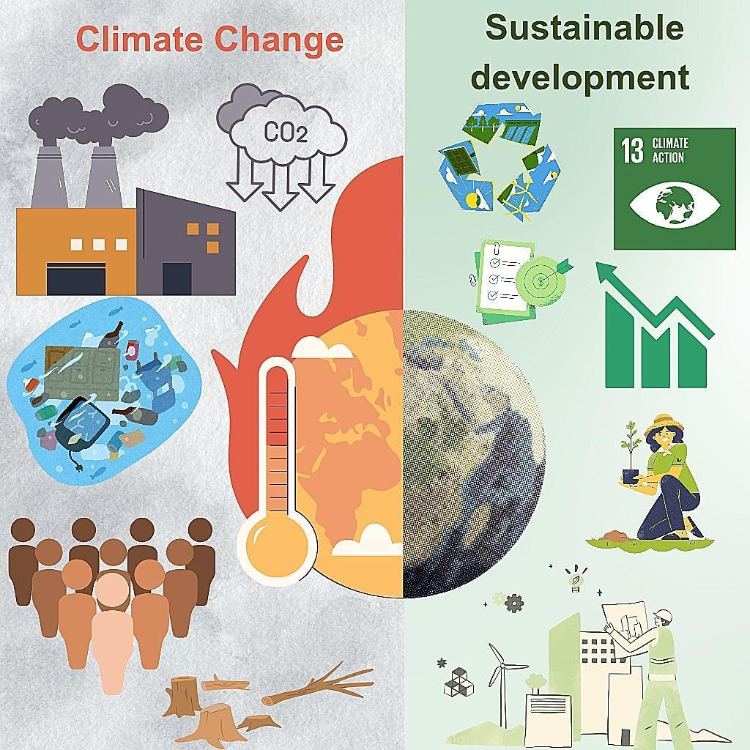
Graphical Abstract
- INTRODUCTION
Climate change is a global phenomenon of long-lasting weather changes impacting ecosystems, health, and economies (Adger, 2005; Feliciano,2022). It presses the species to stress and shift their optimum ranges accompanied by biodiversity losses coinciding with progressive changes in the environment. Climatic variations impact agricultural harvesting and yield as well alter the likelihood of vector-borne and infectious opportunists (Figure 1).
Climate change is characterized by increased surface temperatures, irregular weather patterns, and receding global ice covers leading to elevated sea level rise (Arnall, 2023). The causative factors for climate change include the rapid industrial revolution, especially during the past century, volcanoes, and forest fires which release thermogenic greenhouse gases (GHG). The GHGs can be classified based on origins as i) natural such as CO2, N2O, CH4, volatile organic compounds, and water vapours; and ii) industrial such as HFCs, SF6, and PFCs (Murshed, 2020; Murshed, 2022; Usman, 2022). These heat-trapping gases also erode the helpful ozone layer in the atmosphere. Anthropogenic activities such as the extensive use of fossil fuel-consuming machinery, burning of cultivation waste, fuel combustion, deforestation, and the national and domestic transportation sectors, among others, accelerate their emission into the atmosphere (Huang, 2016).
Environmental imbalance due to global warming is directly linked to a significant increase in GHG emissions post the industrial revolution (Hussain, 2019). Apart from fossil fuel combustion for various human activities, land-use changes are also among the leading contributors to global warming (Yousaf, 2016). An unprecedented increase of 5.8% in GHG emissions worldwide was reported in 2010 (Carter, 2015), such erratic increments are further expected to intensify in the future due to accelerating urban growth, rise in transportation, rising energy use, and unmanaged waste disposal.
The tangible outcomes and effects of climate change include:
- unforeseen and unpredictable rainfalls, floods, droughts, storms, hurricanes
- extreme variations in temperature, intense heat waves
- super-saturation of lakes,
- melting of glaciers
- landslides, earthquakes,
- agriculture,
- ecosystem health and diseases
Such seasonal variations accompanied with lifestyle changes also threaten biodiversity, human communities, and animal habitations.
Considering these, several nations under the Paris Agreement signed at the United Nations Framework Convention on Climate Change (UNFCCC) in 2015 agreed to resolve sustainable efforts and investments towards low GHG emissions and climate-resilient policies. Apart from a low-carbon future, the agreement set its goal to keep and limit the global temperature increase to 1.5°C (Chien, 2021). To support sustainable environmentally friendly programs, green climate bonds investments are issued by the governments for environmental, social, and corporate governance. Introduced in 2008 by the World Bank, the global market for green bonds has shown an increase of 10-fold to 250 million USD according to Environmental Finance Citation (2020). This polycentric approach adheres to the UNFCCC and aims to mobilize corporation finance towards carbon neutrality. The UN's Sustainable Development Goals (SDGs), SDG13 for climate action, links the conservation and improvements for agriculture, healthcare, water, energy, commercial and domestic infrastructure (Purnell, 2022). Prompted by the UN Agenda 2030, the green climate bonds have diversified into Social Bonds, Sustainability Bonds, Environmental, Social, and Governance (ESG) Bonds, and the Sustainable Development Goal (SDG) Bonds for successful implementation of the SDG13 (Ahmed, 2023).
Strengthened actions require long-term mitigation plans aiming to prevent future GHG emissions and reducing their current levels in the atmosphere, and their amalgamation with short-term adaptation strategies for the effects, and consequences of climate change.
In the present review, a brief synopsis of the effects and impact of climate change, mitigation and adaptation strategies, and green initiatives to offer possible solutions are discussed. Green initiatives in industrial and civil sectors, aligning with the principles of SDGs are required to mitigate and adapt to climate changes. Climate-friendly initiatives are essential to promote a green economy and green growth. Several countries including India are investing in green technologies and devising action policies and plans to promote environmental sustainability. To assess the progress of such policies, indicators like Knowledge Platform (GGKP) and Sustainable Development Indices have been formulated and implemented. Such measures will eventually lead to the generation of Smart green planet with inclusion of green practices to promote sustainability and resource efficiency.
2. EFFECTS OF CLIMATE CHANGE ON ECONOMIC GROWTH, SOCIAL GROWTH, AGRICULTURE, AND BIODIVERSITY
Climate change is one of the most urgent challenges confronting the global community today, accelerating a swift and unparalleled alteration of the Earth’s climate system and posing potentially disastrous impacts on human societies and natural ecosystems (Bernauer, 2013; Munasinghe, 1998). This section presents a brief overview of some of the most challenging effects of climate change as summarised in Figure 2.
2.1. Economic Growth
Industrial development was initially considered a major step towards a better future. However, it has also led to adverse consequences, evidently, climate change. Climate change, marked by increasing temperatures, rising sea levels, and severe weather events, harms property and essential infrastructure, negatively influences human health and productivity, and adversely affects industries like agriculture, forestry, fisheries, and tourism. Additionally, energy demand will rise as power generation becomes less reliable, and water resources will be strained (Abbas, 2022).
Erratic weather and climatic changes, such as snowmelt and shrinking glaciers, heat stress, have reduced crop yields, lowered food availability, caused natural calamities, and escalated disease risk. Extreme heat and severe cold decrease work productivity, thereby impacting industrial yields and economic growth. Low-income families are disproportionately affected, facing higher food prices, lower wages, and marginalised budgets, lesser concerns for health and hygiene, thereby slowing economic growth. The shifts in weather patterns also concern the advanced economies as altered and unpredictable weather events and patterns can have lasting macroeconomic consequences by reducing labor productivity, hindering investment, and agricultural yields, and harming human health. Research has shown that accelerated economic activity leads to higher GHG emissions, which in turn raise the average temperature, and diminish economic progress by triggering a cascade of climate change (Nordhaus, 1992; Kahn, 2021).
The analysis of annual data from 34 countries in Africa between 1961 and 2009 showed that climate change negatively affects economic growth. A 1°C increase in temperature has been shown to reduce GDP growth by 0.67 percent (Abidoye, 2015). A positive correlation between the changing pattern of rainfall due to climate change with overall economic growth in Turkey provides foundational insights for future studies on the connection between rainfall, drought, and economic growth (Kara, 2020). Scientists (Kalkuhl, 2020) have predicted, based on panel data analysis, that a sustained rise in temperature will result in a lasting decline in hotter regions’ economic output. It is estimated from the study that a 1°C rise in temperature in a region with an average annual temperature of 25°C results in a reduction in the Gross Regional Product (GRP) by approximately 3.5%. In the Swiss Re Institute’s report (Guo, 2021), the projected effect of climate change assumes temperature rise will continue its present course and that the objectives of the Paris Agreement and net-zero emission targets might not be achieved. Moreover, the report cautions that if no measures are implemented and temperatures increase by 3.2°C, the economic effect could escalate significantly, potentially reducing global GDP by 18% by mid-century. The newswire report (Dobber, 2020) estimates an annual global economic impact of USD 200 billion, with countries like the Philippines and the United States of America being especially at risk, facing potential losses of 3% and 0.4% of their GDP, respectively (Cho, 2019; Merchant, 2021).
2.2. Social Growth
Another undesirable yet unavoidable consequence of climate change is an intensification of competition over land, food, water, and facilities because of erosion of soil, desiccated grazing lands, and diminished crop yields. Landslides and floods devastate farmlands and buildings, leading to scarce water resources and heightened tensions between farming and herding communities (Solangi, 2022; Son, 2023). Additionally, its effect on food production drives up hunger and food prices, which can lead to social unrest. It forces people to move, with over 20 million individuals displaced annually due to extreme weather events. The poorest are the most vulnerable populations, who are disproportionately affected, further widening the poverty and economic inequalities. Security risks for women and girls are anticipated due to pre-existing inequalities and the intersection of conflict and climate crises. In response, the UN Secretary-General has proposed a $500 billion annual stimulus package for the SDGs to tackle these challenges (UNEP Org., 2017). It also causes the spread of vector-borne diseases like tick-borne encephalitis, malaria, Rift Valley fever, and West Nile virus. People in economically disadvantaged and poverty-stricken communities are especially vulnerable (Levy, 2015). A global occurrence of collective violence, including wars, state-sponsored violence, and organized crime, is also expected (Levy, 2014). In regions of North Africa, it is expected that increased food prices and food insecurity may result in public objections and uproar opposed to the government (Scheffran, 2019; Waha, 2017; Schilling, 2020).
Climate change intensifies global inequality and challenges women, children, disabled people, native and marginalised communities. Their susceptibility stems from factors such as their geographic location, economic and social standing, and restricted access to resources and decision-making ability. Given that the Climate Crisis is both an environmental and social issue, marginalised sections of society need urgent and aggressive climate action plans. The IPCC (2014) emphasises climate solutions based on fair and equitable distribution for effective development outcomes. Misaligned policies can inadvertently further harm the most vulnerable and widen the divide and unrest. An example is increased carbon-pricing costs for poorer households and the non-involvement of indigenous communities in forestry activities (Gupta, 2022). Addressing the distributional impacts of decarbonizing economies involves understanding social inclusion, cultural, and political-economic aspects, and identifying opportunities to reduce social inequality. Despite advancements in climate science and policy, many countries struggle to engage citizens who may not understand climate change or fear the unfair impacts of climate policies (Dietz, 2020).
2.3. Agriculture
Climate change has extensive implications across multiple sectors, including agriculture, influencing crop yields, livestock production, and overall food security, drawing significant attention from scientists worldwide (Arora, 2019; Sajid, 2021). A key way in which climate change impacts agriculture is through alterations in temperature and precipitation patterns (Kusumasari, 2016; Liang, 2017; Rachid, 2024; Arora, 2019; Raza, 2019). As the global climate becomes increasingly variable, causing frequent severe weather phenomena like droughts, flooding, and intense heat waves, it becomes challenging for farmers to ensure consistent productivity and maintain livestock. Climate change can also cause the emergence of new opportunistic pests and diseases and plant pathogens, hence further hindering agricultural productivity. Rising sea levels and alterations in water resources create a crisis for irrigation and the availability of land for farming, especially in coastal areas. Increased pest infestations, flash floods, agricultural runoff, soil erosion, frequent crop damage from heat waves, habitat destruction, northward crop shifts, reduced agricultural yields, economic and psychological stress on farming communities, soil quality degradation, and permanent loss of fertile soil are some immediate impacts of temperature trends and rainfall patterns because of climate change (Raihan, 2023; Godde, 2021). Climate change reduces global crop production by approximately 5.5 × 10¹⁴ kilocalories per year for every 1 °C rise in global temperature (Hultgren, 2025). Table 1 presents some of the effects of climate change on agriculture and the suggested strategies for mitigation and adaptation.
2.4. Biodiversity And Human Health
The major drivers of climate change include anthropogenic activities like large-scale industrialization, the emission of GHGs, and deforestation. The major consequences of these activities include loss or alteration of natural habitats of living organisms, which may further lead to loss of biodiversity. This loss of biodiversity may further accelerate climate change processes, thereby further aggravating the problems faced by living organisms, including humans. Also, such climate changes may increase environmental severities such as heat waves, hurricanes, wildfires, droughts, and floods. The following section summarises recent research findings highlighting the critical impact of climate change on biodiversity.
Climate change disturbs the natural ecosystems and habitats of organisms. The habitats become fragmented or disturbed due to environmental disturbances. For instance, the melting of snow peaks due to elevated temperatures has disrupted the aquatic ecosystems and freshwater habitats, which has further impacted fish biodiversity in North-East India (Pandey, 2022). Similarly, the thawing of Greenland ice sheets has posed a serious threat to over 21,146 animal and plant species at risk of rapid population declines. The high-risk groups include amphibians, including frogs, toads, salamanders, tetrapods, and vascular plants (Ureta, 2022). The increased aridity caused due to climate change has led to biodiversity loss, wherein around 55.29% of terrestrial vertebrate species may lose their habitat by 2100 (Liu, 2023).
Thus, with such fragmentation or disruption of natural habitats driven by climate change, the organisms are forced to reorient and change their geographic habitats, which becomes part of their survival or rescue mechanism. The organisms that are able to successfully respond to such climate changes and altered habitats may successfully survive and reproduce as well, while the organisms that fail to do so may become extinct. For example, climate change causes habitat loss and fragmentation, limiting suitable environments for endangered species like Firmiana kwangsiensis (Gao, 2022). If a species is already on the verge of extinction, habitat loss may accelerate its disappearance, as reported in scorpionflies (Su, 2023) or a reduction in the spatial distribution of key native dung beetle species found in South American grasslands (Maldaner, 2021).
Species may respond differently to climate change and may shift their geographic distributions, like moving to different latitudes or elevations, while others may show changes in their timing and events of life cycles, referred to as phenological shifts. Many recent studies have reported the range shifts in organisms as adaptive mechanisms to survive. In general, species with broader climatic niches, like moths and birds with narrow thermal niches, show stronger shifts towards the north (Hällfors, 2023). For instance, Rodríguez-Pacheco et al., report temporal changes in the community composition of montane leaf beetles, with upward shifts of species adapted to warmer regions and downward shifts of cold-adapted species (Rodríguez-Pacheco, 2024). Similarly, neotropical skinks like Notomabuya frenata have been reported to shift towards eastern South America (Pio Caetano Machado, 2023). Jiang et al., found that lizards at both higher elevations are predicted to shift upslope in response to climate change by 2081–2100 (Jiang, 2023). However, mitigation measures are required to prevent the loss of species that do not exhibit such adaptive capacities and are not shifting as expected by some plant species, as well as some amphibians and reptiles. For example, 4.2% of amphibian species may go extinct if they fail at nature's test of survival and do not undergo evolutionary rescue (Souza, 2023). Interestingly, Fekete et al., have termed the species that have successfully adapted to changing conditions as ‘winners’, and species like amphibians, plants, and reptiles are categorised as ‘losers’ since they are not shifting as expected in response to climate change. Different studies predict that the list of winners may increase over the coming years as part of the evolutionary rescue mechanism (Fekete, 2023).
A shift in the distribution of species triggered by climate change impacts the overall biodiversity and phylogenetic diversity of an area as well as its community composition. In some cases, it may lead to decreased reproductive success as reported in African wild dogs by Abrahms et al., (Abrahms, 2022) or time-delayed responses in the world’s terrestrial birds, with small birds experiencing a 13-year lag and larger species a 40-year lag, significantly influencing population trends by 2050 (Cornford, 2023). The situation is worse in India, where ~66–73% of bird species are expected to undergo geographical shifts due to climate change, while 59% may lose part of their range (Deomurari, 2023). In addition to animal biodiversity, plant biodiversity is also affected due to climate change. For instance, A. moorei, a sub-shrub, displayed phenological symptoms driven by climate change in terms of decreased stem length, an earlier onset of reproduction, and reduced adult longevity (Alarcón, 2023). The habitat suitability of the fungus, Fusarium oxysporum, has been reported to be influenced by increasing temperatures due to global warming, especially in regions like Europe (Alkhalifah, 2023). Alpine plant species (Abies chensiensis), which are already rare and endangered, are facing habitat loss, spatial isolation, and increased competition from native plants in East Asia (Dong, 2022). Similar factors have been found to affect the habitats of rare and endangered trees, Firmiana kwangsiensis in Guangxi, China (Gao, 2022). Genetic diversity is also seriously affected due to climate change as seen in the case of Senegalia senegal, a common and widely distributed African tree species (Lyam, 2018), or Carex species in the Western Mediterranean Basin due to the loss of admixture among populations (Benítez-Benítez, 2022). Further, approximately 83% of vascular plant cells in Argentina are estimated to experience a decline in species richness due to climate change (Salariato, 2022). Some plant species are more resilient to climate change than others, for instance, herbaceous species react to climate change more quickly than woody species (Sun, 2021). Also, some plants may experience shifts to higher elevated regions due to climate change, like many high-elevation temperature-sensitive plant species in the Himalayan region are experiencing shifts to higher elevations due to climate change (Yadav, 2021). Also, a shift in vegetation has been reported in J. macropoda as an adaptive response to climate change in the North-Western Himalayas of India (Kumar, 2022). The section above discussed several examples and studies reporting climate change-induced changes or adaptations in animals and plants, which in turn affect their biodiversity.
3. MITIGATION AND ADAPTATION STRATEGIES FOR CLIMATE CHANGES
Climate change has profound impacts on ecosystems, human health, and economies. Global and national-level mitigation and adaptation strategies require technologies for environmentally friendly, carbon sequestration, emission reduction, renewable energy, and power-efficient appliances (Jahanzad, 2020; Bhanye, 2025). Examples of such eco-friendly technologies are solar energy and modern micro-hydropower plants. To support the most vulnerable sectors of water and agriculture, suggested options include rainwater harvesting, stormwater management, groundwater recharge, efficient irrigation systems (both drip and sprinkler), cultivation of drought-tolerant crops,weather forecasting, and availability of robust rescue and networking systems (Hussain, 2019).
Adaptation and mitigation policies are targeted mainly at agriculture, forestry, industry, transportation, and land use (Waheed, 2021). Mitigation plans aim to reduce the magnitude of change while adaptation actions are planned to minimize immediate harmful effects (Figure 3). Although the magnitude of the socioeconomic effect of climate change may vary according to geography, a well-informed choice of adaptation and mitigation plan by policymakers can make its impact less severe.
A total of 24% of global GHG emissions are due to human-centric activities, 10–12% stem from agriculture and 10–13% are from land use changes, primarily due to deforestation for agriculture (IPCC 2014). Mitigation actions include smart technologies for agriculture and landscaping, with a focus on organic cultivation and conservation agriculture, and sustainable use of ecosystems for a net positive production with fewer negative environmental impacts. Forestry protection from land use and cover includes forest conservation, protected area management, afforestation and reforestation, bioenergy plantations, agroforestry, sustainable forest management, and urban forestry (Kongsager, 2018). Conventional mitigation technologies used in energy, industry, transport, and construction consist of renewable energy; nuclear power; carbon capture; storage and utilization; and fuel switching (Fawzy, 2020). The choice and integration of mitigation and adaptation is crucial, especially in agriculture and forestry, to support societal growth and economic stability. Another important aspect of such plans is to address the health implications of climate change, ensuring equitable protection, prevention, and healthcare access across all sectors of society. Overall, a comprehensive approach that integrates mitigation and adaptation strategies along with social, economic, and environmental factors is crucial in combating the challenges posed by climate change.
3.1. Green Activities And Sustainable Development Goals
The relationship between the biosphere-that is, the function of plants on Earth-and the economy is where the term "green" in its current usage originated (Ahmed, 2023). Consequently, to influence corporate behavior toward sustainability, green initiatives require promoting partnerships between industry and civil society. Recognizing the principles of the green economy and green growth is vital in molding development strategies and overcoming challenges associated with both adaptation and mitigation efforts to counteract climate change. The SDGs related to climate action are interconnected with other goals like food production, health, water, energy, and infrastructure, underscoring the need to adopt an all-inclusive approach to sustainability (Ahmed, 2023; Adamowicz, 2022). Hence, the global initiatives to mitigate and adapt to climate change can greatly benefit from the involvement of the financial sector. This will also help in achieving the SDGs set forth by the United Nations (Ahmed, 2023; Nguyen, 2025).
Understanding investor preferences for green initiatives helps corporations develop products that attract sustainability-minded investors, promoting a green mandate in society. One such approach is the use of green bonds, which are used by companies for environmentally friendly projects, that help reduce carbon emissions in non-financial sectors (Fatica, 2021). Positive results from green bonds emphasize their role in achieving SDGs, particularly in climate mitigation and adaptation, and underscore the importance of sustainable business practices in advancing environmental goals (Ahmed, 2023). Although the funds raised through green bonds are limited, they indicate a commitment to climate-friendly initiatives.
An illustration of green bonds is the World Bank's issuance, as it has been a leader in the green bond market. In 2008, the World Bank introduced its first green bond to fund climate-centric projects. Among these projects is the Rampur Hydropower Project in India, which was financed through these bonds. A thermal power station of the same capacity, if powered by coal or oil, would emit about 2 million tonnes of carbon dioxide yearly, 6000 tonnes of nitrogen oxides, and 12000 tonnes of sulphur oxides into the atmosphere every year. The construction and operation of the Rampur hydropower plant effectively prevents this significant amount of pollution. This project demonstrates how green bonds can support climate mitigation efforts while also providing social and economic benefits, such as reliable power supply and local job creation (World Bank, 2019).
Green growth, therefore, focuses on economic development alongside environmental enhancement through innovation, efficient resource management, and the generation of green jobs. A green economy integrates economic growth with environmental sustainability to enhance human well-being while maintaining natural systems. It involves efficient resource use, green investments, and green jobs that reduce energy consumption and greenhouse gas emissions. Making the environment the primary consideration when taking economic decisions contributes to reducing pollution, mitigating climate change, preserving biodiversity, and protecting natural resources for future generations. Investing in renewable energy sources, which reduce dependency on fossil fuels, such as solar and wind power, can help achieve this. Eco-friendly practices in industries and transportation, such as limiting emissions and promoting cleaner technologies, improve air and water quality, benefiting both the environment and public health. Integrating environmental priorities into economic strategies improves overall health, promotes social equity through green job creation, and fosters resilience against environmental challenges.
3.2. The Green Deals and Action Plans
Several initiatives around the world aim to address climate change and promote sustainability. These include China's Green Development Policy; Canada’s Climate Plans and Targets; Japan’s Green Growth Strategy; Korean Green New Deal; Germany’s Climate Action Plan 2050; India’s National Action Plan on Climate Change (NAPCC) among others. The European Green Deal, introduced in December 2019, aims to make the EU more environmentally friendly and sustainable. The plan includes new rules for industries, transportation, agriculture, and buildings to reduce energy consumption and pollution. It emphasizes investments in clean technologies, eco-friendly transport, and energy efficiency to create a healthier and more sustainable economy. The goal is for Europe to become the first climate-neutral continent, demonstrating leadership in environmental protection and combating climate change for a better future (Barry, 2021).
3.2.1. India’s National Action Plan On Climate Change
India's performance in achieving the UN-mandated Sustainable Development Goals is ranked 112th out of 166 countries, according to a 2023 assessment by the Centre for Science and Environment. India has effectively accomplished its pre-2020 voluntary goal of lowering its GDP's emissions intensity by 20–25% relative to 2005 levels. Both mitigation and adaptation methods are covered within the NAPCC, which serves as India’s climate policy framework. Sustainable habitat, water conservation, preserving Himalayan ecosystems, solar energy, enhanced energy efficiency, Green India programs, sustainable agriculture, and strategic climate change knowledge are the eight core aims of the plan (United Nations, 2023).
4. Assessment Of Green Economy And Green Growth
One of the most important metrics for evaluating environmental sustainability is carbon dioxide emissions. By tracking progress and driving policy, these metrics and indicators of a green economy and green growth contribute to sustainable development. Key indicators are created by the Green Growth Knowledge Platform (GGKP), an international network of specialists and institutions that includes the World Bank and the United Nations Environment Programme (UNEP). The environmental issues covered by UNEP's indicators include waste management, resource efficiency, ecosystem management, and climate change. These are grouped into four categories: identifying problems, creating policies, evaluating them, and monitoring progress. These indicators extend beyond the green economy to include broader policy aspects like green investments, fiscal reforms, and training in green skills (Guo, 2020).
All countries, regardless of their natural resources or geopolitical status, encounter difficulties on the path to sustainability, such as depleting natural resources and climate change. Normalized Sustainable Development Index (NSDI), Averaging Sustainable Development Index (ASDI) and the Sustainable Development Goal Index (SDGI) are metrics used to assess and compare the sustainability and development progress of countries. While the NSDI focuses on a broader assessment of sustainable development within a country, the SDGI specifically tracks progress towards the UN's global sustainability goals (Guo, 2020). However, there are discrepancies between the values of NSDI and ASDI, showing that most developing countries face challenging conditions for adopting green technology. This is because industrialized countries often consume more energy and resources than countries with lower levels of consumption, thereby exacerbating environmental degradation (Guo, 2020).
Countries like Kazakhstan, Russia, the United Arab Emirates, Korea, and the United States experience high levels of CO2 emissions because of their heavy involvement in brown industry activities (Carbon-intensive or fossil-fuel-based industries). These emissions are produced by various industries, including oil, gas, and mining. According to Guo et al., Russia stood out as a developed country with a positive trend in greentech development, having a higher ASDI than its SDGI (Figure 4). Notably, Switzerland, Kazakhstan, and Russia also excelled in managing water and sanitation sustainably according to reports (Guo, 2020).

5. Challenges And Adaptation Strategies
Implementing the green economy and green transformation processes revolves around several key principles. It primarily involves the proper valuation of natural capital, recognizing the essential economic value of nature, such as forests, clean air, and water. Regulation and incentives are employed to encourage eco-friendly practices among businesses and individuals, supported by economic and legal instruments to control pollution, waste, and resource consumption. Sustainable production and consumption are promoted to ensure goods are made without harming the environment, coupled with responsible consumption. Equitable distribution ensures that the benefits of a green economy are shared fairly among all people. Education and knowledge sharing, along with building green skills, are vital for encouraging sustainable habits and training individuals in environmentally supportive jobs. The principles of the Green Economy Coalition emphasise sustainability, social justice, and maintaining a healthy planet. Good governance ensures transparency and accountability in managing policies, while resilience focuses on adapting to environmental changes. Efficiency and sufficiency aim at using resources to meet needs without waste, and consideration of future generations ensures long-term impacts are accounted for in present actions.
The private sector is essential in implementing the SDGs by backing initiatives such as corporate social responsibility, circular economy, and environmental efforts. However, there are still significant challenges in achieving the SDGs, including a lack of influential leadership, difficulties in forming effective partnerships, insufficient investments, complex interlinkages among the goals and targets, and inadequate monitoring and evaluation methods (Rashed, 2020). Furthermore, there is an urgent need for more effective, reliable, and measurable indicators to enable the private sector to effectively track progress in implementing the SDGs. For successful collaborations, encouraging multi-stakeholder partnerships and development and ensuring accountability within the private sector are essential. By embedding the SDGs within assessment rules, both governments and the private sector can facilitate decision-making processes and strengthen partnerships for sustainable development (Rashed, 2020; Masuda, 2022).
5.1. Co-benefits Approach And Policy Trade-offs
The co-benefits approach involves identifying additional benefits from pursuing environmental or sustainable goals alongside primary objectives. Actions taken to address one issue, such as climate change or pollution, can positively impact other areas, promoting multiple benefits simultaneously. For instance, encouraging the use of renewable energy sources can lower greenhouse gas emissions and mitigate climate change. However, this might negatively affect traditional energy industries, leading to job losses or economic challenges (Cohen, 2021; Wyne, 2024). By considering these trade-offs, policymakers can implement measures to support affected industries or communities during the transition to a greener economy.
5.1.1. Smart Green Planet
A Smart Green Planet envisions harnessing digitalization to achieve sustainability goals, ensuring resource efficiency while safeguarding the environment and global health. The concept advocates for a transformation in industries towards practices like designing for zero waste, smart auditing, waste-to-resource conversion, and industrial symbiosis to promote sustainability and resource efficiency. For example, in industrial symbiosis, one company's waste material e.g. heat, water, or by-products can be used as a resource by another company, creating a mutually beneficial relationship that minimizes waste and optimizes resource utilization for both parties (Mondejar, 2021; Gast, 2022). Establishing efficient recycling programs that promote the reuse of materials and resources can significantly contribute to achieving zero waste. Companies like Tesla implement advanced recycling technologies in their manufacturing processes to repurpose materials such as lithium-ion batteries and plastics, reducing waste generation and promoting sustainable practices. The circular economy model can be advantageous because it treats waste as a valuable resource, helping to achieve zero waste objectives. Green Fusion Innovations, Hyderabad, is a prime example of a Smart Green Planet Firm that has successfully implemented sustainable practices in its operations, focusing on zero-waste manufacturing strategies. GFI delivers sustainable, cost-effective, and innovative strategies using new technological solutions to the Renewable Energy Sector.
In a Smart Green Planet, innovations such as autonomous vehicles and lights-out manufacturing reduce hazards by minimizing human presence in factories and transport infrastructure. However, these advancements may also lead to potential job losses, necessitating a thorough assessment of societal impacts (Mondejar, 2021). Digitalization offers the potential to leverage untapped big data for societal and environmental benefits, paving the way toward addressing challenges related to the United Nations SDGs.
6. Conclusion And Future Perspectives
Human and environmental health relies on a foundation of agriculture, economy, social structure, and biodiversity all of which are threatened by climate change. Actions and policies are devised at both national and international levels to combat and prevent it. Recent research efforts have been for enhanced crop production with improved product quality, and properties for increased resilience against heat, drought, pests, and other extremes (Rivero, 2021; Yoselin, 2023). Biofuels such as bioethanol, biodiesel, biogas, and biohydrogen are organic, biodegradable, and environment-friendly energy alternatives, that require technological and governmental policy encouragement to develop as a sustainable measure to lessen the effect of climate change (Prasad, 2024). The application of nano-sized particles and materials as a technology is well established in the environmental remediation of wastewater treatment, greenhouse gas emission, fuel crisis, and pollutants all of which contribute to climate change (Chausali, 2023; Kuhn, 2022). The various forms of nanomaterial application include sensors, coatings, lubricants, metals, catalysts, packaging, functionalized nanomaterials, metal-organic frameworks (MOFs), carbonaceous materials, and zeolites to name a few. A reliable and transparent information-based distribution of resources and rational usage of resources backed by government support and control are required for the successful implementation of climate change pledges.

Disclaimer (Artificial intelligence)
Option 1:
Author(s) hereby declare that NO generative AI technologies such as Large Language Models (ChatGPT, COPILOT, etc.) and text-to-image generators have been used during the writing or editing of this manuscript.
Option 2:
Author(s) hereby declare that generative AI technologies such as Large Language Models, etc. have been used during the writing or editing of manuscripts. This explanation will include the name, version, model, and source of the generative AI technology and as well as all input prompts provided to the generative AI technology
Details of the AI usage are given below:
1.
2.
3.

References
- Neil Adger W, Arnell NW, Tompkins EL. Successful adaptation to climate change across scales. Global Environmental Change. 2005 Jul;15(2):77–86. https://doi.org/10.1016/j.gloenvcha.2004.12.005
- Feliciano D, Recha J, Ambaw G, MacSween K, Solomon D, Wollenberg E. Assessment of agricultural emissions, climate change mitigation and adaptation practices in Ethiopia. Climate Policy. 2022 Jan 22;22(4):427–44. https://doi.org/10.1080/14693062.2022.2028597
- Arnall A. Climate change and security research: Conflict, securitisation and human agency. Barua A, editor. PLOS Climate. 2023 Mar 2;2(3):1–11. https://doi.org/10.1371/journal.pclm.0000072
- Murshed M. An empirical analysis of the non-linear impacts of ICT-trade openness on renewable energy transition, energy efficiency, clean cooking fuel access and environmental sustainability in South Asia. Environmental Science and Pollution Research. 2020 Jun 18;27(29):36254–81. https://link.springer.com/article/10.1007/s11356-020-09497-3
- Murshed M. Pathways to clean cooking fuel transition in low and middle income Sub-Saharan African countries: The relevance of improving energy use efficiency. Sustainable Production and Consumption. 2022 Mar;30:396–412. https://doi.org/10.1016/j.spc.2021.12.016
- Usman M, Balsalobre-Lorente D, Jahanger A, Ahmad P. Pollution concern during globalization mode in financially resource-rich countries: Do financial development, natural resources, and renewable energy consumption matter? Renewable Energy. 2022 Jan;183:90–102. https://doi.org/10.1016/j.renene.2021.10.067
- Huang W, Gao QX, Cao G, Ma ZY, Zhang WD, Chao QC. Effect of urban symbiosis development in China on GHG emissions reduction. Advances in Climate Change Research. 2016 Dec;7(4):247–52. https://doi.org/10.1016/j.accre.2016.12.003
- Hussain M, Butt AR, Uzma F, Ahmed R, Irshad S, Rehman A, et al. A comprehensive review of climate change impacts, adaptation, and mitigation on environmental and natural calamities in Pakistan. Environmental Monitoring and Assessment. 2019 Dec 16;192(1):48. https://link.springer.com/article/10.1007/s10661-019-7956-4
- Yousaf B, Liu G, Wang R, Abbas Q, Imtiaz M, Liu R. Investigating the biochar effects on C-mineralization and sequestration of carbon in soil compared with conventional amendments using the stable isotope (δ13C) approach. GCB Bioenergy. 2016 Nov 29;9(6):1085–99. https://doi.org/10.1111/gcbb.12401
- Carter JG, Cavan G, Connelly A, Guy S, Handley J, Kazmierczak A. Climate change and the city: Building capacity for urban adaptation. Progress in Planning. 2015 Jan;95:1–66. https://doi.org/10.1016/j.progress.2013.08.001
- Hussain M, Liu G, Yousaf B, Ahmed R, Uzma F, Ali MU, et al. Regional and sectoral assessment on climate-change in Pakistan: Social norms and indigenous perceptions on climate-change adaptation and mitigation in relation to global context. Journal of Cleaner Production. 2018 Nov 1;200:791–808. https://doi.org/10.1016/j.jclepro.2018.07.272
- Chien F, Anwar A, Hsu CC, Sharif A, Razzaq A, Sinha A. The role of information and communication technology in encountering environmental degradation: Proposing an SDG framework for the BRICS countries. Technology in Society. 2021 May;65:101587. https://doi.org/10.1016/j.techsoc.2021.101587
- Sustainable Bonds Insight 2020. Environmental Finance. 2020. https://www.google.com/url?sa=t&source=web&rct=j&opi=89978449&url=https://www.environmental-finance.com/assets/files/research/sustainable-bonds-insight-2020.pdf&ved=2ahUKEwjXyZzAnpSRAxWRYvUHHe7OANcQFnoECBcQAQ&usg=AOvVaw28YNf9pFSMpRIfhm1HwQBs

- Purnell PJ. A comparison of different methods of identifying publications related to the United Nations Sustainable Development Goals: Case study of SDG 13—Climate Action. Quantitative Science Studies. 2022 Nov 15;3(4):1–27. https://doi.org/10.1162/qss_a_00215
- Ahmed R, Yusuf F, Ishaque M. Green bonds as a bridge to the UN sustainable development goals on environment: A climate change empirical investigation. International Journal of Finance & Economics. 2023 Feb 6;29(2). https://doi.org/10.1002/ijfe.2787
- Bernauer T. Climate Change Politics. Annual Review of Political Science. 2013 May 11;16(1):421–48. https://doi.org/10.1146/annurev-polisci-062011-154926
- van Andel T. JEPMA, C. J. & MUNASINGHE, M. 1998. Climate Change Policy. Facts, Issues and Analyses. xv + 331 pp. Cambridge, New York, Port Chester, Melbourne, Sydney: Cambridge University Press. ISBN 0 521 59314 X; 0 521 59688 2 (pb). Geological Magazine. 1999 Jan;136(1):83–108. https://doi.org/10.1017/S0016756899541770
- Abbass K, Qasim MZ, Song H, Murshed M, Mahmood H, Younis I. A Review of the Global Climate Change impacts, adaptation, and Sustainable Mitigation Measures. Environmental Science and Pollution Research . 2022 Apr 4;29(1). https://link.springer.com/article/10.1007/s11356-022-19718-6
- Nordhaus, W. D. 1992. The ‘DICE’ Model: Background and Structure of a Dynamic Integrated Climate-Economy Model of the Economics of Global Warming. https://elischolar.library.yale.edu/cowles-discussion-paper-series/1252/
- Kahn ME, Mohaddes K, Ng RNC, Pesaran MH, Raissi M, Yang JC. Long-term macroeconomic effects of climate change: A cross-country analysis. Energy Economics. 2021 Oct 15;104:105624. https://doi.org/10.1016/j.eneco.2021.105624
- Abidoye BO, Odusola AF. Climate Change and Economic Growth in Africa: An Econometric Analysis. Journal of African Economies. 2015 Jan 20;24(2):277–301. https://doi.org/10.1093/jae/eju033
- Kara, E., and A. Diken. Climatic Change: The Effect of Rainfall on Economic Growth. Süleyman Demirel Üniversitesi Vizyoner Dergisi. 2020 Sep 30;11(28):665–79. https://dergipark.org.tr/tr/download/article-file/980168
- Kalkuhl M, Wenz L. The impact of climate conditions on economic production. Evidence from a global panel of regions. Journal of Environmental Economics and Management. 2020 Sep;103:102360. https://doi.org/10.1016/j.jeem.2020.102360
- Guo, Jason, Daniel Kubli, and Philip Saner. The Economics of Climate Change: No Action Not an Option. Swiss Re Institute. 2021.
- Dobber, Robert. New Data from AstraZeneca’s Renal Medicines Will Be Presented at the 57th European Renal Association–European Dialysis and Transplant Association (ERA-EDTA) Virtual Congress. 2020. https://news.europawire.eu/new-data-from-astrazenecas-renal-medicines-will-be-presented-at-the-57th-european-renal-association-european-dialysis-and-transplant-association-era-edta-virtual-congress/eu-press-release/2020/06/05/11/37/06/80203/
- Cho R. How Climate Change Impacts the Economy. State of the Planet. Columbia Climate School; 2019. https://news.climate.columbia.edu/2019/06/20/climate-change-economy-impacts/
- Marchant N. This is How Climate Change Could Impact The Global Economy [Internet]. World Economic Forum. 2021. https://www.weforum.org/agenda/2021/06/impact-climate-change-global-gdp
- Solangi GS, Siyal AA, Siyal ZA, Siyal P, Panhwar S, Keerio HA, et al. Social and ecological climate change vulnerability assessment in the Indus delta, Pakistan. Water Practice and Technology. 2022 Aug 1;17(8):1666–78. https://doi.org/10.2166/wpt.2022.087
- Son HN, Kingsbury A, Nguyen DC, Tuan BT. Social Vulnerability, Climate Change, and Ethnic Minority Communities in the Northern Mountainous Region of Vietnam. The International Journal of Climate Change: Impacts and Responses. 2023;16(1):21–44. https://www.proquest.com/openview/a3f7e151d9b7774b7bd54c916160c9b1/1?pq-origsite=gscholar&cbl=5528230
- Nations U, Union E. Climate Change and Security Partnership Project - Final Report: March 2017 - February 2022. Unep Org. 2017. https://wedocs.unep.org/20.500.11822/40549
- Levy BS, Patz JA. Climate Change, Human Rights, and Social Justice. Annals of Global Health. 2015 Nov 27;81(3):310–22. https://doi.org/10.1016/j.aogh.2015.08.008
- Levy BS, Sidel VW. Collective violence caused by climate change and how it threatens health and human rights. PubMed. 2014 Jun 14;16(1):32–40. https://heinonline.org/hol-cgi-bin/get_pdf.cgi?handle=hein.journals/harhrj16&section=8
- Scheffran, J., P. M. Link, and J. Schilling. Climate and Conflict in Africa. In Oxford Research Encyclopedia of Climate Science. 2019. https://doi.org/10.1093/acrefore/9780190228620.013.557
- Waha K, Krummenauer L, Adams S, Aich V, Baarsch F, Coumou D, et al. Climate change impacts in the Middle East and Northern Africa (MENA) region and their implications for vulnerable population groups. Regional Environmental Change. 2017 Apr 12;17(6):1623–38. https://link.springer.com/article/10.1007/S10113-017-1144-2
- Schilling J, Hertig E, Tramblay Y, Scheffran J. Climate change vulnerability, water resources and social implications in North Africa. Regional Environmental Change. 2020 Mar;20(1). https://link.springer.com/article/10.1007/s10113-020-01597-7
- IPCC. Climate Change 2014: Synthesis Report. Contribution of Working Groups I, II and III to the Fifth Assessment Report of the Intergovernmental Panel on Climate Change. Geneva: IPCC. 2014. https://epic.awi.de/id/eprint/37530/
- Gupta A, and Singh M. Social Dimensions of Climate Change. Journal Global Values. 2022. https://doi.org/10.31995/
- Dietz T, Shwom RL, Whitley CT. Climate Change and Society. Annual Review of Sociology. 2020 Jul 30;46(1):135–58. https://doi.org/10.1146/annurev-soc-121919-054614
- Arora NK. Impact of climate change on agriculture production and its sustainable solutions. Environmental Sustainability. 2019 Jun 27;2(2):95–6. https://link.springer.com/article/10.1007/s42398-019-00078-w
- Sajid MJ, Rahman MH ur. The Nexus between Environmental Impact and Agricultural Sector Linkages: A Case Study of Pakistan. Atmosphere. 2021 Sep 16;12(9):1200. https://doi.org/10.3390/atmos12091200
- Kusumasari B. Climate Change and Agricultural Adaptation in Indonesia. MIMBAR, Jurnal Sosial dan Pembangunan. 2016 Dec 30;32(2):243. http://download.garuda.kemdikbud.go.id/article.php?article=1382623&val=1588&title=Climate%20Change%20and%20Agricultural%20Adaptation%20in%20Indonesia
- Liang XZ, Wu Y, Chambers RG, Schmoldt DL, Gao W, Liu C, et al. Determining climate effects on US total agricultural productivity. Proceedings of the National Academy of Sciences. 2017 Mar 6;114(12):E2285–92. https://doi.org/10.1073/pnas.1615922114
- Rachid Lahlali, Mohammed T, Salah-Eddine Laasli, Gachara G, Rachid Ezzouggari, Zineb Belabess, et al. Effects of climate change on plant pathogens and host-pathogen interactions. Crop and environment. 2024 May 1;3(3). https://doi.org/10.1016/j.crope.2024.05.003
- Raza A, Razzaq A, Mehmood SS, Zou X, Zhang X, Lv Y, et al. Impact of Climate Change on Crops Adaptation and Strategies to Tackle Its Outcome: A Review. Plants. 2019 Jan 30;8(2). https://doi.org/10.3390/plants8020034
- Raihan, A. A Review of the Global Climate Change Impacts, Adaptation Strategies, and Mitigation Options in the Socio-Economic and Environmental Sectors. Journal of Environmental Science and Economics 2023; 2 (3): 36-58. https://doi.org/10.56556/jescae.v2i3.587
- Godde CM, Mason-D’Croz D, Mayberry DE, Thornton PK, Herrero M. Impacts of climate change on the livestock food supply chain; a review of the evidence. Global Food Security. 2021 Mar 1;28(2211-9124):100488. https://doi.org/10.1016/j.gfs.2020.100488
- Hultgren A, Carleton T, Delgado M, Gergel DR, Greenstone M, Houser T, et al. Impacts of climate change on global agriculture accounting for adaptation. Nature. 2025 Jun 18;642(8068):644–52. https://www.nature.com/articles/s41586-025-09085-w
- Pandey, K. P., and K. V. Radhakrishnan. Impact of Climate Change on Fish Biodiversity of North-East India and Conservation Strategies. In Impact of Climate Change on Hydrological Cycle, Ecosystem, Fisheries and Food Security, 321-340. CRC Press. 2022. https://www.taylorfrancis.com/chapters/edit/10.1201/9781003299769-32/impact-climate-change-fish-biodiversity-north-east-india-conservation-strategies-kumar-pramod-pandey-radhakrishnan
- Ureta, C., S. Ramírez-Barahona, Ó. Calderón-Bustamante, P. Cruz-Santiago, C. Gay-García, D. Swingedouw, et al. Evaluation of Animal and Plant Diversity Suggests Greenland’s Thaw Hastens the Biodiversity Crisis. Communications Biology. 2022;5 (1): 985. https://www.nature.com/articles/s42003-022-03943-3
- Liu X, Guo R, Xu X, Shi Q, Li X, Huang J, et al. Future Increase in Aridity Drives Abrupt Biodiversity Loss Among Terrestrial Vertebrate Species. 2023 Apr 1;11(4). https://doi.org/10.1029/2022EF003162
- Gao, Xia, Jinhua Liu, and Zhen Huang. The Impact of Climate Change on the Distribution of Rare and Endangered Tree Firmiana Kwangsiensis Using the Maxent Modeling. Ecology and Evolution. 2022;12 (8): e9165. https://doi.org/10.1002/ece3.9165
- Su J, Liu W, Hu F, Miao P, Xing L, Hua Y. The Distribution Pattern and Species Richness of Scorpionflies (Mecoptera: Panorpidae). Insects. 2023 Apr 1;14(4):332. https://doi.org/10.3390/insects14040332
- Maldaner ME, Sobral-Souza T, Prasniewski VM, Vaz-de-Mello FZ. Effects of Climate Change on the Distribution of Key Native Dung Beetles in South American Grasslands. Agronomy. 2021 Oct 1;11(10):2033. https://doi.org/10.3390/agronomy11102033
- Hällfors M, Heikkinen RK, Mikko Kuussaari, Aleksi Lehikoinen, Luoto M, Juha Pöyry, et al. Recent range shifts of moths, butterflies, and birds are driven by the breadth of their climatic niche. Evolution letters. 2023 Mar 12. https://doi.org/10.1093/evlett/qrad004
- Rodríguez‐Pacheco A, Formoso‐Freire V, M. Olalla Lorenzo‐Carballa, Andrés Baselga, Gómez‐Rodríguez C. Thermophilization and reshuffling of montane leaf beetle communities over a two‐decade period. Journal of Systematics and Evolution. 2024 Feb 8;62(2):321–31. https://doi.org/10.1111/jse.13054
- Pio Caetano Machado L, de Oliveira Caetano GH, Lacerda Cavalcante VH, B. Miles D, Rinaldi Colli G. Climate change shrinks environmental suitability for a viviparous Neotropical skink. Conservation Science and Practice. 2023 Feb 23;5(4). https://doi.org/10.1111/csp2.12895
- Jiang ZW, Ma L, Mi CR, Tao SA, Guo F, Du WG. Distinct responses and range shifts of lizard populations across an elevational gradient under climate change. Global change biology. 2023 May;29(10):2669–80. https://doi.org/10.1111/gcb.16656
- Souza KS, Fortunato DS, Jardim L, Terribile LC, Lima-Ribeiro MS, Mariano CÁ, et al. Evolutionary rescue and geographic range shifts under climate change for global amphibians. Frontiers in Ecology and Evolution. 2023 Feb 10;11. https://doi.org/10.3389/fevo.2023.1038018
- Fekete J, Geert De Knijf, Dinis M, Judit Padisák, Boda P, Edvárd Mizsei, et al. Winners and Losers: Cordulegaster Species under the Pressure of Climate Change. Insects. 2023 Mar 31;14(4):348–8. https://doi.org/10.3390/insects14040348
- Abrahms B, Rafiq K, Jordan NR, McNutt JW. Long-term, climate-driven phenological shift in a tropical large carnivore. Proceedings of the National Academy of Sciences. 2022 Jun 27;119(27). https://doi.org/10.1073/pnas.2121667119
- Cornford R, Spooner F, McRae L, Purvis A, Freeman R. Ongoing over-exploitation and delayed responses to environmental change highlight the urgency for action to promote vertebrate recoveries by 2030. Proceedings of The Royal Society B: Biological Sciences. 2023 Apr 19;290(1997). https://doi.org/10.1098/rspb.2023.0464
- Deomurari A, Sharma A, Ghose D, Singh R. Projected Shifts in Bird Distribution in India under Climate Change. Diversity. 2023 Mar 10;15(3):404. https://doi.org/10.3390/d15030404
- Alarcón D, Santos D, Mary. Population-Based Evidence of Climate Change Adaptation in an Endangered Plant Endemic to a Biodiversity Hotspot. Plants. 2023 May 18;12(10):2017–7. https://doi.org/10.3390/plants12102017
- Alkhalifah DHM, Damra E, Melhem MB, Hozzein WN. Fungus under a Changing Climate: Modeling the Current and Future Global Distribution of Fusarium oxysporum Using Geographical Information System Data. Microorganisms. 2023 Feb 13;11(2):468. https://doi.org/10.3390/microorganisms11020468
- Dong, Pan B., Lian Y. Wang, Li J. Wang, Yamin Jia, Zhen H. Li, Guang Bai, and Yan Chen. Distributional Response of the Rare and Endangered Tree Species Abies chensiensis to Climate Change in East Asia. Biology. 2022 Nov 1;11(11):1659–9. https://doi.org/10.3390/biology11111659
- Paul Terwase Lyam, Joaquín Duque-Lazo, Durka W, Hauenschild F, Schnitzler J, Michalak I, et al. Genetic diversity and distribution of Senegalia senegal (L.) Britton under climate change scenarios in West Africa. PLOS ONE. 2018 Apr 16;13(4):e0194726–6. https://doi.org/10.1371/journal.pone.0194726
- Benítez-Benítez C, María Sanz-Arnal, Urbani M, Jiménez-Mejías P, Martín-Bravo S. Dramatic impact of future climate change on the genetic diversity and distribution of ecologically relevant Western Mediterranean Carex (Cyperaceae). PeerJ. 2022 May 31;10:e13464–4. https://doi.org/10.7717/peerj.13464
- Salariato DL, Zanotti C, Zuloaga FO. Assessing the impact of climate change on threatened endemic vascular plants of Argentina. Folia Geobotanica. 2022 Mar 1;57(1):49–69. https://doi.org/10.6084/m9.figshare.15180195
- Sun Y, Sun Y, Yao S, Akram MA, Hu W, Dong L, et al. Impact of climate change on plant species richness across drylands in China: From past to present and into the future. Ecological Indicators. 2021 Dec 1;132:108288. https://doi.org/10.1016/j.ecolind.2021.108288
- Yadav RR, Negi PS, Singh J. Climate change and plant biodiversity in Himalaya, India. Proceedings of the Indian National Science Academy. 2021 Jun;87(2):234–59. https://link.springer.com/article/10.1007/s43538-021-00034-5
- Kumar D, Bhardwaj DR, Thakur CL, Sharma P, Ayele GT. Vegetation Shift of Juniperus macropoda Boisser Forest in Response to Climate Change in North-Western Himalayas, India. Forests. 2022 Dec 8;13(12):2088–8. https://doi.org/10.3390/f13122088
- Jahanzad E, Holtz BA, Zuber CA, Doll D, Brewer KM, Hogan S, et al. Orchard recycling improves climate change adaptation and mitigation potential of almond production systems. Ma Y, editor. PLOS ONE. 2020 Mar 27;15(3):e0229588. https://doi.org/10.1371/journal.pone.0229588
- Bhanye J, Shayamunda RH, Matamanda A. Smart Technologies and Approaches in Climate Change Mitigation and Adaptation: Implications for Policy-Making. Climate Change Management. 2025;121–46. https://link.springer.com/chapter/10.1007/978-3-031-85217-6_8
- Waheed A, Bernward Fischer T, Khan MI. Climate Change Policy Coherence across Policies, Plans, and Strategies in Pakistan—Implications for the China–Pakistan Economic Corridor Plan. Environmental Management. 2021 Mar 17. https://link.springer.com/article/10.1007/s00267-021-01449-y
- Kongsager R. Linking Climate Change Adaptation and Mitigation: A Review with Evidence from the Land-Use Sectors. Land. 2018 Dec 14;7(4):158. https://doi.org/10.3390/land7040158
- Fawzy, Shaikh, Ahmed I. Osman, James Doran, and David W. Rooney. Strategies for Mitigation of Climate Change: A Review. Environmental Chemistry Letters. 2020;18: 2069-2094. https://link.springer.com/article/10.1007/s10311-020-01059-w
- Adamowicz M. Green Deal, Green Growth and Green Economy as a Means of Support for Attaining the Sustainable Development Goals. Sustainability. 2022 May 12;14(10):5901. https://doi.org/10.3390/su14105901
- Nguyen HC, Duong HK. An international empirical study of the impact of green bonds on sustainable development goals. Review of Behavioral Finance. 2025 Apr 8. https://doi.org/10.1108/RBF-08-2024-0243
- Fatica, Serena, and Roberto Panzica. Green Bonds as a Tool Against Climate Change? Business Strategy and the Environment. 2021; 30 (5): 2688-2701. https://doi.org/10.1002/bse.2771
- World Bank Group - International Development, Poverty, & Sustainability. World Bank. 2019. Available from: http://worldbank.org
- Barry D, Hoyne S. Sustainable measurement indicators to assess impacts of climate change: Implications for New Green Deal Era. Current Opinion in Environmental Science & Health. 2021 Apr;22:100259. https://doi.org/10.1016/j.coesh.2021.100259
- United Nations. UNFCCC. Unfccc.int. United Nations; 2023. Available from: https://unfccc.int/
- Guo M, Nowakowska-Grunt J, Gorbanyov V, Egorova M. Green Technology and Sustainable Development: Assessment and Green Growth Frameworks. Sustainability. 2020;12(16):1–13. https://doi.org/10.3390/su12166571
- Rashed AH, Shah A. The role of private sector in the implementation of sustainable development goals. Environment, Development and Sustainability. 2020 Apr 15;23(5):2931–48. https://doi.org/10.1007/s10668-020-00718-w
- Masuda H, Kawakubo S, Okitasari M, Morita K. Exploring the Role of Local Governments as Intermediaries to Facilitate Partnerships for the Sustainable Development Goals. Sustainable Cities and Society . 2022 Apr;82(103883):103883. https://doi.org/10.1016/j.scs.2022.103883
- Cohen B, Cowie A, Babiker M, Leip A, Smith P. Co-benefits and trade-offs of climate change mitigation actions and the Sustainable Development Goals. Sustainable Production and Consumption. 2021 Apr;26:805–13. https://doi.org/10.1016/j.spc.2020.12.034
- Wyne J. Climate Change And Jobs: How A Warming Planet Affects Labor Markets. Forbes. 2024 Dec 12. https://www.forbes.com/sites/jamilwyne/2024/12/12/climate-change-and-jobs-how-a-warming-planet-affects-labor-markets/
- Mondejar ME, Avtar R, Diaz HLB, Dubey RK, Esteban J, Gómez-Morales A, et al. Digitalization to Achieve Sustainable Development goals: Steps Towards a Smart Green Planet. Science of the Total Environment. 2021 Nov;794(148539):148539. https://doi.org/10.1016/j.scitotenv.2021.148539
- Gast L, André Cabrera Serrenho, Allwood JM. What Contribution Could Industrial Symbiosis Make to Mitigating Industrial Greenhouse Gas (GHG) Emissions in Bulk Material Production? Environmental Science & Technology. 2022 Jun 30;56(14):10269–78. https://doi.org/10.1021/acs.est.2c01753
- Rivero RM, Mittler R, Blumwald E, Zandalinas SI. Developing climate‐resilient crops: improving plant tolerance to stress combination. The Plant Journal. 2021 Sep 22;109(2). https://doi.org/10.1111/tpj.15483
- Yoselin Benitez‐Alfonso, Soanes BK, Zimba S, Besiana Sinanaj, German L, Sharma V, et al. Enhancing climate change resilience in agricultural crops. Current Biology. 2023 Dec 1;33(23):R1246–61. https://www.cell.com/curre.../fulltext/S0960-9822(23)01429-X
- Prasad S, Krishna Kumar Yadav, Kumar S, Pandita PN, Javed Khan Bhutto, Maha Awjan Alreshidi, et al. Review on Biofuel production: Sustainable Development scenario, environment, and Climate Change perspectives- a Sustainable Approach. Journal of Environmental Chemical Engineering. 2024 Jan 1;12(2):111996–6. https://doi.org/10.1016/j.jece.2024.111996
- Chausali N, Saxena J, Prasad R. Nanotechnology as a sustainable approach for combating the environmental effects of climate change. Journal of Agriculture and Food Research. 2023 Jun;12:100541. https://doi.org/10.1016/j.jafr.2023.100541
- Kuhn R, Bryant IM, Jensch R, Böllmann J. Applications of Environmental Nanotechnologies in Remediation, Wastewater Treatment, Drinking Water Treatment, and Agriculture. Applied Nano. 2022 Mar 17;3(1):54–90 https://doi.org/10.3390/applnano3010005

Figures and Tables

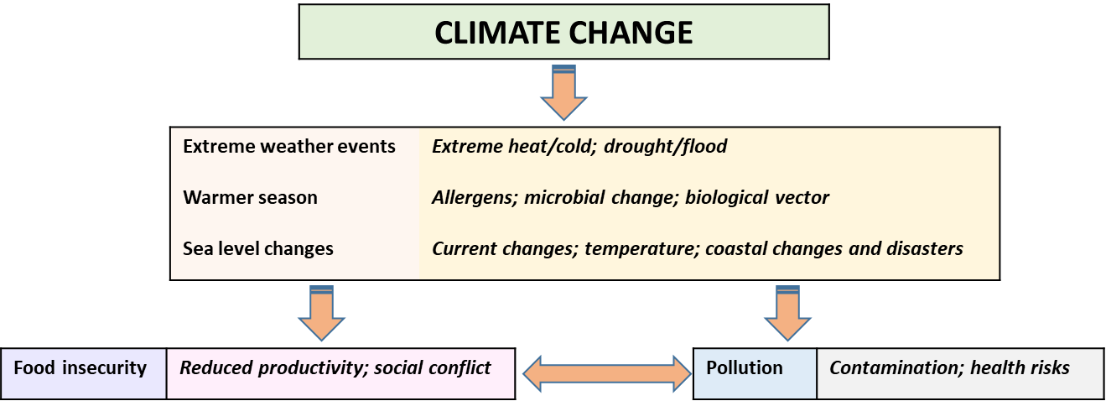
Figure 1: Effects of climate change and interconnections. Adapted from (Hussain, 2018).

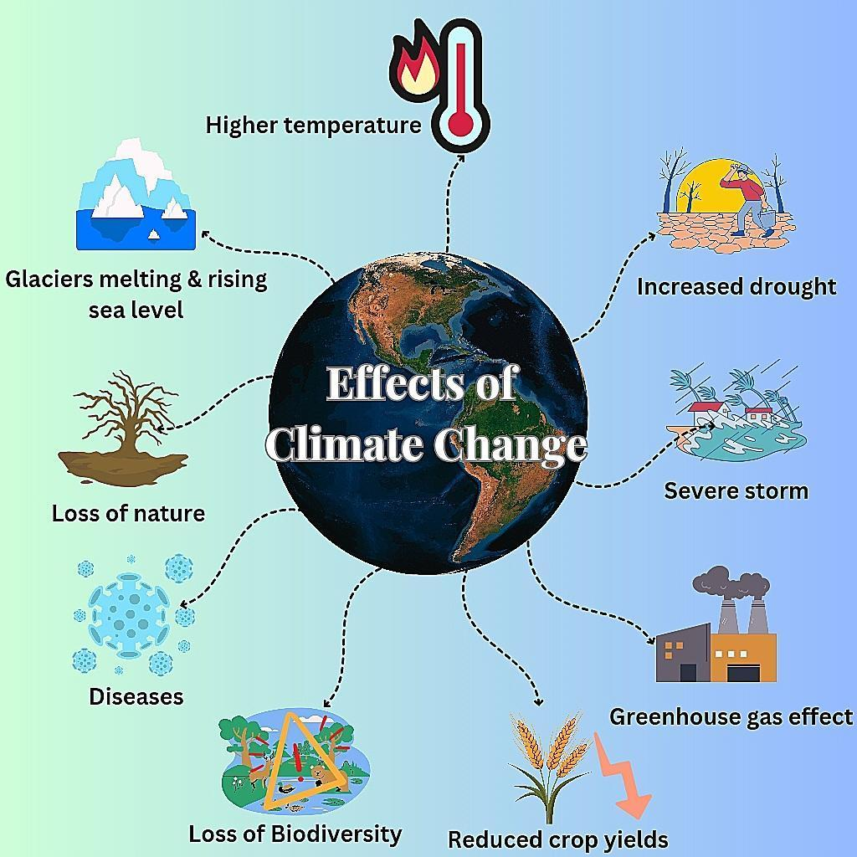
Figure 2: Effects of climate change

Table 1: Climate change Impacts on agriculture and Mitigation Approaches and adaptation strategies.

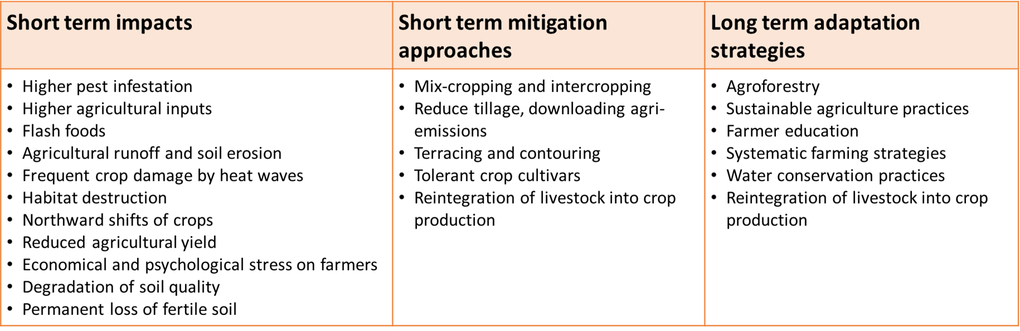

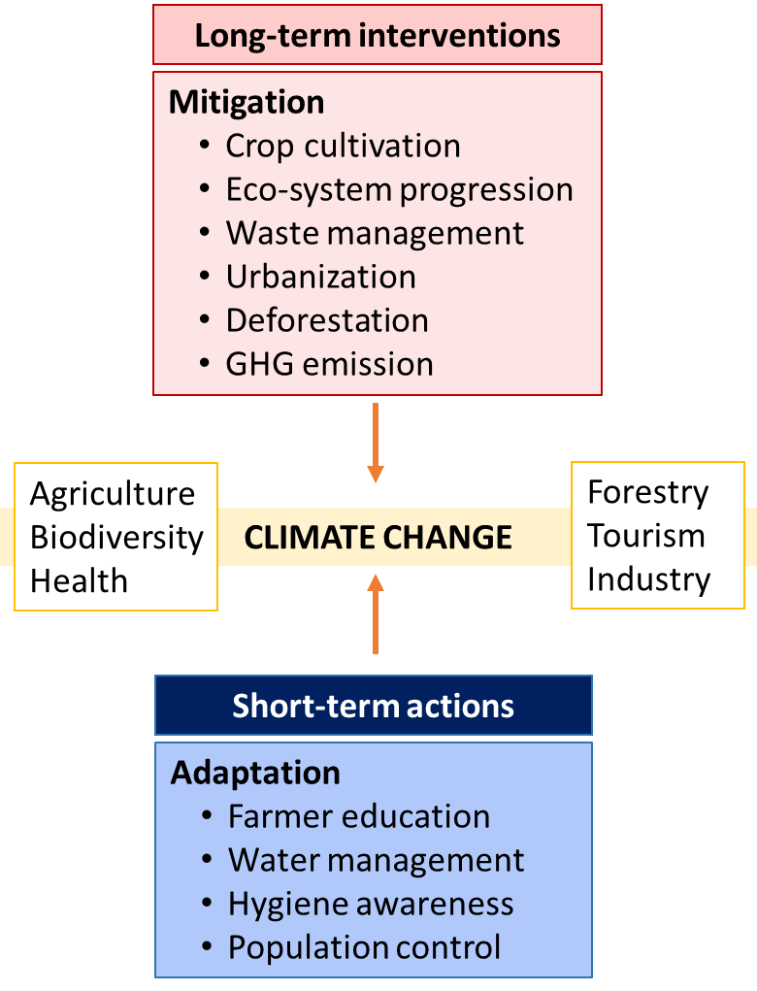
Figure 3: A summary of mitigation and adaptation strategies for combating climate change. Boxed sectors impact the decision-making for the strategy. Adapted from Abbas et al., 2022 [17].

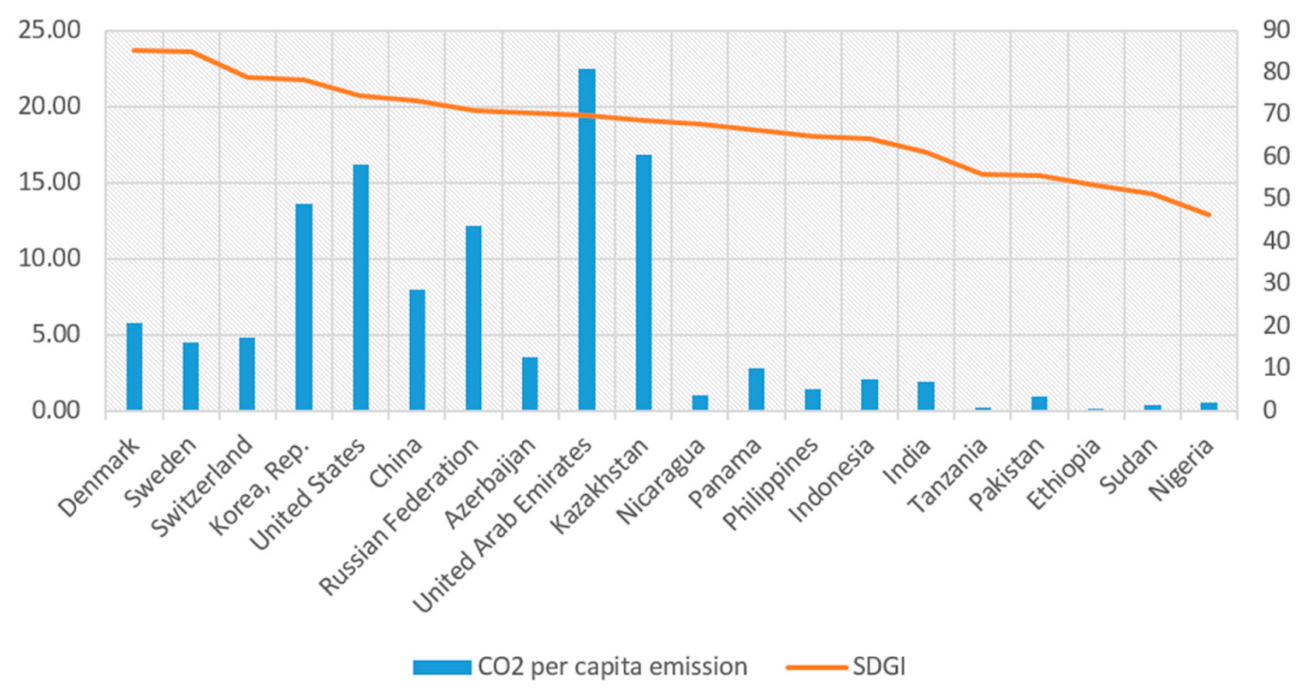

Figure 4: Carbon dioxide per capita emission and SDGIs in 2019. Adapted from Guo et al., 2020.

