LAND USE DYNAMICS AND FORAGE AVAILABILITY OF PASTURES IN SOUTHWEST BURKINA FASO

ABSTRACT
Land is subject to various uses aimed at meeting human needs for crop and livestock production as well as infrastructure. These multiple uses and demands make land occupation dynamic. To understand this dynamic and its potential impacts on livestock activities, the present study was conducted in the area of Batié. It aimed to examine the conditions of feed availability for livestock by analysing both the evolution of grazing areas and the productivity of forage herbaceous species. A diachronic analysis of land use dynamics from 1990 to 2019 was carried out, followed by an evaluation of the pastures in Batié area. The results show a strong decrease in natural formations to the benefit of human-modified ones between 1990 and 2019. For example, wooded savanna decreased by 8,494.55 ha, while farmland gained 9,128.09 ha during the same period. At the same time, bare areas increased by 690.33 ha. These changes negatively affected both the availability and quality of pastures. Indeed, the expansion of bare areas and settlements reduced the extent of grazing lands, while the increase in cropland and orchards favored the spread of non-palatable species such as Spermacoce verticillata, Hyptis spicigera, and Tridax procumbens. The results also show that Fields, with the lowest gross pastoral value (19%), constituted a poor pastoral unit. Conversely, shrub savanna, with the highest pastoral value (70.12%) and the best phytomass yield, was identified as the best pastoral unit in the study. Its reduction in area has therefore led to a decline in forage quality and availability. It is thus necessary to further reflect on the dynamics of land occupation in the area through a study on local perceptions of the phenomenon.
Keywords: herbaceous species; pasture; land use; pastoral value

1. INTRODUCTION
At the end of the 1960s, the western region of Burkina Faso was characterized by a low population density, hardly exceeding 10 inhabitants per km². This situation has changed considerably due to strong demographic growth, largely driven by migration linked to extreme climatic events. Following the successive droughts of 1973–1974 and 1983–1984, many herders and farmers migrated from the northern to the western parts of the country in search of better living conditions (Sanon et al., 2014). These events accelerated the occupation of the area.
Batié, one of the area in western Burkina Faso, which has also faced the adverse effects of drought (Nougtara et al., 2021), has experienced a significant population increase since that time, reaching a density of about 46 inhabitants per km² (Ouédraogo et al., 2022). Furthermore, successful control of trypanosomiasis and the use of crossbreeds between Zebu and Taurine Cattle more resistant to trypanosomiasis have encouraged a large influx of Cattle herds into the region (Gonin, 2012).
These human and animal migrations have generated diverse needs, particularly for housing, cropland, and grazing space. There is an increasing demand for land to meet both domestic and export needs for food and cash crops (Gonin, 2018). The expansion of agricultural areas has also been facilitated by the use of animal traction, which reduces labor constraints. Moreover, the rapid growth of livestock populations has increased the demand for grazing land.
In this context characterized by a pastoral livestock system requiring extensive space (Sawadogo, 2011) and extensive agriculture under high demographic pressure—pasturelands and forage resources are increasingly threatened and degraded. It is therefore essential to assess pasture areas in terms of their availability and productivity. It is within this perspective that the present study was conducted. Its objective is to examine livestock feed availability by analyzing both the evolution of grazing area availability and the current productivity of herbaceous forage species.
2. MATERIALS AND METHODS
2.1. The study site
The study was conducted in the area of Batié, located in the extreme south of Burkina Faso (Figure 1). The area of Batié shares part of its border with two neighbor countries, the Republics of Côte d’Ivoire and Ghana. It is a relatively well-watered area, with an average annual rainfall of about 1,200 mm (Thiombiano & Kampmann, 2010), and it hosts a diverse vegetation cover (Nougtara et al., 2023). The main economic activities practiced are agriculture and livestock rearing, both carried out extensively. These economic activities therefore play an important role in shaping the dynamics of land use in the area. Long regarded as a reception and transit zone for transhumant herders, Batié appears to be a strategic area for pastoral livestock production, as evidenced by the Fulani camps scattered throughout the region.
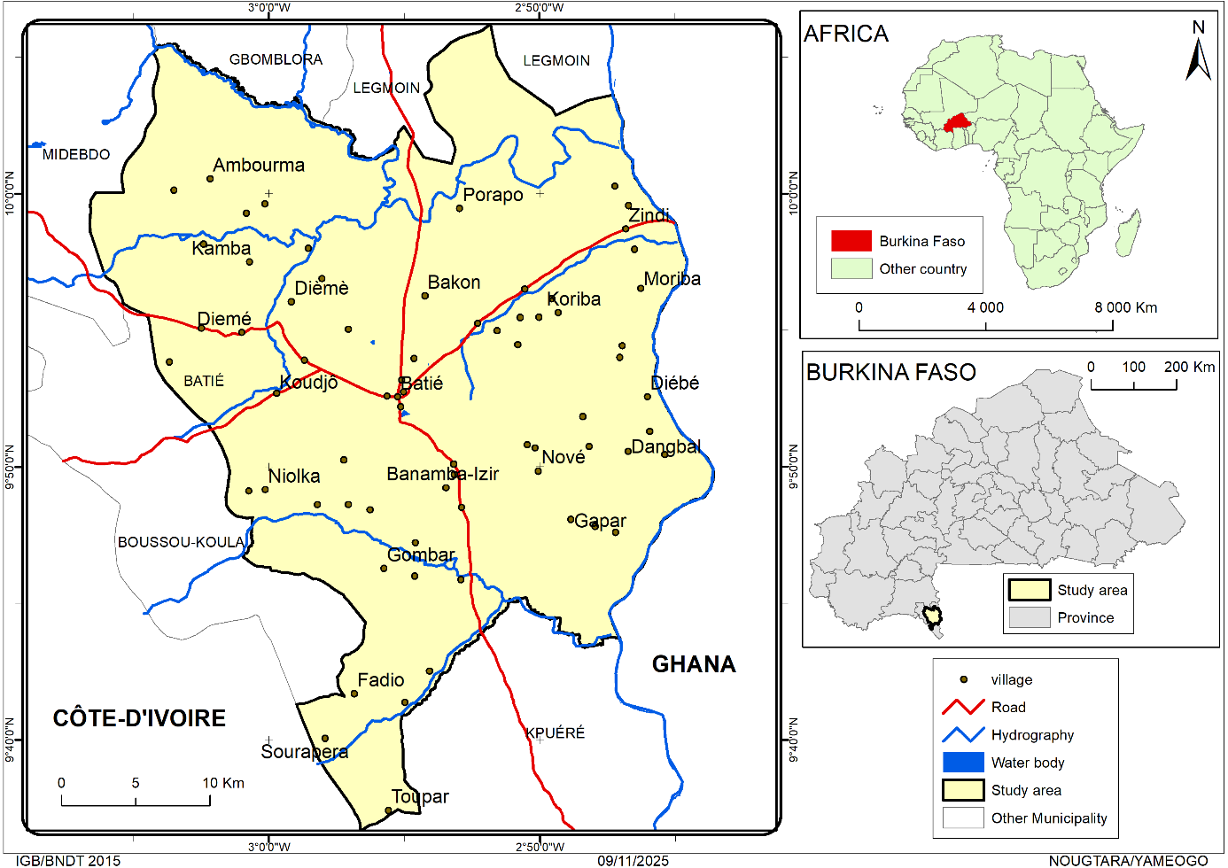
Figure 1: Location of the Study Area
Source: Our fieldwork, 2022
2.2. Mapping
2.2.1. Cartographic Data Collected
The mapping of the study area required the collection of Landsat images from three different periods 1990, 2005, and 2019 from the National Topographic Data Bank of Burkina Faso. This 30-year time span made it possible to conduct a diachronic analysis of land use dynamics in Batié. The images, taken in October, had a spectral resolution of 30 m × 30 m. This period corresponds to the end of the rainy season, which is characterized by better visibility
To identify land use units in Batié from the satellite images of the three periods, the land use nomenclature from the Burkina Faso Land Use Database was used. Previous studies, notably those by Yaméogo et al. (2021), have already applied this nomenclature in identifying land use units.

2.2.2 Processing and Analysis of Land Use Data
The processing of satellite images for determining land use units was carried out using the BDOT reference system of Burkina Faso. To evaluate the classification accuracy, the confusion matrix and the Kappa index were employed. According to Mama & Oloukoi (2003), the confusion matrix highlights errors that occur both within and between land use classes during interpretation.
In this study, the overall classification accuracies were 97.92%, 97.62%, and 98.59% for the years 1990, 2005, and 2019, respectively. The corresponding Kappa indices were 0.97, 0.96, and 0.98 for the same years.
To highlight the land use dynamics across the three periods, the transition matrix method was used. Several studies (Mama & Oloukoi, 2003; Bamba et al., 2008; Yaméogo, 2021) have applied this method in similar analyses.

2.3. Methods for Collecting and Processing Pasture Data
2.3.1. Methods for Collecting Data
Pasture assessment was carried out through the examination of floral diversity and the analysis of phytomass production across different vegetation units. These vegetation units were identified based on the analysis of land use maps and confirmed through a field transect.
The identified units included riparian formations, wooded savannas, shrub savannas, orchards, and Fields. In each unit, three observation plots of 2,500 m² each were delineated.
The investigations on pastures were both qualitative and quantitative, focusing exclusively on herbaceous forage. This choice was justified by the relative accessibility of the herbaceous layer and its predominant role in the diet of ruminants.
The quality of the forage available in the pastures was assessed using the ‘aligned quadrat points’ method developed by Daget and Poissonnet (1971). This method of pasture inventory made it possible to identify the herbaceous species in the study area, determine their Specific contribution (SC) and calculate the Gross pastoral Value (GPV) within the units studied. The following formulas were used:
- $CSi=\frac{FSi}{\sum_{i=1}^{n}{FSi}}$
- VPB=0,2 $\sum_{i=1}^{n}{(CSi*ISi)}$ with
FSi = Specific frequency of species i
CSi = Specific contribution of species i
GPV = Gross Pastoral Value
ISi = Specific quality index of species i
The evaluation of phytomass was carried out to quantify the herbaceous biomass. To do so, the complete harvesting method, commonly used in several studies in West Africa (Sanon et al., 2014; Samandoulgou et al., 2019), was adopted. Thus, in each observation plot, 10 subplots of 1 m² each were established, and their contents were completely cut and measured.
To determine the dry matter production, 250 gr samples of grasses were taken from each subplot, weighed, and then dried until a constant dry weight was obtained. To estimate the forage production of the studied pastures, the amount of dry matter per square meter was extrapolated to a per-hectare basis.

2.3.2. Processing of Pasture Data
Data were entered using Microsoft Excel (2016), which was also used for the design of figures and tables. The Statistical Package for the Social Sciences (SPSS) version 21.0 was employed to calculate means, standard deviations, and to perform mean comparisons.

3. RESULTS

3.1. Land Use Dynamics in Batié from 1990 to 2019

3.1.1. Spatial Land Use Patterns
The diachronic analysis of spatial land use in Batié between 1990 and 2019 reveals that the surface areas of land use units have undergone rapid changes (Figure 2; Table 1).
In 1990, the territory of Batié area was dominated by shrub savanna, which covered 43,787.81 ha, representing 35.70% of the area total area. This land use unit was followed by Fields and wooded savanna, which occupied 32.65% and 26.96%, respectively, of the area.
Thirty years later, in 2019, Fields, which previously ranked second, had become the main land use unit in Batié, covering 49,171.38 ha, or 40.09% of the area. The shrub savanna followed, with 39,223.20 ha, representing 31.98% of the total surface area.
Orchards, which covered only 39.34 ha in 1990, expanded to 1,794.34 ha in 2019. During the same period, there was a noticeable land degradation, with bare areas increasing significantly from 480.08 ha in 1990 to 1,170.40 ha in 2019.
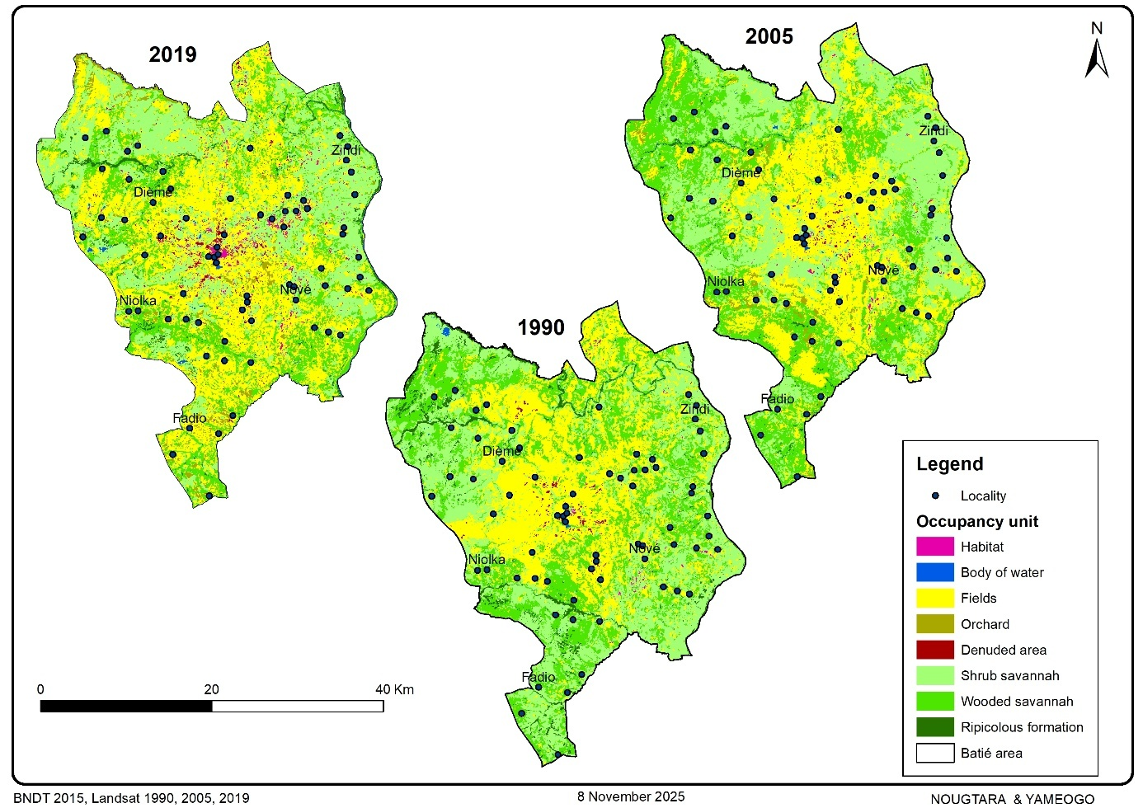
Figure 2: Land Use Dynamics in Batié from 1990 to 2019
Source: Fieldwork, 2022

Table 1: Area and Proportion of Land Use Extent
Unit | 1990 |  | 2005 |  | 2019
Unit | ha | % | ha | % | ha | %
Fields | 40,043.30 | 32.65 | 39,981.24 | 32.60 | 49,171.38 | 40.09
Riparian formation | 4,622.48 | 3.77 | 789.26 | 0.64 | 2,614.22 | 2.13
Settlements/Habitat | 273.06 | 0.22 | 391.84 | 0.32 | 1,794.34 | 1.46
Water body | 330.12 | 0.27 | 540.41 | 0.44 | 509.05 | 0.42
Wooded savanna | 33,066.05 | 26.96 | 34,940.45 | 28.49 | 24,571.51 | 20.04
Shrub savanna | 43,787.81 | 35.70 | 43,065.35 | 35.11 | 39,223.20 | 31.98
Orchard | 39.34 | 0.03 | 2,543.39 | 2.07 | 3,588.15 | 2.93
Bare area | 480.08 | 0.39 | 390.329 | 0.32 | 1,170.40 | 0.95

Source: Our collected, 2022
Table 2 provides an assessment of land occupation in Batié over the different periods. Overall, it appears that land-use units influenced by human activities expanded at the expense of natural units between 1990 and 2019.
Thus, the area occupied by Fields increased sharply (+9,128.09 ha, or +7.44%) over the period from 1990 to 2019. The same trend is observed for orchards and settlements, which increased by +2.89% and +1.24%, respectively. Bare lands also expanded, with an increase of +0.64% between 1990 and 2005 and an overall increase of +0.56% between 1990 and 2019.
Meanwhile, natural formations (wooded savanna, shrub savanna, and riparian formations) experienced a decline in surface area: –6.93% for wooded savanna, –3.72% for shrub savanna, and -1.64% for riparian formations.
In summary, the overall assessment from 1990 to 2019 indicates that natural units (riparian formations, wooded savanna, and shrub savanna) declined regardless of the time interval considered, while human-modified units showed strong and continuous increases over the different periods except Fields, which decreased between 1990 and 2005 before increasing again between 2005 and 2019.
Table 2: Land Use Balance for the period 1990 to 2019
Type of occupation | Assessment of  2005-1990 |  | Assessment of  2019-2005 |  | Assessment of  2019-1990
Type of occupation | Ha | % | Ha | % | ha | %
Fields | -62.03 | -0.05 | 9,190.12 | 7.49 | 9,128.09 | 7.44
Riparian formations | -3,833.21 | -3.13 | 1,824.96 | 1.49 | -2,008.25 | -1.64
Habitat | 118.78 | 0.10 | 1,402.5 | 1.14 | 1,521.28 | 1.24
Water body | 210.29 | 0.17 | -31.35 | -0.03 | 178.94 | 0.15
Wooded savannah | 1,874.39 | 1.53 | -10,368.94 | -8.45 | -8,494.55 | -6.93
Shrubby savannah | -722.47 | -0.59 | -3,842.17 | -3.13 | -4,564.64 | -3.72
Orchard | 2,504.04 | 2.04 | 1,044.76 | 0.85 | 3,548.8 | 2.89
Bare area | -89.79 | -0.07 | 780.12 | 0.64 | 690.33 | 0.56

Source: Our collected, 2022
    - Changes in Land Use Types
An overview of the dynamics of these areas shows a transformation of natural vegetation into degraded or even anthropised vegetation (Table 3).
Between 1990 and 2019, riparian formations lost areas that were transformed into wooded savannah (1,782.19 ha), shrubby savannah (878.41 ha) and fields and orchards (1,034.6 ha). Shrub savannah lost ground, with 15,620.47 ha being converted to fields, 9,768.32 ha to wooded savannah, 1,041.32 ha to orchards and 424.28 ha to housing. The biggest changes occurred in wooded savannah, where 11,789.48 ha, 10,264.26 ha and 1,296.65 ha were converted into fields, shrub savannah and orchards, respectively.
The area of habitat has increased considerably over the past 30 years at the expense of fields and savannahs. As a result, 1,091.5 hectares of fields, 424.28 hectares of shrub savannah and 162.37 hectares of wooded savannah have been converted into residential areas. Orchards have also been a major factor in changing land use patterns. From 39.34 ha in 1990, orchards had expanded to 3,588.14 ha in 2019, to the detriment of wooded savannah, shrub savannah, fields and riparian formations, which lost 1,296.65 ha, 1,041.32 ha and 719.15 ha and 501.45 ha respectively. Fields were the biggest factor in land use change. They mainly benefited from the area of shrub savannah (15,620.47 ha), wooded savannah (11,789.48 ha) and riparian formations (533.13 ha).

Table 3: Transition Matrix of Batié from 1990 to 2019
Unit | Fields | ForRi | Habitat | Water  body | TreeSav | ShrSav | Verger | Bare area | Total 2019
Fields | 20,808.69 | 533.13 | 109.89 | 25.83 | 11,789.48 | 15,620.47 | 4.23 | 279.65 | 49,171.38
ForRi | 232.59 | 867.71 | 1.17 | 0.99 | 715.62 | 795.6 | 0.45 | 0.09 | 2,614.22
Habitat | 1,091.5 | 5.49 | 72.99 | 0 | 162.37 | 424.28 | 0.18 | 37.53 | 1,794.34
Water body | 83.26 | 52.12 | 0.63 | 207.36 | 31.87 | 128.95 | 4.59 | 0.27 | 509.05
TreeSav | 4,277.86 | 1,782.19 | 22.86 | 9.9 | 8,696.74 | 9,768.32 | 7.97 | 5.67 | 24,571.51
ShrSav | 11,944.8 | 878.41 | 61.02 | 79.65 | 10,264.26 | 15,877.16 | 1.62 | 116.28 | 39,223.2
Verger | 719.15 | 501.45 | 1.08 | 6.39 | 1,296.65 | 1,041.32 | 20.3 | 1.8 | 3,588.14
Bare area | 885.44 | 1.98 | 3.42 | 0 | 109.06 | 131.71 | 0 | 38.79 | 1170.4
Total 1990 | 40,043.3 | 4,622.48 | 273.06 | 330.12 | 33,066.05 | 43,787.81 | 39.34 | 480.08 | 122,642.23

Legend: ForRi = Riparian formation; TreeSav = Tree savanna; ShrSav = Shrub savanna.

Source: Our collected, 2022

3.2. Pasture Analysis

3.2.1. Floristic Diversity of Pastures in Batié
The inventory of herbaceous species in the pastures of the study area identified 98 herbaceous species, belonging to 68 genera and 21 families. The main herbaceous families recorded were Poaceae, Fabaceae, Rubiaceae, Asteraceae, and Malvaceae.
Across all vegetation units, Poaceae were by far the most represented family (Table 4). Except in Fields, where they accounted for only 30.4% of families, Poaceae showed high proportions ranging between 48.4% and 62.2% in the remaining vegetation units. Among all units, shrub savanna contained the highest proportion of Poaceae (62.2%). In addition, Asteraceae, Fabaceae, and Malvaceae were the second most represented families within the vegetation formations.
The results also indicate that Fields constituted the vegetation unit with the highest family diversity (16 families). These findings contrast with those from the riparian formations, where only six families were recorded.
Table 4: Main Herbaceous Families of the Studied Units
Vegetation Unit | Number of Species | Number of Families | Characteristic Families (in %)
Fields | 46 | 16 | Poaceae | 30.4
Fields |  |  | Rubiaceae | 13.0
Fields |  |  | Asteraceae | 8.7
Fields |  |  | Lamiaceae | 8.7
Orchard | 31 | 9 | Poaceae | 48.4
Orchard |  |  | Rubiaceae | 9.7
Orchard |  |  | Fabaceae | 9.7
Orchard |  |  | Malvaceae | 9.7
Shrub savanna | 37 | 10 | Fabaceae | 10.8
Shrub savanna |  |  | Malvaceae | 5.4
Shrub savanna |  |  | Poaceae | 62.2
Shrub savanna |  |  | Rubiaceae | 5.4
Wooded savanna | 37 | 10 | Amaranthaceae | 5.4
Wooded savanna |  |  | Asteraceae | 10.8
Wooded savanna |  |  | Malvaceae | 10.8
Wooded savanna |  |  | Poaceae | 48.6
Riparian formation | 9 | 5 | Asteraceae | 16.7
Riparian formation |  |  | Fabaceae | 16.7
Riparian formation |  |  | Poaceae | 50
Source: Our Collected Data, 2022
The analysis of floristic composition (Table 5) indicates that Fields are the most diversified, with 46 herbaceous species. This vegetation unit is dominated by forbs (31.4%), among which Spermacoce verticillata L. is the most represented species. Forbs are also well represented in orchards and riparian formations.
In contrast, annual grasses are the most dominant species in both shrub savanna and wooded savanna. Hyparrhenia smithiana (Hook. f.) Stapf (20.1%) and Brachiaria decumbens Stapf (14.88%) are the main species in the wooded savanna, while Hyparrhenia smithiana (Hook. f.) Stapf (20.38%) and Schizachyrium exile (Hochst.) Pilg. (18.9%) are the most dominant species in the shrub savanna.
The results also show that, apart from the riparian formations and shrub savanna, where they are relatively more common (Andropogon tectorum Schumach. & Thonn accounting for 34.6% in riparian formations and Andropogon ascinodis C.B. representing 8.3% in shrub savanna), perennial grasses are rare in the other vegetation units.

Table 5: Main Recorded Herbaceous Species and their Contribution
Vegetation Type | Producing Species | TF | FS (%) | CS (%)
Field | Spermacoce verticillata L. | Au | 91 | 15.53
Field | Gomphrena celosioides Mart. | Au | 52 | 8.87
Field | Hyptis spicigera Lam. | Au | 41 | 7.0
Field | Brachiaria distachya (L.) Stapf | Ga | 40 | 6.83
Field | Kyllinga pumila Michx. | Au | 37 | 6.31
Tree savanna | Hyparrhenia smithiana (Hook. f.) Stapf | Ga | 156 | 20.18
Tree savanna | Brachiaria decumbens Stapf | Gv | 115 | 14.88
Tree savanna | Brachiaria lata (Schumach.) C.E. Hubb. | Gv | 58 | 7.50
Tree savanna | Setaria pumila (Poiret) Roemer & Shultes. | Ga | 41 | 5.30
Shrub savanna | Hyparrhenia smithiana (Hook.f.) Stapf | Ga | 241 | 20.38
Shrub savanna | Schizachyrium exile (Hochst.) Pilg. | Ga | 224 | 18.9
Shrub savanna | Andropogon pseudapricus | Ga | 102 | 9.22
Shrub savanna | Andropogon ascinodis C.B. Clarke | Gv | 98 | 8.3
Shrub savanna | Spermacoce filifolia (Schumach, & Thonn.) | Au | 98 | 6.6
Riparian formation | Andropogon tectorum Schumach. & Thonn | Gv | 28 | 34.6
Riparian formation | Aneilema setiferum A. Chev. | Au | 26 | 32.1
Riparian formation | Aspilia bussei O. Hoffman & Muschl. | Au | 5 | 6.2
Riparian formation | Crotalaria palida Ait. | Ga | 12 | 14.8
Orchard | Digitaria horizontalis Willd. | Ga | 231 | 41.7
Orchard | Spermacoce ruelliae DC. | Au | 80 | 14.4
Orchard | Pennisetum polystachion (L.) Schult. | Ga | 50 | 9.0
Orchard | Tridax procumbens (L.) L. | Au | 40 | 7.2
Source: Our collected data, 2022

3.2.2. Phytomass Production and Gross Pastoral Value
Phytomass yield varied from one vegetation unit to another (Table 6). The lowest yield was recorded in orchards, with a production of 0.31 ± 0.21 tDM·ha⁻¹, while the highest amount of phytomass was obtained in the shrub savanna, with a yield of 2.62 ± 1.21 tDM·ha⁻¹. Comparing the different vegetation units, it is clear that the shrub savanna was the most productive, with a yield of 2.62 ± 1.21 tDM·ha⁻¹. Its phytomass production was significantly higher than that of all other vegetation units.
Fields (1.83 ± 1.13 tDM·ha⁻¹) also recorded a significantly higher quantity of phytomass than the wooded savanna (0.95 ± 0.73 tDM·ha⁻¹), orchards (0.61 ± 0.25 tDM·ha⁻¹), and riparian formations (0.31 ± 0.20 tDM·ha⁻¹).
The results of total phytomass production clearly show that shrub savanna was the vegetation unit that produced the most forage (102,913.09 tDM). Fields represented the second most productive unit, with 90,029.16 tDM. However, this unit, which is dominated by herbaceous species with low quality indices, had a low pastoral value (19.82%) compared with the other vegetation units.
Among these vegetation units, orchards (57.58%), wooded savanna (64.53%), and shrub savanna (70.12%) achieved a gross pastoral value close to the reference value of 65%.

Table 6: Forage Production of the Vegetation Units
Vegetation Unit | Area (ha) | Yield (tDM·ha⁻¹) | Total Phytomass | GPV %
Fields | 49,171 | 1.83 | 90,029.16 | 19.82
Riparian formation | 2,614 | 0.31 | 822.92 | 49.63
Tree savanna | 24,572 | 0.95 | 23,251.63 | 64.53
Shrub savanna | 39,223 | 2.62 | 102,913.09 | 70.12
Orchard | 3,588 | 0.64 | 2,304.62 | 57.58
Source: Our collected data, 2022
- DISCUSSION

Spatial Use of the area of Batié
The diachronic analysis reveals a permanent reorganization of land use in the area of Batié over the period from 1990 to 2019. This reorganization is marked by the reduction of natural formations in favor of human-modified units. Indeed, wooded and shrub savannas and riparian formations which covered two-thirds of the area in 1990 declined considerably and represented barely half of the municipal surface area in 2019. This finding is consistent with earlier studies, particularly those by Kima et al. (2016) and Yaméogo (2021), who analyzed land occupation from 1980 to 2020 in Burkina Faso and showed that although natural vegetation formations were dominant, they have been progressively decreasing.
The study reveals that large areas of riparian formations have been converted into wooded and shrub savannas, while extensive wooded savanna spaces have shifted into shrub savannas. These observed changes in natural vegetation formations reflect their degradation. This degradation can be attributed to climate change, which is considered a driver of resource depletion (Hellendorff, 2012). In the same vein, Igué et al. (2010) indicate that climate modifications particularly the declining trend in rainfall totals since the drought of the 1970s may explain the current state of degradation of vegetation formations.
The diachronic analysis also shows a considerable increase in bare soils, suggesting likely soil degradation. In their work in the North-Central region of Burkina Faso, Kaboré et al. (2019) demonstrated that several factors, including the expansion of bare soils, are indicators of soil degradation.
Beyond climate effects, human activities have had a substantial impact on the reorganization of land use in Batié. The study results show a regression in riparian formations and savannas in favor of Fields, orchards, and settlements. This dynamic of land anthropization is widely recognized by several authors who have studied the topic (Oloukoi, 2013; Djohy et al., 2016; Kima et al., 2016; Akpoyètè et al., 2018; Yaméogo, 2021). The reorganization aims primarily to meet the population's needs for food resources, housing, and economic development.
Our results show that Fields constitute the main land-use unit and one of the most dynamic, with a gain of 9,128.09 ha over 30 years. This may be explained by the fact that agriculture in Burkina Faso is predominantly extensive, and expanding agricultural land is perceived as an adaptation strategy to declining agricultural yields (Nougtara et al., 2018). However, according to Hountondji (2008), the expansion of agricultural land is partly responsible for natural resource degradation.
The expansion of cropland may also be linked to significant population growth in the area, which increased from 5,036 households to 8,329 households (Ouédraogo et al., 2022), a rise of 65.39%. Furthermore, orchard areas experienced rapid expansion, increasing from about 40 ha to more than 2,500 ha between 1990 and 2015. The mass return of Burkinabè from Côte d’Ivoire following the socio-political crises of the 1990s–2000s and their shift toward market gardening and especially cashew planting may explain this increase.
Overall, the trend marked by the reduction of natural areas, the expansion of human-modified formations, and the growth of bare lands leads to a reduction in both the availability and quality of pastures in the Batié area.

Pasture Assessment
The floristic inventory revealed a species richness of 98 herbaceous species grouped into 21 families. Regardless of the vegetation unit, the Poaceae family was by far the most represented. These results are consistent with those of Samandoulgou et al. (2019) and may be due to the adaptability of Poaceae to difficult rainfall conditions. Ndotam et al. (2017) associate the adaptability of Poaceae with their resistance to climatic hazards and diseases.
Fields recorded the highest species richness. This result aligns with those reported by other authors (Yanra, 2004 in the West; Sanon et al., 2014 in the Southwest; Sawadogo et al., 2012 in Eastern Burkina Faso) and can be explained by the fact that highly anthropized environments are often characterized by high species richness (Sawadogo et al., 2012).
Contrary to earlier findings (Zoungrana, 1991; Sanon et al., 2014), which reported a dominance of perennial grasses in the Southwest, the results of the present study show that forbs and annual grasses are now the dominant life forms. This situation indicates pasture degradation in the area and corroborates Diallo (1997), who reported degraded savanna pastures dominated by annual herbaceous species in western Burkina Faso.
In the study area, some plant species considered indicators of overgrazing (Hofmann, 1985) were recorded, such as Sporobolus pyramidalis, Spermacoce stachydea DC., Tephrosia bracteolata Guill. & Perr., and Tridax procumbens (L.) L. Additionally, in the context of land anthropization and soil denudation, pastoral units are shrinking in surface area. This suggests that the pastures of Batié are subject to overexploitation, which may explain their degradation.
The phytomass assessed can be considered a default estimate of potential production, as the evaluated pastures were either exposed to grazing as in riparian formations and shrub and wooded savannas or influenced by human activities, as in Fields and orchards, which are regularly managed. Several phytomass assessment studies have been conducted under similar conditions (Béchir et al., 2010; Sawadogo, 2011).
The phytomass of vegetation units ranged from 0.31 tDM·ha⁻¹ to 2.62 tDM·ha⁻¹, with the highest production observed in shrub savanna. Overall, phytomass yield is moderate. Indeed, the results of this study are lower than those reported by other authors in the same phytogeographical zone (Yanra, 2004; Sawadogo 2011; Sanon et al., 2014), which ranged from 1 to 5 tDM·ha⁻¹. This situation may be attributable to grazing pressure from livestock.
Moreover, in most vegetation units, annual grasses and forbs were the most dominant groups. However, pastures dominated by annual grasses and forbs have lower phytomass productivity than those dominated by perennial grasses (Sanon et al., 2014).
The examination of pastoral value showed that shrub and wooded savannas had a gross pastoral value of 65% or higher, which is considered good-quality pasture according to Daget and Poissonnet (1971) and César (2005). These savannas contain a high proportion of annual grasses with excellent specific index values, such as Hyparrhenia smithiana (Hook. f.) Stapf and Schizachyrium exile, as well as perennial species of the genera Brachiaria and Andropogon.
The strong contribution of these forage species likely explains why the pastoral value of savannas in this study is higher than the 42–45% found by Kiema et al. (2015) and Yanra (2004) in the south-Sudanian zone.
However, most pastoral units showed pastoral values below the reference threshold, which suggests that overall, the pastures in the area are of moderate to low pastoral quality. Fields, with a gross pastoral value of 19.82%, represent the poorest unit.
These Fields are dominated by forbs such as Spermacoce verticillata and Gomphrena celosioides Mart., and Hyptis spicigera, which have low to zero specific indices. They also contain species such as Hyptis suaveolens (L.) Poit. and Hyptis spicigera Lam., which are invasive plants that reduce the biological diversity of pastures (Thiombiano et al., 2009; Samandoulgou et al., 2019).
Nevertheless, Fields remain a key source of livestock feed due to their contribution of crop residues.

- CONCLUSION
The study was carried out with the aim of examining livestock feed availability by assessing the evolution of grazing areas between 1990 and 2019 and conducting a point analysis of the productivity of herbaceous forage species in the area of Batié. The results show that anthropogenic land-use units (Fields, orchards, settlements) have increased significantly at the expense of natural land-use units such as savannas and riparian formations.
Human activities have thus led to the conversion of thousands of hectares of riparian formations and savannas into Fields, orchards, and settlements. They have also contributed to the expansion of bare soils, which increased from 480 ha in 1990 to 1,170 ha in 2019.
The land-use dynamics suggest a reduction in the extent and even the quality of pastures. Indeed, within the diversity of herbaceous species recorded, the study revealed the appearance of plant species considered indicators of overgrazed or degraded pastoral units, such as Sporobolus pyramidalis, Spermacoce stachydea, Tephrosia bracteolata, Tridax procumbens, as well as invasive species such as Hyptis spicigera.
The phytomass yield of vegetation units—considered moderate—ranged from 0.31 to 2.62 tDM·ha⁻¹, and most vegetation units showed low to moderate gross pastoral value, which poses a major constraint for pastoral practices.
In the future, and with the aim of reducing the impact of land-use dynamics on the environment and pastoral activities, it would be important to conduct an investigation into local perceptions of the physical land-use changes observed.
- DISCLAIMER (ARTIFICIAL INTELLIGENCE)
The authors hereby declare that NO generative AI technologies, such as large language models (ChatGPT, COPILOT, etc.) or text-to-image generators, were used in the writing or revision of this manuscript.
- CONFLICT OF INTEREST
The authors declare that there is no conflict of interest.
- REFERENCES
- Sanon H.O., Savadogo M., Tamboura H.H., Kanwé B.A., 2014. Characterization of production systems and forage resources in a test area of the Sudanian zone of Burkina Faso. VertigOelectronic journal in environmental sciences, 14(2). 10.4000/vertigo.15171
- Nougtara S., Kiema A., Soudré A., Sougoti/Guissou L., Berthe T.H., 2021. Adaptation of cattle farming in western Burkina Faso to recurrent droughts. Int. J. Biol. Chem. Sci., 15: 1648–1666. DOI: 10.4314/ijbcs.v15i4.27
- Ouédraogo B., Béré B., Bayala/Ariste L.L., Tapsoba/Tapsoba T.V.M.E., Ouédraogo F.G., Zida/Bangré H., Savadogo N., Sawadogo S.P., Niamba L., Kiema C., Segueda P.N.T., Dabiré A.W.G., Traoré S., Nombré A., 2022. Fifth General Population and Housing Census of Burkina Faso. Synthesis of final results, 133 p. https://www.insd.bf/fr/rapports-et-publications/5e-rgph
- Gonin A., Tallet B., 2012. What future for livestock farming in the cotton basin of western Burkina Faso? Agro-pastoral dynamics and territorial changes. Autrepart – revue de sciences sociales au Sud, 95–110. DOI: 10.3917/autr.060.0095
- Gonin A., 2018. Pastoral land tenure in the Sahel: weakened mobility. Bulletin des géographes français, 95(2). DOI: https://doi.org/10.4000/bagf.3049
- Sawadogo I., 2011. Forage resources and herders’ perceptions, evolution of pastoral practices in a protected area: Case of Kotchari territory on the outskirts of the W biosphere reserve, Burkina Faso. PhD Thesis, Muséum National d’Histoire Naturelle, Paris. https://www.scispace.com/paper/issasawadogoressourcesfourrageresetr-2992987116
- Thiombiano A., Kampmann D., 2010. Atlas of Biodiversity of West Africa. Vol. II, Ouagadougou & Frankfurt. http://www.sud-expert-plantes.ird.fr/writable/plugins/sep/files/1992_308_Pbl._rev._Hyptis_Suaveolens.pdf
- Nougtara S., Tensaba R.S., Kiema A., Soudré A., Traore K., 2023. Forage resources in pastures of southwestern Burkina Faso: herders’ perceptions of the biodiversity of palatable plant species. International Journal of Innovation Scientific Research and Review, 05(05): 4573–4578
- Mama V.J., Oloukoi J., 2003. Evaluation of the accuracy of analog satellite image processing in the study of land-use dynamics. Contemporary Publishing International, 5(3): 429– 441.
- Bamba I., Barima Y.S.S., Bogaert J., 2010. Influence of population density on the spatial structure of a forest landscape in the Congo Basin, D.R. Congo. Mongabay.com Open Access Journal Tropical Conservation Science, 3(1): 31–44. 10.1177/194008291000300104
- Yaméogo A., 2021. Characterization of erosive dynamics in the upper Sissili watershed (Burkina Faso). PhD Thesis, Université Norbert Zongo, Koudougou.
- Hellendorff B., 2012. Climate change and agro-pastoral conflicts in the Sahel. GRIP Analysis Note, Brussels. URL: http://www.grip.org/fr/node/546
- Daget Ph., Poissonnet J., 1971. A method for estimating the pastoral value of rangelands. Summary of a presentation at the 4th General Assembly of the European Grassland Federation, Lausanne, pp. 31–39. https://www.afpf.asso.fr/produit/un-procede-destimation-de-la-valeur-pastorale-des-paturages/
- Samandoulgou Y., Compaoré H., Zoundi S.J., Zoungrana-Kabore Y.C., 2019. Assessment of herbaceous forage productivity in the sacred forests of Koupéla in west-central Burkina Faso. Int. J. Biol. Chem. Sci., 13(1): 99–109. 10.4314/ijbcs.v13i1.9
- Kima S.A., Okhimamhe A.A., Kiema A., 2016. Assessing the impacts of land use and land cover change on pastoral livestock farming in southeastern Burkina Faso. Environment and Natural Resources Research, 6(1): 110–124. URL: 10.5539/enrr.v6n1p110
- Hellendorff B., 2012. Climate change and agro-pastoral conflicts in the Sahel. GRIP Analysis Note, Brussels. URL: http://www.grip.org/fr/node/546

- Igué A.M., Houndagba C.J., Worou R., Gaiser T., Mensah G.A., Stahr K., 2010. Aspects of land-use dynamics and participatory management of the Toui-Kilibo classified forest in Benin. Rev. Sc. Env., Univ. Lomé (Togo), pp. 113–134. https://www.researchgate.net/publication/262573233_Aspect_de_la_dynamique_de_l'occupation_du_sol_et_du_projet_d'amenagement_participatif_de_la_foret_classee_de_Toui-Kilibo_au_Benin
- Kaboré P.N., Barbier B., Ouoba P., Kiema A., Somé L., Ouédraogo A., 2019. Perceptions of climate change, environmental impacts, and endogenous adaptation strategies among farmers in North-Central Burkina Faso. VertigO – electronic journal in environmental sciences, 19(1). DOI: 10.4000/vertigo.24637
- Oloukoi J., 2013. Socio-economic and ecological scenarios of land-use change in Benin. VertigOelectronic journal in environmental sciences, 1(13). DOI: 10.4000/vertigo.13267
- Djohy G.L., Totin Vodounon H.S., Kinzo N.E., 2016. Land use dynamics and the evolution of agricultural lands in the commune of Sinendé, northern Benin. Cahiers du CBRST, Lettres, Sciences Humaines et Sociales, Cotonou, Benin. https://www.researchgate.net/publication/322384954_DYNAMIQUE_DE_L'OCCUPATION_DU_SOL_ET_EVOLUTION_DES_TERRES_AGRICOLES_DANS_LA_COMMUNE_DE_SINENDE_AU_NORD-BENIN
- Akpoyètè D.H., Landeou R.C., Orékan V.O., 2018. Anthropization and landscape dynamics in the Agonlin region of Benin. European Scientific Journal, 14(36): 571–594. DOI: 10.19044/esj.2018.v14n36p571.URL: 10.19044/esj.2018.v14n36p571
- Nougtara S., Kiema A., Nacro B.H., 2018. Local populations’ experiences in managing climate risks and adapting to recurrent droughts in the Sahel of Burkina Faso. Science et Technique, 4: 59–76
- Hountondji Y.C.H., 2008. Environmental dynamics in Sahelian and Sudanian zones of West Africa: analysis of changes and evaluation of vegetation cover degradation. PhD Thesis, University of Liège, 131 p. https://orbi.uliege.be/handle/2268/76497
- Ndotam Tatila I., Reounodji F., Lumande Kasali J., Diaouangana J., 2017. Assessment of herbaceous floristic diversity in Manda National Park, Chad. Int. J. Biol. Chem. Sci., 11(4): 1484–1496. DOI: 10.4314/ijbcs.v11i4.7
- Yanra J.D.D., 2004. Characterization of natural pastures in the south-Sudanian zone of Burkina Faso: Case of Sidi, Guena, and Banfoulague territories in Kénédougou Province. Engineering Thesis, IDR-UPB, Bobo-Dioulasso, 77 p. https://vertexaisearch.cloud.google.com/grounding-api-redirect/AUZIYQFIaUS4q-5TOxqaIQoHsZ6P9zG7LL3sEwBnJVViDoKwPPJ72wiLUPpIyAApEMq_nJyrdZ6_w5iPlz9xhVibg6bBb8KPKG2xN95mP8O_PFnebVEWxbSFo_dwCf84-GBHr84dX-hHj1xE6XoMyo1_d9OfcqZZ0uCgKIE8nKk3NTKJeeB6aHv_4P6veudxXfMSSdMNioySQLY2f2b-IQ==
- Sawadogo I., Devineau J-L., Fournier A., 2012. State of pastoral resources in a host and transit area for transhumant herders: The Kotchari territory (southeastern Burkina Faso). Rev. Écol. (Terre Vie), 67: 157–178. https://www.researchgate.net/publication/262240954_Etat_des_ressources_pastorales_dans_une_terre_d'accueil_et_de_transit_des_pasteurs_transhumants_le_terroir_de_Kotchari_sud-est_du_Burkina_Faso_The_condition_of_pastoral_resources_of_a_land_of_reception_and_transit_for_transhumant_herders_the_Kotchari_territory_Southeastern_Burkina_Faso
- Zoungrana C-Y., 1991. Research on grazed areas of Burkina Faso. Doctoral Thesis, University of Bordeaux III, UFR Land Management and Natural Resources, 277 p.
- Diallo M.S., 1997. Research on vegetation evolution under grazing pressure in western Burkina Faso (Sudanian zone): Case of Bondoukuy, Kassaho, and Kourouma. PhD Thesis, Faculty of Science and Technology, University of Ouagadougou, 147 p
- Hoffmann O., 1985. Pastoral practices and vegetation cover dynamics in the Lobi area (Northeast Côte d’Ivoire). ORSTOM, 352 p. https://horizon.documentation.ird.fr/exldoc/pleins_textes/pleins_textes_6/colloques2/25607.pdf
- Béchir A.B., 2010. Productivity, rangeland dynamics, and Cattle farming practices in the Sudanian zone of Chad. PhD Thesis, Institut du Développement Rural, Université Polytechnique de Bobo-Dioulasso, 303 p.
- César J., 2005. Assessment of natural forage resources. Technical Sheet, CIRDES (URPAN), Bobo-Dioulasso, 12 p.
- Kiema A., Honadia C., Somda J., Sawadogo I., Seynou O., Nianogo A., Savadogo M., 2015. Assessment of the general state of pastoral resources in Burkina Faso. Final report, IUCN, Ouagadougou, 118 p.
- Thiombiano N., Ouédraogo R.L., Belem M., Guinko S., 2009. Dynamics and impact of an invasive plant in Burkina Faso: Hyptis suaveolens (L.) Poit. Ann. Univ. Lomé (Togo), Sciences Series, XVIII: 97–115.

