Assessment of Vegetative Phases And Optimization Of Rainfed Rice Cycle Timing Under Climatic Risk In The Tonkpi Agroecological Zone, Western Côte d’Ivoire

.ABSTRACT

Aims: This study aimed to determine the vegetative periods and identify optimal sowing windows for rainfed rice in the Tonkpi agroecological zone of western Côte d’Ivoire, in order to reduce exposure to climatic risks and improve crop-cycle planning.

Study design: Agroclimatic assessment based on long-term climatic analysis using the Eldin climatic risk approach.

Place and Duration of Study: The study was conducted in five localities of the Tonkpi Region (Man, Biankouma, Danané, Zouan-Hounien, and Sipilou) using a 40-year climatic dataset covering the period 1984–2024.

Methodology: Water satisfaction probability curves were generated by comparing rainfall (P), potential evapotranspiration (ETP), and ETP/2. A climatic risk threshold of 25% was used to identify periods with sufficient moisture for vegetative development. The same threshold was applied to the heading–flowering phase, considered the most sensitive to water deficit. Sowing windows for 100-day and 120-day varieties were established based on the alignment between crop requirements and favorable hydric periods.

Results: Vegetative growth can be sustained from April to late October in Man, Biankouma, and Zouan-Hounien, and from April to mid-October in Danané. In Sipilou, the onset of favorable moisture conditions is delayed until late May due to higher early-season water deficit. The heading–flowering phase benefits from adequate water availability between late May and mid-October across most sites, ending earlier in Danané and starting later in Sipilou. For 100-day varieties, optimal sowing occurs from mid-April to early August (late May in Sipilou). For 120-day varieties, sowing should occur earlier, between mid-April and mid-July, to avoid moisture decline during maturation.

Conclusion: Sowing windows and vegetative phase durations vary across the Tonkpi Region due to localized climatic disparities. The findings provide evidence-based guidance for climate-smart planning and support the development of locally adapted cropping calendars to enhance the resilience of rainfed rice production systems.

Keywords:Climaticrisk, sowingwindow, water stress, rainfedrice, climatevariability, agroclimatic adaptation, TonkpiRegion

1. INTRODUCTION
Rainfed rice is a strategic subsistence crop for food security in Côte d’Ivoire, accounting for nearly 90% of the country’s rice production (AfricaRice, 2011; FAO, 2017). Although current yields reach several hundred thousand tonnes per year, they remain insufficient to meet national consumption needs, resulting in annual imports of approximately 900,000 tonnes (FAO, 2017). Production is mainly concentrated in agroecological zones with high rainfall potential, such as the Tonkpi Region in western Côte d’Ivoire (Kouakou et al., 2013). However, the predominance of rainfed cultivation renders rice production highly vulnerable to the increasing inter-annual and intra-seasonal variability of rainfall. This variability intensifies the risk of water stress, particularly during the critical heading–to–flowering stage, which has been shown to influence yield strongly (Dingkuhn et al., 1998; Sultan et al., 2013). In the context of ongoing climate change across West Africa—characterised by shifting rainfall regimes, erratic distribution, and heightened frequency of dry spells (Traoré et al., 2013)—there is a pressing need to reassess vegetative periods and revise cropping calendars. Current agricultural schedules are often misaligned with evolving rainfall patterns, increasing exposure to yield-reducing climatic risks. Optimizing sowing dates has therefore emerged as a key adaptation mechanism to protect crops from moisture deficits by aligning water requirements with periods of favourable hydric availability (Allen et al., 1998).
This study aims to determine the vegetative periods and optimize the cycle timing of rainfed rice in key localities of the Tonkpi Region, using the climatic risk threshold method developed by Lhomme & Eldin (1985). Two varieties were considered: a short-cycle (100-day) and a long-cycle (120-day) rice cultivar. The results are intended to define risk-based sowing windows that reduce exposure to water stress and support the development of climate-resilient rice production strategies in a region of high agricultural potential.

2. MATERIAL AND METHODS / EXPERIMENTAL DETAILS / METHODOLOGY

2.1. Study site
The study was conducted in the Tonkpi Region, located in the far west of Côte d’Ivoire, within the District of Mountains. The region spans latitudes 7°00’N to 8°30’N and longitudes 7°00’W to 8°30’W, covering an area of 12,284 km² with an estimated population of 1.39 million (INS, 2021). It comprises five departments: Man, Biankouma, Danané, Zouan-Hounien, and Sipilou. The topography is rugged, dominated by Mount Tonkpi (1,189 m) and the UNESCO Biosphere Reserve, Mount Nimba (1,752 m) (UNESCO, 2017).
The climate is classified as sub-equatorial mountain type, characterized by two rainy seasons (March–July and August–October) and two dry seasons (November–February and a brief one in July–August). Mean annual rainfall ranges from 1,400 to 2,500 mm, with mean temperatures between 25 and 30 °C (Kouadio et al., 2018). The area is characterized by clay-rich soils favorable for agriculture and a diverse vegetation cover, including dense and open forests, wooded savannas, and protected areas such as Mount Nimba and Mont Sangbé National Park (FAO, 2019). The region is agriculturally rich, with cash crops including coffee, cocoa, rubber, and cashew, as well as staple food crops such as cassava, maize, and rice, which are cultivated under both irrigated and rainfed systems (Wopereis et al.,2008).

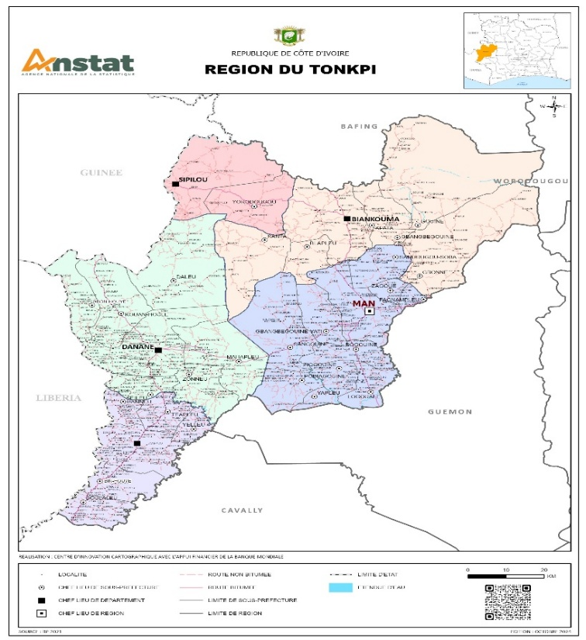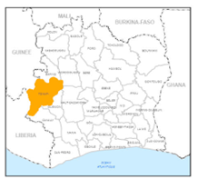

Figure 1: Location of the Tonkpi Region in western Côte d’Ivoire

2.2. Data sources

The climatic data used in this study included daily series (1984–2024) of precipitation, dew point, minimum, maximum, and mean temperature, relative humidity, wind speed, and global solar radiation (Rg). These data were extracted from the NASA POWER database (https://power.larc.nasa.gov/data-access-viewer/).

These variables were used to calculate the reference evapotranspiration (ET₀) using theFAO Penman-Monteith equation (Allen et al., 1998).

Agronomic data on phenological phase durations and decadal crop coefficients for 100-day and 120-day rainfed rice cycles were used to assess crop development and water satisfaction.

2.3. Methods

2.3.1 Calculation of reference evapotranspiration (ET₀)

The reference evapotranspiration (ET₀) was estimated using the standardized FAO Penman-Monteith equation (Allen et al., 1998), which integrates radiative, thermal, aerodynamic, and hygrometric parameters:

ET₀ = [0.408 × Δ × (Rₙ − G) + γ × (900 / (T + 273)) × u₂ × (eₛ − eₐ)] / [Δ + γ × (1 + 0.34 × u₂)]

Where:
- Rₙ: Net radiation at the crop surface (MJ m⁻² day⁻¹)
- G: Soil heat flux density (MJ m⁻² day⁻¹)
- T: Mean daily air temperature at 2 m height (°C)
- u₂: Wind speed at 2 m height (m s⁻¹)
- eₛ: Saturation vapour pressure (kPa)
- eₐ: Actual vapour pressure (kPa)
- (eₛ − eₐ): Saturation vapour pressure deficit (kPa)
- Δ: Slope of the vapour pressure curve (kPa °C⁻¹)
- γ: Psychrometric constant (kPa °C⁻¹)

2.3.2 Determination of vegetative periods and critical phase water satisfaction

The Lhomme & Eldin (1985) method was applied to assess the decadal plant water status and identify the vegetative periods and the water satisfaction period for the critical heading–flowering phase of rainfed rice (Kouakou et al., 2013).
For each decade *i*, the plant water status was determined by comparing decadal rainfall (Pᵢ) with ET₀ᵢ/2, a threshold representing the minimum water requirement for sustained vegetative growth. This comparison defines the vegetative periods.
Similarly, for each decade *i*, the condition Pᵢ ≥ ET₀ᵢ was used to identify periods where water supply meets the higher demand of the critical heading–flowering phase, ensuring its water requirements are fully satisfied.
The probabilities that decadal rainfall meets or exceeds these thresholds were calculated as follows:

Probability (P ≥ ET₀) = ΣNᵢ(P ≥ ET₀) / N
Probability (P ≥ ET₀/2) = ΣNᵢ(P ≥ ET₀/2) / N

Where:
- P: Decadal rainfall
- ET₀: Reference evapotranspiration
- ΣNᵢ(P ≥ ET₀): Count of decades where rainfall ≥ ET₀
- ΣNᵢ(P ≥ ET₀/2): Count of decades where rainfall ≥ ET₀/2
- N: Total number of observed years (40 years)

The resulting probabilities were used to plot two curves:

- Curve 1: Probability P ≥ ET₀/2
- Curve 2: Probability P ≥ ET₀

A probability threshold of P = 0.75 (corresponding to a 25% risk of crop failure, or one in four years) was adopted. The intersections of this threshold with:

- Curve 1 (P ≥ ET₀/2) defines the start and end dates of the vegetative period.
- Curve 2 (P ≥ ET₀) defines the start and end dates of the water satisfaction period for the critical heading–flowering phase.

2.4. Determination of sowingwindows

The pheromonesusedwere commercial syntheticsex attractants specific to male Tutaabsoluta. Theyweresupplied in small green conical capsules. Each capsule remainedeffective for 4–6 weeks, depending on climatic conditions. In thisstudy, pheromonelureswerereplacedweekly to maintain optimal attractivenessthroughout the experiment.

2.5. Calibration of 100-day and 120-day Rainfed Rice Cycles
Once the sowing window was identified, a sowing date within this window was fixed. The entire crop cycle was then calibrated by accounting for the vegetative duration of the specific rice variety (100 or 120 days), ensuring the critical phase coincides with the period of highest water security and harvest occurs before the onset of terminal drought.

3. RESULTS AND DISCUSSION

3.1. Vegetativeperiods and water satisfaction for the critical phase

The application of the Eldin method yielded probability values used to plot two curves—the probability of P ≥ ET₀/2 and the probability of P ≥ ET₀—for each locality in the Tonkpi Region (Figure 2).

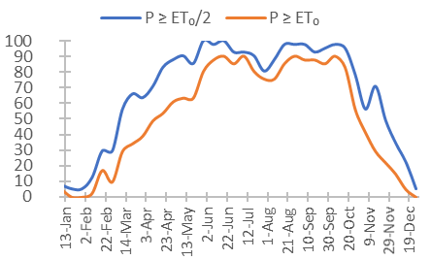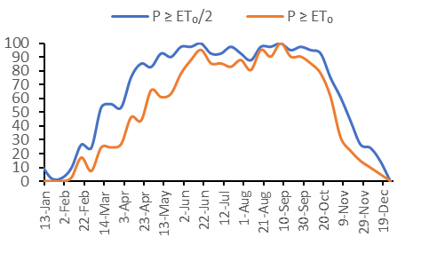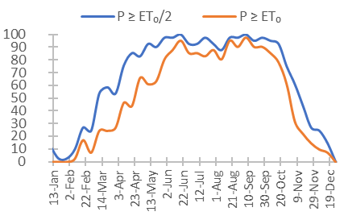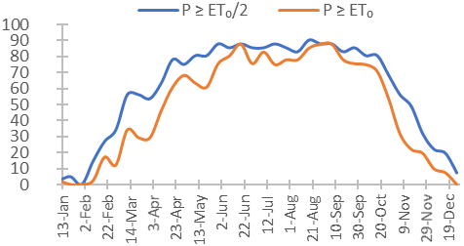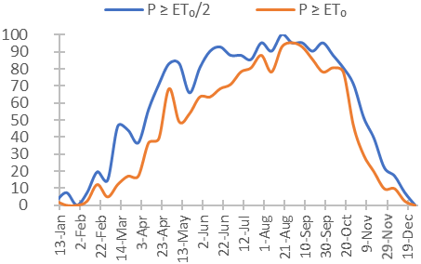
- Man
(b) Biankouman
(c) Zouan-Hounien
(d) Danané DANANE
(e) Sipilou

Figure 2: Probability curves for water satisfaction during vegetative phases (P ≥ ET₀/2) and the heading–flowering phase (P ≥ ET₀) for rainfed rice in localities of the Tonkpi Region
For each locality, the intersection of the P = 0.75 threshold (corresponding to a 25% risk of crop failure) with the probability curves determined the key periods:

- Its intersection with the P ≥ ETP₀/2 curvedefined the start and end dates of the vegetativeperiod.
- Its intersection with the P ≥ ETP₀curvedefined the start and end dates of the water satisfaction period for the criticalheading–flowering phase.
The results are summarized in Table 1..

Table 1: Vegetative periods and water satisfaction periods for the heading–flowering phase of rainfed rice in the Tonkpi Region (P = 0.75).
Locality | VegetativePeriod (P ≥ ETP₀/2, P = 0.75) | Water Satisfaction for Critical Phase (P ≥ ETP₀, P = 0.75)
Man | April 10 – October 27 | May 30 – October 17
Biankouma | April 10 – October 27 | May 30 – October 17
Zouan-Hounien | April 20 – October 27 | May 30 – October 17
Danané | April 20 – October 17 | May 30 – October 07
Sipilou | May 30 – October 17 | June 09 – October 17

3.2. Sowingwindows
The optimal sowing windows, defined as those that maximize the probability (≥75%) of meeting water requirements during the critical heading–flowering phase, were determined for both 100-day and 120-day varieties. The results are presented in Table 2.

Table 2: Optimal sowing windows for rainfed rice in the Tonkpi Region.
Locality | SowingWindow (100-day rice) | SowingWindow (120-day rice)
Man | April 15 – September 02 | March 26 – August 13
Biankouma | April 15 – September 02 | March 26 – August 13
Zouan-Hounien | April 15 – September 02 | March 26 – August 13
Danané | April 15 – August 23 | March 26 – August 03
Sipilou | May 25 – September 02 | May 05 – August 13

3.3 Calibration of 100-day and 120-day rainfed rice cycles
The crop cycle calibration, which integrates the sowing window with the vegetative period, was performed to align critical phenological phases with water availability and ensure harvest before the onset of terminal drought.
In Man, Biankouma, and Zouan-Hounien, the vegetative period extends until October 27, allowing for a safe harvest deadline of November 15, which accounts for a one-decade security margin. For the 100-day rice, this results in an optimal sowing window from April 15 to August 7, facilitating harvests between July 24 and November 15. For the 120-day rice, the sowing window spans from April 15 to July 18, with harvests occurring from August 13 to November 15.
In Danané, where the vegetative period ends in mid-October, the harvest deadline was set to October 31. Consequently, the sowing window for 100-day rice is from April 15 to July 23, with harvests from July 24 to October 31. For the 120-day rice, sowing is recommended from April 15 to July 03, leading to harvests between August 13 and October 31.
In Sipilou, the vegetative period ends on October 17, also limiting harvests to October 31. For the 100-day rice, sowing is viable from May 25 to July 23, with harvests from September 02 to October 31. For the 120-day variety, the sowing window is from May 25 to July 3, resulting in a harvest period from September 22 to October 31. The results of the cycle calibration are summarized in Table 3.

Table 3: Calibrated cycle periods for 100-day and 120-day rainfed rice in the Tonkpi Region.
Locality | Cycle Length | SowingPeriod | Sowing Duration (days) | Harvest Period | Harvest Duration (days)
Man | 100-day | April 15 – August 07 | 115 | July 24 – November 15 | 115
Man | 120-day | April 15 – July 18 | 95 | August 13 – November 15 | 95
Biankouma | 100-day | April 15 – August 07 | 115 | July 24 – November 15 | 115
Biankouma | 120-day | April 15 – July 18 | 95 | August 13 – November 15 | 95
Zouan-Hounien | 100-day | April 15 – August 07 | 115 | July 24 – November 15 | 115
Zouan-Hounien | 120-day | April 15 – July 18 | 95 | August 13 – November 15 | 95
Danané | 100-day | April 15 – July 23 | 100 | July 24 –October 31 | 100
Danané | 120-day | April 15 – July 03 | 80 | August 13 – October 31 | 80
Sipilou | 100-day | May 25 – July 23 | 60 | September 02 – October 31 | 60
Sipilou | 120-day | May 25 – July 03 | 40 | September 22 – October 31 | 40
3.4. Proposed cropping calendar for rainfed rice in the Tonkpi Region
Based on the results above, a revised cropping calendar for 100-day and 120-day rainfed rice was developed for each locality in the Tonkpi Region. These calendars, illustrated in Figure 3, provide a new foundational guideline for rainfed rice cultivation in the region.

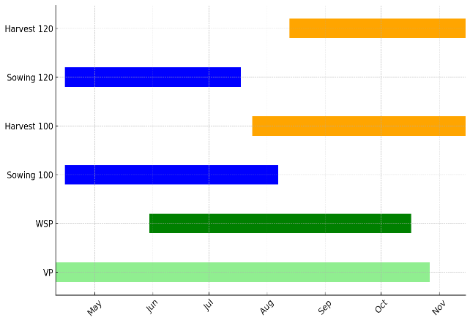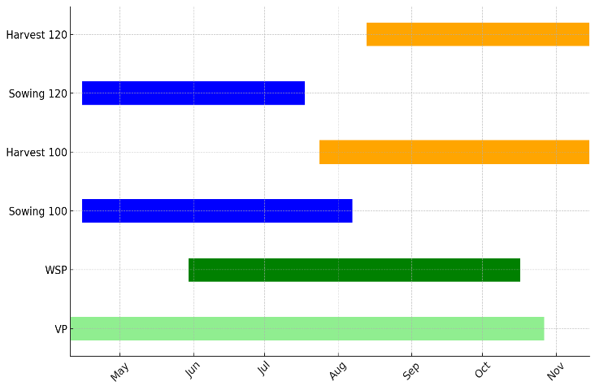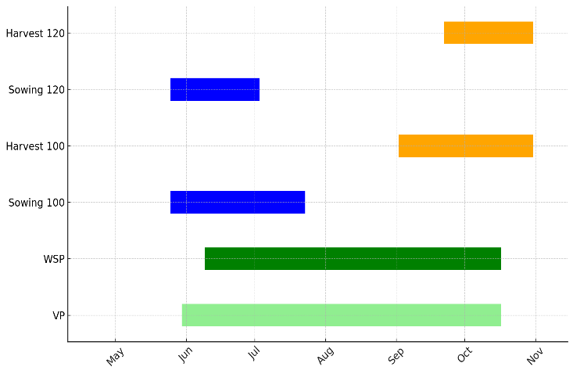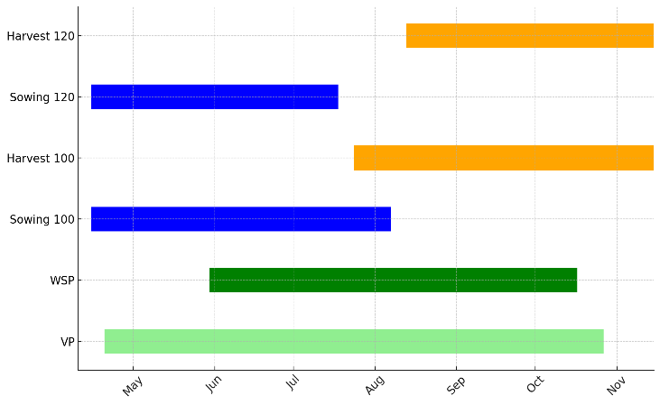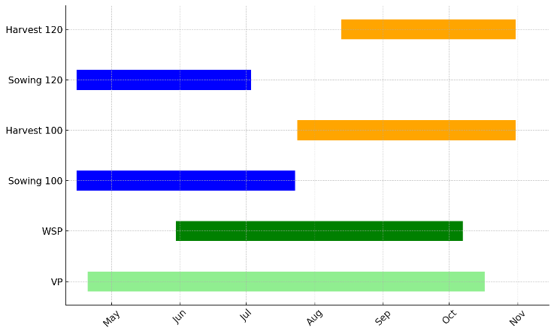
- Man
(b) Biankouman
(e ) Sipilou
(d) Danané DANANE
(c )Zouan-Hounien

Legend:
VP : Vegetative period ; WSP : Water satisfaction period ; Sowing 100 : Sowing period for 100-day rice ; Harvest 100 : Harvest period for 100-day rice ; Sowing 120 : Sowing period for 120-day rice : Harvest 120 : Harvest period for 120-day rice

Figure 3: Cropping calendar for rainfed rice (100-day and 120-day) in the localities of the Tonkpi Region.

This study elucidates a relative agroclimatic homogeneity across much of the Tonkpi Region, characterized by generally long vegetative periods (April to October) and windows of adequate water satisfaction covering the critical heading–flowering phase from late May to mid-October. These findings confirm that Tonkpi constitutes a favorable agroecological zone for rainfed rice cultivation, corroborating previous assessments by Kouakou et al.(2013) and FAO ( 2017) , which emphasize the importance of synchronizing crop cycles with water availability to ensure stable production.
The identified optimal sowing window converges around mid-April to early May for most localities (Man, Biankouma, Zouan-Hounien, Danané). In contrast, Sipilou exhibits a marked shift, with sowing delayed until late May. This local specificity is attributable to regional rainfall variability, confirming observations by Kouadio et al. (2018) on the heterogeneity of rainfall regimes within the mountainous areas of western Côte d’Ivoire. Furthermore, the truncated vegetative period observed in Danané and Sipilou highlights the need to tailor cropping calendars to local microclimatic contexts, a principle strongly advocated by Dingkuhn et al. (1998) to minimize yield losses induced by water stress.
The Lhomme & Eldin (1985) methodology, applied in this study, proved effective in delineating vegetative periods and critical phenological phases. However, as noted by Traoré et al. (2013), integrating complementary agroclimatic approaches—such as the Franquin method or intra-seasonal rainfall analysis—with modern crop modeling tools (e.g., DSSAT, SARRA-H) could further refine these recommendations. Such an integrated approach would be particularly valuable for anticipating the impacts of rainfall anomalies associated with climate change, which are increasingly altering the temporal distribution of rainfall in West Africa (Sultan et al., 2013).
Moreover, our results highlight a distinct difference in cultivation flexibility between the two varieties. The 100-day rice permits a wider sowing window, enhancing its adaptability to inter-annual climate variability. Conversely, the 120-day variety demands a more precise and earlier sowing schedule to avoid exposure to terminal water deficits and erratic late-season rains during its maturation phase. These findings align with those of by Wopereis et al. (2013) who demonstrated that short-cycle varieties are better suited to regions experiencing high rainfall variability.
Finally, the implications of these results extend beyond immediate agronomic planning. They provide a scientific basis for developing climate-smart agricultural advisory services and strengthening the resilience of rainfed rice systems, which remain crucial for food security in Côte d’Ivoire and West Africa as a whole (AfricaRice, 2011). The localized sowing calendars and variety-specific recommendations presented here are a tangible step towards translating agroclimatic research into actionable strategies for farmers.

4. CONCLUSION
This study successfully delineated vegetative periods and calibrated the growth cycles for rainfed rice across key localities of the Tonkpi Region by applying the Eldin method to a 40-year climatic series (1984–2024). The results demonstrate that while a significant agroclimatic homogeneity exists across much of the region, critical local variations necessitate differentiated agricultural planning.
The core findings indicate that the majority of localities share a broadly optimal sowing window from mid-April to early August. In contrast, Sipilou is distinguished by a delayed commencement of sowing, shifting optimally to late May. The critical heading–flowering phase was found to generally benefit from adequate water satisfaction from late May to mid-October; however, this period is more constrained in Danané and begins later in Sipilou, reflecting localized disparities in rainfall regimes. A key varietal distinction emerged, with the 100-day rice offering greater sowing flexibility, while the successful cultivation of the 120-day variety necessitates earlier sowing to avoid exposure to terminal water deficits during its maturation.
These findings underscore the critical importance of tailoring cropping calendars to specific local climatic constraints and varietal characteristics. The study provides a robust, scientifically grounded framework to guide farmers and policymakers in developing adapted, climate-resilient cultivation schedules. This work lays the groundwork for future research that integrates advanced agroclimatic modeling, participatory on-farm monitoring, and varietal selection to anticipate the impacts of climate change further and sustainably enhance the resilience of rainfed rice systems in western Côte d’Ivoire.

DISCLAIMER (ARTIFICIAL INTELLIGENCE)
Author(s) herebydeclarethat NO generative AI technologies such as Large LanguageModels (ChatGPT, COPILOT, etc) and text-to-image generators have been usedduringwriting or editing of thismanuscript.

COMPETING INTERESTS
Authors have declared that they have no known competing financial interests or non-financial interests or personal relationships that could have appeared to influence the work reported in this paper.

REFERENCES
- AfricaRice. (2011). A new riceresearch for developmentstrategy for Africa: Strategic Plan 2011–2020. AfricaRice. https://www.africarice.org
- Allen, R. G., Pereira, L. S., Raes, D., & Smith, M. (1998). Cropevapotranspiration: Guidelines for computingcrop water requirements (FAO Irrigation and Drainage Paper 56). FAO. https://www.fao.org/3/X0490E/X0490E.pdf
- Dingkuhn, M., Jones, M. P., Johnson, D. E., & Sow, A. (1998). Growth and yieldpotential of Oryza sativa and O. glaberrimauplandrice cultivars and theirinterspecificprogenies. Field CropsResearch, 57(1), 57–69. https://doi.org/10.1016/S0378-4290(97)00115-9
- Lhomme, J.-P., &Eldin, M. (1985). Un modèle agroclimatique de simulation du bilan hydrique des cultures. In Les besoins en eau des cultures (pp. 841–852). CIID/INRA.
- Food and Agriculture Organization of the United Nations (FAO). (2017). Rice Market Monitor (Vol. XX, Issue 2). FAO. https://www.fao.org/3/I7466EN/i7466en.pdf
- Food and Agriculture Organization of the United Nations (FAO). (2017). Climate-Smart Agriculture Sourcebook (2nd ed.). FAO. http://www.fao.org/climate-smart-agriculture-sourcebook
- Institut National de la Statistique (INS). (2021). Recensement général de la population et de l’habitat (RGPH 2021) – Résultats globaux. INS. https://www.plan.gouv.ci/assets/fichier/RGPH2021-RESULTATS-GLOBAUX-VF.pdf
- Kouadio, Y. K., Servat, E., & Paturel, J. E. (2018). Variabilité et changement climatique en Afrique de l’Ouest : Tendances des pluies et des débits. Sécheresse, 29(2), 163–172.
- Kouakou, B., N’zi, J.-C., & Soro, N. (2013). Détermination des périodes de culture en fonction de la satisfaction hydrique des plantes : Application de la méthode d’Eldin en Côte d’Ivoire. Revue Ivoirienne des Sciences et Technologie, 21, 85–101.
- Sultan, B., Roudier, P., Quirion, P., Alhassane, A., Muller, B., Dingkuhn, M., Ciais, P., Guimberteau, M., Traoré, S., & Baron, C. (2013). Assessingclimate change impacts on sorghum and millet yields in the Sudanian and Saheliansavannas of West Africa. EnvironmentalResearchLetters, 8(1), 014040. https://doi.org/10.1088/1748-9326/8/1/014040
- Traoré, B., Corbeels, M., van Wijk, M. T., Rufino, M. C., &Giller, K. E. (2013). Effects of climatevariability and climate change on crop production in southern Mali. European Journal of Agronomy, 49, 115–125. https://doi.org/10.1016/j.eja.2013.04.004
- UNESCO World Heritage Centre. (2017). State of Conservation – Mount Nimba Strict Nature Reserve (Côte d'Ivoire/Guinea) (N 155bis). https://whc.unesco.org/document/157295
- Wopereis, M. C. S., Johnson, D. E., Ahmadi, N., Tollens, E., &Jalloh, A. (Eds.). (2013). RealizingAfrica’s Rice Promise. CABI. https://doi.org/10.1079/9781845938123.0000

