Original Research Article
Geographical information system-based morphometric analysis of Kupti Watershed, Maharashtra, India
Abstract:
The morphometric analysis of the Kupti watershed in parts of Yavatmal and Washim districts has been carried out to evaluate the drainage morphometry and its influence on hydrogeology. In this study, a topographic map of the Kupti watershed was prepared using Shuttle Radar Topography Mission (SRTM) DEM data processed in ArcGIS. This data is used for drainage morphometry and to evaluate and compare linear, relief, and aerial parameters. The basin exhibits a seventh-order drainage pattern comprising 1480 stream segments. The study reveals the elongated shape of the basin, characterized by lower peak flows and longer runoff potential due to values of form factor (0.26), circularity ratio (0.48), and elongation ratio (0.58). For the Kupti watershed, the value of the mean bifurcation ratio is 3.39, which indicates that the watershed is less affected by structural disturbances and geological structure has little influence on the drainage pattern. The drainage system of the watershed exhibits a dendritic to sub-dendritic drainage pattern. The drainage density of the study area is 2.62 km/km², indicating upper moderate drainage density and a well-developed drainage network, and the region has moderate surface runoff and sediment transport conditions. The methodological approach and results serve as a valuable resource for future studies in river basin management, environmental planning, and formulating a watershed management plan. These findings are useful for decision makers and policymakers for the sustainable development and conservation of water resources.
Keyword: Remote Sensing, GIS, SRTM, Morphometry .
1) INTRODUCTION
For a region like Vidarbha in the Maharashtra State of India, where precipitation is very uncertain and nearly 89% of the cultivated area is under rainfed farming water resources planning and development in the micro-watershed area are required. (Dongardive et al.,2018). With an increasing population and higher water demand for industrialization, water availability becomes a significant constraint to agriculture, including aquaculture and animal husbandry. The further scarcity of water for different agricultural production systems should be checked for sustaining food security through efficient water conservation and management practices. There is a need for adoption of advanced agricultural and water management practices to produce more per drop of water (Patode et al., 2016). Morphometry involves the measurement and mathematical analysis of the configuration of the earth's surface, as well as the shape and dimensions of its landforms (Horton 1945; Strahler1952,1964; Muller1968; Clarke 1996; Agarwal 1998; ). According to Gautam et al. (2020), GIS-based morphometric evaluation of the Sai River Basin provides valuable insights into the hydrological and geomorphic characteristics of the watershed. Analysis of drainage basins is crucial in hydrogeological studies, such as evaluating groundwater potential, managing groundwater, and conducting pedological and environmental assessments (Sreedevi et al., 2005). A drainage basin is a well-defined portion of the earth’s surface within a physical boundary defined by topographic slopes that diverts all runoff to the same discharge outlet. It also plays an active role in the hydrogeomorphic performance and hydrologic behavior of a basin. Kumari et al. (2023) demonstrated that weighted-sum-based morphometric analysis is a useful tool for prioritizing the Harohar sub-basin for water management. Horton (1932,1945) was a pioneer in hydromorphometric analysis, focusing on drainage basins. He developed a rational and systematic approach, creating a framework that outlines geomorphological traits and connects them to various hydrological properties of these basins. Morphometric assessment of a watershed offers a quantitative depiction of the drainage network, which is a crucial element in the characterization of watersheds (Strahler 1964). The drainage basin can be thought of as a system that converts rainfall into runoff. It also plays a vital role in the hydrogeomorphic performance and hydrologic behavior of a basin. Remote sensing and GIS methods offer more dependable and precise assessments, making them highly suitable for hydrological studies.(Vijith and Satheesh, 2006; Magesh et al., 2012; Wakode et al.,2011; Shimpi et al.,2018). Hammouda and Mahmoud (2023) utilized remote sensing data combined with GIS analytical approaches to assess essential morphometric indices and to understand the geomorphic features of the Wadi Wizr Basin in the Eastern Desert of Egypt. Kumari and Misra (2023) applied geoinformatics techniques to analyze watershed characteristics in Munger District, providing valuable insights for planning effective groundwater recharge measures. An attempt has been made to utilize the SRTM data and the interpretative techniques of GIS to find out the relationship between the morphometric parameters and hydrological parameter. Many workers have carried out morphometric analysis using these new techniques. According to Krishnan and Ramasamy (2022), a geo-computational framework was employed to evaluate morphometric indices and determine priority sub-watersheds within the Moyar River Basin. Shekar and Mathew (2022) reported that GIS-based morphometric analysis is useful for identifying and ranking priority sub-watersheds in the Murredu River Basin. Bogale et al. (2021) applied GIS and remote sensing tools to study the morphometric features of the Gilgel Abay drainage basin. According to Suresh et al. (2022), GIS and RS-based morphometric evaluation of the Vanniyar Basin provides a valuable understanding of its watershed behavior and geomorphological setup. Chowdhury (2024) applied GIS and remote sensing methods to analyze the Halda River Basin's morphometric characteristics. Pal et al. (2020) examined how variations in DEM source and resolution affect drainage morphometric analysis and found that morphometric outputs change significantly with different DEM datasets. Khurana et al. (2020) showed that morphometric analysis using GIS is useful for ranking sub-watersheds in the Upper Ravi catchment. According to Singh et al. (2021), morphometric evaluation combined with watershed prioritization provides an effective basis for identifying soil-erosion-prone areas in the Dudhnai Watershed. Singh (2020) performed a detailed morphometric assessment of the Ghaghara River Basin, providing important insights into the basin's surface processes and geomorphic characteristics. Oyedotun et al. (2022) performed an in-depth quantitative analysis of drainage network characteristics and basin morphometry, utilizing GIS-based methodologies to interpret hydrological dynamics and geomorphic attributes of the watershed. The drainage features of a basin reveal the existing climatic conditions, geological structure, topography, surface runoff, rock permeability, and tectonic configuration of the area. Rainfall, lithology, and the slope of the land are the key factors that influence how surface water behaves in a watershed (Mesa 2006, Machiwal and Jha 2014).
2) Study Area
The watershed is located in the Washim and Yavatmal districts of Maharashtra; The Kupti River is a tributary of the Adan River that covers an area of approximately 314.53 km², where the elevation varies from 298.0 m to 474.0 m. It is located between latitude 21°41′20.10″N and 21°58′4.10″N and longitude 78°25′42.84″E and 78°46′58.58″E. The study area is covered in survey of India toposheet number 55H/11,15,16. The average annual rainfall varies from 729 to 714 mm, most of which falls during southwest monsoon. The maximum and minimum temperatures varied from 41.8°C to 15.1°C. The main crops are cotton and soybean in the Kharip season, grams,wheat and pulses in the winter season, groundnut and watermelon in the summer. The extent of surface irrigation is very low, so present irrigation practices mainly depend on the dug wells, bore wells, or dug-cum-bore wells. The geology of the study area comprises basaltic flows of the Deccan Volcanic Province (DVP) 0f Upper Cretaceous to Lower Paleocene in age.
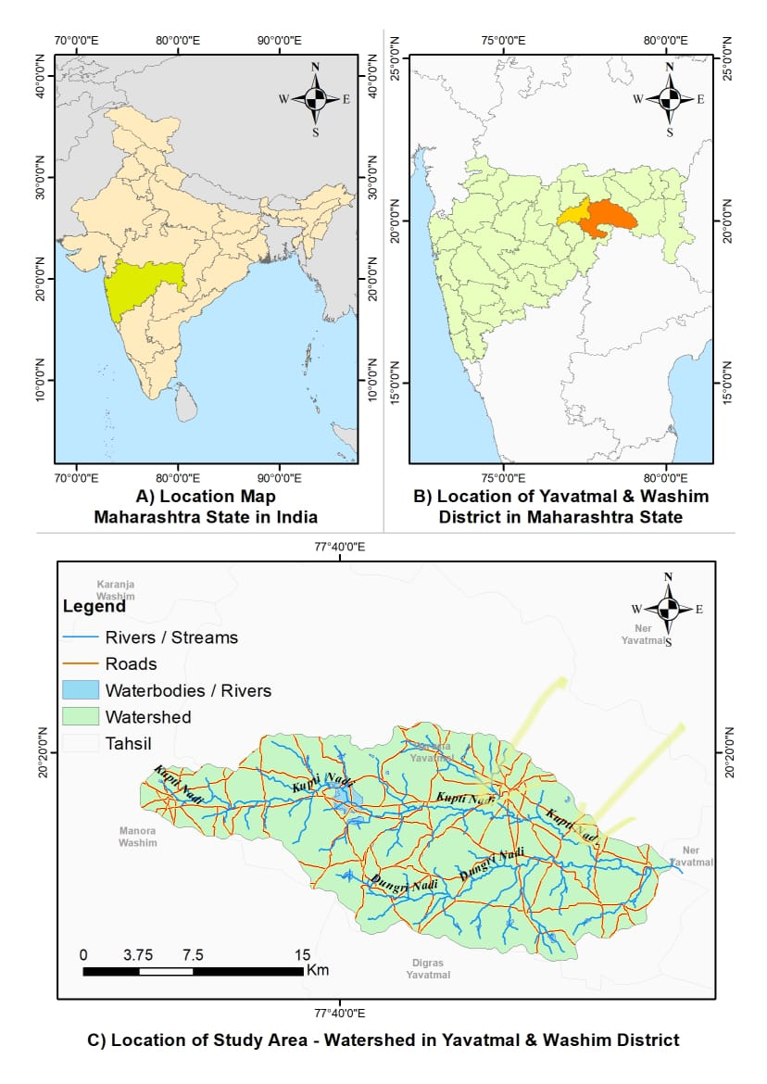Fig. 1 Location map of the study Area
3) METHODOLOGY
Morphometric analysis of the Kupti watershed was carried out using survey of India (SOI) toposheets at a scale of 1:50,000 and Shuttle Radar Topography Mission (SRTM) data using Arc GIS software . The SRTM data used had 30-meter spatial resolution, which is suitable for delineating the Kupti watershed. The SRTM DEM (Digital Elevation Model) was downloaded from the USGS Earth Explorer portal by selecting the AOI boundary of kupti watershed. Once the data were downloaded, they were imported into ArcGIS. The DEM was reprojected to match the spatial reference system used for the study area, ensuring spatial accuracy during further analysis. After importing the DEM into ArcGIS, the watershed boundary was used to clip the DEM using the Extract by Mask tool. This step is essential for focusing on watershed and removing unnecessary data. Elevation variation within the Kupti watershed was depicted using the clipped DEM.
The contour tool from the Arc toolbox was used to generate the contour lines.. These contours represent lines of equal elevation and are helpful in analyzing the slope, gradient, and landform features of the watershed. The contour lines were symbolized with appropriate line thickness and color. using this approach, the topographic map of the Kupti watershed was effectively created. The drainage system of the watershed was analyzed according to the laws of Horton (1945), and the stream order was determined using the Strahler method. In this classification, streams with no tributaries are defined as first-order; two first-order streams join together to form a second-order stream, and so on. The details of individual stream orders (i.e., one to seven orders) were determined, and subsequently, quantitative drainage analysis was performed in accordance with linear, areal, and relief aspects.
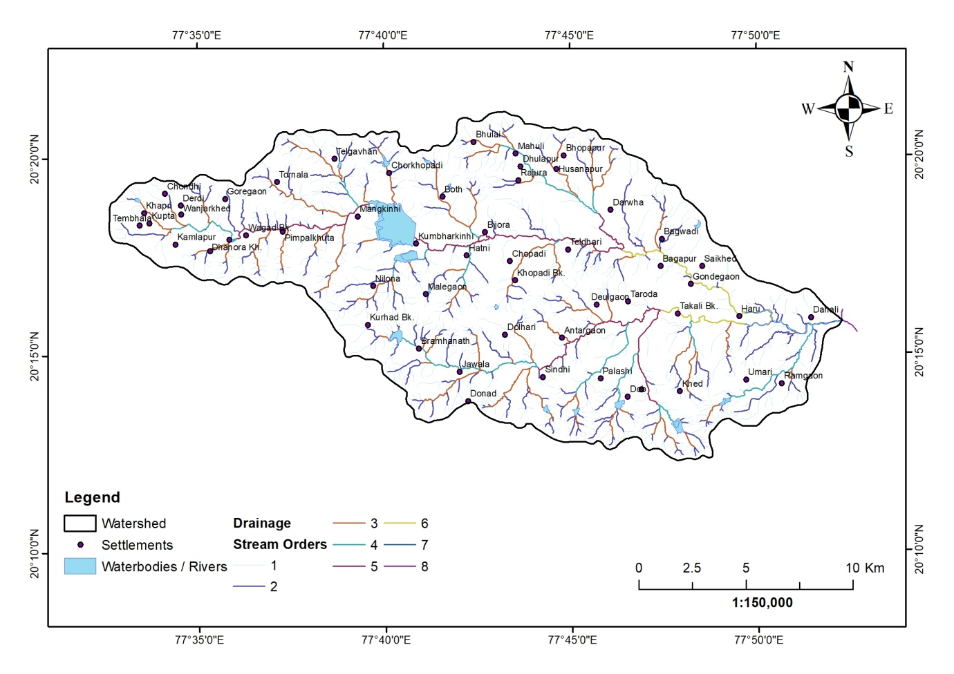 Fig. 2. Delineation of the Kupti watershed

RESULTS AND DISCUSSION
- Linear Aspect
Computation of the linear aspects, such as stream order, stream number for various Orders , bifurcation ratio, and stream length for various stream orders are, described below.
- Stream Order (U)
Stream order refers to a system that ranks a stream based on its place within the network of tributaries. (Leopold et al.,1969). The streams of the Kupti watershed were ranked according to Strahler's (1964) stream ordering system. The smallest fingertip streams are classified as first-order streams. The trunk stream represents the section of the stream with the highest order. The highest order stream carries the discharge and sediment load. The Kupti watershed was identified as a seventh-order stream .
2) Stream Number (Nu)
The stream number is the total number of stream segments present in each order (Nu). Nu is the number of streams of order u. Strahler (1964) established a classification system for ordering, which includes the quantity of streams corresponding to each order (Nu), referred to as (U). The overall number of streams consistently decreased as the stream order increased. The differences in the order and size of the tributary basin are primarily influenced by the physiographic and structural characteristics of the area. The Nu of the 1 st, 2nd, 3 rd 4 th , 5th, 6th ,7th orders constitute 1124, 271, 71, 17, 4, 2, and 1 streams, respectively.
3) Stream Length (Lu)
Stream length reflects the contributing area of a basin associated with a particular order (Horton, 1945). The number of streams of various orders in the watershed was counted and their lengths from the mouth to the drainage divide were measured. Lu has been computed on the basis of Horton's law of stream length.
4) Mean Stream Length (Lsm)
The Mean Stream Length (Lsm) is indicative of the characteristic dimensions of the components within a drainage network and their associated contributing surfaces (Strahler 1964). It is calculated by dividing the total stream length of a given order, u, by the number of stream segments within that order,as follows: It was observed that the Lsm of any specific order was greater than that of the preceding lower order and less than that of the subsequent higher order within the watershed. The LSM value of the Kupti watershed ranged from 0.40 to 9.78 km.
5) Bifurcation Ratio (Rb)
According to Schumn (1956), the bifurcation ratio (Rb) is determined by taking the number of stream segments of a specific order and dividing it by the number of segments in the next higher order. This dimensionless characteristic reflects the level of connectivity among streams of different orders within a drainage basin. The bifurcation ratio (Rb) value for the Kupti watershed was between 2.0 to 4.11. As stated by Strahler (1964), the bifurcation ratio typically lies between 3.0 and 5.0 for drainage basins in which geological structures do not interfere with the drainage patterns. In the Kupti watershed, a higher Rb value suggests a significant structural influence on the drainage pattern, whereas a lower value implies that the sub-basins are less impacted by structural disturbances (Strahler, 1964).
6) Mean Bifurcation ratio (Rbm)
The mean Bifurcation ratio (Rbm) is defined as the average of the bifurcation ratios of all orders and it is 3.92 in the case of the Kupti watershed.
Table 1: Linear aspects of drainage network of Kupti Watershed
Stream Order(u) | Number of Stream (Nu) | Stream Length(Lu) | Mean stream length (Lsm) | Bifurcation Ratio
1 | 1114 | 444.56 | 0.40 | -
2 | 271 | 163.23 | 0.60 | 4.11
3 | 71 | 111.55 | 1.57 | 3.82
4 | 17 | 45.59 | 2.68 | 4.18
5 | 4 | 39.12 | 9.78 | 4.25
6 | 2 | 16.8 | 8.40 | 2.00
7 | 1 | 4.07 | 4.07 | 2.00
Total | 1480 | 824.92 | 27.50 | Avg 3.39

- Areal Aspect
The areal aspect refers to the two-dimensional characteristics of the basin. It is feasible to outline the basin area that supplies water to each segment.
1) Drainage Density (Dd)
The total length of the stream channels was determined by dividing it by the basin area, thereby indicating the average stream length per unit area. (Gregory and Walling,1968). Strahler (1956, 1964) indicated that the of drainage is influenced by geological and climatic factors and tends to rise as the size of the individual drainage units decreases. The drainage density of the Kupti watershed was measured at 2.62 km/km, suggesting that the basin area was characterized by a coarse texture.
2) Drainage Frequency (Fs)
The proportion of all stream segments within a watershed divided by its total area is known as the stream frequency (Horton 1932). The stream frequency value for sixth and seventh order streams was low compared to that of first- order streams. The stream frequency value of the Kupti watershed was 4.71 km/km².
- Texture Ratio (T)
According to Schumm (1956), the texture ratio pertains to the correlation between the first-order streams and the basin boundary. The Kupti watershed had a texture ratio of 16.26.
4) Circularity Ratio (Rc)
Miller (1958) employed a dimensionless circulatory ratio, Rc which is calculated by dividing the basin area by the area of a circle that has an identical perimeter to the basin. The circularity ratio values range from zero (indicating a line) to one (representing a circle). This ratio is affected by several factors, including stream length, stream frequency (Fs), geological formations, land use, climate, topography, and basin slope (Bali et al.2012). The value of the Kupti watershed was 0.48, indicating a lack of circularity.
5) Form Factor (Rf)
Horton (1932) The specified form factor is defined as the ratio of the basin's area to the square of its length. The form factor of a perfectly circular basin is always greater than 0.78. A lower value of the form factor indicates that the basin is more elongated. The Rf value of Kupti watershed is 0.26 indicative of a Slightly elongated and shows flatted peak flow.
6) Elongaton Ratio (Re)
The shape of any basin is conveyed by an elongation ratio, where t is the ratio between the diameter of the circle of the same area as the drainage basin and the maximum Schumn (1956).The Re value can vary from 0, signifying a very elongated form, to 1.0, which denotes a circular form. the value for Kupti watershed is 0.58 ,indicative of elongated shape.
7) Length of Overland Flow (Lg)
The length of overland flow was measured as half the inverse of the drainage density (Horton, 1945). The distance that water flows across the landscape before gathering into a distinct stream is referred to as the length of flow. It is quite synonymous with the length of sheet flow over a large degree (Rudraiah et al.2008) in the kupti watershed, the value of Lg is 1.31.
8) Constant of Channel Maintenance ( C )
The constant of Channel Maintenance is the inverse of the drainage density (Schumm 1956) . The constant of channel maintenance (C) depends on the slope of the basin, nature of the rock, and duration of erosional activity. The Channel Maintenance constant value of the Kupti Watershed is 0.38 km/km2, which implies the requirement of an average 0.38 km² surface area to maintain each kilometer of channel length.
3) Relief Aspects
Linear and areal features are viewed as two-dimensional elements that exist on a plane. The introduction of a third dimension brings forth the idea of relief. By assessing the vertical drop from the beginning of each stream segment to the point where it meets the higher order stream, then dividing the total vertical fall by the number of streams of that order, one can calculate the average vertical fall.
- Basin Relief (Bh)
Basin relief refers to the elevation difference between the highest and lowest points within a basin, which influences the shape of the basin and the movement of sediments. (Hadley and Schumm,1961). This is a critical parameter that helps in comprehending the erosional traits of the drainage basin.

- Ruggedness Number (Rn)
The ruggedness number indicates the structural complexity of the terrain. Strahler (1968) described the ruggedness number (HD) as the product of basin relief and drainage density,which is usually combined with slope steepness and length. For the present watershed ruggedness number obtained is 461.60

- Relief Ratio (Rh)
Schumm (1956) described the relief ratio as the maximum elevation difference relative to the horizontal distance measured along the longest stretch of the basin that aligns with the primary drainage line. The term total relief of the river basin refers to the variation in elevation between the highest point in the basin and the lowest point on the valley floor. The relief ratio reflects the general steepness of a drainage basin and serves as a measure of the intensity of erosional processes occurring on the basin's slopes (Mangesh et al.,2012).In case of Kupti watershed it is 5.09

- Infiltration Rate
The Infiltration number is the product of the drainage density (Dd) and stream frequency (Fs) of the drainage basin, demonstrating the infiltration characteristics of a drainage basin. The infiltration number for the Kupti watershed is observed as 12.34.

- Elipticity Index. (Ie)
The value of the ellipticity index varies from 1.0 to infinity, and is inversely proportional to the form factor.

TABLE 2. Linear, relief and areal morphometric parameters used for kupti Watershed
- Channel Gradient (Cg)
Channel gradient is the total drop in elevation from the source to the mouth of trunk channels in each drainage basin. In the Kupti watershed, the gradient observed is 0.093 m/km.

- Average Slope of Watershed Wenthworth (1930) suggests that the erodibility of a watershed can be analyzed and compared by examining its average slope. A higher percentage of slopes indicates greater erosion.
4) Conclusion
The conventional methods of morphometric analysis are time-consuming, tedious, and error-prone, while the employment of present techniques in GIS and Remote Sensing provides more reliable and accurate estimations and serves as an excellent tool for examining similar watershed parameters in hydrological studies. Remote sensing satellite data combined with GIS techniques has proven to be a powerful approach for mapping drainage systems. It is inferred that the kupti watershed is dominated by lower-order streams. Morphometric analysis is carried out through the quantitative measurement of the linear, areal and relief aspects of watershed. Detailed morphometric analysis shows it is a Seventh-order river basin and covers an area of about 314. km², basin perimeter is 91.01 km and the basin length is 34.60 km. The river is trending in NW-SE direction. Total Number of 1st, 2nd, 3rd, 4th, 5th, 6th, 7th order streams are 1144, 271, 71, 17, 4, 2 and 1 respectively. The total number of streams are 1480, With total length (824.92) m. The drainage system of the watershed displays a pattern ranging from dendritic to sub-dendritic.
The first-order streams exhibit the greatest frequency of stream order, followed by the second-order streams. This indicates a decrease in stream frequency as the stream order increases, and conversely, an increase in frequency as the stream order decreases. The values of stream frequency demonstrate a positive correlation across the watershed, indicating an increase in stream population corresponding to an increase in drainage density. The elongated shape of the basin is evident in the values associated with the form factor, circulatory ratio, and elongation ratio. The average bifurcation ratio of 3.39 suggests that the watershed is minimally influenced by structural disturbances, and the drainage pattern remains largely unaffected by geological structures.

DISCLAIMER (ARTIFICIAL INTELLIGENCE)
Authors hereby declare that no generative AI technologies such as Large Language Models (ChatGPT, COPILOT, etc.) and text-to-image generators have been used during writing or editing of this manuscript.
COMPETING INTERESTS
Author has declared that no competing interests exist.

5)Reference
- Agarwal, C.S. (1998) Study of Drainage Pattern through Aerial Data in Naugarh Area of Varanasi District, U.P. Journal of the Indian Society of Remote Sensing, 26,169-175. https://doi.org/10.1007/bf02990795
- Bali, R., Agarwal, K. K., Nawaz Ali, S., Rastogi, S. K., & Krishna, K. (2012). Drainage morphometry of Himalayan Glacio-fluvial basin, India: hydrologic and neotectonic implications. Environmental Earth Sciences, 66, 1163-1174. https://doi.org/10.1007/s12665-011-1324-1
- Bogale, A. G.,Adem, A. A., Mekuria, W., & Steenhuis, T. S. (2021). Morphometric analysis of a drainage basin using GIS and remote sensing (Gilgel Abay/Lake Tana Basin, Ethiopia). Applied Water Science.
DOI:10.1007/s13201-021-01447-9.
- Chowdhury, M. S. (2024). Morphometric analysis of Halda River Basin, Bangladesh, using GIS and remote sensing techniques. DOI: 10.1016/j.heliyon.2024.e29085.
- Clarke JI (1996) Morphometry from maps. Essays in geomorphology. Elsevier Publ. Co., New York, pp 235–27 DOI:10.1007/978-981-13-8181-2_13.
Dongardive, M. B., Patode, R. S., Nagdeve, M. B., Gabhane, V. V., & Pande, C. B. (2018). Water resources planning for the micro watersheds using geospatial techniques, International Journal of Chemical Studies, 6(5), 2950-2955.
- Gautam, P. K., Singh, D. S., Kumar, D., & Singh, A. K. (2020). A GIS-based approach in drainage morphometric analysis of Sai River Basin, Uttar Pradesh, India. Journal of the Geological Society of India. DOI: 10.1007/s12594-020-1445-9.
- Gregory KJ, Walling DE (1968) The variation of drainage density within a catchment. Int Assoc Sci Hydrol 13:61–68 0.1080/02626666809493583 https://doi.org/10.1080/02626666809493583
- Hadley, R. F., and Stanley Alfred Schumm. "Sediment sources and drainage basin characteristics in upper Cheyenne River basin." US geological survey water-supply paper 1531 (1961): 198. https://doi.org/10.3133/wsp1531
- Hammouda, S., & Mahmoud, S. (2023). Analysis of morphometric parameters using remote sensing data and GIS techniques in Wadi Wizr Basin, Eastern Desert, Egypt. Journal of Geoscience & Environment Protection.
DOI:10.4236/gep.2023.116014.
Horton RE (1932) Drainage basin characteristics. Trans Am Geophys Union 13:350–361 https://doi.org/10.1029/tr013i001p00350
- Horton, R.E. (1945). Erosional development of streams and their drainage basins. Bull. Geol. Soc.Am., v. 56, pp. 275-370. https://doi.org/10.1130/0016-7606(1945)56[275:edosat]2.0.co;2
- Khurana, D., Rawat, S. S., Raina, G., Sharma, R., & Jose, P. G. (2020). GIS-based morphometric analysis and prioritization of Upper Ravi catchment, Himachal Pradesh, India. In: Advances in Water Resources Engineering and Management (chapter). https://doi.org/10.1007/978-981-13-8181-2_13
- Krishnan, A., & Ramasamy, J. (2022). Morphometric assessment & prioritization of the South-India Moyar River Basin sub-watersheds using a geo-computational approach. Geology, Ecology and Landscapes / Taylor & Francis.DOI:10.1080/24749508.2022.2109819.
Kumari, A., Upadhyaya, A., Jeet, P., et al. (2023). Morphometric analysis and prioritization of watershed for water management using weighted sum approach — Harohar sub-basin, India. Journal of the Geological Society of India, 99, 859–867. https://doi.org/10.1007/s12594-022-2393-y
- Kumari, P., & Misra, A. K. (2023). Geoinformatics-based watershed analysis for effective groundwater recharge planning in Munger District, Bihar, India. Sustainable Water Resources Management. DOI: 10.1007/s40899-023-00929-9. https://doi.org/10.1007/s40899-023-00929-9
Leopold, L. B., Wolman, M. G., Miller, J. P., & Wohl, E. E. (2020). Fluvial processes in geomorphology. Courier Dover Publications.
- Machiwal D, Jha MK (2014) Characterizing rainfall–groundwater dynamics in a hard rock aquifer system using time series, geographic information system and geostatistical modelling. Hydrol Process 28(5):2824–2843 https://doi.org/10.1002/hyp.9816
- Magesh, N. S., Jitheshlal, K. V., Chandrasekar, N., & Jini, K. V. (2012). GIS based morphometric evaluation of Chimmini and Mupily watersheds, parts of Western Ghats, Thrissur District, Kerala, India. Earth Science Informatics, 5, 111-121. https://doi.org/10.1007/s12145-012-0101-3
- MESA,L.M (2006) Morphometric analysis of a subtropical Andeanbasin (Tucumam, Argentina). Environmental Geology, v.50(8),pp.1235-1242 https://doi.org/10.1007/s00254-006-0297-y
- Miller, V.C. (1953) A Quantitative Geomorphic Study of Drainage Basin Characteristics in the Clinch Mountain Area, Virginia and Tennessee. Department of Geology Columbia University, New York, 389-402. Authors: Paul Edwin Potter https://doi.org/10.1086/626413
- Mueller, J.E. (1968) An Introduction to the Hydraulic and Topographic Sinuosity Indexes 1. Annals of the Association of American Geographers, 58, 371-385 https://doi.org/10.1111/j.1467-8306.1968.tb00650.x
- Oyedotun, T. D. T., et al. (2022). Quantitative assessment of the drainage network and basin morphometry using GIS techniques. (regional Journal/ Taylor & Francis). DOI:10.1080/24749508.2020.1812147
- Pal, S., Roy, S., et al. (2020). Determination of sensitivity of drainage morphometry to DEM sources and resolutions.Environmental Development and Sustainability. DOI: 10.1007/s10668-020-00652-x.
- Patode, R. S., M. B. Nagdeve and C. B. Pande (2016). Groundwater level monitoring of Kajaleshwar- Warkhed watershed Tq. Bashitakli Distt. Akola, Advances in Life Sciences 5(24): 11207-11210.
- Rai PK, Mohan K, Mishra S, Ahmad A, Mishra VNA. 2014. GIS-based approach in drainage morphometric analysis of Kanhar River Basin, India. Applied Water Science 7(1): 217-232. Authors: Praveen Kumar Rai | Kshitij Mohan | Sameer Mishra | Aariz Ahmad | Varun Narayan Mishra https://doi.org/10.1007/s13201-014-0238-y
- Rudraiah, M., Govindaiah, S., & Vittala, S. S. (2008). Morphometry using remote sensing and GIS techniques in the sub-basins of Kagna river basin, Gulburga district, Karnataka, India. Journal of the Indian society of remote sensing, 36, 351-360. https://doi.org/10.1007/s12524-008-0035-x
- Schumm, S.A. (1956). Evaluation of drainage systems and slopes in badlands at Perth Amboy, New Jersy. Bull. Geol. Soc.Am., v.67, pp.597-646. https://doi.org/10.1130/0016-7606(1956)67[597:eodsas]2.0.co;2
- Sheik Mohideen, A. R. (2021). Morphometric assessment of hydrogeomorphic processes and landscape evolution in the Kallar watershed (Western Ghats, India): regionalisation and prioritisation. Arabian Journal of Geosciences, 14, 1-28. https://doi.org/10.1007/s12517-021-08105-z
- Shekar, P. R., & Mathew, A. (2022). Morphometric analysis for prioritizing sub-watersheds of Murredu River Basin, Telangana State, India, using a GIS. Journal of Engineering and Applied Science DOI: 10.1186/s44147-022-00094-4.
- Shimpi, Sujit S., and V. M. Rokade. "GIS based morphometric analysis of Bori-Chikli watershed of Jalgaon District, Maharashtra, India." Int. J. Econ. Environ. Geol. Vol 8.3 (2017): 1-8. https://doi.org/10.56153/g19088-022-0084-13
- Siddi Raju R, Sudarsana Raju G, Rajasekhar M. 2020. Morphometric analysis of Mandavi River Basin in Rayalaseema region of Andhra Pradesh (South India), using remote sensing and GIS. Jr. Ind. Geophys. Union 24(1): 54-67. https://doi.org/10.1016/j.hydres.2019.09.001
- Singh,A. P. (2020). Morphometric analysis of Ghaghara River Basin, India — implications for surface processes and basin characteristics. Journal of the Geological Society of India. DOI: 10.1007/s12594-020-1406-3.
- Singh,W. R., Barman, S., Tirkey, G.,et al. (2021). Morphometric analysis and watershed prioritization in relation to soil erosion in Dudhnai Watershed. Applied Water Science, 11:??. DOI: 10.1007/s13201-021-01483-5.
- Sreedevi, P. D., Owais, S. H. H. K., Khan, H. H., & Ahmed, S. (2009). Morphometric analysis of a watershed of South India using SRTM data and GIS. Journal of the geological society of india, 73, 543-552. https://doi.org/10.1007/s12594-009-0038-4
- Strahler AN (1952) Hypsometric analysis of erosional topography. Bull Geol Soc Am 63:111 https://doi.org/10.1130/0016-7606(1952)63[1117:haaoet]2.0.co;2
- Strahler AN (1956) Quantitative slope analysis. Bull Geol Soc Am 67:571–596 hors https://doi.org/10.1130/0016-7606(1956)67[571:qsa]2.0.co;2
- Strahler, A.N. (1964). Quantitative geomorphology of drainage basinsand channel networks.: Chow, V.T. ( ) Handbook of Applied Hydrology, McGraw Hill Book Com., NewYork, pp. 4-1
https://doi.org/10.1126/science.148.3667.219
- Suresh, S., et al. (2022). Morphometric analysis on Vanniyar basin in Dharmapuri district using GIS & Remote Sensing. Frontiers in Remote Sensing. DOI: 10.3389/frsen.2022.845705.
- Vijith, H., Satheesh, R. (2006). GIS based morphometric analysis of two major upland sub watersheds of Meenachil River in Kerala. Journal of the Indian Society of Remote Sensing, 34 (2), 181-185. https://doi.org/10.1007/bf02991823
- Wakode Hemant Balwant, Dibyendu Dutta, V. R. Desai, Klaus Baier and Rafig Azzam (2011) Morphometric analysis of the upper catchment of Kosi River using GIS techniques. Arabian J. Geosci, 6, 395–408. . https://doi.org/10.1007/s12517-011-0374-8
- Wentworth, C.K (1930), “A Simplified Method of Determining the Average Slope of Land Surfaces”, American Journal of Science, 21, pp 184-194. https://doi.org/10.2475/ajs.s5-20.117.184

- 29. Wentworth, C.K (1930), “A Simplified Method of Determining the Average Slope of
- 29. Wentworth, C.K (1930), “A Simplified Method of Determining the Average Slope of
- 29. Wentworth, C.K (1930), “A Simplified Method of Determining the Average Slope of
- 29. Wentworth, C.K (1930), “A Simplified Method of Determining the Average Slope of
- 29. Wentworth, C.K (1930), “A Simplified Method of Determining the Average Slope of

Wentworth, C.K (1930), “A Simplified Method of Determining the Average Slope of

