Study of Atmospheric Particle Fallout in Nakoyakpala, NZerekore, Guinea

Abstract

This study is a contribution to the study of air pollution at Nakoyakpala neighborhood, Urban Commune of Nzerekore, Republic of Guinea. Its main objective is to analyze atmospheric fallout at Nakoyakpala neighborhood. To do this, four (04) atmospheric fallout measuring sites were identified in this neighborhood: S1 (Nakoyakpala Market Roundabout); S2 (Crossroads bordering the Mohomou, Gbangana and Nakoyakpala neighborhood very close to the welding workshop); S3 (Empty space facing the Parc des Princes nightclub) and S4 (University of NZerekore Courtyard). Atmospheric fallouts were measured over a 13-hour period for a 12-day period (from May 5 to May 16, 2025) at our various stations. The dust amount was 0.1350 g at S1, 0.1111 g at S2, 0.0961 g at S3 and 0.0451 g at S4, respectively. Thus, the total quantity of dust per hour in the Nakoyakpala neighborhood across the different sampling stations is 27.72
mg.m-2.h-1. It was also determined by day; it is 665.28 mg.m-2.day-1 over an area of 237 ha. This

study on atmospheric fallout is the first in Guinea.

Keywords: Air pollution; Atmospheric fallout; Dust quantity ; Nakoyakpala ; Guinea.
1. INTRODUCTION

“Air pollution due to high concentrations of small particles is a severe issue in West Africa” (Kounouhewa et al., 2020). “However, dust fallout can have diverse impacts ranging from major health problems to environmental concerns in West Africa” (Mweendi et al., 2023). According to Canha et al., (2021), Durant et al., (2009) and Kgabi et al., (2012), “the substances present in the air include but not limited to particulate matter (i.e., dust, liquid droplets, and smoke), gaseous pollutants (i.e., nitrogen oxides, volatile organic compounds, oxone, ammonia, and carbon monoxide), heavy metals and culturable bacteria which all lead to the depreciation of the air quality, and they are an indication of the air quality state with respect to a particular site. Also, urban dust samples are normally associated with more negative health impacts than those collected from rural areas, and this is attributed to the high rate of development and massive traffic”. In DACCIWA project (Dynamics-Aerosol-Chemistry-Cloud- Interactions In West Africa), Djossou et al., (2018) published “the policy relevant findings of this action and clearly claimed the need for long-term and reliable measurements of meteorological data and particulate matter concentrations in South West Africa”. The policy relevant findings of the DACCIWA project, an international research action funded by the European Union 7th Framework Programme, were published in 2018 (Evans et al., 2018). “Particulate matter also represents suspended dust that is settleable or can be deposited at a particular site in the atmosphere and referred to then as dust fallout” (Dudu et al., 2018 ; Liebenberg-Enslin et al., 2017 ; Pope and Dockery 2006). “However, the components and quantities of atmospheric dusts fallout have been reported to be the pollution indicator of large urban areas” (Pervez et al., 2009).

“Dust storms are common phenomena in many parts of the world, especially in arid and semi- arid region” (Al-Awadhi et al., 2014). Dust can be a nuisance as it can settle on tree leaves, open surfaces such as roads and streets, on roof tops of buildings, and even inside buildings (Mweendi et al., 2023), also, dust fallout or dust in general is constantly emitted into the ambient air from a variety of activities and sources that can be natural or anthropogenic. “Such anthropogenic activities lead to the accumulation of trace elements on buildings, plants, in air, soil, water, and on road dust” (Mugudamani et al., 2022). Road dust refers to the re-suspended particulate matter found on roads, mostly in troughs. According to Sampson (2017), the road dust sometimes comprises of soil and sand particles that are assorted with litter, and rubble that becomes airborne due to traffic movements. “Moreover, the multiplicity and complexity of sources of atmospheric dusts in urban regions (e.g. industrial complexes composed of a variety
of industrial processes, automobiles, construction activities etc.) has put forward the need of source apportionment of these sources indicating their contribution to specific environmental receptor” (Pervez et al., 2009). Dust storms are common phenomena in many parts of the world, especially in arid and semi-arid region. Today, atmospheric fallout is considered a major problem affecting both developed and developing countries (Guerin et al., 2003). Its negative impacts are felt directly or indirectly by different countries. According to WHO, 2019, 99% of the world's population lived in places where air quality thresholds were not met, and 4.2 million premature deaths were caused by ambient air pollution mainly due to exposure to fine particulate matter (PM2.5). In France, for example, nearly 40,000 deaths are attributed to population exposure to PM2.5 each year, resulting in an average loss of 8 months of life expectancy and accounting for 7% of total annual mortality due to PM2.5 exposure, particularly among people aged 30 and over (Medina et al 2021). “According to the Global Burden of Disease (GBD) study estimates, around 4.2 million total deaths were directly attributable to particulate matter smaller than 2.5 μm (PM2.5) ambient air pollution in 2015” (Cohen et al.,
2017 and Fofana et al., 2025).

In Guinea, the problem of air quality is a crucial issue that deserves everyone's attention. Agricultural practices, road traffic, and the various fires that have struck the country represent a real problem contributing to the release of enormous quantities of fine particles (PM2.5) into the atmosphere. Air pollution is causing increasing damage to the environment, affecting all prefectures in the country. Rainfall is a factor influencing the transport of particles to the ground. Depending on its frequency and intensity, it contributes to varying degrees to limiting dust dispersion. The lack of rain, on the other hand, encourages the resuspension of dust in the air by wind or passing vehicles. Therefore, dust levels are higher during dry periods than during humid periods. The capital of Guinea's Forest Region (NZerekore) is no exception to this reality. During the dry season, the city remains shrouded in a cloud of dust from its roads. Given these issues, government intervention is crucial for improving air quality in all of the country's prefectures. In a context of urban densification, where pressures on the environment are increasing, this study fills a gap in local data on air quality in NZerekore.

However, most of the researchers did not address the dust fallout. Nevertheless, no research has been done on dust fallout at Nakoya Kpala in NZererkore. Therefore, the main objective of this study was to evaluate the dust fallout in Kakoya kpala. This study provides database that can be used to establish a baseline of dust fallout.

2. METEOROLOGY

Nakoyakpala is located to the west of the urban commune of NZerekore on the NZerekore- Yomou national road. It is limited to the east by the Gbanghana district, to the west by the village of Kéréma to the north by the Mohomou district and to the south by the Theyegno village. The prefecture of NZerekore (latitude between 7°32 and 8°22 North, longitude 9°04
West and 560 m altitude) is located in the south-east of Guinea. The climate type is Equatorial guinean with a rainy season extending from May to October and a dry season from November to April (Kante et al., 2019 and Djossou et al., 2024).

For this study, we got the four measurement sites by random sampling of atmospheric fallout in the Nakoyakpala neighborhood. Atmospheric fallout was collected over a period of 12 days at each site. These different pollution sites are: S1 (Nakoyakpala Market Roundabout); S2 (Crossroads bordering the Mohomou, Gbangana and Nakoyakpala neighborhood very close to the welding workshop); S3 (Empty space facing the Parc des Princes nightclub) and S4 (University of NZerekore Courtyard) (See Fig. 1).

The table 1 presents the material used in this study. For the collection of dust samples, we have adopted the following approaches:

➢ Preparation of the devices: In accordance with the accredited method (NF X 43-

014), Owen dust gauges consist of a funnel and a bottle, allowing for the quantification of dust fallout. The contents of the buckets are exposed to the ambient air and contain black plastic to limit the proliferation of algae and micro- organisms, then covered with a mesh to prevent coarse materials from entering. The entire system is inserted into a tripod that serves as a support. The collection height is 3 m from the ground. The devices we used consisted of iron tripods, 18.5 cm diameter buckets, and wire mesh.
➢ Distilled water sampling: We then sampled distilled water for sterilizing the equipment and for collection.
➢ Installation of the devices: All buckets were thoroughly washed with distilled water

before being displayed to remove all traces of dust.
➢ Device Removal: The activity took place between May 5 and May 16, 2025, a period of 12 days. We removed all the buckets on the same day to minimize exposure variations. The storage period between sampling and analysis must not exceed 60 days (according to the standard).
➢ Analysis: After collection, the various samples were sent to the analytical chemistry

laboratory of the NZerekore University for analysis and interpretation, taking into account the study objectives.

The determination of the dust quantity in the study area at the various sampling stations is carried out in three steps. The method used is thermogravimetric, which consists of: Weighing the MN 615 filter paper, 90 mm in diameter, on the analytical balance to obtain a weight (PV) before filtering; then, filtering the sample through the filter paper and placing it in the oven for a specific time (the drying time depends on the paper load) at a temperature of 105°C; and finally, reweighing the loaded paper after filtering to obtain the weight (PC).

The mass of substance extracted (QP) from the entire collection system at the four (04) stations is calculated using the following formula:
�� = �𝐂 − �𝐕
We also calculated the total amount of dust at each station (QPTi) for the 12 days of

measurements using the following formula:
��𝐓𝐢 =
𝐕�𝐢 ∗ ��𝐢
𝐕�

Where, Vp: Volume collected after exposure ; Mpi: Quantity of dust obtained in Vp ; Vfi: Final volume obtained after exposure.

Calculation of average dust quantity QPTmoyenne:

��𝐓�������� =
∑ 𝐢 ��𝐓𝐢
�

Where, QPTi: Total amount of dust at each station and N: Number of Stations.

Finally, to determine the total amount of dust in the study area (QPTZ), we used the following

formula:

��𝐓𝐙 (mg/m2/jour ) =
��������𝒆��𝒆
𝐀 ∗ �

Where, QPTmoyenne (mg): Average dust quantity; A (m2): Size of the study area and n (j): Number of days.

3. RESULTS AND DISCUSSION

Atmospheric fallout was studied at the four sites. They were measured over a 13-hour period for a 12-day period (from May 5 to May 16, 2025) at our various stations. To determine the amount of substance, we collected and analyzed 500 ml of each sample for quantification. The results from the different analyses are presented in Table 2. Figure 2 shows the mass of the substance extracted at the four stations. The mass of the substance extracted was 0.1350 g at S1, 0.1111 g at S2, 0.0961 g at S3 and 0.0451 g at S4, respectively. These masses range from
0.0451 g to 0.1350 g. They are highest at S1 and lowest at S4. The heavy traffic observed would be difficult for the market women to navigate at the crossroads where this site is located. We also calculated the amount of dust at each site. It varies from 0.1605 g. to 0.4185 g. As a note, the amount of dust on station S1 is higher than those of the other stations and the lowest amount of dust is measured on station S4. Thus, we determined the total amount of dust over an area of
237 ha; this allowed us to determine the total amount of dust in that area. This average quantity was 0.0968g. The total quantity of dust per hour in the Nakoyakpala neighborhood across the different sampling stations is 27.72 mg.m-2.h-1. It was also determined by day; it is 665.28 mg.m-
2.day-1 over an area of 237 ha.

The indicative dust levels according to AIR Languedoc-Roussillon were of different levels: low dust levels (less than 150 mg/m2/day); medium dust levels (between 150 and 250 mg/m2/day) and high dust levels (more than 250 mg/m2/day). For this study, we found 665.28 mg/m2/day. This value is greater than 250 mg/m2/day (Figure 3), which allows us to say that the dust level is high in our study area. However, we can say with certainty that our study area is facing heavy dust accumulation linked to atmospheric fallout. According to Al-Barakah et al., (2014), a wide variety of pollutants and/or microbial diversity has been associated with dust and/or dust fallout particles. Concerning the inconsistent of these heavy metal indices that are the
contamination factor, pollution load index and the enrichment factor, the dust fallout contains heavy metals occurring in varying concentrations and the status of pollution of the dust fallout varies from low to severe (Mweendi et al., 2023).

4. CONCLUSION

This study presents new and unique observations from daily measurements of atmospheric fallout in the Nakoya-Kpala neighborhood, urban commune of NZerekore. These measurements were taken over a period of 12 days. The amount of dust was 0.4185 g at S1,
0.3675 g at S2, 0.1722 g at S3 and 0.1605 g at S4, respectively. Thus, the total amount of dust measured in the neighborhood was 665.28 mg.m-2.day-1. This study could thus provide the first element of expertise for urban and environmental policies in Guinea. This work will enable them to set up a continuous watering system during the dry season and then implement an air quality monitoring system.

DISCLAIMER (ARTIFICIAL INTELLIGENCE)

Author(s) hereby declare that NO generative AI technologies suchas Large Language Models (ChatGPT, COPILOT, etc.) and text-to-image generators have been used during the writing or editing of this manuscript.

COMPETING INTERESTS

Authors have declared that no competing interests exist.
References

Kounouhewa B., Koto N'Gobi, G., Houngue H., Müller L., Wirtz M.,
Yurtsever-Kneer M., Fink H., Kneer A., Barbe S. (2020). Cotonou's next breath: Particulate matter monitoring and capturing, Scientific African, 2468-2276.
h ttp s://d o i.o rg /1 0 .1 0 16 /j.sciaf . 2 0 20 . e0 03 6 7

Mweendi, P. N., Shafodino, F. S., Munyaradzi, Z., & Mwapagha, L. M. (2023). Assessment of Bacteria, Morphological Characteristics, and Elemental Composition of Dust Fallout. Journal of Geoscience and Environment Protection, 114-130. h ttp s://d o i.o rg /1 0 .4 2 36 /g ep .2 0 23 . 118 0 0 7

Canha, N., Diapouli, E., & Almeida, S. M. (2021). Integrated Human Exposure to Air Pollution. International Journal of Environmental Research and Public Health, Article 2233. h ttp s://d o i.o rg /1 0 . 33 9 0 /ijer ph 1 80 5 22 3 3

Durant, A. J., Harrison, S. P., Watson, I. M., & Balkanski, Y. (2009). Sensitivity of Direct Radiative Forcing by Mineral Dust to Particle Characteristics. Progress in Physical Geography, 80-102. h ttp s://d o i.o rg /1 0. 11 7 7 /03 0 91 3 3 30 91 0 5 03 4

Kgabi, N., Shitaatala, E., & Izaaks, C. (2012). Morphological Analysis of Fallout Dust in
Windhoek, Namibia. Journal of Chemical, Biological and Physical Sciences,
2201-2209.

Djossou, J.; Léon, J.-F.; Akpo, A.B.; Liousse, C.; Yoboué, V.; Bedou, M.; Bodjrenou, M.; Chiron, C.; Galy-Lacaux, C.; Gardrat, E. (2018). Mass concentration, optical depth and carbon composition of particulate matter in the major southern West African cities of Cotonou (Benin) and Abidjan
(Côte d’Ivoire). Atmos. Chem. Phys, 6275–6291. h ttp s://d o i.o rg /10 . 5 19 4 /acp - 18-6 2 75 -2018

Evans M.J., Knippertz P., Akpo A., Allan R.P., Amekudzi L., Brooks B., Chiu J.C., Coe H., Fink A.H., Flamant C., Jegede O.O., Leal-Liousse C., Lohou F., Kalthoff N., Mari C., Marsham J.H, Yoboué V., Reimann Zumsprekel C. (2018). Policy-relevant findings of the Dacciwa project.
https://doi.org/10.5281/zenodo.1476843

Dudu, V. P., Mathuthu, M., & Manjoro, M. (2018). Assessment of Heavy Metals and Radionuclides in Dust Fallout in the West Rand Mining Area of South Africa. Clean Air Journal, 42-52. h ttp s://d o i.o rg /1 0 . 17 1 59 /2 41 0 - 97 2 x /2 0 18/v 2 8 n 2a1 7

Liebenberg-Enslin, H., Rauntenbach, H., Gruenewaldt, R. Von, & Burger, L. (2017).
Understanding the Atmospheric Circulations That Lead to High Particulate Matter
Concentrations on the West Coast of Namibia. Clean Air Journal, 66-74.
h ttp s://d o i.o rg /1 0 .1 7 15 9 /24 1 0 -9 7 2 X/20 1 7 /v2 7 n2 a9

Pope, C. A., & Dockery, D. W. (2006). Health Effects of Fine Particulate Air Pollution : Lines That Connect. Journal of the Air and Waste Management Association,
709-742. h ttp s://d o i.o rg /10 . 1 0 80 /1 04 7 32 8 9 .2 0 06 . 10 4 644 8 5

Pervez S., Balakrishna G., and Tiwar S. (2009). Source apportionment of mercury in dust fallout at urban residential area of Central India. Atmos. Chem. Phys. Discuss.,
21915–21940.

Al-Awadhi, J. M., Al-Dousari, A. M., & Khalaf, F. I. (2014). Influence of Land
Degradation on the Local Rate of Dust Fallout in Kuwait. Atmospheric and Climate
Sciences, 437-446. h ttp s://d o i.o rg /1 0. 4 23 6 /acs.2 01 4 . 43 04 2

Mugudamani, I., Oke, S. A., & Gumede, T. P. (2022). Influence of Urban Informal Settlements on Trace Element Accumulation in Road Dust and Their Possible Health Implications in Ekurhuleni Metropolitan Municipality, South Africa. Toxics,
Article 253. h ttp s://d o i.o rg /1 0 . 33 9 0 /tox ics1 0 0 50 2 53

Sampson, C. (2017). Trace Elements in Christchurch Road Dust. Master’s Thesis, University of Canterbury, Christchurch, New Zealand.

Guerin M, Huntley ME, Olaizola M. (2003). Haematococcus astaxanthin: applications for human health and nutrition. Trends Biotechnol. 21(5):210-6.
h ttp s://d o i.o rg /1 0. 1 01 6 /S0 1 6 7 - 7 79 9 ( 03 ) 00 0 78 - 7

Cohen, A.J., Brauer, M., Burnett, R., Anderson, H.R., Frostad, J., Estep, K., et al. (2017). Estimates and 25-Year Trends of the Global Burden of Disease Attributable to Ambient Air Pollution:
An Analysis of Data from the Global Burden of Diseases Study 2015. The Lancet, 389, 1907-1918.
h ttp s://d o i.o rg /10 . 1 01 6 /s0 1 4 0 - 6 73 6 ( 17 ) 30 5 05 - 6

Fofana, M.A., Djossou, J., Diallo, A. and Diallo, A.M. (2025). Characterisation Test of PM2.5 and PM10 Particulate Matter in the Ambient Air in Conakry City, Republic of Guinea. Open Journal of Air Pollution, 14, 29-40. h ttp s://d o i.o rg /1 0 .4 2 36 /o jap . 20 2 5 . 14 2 00 3

Kante I.K., Sall S.M., Badiane D., & Diouf I. (2019). Seasonal Variability of Rainfall and Thunderstorms in Guinea over the Period 1981 to 2010. African Journal of Environment Science and Technology, 324-341.

Djossou J., Mathos K. P., Zinsou H. L., Yombouno F. M., and
Camara N. (2024). “Impact of the ITF Relationship and the Onset of Rainfall on Precipitation in the Republic of Guinea”. International Journal of Environment and Climate Change,
1-12. h ttp s://d o i.o rg /1 0 . 97 3 4 /ijecc/2 0 24 /v 14 i1 2 46 0 2 .

Al-Barakah, F. N., Radwan, S. M. A., & Modaihsh, A. S. (2014). Seasonal and Spatial
Variation of Microbial Contents in Falling Dust in Riyadh City, Saudi Arabia. International
Journal of Current Microbiology and Applied Sciences, 3, 647-656.

Table1: List of materials used

Materials | Use
Bucket with a volume of 5 liters | To collect the fallout
Tripods | To support the buckets
Distilled water | For sterilizing equipment and retaining dust in buckets
Cans | For the collection of distilled water
Black plastic | To protect buckets from solar radiation
Fences | To prevent coarse matter from entering the buckets
Magnetic Stirrer Hotplate | To shake the sample
Balance analytique | Analytical balance
Test tube and beaker | To measure the quantity of water
Funnel and filter paper | For filtration
Oven | For drying

Table 2 : Amount of dust for each station

 | S1 | S2 | S3 | S4
Vp (ml) | 500 500 500 500
Vf (ml) | 1550 1654 896 1780
Mp (g) | 0.135 0.1111 0.0961 0.0451
QTP (g) | 0.4185 0.3675 0.1722 0.1605

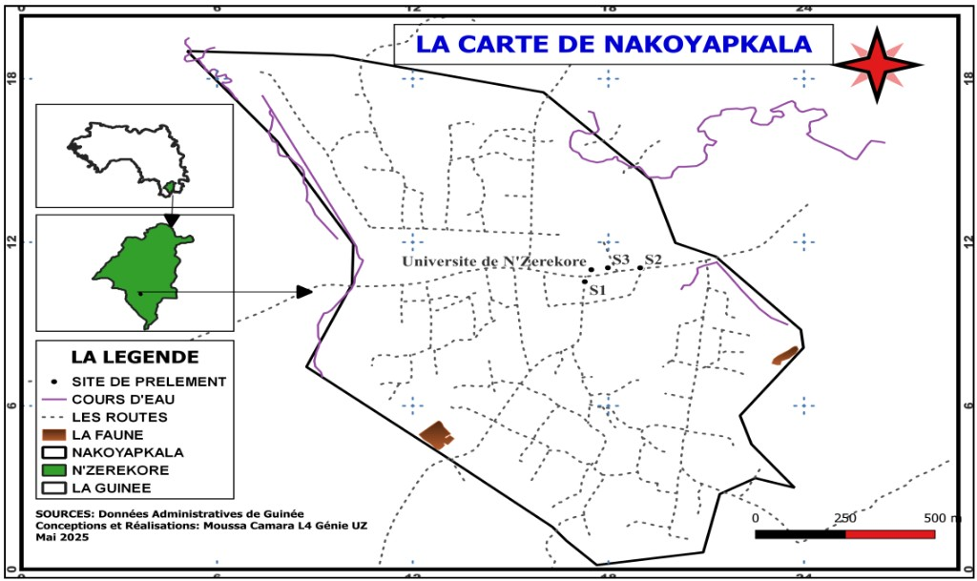

Figure 1 : Location of the stations

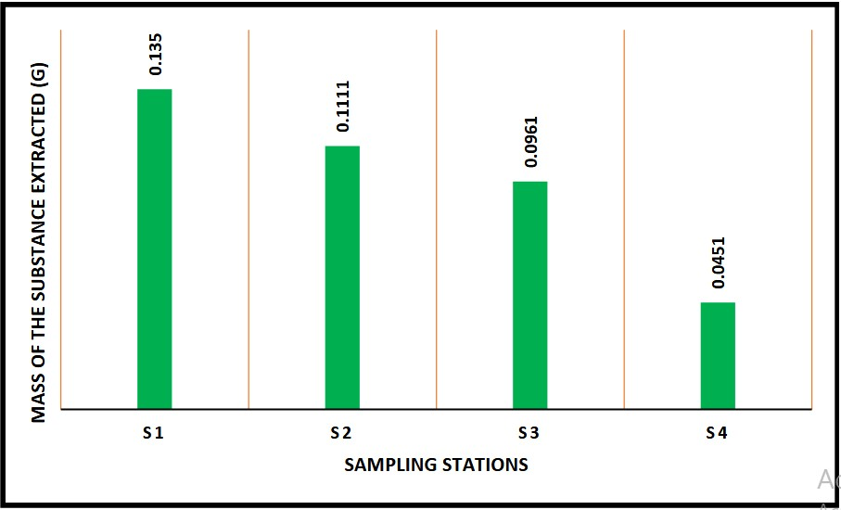

Figure 2: Mass of substance extracted at the four stations
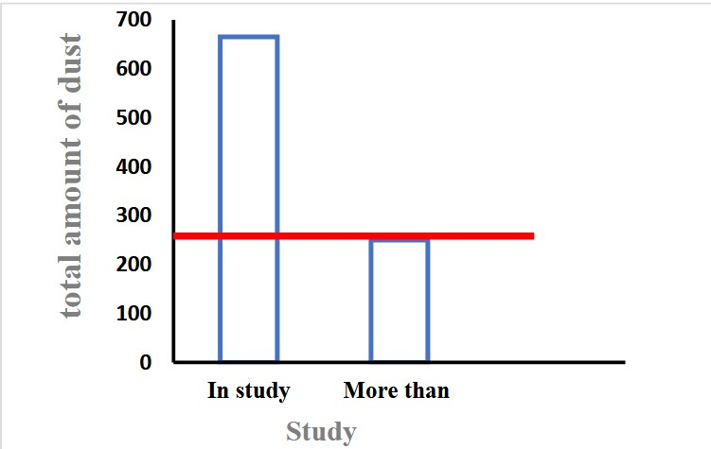

Figure 3 : Comparison of the total quantity of dust per day in the Nakoyakpala neighborhood with that in AIR Languedoc-Roussillon. Red vertical line illustrates current AIR Languedoc- Roussillon guideline

