Original Research Article

Assessment of Historical and Future Climate Trends in Kapoeta Region of South Sudan

.

ABSTRACT
The future climate situations depend on greenhouse gas emissions in the Kapoeta region of South Sudan. The study determined historical (1984-2016) and projected (2021-2050) climate trends in the Kapoeta region. Descriptive and non-parametric statistics, including the Man-Kendall-tau and Sein's s-Slope estimator in XLSTAT 2016, were employed to project historical (1984-2016) and future (2021-2050) climate trends. The study was conducted in Greater Kapoeta, Eastern Equatoria State of South Sudan in 2016. The rainfall and temperature projections were presented under Representative Concentration Pathways (RCP) 4.5 and 8.5 from 2021 to 2050 using the Norwegian Earth System Model One (NorESM1). Evidently, the annual rainfall amount declined (P = 0.05) by 0.32 mm from 1984 to 2016, and its monthly patterns changed from unimodal (1984-1994) to bimodal patterns (1995-2016). Similarly, the maximum annual temperature increased significantly (P=0.05) by 0.061 °C, and the monthly temperature increased significantly (P=0.05) in March, April, May, July, and October from 1984 to 2016. Although not significant (P=0.06), the annual rainfall projection shows a rise of 2.912 mm under RCP8.5 and a decrease of 3.080 mm under RCP4.5 from August-December between 2021 and 2025. The peak monthly rainfall amounts of 111 mm and 89 mm will occur in November under RCP8.5 and RCP4.5 from 2021-2050. The study anticipates a significant (P=0.05) increase in annual temperature by 0.016 °C and 0.028 °C, and average monthly temperature increase from January-May under RCP4.5 and RCP8.5 from 2021-2050. The peak maximum average monthly temperature will reach 28.4 °C and 28.3 °C in March under RCP4.5 and RCP8.5 from 2021-2050. Ultimately, climate trends increased (1984-2016) with an anticipated future increase (2021-2050) that requires awareness of the pastoral and agropastoral communities on climate anomalies in the Kapoeta region.

Keywords: Climate trends, Greenhouse gas emissions, Representative Concentration Pathways, Rainfall and temperature trends
1. INTRODUCTION

Climate change emanating from greenhouse emissions will affect pastoral and agropastoral livelihoods (Alam and Rukhsana 2023; IPCC 2023; Yuan et al. 2024; Zenda 2024). Intergovernmental Panel on Climate Change (IPCC) Sixth Assessment Report (AR6) (2023) indicated an increase in global temperature by 1.1 °C from 2011-2020 compared to 0.8 °C from 1850-1900. These temperature increments emanated from greenhouse gas emissions (79%) from energy production, industrial developments, transportation sectors, buildings, and 22% from agriculture production and forest exploitations in 2019 (IPCC 2023). Evidently, the major global sources of CO₂ emissions are energy production, whereas CH₄ and N₂O are mainly generated from agriculture (Filonchyk et al., 2024; Jos G.J. et al., 2005). Accordingly, the African temperature rate was 0.3 °C from 1991-2024 relative to the global temperature rate of 0.2 °C from 1961-1991 (Chamma, 2024; WMO, 2024a; Wright et al., 2024), where Tunisia and Morocco of the Northern African region recorded maximum temperatures of 49 °C and 50.4 °C, with short rainy seasons in 2024 (Chamma, 2024) that affected livestock, crops, and forage production (Ayanlade et al., 2022; Serdeczny et al., 2017).

In the same vein, the East African region temperature rates were 1.37 °C and 0.68 °C in 2024, compared to the global temperature rate of 0.02 °C and 0.67 °C between 1961-1990 and 1991-2020 (Serdeczny et al., 2017; WMO, 2024a). Increased droughts and precipitation are associated with negative and positive Indian Ocean Dipole (IOD) from October to December in the East African region (Zheng et al. 2025). The East African temperature trends rise by 0.2 °C and 0.3 °C between 1961-1990 and 1991-2024 (WMO, 2024a). The temperatures and precipitation intensities are projected to increase with the CO₂ gas emissions levels in East Africa (Demissie et al., 2025). Particularly, South Sudan has an average annual temperature and rainfall amount of 28 °C and 994.89 mm from 1991-2020, with seasonal temperature rise of 1.15 °C and 1.4ºC from December-February and March-May since 1901 (Tarif et al., 2025). The highest temperature of 45 °C occurred in March 2024, while severe flooding along White Nile occurred in February 2024 (WMO, 2024a). Heavy rain above 400 mm (55%) above normal was anticipated to occur across the Kapoeta region by December 2025 (FAO, 2017; Omay et al., 2016). Temperature trends in the Kapoeta region increased and are expected to continue increasing in the region. The drivers of climate change in the Kapoeta region are mainly anthropogenic and agricultural activities: high livestock numbers and their waste disposal in the grazing lands, deforestation through bush burning for charcoal production (FAO et al., 2023; Jos G.J. et al., 2005). These human phenomena culminated in climate change and seasonal shifts in the Kapoeta region. Currently, the Kapoeta region is faced with stiff competition over access to grazing resources within and with neighboring groups, such as the Karamojong of Uganda and the Turkana of Kenya, culminating in increased migration to water and pasturelands during dry seasons (FAO et al., 2023). Climate change-induced migration and competition over access to pasture undermine food security and increase conflict incidences in the region. Certainly, these extreme climates have and will negatively affect pastoral and agro-pastoral communities (IPCC 2023; Yuan et al. 2024; Zenda 2024). This is because they rely on rain-fed agriculture and livestock production with limited technological advancement. Therefore, the study determined the historical (1984-2016) and projected (2021-2050) rainfall and temperature trends in the Kapoeta region.

2. MATERIAL AND METHODS

2.1 Study Area

The Greater Kapoeta covers 36945.09 Kilometer Square (Km², located between latitude 33.133 Degree East to 35.947 Degree East and longitude 4.19 Degree North to 5.974 Degree North, comprising three counties (Kapoeta East, South, and North) of Eastern Equatoria State in South Sudan (Fig.1). Kapoeta has a population of 346551 people. (SSCCSE, 2010) Who practice pastoral and agropastoral production systems emanating from semi-arid and arid conditions with short rainy seasons that hinder effective crop cultivation. This region is characterized by a low average rainfall amount of 200 mm to 500 mm annually (CSRF, 2023) and a high average temperature of 27-34 degrees Celsius. Most of the households (85 percent) depend on livestock production as their main livelihood (AVSI, 2023). These households practice transhumance and nomadic livestock production systems where ruminants, cattle, goats, sheep, and pseudo-ruminants, camels, horses, and donkeys are kept. These livestock production systems rely on natural and communal grazing land to access pastureland. Kapoeta landscape is characterized by hills, mountains, grasses, forbs, thickets, and shrubs that provide pasture for livestock supported by black cotton clay soil that becomes sticky in rainy seasons.

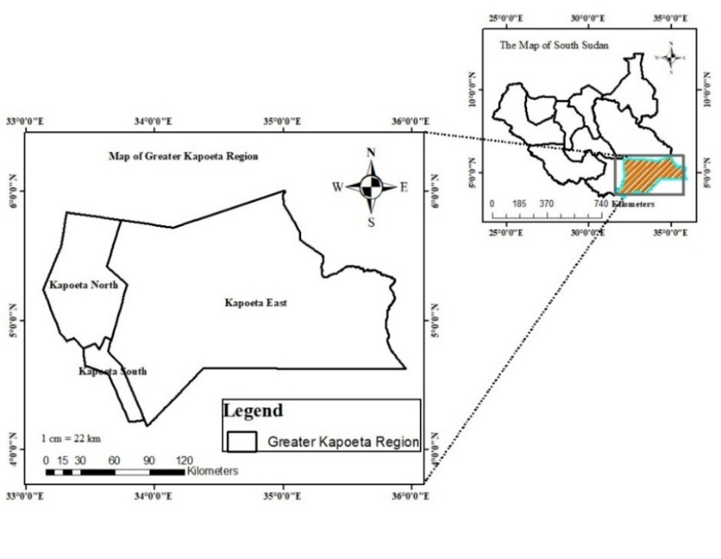
Fig. 1. The Map of Greater Kapoeta of Eastern Equatoria State of South Sudan

2.2 Rainfall and Temperature Data Collection
The rainfall and temperature data were downloaded from the National Aeronautic Space Administration for Prediction of World Energy Resources (NASA POWER) Climatology Resource for Agro-climatology website (https://power.larc.nasa.gov/cgi-bin/cgiwrap/solar/agro.cgi), and the Global Weather Data for Soil Water Assessment Tool (SWAT) (uoguelph.ca/watershed/w3s) data was used to fill the gaps of no data in the NASA POWER climatology data set. The climate data set was downloaded from latitude 33.579 degrees East and longitude 4.692 degrees North at an elevation of 473 meters (m). NASA measured rainfall and temperature amounts at 2 meters above the Earth's surface. In addition, the SWAT climate data was downloaded from Latitude 33.4375 degrees East and Longitude 4.52732 degrees North at an elevation of 766 meters. The data sets were cleaned and processed by summing the total monthly rainfall amounts for each year from 1984 to 2016. Accordingly, the average rainfall amounts were obtained by dividing the total monthly rainfall amounts by the number of months from 1984 to 2016. The average rainfall amount was presented per decade in a graph: 1984-1994, 1995-2005, and 2006-2016. Further, the annual rainfall amounts were obtained from the summation of the monthly rainfall amounts in each year from 1984 to 2016. Similarly, rain days were considered when the rainfall amount received was above 0.2 millimeters (mm) in a day (WMO, 2008). As such, the total monthly rain days were calculated by summing all the rainfall amounts received in each day for each month from 1984 to 2016, while average rain days were obtained by dividing the total rain days in a month by the number of months in a year from 1984 to 2016. The annual rain days were the summation of monthly rain days in a year from 1984 to 2016. Additionally, the annual temperature resulted from summing monthly temperatures and dividing them by 12 months of each year from 1984 to 2016. To obtain the minimum, mean, and maximum monthly temperatures, the total monthly temperature was divided by the number of days in each month from 984 to 2016.

2.3 Analysis of Rainfall and Temperature Data
Descriptive statistic was employed to present the trends of rainfall, rain days, and temperature amounts in graphs and charts from 1984 to 2016 using Microsoft Excel version 2013 and XLSTAT 2016. Non-parametric statistics were used to determine the trends of rainfall, rain days, and temperature between 1984 and 2016, and the projected rainfall amount and temperature from 2021 to 2050 by employing the Mann-Kendall test and Theil-Sein’s slope estimator at a significance of P=0.05. The direction of the trend in annual rainfall, rain days, and temperature was determined by Theil Sein’s slope (Yadav et al., 2014).

2.3.1 Mann-Kendall Test
Mann-Kendall Test Statistic (S) is given by:
……………………………………………………………… (1)
X_{i} is the time series rank from i=1, 2………. n-1 and X_{j}=i+1, 2………...n. Every data point X_{i} is a reference point compared with the data point X_{j,} so that,
It has been indicated that when n≥8, the statistic S is normally distributed with the mean.
E(S) =0 (Mondal et al., 2012).
…………………………………………………………………… (2)
Where δ is the standard deviation and n is the number of data points in the time series.
The Mann-Kendall statistic can also be rewritten as:
………………………………………………………………………………… (3)
It can be therefore concluded that a positive value of S denotes an increasing trend while the negative value indicates a decreasing trend in rainfall and temperature between 1984 and 2016. The critical statistical test value was 1.97 at a 95 percent probability level (Mondal et al., 2012; Yadav et al., 2014).

2.3.2 Theil-Sen’s estimator
The slope of n pairs of data points estimated by Theil-Sen’s estimator is used in the following formula.
…………………………………………………………………... (4)
Where β is the Theil-Sen Slope and X_{j} and X_{i} are the data values at time j and i. The median of the total points in the data set (N) values of β is the Sen’s estimator of slope. The change in historical and projected annual rainfall, rain days, and temperature was obtained by multiplying annual values of Sen’s Slope by the historical (1984-2016) and projected (2021-2050) number of years.

2.4 Acquisition of Rainfall and Temperature Projection Data
Rainfall and temperature data were downloaded from the Climate Systems Analysis Group (CSAG) of the University of Cape Town (http://www.csag.uct.ac.za/) under the Coordinated Regional Downscaling Experiments (CORDEX) (https://rcmes.jpl.nasa.gov/content/cordex). The rainfall and temperature data were captured by the Norwegian Climate Centre’s Earth System Model 1 (NorESM1).

2.4.1 Description of the Climate Projection Model
The Norwegian Climate Centre’s Earth System Model 1 (NorESM1-M) is one of the Norwegian Climate Models with intermediate resolution (Bentsen et al., 2013) and one of the Community Climate System Model versions 4 (CCSM4) family. NorESM1-M differs from CCSM4 because it has isopycnic coordinates and advanced chemistry for aerosol-cloud-radiation interactions with a horizontal resolution of two (2) degrees (1.9 °C Latitude by 2.5 °C Longitude) for atmosphere and land components, and one degree for ice and ocean components (Bentsen et al., 2013). The sensitivity of the NorESM1 was tested through climate projection simulated from 2006 to 2100 under Representative Concentration Pathways (RCP) 2.6, 4.5, 6.0, and 8.5. The model is capable of projecting the climate from 2006 to 2300 under RCP 4.5 (Bentsen et al., 2013). However, the NorESM1 has coarse resolution and negligible underestimates of sensible heat flux in the African continent. In this study, RCP 8.5 and 4.5 scenarios were used to project rainfall and temperature trends from 2021 to 2050. The RCP 8.5 assumes that greenhouse gas emissions (CO₂) will reach the highest level of 8.5 watts/m² by 2100 without climate mitigation policies (Riahi et al., 2011). That will affect the global rainfall and temperature distributions. As such, the RCP 8.5 greenhouse gas (GHG) emission scenario was used to project rainfall and temperature trends at high greenhouse emissions by 2050 in the Kapoeta region. Further, RCP 4.5 assumes that GHG emissions are moderate at 4.5 watts/m² by 2100 because of technological advancement and some enforcement of climate mitigation policies. (Brown et al., 2014; Thomson et al., 2011). The RCP8.5 and RCP4.5 scenarios were used to determine rainfall and temperature trends without and with climate change mitigation measures by 2050 in the Kapoeta region of Eastern Equatoria State, South Sudan.

2.5 Rainfall and Temperature Projection
Rainfall and temperature projections employed the Norwegian Earth System Model (NorESM1), a General Climate Model (GCM) with a horizontal resolution of 250 Km. (Bentsen et al., 2013). This coarse resolution was downscaled to 50 Km grid boxes using Rossby Centre Regional Climate Model (RCA4), a Swedish Meteorological and Hydrological Institute (SMHI) regional climate modelling software (https://www.smhi.se/en/research/research-departments/climate-research-rossby-centre2-552/rossby-centre-regional-atmospheric-model-rca4-1.16562). Thereafter, the average 50 Km grid boxes of the Kapoeta region were used to project monthly rainfall and temperature amounts under RCP8.5 and RCP4.5 emission scenarios from 2021-2050. The annual rainfall and temperature projections were summations of the monthly rainfall and temperature amounts in each year, whereas average monthly rainfall and temperature amounts were the summations of monthly rainfall and temperature amounts divided by the number of months from 2021-2050 under RCP8.5 and RCP4.5. The annual and average monthly rainfall and temperature were presented in graphs and charts using Microsoft Excel version 2013.

3 RESULTS

3.1 Trends of Annual Rainfall, Rain Days, Monthly Rainfall, and Rain Days from 1984-2016 in the Kapoeta region
The result indicates a non-significant (P=0.05) decline in annual rainfall amount with a mean annual rainfall amount of 144.35+/-50.33 mm from 984-2016 (Fig. 2). The rate of decline in annual rainfall amount was 0.316 mm from 1984-2016 (Fig. 2). This decline in annual rainfall amount culminated in the loss of 10.11 mm from 1984-2016. Although the highest and the lowest annual rainfall amounts received were 276.75 mm and 54.5 mm in 1988 and 1998, the mean annual rainfall amount received was: 158.58+/-60.65 mm, 129.67+/-56.16 mm, and 144.83+/-24.94 mm between 1984-1994, 1995-2005, and 2006-2016. The finding also indicates a change in monthly rainfall from unimodal to bimodal rainfall patterns from 1984-2016 (Fig. 2). The unimodal average monthly rainfall pattern occurred from 1984-1994, whereas bimodal monthly rainfall patterns were observed from 1995-2005, and 2006-2016. The highest and lowest average rainfall amounts of 53.40 mm and 0.20 mm were recorded in July and December in the first decade (1984-1994). However, the subsequent decades between 1995-2005 and 2006-2016 recorded increased average monthly rainfall amount from September to December. Similarly, Kendall tau and Sen’s slope indicate a significant (P=0.05) increase in monthly rainfall amount from September-December and January-March in the Kapoeta region (Table 1). Conversely, Kendall tau and Sen’s Slope indicate a significant decline in average monthly rainfall amount in July from 1984 to 2016 in the Kapoeta region (Table 1). Conversely, annual rain days significantly (P=0.05) decline by 1.44 days with a mean annual rain days of 64.41+/-28.37 days and a loss of 46 rain days from 1984-2016 (Fig. 2). The highest and the lowest rain days of 129 days and 22 days were recorded in 1996 and 2000, respectively. The mean annual rainy days between 1984-1996, 1995-2005, and 2006-2016 were 90+/-17 days, 50+/-30 days, and 51+/-8.0 days. (Fig. 2. There was an unimodal monthly rain days pattern with nine average days in July and three rain days from January-March from 1984-2016 (Fig. 2.

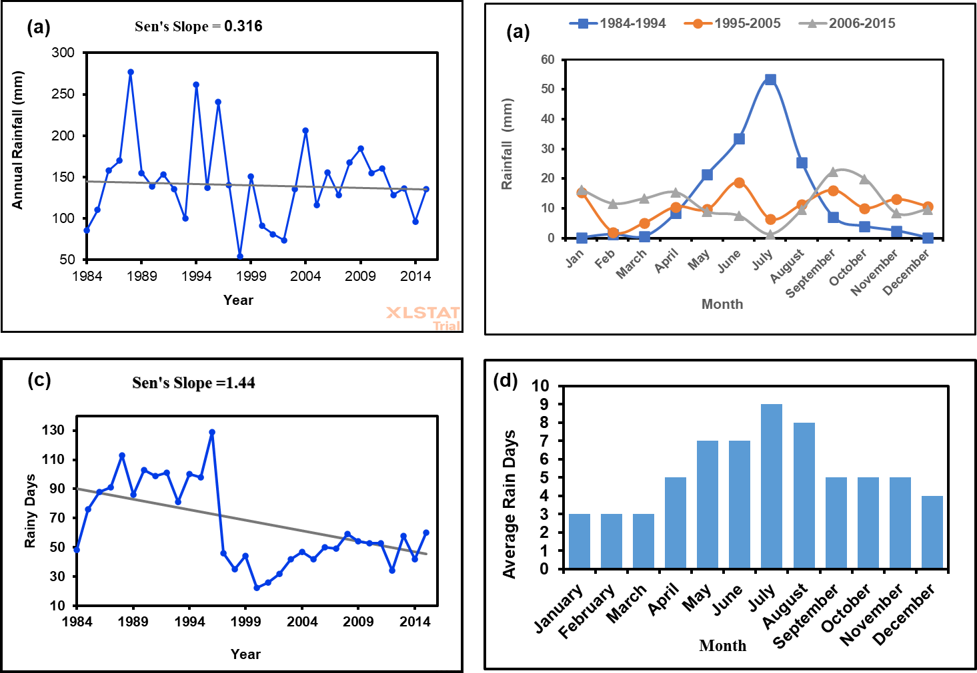
Fig. 2. The trends of rainfall amount and rain days. (a) Shows the trends in annual rainfall amount; (b) Variations in monthly rainfall amount per decade; (c) Trends of annual rain days; (d) Variations in monthly rain days

Table 1. The trend of monthly rainfall between 1984 and 2016 in the Kapoeta region
Month | Minimum  (mm) |  | Maximum  (mm) |  | Mean | Std. deviation |  | Kendall's tau | P-value | Sen's slope
January |  | 0.000 | 61.500 | 10.501 |  |  | 15.383 | 0.485 | 0.000 | 0.396
February |  | 0.000 | 31.100 | 4.832 |  |  | 7.133 | 0.470 | 0.000 | 0.219
March |  | 0.000 | 30.300 | 6.168 |  |  | 9.482 | 0.389 | 0.002 | 0.242
April |  | 0.000 | 45.800 | 11.379 |  |  | 14.167 | 0.048 | 0.709 | 0.037
May |  | 0.000 | 89.400 | 13.508 |  |  | 18.141 | -0.054 | 0.673 | -0.069
June |  | 0.000 | 143.440 | 20.354 |  |  | 29.572 | -0.206 | 0.101 | -0.446
July |  | 0.000 | 107.950 | 21.013 |  |  | 32.049 | -0.535 | < 0.0001 | -1.204
August |  | 0.400 | 84.320 | 15.726 |  |  | 19.882 | -0.160 | 0.206 | -0.136
September |  | 0.000 | 43.300 | 15.006 |  |  | 12.544 | 0.331 | 0.008 | 0.583
October |  | 0.070 | 84.200 | 11.091 |  |  | 16.089 | 0.379 | 0.002 | 0.421
November |  | 0.070 | 32.500 | 8.002 |  |  | 8.998 | 0.390 | 0.002 | 0.276
December |  | 0.000 | 22.600 | 6.767 |  |  | 8.356 | 0.491 | < 0.0001 | 0.266

3.2 Annual Temperature Trends from 1984 to 2016 in the Greater Kapoeta Region
The maximum temperature significantly (P=0.05) rises by 0.061 °C annually from 1984-2016 (Fig. 3). The result indicates a non-significant increase (P=0.724) in mean and a decrease (P=0.701) in minimum temperature from 1984-2016. Generally, the maximum and mean temperatures increased by 1.95 °C and 0.128 °C, whereas the minimum temperature decreased by 0.224 °C from 1984 to 2016, respectively.
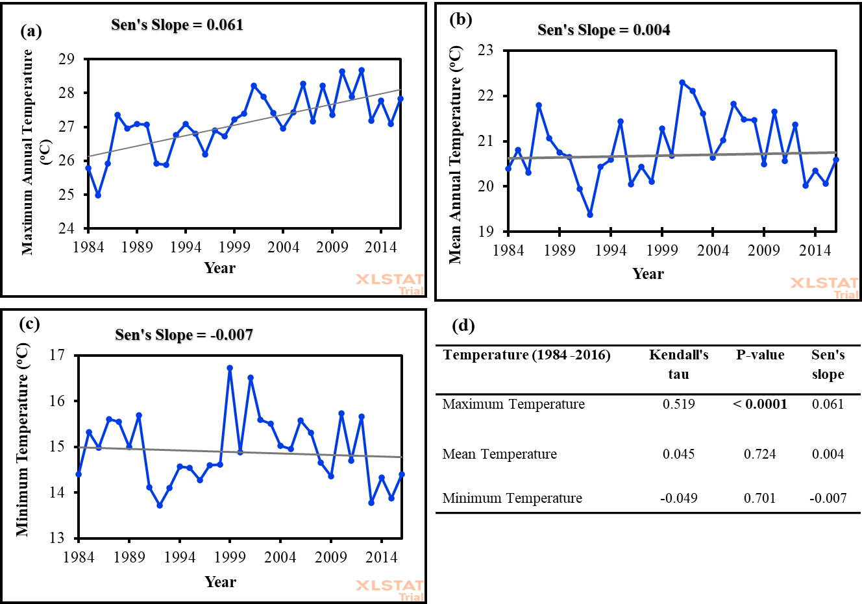
Fig. 3. The trend of annual temperature in the Kapoeta region from 1984 to 2016. (a) Shows maximum annual temperature trend; (b) Mean annual temperature trends; (c) Minimum annual temperature trend; (d) Man, Kendall, and Sen’s slope temperature trends at P=0.05

3.2.1 Trends of Monthly Temperature between 1984 and 2016 in the Kapoeta region
The results showed a significant (P=0.05) increase in maximum monthly temperature trends from March-May, July, and October, with a decreasing trend from December-January from 1984 to 2016 (Table 2). The highest maximum monthly temperature increased per decade were 38.9 °C, 39.6 °C, and 40.8 °C from 1984-1994, 1995-2005, and 2006-2016. Essentially, the maximum monthly temperature significantly (P=0.05) increased by 1.9 °C compared to no significant increase in mean and minimum temperatures from 1984-2016 (Table 3 and Table 4), despite a significantly (P=0.05) decreased minimum temperature in February and November in the same period.

Table 2: Maximum Monthly Temperature Trends between 1984 and 2016 in the Kapoeta region
Month | Minimum  (ºC) | Maximum  (ºC) | Mean | Std. deviation | Kendall's tau | P-value | Sen's slope
January | 13.335 | 18.642 | 15.697 | 1.424 | 0.220 | 0.075 | 0.045
February | 14.052 | 20.407 | 17.657 | 1.660 | -0.038 | 0.768 | -0.017
March | 18.061 | 26.868 | 21.508 | 1.812 | 0.345 | 0.005 | 0.082
April | 22.993 | 29.480 | 26.130 | 1.871 | 0.356 | 0.004 | 0.110
May | 26.477 | 34.894 | 31.235 | 1.962 | 0.386 | 0.002 | 0.103
June | 17.793 | 41.933 | 35.691 | 3.663 | 0.227 | 0.065 | 0.065
July | 36.439 | 43.265 | 39.746 | 1.677 | 0.282 | 0.022 | 0.061
August | 35.490 | 42.406 | 39.063 | 1.503 | 0.220 | 0.075 | 0.058
September | 31.190 | 37.660 | 33.520 | 1.574 | 0.212 | 0.085 | 0.051
October | 22.165 | 31.745 | 28.107 | 2.212 | 0.292 | 0.018 | 0.096
November | 18.200 | 28.650 | 21.087 | 1.776 | 0.125 | 0.314 | 0.020
December | 13.410 | 19.781 | 16.409 | 1.640 | -0.087 | 0.486 | -0.022

Table 3: Mean Monthly temperature trends between 1984 and 2016 in Kapoeta Region
Month | Minimum  (ºC) | Maximum  (ºC) | Mean | Std. deviation | Kendall's tau | P-value | Sen's slope
January | 6.926 | 12.881 | 9.629 | 1.435 | -0.083 | 0.505 | -0.014
February | 7.062 | 14.375 | 11.166 | 1.669 | -0.186 | 0.133 | -0.055
March | 11.690 | 19.165 | 14.815 | 1.459 | 0.089 | 0.476 | 0.020
April | 15.660 | 28.027 | 19.507 | 2.166 | 0.186 | 0.133 | 0.046
May | 17.732 | 31.187 | 24.649 | 2.431 | 0.140 | 0.258 | 0.040
June | 24.310 | 38.877 | 29.346 | 2.495 | 0.102 | 0.412 | 0.027
July | 27.194 | 42.797 | 32.909 | 2.531 | 0.152 | 0.221 | 0.051
August | 21.003 | 38.406 | 31.682 | 3.390 | 0.154 | 0.215 | 0.041
September | 25.230 | 40.003 | 28.506 | 3.440 | -0.023 | 0.865 | -0.005
October | 17.645 | 32.855 | 22.194 | 2.710 | 0.136 | 0.271 | 0.049
November | 12.020 | 21.490 | 15.188 | 1.631 | -0.125 | 0.314 | -0.026
December | 7.184 | 13.400 | 10.442 | 1.526 | -0.144 | 0.245 | -0.029

Table 4: Minimum monthly temperature trends from 1984 to 016 in the Kapoeta region
Month | Minimum  (ºC) | Maximum  (ºC) | Mean | Std. deviation | Kendall's tau | P-value | Sen's slope
January | 1.777 | 6.471 | 4.603 | 1.329 | -0.106 | 0.394 | -0.025
February | 1.276 | 11.271 | 5.554 | 1.893 | -0.254 | 0.039 | -0.067
March | 6.732 | 12.584 | 8.729 | 1.322 | -0.061 | 0.631 | -0.011
April | 9.930 | 21.633 | 12.990 | 1.982 | 0.042 | 0.745 | 0.012
May | 14.974 | 25.006 | 18.422 | 2.306 | 0.008 | 0.963 | 0.001
June | 20.233 | 27.170 | 23.152 | 1.635 | -0.163 | 0.188 | -0.039
July | 19.926 | 34.487 | 26.582 | 2.467 | 0.076 | 0.546 | 0.020
August | 22.090 | 27.971 | 25.689 | 1.192 | 0.095 | 0.448 | 0.020
September | 17.980 | 22.997 | 21.004 | 1.278 | 0.076 | 0.546 | 0.017
October | 13.248 | 18.810 | 16.335 | 1.424 | 0.142 | 0.251 | 0.039
November | 7.127 | 12.307 | 10.118 | 1.100 | -0.264 | 0.032 | -0.046
December | 3.377 | 8.645 | 6.002 | 1.381 | -0.235 | 0.057 | -0.047

3.3 Rainfall and Temperature Projection from 2021 to 2050 in Kapoeta Region

3.3.1 Projection of Annual Rainfall and Temperature Trends between 2021 and 2050
The annual rainfall projection shows a non-significance (P=0.05) increase (Kendall’s tau=0.241 mm; P=0.064; Sen’s slope=2.912 mm) under RCP8.5 and a non-significant decrease (Kendall’s tau=-0.195 mm; P=0.134; Sen’s slope=-3.808 mm) under (RCP4.5) from 2021-2050 in Kapoeta region (Fig. 4). The annual rainfall amount will increase at rate of 2.912 mm and 3.808 mm under RCP8.5 and RCP4.5 from 2021-2050 (Fig. 4). Altogether, the annual rainfall will increase by 84.45 mm and 110.43 mm under RCP8.5 and RCP4.5 from 2021-2050 respectively. Further, annual temperature will significantly (P=0.05) increase under the RCP4.5 greenhouse gas emission scenario (Kendall’s tau=0.356; P=0.007; Sen’s slope=0.028) and RCP8.5 (Kendall’s tau=0.301; P=0.020; Sen’s slope=0.016) greenhouse gas emissions from 2021-2050. The finding indicates a significant (P=0.05) annual temperature rate of 0.028 °C and 0.016 °C under RCP4.5 and RCP8.5 from 2021-2050 (Fig. 4). Ultimately, the annual temperature will increase by 0.81°C and 0.46°C under RCP4.5 and RCP8.5 from 2021-2050 (Fig. 4).

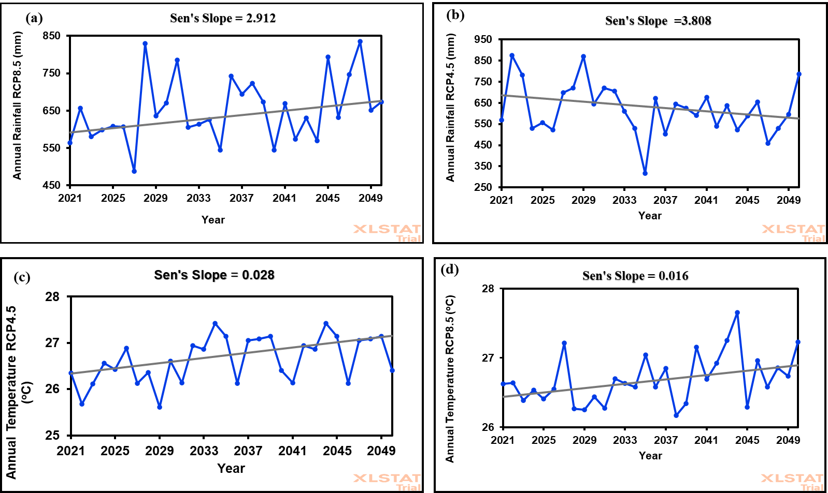
Fig. 4. Projected annual rainfall and temperature trends under RCP8.5 and RCP4.5 from 2021-2050: (a) Shows annual rainfall projection under RCP8.5; (b) Annual rainfall projection under RCP4.5; (c) Annual temperature projection under RCP8.5; (d) Annual temperature projection under RCP4.
3.3.2 Projection of Average Monthly Rainfall and Temperature from 2021 to 2050
The result indicates the highest average monthly rainfall amount will occur from August to December under RCP4.5 and RCP8.5 from 2021-2050 in Kapoeta Region (Fig. 5). Accordingly, the highest average monthly rainfall amount of 111 mm and 89 mm will occur in November under RCP8.5 and RCP4.5 from 2021, 2050. The average monthly rainfall amount of 51.84+/-23.00 mm and 51.80+/-28.60 mm will occur under RCP8.5 and RCP4.5 from 2021-2050. Conversely, the average monthly temperature will increase from January to May under RCP4.5 and RCP8.5 from 2021-2050 (Fig. 5). The highest average monthly temperature of 28.4 °C and 28.3 °C is anticipated to occur in March, whereas the lowest average monthly temperature of 25.6 °C and 25.5 °C will occur in July under RCP4.5 and RCP8.5 from 2021, 2050. The results projected the highest average monthly temperature under RCP4.5 and RCP8.5 from January-May and low average monthly temperature from June-December under the two gas emission scenarios from 2021-2050 in the Kapoeta region (Fig. 5).
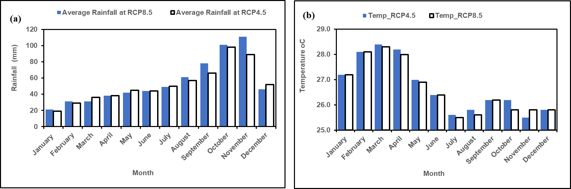
Fig. 5. Projected monthly rainfall and temperature under RCP8.5 and RCP4.5 from 2021-2050. (a) Shows average monthly rainfall amount under RCP8.5 and 4.5; (b) Average monthly temperature under RCP8.5 and 4.5

4.0 DISCUSSIONS

4.1 Climate Trends and Patterns in the Kapoeta Region of South Sudan
There is intensified climate change emanating from changes in rainfall and temperature patterns in the Kapoeta region. The evidence demonstrated that the region experienced changes in rainfall, rain days, and temperature trends. This finding is consistent with the study of Alhassan et al., (2025), which found a significant marginal rainfall increase in Northern Ethiopia. Since 1984, the Kapoeta region has lost 10.11 mm of its annual rainfall amounts, with variations in average annual rainfall amount of 158.58+/-60.65 mm, and 129.67+/-56.16 mm from 1984-2016. Additionally, annual rain days reduced from 90 days to 51 days, and monthly rainfall patterns shifted from unimodal to bimodal from 1984-2016. However, the increased monthly rainfall from September-December (2006-2016) in Kapoeta region emanated from a positive Indian Ocean Dipole (IOD) that brought rains from October-December in the East African region (Zheng, et al., 2025). However, there was a marginal increase in monthly rainfall from January-March (1984-2016) that agrees with the FAO (2024) prediction of 55% monthly rainfall amount from March-May in 2025 in the Kapoeta region.

The future annual rainfall amount will not change under RCP8.5 and RCP4.5 by 2050. This can be explained by the insignificant increase in precipitation (Alhassan et al., 2025). Unimodal rainfall pattern is projected to occur from August-November by 2050, which differs from monthly rainfall occurrences from May-September, from 1984-1994 and 1995-2016, which occurred between March-June, and August-December. Remarkably, the model projected higher mean and maximum monthly rainfall amounts under high (RCP8.5) gas emissions (52 mm and 111 mm) and low (RCP4.5) gas emissions (52 mm and 98 mm) compared to the period 1984-2016 (12 mm and 21.01 mm). This projection is similar to that of Lomeling (2020), who anticipated monthly rainfall of 100 mm, 150 mm, and 80 mm between March-June, July-September, and October-December by 2034 in Juba County of South Sudan. However, rainfall patterns shifted in the last three decades (1984-2016) relative to the projected rainfall pattern (2021-2050) in the Kapoeta region, though WMO (2024b) projected a general increase in monthly rainfall in 2024 in the region. The shift in the projected rainy seasons and average monthly rainfall amounts will have significant implications for the pastoral and agropastoral communities in the Kapoeta region. Ndebele and Zenda (2023) indicated that climate change and variability caused troubles to pastoral and agropastoral livelihoods, causing livestock losses, deforestation, and livestock and human water scarcity in Awerial County of South Sudan. Certainly, seasonal rainfall variabilities undermine annual forage availability and distribution in the Kapoeta region (Peters et al., 2022). The average rainfall amounts of less than 120 mm are less likely to support grasslands, but will support woody plants, which depend on a tap root system to draw groundwater. These types of plants will not favor grazers but will support browsers (Kipchirchir, Ngugi, and Wahome, 2011). Further, low soil moisture will encourage the emergence and spread of drought-resistant acacia and Prosopis juliflora that are feeds for goats, encourage the formation of plant lignin, and loss of seed viability (Kipchirchir et al, 2011; Roberts et al., 2023). Low average monthly rainfall amount can reduce the above-ground forage biomass sufficient for grazing (Zhu et al., 2025), the nutritional value of grass and legume forage for livestock, and destroy the seed banks of perennial grass and dwarf shrubs (Rojas-Botero et al., 2023). Ultimately, any changes in forage availability will affect livestock composition, animal production, and the livelihoods of the pastoralists. In addition, a shift in rainfall patterns culminated in changes in wildlife movement patterns, the emergence of invasive plant species, new livestock, and human disease (CSRF, 2023). Consequently, seasonal changes resulted in incidences of human-wildlife conflicts and loss of cultivation land and grazing land due to encroachment of invasive plant species such as Prosopis juliflora and Parthenium hysterophorus that increase food insecurity and reduce income for pastoral and agropastoral communities in the Kapoeta region. It is unequivocal that rainfall patterns changed between 1984 and 2016, relative to the next three decades (2021-2050). This calls for the development of drought-tolerant forage species with more water use efficiency and a shift to livestock species with high water use efficiency.

Temperature was increasing annually between 1984 and 2016 relative to future temperature trends under low and high greenhouse gas emissions from 2021-2050. The highest maximum monthly temperature showed increasing trends of 38.9 °C, 39.6 °C, and 40.8 °C between 1984-1994, 1995-2005, and 2006-2016, consistent with the highest temperature of 45 °C experienced in March 2024 in South Sudan (WMO, 2024a). However, future monthly temperature projection shows lower peak average values of 28.4 °C and 28.3ºC in March under RCP4.5 and RCP8.5 from 2021-2050 compared to temperatures from 1984-2016. The changes in previous and future annual temperatures will intensify evaporation of soil moisture, affect nutrient availability for grass species, reduce biomass, and cause wilting (Oliveira et al., 2024). This will affect the productivity of domestic ruminants such as cattle and sheep that graze on natural forage and will hinder future pastoral livelihoods in the Kapoeta region. Ndebele and Zenda (2023) showed that pastoralists observed an increase in temperature in the last decade, consistent with the reports of several studies in dry areas of South Sudan (Tarif et al. 2025; WMO 2024a; Zheng et al., 2025). The prolonged droughts cause crop failures and livestock deaths, emanating from inadequate soil moisture and pasture, which increases household food insecurity and socioeconomic vulnerability in the Kapoeta region. Extreme temperatures cause heat stroke and other heat-related diseases that affect human health and lower livestock reproductive performance. Indeed, high temperatures above 45 °C are detrimental to humans, animals, and plants in the Kapoeta region.

5.0 CONCLUSION
The historical (1984-2016) and future (2021-2050) rainfall and temperature trends increased and are expected to increase in the Kapoeta region, though the future rainfall increase is marginal compared to temperature trends. The monthly rainfall patterns shifted from unimodal to bimodal patterns with more monthly rainfall amount anticipated to occur from October to December between 1984-2016, consistent with the anticipated future rainfall amount in November from 2021-2050. Conversely, annual and monthly temperatures increased and are expected to increase in March by 20250 in the Kapoeta region. Therefore, this necessitates an early warning system and awareness of the pastoral and agropastoral communities on climate hazards in the Kapoeta region of South Sudan.

DISCLAIMER ON THE USE OF ARTIFICIAL INTELLIGENCE (AI)
The authors declare no use of AI during editing and writing the Manuscript, and the Manuscript is the original work of the authors without publication anywhere.

REFERENCES
Alam, A., & Rukhsana. (2023). Climate Change Impact, Agriculture, and Society: An Overview. In A. Alam & Rukhsana (Eds.), Climate Change, Agriculture and Society: Approaches Toward Sustainability (pp. 3–13). Springer International Publishing. https://doi.org/10.1007/978-3-031-28251-5_1
Alhassan, I., Teklehaimanot, A., Solomon, N., Gufi, Y., Gebre, M. B., Birhane, K., & Eze, E. (2025). Perception and trends of climate change: assessing impacts on smallholder farmers and Agro-Pastoral communities in Northern Ethiopia. Environmental Science, 3(1), 1–25. https://doi.org/10.1007/s44279-025-00272-x
AVSI. (2023). Household Multisector Survey. https://www.avsi.org/en/what-we-do/countries/south-sudan
Ayanlade, A., Oluwaranti, A., Ayanlade, O. S., Borderon, M., Sterly, H., Sakdapolrak, P., Jegede, M. O., Weldemariam, L. F., & Ayinde, A. F. O. (2022). Extreme climate events in sub-Saharan Africa: A call for improving agricultural technology transfer to enhance adaptive capacity. Climate Services, 27, 1–11. https://doi.org/10.1016/j.cliser.2022.100311
Bentsen, M., Bethke, I., Debernard, J. B., Iversen, T., Kirkevåg, A., Seland, Ø., Drange, H., Roelandt, C., Seierstad, I. A., Hoose, C., & Kristjánsson, J. E. (2013). The Norwegian Earth System Model, NorESM1-M – Part 1: Description and basic evaluation of the physical climate. Geoscientific Model Development, 6(3), 687–720. https://doi.org/10.5194/gmd-6-687-2013
Brown, D. G., Polsky, C., Bolstad, P., Brody, S. D., Hulse, D., Kroh, R., Loveland, T. R., & Thomson, A. (2014). Chapter 13: Land use and land cover change. Climate Change Impacts in the United States: The Third National Climate Assessment, 318–332. https://doi.org/10.7930/J05Q4T1Q.On
Chamma, D. D. (2024). Climate change and economic growth in sub-Saharan Africa: an empirical analysis of aggregate- and sector-level growth. Journal of Social and Economic Development, 1–13. https://doi.org/10.1007/s40847-024-00377-x
CSRF. (2023). Climate change and conflict in South Sudan: Community perceptions and implications for conflict-sensitive aid. https://csrf-southsudan.org/
Demissie, T., Diro, G. T., Duku, C., Solomon, D., & Jimma, T. B. (2025). Current and projected changes in climate extremes and agro-climatic zones over East Africa. Theoretical and Applied Climatology, 156(3), 1–19. https://doi.org/10.1007/s00704-025-05405-2
FAO. (2017). Climate change predictions in sub-Saharan Africa: impacts and adaptations. www.fao.org/publications
FAO, IGAD, & Interpeace. (2023). Conflict, climate change, food security, and mobility in the Karamoja Cluster. In Conflict, climate change, food security, and mobility in the Karamoja Cluster. FAO; Intergovernmental Authority on Development (IGAD); Interpeace; https://doi.org/10.4060/cc7672en
Filonchyk, M., Peterson, M. P., Zhang, L., Hurynovich, V., & He, Y. (2024). Greenhouse gas emissions and global climate change: Examining the influence of CO2, CH4 and N2O. Science of The Total Environment, 935. https://www.sciencedirect.com/science/article/pii/S004896972403506X
IPCC. (2023). IPCC, 2023: Climate Change 2023: Synthesis Report, Summary for Policymakers. Contribution of Working Groups I, II, and III to the Sixth Assessment Report of the Intergovernmental Panel on Climate Change [Core Writing Team, H. Lee and J. Romero (eds.)]. IPCC, Geneva, Switzerland. (P. Arias, M., Bustamante, I., Elgizouli, G., Flato, M., Howden, C., Méndez-Vallejo, J. J., Pereira, R., Pichs-Madruga, S. K., Rose, Y., Saheb, R., Sánchez Rodríguez, D., Ürge-Vorsatz, C., Xiao, N., Yassaa, J., Romero, J., Kim, E. F., Haites, Y., Jung, R., Stavins, … Y. Park, Eds. https://doi.org/10.59327/IPCC/AR6-9789291691647.001
Jos G.J., Oliver, J.A., Van A., Frank J. D., Valerio P., Laurens N. G., & Joeroem A.H.W. Peters. (2005). Recent trends in global greenhouse gas emissions: regional trends 1979-2000 and spatial distribution of key sources in 2000. Environmental Science, 2–3(2), 81–90. https://www.tandfonline.com/doi/abs/10.1080/15693430500400345
Kooech O. Kipchirchir, Kinuthia R. Ngugi, & R.G. Wahome. (2011). Use of Dry Land Tree Species (Prosopis juliflora)Seed Pods as Supplementary Feed for Goats in the Arid and Semi-Arid Lands of Kenya. Environmental Research Journal, 2(5), 66–73. https://www.makhillpublications.co › erj.2011.66.73
Lomeling, D. (2020). Predicting Seasonal Rainfall Patterns and Trends in Juba County, South Sudan Using Artificial Neural Networks. European Journal of Agriculture and Food Sciences, 2(2), 1–8. https://doi.org/10.24018/ejfood.2020.2.2.32
Mondal, A., Kundu, S., & Mukhopadhyay, A. (2012). Rainfall Trend Analysis By Mann-Kendall Test: A Case Study of the North-Eastern Part of Cuttack District, Orissa. International Journal of Geology, Earth and Environmental Sciences, 2(1), 2277–208170. https://doi.org/10.1017/CBO9781139013895.014
Ndebele, Z., & Zenda, M. (2023). Climate Change Impact and Adaptation of Agro-Pastoral Farmers in Awerial County, Lakes State of South Sudan. South African Journal of Agricultural Extension, 51(3), 135–160. https://doi.org/10.17159/2413-3221/2023/v51n3a14086
Oliveira, B. A., López, I. F., Cranston, L. M., Kemp, P. D., Donaghy, D. J., Dörner, J., López-Villalobos, N., García-Favre, J., Ordóñez, I. P., & Van Hale, R. (2024). 18O isotopic labelling and soil water content fluctuations validate the hydraulic lift phenomena for C3 grass species in drought conditions. Plant Stress, 11. https://doi.org/10.1016/j.stress.2024.100414
Omay, P., Ogallo, L., Oludhe, C., & Gitau, W. (2016). Temporal and Spatial Characteristics of the June-August Seasonal Rainfall and Temperature over South Sudan. Journal of Meteorology and Related Sciences, 9(2), 35–49. https://doi.org/10.20987/jmrs.5.08.2016
Peters, T., Kluß, C., Vogeler, I., Loges, R., Fenger, F., & Taube, F. (2022). GrasProg: Pasture Model for Predicting Daily Pasture Growth in Intensive Grassland Production Systems in Northwest Europe. Agronomy, 12(7), 1–12. https://doi.org/10.3390/agronomy12071667
Riahi, K., Rao, S., Krey, V., Cho, C., Chirkov, V., Fischer, G., Kindermann, G., Nakicenovic, N., & Rafaj, P. (2011). RCP 8.5-A scenario of comparatively high greenhouse gas emissions. Climatic Change, 109(1), 33–57. https://doi.org/10.1007/s10584-011-0149-y
Roberts, N., Moloney, K., Monie, K., & Florentine, S. (2023). Effect of selected environmental factors on the seed germination of the invasive species Polygala myrtifolia (Polygalaceae) in Australia. Australian Journal of Botany, 71(6), 286–295. https://doi.org/10.1071/BT22094
Rojas-Botero, S., Teixeira, L. H., & Kollmann, J. (2023). Low precipitation due to climate change consistently reduces the multifunctionality of urban grasslands in mesocosms. PLoS ONE, 18(2 February). https://doi.org/10.1371/journal.pone.0275044
Serdeczny, O., Adams, S., Baarsch, F., Coumou, D., Robinson, A., Hare, W., Schaeffer, M., Perrette, M., & Reinhardt, J. (2017). Climate change impacts in Sub-Saharan Africa: from physical changes to their social repercussions. Regional Environmental Change, 17(6), 1585–1600. https://doi.org/10.1007/s10113-015-0910-2
SSCCSE. (2010). Statistical Yearbook for Southern Sudan 2010 Southern Sudan Centre for Census, Statistics and Evaluation. www.ssccse.org
Tarif, K., Koefoed, M., Seyuba, K., Bunse, S., Iverson, T. O., De Coning, C. H., & Krampe, F. (2025). Climate, Peace and Security Fact Sheet: South Sudan. https://www.nupi.no/news/climate-peace-and-security-fact-sheet-south-sudan3
Thomson, A. M., Calvin, K. V., Smith, S. J., Kyle, G. P., Volke, A., Patel, P., Delgado-Arias, S., Bond-Lamberty, B., Wise, M. A., Clarke, L. E., & Edmonds, J. A. (2011). RCP4.5: A pathway for stabilization of radiative forcing by 2100. Climatic Change, 109(1), 77–94. https://doi.org/10.1007/s10584-011-0151-4
WMO. (2024a). Africa faces a disproportionate burden from climate change and adaptation costs. https://wmo.int/news/media-centre/africa-faces-disproportionate-burden-from-climate-change-and-adaptation-costs
WMO. (2024b). State of the Climate in Africa 2024. https://wmo.int/publication-series/state-of-climate-africa-2024.
Wright, C. Y., Kapwata, T., Naidoo, N., Asante, K. P., Arku, R. E., Cissé, G., Simane, B., Atuyambe, L., & Berhane, K. (2024). Climate Change and Human Health in Africa in Relation to Opportunities to Strengthen Mitigating Potential and Adaptive Capacity: Strategies to Inform an African “Brains Trust.” Annals of Global Health, 90(1), 1–21. https://doi.org/10.5334/aogh.4260
Yadav, R., Tripathi, S. K., Pranuthi, G., & Dubey, S. K. (2014). Trend analysis by the Mann-Kendall test for precipitation and temperature for thirteen districts of Uttarakhand. Journal of Agrometeorology, 16(2), 164–171.
Yuan, X., Li, S., Chen, J., Yu, H., Yang, T., Wang, C., Huang, S., Chen, H., & Ao, X. (2024). Impacts of Global Climate Change on Agricultural Production: A Comprehensive Review. Agronomy, 14(7), 1–19. https://doi.org/10.3390/agronomy14071360
Zenda, M. (2024). A systematic literature review on the impact of climate change on the livelihoods of smallholder farmers in South Africa. Heliyon, 10(18), 1–13. https://doi.org/10.1016/j.heliyon.2024.e38162
Zheng, Y., Tam, C. Y., & Collins, M. (2025). Indian Ocean Dipole Impacts on Eastern African Short Rains Across Observations, Historical Simulations, and Future Projections. Earth’s Future, 13(6), 1–14. https://doi.org/10.1029/2024EF005219
Zhu, A., Wu, Q., Han, G., Wang, R., Wang, B., Yang, Y., Wang, R., & Wu, L. (2025). Aboveground Biomass and Importance Value of Constructive Species in Desert Steppe Are Co‐Regulated by Grazing Intensity and Climate. Ecology and Evolution, 15(10). https://doi.org/10.1002/ece3.72243

