From Pharmacophore to Free Energy: A Multi Scale Approach to DJ-1 (PARK7) Inhibitor Identification

Abstract
DJ-1 (PARK7), a multifunctional protein implicated in both neurodegeneration and oncogenesis, remains an underexploited therapeutic target due to limitations in the structural and dynamic interrogation of its ligand-binding landscape. In this study, we employed an integrated computational pipeline to identify novel DJ-1 modulators, leveraging pharmacophore-guided virtual screening, molecular docking, molecular dynamics (MD) simulations, and MM/PBSA binding free energy calculations. Using the 7PA3 crystal structure and its co-crystallized ligand (6SI) as a reference, we constructed a pharmacophore model encapsulating key noncovalent features around the redox-active Cys106 and neighboring residues. A filtered library of 180 PubChem analogs underwent structure-based docking, identifying three top candidates (CID140877623, CID108749815, CID118980429) with superior binding affinities relative to 6SI. MD simulations over 200 ns revealed CID140877623 as the most dynamically stable complex, marked by a low RMSD, minimal fluctuation, and compact conformation. Notably, MM/PBSA analysis confirmed its high binding free energy, surpassing the reference ligand and underscoring its strong van der Waals and electrostatic contributions. These findings position CID140877623 as a high-confidence lead for downstream biochemical validation. This work not only expands the repertoire of DJ-1-targeting scaffolds but also establishes a robust in silico paradigm that integrates pharmacophore modeling with dynamic ensemble screening for rational inhibitor prioritization in redox-regulated protein targets.
Keywords: DJ-1 (PARK7); Pharmacophore Modeling; Molecular Dynamics Simulation; MM/PBSA Calculations; Small-Molecule Inhibitors.

1. Introduction
The Parkinson’s disease protein 7 (PARK7), also known as DJ-1, is increasingly recognized as a multifunctional regulator whose dysregulation contributes to both neurodegenerative disorders and cancer. First discovered as an oncogene product involved in Ras-mediated signaling, DJ-1 was later linked to autosomal recessive, early-onset Parkinson’s disease through loss-of-function mutations, particularly those affecting the redox-sensing residue Cys106, that compromise its stability, dimerization, and cytoprotective activities (Bonifati et al., 2003). Structurally, DJ-1 is a small (20 kDa) homodimer with each monomer harboring the critical Cys106 residue in a shallow, solvent-accessible pocket flanked by Glu18 and His126. This pocket underlies DJ-1’s capacity to act as both an oxidative stress sensor via reversible oxidation of Cys106, and a glyoxalase/deglycase that detoxifies reactive carbonyl species, thus safeguarding mitochondrial integrity and cellular homeostasis (Jia et al., 2022).
Beyond its neuroprotective functions, aberrant upregulation of DJ-1 has been observed across multiple cancers, where it fosters resistance to apoptosis and ferroptosis pathways, promoting tumor cell survival under chemotherapeutic stress (Cao et al., 2020). In dopaminergic neurons, loss of DJ-1 activity precipitates mitochondrial dysfunction and enhances vulnerability to oxidative insults, ultimately leading to cell death. Thus, small-molecule modulators of DJ-1 hold promise both as chemical probes to dissect its multifaceted biology and as leads for therapeutic development in neurodegeneration and oncology.
To date, only a limited number of DJ-1 inhibitors have been reported. Initial virtual‐screening campaigns yielded UCP0045037 and UCP0054278, which exhibited modest neuroprotective effects in cellular models of oxidative stress (Tashiro et al., 2018). Subsequent fragment‐based screening identified isatin derivatives as reversible binders of the DJ-1 pocket, leading to bis-isatin analogs that inhibited its deglycase activity in the submicromolar range and demonstrated anticancer efficacy in xenograft models (Chen et al., 2021). More recently, high-throughput fluorescence-polarization assays employing a cyanimide-based probe facilitated the discovery of noncovalent ligands with improved binding affinities, yet these scaffolds have not advanced to chemical probes with robust selectivity profiles (Miyazaki et al., 2008).
Complementary drug-repurposing efforts have explored FDA-approved libraries by docking compounds into the DJ-1 binding site and evaluating top hits with molecular dynamics (MD) simulations. Notably, droxicam, pteroylglutamic acid, and niraparib emerged as potential modulators, each showing favorable docking scores (≈ –7.5 kcal/mol) and stable MD trajectories over 100 ns. Subsequent MM/PBSA free-energy calculations ranked niraparib (ΔG ≈ –13.5 kcal/mol) and pteroylglutamic acid (ΔG ≈ –11.4 kcal/mol) as the most promising candidates, although experimental validation remains pending (Aldakhil et al., 2025).
Despite these advances, three key gaps persist. First, existing efforts largely treat the DJ-1 pocket as a rigid entity, overlooking subtle conformational fluctuations known to influence ligand binding. Second, current pharmacophore descriptions do not systematically capture the spatial arrangements of hydrogen-bond donors/acceptors, hydrophobic hot spots, and electrostatic features essential for high-affinity engagement. Finally, few studies integrate MD‐derived dynamic ensembles with quantitative free-energy profiling to prioritize ligands for downstream biochemical assays.
In this work, we present an integrated computational framework for the discovery of novel DJ-1 inhibitors based on the 7PA3 crystal structure. We will (1) generate a comprehensive pharmacophore model that encodes key noncovalent interaction features around Cys106, Glu18, and His126; (2) perform rigid‐receptor docking against both fragment collections and repurposed drug libraries, enforcing pharmacophore constraints to ensure critical binding interactions; and (3) refine top docking hits through all-atom MD simulations and MM/PBSA binding‐free‐energy calculations to select candidates with optimal stability, favorable thermodynamics, and minimal off-target liabilities. By combining rigorous pharmacophore modeling with dynamic simulation and energy‐based ranking, our approach aims to expand the toolkit of DJ-1 modulators, providing high‐confidence leads for biochemical validation and medicinal chemistry optimization.
2. Materials & Methods
2.1. Pharmacophore-Based Screening
To initiate compound selection, the co-crystallized ligand of the DJ-1 protein (PDB ID: 7PA3), identified as ligand 6SI (Jia et al., 2022), was used as the reference pharmacophore model. The structural and chemical features of 6SI, including hydrogen bond donors/acceptors, hydrophobic regions, and aromatic centers, were extracted and used as a query for similarity-based virtual screening. A structure similarity search was conducted against the PubChem compound database, applying an 85% Tanimoto similarity threshold to filter candidates with structural resemblance to 6SI. This yielded a total of 180 compounds, which were subsequently downloaded in SDF format with preserved 3D coordinates.
The compound structures were processed using Open Babel (v3.1.1). Geometry optimization was performed via energy minimization using the MMFF94 force field to relieve strain in the 3D conformations. The minimized structures were then converted into PDBQT format, the required input for AutoDock Vina, using Open Babel’s batch scripting.
2.2. Molecular Docking
Molecular docking was performed using AutoDock Vina (v1.2.0) to evaluate the binding potential of the 180 screened compounds along with the reference ligand 6SI against the DJ-1 protein target (PDB ID: 7PA3). The receptor protein was prepared by removing crystallographic water molecules and other heteroatoms, followed by the addition of polar hydrogens and assignment of Kollman charges using AutoDockTools (ADT v1.5.7) (Trott and Olson, 2010). The grid box was centered around the active site pocket, as identified from both the co-crystallized pose of 6SI in Discovery Studio (https://discover.3ds.com/discovery-studio-visualizer-download) and the binding site description from the original 7PA3 structure publication.
To validate the docking protocol, a re-docking experiment was first conducted: 6SI was extracted from 7PA3, prepared independently, and docked back into the DJ-1 binding pocket. The resulting docked pose was superimposed onto the crystallographic pose, and the root mean square deviation (RMSD) was calculated to assess reproducibility. An RMSD ≤ 2.0 Å was considered acceptable.
Following validation, the prepared compound library was docked into the active site using default Vina scoring parameters. Each compound’s binding affinity (in kcal/mol) and predicted binding pose were recorded. Top-ranking compounds were prioritized based on their binding scores and favorable interaction patterns, such as hydrogen bonding with Cys106, Glu18, or His126 and hydrophobic engagement within the DJ-1 pocket.
2.3. Molecular Dynamics (MD) Simulations
To evaluate the dynamic stability and binding persistence of top-scoring ligand–protein complexes identified from molecular docking, molecular dynamics (MD) simulations were carried out using GROMACS (Van der Spoel et al., 2005). The top three docked compounds, identified by their PubChem CIDs (CID140877623, CID108749815, and CID118980429), along with the reference ligand 6SI, were selected for simulation against the DJ-1 protein (PDB ID: 7PA3).
The CHARMM36 force field was employed for both protein and ligand parameterization. Ligand topology and force field parameters were generated via CHARMM-GUI, which also facilitated system preparation through pdb2gmx, solvation, and ion addition steps. Each protein–ligand complex was solvated in a TIP3P water model within a dodecahedral periodic box, and counterions were added to neutralize the system charge.
Simulation parameters were prepared using CHARMM-GUI-generated .mdp files tailored for energy minimization, equilibration (NVT and NPT phases), and production dynamics. Temperature coupling during the NVT ensemble (125 ps) was performed using the V-rescale thermostat, while C-rescale was applied for pressure coupling in the NPT ensemble (125 ps).
Production MD runs were conducted for 200 nanoseconds for each ligand–protein complex. A Bash automation script was written to sequentially execute all simulation phases (minimization to production) across the four systems. Trajectories were saved every 10 ps, and trajectory stability was monitored through RMSD, RMSF, and hydrogen bonding analyses using GROMACS utilities.
2.4. MM/PBSA Free Energy Calculations
To estimate the binding free energies of the docked ligands, Molecular Mechanics Poisson–Boltzmann Surface Area (MM/PBSA) analysis was conducted using Valdez software (Valdés-Tresanco et al., 2021). For each MD trajectory, the last 10 ns were extracted and used for ensemble-based energy analysis.
MM/PBSA calculations included the decomposition of total binding energy into key components: van der Waals interactions (ΔE_vdW), electrostatic interactions (ΔE_elec), gas-phase energy (ΔG_gas), solvation energy (ΔG_solv), and the average binding free energy (ΔG_bind). Binding energies were computed as:
ΔG_bind = G_complex − (G_receptor + G_ligand)
All values were reported as means across multiple extracted frames and served to quantitatively prioritize ligands based on their thermodynamic favorability and stability in complex with DJ-1.
- Results and Discussion
3.1 Molecular docking-based Virtual Screening
The molecular docking screening phase of our study provided valuable insights into the binding potential of a pharmacophore-derived library of 180 compounds against the DJ-1 protein (PDB ID: 7PA3), with a focus on the active site pocket encompassing the functionally critical residues Cys106, Glu18, and His126. To establish the reliability of our docking protocol, we first conducted a re-docking experiment using the co-crystallized ligand 6SI. The re-docked pose of 6SI closely recapitulated its experimental X-ray crystallographic conformation showing a well-validated protocol (Fig. 1). This outcome aligns with established practices in computational chemistry, where re-docking is routinely employed to confirm the accuracy of docking algorithms such as AutoDock Vina (Tashiro et al., 2018). The binding affinity of the re-docked 6SI was determined to be -5.94 kcal/mol (Table S1), establishing a reference point against which the performance of the screened compounds could be evaluated.
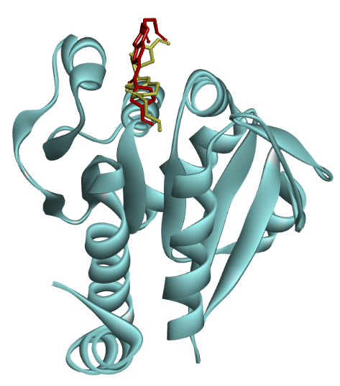
Figure 1: Redocking experiment of co-crystal x-ray structure shows redocked structure (yellow) recapitulate the original binding pose of the co-crystal ligand (Red).
Subsequent docking of the 180-compound library revealed several promising candidates, with the top three performers, CID140877623, CID108749815, and CID118980429, exhibiting binding affinities of -8.26 kcal/mol, -7.802 kcal/mol, and -7.564 kcal/mol, respectively (Fig. 2, Table S1). These values markedly surpass the affinity of 6SI, indicating that these compounds may possess a greater thermodynamic propensity to engage the DJ-1 active site. Examination of the 3D binding poses further underscored the consistency of our screening approach, as all top-scoring compounds docked within the same solvent-accessible pocket as both the re-docked and experimental poses of 6SI. This region, centered around Cys106, Glu18, and His126, is well-documented as the primary binding site in the 7PA3 structure, reinforcing the effectiveness of our pharmacophore constraints, which were designed to prioritize hydrogen bond donors/acceptors, hydrophobic interactions, and aromatic features derived from 6SI.
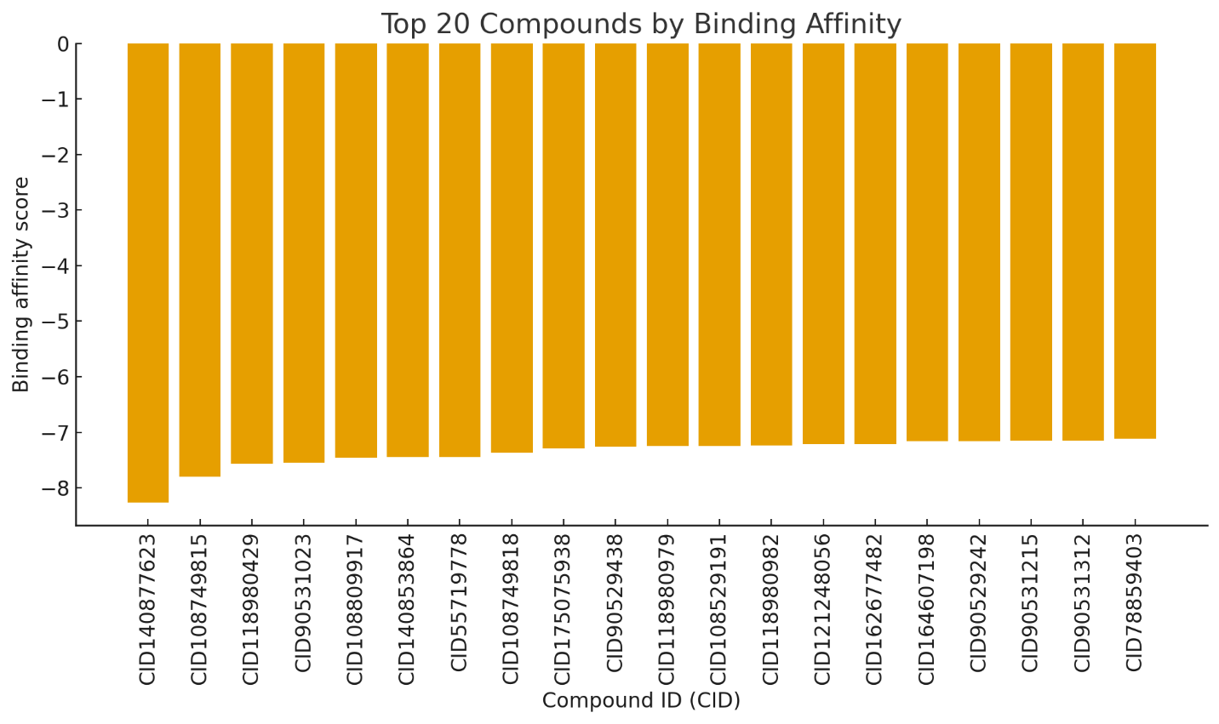
Figure 2: Top 20 best binding affinity compounds from the virtual screening experiment.

To elucidate the molecular basis of these favorable binding affinities, we analyzed the 2D and 3D interaction diagram for CID140877623 (Fig. 3), the highest-scoring compound. This analysis revealed a robust network of noncovalent interactions stabilizing the ligand within the DJ-1 pocket. Specifically, CID140877623 forms a conventional hydrogen bond with Cys106, a residue pivotal to DJ-1’s redox-sensing and deglycase functions (Bonifati et al., 2003). This interaction likely serves as an anchor, securing the ligand within the shallow binding site. Additionally, a carbon-hydrogen bond with Leu128 enhances the compound’s stability by providing further contact points within the hydrophobic milieu of the pocket. The ligand also engages in pi-alkyl interactions with Ala107 and His126, as well as an alkyl interaction with Lys132, which collectively bolster its binding through hydrophobic and van der Waals forces. The involvement of His126, a residue known to modulate the electrostatic properties of the pocket alongside Cys106, is particularly noteworthy and aligns with findings by Jia and colleagues, who emphasized its role in stabilizing ligand interactions within DJ-1 (Jia et al., 2022).
In a comparative context, the interaction profiles of CID108749815 and CID118980429 (Fig. 3), while similarly promising, exhibit subtle distinctions that may underlie their slightly lower affinities. CID108749815 also forms a hydrogen bond with Cys106, mirroring CID140877623, but substitutes the carbon-hydrogen bond with Leu128 for a pi-pi T-shaped interaction with His126. This aromatic stacking could offer an alternative stabilization mechanism, potentially compensating for the loss of hydrophobic contacts. Meanwhile, CID118980429 establishes hydrogen bonds with both Cys106 and Arg48, broadening its engagement with polar residues, and forms alkyl interactions with Ala129 and Lys132, though it lacks the pi-alkyl interaction with Ala107 seen in CID140877623. These variations suggest that while all three compounds effectively target the Cys106-centric pocket, CID140877623 benefits from a more extensive and diverse interaction network, which may account for its superior binding affinity. The consistent interaction with Cys106 across these compounds echoes observations by Chen and his team, whose bis-isatin derivatives similarly leveraged this residue to achieve potent inhibition of DJ-1’s deglycase activity (Chen et al., 2021).
2D structure of CID140877623-7PA3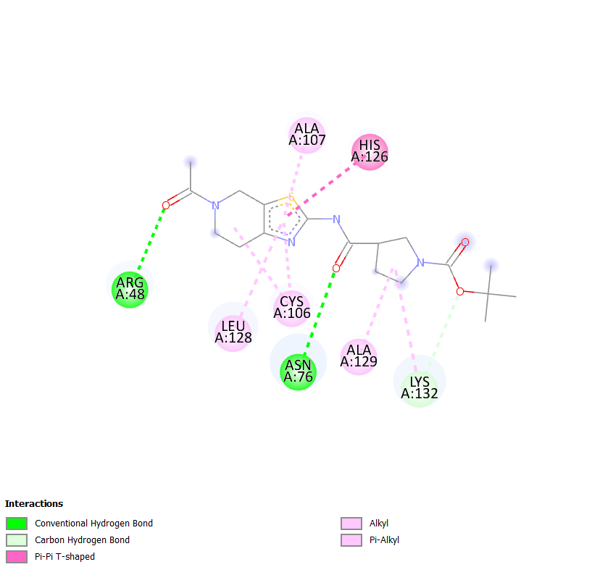 | 3D structure of CID140877623-7PA3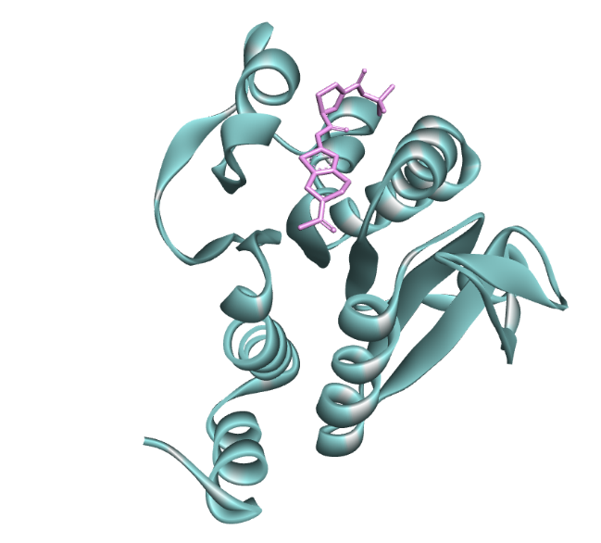
2D structure of CID108749815-7PA3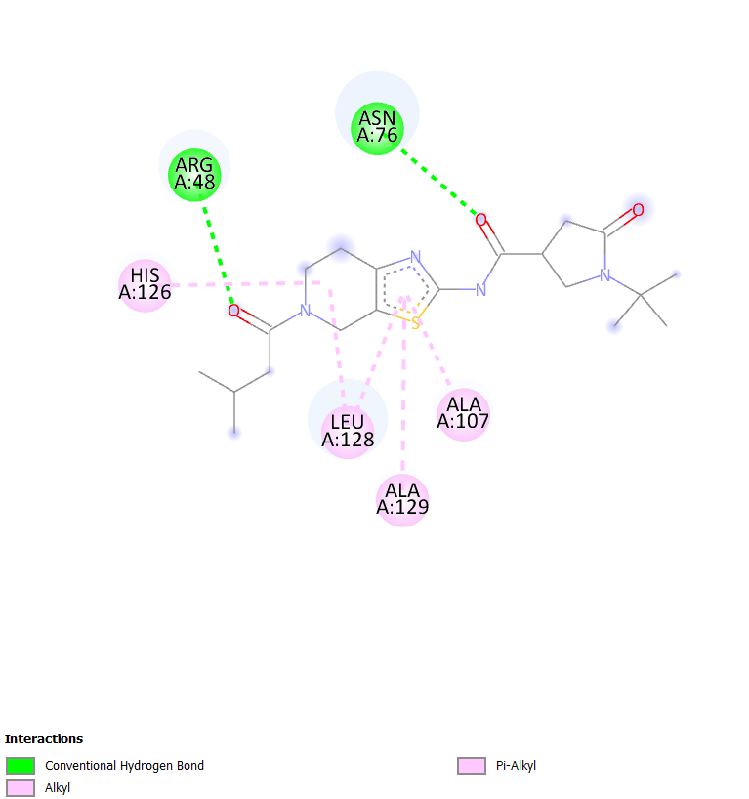 | 3D structure of CID108749815-7PA3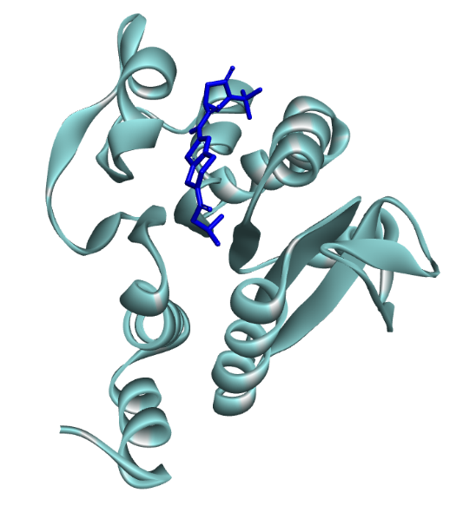
2D structure of CID118980429-7PA3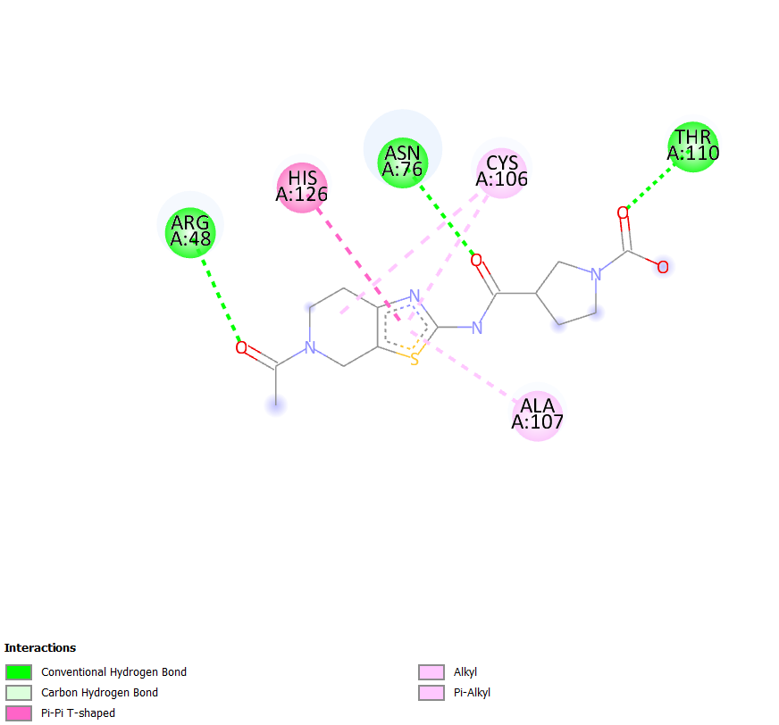 | 3D structure of CID118980429-7PA3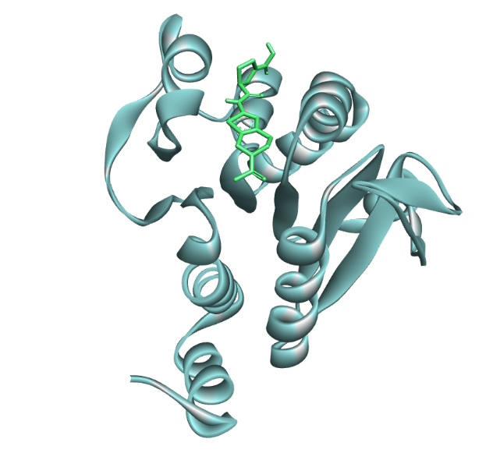
2D interaction of the co-crystal ligand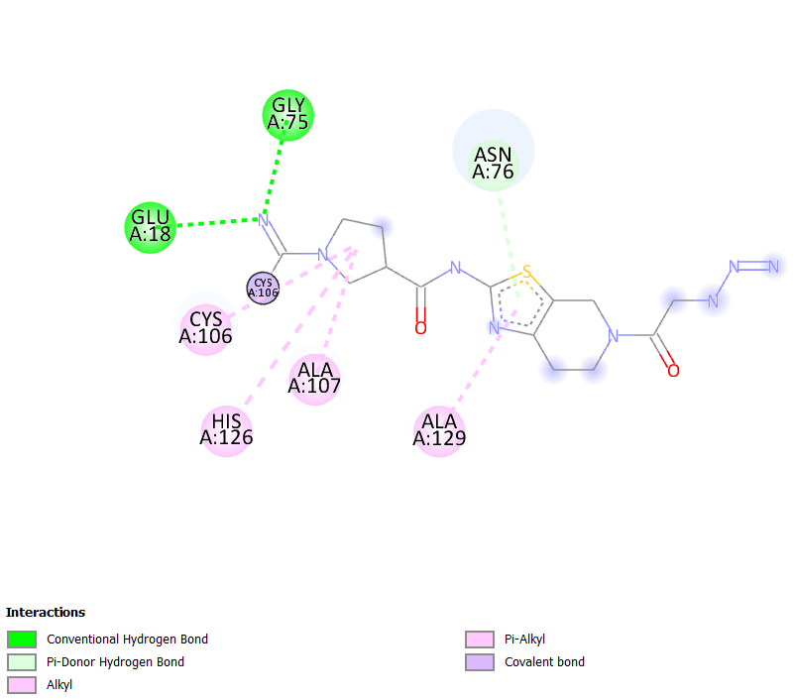
Figure 3: 2D and 3D interaction of the top scoring compounds.
Further inspection of the interaction diagrams highlighted additional residues contributing to ligand stabilization. For instance, hydrophobic contacts with Asn76 and Ala129 in CID118980429 align with known hydrophobic hot spots in the DJ-1 pocket, a feature previously implicated in computational studies of ligand binding (Aldakhil & Altharawi, 2025). However, the absence of direct hydrogen bonding with Glu18 across all three top compounds stands out as a potential area for optimization. Glu18 is recognized as a critical residue for high-affinity binding in other DJ-1 modulators (Jia et al., 2022), and its underrepresentation in our current hits suggests that refining the pharmacophore model to emphasize this interaction could yield even more potent candidates. Nevertheless, the binding affinities of our top compounds compare favorably to prior efforts. For example, Aldakhil and Altharawi reported docking scores of approximately -7.5 kcal/mol for repurposed drugs like niraparib against DJ-1, whereas CID140877623’s -8.26 kcal/mol suggests a competitive edge in binding potential (Aldakhil and Altharawi, 2025).
These docking results provide a compelling static snapshot of ligand-protein interactions, positioning CID140877623, CID108749815, and CID118980429 as promising candidates for further exploration. However, molecular docking inherently treats the DJ-1 pocket as a rigid entity, potentially overlooking the dynamic conformational changes that influence binding under physiological conditions. To address this limitation and build on the foundation established by our docking campaign, we plan to advance these top compounds to molecular dynamics simulations. These simulations will enable us to probe the flexibility of the DJ-1 active site and assess the stability of the ligand poses over time, offering a more realistic depiction of their binding behavior. Additionally, MM/PBSA free energy calculations will provide a quantitative measure of thermodynamic favorability, refining our understanding of these compounds’ potential as DJ-1 modulators. By integrating these dynamic and energetic analyses, we aim to prioritize candidates for experimental validation, bridging the gap between computational predictions and biochemical reality.
3.2 Molecular Dynamics Simulation
The MD simulations of the DJ-1 protein in complex with four ligands, 6SI, CID108, CID118, and CID1408, offer a comprehensive view of their dynamic behavior, evaluated through key metrics: Root Mean Square Deviation (RMSD), Root Mean Square Fluctuation (RMSF), Radius of Gyration (RoG), and hydrogen bonds (H-bonds). These metrics shed light on the stability, flexibility, compactness, and interaction strength of each complex, providing critical insights into their potential as modulators of DJ-1, a protein implicated in Parkinson’s disease (Bonifati et al., 2003; Ashiru et al., 2023; Akinboade et al., 2023; Omotara et al., 2025; Manica et al., 2025). RMSD, which quantifies structural deviation from the initial conformation over the simulation trajectory, serves as a primary measure of complex stability. Among the ligands, CID1408 exhibited the lowest mean RMSD of 0.492 ± 0.142 nm (Table 1), with its trajectory maintaining minimal fluctuations between 0.3 and 0.8 nm, as observed in the RMSD graph (Fig. 4). This stability likely stems from strong interactions within the binding pocket, evidenced by its interaction diagram showing hydrogen bonds with ARG A:48 and CYS A:106, alongside Pi-Pi T-shaped interactions with HIS A:126 and hydrophobic contacts (Berendsen et al., 1995). These interactions appear to lock CID1408 into a stable conformation, limiting structural drift. The reference compound 6SI, by comparison, recorded an RMSD of 0.574 ± 0.148 nm, with its graph showing fluctuations around 0.5–0.7 nm and occasional peaks reaching 1.4 nm, suggesting moderate stability punctuated by conformational shifts. CID118 and CID108 displayed higher RMSD values of 0.697 ± 0.135 nm and 0.775 ± 0.178 nm, respectively (Fig. 4, Table 1). The RMSD graph for CID118 reveals a broader fluctuation range (0.4–1.2 nm), while CID108’s trajectory is marked by frequent spikes up to 1.5 nm, indicating pronounced instability. This instability in CID108 aligns with its interaction profile, which shows only two hydrogen bonds with ASN A:76 and HIS A:126, supplemented by weaker Pi-alkyl interactions (Van der Spoel et al., 2005).
Table 1: Binding stability data of the lead-like compounds, including the co-crystal compounds, after MD simulation.
Compound | RMSD (nm, mean ± SD) | RMSF (nm, mean ± SD) | RoG (nm, mean ± SD) | H-Bonds (mean ± SD)
6SI | 0.574 ± 0.148 | 0.184 ± 0.223 | 1.620 ± 0.0256 | 0.744 ± 1.025
CID108749815 | 0.775 ± 0.178 | 0.224 ± 0.184 | 1.597 ± 0.0280 | 0.125 ± 0.346
CID118980429 | 0.697 ± 0.135 | 0.168 ± 0.176 | 1.590 ± 0.0267 | 1.586 ± 1.734
CID140877623 | 0.492 ± 0.142 | 0.170 ± 0.192 | 1.595 ± 0.0297 | 0.245 ± 0.497

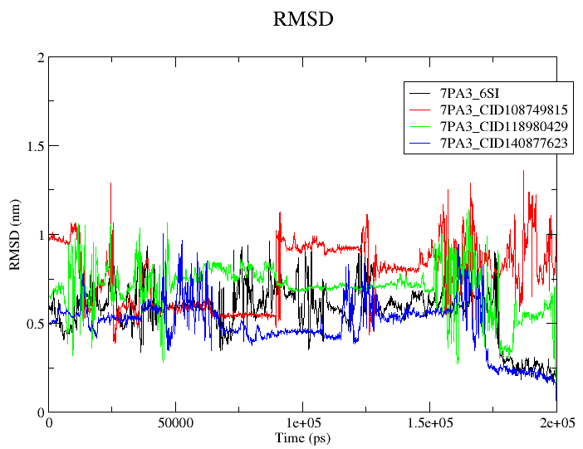
Figure 4: RMSD spectrum of the top 3 compounds including the reference co-crystal compound.

Shifting focus to RMSF, which captures residue-level flexibility across the protein, CID118 demonstrated the lowest mean value of 0.168 ± 0.176 nm (Fig. 5, Table 1). Its RMSF graph (Fig. 5) exhibits restrained peaks, particularly at the termini, reflecting a rigid structure likely stabilized by an extensive hydrogen bonding network with residues such as ARG A:48, ASN A:76, and THR A:110 (Abraham et al., 2015). CID1408 followed closely with an RMSF of 0.170 ± 0.192 nm, its graph similarly showing subdued fluctuations, consistent with its stable RMSD and key interactions with CYS A:106 and ARG A:48. In contrast, 6SI and CID108 displayed greater flexibility, with RMSF values of 0.184 ± 0.223 nm and 0.224 ± 0.184 nm, respectively. The RMSF graph for 6SI reveals moderate peaks, while CID108 shows the most significant residue movements, especially at the termini, corroborating its poor stability and limited interaction strength. The high standard deviation in 6SI’s RMSF points to variability in its ability to constrain protein motion, possibly due to intermittent stabilization within the binding site.
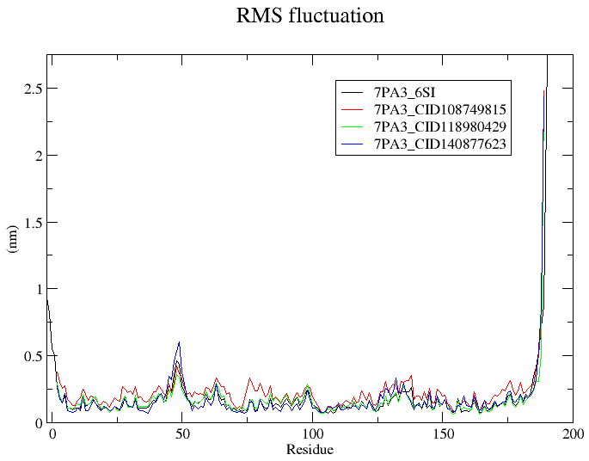
Figure 5: RMSF spectrum of the top 3 compounds including the reference co-crystal compound.

The Radius of Gyration (RoG) analysis, which evaluates the compactness of each complex, further differentiates the ligands. CID118 recorded the lowest mean RoG of 1.590 ± 0.0267 nm (Table 1), its graph maintaining a steady value around 1.59 nm (Fig. 6), suggesting a tightly packed structure. This compactness likely arises from its robust hydrogen bonding network, which pulls the protein into a condensed conformation (Lobanov et al., 2008). CID1408 and CID108 showed comparable RoG values of 1.595 ± 0.0297 nm and 1.597 ± 0.0280 nm, respectively, with their graphs stabilizing near 1.60 nm. For CID1408, this compactness reinforces its stability, whereas for CID108, it contrasts sharply with its high RMSD and RMSF, implying that while the overall size remains compact, internal dynamics are disrupted by weak interactions. 6SI, with a mean RoG of 1.620 ± 0.0256 nm, exhibited a slightly more extended structure, its graph averaging 1.62 nm, potentially reflecting less efficient packing or ligand-induced conformational expansion.
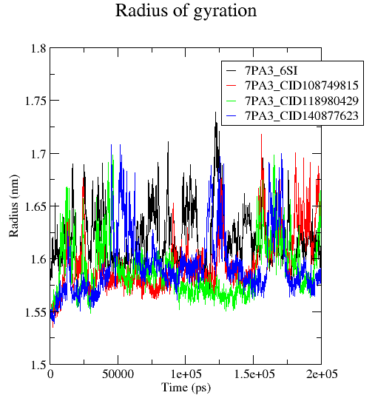
Figure 6: Rog of the top 3 compounds including the reference co-crystal compound.

Hydrogen bond analysis illuminates the strength and specificity of the ligand-protein interactions driving these dynamics. CID118 topped the group with a mean H-bond count of 1.586 ± 1.734 (Table 1, Fig. 7), its H-bond graph displaying frequent peaks reaching 8–9 bonds, fueled by interactions with ARG A:48, ASN A:76, and THR A:110. The high standard deviation, however, suggests these bonds are transient, which may contribute to its elevated RMSD (Chen et al., 2016). 6SI averaged 0.744 ± 1.025 H-bonds, with its graph fluctuating between 0 and 4, occasionally spiking to 6–7, indicating a moderate interaction network. CID1408, despite a lower H-bond count of 0.245 ± 0.497, maintained remarkable stability, its graph rarely exceeding 3 bonds. Its critical interactions with ARG A:48 and CYS A:106, reinforced by hydrophobic contacts, appear highly efficient. CID108, with only 0.125 ± 0.346 H-bonds, showed the weakest profile, its graph remaining largely flat with rare spikes to 2, reflecting minimal interaction strength with ASN A:76 and HIS A:126.
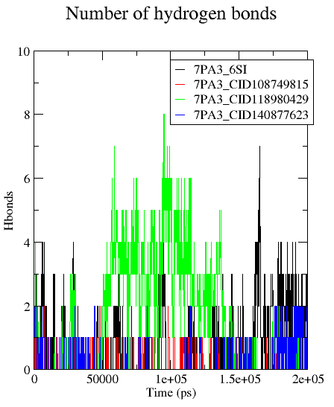
Figure 7: Hbond graph of the top 3 compounds including the reference co-crystal compound.

Comparing these metrics across the ligands, CID1408 and CID118 emerge as standout performers. CID1408’s low RMSD (0.492 nm), restrained RMSF (0.170 nm), and compact RoG (1.595 nm), despite a modest H-bond count (0.245), highlight its ability to form a highly stable complex, driven by optimized interactions with residues like CYS A:106 and ARG A:48. CID118 excels in H-bonding (1.586) and compactness (RoG: 1.590 nm), yet its higher RMSD (0.697 nm) suggests that its dynamic interaction network introduces some instability. 6SI performs adequately across all metrics, while CID108 consistently underperforms, with high RMSD (0.775 nm), elevated RMSF (0.224 nm), and scant H-bonds (0.125). These findings position CID1408 and CID118 as promising candidates for further study, with CID1408’s superior stability marking it as a particularly strong contender for development as a DJ-1 modulator.
3.3 MM/PBSA Calculation
The Molecular Mechanics Poisson–Boltzmann Surface Area (MM/PBSA) method offers a robust framework for evaluating the binding affinity of ligands to the DJ-1 protein, a target implicated in Parkinson’s disease (Bonifati et al., 2003). Here, we analyze the binding free energies of four DJ-1-ligand complexes, 7PA3-6SI (reference ligand), 7PA3-CID140877623, 7PA3-CID108749815, and 7PA3-CID118980429, based on the provided MM/PBSA results (Table 2). These results decompose the binding free energy into key components: van der Waals energy (ΔVDWAALS), electrostatic energy (ΔEEL), gas-phase energy (ΔGGAS), solvation energy (ΔGSOLV), and total binding free energy (ΔTOTAL), all reported in kcal/mol. A more negative ΔTOTAL signifies stronger binding affinity, guiding our assessment of these ligands as potential DJ-1 modulators (Genheden & Ryde, 2015). Below, we discuss the results for each system, compare their binding profiles, and contextualize their implications.
Table 2: MM/PBSA of the top 3 compounds including the reference co-crystal compound.
System | ΔVDWAALS | ΔEEL | ΔGGAS | ΔGSOLV | ΔTOTAL
7PA3-6SI | -20.92 | 1.88 | -19.05 | 5.35 | -13.69
7PA3-CID140877623 | -24.86 | -20.08 | -44.95 | 26.03 | -18.91
7PA3-CID108749815 | -4.84 | -2.31 | -7.15 | 4.74 | -2.4
7PA3-CID118980429 | -13.11 | -0.16 | -13.27 | 5.62 | -7.66

For the reference ligand, 7PA3-6SI, the MM/PBSA analysis yields a ΔTOTAL of -13.69 kcal/mol. This value arises from a favorable ΔVDWAALS of -20.92 kcal/mol, indicating strong van der Waals interactions, contrasted by an unfavorable ΔEEL of 1.88 kcal/mol, suggesting weak or repulsive electrostatic contributions. The gas-phase energy, ΔGGAS (ΔVDWAALS + ΔEEL), is -19.05 kcal/mol, reflecting the net non-polar and polar interactions in the absence of solvent. The solvation energy, ΔGSOLV, is 5.35 kcal/mol, a positive value that indicates an energetic penalty as water molecules are displaced from the binding interface. This ΔTOTAL of -13.69 kcal/mol serves as the benchmark for evaluating the screened ligands.
The ligand 7PA3-CID140877623 demonstrates a markedly superior binding affinity, with a ΔTOTAL of -18.91 kcal/mol. This is driven by a highly favorable ΔVDWAALS of -24.86 kcal/mol and a substantial ΔEEL of -20.08 kcal/mol, both significantly stronger than those of 6SI. The resulting ΔGGAS is -44.95 kcal/mol, highlighting exceptional gas-phase interactions. However, the solvation energy is notably higher at 26.03 kcal/mol, reflecting a greater cost of desolvation. Despite this penalty, the robust gas-phase contributions yield a net ΔTOTAL that surpasses 6SI by over 5 kcal/mol, underscoring CID140877623’s potential as a high-affinity binder (Sun et al., 2014). This balance between strong intermolecular forces and solvation effects is a hallmark of effective ligand design (Genheden & Ryde, 2015).
In stark contrast, 7PA3-CID108749815 exhibits a poor binding profile, with a ΔTOTAL of -2.4 kcal/mol. The ΔVDWAALS is a modest -4.84 kcal/mol, and the ΔEEL is -2.31 kcal/mol, both indicating weak interactions with DJ-1. Consequently, the ΔGGAS is only -7.15 kcal/mol, insufficient to offset the solvation energy of 4.74 kcal/mol. This minimal binding free energy, over 11 kcal/mol less favorable than 6SI, suggests that CID108749815 has limited affinity for DJ-1, likely due to insufficient contacts at the binding site (Kumari et al., 2014). This weak performance positions it as the least promising candidate in this set.
The ligand 7PA3-CID118980429 presents an intermediate case, with a ΔTOTAL of -7.66 kcal/mol. Its ΔVDWAALS is -13.11 kcal/mol, reflecting moderate van der Waals interactions, while the ΔEEL is nearly neutral at -0.16 kcal/mol, indicating minimal electrostatic stabilization. The ΔGGAS is -13.27 kcal/mol, and the solvation energy is 5.62 kcal/mol, comparable to that of 6SI. Although this binding free energy is less favorable than that of 6SI by approximately 6 kcal/mol, it outperforms CID108749815, suggesting a moderate but suboptimal affinity for DJ-1.
Comparing these results, CID140877623 emerges as the standout ligand, with a ΔTOTAL of -18.91 kcal/mol, followed by 6SI (-13.69 kcal/mol), CID118980429 (-7.66 kcal/mol), and CID108749815 (-2.4 kcal/mol). The exceptional binding affinity of CID140877623 can be attributed to its strong van der Waals and electrostatic interactions, which effectively counterbalance the unfavorable solvation energy. This aligns with previous MM/PBSA studies where gas-phase interactions often dictate binding strength when solvation penalties are significant (Sun et al., 2014). Conversely, the poor performance of CID108749815 likely stems from limited interactions, while CID118980429’s moderate affinity suggests a partial optimization of binding contacts. The positive ΔGSOLV across all systems underscores the universal challenge of desolvation in protein-ligand binding, yet CID140877623’s gas-phase energy compensates most effectively (Genheden & Ryde, 2015).
These findings have clear implications for DJ-1 modulation. CID140877623, with its superior ΔTOTAL, warrants prioritization for further experimental validation, such as binding assays or crystallographic studies, to confirm its efficacy as a DJ-1 modulator. Its strong binding affinity positions it as a promising candidate for therapeutic development in Parkinson’s disease contexts (Bonifati et al., 2003). While 6SI remains a viable reference, CID118980429 may merit optimization efforts, whereas CID108749815 appears unsuitable for advancement based on its weak binding profile. Collectively, these MM/PBSA results provide a quantitative foundation for rational drug design targeting DJ-1, highlighting CID140877623 as the lead compound.
4. Conclusion
The analysis of the MM/PBSA results, alongside the MD simulations, offers a detailed understanding of the binding affinities and dynamic behaviors of the ligands 6SI, CID140877623, CID108749815, and CID118980429 when bound to the DJ-1 protein, a key target in Parkinson’s disease research. The MM/PBSA data highlights CID140877623 as the standout performer, with a total binding free energy of -18.91 kcal/mol, outpacing the reference ligand 6SI’s -13.69 kcal/mol, thanks to strong van der Waals (-24.86 kcal/mol) and electrostatic (-20.08 kcal/mol) contributions that overcome a notable solvation penalty (26.03 kcal/mol). This impressive binding strength aligns with its stable MD behavior, marked by a low RMSD of 0.492 nm and a restrained RMSF of 0.170 nm, positioning it as a promising lead for further exploration. CID118980429, with a ΔTOTAL of -7.66 kcal/mol and a high hydrogen bond count of 1.586, shows moderate binding potential, supported by a compact RoG of 1.590 nm, though its higher RMSD of 0.697 nm suggests some instability that could benefit from structural adjustments. Conversely, CID108749815’s weak ΔTOTAL of -2.4 kcal/mol, combined with an unsteady MD profile (RMSD 0.775 nm, RMSF 0.224 nm), points to limited affinity and poor suitability, likely due to insufficient contacts within the binding site. The reference ligand 6SI, while maintaining a balanced MD performance (RMSD 0.574 nm, RoG 1.620 nm), provides a baseline that underscores the enhanced capabilities of CID140877623. Taken together, these findings suggest that CID140877623 offers a solid starting point for therapeutic development, potentially guiding future efforts toward refining its interactions or exploring related compounds to improve selectivity and effectiveness in addressing DJ-1’s role in neurodegenerative processes

Disclaimer (Artificial intelligence)
Option 1:
Author(s) hereby declare that NO generative AI technologies such as Large Language Models (ChatGPT, COPILOT, etc.) and text-to-image generators have been used during the writing or editing of this manuscript.
Option 2:
Author(s) hereby declare that generative AI technologies such as Large Language Models, etc. have been used during the writing or editing of manuscripts. This explanation will include the name, version, model, and source of the generative AI technology and as well as all input prompts provided to the generative AI technology
Details of the AI usage are given below:
1.
2.
3.

References
- Abraham MJ, Murtola T, Schulz R, Páll S, Smith JC, Hess B, et al. GROMACS: High performance molecular simulations through multi-level parallelism from laptops to supercomputers. SoftwareX. 2015;1–2:19–25. doi:10.1016/j.softx.2015.06.001.
- Aldakhil T, Altharawi A. Drug repurposing for the discovery of potential inhibitors targeting DJ-1 (PARK7) against Parkinson’s disease. Crystals. 2025;15(3):239.doi:10.3390/cryst15030239.
- Ashiru MA, Ogunyemi SO, Temionu OR, Ajibare AC, Cicero-Mfon NC, Ihekuna OA, et al. Identification of EGFR inhibitors as potential agents for cancer therapy: pharmacophore-based modeling, molecular docking, and molecular dynamics investigations. J Mol Model. 2023;29(5):128. doi:10.1007/s00894-023-05531-6.
- Berendsen HJC, van der Spoel D, van Drunen R. GROMACS: A message-passing parallel molecular dynamics implementation. Comput Phys Commun. 1995;91(1–3):43–56.
- Bonifati V, Rizzu P, van Baren MJ, Schaap O, Breedveld GJ, Krieger E, et al. Mutations in the DJ-1 gene associated with autosomal recessive early-onset parkinsonism. Science.2003;299(5604):256–9.
- Cao J, Chen X, Jiang L, Lu B, Wang Y, Fan J, et al. DJ-1 suppresses ferroptosis through preserving the activity of S-adenosyl homocysteine hydrolase. Nat Commun. 2020;11(1):1251. doi:10.1038/s41467-020-15109-y.
- Chen J, Sawyer N, Regan L. Protein–protein interactions: general trends in the relationship between binding affinity and interfacial buried surface area. Protein Sci. 2013;22(4):510–5. doi:10.1002/pro.2230.
- Chen XB, Zhu LY, Ma LJ, Sun MX, Li XY, Zhang Y. Bis-isatin derivatives: design, synthesis and biological activity evaluation as potent dimeric DJ-1 inhibitors. Acta Pharmacol Sin. 2021;42(7):1160–70. doi:10.1038/s41401-020-00572-2.
- Genheden S, Ryde U. The MM/PBSA and MM/GBSA methods to estimate ligand-binding affinities. Expert Opin Drug Discov. 2015;10(5):449–61.doi:10.1517/17460441.2015.1032936.
- Jia Y, Kim RQ, Kooij R, Ovaa H, Sapmaz A, Geurink PP. Chemical toolkit for PARK7: potent, selective and high-throughput. J Med Chem. 2022;65(19):13288–304.doi:10.1021/acs.jmedchem.2c01113.
- Kumari R, Kumar R, Lynn A. g_mmpbsa—A GROMACS tool for high-throughput MM-PBSA calculations. J Chem Inf Model. 2014;54(7):1951–62. doi:10.1021/ci500020m.
- Lobanov MY, Bogatyreva NS, Galzitskaya OV. Radius of gyration as an indicator of protein structure compactness. Mol Biol (Mosk). 2008;42(4):623–8.doi:10.1134/S0026893308040195.
- Manica AK, Quainoo B, Cudjoe J, Adekunle AM, Agadagba C, Adeniran TR, et al. Unveiling novel KRAS G12V inhibitors: a comprehensive study using computer-aided drug design approach. Int J Biochem Res Rev. 2025;34(2):216–29.doi:10.9734/ijbcrr/2025/v34i2978.
- Miyazaki S, Yanagida T, Nunome K, Ishikawa S, Inden M, Kitamura Y, et al. DJ-1-binding compounds prevent oxidative stress-induced cell death and movement defect in Parkinson’s disease model rats. J Neurochem. 2008;105(6):2418–34. doi:10.1111/j.1471-4159.2008.05327.x.
- Omotara BS, Solanki PR, Manica AK, Ajala CF, Junaid IO, Anifowose LO, et al. Unveiling KRAS G12D inhibition: from molecular dynamics to therapeutic strategies. J Biomol Struct Dyn. 2025 Sep 23;1–24. doi:10.1080/07391102.2025.2563084.
- Sun H, Li Y, Tian S, Xu L, Hou T. Assessing the performance of MM/PBSA and MM/GBSA methods. 4. Accuracies of MM/PBSA and MM/GBSA methodologies evaluated by various simulation protocols using PDBbind data set. Phys Chem Chem Phys. 2014;16(31):16719–29. doi:10.1039/c4cp01388c.
- Tashiro S, Caaveiro JMM, Nakakido M, Tanabe A, Nagatoishi S, Tamura Y, et al. Discovery and optimization of inhibitors of the Parkinson’s disease associated protein DJ-1. ACS Chem Biol. 2018;13(9):2783–93. doi:10.1021/acschembio.8b00701.
- Trott O, Olson AJ. AutoDock Vina: improving the speed and accuracy of docking with a new scoring function, efficient optimization and multithreading. J Comput Chem. 2010;31(2):455–61. doi:10.1002/jcc.21334.
- van der Spoel D, Lindahl E, Hess B, Groenhof G, Mark AE, Berendsen HJC. GROMACS: fast, flexible and free. J Comput Chem. 2005;26(16):1701–18. doi:10.1002/jcc.20291.

Table S1. Binding Affinity Results
CID | Binding Affinity
CID140877623 | -8.26
CID108749815 | -7.802
CID118980429 | -7.564
CID90531023 | -7.547
CID108809917 | -7.459
CID140853864 | -7.452
CID55719778 | -7.444
CID108749818 | -7.374
CID175075938 | -7.294
CID90529438 | -7.263
CID118980979 | -7.251
CID108529191 | -7.246
CID118980982 | -7.24
CID121248056 | -7.218
CID162677482 | -7.216
CID164607198 | -7.164
CID90529242 | -7.16
CID90531215 | -7.152
CID90531312 | -7.147
CID78859403 | -7.119
CID130377057 | -7.079
CID90529479 | -7.077
CID90525447 | -7.076
CID118980986 | -7.074
CID118980981 | -7.066
CID164607197 | -7.049
CID127112484 | -7.026
CID118981067 | -7.018
CID90525648 | -7.003
CID164664338 | -7.001
CID90525738 | -6.999
CID108471953 | -6.981
CID90531257 | -6.979
CID108496879 | -6.974
CID162677485 | -6.974
CID118980876 | -6.954
CID164664339 | -6.949
CID168322665 | -6.927
CID121247969 | -6.925
CID175079171 | -6.925
CID90529940 | -6.912
CID130364628 | -6.906
CID90529734 | -6.886
CID108529190 | -6.87
CID86931574 | -6.868
CID118979991 | -6.84
CID90531346 | -6.812
CID155316692 | -6.805
CID121247749 | -6.802
CID90525218 | -6.8
CID90529983 | -6.798
CID108876225 | -6.796
CID90531411 | -6.785
CID118980327 | -6.77
CID108506003 | -6.767
CID46525594 | -6.759
CID118980329 | -6.755
CID90529293 | -6.696
CID90525686 | -6.692
CID90531412 | -6.679
CID118980208 | -6.677
CID108749745 | -6.663
CID90531336 | -6.662
CID78798748 | -6.659
CID70715687 | -6.614
CID90525758 | -6.608
CID90525176 | -6.598
CID90524974 | -6.589
CID108876950 | -6.588
CID90525267 | -6.587
CID90525839 | -6.568
CID90525768 | -6.562
CID108469803 | -6.556
CID97114048 | -6.553
CID90525840 | -6.549
CID168658537 | -6.539
CID118980836 | -6.521
CID86918187 | -6.511
CID118980209 | -6.507
CID118980133 | -6.489
CID118980135 | -6.488
CID108725560 | -6.477
CID108475322 | -6.443
CID43593200 | -6.426
CID90531334 | -6.424
CID108725616 | -6.406
CID108529205 | -6.405
CID90531345 | -6.388
CID83191888 | -6.384
CID90531267 | -6.384
CID108521096 | -6.382
CID90531332 | -6.381
CID118980442 | -6.353
CID120169840 | -6.343
CID90531338 | -6.343
CID90525756 | -6.328
CID90525760 | -6.325
CID108504887 | -6.285
CID130364601 | -6.283
CID168285186 | -6.261
CID108725580 | -6.254
CID108104019 | -6.252
CID108529171 | -6.249
CID37672692 | -6.244
CID169545093 | -6.241
CID90531333 | -6.241
CID110462167 | -6.232
CID90525757 | -6.216
CID90529295 | -6.204
CID103501030 | -6.193
CID90525286 | -6.19
CID118980840 | -6.187
CID78903412 | -6.167
CID110461404 | -6.157
CID168668964 | -6.152
CID54938460 | -6.145
CID119828575 | -6.144
CID90529786 | -6.136
CID97114049 | -6.133
CID118980460 | -6.117
CID120257723 | -6.115
CID86978191 | -6.11
CID108524787 | -6.093
CID108521711 | -6.091
CID81683167 | -6.083
CID118980462 | -6.072
CID61700432 | -6.062
CID118980324 | -6.053
CID43593273 | -6.043
CID90525754 | -6.04
CID107842152 | -6.038
CID108505160 | -6.038
CID108104018 | -6.026
CID90525767 | -6.026
CID146233140 | -6.023
CID29413016 | -6.023
CID108529143 | -6.022
CID118980983 | -6.014
CID90525026 | -6.009
CID108522204 | -6.007
CID108749753 | -5.996
CID90529788 | -5.992
CID108498388 | -5.989
CID168699062 | -5.985
CID90525755 | -5.968
CID57659717 | -5.961
CID119828505 | -5.953
CID50957485 | -5.948
CID90525295 | -5.948
6SI | -5.944
CID90525024 | -5.943
CID120502441 | -5.938
CID118980980 | -5.931
CID108725568 | -5.924
CID168506290 | -5.919
CID168686610 | -5.917
CID168495179 | -5.874
CID118980873 | -5.871
CID168661370 | -5.844
CID108521453 | -5.838
CID120381146 | -5.827
CID63272585 | -5.827
CID43593192 | -5.826
CID118980837 | -5.822
CID61350554 | -5.807
CID119828577 | -5.797
CID120257731 | -5.797
CID90525696 | -5.788
CID118979994 | -5.758
CID168672293 | -5.731
CID168701267 | -5.712
CID168698521 | -5.704
CID110481430 | -5.688
CID120257735 | -5.682
CID119828539 | -5.661
CID168502971 | -5.563

