Brentuximab Vedotin and Bendamustine protocol in Hodgkin Lymphoma: Report of two cases in Abidjan, Côte d'Ivoire

ABSTRACT
Background : Hodgkin lymphoma is the first hematology malignancy to be cured. The Management of mediastinal or pulmonary location, whether inaugural or secondary, is restricted with conventional chemotherapy which contains cardio- or pneumotoxic molecules. The new Advanced therapeutic strategies including targeted therapy Can improve prognosis. Those molecules remain expensive for many patients without social security protection [1]. We reported the contribution of the Brentuximab Vedotin associated with Bendamustine (Bv-B) protocol for two patients with refractory Hodgkin lymphoma pulmonary location.
Observation: The first patient is 40years lady who presented lymphadenopathy associated with symptoms such fever and loss of weight the evolution was marked by the pulmonary symptoms cought chest pains the CT scan (TAP): revealed a bilateral mediastino-hilar ganglio-tumoral complex,, presence of multiple thoraco-abdomino-pelvic lymphadenopathies; pleuro-pulmonary involvement the patient received two lines of treatment AVD adriblastin velbe Dacarbazine. EACOPP (Etoposide, Doxorubicin, Endoxan (Cyclophosphamide), Oncovin (Vincristine), Procarbazine, Prednisone) without any response the 3rd line treatment was initiated with good remission.
The second case was 22 years young adult patients with progressive weight loss associated with evening fever, The appearance a few months later (March 2022) of laterocervical lymphadenopathies of large size (5 cm in greatest diameter on the right and 3 cm on the left) a biopsy was performed with anatomopathological examination revealing the presence of large malignant cells (Reed-Sternberg) . classified as Ann Arbor Stage IVBb with unfavorable prognosis according to Hasenclever. The therapeutic protocol adopted was 4 AVD (Doxorubicin, Vincristine and Dacarbazine) without Bleomycin followed by escalation with 2 EACOPP (Etoposide, Doxorubicin, Cyclophosphamide, Vincristine, Procarbazine).unfornately no good response observed the second line of the treatment was made with DHAP also without good response .the 3rd line a Bv-Benda-Pembro protocol (Brentuximab + Bendamustine + Pembrolizumab) was decided due to appearance of the lymphoadenopathy and administrated the patient died after
Conclusion: The Bv-B combination demonstrates its efficacy with good tolerance in patients with relapsed hodgkin lymphoma.
Keywords: Refractory Hodgkin lymphoma, Brentuximab vedotin, Bendamustine, conventional chemotherapy

Introduction
“Hodgkin lymphoma is a rare malignant B-cell tumor, affecting approximately 9,000 new patients each year, with an incidence of about 3 new cases per 100,000 people per year” [2-3, 21-22]. It has a particular age distribution, with prevalence not only in the elderly but also in young adults. This makes it one of the most common cancers in this age group and encompasses two distinct entities: classic Hodgkin lymphoma and nodular lymphocyte-predominant Hodgkin lymphoma [2-3]. “The classic Hodgkin lymphoma subcategory includes defined subgroups: nodular sclerosis, mixed cellularity, lymphocyte depletion and lymphocyte-rich Hodgkin lymphoma” [2]. “Staging of this disease is essential for selecting the optimal treatment” [4]. Prognostic models have been developed to identify patients who are at either high or low risk of relapse. These models, combined with positron emission tomography, allow treatment optimization [4]. “Initial treatment of patients with Hodgkin lymphoma is based on the histological characteristics of the disease, initial stage and the presence or absence of prognostic factors associated with unfavorable evolution” [4]. Patients with early-stage Hodgkin lymphoma generally receive combined treatments including abbreviated chemotherapy cycles followed by involved field radiotherapy. On the contrary, patients with advanced-stage Hodgkin lymphoma generally undergo longer combined chemotherapy treatment, with radiotherapy being used only in specific cases. In relapsed or refractory patients, salvage chemotherapy followed by high-dose treatment and autologous stem cell transplantation constitutes the standard treatment [4-5]. “For patients ineligible for this treatment or in whom high-dose treatment and autologous stem cell transplantation have failed, treatment with Brentuximab vedotin is a standard approach, sometimes associated with Bendamustine” [4,6].
Brentuximab vedotin (BV) is an antibody-drug conjugate (ADC) composed of an antibody directed against CD30 linked to the cytotoxic payload monomethyl auristatin E (MMAE), which induces apoptosis in CD30-positive cells. Bendamustine has also been shown to be a safe and effective treatment for patients with HL who relapse after autologous hematopoietic stem cell transplantation (HSCT) and an interesting cytoreductive agent before allogeneic transplantation. Given the considerations mentioned above, we hypothesized that BV in combination with bendamustine could be an appropriate salvage treatment for both pediatric/young adult patients with relapsed or refractory HL.
CASE PRESENTATION
Case 1
This concerns Mrs. Y. A. B., born on 05/20/1984, who was followed at CNRAO (Centre National de Radiothérapie Alassane Ouattara) and at Cocody University Hospital for management of scleronodular-type Hodgkin lymphoma.
The clinical history dates back to March 2022 with the occurrence of cervical lymphadenopathies associated with pulmonary symptoms in the form of pleural effusion syndrome in the setting of altered general condition.
Lymph node biopsy and histological analysis concluded scleronodular Hodgkin disease with nodal and extranodal involvement with signs of mediastinal compression. The extension workup showed on CT scan (TAP): a bilateral mediastino-hilar ganglio-tumoral complex, invading the superior vena cava, presence of multiple thoraco-abdomino-pelvic lymphadenopathies; pleuro-pulmonary involvement (pleurisy, nodules and consolidation), peritoneal involvement (ascites and infiltration) and homogeneous hepatomegaly. The patient was classified as modified Ann Arbor Cotswold Stage IVBb and Hasenclever 4. In addition, the pretherapeutic workup revealed severe mixed ventilatory disorder on pulmonary function testing (PFT).
In terms of treatment, the patient received 05 cycles of the AVD protocol combining Doxorubicin, Velbe (Vinblastine) and Dacarbazine.
At reevaluation in 2023, persistent cervical, axillary and supraclavicular lymphadenopathies along with altered general condition was noted. On TAP CT, a picture of bilateral mediastino-hilar, paratracheal, celiac-mesenteric and bilateral lateroaortic lymphadenopathies was described; and pulmonary parenchymal micronodules.
Given the persistence of the tumoral mass with compression signs, 8 cycles of EACOPP chemotherapy associated with hydroelectrolytic and metabolic resuscitation were indicated in May 2023.
However, evolution under this protocol was marked in April 2024 by reappearance of mediastinal compression syndrome, altered general condition with severe malnutrition. Thoraco Abdominal Pelvis CT showed: secondary thoracic involvement combining: mediastinal lymphadenopathy extending to the hilar and cardiophrenic regions, carcinomatous-appearing lymphangitis and pleural involvement, deep abdominal lymphadenopathies; pelvic ascites; absence of hepatic and bone involvement. Chest radiography showed a mediastino-thoracic ratio of 1.35.
This was therefore a refractory Hodgkin lymphoma, after 05 AVD and 08 EACOPP, complicated by deteriorated general condition and mediastinal compression. After nutritional and hydroelectrolytic restoration, she received a Bv-Benda protocol (Brentuximab + Bendamustine), 6 cycles, with favorable evolution. The end-of-course workup concluded in favor of a complete remission.
The protocol was administered every 21 days:
- Brentuximab: 67 mg on D1
- Bendamustine: 110 mg on D1 and D2.

Case 2
Patient M. A. B. U., a 22 years old student resident in Yopougon, has been followed at Cocody University Hospital and at the Polyclinic of Deux Plateaux since May 2022 for refractory Hodgkin lymphoma.
The history reveals that the onset dates back to December 2021 with progressive weight loss associated with evening fever, pruritus and profuse sweats. All of this have motivated several consultations in local healthcare facilities where the workups performed revealed pleurisy associated with pericarditis. Thus, he was referred to the cardiology institute where undocumented management was performed with transient improvement of symptoms. The appearance a few months later (March 2022) of laterocervical lymphadenopathies of large size (5 cm in greatest diameter on the right and 3 cm on the left) motivated a consultation in our department. Initially, a biopsy was performed with anatomopathological examination revealing the presence of large malignant cells (Reed-Sternberg) binucleated, with prominent nucleoli and destruction of normal lymph node architecture and sclerosis. The immunohistochemical complement showed CD15+, CD30+, CD20+, CD5+ and CD45+, in favor of Hodgkin lymphoma. The extension workup revealed on CTAP (cervico-thoraco-abdomino-pelvic) scan multiple subcentimetric lymph nodes in the jugulo-carotid chains, mediastinal lymphadenopathy masses and heterogeneous splenomegaly type II according to Hackett. On chest radiography, a mediastino-thoracic ratio of 1 and blunting of pleural recesses with normal lung parenchyma. On pretherapeutic assessment, severe pulmonary restriction was noted on PFT (Pulmonary Function Testing) in an allergic subject; on blood count, anemia at 10.2 g/dl microcytic hypochromic, hyperleukocytosis at 17,200/mm³ with neutrophilic predominance, and normal platelets. Among others, there were: normal transaminases, negative viral serologies (hepatitis, HIV), LDH at 241, Beta-2 microglobulin at 3.1 and normal renal function. Therefore, this was a classic scleronodular Hodgkin lymphoma, classified as Ann Arbor Stage IVBb with unfavorable prognosis according to Hasenclever. The therapeutic protocol adopted was 4 AVD (Doxorubicin, Vincristine and Dacarbazine) followed by escalation with 2 EACOPP (Etoposide, Doxorubicin, Cyclophosphamide, Vincristine, Procarbazine).
Evolution was marked by the disappearance of lymphadenopathies, splenomegaly and appearance of an isolated left mediastinal mass of 2015 cm in diameter. On imaging (thoracic MRI), we documented a mediastinal lymphoma with extramediastinal extension to the left parasternum at the level of the 2nd and 3rd costal arches; a left pleural lymphomatous graft, opposite the anterobasal segment of the lower lobe and a small amount pleurisy [15,16]. A fine-needle aspiration of the mass performed was in favor of an inflammatory granuloma, which was the biopsy + histology. In addition, on immunohistochemistry, positive staining for anti-CD15 and CD30 antibodies was noted, in favor of refractory Hodgkin lymphoma. In multidisciplinary meeting (RCP), the DHAP protocol was recommended (04 cycles) + radiotherapy at end of cycle. After 4 cycles of DHAP, the thoracic MRI performed documented a process occupying the superior and middle mediastinum, relatively well delimited, encompassing the bronchovascular axes and infiltrating the left chest wall, measuring 145 mm 66 mm in the axial plane, 115 mm in the coronal plane, versus 157 mm * 115 mm * 142 mm on 07/24/2023; a pleural mass of 25 mm * 11 mm compared with 38 mm * 26 mm on the MRI of 07/24/2023; overall, a 31% reduction in volume of previously detected lesions, without additional lesions.
After 4 cycles of DHAP and 15 radiotherapy sessions (March 2024), the thoracic CT scan showed an unchanged appearance of the tumoral process with pulmonary nodules found sparsely in both lung fields, the largest measuring 12 and 10 mm found in the right lower lobe. The thoracic MRI performed documented favorable evolution of the process occupying the superior and middle mediastinum described previously, measuring this day 9.35.5 cm on axial slices versus 14.56.6 cm on the previous examination. In addition, it showed a stable appearance of the anterobasal pleural mass of the left lower lobe, appearance of pulmonary nodules in both lung fields, a right pleural effusion; absence of lymphadenopathies [19,20]. It should be noted that in our setting, we remain unable to perform PET scans. Based on what precedes, the response level given was estimated at 47%, indicating therapeutic failure.
While awaiting a transfer for a transplant project in the United States, evolution was marked by appearance of deteriorated general condition with exacerbation of the tumoral syndrome and signs of mediastinal compression, all in a febrile context [17,18]. Given the current clinical picture, he was urgently hospitalized at the Polyclinic of Deux Plateaux. In parallel, during the multidisciplinary meeting on 07/26/2024, performance of a Bv-Benda-Pembro protocol (Brentuximab + Bendamustine + Pembrolizumab) was decided while awaiting evacuation for transplantation. Note that during each cycle (every 3 weeks or 21 days), premedication was planned and close monitoring including administration of growth factors (Neutromax 30 MIU Injectable). However, the patient died during the first cycle due to acute hypoxemic respiratory distress.
Discussion:
This study was conducted in heavily pretreated patients and reveals that the combination of brentuximab vedotin and bendamustine has high activity and good tolerability. Luciana Vinti et al, in a study on a pediatric population (23 heavily pretreated patients), reported similar results [8]. Similarly, Owen A O'Connor et al in an international multicenter phase 1 and 2 study reported in 2017 that: “the combination of brentuximab vedotin and bendamustine, with a favorable safety profile, constitutes an active salvage treatment for heavily pretreated patients with relapsed or refractory Hodgkin lymphoma” [9].
“This salvage treatment may constitute an effective and safe alternative to platinum-based chemotherapy before autologous stem cell transplantation. Brentuximab vedotin monotherapy has been approved for patients with relapsed or refractory Hodgkin lymphoma, largely due to data showing an exceptionally high proportion of patients with overall and complete response” [10].
“The main disadvantage of brentuximab vedotin is that progression-free survival of patients achieving partial response has not been improved compared to patients with stable disease” [11]. Therefore, “combination strategies with brentuximab vedotin could open the way to the use of this active drug in patients with Hodgkin lymphoma and evaluation of survival benefits in this context. Brentuximab vedotin has also been evaluated in other early phase studies in combination with DHAP and ESHAP (etoposide, methylprednisolone, cytarabine and cisplatin) in patients with relapsed or refractory Hodgkin lymphoma before benefiting from autologous stem cell transplantation (ASCT)” [11-12]. “These two combinations show promising activity, with a high proportion of patients achieving complete response according to PET imaging results and stem cell mobilization. In standard treatment of Hodgkin lymphoma, patients who do not respond to initial treatment with one of the traditional therapeutic regimens (ABVD [doxorubicin, bleomycin, vinblastine and dacarbazine] or BEACOPP [bleomycin, etoposide, doxorubicin, cyclophosphamide, oncovin, procarbazine and prednisone]) may be treated with salvage chemotherapy regimens consolidated by autologous hematopoietic stem cell transplantation (ASCT)” [13]. “The most relevant clinical criterion for evaluating patients for subsequent treatments after ASCT is their ability to achieve a negative PET result (complete remission). ASCT associated with therapeutic regimens avoiding drugs likely to induce acquired resistance could offer better chances of achieving complete response and improving prognosis in patients with relapsed or refractory Hodgkin lymphoma” [10-12]. Previous biomarker’s studies conducted in untreated or single-treatment patients with Hodgkin lymphoma have suggested that “the chemokine CCL17, also called TARC, expressed by Reed-Sternberg cells of Hodgkin lymphoma, could be used as a predictive marker of disease progression” [13]. Similarly, “high concentrations of soluble galectin-1 and CD163 have been correlated with disease progression [14]. Soluble CD30 has also demonstrated prognostic value in Hodgkin lymphoma. In this trial, a large biomarker discovery initiative revealed that variations in serum CD30 concentrations compared to baseline values could identify patients likely to achieve complete response compared to those unlikely to respond” [13].
In summary, the combination of brentuximab vedotin and bendamustine is well tolerated in heavily pretreated patients with relapsed or refractory Hodgkin lymphoma, even in those who have benefited from ASCT or allogeneic hematopoietic stem cell transplantation. Our results also show substantial clinical benefit, with a high proportion of patients achieving complete response.

Conclusion
In a resource-limited setting and in patients with severe pulmonary compromise, brentuximab vedotin plus bendamustine (BV-B) was feasible and achieved a complete remission in one case. The second patient experienced fatal acute hypoxemic respiratory failure during the first cycle of BV-B combined with pembrolizumab; causality cannot be established from these data. Together, these cases underscore both the potential and the risks of BV-B–based salvage in this context and highlight the need for standardized response assessment (Lugano), systematic toxicity monitoring (CTCAE), and larger multicase series.
Table 1: summary of clinical cases
demographics | Case 1 | Case 2
Age | 40 years | 22 years
Sex | female | male
Profession | housewife | Student
symptoms | Polyadenopathy | progressive weight loss associated with evening fever, pruritus and profuse sweats
 | Fever | Fever, dyspnea, cough
immunohistochemistry | scleronodular Hodgkin disease with nodal and extranodal involvement with signs of mediastinal compression. | Reed-Sternberg  CD15+, CD30+, CD20+, CD5+ and CD45+
Prognostic | Ann Arbor Cotswold Stage IVBb and Hasenclever 4
Treatment
First line | 05 cycles of the AVD protocol | 4 AVD
Second line | 8 cycles of EACOPP chemotherapy | 2 EACOPP
Third line  Final treatment | Bv-Benda protocol (Brentuximab + Bendamustine), 6 cycles | 4 cycles of DHAP  Brentuximab + Bendamustine + Pembrolizumab
Response | Complete remission | Death

Iconography before treatment
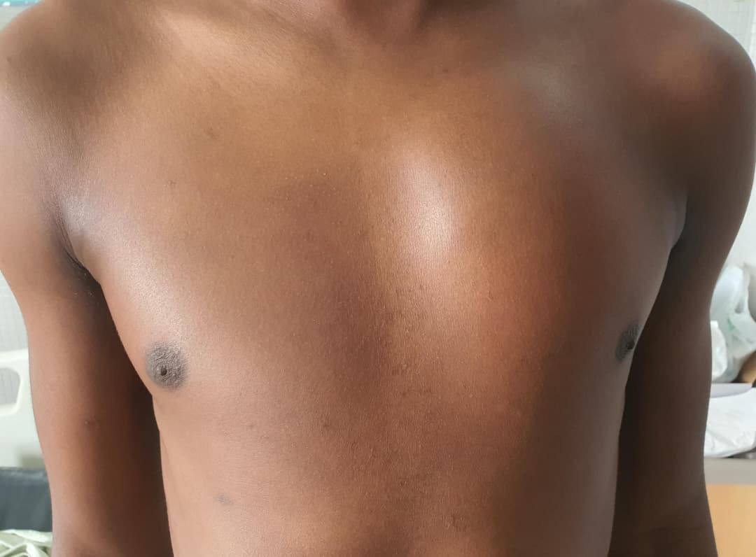
Fig 1: Picture of mediastinal tumor

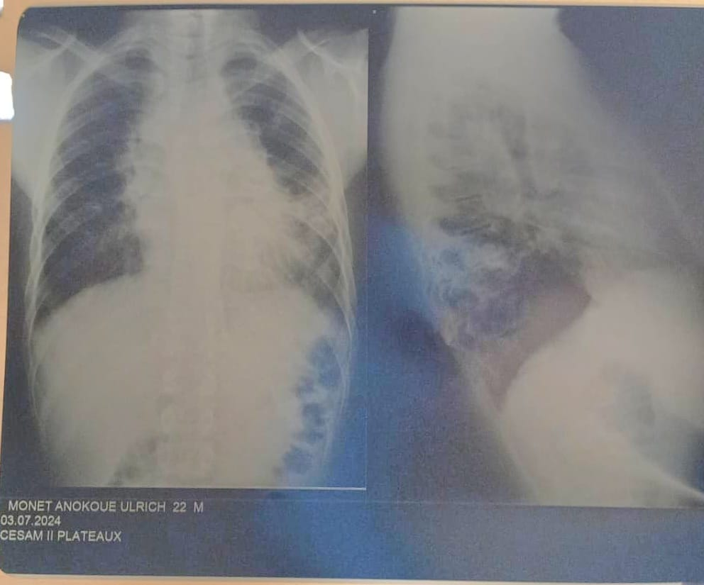
Fig 2 Chest X-ray

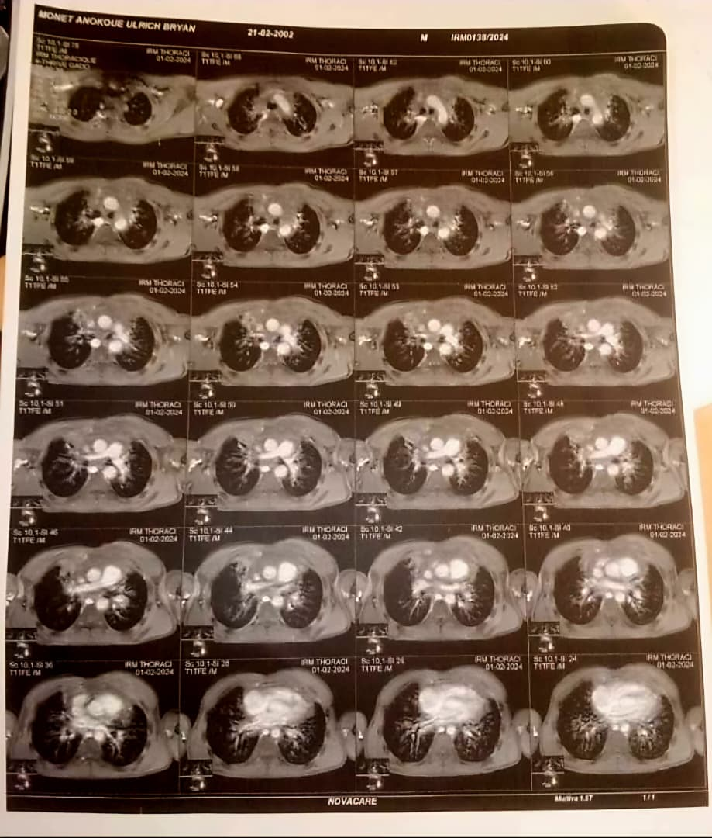
Fig 3 Mediatinal CT scan

Consent
As per international standards or university standards, patient(s) written consent has been collected and preserved by the author(s).

Disclaimer (Artificial intelligence)

Authors hereby declare that no generative AI technologies such as Large Language Models (ChatGPT, COPILOT, etc.) or text-to-image generators have been used during the writing or editing of this manuscript.

References
- Jones K, Vari F, Keane C, et al. Serum CD163 and TARC as disease response biomarkers in classical Hodgkin lymphoma. Clin Cancer Res 2013; 19: 731–42.
- Siegel RL, Miller KD, Jemal A. Cancer statistics, 2015. CA Cancer J Clin. 2015;65(1):5-29.
- Glaser SL, Jarrett RF. The epidemiology of Hodgkin’s disease. Baillieres Clin Haematol. 1996;9(3):401-416.
- Weiss LM, Strickler JG, Warnke RA, Purtilo DT, Sklar J. Epstein Barr viral DNA in tissues of Hodgkin’s disease. Am J Pathol. 1987;129(1):86-91
- Swerdlow SH, Campo E, Harris NL, et al. WHO Classification of Tumours of Haematopoietic and Lymphoid Tissues. 4th ed. Lyon, France: IARC Press; 2008.
- Ekstrand BC, Horning SJ. Hodgkin’s disease. Blood Rev. 2002; 16(2):111-117.
- Devizzi L, Santoro A, Bonfante V, Viviani S, Bonadonna G. Vinorelbine: a new promising drug in Hodgkin’s disease. Leuk Lymphoma. 1996;22(5-6):409-414.
- Vinti L, Pagliara D, Buffardi S, Di Ruscio V, Stocchi F, Mariggiò E, Parasole R, Di Matteo A, Petruzziello F, Paganelli V, De Vito R, Del Bufalo F, Strocchio L, Locatelli F. Brentuximab vedotin in combination with bendamustine in pediatric patients or young adults with relapsed or refractory Hodgkin lymphoma. Pediatr Blood Cancer. 2022 Apr;69(4):e29557. doi: 10.1002/pbc.29557. Epub 2022 Feb 2. PMID: 35107876. DOI: 10.1002/pbc.29557

- Owen A O’Connor, Jennifer K Lue, Ahmed Sawas, Jennifer E Amengual, Changchun Deng, Matko Kalac, Lorenzo Falchi, Enrica Marchi, Ithamar Turenne, Renee Lichtenstein, Celeste Rojas, Mark Francescone, Lawrence Schwartz, Bin Cheng, Kerry J Savage, Diego Villa, Michael Crump, Anca Prica, Vishal Kukreti, Serge Cremers, Joseph M Connors, John Kurvuilla. Brentuximab vedotin plus bendamustine in relapsed or refractory Hodgkin’s lymphoma: an international, multicentre, single-arm, phase 1–2 trial
- Younes A, Gopal AK, Smith SE, et al. Results of a pivotal phase II study of brentuximab vedotin for patients with relapsed or refractory Hodgkin’s lymphoma. J Clin Oncol 2012; 30: 2183–89.
- Moskowitz CH, Nimer SD, Zelenetz AD, et al. A 2-step comprehensive high-dose chemoradiotherapy second-line program for relapsed and refractory Hodgkin disease: analysis by intent to treat and development of a prognostic model. Blood 2001; 97: 616–23.
- Martín A, Fernández-Jiménez MC, Caballero MD, et al. Long-term follow-up in patients treated with Mini-BEAM as salvage therapy for relapsed or refractory Hodgkin’s disease. Br J Haematol 2001; 113: 161–71
- Ferme C, Mounier N, Divine M, et al. Intensive salvage therapy with high-dose chemotherapy for patients with advanced Hodgkin’s disease in relapse or failure after initial chemotherapy: results of the Groupe d’Etudes des Lymphomes de l’Adulte H89 Trial. J Clin Oncol 2002; 20: 467–75.
- Bartlett NL, Niedzwiecki D, Johnson JL, et al. Gemcitabine, vinorelbine, and pegylated liposomal doxorubicin (GVD), a salvage regimen in relapsed Hodgkin’s lymphoma: CALGB 59804. Ann Oncol 2007; 18: 1071–79.
- LaCasce, A. S., Bociek, R. G., Sawas, A., Caimi, P., Agura, E., Matous, J., ... & Advani, R. (2018). Brentuximab vedotin plus bendamustine: a highly active first salvage regimen for relapsed or refractory Hodgkin lymphoma. Blood, The Journal of the American Society of Hematology, 132(1), 40-48.
- O'Connor, O. A., Lue, J. K., Sawas, A., Amengual, J. E., Deng, C., Kalac, M., ... & Kuruvilla, J. (2018). Brentuximab vedotin plus bendamustine in relapsed or refractory Hodgkin's lymphoma: an international, multicentre, single-arm, phase 1–2 trial. The Lancet Oncology, 19(2), 257-266.
- LaCasce, A. S., Bociek, G., Sawas, A., Caimi, P. F., Agura, E., Matous, J., ... & Advani, R. (2015). Brentuximab vedotin plus bendamustine: a highly active salvage treatment regimen for patients with relapsed or refractory Hodgkin lymphoma. Blood, 126(23), 3982.
- Broccoli, A., Argnani, L., Botto, B., Corradini, P., Pinto, A., Re, A., ... & Fondazione Italiana Linfomi ONLUS. (2019). First salvage treatment with bendamustine and brentuximab vedotin in Hodgkin lymphoma: a phase 2 study of the Fondazione Italiana Linfomi. Blood Cancer Journal, 9(12), 100.
- Friedberg, J. W., Forero-Torres, A., Bordoni, R. E., Cline, V. J., Patel Donnelly, D., Flynn, P. J., ... & Yasenchak, C. A. (2017). Frontline brentuximab vedotin in combination with dacarbazine or bendamustine in patients aged≥ 60 years with HL. Blood, The Journal of the American Society of Hematology, 130(26), 2829-2837.
- Sawas, A., Connors, J. M., Kuruvilla, J. G., Rojas, C., Lichtenstein, R., Neylon, E., ... & O'Connor, O. A. (2015). The combination of brentuximab vedotin (Bv) and bendamustine (B) demonstrates marked activity in heavily treated patients with relapsed or refractory Hodgkin lymphoma (HL) and anaplastic large T-cell lymphoma (ALCL): results of an international multi center phase I/II experience. Blood, 126(23), 586.
- Nadia Mebrouk, Rachid Abilkassem, Anass Ayad & Aomar Agadr. (2022). Macrophagic Activation Syndrome Revealing Hodgkin Lymphoma: Case Report. Asian Journal of Pediatric Research, 9(3), 7–10. https://doi.org/10.9734/ajpr/2022/v9i330266
- Viwek Nade, Vaishali Tembhare, Ruchira Ankar, Sheetal Sakharkar, Archana Dhengare, Swapana More, Prerana Sakharwade & Khushbu Meshram. (2021). Case Report on Rom Exercises Effective in Reducing Pain and Discomfort in Hodgkin’s Lymphoma. Journal of Pharmaceutical Research International, 33(58B), 19–23. https://doi.org/10.9734/jpri/2021/v33i58B34165

