Influence of Particle Size, Extraction Solvent and pH on the Protein Recovery from Defatted Kusum (Schleichera oleosa (Lour.) Oken) Seed Cake

Abstract

This study evaluated the influence of three key extraction parameters, particle size, solvent type and precipitation pH, on protein recovery to identify optimal extraction conditions. Two particle size classes (<0.5 mm and 0.5-1.0 mm) and three solvent systems, namely distilled water (alkaline adjusted), 0.25 M sodium hydroxide (NaOH) and 0.2 M potassium hydroxide (KOH), were assessed across precipitation pH values ranging from 2 to 5.
Protein recovery varied markedly across extraction treatments. The highest yield (26.15%) was recorded when the fine particle fraction (<0.5 mm) was extracted using 0.2 M KOH and precipitated at pH 5, suggesting enhanced solubility and precipitation behavior under alkaline-assisted extraction near the protein’s isoelectric point. In contrast, the lowest protein yield (15.66%) occurred in the coarse particle fraction (0.5-1.0 mm) extracted using distilled water and precipitated at pH 2, demonstrating limited solubilization under non-alkaline conditions. Across all solvent systems, the finer particle fraction consistently produced higher yields than the coarser fraction, reflecting improved solvent accessibility and reduced mass transfer resistance. Alkaline solvents (NaOH and KOH) outperformed distilled water, confirming the critical role of pH-induced protein ionization and structural disruption in enhancing solubility and extractability.
Overall, the results demonstrate that protein recovery from Kusum seed cake is not material-fixed but process-dependent. Optimization of particle size, solvent strength and precipitation pH significantly improves extraction efficiency and supports the potential utilization of Kusum protein in food, feed and bioprocessing applications.

Keywords: Kusum seed cake; protein extraction; protein precipitation pH; plant protein recovery; oilseed by-products.

1. Introduction
The global demand for sustainable and plant-based protein ingredients has increased significantly in recent years due to challenges associated with the environmental footprint, cost, and resource intensity of animal-derived proteins (Singh et al., 2022). This shift has led to growing research interest in underutilized agricultural by-products, particularly oilseed cakes, which present a low-cost, protein-rich raw material suitable for extraction and value addition. By valorizing such biomass through efficient processing strategies, food and agro-processing industries can improve circularity, reduce waste and generate new functional ingredients suitable for feed, food and bioprocessing applications.
Schleichera oleosa (Lour.) Oken, commonly known as Kusum, is a perennial tree native to South and Southeast Asia and widely exploited for its oil-bearing seeds. After oil expression, a substantial quantity of defatted press cake is generated, typically with limited commercial use despite its promising biochemical composition. Earlier reports indicate that Kusum seed cake contains approximately 20-22% crude protein along with essential amino acids and other nutrients (Feedipedia, 2013; Goswami & Singh, 2017), suggesting strong potential as an alternative plant protein source. Yet, unlike other oilseed cakes such as soybean, rapeseed and sunflower, Kusum remains scientifically underexplored and research on its protein extraction behavior is almost absent from current literature.
Protein extraction efficiency from oilseed matrices is known to be influenced by several physicochemical parameters including particle size, extraction solvent and pH. Particle size reduction plays a critical role in increasing surface area, enhancing solvent accessibility and breaking down the structural integrity of lignocellulosic matrices. For example, Bárta et al. (2021) demonstrated that finer fractions (<250 µm) of oilseed cakes exhibited significantly higher protein recovery and improved functional attributes, reflecting better exposure of protein-rich tissues. Similar observations were reported in soybean protein extraction research, where particle size reduction enhanced solubilization and significantly improved extraction efficiency due to increased surface area exposure and improved mass transfer during alkaline treatment (Hettiarachchy et al., 1995). However, some pilot-scale studies indicate diminishing returns beyond a critical threshold due to changes in mass transfer dynamics rather than material limitations (Rommi et al., 2015). These findings justify systematic evaluation of granulometry in emerging raw materials, including defatted Kusum seed cake.
In addition to particle size, extraction pH has consistently been reported as one of the most influential factors governing protein solubilization, recovery yield, and functional quality. Studies on cold-pressed rapeseed cake found that extraction under alkaline conditions significantly improved protein solubility and yield, with optimum recovery occurring between pH 9 and 11 depending on extraction temperature and time (Szydłowska-Czerniak et al., 2021). Comparable results in Sacha Inchi press-cake demonstrated protein recoveries of approximately 83.6% under strongly alkaline conditions (pH 12, 60°C, 30 min), highlighting the role of protein ionization and increased electrostatic repulsion in enhancing solubilization (Mich et al., 2024). Beyond yield, pH also influences the removal of antinutritional factors; for example, Zhang et al. (2020) observed that adjusting extraction pH significantly reduced glucosinolates and phytic acid contents in rapeseed protein isolates, which has important implications for downstream safety and functionality.
Extraction solvent selection represents another critical parameter affecting protein yield, purity, selectivity and functional outcomes. Conventional aqueous or alkaline systems remain widely used; however, recent advancements have introduced greener or modified solvents that enhance mass transfer and target specific molecular interactions. For instance, Vasileiou et al. (2025) demonstrated that the extraction medium composition influenced not only protein yield in sunflower cake but also structural integrity and techno-functional properties, with alkaline-buffer systems outperforming neutral extractions. Similarly, Hadidi et al. (2023) reported that alkaline-assisted extraction improved cell wall disruption and solvent penetration in dense oilseed matrices, reinforcing solvent-mediated structural modification as a key determinant of extraction performance.
Together, these studies demonstrate that protein extraction from oilseed residues is not a fixed characteristic of the material itself, but rather an outcome influenced by controllable process variables that reshape the solubilization environment, mass transfer behavior and final protein structure. Despite extensive evidence in other oilseed systems, no comprehensive study has evaluated how particle size, extraction solvent and pH interact to influence protein recovery from defatted Schleichera oleosa seed cake.
Therefore, this study contributes to sustainable protein sourcing by valorizing defatted Kusum (Schleichera oleosa) seed cake, an underutilized oilseed by-product. By systematically evaluating the effects of particle size, solvent type and precipitation pH on extraction efficiency, the work provides process-level insight necessary for improving recovery of plant-based proteins. The findings can support formulation of cost-effective feed and food ingredients, industrial-scale processing and future research on functional properties of Kusum protein. Therefore, the study has relevance for animal nutrition, food science and circular bioeconomy research.
2. Materials and Methods
2.1 Materials
2.1.1 Chemicals, Reagents, Glassware and Instruments
All chemicals used for experimental procedures were of analytical grade. Reagents included hydrochloric acid (HCl), sodium hydroxide (NaOH), potassium hydroxide (KOH) and distilled water. Standard laboratory glassware such as conical flasks, Petri dishes, beakers, measuring cylinders and borosilicate glass funnels was utilized throughout the experiments. The analytical instruments employed included an electric grinder (for sample milling and granulation), an analytical balance (±0.001 g precision), a rotary shaker (for controlled solvent agitation), a refrigerated centrifuge (for protein separation and clarification), micropipettes and a calibrated digital pH meter for accurate pH adjustment during extraction procedures.
2.1.2 Raw Materials
Defatted Schleichera oleosa (Kusum) seed cake was procured from the Agricultural Structure and Process Engineering Division, ICAR-National Institute of Secondary Agriculture, Namkum, Ranchi, Jharkhand, India (Pin: 834010), shown in Plate 1. The seed cake was stored in airtight, food-grade containers at ambient laboratory conditions until further processing to prevent moisture absorption and oxidative quality degradation.
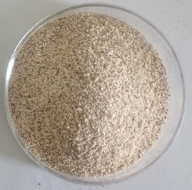
Plate 1: Defatted Kusum seed cake powder
2.2 Methods
2.2.1 Preparation of Seed Cake Powder and Particle Size Separation
The defatted Schleichera oleosa (Kusum) seed cake was initially reduced in size using a laboratory electric grinder to obtain a fine and homogeneous powder suitable for extraction trials. The milled material was subsequently subjected to particle size classification using British Standard Sieves (BSS). Two distinct sieve fractions were collected to assess the role of particle size in extraction efficiency: 16-30 BSS mesh (corresponding to approximately 0.5-1.0 mm) and a finer fraction passing through a 30 BSS mesh (<0.5 mm). Each fraction was stored in airtight containers before analysis, and these two particle size classes were later incorporated into protein extraction experiments to determine their influence on protein recovery.
2.2.2 Protein Extraction Procedures
Protein extraction from Kusum seed cake was carried out using three solvent systems: distilled water with alkaline pH modification, potassium hydroxide (KOH), and sodium hydroxide (NaOH). The overall extraction approach followed an alkaline solubilization acid precipitation framework, consistent with approaches previously described for oilseed protein recovery (Kalpana et al., 2013, 2020; Uddin et al., 2018), with procedural adjustments suitable for Kusum seed matrix behavior.
2.2.2 (a) Distilled Water with pH Regulation
For each extraction run, 10 g of defatted Kusum seed cake powder was dispersed in 150 mL of distilled water. The pH of the suspension was gradually raised to 12 using 1 M NaOH to initiate alkaline solubilization of protein, following the conditions adapted from Uddin et al. (2018). The sample was then placed on a rotary shaker and agitated at 150 rpm for 2 hours to facilitate solute-solvent interaction. After shaking, the mixture was centrifuged at 4,500 rpm for 20 minutes, and the clear supernatant containing dissolved protein fractions was carefully collected.
To induce protein precipitation, the extracted supernatant was acidified to varying pH levels (2, 3, 4 and 5) using 1 N HCl, following precipitation conditions adapted from Kalpana et al. (2020). The resulting protein curd, which appeared creamy white, was isolated by centrifugation (4,500 rpm, 20 minutes). The precipitate was subsequently rinsed with distilled water and centrifuged again (4,500 rpm, 10 minutes) to eliminate residual acidity, as recommended by Kalpana et al. (2013). Finally, the purified protein precipitate was dried in a hot-air oven at 40 °C until a consistent weight was achieved.
2.2.2 (b) Potassium Hydroxide (KOH) Extraction
For the potassium hydroxide-based extraction, the procedure followed the same general workflow described in Section 2.2.2(a), with the exception of the solvent composition. A measured quantity of 10 g of defatted Kusum seed cake powder was combined with 150 mL of 0.2 M KOH solution. The suspension was adjusted to alkaline conditions and agitated on a rotary shaker at 150 rpm for 2 hours to facilitate solubilization. Following extraction, the mixture was centrifuged at 4,500 rpm for 20 minutes, and the resulting supernatant containing the solubilized protein fraction was carefully separated.
To recover the protein, the supernatant was subjected to acid precipitation by adjusting the pH to values between 2 and 5 using 1 N HCl. The precipitated protein fraction was subsequently isolated by centrifugation (4,500 rpm, 20 minutes). The collected protein curd was washed with distilled water to remove residual alkali and acid, and then centrifuged again under identical conditions to ensure purification. The recovered protein isolate was finally dried in a hot-air oven at 40 °C until constant weight was attained.
2.2.2 (c) Sodium Hydroxide (NaOH) Extraction
For the sodium hydroxide extraction treatment, the general workflow remained consistent with the previously described alkaline extraction procedures. In this method, 10 g of defatted Schleichera oleosa seed cake powder was dispersed in 150 mL of 0.25 M NaOH, following extraction conditions adapted from Uddin et al. (2018). The suspension was then subjected to controlled mixing on a rotary shaker at 150 rpm for 2 hours to promote protein solubilization. After agitation, the step-by-step process is given in Figure 1 and Plate 2.

Figure 1: Flow chart for the extraction of protein with alkaline solvent

2.2.3 Replication and Yield Reporting
All extraction procedures were conducted in triplicate to ensure experimental reliability and reproducibility. The protein yield from each extraction treatment was determined on a dry weight basis, and the results were reported as mean values derived from the three independent replicates.
Plate 2: Process flow chart for the methodology of the Kusum protein extraction using alkaline solvent

3. Results
3.1 Effect of Particle Size on Protein Extraction Yield
The protein extraction yields obtained from Kusum (Schleichera oleosa) seed cake at two particle size categories, ≤ 0.5 mm (passing 30 BSS) and 0.5-1.0 mm (16-30 BSS), are summarized in the corresponding results Table 1. Across all extraction media evaluated, including distilled water (alkaline adjusted), 0.25 M NaOH, and 0.2 M KOH solutions, a consistent trend was observed: the finer particle fraction (≤ 0.5 mm) exhibited higher protein recovery compared to the coarser fraction (0.5-1.0 mm).
Table 1 Protein yield (%) from defatted Kusum (Schleichera oleosa) seed cake as affected by particle size, solvent system, and precipitation pH.
 | Distilled water |  | NaOH |  | KOH
Particle size  pH | <0.5mm | 0.5-1mm | <0.5mm | 0.5-1mm | <0.5mm | 0.5-1mm
2 | 13.70 | 03.54 | 21.25 | 13.09 | 23.29 | 15.67
3 | 18.23 | 08.16 | 19.75 | 13.93 | 25.25 | 17.04
4 | 21.20 | 10.60 | 15.90 | 15.19 | 25.89 | 17.59
5 | 22.65 | 11.13 | 19.35 | 12.00 | 26.15 | 17.58

The protein extraction values obtained from Kusum seed cake using different solvents, particle size classes, and precipitation pH levels are summarized in Table 1. A consistent pattern was observed across all extraction conditions: the finer particle fraction (<0.5 mm) produced higher protein recovery than the coarser fraction (0.5-1.0 mm). This trend demonstrates that particle size plays a significant role in extraction efficiency, with reduced particle size likely improving solvent accessibility and mass transfer during the solubilization process.
Among the extraction treatments evaluated, potassium hydroxide (0.2 M KOH) yielded the highest recovery values. The maximum extraction yield recorded was 26.15% at pH 5 for the <0.5 mm fraction using KOH, whereas the corresponding coarser fraction (0.5-1.0 mm) achieved a comparatively lower yield of 17.59% at pH 4 under the same solvent system. In contrast, distilled water extraction resulted in the lowest protein yields. The minimum recovery observed was 3.54% at pH 2 for the 0.5-1.0 mm particle fraction, while the fine fraction under the same condition yielded 13.70%, indicating limited extraction efficiency under non-alkaline conditions.
Overall, these results confirm that both solvent type and particle size substantially influence protein extraction performance. The superior performance of alkaline solvents, particularly KOH, suggests a stronger solubilization capability compared to distilled water. Additionally, the combined effects of finer particle size and optimal pH conditions led to improved protein precipitation and final recovery. These findings highlight the importance of controlled pretreatment and solvent selection when developing an optimized protein recovery protocol for Kusum seed cake.
3.2 Effect of Different Extraction Methods on Protein Yield
Protein extraction from plant-based matrices is commonly performed under alkaline conditions, as alkaline solvents promote protein solubilization by increasing the net negative charge on protein molecules. In this study, sodium hydroxide (NaOH) and potassium hydroxide (KOH) were employed as alkaline extraction media, while distilled water was used as a comparative non-alkaline control. The elevated pH conditions achieved through NaOH and KOH facilitate cleavage of disulfide linkages and electrostatic repulsion among protein molecules, thereby improving protein release from cellular structures and increasing extractability. Furthermore, alkaline treatment assists in disrupting the seed cake microstructure, enhancing solvent penetration and weakening the integrity of the cell wall protein matrix. As a result, variations in extraction yield observed across the tested methods reflect not only chemical effects of the solvent system, but also interactions between solvent strength, pH and structural accessibility of proteins within Kusum seed cake.
3.2.1 Distilled Water with pH Adjustment Method
The protein extraction performance of distilled water with controlled pH adjustment was evaluated at two particle size classifications (<0.5 mm and 0.5-1.0 mm) across precipitation pH levels of 2, 3, 4, and 5. The results are illustrated in the corresponding graphical representation in Figure 2. A clear trend emerged wherein the finer particle fraction consistently produced higher protein yield than the coarser fraction, reinforcing the role of particle size in facilitating mass transfer and solubilization efficiency.
The extraction results for Kusum seed cake demonstrated that the finer particle fraction (<0.5 mm) consistently yielded higher protein content compared to the coarser fraction (0.5-1 mm). Among the evaluated conditions, the maximum protein recovery (26.15%) was observed at pH 5 for the <0.5 mm particle size, whereas the lowest yield (15.66%) occurred in the 0.5-1 mm fraction at the 2 pH level. This trend indicates that both particle size reduction and pH condition play an important role in enhancing protein precipitation and overall extraction efficiency. Protein solubility in salt-based extraction systems is strongly affected by the ionic strength and pH of the medium, as these parameters regulate electrostatic interactions, hydration behavior and aggregation of protein molecules (Damodaran & Parkin, 2017). These findings support the current observations and suggest that alkaline-assisted extraction combined with optimized particle size and precipitation pH can significantly improve protein recovery from Kusum seed cake.
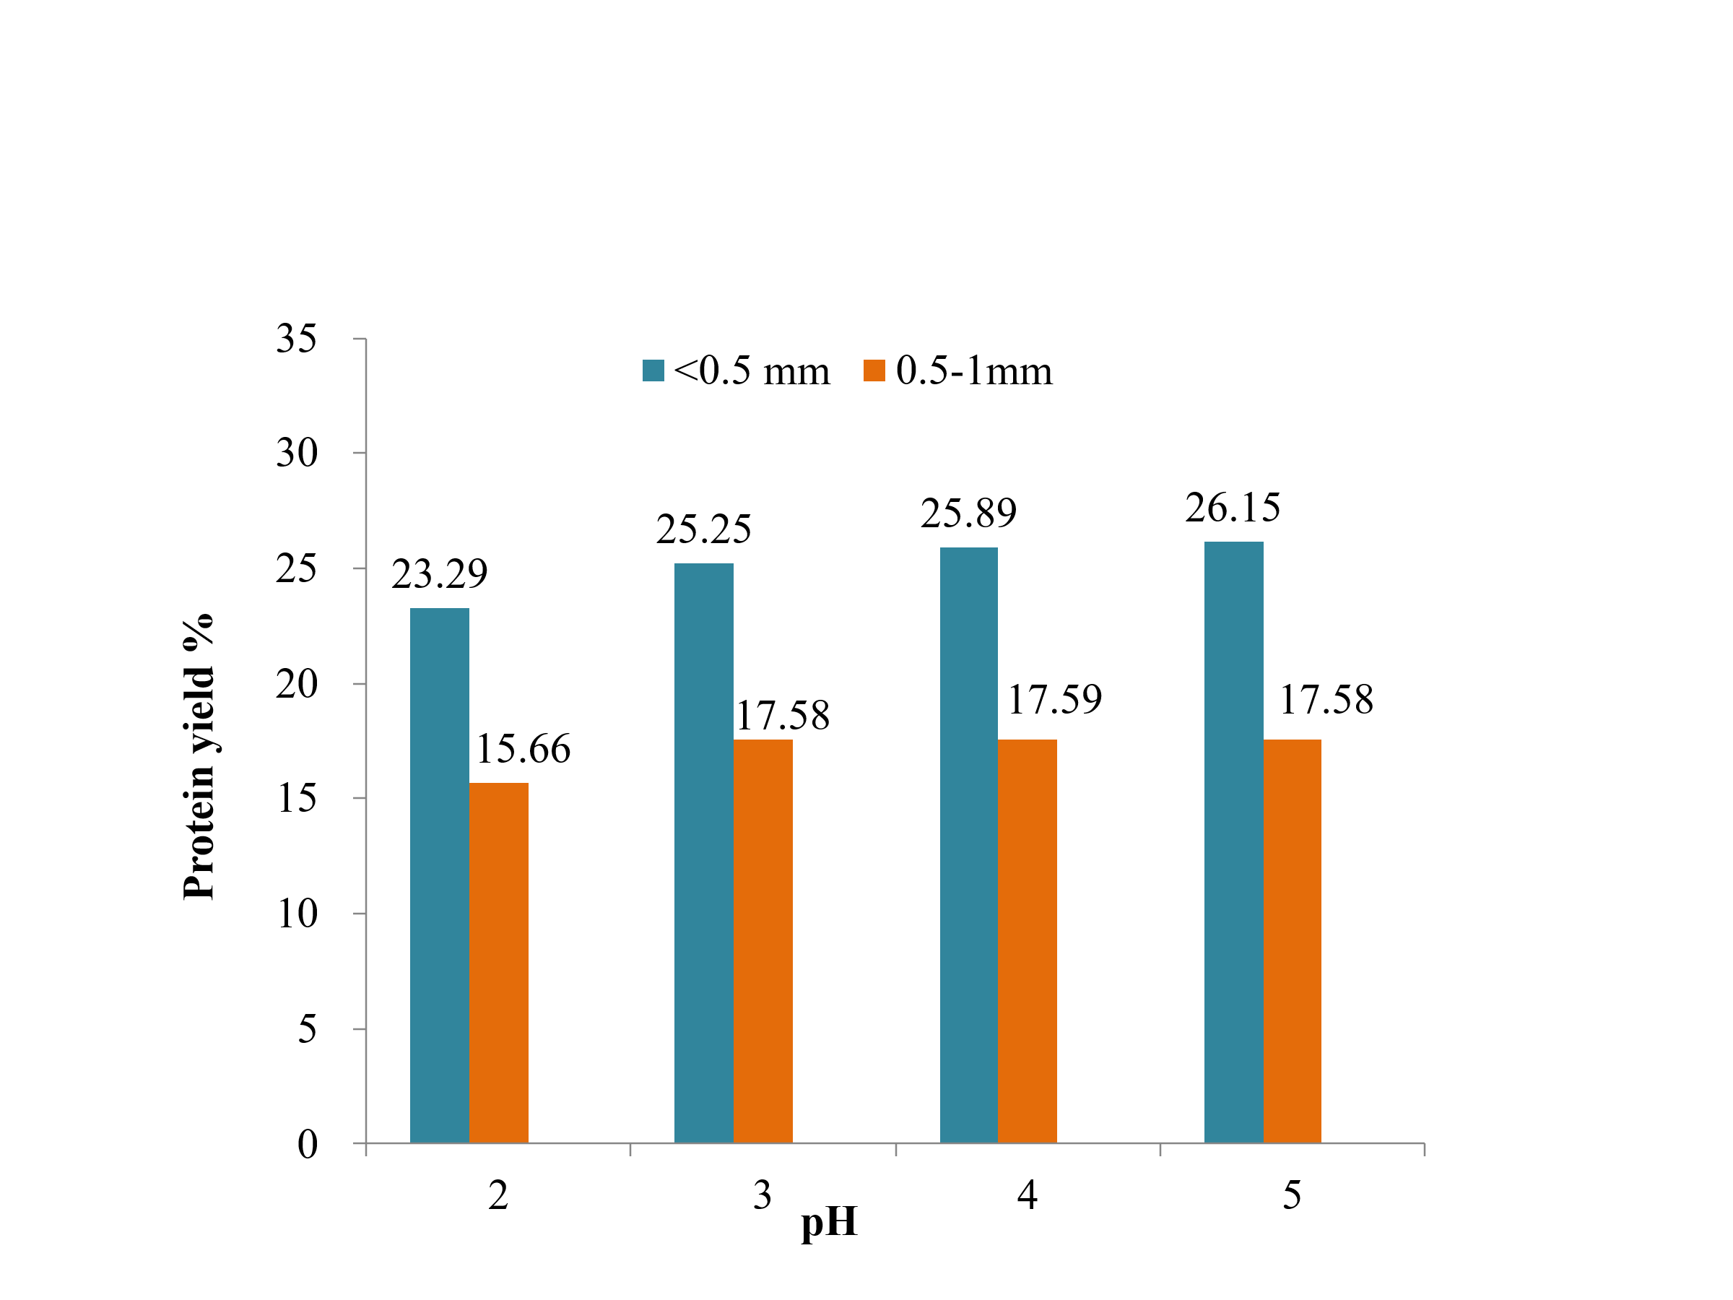
Figure 2: Effect of pH and particle size on protein yield of Kusum seed extracted with distilled water.
3.2.2 NaOH Alkaline Solvent Extraction Method
The protein extraction behavior of Kusum seed cake using 0.25 M NaOH was evaluated across two particle size categories (<0.5 mm and 0.5-1 mm) and precipitation pH levels of 2, 3, 4 and 5. The results are presented in the corresponding graph in Figure 3. A clear trend emerged indicating that particle size had a substantial effect on extraction efficiency. The finer particle fraction (<0.5 mm) consistently yielded higher protein recovery than the coarser 0.5-1 mm fraction, demonstrating that reduced particle size improves solvent accessibility and promotes greater protein solubilization during alkaline extraction.

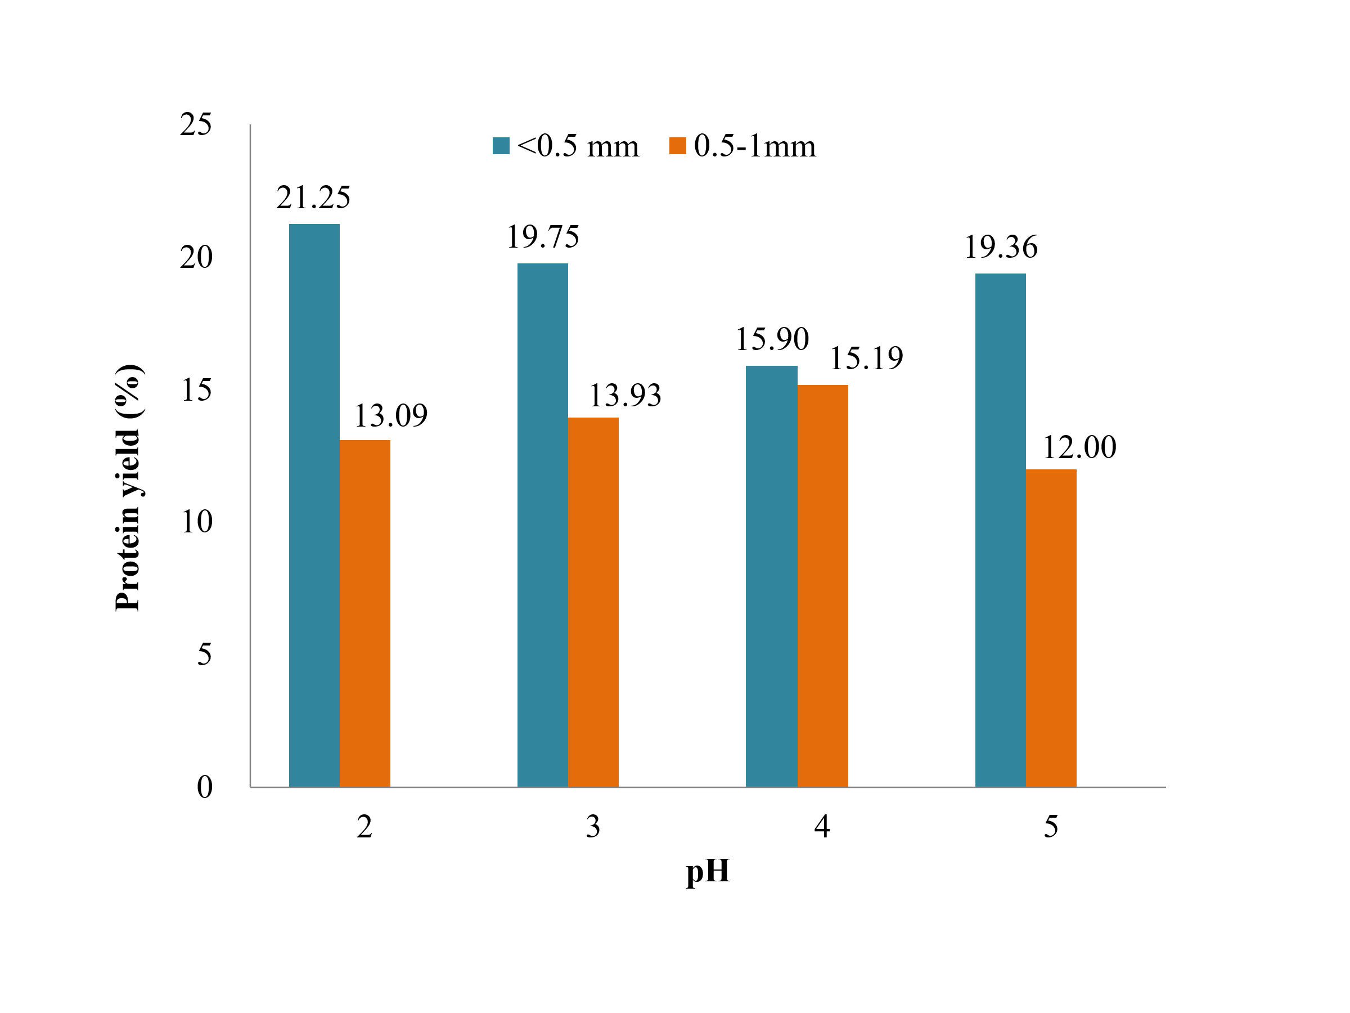
Figure 3: Effect of pH and particle size on protein yield of Kusum seed extracted with NaOH.

Among the evaluated treatments, the highest extraction yield was obtained at pH 2, reaching 21.25% for the <0.5 mm fraction. This suggests that strongly acidic precipitation immediately after alkaline solubilization favours maximum protein recovery. In contrast, the lowest yield was observed at pH 5 in the coarser particle size category (12.00%), indicating limited precipitation efficiency at higher pH values for larger particles. The extraction trend showed a gradual decline in yield from pH 2 to pH 4 for the fine fraction, followed by a slight recovery at pH 5. Meanwhile, the coarser fraction exhibited the opposite pattern, with yields increasing from pH 2 to pH 4, then declining at pH 5. These observations confirm that both pH and particle size significantly influence protein precipitation dynamics under NaOH extraction conditions.
3.2.3 KOH Alkaline Solvent Extraction Method
The protein extraction performance of Kusum seed cake using 0.2 M KOH was evaluated across two particle size ranges (<0.5 mm and 0.5-1 mm) and four precipitation pH levels (2, 3, 4, and 5), as shown in the graphical representation in Figure 4. Similar to the trend observed in the NaOH extraction method, the finer particle fraction (<0.5 mm) consistently produced higher protein yields compared to the coarser fraction (0.5-1 mm), indicating the importance of particle size reduction in improving solvent accessibility and extraction efficiency.
Within the <0.5 mm category, protein yield increased progressively with rising pH, reaching the maximum recorded value of 26.15% at pH 5. A slight decrease in yield was observed beyond this trend, although the overall extraction remained higher than the coarser fraction across all pH levels. In contrast, the lowest yield (15.67%) was observed at pH 2 in the larger particle size fraction, demonstrating weaker precipitation efficiency and limited protein solubilization at lower pH conditions. Overall, the extraction pattern suggests that KOH is an effective alkaline solvent for Kusum protein recovery, with extraction efficiency strongly influenced by both pH and particle size.

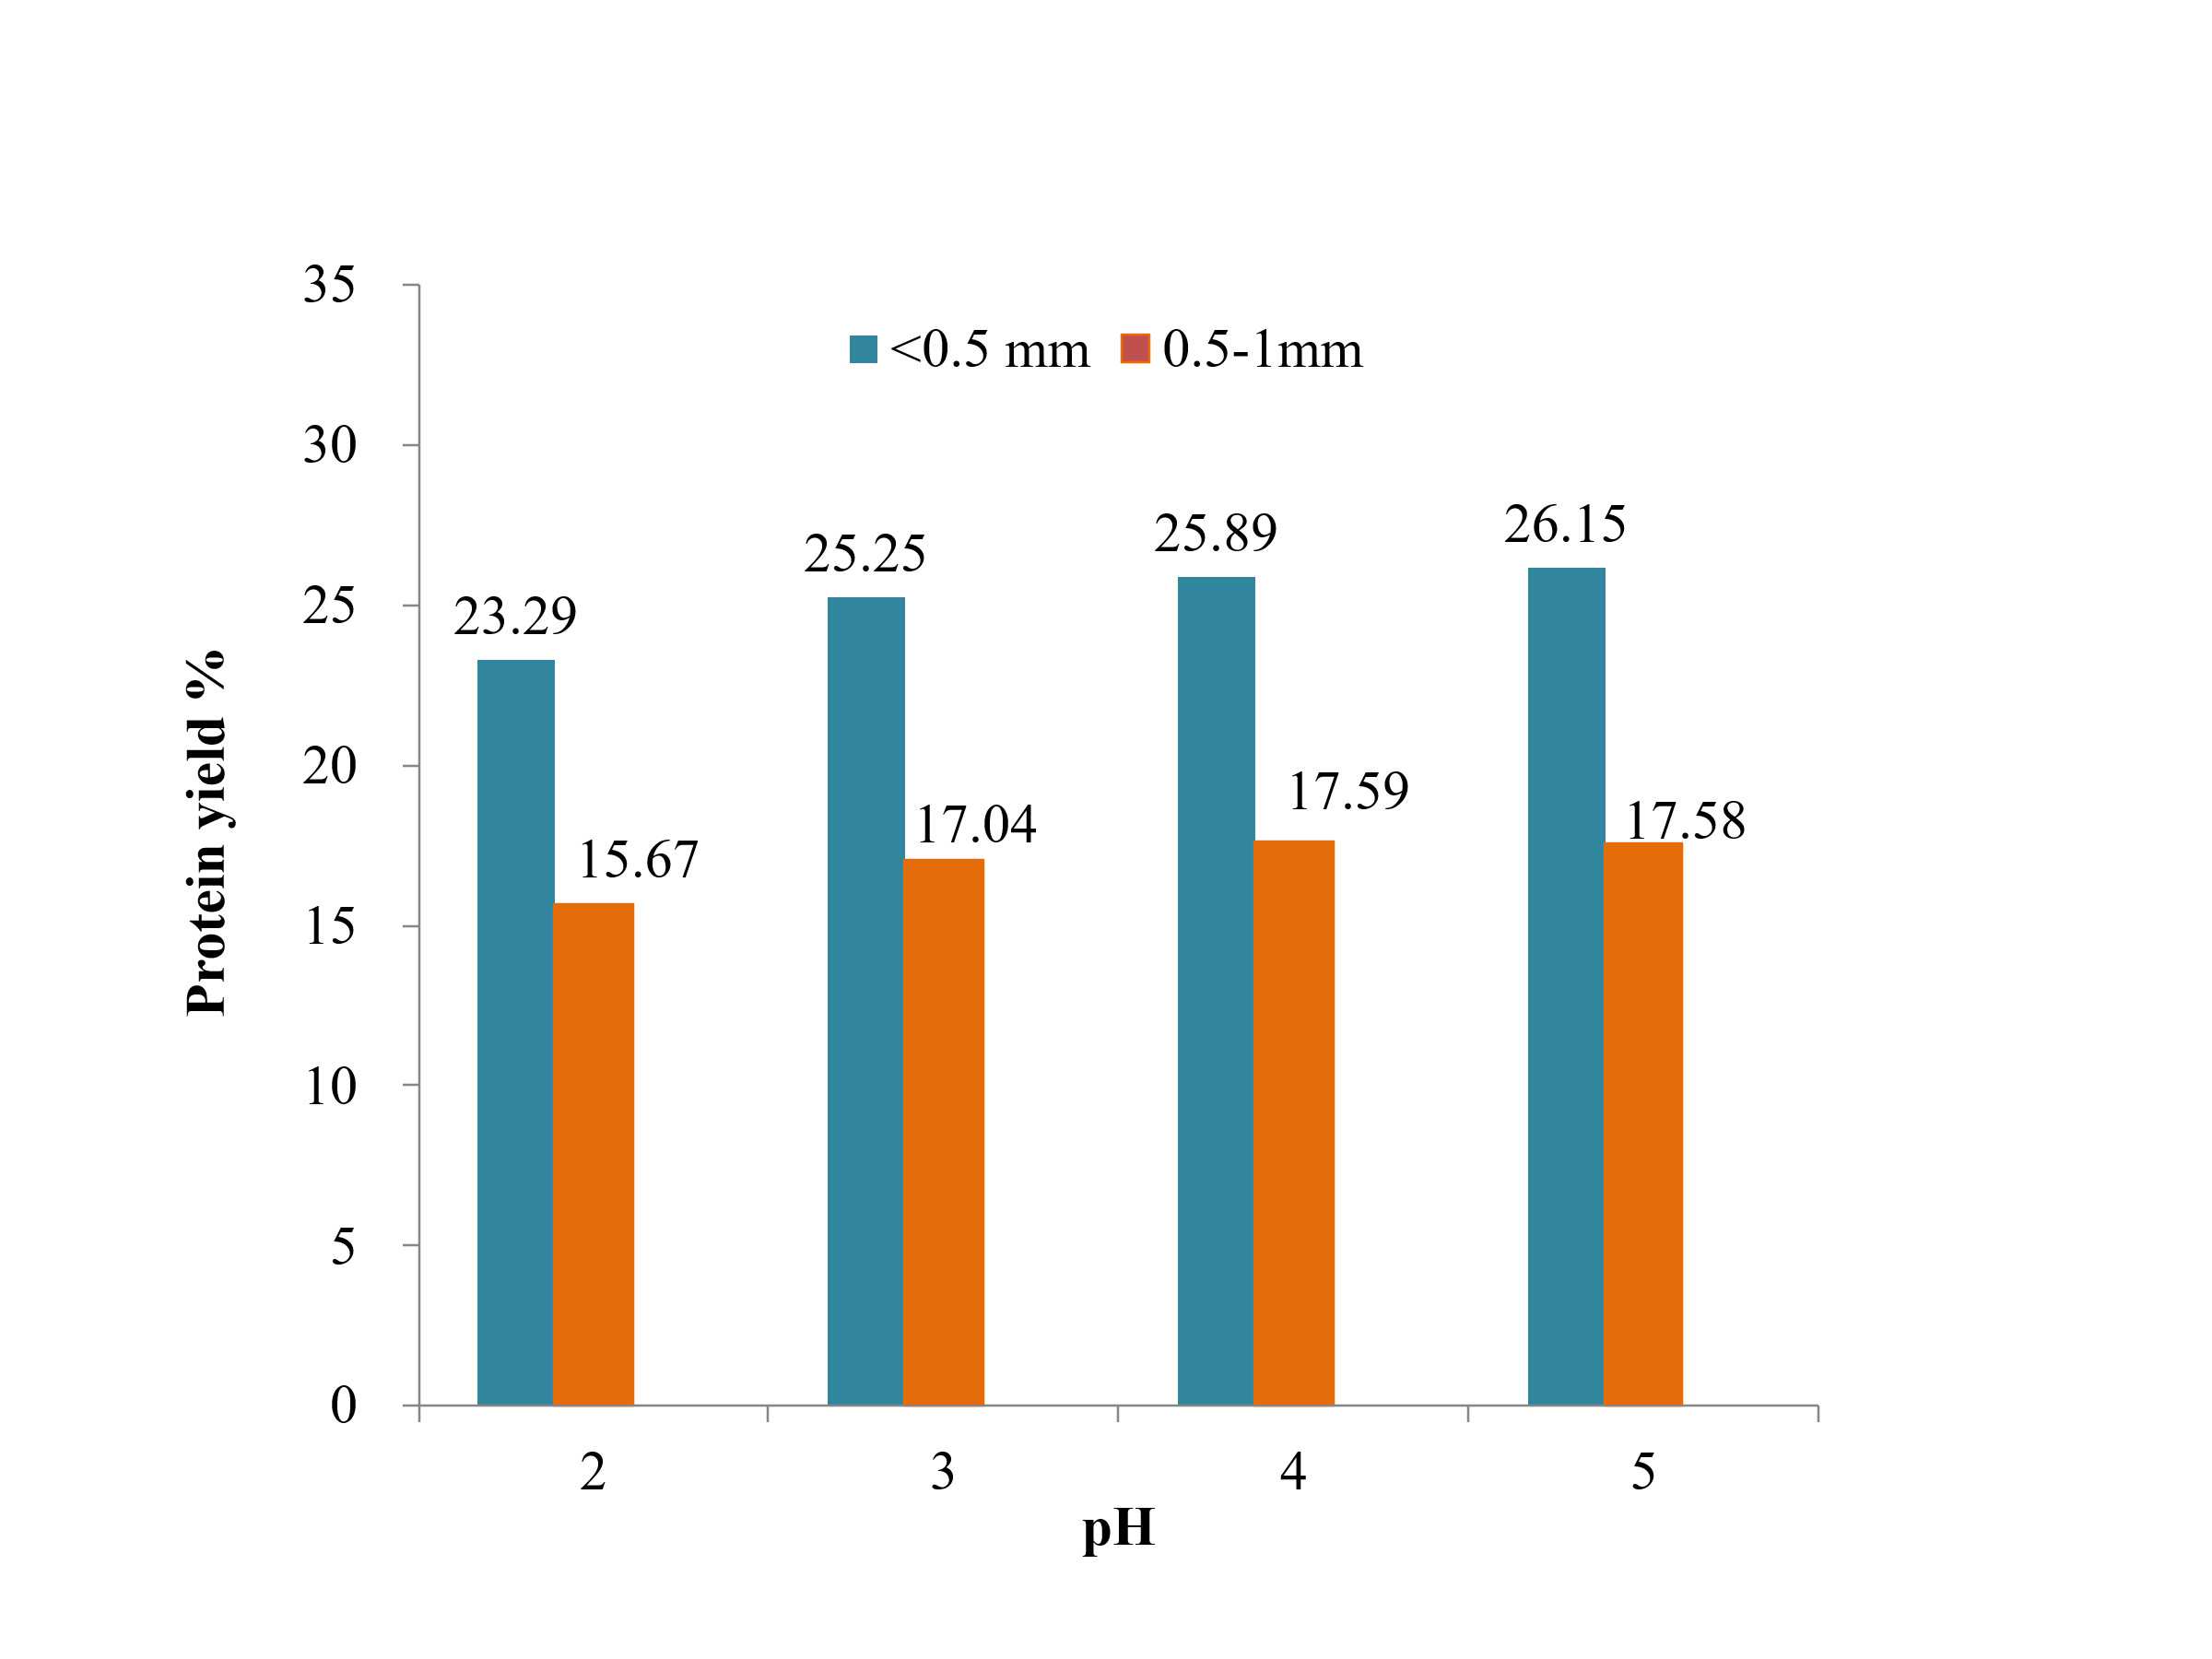
Figure 4: Effect of pH and particle size on protein yield of Kusum seed extracted with KOH.

4. Discussion
The findings of this study demonstrate that both the extraction method and particle size significantly influenced protein recovery from defatted Kusum (Schleichera oleosa) seed cake. Across all treatments, the finer particle fraction (<0.5 mm) consistently yielded higher protein extractability than the coarser fraction (0.5-1 mm). This outcome aligns with established extraction principles, where reduced particle size increases surface area exposure, enhances solvent penetration, and improves mass transfer during solubilization.
Among the three extraction media, alkaline solvents clearly outperformed distilled water. Both NaOH and KOH treatments resulted in notably higher protein yields, confirming the role of alkaline conditions in breaking disulfide bonds, destabilizing cell wall structures, and increasing solubility through protein ionization. KOH produced the highest recovery value (26.15% at pH 5 for <0.5 mm), suggesting stronger extraction efficiency compared to NaOH. Distilled water extraction resulted in the lowest yields, indicating limited protein solubilization in the absence of alkaline conditions.
Variation in precipitation pH also played a key role in recovery patterns. The general trend indicated improved precipitation and higher final yields near pH 5, possibly corresponding to the isoelectric precipitation behavior of Kusum protein. Overall, the results highlight the combined influence of solvent type, pH and particle size in determining extraction efficiency.
5. Conclusion
The present study investigated the influence of particle size, extraction solvent and precipitation pH on protein recovery from defatted Kusum (Schleichera oleosa) seed cake. The findings clearly demonstrate that these variables significantly affect extraction efficiency and can be optimized to maximize protein yield. Among the two particle size fractions evaluated, the finer fraction (<0.5 mm) consistently exhibited a higher extraction yield compared to the larger fraction (0.5-1 mm). This trend reflects the importance of increased surface area and improved mass transfer during solvent interaction, which facilitates enhanced solubilization of protein structures embedded within the seed matrix.
The choice of extraction medium also played a critical role. Alkaline solvents (NaOH and KOH) were significantly more effective than distilled water, confirming the importance of alkaline-induced solubilization mechanisms involving disruption of disulfide bonds, cell wall weakening, and enhanced ionization of amino acids. Between the two alkaline treatments, KOH produced the highest yield (26.15% at pH 5), indicating its superior efficiency for Kusum protein recovery when combined with fine particle size and optimized pH conditions. Distilled water, although capable of extracting measurable protein fractions, provided the lowest yields, indicating limited solubility under non-alkaline conditions.
Precipitation pH further influenced extractability, with the highest yields consistently observed near pH 5, suggesting proximity to the isoelectric precipitation behavior of Kusum proteins. At lower pH values, decreased precipitation efficiency was observed, highlighting the sensitivity of Kusum protein solubility to pH variations. Collectively, these findings demonstrate that an integrated approach combining particle size reduction, alkaline extraction, and optimized precipitation parameters can substantially improve protein recovery from Kusum seed cake.
Future research should focus on characterizing the functional and nutritional properties of extracted Kusum protein and evaluating its potential applications in food and feed formulations. Advanced optimization using response surface methodology, enzyme-assisted extraction, and scalability assessment will further support industrial applicability and value addition of this underutilized resource.

Declaration of generative AI and AI-assisted technologies in the manuscript preparation process
During the preparation of this manuscript, the author(s) used Microsoft Copilot and Perplexity AI in order to improve the structure, flow, grammar and language style of the text. After using this tool/service, the author(s) reviewed and edited the content as needed and take full responsibility for the content of the published article.
References
- Bárta, J., Bártová, V., Jarošová, M., Švajner, J., Smetana, P., Kadlec, J., Filip, V., Kyselka, J., Berčíková, M., Zdráhal, Z., Bjelková, M., & Kozak, M. (2021). Oilseed cake flour composition, functional properties and antioxidant potential as affected by sieving and species differences. Foods, 10(11), 2766. https://doi.org/10.3390/foods10112766
- Chirinos, R., Aquino, M., Pedreschi, R., & Campos, D. (2017). Optimized methodology for alkaline and enzyme‐assisted extraction of protein from sacha inchi (Plukenetia volubilis) kernel cake. Journal of Food Process Engineering, 40(2), e12412. https://doi.org/10.1111/jfpe.12412
- Damodaran, S., & Parkin, K. L. (2017). Amino acids, peptides, and proteins. In S. Damodaran, K. L. Parkin, & O. R. Fennema (Eds.), Fennema’s food chemistry (5th ed., pp. 235–356). CRC Press. https://doi.org/10.1201/9781315372914-5
- Feedipedia. (2013). Schleichera oleosa seed cake. INRAE, CIRAD, AFZ & FAO. Retrieved February 2025, from https://www.feedipedia.org/node/643
- Goswami, S., Singh, R. P., & Gilhotra, R. M. (2020). The effect of isolated quercetin from leaf extract of Schleichera oleosa (Lour.) Oken on Ascaridia galli. International Journal of Pharmaceutical Research, 12(2), 1-6. https://doi.org/10.31838/ijpr/2020.12.02.0071
- Hadidi, M., Aghababaei, F., & McClements, D. J. (2023). Enhanced alkaline extraction techniques for isolating and modifying plant-based proteins. Food Hydrocolloids, 145, 109132. https://doi.org/10.1016/j.foodhyd.2023.109132
- Hettiarachchy, N. S., Kalapathy, U., & Myers, D. J. (1995). Alkali‐modified soy protein with improved adhesive and hydrophobic properties. Journal of the American Oil Chemists' Society, 72(12), 1461-1464. https://doi.org/10.1007/BF02577838
- Kalpana B., Ramya KG, Munishamanna KB, And Palanimuthu V. (2020). Extraction of Protein from Sunflower Deoiled Cake. Journal of PHarmacognosy and PHytochemistry. Sp University of Agricultural Sciences, GKVK, Bengaluru, Karnataka, India 2020, 9(3): 23-27. https://www.phytojournal.com/archives/2020/vol9issue3/PartA/9-2-33-317.pdf
- Kalpana Devi B., Vidhya R. And Jaganmohan R. (2013). Determination and Isolation of Protein from Different Fractions of Defatted Groundnut Oil Cake. African Journal of Plant. 7(8), 394-400. https://doi.org/10.5897/AJPS12.021
- Kalpana, B., Ramya, K. G., Munishamanna, K. B., & Palanimuthu, V. (2019). Process optimization for extraction of protein from defatted safflower oil cake. Journal of Pharmacognosy and Phytochemistry, 8(6), 865–870.
- Mich, M., Ung, R. P., Chab, S., Net, M., Kong, S., Tan, R., & Say, M. (2024). Yukleav Nat, Chin Ping Tan. Alkaline Extraction of Protein from Sacha Inchi Oil Press-cake: Effect of pH, Temperature, and Extraction Time. Journal of Food Science and Nutrition Research, 7, 74-79. https://doi.org/10.26502/jfsnr.2642-110000154
- Rommi, K., Holopainen, U., Pohjola, S., Hakala, T. K., Lantto, R., Poutanen, K., & Nordlund, E. (2015). Impact of particle size reduction and carbohydrate-hydrolyzing enzyme treatment on protein recovery from rapeseed (Brassica rapa L.) press cake. Food and Bioprocess Technology, 8(12), 2392-2399. https://doi.org/10.1007/s11947-015-1587-8
- Singh, R., Langyan, S., Sangwan, S., Rohtagi, B., Khandelwal, A., & Shrivastava, M. (2022). Protein for human consumption from oilseed cakes: a review. Frontiers in Sustainable Food Systems, 6, 856401. https://doi.org/10.3389/fsufs.2022.856401
- Szydłowska-Czerniak, A., Poliński, S., & Momot, M. (2021). Optimization of ingredients for biscuits enriched with rapeseed press cake—Changes in their antioxidant and sensory properties. Applied Sciences, 11(4), 1558. https://doi.org/10.3390/app11041558
- Uddin, M. S., Islam, A., Rahman, M. M., Uddin, M. B., & Mazumder, A. R. (2018). Isolation of protein from defatted peanut meal and characterize their nutritional profile. Chem. Res. J, 3, 187-196. https://www.researchgate.net/publication/325877402_Isolation_of_Protein_from_Defatted_Peanut_Meal_and_Characterize_their_Nutritional_Profile
- Vasileiou, C., Dimoula, M., Drosou, C., Kavetsou, E., Stergiopoulos, C., Gogou, E., Boukouvalas, C., & Krokida, M. (2025). Valorization of edible oil industry by-products through optimizing the protein recovery from sunflower press cake via different novel extraction methods. AgriEngineering, 7(5), 146. https://doi.org/10.3390/agriengineering7050146
- Zhang, Z., He, S., Liu, H., Sun, X., Ye, Y., Cao, X., ... & Sun, H. (2020). Effect of pH regulation on the components and functional properties of proteins isolated from cold-pressed rapeseed meal through alkaline extraction and acid precipitation. Food chemistry, 327, 126998. https://doi.org/10.1016/j.foodchem.2020.126998

