Ethnobotanical knowledge and importance of Balanites aegyptiaca (L.) Delile (Zygophyllaceae) in the Ouadi-Rimé Ouadi-Achim Wildlife Reserve and its surroundings in North-Central Chad

ABSTRACT
In Chad, Balanites aegyptiaca is a highly useful species that is conserved by farmers in agroforestry parks, but its long-term survival is under threat. The aim of this study is to understand endogenous knowledge about B. aegyptiaca. Surveys were conducted among local populations. Ethnobotanical surveys were carried out from July to August 2024 among 220 people of two sexes living in the Ouadi-Rimé Ouadi-Achim Wildlife Reserve. The results of these ethnobotanical surveys reveal several methods of exploitation and a good knowledge of the species among the local population. The plant is used in a number of areas, including health and food. The park reserve located in the Sahelian sector is the priority site in terms of repopulating B. aegyptiaca. The soap plant must be the subject of assisted regeneration and protection against over-exploitation throughout its distribution area in Chad.
Key words: Ethnobotanical knowledge, Balanites aegyptiaca, exploitation, soap plant

INTRODUCTION
The decline of ligneous resources is a reality in the Sahelian zone. It is characterised by the rarefaction or even disappearance of certain species (Ganaba, 2008). In the Sahelian zone, one of the main activities of human populations has long been the harvesting of plant products and hunting to satisfy their primary needs. Several types of product are sought by farmers on a daily basis (Mpondo et al., 2017 ; Rabiou et al., 2020). The products sought by farmers include edible nuts, mushrooms, fruit, herbs, spices, gums, aromatic plants, game, wood, fodder and plant or animal products for medicinal, cosmetic, food and/or cultural uses (Sinsin et al., 2004, Oumar et al., 2023). Human activity is the main factor responsible for the degradation of ecosystems and therefore biodiversity (Hama et al., 2019). Harvesting often exceeds the production capacity of many species and is the primary cause of their destruction (Douma et al., 2010). The uncontrolled exploitation of plant formations leads to the rapid decline or even total disappearance of certain species that are very important to the population (Yossi et al., 2006). Balanites aegyptiaca is an important species that is much exploited by the population of Chad. All parts of the plant are used in traditional pharmacopoeia. The fruits are a highly prized food resource for the local population and can be used for medicinal purposes; the insect-resistant wood is a high-calorific fuel, used for construction, tool handles, toothpicks, firewood and charcoal, fences, mortars, pestles and Koranic tablets; the seeds are used to make oils and soaps ; and the young leaf twigs are harvested for human consumption (Arbonnier, 2019); Ganaba et al., 2004). The fruit pulp has a bittersweet taste and is sweetened as a candy. The drupes are sold by women and are also macerated in water, replacing sugar in the porridge. Oil is extracted from the kernels for cooking and soap-making. In Sahelian countries, the species plays a key role in the food and nutritional security of farmers and in timber production (Abdou et al., 2019).
The general objective of this work is to contribute to the sustainable management of B. aegyptiaca in Chad by filling the knowledge gap on local knowledge of the species in the Ouadi Rimé-Ouadi Ochim wildlife reserve.
Monograph of Balanites aegyptiaca (L) Del.
B. aegyptiaca is a very thorny, deciduous tree or shrub with extensive, complex branching and a spherical, flattened or irregular crown, reaching 8 to 9 m in height (Normand, 1955; Arbonier, 2019). The trunk is well-defined, straight or slightly twisted, with greyish-brown bark and longitudinal cracks. The growth habit is remarkable, with flexible, drooping branches armed with long, straight, alternate or more or less spiral thorns, inserted above the leaf axils. Its bark is grey and smooth when young, becoming cracked and fissured in older trees (Arbonier, 2019). The young secondary branches are green, pubescent and also bear thorns. The short-stalked leaves are compound, bifoliolate, reaching 1 to 7 cm in length, inserted below the base of the spines (Arbonier, 2019). In terms of phyllotaxy, the leaves are arranged alternately. They are compound leaves with two elliptical, obovate rhomboid leaflets, with pointed, obtuse or emarginate apexes, 1 to 5 cm long by 0.7 to 3.5 cm wide, subsessile, leathery, green on both sides and slightly pubescent. The inflorescences are small racemes arranged in the leaf axils, composed of fascicles up to 3 cm wide. The greenish-yellow flower has 5 petals and 5 sepals and is borne on a pedicel about 1 cm long. The olive-shaped fruits, 2 to 3 cm long, are drupes ; first green, then yellow when ripe. The pulp of the edible fruit surrounds a hard, ovoid, pointed, ripe stone (Figure 1). Like most plants in semi-arid environments, the desert date palm has different morphological adaptations to drought. These adaptations are particularly varied: pubescence, sclerification, leathery leaves, assimilative chlorophyll branches reduced to spines. This tree has a dual root system : central taproots to access deep-seated moisture and a series of radiating but deep lateral roots that can capture surface moisture while ensuring stability. This tree produces greenish-brown to yellow fruit when ripe (after 5 to 8 years).
Systematics of B. aegyptiaca :
Kingdom: Plantae
Subkingdom: Tracheobionta
Division : Magnoliophyta
Class : Magnoliopsida
Subclass: Rosidae
Order : Sapindales
Family : Zygophyllaceae
Genus: Balanites
Species : aegyptiaca
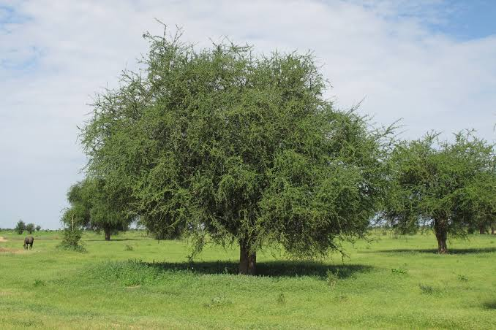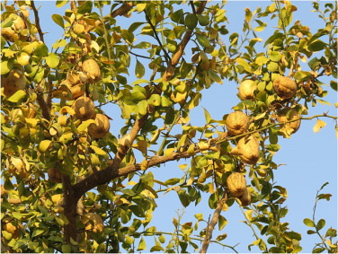
B
A
Figure 1. Mature tree of B. aegyptiaca (A), fruit-bearing branch of B. aegyptiaca (B).
MATERIALS AND METHODS
Presentation of the study area
The study was conducted in the Ouadi-Rimé Ouadi-Achim Faunal Reserve (RFOROA) and its surroundings (Figure 2) located in north-central Chad between latitudes 14° and 17.5°N and longitudes 17.2°-216.5°E (Wacher et al., 2011). It is shared between the provinces of Ba6tha, Borkou, Bahr el Ghazal, Wadi Fira and Ennedi Ouest. This reserve is one of the largest in Africa, covering an area of 7795.00 ha (77950 km²). Overall, RFOROA has an arid to semi-arid desert bioclimate (Hiernaux and Le Houérou, 2006). Rainfall varies in duration and abundance according to latitude, and the gradient is such that average annual rainfall decreases by 1 mm/km as latitude increases. Over the course of the year, relative humidity is extremely low (Hiernaux and Le Houérou, 2006) and average monthly temperatures range from 14 to 42°C (Climate-Data, 2012) depending on the season and latitude, reflecting the harshness of the climate. The vegetation of the Ouadi Rimé-Ouadi Achim reserve is represented by the steppe characteristic of the vegetation of Sahelian zones. The grassy stratum is represented by the following genera: Aristida, Panicum, Cenchrus, Chrozophora, etc. and a few creepers and climbers such as Citrullus colcynthis and Leptadania hastata. Woody plants are represented by: B. aegyptiaca, Vachellia radiana, Vachellia seyal, Boscia senegalensis, Maerua crassifolia, Capparis decidua, Cordia sinensis, Leptadania pyrotecnica, etc.
The reserve is also home to a huge diversity of desert animal species, including: the white-tailed mongoose, common genet, sand cat, fox, fennec, golden jackal, pale fox, ratel, striped hyena, desert antelopes such as the dorcas gazelle, the dama gazelle, which is an emblematic species, the Arab bustard, etc.

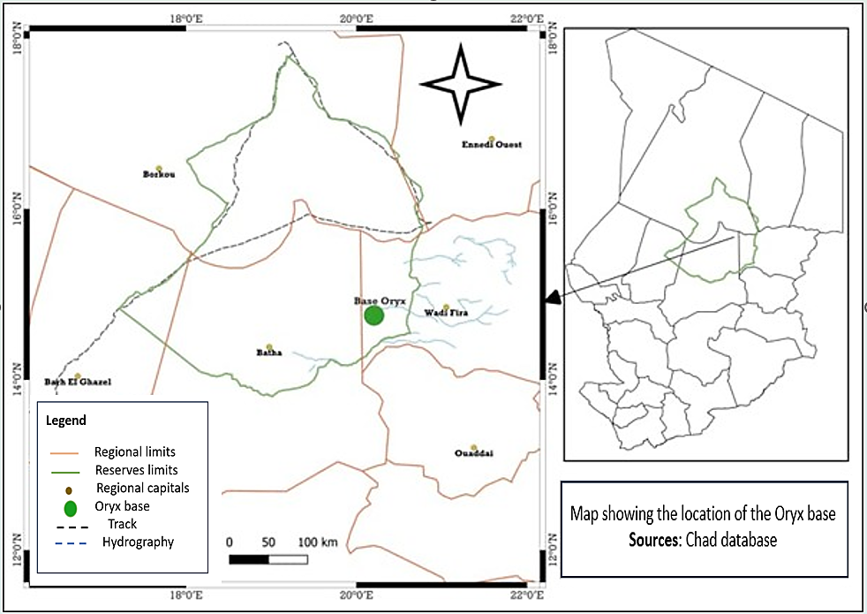
Figure 2. Map showing the location of the study area (Source : Chad database)
Ethnobotanical surveys of farmers
The investigations were conducted among 220 people, comprising 110 women and 110 men living near the park. The respondents were selected using the method described by Diouf et al. (1999), which combines systematic sampling with simple random sampling (Diarassouba et al., 2008). This method has the advantage of being quick, practical and reliable in the field and allows for a regular distribution of the people sampled. The data were collected through ethnobotanical surveys using semi-structured interviews based on a questionnaire. The information sought concerned the vernacular name of B. aegyptiaca, perceptions of its availability, the main threats to it and its various uses. The interviews were conducted with the help of translators. The ethnotypes cited were confirmed through field observations (Albuquerque et al., 2006).

Data analysis and processing
The people surveyed were divided by age category and sex, i.e. young people (age ≤ 30 years), adults (30 < age < 60) and old people (age ≥ 60 years) (Assogbadjo et al., 2008). The analyses focused on the calculation of ethnobotanical indices, namely use value (UV) and frequency of quotation (FC). The following formulae were adopted:
- Relative frequency of citation (FC) (Friedman et al., 1986) :
FC = ($\frac{n}{N}$) x 100 ;
where n is the number of people who cited different varieties of B. aegyptiaca and N is the total number of respondents. We use a threshold of 20% to distinguish between the least and most cited ethnotypes (Tiétiambou et al., 2016). High CF values for a group generally reflect a consensus among informants for that group. According to Kouakou et al. (2020), a species is said to be well known if the level of knowledge is between 50% and 100% ; a species is said to be moderately known if the level of knowledge is between 25% and 50% ; a species is said to be little known if the level of knowledge is between 00% and 25%.

RESULTS
Socio-demographic characteristics of respondents
A total of 220 peoples were surveyed, 110 of them men and 110 women. The majority of respondents were aged over 30 (54.16%) and farmers were the best represented (Table 1). The majority of respondents were aged over 30 (54.16%) and farmers were the best represented.
Table 1. Breakdown by socio-demographic characteristics.
Sexes | Age groups | Single | Monogamous | Polygamous | Widow
Women | Adults | 8 | 46 | 0 | 6
Women | Young | 16 | 18 | 0 | 0
Women | Old | 0 | 6 | 0 | 10
Man | Adults | 2 | 28 | 20 | 0
Man | Young | 12 | 16 | 0 | 0
Man | Old | 0 | 20 | 12 | 0

Relative frequency of citation (FC)
An analysis of the frequency of quotation in relation to the most commonly used plant organs reveals that the level of use varies according to gender and the part of the plant used (Figure 3). However, we note that the level of wood consumption remains the same for both men and women. Fruits and branches are the organs most used by both sexes. These different parts are used for four different purposes: food, energy, medicine and crafts.

Figure 3. Frequency of plant organ use by gender.
Factors responsible for the reduction in B. aegyptiaca stands
Analysis of respondents' answers revealed that several factors contribute to the reduction in the presence of B. aegyptiaca in its range. These include carbonisation, felling, debarking, bush fires, land clearing and urbanisation. Among these factors, felling and debarking are the main factors in the reduction in the distribution area of B. aegyptiaca, according to the respondents (Figure 4).

Figure 4. Types of pressure on forest stands.

Different phytotherapeutic uses of B. aegyptiaca
An analysis of respondents' answers regarding the use of the plant in traditional medicine showed that it is used to treat a number of diseases. These include typhoid, jaundice, dermatitis, malaria, snake bites, scorpion stings, constipation, stomach aches, etc. (Figure 5). This study shows that most parts of the plant are used in the various medical compounds.

Figure 5. Some diseases and the parts of B. aegyptiaca used to treat them.
Strategies for the conservation of B. aegyptiaca by local people
Several strategies for the sustainable management of B. aegyptiaca were reported by local people in different communities. The main measures and strategies proposed by the respondents in this study include assisted natural regeneration (ANR), planting, nurseries and awareness-raising. Analysis of the results of the respondents' answers reveals that assisted natural regeneration and planting are the measures most frequently adopted. These measures are supplemented by awareness-raising, particularly with regard to their socio-economic importance. These existing practices need to be perpetuated and extended throughout the study area. Among the people interviewed, 8.2% stated that they had no conservation strategy for the species. For them, B. aegyptiaca is a forest species and conservation is a natural task, independent of human intervention.
DISCUSSION
The results of this study show that B. aegyptiaca is well known by the local population and that all parts of the plant are appreciated. This result could be explained on the one hand by the cohabitation and transmission of endogenous knowledge between these groups who have been living in the same area for years.
With regard to the frequency with which the different organs reported by the respondents are cited, use varies according to gender. Fruits and branches are the organs most used by both sexes. Similar work was carried out by Abdoulaye et al. (2017) in the Ouaddaï region of Chad. These different parts are used in four different ways: food, energy, medicinal and craft. Similar work was carried out by Abdel Aziz et al. (2019) in Benin. These results are also consistent with those of Abdoulaye et al. (2020) in northern Cote d'Ivoire. The same results were obtained by Abdoulaye et al. (2017) in the Ouaddaï region of Chad and N'Guessan (2019) in Côte d'Ivoire. Work by Chaachouay (2020) in northern Morocco has shown that leaves are the most commonly used organs. Fruits are used more frequently and branches are the most commonly cited parts, followed by wood. The other parts are consumed less frequently. This could be explained by the population's appreciation of fruits and the abundance of these organs during periods of famine. These results are similar to those of Douma (2016), who showed that these same organs were the most commonly consumed.
Anthropogenic pressure seems to play an important role in the destruction of plant cover in the study area. According to the respondents, human pressure on B. aegyptiaca is contributing to the reduction in its habitat area. According to Traoré et al. (2011), farmers in Burkina Faso cut down large areas each year in search of arable land. These results corroborate those of Bindaoudou et al. (2022) in the Amou Prefecture in south-west Togo. Because of the plant's many uses, B. aegyptiaca wood is an important source of energy for the local population. The species is therefore subject to very strong anthropogenic pressure, reducing the plant's distribution area. These results are similar to those obtained by Abdoulaye et al. (2017) in the Ouaddaï region of Chad.
CONCLUSION
The study provided an overview of a wild food plants exploited in north-central Chad, with particular emphasis on characterising its uses. B. aegyptiaca plays an important role for rural populations living in the vicinity of the Ouadi-Rimé Ouadi-Achim Wildlife Reserve. In Chad, the species is present in the floristic procession of the vegetation of the sahel. It is a species of socio-economic interest, most of its parts are used by farmers. The forestry code, which prohibits the cutting of species in agrosystems, must be respected throughout the species' range in Chad. he results of this study constitute a scientific database that will be used by decision-makers to inform their decisions. For example, in the context of restoring degraded land, emphasis could be placed on planting fruit species and ensuring sustainable use of resources. Further research is therefore needed to clarify the ecological conditions required to reconcile the exploitation and conservation of food species in order to ensure the sustainability of their exploitation. However, it is essential to improve the recognition of these plants in the markets and to support their cultivation and marketing in the high-production areas where they originate.

DATA AVAILABILITY
The datasets used and analyzed during the current study are available from the corresponding author on reasonable request.
DISCLAIMER (ARTIFICIAL INTELLIGENCE)
Authors declare they have no conflict of interest/competing interest. Authors hereby declare that NO generative AI technologies such as Large Language Models (ChatGPT, COPILOT, etc.) and text-to-image generators have been used during the writing or editing of this manuscript.
COMPETING INTERESTS
Authors have declared that no competing interests exist.
REFERENCES
Abd El-Aziz M. E., Morsi S. M. M., Salama D. M., Abdel-Aziz M. S., Abd Elwahed M. S., Shaaban, E. A., & Youssef A. M., 2019. Preparation and characterization of chitosan/polyacrylic acid/copper nanocomposites and their impact on onion production. International journal of biological macromolecules, 123, 856-865. Doi :
https://doi.org/10.1016/j.ijbiomac.2018.11.155

Abdoulaye B., Bechir A. B., Mapongmetsem P. M., 2017. Utilités socioéconomiques et culturelles du Balanites aegyptiaca (L) Del. (Famille Zygophyllaceae) chez les populations locales de la Région du Ouaddaï au Tchad. Journal of Applied Biosciences 111 : 10854-10866. ISSN 1997-5902. Doi :http://dx.doi.org/104314/jab.v111i1.2
Abdoulaye C., Ouattara M., N’Guessan E. A., Abrou J. E. N., 2020. Diversité végétale et usages des plantes dans une zone savane soudanienne : Cas de la localité de Ferkessédougou (Nord, Cote d’Ivoire). International Journal of Biological and Chemical Sciences, 14 (8) : 2807-2825. Doi :https://dx.doi.org/10.4314/ijbcs.v14i8.13
Albuquerque U. P., Lucena R. F. P., Monteiro J. M. & Florentino A. T. N., 2006. Evaluating two quantitative ethnobotanical techniques. Ethnobotany Research et Applications, 4:51-60. https://ethnobotanyjournal.org/index.php/era/article/view/101
Arbonnier M., 2019. Arbres, Arbustes et Lianes Des Zones Sèches d’Afrique de l’Ouest. Quae, 775p
Assogba S., Akpinfa É., Gouwakinnou G., Stiem L., Amadji F., Allabi P. M., 2017. La Gestion Durable des Terres : Analyse d'expériences de projets de développement agricole au Bénin. Institute for Advanced Sustainability Studies (IASS).
Assogbadjo A. E., Glèlè Kakaï R., Chadare F. J., Thomson L., Kyndt T., Sinsin B., Van Damme P., 2008. Folk classification, perception and preferences of baobab products in West Africa: consequences for species conservation and improvement. Economic Botany, 62 (1): 74-84. Doi :https://doi.org/10.1007/s12231-007-9003-6
Bindaoudou I. A-K., Koné I. Z., Salihou Djari M. M., 2022. Facteurs explicatifs de la déforestation et de la dégradation forestière dans la Préfecture d’Amou au Sud-Ouest du Togo. International journal of Engineering Science Invention (IJSI). ISSN (Online) : 2319-6734, ISSN (Print) : 2319-6726.
Chaachouay N., 2020. Etude floristique et ethnomédicinale des plantes aromatiques et médicinales dans le Rif (Nord du Maroc). Faculté des Sciences de Kénitra CED Sciences et Techniques, 216p.
Climate-Data, 2012. Climat : Tchad. Doi : https://fr.climate-data.org/afrique/tchad-59/, (04/07/2020).
Douma S., Chaibou R., Mahamane A., N’da D. H., Saadou M., 2010. Etat actuel de dégradation des populations de quatre espèces ligneuses fruitières en zone soudanienne du Niger : réserve totale de faune de Tamou. Revue Ivoirienne des Sciences et Technologie, 16 : 191-210. http://revist.net/REVISTˍ16/REVISTˍ16ˍ10.pdf
Friedman M., Thoresen C. E., Gill J. J., Ulmer D., Powell L. H., Price V. A., ... Dixon T. (1986). Alteration of type A behavior and its effect on cardiac recurrences in post myocardial infarction patients : summary results of the recurrent coronary prevention project. American heart journal, 112(4), 653-665. Doi : https://doi.org/10.1016/0002-8703(86)90458-8
Ganaba S. ; Ouadba J. M. ; Bognounou O., 2004. Plantes de construction d’habitations en région sahélienne. Bois des trophiques, 282(4) :11-17. Doi : http://doi.org/10.19182/bft2004.282.a20215.
Ganaba S., 2008. Caractérisation, utilisations, tests de restauration et gestion de la végétation ligneuse au Sahel, Burkina Faso. Thèse de doctorat d’Etat, université Cheik Anta Diop de Dakar, 287p.
Guigma Y., Zerbo P., Millogo-Rasolodimby J., 2012. Utilisation des espèces spontanées dans trois villages contigus du Sud du Burkina Faso. Tropicultura, 30 (4).
Hama S. M., Mahmoud A. S., Yassen M. M., 2019. Flexural behavior of reinforced concrete beam incorporating waste glass powder. In Structures, 20, pp. 510-518). Elsevier. Doi :https://doi.org/10.1016/j.istruc.2019.05.012
Hiernaux P. ; Le Houerou H. N., 2006. Les parcours du Sahel. In sécheresse, 17 (1-2), p51-57.
Kouakou, Y. B., Kougbo, M. D., Konan, A. S., Malan, D. F., & Bakayoko, A. (2020). Usages traditionnels et disponibilite des plantes exploitees dans l’artisanat chez les populations koulango et lobi de la peripherie est du parc national de la comoe, Côte d’Ivoire. European Journal of Soil Science, 16 (9), 1857-7881. Doi :https://doi.org/10.19044/esj.2020.v16n9p295
Mpondo M.E., Ngene J.P., Mpounze S.L., Etame L.G., Boumsong. G.C.P., Yinyang J. & Dibong S.D. 2017. Connaissances et usages traditionnels des plantes médicinales du département du haut Nyong. Journal of Applied Biosciences, 113 : 11229-11245. Doi :https://dx.doi.org/10.4314/jab.v113i1.12
Normand D., Chatelet R., 1955. Sur le bois de quatre espèces africaines (Césalpiniacées, Ochnacée et Huacée). Journal d'agriculture traditionnelle et de botanique appliquée, 2(1), 19-27.
Oumar, D., Djekota, C. N., Sabo, p., & Mbaide, Y., 2023. Farming of white gum tree: Senegalia senegal (l.) willd. in the Chari Baguirmi Region of Chad. International Journal of Engineering Sciences & Research Technology. Doi :http://doi.org/110.5281/zenodo.10209615
Rabiou H. ; Moussa M., Tougiani A., Mahamane A., Mahamane L., Patrick V. D., 2020. Structure et régénération des peuplements naturels de Balanites aegyptiaca (L) Del. Et Ziziphus mauritiana Lam. suivant un gradient écologique dans la région de Maradi au Niger. Africa focus, 33 :83-104. Doi : https://doi.org/10.1163/2031356X-03301006
Sinsin B., Eyog Matig O., Assogbadjo A. E., Gaoué O. G., Sinadouwirou T., 2004. Dendrometric characteristcs as indicators of pressure of Afzelia africana Sm. Dynamic changes in trees found in different climatic zones of Benin. Biodiversity and conservation, 13 : 1555-1570. Doi : https://doi.org/10.1023/B:BIOC.0000021328.56517.46
Tiétiambou F. R. S. T., Lykke A. M., Korbéogo G., Thiombiano A., Ouédraogo A., 2016. Perceptions et savoirs locaux sur les espèces oléagineuses locales dans le Kénédougou, Burkina Faso. Bois & Forets des Tropiques, 327, 39-50. Doi :https://doi.org/10.19182/bft2016.327.a31295
Traoré L., Ouédraogo I., Ouédraogo A. & Thiombiano A., 2011. Perceptions, usages et vulnérabilité des ressources végétales ligneuses dans le Sud-ouest du Burkina Faso. International Journal of Biological and Chemical Sciences. 5(1): 258-278. Doi :https://doi.org/10.4314/ijbcs.v5i1.68103
Wacher, T., Wronski, T., Hammond, R. L., Winney, B., Blacket, M. J., Hundertmark, K. J., ... Bleidorn, C. (2011). Phylogenetic analysis of mitochondrial DNA sequences reveals polyphyly in the goitred gazelle (Gazella subgutturosa). Conservation genetics, 12 : 827-831. Doi : https://doi.org/10.1007/s10592-010-0169-6
Yossi, H., Kaya, B., Traoré, C. O., Niang, A., Butare, I., Levasseur, V., & Sanogo, D. (2006). Les haies vives au Sahel : état des connaissances et recommandations pour la recherche et le développement. World Agroforestry Centre.

