Extraction Optimization For Comparative Phytochemical Profiling and Antioxidant Properties of Calotropis procera Leaves and Zanthoxylum decaryi Barks

.
ABSTRACT

Calotropis procera and Zanthoxylum decaryi are endemic plants of Madagascar that have recently attracted scientific interest due to their invasive nature and their potential valorization as sustainable biomass resources. Those two plant materials are traditionally used in different ethno medicines to cure ailments. The study focuses on the phytochemical analysis and antioxidant evaluation of Calotropis procera leaves (CPL) and Zanthoxylum decaryi bark (ZDB), two endemic plant species of Madagascar with promising applications in pharmaceutical and cosmetic formulations. The main objectives are: (1) To characterize the phytochemical composition of CPL and ZDB; (2) To assess their antioxidant activity using spectrophotometric assays (TPC, DPPH, ABTS); and (3) To perform qualitative and quantitative analysis of phenolic compounds via LC-MS. Limited information is available regarding the detailed chemical composition of these plants and their specific parts. This study aims to address this knowledge gap through comprehensive phytochemical screening and the evaluation of their antioxidant activities. A better understanding of these plants would help to manage them correctly in the wild. Indeed, they are two endangered species, making their promotion within the modern scientific community crucial. Besides, the study of natural products, including those two Malagasy plants, is of huge relevance in the current scientific context.

Keywords: Calotropis procera; Zanthoxylum decaryi; Madagascar; chemical composition; antioxidant activity; phytochemical

1. INTRODUCTION

Calotropis procera is a plant native to western Asia and intertropical Africa.[1] Introduced to Madagascar for its medicinal properties, it has since spread widely, to the detriment of other plants on the island.[2] The first precise description of this species dates back to 293 A.D. and was written by Abu Hanifah.[3] The plant belongs to the Asclepiadaceae family, a name that refers to Asclepius, the Greek god of medicine.[4]
Calotropis procera is a plant that grows in arid and semi-arid regions.[5] It is mainly found in the equatorial zone and extends over a vast geographical area.[6] It has been described as an invasive species because of its widespread and its harmful effects on ecosystems.[7] It is considered a weed in various regions and thrives in a variety of habitats, such as along rivers, roads and even deserts.[8] To limit its spread, various methods are employed: uprooting when numbers are low, and chemical control with herbicides such as 2,4-dichlorophenoxyacetic acid or Triclopyr when numbers are high.[4]
Calotropis procera is a bush that can grow up to five meters in height. It can be recognized by its large, green, obovate leaves, measuring around thirty centimeters.[3] The leaves are joined in opposing pairs, creating a crisscross pattern. In fact, they are attached in such a way that each pair is positioned perpendicular to the next.

Zanthoxylum decaryi is a plant native of southern Madagascar, with diverse vernacular names such as fahavalonkazo, manago, manako, manango, manongo, manongolahy, manongovola (all in Malagasy) and monongo (in Malagasy and French). Z. decaryi is a thorny tree belonging to the Rutaceae family. The average height of the tree is 5 meters, with a maximum height of 8 meters.[9,10]
Zanthoxylum decaryi barks are only described for their alkaloids. Vaquette et al.[10] highlighted 4 of them : the dictamnine (furoquinolein alkaloid), the skimmianine (furoquinolein alkaloid), the 4-methoxy-1-methyl-2-quinolone (quinoline alkaloid) and 9-methoxy-10-hydroxy-2,3-methylenedioxybenzophenanthridine also known as decarine (isoquinoline alkaloid). It has been postualated that decarine has a benzophenanthridine structure, inducing an anti-tumoral and anti-inflammatory potential.[11]
Zanthoxylum decaryi H. Perrier, 1948 is little described, unlike Zanthoxylum rhetsa, a species close to Z. decaryi. Because of scientific classification similarity, a phytochemical composition similarity can be brought to the fore. Maduka and Ikpa [12] explained in a review that the main compounds of Z. rhetsa are alkaloids, phenolics and terpenoids. The same alkaloids of Z. decaryi have been found in Z. rhetsa, additionally to other alkaloids (rutaecarpine, canthin-6-One, evodiamine).[13] In Z. rhetsa, phenolic compounds such as lignans (yangambin, kobusin, sesamin, syringaresinol) and coumarin (xanthyletin), and terpenoids compounds (lupeol, 3,5-dimethoxy-4- geranyloxycinnamyl alcohol) have also been described.[13–15] Various biological properties are also pointed out, such as antibacterial, anti-inflammatory, antinociceptive and antidiarrhea, antioxidant, cytotoxic, thrombolytic activity and photoprotective properties. Zanthoxylum rhetsa is used in folk medicine, for the treatment of dental caries, dizziness and bloating, malaria, urinary diseases, rheumatism, diuretic, stomachache and diarrhea. Because of scientific classification similarity, a phytochemical composition similarity can be indeed brought to the fore.

2. material and methods

2.1. Plant material

Leaves of Calotropis procera (CPL) and bark of Zanthoxylum decaryi (ZDB) were collected in July 2021 in Toliara District 2, Madagascar. The plant materials were air-dried at room temperature (25 °C) for three weeks and four days in the absence of light, then finely ground using an electric grinder. The resulting powders were stored at room temperature until further use. The time elapsed between harvesting and analysis may have caused potential deterioration of plant material, raising concerns about the stability of the compounds.

2.2. Trial environment conditions

Extractions, spectrophotometric assays, and HPLC analyses were carried out in the Hauts-de-France region in February 2025.

2.3. Chemicals

Ethanol absolute anhydrous ≥99.9%; CAS No: 64-17-5; CARLO ERBA; France
The water used was purified using a Purelab Chorus system (resistivity >18 MΩ cm; ELGA).
Folin-Ciocalteu’s Reagent for clinical diagnosis; PanReac AppliChem; Spain
Sodium carbonate; CAS No: 497-19-8; PROLABO; France
Gallic acid 98%; CAS No: 149-91-7; Thermo Scientific; USA
2,2-diphenyl-1-picrylhydrazyl (DPPH); CAS No: 1898-66-4; SIGMA-ALDRICH; India
Methanol ≥99.9%; CAS No: 67-56-1; CARLO ERBA; France
(±)-6-Hydroxy-2,5,7,8-tetramethylchromane-2-carboxylic acid (trolox) 97%; CAS No: 53188-07-8; SIGMA-ALDRICH; Switzerland
2,2’Azino-bis(3-ethylbenzothiazoline-6-sulfonic acid) diammonium salt (ABTS) ≥98% (HPLC); CAS No: 30931-67-0; SIGMA-ALDRICH; USA
Potassium persulfate; CAS No: 7727-21-1; SIGMA-ALDRICH; USA
2.4. Extraction methods

Two extraction methods, maceration and decoction, were employed to recover secondary metabolites from CPL and ZDB. Ethanol and water were selected as solvents to maximize extraction yield, based on the polarity of the target compounds.
For maceration, 10 g of raw plant material were immersed in 200 mL of an ethanol–water mixture at room temperature (25 °C) under moderate stirring for 20 h. For decoction, 10 g of raw material were boiled under reflux in 200 mL of an ethanol–water mixture, and under stirring for 1 h. Both solvent ratios, ethanol–water (4:1, v/v) and ethanol–water (1:1, v/v), were tested for each extraction procedure. These two extraction approaches were selected to facilitate future method transfer to the Malagasy laboratory context.
Following extraction, the mixtures were centrifuged at 4,000 rpm for 10 min to separate the liquid and solid phases. The supernatant was filtered using the Büchner method with Whatman filter paper. Ethanol was subsequently removed using a rotary evaporator in a 40 °C water bath. The aqueous fraction was frozen at −32 °C and then lyophilized at −80 °C for 24 h under 0.5 mbar. The dried extracts were stored at 4 °C until further use.
No technical or biological replicates were performed for the different extractions.

2.5. Spectrophotometric tests

2.5.1. Total Phenolic Content

The total phenolic content (TPC) of the extracts was determined using the Folin–Ciocalteu colorimetric method, which quantifies phenolic compounds based on their reducing capacity. This method was adapted from Singleton and Rossi (1965).[16]
For the assay, 400 µL of extract solution (1 mg/mL), gallic acid standard (calibration curve), or distilled water (blank) were mixed with 2 mL of Folin–Ciocalteu reagent (0,2 N). The mixture was vortexed and incubated in the dark at 25 °C for 5 min. Subsequently, 1,6 mL of sodium carbonate solution (75 g/L) was added, followed by vortexing and incubation for 1 h at 25 °C in the dark.
All measurements were performed in triplicate. Absorbance was recorded at 765 nm using a UV–Vis spectrophotometer. A calibration curve was prepared with gallic acid (10–200 mg/L), and results were expressed as milligrams of gallic acid equivalents per gram of dry extract (mg GAE/g DE).

2.5.2. Antioxidant activities

2.5.2.1. DPPH Assay

The antioxidant activity was studied using 2,2-diphenyl-1-picrylhydrazyl free radical (DPPH), with some modifications of the Blois [39] method. In a test tube, a 100 µL volume of samples (1 mg/mL), daughter solutions (calibration curve), 96% ethanol (negative blank) or water (blank) is added to 3 mL of a methanolic DPPH solution (0,1 M). The mixture is vortexed, then incubated at 25 °C in the dark for 30 minutes. This operation is performed in triplicate for all sample solutions. Absorbance is measured on a UV-Visible spectrophotometer at 517 nm. A calibration curve ranging from 0,05 to 0,3 mg/mL is plotted using trolox as the reference standard. Sample concentrations are expressed in µmol of trolox equivalent per grams of dried extract (µmol TE / g DE).
2.5.2.2. ABTS Assay

The antioxidant activity of plant extracts was also evaluated using the ABTS^{•+} (2,2'-azino-bis(3-ethylbenzothiazoline-6-sulfonate)) radical cation decolorization assay, adapted from Re et al. (1999).[17]
Preparation of stock solutions. An ABTS stock solution (8 mM) was prepared by dissolving 124 mg of ABTS in 30 mL of ethanol. A potassium persulfate stock solution (3 mM) was prepared by dissolving 24,33 mg of K₂S₂O₈ in 30 mL of ethanol.
Generation of the ABTS^{•+} radical. The ABTS^{•+} radical cation was generated by mixing equal volumes of the ABTS (8 mM) and potassium persulfate (3 mM) solutions (5 mL each). The mixture was stored in the dark at room temperature for 12–16 h to ensure complete radical formation.
Working solution and assay procedure. Prior to analysis, the radical solution was diluted with ethanol (1 mL of ABTS^{•+} solution in 9 mL of ethanol) to obtain the working solution. For the assay, 100 µL of sample solution (1 mg/mL), Trolox standards (calibration curve), or 50% ethanol (blank) were mixed with 2,9 mL of the ABTS^{•+} working solution in test tubes. The mixtures were vortexed and incubated in the dark at 25 °C for 30 min.
All determinations were carried out in triplicate. Absorbance was recorded at 734 nm using a UV–Vis spectrophotometer. A standard calibration curve was prepared with Trolox, and antioxidant activity was expressed as µmol Trolox equivalents per grams of dry extract (µmol TE/g DE).
2.5.3. High-Performance Liquid Chromatography analysis (HPLC-PDA-TOF)
Each plant extract (5 g/L) was analyzed by high-performance liquid chromatography (HPLC). The chromatographic separation was performed on a CSH C18 column (1,7 µm, 2,1 × 150 mm, Acquity, Waters) maintained at 50 °C. The mobile phase consisted of acetonitrile (solvent A) and water containing 1% formic acid (solvent B). The flow rate was set at 0,5 mL/min, the injection volume at 1 µL, and detection was carried out using a photodiode array (PDA) detector, with particular focus on 280 nm. Samples were eluted according to the gradient program described in Table 1.
Compound identification was achieved by comparing retention times with those of authentic standards. Additionally, high-definition time-of-flight (HD-TOF) mass spectrometry was performed in electrospray ionization (ESI) mode, applying elevated collision energies (6 V), to support compound characterization.
Table 1. Solvent gradient of the HPLC method

Time (min) | Solvent A (%) | Solvent B (%)
5 | 15 | 85
10 | 25 | 75
15 | 25 | 75
30 | 35 | 65
40 | 35 | 65
55 | 50 | 50
65 | 50 | 50
70 | 80 | 20
82 | 10 | 90
92 | / | /

3. results and discussion

3.1. Total phenolic compounds (TPC)
According to the TPC assay (Figure 1), ZDB extracts exhibited 3-fold higher phenolic content than CPL extracts. The presence of these metabolites in both bark and leaves is consistent with their protective roles, as they contribute to UV shielding and defense against prolonged environmental stresses and herbivory.
For CPL, phenolic concentrations were higher when extracts were obtained by decoction. This can be attributed to the effect of heat, which disrupts cell wall structures and enhances the release of bound polyphenols. Among the solvents tested, the ethanol–water (4:1, v/v) mixture yielded the highest phenolic content in both maceration and decoction, although TPC values obtained with the two solvent ratios were relatively similar under decoction conditions.
A similar trend was observed for ZDB, where decoction resulted in higher phenolic yields compared to maceration. However, in this case, the most effective solvent mixture differed between extraction methods. The highest TPC value for ZDB was obtained with decoction using ethanol–water (1:1, v/v).
Overall, the results suggest that decoction with ethanol–water (1:1, v/v) represents the most suitable extraction condition for maximizing phenolic recovery from both plant materials.

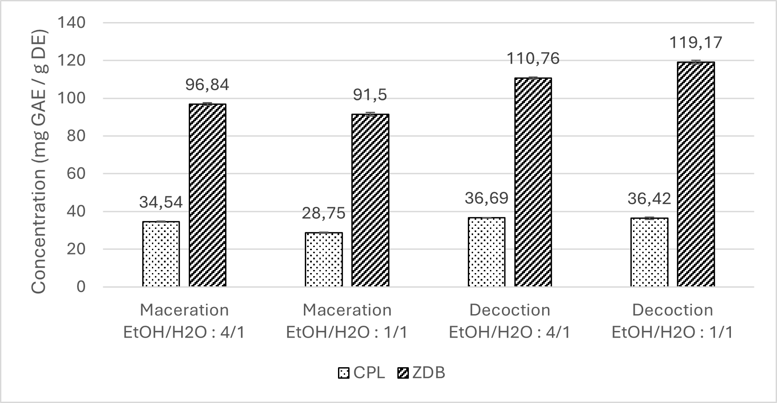
A technical triplicate was performed for each sample. (R² = 0.9999)
Maceration extraction: 10 g of raw plant material, 200 mL solvent mixture, room temperature (25 °C), stirring, 20 h. Decoction extraction: 10 g of raw material, 200 mL of solvent mixture, 100 °C (reflux), stirring, 1 h.

Fig. 1. TPC assays on CPL and ZDB

3.2. Antioxidant activity

The antioxidant activity of CPL and ZDB extracts was evaluated using the DPPH assay (Figure 2). Overall, ZDB extracts exhibited 4-fold higher DPPH scavenging activity than CPL extracts. For both plant materials, the ethanol–water (4:1, v/v) solvent mixture produced the highest activity, particularly when combined with decoction. In all cases, decoctions yielded stronger antioxidant activities than macerations with the same solvent system. Consequently, decoction with ethanol–water (4:1, v/v) represents the most effective condition for maximizing the DPPH scavenging capacity of both CPL and ZDB. These findings highlight the potential applications of these species, particularly ZDB, in the cosmetic and pharmaceutical sectors.
Phenolic compounds are well-recognized contributors to antioxidant activity. As shown earlier, the highest TPC value for ZDB was obtained with decoction using ethanol–water (1:1, v/v). However, in the DPPH assay, the ethanol–water (4:1, v/v) mixture provided superior antioxidant activity compared to ethanol–water (1:1, v/v). A similar pattern was observed for CPL: while decoction with both solvent systems yielded comparable phenolic contents, DPPH activity was significantly higher with ethanol–water (4:1, v/v). This discrepancy suggests that, in addition to phenolic compounds, other classes of bioactive molecules likely contribute to the antioxidant activity of both CPL and ZDB.

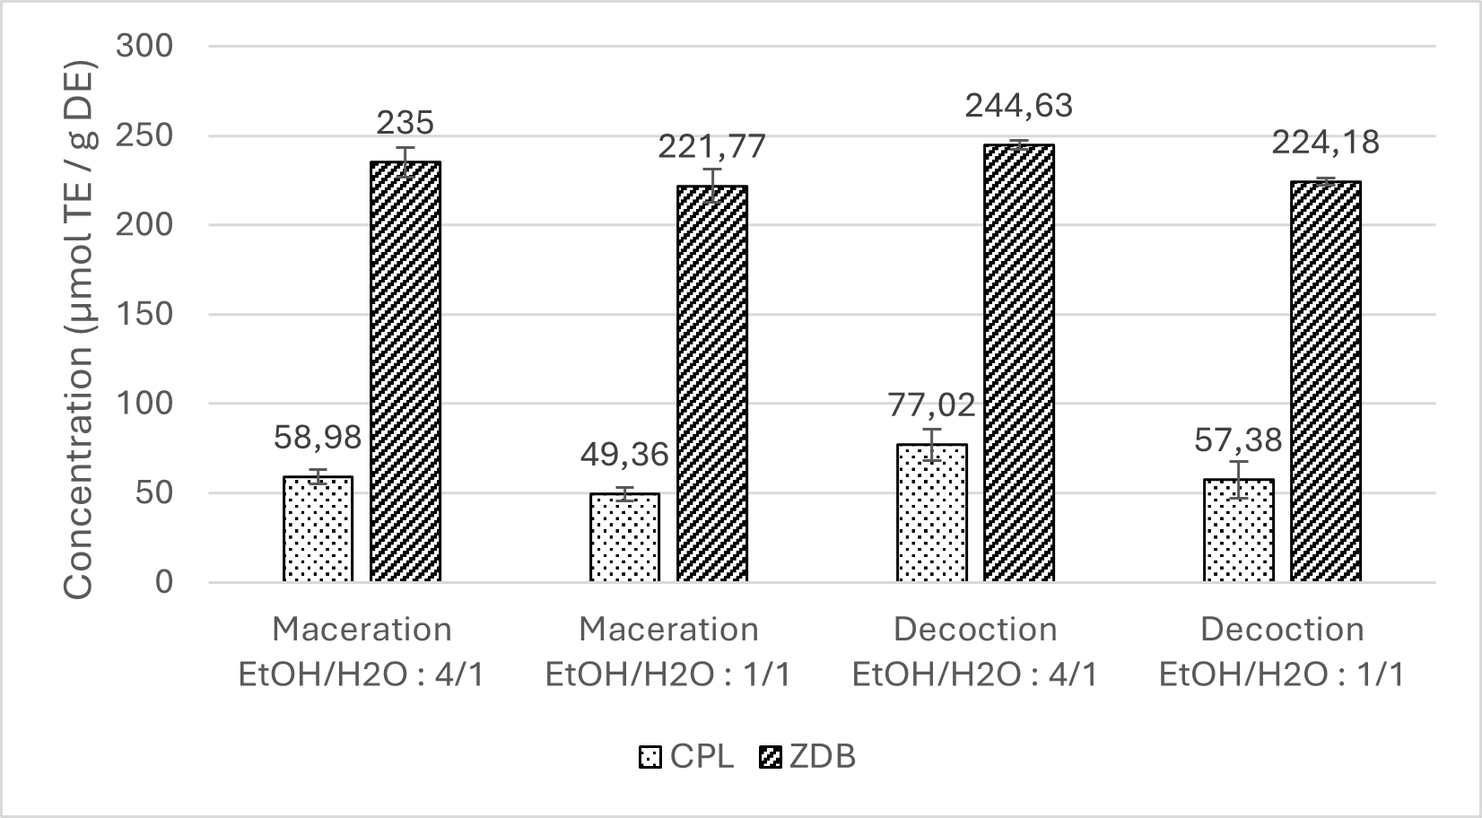
A technical triplicate was performed for each sample. (R² = 0.9951)
Maceration extraction: 10 g of raw plant material, 200 mL solvent mixture, room temperature (25 °C), stirring, 20 h. Decoction extraction: 10 g of raw material, 200 mL of solvent mixture, 100 °C (reflux), stirring, 1 h.

Fig. 2. DPPH assays on CPL and ZDB

The ABTS assay was also performed on CPL and ZDB extracts (Figure 3). Globally, ZDB extracts exhibited 2.5-fold higher ABTS antioxidant activity than CPL extracts. For CPL, extracts prepared with ethanol–water (4:1, v/v) exhibited higher antioxidant activity than those obtained with the ethanol–water (1:1, v/v) mixture. Among these, the ethanol–water (4:1) decoction provided the strongest response.
All four ZDB extracts demonstrated consistently high activity in the ABTS assay. In particular, decoction extracts showed higher activity than macerations, with the best result obtained for ethanol–water (1:1, v/v). When comparing results across the different assays, the most effective extraction process for Calotropis procera leaves was consistently the ethanol–water (4:1) decoction, regardless of the method used (TPC, DPPH, or ABTS). For Zanthoxylum decaryi barks, decoction was also the most relevant approach. While the ethanol–water (1:1) mixture proved most effective in the ABTS and TPC assays, the ethanol–water (4:1) mixture yielded superior performance in the DPPH assay. This divergence suggests that different antioxidant compound families contribute variably across assays, with decoction emerging as the optimal extraction strategy overall.

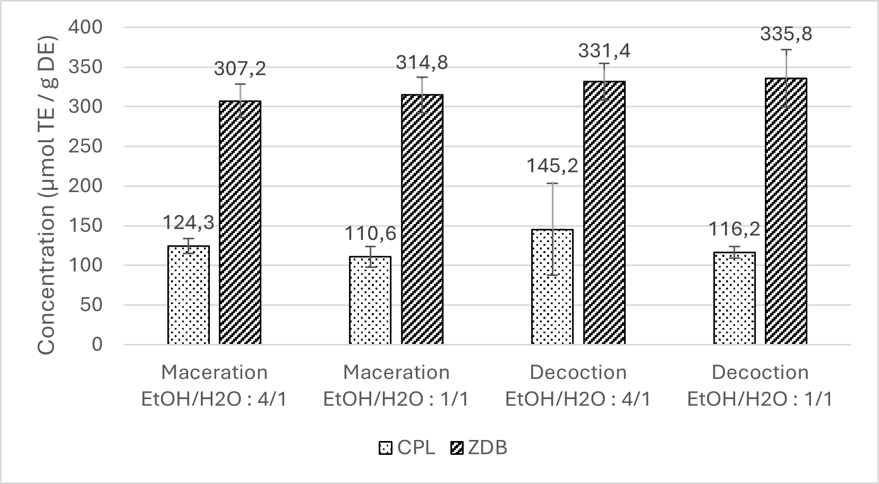
A technical triplicate was performed for each sample. (R² = 0.9951)
Maceration extraction: 10 g of raw plant material, 200 mL solvent mixture, room temperature (25 °C), stirring, 20 h. Decoction extraction: 10 g of raw material, 200 mL of solvent mixture, 100 °C (reflux), stirring, 1 h.

Fig. 3. ABTS assays on CPL and ZDB

The correlation coefficients obtained between total polyphenol content and antioxidant activity show varying levels of correlation, as shown in the data in Table 2.

Table 2. Correlation between antioxidant activity and total polyphenol content of CPL and ZDB extracts

Extract | Criterion | DPPH | ABTS
CPL | Maceration | 0,9070 | 0,7533
CPL | Decoction | 0,6760 | 0,3321
CPL | EtOH/H₂O : 4/1 | 0,6926 | -0,4440
CPL | EtOH/H₂O : 1/1 | 0,1991 | -0,1674
ZDB | Maceration | 0,6815 | -0,3372
ZDB | Decoction | -0,9850 | 0,1449
ZDB | EtOH/H₂O : 4/1 | 0,6815 | -0,7488
ZDB | EtOH/H₂O : 1/1 | -0,9850 | 0,5812

The differences between DPPH and ABTS radical scavenging activities can be attributed to the reaction medium. The DPPH assay is usually performed in a medium composed of ethanol–water (1:1, v/v), while the ABTS assay is carried out in aqueous conditions. In addition, the solubility of flavonoids in both mediums must be considered. Some bioactive compounds may not be or less soluble in the reaction medium of the assay and may not or less exhibit radical scavenging activity.
Also, different radicals have different antioxidant potential when they react with phenolic compounds. Indeed, both radicals may dissolve differently, and their molecular sizes are different. The ABTS radical must be formed initially, while DPPH is a stabilized radical by itself. In addition, they may also have different affinities with other compounds present in the samples, and they do not have a high specificity for phenolic compounds.

3.3. LC-MS identification

3.3.1. Molecular identification

UHPLC–HRMS analysis enabled the identification of the major phenolic compounds in Calotropis procera leaves. In descending order of abundance, the predominant compounds were narcissin (4), manghaslin (1), kaempferol-3-O-rutinoside (3), and rutin (2). These results are primarily qualitative (Table 3).

Table 3. Molecular identification of Calotropis procera leaves

Retention time (min) | m/z | Molecular formula (neutral) | Type of molecule | Hypothetical molecule
18.581 | 756.2106 | C₃₃H₄₀O₂₀ |  | Manghaslin
18.581 | 755.2032 | C₃₃H₄₀O₂₀ | [M–H]⁻ | Manghaslin
22.172 | 610.1542 | C₂₇H₃₀O₁₆ | Neutral molecule | Rutin
22.172 | 609.1533 | C₂₇H₃₀O₁₆ | [M–H]⁻ | Rutin
22.172 | 633.1400 | C₂₇H₃₀O₁₆ | [M+Na]⁺ | Rutin
22.172 | 303.1437 | C₁₅H₁₀O₇ | [M–Rhamnose–Glucose+H]⁺ | Rutin
22.777 | 594.1594 | C₂₇H₃₀O₁₅ | Neutral molecule | Kaempferol-3-O-rutinoside
22.777 | 593.1521 | C₂₇H₃₀O₁₅ | [M–H]⁻ | Kaempferol-3-O-rutinoside
22.777 | 617.1454 | C₂₇H₃₀O₁₅ | [M+Na]⁺ | Kaempferol-3-O-rutinoside
22.777 | 595.1643 | C₂₇H₃₀O₁₅ | [M+H]⁺ | Kaempferol-3-O-rutinoside
22.777 | 449.1047 | C₂₁H₂₀O₁₁ | [M–Rhamnose+H]⁺ | Kaempferol-3-O-rutinoside
22.777 | 287.0544 | C₁₅H₁₀O₆ | [M–Rhamnose–Glucose+H]⁺ | Kaempferol-3-O-rutinoside
26.845 | 624.1704 | C₂₈H₃₂O₁₆ | Neutral molecule | Narcissin
26.845 | 623.1651 | C₂₈H₃₂O₁₆ | [M–H]⁻ | Narcissin
26.845 | 625.1740 | C₂₈H₃₂O₁₆ | [M+H]⁺ | Narcissin
26.845 | 479.1164 | C₂₂H₂₂O₁₂ | [M–Rhamnose+H]⁺ | Narcissin
26.845 | 317.0645 | C₁₆H₁₂O₇ | [M–Rhamnose–Glucose+H]⁺ | Narcissin

Manghaslin (C₃₃H₄₀O₂₀) was detected at m/z 756.2106, with a [M–H]⁻ ion at m/z 755.2032.
Rutin (C₂₇H₃₀O₁₆) was identified at m/z 610.1542, displaying a [M–H]⁻ ion at m/z 609.1533, a [M+Na]⁺ ion at m/z 633.1400, and a positive fragmentation ion at m/z 303.1437 (C₁₅H₁₀O₇), consistent with the simultaneous loss of rhamnose (–146 Da) and glucose (–162 Da) units.
Kaempferol-3-O-rutinoside (C₂₇H₃₀O₁₅) was detected at m/z 594.1594, with a [M–H]⁻ ion at m/z 593.1521, a [M+Na]⁺ ion at m/z 617.1454, and a [M+H]⁺ ion at m/z 595.1643. Fragmentation produced a [M+Na]⁺ ion at m/z 475.3232 (C₂₃H₄₈O₈), a positive ion at m/z 449.1047 (C₂₁H₂₀O₁₁) corresponding to the loss of rhamnose (–146 Da), and a positive ion at m/z 287.0544 (C₁₅H₁₀O₆) indicating the subsequent loss of glucose (–162 Da).
Narcissin (C₂₈H₃₂O₁₆) was observed at m/z 624.1704, with a [M–H]⁻ ion at m/z 623.1651 and a [M+H]⁺ ion at m/z 625.1740. Fragmentation generated a positive ion at m/z 479.1164 (C₂₂H₂₂O₁₂), reflecting the loss of rhamnose (–146 Da), and a positive ion at m/z 317.0645 (C₁₆H₁₂O₇), corresponding to the additional loss of glucose (–162 Da).
These results highlight the predominance of flavonoid glycosides in C. procera leaves, compounds well-documented for their antioxidant and pharmacological activities.

Liquid chromatography–mass spectrometry (LC–MS) analysis was performed to identify the major phenolic compounds in ZDB extracts (Table 4). Among four prominent peaks, the most abundant compound (peak 4) was identified as hesperidin.

Table 4. Molecular identification of Zanthoxylum decaryi barks

Retention time (min) | m/z | Molecular formula (neutral) | Type of ion | Hypothetical molecule
19.653 | 582.2322 | C₂₈H₃₈O₁₃ | Neutral molecule | Peak 1, No hypothesis
19.653 | 581.2248 | C₂₈H₃₈O₁₃ | [M–H]⁻ | Peak 1, No hypothesis
19.653 | 551.2146 | C₂₇H₃₆O₁₂ | [M–H]⁻ | Peak 1, No hypothesis
19.653 | 605.2191 | C₂₈H₃₈O₁₃ | [M+Na]⁺ | Peak 1, No hypothesis
19.653 | 575.2078 | C₂₇H₃₆O₁₂ | [M+Na]⁺ | Peak 1, No hypothesis
19.653 | 249.1115 | C₁₄H₁₆O₄ | [M+H]⁺ | Peak 1, No hypothesis
21.404 | 584.2479 | C₃₅H₄₄O₁₂ | Neutral molecule | Peak 2, No hypothesis
21.404 | 583.2443 | C₃₅H₄₄O₁₂ | [M–H]⁻ | Peak 2, No hypothesis
21.404 | 607.2338 | C₃₅H₄₄O₁₂ | [M+Na]⁺ | Peak 2, No hypothesis
23.106 | 333.0981 | C₂₀H₁₅NO₄ | Neutral molecule | Peak 3, No hypothesis
23.106 | 334.1077 | C₂₀H₁₅NO₄ | [M+H]⁺ | Peak 3, No hypothesis
23.106 | 607.2339 | / | [M’+H]⁺ | Peak 3, No hypothesis
29.503 | 610.1888 | C₂₈H₃₄O₁₅ | Neutral molecule | Hesperidin
29.503 | 609.1837 | C₂₈H₃₄O₁₅ | [M–H]⁻ | Hesperidin
29.503 | 301.0755 | C₁₆H₁₄O₆ | [M–Glucose–Rhamnose–H]⁻ | Hesperidin
29.503 | 633.1780 | C₂₈H₃₄O₁₅ | [M+Na]⁺ | Hesperidin
29.503 | 611.1962 | C₂₈H₃₄O₁₅ | [M+H]⁺ | Hesperidin
29.503 | 449.1434 | C₂₂H₂₄O₁₀ | [M–Glucose+H]⁺ | Hesperidin
29.503 | 303.0860 | C₁₆H₁₄O₆ | [M–Glucose–Rhamnose+H]⁺ | Hesperidin

Peak 1 (C₂₈H₃₈O₁₃), detected at m/z 582.2322, displayed a [M–H]⁻ ion at m/z 581.2248 and a [M+Na]⁺ ion at m/z 605.2191. Fragmentation ions included a [M–H]⁻ ion at m/z 551.2146 (C₂₇H₃₆O₁₂), a [M+Na]⁺ ion at m/z 575.2078 (C₂₇H₃₆O₁₂), and a [M+H]⁺ ion at m/z 249.1115 (C₁₄H₁₆O₄).
Peak 2 (C₃₅H₄₄O₁₂), observed at m/z 584.2479, showed a [M–H]⁻ ion at m/z 583.2443, and a [M+Na]⁺ ion at m/z 607.2338.
Peak 3 (C₂₀H₁₅NO₄), identified at m/z 333.0981, presented a [M+H]⁺ ion at m/z 334.1077, along with an additional [M+H]⁺ ion at m/z 607.2339.
Peak 4 (hesperidin) (C₂₈H₃₄O₁₅), detected at m/z 610.1888, exhibited a [M–H]⁻ ion at m/z 609.1837, a [M+Na]⁺ ion at m/z 633.1780, and a [M+H]⁺ ion at m/z 611.1962. Characteristic fragmentation ions confirmed its identity: a positive ion at m/z 449.1434 (C₂₂H₂₄O₁₀), corresponding to the loss of a glucose unit (–162 Da), and ions at m/z 303.0860 (positive mode) and m/z 301.0755 (negative mode; C₁₆H₁₄O₆), consistent with the additional loss of a rhamnose unit (–162 Da).

3.3.2. Molecular quantification

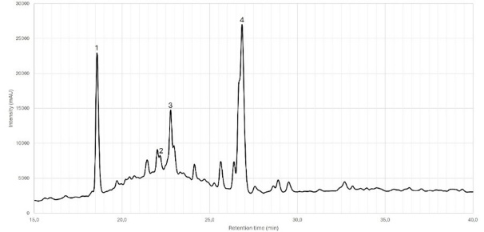 | 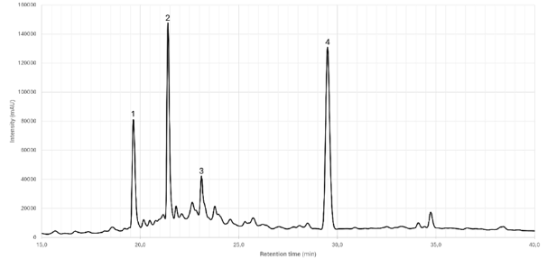

Fig. 4. Chromatographic spectra of Calotropis procera leaves (left) and Zanthoxylum decaryi barks (right)

In addition, the molecules identified in CPL and ZDB are analyzed quantitatively. However, only rutin and hesperidin were properly quantified because of a lack of internal standards (Table 4 and Table 5).

Table 5. Molecular quantification of Calotropis procera leaves

Peak / Molecule | Retention time (min) | Ratio of molecules in sample (%Area) | Concentration (mg/L) | λ_{max} (nm)
1 / Manghaslin | 18.581 | 5.616 | n.d. | 237, 255, 279, 313
2 / Rutin | 22.172 | 1.549 | 7.15 | 237, 355
3 / Kaempferol-3-O-rutinoside | 22.777 | 4.747 | n.d. | 237, 282, 292
4 / Narcissin | 26.845 | 11.156 | n.d. | 237, 286, 355
*n.d. = Not determined

Table 6. Molecular quantification of Zanthoxylum decaryi barks

Peak / Molecule | Retention time (min) | Ratio of molecules in sample (%Area) | Concentration (mg/L) | λ_{max} (nm)
1 | 19.653 | 7.529 | n.d. | 238, 283
2 | 21.404 | 11.620 | n.d. | 239, 282
3 | 23.106 | 5.600 | n.d. | 238, 281
4 / Hesperidin | 29.503 | 15.656 | 195.80 | 237, 284
*n.d. = Not determined

4. Conclusion

This study demonstrated that Calotropis procera leaves (CPL) and Zanthoxylum decaryi barks (ZDB) are valuable sources of phenolic compounds with notable antioxidant potential. Indeed, satisfying correlations between the total polyphenol content of the extracts and their antioxidant capacity have been observed in this regard. Thus, this study provides novel data on the polyphenolic profile and antioxidant activity of CPL and ZDB, two species that remain largely underexplored in the international literature.
The findings reveal that ZDB contains significantly higher levels of phenolic compounds and exhibits superior radical scavenging capacity compared to CPL, with a 3-4 times enhancement depending on the analytical method. While phenolic compounds are key contributors, the results suggest that other metabolite families also play a role. Also, decoction with ethanol/water (4:1, v/v) was the most suitable extraction method for CPL, whereas decoction with ethanol/water (1:1, v/v) proved optimal for ZDB.
UHPLC–DAD–TOF analysis revealed narcissin, manghaslin, kaempferol-3-O-rutinoside, and rutin as the major compounds in CPL, with only rutin quantified due to the lack of internal standards. In ZDB, hesperidin was both identified and quantified, while additional peaks could not be assigned with the available spectral library. Further purification of extracts and structural elucidation using complementary techniques such as NMR would allow complete compound identification. Moreover, future studies should include targeted bioassays, particularly for antidiabetic potential, to further assess the pharmacological relevance of these two plant resources.
This work contributes to elucidating the biological potential of ZDB for future high value-added applications in pharmaceutical and natural cosmetic formulations. Future studies should focus on the purification of major compounds to enable complete structural elucidation, as well as targeted biological assays to further validate their pharmacological potential.

Consent

All authors declare that written informed consent was obtained from the patient (or other approved parties) for publication of this case report and accompanying images. A copy of the written consent is available for review by the Editorial office/Chief Editor/Editorial Board members of this journal.

Disclaimer (Artificial intelligence)

Author(s) hereby declare that no generative AI technologies such as Large Language Models (ChatGPT, COPILOT, etc.) and text-to-image generators have been used during the writing or editing of this manuscript.

References

- Gillet H. (1968). Note écologique et ethnobotanique sur Calotropis procera. Journal d’Agriculture Tropicale et de Botanique Appliquée, 15, 543–545. https://doi.org/10.3406/jatba.1968.3007.
- Perrier de la Bathie H. (1931). Les Plantes introduites à Madagascar (Suite). Journal d’Agriculture Traditionnelle et de Botanique Appliquée, 11, 991–999. https://doi.org/10.3406/jatba.1931.5060.
- Neuwinger H.D. (1996). African Ethnobotany: Poisons and Drugs : Chemistry, Pharmacology, Toxicology. CRC Press.
- Parsons W.T., Cuthbertson E.G. (2001). Noxious Weeds of Australia. Csiro Publishing.
- Sharma R., Thakur G.S., Sanodiya B.S., Savita A., Pandey M., Sharma A., et al. (2012). Therapeutic Potential of Calotropis procera: A giant milkweed. Journal of Pharmacy and Biological Sciences, 4, 42–57. https://doi.org/10.9790/3008-0424257.
- Hassan L.M., Galal T.M., Farahat E.A., El-Midany M.M. (2015). The biology of Calotropis procera (Aiton) W.T. Trees, 29, 311–320. https://doi.org/10.1007/s00468-015-1158-7.
- Kaur A., Batish D.R., Kaur S., Chauhan B.S. (2021). An Overview of the Characteristics and Potential of Calotropis procera From Botanical, Ecological, and Economic Perspectives. Frontiers in Plant Science, 12, 1–13. https://doi.org/10.3389/fpls.2021.690806.
- Dhileepan K. (2014). Prospects for the classical biological control of Calotropis procera (Apocynaceae) using coevolved insects. Biocontrol Science and Technology, 24, 977–998. https://doi.org/10.1080/09583157.2014.912611.
- Zanthoxylum decaryi H. Perrier, 1948 | monongo – Xycol. (Accessed March 31, 2025). https://xycol.net/fiche/OTE5MQ,,
- Vaquette J., Pousset J.-L., Paris R.-R., Cavé A. (1974). Alcaloïdes de Zanthoxylum decaryi: la decarine, nouvel alcaloide dérivé de la benzophénanthridine. Phytochemistry, 13, 1257–1259. https://doi.org/10.1016/0031-9422(74)80113-5.
- Sandenon Seteyen A.-L. (2024). Activités antivirales et immunomodulatrices d’alcaloïdes contre l’infection par l’alphavirus arthritogénique O’nyong-nyong. Université de La Réunion. https://theses.hal.science/tel-04560439/
- Maduka T.O., Ikpa C.B.C. (2021). Zanthoxylum rhetsa (Roxb.) DC.: A Systemic Review of its Ethnomedicinal Properties, Phytochemistry and Pharmacology. World News of Natural Sciences, 37, 41–57.
- Rahman M.M., Gray A.I., Khondkar P., Islam M.A. (2008). Antimicrobial Activities of Alkaloids and Lignans from Zanthoxylum budrunga. Natural Product Communications, 3, 1–3. https://doi.org/10.1177/1934578X0800300110.
- Santhanam R.K., Ahmad S., Abas F., Safinar Ismail I., Rukayadi Y., Tayyab Akhtar M., et al. (2016). Bioactive Constituents of Zanthoxylum rhetsa Bark and Its Cytotoxic Potential against B16-F10 Melanoma Cancer and Normal Human Dermal Fibroblast (HDF) Cell Lines. Molecules, 21, 1–652. https://doi.org/10.3390/molecules21060652.
- Ahsan M., Zaman T.A., Hasan C.M., Ito C., Islam S.K.N. (2000). Constituents and cytotoxicity of Zanthoxylum rhesta stem bark. Fitoterapia, 71, 697–700. https://doi.org/10.1016/S0367-326X(00)00214-8.
- Singleton V.L., Rossi J.A. (1965). Colorimetry of Total Phenolics with Phosphomolybdic-Phosphotungstic Acid Reagents. American Journal of Enology and Viticulture, 16, 144–158. https://doi.org/10.5344/ajev.1965.16.3.144.
- Re R., Pellegrini N., Proteggente A., Pannala A., Yang M., Rice-Evans C. (1999). Antioxidant activity applying an improved ABTS radical cation decolorization assay. Free Radical Biology and Medicine, 26, 1231–1237. https://doi.org/10.1016/S0891-5849(98)00315-3.

