Kinetic Modeling and Bio-Energy Potential of Anaerobic Co-digestion: Cow Dung with Invasive Water Hyacinth versus Agro-Industrial Cassava Peels

Abstract
Third world areas are facing a twofold problem in terms of how the organic waste streams can be handled and how they can be provided with predictable and decentralized energy. This research paper is a comparative kinetic evaluation of the anaerobic co-digestion of cow dung (CD) with 2 different high-carbon feedstuffs, cassava peel (CP), a starch-based agro-industrial byproduct, and water hyacinth (WH), an invasive lignocellulosic weed in water. Three 1,000-L batch digesters were used with natural mesophilic conditions (25-32ºC) in 30-days of operation to compare stability of the process, biogas production and reaction rate. Cells were compared using an experimental design compared to a baseline mono-digestion of CD versus 50:50 co-digestion blends of CD+CP and CD+WH. The outcomes showed that co-digestion was much better than mono-digestion in yield and quality of methane. Knowing that CD+CP mix experienced the highest cumulative yield of 5,041.7 L (81.1 percent increase with the control), quick hydrolysis and short lag phase (3 days,) occurred in the CD and CP mix, respectively. On the other hand, (CD+WH) system yielded 4,810.3 and (72.8) increase, but the kinetic profile showed a slow-marathon profile because of lignocellulosic recalcitrance. In co-digestion systems, the concentration of methane increased to 61.0-62.0 percent as a result of improvement of 52.0 percent in the baseline. Moreover, an iron-oxide scrubber made locally effectively lowered raw hydrogen sulfide (H₂S) concentration of a critical 5,000-8,000 ppM to the 0 ppM level, confirming an opportunity to use low-cost path of the purification. These findings suggest that while cassava peel offers rapid energy recovery suitable for systems with shorter retention times, water hyacinth remains a viable long-term substrate if retention times are extended. Future implementation, however, must critically assess the potential for heavy metal accumulation in water hyacinth digestate to ensure agricultural safety.
Keywords: Anaerobic digestion; Co-digestion; Cassava peel; Water hyacinth; Kinetic modeling; Biogas purification; Biogas Production, Cow Dung, Desulfurization, Renewable Energy, Waste-to-Energy.

1. Introduction
Nigeria, as many developing economies, is faced with a long-running energy poverty situation where it is significantly dependent on fossil fuels and traditional biomass but at the same time has to deal with large amounts of organic waste (Simonyan and Fasina, 2013; Agbo et al., 2011). The move to a circular economy also requires that these wastes- especially the agricultural Fig wastes and an invasive species- be valorised into clean energy. The forceful technology that aspires to make this transition is anaerobic digestion (AD) that has the advantage of providing two outcomes; biogas (methane) to generate energy as well as digestate to condition the soil (Weiland, 2010). However, the physicochemical characteristics of the feedstock, in particular Carbon-Nitrogen (C/N) ratio and the biodegradability of the organic matter, determine the efficiency of AD.
In sub-Saharan Africa, cow dung (CD) is the ultimate feedstock in the biogas generation, as it is abundant and contains a good microbial consortium (Abbasi et al., 2012). Nevertheless, lone-digestion of cow dung is inherently restricted in having a low C/N ratio (15:1 to 25:1) and a lower volatile solids content. This nutritional unbalance often gives rise to the deposition of free ammonia, which stops the formation and lead to low-optimal yields of biogas (Chen et al., 2008; Moller and Muller, 2012). In order to overcome these thermodynamic and biological limitations, the idea of anaerobic co-digestion (AcoD) has been suggested to manage the composition of the nutrient profile, dilute it, and increase the buffering capacity of the system (Mata-Alvarez et al., 2014). Cassava peel and water hyacinth are two high-carbon feeds that have high potential to co-digest in the Nigerian environment. Cassava is the largest producer of peel waste in the world, which is a challenge to dispose of due to high leachate levels and greenhouse effect (Iyagba et al., 2013). Earlier reports have shown that cassava peel is a high energy feedstock as residual starch is available, but its fast hydrolysis is a risk of acidification of the system (Ofoefule et al., 2010; Salami et al., 2019). On the other hand, Eichhornia crassipes, also known as water hyacinth, is a very aggressive invasive water weed that impedes the passage of water channels in the Niger delta and poses disruption to aquatic ecosystems (Ndimele, 2012). Even though it is a rich source of lignocellulosic biomass, its digestion is made complex by the hard lignin framework that obstructs the microbial enzymes, which can be sometimes forced to undergo pretreatment (Gunnararsson and Petersen, 2007; Kumar et al., 2017).
Although the individual methanogenic potential of cassava peel and water hyacinth has been studied in isolation, the literature sources on a controlled, side-by-side kinetic comparison of the two different feedstock under the same set of mesophilic conditions are very limited, echoing recent findings by Pattnaik et al. (2020) and Dölle and Hughes (2020), who both confirmed that optimizing the mixing ratio of cow manure to water hyacinth is critical for overcoming the hydraulic limitations of the aquatic weed. In addition, the literature also puts much emphasis on volumetric yield and far ignores quality of gas and the feasibility assessment of cost-effective scrubbing technologies (Ryckebosch et al., 2011). The research paper fills these gaps by comparing the relative bio-energy of cow dung mono-digestion and co-digestion using cassava peel and water hyacinth. The particular objectives are to: examine the sign of reaction kinetics with the help of first-order biodegradation models to identify a difference between the fast-sprint degradation of starch and slow-marathon degradation of lignocellulose; and to confirm that a low-cost iron-oxide scrubbing unit is effective to remove H₂S. The intended idea is that this integrated approach would deliver available empirical data that would underpin empowerment of waste-to-energy implementation at the community-scale.

2. Materials and Methods
2.1 Feedstock Acquisition and Pre-treatment Protocols
The case study experiment was conducted at the Centre of Gas, Refining and Petrochemicals Engineering (CGRP) of the University of Port Harcourt, Rivers State, Nigeria. The location lies in tropical rainforest region with natural mesophilic ambient temperature range of 25-32ºC that supports anaerobic digestion without the need to adjust the temperature using heating. Three organic substrates have been selected based on their domination and environmentally validity in the area of Nigeria Delta:
Cow Dung (CD): Fresh cow dung was obtained in one of the nearby abattoirs of Aluu, Rivers State. In order to ensure a viable microbial inoculum and to avoid aerobic pre-decomposition of the substances, the material was harvested within 24 hours of excretion. Manual sorting of the samples was done to remove inorganic debris including the stones and grit.

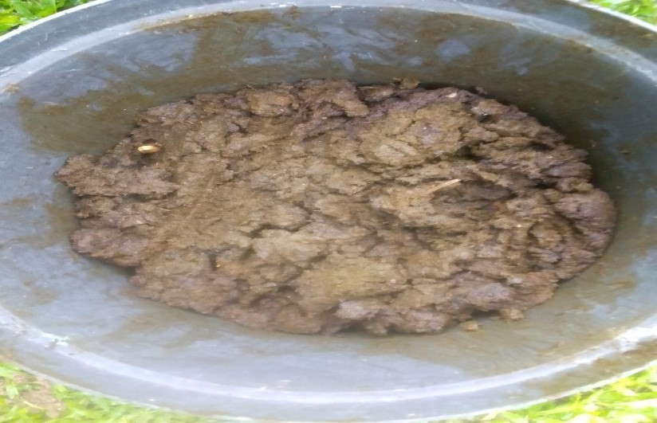

Plate 1: Freshly sourced cow dung from a cattle ranch

Cassava Peels (CP): Fresh peels were obtained at small-scale garri mills at the location of Choba/Aluu. These residues are normally high in starch, but may also include cyanogenic glucosides, hence the presence of this was harvested at once the peeling had taken place.

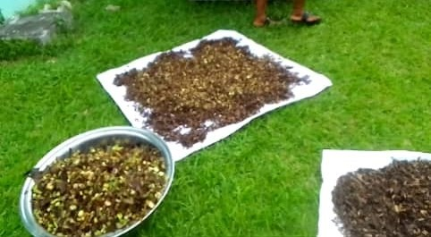

Plate 2: Freshly sourced cassava peel from local garri mill

Water Hyacinth (WH): Fresh Eichhornia crassipes: It was manually harvested in freshwater with high concentration of the weed in the local creeks. Entire plants including root, stem, and leaf of the plant were used to offer representative lignocellulosic profile (Kumar et al., 2017).

2.2 Feedstock Pre-Treatment and Preparation.
Separated pre-treatment regimens were used to render the biodegradability and to reduce the toxicity.
Cassava Peels: The peels were well washed to take away soil and sand. Thereafter, 2–3 days sun-drying was done. This physical pre-treatment had two purposes, firstly, moisture reduction and, more importantly, cyanogenic glycosides (linamarin) volatilisation, which could decrease cyanide toxicity, which is an inhibitor of methanogenesis (Ubalua, 2010; Ofoefule et al., 2010). The dry peels were then milled into small granules in order to maximize the specific surface area that could be exposed to microbial hydrolysis.
Water Hyacinth: The crops were washed but the root systems were silted and the adsorbates of heavy metals were taken off. Since the raw material had a high initial moisture content (>90 percent), the biomass was cut and dried in the sun to concentrate the total solids (TS). The material was dried and then ground to disintegrate the lignocellulosic structure to overcome the recalcitrance attestations mentioned in earlier work (Gunnararsson and Petersen, 2007).
Cow Dung: The fresh cow dung was directly used to provide the primary inoculum source because it possessed a large buffering ability and innate population of methanogenic archaea (Möller & Muller, 2012).

2.3 Reactor Configuration and Experimental Design
This research used three batch digesters locally made assembled using 1,000 L high-density polyethylene (HDPE) intermediate bulk containers (IBC) (Plate 3). To follow low-cost rural applications whilst maintaining exact laboratory standards the exterior surfaces were kept black to reduce the amount of light entering (and consequently algal growth) as well as to take advantage of maximum absorption of solar-thermal radiation. The reactor working volume of each reactor was 700 mL (leaving 300 mL of headspace to be occupied by gases). The experimental design involved three different structures, which were run simultaneously throughout 30 days in retention:
• System 1: Cow Dung (CD) mono-digestion 100%.
• System 2: 50 percent Cow Dung and 50 percent Cassava Peel (CD +CP) co-digestion.
• System 3: 50-percent Cow Dung + 50-percent Water Hyacinth (CD +WH) co-digestion.
Constant substrate to water ratio of 1:4 (v/v) was kept through all systems to qualify to get sufficient rheology in all systems to be mixed evenly. To this end, the loading was completed by adding 140L of substrate (or substrate blend) to 560L of water to form a homogenate slurry. Different digesters were completely enclosed to maintain a high level of anaerobic conditions and agitation was carried out manually daily to avoid the development of scum and stratification of the liquids (Kaparaju et al., 2008). Daily monitoring of process stability and biogas production was done using standard procedures with respect to monitoring.
2.4 Process Parameters
There was an in-situ evaluation of the physicochemical characteristics of the slurry. A handheld multi-parameter meter (Plate 4) was used to measure the pH and total dissolved solids (TDS) and electrical conductivity (EC) on a daily basis. Recording of temperatures was also done such that the system did not exceed the mesophilic range.

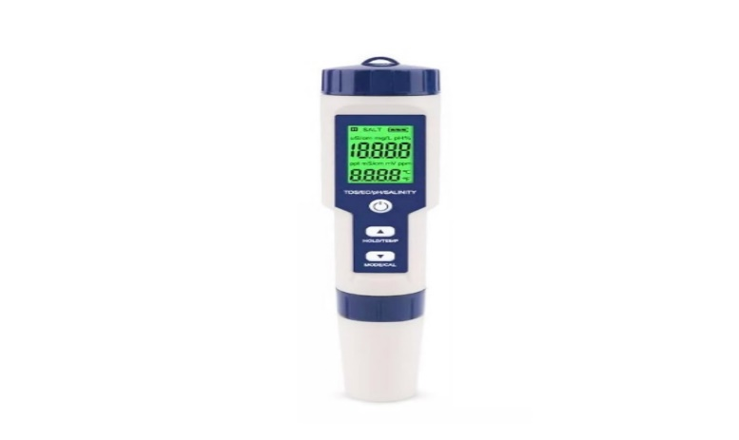
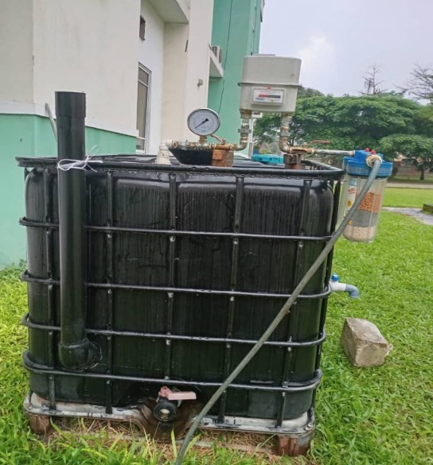

Plate 3: Fully constructed biodigester Plate 4: Multi-function pH meter

2.5 Biogas Yield Measurement (Mass-Balance) Method.
The production of biogas on a daily basis was measured using the weight-loss method. The weight of the entire digester assembly was measured daily with a high-capacity digital hanging scale (50kg capacity, Plate 5). The mass loss (Δm) between consecutive days was explained by the mass of the biogas released which was transformed to volumetric yield (V) via standard density equation:
$$V= \frac{Δm}{ ρ_{biogas}}$$
(Equation 1)

where the approximation of ρ_{biogas} was determined at standard temperature and pressure (STP) as 1.2kgm⁻³.
2.6 Gas Composition Analysis
Portable Altair 5X multi-gas analyzer (MSA Safety, Plate 6) was used to find the biogas composition. The tool was used to measure the amounts in real time of methane (CH₄), carbon dioxide (CO₂) and hydrogen sulfide (H₂S). The progress of the methanogenesis was monitored by having periodic measurements of the gas sampling port.

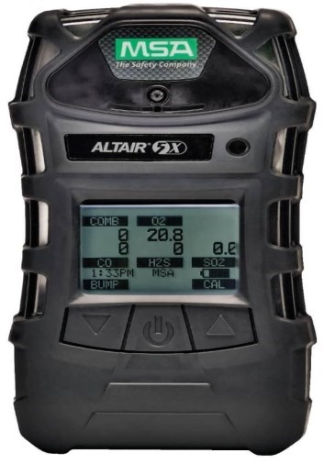


Plate 5: Weighing Balance used for daily gas yields Plate 6: MSA ALTAIR 5X multi gas detector

2.7 Bio Gas purification and flammability test.
In order to reduce the occurrence of corrosive contaminants, a low-cost two-stage scrubbing unit has been made and fitted downstream of the digester gas discharge line.
Moisture Trap: A water bubbler unit was used to condense water vapor and solubilize a fraction of CO₂.
Desulfurization: An iron-oxide (steel wool) dry scrubber was used to get rid of hydrogen sulfide through the reaction:

Fe₂ O₃ + 3H₂S Fe₂ S₃ + 3H₂O
(Equation 2)

The flammability of a raw and a scrubbed gas sample was analyzed visually to determine the purity of methane which could be defined as the disappearance of a weak yellow flame and the emergence of a steady blue flame (Bacenetti et al., 2013).

2.8 Kinetic Modeling
To explain the kinetic parameters of biodegradation, it was investigated by fitting cumulative data of yielding methane to a first order kinetic model calculated using the general equation of batch digestion. Volatile solids expressed biodegradation as:
B(t) = B₀(1−e^{−kt})
(Equation 3)

B(t) herein is used to describe the cumulative biogas at time t (L),
B₀ is the ultimate Biogas potential (L), and
k is the first-order biodegradation rate constant (day-¹).
The interpretation of reaction kinetics was based on the particular degree of outwardly breaking down starch (present in CP) and lignocellulose (present in WH), relying on the theoretical representation offered by the equation of Buswell on the stoichiometric potential to produce methane.

Based on the experimental data, the degradation constants (k) were estimated as:
- k_{CD} ≈ 0.12 day⁻¹
- k_{CD+WH} ≈ 0.09 day⁻¹ (reflecting slower lignocellulosic hydrolysis)
- k_{CD+CP} ≈ 0.18 day⁻¹ (reflecting rapid starch hydrolysis)

2.9 General Batch Design Equation
The required digester volume (V_{D}) for a batch system was defined based on substrate mass (M_{s}), Total Solids (TS), and slurry density ($ρ$_{s}), accounting for the gas space fraction ($ϕ$):
$$VD=\frac{Ms}{TS x ρS }(\frac{1}{1-ϕ})$$
(Equation 4)

2.10 Integrated Design Equation
Combining the loading parameters and the specific methane yield (SMY), the total digester volume (V_{Total}) required to accommodate both the slurry and the gas production pressure (P) was derived as:
$$V_{Total}=\left(\frac{Ms}{TSρs\left(1- ∅\right)}\right)+(\frac{(SMY x Mvs) (1 - e^{-kt})}{P})$$
(Equation 5)

2.11 Stoichiometric Reaction Models (Buswell Equation)
To predict the theoretical methane potential and gas composition, the elemental composition of the substrates was modeled using the Buswell equation principles. The specific stoichiometric equations derived for the three experimental systems are as follows:
Cow Dung Mono-Digestion:
C₂₃H₃₅O₁₃N + 11.25H₂O → 7.75CO₂ + 11.25CH₄ + NH₃
(Equation 6)
Cow Dung + Cassava Peel (50:50 Blend):
C₁₄.₅H₂₂.₅O₉N₀.₅ + 9.25H₂O → 11.0CH₄ + 5.5CO₂ + 0.5NH₃
(Equation 7)
Cow Dung + Water Hyacinth (50:50 Blend):
C₂₆.₅H₄₁.₅O₁₇N + 15.5H₂O → 17.5CH₄ + 9.0CO₂+NH₃
(Equation 8)

These models were utilized to interpret the variations in methane fraction and ammonia production observed during the laboratory trials.

3. Results
This experimental procedure compared three batch anaerobic systems of digestion after 30-day retention period: System 1(100% Cow Dung, CD), System 2 (50% Cow Dung +50% Cassava Peel, CD+CP) and System 3 (50% Cow Dung +50% Water Hyacinth, CD+WH). The findings of process stability inspection, total biogas product, kinetic behaviour and a gas compositional examination are shown below.
3.1 Stability of the operating conditions and processes.
Continuous control of process parameters showed that all three digesters did not exceed the mesophilic range of temperatures, ranging between 25 °C and 32 °C (mean T ≈28.5 °C ) as a result of ambien fluctuations. This thermal uniformity allowed any variations in the yield of gases to be attributed to the composition of the substrates and not the anomalies of the environment. The pH profiles were useful in giving an insight into the biochemical stability of the co‑digestion blends. As opposed to the fears of fast acidification of high-starch substrates, experienced by Salami et al. (2019), the CD+CP system did not feature an inhibitory drop in pH during the hydrolysis phase. During the initial 25 days pH readings in the three systems were within the optimum slightly alkaline status of 7.2 to 8.9, containing the volatile fatty acids (VFAs) that were formed during the quick breakdown of cassava starch. When all reactors were subjected to the final phase of digestion (Days 28-30), instances of significant pH drop (to around: 5.2-6.1) occurred, indicating end of gas production and the absence of buffering capacity in addition to signifying failure of processes, rather than depletion of the buffering capacity. Simultaneously, Total Dissolved Solids (TDS) and Electrical Conductivity (EC) showed a steady decreasing pattern throughout all the systems (e.g., CD+WH TDS dropped to 295ppm from 915ppm), which attests to active hydrolysis of soluble organic matter and ionic species by microbes.
There was considerable difference in the cumulative volumes of biogas produced by the treatment groups and established the effects of feedstock optimization.
- System 1 (CD Mono-digestion): This was the control system and produced a total of 2783.35 L as a result. The daily profile showed a latency phase of five days and non-productive formation early (Day 21) which is in line with the constraints of mono-digestion observed by Moller & Muller (2012) with regards to low C /N ratios and 3ing of ammonia in pure manure substrates.
- System 3 (CD +WH): Co-digestion of water hyacinth resulted in 4810.3 L, which was 72.8 percent higher than the control. Although this system, too, exhibited a lag phase of five days, the production of the gas was maintained up to Day 30. This long production chain is also typical of the breakdown of lignocellulosic biomass whose complex lignin structure explains that the rates of hydrolysis are hindered but supplies a long-term carbon source (according to Gunnarsson & Petersen, 2007).
- System 2 (CD+CP): The cassava peel mix delivered the best result and a total yield of 5O41.68 L has been recorded, 81.1 percent better than the control. This system had the shortest lag time (gas production commenced on Day 3) as well as the highest daily maximum (maximum 366.7 L day ⁻¹).
The yields obtained by co-digestion validate the existence of synergized effect in the co-digestion given that the C/N ratio balance and loss of inhibitory compounds to dilute the substrates results in higher yields than mono-substrates as expected by Mata-Alvarez et al. (2014).

Figure 1: Daily Methane Yield from System 1 (100% CD Mono-Digestion)

Table 1: Summary of Comparative Process Performance and Biogas Quality (30-Day Retention)
Parameter | System 1 (Baseline) | System 3 (Water Hyacinth) | System 2 (Cassava Peel)
Feedstock Composition | 100% Cow Dung (CD) | 50% CD + 50% WH | 50% CD + 50% CP
Cumulative Biogas Yield (L) | 2,783.35 | 4,810.30 | 5,041.68
Yield Increase (vs. Baseline) | — | +72.8% | +81.1%
Methane Content (CH₄) | 52.0% | 62.0% | 61.0%
Kinetic Rate Constant (k) | 0.12 day⁻¹ | 0.09 day⁻¹ | 0.18 day⁻¹
Lag Phase (λ) | 5 Days | 5 Days | 3 Days
Final H₂S (Post-Scrubbing) | 0 ppm | 0 ppm | 0 ppm

Figure 2: Daily Methane Yield from System 3 (50% CD + 50% WH)

Figure 3: Daily Methane Yield from System 2 (50% CD + 50% CP)

3.2 Analysis of Kinetics and Biodegradation Behaviour.
The daily production data when the first-order kinetic model
B(t) = B₀(1−e^{−kt})
was used showed that there was a clear difference in both biodegradation processes of the two co-substrates. The CD+ CP system had a high reaction rate constant (k=0.18 d⁻¹), which is comparable to the significant rate of hydrolysis in starch, and this can readily be cleaved by acidogenic bacteria. The CD +WH system, in contrast, exhibited slow-marathon kinetics of the lignocellulosic matrix in water hyacinth which produces a physical barrier to enzymatic action (k an approximate to 0.09 d ⁻¹). Baseline CD system exhibited moderate kinetics (k is approximate to 0.12 d ⁻¹) but had a smaller ultimate potential of methane, B₀.
Gas Composition and Improvement of Quality.
Although the CD mono- digestion generated biogas with a concentration of 52.0 per cent of methane (CH₄) the CD plus CP and CD plus WH systems generated concentrations of 61.0 and 62.0 per cent, respectively. Such increase indicates that the optimized nutrient balance in the co-digestion had a preference to the methanogenic pathway rather than decarboxylation.

4. Discussion
The experimental results definitively established the superiority of co-digestion strategies over mono-digestion for the selected Nigerian feedstocks. The baseline mono-digestion of cow dung (CD) yielded the lowest cumulative biogas volume (2,783.35 L) and demonstrated a premature cessation of gas production after Day 21. This performance limitation is consistent with established literature, which attributes the inefficiency of mono-digestion to the low Carbon-to-Nitrogen (C/N) ratio of ruminant manure. The nitrogen-rich environment likely induced free ammonia inhibition, a known toxicant to methanogenic archaea (Chen et al., 2008), thereby restricting the total biochemical methane potential (BMP).
In contrast, the co-digestion systems exhibited significant synergistic effects. The blending of cow dung with cassava peel (CD+CP) resulted in an 81.1% increase in biogas yield (5,041.68 L), while the blend with water hyacinth (CD+WH) achieved a 72.8% increase (4,810.3 L). These enhancements validate the hypothesis that balancing the C/N ratio through the addition of carbon-rich co-substrates optimizes methanogenesis (Mata-Alvarez et al., 2014). Mechanistically, the two co-substrates displayed distinct kinetic profiles derived from their biochemical composition. The CD+CP system functioned as a "fast-sprint" reactor, characterized by the shortest lag phase (3 days) and high-amplitude daily production peaks. This behavior is attributed to the rapid hydrolysis of the starch-rich cassava peel, providing an immediate substrate load for acidogenesis (Salami et al., 2019). Conversely, the CD+WH system operated as a "slow-marathon" reactor. While it produced a high total volume, it exhibited a longer lag phase (5 days) and a sustained, gradual release of gas through Day 30. This aligns with the findings of Gunnarsson & Petersen (2007) and more recent modeling by Omondi et al. (2023), who similarly identified that while co-digestion improves yield, the lignocellulosic nature of water hyacinth necessitates a longer retention time to fully realize its potential.
Substrate composition profoundly influenced the qualitative profile of the biogas. The mono-digestion of cow dung produced a biogas with a methane concentration of 52.0%, whereas the co-digestion systems significantly enriched the methane content to 61.0% (CD+CP) and 62.0% (CD+WH). This shift indicates that optimizing the feedstock nutrient balance directs metabolic pathways preferentially toward methanogenesis rather than decarboxylation. However, the raw biogas analysis revealed critically high concentrations of hydrogen sulfide (H₂S) across all systems, ranging from 5,000 to 8,000 ppm. These levels, derived from the degradation of sulfur-containing amino acids in the manure (Ryckebosch et al., 2011), pose severe corrosion risks to engines and toxicity hazards to users. The application of the locally fabricated iron-oxide scrubber successfully reduced H₂S concentrations to 0 ppm in all trials. The post-scrubbing flammability tests visually corroborated this improvement; the weak, yellow-tinged flame of the raw gas was replaced by a bright, steady blue flame in the purified samples, a characteristic indicator of high-purity methane combustion (Bacenetti et al., 2013).

5. Conclusions
This comparative study provides empirical evidence that the anaerobic co-digestion of cow dung with locally abundant agricultural residues offers a robust pathway for decentralized energy production in Nigeria. The following specific conclusions are drawn:
Cassava peel (50:50 blend with cow dung) emerged as the superior co-substrate for rapid energy generation, yielding the highest cumulative biogas volume (5,041.68 L) and demonstrating the fastest kinetic response. Water hyacinth serves as a viable, high-yield alternative (4,810.3 L) but requires longer retention times due to lignocellulosic recalcitrance.
The inclusion of cow dung provides essential buffering capacity that stabilizes the digestion of high-starch substrates. The study disproves the assumption that cassava peel digestion inherently leads to rapid acidification, provided it is co-digested at appropriate ratios with animal manure.
The prohibitively high H₂S levels (>5,000 ppm) inherent to manure-based biogas can be effectively eliminated using low-cost, iron-oxide desulfurization. This validates a scalable technological solution that renders the biogas safe, a conclusion supported by Mrosso et al. (2024), whose recent review highlights locally sourced iron-rich materials as the most economically viable purification pathway for decentralized biogas systems in developing regions.
The conversion of cassava waste and invasive water hyacinth into clean fuel addresses the dual challenges of waste management and energy poverty. However, future implementation must consider the potential heavy metal accumulation in digestate derived from water hyacinth harvested from polluted water bodies.

Disclaimer (Artificial intelligence)
Option 1:
Author(s) hereby declare that NO generative AI technologies such as Large Language Models (ChatGPT, COPILOT, etc.) and text-to-image generators have been used during the writing or editing of this manuscript.
Option 2:
Author(s) hereby declare that generative AI technologies such as Large Language Models, etc. have been used during the writing or editing of manuscripts. This explanation will include the name, version, model, and source of the generative AI technology and as well as all input prompts provided to the generative AI technology
Details of the AI usage are given below:
1.
2.
3.

6. References
- Abbasi, T., Tauseef, S. M., & Abbasi, S. A. (2012). Biogas energy. Springer.
- Adebayo, G. B., Sanni, M., & Olaleye, S. (2018). Biogas production from co-digestion of cow dung and cassava peels. Journal of Applied Sciences and Environmental Management, 22(1), 79-83.
- Bacenetti, J., Negri, M., Fiala, M., & González-García, S. (2013). Anaerobic digestion of different feedstocks: impact on energetic and environmental balances. Biomass and Bioenergy, 53, 40-50.
- Chen, Y., Cheng, J. J., & Creamer, K. S. (2008). Inhibition of anaerobic digestion process: A review. Bioresource Technology, 99(10), 4044-4052.
- Dölle, K., & Hughes, T. (2020). Biogas production from anaerobic co-digestion of water hyacinth (Eichhornia crassipes) and cow manure. Journal of Energy Research and Reviews, 5(3), 49–60.
- Gunnarsson, C. C., & Petersen, C. M. (2007). Water hyacinths as a resource in agriculture and energy production: A literature review. Waste Management, 27(1), 117-129.
- Iyagba, A. G., Mangibo, I. A., & Mohammad, Y. S. (2013). Waste management in cassava processing plants in Rivers State, Nigeria. Journal of Engineering and Technology, 8(1), 60-68.
- Kaparaju, P., Buendia, I., Ellegaard, L., & Angelidaki, I. (2008). Effects of mixing on methane production during thermophilic anaerobic digestion of manure: Lab-scale and pilot-scale studies. Bioresource Technology, 99(11), 4919-4928.
- Kumar, A., Singh, E., Mishra, R., & Kumar, S. (2017). Bio-energy potential of water hyacinth: A review. International Journal of Engineering Technology Science and Research, 4(10), 808-814.
- Malik, A. (2007). Environmental challenge vis a vis opportunity: The case of water hyacinth. Environment International, 33(1), 122-138.
- Mata-Alvarez, J., Dosta, J., Romero-Güiza, M. S., Fonoll, X., Peces, M., & Astals, S. (2014). A critical review on anaerobic co-digestion achievements, challenges and perspectives. Bioresource Technology, 167, 322-337.
- Möller, K., & Müller, T. (2012). Effects of anaerobic digestion on digestate nutrient availability and crop growth: A review. Engineering in Life Sciences, 12(3), 242-257.
- Mrosso, R. M., Machunda, R. L., & Karoli, N. J. (2024). Innovative low-cost approaches to biogas purification in developing economies: A review. Scientific African, 24, e02237.
- Omondi, E. A., Ndiba, P. K., Chepkoech, G. K., & Kegode, A. A. (2023). Modeling anaerobic co-digestion of water hyacinth with ruminal slaughterhouse waste for first order, modified Gompertz and logistic kinetic models. International Journal of Renewable Energy Development, 12(3), 627-634.
- Ofoefule, A. U., Nwankwo, J. I., & Ibeto, C. N. (2010). Biogas production from paper waste and its blend with cow dung. Advances in Applied Science Research, 1(2), 1-8.
- Pattnaik, S., Swain, M. K., & Das, M. (2020). Anaerobic co-digestion of water hyacinth and cattle dung: Optimization of process parameters. Journal of Environmental Chemical Engineering, 8(5), 104193.
- Ryckebosch, E., Deroo, J., & Deboosere, S. (2011). A review of biogas purification and upgrading technologies. Biomass and Bioenergy, 35(5), 1633-1645.
- Salami, O. O., Awosolu, B., & Ejiofor, C. C. (2019). Anaerobic co-digestion of cassava peel and poultry droppings for biogas production. International Journal of Integrated Engineering, 11(6), 263-270.
- Ubalua, A. O. (2010). Cassava waste: a silent killer and a potential environmental hazard. Journal of Applied Sciences and Environmental Management, 14(1), 51-55.
- Walker, M., Zhang, Y., Heaven, S., & Banks, C. (2009). Potential errors in the quantitative evaluation of biogas production in anaerobic digestion processes. Bioresource Technology, 100(24), 6339-6346.
- Yan, Y., Feng, L., Zhang, C., & Zhang, R. (2017). Pretreatment of water hyacinth for enhanced biogas production. Energy Procedia, 142, 298-303.

