Original Research Article
Comparative analysis of seed and leaf proteins by SDS-PAGE gel electrophoresis within seed Morphotypes of Winged bean

.
ABSTRACT

The importance of winged bean in nutrition, pharmaceutical fields, and agriculture is well known. It improves soil fertility as it helps to fix nitrogen into the soil. However, there are a lot of factors militating against its development. Some of these factors like temperature, delay in flowering, susceptibility to insect infestation etc. needs to be worked upon if the promising benefits of winged bean will be fully harnessed. It is thus necessary to focus on its genetic diversity. In this study, proteins of seed and leaves of the three seed morphotypes of winged bean were extracted and screened for total protein banding patterns using gel electrophoresis. Results showed the presence of banding patterns unique to each of the morphotypes and those common to them. The highest level of common bands was observed between black seeds of winged beans and deep brown seeds. Sokal and Sneath coefficient of similarity ranges from 19.05 – 33.33 for seed protein profile and 0.36 – 0.42 for the leaf protein profile. The study concluded that there exists a high level of genetic variations which could be exploited for crop improvement of this germplasm and to delimit each of this morphotypes.

Keywords: [crop improvement, protein bands, pharmaceutical, nutrition} (Arial, inclined, 10 font, justified)

1. INTRODUCTION

The genus Psophocarpus belongs to the family Fabaceae commonly known as legumes and subfamily Papilionoidea (Tanzi et al., 2019, Lepcha et al., 2017). The family consist of 800 genera and 20000 species making it only second to Poaceae in terms of its economic benefits (Hasanuzzaman et al., 2020). The family has a wide range of distribution in Europe, Asia and America (Sheikh, 2006). Winged bean has been reported to be a worthy alternative to Soya-beans in the Tropical regions of the world (Lepcha et al., 2017). Morphologically, winged bean has been reported to exhibit tuberous roots, thinning habits with perennial and annual properties (Tsoutsoura et al., 2022). Egleton 2019 reported that flower coloration in winged bean varies from white to blue and deep purple. Leaves are trifoliate in form but ovate in shape (Tsoutsoura et al., 2022). It exhibits growth which could be up to 4m tall (Lepcha et al., 2017). Winged bean produces underground tubers (Nazri et al., 2011). They have a diploid genome (2n=2x=18). (Harder 1992). When compared to other legumes, they are less tolerant to water shortage (Tanzi et al., 2019). It has high sensitivity to light and temperature during its developmental stages (Tanzi et al., 2019). From the data available in literature, winged bean possesses a lot of economic potential. It is often referred to as ‘one species supermarket’ (TSoutsoura et al., 2022). Essentially all its parts are useful. The seeds, immature pods, leaves, flowers are all edible providing vitamins, proteins, minerals and other essential nutrients (Cheng et al., 2019; Amoo et al, 2006). Winged bean helps to fix nitrogen into the soil hence serving as a great tool for mixed cropping with other non-legumes (Adegboyega et al., 2021). To further stress the multifarious applications of this crop, Lepcha et al 2017 reported its medicinal importance. It has been used to cure smallpox, boils, ulcers etc. due to its antimicrobial, anti-oxidant properties (Stopp 1962; Perry & Metzger 1980; Latha et al., 2006; Khalili et al., 2013). They are used in the production of soups and curries (Sri et al., 1984;), peanuts, snacks etc. (Adegboyega et al., 2021).
Despite all of these advantages, research on genetic diversity and crop improvement practices on winged beans is still sparse. The few in literature are largely molecular based and have been largely inconsistent and complicated. Genetic diversity studies using biochemical markers for different plants have been reported in literature while that of winged bean is still lacking. Adhikeri et al., 2019 and Hou et al., 2015 reported that biochemical markers give a high yield of variability in faba bean. Mirali et al., 2007 also reported that biochemical markers are very important tool for genetic diversity studies in different Vicia species. Electrophoresis offers a lot of advantages in diversity studies as it is not affected by environmental effects, year of production, place where the plant material was raised (Ham et al., 2001).Different researchers over the years have been able to use electrophoretic analysis to elucidate the level of genetic diversity within the plant genome (Folorunso and Olorode., 2002; Oladipo and Illoh, 2012; Ochiai et al. 1983,; Osei et al; 2018).Electrolysis is a tool used in plant taxonomy, genetics; crop improvement, molecular biology etc. It is fast, simple and easy to use and can be used for the analysis of large numbers of samples (Forde and Slack, 1996). Understanding the genetic variance and diversity using electrophoresis will likely provide a great insight to the level of variation and this can be exploited for crop improvement. This will ultimately help remove some constraints in harnessing the full potentials present in this crop. Information from electrophoresis can be used in the identification of useful proteins, understanding its benefit and protein-protein interaction. This research was undertaken to (1) characterize the seed and leaf of different accessions of three distinct seed morphotypes of winged beans using electrophoresis. (2) determine the level of variations within the protein bands in order to provide insight for crop improvements (3) Understand the level of protein richness in them. This is the first known report of leaf and seed electrophoresis of black, deep brown and light brown seeds morphotypes of winged beans.

2. material and methods

Seeds of twenty-five accessions of traditional cultivars of Psophocarpus tetragonolobus were collected from International Institute of Tropical Agriculture (IITA), Ibadan, Oyo State, Nigeria in the month of June, 2023. The mature seeds of Psophocarpus tetragonolobus collected were selected. The mature seeds were visually sorted into the three distinct morphotypes which are black seeds (BKS), Deep brown seeds (DBS), Light brown seeds (LBS). Each of these were sown in buckets filled with sterilized topsoil and raised at the screen house of the Department of Botany, Obafemi Awolowo University, Ile-Ife, Nigeria. The experiment was laid out in an utterly randomized design while regular agronomic practices like weeding and watering were carried out regularly. Electrophoretic study of the protein variations from the leaves of and seeds of the three morphotypes studied were carried out using 12% polyacrylamide gels. The morphotypes were screened for total protein banding patterns by using the method described by Omitogun et al. 1999 and Tokpo et al., 2006. Young leaves (0.8 g) of the plants were washed with distilled water and macerated with sterile mortar and mixed with the sample buffer (loading buffer). It was then heated in boiling water for 10 minutes and loaded into wells preventing overflows. SDS-PAGE running continued till when the down-most sign of the protein marker (the standard) almost reached the foot line of the glass plate.
The proteins of the blended seeds of each winged bean morphotype studied were extracted by separation technique. One gram of each sample of seeds was homogenized in a 9 ml sample buffer (0.1 M sodium phosphate with pH 7.2, 1% SDS and 2-mercaptoethanol) separately. This was centrifuged at 4 °C at a speed of 1000 rpm for 30 minutes. The supernatant obtained was boiled at 100 °C for 3-4 minutes and electrophoresis was then run according to Weber and Osborn (1975). About 0.5 ml of the protein samples, 0.02 ml tracking dye, 0.1 ml glycerol and 0.01 ml 2-mercaptoethanol were mixed together and layered on the 10% final acryl-amide gel concentration. Electrophoresis of the sample extract was run with current of 8mA per gel. The process was stopped when the tracking dye is almost getting to the end of the gel. The gel was removed from the tubes and stained in Coomassie Brilliant Blue R250 for 2 hours after which the gel was destained in a destaining solution of methanol, glacial acetic acid and water. Gels were stained with 0.3% Coomassie Brilliant blue for 18 hours. The gels were scanned with HP 3320 scanner and the images stored for scoring.
Sokal and Sneath similarity coefficient was then calculated as follows:
a× 100
a+b+c

Where
a is the number of common bands in a pair of species
b is the number of unique bands in one of the pair of species
c is the number of unique bands in the other pair of the species

3. results and discussion

The gel of the seed protein electrophoresis of the three seed morphotypes of accessions of winged beans studied is presented in Fig 1 while that of the leaf protein electrophoresis is presented in figure 2. The seed and leaf protein profile has all the band distribution. The use of the SDS-PAGE method for identification of the different protein profiles in both seeds and leaves was very successful. However, there were more protein bands in the seed than in the leaves. The Schematic diagrams of both the seed and the leaf protein electrophoresis are shown in fig 3 and 4 respectively. A total number of 46 proteins bands were observed in seed electrophoresis profile (Table 1) while a total of 28 bands was observed for the leaf electrophoresis (Table 2). There was a close similarity in the intensity of bands, number of bands and combination of bands within the seed morphotypes. From the

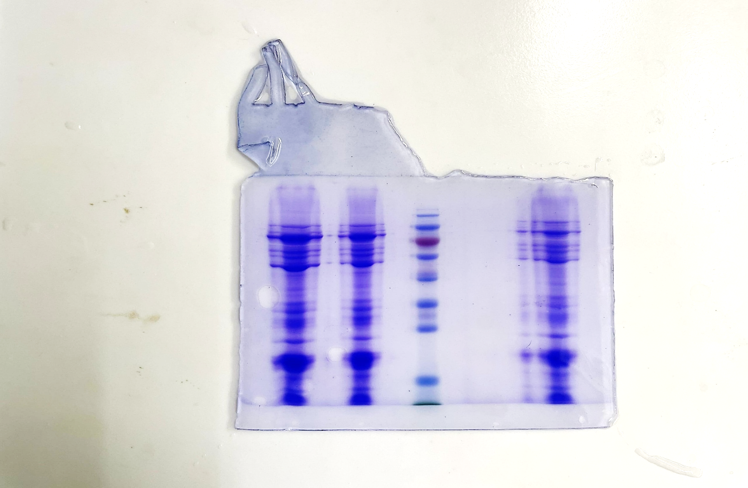
DBS
BKS
LBS
Figure 1: Seed Electrophoresis of accessions of Winged bean Studied

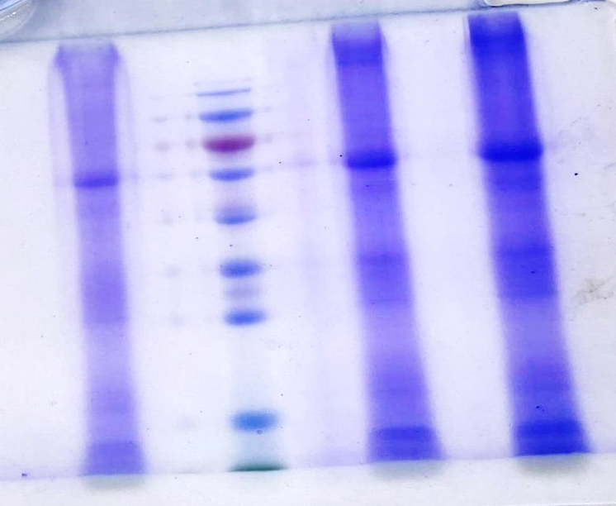
LBL
BKL
DBL

Figure 2: Leaf Electrophoresis of accessions of Winged bean Studied

Figure 3: Schematic diagrams of Seed Electrophoresis of accessions of Winged bean Studied

Figure 4: Schematic diagrams of Leaf Electrophoresis of accessions of Winged bean Studied

Table 1: Seed Electrophoresis Profile of the Winged Bean Studied
Seed colour | Slow bands (0-1.9) | Intermediate bands (2.0-3.8) | Fast bands (4.0-5.8) | Total Number of Bands | Unique Band
DBS | 4 | 7 | 5 | 16 | 3
BKS | 4 | 6 | 5 | 15 | 4
LBS | 5 | 5 | 5 | 15 | 7

Table 2: Leaf Electrophoresis Profile of the Winged Bean Studied
Seed colour | Slow bands (0-1.9) | Intermediate bands (2.0-3.8) | Fast bands (4.0-5.8) | Total Number of Bands | Unique Band
LBL | 3 | 2 | 3 | 8 | 2
BKS | 3 | 3 | 3 | 9 | 1
DBL | 4 | 3 | 4 | 11 | 3

analysis of the seed protein electrophoresis, the ratio of fast to intermediate bands and to slow bands were 15:18:13 respectively while that of leaf protein is 10:8:10 respectively (Table 3 and Table 4). The result further showed that 32.6% were fast bands, 39% were intermediate bands while 28.3% were slow bands for the seed electrophoresis while the leaf protein electrophoresis yielded 35.7% fast bands, 28.6% intermediate bands and 35.7% slow bands. The common bands occurred at 1.2, 3.3, 4.5, 5.1, 5.4, 5.6 cm for the seed electrophoresis (fig 1) while for the leaf proteins, it occurred at 1.9, 3.4, 5.1 and 6.2 cm. The highest number of common bands was found between the deep brown and black seeds morphotypes in both the seed and leaf profile of the protein. Upon further analysis, inter-varietal bands involving two morphotypes occurred at 1.0, 1.6, 1.7, 1.9, 2.2, 2.9, 3.1 and 4.1 for the seed profile (Table 3) while for the leaf profile it occurred at 0.2, 0.5, 0.9, 2.3, 5.4 and 5.9 cm (Table 4). Furthermore, unique bands occurred at 0.9, 1.8, 2.0, 2.1, 2.4 2.5, 2.6, 2.7, 3.4, 3.5, 3.6, and 4.0 for the seeds but for the leaf protein profile it occurred at 0.1, 2.4, 4.0 and 4.1cm.
The Sokal and Sneath coefficient of similarity revealed a generally low level of similarity in the leaf and seed protein bands of the three morphotypes and ranged from 19.05 -33.33 for the seed protein profile and 0.36 – 0.42 cm for the leaf protein profile (Table 5, Table 6).

Table 3: Number of Common Bands Between Pairs of Winged Bean Studied in the Seed Protein Profile
Seed | DBS | BKS | LBS
DBS | - | - | -
BKS | 10 | - | -
LBS | 7 | 5 | -

Table 4: Number of Common Bands Between Pairs of Winged Bean Studied in the Leaf Protein Profile
Leaf | LBL | BKL | DBL
LBL | - | - | -
BKL | 6 | - | -
DBL | 6 | 7 | -

Table 5: Sokal and Sneath Similarity Coefficient among the Winged Bean Studied in Seed Protein Profile
Seed | DBS | BKS | LBS
DBS | - | - | -
BKS | 19.05 | - | -
LBS | 26.67 | 33.33 | -

Table 6: Sokal and Sneath Similarity Coefficient among the Winged Bean Studied in Leaf Protein Profile
Leaf | LBL | BKL | DBL
LBL | - | - | -
BKL | 0.36 | - | -
DBL | 0.42 | 0.36 | -

DISCUSSION
This study brings to scientific perspective the mobility of proteins in the seed and leaf of winged bean. The fact that both the seed and leaf proteins both contained bands showed that the methods used were suitable. The unique bands observed in this study is an indication of differences in the protein composition. Such differences in the composition of protein have been used in literatures to separate members of a population into their respective taxonomic groups (Folorunso and Olorode, 2007) In other words the unique bands at 0.1, 0.9, 1.8, 2.0, 2.1, 2.4 2.5, 2.6, 2.7, 3.4, 3.5, 3.6, 4.0, and 4.1 cm could be useful in delimiting each of the morphotypes from one another. These large number of unique bands even though they are taxonomically the same indicates that there is diversity in the genetic composition in the leaf and seed of winged beans. This finding is further corroborated by the work of Gotlieb 1971, who reported similar occurrence in Moringa Oleifera. Shonde et al., 2023 carried out genetic diversity studies on accessions of winged beans using SSR primers and reported the presence of large variabilities within the accessions studied. Unique bands depict genetic variations and so could be exploited for crop improvement programs of winged beans. Wong et al., 2014, Adeniran and Bolaji., 2024., Bolaji et al., 2023) also reported the use of variations in crop development programmes. Breeders could use these distinct features for the possibility of heterosis (Olomitutu et al., 2022, Olanrewaju, et al., 2021). The fact that none of the morphotypes have the same protein band for both the seed and leaf protein analysis could indicate an ongoing evolution and speciation between the varieties. The unique bands present at 1.3, 2.3 cm and 2.1cm, 3.6cm for both the leaf and seed protein profile respectively could be the proteins that codes for the black pigment observed in the black seeds of winged beans. Adegboyega et al., 2021 reported that quantitative results from electrophoretic methods are related to biogenetic relationships. The presence of common bands among the morphotypes could be the reason why taxonomists consider them as the same species. It could also depict common evolutionary origin. Gotlieb 1971 reported that the presence of common band among members of a population portends that the genes which codes the enzymes or protein does not vary. Furthermore, it also shows that such bands contain proteins with identical amino acid sequences. Similar assertions have been made by Folorunsho and Olorode., 2007. The higher number of common bands observed between the black and deep brown morphotypes shows a higher phylogenetic closeness than light brown seed morphotypes. This is in line with the morphological closeness observed in them. The presence of fast-moving bands informs that the proteins have higher molecular weights while the presence of slow-moving bands depicts that the proteins have lower molecular weight.

4. Conclusion
From the analysis above on the protein profile of winged bean morphotypes (both leaves and seeds); unique bands and common bands were identified among the morphotypes. The seed contains more protein bands than that of the leaves. This data can serve as a great tool for taxonomic and breeding efforts. From this result, it appears there is a broad-based relationship between the morphotypes. it is concluded that SDS PAGE (Sodium Dodecyl Polyacrylamide Gel Electrophoresis) is a good marker for detecting the protein profile of winged bean morphotypes studied by showing that they can be used in a breeding program because the accession shows high genetic variability and low similarity index.

Consent (where ever applicable)

Not applicable

Ethical approval (where ever applicable)

The plant materials used in this study were collected from International Institute of Tropical Agriculture, Ibadan and maintained at the screen house of Obafemi Awolowo University, Ile-Ife, Nigeria in compliance with local or national guidelines, with no need for further affirmations.

Disclaimer (Artificial intelligence)
Option 1:
Author(s) hereby declare that NO generative AI technologies such as Large Language Models (ChatGPT, COPILOT, etc.) and text-to-image generators have been used during the writing or editing of this manuscript.

References

- Adeniran, I. O, Bolaji, A.O. 2024. Genetic diversity assessment of accessions of Basella alba var alba and Basella alba var rubra morphotypes using vegetative and reproductive traits. International Journal of Vegetable Science, 1-10. https://doi.org/10.1080/19315260.2024.2354769
- Adegboyega, T. T., Abberton, M. T., Abdelgadir, A. H., Mahamadi, D., Olaniyi, O. A., Ofodile, S. A. M., & Babalola, O. O. (2021). Variation in winged bean (Psophocarpus tetragonolobus) growth parameters, seed yield, nodulation, and nitrogen fixation. Asian Journal of Agriculture, 5(2). DOI: 10.13057/asianjagric/g050203
- Adhikari Kedar N, Khazaei Hamid, Ghaouti Lamiae, Maalouf Fouad, Vandenberg Albert, Link Wolfgang, O'Sullivan Donal M. Conventional and molecular breeding tools for accelerating genetic gain in faba bean (Vicia faba L.) Frontiers in Plant Science. 2021;12. DOI: 10.3389/fpls.2021.744259
- Amoo IA, Adebayo OT, Oyeleye AO. 2006. Chemical evaluation of winged beans (Psophocarpus tetragonolobus), Pitanga cherries (Eugenia uniflora) and orchid fruit (Orchid fruit myristica). African Journal of Food, Agriculture, Nutrition and Development. ;6(2).https://doi.org/10.4314/ajfand.v6i2.71734
- Bolaji AO, Oladejo AS, Adeniran OI. 2023 Morphological characterization and cytological studies of the green-stemmed and the red-stemmed Basella alba. Notulae Scientia Biologicae. Jun 19;15(2):11338-.https://doi.org/10.55779/nsb15211338
- Cheng A, Raai MN, Zain NA, Massawe F, Singh A, Wan-Mohtar WA. 2019 In search of alternative proteins: unlocking the potential of underutilized tropical legumes. Food Security. Dec;11:1205-15. https://doi.org/10.1007/s12571-019-00977-0
- Eagleton G. 2019 Prospects for developing an early maturing variety of winged bean (Psophocarpus tetragonolobus) in Bogor, Indonesia. Biodiversitas Journal of Biological Diversity. Oct 10;20(11).https://doi.org/10.13057/biodiv/d201106
- Folorunso AE, Olorode O. 2002 Electrophoresis of crude protein of seeds of some genera of Annonaceae. DOI: 10.4314/njhs.v7i1.3327
- Folorunso AE, Olorode O. 2007 Crude protein electrophoresis of some species of Annona in Nigeria. Ife Journal of Science; 8(1):15-8. https://doi.org/10.4314/ijs.v8i1.32195
- Gottlieb LD. 1971 Gel electrophoresis: new approach to the study of evolution. Bioscience. Sep 15;21(18):939-44.https://doi.org/10.2307/1296112
- Ham H, Bosman M, Vorster PJ. 2001 Electrophoresis of leaf and seed proteins of Englerophytum natalense (fam. Sapotaceae). South African Journal of Plant and Soil. Jan 1;18(3):98-103.10.1080/02571862.2001.10634411
- Harder DK. 1992 Chromosome counts in Psophocarpus. Kew bulletin. Jan 1:529-34. https://doi.org/10.2307/4110581
- Hasanuzzaman M, Araújo S, Gill SS. 2020. The plant family fabaceae. Springer Singapore;.https://doi.org/10.1007/978-981-15-4752-2
- Hou W, X Zhang, J Shi, Y Liu. Genetic diversity analysis of faba bean (Vicia faba L.) germplasms using sodium dodecyl sulfate polyacrylamide gel electrophoresis. Genet Mol Res. 2015;14:13945‒13953.
- Khalili RM, Shafekh SE, Norhayati AH, Fatahudin IM, Rahimah R, Norkamaliah H, Azimah AN. 2013 Total phenolic content and in vitro antioxidant activity of winged bean (Psophocarpus tetragonolobus). Pakistan Journal of Nutrition. May 1;12(5):416. http://pjbs.org/pjnonline/fin2612.pdf
- Latha LY, Sasidharan S, Zuraini Z, Suryani S, Shirley L, Sangetha S, Davaselvi M. 2006.Antimicrobial activities and toxicity of crude extract of the Psophocarpus tetragonolobus pods. African Journal of Traditional, Complementary and Alternative Medicines. Feb 8;4(1):59-63.
- Lepcha P, Egan AN, Doyle JJ, Sathyanarayana N. 2017 A review on current status and future prospects of winged bean (Psophocarpus tetragonolobus) in tropical agriculture. Plant Foods for Human Nutrition. Sep;72:225-35. https://doi.org/10.1007/s11130-017-0627-0
- Mirali N, El-Khouri S, Rizq F. Genetic diversity and relationships in some Vicia species as determined by SDSPAGE of seed proteins. Biol. Plant. 2007;51:660–666. Available:https://doi.org/10.1007/s10535-007- 0139-0
- Nazri NM, Ahmat N, Adnan A, Mohamad SS, Ruzaina SS. 2011 In vitro antibacterial and radical scavenging activities of Malaysian table salad. African Journal of Biotechnology.;10(30):5728-35.10.5897/AJB11.227
- Ochiai Yanagi S, Yoshida N, Saio K. 1983 Generality and diversity of winged bean (Psophocarpus tetragonolobus) protein in eight various lines. Agricultural and biological chemistry. Oct 1;47(10):2267-71.https://doi.org/10.1080/00021369.1983.10865942
- Oladipo OT, Illoh HC. 2012 Leaf protein electrophoresis and Taxonomy of Species of Jatropha L.(Euphorbiaceae). Notulae Scientia Biologicae. Aug 30;4(3):92-6.https://doi.org/10.15835/nsb437601
- Olanrewaju OS, Oyatomi O, Babalola OO, Abberton M. 2021 Genetic diversity and environmental influence on growth and yield parameters of Bambara groundnut. Frontiers in Plant Science. Dec 20;12:796352.https://doi.org/10.3389/fpls.2021.796352
- Olomitutu OE, Abe A, Oyatomi OA, Paliwal R, Abberton MT. 2022 Assessing Intraspecific Variability and Diversity in African Yam Bean Landraces Using Agronomic Traits. Agronomy.; 12(4):884. https://doi.org/10.3390/agronomy12040884
- Omitogun OG, Jackai LE, Thottappilly G.1999. Isolation of insecticidal lectin‐enriched extracts from African yam bean (Sphenostylis stenocarpa) and other legume species. Entomologia Experimentalis et Applicata. Mar;90(3):301-11.https://doi.org/10.1046/j.1570-7458.1999.00450.x
- Perry LM, Metzger J. 1980. Medicinal plants of East and Southeast Asia: attributed properties and uses.
- Shonde TE, Adebayo MA, Bhadmus AA, Adejumobi II, Oyatomi OA, Faloye B, Abberton MT. 2023. Diversity assessment of winged bean [Psophocarpus tetragonolobus (L.) DC.] accessions from IITA Genebank. Agronomy. Aug 16;13(8):2150. 10.3390/agronomy13082150
- Sokal RR, Sneath PH. 1963. Principles of numerical taxonomy. San Francisco: W. H. H. Freeman & Company 359p.(F)
- Sri Kantha S, Erdman JW (1984). The winged bean as an oil and protein source: a review. J Am Oil ChemSoc 61(3):515–525 https://doi.org/10.1007/BF02677021
- Stopp K (1962): The medicinal used by the Mt. Hagen people (mbowamb) in New Guinea. Econ Bot 17: 16–22. : https://doi.org/10.1080/13880200701740858
- Tanzi AS, Eagleton GE, Ho WK, Wong QN, Mayes S, Massawe F. 2019.Winged bean (Psophocarpus tetragonolobus (L.) DC.) for food and nutritional security: synthesis of past research and future direction.https://doi.org/10.1007/s00425-019-03141-2
- Torkpo SK, Danquah EY, Offei SK, Blay ET. 2006 Esterase, total protein and seed storage protein diversity in Okra (Abelmoschus esculentus L. Moench). West African Journal of Applied Ecology.;9(1). 10.4314/wajae.v9i1.45677
- Tsoutsoura N, Chong YT, Ho WK, Chai HH, Tanzi AS, Salazar-Licea L, Massawe F, Brameld J, Salter A, Mayes S. The Winged Bean Genome: Winged Bean—One Species Supermarket. InUnderutilised crop genomes 2022 Nov 4 (pp. 315-336). Cham: Springer International Publishing.https://doi.org/10.1007/978-3-031-00848-1_17
- Weber K, Osborn M (1969) The reliability of molecular weight determinations by sodium dodecyl sulphate-polyacrylamide gel electrophoresis. J Biol Chem 244: 4406–4412. https://doi.org/10.1016/S0021-9258(18)94333-4
- Wong QN, Massawe F, Mayes S. Improving winged bean (Psophocarpus tetragonolobus) productivity: An analysis of the determinants of productivity. InXXIX International Horticultural Congress on Horticulture: Sustaining Lives, Livelihoods and Landscapes (IHC2014): 1102 2014 Aug 17 (pp. 83-88).DOI 10.17660/ActaHortic.2015.1102.9.

