Original Research Article

Optimization of Material Consumption in Reinforced Concrete Beams Using Post-Tensioning and Particle Swarm Optimization

.
ABSTRACT

The objective of this work is to evaluate the reduction in concrete and rebar weight in continuous beams of reinforced concrete frame buildings with spans greater than 9 meters, by integrating post-tensioning design with the Particle Swarm Optimization (PSO) algorithm. The study is based on numerical modelling carried out using the SAP2000 API and Python, and was applied to two study cases of a three-story hospital building with four bays in each direction and spans of 9 m and 13 m, respectively. It was done at the Faculty of Engineering of the Autonomous University of Querétaro, in Querétaro, Mexico, during the period between September 2024 and November 2025. The optimization variables are the width and depth of the beam and the number of post-tensioned strands, while the objective function is defined as a pondered combination of concrete and steel weight, subject to strength and serviceability limit state checks according to applicable design codes. In the case of 9 meters, savings of 46% in concrete and 18% in steel were achieved in comparison to the non-prestressed design. On the other hand, in the case of 13 meters, concrete was reduced by 34% while steel remained the same, concluding that the methodology applied successfully reduces the volume of material used in the continuous beam under study, which can have a significant impact if applied to an entire building, contributing to a sustainable, low-cost design due to lower material consumption and good structural performance.

Keywords: Structural optimization; Particle Swarm Algorithm; Post-tensioned concrete; Material consumption; Python.

1. INTRODUCTION

Structural engineering optimization is the process of finding the most efficient and economical design for a structure. This involves finding a balance between using as less material as possible and guaranteeing that the structure is safe enough to support all the forces it will be exposed to during its lifetime (Asghshahr, 2021). The aim is to find a solution that not only complies with safety standards, but also saves time, money, and materials, ensuring that each structural component is calculated to maximize its performance.

Optimization and the use of construction techniques such as post-tensioned concrete are closely related, as the aim is to maximize the performance of a structure while minimizing the resources used. By combining these elements, it is possible to design lighter structures with greater load- resisting capacity and crack control (Lee et al., 2020).

In current professional practice, traditional design methods often require numerous manual iterations, which depend on the engineer's experience to propose the amount of reinforcing steel, the distribution of post-tensioning, or the cross-sections of the elements. This can result in conservative designs that increase material demands, as well as long working hours for the design stage.

Instead of performing current practices, it should be possible to use procedures that, in addition to considering structural integrity, do not ignore important factors such as the use of resources and the impact this has on the environment or the cost of the work. The implementation of optimization algorithms in addition to post-tensioning is an efficient way to combat these problems in order to obtain a better proposal from the conception of a building's structural design to its construction.

Currently, after water, concrete is the most widely used construction material in the world due to its strength, durability, and affordability. On the other hand, according to the (IEA, 2022), the concrete sector is responsible for 7% of global CO2 emissions, so any reduction in the use of large volumes of concrete can have a positive impact on the environment.

In addition to providing good control of cracking, deformation, and flexural strength, the post-tensioning technique can be used as a reinforcement solution for existing elements. Research, such as that conducted by (Ghalla et al., 2025), has shown that the integration of post-tensioning greatly improves the stiffness, shear capacity, and energy absorption of beams with insufficient transverse reinforcement, allowing them to transition from a fragile mode of failure to a ductile one. However, this focuses on reinforcing existing elements to increase their shear capacity, not on material optimization in the complete design of post-tensioned beams for concrete frame buildings.

In this context, it is essential to conduct studies focused on optimizing post-tensioned concrete beams, integrating modern optimization methodologies such as metaheuristic algorithms, as these help maximize the benefits of post-tensioning, helping to optimize both the amount of steel and concrete used and the structural behavior compared to conventional reinforced concrete design techniques.

Therefore, the objective of this work is to perform the analysis and structural design of post-tensioned concrete beams in buildings with spans greater than 9 meters based on the particle swarm optimization (PSO) algorithm, minimizing material consumption and ensuring that the strength and service limit states are met in accordance with current regulations.

2. THEORICAL BACKGROUND

The two pillars that support this research work will be optimization and prestressing, both applied to reinforced concrete beams. Therefore, this section will introduce the theoretical background related to this subject.

2.1 Prestress

Prestressed concrete, both pre-tensioned and post-tensioned, consists of creating permanent stresses in a structural element in order to increase its strength and response to service loads. To do this, high-strength steel cables are strategically placed and tensioned with a certain force before or after the concrete hardens. The cables are then released, thereby releasing the tension and causing both tension and compression stresses in different fibers of the concrete element (Asociación Nacional de Industriales del Presfuerzo y la Prefabricación [ANNIPAC], 2018).

This technique is greatly influenced by the eccentricity with which the prestressing cables are placed with respect to the neutral axis. Fig. 1 shows how the moment diagrams vary for three different situations. All beams are subject to a distributed load w. The load P is the load due to prestressing, which is located at a distance e from the neutral axis, known as eccentricity. In beam A, the steel is placed on the neutral axis; in beam B, it is placed below the neutral axis; and in beam C, it follows a curved or catenary path, which is the case that will be studied in this work.

Fig 1. Bending moment according to prestress eccentricity

2.1.1 Post tensioning

The post-tensioning technique consists of tensioning the steel strands and anchoring them at the ends of the element once the concrete has hardened and reached the strength required to resist the loads induced by the prestressing. The concrete used is high-strength, with a compression strength (f'c) between 350-500 kg/cm², and the prestressing steel, such as strands and cables, in this case, is in the form of a twisted spiral or helix, reaching a rupture strength (fsr) of 19,000 kg/cm² for grade 270K or 270,000 lb/in², in addition to an elastic modulus ranging between 1,900,000 and 1,960,000 kg/cm². The strands will be tensioned to 80% of their rupture strength. The characteristics described above are essential for achieving the adhesion and strength required in structures of great importance. This section, as well as the following section on the theory of prestressed element design, is based on (ANIPPAC, 2018), which provides a detailed explanation of everything related to this field of study.

2.1.2 Losses

Something to take into account is the loss of force that will occur during this process. These losses can be immediate or differed, and are named according to the moment in which they occur. Some examples of immediate losses are anchor slippage due to friction, strand deviation, elastic shortening, and instant relaxation, while differed losses include concrete drying shrinkage, plastic flow, and differed relaxation. All of these will cause a reduction in effective force, which can be up to 30% when designing conservatively (ANIPPAC, 2018).

2.1.3 Stages

In order to review the stress state of prestressed elements, different stages of their service life will be taken into account as follows:

- Transfer stage: This occurs when the wires are cut into prestressed or post-tensioned elements when the pressure from the jacks is released. This must be done once the concrete has reached 80% of its final strength.

- Intermediate Stage: This occurs during the transport and assembly of the element. For this stage, it is important to have temporary supports and assembly devices in place, anticipating the static condition in the design.

- Final stage: In this stage, all applied load combinations are evaluated, service conditions are reviewed to ensure that stresses, deformations, and cracks are within permissible limits, and the ultimate strength of the element is also considered.

It is necessary to check the forces acting on the element for each of the stages described above. To do this, Fig. 2 and Equation (1) and Equation (2) show the stresses, that must be calculated considering the different actions to which the structural element will be subjected, as well as its geometric properties.

$$f=-f_{P}±f_{Pe}±f_{pp}±f_{f}±f_{cm}±f_{cv}$$ | (1)

$$f=\frac{P}{A_{ss}}±\frac{P_{e}}{I_{ss}}y±\frac{M_{pp}}{I_{ss}}y±\frac{M_{f}}{I_{ss}}y±\frac{M_{cm}}{I_{sc}}y±\frac{M_{cv}}{I_{sc}}y$$ | (2)

Fig. 2. Bending forces in a beam with a simple and composite cross-section

P = Effective prestressing force  E = prestressing eccentricity  M_{pp} = moment due to self-weight  M_{f} = moment due to subgrade  M_{cm} = moment due to dead overload  M_{cv} = moment due to live load  A = cross-sectional area  I = moment of inertia of the section  y = distance to the fiber where the stresses are calculated  ss = subscript referring to the simple section  sc = subscript referring to the composite section | fp = Stress due to effective prestressing force  f_{Pe} = Stress due to prestressing with eccentricity  f_{Pp} = Stress due to self-weight  f_{f} = Stress due to the road surface  f_{cm} = Stress due to dead overload  f_{cv} = Stress due to live load  h_{ss} = Simple section height  h_{sc} = Composite section height  n_{be} = Skid width in composite section  E.N. = Neutral axis

2.1.4 Allowable stresses

For concrete, care must be taken not to exceed the tension and compression stresses specified in Table 1, where f’_{ci} is the compression strength of the concrete at the transfer of prestress.

Table 1. Limit tension and compression stresses in concrete

Immediately after transfer |  | Under service loads
Extreme compression fiber | $$0.60 {f'}_{ci}$$ | Extreme compression fiber due to:  prestressing plus sustained loads  prestressing plus total load | $$0.45 {f'}_{ci}$$  $$0.60 {f'}_{ci}$$
Extreme tension fiber | $$0.80 {f^{'}}_{ci}^{(1/2)}$$ | Extreme tension fiber | $$1.60 {f^{'}}_{ci}^{(1/2)}$$

The allowable stress limits adopted in this work are compatible with the recommendations of (ACI, 2025) and (NTC, 2023a) for prestressed concrete members.

2.1.5 Limit states

2.1.5.1 Service limit state

In the case of prestressed elements, the effect of prestressing will cause a counter-deflection, which will occur to a greater magnitude during the transfer stage. This deformation will be known as initial deformation. On the other hand, once the loads are applied in the service condition, the element will tend to deform downward, at which point we will have the final deformation. To calculate the deflections, the methods of elastic theory will continue to be used. In this case, the deformation caused by the prestressing must be considered.

In addition, the limits established in (NTC, 2023b) will continue to be applied, such as the span divided by 240 plus five millimeters, or the span divided by 480 plus three millimeters for elements whose deformation affects non-structural elements.
2.1.5.2 Ultimate limit state

The ultimate limit states for bending and shear forces will be taken into account for the design of post-tensioned concrete beams. The same elastic theory used for the design of reinforced concrete beams will be followed, except that this time the contribution of the prestressing steel will be considered.

For bending, the resistant moment will be calculated as shown in Equation (3) and the height of the compression block a, according to Equation (4), all in accordance with elastic theory where the unit deformation of concrete is equal to 0.003 and of steel 0.0021.

$$M_{R}=F_{R}\left[A_{ps}f_{ps}\left(d_{p}-a/2\right)+A_{s}f_{y}\left(d_{s}-a/2\right)\right]$$ | (3)

$$a=\frac{A_{ps}f_{ps}+A_{s}f_{y}}{0.85 f_{c}^{'}b_{w}}$$ | (4)

M_{R} is the resistant moment, F_{R} the flexion reduction factor, A_{ps} the prestress reinforcement area, f_{ps} the effective prestress, d_{p} the effective depth to the center of prestress reinforcement, a, the height of the compression block, A_{s} the reinforcement area of steel, f_{y} the fluence limit of steel, f’_{c} the compression strength of concrete and b_{w} the width of the beam.
The minimum and maximum steel bending limits for low ductility structures established in (NTC, 2023a) are respected, as are the minimum and maximum separations between bars.

For shear resistance, as shown in Equation (5), the contribution of the concrete section and transverse steel reinforcement shall be considered, in addition to the contribution of the prestressing.

$$V_{R}=F_{R}V_{C}+F_{R}V_{S}$$ | (5)

Where F_{R} is the shear reduction factor, V_{C} the shear resistance of concrete and V_{S} the shear resistance of the steel reinforcement. When we talk about prestressed elements, the shear resistance of concrete has to be calculated according to the shear-flexure resistance or the shear web resistance, where the vertical component of the prestress is taken in account.

2.2 Optimization

Optimization is a mathematical discipline focused on finding the best possible solution to a specific problem in which certain restrictions or conditions must be respected (Fajardo Calderin & Rosete Suárez, 2010). It consists of determining the set of values that minimize or maximize an objective function, which is represented by certain decision variables.

2.2.1 Metaheuristic methods

Among the most widely used optimization methods are metaheuristic algorithms, which are based on the simulation of natural or social processes and are used to solve optimization and search problems. They do not guarantee finding the globally optimal solution, but they are capable of providing acceptable solutions to highly complex problems (Vega et al., 2003). Bio-inspired algorithms are a classification of metaheuristic algorithms, which include the PSO algorithm.

2.2.1.1 Particle Swarm Optimization Algorithm
The PSO algorithm was developed by James Kennedy and Russell Eberhart in 1995. This method is inspired by collective behaviors observed in nature, such as the coordinated movement of flocks of birds or schools of fish. It focuses on collaboration and communication between particles within a search space to find optimal solutions (Freitas et al., 2020).

Essentially, PSO consists of particles that represent solutions. Each particle is guided by its best-known position (Pbest) and the best global position (Gbest), which represent a balance between exploration and exploitation of the search space. All this is done by combining two components:

- Cognitive factor: Represents a particle's tendency to return to its Pbest

- Social factor: Represents the influence of the Gbest on the particle.

PSO is based on equations that determine the updating of particle velocity and position. These equations include random terms to encourage exploration of the search space and avoid premature convergence to local optima. The Equation (6) is used to update velocity.

$$v_{i}^{k+1}={wv}_{i}^{k}+c_{1}r_{1}\left({pbest}_{i}-x_{i}\right)+c_{2}r_{2}\left({gbest}_{i}-x_{i}\right)$$ | (6)

Where w is the inertia factor that controls the balance between exploration and exploitation, which varies from 0.9 to 0.4 as iterations pass, c₁ and c₂ are cognitive and social coefficients, respectively, in this case, considered equal to 1.5 according to the good convergence behavior shown by (Wang & Qiu, 2013), r₁ and r₂ are random values between 0 and 1 that promote diversity in the search. On the other hand, the position is updated according to Equation (7).

$$x_{i}^{k+1}=x_{i}^{k}+v_{i}^{k+1}$$ | (7)

Where x_{i} is the position, v_{i} is the velocity, and k is the iteration number.

As PSO is a metaheuristic method, it allows multiple constraints and objectives to be considered, such as minimizing concrete and steel volumes and maximizing strength, adapting to the complexities of the problem.

3. methodology

3.1 Previous works

Previously, optimization problems in reinforced concrete structures have been studied by different authors, such as (Dong et al., 2024), who formulate the objective function depending on the structural seismic response, using the interstory displacement ratio (IDR) variable.

Another approach was taken by (Hajirasouliha et al., 2012), where performance-based seismic design of concrete structures was implemented. In this approach, longitudinal reinforcement was distributed using nonlinear dynamic analysis and finite element models of the strongest to weakest elements, in order to uniformize deformations and reduce overall damage to the structure under seismic effects.

In other hand, a study conducted by (Mergos, 2018) attempted to develop optimal seismic designs for reinforced concrete frames to minimize the CO₂ emissions embedded in their manufacture and compare them with optimized designs based on construction cost, using genetic algorithms for the design of reinforced concrete frames.

At the same time, (Ghalla et al., 2025) conducted a study in which he proposed external post-tensioning as a reinforcement system for concrete beams without transversal reinforcement. In this way, he verified that post-tensioning, regardless of its magnitude or the direction of the strands, greatly increased the shear strength of these deficient beams.

When analyzing studies such as the previous ones, it can be seen that none of them approach the subject of post-tensioning in concrete beams for structural optimization purposes. In this paper, I take the liberty of dealing with it.

3.2 Study cases

For this study, two case studies were analyzed, as shown in Table 2, using regular reinforced concrete frame buildings with different spans. The aim was to analyze and compare the results obtained for relatively short spans, as in case 1, with long spans, as in case 2.

Table 2. Study cases usage and geometry.

Case | Building use | Frames | Levels | Spans
1 | Hospital | 4 | 3 | 9 meters
2 | Hospital | 4 | 3 | 13 meters

3.3 Materials and predimensioning

Once the geometry of the design buildings had been defined, the structural analysis of the buildings was programmed parametrically in Python using the SAP 2000 design software API, in which the concrete material was specified with a f'c of 400 kg/cm², conventional reinforcing steel with a fy of 4200 kg/cm², and post-tensioned strands with an fsr of 19000 kg/cm². The geometric sections of the concrete beams are based on a preliminary dimensioning suggested by Table 3 where L is the maximum span considered, for the reticular slab the span divided by 24 was the minimum camber criteria. Separations between ribs in both directions were taken of 70 cm and with a width of 20 cm.

These material properties are consistent with the recommendations of (NTC, 2023a) and (ANIPPAC, 2018), and they are used consistently in both the conventional and the PSO-optimized post-tensioned designs. These properties are consistent with the requirements of (ACI, 2025) for flexure, shear and serviceability of reinforced and prestressed concrete beams.

Table 3. Non-prestressed beams minimum camber load condition

Support condition | Minimum height
Simply supported | $$\text{L/16}$$
One continuous extreme | $$\text{L/18.5}$$
Two continuous extremes | $$\text{L/21}$$
Cantilever | $$\text{L/8}$$

In this case, as it involves the structural design of a beam that is continuous at both ends, the third case shown in Table 3 was taken. A width-to-height ratio of 2 was used for beams without prestressing, and all measurements were rounded up to the nearest multiples of 2 or 5 cm in an effort to adhere to practical construction measurements.
For columns, a rapid load drop was carried out to determine the width. Ultimately, the most important element for this work would be the beams.

3.4 Load conditions

Dead, live, and accidental loads were considered for this analysis. The load increase factors were 1.5 for dead load, 1.7 for maximum live load for gravitational design combinations, for accidental combinations the corresponding actions were multiplied by 1.1, and for service a unit load increase factor was applied, based on the requirements of (NTC, 2023b).

3.4.1 Dead and live loads

The dead load condition considered is shown in Table 4 for mid-floor slabs and in Table 5 for roof slabs.

Table 4. Dead load condition for mid-floor slabs.

Material | Thickness (m) | Volumetric weight (kg/m³) | Weight (kg/m²)
Ceramic tile | 0.01 | 1840 | 18.4
Tile adhesive | 0.015 | 1500 | 22.5
Ceiling | - | - | 20
Installations | - | - | 20
Additional concrete load |  |  | 20
Additional mortar load |  |  | 20
Dead load without slab system |  |  | 120.9

Table 5. Dead load condition for roof-floor slabs.

Material | Thickness (m) | Volumetric weight (kg/m³) | Weight (kg/m²)
Waterproofing | 0.002 | 2500 | 5
Fine Grout | 0.005 | 2100 | 10.5
Mortar | 0.01 | 1900 | 19
Filling | 0.1 | 1300 | 130
Ceiling | - | - | 0
Installations | - | - | 20
Additional concrete load |  |  | 20
Additional mortar load |  |  | 20
Dead load without slab system |  |  | 224.5

On the other hand, the live loads considered were obtained from (NTC, 2023b), where for hospitals there is an average live load of 80 kg/m², instantaneous live load of 100 kg/m², and maximum live load of 190 kg/m².

3.4.2 Accidental loads

In addition to the gravitational analysis, a dynamic modal analysis with a design seismic spectrum for the city of Querétaro, Querétaro, Mexico, shown in Fig. 3, was considered in the design envelope.

Fig. 3. Elastic Response Spectrum considered
Acceleration (Sa) is expressed in gravity fractions

3.5 Analysis and Structural Design

The continuous beam of the central axis of the ground floor was taken, as shown in Fig. 4, considering that it is one of the most structurally demanding beams, and the structural design for this beam was programmed.

Two different codes were used, one for conventional analysis, which do not include the effect of prestressing, and another where prestressing influences the displacements of the continuous beam under study. For both cases, the conventional design and the PSO-optimized prestressed design, this same beam was designed to provide a common point of comparison.

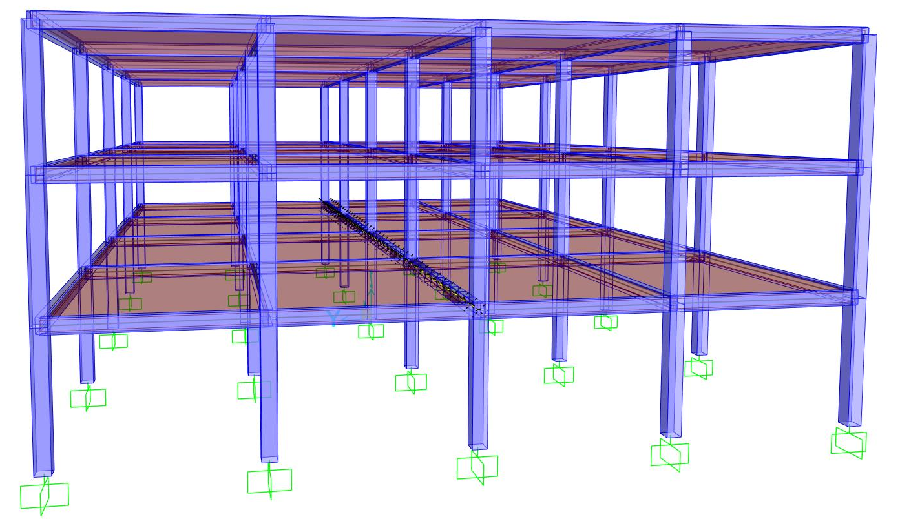

Fig. 4. Selected beam for structural design.

3.5.1 Conventional design

For the conventional design, moment and shear revisions were made using Load and Resistance Factor Design (LRFD). The maximum negative and positive moments of the model were obtained, and the longitudinal steel for the upper and lower flanges of the beam was designed. Similarly, the maximum shear was used to determine the diameter and spacing of the stirrups, all in accordance with the requirements specified by (NTC, 2023a).

Finally, for each study case, the weight of concrete and steel obtained was quantified, which are our output variables that we will be comparing in both study cases.
3.5.2 Prestressed optimized with PSO design

3.5.2.1 Post-tensioning design aspects

For the post-tensioning analysis, a tension force of 15,200 kg/cm² was considered, distributed across the number of strands proposed in each solution, where the strands have an effective area of 0.987 cm² each.

The strands were considered to be distributed in a single layer or bed, so as not to affect the eccentricity with which they act. The trajectory of the strands was catenary as described in the theoretical framework, following the shape of the moments acting on the beam, so that both at its lowest point in the centers of the spans and at its highest point, the minimum cover is 5 cm with respect to the tensioned face of the beam. For practical purposes, immediate losses of 5% and deferred losses of 10% were considered for permissible stress checks and for obtaining the deformation in the software.

3.5.2.2 Solutions space

The solution space was defined by limiting the beam width between 25 and 35 cm, since at least 25 cm width is required for structural beams according to regulations and 35 cm maximum, as this is based on the results obtained with conventional analysis. On the other hand, the height was limited to a minimum of the beam width and a maximum of 65 cm, which is the result of the critical case of a 13-meter span for continuous beams at both ends, as dictated by Table 3. At all times, care was taken to ensure that the candidate solutions were multiples of 2 or 5 cm, as this is how it is handled in practice for construction ease.
Finally, according to the minimum separations between bars shown in the regulations and the beam widths of the solution space, 1 to 5 strands are proposed, considering that they are in a single bed.

3.5.2.3 Objective function

For the objective function, an aggregate function was defined in which a weight or importance is assigned to the savings in concrete and steel. In other words, a pseudo multi-objective formulation was adopted and converted into a single scalar fitness value by means of pondered weights, as shown in Equation (8).

$$F=αP_{c}+\left(1-α\right)P_{a}+penalizations$$ | (8)

Where F will be the return value of the pondered fitness function that will help us decide the PBest and GBest in each iteration for the particles, Pc and Pa are the reinforcement steel and concrete quantified weight, respectively, penalizations are obtained according to section 3.5.2.4 and α the weight factor assigned for the concrete weight, it must be a value from zero to one and controls the relative emphasis on concrete versus steel savings in the optimization process.
Since the pre-dimensioning for conventional analysis shown in Table 3 can be a little conservative, the alpha value of 0.6 tilts the balance slightly toward concrete over steel savings. Therefore, we looked to approach the problem from an angle where we already know it is possible to obtain a desirable result. On the other hand, by limiting it to 0.6, we avoid reducing the priority of steel savings too significantly.

3.5.2.4 Restrictions
The main restrictions for this work were the allowable stress designs (ASD) and the review of displacements. The stresses were checked both during the transfer stage and in service for the upper and lower fibers, when the maximum and minimum moments occur in the beam.

The maximum positive and minimum negative moments were taken, and the review was made by ASD and by flexion at both points, while for the shear, only the maximum absolute shear was taken. According to the point at which these maximum stresses occurred, the eccentricity and angle of inclination of the strands were obtained, and the indicated reviews were made.

For limit state designs, the amount of longitudinal and transversal steel reinforcement was simply obtained according to the mechanical elements acting on the beam according to its proposed geometry, while for ASD and displacement checks, if it did not comply with these checks, a penalty was assigned. In the case of ASD, the check was performed for upper and lower fibers, in transfer and service conditions, with sustained and total loads, for the maximum positive moment and the minimum negative moment.
The ratio was obtained in each review, that is, the relation between the permissible stress and the acting stress. If the ratio is greater than one, it means that the section exceeds the permissible limit. Then, as indicated by the Equation (9), the difference between the obtained ratio and one was calculated and squared to obtain the penalty. This was done for each ASD revision until the penalties were finally added to the fitness function.
$$penalization={\left(ratio-1\right)}^{2}$$ | (9)

If the ratio obtained is less than unity, it means that the beam section and prestress are correct, so there is no penalty for that revision. This is a widely used method in optimization problems, where there is a quadratic, adimensional and simple penalty, which is zero if the constraint is met, soft if there is a small violation, and very punitive for large violations.

The same principle is used to evaluate displacements, where the permissible displacement is obtained by dividing the span by 480 plus 3 mm, and the ratio between the permissible displacement and the maximum displacement obtained in the beam under study is used to finally add the penalty also obtained with the Equation (9) to the fitness function.

3.5.2.5 Algorithm parameters

To perform the PSO design, 10 iterations and 20 particles were considered, due to the computational effort involved in analyzing a single particle in each iteration. The values of C₁ and C₂ were set at 1.5 according to the good convergence behavior shown in (Wang & Qiu, 2013). According to results obtained since the founder of the PSO algorithm, the concept of the inertia factor has been developed, with fixed values between 0.9 and 1.2 giving good results, up to current work such as (Meziane et al., 2019), who highlights the use of Equation (10), where solutions start from exploration, and as iterations reach their end, particles focus on exploitation, ensuring a good search in the solution space initially and then, after several iterations, exploiting the area where a better solution exists.

$$W=W_{max}-\frac{\left(W_{max}-W_{min}\right)t}{Iterations-1}$$ | (10)

Where W_{max} and W_{min} are 0.9 and 0.4 respectively, t the current number of iteration and Iterations the total amount of iterations that will be done.

3.6 Quantification, analysis, and comparison of results

After performing both analyses and quantifying the concrete and steel weights for the results obtained in each study case, they were compared and analyzed in order to identify any significant trends and reach conclusions.

3.7 General procedure

Figure 6 describes the general process performed for this work.
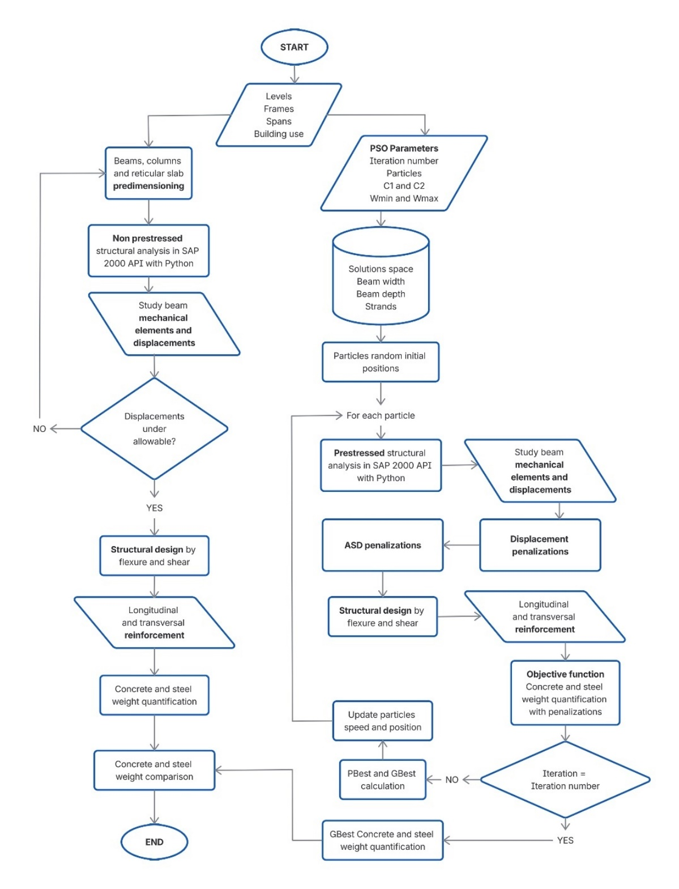

Fig. 5. General flowchart
4. results and discussion

This section will show the results obtained for both types of analysis for the two study cases, from results oriented towards structural design to the behavior of the algorithm and its convergence to its optimal solution, finally concluding with the ultimate data that shows us whether or not there was actually a saving in material, and if so, how much it was.

4.1 PSO Algorithm

The following shows the path of the particles through some representative iterations until reaching the last one to obtain a final optimized solution for cases 1 and 2, in Fig. 6 and Fig. 7, respectively.

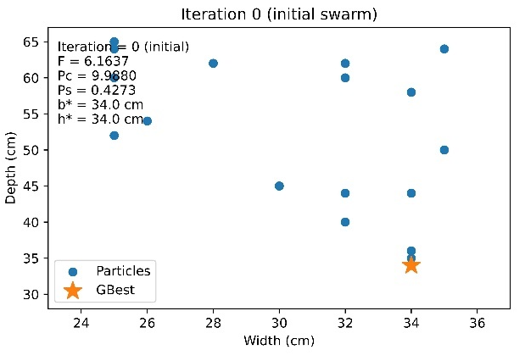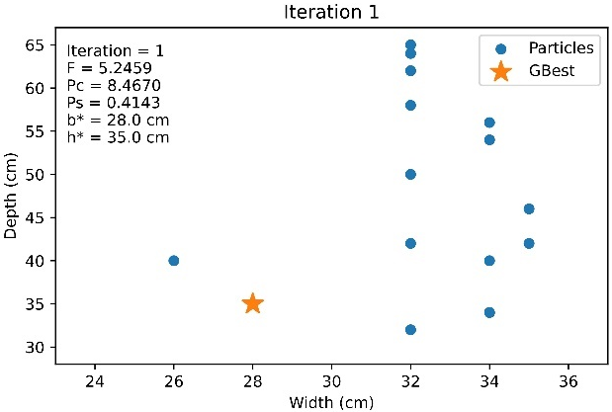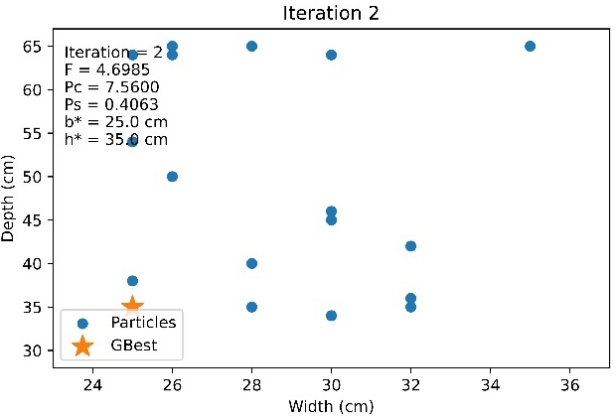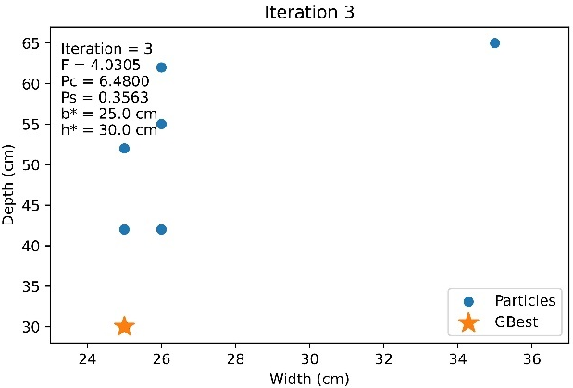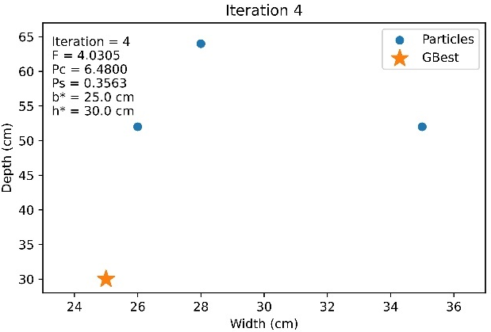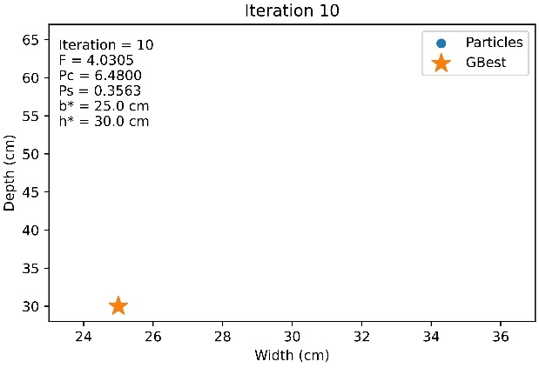

Fig. 6. Particles trajectory through representative iterations until reaching the optimal solution for study case 1

In case 1, in the initial iteration, the particles are distributed over a wide range of solutions. However, it can be observed that as the iterations progress, the particles concentrate in the area near the GBest, showing how they quickly move from exploration to exploitation in very early iterations. It can be seen how an initial particle fell very close to the optimal section in terms of both geometry and strands in the solution space, making it impossible for the other particles to find a better one, which in this case is the beam 25 cm wide (b) by 30 cm high (h), with 1 strand, with a concrete weight (P_{c}) of 6.48 tons, a steel weight (P_{s}) of 0.35 tons, and a pondered function value (F) of 4.03 tons.

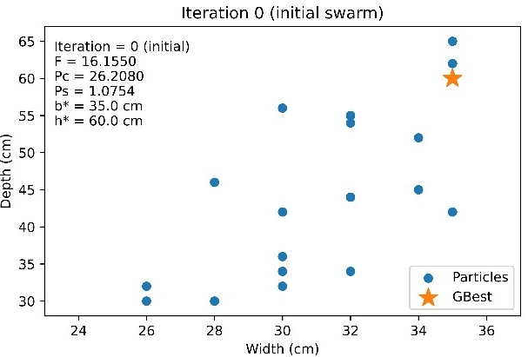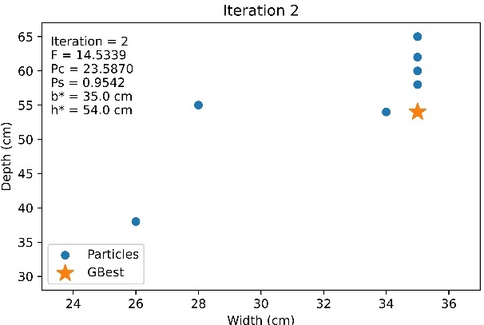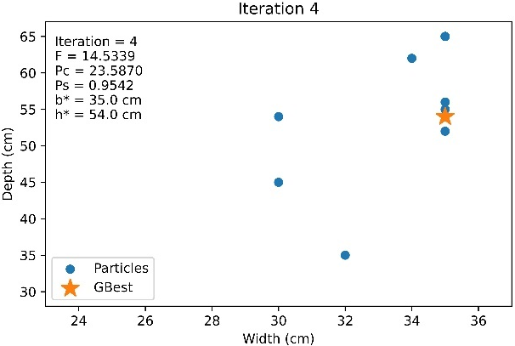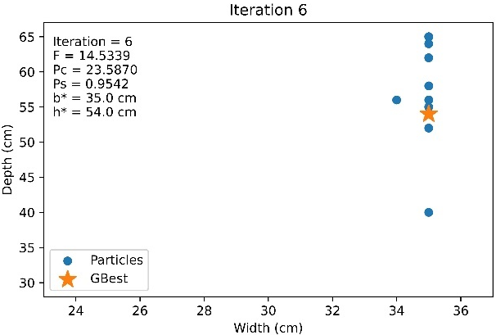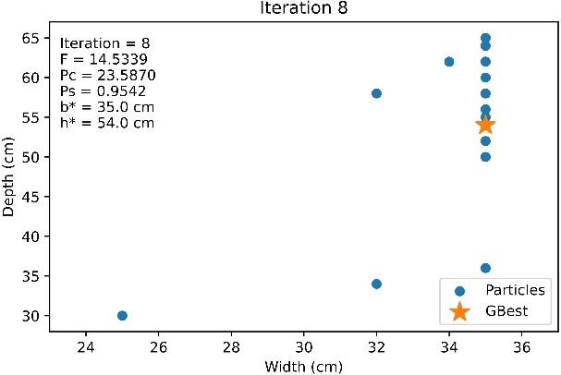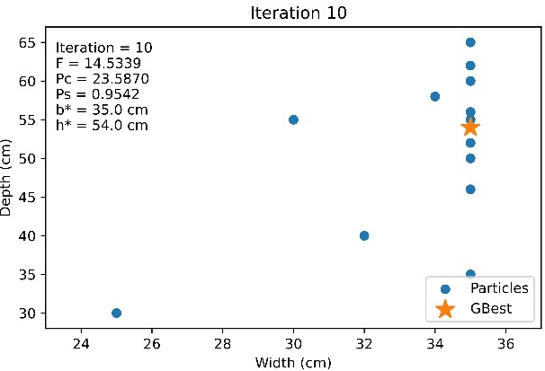

Fig. 7. Particles trajectory through representative iterations until reaching the optimal solution for study case 2

This may be because, in this case, there may be too many penalized solutions due to ASD revisions, which prevent a specific search area from being found. However, it can be observed that the F function is always decreasing, which shows us that the algorithm worked well, always searching for a better solution than the previous one. Probably, if a larger number of iterations, or particles, had been considered, another solution could have been obtained.

4.2 Structural design comparison

Table 6 provides more technical and digestible data for a structural engineer, showing the ultimate moments and shear forces, Mu and Vu respectively, for both positive and negative layers, with the proposed number of strands, rebars or stirrups and their diameter and spacing, as well, Table 7 shows whether they pass the Uz and ASD displacement check, both tables for conventional and prestressed design cases with PSO.

Table 6. Structural analysis and design results.

Case | Width  (cm) | Depth  (cm) | - Mu  (t-m) | As  (cm²) | + Mu  (t-m) | As  (cm²) | Vu  (t) | Stirrup  Φ | Spacing  (cm) | Strands
1 | 25 | 45 | -7.7 | 5.7 | 3.2 | 3.8 | 7.9 | 3 | 20 | 0
2 | 35 | 65 | -33.9 | 15.8 | 12.7 | 7.9 | 22.9 | 3 | 16 | 0
1* | 25 | 30 | -3.42 | 2.53 | 1.3 | 2.53 | 4.12 | 3 | 12 | 1
2* | 35 | 54 | -27.85 | 6.33 | 10.12 | 6.33 | 20.62 | 3 | 20 | 4
* PSO results for prestressed design

Table 7. Structural analysis and design results.

Case | Uz max (cm) | Uz OK? | ASD Bottom | ASD Top
1 | 0.34 | Ok | Not applicable | Not applicable
2 | 0.6 | Ok | Not applicable | Not applicable
1* | 0.4 | Ok | Ok | Ok
2* | 0.72 | Ok | Ok | Ok
* PSO results for prestressed design

The previous results show how slenderer sections are obtained in the PSO analyses, which leads to lower values of moment and ultimate shear due to the large difference in the self-weight of the beams. Subsequently, it can be seen that the amount of longitudinal steel is also lower, although the steel quantity could be higher for the prestressed sections as they are slenderer. For shear force, there are more stirrups in case 1 with PSO, as there is much less camber than in the conventional analysis. On the other hand, in case 2, there are fewer stirrups in PSO than in the conventional analysis, despite having less camber. This is because it has four prestressing strands, which greatly contribute to the resistance of this mechanical element. Finally, it can be seen that all sections comply with the displacements, which are very similar for each case in both analysis thanks to the counter-camber effect generated by the prestressing. In addition, both study cases comply with the ASD reviews.

4.3 Material savings

The final results aimed at in this study are summarized in Fig. 8 and Fig. 9, which show a comparison of the tonnage of concrete and steel for each study case. Finally, Table 8 summarizes the percentage savings in concrete and steel for each study case.

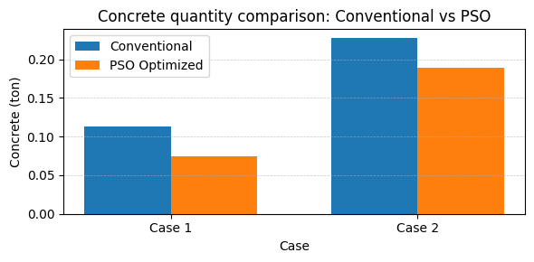
Fig. 8. Comparison of concrete’s quantity between conventional and prestressed PSO optimized method

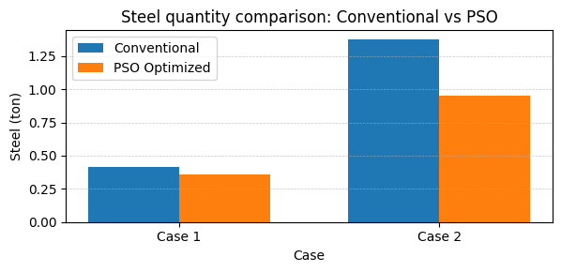
Fig. 9. Comparison of steel’s quantity between conventional and prestressed PSO optimized method

Table 8. Material savings in each study case

Study case | Concrete savings | Steel savings
1 | 33.33% | 13.72%
2 | 16.92% | 30.60%

In case 1, there was a significant improvement in the amount of concrete in comparison than steel, this is mainly because the solution obtained is the smallest geometry in the field of solutions. As for concrete, a reduction of more than the expected 20% was achieved. However, although there was a reduction in steel, it was not to the same extent as concrete.

On the other hand, in case 2, the amount of steel was reduced more than the amount of concrete, which indicates that in larger spans, the geometric section of the beam is not as affected by the forces acting on it, but the steel does decrease when prestressing is included, and in smaller spans, the cross-section of the beam tends to decrease significantly.

This confirms that the proposed algorithm was performed correctly, where the pondered function F was intended to give greater importance to the reduction of the concrete section than to the amount of steel.

5. Conclusion

It has been demonstrated that combining the post-tensioning design methodology with the PSO algorithm has been successful, resulting in a considerable reduction in the amounts of concrete and steel used for beams in reinforced concrete frame buildings with regular to large spans. This has been achieved while complying with the applicable restrictions and regulatory revisions.

The results obtained suggest that metaheuristic algorithms, and specifically PSO, are suitable and highly applicable to structural engineering problems where we have a very large set of solutions and we seek to obtain a quality solution in an automatized manner without having to rely on manual design methodologies where trial and error and long hours of work predominate.

It is of interest to expand the scope of this methodology not only to a beam but to the entire building, where the structural requirements are adapted to the use of post-tensioned concrete beams, as well as the evaluation of more study cases where more factors than just the length of the spans come into play.

COMPETING INTERESTS DISCLAIMER:
Authors have declared that they have no known competing financial interests OR non-financial interests OR personal relationships that could have appeared to influence the work reported in this paper.

DISCLAIMER (ARTIFICIAL INTELLIGENCE)
Author(s) hereby declare that NO generative AI technologies such as Large Language Models (ChatGPT, COPILOT, etc.) and text-to-image generators have been used during the writing or editing of this manuscript.

References

- ACI. (2025). Building code for structural concrete - code requirements and commentary. American Concrete Institute.
- ANIPPAC. (2018). Manual de diseño de estructuras prefabricadas y presforzadas.
- Asghshahr, M. S. (2021). Reliability based design optimization of reinforced concrete frames using genetic algorithm. Periodica Polytechnica Civil Engineering, 65, 566–576. https://doi.org/10.3311/PPci.17150
- Dong, G., Garcia, R., Pilakoutas, K., & Hajirasouliha, I. (2024). A review of optimum seismic design of RC frames: State-of-the-art, challenges and future directions. In Engineering Structures (Vol. 315). Elsevier Ltd. https://doi.org/10.1016/j.engstruct.2024.118455
- Fajardo Calderín, J., & Rosete Suárez, A. (2010). Algoritmo Multigenerador de Soluciones para la competencia y colaboración de generadores metaheurísticos. Revista Internacional de Investigación de Operaciones, 57–62.
- Freitas, D., Lopes, L. G., & Morgado-Dias, F. (2020). Particle Swarm Optimisation: A historical review up to the current developments. In Entropy (Vol. 22, Issue 3). MDPI AG. https://doi.org/10.3390/E22030362
- Ghalla, M., Bahrami, A., Mlybari, E., & Badawi, M. (2025). Shear behavior of reinforced concrete beams strengthened utilizing optimized external post-tensioning techniques. Frontiers of Structural and Civil Engineering, 19(6), 961–979. https://doi.org/10.1007/s11709-025-1185-4
- Hajirasouliha, I., Asadi, P., & Pilakoutas, K. (2012). An efficient performance-based seismic design method for reinforced concrete frames. Earthquake Engineering and Structural Dynamics, 41(4). https://doi.org/10.1002/eqe.1150
- IEA. (2022, September 22). Global cement demand for building construction in the Net Zero Scenario, 2000-2030. Licence: CC BY 4.0.
- Lee, S. H., Abolmaali, A., Shin, K. J., & Lee, H. Du. (2020). ABAQUS modeling for post-tensioned reinforced concrete beams. Journal of Building Engineering, 30. https://doi.org/10.1016/J.JOBE.2020.101273
- Mergos, P. E. (2018). Seismic design of reinforced concrete frames for minimum embodied CO2 emissions. Energy and Buildings, 162, 177–186. https://doi.org/10.1016/j.enbuild.2017.12.039
- Meziane, M. A., Mouloudi, Y., Bouchiba, B., & Laoufi, A. (2019). Impact of inertia weight strategies in particle swarm optimization for solving economic dispatch problem. Indonesian Journal of Electrical Engineering and Computer Science, 13(1), 377–383. https://doi.org/10.11591/ijeecs.v13.i1.pp377-383
- NTC. (2023a). Normas Técnicas Complementarias para diseño y construcción de estructuras de concreto. Secretaría de Obras y Servicios.
- NTC. (2023b). Normas Técnicas Complementarias sobre criterios y acciones para el diseño estructural de edificaciones.
- Vega, J. M. M., Batista, M. B. M., & Pérez, J. A. M. (2003). Metaheuristicas: una visión global. Revista Iberoamericana de Inteligencia Artifical, 7.
- Wang, X., & Qiu, X. (2013). Application of Particle Swarm Optimization for Enhanced Cyclic Steam Stimulation in a Offshore Heavy Oil Reservoir. International Journal of Information Technology, Modeling and Computing, 1(2), 37–47. https://doi.org/10.5121/ijitmc.2013.1204

