Nonlinear stability analysis of self-supporting roofs under wind loads using Ansys Workbench Simulation

.
ABSTRACT

Aims: The main objective of this study was to evaluate the nonlinear stability of a self supports roof with different spans subjected to wind loads. Specifically, this study investigated the behavior considering geometric and material imperfections and nonlinearities, obtaining the buckling load before the structural system loses stability.
Study design: For this research, a computational approach was used, employing the finite element method to estimate the stability of self-supporting roofs under wind loads for different spans. The models were analyzed using eigenvalue buckling, and for non-linear buckling, a solution was found using the full Newton-Raphson method.
Place and Duration of Study: Faculty of Engineering (postgraduate division), Universidad Autónoma de Querétaro (UAQ), between June 2024 and November 2025.
Methodology: Four different scenarios were modeled in ANSYS Workbench, varying the length of the self-supporting roofs, using Shell181 elements for section MIC 240.The material used was ASTM A1008 Grade 33 cold-rolled structural steel. The critical load for linear buckling under wind loads was estimated by the CFE and INEEL wind design manual. Subsequently, in new models, stability was estimated considering imperfections, geometric and material nonlinearities, and the deformed configuration of the first buckling mode analyzed, in order to consider a degree of imperfection for each scenario. The critical load for nonlinear buckling was obtained, and the results obtained in the linear and nonlinear cases were compared.
Results: The results for most of the scenarios evaluated showed that the critical load for nonlinear buckling is greater than that for linear buckling. Load increases of up to 275% were obtained, demonstrating that, for some load cases due to the pressures and suctions applied to the system, as well as the geometry of the arch, membrane effects occurred, increasing the stiffness of the roof. In addition, it was demonstrated that stability review is important for thin-walled structures, because even with an increase in critical load due to nonlinear buckling, in most scenarios the system becomes unstable before reaching the limit states for stress and deformation.
Conclusion: This study suggests the importance of evaluating stability in self-supporting roofs, since instabilities can occur before reaching the design and service limit states. Likewise, it is necessary to evaluate linear and nonlinear buckling, since in some cases, depending on the geometry of the roof and the wind loads applied, the load capacity due to nonlinear buckling may be greater or less than that calculated using the linear method. The results obtained can serve as a basis for the development of a standardized procedure or even for the future incorporation of specific guidelines into technical standards, given that this type of review is not currently formally regulated.

Keywords: buckling, arch roof, nonlinear analysis, k-span, wind loads.

1. INTRODUCTION
Self-supporting roof systems are widely used in various sectors, such as educational spaces, sports fields, shopping centers, and warehouses. These roof systems are popular due to their versatility, fast construction times, and cost-effectiveness, as they do not require intermediate supports to cover large spans. This system allows the roof to have support elements made of various materials such as steel, concrete, wood, or masonry (Del Coz Díaz et al., 2010; del Coz Díaz et al., 2012). The origin of this construction roof system can be traced back to the United States, where the U.S. Navy first used it for the construction of temporary structures. Today, the patent for this system belongs to M.I.C. Industries Inc. Thanks to its flexibility and adaptability, it has become a popular solution for civil construction, especially in large open spaces that require efficient and cost-effective roof designs (Cybulski et al., 2014).
The forming process begins with a roll of galvanized or painted steel sheet, which is fed into a portable rolling machine (ABM 240 technology). This sheet generates the desired trapezoidal section as the first stage of forming. It then goes through a second stage of forming, where corrugations are generated using rollers, obtaining the desired section and allowing the geometric shape of the arch to be generated (Piekarczuk et al., 2021).
Fig 1. Example K-span structure, a) K-span structure assembly, b) Scheme of the cold forming process for a single profile made by the ABM 240 machine. Source: Google (2025)
Within the K span system, there are two sections that are widely used worldwide: MIC 120 and MIC 240, the latter being very popular in Mexico and the subject of this research. Commercial sheet thicknesses range from 0.61 mm to 1.52 mm, allowing for spans of up to 30 meters.
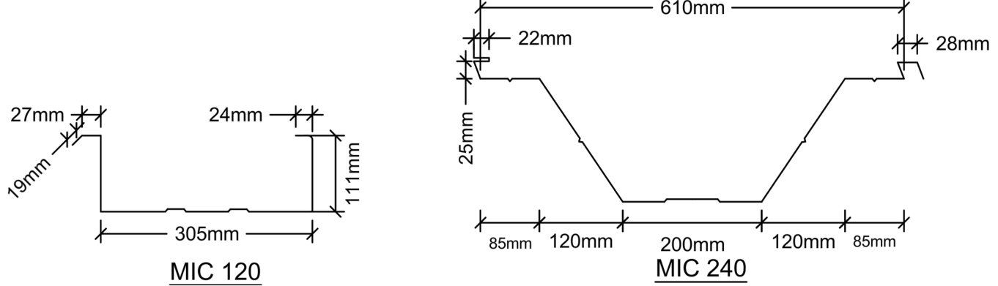
Fig 2. K span cross sections profiles
The finite element method has been employed to achieve a more accurate representation of the structural behavior of self-supporting roofs, since simplified analytical approaches are not adequate for capturing their mechanical response. This numerical technique enables a detailed analysis of the stresses and deformations induced by dead loads associated with self-weight and by live loads (Páez Redrován & Guerrero Cuasapaz, 2022), as well as the evaluation of the effects produced by static wind loads (Narvydas & Puodžiūnienė, 2013).
With the aid of finite element modeling, CFD simulations, and experimental wind tunnel testing, several studies have investigated the behavior of self-supporting roofs, focusing on phenomena that are not adequately captured by current design codes when subjected to accidental loads such as wind or snow. Wind pressures have been obtained using advanced CFD simulations with LES (Balbastro & Sonzogni, 2012), as well as using turbulence models with lower computational costs such as RANS, where it has been demonstrated that numerical modeling is necessary to predict local details that design codes do not consider (Del Coz Díaz et al., 2013).
In the case of geometries not covered by design codes, such as arched roofs with variable sections, it is necessary to determine specific pressure coefficients for this configuration (Yao et al., 2024). Furthermore, the influence of neighboring structures on snow accumulation on arched roofs has also been evaluated, finding amplification factors higher than those recommended by current standards (Zhang et al., 2025).
In Mexico, there are no established design codes that specify buckling checks for this type of structure. A common practice during the design process is to ignore the corrugations of the section (Piekarczuk & Malowany, 2016; Piekarczuk et al., 2017), and base calculations on the maximum allowable stresses and deformations, often indicated in the technical data sheets provided by manufacturers. This approach omits stability checks, which may result in inconsistencies in the structural behavior and potentially lead to collapse in the worst case scenario (Kollár & Holický, 2013).
The stability problem, known as buckling in engineering, occurs when a structure subjected to high compressive forces exceeds the critical load capacity that the material can withstand. This causes sudden deformation, reducing the stability of the structure and, in some cases, causing partial or total collapse (Ataei & Niazy, 2015).
Research has been conducted to estimate how buckling affects arch-type roofs, from pre-stressed textile membrane roofs (Macháček et al., 2021) to advanced numerical models that estimate the stability of thin steel arches supporting textile roofs (Hegyi, 2021).
Because these roof systems are relatively thin compared to the large spans they cover, they are vulnerable to stability failures under accidental loads, especially wind loads (Piekarczuk & Więch, 2021)
There are methods for estimating the critical load at which a structure loses stability, such as linear buckling or Eigenvalue Buckling Analysis, where the critical load obtained is known as the bifurcation point, at which the structure becomes unstable. However, research on self-supporting roof systems has shown that linear buckling methods tend to overestimate the critical load capacity of these systems (Piekarczuk et al., 2015).
Key factors affecting the accuracy of critical load estimates include imperfections (Casafont et al., 2024), geometric and material nonlinearities. Taking these elements into account allows for more accurate predictions, as demonstrated by experimental studies comparing theoretical models with practical results (Piekarczuk, 2019; Piekarczuk, 2023).
Contemporary studies on double-corrugated profiles have shown that the main problem with this construction system is local instability, located in the corrugations of the sheet. Research led by Piekarczuk et al. (2021) managed to solve the stability issue for specific load cases thanks to new analysis methodologies using finite elements. However, these results were limited to particular load scenarios.
In research by Cybulski et al. (2014), linear and nonlinear analysis methods were compared to study the buckling of double-corrugated steel panels, considering geometric imperfections. It was concluded that linear analysis, although applicable to straight panels without significant imperfections, overestimates the critical load and does not capture post-buckling behavior. Experimental and numerical results demonstrated that nonlinear analysis is essential for accurate evaluation of stability and critical load in both curved and flat panels, especially under conditions of geometric imperfections (Piekarczuk et al., 2015; Piekarczuk et al., 2017; Piekarczuk, 2019).
It is important to consider geometric and material imperfections and nonlinearities when modeling structures, as research by Piekarczuk et al. (2017) shows that these are vulnerable to local instabilities due to geometric imperfections in the manufacturing and assembly process. It is concluded that nonlinear geometric and material analyses are crucial for an accurate estimation of the critical load, as linear analyses do not consider large deformations or local instabilities. The study also recommends improving numerical models by considering the corrections involved in sheet modeling. The results show that combining conventional methods with digital image correlation (DIC) improves the measurement of deformations in the structure due to geometric imperfections in the manufacturing and assembly process.
Research by Del Coz Díaz et al. (2010) has shown that geometric imperfections have a significant impact on the load-bearing capacity of self-supporting metal roofs, which is why they must be considered in structural models. Through nonlinear analysis, it was predicted that the collapse load is considerably lower than in linear analysis, highlighting the importance of considering both material and geometric nonlinearities. It should be noted that this model does not fully consider the modeling of imperfections in the corrugation of the sheets, and even under this assumption, the results emphasize the importance of considering imperfections for the estimation of the critical buckling load.
Due to the complexity of isolating different load cases to analyze stability and the effects generated using full-scale models, this work proposes developing a design methodology capable of capturing the variables that directly affect the stability of the roof.

The aim of this paper is to evaluate the stability of a self-supporting roof under wind loads, considering the effects of pressure and suction distributed across its surface, as well as geometric imperfections and nonlinearities, in order to estimate stability levels that a traditional study is unable to capture in its formulation.
2. THEORICAL BACKGROUND
2.1 Lineal buckling formulation
Buckling stability is evaluated using an eigenvalue analysis, in which the critical load is obtained by solving an eigenvalue problem similar to those used in structural dynamics (Walentyński et al., 2014).
$$(K -λK_{g})u=0$$ | ( 1)
Where:
K: Elastic stiffness matrix,
Kg: Geometric stiffness matrix.
$λ$: Critical buckling load factor or eigenvalue.
u: Eigenvector or buckling mode.

This formulation, known in the literature as first-order analysis, considers the material in the inelastic range and keeps the rest of the assumptions unchanged. It also assumes small deformations that do not affect the stiffness of the system, so that the initial geometry remains practically constant. Likewise, it is not possible to consider imperfections in the analysis model.
2.2 Non lineal buckling formulation
Under the principle of energy conservation in terms of kinetic energy and potential energy in the face of external forces in a dynamic system (ANSYS Inc., 2020).
$$M(\ddot{u}) + K_{T}(u)u=f(t)$$ | ( 2)
Where:
M: Mass matrix.
$\ddot{u}$: Vector of nodal accelerations.
$K_{T}(u)$: Tangent stiffness matrix.
$u$: vector of nodal displacements.
$f(t)$: Time-dependent external load vector.
It is considered to be in static equilibrium, therefore ü=0.
$$K_{T}(u)u=f(t)$$ | ( 3)
When displacements are large, the geometry of the structure changes significantly during loading, which alters the equilibrium equations. To represent this behavior, the principle of virtual work in the deformed configuration is used (Del Coz Díaz et al., 2010).
$$Ψ(E_{a})=\int_{V}{B^{T}σdV-F_{ext}=0}$$ | ( 4)
Where:
$Ψ(E_{a})$: Balancing function.
$B^{T}$: Deformation matrix, which depends on displacements Ea.
$σ$: Stress tensor deformed configuration.
V: Volume of the structure.
$F_{ext}:$ External load vector.

The displacement field causes the strain–displacement matrix $\overline{B}$ to take a nonlinear form.
$$B=B_{0}+B_{L}(E_{a})$$ | ( 5)
Where:
$B_{0}$: Small deformation matrix (linear case)
$B_{L}(E_{a})$: Nonlinear dependence on displacement.

To solve the nonlinear problem, an incremental formulation based on Newton-Raphson iteration is used. The variation of the equilibrium function is expressed as (Del Coz Díaz et al., 2010).

$$dΨ=\int_{V}{d{\overline{B}}^{T}σdV} +\int_{V}{{\overline{B}}^{T}dσdV=K_{T}dE_{a}}$$ | ( 6)
$$K_{T}=K_{0}+K_{σ}+K_{L}$$ | ( 7)
Where:
$K_{T}$: It is the total tangent matrix dependent on the displacements of u.

$$K_{0}=\int_{V}{dB_{0}^{T}}DB_{0}dV, Matrix in small deformations.$$
$$K_{σ}=\int_{V}{dB_{0}^{T}}DB_{0}dV, Geometric stiffness matrix, which captures axial forces.$$
$$K_{L}=\int_{V}{(B_{0}^{T}}DB_{L}+B_{L}^{T}DB_{0}+B_{L}^{T}DB_{L})dV, Contribution of large displacements.$$

Based on the stress-strain relationship:
ε=Bu | ( 8)
In nonlinear problems, matrix B depends on displacements u, meaning that deformation ε changes nonlinearly with displacements.

Given that the following relationship is nonlinear:
𝜎=f (ε, u) | ( 9)
Rigidity is related to the stresses and deformations that the system undergoes; therefore, the stiffness matrix must be updated.$K_{T}$.

$K_{T}$=$\frac{∂σ}{∂ε}=\frac{∂f(ε, u)}{∂ε}$ | ( 10)
As can be seen, the stiffness of the structure changes depending on the displacements of u, so it must be updated in each iteration to reflect the behavior of the material as the displacements increase.

Therefore, the equation for nonlinear buckling is equal to:
$$K_{T}(u)u=f(t)$$ | ( 11)
Where:
$K_{T}(u):$ Tangential stiffness matrix.
u: Displacement vector.
f: It’s the vector of external forces.

3. METHODS
3.1 Models
The finite element models for all cases were considered smooth surface without corrugations produced by the second rolling process, due to the computational cost along with the complexity of faithfully reproducing the corrugations.
Ten different cases were analyzed, varying the span length and load cases while keeping the arch height and width constant, as shown in in the Fig 3.
Fig 3. Model geometry parameters
Note: Only the roof system was analyzed, and the support elements were not considered
The material properties, thickness and section for each scenario are shown in the Table 1.
Table 1. Geometric and material properties

Length (m) | Width(m) | Height(m) | Gauge (mm) | Section | Material
15,20,25,30 | 21.96 | 3.5 | 1.52 | KS-02 | ASTM A1008 Gr33

3.2 Boundary condition
The boundary conditions were considered to be simply supported at the ends (Fig 4), due to how the arched roof system is fixed to the support elements as shown in the Table 2.
Table 2. Model support conditions
Left support | Right support
X1=0 | X2=0
Y1=0 | Y2=0
Z1=0 | Z2=0
Fig 4. Model boundary conditions
3.3 Finite elements implemented
SHELL 181 elements were used, which are commonly used for modeling thin structures and are ideal for linear and nonlinear analysis as they can handle large deformations and rotations. The SHELL 181 element has four nodes with six degrees of freedom per node, three in the translations in the x, y, and z directions and three in the rotations about the x, y, and z axes [2].
3.4 Mesh quality
For the finite elements, meshing was performed using QUAD4 quadrilateral elements, which are suitable for representing thin surfaces as shown in the Table 3.

Table 3. Finite Element Selection Summary
Finite element mesh parameters
Length (m) | No. of nodes | No. of elements | Element quality | Aspect ratio
15 | 113013 | 112320 | 0.97 | 1.19
20 | 147653 | 146880 | 0.97 | 1.21
25 | 173633 | 172800 | 0.97 | 1.19
30 | 323697 | 322560 | 0.99 | 1.09
3.5 Material properties
The multilinear kinematic curve was generated (Fig 5) based on the modified Ramberg-Osgood mathematical model proposed by Gardner and Yun (2018), which aims to generate elastoplastic curves for cold-rolled steels, validated with more than 700 experimental data points on cold-rolled steel from different parts of the world.
The steel used for forming the roof section consists of cold-rolled galvanized steel of type ASTM A1008 Grade 33 (ASTM International, 2020) whose mechanical characteristics and material parameters for generating the stress-strain curve are shown in the Table 4.
Table 4. Material properties
ASTM A1008 Grade 33
E (GPa) | fy (MPa) | fu (MPa) | n | m | eu (%)
200 | 230 | 330 | 8 | 4 | 20
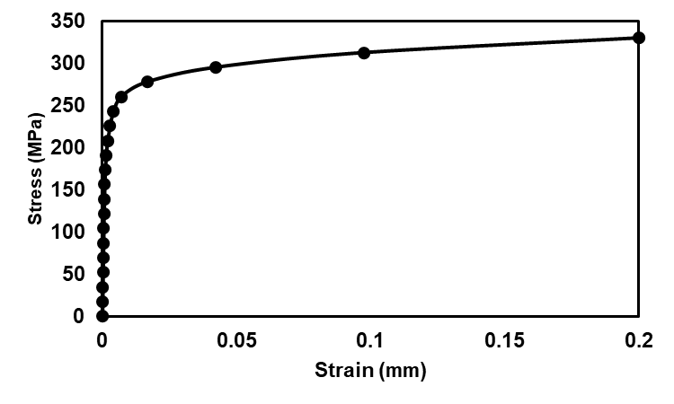
Fig 5. Multi-linear material ASTM A1008 Grade 33

3.6 Loads
3.6.1 Self weight load
The self weight of the structure was considered in the software applying the density of the material ρ=7850 kg/m³, which corresponds to the ASTM A1008 grade 33 steel type for a MIC 240 type section with a gauge of 1.52mm.
3.6.2 Wind load
Based on the Mexican regulations for wind design edition 2020 (CFE), which stands for Comision Federal de Electricidad. The wind loads for each of the ten cases were generated as shown in the Fig 6. The loads applied in each of the ten cases analyzed are shown in the Table 5. The schemes of the wind pressure loads on the structure, according to CFE (2020) are presented in Fig 7,Fig 8 and Fig 9.
Table 5. Distribution of wind pressure loads for the ten cases
 |  | Load case
Case | Length | Windward | Central | Leeward
Case | (m) | (kg/m²) | (kg/m²) | (kg/m²)
1 | 15 | 9.77 | -33.02 | -10.83
2 | 15 | 27.74 | -33.02 | 27.74
3 | 15 | -17.96 | -60.75 | -38.56
4 | 15 | 0 | -60.8 | 0
5 | 20 | 0.53 | -42.26 | -20.07
6 | 20 | 18.49 | -42.26 | 18.49
7 | 25 | 0.53 | -42.26 | -20.07
8 | 25 | 18.49 | -42.26 | 18.49
9 | 30 | 0.53 | -42.26 | -20.07
10 | 30 | 18.49 | -42.26 | 18.49

Fig 6. Wind is perpendicular to the roof (ϴ=0°)
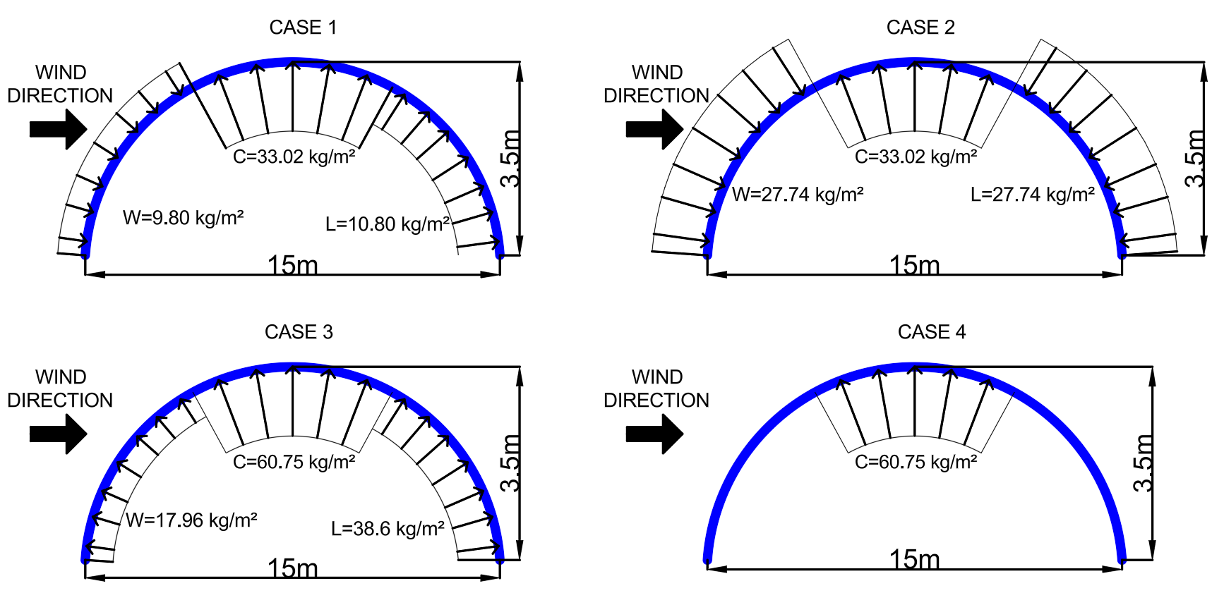
Fig 7. Scheme of the wind pressure loads on structure case 1,2,3,4.
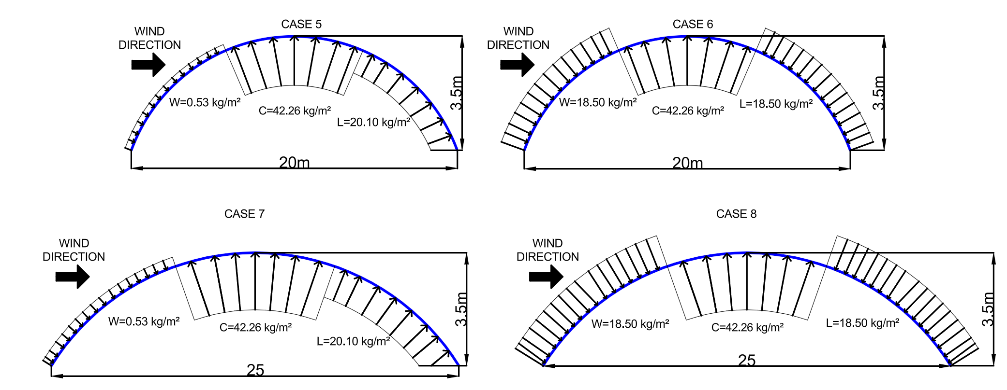
Fig 8. Scheme of the wind pressure loads on structure case 5,6,7,8
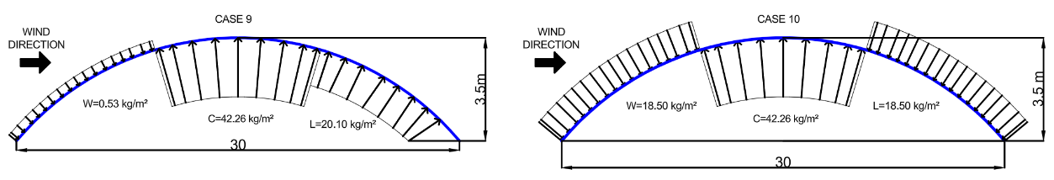
Fig 9. Scheme of the wind pressure loads on structure case 9,10

4. results and discussion
4.1 Lineal buckling analysis
The critical loads for each scenario and load case were obtained. The Table 5 shows that the critical load tends to decrease as the length increases. These load factors λ must be multiplied by the maximum applied load in order to obtain the critical buckling load.

Table 6. Critical linear load for each case
Length | Case | λ | Load (kg/m²) | Critical
(m) | Case | λ | Load (kg/m²) | load (kg/m²)
15 | 1 | 4.68 | 33.02 | 154.52
15 | 2 | 4.74 | 33.02 | 156.5
15 | 3 | 4.5 | 60.75 | 273.39
15 | 4 | 4.6 | 60.75 | 279.46
20 | 5 | 3.76 | 42.26 | 158.84
20 | 6 | 2.57 | 42.26 | 108.49
25 | 7 | 2 | 42.26 | 84.53
25 | 8 | 2.02 | 42.26 | 85.19
30 | 9 | 1.41 | 42.26 | 59.41
30 | 10 | 1.41 | 42.26 | 59.46

The critical loads obtained were 279.46 kg/m² for the 15 m length (case 4), 158.84 kg/m² for the 20 m length (case 5), 85.19 kg/m² for the 25 m length (case 2), and 59.46 kg/m² for the 30 m length (case 2).
4.2 Non lineal buckling analysis
The deformed configuration from the first linear buckling mode for each case was taken as the initial imperfection, and geometric and material nonlinearities were then added. The buckling load was found by analyzing the deflection–load curve. The following graphs showed how the curve began to flatten as the structure lost stability, both globally (left) and locally at the point of maximum deformation (right).
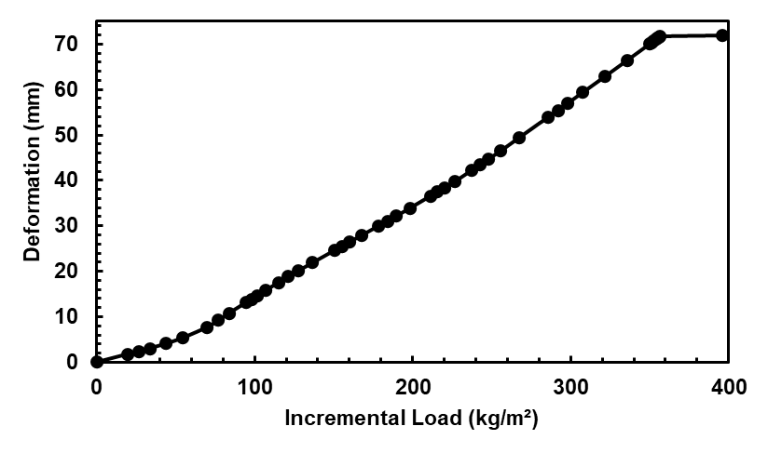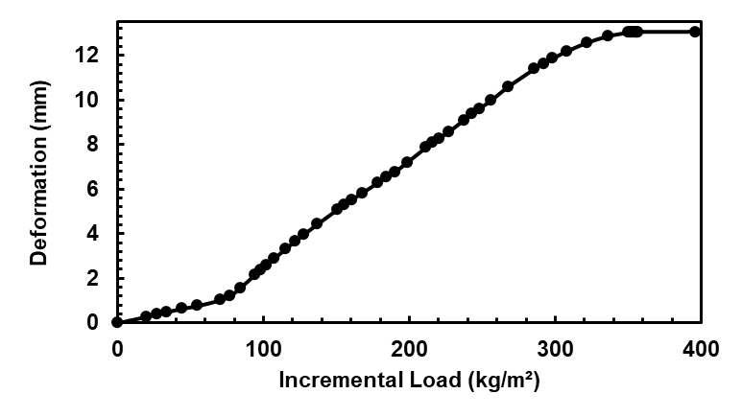
Fig 10. Deformation–load curve for the case 1, indicating global instability (left) and local instability (right)
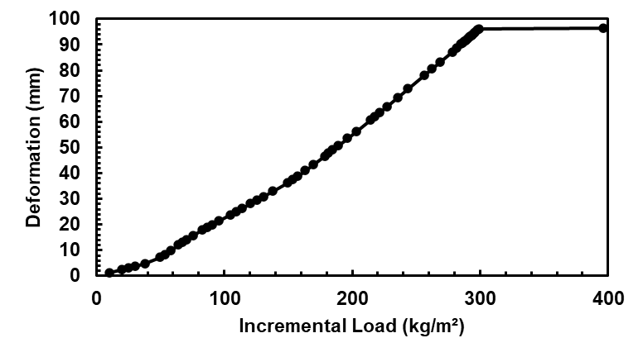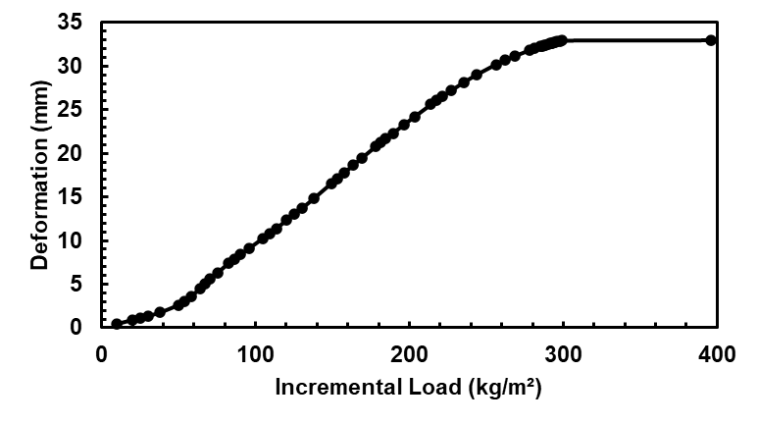
Fig 11. Deformation–load curve for the case 2, indicating global instability (left) and local instability (right)
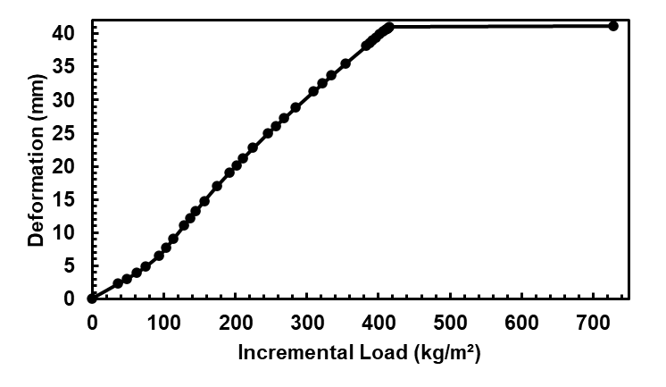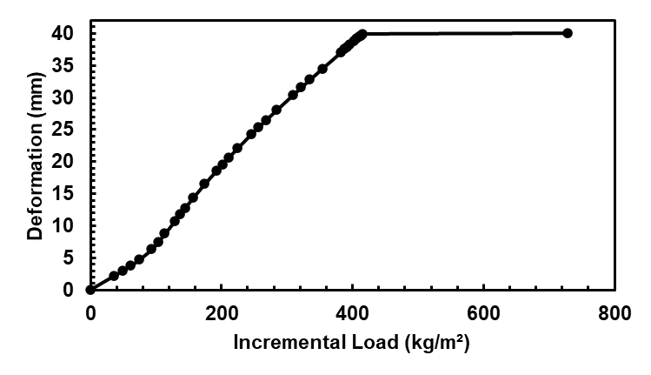
Fig 12. Deformation–load curve for the case 3, indicating global instability (left) and local instability (right)
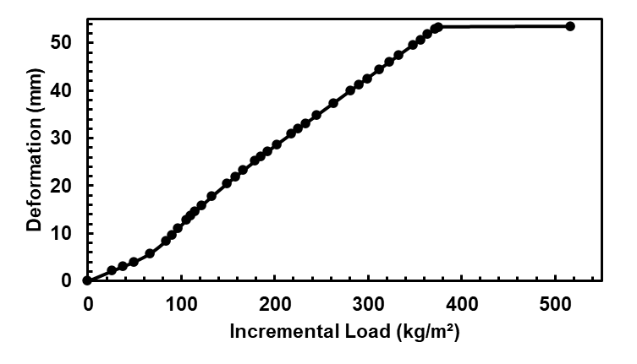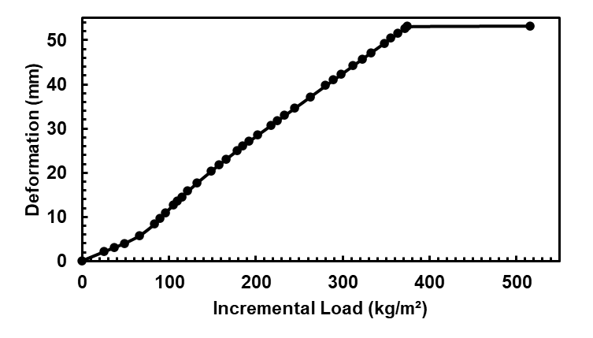
Fig 13. Deformation–load curve for the case 4, indicating global instability (left) and local instability (right)
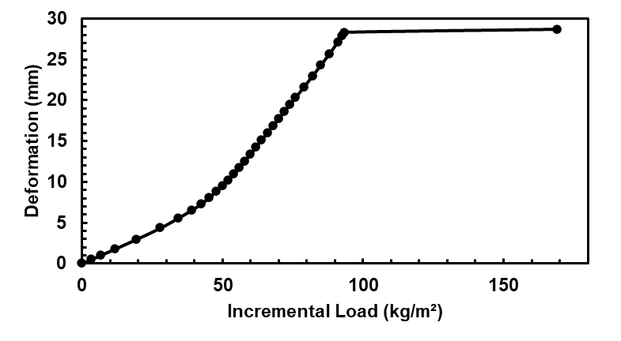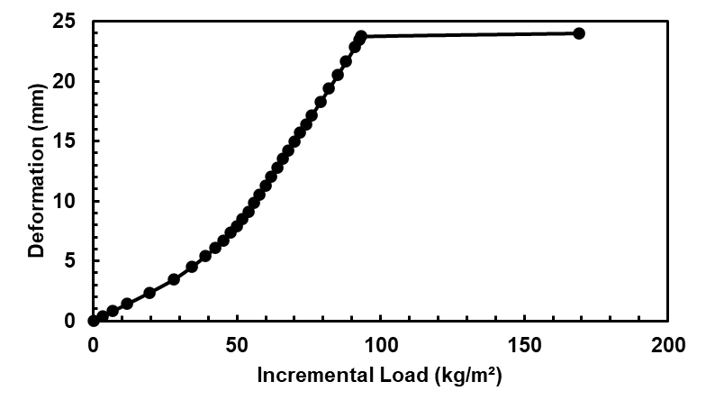
Fig 14. Deformation–load curve for the case 5, indicating global instability (left) and local instability (right)
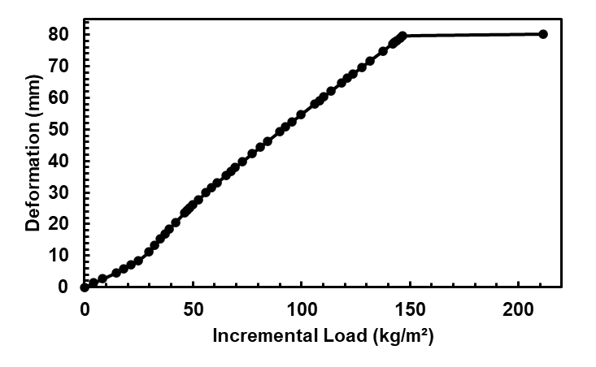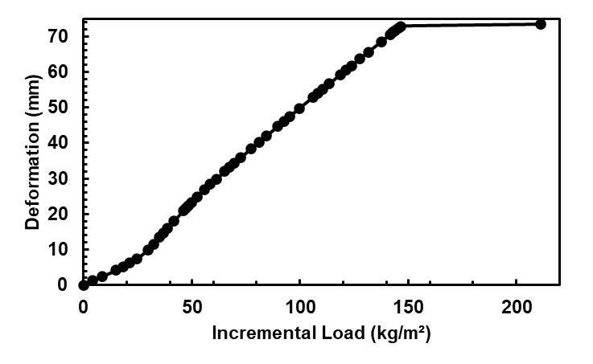
Fig 15. Deformation–load curve for the case 6, indicating global instability (left) and local instability (right)
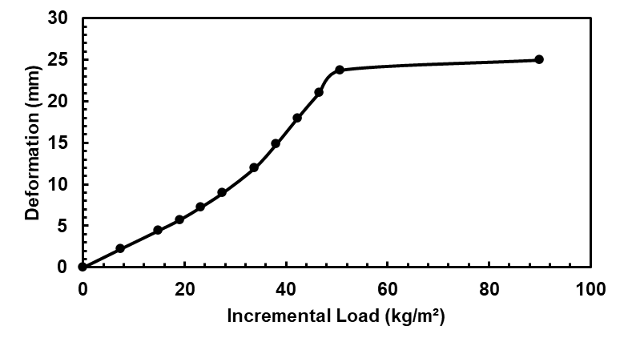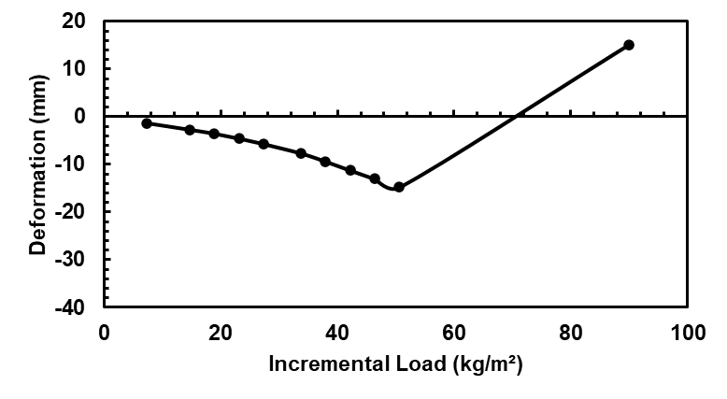
Fig 16. Deformation–load curve for the case 7, indicating global instability (left) and local instability (right)
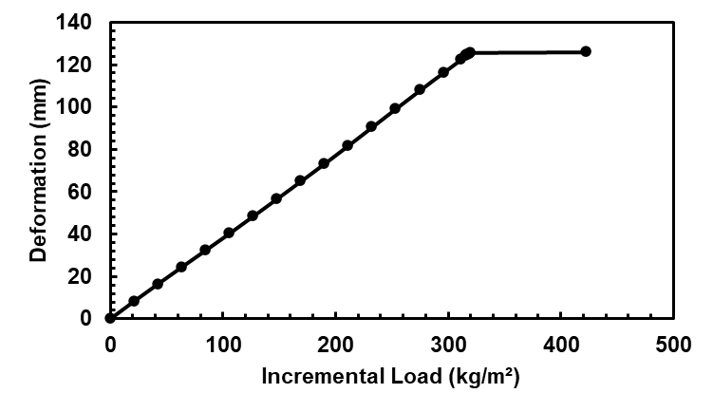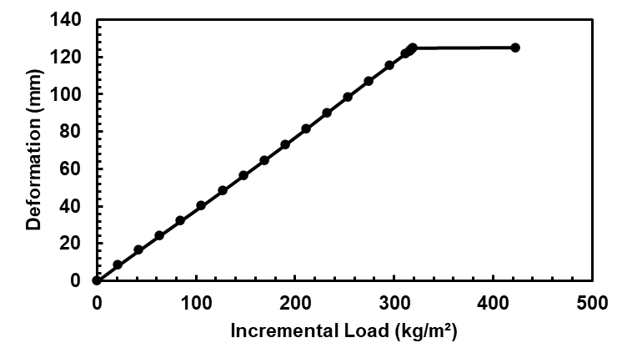
Fig 17. Deformation–load curve for the case 8, indicating global instability (left) and local instability (right)
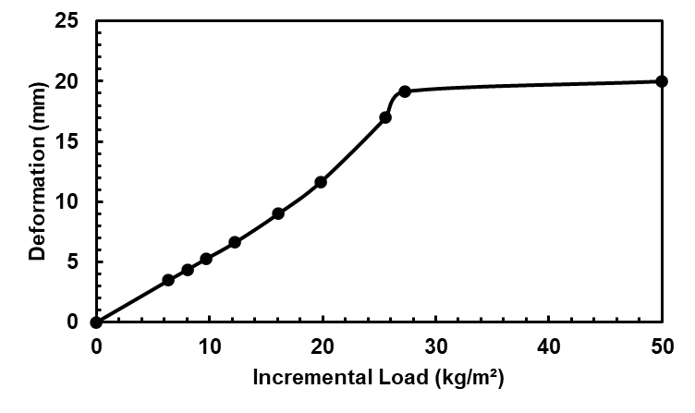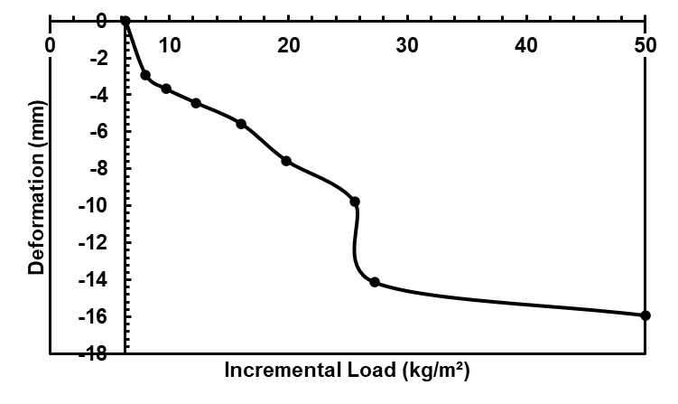
Fig 18. Deformation–load curve for the case 9, indicating global instability (left) and local instability (right)
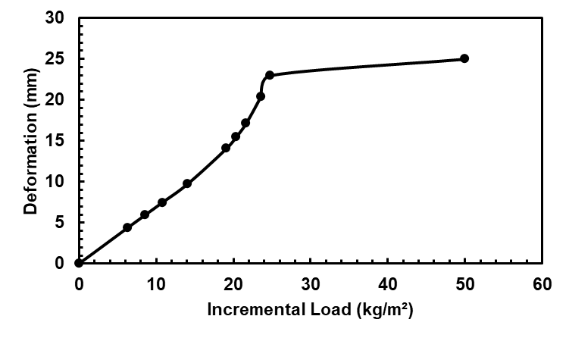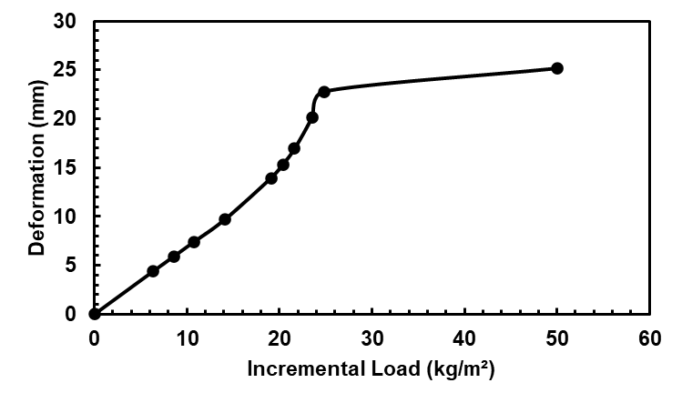
Fig 19. Deformation–load curve for the case 10, indicating global instability (left) and local instability (right)
A summary of the critical loads for each nonlinear buckling analysis case is shown in the Table 7.
Table 7. Critical nonlinear load for each length and load case
Length | Case | Critical Load (kg/m²)
(m) | Case | Critical Load (kg/m²)
15 | 1 | 356.76
15 | 2 | 299.24
15 | 3 | 415.83
15 | 4 | 375.01
20 | 5 | 93.278
20 | 6 | 146.65
25 | 7 | 50.716
25 | 8 | 319.46
30 | 9 | 27.26
30 | 10 | 24.8
In comparing the critical load predicted by linear buckling analysis with that obtained from nonlinear buckling analysis the expected behavior is a reduction in the buckling load once imperfections and nonlinearities are considered. However, an increase in the load-carrying capacity of the system was observed, as shown in the Fig 20.
Fig 20. Comparison of critical load for linear buckling versus nonlinear buckling (50 100 150 200 250 300 350 400 kg/m²) on different cases depending on their wind pressure loads and span lengths
Only four cases showed a lower critical load in the nonlinear buckling analysis compared to the linear one: case 5 for the 20 m length, case 7 for the 25 m length, and cases 9 and 10 for the 30 m length.
4.2.1 Stresses and total deformation
According to the nonlinear buckling analysis, the normal stresses and total deformations of the roof were evaluated before the system lost stability, in order to observe whether the stresses and deformations reached their maximum permissible limits.
Stress checks are performed using the Allowable Stress Design (ASD), criterion is considered, whereby the maximum stress must not exceed 60% of the yield stress. This criterion has historically been used in various standards such as: AISC, ASD, AISI.
In the case of maximum permissible deformations, it was verified that the maximum deformation will not exceed the total length between 240. This service limit criterion has been used in Mexican regulations (NTC), which stands for Normas Técnicas Complementarias (Complementary Technical Standards).
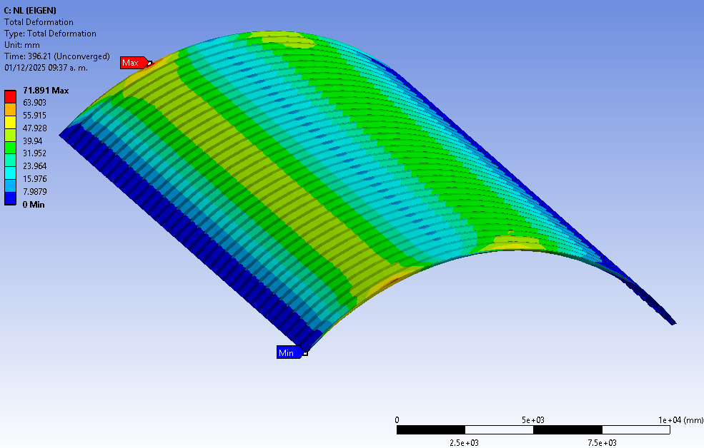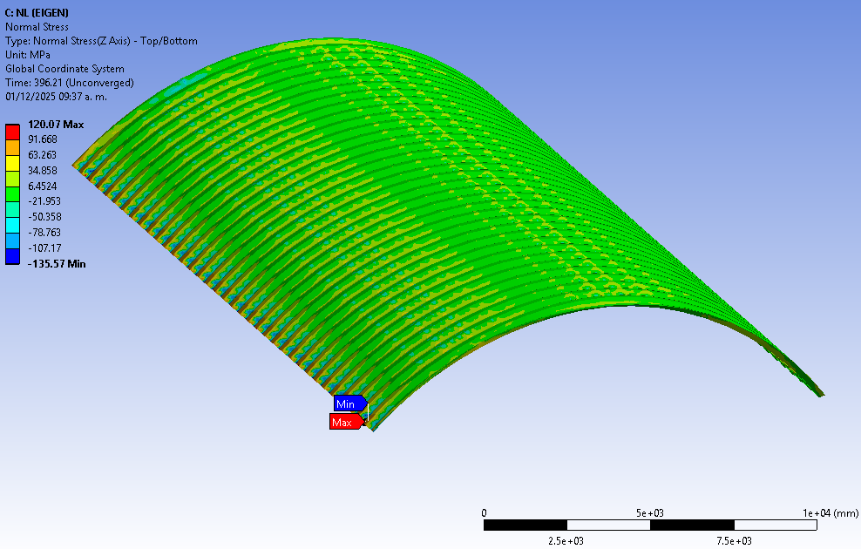
Fig 21. Case 1, maximum total deformation 71.90 mm on the left and maximum normal stress -135.57 MPa on the right
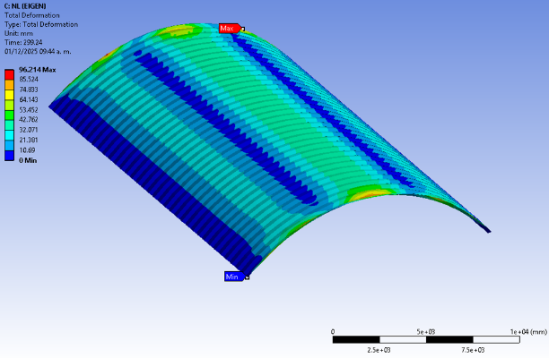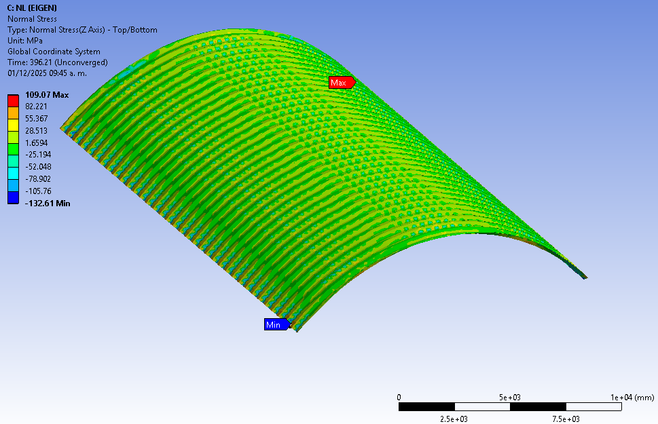
Fig 22. Case 2, maximum total deformation 96.21 mm on the left and maximum normal stress 109.07 MPa on the right
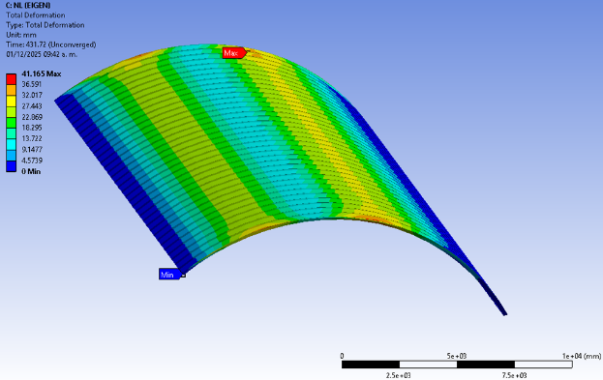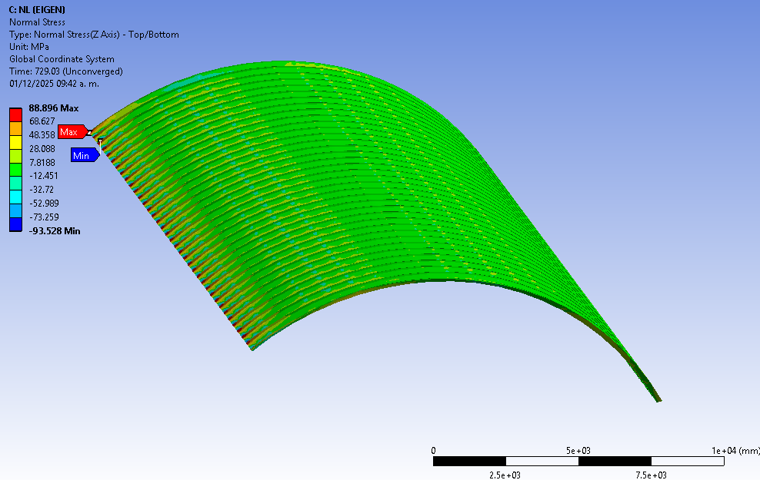
Fig 23. Case 3, maximum total deformation 41.17 mm on the left and maximum normal stress 88.9 MPa on the right
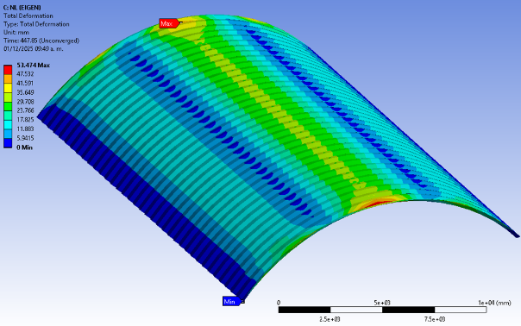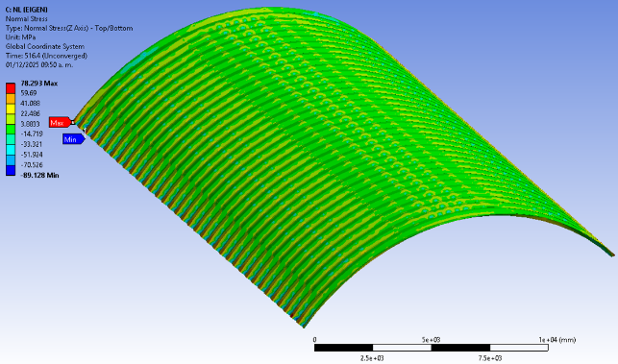
Fig 24. Case 4, maximum total deformation 53.47 mm on the left and maximum normal stress 78.29 MPa on the right
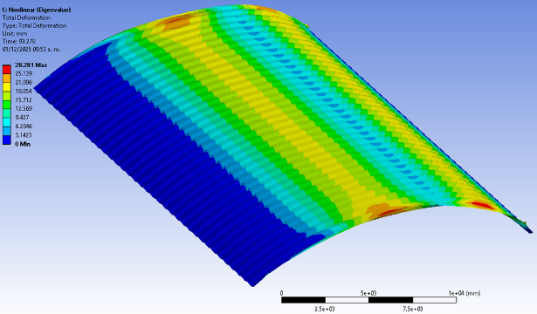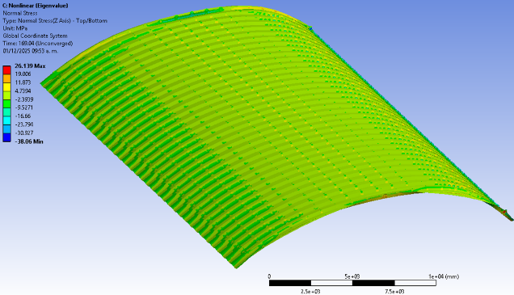
Fig 25. Case 5, maximum total deformation 28.28 mm on the left and maximum normal stress 26.14 MPa on the right
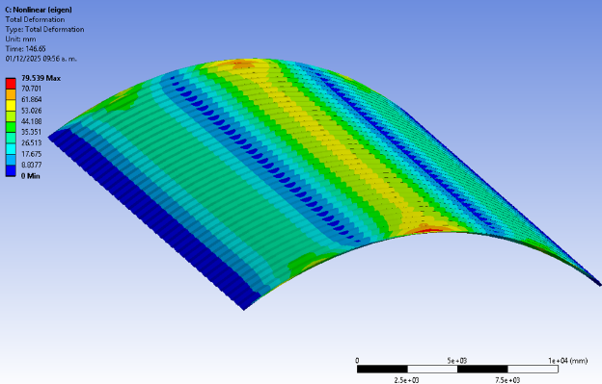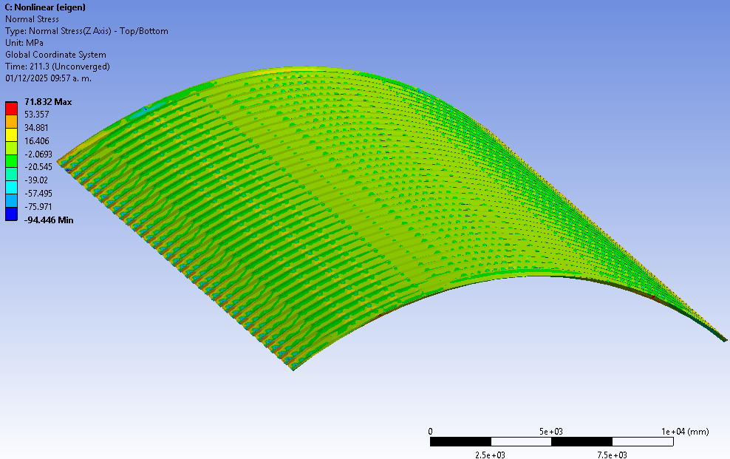
Fig 26. Case 6, maximum total deformation 79.54 mm on the left and maximum normal stress 71.83 MPa on the right
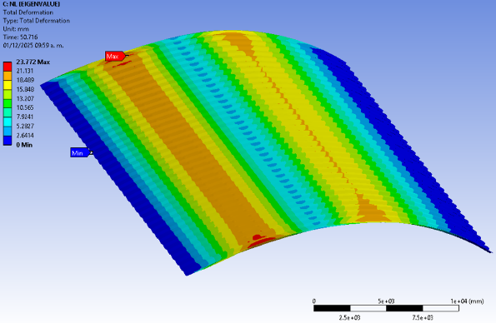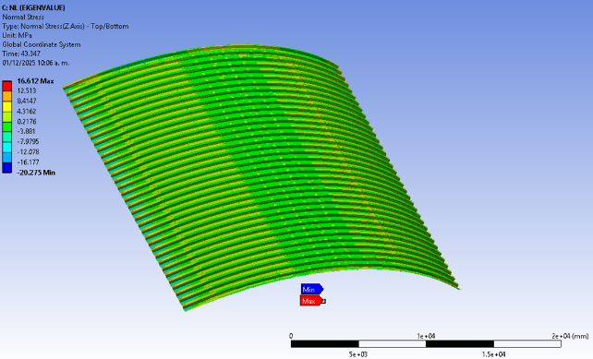
Fig 27. Case 7, maximum total deformation 23.73 mm on the left and maximum normal stress 16.61 MPa on the right
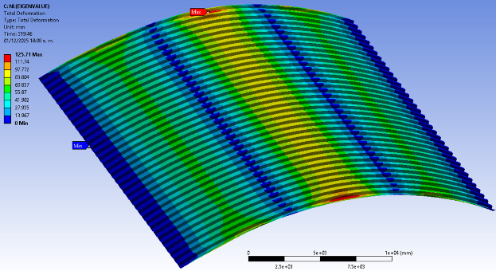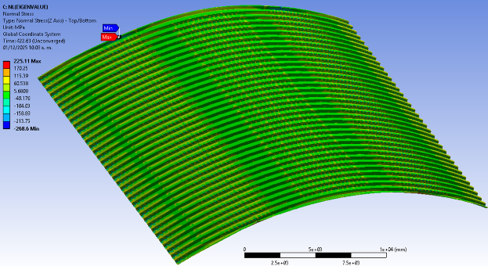
Fig 28. Case 8, maximum total deformation 125.71 mm on the left and maximum normal stress 225.11 MPa on the right
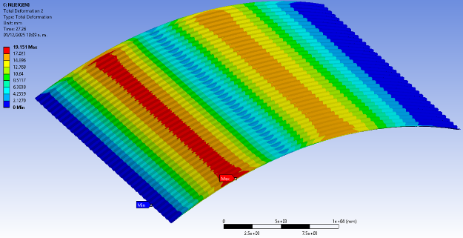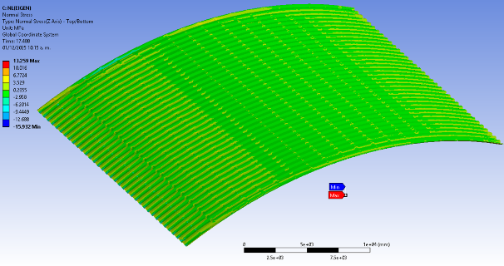
Fig 29 Case 9, maximum total deformation 19.15 mm on the left and maximum normal stress 13.26 MPa on the right
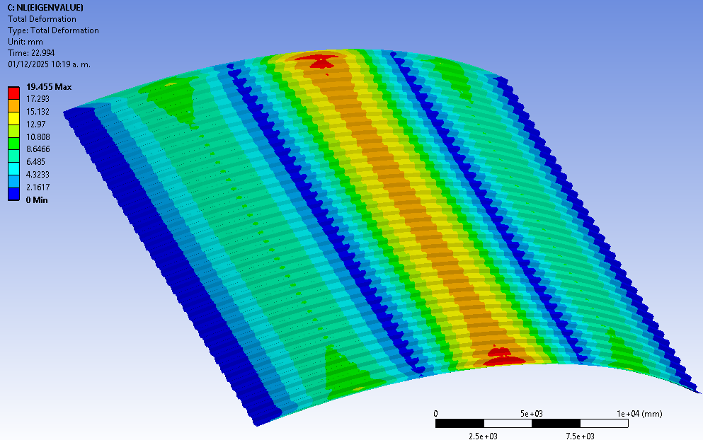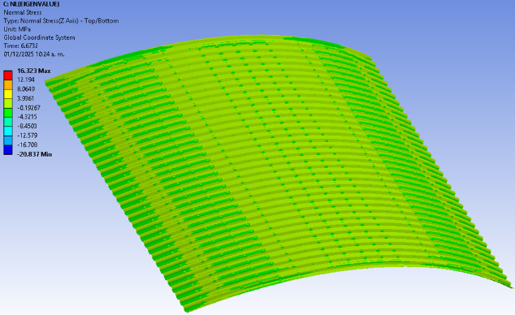
Fig 30. Case 10, maximum total deformation 19.46 mm on the left and maximum normal stress 16.32 MPa on the right

Table 8. Verification of maximum permissible stresses and strains for each case
Length | Case | Total deformation | Normal stress Max | Normal stress Min | Allowable | Limit deformation
 |  |  |  |  | Stress | Limit deformation
(m) | Case | (mm) | (kg/cm²) | (kg/cm²) | 0.6fy | L/240
15 | 1 | 71.689 | 1224.37 | -1382.53 | Pass | Fail
15 | 2 | 96.214 | 1112.2 | -1352.14 | Pass | Fail
15 | 3 | 41.036 | 906.63 | -953.71 | Pass | Pass
15 | 4 | 53.329 | 798.3 | -908.85 | Pass | Pass
20 | 5 | 28.281 | 265.99 | -387.9 | Pass | Pass
20 | 6 | 79.539 | 732.76 | -963.01 | Pass | Pass
25 | 7 | 23.772 | 169.4 | -206.75 | Pass | Pass
25 | 8 | 125.71 | 2288.14 | -2731.62 | Fail | Fail
30 | 9 | 19.15 | 135.2 | -162.46 | Pass | Pass
30 | 10 | 22.99 | 166.45 | -212.48 | Pass | Pass
As can be seen in table 8, for the 15 m length, the deformations in cases 1 and 2, with deformations of 71.69 mm and 96.21 mm respectively, are greater than the maximum permissible deformation of 62.5 mm. Therefore, they do not meet the service conditions. In the 25 m length for case 8, it can be seen that the normal stress of 2288.14 kg/cm², is greater than the permissible limit stress of 1320 kg/cm², and the maximum deformation of 125.71 mm is greater than the maximum permissible deformation of 104.17 mm.
For the rest of the cases associated with the various lengths, the structural system becomes unstable before reaching the limit states of stress and deformation, even with a gain in stiffness due to the geometry of the structure. The critical load capacity due to nonlinear buckling was greater than that due to linear buckling. This is because the geometry of the roof and the simultaneous action of wind pressure and suction created a membrane effect in the structure. To reach this conclusion, the membrane and bending stresses were evaluated in the maximum case, corresponding to the scenario where the critical load for nonlinear buckling is greater than obtained through linear analysis (case 3). Likewise, these stresses were analyzed for the minimum case, i.e., the one in which the critical load for linear buckling is greater than the nonlinear load (case 10). The Fig 31 and Fig 32 show the comparison between the membrane and bending stresses for both cases.
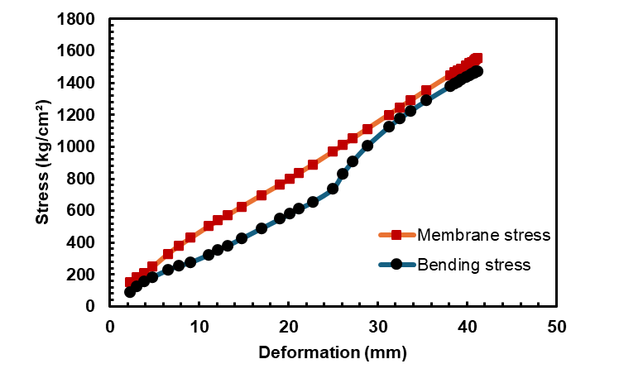
Fig 31.Membrane stress vs bending stress for case 3. The dominant stress is the membrane stress
The Fig 31 shows that membrane stress progressively dominates over bending stress as deformation increases. This indicates that the plate or element is developing a significant membrane effect, typically when large deflections induce axial stresses that increase apparent stiffness.
The difference between the two curves becomes more pronounced from 20 to 25 mm, suggesting that the behavior shifts from being governed by bending to being strongly influenced by in-plane actions, increasing the resistance capacity before losing stability.
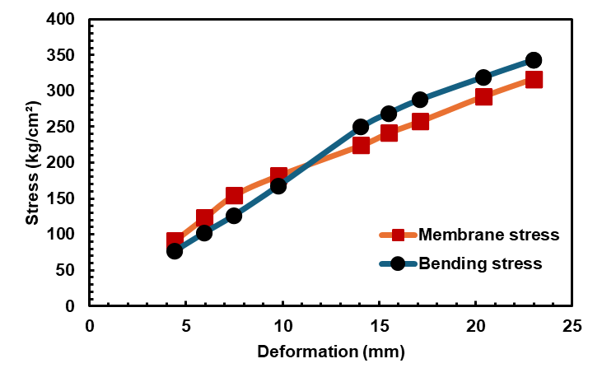
Fig 32. Membrane stress vs bending stress for case 10. The dominant stress is the bending stress
The Fig 32 shows the membrane and bending stress curves that remain much closer to each other, showing that the membrane effect exists but is moderate. The bending stress even exceeds the membrane stress in certain intervals, indicating that the structural response is still dominated mainly by flexural behavior. This pattern is typical of more flexible elements, with less confinement or less development of additional geometric stiffness, resulting in a less marked transition to a regime dominated by in-plane stresses.

5. Conclusion
This research implemented a methodology to evaluate the critical buckling load, considering imperfections and geometric and material nonlinearities for self-supporting roofs. This system is widely used in various sectors, ranging from industrial to commercial and educational, with the latter being the most popular due to its rapid execution and relatively simple construction process.
It was observed that the critical load for nonlinear buckling is not always lower than that obtained for linear buckling under wind loads where pressure and suction loads act in a single load case. Load increases of up to 275.02% were obtained with respect to linear buckling. This behavior may be attributed to an increase in system stiffness induced by a dominant axial compression force that contributes to structural resistance. This phenomenon, known as the membrane effect, develops as a function of the roof geometry.
In contrast to previous studies that reported a reduction in the critical buckling load due to nonlinear buckling under snow loads, considering imperfections from the first buckling mode, this did not fully represent the behavior of the structure because only sections in the vertical direction were tested and modeled, as would be the case with a column or straight profile. On the other hand, in other studies, only partial sections of the roof were modeled and tested, omitting the continuity at the edges of the structure, which changes the stiffness of the system.
Stability must be considered in structural designs for thin-walled systems because the system can lose balance and become unstable before reaching the permissible service limit states and maximum stresses. On the other hand, as the length increases, both linear and nonlinear buckling critical loads tend to decrease.
Currently, there are no international standards, recommendations, or methodologies for evaluating the stability of this type of system. Therefore, future work will require the development of full-scale experimental tests, as well as models that integrate corrugations using Digital Image Correlation (DIC), which will allow a correlation to be found through imperfection factors that can be considered in nonlinear models without the need for high computational costs, in order to obtain the actual critical load and avoid underestimating or overestimating the critical buckling load for self-supporting systems.
AcknowledgEments
Authors acknowledge the support of the Autonomous University of Queretaro (UAQ), as well the Secretariat of Science, Humanities, Technology and Innovation (SECIHTI) and the Universidad Autónoma de Querétaro for the valuable support provided for this research.

Disclaimer (Artificial intelligence)
Option 1:
Author(s) hereby declare that NO generative AI technologies such as Large Language Models (ChatGPT, COPILOT, etc.) and text-to-image generators have been used during the writing or editing of this manuscript.
Option 2:
Author(s) hereby declare that generative AI technologies such as Large Language Models, etc. have been used during the writing or editing of manuscripts. This explanation will include the name, version, model, and source of the generative AI technology and as well as all input prompts provided to the generative AI technology
Details of the AI usage are given below:
1.
2.
3.
Competing interests
Authors have declared that no competing interests exist.

References
1. Del Coz Díaz, J. J., García Nieto, P. J., Vilán Vilán, J. A., & Suárez Sierra, J. L. (2010). Non-linear buckling analysis of a self-weighted metallic roof by FEM. Mathematical and Computer Modelling, 51, 216–228. https://doi.org/10.1016/j.mcm.2009.08.032
2. del Coz Díaz, J. J., Álvarez Rabanal, F. P., García Nieto, P. J., Roces-García, J., & Alonso-Estébanez, A. (2012). Nonlinear buckling and failure analysis of a self-weighted metallic roof with and without skylights by FEM. Engineering Failure Analysis, 26, 65-80. https://doi.org/10.1016/j.engfailanal.2012.07.019
3. Cybulski, R., Walentyński, R., & Cybulska, M. (2014). Local buckling of cold-formed elements used in arched building with geometrical imperfections. Journal of Constructional Steel Research, 96, 1–13. https://doi.org/10.1016/j.jcsr.2014.01.004
4.- Piekarczuk, A., Więch, P., Kuczyński, K., & Walentyński, R. (2021). Experimental and computational approaches to the evaluation of double corrugated arch structures: A review of the latest advancements. Archives of Civil Engineering, 67(2), 7–35. https://doi.org/10.24425/ace.2021.137152
5. Páez Redrován, C. D., & Guerrero Cuasapaz, D. P. (2022). Cubiertas autoportantes circulares aplicando el método de elementos finitos. Gaceta Técnica, 23(1), 72–91. https://doi.org/10.51372/gacetatecnica231.6
6. Narvydas, E., & Puodžiūnienė, N. (2013). A preliminary approach to the load and stress analysis of the arc-shaped corrugated steel structure. Mechanika, 19(1), 12–18. https://doi.org/10.5755/j01.mech.19.1.3629
7. Balbastro, G. C., & Sonzogni, V. E. (2012). Uso de CFD para estudio de presiones del viento en cubiertas curvas aisladas. Rev. Int. Metod. Numer. Calc. Diseno Ing., 28(1), 49–54. https://doi.org/10.1016/j.rimni.2011.11.003
8. Del Coz Díaz, J. J., García Nieto, P. J., Vilán Vilán, J. A., Alvarez Rabanal, F. P., Navarro-Manso, A., & Alonso-Martínez, M. (2013). Nonlinear analysis of the pressure field in industrial buildings with curved metallic roofs due to the wind effect by FEM. Appl. Math. Comput., 221, 202–213. https://doi.org/10.1016/j.amc.2013.06.067
9. Yao, J., Peng, M., Huang, J., Zhang, Q., & Zhou, Y. (2024). Numerical simulation study on wind pressure coefficient of variable cross-section arched roof. Results Eng., 21, 101844. https://doi.org/10.1016/j.rineng.2024.101844
10. Zhang, G., Zhang, Q., Mo, H., Guo, D., Zhi, X., & Fan, F. (2025). Numerical investigations of snow load interference effects on multiple arched roofs under wind–snow coupled actions. Appl. Sci., 15(23), 12414. https://doi.org/10.3390/app152312414
11. Piekarczuk, A., & Malowany, K. (2016). Comparative analysis of numerical models of arch-shaped steel sheet sections. Archives of Civil and Mechanical Engineering, 16(4), 645–658. https://doi.org/10.1016/j.acme.2016.04.006
12. Piekarczuk, A., Więch, P., & Malowany, K. (2017). Numerical investigation into plastic hinge formation in arched corrugated thin-walled profiles. Thin-Walled Struct., 119, 13–21. https://doi.org/10.1016/j.tws.2017.05.029
13. Kollár, L., & Holický, M. (2013). Collapse of halls made from cold-formed steel sheets. Eng Fail Anal, 30, 1–12. https://doi.org/10.1016/j.engfailanal.2012.12.009
14. Ataei, H., & Niazy, A.-S. M. (2015). Buckling analysis of arched structures using finite element analysis. Forensic Eng, 2015, 824–834. https://doi.org/10.1061/9780784479711.080
15. Macháček, J., Jermoljev, D., & Svoboda, O. (2021). Stability of steel arches strengthened by textile membranes. Thin-Walled Struct, 164, 107840. https://doi.org/10.1016/j.tws.2021.107840
16. Hegyi, D. (2021). Numerical stability analysis of arch-supported membrane roofs. Structures, 29, 785–795. https://doi.org/10.1016/j.istruc.2020.11.025
17. Piekarczuk, A., & Więch, P. (2021). Numerical prediction of local instability in double corrugated profiles. Materials, 14(20), 6002. https://doi.org/10.3390/ma14206002
18. Piekarczuk, A., Malowany, K., Więch, P., Kujawińska, M., & Sulik, P. (2015). Stability and bearing capacity of arch-shaped corrugated shell elements: Experimental and numerical study. Bulletin of the Polish Academy of Sciences – Technical Sciences, 63(1), 113–123. https://doi.org/10.1515/bpasts-2015-0013
19. Casafont, M., Marimon, F., Bové, O., Ferrer, M., & Centelles, X. (2024). Local buckling of cold-formed steel trapezoidal sheets: Data for finite element model validation. Data Brief, 53, 110075. https://doi.org/10.1016/j.dib.2024.110075
20. Piekarczuk, A. (2019). Experimental and numerical studies of double corrugated steel arch panels. Thin-Walled Structures, 140, 60–73. https://doi.org/10.1016/j.tws.2019.03.032
21. Piekarczuk, A. (2023). Evaluation of limit curves of double corrugated profiles for arched roofs. J. Constr. Steel Res., 207, 107958. https://doi.org/10.1016/j.jcsr.2023.107958
22. Walentyński, R., Cybulski, R., & Kozieł, K. (2014). Local buckling and post-buckling investigation of cold-formed self-supported elements. Recent Adv Comput Mech, 23–37. https://doi.org/10.1201/b16513-6
23. ANSYS Inc. (2020). Buckling: Local buckling vs buckling, methods for solving. Solid Mechanics III – Methods of Solving Problems (Structural Instabilities). ANSYS Training Materials.
24. Gardner, L., & Yun, X. (2018). Description of stress–strain curves for cold-formed steels. Construction and Building Materials, 189, 527–538. https://doi.org/10.1016/j.conbuildmat.2018.08.195
25. ASTM International. (2020). ASTM A1008/A1008M-20: Standard specification for steel, sheet, cold-rolled, carbon, structural, high-strength low-alloy, high-strength low-alloy with improved formability, and ultra-high strength. West Conshohocken, PA: ASTM International.
26. Comisión Federal de Electricidad (CFE). (2020). Manual de diseño por viento. Ciudad de México: Comisión Federal de Electricidad

