Local perceptions and knowledge of animal diseases among producers in the Guiriko region of Burkina Faso
Abstract
The health situation in the animal production sector remains a real challenge for good productivity. Its management is strongly influenced by producers' perceptions of these diseases. It is in this context that the study was launched. This study was conducted in the Guiriko region, in western Burkina Faso, to analyse local perceptions of livestock diseases among producers. A sample of 270 producers was drawn from the working population of Guiriko using the Slovin formula. The descriptive cross-sectional survey was conducted among these 270 farmers using a semi-structured questionnaire. The farmers were identified by the heads of the village development council and the technical support areas for livestock farming. The data were analysed using R.5.0 software. The results identified more than twenty diseases reported by farmers, with trypanosomiasis and foot-and-mouth disease being the most frequently mentioned. The perceived causes were mainly related to environmental conditions, feed shortages and insect bites. Most diagnoses were based on empirical observation of clinical signs, reflecting consistent but incomplete local knowledge. Although empirical, these perceptions provide valuable information for participatory surveillance and animal health planning. Integrating local knowledge into veterinary strategies and adopting a ‘One Health’ approach could strengthen the resilience of livestock systems to endemic and emerging diseases.
Keywords: local perceptions, livestock diseases, farmers, empirical knowledge, animal health, Burkina Faso
1.INTRODUCTION
Livestock farming, particularly ruminant farming, is a key pillar of socio-economic development in Burkina Faso. It contributes to food self-sufficiency, nutritional security and income generation for many rural households (Guire et al., 2024; Inter-réseaux, 2017). However, the sustainability of this sector depends on animal health, which is a determining factor in farm productivity and profitability.
Animal diseases are a major constraint on the performance of livestock systems. Average losses related to cattle, sheep and goat diseases have been estimated at around $ 994,83 per year per farmer (Atakpama et al., 2016). Trypanosomiasis alone causes a decline of around 20% in agricultural productivity (Assefa & Shibeshi, 2018), while annual economic losses due to livestock diseases amount to nearly $1 billion in Africa. The management of gastrointestinal parasites costs more than $1.2 billion for cattle and $7 billion for small ruminants (Grace et al., 2015). In Burkina Faso, foot-and-mouth disease alone causes economic losses estimated at $ 177 985,35 per year (Dahourou et al., 2022). These figures illustrate the considerable impact of animal diseases on livestock productivity and profitability. The persistence and distribution of animal diseases are influenced by environmental factors (climate change, pasture degradation), but also by production systems and access to veterinary services (Magiri et al., 2021; Tebug et al., 2014). In remote rural areas, where these services remain limited, livestock farmers often rely on their empirical knowledge and traditional practices to diagnose and treat livestock diseases (Garba et al., 2019; Eiki et al., 2021). These ethnoveterinary practices, passed down from generation to generation, are an important resource for animal health, especially in a context of poverty and scarcity of veterinary inputs (Luseba & Vander Merwe, 2006; McGaw et al., 2020).
Producers' perceptions of diseases influence their choices regarding prevention, treatment and use of veterinary services (Hien et al., 2024; Ilboudo et al., 2025). These perceptions, based on empirical observations and local beliefs, often reflect a functional understanding of the environment, but may differ from biomedical models (Djibril et al., 2024; Lesne, 2021)
Misperceptions about the cause or mode of transmission of a disease can limit the effectiveness of health interventions and increase zoonotic risks, particularly in mixed farming systems (WHO/FAO/OIE, 2019; Bissong et al., 2022)
In this context, it was necessary to analyse and understand local perceptions of animal diseases in order to better adapt surveillance and health intervention strategies. This study aimed to document local perceptions and knowledge of animal diseases in the Guiriko region (Houet province, Burkina Faso). It sought to identify the empirical logic used by producers to explain the aetiology, contagiousness, seasonality and diagnosis of diseases. This information would contribute to the development of integrated health management approaches that take into account both local knowledge and modern scientific recommendations.
2. Methodology
2.1. Study area
The study was conducted in Houet Province, located in the Guiriko region in western Burkina Faso. This area is characterised by a tropical Sudanese climate, with annual rainfall varying between 900 and 1,100 mm and an average temperature of around 29 °C (INSD, 2022). The terrain is dominated by plains and forest areas, including nine classified forests (MEEVCC, 2017). The Houet province is notable for its high level of agro-pastoral activity, representing one of the country's main livestock farming areas, with an estimated population of over 2.7 million ruminants (ISND, 2022). This area was chosen because of its climatic characteristics, which are favourable to the persistence of pathogens and vectors, and because of the coexistence of various production systems (extensive, semi-intensive and peri-urban). Five municipalities were selected to reflect this diversity: Bama, Karangasso-Vigué, Koundougou, Padéma and Bobo-Dioulasso.
2.2. Type of study
A descriptive, cross-sectional study was conducted from July to October 2022 to explore farmers' perceptions of the main animal diseases present on their farms. This type of design provides a snapshot of perceptions and practices at a given point in time, in their real-world context (Kasiulevičius et al., 2006)
2.3. Sampling
A sample of 270 producers (shepherds and agro-livestock farmers) was randomly selected from the working population of the study municipalities. The sample size was determined using the Slovin formula (Slovin et al., 2005).
n= N/($1+N\left(e^{2}\right)$)
where n is the sample size, N is the estimated total population of livestock farmers, and e is the precision level set at 5%.
Participants were identified with the support of technical livestock services and village development councils. The inclusion criteria were: (i) having been involved in livestock farming for at least three years; (ii) owning at least one species of ruminant; and (iii) agreeing to participate in the survey.
2.4. Data collection
Data were collected using a pre-tested semi-structured guide administered during individual interviews and focus group discussions. The guide had four main sections: (1) socio-demographic characteristics of producers; (2) knowledge and perception of animal diseases; (3) empirical diagnosis of diseases; and (4) prevention and treatment practices. The surveys were conducted in the local language (Dioula, Fulfulde or Mooré) with the assistance of trained technical agents. The pre-test allowed the wording of the questions to be adjusted to ensure their comprehensibility and relevance.
2.5. Data analysis
The data collected were entered into Excel 2019 and cleaned before analysis. Descriptive statistics (frequencies = number of producers) were calculated using R software (version 4.5.0). The packages readxl, dplyr, ggplot2, patchwork, ggcorrplot, fastDummies. The results were presented in graph form. The relationships between certain variables (e.g. perception and perceived contagiousness) were explored using correlation analysis.
2.6. Ethical considerations
The survey protocol was approved by the Guiriko Regional Livestock and Animal Health Service. The free and informed consent of the producers was obtained before each interview. Responses were treated anonymously and confidentially.
3. Results
3.1. Perception of the causes of disease (local aetiology)
Producers' perceptions of the causes of animal diseases are illustrated in Figure 1. Foot-and-mouth disease is mainly attributed to environmental causes such as wind, humidity, or contact with contaminated drinking troughs. Trypanosomiasis is associated with a lack of fodder and insect bites (flies, mosquitoes). Pulmonary worm infestations are generally explained by the consumption of contaminated water, while intestinal infestations are linked to grazing in contaminated areas.
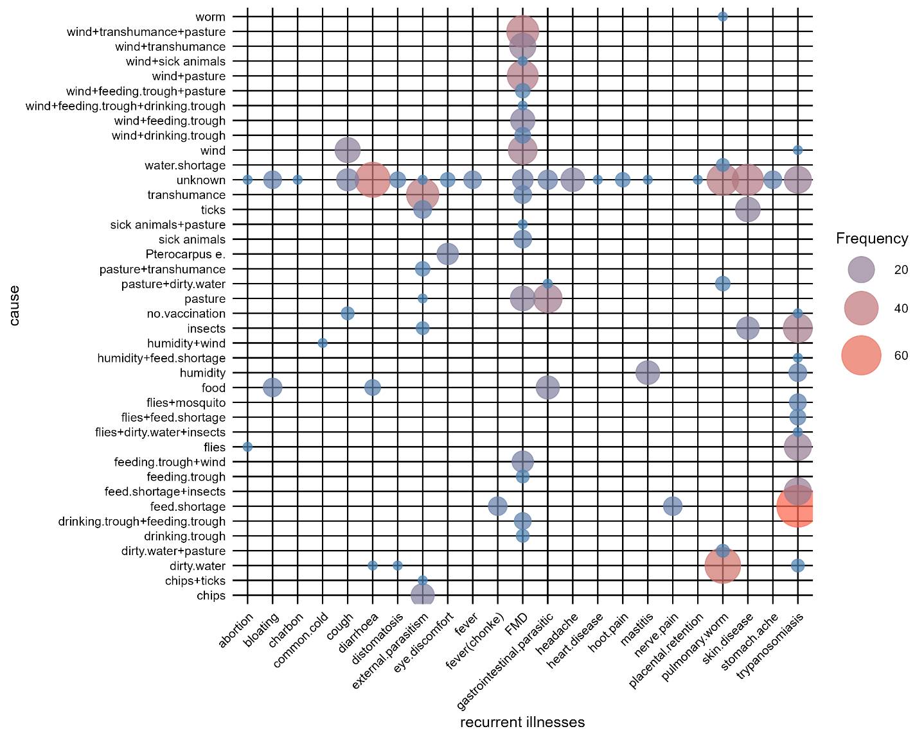
Figure 1: Perceived causes of major animal diseases according to producers
3.2. Season of occurrence of diseases
The majority of producers believe that most diseases occur throughout the year, with peaks during the rainy season (Figure 2). Trypanosomiasis, infestations and mastitis are particularly common during this period, while foot-and-mouth disease and coughing are more commonly reported during the dry season.
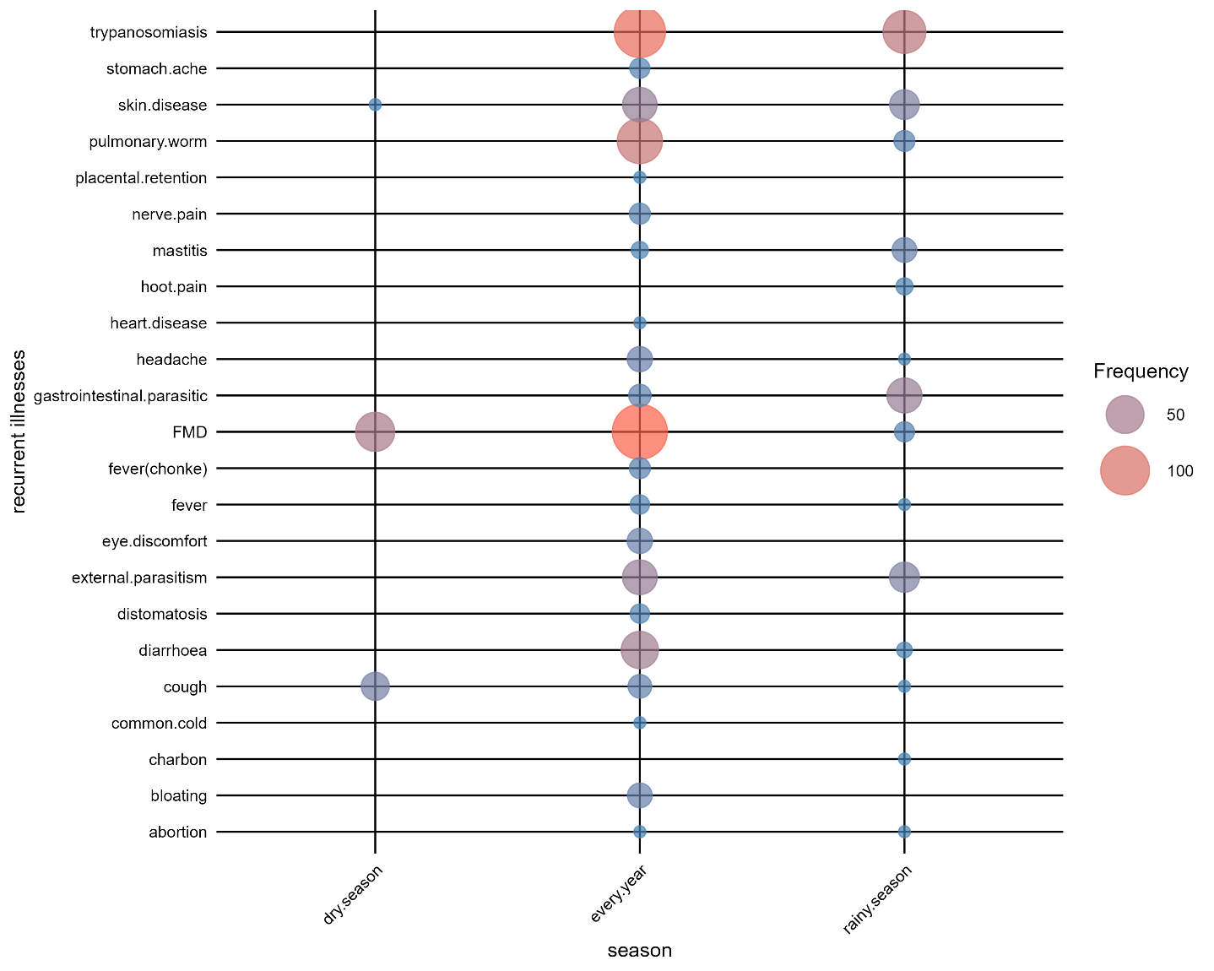
Figure 2: Perceived seasonal frequency of animal diseases on the farms surveyed
3.3. Perceived contagiousness of diseases
According to producers, the majority of the diseases recorded are non-contagious (Figure 3). However, foot-and-mouth disease, coughing, external parasites (ticks, fleas) and anthrax are perceived as highly contagious. A minority of producers also consider trypanosomiasis to be transmissible from one animal to another.
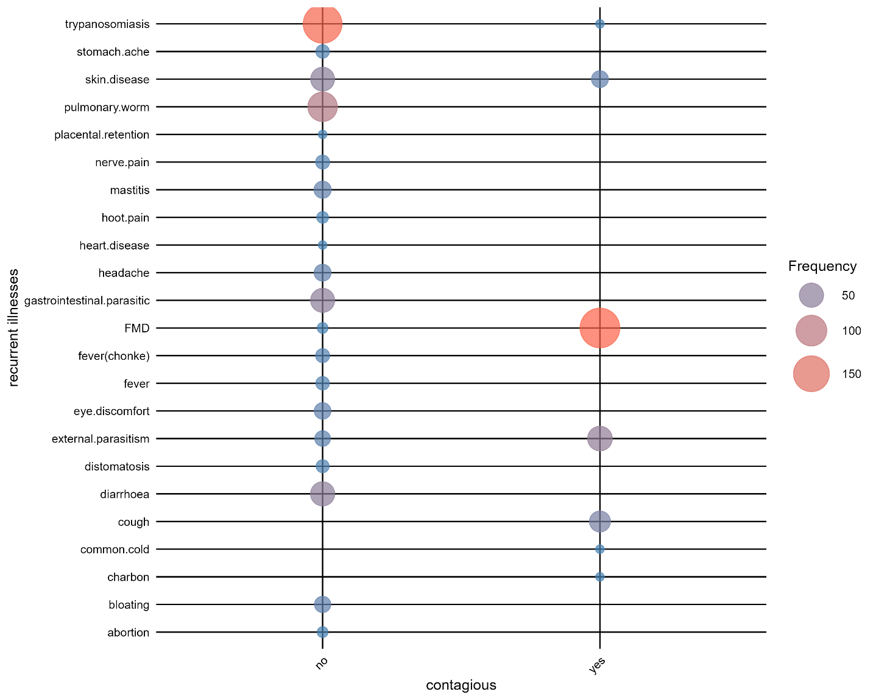
Figure 3: Producers' perception of the contagiousness of animal diseases
3.4. Empirical diagnosis of diseases
Producers base their diagnosis mainly on clinical observation of symptoms (Figure 4). For foot-and-mouth disease, the most commonly cited signs are mouth sores, excessive salivation and foot lesions. Trypanosomiasis is diagnosed on the basis of loss of appetite, fever, weight loss and a dull coat (rough hair coat). Pulmonary worm infestations are associated with coughing and breathing difficulties, while intestinal infestations are identified by the presence of eggs or worms in the faeces. Distomatosis is identified by swelling of the abdomen after meals.
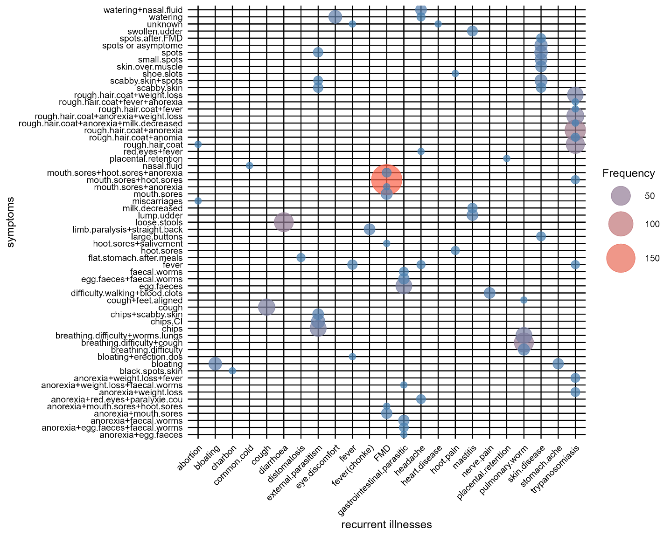
Figure 4: Clinical signs used by producers to diagnose animal diseases
3.5. Correlations between perception variables
Analysis of the correlations between variables (Figure 5) highlights several significant relationships. A strong positive correlation is observed between eye diseases and consumption of the fodder plant Pterocarpus erinaceus during the dry season. Foot-and-mouth disease shows a high correlation with environmental factors (wind, humidity). Trypanosomiasis is strongly correlated with lack of fodder, confirming the consistency of local perceptions.
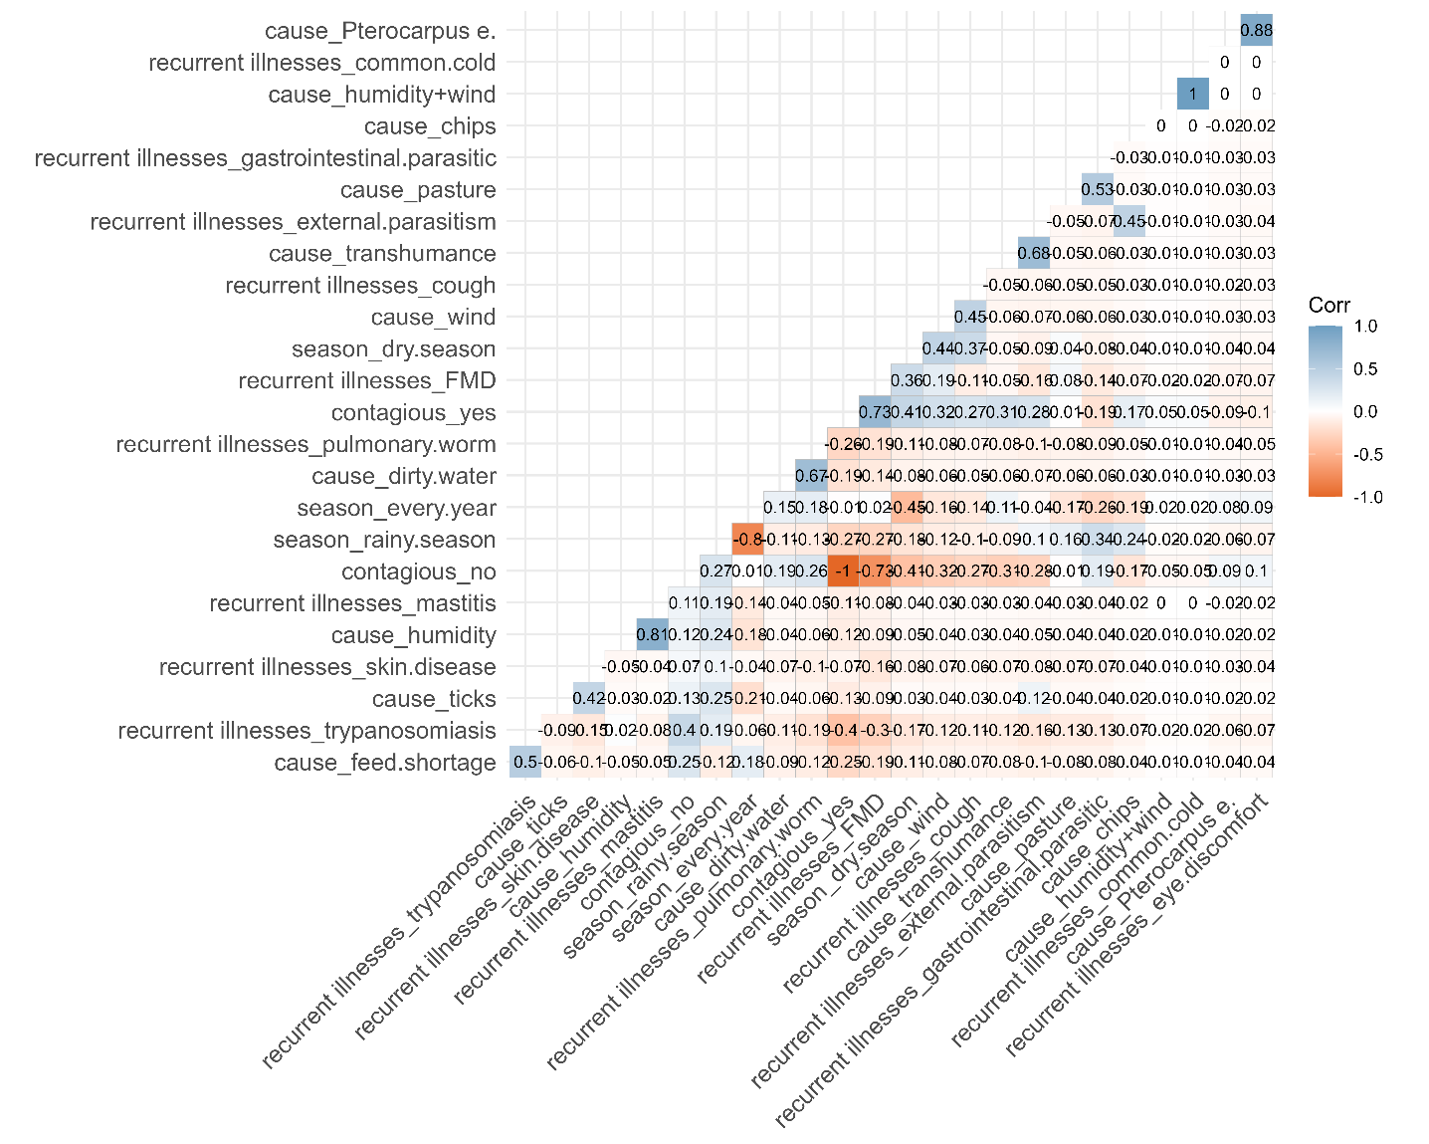
Figure 5: Correlations between local perceptions of the causes, symptoms and contagiousness of diseases
4. Discussion
4.1. Consistency of local perceptions with scientific reality
The results of this study show that producers have fairly accurate empirical knowledge of the main animal diseases encountered on their farms. Trypanosomiasis and foot-and-mouth disease are among the most frequently cited diseases, confirming the observations of other studies conducted in western Burkina Faso (Hien et al., 2024; Ilboudo et al., 2025). The causes mentioned by producers (lack of fodder, insect bites, environmental conditions) reflect a functional interpretation of diseases based on daily experience. These perceptions are consistent with recent work showing that local knowledge is based on empirical observation of the environment and may differ from biomedical classifications, without necessarily being unfounded. For example, nutritional stress related to lack of fodder has been documented as a factor increasing susceptibility to infection in animals in semi-arid systems (Fushai et al., 2025). Furthermore, field studies have shown that poorer body condition is associated with an increased risk of parasitic infection in free-ranging small ruminants (Paul et al., 2016).
4.2. Influence of the socio-economic and environmental context
Local representations of disease are shaped by a context marked by precariousness, degradation of pastures and difficult access to veterinary services. This observation is consistent with studies showing that extensive livestock farming systems in West Africa rely heavily on traditional ethnoveterinary practices (Kone et al., 2019; Jaime et al., 2022) and that access to modern veterinary inputs and services remains limited by economic and logistical constraints (Marandure et al., 2020; Shahzad et al., 2025). Furthermore, the perception of an almost permanent presence of diseases throughout the year reflects an empirical awareness of a change in epidemiological cycles, probably linked to climate change and the ecological adaptation of vectors (Magiri et al., 2021; Shahzad et al., 2025). These observations are consistent with those of Grace et al., (2015) according to whom livestock farmers are valuable field observers in the early detection of emerging diseases.
4.3. Limitations of empirical diagnosis
The diagnosis of diseases is based primarily on the observation of symptoms (coughing, weight loss, mouth lesions, swelling of the abdomen). Although relevant, these indicators remain non-specific. Several symptoms cited by producers (anorexia, weight loss, loss of appetite) can correspond to various pathologies, making empirical diagnosis unreliable without clinical confirmation. This observation was also made by Tamboura et al., (1998) in Burkina Faso and confirmed by McGaw et al., (2020) who emphasise the need to value local knowledge while supplementing it with modern diagnostic tools. Confusion between certain diseases (e.g. trypanosomiasis and pasteurellosis) could explain the underestimation or misclassification of certain endemic diseases. The lack of regular veterinary monitoring exacerbates this diagnostic uncertainty.
4.4. Implications for health management
The integration of local knowledge into animal health programms is a strategic lever for strengthening participatory epidemiological surveillance, especially for diseases such as trypanosomiasis, which have zoonotic implications (WHO/FAO/OIE, 2019). A better understanding of farmers' perceptions would make it possible to adapt awareness messages and prevention strategies to the realities on the ground. In this perspective, the ‘One Health’ approach, linking animal, human and environmental health, represents a promising avenue for designing sustainable and culturally acceptable interventions (Grace et al., 2015).
4.5. Limitations of the study
This study is based on self-reported data and perceptions, which may introduce a subjective bias. The lack of clinical validation of the reported diagnoses is also a limitation. However, the consistency observed between local perceptions and certain epidemiological data reinforces the credibility of the results.
5. Conclusion
This study conducted in the Guiriko region shows that producers have a wealth of empirical knowledge about animal diseases, acquired through observation and experience. Trypanosomiasis and foot-and-mouth disease are the most frequently cited diseases, reflecting farmers' awareness of major endemic diseases. The causes mentioned, although empirical, often reflect an ecological logic consistent with known risk factors. However, diagnosis remains essentially clinical and empirical, due to limited access to veterinary services. The integration of local knowledge into scientific approaches therefore appears essential to strengthen health surveillance, improve prevention and promote a participatory One Health approach. By valuing this traditional knowledge and combining it with technical interventions, it would be possible to increase the resilience of livestock farms and better control animal diseases, particularly zoonotic diseases, in Burkina Faso.
Consent
Before each interview, the objectives and purpose of the study were clearly explained to all participants. Participation was entirely voluntary, and respondents were informed that they could withdraw at any time without consequence. All participants provided their verbal informed consent to take part in the study. No identifying personal data were recorded, and responses were treated with full confidentiality. The authors confirm that informed consent procedures were conducted in accordance with the Declaration of Helsinki (2013) and the FAO/WHO One Health ethical framework for field studies.
Ehnical Approval
This research did not involve any experimental studies on humans or animals. The study protocol was reviewed and approved by the Regional Directorate of Animal Health and Livestock of Guiriko (Burkina Faso), which serves as the competent authority for veterinary field research. The authors confirm that the study complied with the ethical principles of social and behavioral research and respected confidentiality, anonymity, and voluntary participation of respondents.
Disclaimer (Artificial intelligence)
Author(s) hereby declare that NO generative AI technologies such as Large Language Models (ChatGPT, COPILOT, etc.) and text-to-image generators have been used during the writing or editing of this manuscript.
References
1. Guire, O., Mouctari, O., & Chaibou, M. (2024). Uses and socio-economic importance of hides and skins in West Africa. Rev. Mar. Sci. Agron. Vét., 12(4), 306-312. https://doi.org/10.5281//zenodo.14583068
2. Inter-réseaux (2017). Pastoral livestock farming in the Sahel and West Africa: 5 misconceptions put to the test. https://www.inter-reseaux.org/publication/pastoral-livestock-farming-in-the-sahel-and-west-africa-5-misconceptions-put-to-the-test/

3. Atakpama, W., Zabouh, W. K., Nare, M., Batawila, H., & Akpagana, K. (2016). Animal diseases and their impact on the economy of livestock farmers in the savannah region of Togo. Rev. Mar. Sci. Agron. Vét., 4(3), 65-71. https://www.agrimaroc.org/index.php/Actes_IAVH2/article/view/1402/3452
4. Assefa, S., & Shibeshi, W. (2018). Drug resistance in African animal trypanosomes: A review. Afr J Microbiol Re., 12, 380-386. https://doi.org/10.5897/AJMR2017.8754

5. Grace, D., Songe, M., & Knight-Jones, T. (2015). Impact of neglected diseases on animal productivity and public Health in Africa. Paper presented at: 21st Conference of the OIE Regional Commission for Africa; Feb 16-20; Rabat, Morocco. http://www.oie.int/fileadmin/Home/eng/Publications_%26_Documentation/docs/pdf/TT/2015_AFR1_Grace_A.pdf

6. Dahourou L. D., Sanfo K., Kadja M. C., & Traore A. (2022). Epidemiological, clinical, and financial characterization of the 2018 foot-and-mouth disease outbreak in cattle farms in Burkina Faso. Rev. Mar. Sci. Agron. Vét., 10(4), 589-593. https://www.agrimaroc.org/index.php/Actes_IAVH2/article/view/1261

7. Magiri, R., Muzandu, K., Gitau, G., Choongo, K., & Iji P. (2021). Impact of climate change on animal health, emerging and re-emerging diseases in Africa. African Handbook of Climate Change Adaptation, 1-18. https://doi.org/10.1007/978-3-030-45106-6_19
8. Tebug, S F, Njunga, G R, Chagunda, M G G, Mapemba, J P, Awah-Ndukum, J. & Wiedemann, S, (2014). ‘Risk, knowledge and preventive measures of smallholder dairy farmers in northern Malawi with regard to zoonotic brucellosis and bovine tuberculosis’, Onderstepoort Journal of Veterinary Research, 81(1). http://dx.doi.org/10.4102/ojvr.v81i1.594https://doi.org/10.4102/ojvr.v81i1.594
9. Garba, A R I, Adakal, H, Abasse, T, Koudouvo, K, Karim, S, & Akourki, A (2019). Ethnobotanical studies of plants used in the treatment of digestive parasitoses of small ruminants (sheep) in the South West of Niger. Int J Bio Chem Sci, 13(1534) https://doi.org/10.4314/ijbcs.v13i3.26
10. Eiki, N, Sebola, N, Sakong, B, & Mabelebele, M, (2021). Review on Ethnoveterinary Practices in Sub-Saharan Africa. Veterinary Sciences, 88-99 https://doi.org/10.3390/vetsci8060099
11. Luseba, D, & Van der Merwe, D, (2006). Ethnoveterinary medicine practices among Tsonga speaking people of South Africa. Onderstepoort Journal of Veterinary Research, 73(2), 115-122. https://doi.org/10.4102/ojvr.v73i2.156
12. McGaw, L J, Famuyide, I M, Khunoana, E T, Aremu A O., (2020). Ethnoveterinary botanical medicine in South Africa: a review of research from the last decade (2009 to 2019), Journal of Ethnopharmacology, 257, 1-13. https://doi.org/10.1016/j.jep.2020.112864

13. Hien, D F S, Pagabeleguem, S, Pooda, S H, Zonon, K, Sanou, H, & Somda, M. B(2024). Livestock farmers' perceptions of vector-borne and zoonotic diseases related to urban livestock farming in Bobo-Dioulasso, Burkina Faso. Science et technique, 47(1), 91-110, 2024. ISSN 1011-6028

14. Ilboudo, A K, Dione M, Nijhof, A M, Groschup, M H, Traoré, O, & Ilboubo, G S (2025). Factors associated with knowledge, attitudes, and practices of mixed crop-livestock farmers on Crimean-Congo hemorrhagic fever (CCHF) and other zoonoses in Burkina Faso. One Health, 20, 1-11. https://doi.org/10.1016/j.onehlt.2025.101066

15. Djibril, A. S. D., Bothon, F. T. D., Boko, K. C., Koutinhouin, B. G., & Farougou, S. (2024). Farmers’ perceptions of bovine brucellosis in Benin. Veterinary World, 17(2), 434. https://doi.org/10.14202/vetworld.2024.434-447

16. Lesne, J. (2021). The emergence of infectious diseases of zoonotic origin: ecological complexity and socio-economic responsibilities. Environment, Risks & Health, (3), 244-257. https://doi.org/10.1684/ers.2021.1560

17. WHO/FAO/OIE. (2019). Taking a Multisectoral, One Health Approach: A Tripartite Guide to Addressing Zoonotic Diseases in Countries. World Health Organization (WHO), Food and Agriculture Organization of the United Nations (FAO) and World Organization for Animal Health (OIE). Geneva/Rome/Paris. ISBN: 978-92-4-151493-4 (WHO) https://iris.who.int/server/api/core/bitstreams/00a4190f-ff85-4959-b020-db11bca0565b/content
18. Bissong, M E A, Lyombe, J C N, Asongalem, E, Ngamsha, R B, Tendongfor N. (2022). Zoonotic diseases risk perception and infection prevention and control practices among poultry farmers in the Buea Health District, Cameroon: A one health perspective. VetWorld. 15(11):2744-2753. https://doi.org/10.14202/vetworld.2022.2744-2753 .
19. INSD (2022). Fifth General Population and Housing Census of Burkina Faso. Summary of final results [Internet]. Ouagadougou. Available from: https://www.insd.bf/fr/file-download/download/public/2071

20. MEEVCC (2017). 2015 Yearbook of Environmental Statistics. Forestry Sector Support Program (PASF) [Internet]. Ouagadougou. Available from: https://www.environnement.gov.bf/fileadmin/user_upload/rapport_de_l_annuaire_des_statistiques_de_l__environnement_2015.pdf

21. Kasiulevičius, V, Šapoka, V, & Filipavičiūtė, R, (2006) Sample size calculation in epidemiological studies. Gerontologija, 7(4), 225-231.- http://www.gerontologija.lt/files/edit_files//File/pdf/2006/nr_4/2006_225_231.pdf
22. Slovin, M B, Sushka, M E, Polonchek, J A, (2005). Methods of Payment in Asset Sales: Contracting with Equity versus Cash. The Journal of Finance. 60, 2385–2407. https://doi.org/10.1111/j.1540-6261.2005.00802.x
23. Fushai, F, Chitura, T, & Oke, O E, (2025). Climate-smart livestock nutrition in semi-arid Southern African agricultural systems. Frontiers in Veterinary Science, 12, 1507152. https://doi.org/10.3389/fvets.2025.1507152
24. Paul, B T, Biu A A, Gadzama, M A, Ali, M, Mana H P, & Jairus Y, (2016). Point prevalence and intensity of gastrointestinal parasite ova/oocyst and its association with Body Condition Score (BCS) of sheep and goats in Maiduguri, Nigeria. J. Adv. Parasitol. 3(3): 81-88. DOI: https://doi.org/10.14737/journal.jap/2016/3.3.81.88
25. Kone, K H C, Coulibaly, K, & Konan, K S, (2019). Identification de quelques plantes utilisées en médecine ethnovétérinaire à Sinématiali (Nord de la Côte d’Ivoire). Journal of Applied Biosciences, 135, 13766-13774. https://doi.org/10.4314/jab.v135i1.2
26. Traoré, L, Yaro, V S O, Soudré, A, Ouedraogo-Kone, S, Ouedraogo, D, Yougbare, B, et al., (2020). Indigenous knowledge of veterinary medicinal plant use in cattle treatment in southwestern Burkina Faso (West Africa). South African Journal of Botany, 128, 189-199. https://doi.org/10.1016/j.sajb.2019.09.015
27. Jaime, G, Hobeika, A, et Figuié, (2022). M. Access to veterinary drugs in sub Saharan africa: roadblocks and current solutions. Front Vet Sci.; 8 (558973). https://doi.org/10.3389/fvets.2021.558973
28. Marandure, T, Dzama, K, Bennett, J, Makombe, G, Chikwahna, O, & Mapiye, C, (2020) challenge-derived indicators for assessing sustainability of low-input ruminant production systems in sub-Saharan Africa. Environmental and Sustainability Indicators, 8. https://doi.org/10.1016/j.indic.2020.100060
29. Shahzad, S, Akinsulie, O C, Idris I, Devnath, P, Ajagbe, D, Aliyu, V A, et al., (2025). Ticks and tickborne diseases in Global South countries: impact and implications of environmental changes. Frontiers in Tropical Diseases, 6 (1597236), 1-8. https://doi.org/10.3389/fitd.2025.1597236
30. Tamboura, H, Kaboré, H, & Yaméogo, S. M. (1998). Ethnomédecine vétérinaire et pharmacopée traditionnelle dans le plateau central du Burkina Faso : cas de la province du Passoré. Biotechnology, Agronomy and Society and Environment, 2, 181-191 https://popups.uliege.be/base/article/view/792

