Original Research Article

Optimizing CFD Configuration for Accurate Prediction of Wind Pressure Coefficients on Circular Arched Roof Structures

.
ABSTRACT

This study evaluates the influence of Computational Fluid Dynamics (CFD) configurations, including domain size, mesh resolution, and turbulence model, on the prediction of $Cp$ (mean wind pressure coefficients) on circular arched roof structures, and determines the optimal configuration for accurate and efficient simulations. A parametric study was conducted using RANS-based CFD simulations for six different arched roof geometries. The downstream, lateral and upper sides of the computational domain were varied as geometry-based distances in order to assess flow stabilization and blockage effects. Four mesh densities proportional to the structure dimensions were assessed to obtain high accuracy with low-cost computational demand. Finally, five turbulence models were compared for their ability to predict wind pressure coefficients on six circular-arched roof geometries using statistical metrics. The results indicate that domain dimensions and mesh resolution have a slight impact on the accuracy of CFD predictions for arched roof geometries. A downstream domain length of 12S (where S is the greater of the total height and half the span) and a 3.45% blockage ratio provide a good compromise between accuracy and computational efficiency. A mesh resolution of 0.0125W (W is the average of the total height and half the span) based on the structure dimensions was found sufficient to meet the requirements of precision and low computational cost. Among the turbulence models, the Realizable $k-ϵ$ model produced the most accurate results across all geometries, obtaining an average of 0.9 for R² and 0.25 for RSR, followed by the RNG $k-ϵ$ model, whereas the Standard $k-ω$ and SST $k-ω$ models provide a good distribution but underestimate suction magnitude. Overall, the findings provide a guideline for efficient and accurate CFD simulations for arched roof structures, offering recommendations for domain size, mesh resolution, and turbulence model selection. These guidelines can improve the efficiency of future aerodynamic analyses of similar structural configurations.

Keywords: Circular arched roof structures; Wind pressure coefficients; Computational Fluid Dynamics; Turbulence models.

1. INTRODUCTION

Arched roof structures are widely used due to their attractive architecture and their capacity to cover large spans while maintaining clear interior spaces. These structures are commonly employed in sports venues, pavilions, exhibition halls (Yao et al., 2024); in the industrial sector, such as warehouses, workshops, manufacturing units, and hangars (Jha et al., 2022); and in the agricultural production sector as membrane roofing greenhouses and small-scale farms (Blazhnov, 2020). Since these structures are typically thin, flexible, and lightweight, wind load estimation plays a relevant role in structural design decisions.

The effects of wind pressures on a structure are strongly dependent on its geometry because the airflow responds to the shape of the building, leading to variable patterns of pressures on walls and roofs. The standards and codes (ASCE, 2021; CEN, 2020; CFE, 2020) provide a simplified methodology to obtain pressure coefficients that describe the pressure distribution on wind-exposed surfaces. However, these distributions do not fully capture the underlying pressure phenomena and do not cover all possible scenarios. Fouad et al. (2018) conducted a comparative study on the efficiency of international wind design standards and reported differences of about 5%-10% with numerical and experimental studies on low-rise structures.

In general, wind tunnel testing remains the most reliable tool for evaluating the aerodynamics of structures (Kim et al., 2017). However, it presents several limitations, including: 1) a limited simultaneous measurement channels, 2) constraints on model size due to blockage ratio, 3) the cost of manufacturing a model, and 4) significant time and labor requirements. In contrast, computational fluid dynamics (CFD) techniques are increasingly adopted due to their versatility and capability to predict fluid behavior with sufficient accuracy by numerically solving the governing equations (Zawawi et al., 2018).

CFD simulation results are sensitive to variables such as the turbulence model, initial conditions, domain size, and mesh resolution. Wijesooriya et al. (2023) recommend according to the geometry of the object under study. For instance, they propose defining the domain size as a proportion of the total structure height (H), using 5H in all directions and 15H in the downstream direction, while maintaining a blockage ratio between 2% and 5%, which aligns with the recommendations of Meng et al. (2018) and Zheng et al. (2020). Similarly, mesh size is also defined as a function of building height. In Meng et al. (2018) study, a sensitivity analysis was conducted to evaluate the influence of mesh size on the $Cp$ estimation, testing four mesh densities ranging from 0.0109H to 0.00135H, resulting in element counts from 0.61 to 2.67 million.

Kim et al. (2017) evaluated computational domain size for gable roof greenhouses using the structure height as a reference and arrived at recommendations similar to those of Wijesooriya et al. (2023), except for the use of an upstream length of 3H. Other authors have defined the domain dimensions based on the structure width for low-rise buildings, obtaining comparable proportions (Salim & Ooka, 2008; San et al., 2019). Abu-Zidan et al. (2021) optimized the domain configuration by considering: 1) wind blockage effects due to short upstream length; 2) downstream length, which affects flow recirculation; and 3) Venturi effects due to insufficient spacing between the object and the lateral and upper boundaries. Since wind behavior is strongly dependent on the geometry of the structure, the domain dimensions may vary, provided that the above considerations are satisfied.

For curved-roof structures, several studies have used CFD techniques to evaluate wind pressures. In their analysis of gable and arched roofs composed of straight segments, Kim et al. (2017) concluded that the Standard $k-ω$, SST $k-ω$ (Shear Stress Transport), and RNG $k-ϵ$ (Renormalization Group) turbulence models provided the highest agreement indices with wind tunnel data, coinciding with the analyses carried out by Vieira Neto & Soriano (2020). Among these, the SST $k-ω$ model showed the best performance in predicting wind pressures, taking into account the results of gabled-roof structures. In contrast, San et al. (2019) compared the Standard $k-ϵ$, RNG $k-ϵ$, SST $k-ω$, and Reynolds Stress Model (RSM), and reported that RSM produced the closest agreement with wind-tunnel measurements. This behavior is attributed to the fact that RSM does not rely on the Boussinesq approximation and directly solves the Reynolds stress equations, making it more suitable for complex flow scenarios, albeit with significantly higher computational cost and more challenging convergence (Ali et al., 2024).

Despite the extensive research on CFD techniques for different geometries, there are no established guidelines for arched-roof structures. Existing recommendations are mainly based on standard regular geometries, which exhibit wind-flow characteristics that differ from those of curved roofs. Considering the above, the main contributions of this work are:

- Identification of optimal CFD configuration of computational domain, mesh resolution, and turbulence model, obtaining a balance between the accuracy and efficiency of CFD simulations for arched roof structures.
- Demonstration of the robustness of CFD turbulence models to predict the wind behavior on different geometric configurations of arched roof structures.
- Validation for a systematic evaluation methodology applicable to other complex geometries.

As aimed, this study evaluated how the different CFD simulation configurations (turbulence model, domain size, and mesh size) affect the prediction of the $Cp$ (mean pressure coefficient) on circular arched-roof structures. The simulation results were compared against the benchmark study reported by Qiu et al. (2014), which has been used in subsequent studies (Qiu et al., 2018; San et al., 2019; Sun et al., 2015).

The remainder of this paper is organized into three principal sections. Section 2 describes the methodology employed, including the experiment setup and the mathematical model solved by the CFD simulations. Section 3 presents and discusses the results, comparing them with the reference study by Qiu et al. (2014). Finally, Section 4 provides the conclusion of this research.

2. methodology

This section describes the methodology used to determine the optimum CFD setup for estimating wind pressures on circular arched-roof structures. The assessment was carried out in three steps: 1) determination of the computational domain size; 2) a grid independence test to determine the optimum mesh size; and 3) the CFD turbulence models. The methodology followed in this work is shown in Fig. 1. First, the wind tunnel experiment is adopted as the target for replication, and all geometries are evaluated under the various tested conditions. Second, all considerations about the boundary and initial conditions used in CFD simulations are presented. Finally, the statistical metrics employed to evaluate the accuracy of the results are described in the last part of this section.

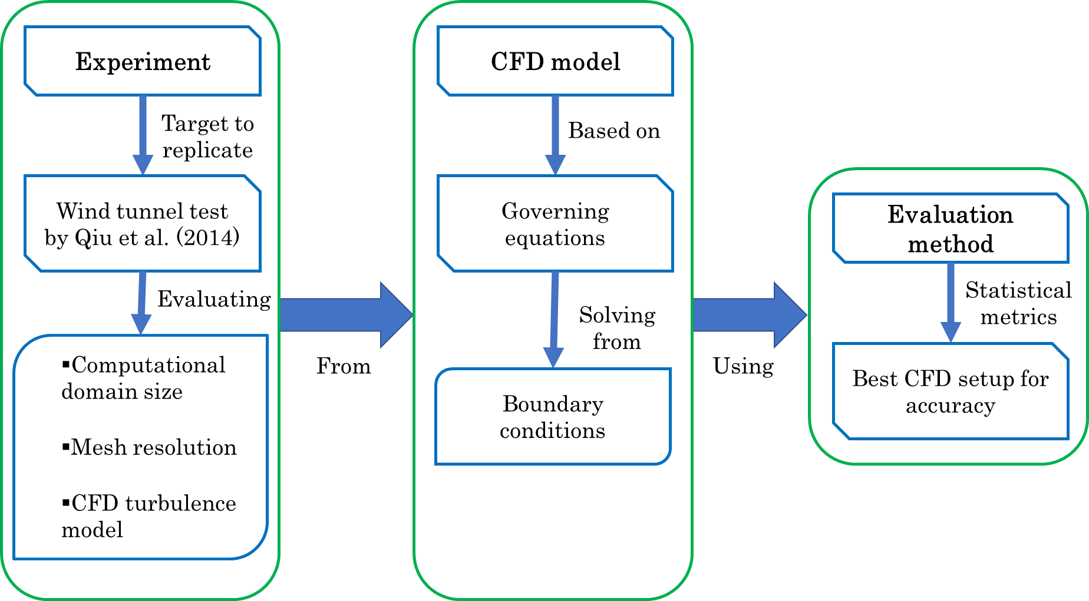
Fig. 1. Flowchart of the methodology used in this research.

2.1 Wind tunnel test target

In this study, various CFD model configurations were evaluated to determine the optimal simulation parameters for estimating wind pressures on structures with curved roofs, as shown in Fig. 2, where B is the length, H is the ridge height, and h is the eave height. The CFD simulations were conducted for six geometric configurations defined by rise height-to-span ratios of R/D = 1/2, 1/3, and 1/6 combined with two span lengths D, as shown in Table 1.

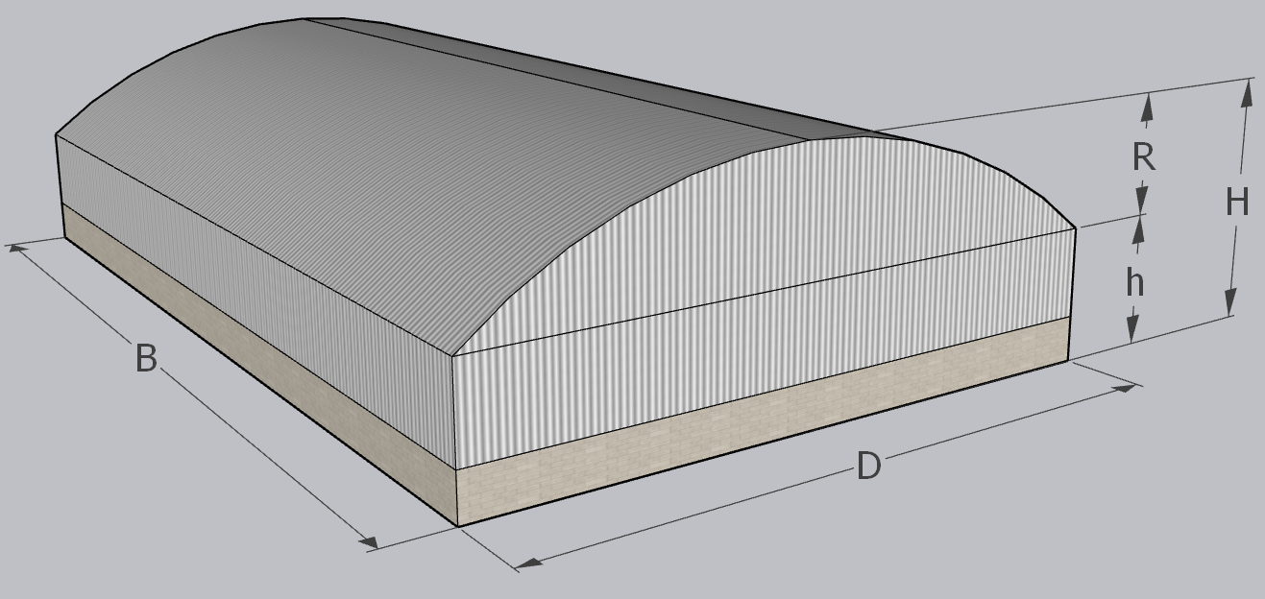
Fig. 2. Geometric representation of the curved roof structures.

Table 1. Geometric configurations used in the CFD simulations. These configurations were selected to replicate the conditions of the wind tunnel experiments.
Geometry | D | R | h | H | h/R | R/D | B/D
Geometry | Span (m) | Rise height (m) | Eave height (m) | Ridge height (m) | Eave-to-rise length ratio | Rise-to-span ratio | Length-to-span ratio
Geom_1 | 60 | 30 | 6 | 36 | 0.2 | 1/2 | 1
Geom_2 | 60 | 20 | 6 | 26 | 0.3 | 1/3 | 1
Geom_3 | 60 | 10 | 6 | 16 | 0.6 | 1/6 | 1
Geom_4 | 20 | 10 | 6 | 16 | 0.6 | 1/2 | 1
Geom_5 | 20 | 6.67 | 6 | 12.67 | 0.9 | 1/3 | 1
Geom_6 | 20 | 3.33 | 6 | 9.33 | 1.8 | 1/6 | 1

Wind tunnel test results were previously published by Qiu et al. (2014), who measured pressures along the centerline of the structure at 21 discrete locations on the roof, parallel to the flow direction. The experimental study investigated the influence of Reynolds number within the range Re = 1.66 × 10⁵ to 8.28 × 10⁵, based on the span D. It was observed that the pressure distribution along the roof becomes relatively stable for Re > 4.14 × 10⁵ for R/D = 1/2, Re > 2.48 × 10⁵ for R/D = 1/3, and in the case of R/D = 1/6, the pressure distribution was found to be independent within the studied Reynolds number range.

To replicate the fluid behavior observed in wind tunnel testing, the Reynolds similarity conditions were applied (Vergara Sánchez, 1993), setting Re = 8.28 × 10⁵ for the long-span geometries and Re = 2.24 × 10⁵ for the short-span geometries. These values correspond to a wind speed of 20 m/s, as used in the wind tunnel study that used a length scale of 1:100. For the CFD experiment, a full-scale model was used, which corresponds to a wind speed of 0.20 m/s according to the Reynolds similarity condition, described in the Eq. (1). This choice is based solely on Reynolds-number similarity between the wind tunnel and the full-scale CFD model and is not intended to represent a realistic full-scale design wind speed, but rather to reproduce the same Reynolds number.

 | $$\frac{Re_{p}}{Re_{m}}=\frac{{\left(\frac{ρvy}{μ}\right)}_{p} }{{\left(\frac{ρvy}{μ}\right)}_{m} }=1$$ | (1)

Where $p$ sub-indices represent the full-scale prototype and $m$ sub-indices represent the scaled model. The rest of the variables are the air density ($ρ$), the fluid velocity ($v$), the dynamic viscosity ($μ$), and the length ($y$), where $ρ$ and $μ$ are fluid properties that do not change for prototype and model, obtaining the prototype velocity Eq. (2).

 | $$v_{p}=\frac{{\left(vy\right)}_{m}}{y_{p} }$$ | (2)

2.2 CFD configuration test

2.2.1 Computational domain size

The domain dimensions were assigned empirically based on the size of the structure under study. Typically, the domain size is determined using the structure height because flow separation and recirculation are governed by the maximum height. Many of the recommendations are established for structures with very pronounced edges because their geometries induce a stronger flow separation and longer recirculation zone compared to a circular-arched roof, where flow separation occurs more gradually, leading to a smoother and shorter recirculation pattern.

For this reason, a similar analysis was carried out in the present study to identify the optimal domain dimensions for a structure with a circular arched roof. The computational domain was evaluated in two stages (Table 3), based on the structure dimensions. A variable S was defined as the greater of H or D/2, ensuring that the domain dimensions would not be underestimated when the structure’s height is small but its horizontal dimensions are significant. In the first stage, four downstream lengths were tested, ranging from 6S to 15S with an interval of 3S. During this stage, the lateral and upper boundaries were kept fixed at a distance of 5S, a value shown that avoid interference with the flow (Kim et al., 2017). After identifying the optimal downstream length, the second stage involved evaluating three different lateral and top boundary distances, ranging from 3S to 5S with an interval of S, as illustrated in Fig. 3.

Table 2. Conditions for the computational domain test.
Computational domain test | Upstream portions | Downstream portion | Side portions | Upper portions
Test 1 | 3S | 6S | 5S | 5S
Test 1 | 3S | 9S | 5S | 5S
Test 1 | 3S | 12S | 5S | 5S
Test 1 | 3S | 15S | 5S | 5S
Test 2 | 3S | Determined in Test 1 | 3S | 3S
Test 2 | 3S | Determined in Test 1 | 4S | 4S
Test 2 | 3S | Determined in Test 1 | 5S | 5S

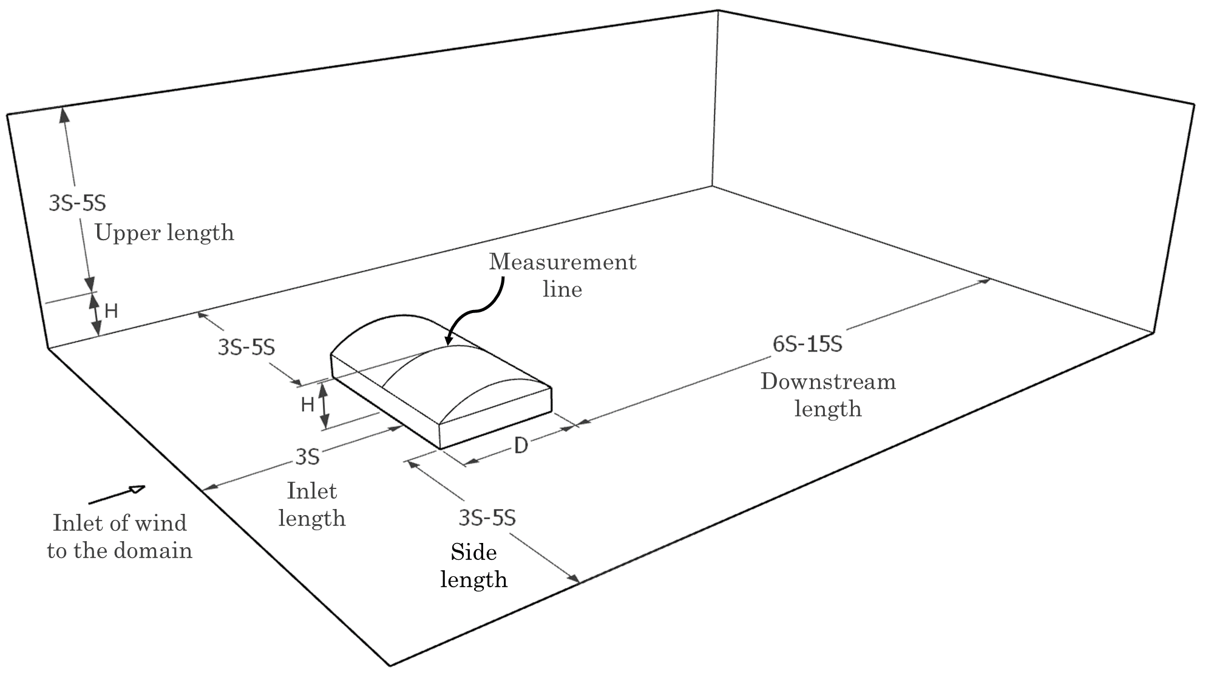
Fig. 3. Length portions for the computational domain test.

These tests were evaluated under the five turbulence model: Standard $k-ω$, SST $k-ω$, Standard $k-ϵ$, RNG $k-ϵ$, and Realizable $k-ϵ$. The purpose of this is to conduct a study that is not biased by the results of a single turbulence model and to evaluate the effect of domain size on each of the turbulence models mentioned.

2.2.2 Mesh size

Another aspect evaluated in this study was the mesh size. A test was conducted to identify the most suitable mesh resolution for the five turbulence models. Four mesh cases were defined based on the proportions of the variable W, defined as the average of H and D/2, following the approach used by Meng et al. (2018). The selected mesh sizes correspond to 0.02W, 0.015W, 0.0125W and 0.01W, which for the first geometry resulted in approximately 0.53, 0.92, 1.35, and 2.06 million cells, respectively.

The grid type used was a poli-hexahedral mesh, a hybrid grid that combines polyhedral and hexahedral elements. The hexahedral elements are known to promote faster convergence, whereas polyhedral cells provide better adaptability to complex geometries and improved accuracy with a lower total cell count compared to tetrahedral meshes (Wijesooriya et al., 2023).

2.2.3 Turbulence model

Finally, once the domain and mesh size had been selected, were tested six geometries with circular arched roofs, under different turbulence models. The evaluated geometries are those presented in Table 1, which considers different h/R and R/D ratios. The aim was to observe the robustness of the turbulence models to distinct geometrical configurations where different flow behaviors are expected, especially in regions of flow separation and recirculation.

The selected turbulence models for this test were the Standard $k-ω$, SST $k-ω$, Standard $k-ϵ$, RNG $k-ϵ$, and Realizable $k-ϵ$ models. Each turbulence model was applied to all geometries to assess its ability to compute the wind flow response and the pressure distribution along the roof of the structure.

2.3 CFD model

2.3.1 Governing equations

The Navier–Stokes equations describe the physical behavior of a fluid. For cases involving Newtonian, incompressible, isothermal, and steady-state flow, the equations can be simplified into the following continuity (3) and momentum (4) equations:

 | $$\frac{∂u_{i}}{∂x_{i}}=0$$ | (3)
 | $$\frac{∂u_{i}}{∂t}+u_{j}\frac{∂u_{i}}{∂x_{j}}=ν\frac{∂^{2}u_{i}}{∂x_{j}∂x_{j}}-\frac{1}{ρ}\frac{∂p}{∂x_{i}}+f_{i}$$ | (4)

Where $u$ is the velocity field, $ν$ the kinematic viscosity, $ρ$ the fluid density, $p$ the pressure, and $f$ represents external body forces. Since this study employs the RANS (Reynolds-Averaged Navier–Stokes) approach, Equation (4) is modified by applying Reynolds decomposition, resulting in (5):

 | $$\frac{∂{\overline{u}}_{i}}{∂t}+{\overline{u}}_{j}\frac{∂{\overline{u}}_{i}}{∂x_{j}}=ν\frac{∂^{2}{\overline{u}}_{i}}{∂x_{j}∂x_{j}}-\frac{1}{ρ}\frac{∂\overline{p}}{∂x_{i}}-\frac{∂\overline{u_{i}^{'}u_{j}^{'}}}{∂x_{j}}$$ | (5)

In this equation, the last term $\overline{u_{i}^{'}u_{j}^{'}}$ represents the Reynolds stress (6). The turbulence models used in this work fall under the category of linear Eddy Viscosity Models (EVM), which are Boussinesq hypothesis-based, a widely adopted approach for turbulence closure that allows estimation of turbulent viscosity (Ali et al., 2024).

 | $$\overline{u_{i}^{'}u_{j}^{'}}=\frac{2}{3}kδ_{ij}-ν_{T}\left(\frac{∂{\overline{u}}_{i}}{∂x_{j}}+\frac{∂{\overline{u}}_{j}}{∂x_{i}}\right)$$ | (6)

The term $k=\frac{1}{2}{\overline{u}}_{i}^{2}$ represents the turbulent kinetic energy (TKE), and $ν_{T}$ the turbulent viscosity (7). The EVM, also known as two-equation models (Lateb et al., 2013), works by modeling the turbulent viscosity by the TKE (8) and the turbulence dissipation rate $ϵ$ (9) or on the specific dissipation rate $ω$ (10), depending on the turbulence model used.

 | $$ν_{T}=C_{μ}\frac{k^{2}}{ϵ}$$ | (7)
 | $$\frac{∂k}{∂t}+{\overline{u}}_{j}\frac{∂k}{∂x_{j}}=\frac{∂}{∂x_{j}}\left(ν_{T}\frac{∂k}{∂x_{j}}\right)+P_{k}-ϵ$$ | (8)
 | $$\frac{∂ϵ}{∂t}+{\overline{u}}_{j}\frac{∂ϵ}{∂x_{j}}=\frac{∂}{∂x_{j}}\left(ν_{T}\frac{∂ϵ}{∂x_{j}}\right)+\frac{ϵ}{k}\left[C_{ϵ1}P_{k}-C_{ϵ2}ϵ\right]$$ | (9)
 | $$\frac{∂ω}{∂t}+{\overline{u}}_{j}\frac{∂ω}{∂x_{j}}=\frac{∂}{∂x_{j}}\left((ν+σ_{ω}ν_{T}\frac{∂ω}{∂x_{j}}\right)+α\frac{ν_{T}}{k}P_{k}-βω^{2}$$ | (10)

Where $P_{k}$ is the production of turbulent kinetic energy and $C_{ϵ}$, $C_{μ}$, $α$, $β$ and $σ_{ω}$ are empirical constants that depend on the specific turbulence model.

2.3.2 Boundary conditions

The equations previously described are commonly simplified for domains where the height is within the atmospheric boundary layer (Richards & Hoxey, 1993). In this study, flow properties were assigned as initial conditions at the domain inlet. These properties include the velocity profile $U\left(y\right)$, and turbulent kinetic energy $k\left(y\right)$, along with the appropriate dissipation rate, either $ϵ$ or $ω$, depending on the turbulence model. These quantities are defined by Equations (11)–(15):

 | $$U\left(y\right)=\frac{u^{*}}{K}\ln\left(\frac{y+y_{0}}{y_{0}}\right)$$ | (11)
 | $$u^{*}=K\frac{U_{ref}}{\ln\left(\frac{y_{ref}+y_{0}}{y_{0}}\right)}$$ | (12)
 | $$k=\frac{u^{*2}}{\sqrt{C_{μ}}}$$ | (13)
 | $$ϵ=\frac{u^{*3}}{K(y+y_{0})}$$ | (14)
 | $$ω=\frac{ϵ}{C_{μ}k}$$ | (15)

Where $U_{ref}$ is the wind speed at the reference height $y_{ref}$, $y_{0}$ is the surface roughness length, $u^{*}$ the friction velocity, $K$ the Von Karman constant equal to 0.41.

A steady-state analysis was conducted in this study using the SIMPLEC algorithm (Semi-Implicit Method for Pressure-Linked Equations - Consistent), which is an improved version of the SIMPLE algorithm and offers greater robustness and faster convergence (Zeng & Tao, 2003). Additionally, second-order discretization schemes were employed to improve the accuracy of the numerical solution (Bournet et al., 2007). A convergence criterion of $1×{10}^{-4}$, was adopted for the residuals of all solved variables, following the recommendations by Oro (2012). The inlet constant values are presented in Table 3 and are consistent with the wind profile type used in the reference study. In this type of analysis, the energy conservation equation is not included in the solution process because its influence on wind pressure prediction is negligible (Kim et al., 2017).

Table 3. Characteristics of the numerical simulation and constant values for boundary conditions.
Inlet parameter | Value | Unit
Numerical algorithm | SIMPLEC | -
Discretization | Second-order | -
Wind environment | Eq. (11)–(15) | -
Gravitational acceleration | 9.81 | m/s²
Air density | 1.225 | kg/m³
Reference wind speed | 0.20 | m/s
Reference height | 6 | m
Surface roughness length | 2 x10⁻⁴ | m
Air viscosity | 1.789x10⁻⁵ | kg/ms

The $y^{+}$ values were kept below 5, in accordance with the recommendations of Wijesooriya et al. (2023). This allowed the use of the Enhanced Wall Treatment (EWT) wall function, which is considered one of the most effective approaches and performs best for $y^{+}< 5$. Although $k-ω$ models do not rely on wall functions, their results are also more accurate when small y+ values are achieved.

2.4 Evaluation method for CFD accuracy

To evaluate the predictive performance of the numerical model, three statistical metrics were applied: the coefficient of determination (R²), the root mean square error-observations standard deviation ratio (RSR), and the index of agreement (d), following the evaluation methodology proposed by Kim et al. (2017).

The coefficient of determination quantifies the degree of correlation between numerical model and experimental values. The R² takes on values in the 0 - 1 range, with 1 indicating a perfect fit. This metric indicates trends but does not express the magnitude of the error. On another hand, the RSR is a statistical index that standardizes the root mean square error (RMSE) by the standard deviation of observed data. In this case, a lower RSR value reflects a higher predictive accuracy of the model, with 0 indicating a perfect fit. Finally, the index of agreement is the ratio of the mean squared error (MSE) and the potential error (PE). It evaluates the degree of agreement between experimental and simulated values, taking values on the 0-1 range, being a higher accuracy when d is closer to 1. This combined approach provides a robust assessment of the agreement between numerical model predictions and experimental data from Qiu et al. (2014) study, overcoming the limitations of relying on a single metric.

3. results and discussion

3.1 Determination of computational domain size

The first step in the domain size evaluation was to determinate of the downstream length of the domain. To illustrate the fluid development for different outlet length ratios, wind velocity vectors are shown in a cross-section of the domain parallel to the flow direction when the wind is perpendicular to the ridge Fig. 4. For all tested distances, the recirculating flow remains fully contained within the domain and is not affected by the outlet boundary location.

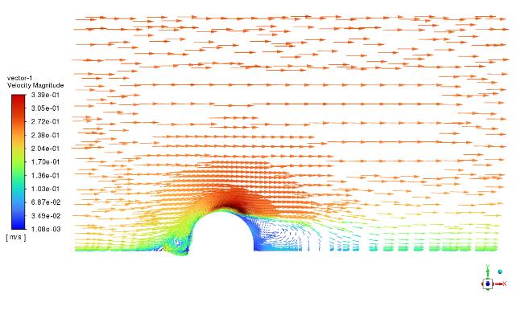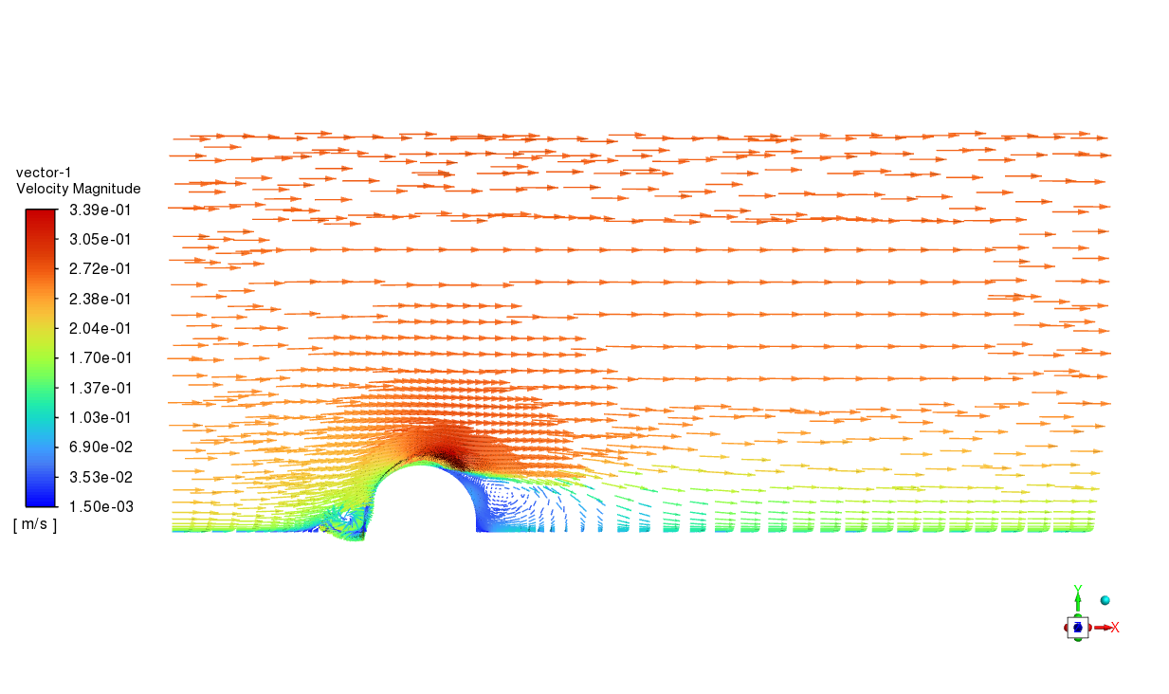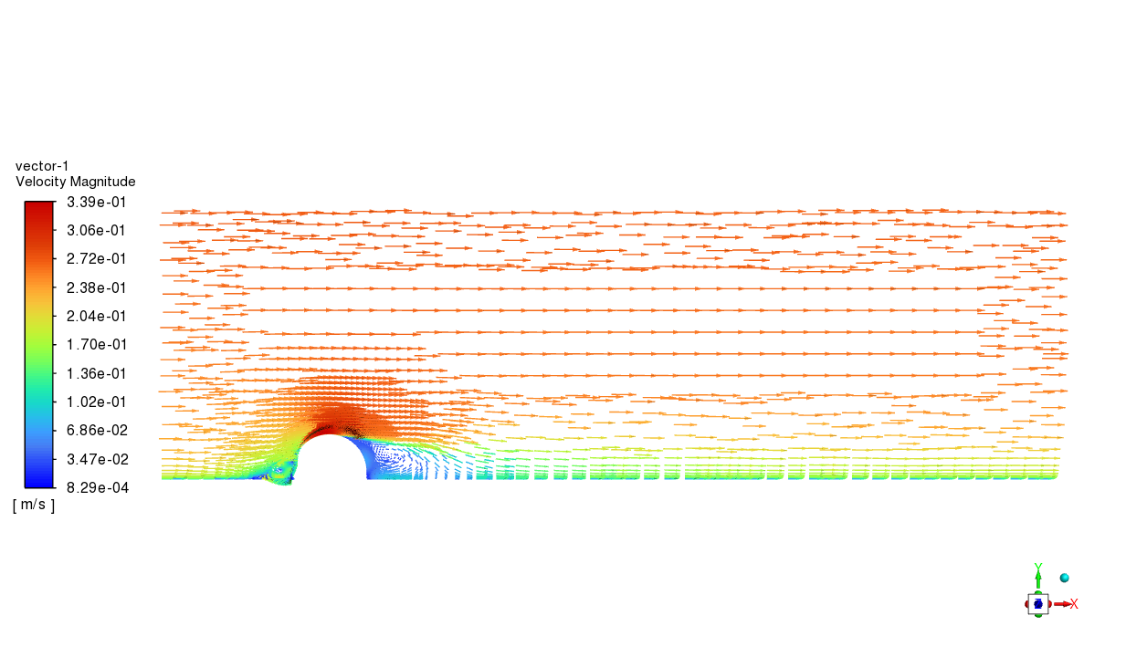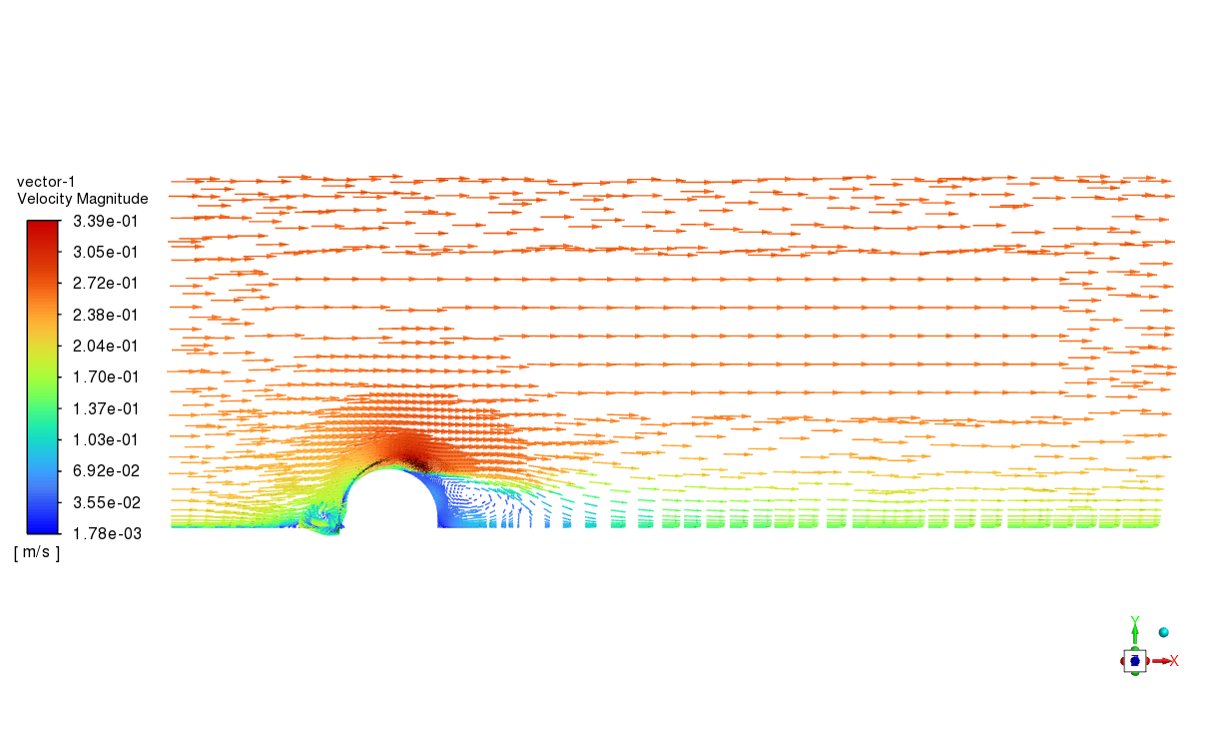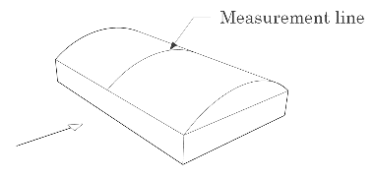Fig. 4. Wind velocity vectors on X-X transversal section of computational domain to different downstream lengths: a) 6S, b) 9S, c) 12S, d) 15S.
a)
b)
c)
d)

The $Cp$ obtained by simulations was compared with the experimental data, as shown in Table 4a. There is a high level of agreement between simulations and measurements for all downstream lengths, since in every case the backflow region remains fully contained within the domain. In the Standard $k-ω$ and Standard $k-ϵ$ cases, the performance is similar for all domain lengths, whereas for the SST $k-ω$, RNG $k-ϵ$, and Realizable $k-ϵ$ models the agreement improves as the downstream length increases, with the best results obtained for 15S. This behavior can be attributed to the increased flow stabilization before the outlet, which promotes better convergence and accuracy.

Table 4. Evaluation metrics for CFD-computed and experimental-measured wind pressure coefficients according to the lengths of the downstream, side, and upper.
Turbulence model | a) First test – Downstream length |  |  |  | b) Second test – Side and upper lengths
Turbulence model | Downstream length | R² | RSR | d | Lateral length | Upper length | R² | RSR | D
Standard  k-ω | 6S | 0.92 | 0.27 | 0.98 | 3S | 3S | 0.93 | 0.25 | 0.98
Standard  k-ω | 9S | 0.92 | 0.27 | 0.98 | 4S | 4S | 0.93 | 0.26 | 0.98
Standard  k-ω | 12S | 0.92 | 0.27 | 0.98 | 5S | 5S | 0.92 | 0.27 | 0.98
Standard  k-ω | 15S | 0.92 | 0.27 | 0.98 | - | - | - | - | -
SST k-ω | 6S | 0.95 | 0.23 | 0.99 | 3S | 3S | 0.95 | 0.23 | 0.99
SST k-ω | 9S | 0.94 | 0.24 | 0.98 | 4S | 4S | 0.95 | 0.22 | 0.99
SST k-ω | 12S | 0.95 | 0.23 | 0.99 | 5S | 5S | 0.95 | 0.23 | 0.99
SST k-ω | 15S | 0.95 | 0.22 | 0.99 | - | - | - | - | -
Standard  k-ε | 6S | 0.82 | 0.41 | 0.96 | 3S | 3S | 0.80 | 0.43 | 0.96
Standard  k-ε | 9S | 0.82 | 0.42 | 0.96 | 4S | 4S | 0.81 | 0.42 | 0.96
Standard  k-ε | 12S | 0.82 | 0.41 | 0.96 | 5S | 5S | 0.82 | 0.41 | 0.96
Standard  k-ε | 15S | 0.82 | 0.41 | 0.96 | - | - | - | - | -
RNG k-ε | 6S | 0.92 | 0.27 | 0.98 | 3S | 3S | 0.93 | 0.27 | 0.98
RNG k-ε | 9S | 0.93 | 0.26 | 0.98 | 4S | 4S | 0.94 | 0.24 | 0.98
RNG k-ε | 12S | 0.94 | 0.25 | 0.98 | 5S | 5S | 0.94 | 0.25 | 0.98
RNG k-ε | 15S | 0.94 | 0.25 | 0.98 | - | - | - | - | -
Realizable  k-ε | 6S | 0.97 | 0.17 | 0.99 | 3S | 3S | 0.96 | 0.20 | 0.99
Realizable  k-ε | 9S | 0.97 | 0.16 | 0.99 | 4S | 4S | 0.97 | 0.16 | 0.99
Realizable  k-ε | 12S | 0.97 | 0.16 | 0.99 | 5S | 5S | 0.97 | 0.16 | 0.99
Realizable  k-ε | 15S | 0.98 | 0.15 | 0.99 | - | - | - | - | -

Across the tested downstream lengths, the statistical indicators R², RSR, and d showed that 12S and 15S yield practically identical accuracy for all turbulence models, with only marginal differences in RSR and no meaningful improvement in R² or d when increasing the domain to 15S. Consequently, 12S can be considered the optimal outlet length, as it is sufficiently long to ensure flow stabilization and robust agreement with the reference data while requiring about 1 % fewer cells than 15S, thereby offering a modest but justified gain in computational efficiency without sacrificing accuracy.

The computational domain was also tested to determine the optimal side and upper extents. These results, shown in Table 4b, were fairly stable across the different domain lengths. The largest differences are observed in the $k-ϵ$ models, particularly in the RNG $k-ϵ$ and Realizable $k-ϵ$ models, where the RSR is higher for the 3S case and decreases in the 4S and 5S cases, with very similar values for the latter two. In the remaining models, the evaluation metrics show no appreciable changes. Based on these results, the side and upper domain extents were set to 4S, corresponding to a blockage ratio of 3.45%, in line with the recommendations from previous studies (Meng et al., 2018; Wijesooriya et al., 2023; Zhao & He, 2017). The resulting computational domain size is shown in Fig. 5.

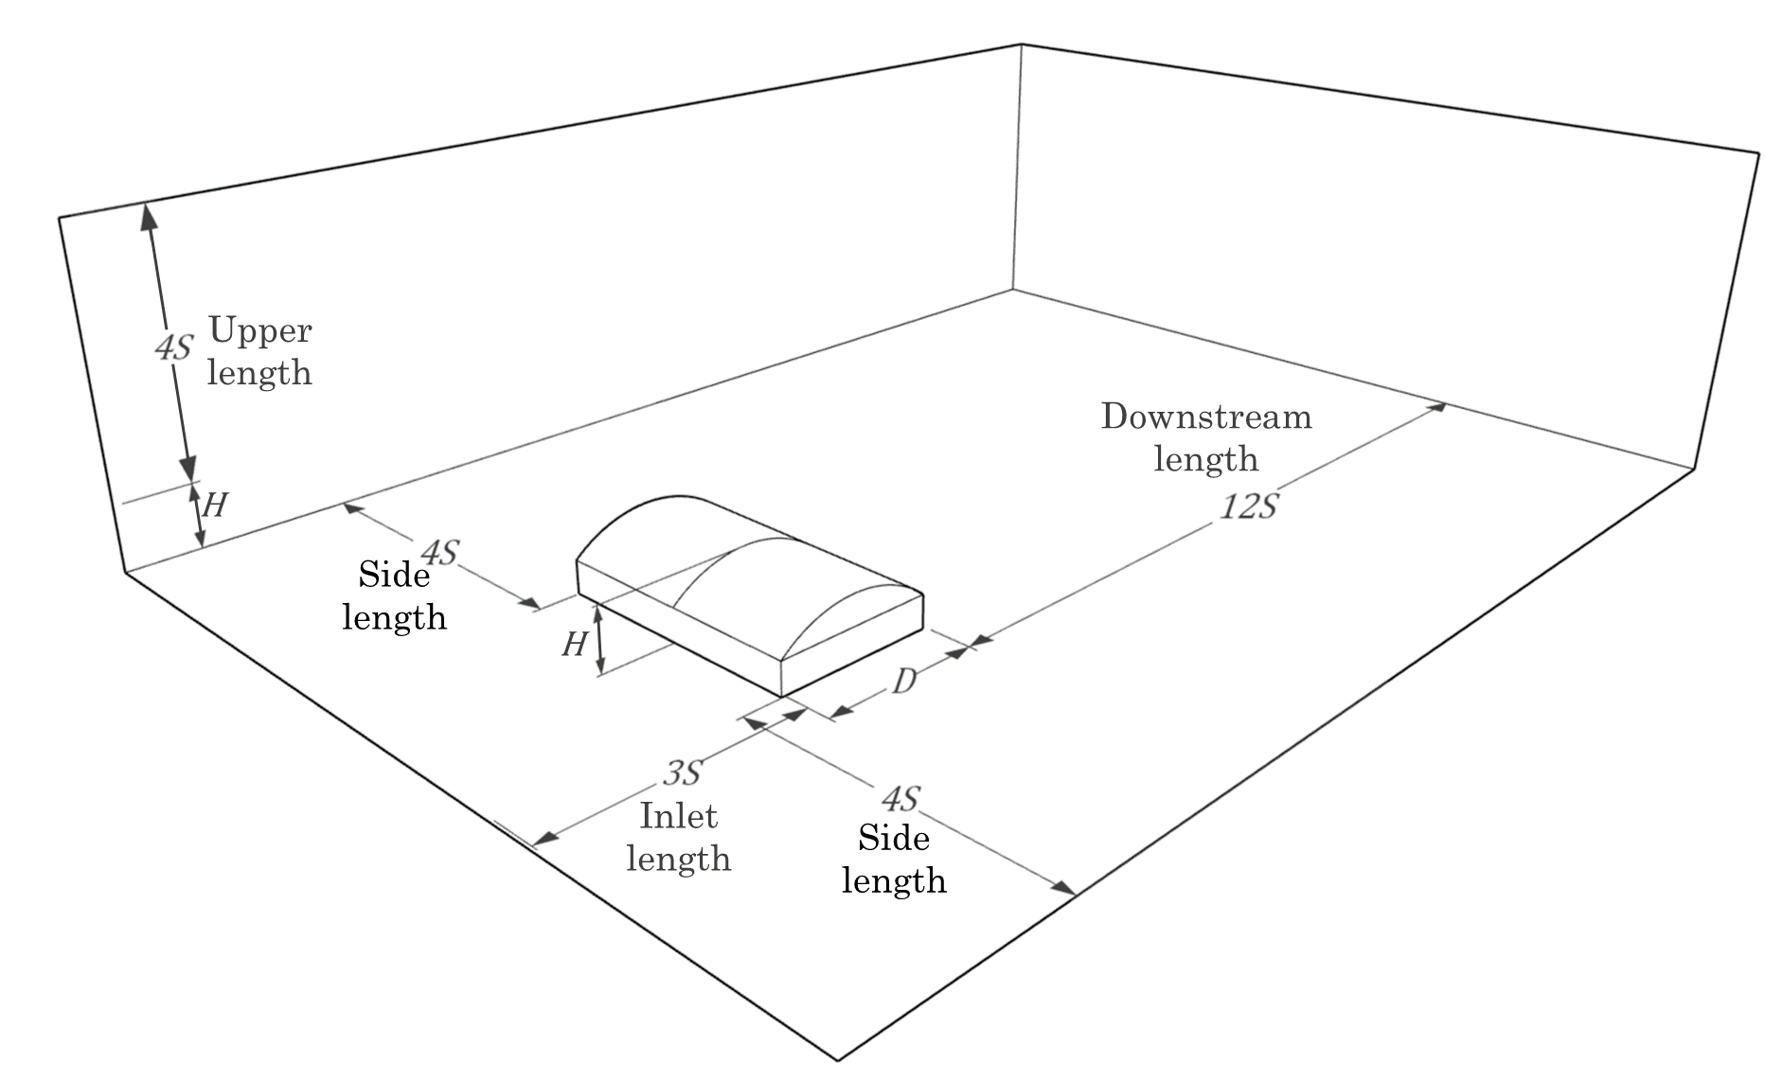
Fig. 5. Determined computational domain size.

3.2 Determination of mesh size

The mesh size evaluation showed that the accuracy of the results is similar for all turbulence models. However, as shown in Table 5, the SST $k-ω$ and RNG $k-ϵ$ models exhibit a slightly better fit when a finer mesh is used. The Fig. 6 illustrates how, for both cases, the $Cp$ distribution changes with the mesh refinement, leading to higher suction pressures for smaller meshes. For the Standard $k-ϵ$ and Realizable $k-ϵ$ models, the performance deteriorates as the mesh is refined. This behaviour can be explained by the same mechanism observed for the SST $k-ω$ and RNG $k-ϵ$ models; the suction is higher with mesh refinement, but in these two cases the turbulence model was already overestimating suction, so a finer mesh results in larger discrepancies.

Table 5. Evaluation metrics for CFD-computed and experimental-measured Cp for the mesh sizes tested.
Turbulence model | Mesh size | R² | RSR | d
Standard k-ω | 0.02W | 0.93 | 0.26 | 0.98
Standard k-ω | 0.015W | 0.94 | 0.24 | 0.98
Standard k-ω | 0.0125W | 0.94 | 0.24 | 0.98
Standard k-ω | 0.01W | 0.94 | 0.25 | 0.98
SST k-ω | 0.02W | 0.94 | 0.24 | 0.98
SST k-ω | 0.015W | 0.94 | 0.24 | 0.98
SST k-ω | 0.0125W | 0.95 | 0.23 | 0.99
SST k-ω | 0.01W | 0.95 | 0.22 | 0.99
Standard k-ε | 0.02W | 0.81 | 0.43 | 0.96
Standard k-ε | 0.015W | 0.80 | 0.44 | 0.96
Standard k-ε | 0.0125W | 0.82 | 0.42 | 0.96
Standard k-ε | 0.01W | 0.78 | 0.45 | 0.95
RNG k-ε | 0.02W | 0.92 | 0.27 | 0.98
RNG k-ε | 0.015W | 0.93 | 0.25 | 0.98
RNG k-ε | 0.0125W | 0.95 | 0.23 | 0.99
RNG k-ε | 0.01W | 0.95 | 0.22 | 0.99
Realizable k-ε | 0.02W | 0.97 | 0.17 | 0.99
Realizable k-ε | 0.015W | 0.96 | 0.19 | 0.99
Realizable k-ε | 0.0125W | 0.96 | 0.19 | 0.99
Realizable k-ε | 0.01W | 0.96 | 0.20 | 0.99

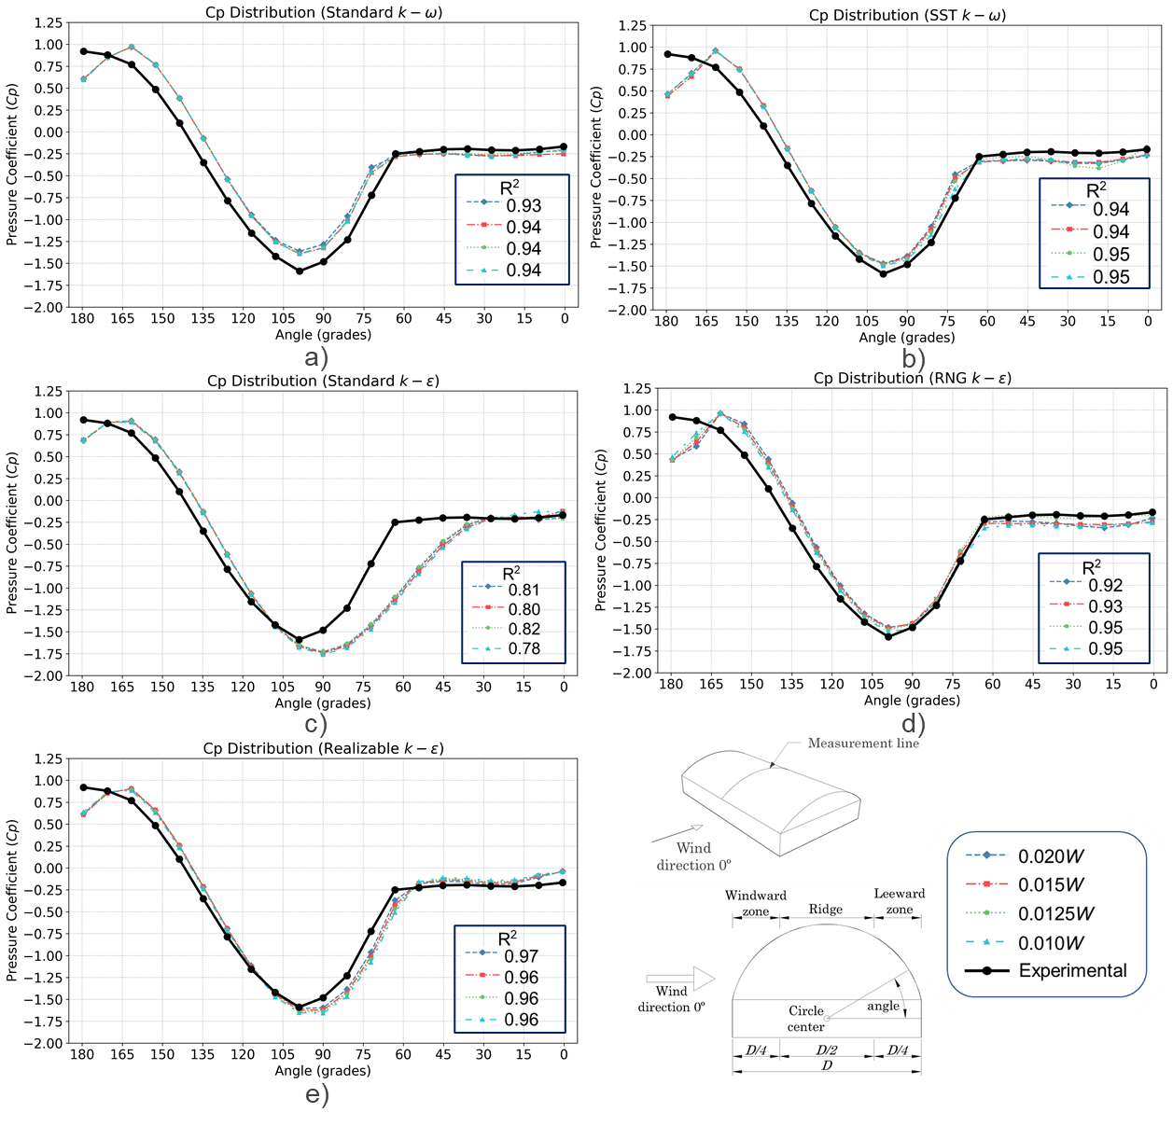

Fig. 6. Comparison of CFD-computed and experimental-measured Cp according to the mesh sizes evaluated with the wind perpendicular to the ridge along the centerline of the roof for the different turbulence models: a) Standard
$k-ω$, b) SST $k-ω$, c) Standard $k-ϵ$, d) RNG $k-ϵ$, e) Realizable $k-ϵ$.

In general, the 0.0125W mesh size was the most suitable, providing a good balance between accuracy and computational efficiency, obtaining similar values to the 0.01W mesh, but with fewer cells. For this reason, the mesh size of 0.0125W was adopted for the turbulence model evaluation.

3.3 Determination of turbulence model

Using the domain and mesh size recommended in previous sections, the turbulence models were evaluated for the six geometries listed in Table 1. The results obtained from this test are presented in Table 6. In general, the Standard $k-ω$ and SST $k-ω$ models showed moderate performance in most cases, except for the first geometry, where both models achieved high indices. In contrast, the RNG $k-ϵ$ and Realizable $k-ϵ$ models provided the best performance for most geometries, except for the third and sixth cases.

Table 6. Statistical indices for CFD-computed and experimental-measured Cp of circular arched-roof geometries for different turbulence models.
Geometry | Statistical index | Standard  $$k-ω$$ | SST  $$k-ω$$ | Standard $k-ϵ$ | RNG $k-ϵ$ | Realizable $k-ϵ$
G_1 | R² | 0.94 | 0.95 | 0.82 | 0.95 | 0.96
G_1 | RSR | 0.24 | 0.23 | 0.42 | 0.23 | 0.19
G_1 | d | 0.98 | 0.99 | 0.96 | 0.99 | 0.99
G_2 | R² | 0.89 | 0.84 | 0.92 | 0.94 | 0.97
G_2 | RSR | 0.32 | 0.39 | 0.28 | 0.24 | 0.17
G_2 | d | 0.97 | 0.95 | 0.98 | 0.98 | 0.99
G_3 | R² | 0.78 | 0.78 | 0.83 | 0.84 | 0.83
G_3 | RSR | 0.46 | 0.45 | 0.41 | 0.40 | 0.40
G_3 | d | 0.95 | 0.94 | 0.96 | 0.96 | 0.96
G_4 | R² | 0.87 | 0.88 | 0.92 | 0.97 | 0.99
G_4 | RSR | 0.35 | 0.33 | 0.28 | 0.16 | 0.06
G_4 | d | 0.96 | 0.97 | 0.98 | 0.99 | 1.00
G_5 | R² | 0.86 | 0.85 | 0.95 | 0.97 | 0.99
G_5 | RSR | 0.37 | 0.38 | 0.23 | 0.16 | 0.09
G_5 | d | 0.96 | 0.95 | 0.99 | 0.99 | 1.00
G_6 | R² | 0.83 | 0.75 | 0.62 | 0.79 | 0.63
G_6 | RSR | 0.40 | 0.49 | 0.60 | 0.45 | 0.60
G_6 | d | 0.95 | 0.93 | 0.89 | 0.93 | 0.90

Furthermore, Fig. 7 illustrates the $Cp$ distribution obtained along the centerline of each geometry. Both $k-ω$ models reproduce a distribution similar to the experimental data, but underestimate the suction, particularly on the ridge and on the leeward zone of the roof for geometries 2, 4, and 5. Likewise, the Standard $k-ϵ$ model shows good agreement in the windward region up to the ridge, whereas the leeward distribution deviates from the measurements, suggesting that this model does not fully capture flow separation and recirculation effects, resulting in a poorer performance. The RNG $k-ϵ$ and Realizable $k-ϵ$ models provide the best agreement with the experimental distributions for most geometries. For the 2, 4, and 5 cases, the RNG model achieves high accuracy with a slight underestimation of suction near to ridge, whereas for cases 1, 4, and 6, the Realizable model attains high accuracy with a slight overestimation of suction on the ridge and leeward zone.

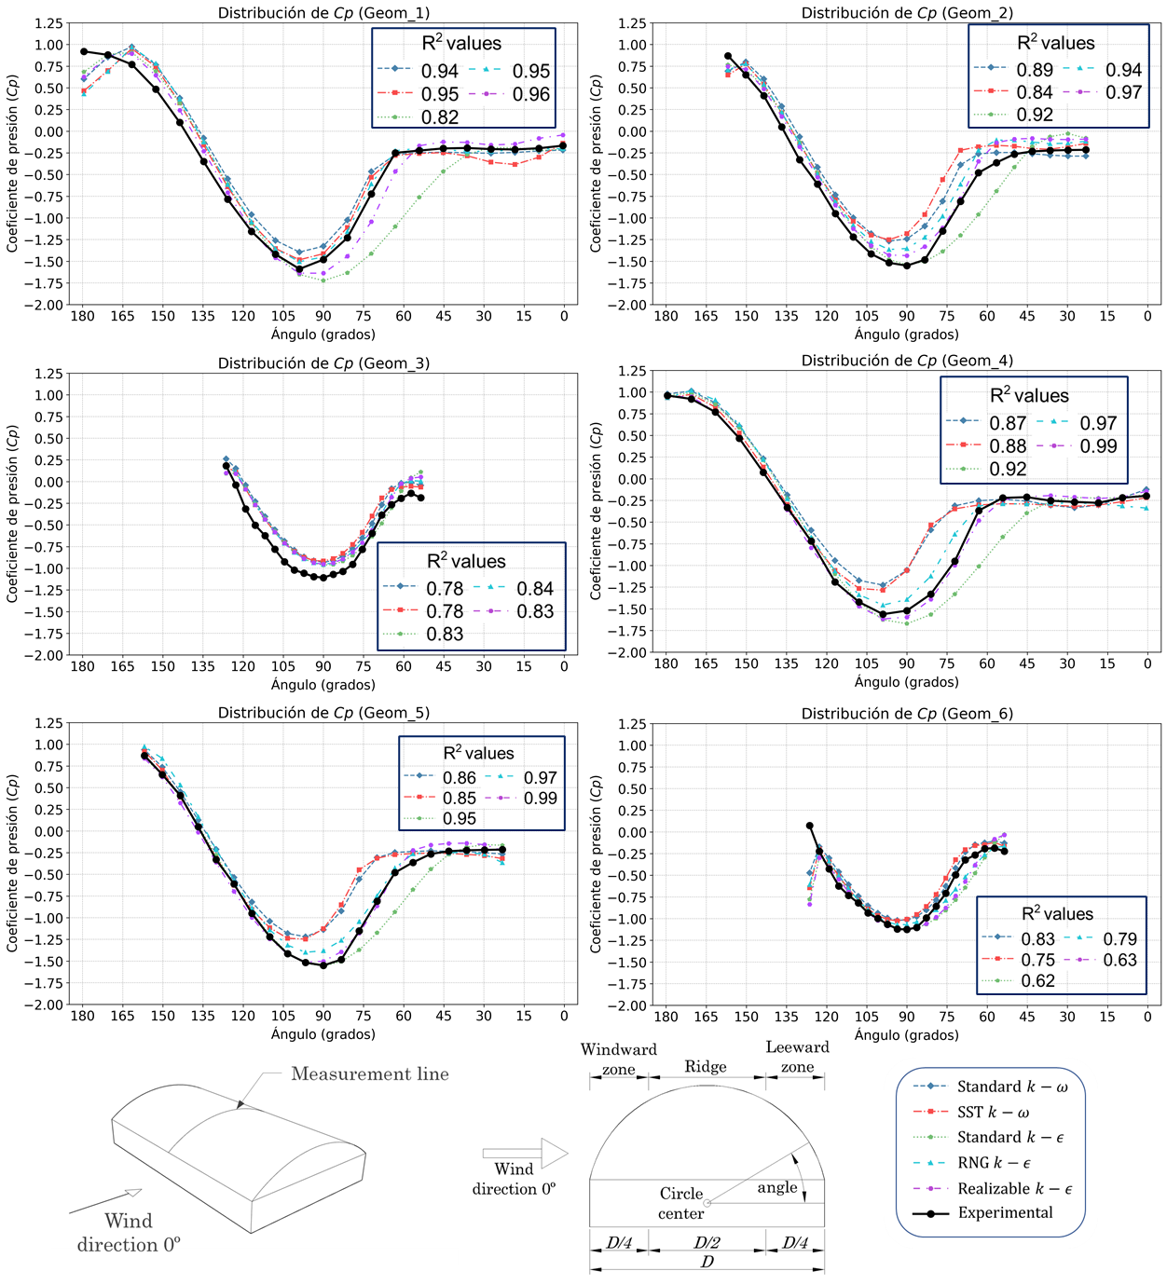
Fig. 7. Comparison of CFD-computed and experimental-measured $Cp$ for each geometry under the different turbulence models.

The third geometry case was the most challenging case for all turbulence models, leading to an underestimation of $Cp$ along the measurement line, with the best accuracy obtained by the RNG $k-ϵ$ and Realizable $k-ϵ$ models. Another case which all models showed lower accuracy, was the sixth geometry; both of these cases correspond to a low R/D ratio. In the sixth geometry, the statistical indices are generally poor, mainly because of the values at the beginning of the windward region. The first point in this zone predicts a sudden high suction that is not observed in the experimental data, which leads to poor accuracy, especially for models that predict stronger suction, such as the Realizable $k-ϵ$ model.

3.4 General discussion
In this section, the performance of the turbulence models is analyzed based on the simulation results for six geometries with circular arched roofs. Table 7 presents the mean values of the statistical metrics for the different R/D ratios, where the R/D=1/2 ratio corresponds to the first and fourth geometries, R/D=1/3 to the second and fifth, and R/D=1/6 to the third and sixth geometries listed Table 1.

Table 7. Summary results of statistical indices for CFD-computed and experimental-measured $Cp$ for distinct R/D ratios cases.
Geometries | Statistical metric | Standard $k-ω$ | SST $k-ω$ | Standard $k-ϵ$ | RNG $k-ϵ$ | Realizable $k-ϵ$
R/D = 1/2 | R² | 0.90 | 0.91 | 0.87 | 0.96 | 0.98
R/D = 1/2 | RSR | 0.30 | 0.28 | 0.35 | 0.19 | 0.13
R/D = 1/2 | d | 0.97 | 0.98 | 0.97 | 0.99 | 0.99
R/D = 1/3 | R² | 0.87 | 0.84 | 0.93 | 0.96 | 0.98
R/D = 1/3 | RSR | 0.34 | 0.39 | 0.25 | 0.20 | 0.13
R/D = 1/3 | d | 0.96 | 0.95 | 0.98 | 0.99 | 0.99
R/D = 1/6 | R² | 0.80 | 0.77 | 0.72 | 0.81 | 0.73
R/D = 1/6 | RSR | 0.43 | 0.47 | 0.50 | 0.42 | 0.50
R/D = 1/6 | d | 0.95 | 0.93 | 0.92 | 0.95 | 0.93
Total average | R² | 0.86 | 0.84 | 0.84 | 0.91 | 0.90
Total average | RSR | 0.36 | 0.38 | 0.37 | 0.27 | 0.25
Total average | d | 0.96 | 0.95 | 0.96 | 0.98 | 0.97

Both $k-ω$ models produced similar results. These turbulence models achieved acceptable metrics for R² and RSR for R/D=1/2, close to 0.90 and 0.28 respectively. However, the statistical metrics deteriorate as the R/D ratio decreases, with R² falling below 0.80 for the lowest R/D case. Overall, the performance of $k-ω$ models is acceptable, with mean values of approximately 0.85 for R² and below 0.38 for RSR.

The standard $k-ϵ$ turbulence model shows a good performance for the R/D=1/3 with R² = 0.93 and RSR = 0.25, but for 1/2 it yields the worst performance and is the only case with R²<0.9 for this ratio. Overall, its global performance is similar to that of the other models in terms of the statistical metrics. However, as shown in Fig. 7, the key difference between these models is the distribution and magnitude of the $Cp$, where the standard $k-ϵ$ model shows similar magnitude according to the experimental measurements but with different distribution, whereas the $k-ω$ models exhibit the opposite behavior.

Finally, the RNG $k-ϵ$ and Realizable $k-ϵ$ turbulence models exhibited the highest performance, with R²>0.95 and RSR<0.20 for the R/D ratios of 1/2 and 1/3, where the Realizable $k-ϵ$ model is clearly superior to the RNG $k-ϵ$ model. However, for the R/D=1/6, the situation is reversed, with the RNG $k-ϵ$ model giving better results; this is mainly due to the sixth geometry, for which the performance metrics of the realizable model deteriorate, as discussed in the previous section. Despite this, both turbulence models perform better than the other models on average. The RNG $k-ϵ$ model shows a slight improvement for R² and d compared with the Realizable $k-ϵ$ model, whereas the Realizable $k-ϵ$ model yields a lower value of the relative error RSR.

Overall, the present results demonstrate that an appropriate choice of domain size, mesh resolution and turbulence model allow accurate prediction of mean pressure coefficients on circular arched roof structures at a relatively low computational cost. Nevertheless, this study has some limitations that should be acknowledged. The simulations are based on stable RANS models rather than transient models, so it is possible that the characteristics of the unstable flow do not require different domain dimensions. In addition, a uniform flow with relatively low turbulence intensity and no terrain roughness effects was implemented, conditions used in the reference study by Qiu et al. (2014), which may not represent realistic conditions in practice.

Future work could extend the present analysis by employing non-steady RANS or LES to investigate unsteady flow structures and peak suction on circular arched roofs. Further studies should also incorporate realistic atmospheric boundary layer profiles to quantify the influence of upstream exposure on the recommended CFD settings. In addition, applying and validating the proposed configuration for roofs with openings, appurtenances or more complex curvatures would help to assess the robustness of the guidelines beyond smooth circular arched geometries.

4. Conclusion

In this study, the CFD modelling configuration was evaluated for the prediction of mean pressure coefficients on circular arched roof structures with different rise-to-span ratios. Based on this evaluation, the most efficient configuration of domain size, mesh resolution, and turbulence model were selected, taking into account both accuracy and computational cost.

The results showed that the downstream, side, and upper domain extents had only a minimal effect on the prediction of $Cp$ for circular arched roof geometry. However, small differences were observed between the tested configurations, and the best compromise between accuracy and computational cost was achieved with a downstream length of 12S and lateral extents 4S, selecting the same for the upper length.

For the mesh resolution, the evaluation showed a higher accuracy with smaller mesh size. Most models, like SST $k-ω$, RNG $k-ϵ$, achieved the best accuracy with a mesh size of 0.01W. However, the difference to 0.0125W mesh were not significant, showing similar results with 35% fewer elements. Therefore, a mesh size of 0.0125W was identified as providing the best balance between accuracy and computational cost.

Finally, the turbulence model evaluation indicates that the Realizable $k-ϵ$ model was the most robust and consistent for most geometry configurations. This turbulence model achieved the higher indices for R² and d, as well as the lower error index (RSR), making it the most suitable model for parametric analysis that involve a high number of simulations.

In conclusion, this work provides a practical guide for configuring CFD simulation of circular arched roof structures, establishing the optimal configuration for domain, mesh, and turbulence model to obtain accurate results with low-cost computational demand. In addition, the findings of this study provide a solid base for future explorations of wind behavior in parametric studies for this type of geometry for CFD validation for complex geometries.

DISCLAIMER (ARTIFICIAL INTELLIGENCE)

Author(s) hereby declare that NO generative AI technologies such as Large Language Models (ChatGPT, COPILOT, etc.) and text-to-image generators have been used during the writing or editing of this manuscript.

AcknowledgEments

The authors thank Secretariat of Science, Humanities, Technology, and Innovation (SECITHI), the Autonomous University of Querétaro (UAQ) and Faculty of Engineering (FI), as well the University of Bordeaux and the Institute of Mechanical Engineering (I2M) for the support in the realization of this project.

References

Abu-Zidan, Y., Mendis, P., & Gunawardena, T. (2021). Optimising the computational domain size in CFD simulations of tall buildings. Heliyon, 7(4), e06723. https://doi.org/10.1016/j.heliyon.2021.e06723
Ali, I., Hussain, T., Unar, I. N., Kumar, L., & Ahad, I. U. (2024). Turbulence model study for aerodynamic analysis of the leading edge tubercle wing for low Reynolds number flows. Heliyon, 10(11), e32148. https://doi.org/10.1016/j.heliyon.2024.e32148
ASCE, (American Society of Civil Engineers). (2021). Minimum Design Loads and Associated Criteria for Buildings and Other Structures (1st ed). American Society of Civil Engineers.
Blazhnov, A. (2020). Static calculation of film roof of cultivation structure. Bulletin of Belgorod State Technological University named after. V. G. Shukhov. https://doi.org/10.34031/2071-7318-2020-5-10-17-22
Bournet, P.-E., Khaoua, S., Boulard, T., Migeon, C., & Chasseriaux, G. (2007). Effect of Roof and Side Opening Combinations on the Ventilation of a Greenhouse Using Computer Simulation. Transactions of the ASABE, 50, 201–212. https://doi.org/10.13031/2013.22401
CEN, (European Committe for Standardization). (2020). EN 1991-1-4: Eurocode 1: Actions on structures—Part 1-4: General actions—Wind actions.
CFE, (Comisión Federal de Electricidad). (2020). Manual de diseño de obras civiles: Diseño por viento. omisión Federal de Electricidad, México.
Fouad, N. S., Mahmoud, G. H., & Nasr, N. E. (2018). Comparative study of international codes wind loads and CFD results for low rise buildings. Alexandria Engineering Journal, 57(4), 3623–3639. https://doi.org/10.1016/j.aej.2017.11.023
Jha, A. K., Sinha, A., & Raj, R. (2022). Effect of wind loads on low-rise pitched and circular arch roof structures: A comparative study based on numerical simulation. Civil Engineering and Architecture, 10(3), 1129–1141. https://doi.org/10.13189/cea.2022.100329
Kim, R., Lee, I., & Kwon, K. (2017). Evaluation of wind pressure acting on multi-span greenhouses using CFD technique, Part 1: Development of the CFD model. Biosystems Engineering, 164, 235–256. https://doi.org/10.1016/j.biosystemseng.2017.09.008
Lateb, M., Masson, C., Stathopoulos, T., & Bédard, C. (2013). Comparison of various types of k–ε models for pollutant emissions around a two-building configuration. Journal of Wind Engineering and Industrial Aerodynamics, 115, 9–21. https://doi.org/10.1016/j.jweia.2013.01.001
Meng, F.-Q., He, B.-J., Zhu, J., Zhao, D.-X., Darko, A., & Zhao, Z.-Q. (2018). Sensitivity analysis of wind pressure coefficients on CAARC standard tall buildings in CFD simulations. Journal of Building Engineering, 16, 146–158. https://doi.org/10.1016/j.jobe.2018.01.004
Oro, J. M. F. (2012). Técnicas numéricas en ingeniería de fluidos: Introducción a la dinámica de fluidos computacional (CFD) por el método de volúmenes finitos. Reverte.
Qiu, Y., Sun, Y., Wu, Y., San, B., & Tamura, Y. (2018). Surface roughness and Reynolds number effects on the aerodynamic forces and pressures acting on a semicylindrical roof in smooth flow. Journal of Structural Engineering, 144(9), 04018140. https://doi.org/10.1061/(ASCE)ST.1943-541X.0002129
Qiu, Y., Sun, Y., Wu, Y., & Tamura, Y. (2014). Modeling the mean wind loads on cylindrical roofs with consideration of the Reynolds number effect in uniform flow with low turbulence. Journal of Wind Engineering and Industrial Aerodynamics, 129, 11–21. https://doi.org/10.1016/j.jweia.2014.02.011
Richards, P. J., & Hoxey, R. P. (1993). Appropriate boundary conditions for computational wind engineering models using the k-ϵ turbulence model. Journal of Wind Engineering and Industrial Aerodynamics, 46–47, 145–153. https://doi.org/10.1016/0167-6105(93)90124-7
Salim, M., & Ooka, R. (2008). Influence of cell geometry and mesh resolution on large eddy simulation predictions of flow around a single building. Building Simulation, 1, 251–260. https://doi.org/10.1007/s12273-008-8321-7
San, B., Xu, C., & Qiu, Y. (2019). Three-Dimensional Aerodynamic Optimization of Single-Layer Reticulated Cylindrical Roofs Subjected to Mean Wind Loads. Advances in Civil Engineering, 2019(1), 4156319. https://doi.org/10.1155/2019/4156319
Sun, Y., Wu, Y., Qiu, Y., & Tamura, Y. (2015). Effects of free-stream turbulence and Reynolds number on the aerodynamic characteristics of a semicylindrical roof. Journal of Structural Engineering, 141(9), 04014230. https://doi.org/10.1061/(ASCE)ST.1943-541X.0001209
Vergara Sánchez, M. A. (1993). Técnicas de modelación en hidráulica. Alfaomega.
Vieira Neto, J. G., & Soriano, J. (2020). Computational modelling applied to predict the pressure coefficients in deformed single arch-shape greenhouses. Biosystems Engineering, 200, 231–245. https://doi.org/10.1016/j.biosystemseng.2020.10.003
Wijesooriya, K., Mohotti, D., Lee, C.-K., & Mendis, P. (2023). A technical review of computational fluid dynamics (CFD) applications on wind design of tall buildings and structures: Past, present and future. Journal of Building Engineering, 74, 106828. https://doi.org/10.1016/j.jobe.2023.106828
Yao, J., Peng, M., Huang, J., Zhang, Q., & Zhou, Y. (2024). Numerical simulation study on wind pressure coefficient of variable cross-section arched roof. Results in Engineering, 21, 101844. https://doi.org/10.1016/j.rineng.2024.101844
Zawawi, M. H., Saleha, A., Salwa, A., Hassan, N. H., Zahari, N. M., Ramli, M. Z., & Muda, Z. C. (2018). A review: Fundamentals of computational fluid dynamics (CFD). AIP Conference Proceedings, 2030(1), 020252. https://doi.org/10.1063/1.5066893
Zeng, M., & Tao, W. Q. (2003). A comparison study of the convergence characteristics and robustness for four variants of SIMPLE‐family at fine grids. Engineering Computations, 20(3), 320–340. https://doi.org/10.1108/02644400310467234
Zhao, D.-X., & He, B.-J. (2017). Effects of architectural shapes on surface wind pressure distribution: Case studies of oval-shaped tall buildings. Journal of Building Engineering, 12, 219–228. https://doi.org/10.1016/j.jobe.2017.06.009
Zheng, X., Montazeri, H., & Blocken, B. (2020). CFD simulations of wind flow and mean surface pressure for buildings with balconies: Comparison of RANS and LES. Building and Environment, 173, 106747. https://doi.org/10.1016/j.buildenv.2020.106747

