Epidemiological, clinical, etiological and therapeutic profile of prosthesis dysfunction

ABSTRACT

Introduction:
Prosthetic heart valves have dramatically improved the prognosis of valvular heart disease, especially in countries with a high prevalence of rheumatic fever. However, prosthetic valve replacement remains associated with significant complications, including valve dysfunction, particularly when anticoagulation is suboptimal. Understanding and properly managing prosthetic valve dysfunction is crucial to reduce morbidity and mortality.
Aim:
To investigate the epidemiological, clinical, etiological, and therapeutic characteristics of prosthetic valve dysfunction at a tertiary cardiac center in Morocco.
Methods:
A retrospective study was conducted over four years (January 2020–January 2025) including 31 patients diagnosed with mechanical prosthetic valve dysfunction.
Results:
Mean age was 45.8 ± 12.4 years, with female predominance (sex ratio = 0.55). Mean time from prosthesis implantation to dysfunction was 7.4 ± 3.2 years. Dyspnea was the most common presenting symptom (80.6%). The main etiologies were thrombosis (38.7%), pannus formation (22.6%), prosthetic detachment (16.1%), and infective endocarditis (12.9%). INR was subtherapeutic in most patients (mean 1.8 ± 0.6). Treatment was surgical in 58% of cases, medical ± fibrinolysis in 32%, and conservative in 10%. In-hospital mortality was 6.4%.
Conclusion:
Thrombosis and pannus remain the leading causes of mechanical prosthetic dysfunction. Optimized anticoagulation, systematic follow-up, and early detection are essential to improve patient outcomes.

INTRODUCTION:

Valvular heart disease remains a major contributor to cardiovascular morbidity and mortality, particularly in low- and middle-income countries where acute rheumatic fever is still endemic (1,14). In Morocco, rheumatic valvular disease continues to affect predominantly younger populations, with rheumatic mitral and aortic lesions representing a significant public health burden (file:1).
The introduction of mechanical and bioprosthetic valves has transformed the long-term prognosis of valvular disease patients, allowing substantial improvement in functional capacity and survival (2, 15). Mechanical valves, although durable, require lifelong anticoagulation to prevent thromboembolic complications. Despite advances in valve design, imaging modalities, and surgical techniques, prosthetic valve dysfunction remains a serious and potentially life-threatening complication (3).
Prosthetic valve dysfunction may result from several mechanisms, including thrombosis, pannus formation, structural deterioration, prosthetic detachment, and prosthetic valve endocarditis (3). In our region, thrombosis remains the most frequent cause, often related to inadequate anticoagulation adherence.
Given the increasing number of patients living with prosthetic valves in Morocco, understanding the epidemiology and etiologies of valve dysfunction is essential for prevention and early management.
The aim of this study is to describe the epidemiological, clinical, etiological, echocardiographic, and therapeutic profile of patients admitted for prosthetic valve dysfunction at the Mohammed VI University Hospital of Marrakech over a four-year period.

MATERIALS AND METHODS :

A retrospective descriptive and analytical study was conducted in the Cardiology Department of Mohammed VI University Hospital, Marrakech, from January 1st, 2020, to January 1st, 2025.

Inclusion Criteria
- Patients with mechanical prosthetic valves (mitral, aortic, or double prosthesis).
- Suspicion or confirmation of prosthetic valve dysfunction based on clinical, biological, echocardiographic, or radiological findings.

Exclusion Criteria
- Bioprosthetic valve dysfunction
- Incomplete medical records
- Patients lost to follow-up immediately after admission

Data Collection
Collected parameters included:
- Demographics
- Clinical presentation
- Anticoagulation status (INR)
- Laboratory findings
- TTE and TEE parameters
- Radiocinéma / fluoroscopy characteristics
- Etiology of dysfunction
- Therapeutic management
- Clinical outcomes

Results:

1. Demographic Characteristics
A total of 31 patients were included. The mean age was 45.8 ± 12.4 years, ranging from 19 to 72 years. Female patients represented 64.5% (sex ratio = 0.55).
Most patients had a history of rheumatic heart disease requiring valve replacement in young adulthood. Only 3 patients had undergone valve replacement for degenerative aortic stenosis.

2. Characteristics of Prosthetic Valves
Mean time from implantation to dysfunction was 7.4 ± 3.2 years (range 2–15 years).
No cases of prosthesis–patient mismatch were identified.

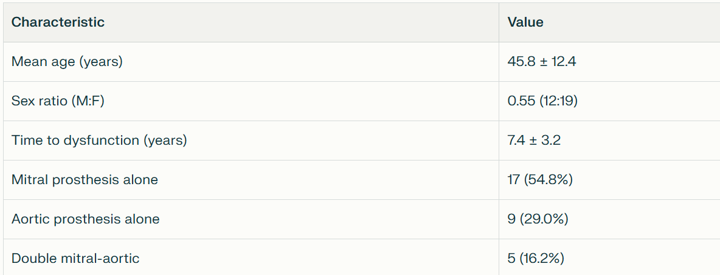
Table 1: Patient Demographics and Prosthesis Characteristics (n=31)

3. Clinical Presentation

Dyspnea was the most common mode of presentation, particularly in obstructive dysfunctions.

Clinical manifestation | n | %
Dyspnea (NYHA II–IV) | 25 | 80.6%
Palpitations | 12 | 38.7%
Chest pain | 7 | 22.5%
Right or left heart failure | 13 | 41.9%
Embolic events (peripheral/cerebral) | 3 | 9.6%
Fever | 5 | 16.1%

Table 2: Symptoms and Signs at Admission

4. Biological Findings

Mean INR at admission was 1.8 ± 0.6, significantly below therapeutic targets (2.5–3.5).
- 74% of patients had INR < 2.
- 19% had elevated CRP (> 20 mg/L).
- 9.6% had positive blood cultures (all Staphylococcus aureus).
Hypocoagulability was strongly associated with prosthetic thrombosis

5. Echocardiographic Evaluation

5.1 Transthoracic Echocardiography (TTE)

TABLE 3. TTE Findings of patients

TTE Findings | n | %
Elevated transprosthetic gradients | 18 | 58%
Reduced or blocked leaflet motion | 13 | 42%
Visualization of thrombus | 8 | 26%
Suspicion of pannus formation | 7 | 22%
Significant paraprosthetic leakage | 6 | 19%

5.2 Transesophageal Echocardiography (TEE)

TABLE 4. TEE was performed in 27 patients.
TEE Findings | n | %
Confirmed prosthetic thrombosis | 12 | 44.4%
Obstructive pannus | 7 | 25.9%
Prosthetic detachment | 5 | 18.5%
Infective endocarditis (vegetations) | 4 | 14.8%

TEE allowed precise differentiation between thrombus and pannus in 92% of cases.

6. Radiocinéma / Fluoroscopy Findings
TABLE 5. Performed in 15 patients.
Finding | n | %
Abnormal leaflet mobility | 8 | 53.3%
Complete leaflet blockage | 5 | 33.3%
Reduced bilateral mobility | 2 | 13.3%

Fluoroscopy was especially useful for mechanical mitral prostheses where acoustic shadowing limited echocardiographic visualization.

7. Etiological Profile (Expanded)

7.1 Thrombosis
Associated with:
- Subtherapeutic INR in 91% of cases
- Dehydration in 3 cases
- Atrial fibrillation in 6 cases

7.2 Pannus Formation
Typically occurred later (mean 9.2 years post-implantation).
TEE showed dense, echo-bright tissue around the sewing ring.

7.3 Prosthetic Detachment
Presented with:
- Severe regurgitation
- Hemodynamic instability in 2 patients
- Infective endocarditis in 1 case

7.4 Infective Endocarditis
TABLE 6. All cases were Staphylococcus aureus, with large vegetations in 2 patients.

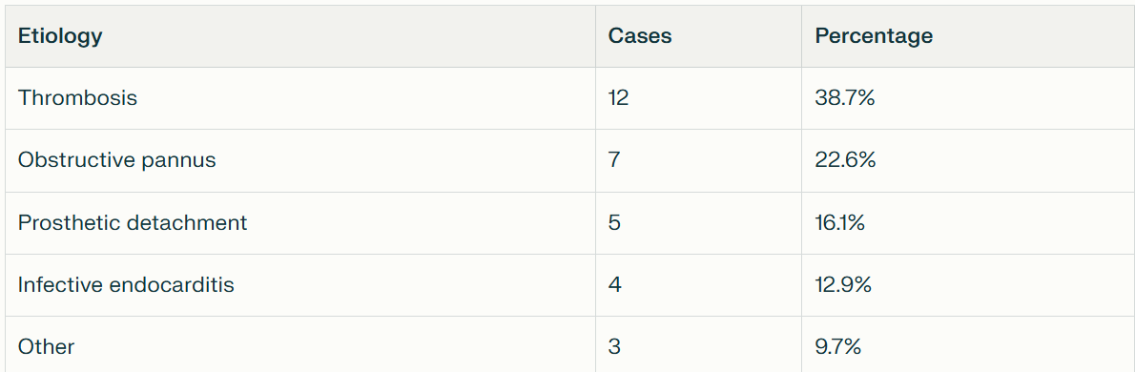

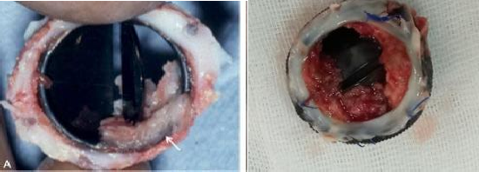

PICTURE 1. Stenotic dysfunction due to pannus (arrow) extending into a mechanical prosthesis (A) , prosthesis thrombosis (B)

8. Therapeutic Management

TABLE 7. Treatment procedures adopted for patients

Treatment | n | %
Surgical reoperation | 18 | 58%
Medical therapy ± fibrinolysis | 10 | 32%
Conservative management | 3 | 10%

8.1 Surgery
Performed mostly in:
- Obstructive pannus
- Prosthetic detachment
- Complicated thrombosis
- Endocarditis with major regurgitation
Procedures included:
- 15 valve replacements
- 3 surgical revisions

8.2 Medical ± Fibrinolytic Treatment
Used for:
- Non-obstructive thrombosis
- High-surgical-risk patients
Fibrinolysis success rate: 70% (7/10 patients).

8.3 Outcomes
- Favorable outcome: 74%
- In-hospital mortality: 6.4% (n=2)
- Early complications:
  - Hemorrhage (n=2)
  - Embolic recurrence (n=1)

DISCUSSION

Prostheticvalve dysfunction remains a serious and potentially life-threatening complication, stemming from a variety of structural, hemodynamic, infectious, and thromboembolic mechanisms. A range of predisposing factors can alter prosthetic performance, leading to obstruction, regurgitation, or mixed dysfunction. From a hemodynamic perspective, the turbulent flow distal to mechanical prostheses contributes to shear stress and platelet activation, particularly in patients with impaired left ventricular systolic function or enlarged left atrial dimensions. Cardiac rhythm disorders—most notably atrial fibrillation—further exacerbate stasis and increase the risk of thrombogenesis, a well-established mechanism in prosthetic valve dysfunction (4). Other contributing factors include the inherent thrombogenicity of older prosthetic designs such as caged-ball or tilting-disc valves, along with transient hypercoagulable states triggered by dehydration or infection (5).
Our study confirms the epidemiological profile frequently described in Moroccan and sub-Saharan African cohorts, where rheumatic heart disease remains the leading cause of valvular pathology requiring prosthetic replacement. The predominance of young to middle-aged women aligns with regional data reported by Oummou S. (6), who observed 61% female patients, and Bivigou A. (7), who reported 60% women in his cohort. This overrepresentation may reflect both the elevated burden of rheumatic fever among young females and their higher likelihood of developing severe valvular involvement necessitating mechanical valve replacement. These findings contrast with Western and Asian series, such as Misawa Y. (5), where degenerative etiologies—rather than rheumatic disease—dominate, and the patient population is generally older with more comorbid conditions. These epidemiological differences underscore the importance of contextualizing prosthetic valve dysfunction within regional public health realities.
In line with the literature, our study found that the leading etiologies of prosthesis dysfunction were prosthetic thrombosis, followed by infective endocarditis—two mechanisms classically described in rheumatic populations where anticoagulation monitoring is often suboptimal. Several recent surgical series have emphasized the role of pannus formation in chronic prosthetic dysfunction. This fibroproliferative process, characterized by excessive scarring around the sewing ring, progressively narrows the prosthetic orifice, mimicking or predisposing to obstructive thrombosis (8). Distinguishing thrombus from pannus is clinically crucial, as management differs substantially; however, both may coexist, particularly in patients with prolonged subtherapeutic anticoagulation.
Prosthetic infective endocarditis represents a particularly severe form of endocarditis, associated with high morbidity and mortality. In a study conducted at the CHUL, prosthetic endocarditis accounted for 21.4% of all infective endocarditis cases, whereas Senegalese data report an incidence of 5% (9). These values are consistent with the prevalence observed in our cohort. The dental portal of entry remains the most frequently identified, highlighting the persistent challenge of improving dental hygiene and prophylaxis in low-resource settings. Notably, the absence of prosthesis–patient mismatch in our study suggests that appropriate prosthetic sizing and initial selection were performed, which may have contributed to the reduced incidence of severe early hemodynamic complications.
Echocardiography—particularly Doppler—has firmly established its role as the cornerstone in the follow-up and diagnosis of prosthetic valve dysfunction (10). When integrated with clinical data, transthoracic echocardiography alone may allow the diagnosis of obstructive thrombosis and guide therapeutic decision-making. However, transesophageal echocardiography (TEE) remains the preferred modality for mitral prostheses due to superior visualization of thrombi, pannus, and prosthetic leaflet motion. In our study, the utility of echocardiography was pivotal in identifying both obstructive and non-obstructive complications.
Biological findings in our cohort similarly mirrored regional publications. As described by Oummou S. (11), subtherapeutic INR levels were frequently noted at the time of dysfunction onset, reflecting inconsistent anticoagulation monitoring, which remains one of the major challenges in African and low-income environments. Bivigou A. (12) also highlighted under-anticoagulation as a central contributor to mechanical valve thrombosis, reinforcing the need for standardized anticoagulation programs, patient education, and improved accessibility to INR monitoring tools.
Regarding therapeutic strategies, our findings echo international recommendations and experience reported by Ma W.G. (13) and Misawa Y. (5). Surgery remains the gold standard for obstructive prosthetic dysfunction, prosthetic endocarditis with complications, or cases where mechanical integrity is compromised. Conversely, fibrinolytic or medical therapies may be considered in selected patients with obstructive thrombosis who present a high surgical risk, or in the absence of contraindications. However, these non-surgical approaches require meticulous monitoring due to risks of embolization or incomplete thrombus resolution. The decision-making process thus requires a careful balance between the urgency of intervention, surgical risk, and availability of advanced therapeutic options

CONCLUSION
This study confirms that thrombosis and pannus are the predominant causes of mechanical prosthetic valve dysfunction in our region. Suboptimal anticoagulation remains a major modifiable risk factor. Regular follow-up, patient education, strict INR monitoring, and timely diagnostic imaging are essential for prevention and optimal management. Valve replacement is the beginning—not the end—of lifelong surveillance and adherence to therapy.
Consent
As per international standards or university standards, patient(s) written consent has been collected and preserved by the author(s).
Ethical Apporval :
Ethical approval was obtained from the institutional review board of our institution.

Disclaimer (Artificial intelligence)
I wish to clarify that the content of my scientific article was entirely developed by myself, without the use of artificial intelligence tools for drafting or automatically generating the text

References :

- Adere A, Bedru M, Afework M. Etiologies and Patterns of Valvular Heart Disease Among Cardiac Patients at the Cardiac Center of Ethiopia During February 2000 to April 2022. Int J Gen Med. 4 juill 2023;16:2849‑56. https://doi.org/10.2147/IJGM.S420591
- Rahimtoola SH. Choice of Prosthetic Heart Valve in Adults: An Update. J Am Coll Cardiol. juin 2010;55(22):2413‑26. https://doi.org/10.1016/j.jacc.2009.10.085

- Gürsoy MO, Kalçık M, Yesin M, Karakoyun S, Bayam E, Gündüz S, et al. A global perspective on mechanical prosthetic heart valve thrombosis: Diagnostic and therapeutic challenges. Anatol J Cardiol. déc 2016;16(12):980‑9. https://doi.org/10.14744/AnatolJCardiol.2016.7486

- H. Kabbaj , J. D. Srairi, W. Akalay, MH. Benomar, M. Benomar .Complication de l’anticoagulation inefficace : la thrombose des prothèses valvulaires cardiaques 2022. https://doi.org/10.48408/IMIST.PRSM/mm-v26i1.954

- Misawa Y. Valve-related complications after mechanical heart valve implantation. Surg Today 2015 ;45 (10):1205–9. https://doi.org/10.1007/s00595-014-1104-0

- Oummou S, Abardazzou A, Karimi S, Benzeroual D, Elhattaoui M. The Contribution of Echocardiography in the Dysfunctions of Mechanical Prosthesis: Report of 11 Cases. Cardiol Res Cardiovasc Med [Internet]. 20 déc 2016 [cité 27 oct 2025] https://doi.org/10.29011/CRCM-110.100010
- Bivigou AE, Akagha Konde C, Kinga A, Ndjibah Alakoua L, Kouna Ndouongo P. Complications des prothèses valvulaires mécaniques : à propos de cinq cas / Complications of mechanical prosthetic heart valves: about five cases. Bull Med Owendo 2022. 20(51):80‑4. https://bulletinmedicaldowendo.com/bmovol2051-22-80-84/
- Toker ME, Eren E, Balkanay M, et al. Multivariate analysis for operative mortality in obstructive prosthetic valve dysfunction due to pannus and thrombus formation. Int Heart J 2006; 47:237-45. https://doi.org/10.1536/ihj.47.237

- Roudant R., M, Lorient F. – Roudant : Traitement antithrombotique chez le porteur de prothèse valvulaire mécanique. Archives des maladies du coeur et des vaisseaux 2006.

- H. Kabbaj , J. D. Srairi, W. Akalay, MH. Benomar, M. Benomar.Complication de l’anticoagulation inefficace : la thrombose desprothèses valvulaires cardiaques 2022. https://doi.org/10.48408/IMIST.PRSM/mm-v26i1.954

- Molina DK, DiMaio VJM. Normal organ weights in men: part I-the heart. Am J Forensic Med Pathol. déc 2012;33(4):362‑7. https://doi.org/10.1097/PAF.0b013e31823d298b
- Anatomy of the Human Heart - Physiopedia [Internet]. [cité 3 nov 2025]. https://www.physio-pedia.com/Anatomy_of_the_Human_Heart

- Ma WG, Hou B, Abdurusul A, Gong DX, Tang Y, Chang Q, et al. Dysfunction of mechanical heart valve prosthesis: experience with surgical management in 48 patients. J Thorac Dis [Internet]. déc 2015 [cité 1 nov 2025];7(12). Kuang FL, Klion AD. Biologic Agents for the Treatment of Hypereosinophilic Syndromes. J Allergy Clin Immunol Pract 2017; 5:1502.

- Yakob, T., Belay, E., Barata, B. Y., Abraham, A., Assele, D. D., & Israel, E. (2025). Valvular heart disease and associated factors among adult cardiac patients in a tertiary hospital, Ethiopia. BMC Cardiovascular Disorders, 25(1), 502. https://doi.org/10.1186/s12872-025-04958-4

- El Oakley, R., Kleine, P., & Bach, D. S. (2008). Choice of prosthetic heart valve in today’s practice. Circulation, 117(2), 253-256. https://doi.org/10.1161/CIRCULATIONAHA.107.736819

