PfDHFR Resistance Mutations in Mali: Impact on Protein Structure and Identification of Novel Natural Inhibitors
Abstract
Malaria drug resistance remains one of the greatest challenges to the malaria control program in Mali. Mutation in the Plasmodium falciparum Dihydrofolate Reductase (PfDHFR), a key enzyme in the folate biosynthesis pathway and primary target of antifolate drugs, are knows to induces resistance to pyrimethamine and Proguanil. Four-point mutations: N51I, C59R, S108N, and I164L are particularly associated with antifolate resistance. This study aims to characterize resistance-associated PfDHFR mutations circulating in three sentinel sites in Mali (Dioro, Missira, and Sélingué) and identify potential inhibitors effective against mutant PfDHFR variants through virtual screening of African natural compound libraries.
A total of 47 Pfdhfr were analyzed to identify Single-Nucleotide Polymorphisms (SNPs) using Geneious Prime. Homology-based 3D protein structures of mutant PfDHFR using PRIMO server, and structural visualization as well as molecular analyses were performed using UCSF Chimera and AutoDock vina.
Among the 47 PfDHFR sequences analyzed, 22 exhibited the triple mutations N51I, C59R, and S108N, will the I164L mutation was absent in all samples across the three sentinel sites. Structural modeling of these mutants revealed restricted access and crowding in the PfDHFR active site, consistent with known antifolate resistance mechanisms. Virtual screening identified several promising inhibitors, among which compound SANC00747 exhibiting exceptional binding affinity (-14.046 kcal/mol), highlighting the potential of African natural products as resistance-breaking candidates.
This study demonstrates the prevalence of key antifolate-resistance mutations in Mali and reveals promising natural compounds capable of effectively targeting mutant PfDHFR. These findings underscore the value of African natural products as a rich reservoir for developing next-generation antimalarial therapies.
Keywords: Pfdhfr gene, Malaria Resistance, folate biosynthesis pathway, Molecular modeling, Mali.

Introduction
Malaria, also known as “marsh fever”, is an infectious disease caused by a parasite of the Plasmodium genus, transmitted through the bite of infected female Anopheles mosquitoes. The parasite first infects the liver cells of the host and then circulates in the blood, colonizing and destroying red blood cells [1].
Among the 123 known species of Plasmodium, five are known to infect humans: Plasmodium falciparum, responsible for many deaths, and the four others that typically cause less severe forms of malaria; Plasmodium vivax, Plasmodium ovale, Plasmodium malariae, and Plasmodium knowlesi, the latter being originally a simian parasite that has increasingly been recognized in human infections [2].
Globally, according to the World Health Organization (WHO) 2024 World Malaria Report, Africa remains the continent most affected by this disease [3]. Worldwide, malaria-related deaths were estimated at 608,000 in 2022, with children under 5 years old being the most vulnerable group, accounting for 78% of malaria deaths in Africa [4]. The WHO African Region recorded 95% of all malaria cases and 96% of malaria-related deaths worldwide in 2022 [5]. In Mali, over 3.1 million confirmed malaria cases were reported in 2023, with 1,920 deaths. National surveys indicate that the most affected groups continue to be pregnant women and children under 5 years of age [6].
Many drugs have been developed to combat malaria. The most used classes of antimalarial compounds include quinolines (chloroquine, quinine, mefloquine, amodiaquine, primaquine), antifolates (pyrimethamine, proguanil, and sulfadoxine), artemisinin derivatives (artemisinin, artesunate, artemether, arteether), and hydroxynaphthoquinones (atovaquone) [7], [8], [9].
Recently, malaria vaccines (RTS, S/AS01 and R21/Matrix-M) have been introduced in 12 African countries as additional preventive tools [10], [11], [12].
Despite these interventions, the resistance of P. falciparum to antimalarials remains a major concern. Resistance is primarily driven by single-nucleotide polymorphisms (SNPs) in genes such as Pfdhfr, Pfdhps, Pfcrt, and Pfmdr1 [13], [14]. Recent molecular surveillance studies across Africa have documented widespread and region specific mutations in these resistance markers [15], [14] ,[16]. Artemisinin partial resistance (ART-R), characterized by delayed parasite clearance, has now been confirmed in 21 countries. Resistance to sulfadoxine-pyrimethamine (SP), first reported at the Thailand-Cambodia border in the 1960s, continues to spread across malaria endemic regions, with mutations in Pfdhfr (particularly at codons 51, 59, and 108) and Pfdhps being major contributors [17], [18]. Recent studies from West and Central Africa have confirmed the persistence and evolution of antifolate resistance haplotypes, with varying prevalence across different geographical regions [15], [19]. Comprehensive mapping efforts in southern Africa have further revealed the complex mutational landscape post-ACT implementation [20].
In Mali, there is particular concern that the widespread use of SP as part of the Seasonal Malaria Chemoprevention (SMC) and intermittent Preventive Treatment during pregnancy (IPTp) may accelerate the emergence and spread of resistant strains [21], [22]. This concern is amplified by recent findings showing high prevalence of multiple drug resistance mutations in neighboring West African countries [14] ,[16].
To elucidate the mechanistic basis of resistance, computational approaches like molecular modeling and docking are indispensable. These methods predict how mutations alter protein structure, stability, and drug binding affinity, providing atomistic insights into resistance mechanisms that inform drug design and policy updates [23],[24],[25], [26]. Given the urgent need for novel antimalarials, we further extend this approach by incorporating virtual screening of African natural product databases, a promising yet underutilized resource for drug discovery against resistant strains [27],[28]. Thus, in this study, we aim to : (i) identify resistance associated mutations from recurrent and reinfection cases collected from three sentinel site in Mali (Dioro, Missira, and Sélingué); (ii) characterize their effects on the structure and function of the PfDHFR protein; and (iii) perform virtual screening of African natural compound libraries to identify potential inhibitors effective against mutant PfDHFR variants, providing crucial data for malaria treatment policy and drug development in the region.

Methods
Genomic DNA sequences of the Plasmodium falciparum dihydrofolate reductase (PfDHFR) gene were generated, trimmed, and imported into Geneious Prime (version 2020.0.5) [29]. Sequences were aligned to the PfDHFR reference sequence (NCIBI accession: NC_004318.2) using the “Map to Reference” function. Variant calling was performed to identify single-nucleotide polymorphisms (SNPs), and identified mutations were analyzed based on the physicochemical properties of the substituted amino acids, with emphasis on steric and electrostatic effects to assess their potential structural impact.
Protein models of the mutant PfDHFR variants were generated using the PRIMO (Protein Interactive Modeling) server [30], employing the crystal structure with PDB ID 3DGA as a template for homology modeling. The modeling workflow included template identification, sequence alignment, and model building using MODELLER, resulting structural models were visualized and analyzed in UCSF Chimera (version 1.15) to evaluate conformational changes, hydrogen bonding patterns, and steric clashes introduced by the mutations [31],[32].
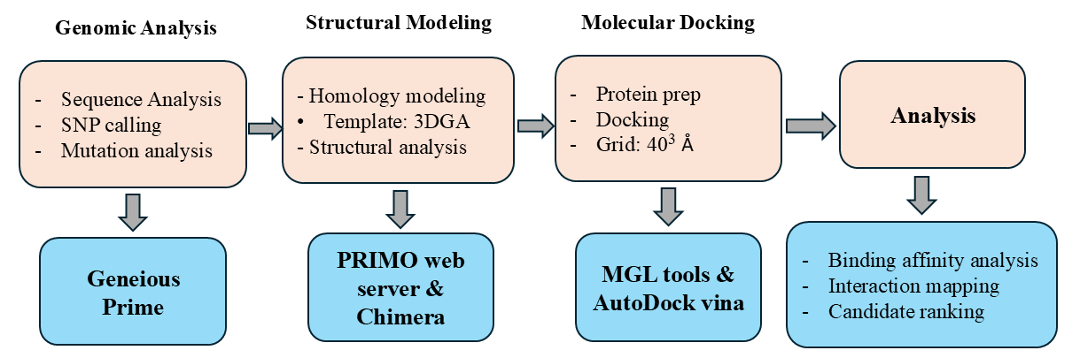
For molecular docking studies, ligand structures were sourced from the South African Natural Compounds Database (SANCDB) and AfroDB [33], [34]. Compounds were energy-minimized and converted to PDPQT format. Protein Structure, including both the wild type and the mutant forms, was prepared using AutoDock MGL Tools version 1.5.7 [35], which included adding polar hydrogens, calculating Gasteiger charges, and defining rotatable bonds where applicable. Docking simulations were conducted with AutoDock Vina [36], defining the binding site using a grid box centered at coordinate (33.220, -0.907, 58.357) Å and dimension of 40×40×40 Å to fully encompass the active site. Docking parameters included an exhaustiveness value of 8 to ensure comprehensive conformational sampling, generation of up to 9 binding modes per ligand (num_modes), and an energy range of 3 Kcal/mol to capture relevant low-energy alternative poses. Predicted binding affinities and binding modes were analyzed to characterize potential protein-ligand interactions and to support prioritization of candidate compounds for further study.
Fig. 1. Methodology workflow

Results
3.1 Identification of SNPs on the Pfdhfr gene
Out of the 47 sequences, 38 were of good quality and nine (09) were not usable. Among the exploitable sequences, 22 carried the triple mutation (N51I, C59R, and S108N); eight (08) carried a single mutation, four (04) carried the double mutation (N51I/C59R or C59R/S108N), and four were wild type. Among the 22 samples with the triple mutation, only two (02) sequences covered position 164 of the Pfdhfr gene and were wild type (S164). We were able to identify variants at codons 51, 59, and 108, all of which are non-synonymous mutations, meaning that the nucleotide changes lead to an amino acid (AA) substitution. These missense mutations are, respectively, for each codon: N51I, C59R, and S108N, where the letters N, I, R, and S are the symbols of the amino acids involved (N= Asparagine, I = Isoleucine, C = Cysteine, R = Arginine, and S = Serine). Non-synonymous substitutions were identified at codons 51, 59, and 108, resulting in amino acids changes N51I, C59R, and S108N, respectively.
Table 1. Number and frequency of SNPs identified on the Pfdhfr gene
SNPs | N51I, C59R, & S108N | 51I,59R or 108N | 51I/59R or 59R/108N | Wild Type | Non exploitable | Total
Number  Frequency (%) | 22  46,81 | 8  17,02 | 4  8,51 | 4  8,51 | 9  19,15 | 47  100

Table I summarizes the distribution of single nucleotide polymorphisms (SNPs) identified in the Pfdhfr gene across 47 analyzed sequences. Of these, 38 were exploitable while 9 (19.15%) were not. Among the exploitable sequences, the majority, 22 (46.81%), carried the triple mutation N51I, C59R, and S108N. In addition, 8 sequences (17.02%) harbored a single mutation (N51I, C59R or S108N), and 4 sequences (8.51%) exhibited a double mutation N51I/C59R or C59R/S108N), and 4 sequences (8.51%) were of the wild-type genotype.
3.2 Structural comparison
Fig. 2 below represents superimposition of the structural combined impact of the three resistance mutations (N51I, C59R, and S108N) identified in twenty-two (22) clinical isolates from the Dioro, Missira and Sélingué sites.
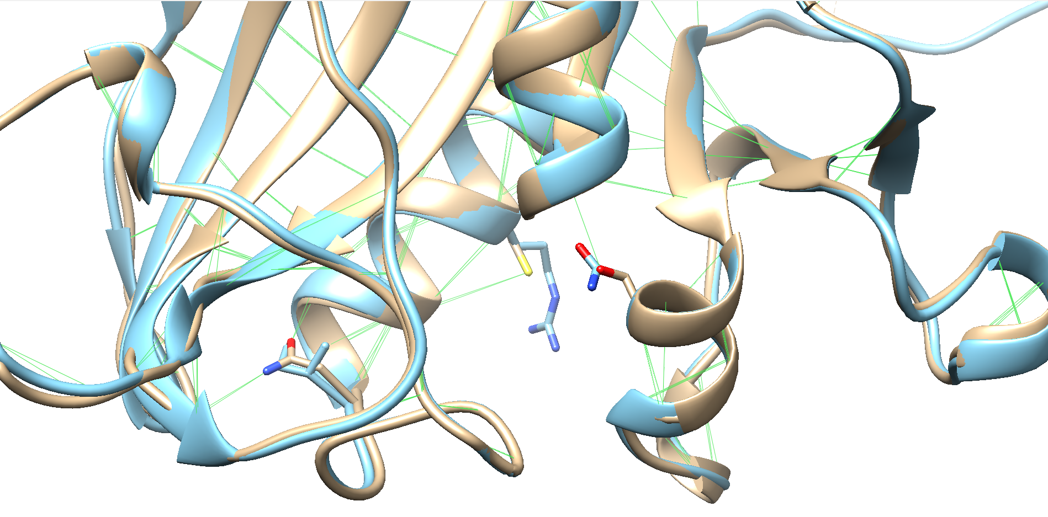
Fig. 2. Structural superposition of wild-type PfDHFR (brown) and triple mutant (cyan).
108N
S108
59R
C59
N51
51I
Belong the structural analysis, the N51I substitution is positioned distally from the active site and may contribute to allosteric effects, while C59R and S108N are located closer to the ligand binding pocket. The S108N mutation directly alters ligand binding within the active site, whereas C59 creates steric hindrance that restricts access to antifolate antimalarials. Together, these mutations significantly reduce both ligand accessibility and binding affinity.
3.3 Virtual screening
Fig. 3 below shows the distribution of binding affinities of the compounds from SANCDB and AfroDB with the PfDHFR protein.
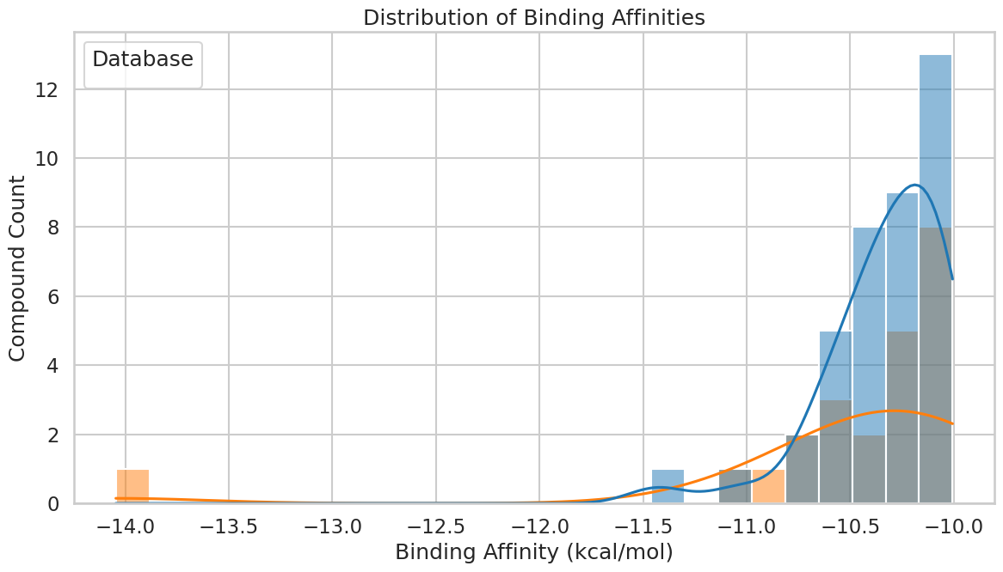
Fig. 3. Distribution of Binding affinity of SANCDB (orange) and AfroDB (blue)
The analysis revealed that AfroDB contains significantly more compounds with strong binding affinities, showing a concentration of compounds in -10.5 to -10.0 kcal/mol range, while SANCDB exhibits a much smaller and more dispersed distribution with only few compounds showing binging affinities around -14.0 kcal/mol. AfroDB contains few compounds with strong binding affinities of -11.4 to -11.0 kcal/mol.

Table 2 and Table 3 below shows the top 10 promising inhibitors of PfDHFR from AfroDB and SANCDB.

Table 2. Top 10 promising inhibitors of PfDHFR from AfroDB
ID | Docking Score (Kcal/mol) | Mw (g/mol) | LogP | HBD | HBA | TPSA
BMC_00086 | -11.427 | 470.43 | 1.6114 | 5 | 10 | 0
EA_0112 | -11.031 | 396.395 | 2.7428 | 1 | 7 | 0
EA_0147 | -10.725 | 336.391 | 2.4123 | 0 | 4 | 0
WA_0045 | -10.695 | 363.457 | 4.8302 | 3 | 4 | 0
BMC_000100 | -10.626 | 363.457 | 4.8302 | 3 | 4 | 0
SA_0088 | -10.583 | 448.519 | 2.6011 | 1 | 6 | 0
AN_UY_034 | -10.549 | 422.477 | 4.4543 | 3 | 6 | 0
EA_0149 | -10.549 | 352.39 | 1.3831 | 1 | 5 | 0
NPR_0009 | -10.494 | 379.456 | 4.5358 | 4 | 5 | 0
SA_179 | -10.481 | 352.386 | 4.2915 | 1 | 5 | 0

Out of 842 compounds from the AfroDB database, 39 complied fully with Lipinski’s rule of five.
Table 3. Top 10 promising inhibitors of PfDHFR from SANCDB
ID | Docking score (Kcal/mol) | MW (g/mol) | LogP | HDonors | HAcceptors | Violations Lipinski
SANC00747 | -14.046 | 446.628 | 3.7996 | 3 | 5 | 0
SANC00414 | -11.046 | 407.271 | 4.3374 | 3 | 3 | 0
SANC00733 | -10.821 | 414.542 | 4.2817 | 1 | 5 | 0
SANC00907 | -10.77 | 372.505 | 3.5244 | 2 | 4 | 0
SANC00413 | -10.75 | 421.254 | 4.7384 | 4 | 3 | 0
SANC00416 | -10.582 | 488.183 | 4.676 | 4 | 2 | 0
SANC00352 | -10.538 | 436.46 | 4.1298 | 3 | 7 | 0
SANC00347 | -10.5 | 434.444 | 3.942 | 2 | 7 | 0
SANC00456 | -10.423 | 430.585 | 4.1181 | 2 | 5 | 0
SANC00312 | -10.335 | 438.071 | 4.6041 | 2 | 4 | 0

Out of a total of 1,013 compounds from the SANCDB database, 23 exhibited no violations of Lipinski’s rule of five.

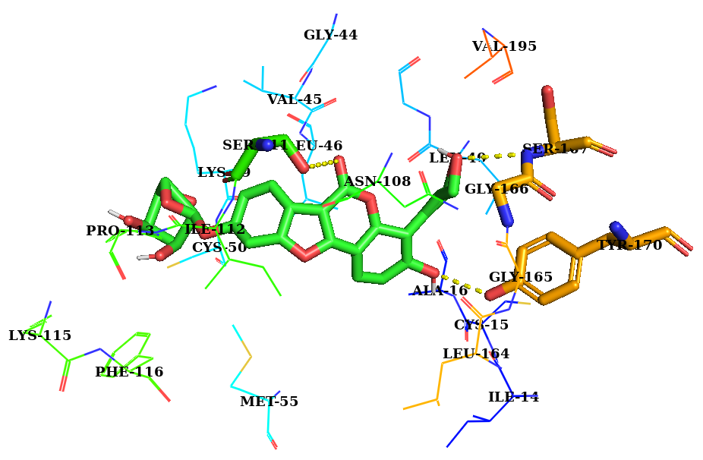
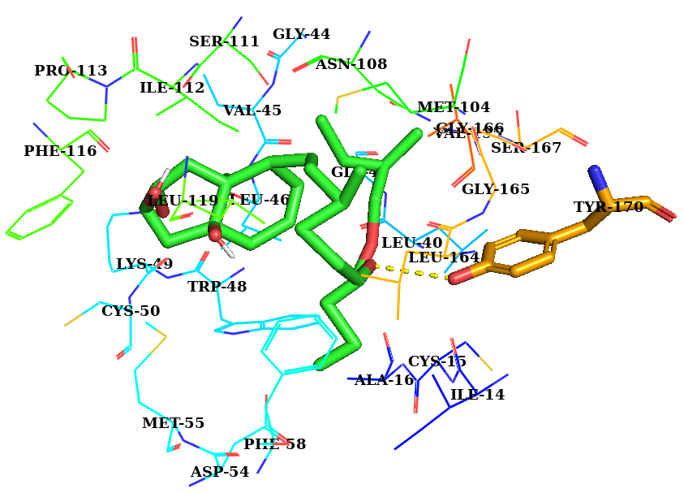
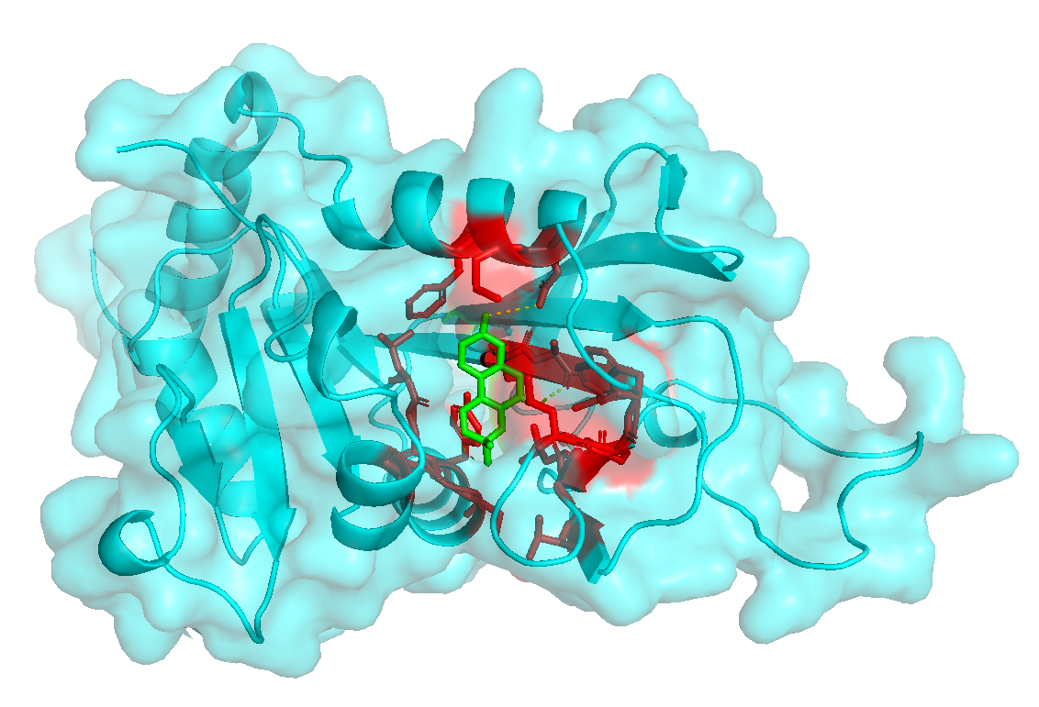
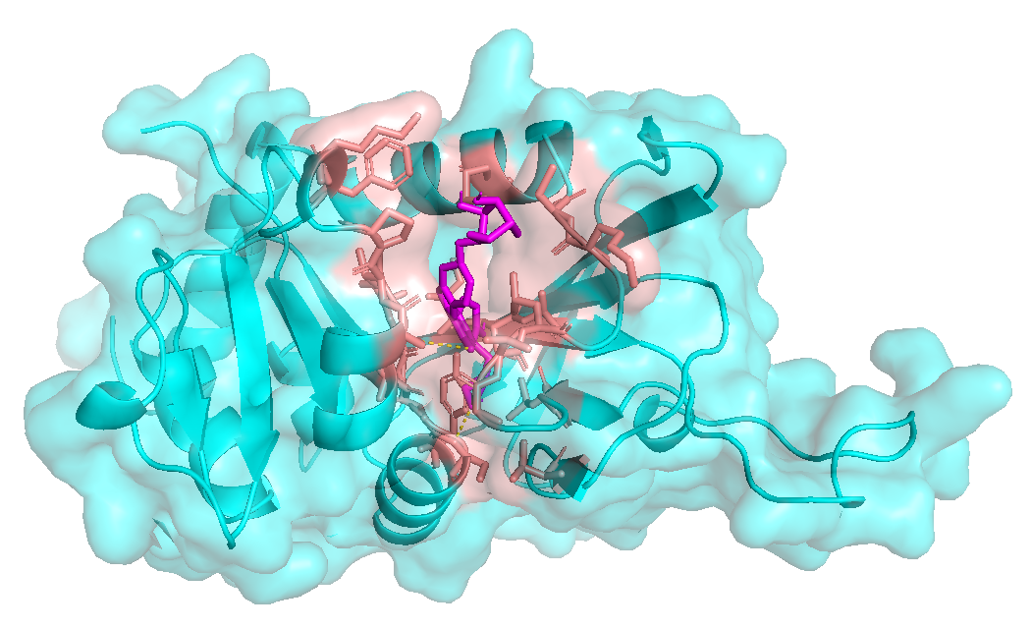
Fig. 4 shows the 3D model of PfDHFR protein in complex with the best compounds with the highest docking score from SANCDB (SANC00747) and AfroDB (BMC_00086).
BMC_00086
SANC00747
A1
B1
A2
B2

Fig. 4. 3D model of PfDHFR complex with SANC00747 (left) and BMC_00086 (right). The protein is shown on surface representation (A1, B1), while detailed protein-ligand interactions are displayed in the lower panels (A2, B2). Ligand molecules are represented in Licorice (Green).
Both ligands SANC00747 and BMC_00086 exhibited the highest docking scores, respectively -14.046 and -11.427 Kcal/mol indicating strong predicted binding affinities. Notably, both compounds bind within the active site of PfDHFR, form key stabilizing interactions essential for enzyme inhibition. SANC00747 establishes hydrogen bonds with PRO-113, ASN-108, and ASP-54; hydrophobic interactions with ILE-14, VAL-13, PHE-116, and LEU-46, and pi-stacking interactions involving PHE-58. Additional contacts include CYS-50, TRP-48, MET-55, ILE-112, SER-111, ILE-164, and GLY-44. BMC_0086 establishes hydrogen bonds with ASN-108, GLY-44.and ILE-14; hydrophobic interactions with VAL-13, 13, LEU-46, PHE-116, and ILE-164; and pi-stacking interactions with PHE-58. Additional contacts include LYS-113, MET-55, and other active site residues. They share several common interacting residues (VAL-13, ILE-14, LEU-46, PHE-58, ASN-108, PHE-116, and ILE-164), suggesting they occupy overlapping binding positions within the active site. These conserved interactions likely contribute to their high predicted binding affinities and potential as PfDHFR inhibitors.

Discussion
The present study reveals a concerning prevalence of triple mutations (N51I, C59R, and S108N) in the Pfdhfr gene, occurring in 22 out of 47 samples (46.81%) from three sentinel sites in Mali (Dioro, Missira, and Sélingué). These high-frequency mutations (S108N + N51I + C59R) have been reported in various African populations, with studies showing prevalence rates ranging from 63.6% to over 70% in West Africa and different regions [37],[38]. The mutation N51I, C59R, or S108N in Pfdhfr has been independently associated with in vitro resistance to Pyrimethamine (odds ratio = 42.34) [39], representing a significant threat to the efficacy of antifolate-based antimalarial interventions. The S108N, C59R, and N51I mutations confer resistance to pyrimethamine and are common in Africa, while the I164L mutation confers high level resistance, is rarely seen. The absence of the I164L mutation in our study population is consistent with the typical evolutionary pathway of antimalarial resistance in sub-Saharan Africa [40], where this super resistance mutation has not yet emerged despite being present in Southeast Asian populations.
The observed mutation pattern follows the established evolutionary sequence described in the literature: CNCSI → CNCNI → CNRNI → CIRNI (amino acid positions 50, 51, 59, 108, and 164, respectively) [41], with S108N appearing first, followed by C59R, then N51L, and finally I164L [42]. This stepwise accumulation of mutations represents a progressive increase in resistance levels, with the triple mutant conferring high level pyrimethamine resistance while the absent I164L mutation would confer super resistance to sulfadoxine-pyrimethamine (SP) combination therapy, the fact that only two sequence could be examined at position 164 and were of wild type (I164) suggests that the I164L mutation has not yet emerged in these Malian Populations, which corresponds to the situation in many sub- Saharan countries and aligns with the relative resistance patterns observed in the region [43], [44].
The molecular modeling analysis provides crucial insights into the mechanistic basis of resistance, confirming previous in vitro and in vivo studies on the impact of Pfdhfr gene SNPs on antifolate resistance c. The structural comparison between wild-type and mutant PfDHFR proteins reveals that the mentioned mutations result in restricted access and crowding of the active site for rigid molecules such as antifolates used as antimalarials [46]. The N51I substitution, located distally from the active site, likely contributes to resistance through allosteric effect rather than direct interference with drug binding. The C59R mutation creates steric hindrance that restricts access to the active site, while the S108N mutation directly alters ligand binding within the binding pocket. Our modeling results consolidate and corroborate other study demonstrating the steric and electrostatic effects of these mutations on protein function [47].
Interestingly, while our prediction confirmed the steric and electrostatic effects of the N51I and C59R SNPs on the protein, it did not fully justify the conclusion that the most significant effect on resistance would come from the S108N mutation, as indicated by this study [48]. This suggests that additional modeling parameters beyond steric and electrostatic effects, such as dynamic factors and protein flexibility under physiological conditions, may be necessary to completely elucidate the mechanism of S108N mediated resistance. It should be noted that these point mutations do not completely block the alternatives to SP [49],[50],[51].
Virtual screening SANCDB and AfroDB identified several natural products with strong predicted binding affinities to mutant PfDHFR variants. SANC00747 (−14.046 kcal/mol) and BMC_00086 (−11.427 kcal/mol) display remarkably favorable docking scores and share several key interacting residues (VAL-13, ILE-14, LEU-46, PHE-58, ASN-108, PHE-116, ILE-164), in line with those reported for classical antifolate inhibitors of PfDHFR [46][47][48], strongly suggesting that they occupy a common, functionally relevant binding region within the active site (Fig. 4). This overlapping interaction pattern, together with the presence of hydrogen bonds involving ASP-54 and ASN-108 for SANC00747, and ASN-108 and GLY-44/ILE-14 for BMC_00086, as well as π–π stacking with PHE-58 for both ligands, is consistent with a competitive inhibition mechanism with respect to dihydrofolate and/or the cofactor, as described for established PfDHFR antagonists. The strong engagement of resistance-associated “hotspot” residues such as S/ASN-108 and ILE/LEU-164, while supportive of high predicted affinity, also underscores the need to examine carefully whether the inhibitory profile of these compounds might be compromised by known resistance mutations, given that ideal next-generation inhibitors should preferably maintain potency against mutant PfDHFR variants. Although the present docking results for SANC00747 and BMC_00086 are encouraging, they should be considered as hypothesis-generating rather than definitive, and therefore warrant follow-up studies, including molecular dynamics simulations to assess the flexibility and persistence of key contacts over time, MM/GBSA calculations to refine the estimated binding free energies, and ultimately in vitro biochemical assays to confirm effective PfDHFR inhibition and antiplasmodial activity.
The identification of compounds with strong binding affinities to mutant PfDHFR variants suggests potential for developing novel antimalarials effective against resistant strains, leveraging the rich biodiversity of African flora which has been underexplored for antimalarial discovery.
The 46.81% prevalence of triple mutations raises significant concerns for current malaria control strategies in Mali, particularly given the widespread use of SP for intermittent preventive treatment in pregnant women (IPTp) and seasonal malaria chemoprevention (SMC). Studies have shown that Seasonal Malaria Chemoprevention consisting of monthly administration of amodiaquine/sulfadoxine-pyrimethamine to children aged 3-59 months during the transmission season could promote SP resistance [22],[49]. The evolution of Pfdhps and Pfdhfr mutations before and after adopting seasonal malaria chemoprevention has been documented in Burkina Faso [50], highlighting the need for continuous monitoring. This high frequency of residence mutations may accelerate the emergence and spread of resistant strains, potentially compromising the effectiveness of these critical interventions. The continued evolution of resistance patterns necessitates enhanced surveillance of genotypic resistance markers and large-scale testing of SP treatment efficacy by relevant stakeholders, as the modeling approach has become essential for discovering new antimalarial drugs effective against resistant strains and understanding their mechanisms of action [24].
This study demonstrates several advantages of the bioinformatics approach, namely the ability to obtain detailed and accurate results in record time and reduced cost compared to traditional experimental methods. Computational approaches like molecular modeling and docking are indispensable for predicting how mutations alter protein structure, stability, and drug binding affinity, providing atomistic insights into resistance mechanisms that inform drug design and policy updates [51]. However, several limitations warrant consideration, including the modest sample size, the need to optimize sequencing methods to cover entire Pfdhfr gene and identify all SNPs, as well as the requirement for molecular dynamics simulations to provide additional information on the effects of these mutations under physiological conditions.
Future research should focus on molecular dynamics studies of wild-type and mutant proteins in the presence of antifolates used as antimalarials in environment close to physiological conditions, Additionally, continued sequencing of field samples with improved techniques to cover the entire Pfdhfr gene and include other genotypic resistance markers, notably the Pfdhps gene, will be essential for comprehensive resistance monitoring. The integration of resistance surveillance data with innovative drug discovery approaches will be critical for maintaining effective malaria control in endemic regions where drug resistance continues to evolve.

Conclusion
This study demonstrates a critical threshold of antimalaria resistance in Mali, with 46.81% prevalence of triple PfDHFR mutations (N51I, C59R, S108N) that threaten the continued effectiveness of sulfadoxine-pyrimethamine interventions. Structural analysis show that these mutations reduce antifolates binding through distinct allosteric and steric mechanisms. The absence of I164L mutation suggest that Mali remains in a pre-super-resistance phase. Virtual screening of African natural compounds databases revealed several promising drug candidates, with SANC00747 showing exceptional binding affinity (-14.046 kcal/mol), highlighting the currently untapped potential for resistance breaking therapeutics. To advance these findings, in vitro and in vivo studies will be essential to validate the predictions of those compounds and guide their progression toward therapeutic development.
Disclaimer (Artificial intelligence)
Authors hereby declare that generative AI technologies such as Large Language Models, etc. have been used during the writing or editing of manuscripts. This explanation will include the name, version, model, and source of the generative AI technology and as well as all input prompts provided to the generative AI technology
Details of the AI usage are given below:
1. We disclose that ChatGPT (OpenAI, GPT-4) was used during the preparation of this manuscript. The tool was employed solely to assist in improving the quality of written English, including grammar, clarity, and style.

References
[1] M. P. Nelder, R. Schats, H. N. Poinar, A. Cooke, et M. B. Brickley, « Pathogen prospecting of museums: Reconstructing malaria epidemiology », Proc. Natl. Acad. Sci. U. S. A., vol. 121, nº 15, p. e2310859121, doi: 10.1073/pnas.2310859121.
[2] S. Sato, « Plasmodium—a brief introduction to the parasites causing human malaria and their basic biology », J. Physiol. Anthropol., vol. 40, p. 1, janv. 2021, doi: 10.1186/s40101-020-00251-9.
[3] A. L. M. Laura Anderson, « World malaria report 2024: addressing inequity in the global malaria response », 2024.
[4] H.-I. Shin et al., « 2023 World Malaria Report (Status of World Malaria in 2022) », vol. 17, nº 32, p. 1351‑1377, août 2024, doi: 10.56786/PHWR.2024.17.32.1.
[5] E. Sakwa, « World Malaria Report 2022 underscores the need for increased investments in research and development to address rising threats », African Institute for Development Policy - AFIDEP. https://afidep.org/world-malaria-report-2022-underscores-the-need-for-increased-investments-in-research-and-development-to-address-rising-threats/
[6] « Mali pioneers novel hybrid vaccine delivery approach to combat malaria ». https://www.unicef.org/mali/en/press-releases/mali-pioneers-novel-hybrid-vaccine-delivery-approach-combat-malaria
[7] E. G. Tse, M. Korsik, et M. H. Todd, « The past, present and future of anti-malarial medicines », Malar. J., vol. 18, nº 1, p. 1‑21, déc. 2019, doi: 10.1186/s12936-019-2724-z.
[8] I. of M. (US) C. on the E. of A. Drugs, K. J. Arrow, C. Panosian, et H. Gelband, « Antimalarial Drugs and Drug Resistance », in Saving Lives, Buying Time: Economics of Malaria Drugs in an Age of Resistance, National Academies Press (US), 2004. https://www.ncbi.nlm.nih.gov/books/NBK215631/
[9] E. R. Watkins et S. R. Meshnick, « Drugs for malaria », Semin. Pediatr. Infect. Dis., vol. 11, nº 3, p. 202‑212, juill. 2000, doi: 10.1053/pi.2000.6232.
[10] M. O. Oduoye et al., « Unlocking the potential of novel RTS, S/AS01, and R21/Matrix‐MTM malaria vaccines in African nations », Health Sci. Rep., vol. 7, nº 1, p. e1797, janv. 2024, doi: 10.1002/hsr2.1797.
[11] A. L. Duga et al., « Malaria vaccine rollout begins in Africa: the need to strengthen regulatory and safety surveillance systems in Africa », BMJ Glob. Health, vol. 9, nº 10, oct. 2024, doi: 10.1136/bmjgh-2024-015445.
[12] O. Ngou, R. Nzoumbou-Boko, P. Bakamba, et Y. Boum, « R21/Matrix-M malaria vaccine: a vital tool in the arsenal against malaria, not a silver bullet », Lancet Infect. Dis., vol. 24, nº 5, p. 438‑439, mai 2024, doi: 10.1016/S1473-3099(24)00010-0.
[13] I. Zeile et al., « Molecular markers of Plasmodium falciparum drug resistance in southern highland Rwanda », Acta Trop., vol. 121, nº 1, p. 50‑54, janv. 2012, doi: 10.1016/j.actatropica.2011.09.009.
[14] A. Martín Ramírez et al., « Mutational profile of pfdhfr, pfdhps, pfmdr1, pfcrt and pfk13 genes of P. falciparum associated with resistance to different antimalarial drugs in Osun state, southwestern Nigeria », Trop. Med. Health, vol. 53, nº 1, p. 49, avr. 2025, doi: 10.1186/s41182-025-00732-6.
[15] C. J. M. Whitty, M. Rowland, F. Sanderson, et T. K. Mutabingwa, « Science, medicine, and the future », vol. 325, 2002.
[16] M. P. Dakorah, E. Aninagyei, J. Attoh, G. Adzakpah, I. Tukwarlba, et D. O. Acheampong, « Profiling antimalarial drug-resistant haplotypes in Pfcrt , Pfmdr 1, Pfdhps and Pfdhfr genes in Plasmodium falciparum causing malaria in the Central Region of Ghana: a multicentre cross-sectional study », Ther. Adv. Infect. Dis., vol. 12, p. 20499361251319665, janv. 2025, doi: 10.1177/20499361251319665.
[17] B. Andagalu et al., « Global assessment of partial artemisinin resistance: Multicenter trial across Kenya, Peru, and Thailand in patients with uncomplicated Plasmodium falciparum malaria », Int. J. Infect. Dis., vol. 0, nº 0, juill. 2025, doi: 10.1016/j.ijid.2025.107971.
[18] N. Noreen, A. Ullah, S. M. Salman, Y. Mabkhot, A. Alsayari, et S. L. Badshah, « New insights into the spread of resistance to artemisinin and its analogues », J. Glob. Antimicrob. Resist., vol. 27, p. 142‑149, déc. 2021, doi: 10.1016/j.jgar.2021.09.001.
[19] S.-D. Dinzouna-Boutamba et al., « Assessment of genetic polymorphisms associated with malaria antifolate resistance among the population of Libreville, Gabon », Malar. J., vol. 22, nº 1, p. 183, juin 2023, doi: 10.1186/s12936-023-04615-1.
[20] C. R. S. Chaves, C. Da Silva, A. Salamandane, et F. Nogueira, « Mapping Antimalarial Drug Resistance in Mozambique: A Systematic Review of Plasmodium falciparum Genetic Markers Post-ACT Implementation », Int. J. Mol. Sci., vol. 25, nº 24, p. 13645, déc. 2024, doi: 10.3390/ijms252413645.
[21] H. Maiga et al., « Assessing of Pfdhps Gene of Sulfadoxine after Five Years of Seasonal Malaria Chemoprevention Implementation at Two Rural Sites in Mali: The Quantitative Method », Fortune J. Health Sci., vol. 8, nº 2, p. 479‑490, juin 2025.
[22] S. Nikiema et al., « Seasonal Malaria Chemoprevention Implementation: Effect on Malaria Incidence and Immunity in a Context of Expansion of <em>P. falciparum</em> Resistant Genotypes with Potential Reduction of the Effectiveness in Sub-Saharan Africa », Infect. Drug Resist., vol. 15, p. 4517‑4527, août 2022, doi: 10.2147/IDR.S375197.
[23] F. E. T. Bohissou et al., « Evolution of Pfdhps and Pfdhfr mutations before and after adopting seasonal malaria chemoprevention in Nanoro, Burkina Faso », Sci. Rep., vol. 14, nº 1, p. 24224, oct. 2024, doi: 10.1038/s41598-024-75369-2.
[24] L. P. Hastuti, F. Hermawan, M. R. Iresha, T. Ernawati, et Firdayani, « In-silico studies of hydroxyxanthone derivatives as potential pfDHFR and pfDHODH inhibitor by molecular docking, molecular dynamics simulation, MM-PBSA calculation and pharmacokinetics prediction », Inform. Med. Unlocked, vol. 47, p. 101485, 2024, doi: https://doi.org/10.1016/j.imu.2024.101485.
[25] A. Manhas, M. Y. Lone, et P. C. Jha, « Multicomplex-based pharmacophore modeling in conjunction with multi-target docking and molecular dynamics simulations for the identification of PfDHFR inhibitors », J. Biomol. Struct. Dyn., vol. 37, nº 16, p. 4181‑4199, nov. 2019, doi: 10.1080/07391102.2018.1540362.
[26] S. S. Duay, R. C. Y. Yap, A. L. Gaitano, J. A. A. Santos, et S. J. Y. Macalino, « Roles of Virtual Screening and Molecular Dynamics Simulations in Discovering and Understanding Antimalarial Drugs », Int. J. Mol. Sci., vol. 24, nº 11, p. 9289, janv. 2023, doi: 10.3390/ijms24119289.
[27] E. Y. Mao, S. W. Page, B. E. Sleebs, M. R. Gancheva, et D. W. Wilson, « A review of natural products as a source of next-generation drugs against apicomplexan parasites », Npj Antimicrob. Resist., vol. 3, nº 1, p. 51, juin 2025, doi: 10.1038/s44259-025-00119-x.
[28] D. R. Bharti et A. M. Lynn, « QSAR based predictive modeling for anti-malarial molecules », Bioinformation, vol. 13, nº 5, p. 154, mai 2017, doi: 10.6026/97320630013154.
[29] M. Kearse et al., « Geneious Basic: An integrated and extendable desktop software platform for the organization and analysis of sequence data », Bioinformatics, vol. 28, nº 12, p. 1647‑1649, juin 2012, doi: 10.1093/bioinformatics/bts199.
[30] R. Hatherley, D. K. Brown, M. Glenister, et Ö. Tastan Bishop, « PRIMO: An Interactive Homology Modeling Pipeline », PLOS ONE, vol. 11, nº 11, p. e0166698, nov. 2016, doi: 10.1371/journal.pone.0166698.
[31] A. Šali et T. L. Blundell, « Comparative Protein Modelling by Satisfaction of Spatial Restraints », J. Mol. Biol., vol. 234, nº 3, p. 779‑815, déc. 1993, doi: 10.1006/jmbi.1993.1626.
[32] E. F. Pettersen et al., « UCSF Chimera—A visualization system for exploratory research and analysis », J. Comput. Chem., vol. 25, nº 13, p. 1605‑1612, oct. 2004, doi: 10.1002/jcc.20084.
[33] B. N. Diallo, M. Glenister, T. M. Musyoka, K. Lobb, et Ö. Tastan Bishop, « SANCDB: an update on South African natural compounds and their readily available analogs », J. Cheminformatics, vol. 13, nº 1, p. 37, déc. 2021, doi: 10.1186/s13321-021-00514-2.
[34] F. Ntie-Kang et al., « AfroDb: A Select Highly Potent and Diverse Natural Product Library from African Medicinal Plants », PLoS ONE, vol. 8, nº 10, p. e78085, oct. 2013, doi: 10.1371/journal.pone.0078085.
[35] G. M. Morris et al., « AutoDock4 and AutoDockTools4: Automated docking with selective receptor flexibility », J. Comput. Chem., vol. 30, nº 16, p. 2785‑2791, déc. 2009, doi: 10.1002/jcc.21256.
[36] O. Trott et A. J. Olson, « AutoDock Vina: Improving the speed and accuracy of docking with a new scoring function, efficient optimization, and multithreading », J. Comput. Chem., vol. 31, nº 2, p. 455‑461, janv. 2010, doi: 10.1002/jcc.21334.
[37] H. Quan et al., « High multiple mutations of Plasmodium falciparum-resistant genotypes to sulphadoxine-pyrimethamine in Lagos, Nigeria », Infect. Dis. Poverty, vol. 9, nº 1, p. 91, juill. 2020, doi: 10.1186/s40249-020-00712-4.
[38] Z. L et al., « Widespread resistance mutations to sulfadoxine-pyrimethamine in malaria parasites imported to China from Central and Western Africa », Int. J. Parasitol. Drugs Drug Resist., vol. 12, avr. 2020, doi: 10.1016/j.ijpddr.2019.11.002.
[39] B. S et al., « The F423Y mutation in the pfmdr2 gene and mutations N51I, C59R, and S108N in the pfdhfr gene are independently associated with pyrimethamine resistance in Plasmodium falciparum isolates », Antimicrob. Agents Chemother., vol. 56, nº 5, mai 2012, doi: 10.1128/AAC.05618-11.
[40] O. E et al., « Plasmodium falciparum strains harboring dihydrofolate reductase with the I164L mutation are absent in Malawi and Zambia even under antifolate drug pressure », Antimicrob. Agents Chemother., vol. 52, nº 11, nov. 2008, doi: 10.1128/AAC.00431-08.
[41] M. T, « Origins and spread of pfdhfr mutant alleles in Plasmodium falciparum », Acta Trop., vol. 114, nº 3, juin 2010, doi: 10.1016/j.actatropica.2009.07.008.
[42] D. T et al., « Exploiting structural analysis, in silico screening, and serendipity to identify novel inhibitors of drug-resistant falciparum malaria », ACS Chem. Biol., vol. 4, nº 1, janv. 2009, doi: 10.1021/cb8002804.
[43] G. C et al., « Substantial increase in mutations in the genes pfdhfr and pfdhps puts sulphadoxine-pyrimethamine-based intermittent preventive treatment for malaria at risk in Burkina Faso », Trop. Med. Int. Health TM IH, vol. 19, nº 6, juin 2014, doi: 10.1111/tmi.12305.
[44] P. Chauvin et al., « Prevalence of Plasmodium falciparum parasites resistant to sulfadoxine/pyrimethamine in pregnant women in Yaoundé, Cameroon: emergence of highly resistant pfdhfr/pfdhps alleles », J. Antimicrob. Chemother., vol. 70, nº 9, p. 2566‑2571, sept. 2015, doi: 10.1093/jac/dkv160.
[45] S. Ci, W. Jm, Q. Ik, S. W, et S. Ch, « Pyrimethamine-resistant dihydrofolate reductase enzymes of Plasmodium falciparum are not enzymatically compromised in vitro », Mol. Biochem. Parasitol., vol. 154, nº 1, juill. 2007, doi: 10.1016/j.molbiopara.2007.03.009.
[46] A. S, J. V, et B. Pv, « Origins of the specificity of inhibitor P218 toward wild-type and mutant PfDHFR: a molecular dynamics analysis », J. Biomol. Struct. Dyn., vol. 33, nº 9, sept. 2015, doi: 10.1080/07391102.2014.979231.
[47] S. W, S. T, S. R, Y. Y, et S. Dv, « Antifolate-resistant mutants of Plasmodium falciparum dihydrofolate reductase », Proc. Natl. Acad. Sci. U. S. A., vol. 94, nº 4, févr. 1997, doi: 10.1073/pnas.94.4.1124.
[48] B. B, S. K, P. P, P. A, M. Pk, et M. J, « In silico screening of antifolate based novel inhibitors from Brucea mollis Wall. ex kurz against quadruple mutant drug resistant PfDHFR », Comb. Chem. High Throughput Screen., vol. 17, nº 8, 2014, doi: 10.2174/1386207317666140521153305.
[49] M. T, L. T, K. Sl, H. Im, et P. Ma, « Seasonal malaria chemoprevention and the spread of Plasmodium falciparum quintuple-mutant parasites resistant to sulfadoxine-pyrimethamine: a modelling study », Lancet Microbe, vol. 5, nº 9, sept. 2024, doi: 10.1016/S2666-5247(24)00115-0.
[50] K. S. Millogo et al., « Seasonal malaria chemoprevention and mutations in Pfdhfr and Pfdhps genes in children in the health district of Nanoro, Burkina Faso », MalariaWorld J., vol. 16, p. 5, 2025, doi: 10.5281/zenodo.15039792.
[51] H. R, B. Dk, G. M, et T. B. Ö, « PRIMO: An Interactive Homology Modeling Pipeline », PloS One, vol. 11, nº 11, nov. 2016, doi: 10.1371/journal.pone.0166698.

