Antibacterial potential of Termitomyces letestui : an edible higher fungus harvested in the Haut Sassandra region (central-western Côte d’Ivoire)

ABSTRACT
Wild mushrooms are an important source of nutrients and bioactive compounds, used in many countries as dietary supplements and therapeutic agents. In Côte d'Ivoire, their integration into traditional medicine remains marginal, despite their pharmacological potential. In this context, a study was conducted in the Haut Sassandra region (central-western Côte d'Ivoire) to evaluate the antimicrobial properties of Termitomyces letestui, an edible higher fungus. To do this, aqueous and ethanolic extracts were prepared from the dry carpophore and then tested in vitro on four bacterial strains responsible for urinary tract infections : Staphylococcus aureus 864, Escherichia coli 739, Salmonella enterica 189 and Shigella flexneri 117. The evaluation was then carried out using the Mueller-Hinton dilution method, with determination of the minimum inhibitory concentrations (MIC), minimum bactericidal concentrations (MBC) and MBC/MIC ratio. The results revealed marked antibacterial activity of the aqueous extract, with MICs of 6.25 mg/ml for Staphylococcus aureus 864, Escherichia coli 739, Shigella flexneri 117 and 3.125 mg/ml for Salmonella enterica 189. A complete bactericidal effect (100%) was observed on all four isolates. The ethanol extract showed partial efficacy, with a bactericidal effect on 75% of the strains tested, while S. aureus showed relative resistance, reflected in an MIC of 25 mg/ml and an MBC of 200 mg/ml, indicating a bacteriostatic effect. The results of our study broaden the spectrum of use of Termitomyces letestui, giving it pharmacological properties that may inhibit bacterial growth.
Keywords : bactericidal, bacteriostatic, Ivory Coast, pharmacopoeia, macromycete.

1. INTRODUCTION
Termitomyces letestui (Pat.) Heim is a species of higher fungus belonging to the Lyophyllaceae family, known for its fruiting on termite mounds in tropical areas of Africa (Sitati et al., 2021). Initially described as Lepiota letestui by Patouillard in 1916, this taxon was reclassified in the genus Termitomyces by Heim in 1942, due to its symbiotic lifestyle with termites, particularly those of the grenus Macrotermes. This species has been described and characterised in several regions of Africa, particularly in West Africa (Koné et al., 2011 ; Kouassi et al., 2012 ; N'douba et al., 2022), Central Africa and Equatorial Africa (Metsebing, 2020 ; Gaye et al., 2025). Termitomyces letestui is widely consumed for its taste, but is also valued for its nutritional and therapeutic properties. As a result, biochemical analyses of Termitomyces letestui have revealed a high vitamin C content, as well as high concentrations of flavonoids and polyphenols (Choumessi et al., 2021). Termitomyces letestui is also rich in carbohydrates and has a high energy value, making it a functional food of interest (Paloi et al., 2023). The present study, conducted in the Haut Sassandra region (central-western Côte d'Ivoire), aims to evaluate the antibacterial properties of Termitomyces letestui. More specifically, it involves (1) preparing aqueous and hydro-ethanolic extracts of Termitomyces letestui and (2) evaluating in vitro the antibacterial activities of these extracts on four bacteria responsible for urinary tract infections (Escherichia coli 739, Staphylococcus aureus 864, Shigella flexneri 117 and Salmonella enterica 189)
2. MATERIALS AND METHODS
2.1 Biological material
Termitomyces letestui was collected from various plant formations in the Haut Sassandra region (central-western Côte d'Ivoire) and then identified at the Agrovalorisation laboratory at Jean Lorougnon Guédé University in Daloa.
2.2 Microorganisms
The microorganisms used in this study are four bacterial strains, all responsible for urinary tract infections (Escherichia coli 739, Staphylococcus aureus 864, Shigella flexneri 117 and Salmonella enterica 189). These different bacterial isolates were provided by the Bacteriology-Virology Laboratory of the Regional Hospital Centre (CHR) in Daloa

2.3 Antibiotic profile of the strains studied
 | Résistant | Intermédiate | Sensitive
Staphylococcus aureus 864 | AM, AZM, TY |  | IMP, LVX, CIP, CRO
Escherichia coli 739 | LVX, CRO, AM, AZM |  | IMP, CIP,
Salmonella enterica 189 | AM, AZM |  | IMP, LVX, CIP, CRO
Shigella flexineri 117 | AM, AZM | I | IMP, CIP, CRO
I: intermediate; AM: ampicillin; AZM: azithromycin; IMP: imipenem; CIP: ciprofloxacin; LVX: levofloxacin; CRO: ceftriaxone.
List 1- Antibiotic profile of the selected strains
2.4 Method for extracting raw extracts (Drying and grinding)
After harvesting, sorting and rinsing with distilled water, the fresh carpophores of Termitomyces letestui were dried in the shade at room temperature for 21 days. Once dried, the carpophores were ground in an ILLUX electric mill to obtain a fine greyish-brown powder.
2.5 Extraction of crude extracts
The various crude extracts were prepared according to the method described. To do this, the aqueous extract required maceration of 100 g of Termitomyces letestui carpophore powder in 1 litre of distilled water. The resulting macerate was then drained, filtered three times through cotton wool and once through 3 mm Whatman fine paper. Finally, the filtrate obtained was dried in an oven at 50°C for 72 hours, scraped and packaged in sterile tubes. The ethanolic extract was produced under the same conditions, except that 700 ml of ethanol was added to 300 ml of water.
2.6 Method for evaluating antibacterial activities, determination of antimicrobial parameters in liquid medium and Determination of the concentration range
The concentration range was prepared according to the method described by (Akré et al., 2022). A stock solution with a concentration of 400 mg/ml was prepared in sterile distilled water with the crude extracts. This solution underwent a series of half-dilutions to obtain concentrations ranging from 200 to 1.26 mg/ml.
2.7 Preparation of inocula
The bacterial inocula were prepared according to the method described by (Akré et al., 2022) using Mueller Hinton broth (MHB).
2.8 Inoculum counting
The method described by (Akré et al., 2022) was used to count the inoculum. A 10-fold dilution of the inoculated BMH was performed down to 10⁻⁴. These different dilutions, as well as the pure inoculum, were seeded using a calibrated loop in 5 cm long streaks on a GMH and then incubated at 37°C for 24 hours. This series of preparations constituted box A.
2.9 Determination of the minimum inhibitory concentration (MIC)
The MIC is the lowest concentration of the substance for which there is no visible growth to the naked eye after an incubation period of 18 to 24 hours. It was determined by observing the turbidity induced by the growth of the germs studied in each tube.
2.10 Determination of the minimum bactericidal concentration (MBC) and bacteriostatic concentration
The minimum bactericidal concentration (MBC) is the lowest concentration of a substance that leaves no more than 0.01% of germs surviving. Using a platinum loop, the contents of the tubes in which no turbidity was observed were sampled and seeded on GMH, starting with the MIC tube. Seeding was performed by making parallel streaks 5 cm long on the surface of the agar (box B). After 24 hours of incubation in an incubator at 37°C, the number of colonies on the streaks was compared to that in the inoculum counting box (box A). The number in the 10⁻⁴ dilution will correspond to the MIC. The antibacterial effect was considered bactericidal or bacteriostatic depending on the ratio : MBC/MIC. If MBC/MIC ≤ 4, the effect is bactericidal, and if MBC/MIC ≥ 4, the effect is bacteriostatic (Akré et al., 2022).
3. RESULTS AND DISCUSSION
3.1 Macroscopic description
The cap of Termitomyces letestui is greyish-white towards the center and measures 6-18 cm in diameter. It is initially bulbous, then conical, firm, fleshy, and convex, subsequently flattening out to take on the shape of a parasol. The margin is sometimes furrowed, cracked, torn, curved, and then spread out. The surface is dry, tomentose-felted, smooth, and light brown. The stipe is slender, central, straight, cylindrical, solid, voluminous, full, fibrous, hard, dry, off-white in color, and 7-45 cm long. The gills are regular, very tight, horizontal, forked, and wide. The smell is significant. The taste is mild and pleasant (Figure 1).

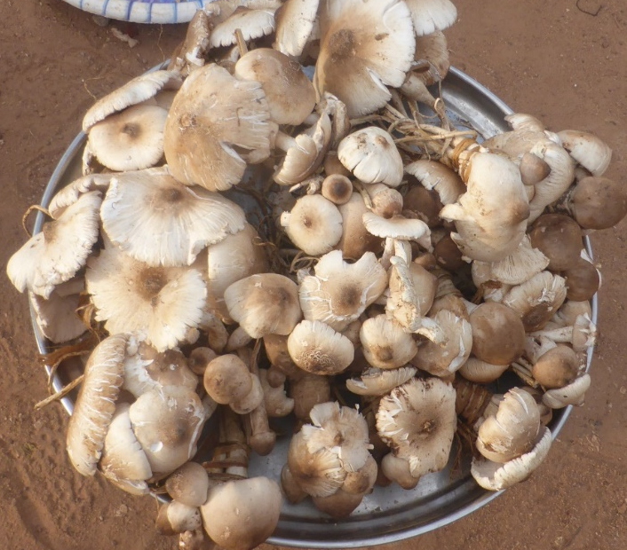
Figure 1: Fresh carpophore of Termitomyces letestui.
3.2 Determination of the minimum inhibitory concentration (MIC) of crude extracts of Termitomyces letestui
In liquid medium, the absence of turbidity was observed at different concentrations on the bacterial isolates tested. Thus, for the aqueous extract, the MIC obtained was 6.25 mg/ml on the bacterial isolates Escherichia coli 739, Staphylococcus aureus 864, Shigella flexneri 117 and 3.125 on the isolate Salmonella enterica 189. However, for the hydro-ethanolic extract, the various MICs obtained were 50 mg/ml for the Shigella flexneri 117 and Salmonella enterica 189 isolates and 25 mg/ml for the Escherichia coli 739 and Staphylococcus aureus 864 isolates (Table 1).

Table 1: Evaluation of the antibacterial activity of aqueous and ethanolic extracts of Termitomyces letestui.
Concentration  mg/ml |  | Tube  Witness |  | Escherichia coli 739 |  | Staphylococcus aureus 864 |  | Salmonella enterica 189 |  | Shigella flexneri 117
 |  | Ts | Tc | Ea | Ee | Ea | Ee | Ea | Ee | Ea | Ee
200 | 1 | - | ++ | - | - | - | - | - | - | - | -
100 | 1/2 | - | ++ | - | - | - | - | - | - | - | -
50 | 1/4 | - | ++ | - | - | - | - | - | - | - | -
25 | 1/8 | - | ++ | - | - | - | - | - | ++ | - | ++
12,5 | 1/16 | - | ++ | - | ++ | - | ++ | - | +++ | - | +++
6,25 | 1/32 | - | ++ | - | +++ | - | +++ | - | +++ | - | +++
3,125 | 1/64 | - | ++ | ++ | +++ | ++ | +++ | - | +++ | ++ | +++
1,56 | 1/126 | - | ++ | +++ | +++ | +++ | +++ | ++ | +++ | +++ | +++
Tc: growth control, Ts: sterility control, absence of culture: (-), presence of culture (+), abundant culture: (++), and very abundant culture: (+++). Ea: aqueous extract, Ee: ethanolic extract
3.3 Determination of the minimum bactericidal concentration (MBC) of crude extracts of Termitomyces letestui and their effects.
In a solid medium, i.e. after inoculation of the different concentration ranges, the aqueous extract of Termitomyces letestui showed inhibition of 100% of the bacterial isolates studied. Table 2 shows that this inhibition (MIC) was 12.5 mg/ml for all bacterial isolates (Staphylococcus aureus 864, Escherichia coli 739, Salmonella enterica 189 and Shigella flexneri 117). Furthermore, the ethanolic extract of Termitomyces letestui showed high inhibitory concentrations (MIC) on the four bacterial strains studied. The MICs were MIC = 200 ml/ml on Staphylococcus aureus 864, Salmonella enterica 189 and Shigella flexneri 117, except for the Escherichia coli 739 isolate, which showed an MIC = 100 mg/ml (Table 3).
Table 2 showed that the aqueous extract of Termitomyces letestui had a bactericidal effect on 100% of the germs studied. However, in the case of the ethanolic extract, the bactericidal effect was observed on 75% of the bacterial isolates (Escherichia coli 739, Salmonella enterica 189 and Shigella flexneri 117). Only the bacterial isolate Staphylococcus aureus 864 (MIC = 25 mg/ml and MBC = 200 mg/ml) showed a bacteriostatic effect, Table 3.
Table 2: Evaluation of the antibacterial activity of aqueous extracts of Termitomyces letestui
 | Termitomyces letestui
 | MIC | MBC
Staphylococcus aureus 864 | 6,25 | 12,5
BMC/MIC | 2
Interp | Bactericide
Escherichia coli 739 | 6,25 | 12,5
CMB/MIC | 2
Interp | Bactericide
Salmonella enterica 189 | 3,125 | 12,5
MBC/MIC | 4
Interp | Bactericide
Shigella flexneri 117 | 6,25 | 12,5
MBC/MIC | 2
Interp | Bactericide
Inter : interpretation

Table 3: Evaluation of the antibacterial activity of the hydro-ethanolic extract of Termitomyces letestui
 | Termitomyces letestui
 | MIC | MBC
Staphylococcus aureus 864 | 25 | 200
MBC/MIC | 8
Interp | Bacteriostatic
Escherichia coli 739 | 25 | 100
MBC/MIC | 4
Interp | Bactericide
Salmonella enterica 189 | 50 | 200
MBC/MIC | 4
Interp | Bactericide
Shigella flexneri 117 | 50 | 200
MBC/MIC | 4
Interp | Bactericide
Inter : interpretation
This section of the study aims to evaluate in vitro the antimicrobial activity of crude extracts of Termitomyces letestui on the growth of four bacterial strains. The results show that the antimicrobial tests carried out yielded several MICs at different concentrations. These MICs were evaluated using the Metsebing method (2020). According to these authors, the effectiveness of antibacterial activities depends on the MIC obtained, and they state that when an MIC is below 0.5 mg/ml, macromycetes are declared to be potent inhibitors. Then, if the MIC is between 0.6 and 1.5 mg/ml, higher fungi are moderate inhibitors. Finally, fungal species considered to be weak inhibitors are those with an MIC greater than 1.6 mg/ml. Based on the results of this study, we can conclude that the two crude extracts studied act as weak inhibitors.
Furthermore, the results reveal that all the crude extracts studied had antibacterial activity on all the bacterial strains tested. With regard to the aqueous extract of Termitomyces letestui (TlEa), the results obtained showed strong inhibitory activity on all the bacterial isolates tested. The MICs were 6.25 mg/ml for the bacterial isolates Escherichia coli 739, Staphylococcus aureus 864, Shigella flexneri 117 and 3.125 for the isolate Salmonella enterica 189, representing the lowest MICs obtained with a bactericidal effect in this study. Unlike the ethanol extract, which also had bactericidal activity except on the Staphylococcus aureus 864 isolate, where a bacteriostatic effect was observed. This bactericidal effect is thought to be due to the various chemical compounds contained in this crude macromycete extract. Sitati et al. (2021) similarly revealed an inhibitory activity of the aqueous extract of the Termitomyces genus on Staphylococcus aureus 864. Sharma et al. (2014) also demonstrated through their studies the antibacterial activity of some fungi on Shigella flexneri. Furthermore, the work of some researcher showed that the genus Termitomyces had bactericidal activity against the bacterial isolate Escherichia coli 739. Our results corroborate those of Mahamat et al. (2018) and Paloi et al. (2023), who demonstrated the antibacterial activity of the aqueous extract of Termitomyces letestui on Escherichia coli, Staphylococcus aureus and Salmonella sp

Fig 2: Action of the aqueous extract of Termitomyces letestui on Staphylococcus aureus 864

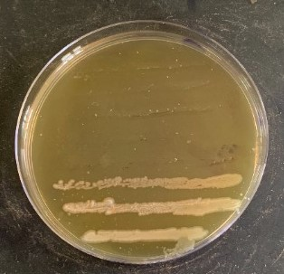  MIC  MBC | Reading is done from top to bottom.  200 mg/ml of crude extract plus bacterial isolate  100 mg/ml of crude extract plus bacterial isolate  50 mg/ml of crude extract plus bacterial isolate  25 mg/ml of crude extract plus bacterial isolate  12,5 mg/ml of crude extract plus bacterial isolate  6,25 mg/ml of crude extract plus bacterial isolate  3,125 mg/ml of crude extract plus bacterial isolate  1,56 mg/ml of crude extract plus bacterial isolate
Fig 3-Action of the aqueous extract of Termitomyces letestui on Escherichia coli 739

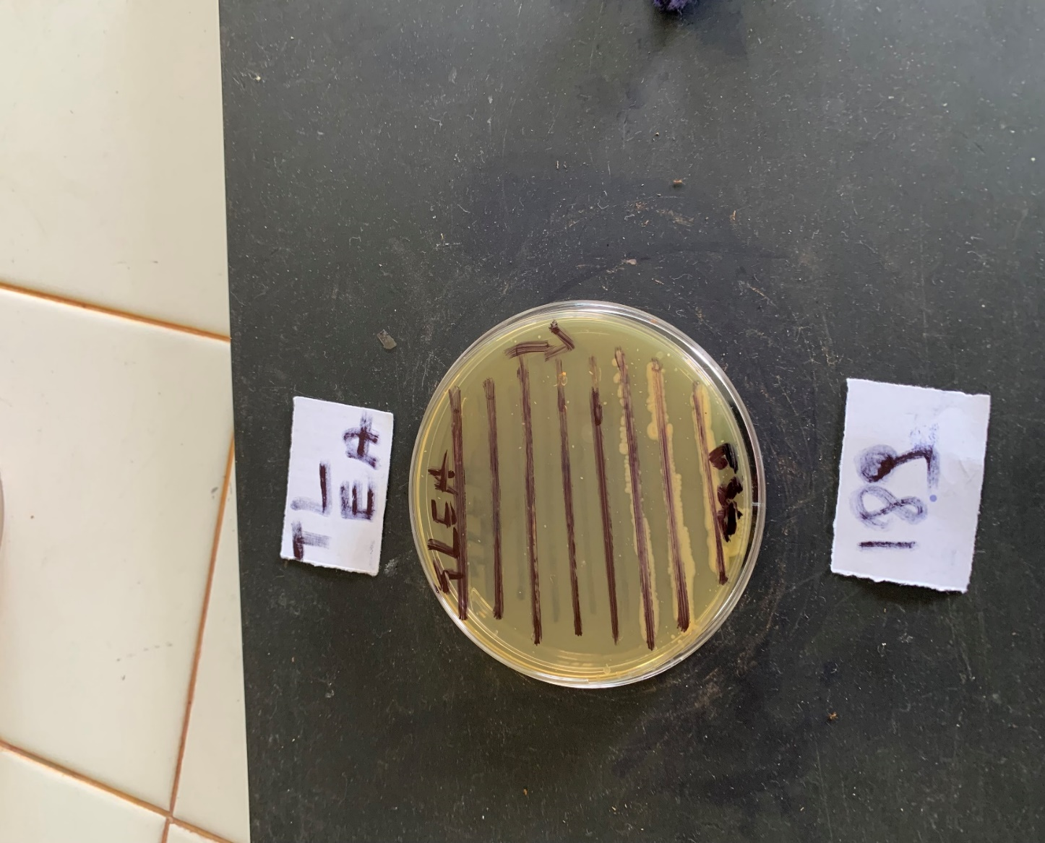  MIC  MBC | Reading is done from top to bottom.  200 mg/ml of crude extract plus bacterial isolate  100 mg/ml of crude extract plus bacterial isolate  50 mg/ml of crude extract plus bacterial isolate  25 mg/ml of crude extract plus bacterial isolate  12,5 mg/ml of crude extract plus bacterial isolate  6,25 mg/ml of crude extract plus bacterial isolate  3,125 mg/ml of crude extract plus bacterial isolate  1,56 mg/ml of crude extract plus bacterial isolate

Fig 4-Action of the aqueous extract of Termitomyces letestui on Shigella flexneri 117
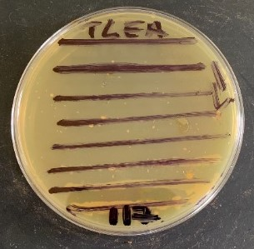 | Reading is done from top to bottom.  200 mg/ml of crude extract plus bacterial isolate  100 mg/ml of crude extract plus bacterial isolate  50 mg/ml of crude extract plus bacterial isolate  25 mg/ml of crude extract plus bacterial isolate  12,5 mg/ml of crude extract plus bacterial isolate  6,25 mg/ml of crude extract plus bacterial isolate  3,125 mg/ml of crude extract plus bacterial isolate  1,56 mg/ml of crude extract plus bacterial isolate
Fig 5-Action of the aqueous extract of Termitomyces letestui on Salmonella enterica 189
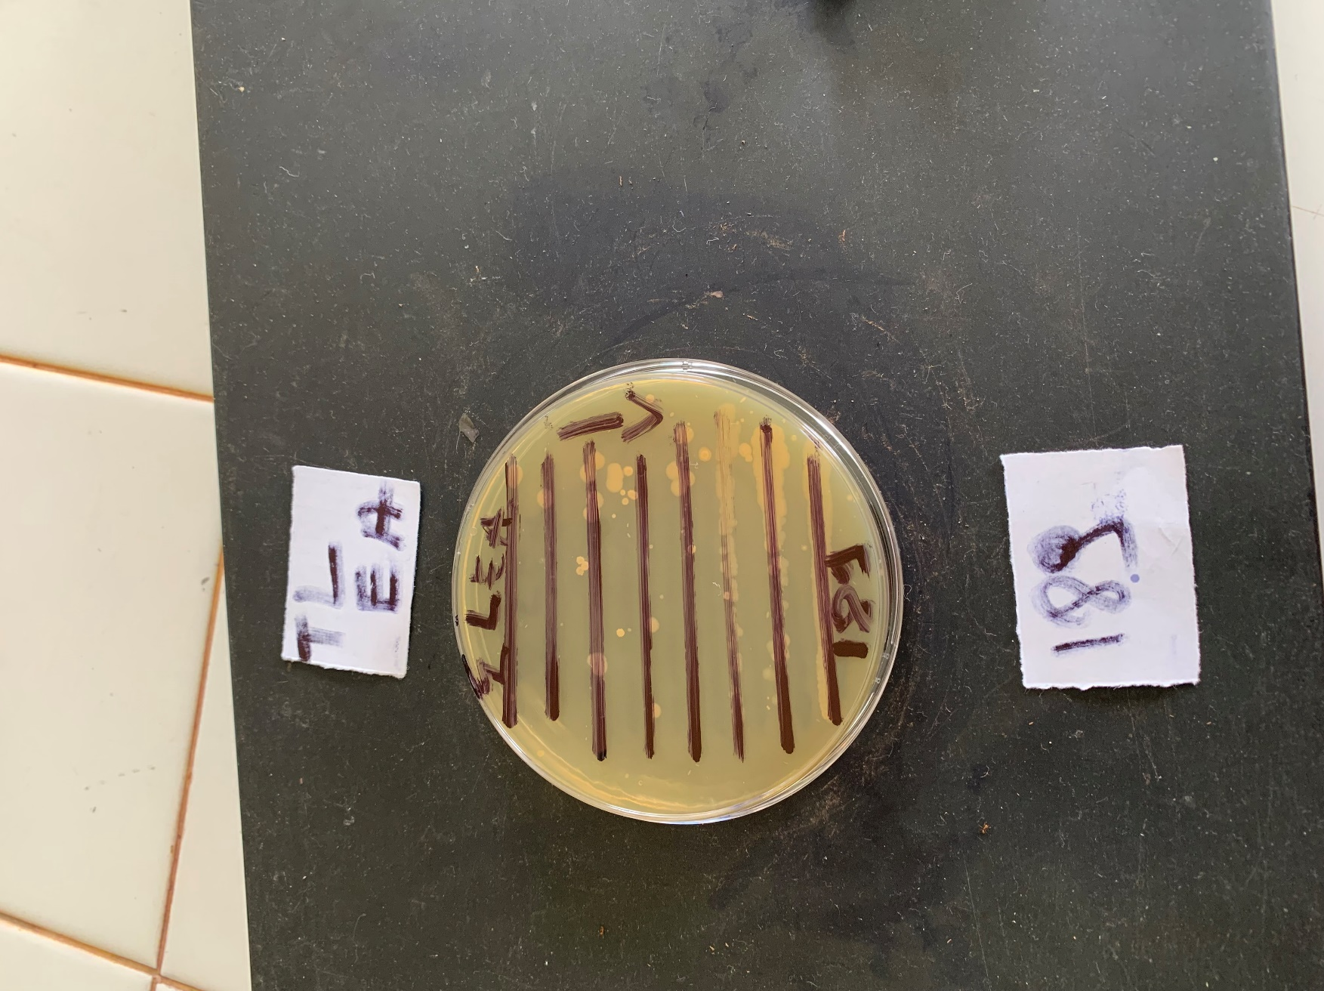  MIC  MBC | Reading is done from top to bottom.  200 mg/ml of crude extract plus bacterial isolate  100 mg/ml of crude extract plus bacterial isolate  50 mg/ml of crude extract plus bacterial isolate  25 mg/ml of crude extract plus bacterial isolate  12,5 mg/ml of crude extract plus bacterial isolate  6,25 mg/ml of crude extract plus bacterial isolate  3,125 mg/ml of crude extract plus bacterial isolate  1,56 mg/ml of crude extract plus bacterial isolate

4. CONCLUSION
The Haut Sassandra region is heavily influenced by carpophores of the Termitomyces genus, especially those of the Termitomyces letestui species. This species is mostly used during the lean season and consumed by the local population. This study, conducted in the region, demonstrates the therapeutic potential of Termitomyces letestui on four bacterial strains responsible for urinary tract infections. The results showed that the aqueous extract of Termitomyces letestui has a good bactericidal effect, as does the hydro-ethanolic extract. This bactericidal effect is observed at a concentration of C ≥ 6.25 mg/ml on bacterial isolates of Escherichia coli 739, Staphylococcus aureus 864, Shigella flexneri 117 and at C ≥ 3.125 on the bacterial isolate of Salmonella enterica 189.
DISCLAIMER (ARTIFICIAL INTELLIGENCE)
Author(s) hereby declare that NO generative AI technologies such as Large Language Models (ChatGPT, COPILOT, etc) and text-to-image generators have been used during writing or editing of this manuscript.

REFERENCE
Choumessi, T. A., Njouonkou, A-L., Binui, V. T., Mbouh, M., Manfo, T. F. P., & Nantia, A. E. (2021). Effect of collection areas, growth stage and fruit body parts on the nutrient and antioxidant contents of Termitomyces letestui (Lyophyllaceae) from Cameroon: IOSR Journal of Environmental Science, Toxicology and Food Technology Vol. 15 (3)p 01 09
Mahamat, O., Christopher, T., Andre-Ledoux, N., Jude, A., Niane, N., & Alber, T. K. (2018) Screening of the immunomodulatory and antibacterial activity of Termitomyces letestui (Pat.) Heim (Lyophyllaceae), an edible mushroom from Cameroon. J. Basic Clin. Physiol. Pharmacol, 29 : 645–650. https://doi.org/10.1515/jbcpp-2017-0189
Metsebing, B-P, (2020). Taxonomy, chemotaxonomy and evaluation of the antifungal and antibacterial activities of some higher basidiomycetes (Agaricales and Polyporales) from Cameroon and the DRC. Department of Plant Biology and Physiology. University of Yaoundé 1. PhD thesis, 190p.
Paloi, S., Kumla, J., Paloi, B. P., Srinuanpan, S., Hoijang, S., Karunarathna, S. C., Acharya, K., Suwannarach, N., & Lumyong, S. (2023). Termite Mushrooms (Termitomyces), a Potential Source of Nutrients and Bioactive Compounds Exhibiting Human Health Benefits: A Review. J. Fungi 9, 112. https://doi.org/10.3390/jof9010112
Sitati, W. N. C., Ogila, O. K., Rebecca, W., Waihenya, W., & Ochola, A. L. (2021). Phytochemical Profile and Antimicrobial Activities of Edible Mushroom Termitomyces striatus Evidence-Based Complementary and Alternative Medicine,10
Sharma, A. K., Jana, A. M., Srivastav, A., Gupta, M., Sharma, S., & Gill, S. S. (2014). Antimicrobial properties of some edible mushrooms: A review. World J. Pharm. Pharm. Sci, 3(5), 1009-1023.

Heim, R. (1942). New descriptive studies on the termitophilous agarics of tropical Africa. Archives of the National Museum of Natural History, Paris, 6 (18): 107–166.
Akré, D. S. T, N’douba, A. P., Koffi, A. E., Attéméné, K. A., Koko, A. C., & Ackah, J. A. A. B. (2022). Evaluation of the antibacterial activity of two higher fungi (Daldinia concentrica and Volvariella volvacea) on the growth of multidrug-resistant Escherichia coli strains isolated in Daloa, Côte d’Ivoire. RevueRAMReS–Série Pharm. Méd. Trad. Afr, 21(2): 116–124.
N'douba, A.P., Koffi N. B. C., Banza, K. M. F., Douira, A., & Ayolié, K. (2022). Some Wild Edible Termitomyces Found in the Region of Daloa. Int. J. Curr. Microbiol. App. Sci. 11(07):267-275. https://doi.org/10.20546/ijcmas.2022.1107.032
Koné, N. A., Dosso, K., Konaté, S., Kouadio, J. Y., & Linsenmair, K. E. (2011). Environmental and biological determinants of Termitomyces species seasonal fructification in central and southern Côte d’Ivoire. Insectes sociaux, 58(3), 371-382
Mbayo, M. K., Kalonda, M. E., Tshisand1, T. P., Olive Tatchoua, O., Sangwa Kamulete, S., Mbayo, K. G., Kihuya, N. E., Kahumba, B. J., & Jean-Baptiste S. Lumbu, S. J-B. (2015) Chemical Screening of some mushrooms of Katanga (DRC) and their biological activities evaluation, 10(1), 435-449.
Kouassi, K. C. (2012). Taxonomy, ecology and ethnomycology of fungi in Côte d'Ivoire: the case of macromycetes in the classified forests of Bouaflé, Bayota and Niégré, doctoral thesis, Félix Houphouet Boigny University, UFR Biosciences, Abidjan, Côte d'Ivoire, 216 p.
Gaye, M., Zinai, A. Z. R., Armstrong, N., Herbette, G., Monnier, V., Bassene, H., ... & Mediannikov, O. (2025). Antibacterial activity of fungus comb extracts from Senegalese fungus-farming termites. AMB Express, 15(1), 117.
Paloi, S., Kumla, J., Paloi, B. P., Srinuanpan, S., Hoijang, S., Karunarathna, S. C., ... & Lumyong, S. (2023). Termite mushrooms (termitomyces), a potential source of nutrients and bioactive compounds exhibiting human health benefits: a review. Journal of Fungi, 9(1), 112.
Sitati, C. N., Ogila, K. O., Waihenya, R. W., & Ochola, L. A. (2021). Phytochemical profile and antimicrobial activities of edible mushroom Termitomyces striatus. Evidence‐Based Complementary and Alternative Medicine, 2021(1), 3025848.

