Original Research Article

EXPLORING THE PLANT GROWTH PROMOTING POTENTIALS OF BACTERIA RECOVERED FROM A COAL MINE SOIL FOR BIORESTORATION PURPOSE

.
ABSTRACT
Aim: Coal mining leads to the degradation of surface soil’s physical, chemical and microbiological properties. However, functional microorganisms (such as plant growth promoting microorganisms) with the potential to produce phytohormones, fix nitrogen, solubilize phosphate, and others, can be effective in restoring coal mine soils (CMS). This study was conducted to explore the plant growth promoting potentials [indole-3-acetic acid (IAA) production and phosphate solubilization] of bacteria isolated from the abandoned Ogbete coal mine, Enugu State, Nigeria.
Study design: A laboratory study to isolate bacteria from the coal mine soil, screen bacterial isolates for plant growth promoting traits (IAA production and phosphate solubilization), and identify the isolates that tested positive for the traits using 16S rRNA gene sequencing.
Place and Duration of Study: Sample: Ogbete coal mine at Enugu State, Nigeria, between June 2025 and August 2025.
Methodology: CMS was analyzed for its physico-chemical properties. Isolation and enumeration of bacterial isolates from the CMS was done on Nutrient agar, after which the bacteria obtained were screened for IAA production and phosphate solubilization following standard methods. Bacterium that tested positive for the trait was identified using 16S rRNA gene sequencing.
Results: The coal mine soil was acidic (pH 5.84), while Total organic carbon (1.31%), Soil organic matter (2.27%), Total Nitrogen (3.89 mg/kg), Total phosphorus (1.04 mg/kg), were below levels required for arable soils. Total heterotrophic bacteria counts (3.5 × 10⁵ CFU/g) of the CMS were low for arable soils. A total of seven (7) bacterial isolates were recovered from the coal mine soil, out of which one (1) isolate was positive for IAA production, but negative for phosphate solubilization. The other 6 isolates were negative for both IAA production and phosphate solubilization. The IAA producing bacterium was identified using 16S rRNA sequencing as Chryseobacterium indologenes,
Conclusion: This study revealed the IAA potential of Chryseobacterium indologenes, which could further be exploited for its potential to biorestore coal mine soil and other disturbed soil ecosystems for future agricultural purpose.This study contributes to the United Nations Sustainable Development Goal 15, targeted at restoring and promoting conservation and sustainable use of terrestrial ecosystems.

Keywords: Biofertilizer, Biorestoration. Chryseobacterium indologenes, Coal mine soil, Indole-3- acetic acid, Plant growth promoting bacteria.

1. INTRODUCTION

Coal mining has profound ecological and environmental consequences. Mining activities degrade topsoil physico-chemical properties and alter microbial community composition (Mao et al., 2024). This has led to the assumption that coal mine environments are not habitable for microorganisms due to their complex chemical structure and resistance to decomposition (Zhang et al., 2022). However, certain microorganisms including those possessing plant growth promoting traits, can adapt to these conditions making them important in agriculture. Such microorganisms can also serve as effective tools for restoring or reclaiming disturbed terrestrial ecosystems and as reliable indicators for assessing the quality of reclaimed soils (Mao et al., 2024). Furthermore, certain natural coals act as reservoirs for microbial strains capable of degrading lignin, a compound with a molecular structure resembling that of coal components (Zhang et al., 2022). Wang et al. (2023) and Mao et al. (2024), reported species of the Phyla Proteobacteria, Acidobacteriota, Actinobacteria, Firmicutes and Bacteroidota, as the dominant Phyla in coal mine soils. While, the genera Thiobacillus, Sphingomonas, Acinetobacter, Variovorax and Novosphingobium were reported as dominant in coal mine soils (de Quadros et al., 2016).
The continuous growth of the global human population is a matter of concern, as it leads to numerous challenges, including food insecurity (Igiri et al., 2018; Salcedo-Gastelum et al., 2020). To ensure access to healthy food, it is essential to optimize crop production through fertile and sustainable agroecosystems. The agricultural sector contributes nearly one-third of the global gross domestic product. However, with the human population projected to reach approximately 9.5 billion by 2050, the demand for food is also expected to rise significantly (Kumar et al., 2022). At the same time, the availability of fertile land is declining due to urbanization, climate change–related extreme weather events, and anthropogenic activities. Various abiotic and biotic stresses also represent major constraints to crop production (Glaser & Lehr, 2019). Other critical factors influencing yield per unit area include soil quality, nutrient availability, environmental conditions, and the biological health of soils, all of which are vital to achieving global food security (Kumar et al., 2022).

One key component of healthy soils is the presence of beneficial microbiota, which enrich the nutrient pool via the biogeochemical cycling of soil constituents. However, many arable soils worldwide fail to provide optimal cultivation conditions due to a range of abiotic stresses, including organic pollutants (Tomar et al., 2019), heavy metals (Rizvi et al., 2020), drought (Wang et al., 2020), salinity (Zahra et al., 2020), and extreme temperatures (Narayanan, 2018). Among these, the oligotrophism and acidity associated with coal mine soils and other degraded soil systems pose serious threat to the sustainability of crop production systems (Mao et al., 2024).
Microorganisms (microbial inoculants or biofertilizers) offer a sustainable alternative, providing a low-cost source of nutrients, enriching soils with micro and micronutrients, supplying organic matter, secreting plant growth hormones, and mitigating the adverse effects of degraded soils and chemical fertilizers (Mahanty et al., 2016). Soil microbes, in particular, are essential for driving key biological processes within the soil ecosystem, ensuring nutrient mobilization and supporting long-term crop productivity (Mahanty et al., 2016).
Microbial inoculants have gained more attention as a vital natural resource for the development of “green methods.” The application of fertilizers enriched with beneficial microbes has become essential for enhancing soil health and crop productivity while ensuring a balance between efficient food production and sustainable agriculture (Nosheen et al., 2021).
Microbial inoculants are a category of biofertilizers that contain beneficial microorganisms with targeted functions (Goyal et al., 2023). Their application can restructure the soil’s microbial community and enhance nutrient availability for plants through soil-mediated processes (Bamdad et al., 2021) (Figure 1). Recent research indicates that microbial fertilizers derived from plant growth–promoting rhizobacteria (PGPR) and plant growth promoting bacteria (PGPB) play a vital role in enhancing soil fertility, stimulating crop growth, and helping plants withstand both biotic and abiotic stresses (Khawula et al., 2025). These microbial fertilizers are renewable, eco-friendly, non-pathogenic to plants, and contribute to improved plant adaptation, growth, and development. They also enhance soil nutrient balance, produce diverse plant growth regulators, detoxify soils contaminated with heavy metals, pesticides, or fungicides, and employ biological control methods for soil remediation (Khawula et al., 2025).

In the soil, most bacterial species are found near plant roots and are collectively known as plant growth-promoting rhizobacteria (PGPR), while some are found in bulk soil, and referred to as plant growth-promoting bacteria (PGPB). These plant growth-promoting rhizobacteria or bacteria (PGPR or PGPB) are a group of beneficial microorganisms that can enhance plant growth and development. They do these through direct or indirect mechanisms (Kochhar et al., 2022). Direct mechanisms involve traits that promote plant growth directly, such as providing beneficial compounds (auxins, cytokinins, gibberelins), as well as, fixing nitrogen, solubilizing phosphorus and enhancing nutrient uptake for host plants Auxins such as, indole -3-acetic acid are significant for plant growth because IAA helps loosen and expand root cell walls, and also greatly increases the release of root exudates which in turn influences the composition and activity of rhizospheric bacteria that depend on these exudates (Duca & Glick, 2020).
This auxin (IAA) serve as a rooting agent and supports processes such as leaf formation, cell division, stem bending and root hair development (Gao et al., 2024). Phosphate solubilizers convert the large portion of soil phosphorus that exists in insoluble complexes into soluble forms that plants can absorb. Their main mechanism is the secretion of organic acids, which chelate divalent cations such as Ca²⁺ and break down insoluble phosphate compounds, releasing soluble phosphorus into the soil (Kalayu, 2019). Through this process, phosphate solubilizing bacteria (PSB) increase the pool of plant available phosphorus (Zhu et al., 2012). Beyond solubilizing phosphorus, PSB also support plant growth by enhancing biological nitrogen fixation, producing phytohormones that stimulate plant development, and improving the availability of essential micronutrients such as zinc and iron (Wani et al., 2007; Sharma et al., 2013). Indirect mechanisms involve traits that inhibit the functioning of plant pathogenic organisms. This can be achieved through the production of antibiotics, which can act as antifungal, antibacterial, antihelmintic, and antiviral agents. Examples of antibiotics produced by PGPBs include surfactin, fengycin, rhamnolipids, phenazine-1-carboxylic acid, pyrrolnitrine, butyrolactones, zwittermicin A, aerugin, azomycin. These mechanisms can act independently or synergistically to benefit the plant (Olanrewaju et al., 2017; Kenawy et al., 2020). In turn, plants release secondary metabolites that nourish the microorganisms inhabiting the rhizosphere. Such interactions are fundamental for maintaining a favorable root microenvironment that supports plant growth and development (Chamkhi et al., 2022).
These bacteria belong to various genera, including Azospirillum, Azotobacter, Pseudomonas, Bacillus, Burkholderia, Paenibacillus, Pantoea, Serratia, Streptomyces, and Rhizobia (Shrivastava et al., 2015; Bhise et al., 2017).

Chryseobacterium species are widespread in nature, occurring predominantly in soil, foodstuffs, plants and aquatic environments (Arouna et al., 2017; Jung et al., 2023). Approximately 80 species of Chryseobacterium have been identified, most of which are non-pathogenic environmental isolates commonly linked to moist habitats (Booth, 2014). However, C. indologenes and C. gleum have been reported as human pathogens, frequently cultured from clinical specimens, causing pneumonia, bacteraemia and other human infections (Chen et al., 2013: Jean et al., 2017).
Recently, Chryseobacterium species have gained attention as a promising PGPB genus (Lee et al., 2017 ; Kim et al., 2020). Some Chryseobacterium species have been reported to promote plant growth by facilitating nutrient cycling and producing beneficial plant hormones (Sang et al., 2018; Jung et al., 2023). Additionally, they can indirectly support plant growth through biocontrol activity against plant pathogens and also aid in stress tolerance by synthesizing 1- aminocyclopropane-1-1-carboxylic acid (ACC deaminase) and producing phytohormones such as IAA, which improves root elongation and shoot growth (Jung et al., 2023).
Biofertilizers, including promising candidates such as Chryseobacterium offer a sustainable alternative to conventional fertilizers (Lee et al., 2017; Kim et al., 2020; Jung et al., 2023). Once established in soils or colonizing root surfaces, these beneficial microbes can modify the mobility and toxicity of pollutants, prevent further contamination, and enrich soil nutrient pools through multiple direct and indirect mechanisms to enhance fertility and crop productivity across diverse agroecosystems (Ajuzieogu et al., 2015; Zaidi et al., 2017).
The increasing global population and consequent high demand for food, have lead to search for eco-friendly strategies for reclamation or restoration of mine dump sites, improved crop production and yield. Thus, this study was done to isolate, screen and identify bacterial species with plant growth promoting traits for potential use as biofertilizer in the restoration of coal mine soils.

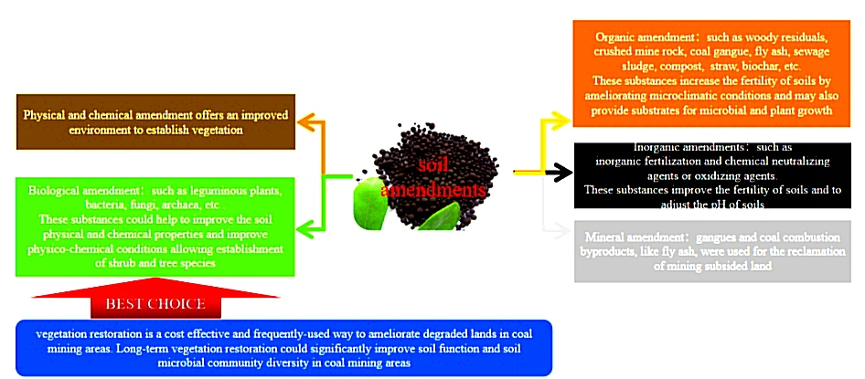
Fig.1. Effects of diverse soil amendments on coal mining areas

Source: Mao et al. (2024)

2. materiaLs and methods

2.1 Study Area
This research was conducted at Nucleometrix Laboratory, Tombia, Yenegoa, Bayelsa State Nigeria, situated at GPS coordinates latitude 4° 56’ 23” N and longitude 6° 21’ 15” E.
2.2. Site Description and Sample Collection
This was done following the method of Norby et al. (2024). Coal mine soil samples were collected from the abandoned Ogbete coal mine site located in Enugu State, Nigeria. The sampling points were geo-referenced using GPS device. Points 1, 2, 3, 4, and 5 were located at latitude 6°26'1. 032"N and longitude, latitude 7°28'5.0412"E, 6°26’1.11012” N and longitude 7°28’5.664” E, latitude 6°26’1. 14612” N and longitude 7°28’5.484” E, latitude 6°26’1.13388” N and longitude 7°28’5.20788” E, and latitude 6°26’1.032” N and longitude 7°28’5.04012” E, respectively. Coal mine spoil soils were collected from depths of 0-15cm (top soil), 7 km apart, from the five randomly selected points using a soil auger. These samples were pooled together to form a composite sample, transferred into sterile plastic containers, placed in ice chests, and transported to the laboratory for further analysis.

2.3 Physico-chemical Analysis of the Coal Mine Soil
Coal mine soil sample was analyzed for physical and chemical properties such as soil moisture content, soil pH, electrical conductivity, organic carbon, nitrogen, phosphorus, and heavy metals.
2.3.1 pH and Conductivity
pH and conductivity were measured using a digital Oakton pH meter (model PCD 650) and HANNA Conductivity/TDS meter (HI 9835) respectively (Melia et al., 2024).

2.3.2 Moisture Content
The method used for determining moisture content in soil was based on ASTM D2216. This is a simple weight loss technique obtained at temperature range of 105 to 115ºC with the moisture content result expressed in percentage.

2.3.3 Total Organic Carbon And Soil Organic Matter
This was done following the Walkey & Black (1934) wet oxidation method. A precisely measured volume of standardized potassium dichromate solution was added into an Erlenmeyer flask containing 1 g of finely ground soil sample. Concentrated sulfuric acid was carefully added to initiate the oxidation reaction. The mixture was allowed to react for 30 minutes. The solution was diluted with water, then phosphoric acid and; sodium fluoride were added (to complex interferences). Few drops of a suitable indicator (diphenylamine) were added. The solution was titrated with standardized ferrous ammonium sulphate until a sharp colour change was noticed which indicated the endpoint. An identical titration without a soil sample (blank titration) was performed to determine the initial amount of dichromate added. The organic carbon percentage was calculated based on the difference in ferrous ammonium sulphate (FAS) consumed between the blank and sample titrations.

2.3.4 Total Nitrogen
This was determined using the Kjeldahl method. An aliquot (0.5 g) of the soil sample was mixed sulfuric acid (H₂SO₄) and copper sulfate to break down organic matter and convert nitrogen to ammonium sulfate. Sodium hydroxide (NaOH) was added to release ammonia (NH₃) which was distilled into boric acid solution and titrated with standardized HCl. The total nitrogen was calculated from the volume of the used acid (Adomako & Dellor 2023).
2.3.5 Total Phosphorus
This was determined using the Olsen method. The soil sample was extracted with 0.5M NaHCO₃ solution and filtered. A fraction (0.5 g) of soil was mixed with a digestion reagent (HNO₃ + HCI) and heated to break down organic matter and release phosphorus. A color developing reagent (ammonium molybdate + antimony potassium tartrate) was added to form phosphomolybdenum blue complex. The absorbance of the complex was measured at 880 nm using a spectrophotometer. The total phosphorus concentration was calculated using a calibration curve prepared with known phosphorus standards (Koralage et al., 2015).
2.3.6 Particle size distribution

The method was primarily adopted from ASTM D1921-Practice for Description and identification of soils (usual -manual procedure) with contributions from other standards such as ASTM D2487 and D422. Soil sample was classified as clay, sandy, loam, and silt.

2.3.7 Heavy Metals Analysis
Acid digestion of the soil sample was conducted prior to analysis. Five (5) grams of each section of the sample was accurately weighed and transferred into a boiling tube. Aqua Regia preparation was made by adding the ratio of 3:1 concentrated hydrochloric acid and concentrated nitric acid. Fifteen (15) mL of the aqua Regia was then added into the boiling tube containing the measured samples and set to heat for 1 hour in the fume cupboard. After heating, the mixture was allowed to cool and then filtered into a 50 mL volumetric flask and filled up to the mark with distilled water. The concentration of each metal in the sample obtained after digestion was determined using Atomic Absorption Spectrophotometer (ASTM D6357-18) methods. This was carried out using PG instrument AAS (Model: AA500PCF). Prior to the analysis, calibration was done with each metal standard of known concentrations. Concentration of each metal was ascertained from the data generated by the AAS and expressed in mg/kg (Mohammadi et al., 2019).
2.4 Bacterial Analysis
2.4.1 Isolation and enumeration of bacteria from coal mine soil
Isolation and enumeration of bacterial species were carried out following the method described by Igbinosa et al. (2020). One (1) gram of the coal mine soil was thoroughly homogenized with 9 mL of sterile distilled water to make suspensions. The suspensions were diluted serially (10⁻¹ to 10⁻⁴ ) using physiological saline and 0.1 mL of the 10⁻³ and 10⁻⁴ dilutions were aseptically plated in duplicates on Nutrient Agar. The inoculated plates were incubated at 37 °C for 24 hours. After incubation, plates were examined for microbial growth, and the morphological characteristics of the isolates including colony shape, size, color, and texture were recorded. Distinct colonies were enumerated, and bacterial counts were expressed as colony-forming units per gram of soil (CFU/g).

2.5 Screening Bacterial Isolates For Plant Growth Promoting Traits
2.5.1 Phosphate Solubilizing
Phosphate solubilization was evaluated using Pikovskaya’s agar. The bacterial isolates were spot inoculated onto the agar plates and incubated for 7 days. After incubation, the plates were examined for the presence of clear zones around the colonies, which indicates phosphate solubilization (Ajuzieogu et al., 2015; Wang et al., 2022).
2.5.2 Indole-3-Acetic Acid (IAA) Production
Each bacterial isolate was inoculated into 20 mL of 1-SP2 liquid medium supplemented with 0.2 mL of 0.2% L-tryptophan and incubated in an agitated incubator (120 rpm) at room temperature (27 °C) for 7 days. After incubation, culture medium cells were centrifuged at 14,000 rpm for 15 minutes. One milliliter of the supernatant from each culture was mixed with 4 mL of Salkowski’s reagent. The mixture was incubated at room temperature in the dark for 30 minutes. Development of a pink color indicated IAA production (Thenappan et al., 2024).
2.6 Molecular Identification of the Bacterium
2.6.1 Bacterial DNA extraction, quantification, 16S rRNA Amplification and Sequencing of 16S rRNA

Extraction was done using the Fungi/Bacteria DNA mini prep extraction kit according to Saitou & Nei (1987). The extracted genomic DNA was quantified using the Nanodrop 1000 spectrophotometer. The ultra-pure DNA was then stored at -20°C for other downstream reaction. The 16S rRNA region of the rRNA genes of the isolates were amplified using the the 27F: 5'-AGAGTTTGATCMTGGCTCAG-3’ and 1492R: 5'-CGGTTACCTTGTTACGACTT-3’ primers on an ABI 9700 Applied Biosystems thermal cycler at a final volume of 50 uL for 35 cycles. The PCR mix included: the X2 Dream Taq Master mix supplied by Inqaba, South Africa (Taq polymerase, DNTPs, MgCl), the primers at a concentration of 0.4M and the extracted DNA as template. The PCR conditions were as follows: Initial denaturation, 95ºC for 5 minutes; denaturation, 95ºC for 30 seconds; annealing, 52ºC for 30 seconds; extension, 72ºC for 30 seconds for 35 cycles and final extension, 72ºC for 5 minutes. The product was resolved on a 1% agarose gel at 120V for 15 minutes and visualized on a UV transilluminator. Sequencing was done using the BigDye Terminator kit on a 3510 ABI sequencer by Inqaba Biotechnological, Pretoria South Africa. The sequencing was done at a final volume of 10 uL, the components included 0.25 uL BigDye® terminator v1.1/v3.1, 2.25 uL of 5 x BigDye sequencing buffer, 10uM Primer PCR primer, and 2-10ng PCR template per 100bp. The sequencing conditions were as follows 32 cycles of 96°C for 10 seconds, 55°C for 5 seconds and 60°C for 4 minutes
2.6.2 Phylogenetic Analysis
Obtained sequences were edited using the bioinformatics algorithm Trace edit. Similar sequences were downloaded from the National Center for Biotechnology Information (NCBI) data base using BLASTN. These sequences were aligned using ClustalX. The evolutionary history was inferred using the Neighbor-Joining method in MEGA 6.0 (Saitou & Nei, 1987). The bootstrap consensus tree inferred from 500 replicates (Felsenstein, 1985) was taken to represent the evolutionary history of the taxa analysed. The evolutionary distances were computed using the Jukes-Cantor method (Jukes & Cantor 1969).

3. results and discussion

3.1 Physico-chemical properties of coal mine soils
The physico-chemical properties of the coal mine soil sample are presented in [Table 1]. The CMS had a pH of 5.84 (acidic), while electrical conductivity (38.8 μs/ cm), total organic carbon (1.31%), Soil organic matter (2.27%), Total Nitrogen (3.89 mg/kg), and Total phosphorus (1.04 mg/kg), were low.

Table 1. Physico-chemical properties of coal mine soil
S/N | Parameters (unit) | Coal Mine Soil
1 | pH | 5.84
2 | Moisture content, (%) | 11.31
3 | Conductivity (μs/cm) | 38. 8
4 | Soil organic matter (%) | 2.27
5 | Total Organic Carbon (%) | 1.31
6 | Total Nitrogen (mg/kg) | 3.89
7 | Total phosphorus (mg/kg) | 1.04
8 | Mn (mg/kg) | 1.18
9 | Cu (mg/kg | 2.88
10 | As (mg/kg) | < 0.001
11 | Cr (mg/kg | 2.32
12 | Exchangeable cations ( meq/ 100g) | 0.108
13 | Particle Size Distribution (%)
14 | Sand (%) | 61. 54
15 | Silt (%) | 30.60
16 | Clay( %) | 7.86
* Mg/Kg: Milligram per Kilogram; Mn: Manganese; Cu: Copper; As: Arsenic; Cr: Chromium
% : Percentage; μs/ cm: Microsiemens percentimetre

3.2 Enumeration of bacterial Isolates from Coal Mine Soil
The bacterial counts from the coal mine soil are presented in [Table 2]. The total heterotrophic bacteria count (THBC) was 3.5 × 10⁻⁵ CFU/g.

Table 2. Bacterial population of the CMS

Sample | Total Heterotrophic Bacteria Counts (CFU/g)
Coal mine  soil | 3.5 × 10⁵
* CFU/g: Colony forming unit per gram

3.3 Morphological properties of bacterial isolates
The morphological properties of the bacterial isolates from the coal mine soil are displayed in [Table 3]. Also the colonial morphology of the bacterium that tested positive for IAA production is presented in [Plate 2].

Table 3. Morphological characteristics of bacterial isolates from coal mine soil

Isolate Code | Colony Colour | Colony Size | Colony Elevation | Colony Edge | Colony Shape
CDY | Dark yellow | Large | Raised | Entire | Round
CCWI | Creamy white | Large | Raised | Irregular | Round
CLY | Light yellow | Small | Raised | Entire | Round
CY | Yellow | Small | Raised | Entire | Round
CDYI | Dark yellow | Small | Raised | Irregular | Round
CCWR | Creamy white | Large | Raised | Entire | Round
CCW | Creamy White | Large | Raised | Entire | Round

3.5. Plant growth promoting traits of the bacterial isolates
Bacterial isolates with plant growth promoting traits (indole-3-acetic acid production and phosphate solubilization) are presented in [Table 4 and Plate 1].

Table 4: Plant growth promoting traits of the bacterial isolates
S/N | Isolate code | Indole-3-acetic acid Production | Phosphate solubilization
1. | CCWI | -ve | -ve
2. | CCW | -ve | -ve
3. | CCWR | -ve | -ve
4. | CDYI | -ve | -ve
5. | CDY | +ve | -ve
6. | CY | -ve | -ve
7. | CLY | -ve | -ve

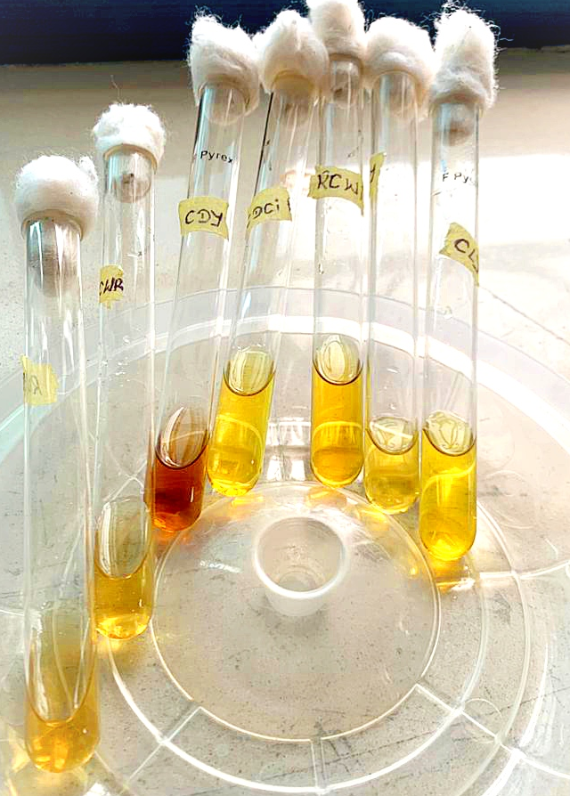

Plate 1. Qualitative screening showing indole-3-acetic acid production (pink colour) by Chryseobacterium indologenes

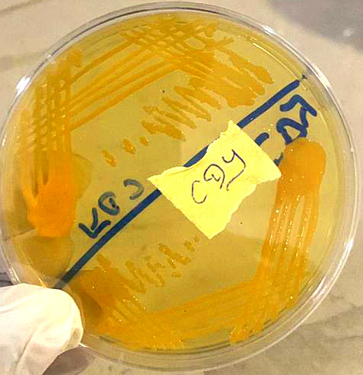
Plate 2. cultural morphology of Chryseobacterium indologenes

3.6 The 16S rDNA identity of the bacterium

The 16S rDNA gene bands of the bacterium and its 16S rDNA identity are presented in [Plate 3], [Figure 2] and [Table 5]. Molecular analysis revealed the identity of the bacterium recovered from the CMS, with IAA production potential as Chryseobacterium indologenes.

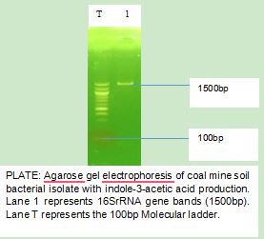
Plate 3. 16S rRNA gene band of Chryseobacterium indologenes during agarose gel electrophoresis

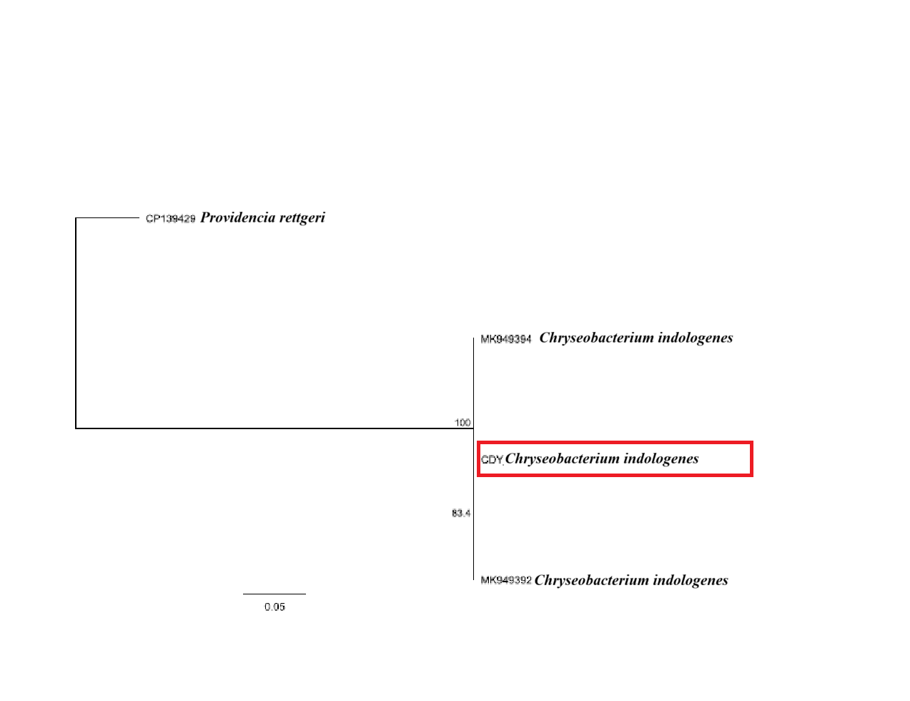
Fig 2. The evolutionary relatedness of the bacterium

Table 5. 16S rRNA identification of bacterium
Isolate Code | Closest Match (NCBI BLAST) | Accession number | Percentage Similarity index
CDY | Chryseobacterium indologenes | MK949394 | 100

This study explored the plant growth promoting potentials (phosphate solubilization and indole -3-acetic acid production) of bacterial species isolated from a coal mine soil. The physico-chemical properties of the CMS indicated the soil was acidic and oligotrophic in nature [Table 1], therefore, unsuitable for plant agriculture purpose. This confirm reports that coal mining alters the physical and chemical properties of soil (texture, organic matter, organic carbon, pH and bulk density) (Xu et al., 2019; Ghosh & Maiti, 2021; Mao et al., 2024; Ahmad et al., 2025).
Bacterial population (Total heterotrophic bacteria counts) were low [Table 2], and beyond levels required for arable soils (10⁻⁶ – 10⁸ CFU/g) (Ratnakar & Shikha, 2018). This underscores the oligotrophic nature of the CMS, depicted by its poor physico-chemical properties [Table1]. Soils affected by mining are usually low in fertility due to continuos excavation and leaching, which depletes nutrients and disrupts microbial life (de-Quadros et al., 2016; Ma et al., 2019). This explains the low bacterial abundance observed in this study. Despite these adverse conditions, the successful recovery of seven (7) bacterial isolates from the coal mine soil demonstrated microbial resilience and adaptation to stressed environments. Microorganisms capable of surviving under such nutrient-limited (oligotrophic) conditions often possess unique metabolic traits that enable them to contribute to ecosystem recovery (Zhang et al., 2022; Mao et al., 2024). However, screening the bacterial isolates for plant growth promoting traits revealed only one was positive for indole-3-acetic acid (IAA) production, while none were able to solubilize phosphate [Table 4]. Also, Rahayu et al. (2024) isolated bacterial species with the potential to produce IAA from rhizosphere of legume plants grown in a post coal mine soil. The limited occurrence of plant growth promoting (PGP) traits among the isolates may be due to the soil’s low organic matter concentration and acidic nature, both of which are unfavorable for microbial expression of enzymes required for phosphorus mineralization and nutrient uptake facilitated by bacterial IAA (Seshachala & Tallapragada, 2012; Alori et al., 2017; Tomar et al., 2019).
The production of IAA by one bacterium is significant because IAA is one of the major phytohormones that stimulate plant root and shoot elongation, cell division, cell expansion, sprouting, genes regulation and nutrient absorption (Ambreetha et al., 2018; Nosheen et al., 2021). This enhances plant resilience under environmental stress, making it well suited for sustainable agriculture, biorestoration and bioremediation purpose (Etesami & Glick 2024). Molecular identification revealed the IAA-producing bacterium as Chryseobacterium Indologenes. Although Chryseobacterium species are more commonly associated with aquatic and moist soil habitats (Jung et al., 2023), several strains within this genus have recently been reported as emerging plant growth promoting bacteria with the ability to produce auxins, promote nutrient cycling, and suppress pathogens (Lee et al., 2017 ; Sang et al., 2018; Kim et al., 2020). The detection of C. indologenes in a coal mine soil environment underscores its ecological adaptability and suggests its potential role as a biofertilizer candidate for restoring degraded soils. Akoijam & Joshi (2023) reported similar findings of isolating and identifying Chryseobacterium sp. with IAA production potential, however, from an acidic and arsenic-contaminated soil.
Bacteria that adapt to oligotrophic conditions often harbor stress-tolerance genes, including those encoding antioxidant enzymes, efflux transporters, and resistance determinants for toxic compounds (Zhang et al., 2022). These adaptive features are advantageous for potential biofertilizer use, as they enable microbial survival and functionality in degraded or contaminated soils where conventional fertilizers are less effective. The role of C. indologenes as a potential biofertilizer extends beyond plant growth promotion. Its involvement in soil bioremediation is particularly significant. Previous studies have demonstrated that Chryseobacterium species can degrade heavy metals, pesticides and aromatic hydrocarbons, contributing to organic matter transformation and detoxification in polluted soils (Szoboszlay et al., 2009; Qu et al., 2015; Chaudhary & Kim, 2017; Zhang et al., 2022). These attributes, coupled with its ability to produce extracellular enzymes and polysaccharides, may improve soil aggregation, enhance moisture retention, and promote microbial colonization, thereby facilitating the early stages of soil reclamation.

CONCLUSION
The results from this study revealed the oligotrophic and acidic state of the coal mine soil and its impact on bacterial abundance. Despite these limitations, several bacterial isolates were successfully recovered from the coal mine soil, indicating that microbial life can persist even under extreme and nutrient-limited conditions. Among the seven (7) bacterial isolates obtained, Chryseobacterium indologenes was the only bacterium with the potential of producing indole-3-acetic acid (IAA), an important phytohormone that stimulate root and shoot elongation, cell division and plant development. Although none of the seven isolates exhibited phosphate solubilization activity, the ability of C. indologenes to produce IAA suggests that it could serve as a promising plant growth promoting bacterium useful in restoring coal mine soils and other degraded environments. These findings emphasize the adaptive capacity of native bacteria and their potential use in sustainable agricultural and environmental restoration. The outcome of this study points to the need for further exploration of Chryseobacterium indologenes for the presence of other plant growth promoting traits, to fully understand its biological and ecological roles, and to evaluate its effectiveness under green house and field conditions for improving soil fertility.
Disclaimer (Artificial intelligence)

Author(s) hereby declare that NO generative AI technologies such as Large Language Models (ChatGPT, COPILOT, etc.) and text-to-image generators have been used during the writing or editing of this manuscript.

References
- Adomako, E. E. A., & Dellor, D. (2023). A preliminary assessment of the effect of urban waste pollution in the Korle Lagoon area of Accra, Ghana, on nutrition and growth of maize (Zea mays L.) plants. Agricultural Sciences, 14, 843-854. https://doi.org/10.4236/as.2023.146056
- Akoijam, N., & Joshi, S.R. (2023). Bioprospecting acid- and arsenic-tolerant plant growth-promoting rhizobacteria for mitigation of arsenic toxicity in acidic agricultural soils. Archives of Microbiology, 205, 209. https://doi.org/10.1007/s00203-023-03567-z.
- Ajuzieogu, C. A., Ibiene, A. A., & Stanley, H. O. (2015). Laboratory study on influence of plant growth promoting rhizobacteria (PGPR) on growth response and tolerance of Zea mays to petroleum hydrocarbon. African Journal of Biotechnology, 14(43), 2949-2956. https://doi.org/10.5897/AJB2015.14549
- Alori, E. T., Glick, B. R., & Babalola, O. O. (2017). Microbial Phosphorus Solubilization and Its Potential for Use in Sustainable Agriculture. Frontiers in Microbiology, 8, 971. https://doi.org/10.3389/fmicb.2017.00971
- Ambreetha, S., Chinnadurai, C., Marimuthu, P., & Balachandar, D. (2018). Plant-associated Bacillus modulates the expression of auxin-responsive genes of rice and modifies the root architecture. Rhizosphere, 5, 57-66.https://doi.org/10.1016/j.rhisph.2017.12.001
- Arouna, O., Deluca, F., Camara, M., Fall, B., Fall, B., Ba Diallo, A., Docquier, J. D., & Mboup, S. (2017). Chryseobacterium gleum in a man with prostatectomy in Senegal: A case report and review of the literature. Journal of Medical Case Reports, 11(1), 118. https://doi.org/10.1186/s13256-017-1269-4
- ASTM International. (2013). ASTM D2974-13: Standard test methods for moisture, ash, and organic matter of peat and other organic soils. West Conshohocken, PA: ASTM International. https://doi.org/10.1520/D2974-13
- ASTM International. (2007). *Standard test method for particle-size analysis of soils* (ASTM D422-63(2007)e2). ASTM International. https://doi.org/10.1520/D0422-63R07E02
- Bamdad, H., Papari, S., Lazarovits, G., & Berruti, F. (2021). Soil amendments for sustainable agriculture: Microbial organic fertilizers. Soil Use and Management, 38, 94–120. https://doi.org/10.1111/sum.12762
- Bhise, K. K., Bhagwat, P. K., & Dandge, P. B. (2017). Synergistic effect of Chryseobacterium gleum sp. SUK with ACC deaminase activity in alleviation of salt stress and plant growth promotion in Triticum aestivum L. 3 Biotech, 7(2), 105. https://doi.org/10.1007/s13205-017-0739-0
- Booth, S. J. (2014). Chryseobacterium related genera infections. In Reference Module in Biomedical Sciences (pp. 1-4). Elsevier. https://doi.org/10.1016/b978-0-12-801238-3.04922-9
- Chamkhi, I., El Omari, N., Balahbib, A., El Menyiy, N., Benali, T., & Ghoulam, C. (2022). Is the rhizosphere a source of applicable multi-beneficial microorganisms for plant enhancement? Saudi Journal of Biological Sciences. https://doi.org/10.1016/j.sjbs.2021.09.032
- Chaudhary, D. K., & Kim, J. (2017). Chryseobacterium nepalense sp. nov., isolated from oil-contaminated soil. International Journal of Systematic and Evolutionary Microbiology. https://doi.org/10.1099/ijsem.0.001680
- Chen, F. L., Wang, G. C., Teng, S. O., Ou, T. Y., Yu, F. L., & Lee, W. S. (2013). Clinical and epidemiological features of Chryseobacterium indologenes infections: analysis of 215 cases. Journal of Microbiology, Immunology and Infection, 46(6), 425–432. https://doi.org/10.1016/j.jmii.2012.08.007
- De Quadros, P. D., Zhalnina, K., Davis-Richardson, A. G., Drew, J. C., Menezes, F. B., Camargo, F. A. de O., & Triplett, E. W. (2016). Coal mining practices reduce the microbial biomass, richness and diversity of soil. Applied Soil Ecology, 98, 195-203. https://doi.org/10.1016/j.apsoil.2015.10.016
- Duca, D. R., & Glick, B. R. (2020). Indole-3-acetic acid biosynthesis and its regulation in plant–associated bacteria. Applied Microbiology and Biotechnology, 104, 8607-8619. https://doi.org/10.1007/s00253-020-10869-5
- Etesami, H., & Glick, B. R. (2024). Bacterial indole-3-acetic acid: A key regulator for plant growth, plant-microbe interactions, and agricultural adaptive resilience. Microbiological Research, 281, 127602. https://doi.org/10.1016/j.micres.2024.127602
- Felsenstein, J. (1985). Confidence limits on phylogenies: An approach using the bootstrap. Evolution, 39, 783-791. https://doi.org/10.1111/j.1558-5646.1985.tb00420.x
- Gao, J., Zhuang, S., & Zhang, W. (2024). Advances in Plant Auxin Biology: Synthesis, Metabolism, Signaling, Interaction with Other Hormones, and Roles under Abiotic Stress. Plants, 13(17), 2523.https://doi.org/10.3390/plants13172523
- Glaser, B., & Lehr, V. I. (2019). Biochar effects on phosphorus availability in agricultural soils: A meta-analysis. Scientific Reports, 9, 9338. https://doi.org/10.1038/s41598-019-45693-z
- Ghosh, D., & Maiti, S. K. (2021). Eco-restoration of coal mine spoil: Biochar application and carbon sequestration for achieving UN sustainable development goals 13 and 15. Land, 10(11), 1112.https://doi.org/10.3390/land10111112
- Goyal, S., Dhanker, R., Hussain, T., Ferreira, A., Gouveia, L., Kumar, K., & Mohamed, H. I. (2023). Modern Advancement in Biotechnological Applications for Wastewater Treatment through Microalgae: a Review. Water, Air, & Soil Pollution, 234, 417. https://doi.org/10.1007/s11270-023-06409-2
- Igbinosa, I. H., Beshiru, A., Egharevba, N. E., & Igbinosa, E. O. (2020). Distribution of enterobacteria in ready to eat food in cafeterias and retail food outlets in Benin city: public health implications. Journal of Community Medicine and Primary Health Care, 32(2), 80-94. https://doi.org/10.4314/jcmphc.v32i2.7
- Igiri, B. E., Okoduwa, S. I. R., Idoko, G. O., Akabuogu, E. P., Adeyi, A. O., & Ejiogu, I. K. (2018). Toxicity and bioremediation of heavy metals contaminated ecosystem from tannery wastewater: A review. Journal of Toxicology. https://doi.org/10.1155/2018/2568038
- Jukes, T. H., & Cantor, C. R. (1969). Evolution of protein molecules. In H. N. Munro (Ed.), Mammalian protein metabolism (pp. 21-132). Academic Press. https://doi.org/10.1016/B978-1-4832-3211-9.50009-7
- Jung, H., Lee, D., Lee, S., Kong, H. J., Park, J., & Seo, Y. S. (2023). Comparative genomic analysis of Chryseobacterium species: Deep insights into plant-growth-promoting and halotolerant capacities. Microbial Genomics. https://doi.org/10.1099/mgen.0.001108
- Kalayu, G. (2019). Phosphate solubilizing microorganisms: Promising approach as biofertilizers. International Journal of Agronomy. https://doi.org/10.1155/2019/4917256
- Kenawy, A. A., Dailin, D. J., Abo-Zaid, G. A., Malek, R. A., Ambehabati, K. K., Zakaria, K. H. N., Sayyed, R. Z., & El Enshasy, H. A. (2019). Biosynthesis of antibiotics by PGPR and their roles in biocontrol of plant diseases. In R. Z. Sayyed (Ed.), Plant growth promoting Rhizobacteria for sustainable stress management (pp. 1-35). Springer Nature Singapore Pte Ltd. https://doi.org/10.1007/978-981-13-6986-5_1
- Khawula, S., Daniel, A. I., Nyawo, N., Ndlazi, K., Sibiya, S., Ntshalintshali, S., Nzuza, G., Gokul, A., Keyster, M., Klein, A., Niekerk, L., & Nkomo, M. (2025). Optimizing plant resilience with growth-promoting Rhizobacteria under abiotic and biotic stress conditions. Plant Stress, 17, 100949. https://doi.org/10.1016/j.stress.2025.100949
- Kim, H., & Yu, S. M. (2020). Complete genome sequence of Chryseobacterium sp. Strain NBC 122, a plant growth-promoting bacterium isolated from freshwater. Microbiology Resource Announcements.https://doi.org/10.1128/mra.01028-19
- Kochhar, N., Kavya, I. K., Shrivastava, S., Ghosh, A., Rawat, V. S., Sodhi, K. K., & Kumar, M. (2022). Perspectives on the microorganism of extreme environments and their applications. Current Research in Microbial Science, 3. https://doi.org/10.1016/j.crmicr.2022.100134
- Koralage, I. S. A., Weerasinghe, P., Silva, N. R. N., & De Silva, C. S. (2015). The determination of available phosphorus in soil: A quick and simple method. OUSL Journal, 8, 1-17. https://doi.org/10.4038/ouslj.v8i0.7315
- Kumar, J. M., & Patel, A. K. (2013). Physico-chemical characterization and mine soil genesis in age series coal mine overburden spoil in chronosequence in a dry tropical environment. Journal of Phylogenetics and Evolutionary Biology, 1(1), 1. https://www.hilarispublisher.com/phylogenetics-evolutionary-biology/physico-chemical-characterization-and-mine-soil-genesis-in-age-series-coal-mine-overburden-spoil-in-chronosequence-ina-dry-tropical-environment.1000101.pdf
- Kumar, S., Diksha, Sindhu, S. S., & Kumar, R. (2022). Biofertilizers: An ecofriendly technology for nutrient recycling and environmental sustainability. Current Research in Microbial Sciences, 3, 100094.https://doi.org/10.1016/j.crmicr.2021.100094
- Lee, S. A., Kim, S. Y., Sang, M. K., Song, J., & Weon, H. Y. (2017). Complete genome sequence of Chryseobacterium sp. T16E-39, a plant growth-promoting and biocontrol bacterium, isolated from tomato (Solanum lycopersicum L.) root. Korean Journal of Microbiology, 53(4), 351–353.https://www.koreascience.or.kr/article/JAKO201733050006000.page
- Mahanty, T., Bhattacharjee, S., Goswami, M., Bhattacharyya, P., Das, B., Ghosh, A., & Tribedi, P. (2017). Biofertilizers: a potential approach for sustainable agriculture development. Environmental Science and Pollution Research, 24(4), 3315-3335. https://doi.org/10.1007/s11356-016-8104-0
- Ma, K., Zhang, Y., Ruan, M., Guo, J., & Chai, T. (2019). Land Subsidence in a Coal Mining Area Reduced Soil Fertility and Led to Soil Degradation in Arid and Semi-Arid Regions. International Journal of Environmental Research and Public Health, 16(20), 3929. https://doi.org/10.3390/ijerph16203929
- Mao, Z., Harris, J., & Zhang, Z. (2024). Responses of Natural Microorganisms to Land Reclamation and Applications of Functional Microorganisms in Biorestoration of Coal Mining Area. Diversity, 16(2), 86.https://doi.org/10.3390/d16020086
- Melia, S., Juliyarsi, I., Aritonang, S. N., Setiawan, R. D., & Rusdimansyah. (2024). Evaluation of fermented goat milk quality lactobacillus plantarum SNT13 enhanced with Clitoria ternatea flower extract and stingless bee honey ( Heterotrigona itama). Preventive Nutrition and Food Science, 29(4), 546-553.https://doi.org/10.3746/pnf.2024.29.4.546
- Mercado-Blanco, J., Abrantes, I., Barra Caracciolo, A., Bevivino, A., Ciancio, A., Grenni, P., Hrynkiewicz, K., Kredics, L., & Proença, D. N. (2018). Belowground Microbiota and the Health of Tree Crops. Frontiers in Microbiology, 9, 1006. https://doi.org/10.3389/fmicb.2018.01006
- Mohammadi, A. A., Zarei, A., Majidi, S., Ghaderpoury, A., Hashempour, Y., Saghi, M. H., Alinejad, A., Yousefi, M., Hosseingholizadeh, N., & Ghaderpoori, M. (2019). Carcinogenic and non-carcinogenic health risk assessment of heavy metals in drinking water of Khorramabad, Iran. MethodsX, 6, 1642-1651.https://doi.org/10.1016/j.mex.2019.07.017
- Narayanan, S. (2018). Effects of high temperature stress and traits associated with tolerance in wheat. Open Access Journal of Science, 2(3), 177–186. https://doi.org/10.15406/oajs.2018.02.00067
- Norby, J., Wang, S., Wang, H., Deng, S., Jones, N., Mishra, A., Pavlov, C., He, H., Subramanian, S., Thangavelu, V., Sihota, N., Hoelen, T., Johnson, A. M., & Lowry, G. V. (2024). Path to autonomous soil sampling and analysis by ground-based robots. Journal of Environmental Management, 360, 121-130.https://doi.org/10.1016/j.jenvman.2024.121130
- Nosheen, S., Ajmal, I., & Song, Y. (2021). Microbes as Biofertilizers, a Potential Approach for Sustainable Crop Production. Sustainability, 13(4), 1868. https://doi.org/10.3390/su13041868
- Olanrewaju, O. S., Glick, B. R., & Babalola, O. O. (2017). Mechanisms of action of plant growth promoting bacteria. World Journal of Microbiology and Biotechnology, 33(11), 197. https://doi.org/10.1007/s11274-017-2364-9
- Qu, J., Xu, Y., Ai, G., Liu, Y., & Liu, Z. (2015). Novel Chryseobacterium sp. PYR2 degrades various organochlorine pesticides (OCPs) and achieves enhancing removal and complete degradation of DDT in highly contaminated soil. Journal of Environmental Management, 161, 350-357.https://doi.org/10.1016/j.jenvman.2015.07.025
- Rahayu, Y.S., Yuliani, Y., & Asri, M.T. (2024). The ability of bacteria from legume plant roots grown on former coal mining soil to produce indole-3-acetic acid (IAA). E3S Web of Conference, 513:03003. https://doi.org/10.1051/e3sconf/202451303003.
- Rizvi, A., Ahmed, B., Zaidi, A., & Khan, M. S. (2020). Biosorption of heavy metals by dry biomass of metal tolerant bacterial biosorbents: an efficient metal clean-up strategy. Environmental Monitoring and Assessment, 192(12), 801. https://doi.org/10.1007/s10661-020-08758-5
- Saitou, N., & Nei, M. (1987). The neighbor-joining method: a new method for reconstructing phylogenetic trees. Molecular Biology and Evolution, 4(4), 406-425. https://doi.org/10.1093/oxfordjournals.molbev.a040454
- Díaz-Rodríguez, A. M., Salcedo Gastelum, L. A., Félix Pablos, C. M., Parra-Cota, F. I., Santoyo, G., Puente, M. L., Bhattacharya, D., Mukherjee, J., & de los Santos-Villalobos, S. (2021). The current and future role of microbial culture collections in food security worldwide. *Frontiers in Sustainable Food Systems, 4*, Article 614739.https://doi.org/10.3389/fsufs.2020.614739
- Sang, M. K., Jeong, J. J., Kim, J., & Kim, K. D. (2018). Growth promotion and root colonisation in pepper plants by phosphate-solubilising Chryseobacterium sp. strain ISE14 that suppresses Phytophthora blight. Annals of Applied Biology, 172(2), 208–223. https://doi.org/10.1111/aab.12413
- Seshachala, U., & Tallapragada, P. (2012). Phosphate solubilizers from the rhizosphere of Piper nigrum L. in Karnataka, India. Chilean Journal of Agricultural Research, 72(3), 397-403. https://doi.org/10.4067/S0718-58392012000300014
- Sharma, S. B., Sayyed, R. Z., Trivedi, M. H., & Gobi, T. A. (2013). Phosphate solubilizing microbes: sustainable approach for managing phosphorus deficiency in agricultural soils. Springerplus, 2, 587https://doi.org/10.1186/2193-1801-2-587
- Shrivastava, S., Egamberdieva, D., & Varma, A. (2015). Plant Growth-Promoting Rhizobacteria (PGPR) and Medicinal Plants: The State of the Art. In S. Shrivastava, D. Egamberdieva, & A. Varma (Eds.), Plant-Growth-Promoting Rhizobacteria (PGPR) and Medicinal Plants (Soil Biology, Vol. 42). Springer.https://doi.org/10.1007/978-3-319-13401-7_1
- Szoboszlay, S., Atzél, B., Kukolya, J., Tóth, E. M., Márialigeti, K., Schumann, P., & Kriszt, B. (2008). Chryseobacterium hungaricum sp. nov., isolated from hydrocarbon-contaminated soil. International Journal of Systematic and Evolutionary Microbiology, 58(12). https://doi.org/10.1099/ijs.0.65847-0
- Tapadar, S. A., & Jha, D. K. (2015). Influence of open cast mining on the soil properties of Ledo Colliery ofTinsukia district of Assam, India. International Journal of Scientific and Research Publications, 5(3), 365-369. http://www.ijsrp.org/research-paper-0315.php?rp=P393791
- Thenappan, D. P., Pandey, R., Hada, A., Jaiswal, D. K., Chinnusamy, V., Bhattacharya, R., & Annapurna, K. (2024). Physiological basis of plant growth promotion in rice by rhizosphere and endosphere associated Streptomyces isolates from India. Rice. https://doi.org/10.1186/s12284-024-00732-w Thenappan, D. P., Pandey, R., Hada, A., Jaiswal, D. K., Chinnusamy, V., Bhattacharya, R., & Annapurna, K. (2024). Physiological basis of plant growth promotion in rice by rhizosphere and endosphere associated Streptomyces isolates from India. Rice.https://doi.org/10.1186/s12284-024-00732-w
- Tomar, R. S., Singh, B., & Jajoo, A. (2019). Effects of organic pollutants on photosynthesis. In P. Ahmad, M. A. Ahanger, M. N. Alyemeni, & P. Alam (Eds.), Photosynthesis, productivity and environmental stress (pp. 1–26). John Wiley & Sons Ltd. https://doi.org/10.1002/9781119501800.ch1
- Walkley, A., & Black, I. A. (1934). An examination of the Degtjareff method for determining Soil Organic Matter, and a Proposed Modification of the Chromic Acid Titration Method. Soil Science, 37(1), 29–38.https://doi.org/10.1097/00010694-193401000-00003
- Wang, C., Linderholm, H. W., Song, Y., Wang, F., Liu, Y., Tian, J., Xu, J., Song, Y., & Ren, G. (2020). Impacts of drought on maize and soybean production in northeast China during the past five decades. International Journal of Environmental Research and Public Health, 17(7), 2459. https://doi.org/10.3390/ijerph17072459
- Wang, J., Li, R., Zhang, H., Wei, G., & Li, Z. (2020). Beneficial bacteria activate nutrients and promote wheatgrowth under conditions of reduced fertilizer application. BMC Microbiology, 20(1), 38. https://doi.org/10.1186/s12866-020-1708-z
- Wang, Z., Zhang, H., Liu, L., Li, S., Xie, J., Xue, X., & Jiang, Y. (2022). Screening of phosphate-solubilizingbacteria and their abilities of phosphorus solubilization and wheat growth promotion. BMC Microbiology, 22, 296. https://doi.org/10.1186/s12866-022-02715-7
- Wang, Y., Li,J., Li, W., Wei, Y., Deng, Z., & Li, F. (2023). Relation analysis of bacterial community in soils of coal mines with potential ecological risk from heavy metals. Environmental Technology & Innovation, 30, 103125. https://doi.org/10.1016/j.eti.2023.103125.
- Wani, P. P., Khan, M. M., & Zaidi, A. A. (2007). Co-inoculation of nitrogen-fixing and phosphate-solubilizing bacteria to promote growth, yield and nutrient uptake in chickpea. Acta Agronomica Hungarica, 55(3).https://doi.org/10.1556/aagr.55.2007.3.7
- Xu, C., McDowell, N. G., Fisher, R. A., Wei, L., Sevanto, S., Christoffersen, B. O., Weng, E., & Middleton, R. S. (2019). Increasing impacts of extreme droughts on vegetation productivity under climate change. Nature Climate Change, 9(12). https://doi.org/10.1038/s41558-019-0630-6
- Zahra, N., Raza, Z. A., & Mahmood, S. (2020). Effect of salinity stress on various growth and physiological attributes of two contrasting maize genotypes. Brazilian Archives of Biology and Technology, 63.
- Zaidi, A., Ahmad, E., Khan, M. S., Saif, S., & Rizvi, A. (2015). Role of plant growth promoting rhizobacteria in sustainable production of vegetables: Current perspective. Scientia Horticulturae, 193, 231-239.https://doi.org/10.1016/j.scienta.2015.07.020
- Zaidi, A., Khan, M. S., Rizvi, A., Saif, S., Ahmad, B., & Shahid, M. (2017). Role of phosphate-solubilizing bacteria in legume improvement. In Microbes for Legume Improvement (pp. 175–197). Springer.https://doi.org/10.1007/978-3-319-59174-2_8v
- Zhang, D., He, H., Ren, Y., Haider, R., Urynowicz, M., Fallgren, P. H., Jin, S., Ishtiaq Ali, M., Jamal, A., Adnan Sabar, M., Guo, H., Liu, F., & Huang, Z. (2022). A mini review on biotransformation of coal to methane by enhancement of chemical pretreatment. Fuel, 308, 121961. https://doi.org/10.1016/j.fuel.2021.121961
- Zhu, H. J., Sun, L. F., Zhang, Y. F., Zhang, X. L., & Qiao, J. J. (2012). Conversion of spent mushroom substrate to biofertilizer using a stress-tolerant phosphate-solubilizing Pichia farinose FL7. Bioresource Technology, 111, 410-416. https://doi.org/10.1016/j.biortech.2012.02.042

