Diversity and Structure of Zooplankton Communities in the Bagoé River in Northern Côte d’Ivoire, West Africa

.
ABSTRACT
The Bagoé River, located in northern Côte d’Ivoire, plays a crucial role in the local economy, notably through its provision of water and fishery resources. However, it is currently under significant anthropogenic pressure, mainly due to illegal gold mining, which severely affects its ecological quality. This study was conducted at three stations along the Bagoé River to assess the composition of the zooplankton community of the river. Sampling, including physicochemical measurements and zooplankton collection using a 55 µm mesh plankton net, was performed monthly from January to June 2025. A total of 30 taxa were identified, distributed across four major groups : Rotifers (17 taxa), Copepods (4 taxa), Cladocerans (4 taxa), and other zooplanktonic organisms (5 taxa), belonging to 17 families. The community was largely dominated by Copepods, representing 68% of total density. The lowest taxonomic richness (9 taxa) and abundance (200 ind/m³) were recorded at station S3, which is impacted by illegal gold mining. Copepods (75–80% of total zooplankton density) dominated in the non-impacted stations, whereas Rotifers (20–31.30% of total abundance) were predominant at the gold mining site, indicating a degradation gradient associated with human activities. The variables most strongly associated with zooplankton distribution were current velocity, transparency, conductivity, depth, temperature, pH, and dissolved oxygen. The relative proportion of Copepods and Rotifers thus appears to be a reliable biological indicator of aquatic ecosystem quality.

Keywords : Composition, Zooplankton, Gold mining, Physicochemical parameters, Bagoé River.

1. INTRODUCTION
Freshwater ecosystems, although covering less than 1% of the Earth’s surface, provide essential goods and services to humanity, including water supply, food resources, and diverse ecological functions (Bernard et al., 2012). Despite their importance, they are increasingly threatened by multiple anthropogenic pressures—such as the construction of hydro-agricultural reservoirs, and the discharge of domestic and industrial effluents—which continue to undermine their ecological integrity (Sanogo et al., 2015).
The Bagoué River, located in northern Côte d’Ivoire, is no exception. Over the past decade, it has been subject to intense anthropogenic disturbances, primarily associated with the rapid expansion of illegal artisanal gold mining along its course and, increasingly, within its riverbed (Sanogo et al., 2015). Dredging operations carried out during gold extraction resuspend fine particles, including clays, silts, and organic matter, which subsequently degrade water quality and disrupt the ecological functioning of the hydrosystem (Konan et al., 2015). Yet, the Bagoué River remains a key socio-economic pillar for riparian communities, supporting agriculture, livestock, fisheries, and inland navigation (Sanogo et al., 2015; Kouamé et al., 2020).
Within this context, studying zooplankton communities becomes critically important. Zooplankton occupy a pivotal position in aquatic food webs, acting as a functional link between primary producers (phytoplankton) and higher trophic levels such as macroinvertebrates and fish (Etilé et al., 2020; Monney et al., 2015). Their diversity, composition, and abundance are highly sensitive to environmental changes and are therefore widely recognized as reliable bioindicators of water quality. Disturbances such as those induced by illegal gold mining can rapidly alter zooplankton community structure, leading to reductions in species richness, increased dominance of pollution-tolerant taxa, and the decline of sensitive species.
Despite the ecological and socio-economic relevance of the Bagoué River, scientific investigations on its planktonic fauna remain extremely limited. There is a lack of baseline zooplankton data, hindering effective monitoring and management strategies aimed at preserving this ecosystem.
The present study therefore aims to (i) assess the taxonomic composition of zooplankton in the Bagoué River, (ii) analyse the spatial distribution of zooplankton taxa, and (iii) identify the environmental variables shaping community patterns in this West African river ecosystem.

2. material and methods

2.1. Study Area
The study was conducted in the Bagoué River, located in northern Côte d’Ivoire between latitudes 9°15’N and 10°50’N and longitudes 5°40’W and 7°51’W. The river originates near Madinani, close to the villages of Kébi and Niempurgué (Avit et al., 1999), and flows northwards into Mali. From its source to the Ivorian–Malian border, it drains a catchment area of approximately 10,150 km² (Adja et al., 2009) and extends over a length of 230 km (Sanogo et al., 2015). Within the sub-prefecture of Kouto, the watershed covers nearly 4,740 km² (Girard et al., 1960).
The river flows through a Sudanian savannah zone and feeds several reservoirs which serve agricultural and livestock purposes (Adja et al., 2009). Its main tributaries in Côte d’Ivoire include the Niangboué River and the Palée River, the latter originating from the Palée Forest northeast of Boundiali (Avit et al., 1999). The region is characterized by a unimodal climate with a dry season extending from November to April, influenced by the dry and cool Harmattan wind blowing from the North, followed by a rainy season from May to October with peak rainfall occurring in August (Adja et al., 2009).

2.2. Zooplankton Sampling and Preservation

Zooplankton sampling was conducted monthly from January to June 2025 at three stations (S1, S2, and S3) along the Bagoué River (Figure 1). Stations S1 and S2 are traditional fishing sites located outside the gold mining zone, whereas S3 lies within a section of the river directly impacted by illegal artisanal gold mining.
Sampling took place between 08:00 and 13:00 to limit diel variation in zooplankton distribution. At each station, four sampling points approximately 15 m apart were selected. At each point, six buckets of surface water (15 L each) were collected from different microhabitats and subsequently filtered using a 55 µm mesh plankton net. The concentrated samples were transferred into labelled vials and preserved following a standardized protocol: (i) addition of 1–2 mg of sucrose to prevent distortion or breakage of cladoceran carapaces (Haney & Hall, 1973), (ii) addition of 2–3 drops of neutral red dye to facilitate organism visualization under the microscope, and (iii) fixation with buffered formaldehyde to a final concentration of 5% to ensure long-term preservation of zooplankton.

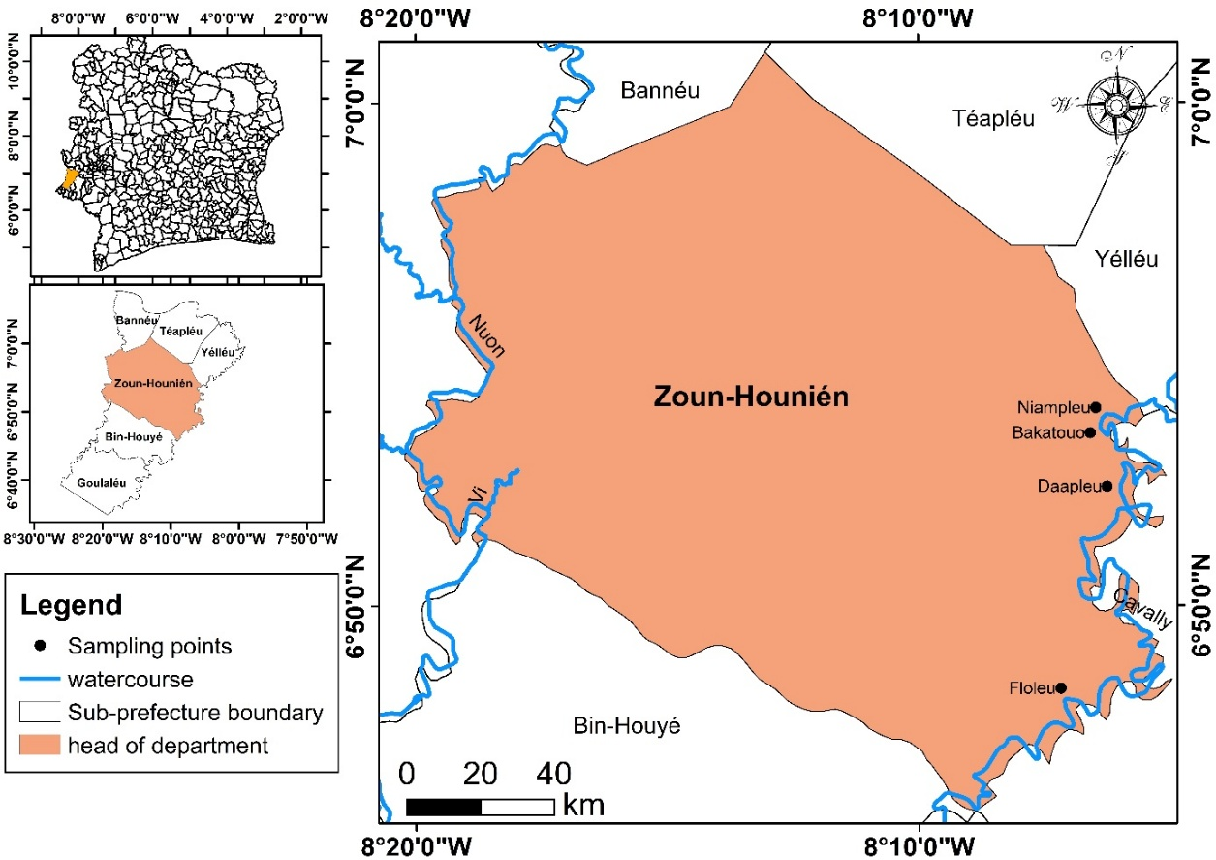

Figure 1: Map showing the localization of the sampling stations in the Bagoué River (Côte d’Ivoire).
2.3. Laboratory Processing and Identification

In the laboratory, each sample was concentrated to a final volume of 50 mL. Zooplankton taxa were identified to the lowest possible taxonomic level using morphological diagnostic characters under a compound microscope. Taxonomic identification relied on standard keys including Dussart and Defaye (2001) for Copepoda and Sharma (2010) for Cladocera. All individuals were enumerated, and results were expressed as taxonomic richness, Shannon–Wiener diversity index (H'), Pielou’s evenness index (J), and density (individuals per cubic meter).

2.4. Physicochemical Parameters

In situ water parameters were recorded simultaneously with zooplankton sampling. Water temperature (°C), pH, conductivity (µS/cm), and dissolved oxygen (mg/L) were measured using a HACH multiparameter probe (model HQ30d). Water transparency (cm) was assessed with a Secchi disk. Current velocity (m/s) and water depth (cm) were measured at each station using a flow meter and a graduated rod, respectively.

2.5. Data Analysis

Biological data (taxonomic richness, occurrence frequency, Shannon diversity, and evenness indices) were used to characterize the structure and diversity of zooplankton communities. Spatial variation in zooplankton density among stations was assessed using the non-parametric Kruskal–Wallis test. Redundancy Analysis (RDA) was performed to examine relationships between environmental variables and zooplankton taxa distribution patterns.

3. results and discussion

3.1. Qualitative Analysis of the Zooplankton Communities
A total of 30 zooplankton taxa were recorded across the three sampling stations of the Bagoué River (Table 1). These taxa belonged to four major groups and 13 families: Rotifera (17 taxa), Copepoda (4 taxa), Cladocera (4 taxa), and other zooplanktonic organisms (5 taxa).
Among Rotifera, the Brachionidae were the most represented family, comprising seven taxa and accounting for 41.18% of the rotifer assemblage. This was followed by Lecane species (Lecanidae) with four taxa (24%), Asplanchnidae with two taxa (12%), and the families Trichocercidae, Flosculariidae, and Synchaetidae, each represented by a single taxon (6% each).
Within Copepoda, the Cyclopidae dominated with two taxa, representing 75% of the copepod group. An unidentified juvenile form (nauplii) accounted for the remaining 25%, suggesting active recruitment within the river system.
For Cladocera, the Daphniidae exhibited the highest taxonomic richness with two taxa (50%), while Moinidae and Bosminidae were each represented by one taxon (25% each).
Taxonomic richness varied across stations, with the highest values observed at S1 and S2 (18 and 17 taxa, respectively), both located outside the gold mining zone. In contrast, station S3, subjected to intense illegal gold mining activities, recorded the lowest richness (9 taxa). Significant differences in taxonomic richness were detected between S1 and S3 (Kruskal–Wallis test and Mann–Whitney U test, p = 0.05).
Table 1 Faunistic list and distribution of zooplankton taxa collected at the sampling stations of the Bagoué River. + = presence.
Zooplankton Groups | Families | Taxa | Codes | S1 | S2 | S3
Rotifera | Brachionidae | Anuraeopsis fissa | Afis | + | +
Rotifera | Brachionidae | Brachionus calyciflorus | Bcal |  |  | +
Rotifera | Brachionidae | Brachionus caudatus | Bcau |  | + | +
Rotifera | Brachionidae | Brachionus falcatus | Bfal | +
Rotifera | Brachionidae | Brachionus angularis | Bang |  |  | +
Rotifera | Brachionidae | Keratella tropica | Ktro | + |  | +
Rotifera | Brachionidae | Platyias patulus | Ppat | +
Rotifera | Asplanchnidae | Asplanchna priodonta | Apri |  | +
Rotifera | Asplanchnidae | Asplanchna sp. | Apla | + |  | +
Rotifera | Lecanidae | Lecane bulla | Lbu | +
Rotifera | Lecanidae | Lecane ungulata | Lung |  | +
Rotifera | Lecanidae | Lecane papuana | Lpap | +
Rotifera | Lecanidae | Lecane lunaris | Llun | +
Rotifera | Flosculariidae | Sinantherina socialis | Ssoc | +
Rotifera | Testudinellidae | Testudinella sp. | Tesp | +
Rotifera | Trichocercidae | Trichocerca chattoni | Tcha | + | + | +
Rotifera | Synchaetidae | Polyarthra vulgaris | Pvul |  | +
Copepoda | Indeterminate | Copepod nauplii | Ncop | + | +
Copepoda | Cyclopidae | Mesocyclops sp. | Meso | + | +
Copepoda | Cyclopidae | Thermocyclops decipiens | Tdeci | + | +
Copepoda | Cyclopidae | Thermocyclops sp. | Thermo | + | +
Cladocera | Moinidae | Moina micrura | Mmic | + | +
Cladocera | Daphniidae | Ceriodaphnia cornuta | Ccor |  | +
Cladocera | Daphniidae | Diaphanosoma excisum | Dexc |  | + | +
Cladocera | Bosminidae | Bosmina longirostris | Blon |  | +
Others | Chironomidae | Chironomid larvae | Lchi | + |  | +
Others | Chaoboridae | Chaoborus larvae | Lcho |  | +
Others | Undeterminate | Plecopteran larvae | Lplé |  | +
Others | Undeterminate | Other insect larvae | Alin |  |  | +
Others | Undeterminate | Ostracods | Ostr | + | +
Total richness | Undeterminate | 30 taxa | — | 18 | 17 | 9

3.2. Quantitative Structure of Zooplankton Communities

The zooplankton assemblage was largely dominated by Copepoda, which accounted for 68% of total density (Figure 2A). Rotifera contributed 24%, while Cladocera and other zooplanktonic organisms each represented 4%.
Within Copepoda, nauplii were the most abundant, constituting 90% of the copepod density, followed by Thermocyclops decipiens (7%) (Figure 2B). Rotifers were dominated by Polyarthra vulgaris, which contributed 31% of total rotifer density, followed by Anuraeopsis fissa (16.31%) and Brachionus falcatus (13.05%) (Figure 2C). Among Cladocera, Moina micrura was the most abundant species (29.13%), followed closely by Diaphanosoma excisum (28.49%) (Figure 2D).

Figure 2. Density of the main zooplankton groups collected in our different sampling stations in the Bagoué River

A: Total zooplankton, B Copepods, C: Rotifers, and D: Cladocerans. Ncop: Copepod nauplii, Meso: Mesocyclops sp., T deci: Thermocyclops decipiens, Thermo: Thermocyclops sp. Afis: Anuraeopsis fissa, Bfal: Brachionus falcatus, Lung: Lecane ungulata, Tcha: Trichocerca chattoni, Pvul: Polyarthra vulgaris.

3.3. Spatial Variation of Zooplankton Diversity

Marked spatial variation was observed in zooplankton diversity across stations (Table 2). Station S1 exhibited the lowest Shannon diversity value (H' = 1.26 bits/ind) and the lowest evenness (J = 0.16), indicating uneven species distribution and strong dominance of one or few taxa. In contrast, station S3 displayed the highest diversity (H' = 1.76 bits/ind) and evenness (J = 0.83), reflecting a more balanced community structure. The Kruskal–Wallis test confirmed significant differences among stations (p < 0.05), indicating pronounced ecological disparities along the river.
Table 2. Diversity index values of the zooplankton community sampled in the Bagoué River
Stations | S1 | S2 | S3
Shannon Index | 1.26 | 1.66 | 1.76
Evenness Index | 0.16 | 0.36 | 0.83

3.4. Spatial Variation of Zooplankton Density

Total zooplankton density varied significantly among stations. The highest mean densities (2,850 to 3,400 ind/m³) were recorded at S1 and S2, whereas S3 exhibited the lowest density (200 ind/m³) (Figure 3). Differences were significant between S1 and S3, and between S2 and S3 (Kruskal–Wallis test, p < 0.05).
Copepods dominated the assemblage at S1 and S2, accounting for 75–80% of total zooplankton density, followed by Rotifera (20–30%). Cladocera and other groups remained poorly represented. Conversely, S3 was dominated by pollution-tolerant taxa such as Chironomidae larvae and Brachionus angularis, contributing 20–31.30% of total abundance. In contrast, S1 and S2 were dominated by copepod nauplii, representing 54.87–73.29% of total zooplankton abundance.

Figure 3. Spatial variation of the mean total density of zooplankton collected in the Bagoué River (Côte d’Ivoire)
CLAD: Cladocerans; COP: Copepods; ROT: Rotifers

3.5. Influence of environmental variables on zooplankton community distribution
A Redundancy Analysis (RDA) was performed to establish the relationship between environmental characteristics and the spatial distribution of zooplankton taxa in the Bagoé River. The results of this analysis showed that the correlation between environmental factors and zooplankton taxa was mainly explained by the first two axes, which accounted for 59.9% and 21.4% of the total variance, respectively. The ordination diagram along the first RDA axis clearly separated station S3, which is affected by illegal gold mining, from stations S1 and S2, which are not impacted. The first group, which included only two taxa — Chironomidae larvae and Diaphanosoma excisum — was associated with station S3 (Figure 4). This station was characterized by high values of water temperature, conductivity, and depth. The second group consisted of the taxa Brachionus angularis, B. caudatus, copepod nauplii, Anuraeopsis fissa, Moina micrura, Lecane ungulata, Trichocerca chattoni, Thermocyclops decipiens, T. yabensis, and Polyarthra vulgaris. This group, negatively correlated with Axis 1, was associated with stations S1 and S2. These stations were characterized by high values of transparency, pH, dissolved oxygen, and current velocity. The ordination along Axis 2 further separated the zooplankton taxa of this group into two subgroups. The first subgroup, composed of Brachionus angularis, B. caudatus, copepod nauplii, Anuraeopsis fissa, and Moina micrura, was positively correlated with Axis 2 and associated with station S1, which exhibited higher values of transparency, pH, and dissolved oxygen. The second subgroup, including Lecane ungulata, Trichocerca chattoni, Thermocyclops decipiens, T. yabensis, and Polyarthra vulgaris, was associated with station S2, characterized by higher current velocity values.
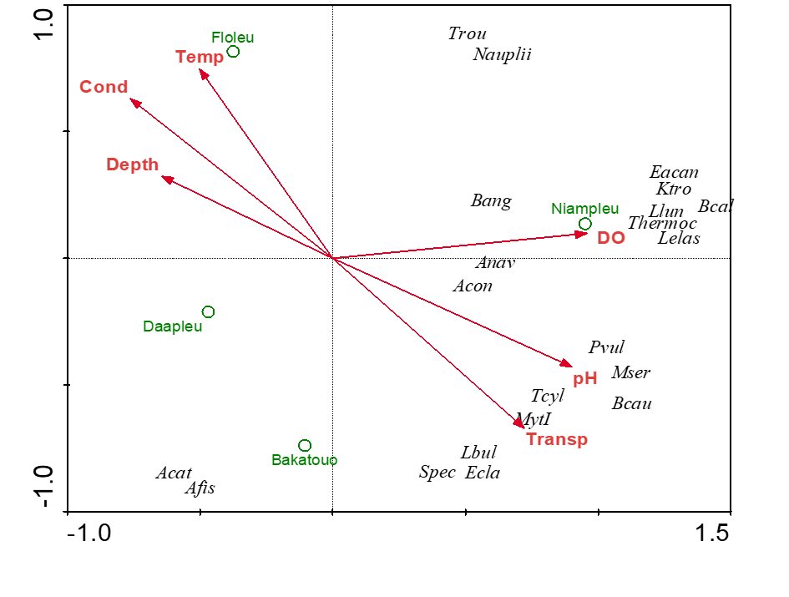
Figure 4: Redundancy Analysis (RDA) indicating the relationship between environmental characteristics and the spatial distribution of zooplankton taxa in the Bagoé River

4. DISCUSSION
This study allowed the collection of 30 zooplankton taxa from the Bagoé River. The species richness recorded in this river is relatively low compared to that observed in other tropical rivers not affected by gold mining, such as the Bia and Agnéby rivers in Côte d’Ivoire (68 taxa) (Ouattara et al., 2000), the Orogodo River in Nigeria (79 taxa) (Yté et al., 2009), the Okhuo River in Nigeria (51 taxa) (Koffi et al., 2019), and the Ikpa River in Nigeria (53 taxa) (Ekpo et al., 2013). Conversely, the number of taxa identified in the present study is similar to that reported by Berté (2019) in the Kankelaba River (31 taxa), a tributary of the Bagoé River in Côte d’Ivoire. This relatively moderate taxonomic richness observed in the Bagoé River likely reflects ecological selectivity influenced by altered physicochemical conditions in this region of northern Côte d’Ivoire.
The qualitative dominance of Rotifers (56.67%), with the Brachionidae family being the most represented, can be explained by their high adaptability, short life cycles, and ability to colonize unstable or disturbed habitats (Onana et al., 2014). These organisms are often the first to develop in environments subject to environmental fluctuations, as observed in areas affected by gold mining where conditions become more stressful. Similar dominance of Rotifers, particularly the Brachionidae, has been reported in other rivers exposed to strong anthropogenic pressures, such as the Ehania and Boulo 1 rivers in southeastern Côte d’Ivoire (Monney et al., 2016) and the Sô River in southern Benin (Koudenoukpo et al., 2017). The lowest taxonomic richness and mean abundance were recorded at station S3, which is affected by illegal gold mining. This clearly indicates the negative impact of clandestine mining activities on zooplankton diversity and abundance.
The RDA results showed that all measured environmental parameters strongly influenced the distribution of zooplankton within the Bagoé River. The RDA clearly separated station S3, affected by gold mining, from stations S1 and S2, which were not impacted. The latter displayed a higher number of taxa, reflecting better environmental quality. In these stations, higher water transparency and dissolved oxygen levels create more stable and favorable conditions for photosynthesis and phytoplankton development—the primary food source of zooplankton. Consequently, these conditions promote sustainable establishment and efficient reproduction of different zooplankton taxa. Conversely, station S3, located in the mining area, exhibited lower taxonomic richness. Activities such as dredging, sediment disturbance, and mercury use lead to decreased transparency and increased conductivity. These disturbances alter aquatic habitats and cause ecological stress that reduces survival, reproduction, and diversity among zooplankton organisms. As a result, only tolerant taxa, such as Brachionus angularis, persist in this degraded station. Similar findings were reported by Doffou (2020) for fish assemblages in the Cavally River, where lower diversity was recorded in mining zones.
The RDA results are consistent with the clear difference in zooplankton taxonomic composition between stations impacted and non-impacted by illegal gold mining. In fact, the non-impacted stations, where artisanal fishing is practiced, were dominated by Copepods, whereas the mining-impacted station was dominated by Rotifers. The dominance of Copepods in unpolluted stations reflects a better ecological status of the environment. Copepods are generally more sensitive to water quality and develop preferentially in well-oxygenated, low-turbidity, and stable waters (Dussart & Defaye, 2001). Their abundance indicates a balanced ecosystem with a natural planktonic productivity that supports aquatic food webs and sustainable artisanal fisheries. On the other hand, the predominance of Rotifers in the station impacted by illegal gold mining suggests a significant ecological disturbance. Rotifers are tolerant and opportunistic organisms capable of adapting to unstable conditions and high organic loads (Pourriot & Rougier, 1997). Gold mining activities, by resuspending sediments, increase turbidity and reduce water transparency. These activities are also associated with metallic pollution (mercury, arsenic) and lower dissolved oxygen levels—conditions unfavorable to Copepods but suitable for Rotifers. Thus, Rotifers become dominant, indicating ecological degradation. The observed differences between the two station types can therefore be interpreted as a biological response of zooplankton communities to anthropogenic pressures caused by illegal gold mining. Zooplankton, particularly the relative proportions of Copepods and Rotifers, appear to be reliable biological indicators of aquatic ecosystem quality.
In summary, the dominance of Copepods in unimpacted stations and the predominance of Rotifers in mining-impacted stations confirm the existence of a degradation gradient linked to human activities. These findings suggest that illegal gold mining, through its physical and chemical effects on the environment, constitutes a major driver of ecological imbalance in the studied aquatic ecosystems.

5. CONCLUSION
The taxonomic composition of the zooplankton community in the Bagoé River revealed a total of 30 taxa distributed across four groups and 13 families. Rotifers (56.67%) were the most diverse, while Copepods (68%) were the most abundant. Overall, station S3, which is affected by illegal gold mining, exhibited the lowest taxonomic richness and mean abundance.
Redundancy Analysis (RDA) indicated that current velocity, transparency, conductivity, depth, pH, dissolved oxygen, and temperature significantly influenced zooplankton diversity and abundance. Station S3 represented a highly impacted environment where anthropogenic activities, particularly illegal gold mining, have severely compromised the ecological quality of the water.
This situation highlights the urgent need for sustainable management and strict regulation of gold mining activities within the Bagoé River basin to prevent further degradation of aquatic resources and to preserve local biodiversity. The results of this study emphasize the value of zooplankton especially the relative proportions of Copepods and Rotifers as effective bioindicators for monitoring the ecological health of freshwater ecosystems in tropical regions.

Disclaimer (Artificial intelligence)
Author(s) hereby declare that NO generative AI technologies such as Large Language Models (ChatGPT, COPILOT, etc.) and text-to-image generators have been used during the writing or editing of this manuscript.

REFERENCES
Adja, M. G., Jourda, J. P., Youan, Ta M., Kouamé, K. J., Kouamé, K. F., Saley, M. B., Djé, K. B., & Biemi J. (2009). Diagnostic à la mise en œuvre d’un projet de gestion intégrée des ressources en eau (GIRE) dans un bassin versant en afrique de l’ouest: cas du bassin versant du N’zi Bandama (Cote d’Ivoire). Sécheresse, 20(1), 33-43.
Adon, M. P., Ouattara, A., & Gourène, G. (2012). Seasonal variation in the diversity and abundance of phytoplankton in a small African tropical reservoir. African Journal of Microbiology Research, 5(18), 2616–2626.
Berté, S., Etilé, R. N., Kamelan, M. T., & Kouamelan, P. E. (2019). First data on zooplankton community structure and abundance of Kankelaba River in Côte d'Ivoire (Bagoué watershed). Journal of Limnology, 78(1), 31.
Doffou, R. J.O. (2020). Influence de l’orpaillage sur la diversité du peuplement ichtyologique et l’écologie alimentaire d’une espèce endémique (Micralestes eburneensis Daget, 1964) dans le fleuve Cavally (Ouest de la Côte d’Ivoire). Thèse de Doctorat, Université Jean Lorougnon Guédé (Daloa, Côte d’Ivoire), 150 p.
Dussart, B. H., & Defaye, D. (2001). Copépodes : Introduction aux copépodes. (2e édition) (révisée et augmentée). Guides pour l’identification des microinvertébrés des eaux continentales du monde. H. J. F. Dumont (éd.). SPB Academic Publishers, La Haye. 16, 1-344.
Ekpo, I. E., & Udoh, J. P. (2013). Species richness and diversity of ichthyofaunal communities of the Lower Cross River Floodplain, Nigeria. International Journal of Fisheries and Aquatic Sciences, 2(4), 180-188.
Etilé, N. R, Kamelan, T. M., Bedia, A. T., Aka, N. M., Gooré, Bi. G., Kouamelan, E. P., & N’douba, V. (2020). Variations spatio-temporelles de l’abondance des nauplii de copépodes dans les lagunes côtières tropicales en relation avec les variables environnementales : cas des lagunes de la Côte d’Ivoire. Tropicultura, 38(3-4), 211–217
Groga, N. (2012). Structure, fonctionnement et dynamique du phytoplancton dans le lac de Taabo, Côte d’Ivoire Thèse de Doctorat. Université de Toulouse (France), 224 p.
Haney, J. F., & Hall, D. J. (1973). Sugar-coated Daphnia: A preservation technique for Cladocera. Limnology and Oceanography, 18, 331-333.
Koffi, A. N., Kouassi, A. M., & Kouamé, I. (2019). Évaluation de la qualité des eaux des marigots de Daloa. Journal Ivoirien des Sciences, 6(2), 45-57.
Konan, K. F., Bony, K. Y., Adon, M. P., & Potgieter, J. (2015). Hydrobiological study of the Bandama Basin in Yaouré Gold Project’s Area of Influence (Côte d’Ivoire). Rapport d’étude. Amara Mining Côte d’Ivoire SARL / AMEC Foster Wheeler / 2D Consulting Afrique, 99 p.
Kouamé, N. A., Kouamé, K. M., Kamelan, T. M., & N’douba, V. (2020). Physical and Chemical Characterization of the Bagoue Watershed (North-Western Côte d’Ivoire) Impacted by Artisanal and Clandestine Gold Mining. Journal of Environmental Pollution and Human Health (8), 20–28.
Koudenoukpo, Z. C., Chikou, A., Adandedjan, D., Hazoumé, R., Youssao, I., Mensah, G. A., Laleye, A. P. (2017). Caractérisation physico-chimique d’un système lotique en région tropicale : la rivière Sô au Sud-Bénin, Afrique de l’Ouest. Journal of Applied Biosciences, 113(1), 11111-11122.
Monney, A. I., Etilé, N. R., Ouattara, N. I., & Koné T. (2015). Seasonal distribution of zooplankton in the Aby-Tendo-Ehy lagoons system (Côte d’Ivoire; West Africa). International Journal of Biological and Chemical Sciences, 9 (5), 2362-2376.
Monney, I. A., Ouattara, I. N., Etilé, R. N. D., Aka, M. N. G., & Koffi, K. E. (2016). Distribution du zooplancton en relation avec les caractéristiques environnementales de quatre rivières côtières du Sud-est de la Côte d’Ivoire. Journal of Applied Biosciences, 98, 9345-9352.
N’da, S. A., Etilé, R. N., N’zi, K. G., Berté, S., & N’douba, V. (2015). Composition and Distribution of Zooplankton Relationship to Environmental Factor in a Tropical River : (Bagoue, Côte d’Ivoire). International Research Journal of Biological Sciences, 4(11), 1-11.
Onana, F. M., Zebaze, T. S. H., Nyamsi, T. N. L., Domche, T. H. B., & Ngassam, P. (2014). Distribution spatio-temporelle du zooplancton en relation avec les facteurs abiotiques dans un hydrosystème urbain : le ruisseau Kondi (Douala, Cameroun). Journal of Applied Biosciences (82) : 7326–7338.
Ouattara, A. (2000). Premières données systématiques et écologiques du phytoplancton du lac d’Ayamé Côte d’Ivoire Thèse de doctorat. Katholieke Universiteit Leuven, (Belgique). 207 p.
Ouattara, A., Kabre T., & André T. (2000). Diversité et structure des communautés de zooplancton dans la rivière Bagoé, bassin du Nord de la Côte d’Ivoire. Thèse de Doctorat en Sciences de la Vie et de la Terre, Université Félix Houphouët-Boigny, Abidjan (Côte d’Ivoire), 180 p.
Ouattara, A., Kouamé, K., Aka, M., Diomandé, D., & Gourène G. (2000). Premières données systématiques et écologiques du phytoplancton du lac d'Ayamé (Côte d'Ivoire). Mémoire de Master en Biologie Végétale, Instituut voor Plantkunde, Université de Gand (Belgique), 60 p. Ouattara O. & Kambiré B. (2023). Stratégies de lutte contre l’orpaillage illégal en Côte d’Ivoire: cas du département de Boundiali. Université Félix Houphouët-Boigny. GEOTROP (2), 45-60.
Sanogo, Y., Samaké, F., Koné, A., & Traoré, D. (2015). Diversité du peuplement ichtyologique de la rivière Bagoé (Bassin du Niger, Mali). Agronomie Africaine, 27(1) : 47–56. SARS G.O. (1887). On Cyclestheriahislopi (Baird) anew generic type of bivalve Phyllopoda. Christ. Vidensk. Selsk. Forh., 1, 1-65.
Sharma, S. (2010). Micro-faunal diversity of Cladocerans (Crustacea : Branchiopoda: Cladocera) in rice field ecosystems of Meghalaya. Records of Zoological Survey of India, 110 (Part-I) ; 35-45.
Yté, W., Getheme, A. M., & Sanogo, T. A. (2009). Zooplancton des eaux de bas-fonds à Gagnoa, centre-ouest côte d’ivoire). Agronomie Africaine, 21(3), 253–260.

