Study of Larval stages of Brachythemis contaminata

--------------------------------------------------------------------------------------------------------------------------
ABSTRACT: The order Odonata is one of the most widely studied groups among insects from the oriental region. They colonize in both stagnant and running water bodies of wide water quality. Identification key with figures on larval stages, using their coloration as distinguishing characters are largely missing. The current work attempts to provide an identification key to aquatic larvae of Brachythemis contaminata with colour illustrations. The specimens were collected from different parts on Indore (Madhya Pradesh). Larval stages of B. contaminate takes only 10 instar stages.
Key words: Odonata, Brachythemis, Instar, Larval stages.
INTRODUCTION:
Dragonflies are one of the most ancient insects from Permian era. They can easily be recognized by their long abdomen, short antennae, long wings and large globular eye. They have conspicuous nodes on their wings and a pterostigma (Kalkman et al., 2008). Odonates comprise about 6000 known species all over the world with 499 species and subspecies recognized from India (Tsuda, 2000). Subramanian (2009) reported 463 species but recently it was confirmed about 499 species with 3 suborders, 17 families and 139 genera from India (Kulkarni and Prasad, 2002; Acharjee, 2013; Subramanian, 2009).
Dragonflies are very good predators as a larva and as an imago and play a key role in the food web as prey also (Sathe and Shinde, 2008; Rathod et al., 2012). They usually show their explicit habitat preference and territorial behavior. Odonates are important as their status gives us a valuable awareness and perception about the health of ecosystem, especially in terms of wetlands. Adult dragonflies are large insects which are diurnal having unique mouthparts and strong toothed mandibles which make them strong predators. They show themselves as major dominant predators of any ecosystem (Manwar et al., 2012). They also play very significant role as natural biocontrol agents of mosquito larvae and provide a big help in controlling epidemic diseases like malaria and dengue (Rowe, 2003; Sahle and Ekestubbe, 2001).
The objective of the present study is to fill the gap in the knowledge of the odonata larvae and to provide a pictorial catalogue to help in their identification
Identification of Odonata Larva: Their life-cycle has three stages in it-egg, larva and adult stage. Odonates spend most of its life time being aquatic in nature in eggs and larval forms. Both the forms inhabit in ponds, rivers, tanks and streams (Corbet, 1962; 1999). They oviposit in variety of habitats like damp soils or waterfalls. Eggs are broad and elliptical in shape, usually laid on the aquatic flora. They lay numerous eggs per batch, hundreds to thousands in range. It takes 5 to 40 days to developing eggs to hatch in tropic regions while in temperate zones they take 80 to 230 days in hatching. After hatching, the larval form of Odonates is now ready to predate on aquatic insects, mosquito eggs or other smaller larval forms of insects (Subramanian, 2009). The larval form of Odonates is generally an ambush predator which waits for their prey to come near them so that they strike easily. Larval stages last from few weeks to 4 or 5 years. All the Odonata larvae have variable number of instars that vary from 9 to 15. Just like any other species, their larvae stop feeding before undergoing molting period. When larvae become completely mature and in its last stage, for going onto adult form, it crawls out of water on the stem of an aquatic plant. This larva stays here to emerge into adult imago; its skin dries and wings expansion takes place. Now it flies away, in adult form of Odonata, in search of food. In the tropic regions or some warmer places, some species of Odonates have shorter life span as they complete one or more generations in one year.

MATERIALS AND METHODS:
In this study of Odonates, different areas were selected to collect the dragonflies and damselflies larvae. Some rural areas, some urban areas and some garden areas of Indore city were selected to study Odonata fauna. The study was carried out from January 2024 to June 2025 in these areas.
Indore is situated in the heart of state Madhya Pradesh. The geographical location of Indore is 22.2º - 23.05º North Latitude and 75.25º -76.16º East Longitude. The location of Indore is just south of the Satpura range, at an altitude of 560 meters above sea level. Indore region has humid subtropical and tropical savanna climatic conditions. Three distinct seasons are observed: summers, monsoons and winters. Summers start in March and can be extremely hot in April and May. The daytime temperatures in summers touch 48° C (118° F) many times. Average summer temperatures may go as high as 40° C (104° F) with low humidity. Winters are moderate and usually dry. Lower temperatures can go as low as 2° C (36° F) to 6° C (43 °F) in nights. Usually, the temperature ranges between 8°C to 26 °C during winters. The typical monsoon season starts from mid- June to mid-September and contributes 32–35 inches of annual rains. 95% of rains occur during monsoon season. A moderate rainfall of 38 to 42 inches (970 to 1,070 mm) during July–September due to the southwest monsoon has been recorded.

Results & Discussion
The observed larvae of B. contaminate and collection of eggs was brought to the laboratory. The eggs were observed to lie on aquatic floating vegetations in the water bodies. The eggs after bringing to the laboratory remained intact on the vegetation and placed in a glass trough filled with water. The dates of eggs hatching is noted down duly and the larvae from instar II stage were transferred separately in petri dishes. The temperature (25º- 40ºC) and normal laboratory conditions were maintained during the whole period. When the larvae reach at instar VII stage, they were transferred to the glass jars. In the initial stages they were fed Paramecium and Cyclops (ad libitum) and on later stages they were given mosquito larvae (reared in the laboratory or collected from the ponds).

All the instar stages were studied which were reared in the laboratory and identified by Kumar (1973). Some similar larval stages were also collected from the fields and observed. The stage of instars collected from the field is determined by the size of instar and the development of wing buds. The growing instars were observed carefully and the changes in its features were recorded using the terminology given by Corbet (1953), Mac Neil (1967) and Snodgrass (1954) for labium, tarsi and anal appendages respectively.

Table 1: Developmental stages and molting duration (in days) of B. contaminata reared in laboratory conditions:
Incubation period |  | Larval instars of B. contaminata
 |  | 1st | 2nd | 3rd | 4th | 5th | 6th | 7th | 8th | 9th | 10th | Total period
Duration (days) | 8-10 | 15-30 | 8-11 | 7-10 | 8-11 | 4-6 | 4-5 | 5-8 | 6-7 | 10-12 | 19-22 | 86-97

Table 2: Characters of B. contaminata different larval stages where ‘- ‘= not present. ‘r’= rudimentary and ‘i’= increasing:
Characters | Larval Instars
Characters | 1st | 2nd | 3rd | 4th | 5th | 6th | 7th | 8th | 9th | 10th
Antennal segments | 3 | 3 | 4 | 5 | 6 | 7 | 7 | 7 | 7 | 7
Premental setae | 0+0 | 3+3 | 4+4 | 5+5 | 6+6 | 7+7 | 8+8 | 10+10 | 11+11 | 12+12
Palpal setae | 0 | 2&2 | 2&2 | 3&3 | 4&4 | 4&4 | 5&5 | 6&6 | 7&7 | 7&7
Tarsal segments | 1 | 1 | 2 | 2 | 2 | 3 | 3 | 3 | 3 | 3
Wing sheaths | - | - | - | - | - | r | i | i | i | i
Anal cerci | - | - | - | - | - | r | i | i | i | i
Body length | 0.7 | 1.1 | 1.8 | 2.5 | 3.5 | 4.6 | 6 | 8 | 11 | 13

Larval development of Brachythemis contaminata:
Eggs: eggs of B. contaminate are milky white in color and after 24 hours they turn pale yellow. After coming in contact to water, the covering eggs become gelatinous to get them bound together. The eggs take 8 to 10 days of incubation time. Around 300 eggs a female dragonfly lays in single batch of oviposition.
Larval stages:
First instar: the first larval form stays for 15 to minutes of duration as it comes from its pro larval form through a longitudinal slit. It has elongated body shape and having broad head. It has three jointed antennae at the anterior part. Its short anal appendages have epiproct and periproct.
Second instar: this instar stage lasts for 8 to 10 days. Its size is one mm. and having light brown colored body. Eyes are small in size looks like beads and black in color. Antennae are three jointed at anterior part consisting of scape, pedicel and flagellum. Labium is spoon shaped with prenatal setae 3+3, another distal marginal end of prementum is straight. Palpal setae 2&2, the distal marginal ends of palpus are wavy. Tarsi presents in it with having one joint. Anal appendages have epiproct and periproct only.

Third instar: this larval stage lasts for 7 to 9 days. It is 1.7 mm in body length. The antennae have four joints as the flagellum is consisting of two joints. Labium having premental setae 4+4, palpal setae 2&2. The distal marginal ends are crenated. Tarsi have two joints and tibial comb is consisted of one trident setae.
Fourth instar: duration of this larval stage being 8 to 10 days. The body length is now 2.5 mm. at the anterior part the antennae having five joints now with two hairy joints.
Fifth instar: Eyes extend to posterior sides. Labium has prenatal setae 4+4 and palpal setae 3&3. Latest setae added to it posteriorly. Tibial comb has two trident setae and tarsi have two joints in it.
Sixth instar: its duration is 4 to 5 days. Elongated with length of 4.5 mm. Now it converts its color to slightly pale green in lateral sides. Its antennae increase joints to 7 which are apically pointed. Labium also increases setae to 7+7 arrangements and palpal 4+4 setae. Tarsi have three joints. A rudimentary wing sheaths with small outgrowths and cerci present rudimentarily at both sides of epiproct.
Seventh instar: it stays in this stage from 6-8 days. Elongated and length measures 6 mm. it has slightly greenish color after molting. Eyes are in peculiar features. Antennae have seven joints and slight increase in length. Labium has premental setae in 8+8 arrangements with distal claviform setae and palpal setae in 5&5 arrangements. In this stage the sheaths enlarge and extend up to second segment of abdomen. Tibial comb has five tridentate setae. Cerci increases in length and shown clearly at the sides.
Eighth instar: its duration is 6 to 7 days. Body length is 8.1 mm. in this stage, antennae have 7 joints. Labium has prenatal setae in 10+10 arrangement with 19 claviform setae at distal margin and palpal setae in 6+6 arrangement. Wing sheath grows longer up to end of the second abdominal segment. Tibial comb has four tridentate setae.
Ninth instar: its duration is 10 to 12 days. It is 11 mm in length with body of slightly green color which gradually convert into light brown color. Labium has premental setae in 11+11 arrangement and palpal setae in 7+7 arrangement. Wing sheaths extend a bit more in this stage as they are now up to fourth segment in length. Tibial comb has tridentate setae which appears haphazardly.
Tenth instar: it has duration of 20 to 23 days. Its brown colored body is 13 to 13.5 mm in length. Head region is almost rectangular in shape and broader than long. Antennae have seven joints. Labium is spoon shaped with premental setae in 12+12 arrangements and palpal setae in 7+7 arrangement. Strong mandible and stout is present. Wing sheaths extend upto fifth segment of abdomen. Hairy and transparent wing sheath is present with developing venation. Tibial comb has haphazardly arranged tridentate setae.
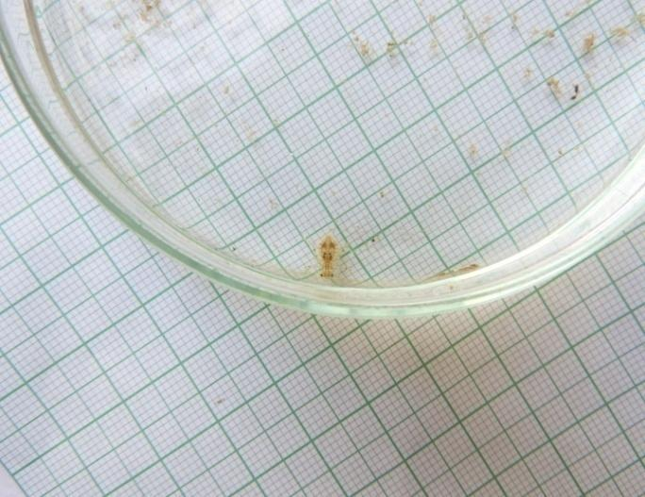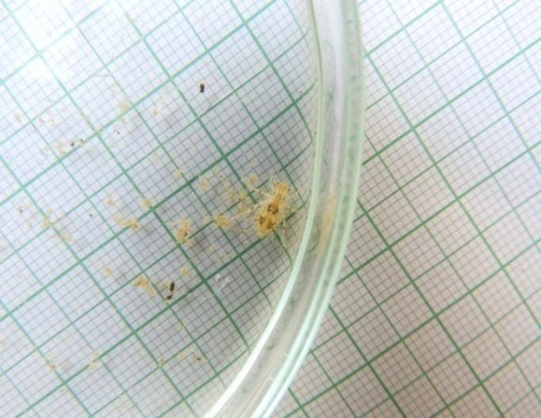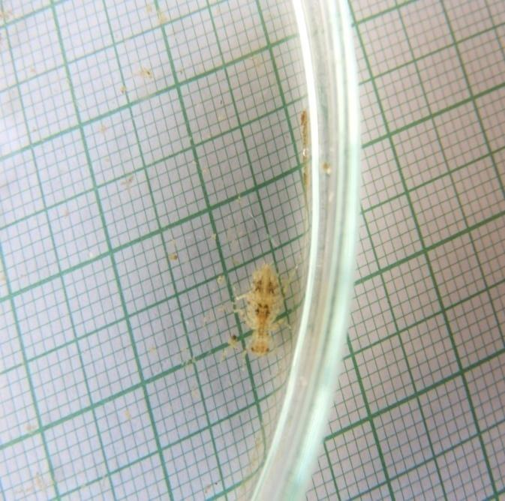
Picture 1: Instar 1 of B. Contaminata Picture 2: Instar 2 of Contaminata Picture 3: Instar 3 of B. Contaminata

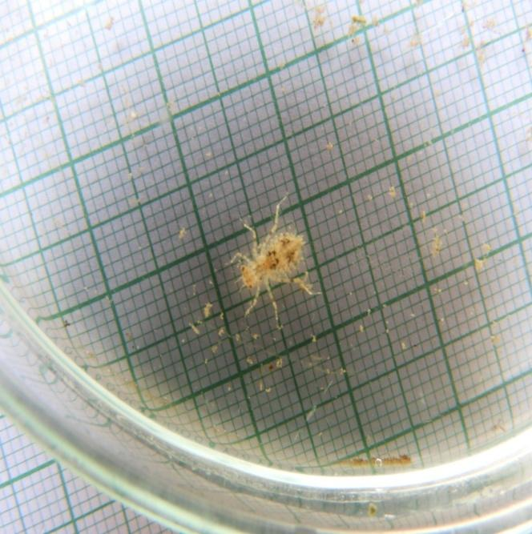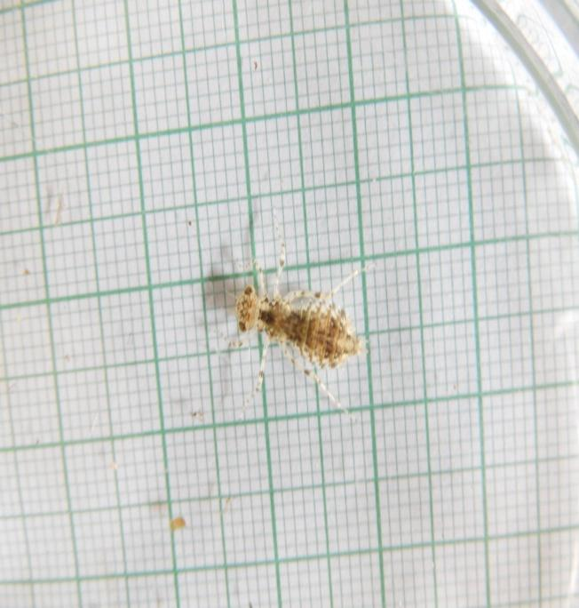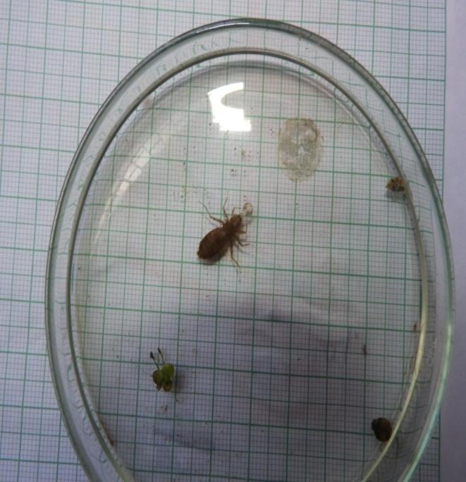
Picture 4: Instar 4 of B. Contaminata Picture 5: Instar 6 of B. Contaminata Picture 6: Instar 8 of B. Contaminata
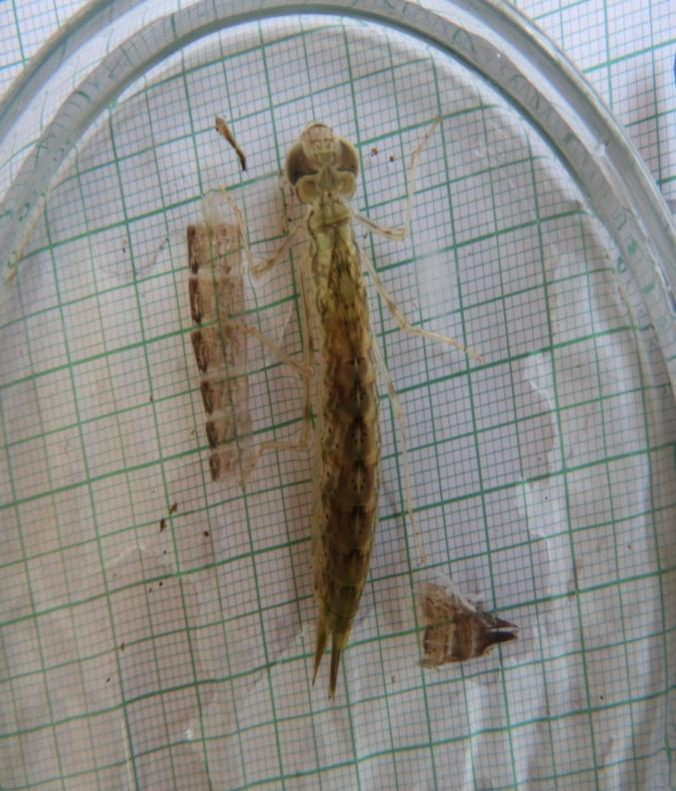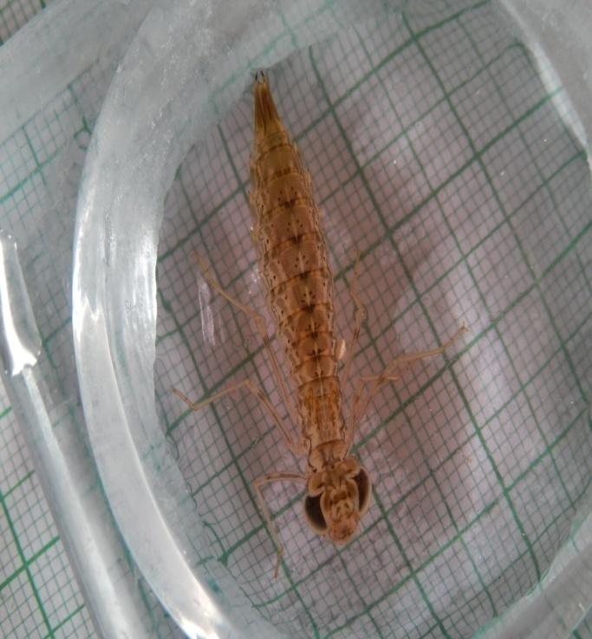
Picture 7: Instar 9 Contaminata with some part of its Exuviae Picture 8: Final instar Contaminata

CONCLUSION:
B. contaminate takes only 10 instar stages. Sometimes females of this species, in winters, can be found at the walls of buildings of remote areas. They were observed to migrate from their source place to another place to breed and food availability (Kumar, 1971). By end of the winters, in mid of February, these individuals were again available in nearby their source places. Oviposition takes place in March to April month. B. contaminate completes its larval development in 5 months and their adult forms can be seen around again in July to August months. After emergence, these individuals breed and oviposit in rest of 7 months. The adults of B. contaminate are very common and can easily be seen around their breeding grounds. The life cycle was studied thoroughly, in which most of the larval forms could not survive in laboratory conditions. A previous study by Kumar (1973) has also been done on B. contaminate and the details were found quite similar to his notes.
The general life history of various other Odonates was also described by Begum et al. (1982), Leggott and Pritchard (1985a) and Naraoka (1987). They suggested the extensive methods for captive rearing of dragonflies and damselflies from egg to adults. Corbet (1960) suggested that seasonal monsoon plays significant role in the development and life history patterns in various species. If pond starts getting dry in scarcity of rainfall than larval development cannot take place. In Indore city while studying Odonates, it is observed that dragonflies and damselflies migrate from their initially suitable habitat which degenerates with time towards an alternative or favorable habitat for present conditions. Their migrating behavior is mainly dependent on the reduction in responses to stimuli which usually promotes localization for some food resources and favorable sites for reproduction (Dingle, 1996; 2006). Storm water ponds and natural ponds have different water quality as they were found similar in temperatures while higher pH, D.O. and conductivity found in storm water pond water. Higher oxygen and higher pH there would result in higher rate of photosynthesis. The algal and plant biomass traps higher nutrients from photosynthesis.

Disclaimer (Artificial intelligence)
Author(s) hereby declares that NO generative AI technologies such as Large Language Models (ChatGPT, COPILOT, etc.) and text-to-image generators have been used during the writing or editing of this manuscript.

REFERENCES:
- Acharjee, B.K. (2013). Survey of Dragonfly diversity in Nagaon paper mill area, Jagiroad, Assam, NeBIo. 4(5), 39-42.
- Ameilia, Z.S., Che Salmah, M.R. and Abu Hassan, A. (2006). Distribution of Dragonfly (Odonata: Insecta) in the Kerian River Basin, Kedah-Perek, Malaysia. USU Repository, 14.
- Andrew, R.J., Subramaniam, K. A. and Tiple, A. D. (2008). Common Odonates of Central India. Ebook for “The 18th International Symposium of Odonatology", Hislop College, Nagpur, India, 1-50.
- Arthiyan, Sivasingham, Thampoe Eswaramohan, Andrew Hemphill, and Sinnathamby Noble Surendran. (2024). "Predatory Potential of Nymphal Odonates on Aedes aegypti Developing in Freshwater and Brackish Water Habitats" Insects 15, no. 7: 547.
- Bakare, A.B., Adu, B.W. & Ehikhamele, E.I (2024). Effects of anthropogenic disturbances on adult Odonata fauna in Akure, south west Nigeria. JoBAZ 85, 56.
- Bhasin, G.D. (1953). Odonata, in Roonwal et.al. A systematic catalogue of the main identified collections of the Forest Research Institute, Dehradun, Parts 9-21, Indian Forest Leaflet, 121(3): 43-69.
- Danswrang Basumatary (2024). A study on the diversity of odonates in Dheer Beel, Chakrashila wildlife sanctuary, Kokrajhar, BTR, Assam, India, International Journal of Entomology Research, Vol 9, 143-147.
- Gain, B. I., & Kulkarni, R. R. (2024). Study on diversity of Odonata (Dragonflies and Damselflies) fauna of Lohara Lake, District-Chandrapur (M.S), India. Environment Conservation Journal, 25(2), 384–387.
- Mairif, M., Bendifallah, L.., & Doumandji, S. (2023). Diversity of Odonates (Odonata, Anisoptera & Zygoptera) in the Theniet El ‎Had National Park-North West of Algeria. Journal of Insect Biodiversity and Systematics, 9(1), 155–182.
- Mishra, D., Sharma, V. K. & Pal, A. (2019). Diversity of Odonates at Sirpur Pond, Indore, International Journal of Zoology and Applied Biosciences, 4 (1), 462-465.
- Nesemann, H., R.D.T. Shah & D.N. Shah (2011). Key to the larval stages of common Odonata of Hindu Kush Himalaya, with short notes on habitats and ecology. Journal of Threatened Taxa 3(9): 2045–2060.

