Endogenous Knowledge of Edible Insects in North Sudanian Localities of Burkina Faso

.
ABSTRACT

Background: The global interest in edible insects is increasing all the more so as there is a diversity of edible insects in the world. They are nutritionally useful because of their content of animal proteins, lipids, minerals and vitamins. In Burkina Faso, more than 10 species of edible insects have been identified. To gain a better understanding of the local knowledge of edible insects in certain localities of the country where there is little information, this study aimed to assess the endogenous knowledge of edible insects encountered in these localities.
Methods: The survey was carried out among 183 informants in three villages located in the North Sudanian zone of Burkina Faso. The questionnaire focused the number of known edible insects, modes of preparation, information on commercialization and the availability of bans, as well as edible and medicinal properties. Chi-square analysis was used to determine whether there were statistically significant differences among villages, ethnic group, and religious in knowledge and preference for edible insects
Results: Five species namely Carbula marginella (Hemiptera), Macrotermes subhyalinus (Blattodea), Kraussaria angulifera (Orthoptera), Gryllus campestris (Orthoptera) and Sternocera interrupta (Coleoptera) were identified as edible insects. Interestingly, C. marginella was the most frequently cited edible species (91.26%). Sternocera interrupta (Coleoptera) with 21.85% was mentioned for the first time in these localities increasing the number of edible insects. Women were the main actors in the commercialization of the insect and C. marginella was sold between 5,000 and 15,000 FCFA per kilogram.
Conclusion: Edible insects represent a potential source of income. The use of insects is part of the cultural habits of the local populations.

Keywords: Carbula marginella, edible insects, local knowledge, commercialization, cultural uses.

1. INTRODUCTION

There are almost a billion chronically undernourished people in the world (Bonneau, 2020). To meet today's food and nutrition challenges, we need to re-evaluate what we produce and consume, and find new ways of producing food. We urgently need to find alternatives to conventional sources of animal protein in our diet. Human consumption of insects therefore contributes positively to the preservation of the environment and livelihoods (Van Huis, 2013). Edible insects in food-insecure countries can contribute to improving diets and preventing undernutrition (Van Huis et al., 2021). Insects are well represented in terrestrial ecosystems, especially tropical ones. They account for around 73% of the total fauna described, with more than one million species identified (Leandro, 2018). They present an immense diversity of forms and behaviors. Essential to the survival of ecosystems and biodiversity, their interactions with human beings are crucial in many areas. Insects are capable of causing serious problems such as crop losses, disease transmission to plants (Pradhan, 1983), to humans and animals (by mosquitoes for example) (Darriet, 1998), and damage to houses (destruction of wood by termites) (Fouquet, 2000). However, these pests only represent less than 1% of the insect species (Lathuillière, 2022). Most insects are extremely useful to humans, providing numerous ecological services such as pollinating plants, biologically degrading waste, and controlling parasites (Van Huis et al., 2014). Insects and their products are used to treat certain diseases (Feng et al., 2009; Ouango et al., 2022). They can be a direct food resource for humans and animals and form an integral part of the nutritional balance of certain peoples (Van Huis et al., 2014). More than 2,000 edible insect species have been identified (Van Itterbeeck & Pelozuelo, 2022). In Africa, around 524 edible insect species have been identified (Ramos-Elorduy et al., 1997), 549 in Mexico, 170 in China, 160 in the Lao People's Democratic Republic, 164 in Thailand and Viet Nam and 428 in Amazonia (Galęcki & Sokól, 2019). The insects consumed worldwide are mainly Coleoptera (around 31%), consisting of ladybirds, beetles and chafer beetles, followed by Lepidoptera (18%) (caterpillars), Hymenoptera (14%) (bees, wasps and ants), Orthoptera (13%) (grasshoppers, locusts and crickets,) and Hemiptera 10%) (cicadas, leafhoppers, mealybugs and bugs,) (FAO, 2014). In West Africa, 91 species of edible insects belonging to five orders (Isoptera, Orthoptera, Coleoptera, Hemiptera, and Lepidoptera) have been identified (Kelemu et al., 2015).
Edible insects supplement the diets of around two billion people worldwide (FAO, 2014). In Africa, many people consume large quantities of insects, particularly in West and Central Africa. More than 15,000,000 people eat insects in West Africa (Tchibozo et al., 2016). Insect consumption is thought to be due to the fact that they are a good source of animal protein, lipids, and minerals and vitamins (Ramos-Elorduy et al., 1997; Raheem et al., 2019; Séré et al., 2021, 2022). They can also be a source of additional income when collected for sale on the market. In Burkina Faso, five (05) insect species are commonly consumed, namely Cirina butyrospermi, Brachytrupes membranaceus, Macrotermes subhyalinus, Carbula marginella and Acanthacris ruficornis (Séré et al., 2018).
Cirina butyrospermi has high levels of iron (31.27 ± 0.002 mg/100g), magnesium (150.09 ± 0.00 mg/100g) and potassium (1277.75 ± 0.01 mg/100g), protein (40.81%), and lipids (19.86%), with an energy value of 480.20 Kcal/100g (Séré et al., 2021). Macrotermes subhyalinus with a high zinc content (13.18 ± 0.09 mg/100g), has an energy value of 637.81 Kcal/100g, and is rich in lipids 50.12% and proteins 45.75% (Séré et al., 2021). Brachytrupes membranaceus has a high calcium content (193.45 ± 0.02 mg/100g), proteins content of 26.44%, lipids 49.56%, with an energy value of 632.82 Kcal/100g (Séré et al., 2021).
As for C. marginella, it's a bug species appreciated by some Burkinabés and is one of the most widely consumed species. It is consumed in roasted form by the Mossi, Bissa and Fulani ethnic groups and is available during the dry season (October-January) (Séré et al., 2018; Sary & Goungounga, 2021). It is rich in protein (41.49%), lipids (51.92%), and mineral salts (362.06 mg/100g potassium, 33.92 mg/100g calcium, 10.10 mg/100g iron and zinc, 74.55 mg/100g Magnesium, 185.84 mg/100g Sodium). Carbula marginella has a relatively balanced fatty acid composition, with 38.04% saturated fatty acids, 30.79% monounsaturated fatty acids and 31.13% polyunsaturated fatty acids (Séré et al., 2021). The iron content obtained with C. marginella, C. butyrospermi and M. subhyalinus covered the recommended iron requirement for adults. The zinc content of M. subhyalinus covers the recommended zinc requirements for adults (Séré et al., 2021).
Despite their nutritional qualities, little is known about these insects in this part of the country, particularly their ecology and economic importance. The objective of this study was to document the species diversity, local knowledge, seasonal availability, collection and processing practices, cultural significance, and commercialization of edible insects in three North Sudanian villages of Burkina Faso.
2. methods

2.1 Study area

The study was conducted from January to May 2023 in three villages across the North Sudanian zone of Burkina Faso. They are Pagou [(N 11°46’36.5’’, W 0°33’06.4’’) (Garango)] in the province of Boulgou, located 167 km from Ouagadougou; Vinnogo [(N 12°24’28.2’’, W 0°41’54.1’’) (Meguet)] in the province of Ganzourgou, 129 Km from Ouagadougou and Boudtenga [(N 12°29’22.4’’, W 1°15’47.9’’) (Saaba)] in the province of Kadiogo, situated 39 Km from the capital (Fig. 1). The climate is tropical with two seasons in both study zones: the dry season from October to April and the rainy season from May to September. Mean annual rainfall ranged from 600 to 900 mm and the average annual temperatures ranged from 20 to 28°C during the rainy season and from 35 - 40°C during the dry season (Ilboudo et al., 2020). The vegetation of the North Sudanian zone is dominated by savanna with annual growing grass, trees, and shrubs (Barthelemy et al., 2017).

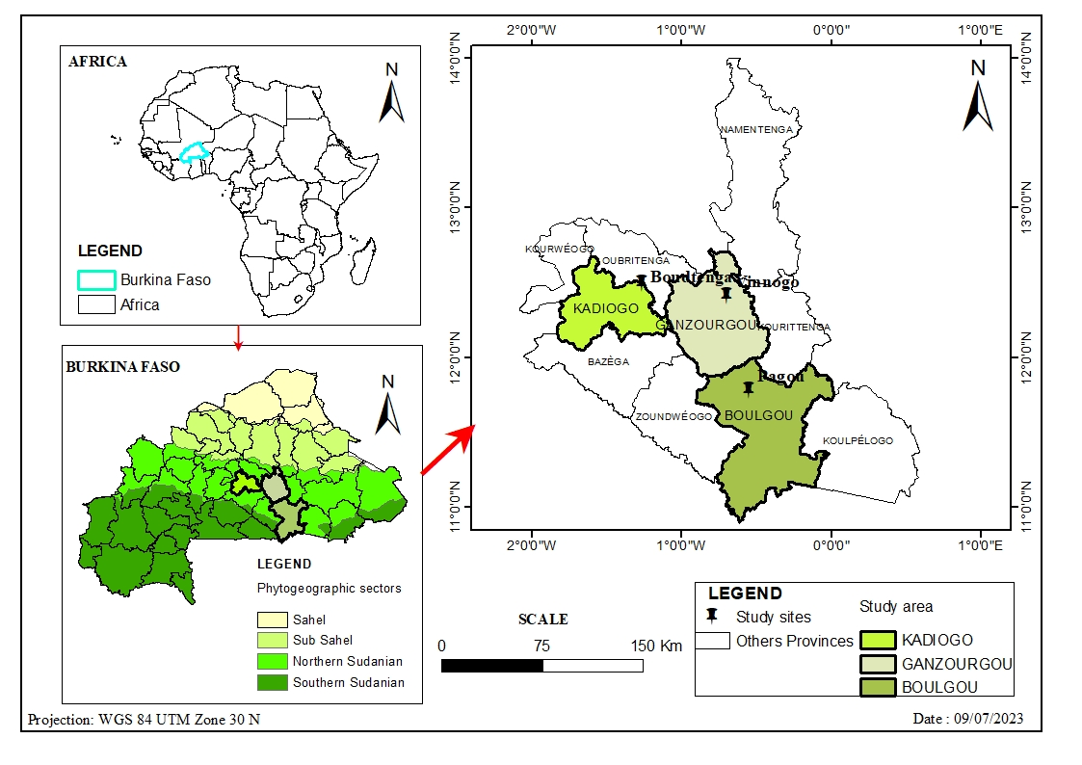
Fig.1: Map of the study area in Burkina Faso

2.2 Data collection
In each village, 61 informants were interviewed through individual semi-structured interviews. Members of the three ethnic groups that make up the villages were interviewed. There were bissa, mossi and peuhl without regarding their religious affiliation and their ages. The informants were between 12 and 83 years old. The respondents were included in the questionnaire regardless of their education and occupation. A total of 110 men and 73 women were interviewed. The questionnaire included the number of known edible insects, seasonal availability, stages of insects consumed, modes of preparation, storage techniques, information on commercialization and the availability of bans, as well as edible and medicinal properties. During interviews or at a given period, insect specimens were collected and kept in bottles containing alcohol for identification. Insects collected were identified in the laboratory under a binocular microscope using previously identified specimens by a taxonomic entomologist. They were also identified based on morphological characteristics described in various entomological classification keys (Scholtz, 2016; Mignon et al., 2016).

2.3 Data analysis
Data processing and analysis were performed with the R 4.3.0 software. Chi-square analysis was used to determine whether there were statistically significant differences among villages, ethnic group, and religious in knowledge and preference for edible insects. Statistical significance was tested at the 5% level.

3. results
3.1 Local knowledge extent on edible insects
3.1.1 Edible insects in the three localities and frequency of mentions

Five edible insect species belonging to four orders were cited as consumed by population (Fig. 2). They were consumed at the same stage of development: C. Marginella (Hemiptera), Macrotermes subhyalinus (Blattodea), Gryllus campestris (Orthoptera), Kraussaria angulifera (Orthoptera), and Sternocera interrupta (Coleoptera) were eaten at the adult stage. Carbula marginella was the most frequently cited species with 91.26%, followed by M. subhyalinus (74.86%) and K. angulifera (55.19%). Sternocera interrupta and G. campestris were rarely cited by the populations surveyed, with frequencies of 21.85% and 6.01%, respectively (Fig. 3).

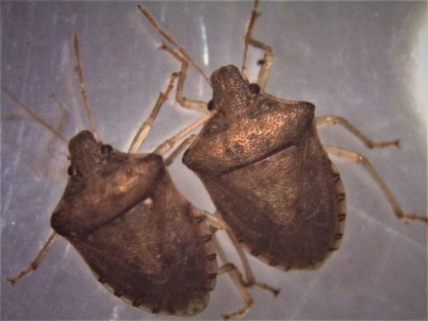  Carbula marginella (Thunberg) | 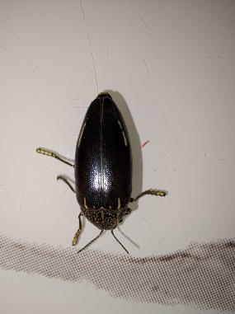  Sternocera interrupta (Olivier, 1790) | 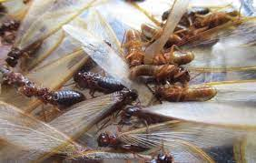  Macrotermes subhyalinus (Rambur)
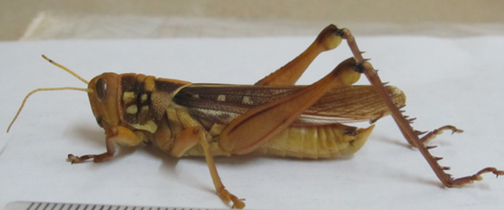  Kraussaria angulifera (Krauss, 1877) | 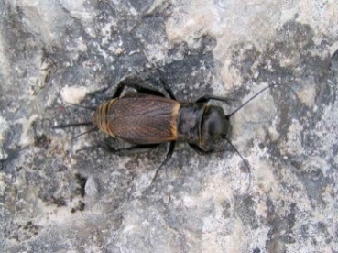  Gryllus campestris (Linnaeus, 1758)
Fig.2: Edible insects across the three localities

Fig. 3: Frequency of mentions of edible insect species across three localities

3.1.2 Distribution of cited edible insects according to localities
Carbula marginella, M. subhyalinus and K. angulifera were mentioned in all three localities, but S. interrupta was mentioned only in Pagou and Vinnogo, whereas G. campestris was only mentioned in Vinnogo (Fig. 4). Thus, in addition to C. marginella, three species were mentioned in the locality of Pagou, four species in the locality of Vinnogo, and two species in the locality of Boudtenga.

Fig.4: Frequency of mentions of edible insect species by locality

3.1.3 Knowledge of edible insects among ethnic groups
There was no significant difference in the consumption of C. marginella and K. angulifera (X² = 2.87, df = 2, P = 0.24) between these three ethnic groups. However, S. interrupta was less cited frequently by the Bissa (10.45%) than by the Mossi (29.25%); Gryllus campestris was cited only by the Mossi group (Fig. 5). Carbula marginella was less cited frequently by the Peuhl group, as well the other species.

Fig. 5: Frequency of mentions of edible insect species by ethnic group

3.1.4 Knowledge of edible insects according to religious group
Insect consumption in the three localities was independent of religion (X²= 2.47; df = 4; P = 0.7). For each species, the frequency of citations was almost the same between the two religious groups (Muslims and Christians) (Fig. 6). Carbula marginella remains the most cited species, followed by M. subhyalinus and K. angulifera. S. interrupta and G.campestris were rarely cited.

Fig. 6: Frequency of citations of edible insect species according religious group

3.2 Seasonal availability of insects, collection methods and consumption stages according to locality
3.2.1 Seasonal availability of C. marginella and other edible insects
Carbula marginella is observed at the end of the rainy season and throughout the dry season from November to May in the localities of Pagou and Vinnogo (Table 1). In Boudtenga, it is available from September to December. Kraussaria angulifera and S. interrupta were reported during the rainy season, from June to October. However, K. angulifera was observed at the start of the dry season, mainly in November. Macrotermes subhyalinus is available at the start of the rainy season between May and August. As soon as the rains begin, the winged reproductives of these species are attracted by light sources. They are abundant in the evenings, especially during morning rains.
Species | Locality | Jan | Feb | Mar | Apr | May | June | July | Aug | Sept | Oct | Nov | Dec
Carbula marginella | Pagou
Carbula marginella | Vinnogo
Carbula marginella | Boudtenga
Kraussaria angulifera | Pagou
Kraussaria angulifera | Vinnogo
Kraussaria angulifera | Boudtenga
Macrotermes subhyalinus | Pagou
Macrotermes subhyalinus | Vinnogo
Macrotermes subhyalinus | Boudtenga
Sternocera interrupta | Pagou
Sternocera interrupta | Vinnogo
Gryllus campestris | Vinnogo

Table 1: Seasonal occurrence of edible insects in different localities
Jan = January; Fev = February; Mar= March; Apr= April; Aug = August; Sept = September; Oct = October; Nov = November; Dec = December. The colored line indicated the period of insect availability.

3.2.2 Edible insect collection methods and the consumption stage
Edible insects were collected and consumed as adults in all three localities (Table 2). However, the methods of collection depended on the edible species. Carbula marginella and M. subhyalinus were particularly sought during their period of availability, while K. angulifera, S. interrupta and G. campestris were captured during travel and agricultural work. The local population collected C. marginella in caves while the other species were captured in fields or around concessions. They can be captured by hand or with sticks. M. Subhyalinus was captured using a container of water and nearby light. C. marginella was collected mainly by young girls and boys. In Vinnogo, women are actively involved, whereas in Pagou, married women do not take part in collecting.

Table 2: Collection, and forms of consumption of edible insects in different localities

Species | Order | Locality | Period of occurrence | Period of collection | Collection site | Collection method | Consumption stage
Carbula marginella | Hemiptera | Pagou | September-november | October – February | Hill (caves) | - Collect in caves during the day  - Build a fire and trap them in the flames | Adult
Carbula marginella | Hemiptera | Vinnogo | September- november | November – may | Hill (caves) | Collect in caves during the day | Adult
Carbula marginella | Hemiptera | Boudtenga | September – october | September – december | Hill (caves) | Collect in caves during the day | Adult
Kraussaria angulifera | Orthoptera | Pagou |  | June – november | Fields, bush | Capture by hand or tap with a stick | Adult
Kraussaria angulifera | Orthoptera | Vinnogo |  | June – november | Fields, roofs | Capture by hand or tap with a stick | Adult
Kraussaria angulifera | Orthoptera | Boudtenga |  | June – october | Fields, bush | Capture by hand or tap with a stick | Adult
Macrotermes subhyalinus | Blattodea | Pagou | May | June – july |  | Using a large container of water to trap near a light source | Winged adult
Macrotermes subhyalinus | Blattodea | Vinnogo | June | June – july |  | Using a large container of water to trap near a light source | Winged adult
Macrotermes subhyalinus | Blattodea | Boudtenga | June | June – july |  | Using a large container of water to trap near a light source | Winged adult
Sternocera interrupta | Coleoptera | Pagou |  | June – october | Bush | Capturing on thorny plants | Adult
Sternocera interrupta | Coleoptera | Vinnogo |  | June – october | Bush | Capturing on thorny plants | Adult
Gryllus campestris | Orthoptera | Vinnogo |  | June – july | Fields | Capturing by digging in the ground | Adult

3.3 Post-harvest processing and commercialisation of edible insects
The insects collected were generally cleaned of debris and other insects. Carbula marginella and desiccated adults of M. subhyalinus were then soaked in hot water to remove droppings and impurities (Table 3). Finally, they were roasted in a pot or pan. Kraussaria angulifera, G. campestris and S. Interrupta were stripped of their wings and then roasted over coals. However, K. angulifera is often fried when large quantities were collected. In the study localities, the main trade focused C. marginella. The other species were collected occasionally for family consumption. The quantities of C. marginella collected per day vary according to the locality. In Pagou, the quantities collected per person per day range from half a dish to six dishes “yorouba”. In Vinnogo, they vary from half to 12 dishes “yorouba”. In Boudtenga, they vary from half to three dishes “yorouba”. The population generates income from the sale of C. marginella. Women are the main actors in the commercialisation of the insect. The insect is sold in roasted form. A kilogram of the insect is sold for between 5,000 and 15,000 FCFA in Pagou, while in Vinnogo it is sold for between 4,000 and 7,500 FCFA. In Boudtenga, C. marginella is not sold. This would appear to be due to a ban on the bug in this locality.
Table 3: Post-harvest processing, quantity collected and sales price

Species | Locality | Post-collection processing and storage | Consumption type | Approximante consumption | Quantity collected per person / day | Price of a dish
Carbula marginella | Pagou | Winnow, sort, clean with water and grill | Grille | ≤ 1 kg | ½ to 6 dishes | 2,500 to 7,500 FCFA
Carbula marginella | Vinnogo | Soak in hot water, then toast. | Grille | ≤ 1 kg | ½ to 12 dishes | 2,000 to 3,000 FCFA
Carbula marginella | Boudtenga | Soak in hot water, then toast. | Grille | ≤ 1 kg | ½ to 3 dishes
Kraussaria angulifera | Pagou, Vinnogo  Boudtenga | Remove Wings and grill | Grille or Frying | - | -
Macrotermes subhyalinus | Pagou, Vinnogo  Boudtenga | Sort, remove Wings, then grill | Grille | - | -
Sternocera interrupta | Pagou  Vinnogo | Remove Wings and grill | Grille | - | -
Gryllus campestris | Vinnogo | Remove Wings and grill | Grille | - | -

3.4 Benefits of eating C. marginella in the three localities
Consumers of C. marginella cited many virtues (Table 4). Citations varied from one locality to another. In Vinnogo and Boudtenga, some respondents believed that that the consumption of C. marginella helped to calm sickle-cell crises, while in Pagou it was said to combat hypertension, joint and stomach aches, coughing and nausea, and sexual weakness. In Pagou, some respondents suspected that C. marginella was involved in cleaning women’s uteruses after childbirth. In Vinnogo, some people believe that the consumption of C. marginella attenuates the effect of alcohol on the nervous system, while others believe that it wards off evil spirits.

Table 4: Frequency of citations of the virtues associated with the consumption of C. marginella according to locality

Therapeutic properties | Pagou  (n) | Vinnogo  (n) | Boudtenga  (n) | Frequency of citations (%)
Calms sickle cell crises | 0 | 2 | 15 | 9.29
Soothes bone pain | 0 | 7 | 0 | 3.83
Hypertension remedy | 10 | 0 | 0 | 5.46
Treats joint pain | 1 | 0 | 0 | 0.55
Reduces nausea and coughing | 4 | 0 | 0 | 2.19
Treats stomach ache | 13 | 0 | 0 | 7.10
Cleanses uterine blood after childbirth | 4 | 0 | 0 | 2.19
Fighting sexual weakness | 2 | 0 | 0 | 1.09
Improves the taste of dolo | 0 | 10 | 0 | 5.46
Reduces the effect of alcohol on the nervous system | 0 | 3 | 0 | 1.64
Dispels evil spirits | 0 | 3 | 0 | 1.64

3.5 Cultural particularity with C. Marginella
The cultural particularities identified during this study relate to the collection and sale of C. marginella (Table 5). Collecting C. marginella is a traditional activity in all three localities. Access to collection sites was forbidden to outsiders and specific groups. In Vinnogo, the hill on which C. marginella was collected is off-limits to the natives of the town of Meguet. In Boudtenga, marketing the insect goes against custom.

Table 5: Cultural particularities according to the locality

Cultural particularity | Pagou | Vinnogo | Boudtenga
Collet | An ancestral tradition;  Forbidden to pregnant women | An ancestral tradition | An ancestral tradition
Access to collection sites | Reserved for local residnts | Reserved for local residnts | Reserved for local residnts
Commercialisation |  |  | Prohibition of sale

4. Discussion
4.1 Local knowledge extent on edible insects
Our results showed that in addition to C. marginella, which is widely consumed in all three localities, four other edible insect species were cited, belonging to three orders. These insects had already been cited by Séré et al. (2018) in the northern Sudanian region. However, to our best knowledge S. interrupta is cited for the first time as an edible insect in this region. Insect consumption could be linked to the fact that insects are an abundant and very cheap source of protein. Indeed, according to Katz (1996), insects are an interesting protein supplement for rural populations whose consumption of animal proteins is low and mainly festive. Insects are eaten for their taste and tradition. Our results showed that the Bissa and Mossi were the ethnic groups that consumed the most C. marginella in the three localities. This could be due to the fact that C. marginella consumption is cultural in these localities. However, the frequency with which edible insects were cited varied according to locality and ethnic group. Edible insects were cited very low among the Peulh. Riggi et al. (2016) also observed a difference in edible insect preferences between ethnic groups in Benin. Oryctes spp. larvae, appreciated by the Anii and Fon ethnic groups, are not eaten by the Waama in Benin (Riggi et al., 2016). According to Séré et al. (2018), the diversity of insects consumed is associated to the availability of species and the dietary and cultural habits of populations. This could explain the variation in mention frequencies from one ethnic group to another in the localities surveyed. Preference has also been reported to be associated with appetence (Chakravorty et al., 2014) and seasonality (Kinyuru et al., 2010). Insect mention frequencies have not varied according to religious group. This could be due to the fact that insect consumption is not rejected by religion and is even encouraged in the books of the three major monotheistic religions (Much, 2012).

4.2 Seasonal availability of insects, collection methods and consumption stages

The seasonal occurrence of edible insects varied according to species. Our results showed two groups of insects: dry-season species (C. marginella) and rainy-season species (G. campestris, M. subhyalinus, S. interrupta and K. angulifera). All the insects consumed are harvested in the wild and are not bred for consumption. Séré et al. (2018) have shown that the availability of certain edible insect species is dependent on the availability of hosts. Environmental factors such as temperature and humidity, in connection with the month of year, can also influence the availability of edible insects. Carbula marginella has been observed in caves in the hills. It is a dry-season species, appearing at the end of the rainy season (October) and disappearing at the end of the dry season (May). This could be explained by the insect's biology related to the season.
Collection methods varied according to the edible insects, but were the same in all three localities. Termites (M. subhyalinus) are collected during swarming and C. marginella is collected in caves. It should be noted that the collection of edible insects is an ancestral tradition in the communities studied. Women are traditionally involved in the collection, processing and commercialization of edible insects. This result was similar to that reported by Séré et al. (2018) in Burkina Faso and to that reported by Nsevolo et al. (2016) in Kinshasa. In most cases, termites are collected by children and/or women, for example in Uganda (Akullo et al., 2017), Nigeria (Alamu et al., 2013), South Africa (Netshifhefhe et al., 2018), and Kenya (Anyuor et al., 2021). They are frequently marketed, particularly in Kenya, where women play a vital role in hawking and retailing of termites (Anyuor et al., 2022; Shikoli et al., 2023). In the Limpopo province of South Africa, the majority (96.77%) of vendors selling termites were women aged between 50 and 60 years (Netshifhefhe et al., 2018). As for crickets, they are also harvested and sold by women in markets in Niger and East Africa (van Huis, 2022; Nabikolo et al., 2023). The sale of edible insects, in this case C. marginella, provides income for these women and their families. This income is used for food, children's education and other family expenses. Edible insects are processed in a wide variety of ways. They are generally eaten fried or grilled. These results were similar to those of Ekpo & Oningbinde (2005) in Nigeria. However, according to these authors, insects are eaten in association with cassava. According to Boko & Angaman (2021) cooking improves insect appetence and nutrient availability, but some insects are enjoyed raw. Populations associate insect consumption, particularly C. marginella, with various medicinal practices in addition to nutrition and cultural practices. The use of insects to treat certain pathologies was mentioned by Raheem et al. (2018). Chen et al. (2009) have recognized the immunostimulant and anticancer properties of caterpillars. Traditional Chinese medicine prescribes Antheraea pernyi males as aphrodisiacs and termites as immunostimulants (Chen et al., 2009).

5. Conclusion

Our survey revealed five edible insect species in the three villages studied, namely C. marginella, M. subhyalinus, G. campestris, K. angulifera and S. Interrupta. Knowledge of edible species varied from one locality to another and according to ethnicity. Carbula marginella M. subhyalinus and K. angulifera were the most frequently cited edible insects in all three villages. The Peuhls and Bissa ethnic groups of the localities studied do not consume G. campestris. Carbula marginella remains the most cited group in all three localities. Edible insects represent a potential source of income. The use of insects is part of the cultural habits of the local populations. The consumption of insects can be a solution to the problems of famine or malnutrition among the populations in the affected areas. However, insects are only available for part of the year and a solution must be found for their permanent availability.

DISCLAIMER (ARTIFICIAL INTELLIGENCE)

Authors hereby declare that NO generative AI technologies such as Large Language Models (ChatGPT, COPILOT) and text-to-image generators have been used during the writing or editing of this manuscript.

References

- Akullo, J., Obaa, B.B., Acai, J.O., Nakimbugwe, D., & Agea, J.G. (2017). Knowledge, attitudes and practices on edible insects in Lango sub-region, northern Uganda. Journal of Insects as Food and Feed, 3 (2),73-81.
- Alamu, O.T., Amao, A.O., Nwokedi, C.I., Oke, O.A., & Lawa, I.O. (2013). Diversity and nutritional status of edible insects in Nigeria: a review. International Journal of Biodiversity and Conservation, 5(4, 215-222.
- Anyuor, S., Ayieko, M. & Amulen, D., (2022). Commercialization of Alate termites (Macrotermes sp.) to improve households’ livelihoods in Vihiga County, Kenya. African Journal of Food, Agriculture, Nutrition and Development, 22 (1), 19326-19338.
- Anyuor, S., Ayieko, M., & Amulen, D. (2021). Utilization of Alate Termites (Macrotermes spp.) to improve nutritional security among households in Vihiga County, Kenya. Journal of Agriculture, Science and Technology, 20 (3), 82-93.
- Barthelemy, Y., Tyano, A., Bationo, B.A., Ouattara, B., Koala, J., & Rasolodimby, J.M. (2017). Effects of Piliostigma reticulatum on the vegetation dynamics in the Sudanian Zone of Burkina Faso. Journal of Plant Studies, 6(2), 77. https://doi.org/10.5539/jps.v6n2p77
- Boko, A.C.E., & Angaman, D.M. (2021). Evaluation of entomophagy in four major cities of Côte d'Ivoire. European Scientific Journal, 17(37), 1. https://doi.org/10.19044/esj.2021.v17n37p119
- Bonneau, S. (2020). Feeding the world of tomorrow: Advantages and risks of entomophagy. Life Sciences, dumas-03125122.
- Chakravorty, J., Ghosh, S., Jung, C., & Meyer-Rochow, V. (2014). Nutritional composition of Chondacris rosea and Brachytrupes orientalis: two common insects used as food by tribes of Arunachal Pradesh, India. Journal of Asia-Pacific Entomology, 17(3), 407–15. https://doi.org/10.1016/j.aspen.2014.03.007
- Chen, X., Feng, Y., & Chen, Z. (2009). Common edible insects and their utilization in China. Entomological Research, 39 (5), 299–303.
- Darriet, F. (1998). Control of nuisance and disease-carrying mosquitoes: evaluation of new insecticides usable against mosquitoes in tropical Africa. Karthala editions, p. 124.
- Ekpo, K. E., & Onigbinde, A. O. (2005). Nutritional potentials of the larva of Rhynchophorus phoenicis (F). Pakistan Journal of Nutrition, 4(5), 287–290. https://doi.org/10.3923/pjn.2005.287.290
- FAO, (2014). Insects intended for human and animal food. https://www.fao.org/edible-insects/en/
- Feng, Z., Liu, H., Lang, J., Li, Y., Shu, M., & Chen, Z. A. (2009). Novel glycine-rich peptide derived from Drosophila with antibacterial activity. Bioscience, Biotechnology, and Biochemistry, 73 (3), 769–71. https://doi.org/10.1271/bbb.80756
- Fouquet, D. (2000). Termites in the French Overseas Departments and Territories: Bois et Forêts tropicales, 264: 5–16.
- Galęcki, R., & Sokól, R. (2019). A parasitological evaluation of edible insects and their role in the transmission of parasitic diseases to humans and animals. PLoS One, 14, e0219303. https://doi.org/10.1371/journal.pone.0219303.
- Ilboudo, A., Soulama, S., Hien, E., & Zombre, P. (2020). Farmers' perceptions of the degradation of natural resources in lowland areas of the Sudanian-Sahelian zone: the case of the Nakanbé Dem sub-basin in Burkina Faso. International Journal of Biological and Chemical Sciences, 14(3), 883–895.
- Katz, E. (1996). Edible insects from the Mixtec high country (Mexico). Anthropozoologica, 23, 77–84.
- Kelemu, S., Niassy, S., Torto, B., Fiaboe, K., Affognon, H., Tonnang, et al. (2015). African edible insects for food and feed: inventory, diversity, commonalities and contribution to food security. Journal of Insects as Food and Feed, 103–119. https://doi.org/10.3920/JIFF2014.0016.
- Kinyuru, J.N., Kenji, G.M., Muhoho, S.N., & Ayieko, M. (2010). Nutritional potential of longhorn grasshopper (Ruspolia differens) consumed in Siaya district, Kenya. Journal of Agricultural Science and Technology, 12 (1), 32–46. https://ojs.jkuat.ac.ke/index.php/JAGST/article/view/158
- Lathuillière, L. (2022). Foresters and so-called “pest” insects: From pests to bioindicators, in: Luglia, R. (Ed.), Nasty Beasts! Weeds: “Pest,” a concept under debate, History. Presses universitaires de Rennes, Rennes, pp. 59–72. https://doi.org/10.4000/books.pur.168347.
- Leandro, C. (2018). Conservation of common insect fauna: Scientific and societal challenges. Doctoral dissertation, Agricultural Sciences, Paul-Valéry University Montpellier III. p. 302.
- Mignon, J., Haubruge, E., & Francis, F. (2016). Identification key for the main insect families of Europe. Gembloux (Belgium) : Presses Agronomiques de Gembloux, pp: 87.
- Much, S. (2012). Edible Insects, Toulouse, Plume de carotte, Terra curiosa collection. 152p.
- Nabikolo, D., Njue, L., Abong, G.O., & Tanga, C.M. (2023). The potential contribution and challenges of edible grasshopper (Ruspolia differens) to food and nutrition security in Uganda-a literature review. East African Journal of Science, Technology and Innovation 4. https://doi.org/10.37425/eajsti.v4i.744
- Netshifhefhe, S.R., Kunjeku, E.C., & Duncan, F.D. (2018). Human uses and indigenous knowledge of edible termites in Vhembe District, Limpopo Province, South Africa. South African Journal of Science, 114,1-10. https://doi.org/10.17159/sajs.2018/20170145
- Nsevolo, P., Taofic, A., Caparros, R., Sablon, L., Haubruge, É., & Francis, F. (2016). Entomological biodiversity as a food source in Kinshasa (Democratic Republic of Congo). Annales de la Société entomologique de France, 52, 57–64. https://doi.org/10.1080/00379271.2016.1186467
- Ouango, M., Romba, R., Drabo, S.F., Ouedraogo, N., & Gnankiné, O. (2022). Indigenous knowledge system associated with the uses of insects for therapeutic or medicinal purposes in two main provinces of Burkina Faso, West Africa. Journal of Ethnobiology and Ethnomedicine, 8(1), 50. https://doi.org/10.1186/s13002-022-00547-3
- Pradhan, S. (1983). Agricultural entomology and pest control. Indian Council of Agricultural. Research, New Delhi. 267 pp.
- Raheem, D., Carrascosa, C., Oluwole, O.B., Nieuwland, M., Saraiva, A., Millan, R., et al. (2018). Traditional consumption of and rearing edible insects in Africa, Asia and Europe. Critical Reviews in Food Science and Nutrition, 39(4), 521-540
- Raheem, D., Raposo, A., Oluwole, O.B., Nieuwland, M., Saraiva, A., & Carrascosa, C. (2019). Entomophagy: Nutritional, ecological, safety and legislation aspects, Food Research International, 126, 108672, https://doi.org/10.1016/j.foodres.2019.108672.
- Ramor-Elorduy, J. (1997). Insects: a sustainable source of food. Ecology of Food and Nutrition, 36, 247-276.
- Ramos-Elorduy, J., Moreno, J.M.P., Prado, E.E., Perez, M.A., Otero, J.L., & De Guevara, O.L. (1997). Nutritional Value of Edible Insects from the State of Oaxaca, Mexico. Journal of Food Composition and Analysis, 10, 142–157. https://doi.org/10.1006/jfca.1997.0530
- Riggi, L. G., Veronesi, M., Goergen, G., MacFarlane, C., & Verspoor, R. L. (2016). Observations of entomophagy across Benin–practice species and potentials. Food Sec Seed, 8, 139–149.
- Sary, M.H., & Goungounga, M.J. (2021). National Monograph on the Biological Diversity of Burkina Faso. Ministry of the Environment, Green Economy and Climate Change (MEEVCC). Ouagadougou, Burkina Faso, 493 p.
- Scholtz, C.H. (2016). The higher classification of southern African insects. African Entomology, 24(2), 545–555. https://doi.org/10.4001/003.024.0545
- Séré, A., Bougma, A., Bazié, B.S.R., Nikièma, P.A., Gnankiné, O., & Bassolé, I.H.N. (2022). Nutritional and Functional Properties of Defatted Flour, Protein Concentrates, and Isolates of Brachytrupes membranaceus (Orthoptera: Gryllidae) (Drury: 1773) and Macrotermes subhyalinus (Isoptera: Blattodea) (Rambur: 1842) from Burkina Faso. Insects, 13, 764. https://doi.org/10.3390/insects13090764
- Séré, A., Bougma, A., Bazié, B.S.R., Traoré, E., Parkouda, C., Gnankiné, O., et al. (2021). Chemical composition, energy and nutritional values, digestibility and functional properties of defatted flour, protein concentrates and isolates from Carbula marginella (Hemiptera: Pentatomidae) and Cirina butyrospermi (Lepidoptera: Saturniidae). BMC Chemistry, 15, 46. https://doi.org/10.1186/s13065-021-00772-z
- Séré, A., Bougma, A., Ouilly, J.T., Traoré, M., Sangaré, H., Lykke, A.M., et al. (2018). Traditional knowledge regarding edible insects in Burkina Faso. Journal of Ethnobiology and Ethnomedicine, 14, 59. https://doi.org/10.1186/s13002-018-0258-z.
- Shikoli, I.N., Gor, C.O., & Museve, E. (2023). Value Chain Mapping of Edible Termites (Macrotermes subhylanus) as an alternative source of income to rural livelihoods in Alego Usonga. East African Journal of Agriculture and Biotechnology, 6 (1), 319-331.
- Tchibozo, S., Malaisse, F., & Mergen, P. (2016). Insects consumed by humans in Francophone West Africa. Geo-Eco-Trop Rev. Int. Geology Geography of Tropical Ecology. 40p.
- Van Huis, A. (2013). Edible insects: future prospects for food and feed security. Rome: Food and Agriculture Organization of the United Nations. FAO forestry paper, 187p.
- Van Huis, A. (2022). Cultural significance of locusts, grasshoppers, and crickets in sub-Saharan Africa. Journal of Ethnobiology and Ethnomedicine,18, 24. https://doi.org/10.1186/s13002-022-00524-w
- Van Itterbeeck, J., & Pelozuelo, L. (2022). How many edible insect species are there? Not such a simple question. Diversity, 14, 143. https://doi.org/10.3390/d14020143.
- Van Huis, A., Rumpold, B., Maya, C., & Roos, N. (2021). Nutritional Qualities and Enhancement of Edible Insects. Annual Review of Nutrition, 41, 551–576. https://doi.org/10.1146/annurev-nutr-041520-010856
- Van Huis, A., Van Itterbeeck, J., Klunder, H., Mertens, E., Halloran, A., Muir, G., et al. (2014). Edible insects: perspectives for food security and animal feed. FAO, Rome, Italy, 207 pp. Available at: http://www.fao.org/3/a-i3253f.pdf.

