Numerical Simulations and Cost-Effectiveness Analysis of Optimal Control Strategies for Pneumonia-HIV Co-Infection

Abstract

This paper examines how best to control Pneumonia–HIV co-infection by extending an existing deterministic model with treatment interventions for both diseases. It presents the numerical simulation and cost-effectiveness analysis of an optimal control model for Pneumonia-HIV co-infection, building upon a previously formulated deterministic model. The optimal control strategies incorporate Pneumonia treatment and HIV Antiretroviral Therapy to minimize both disease prevalence and control costs. Using Pontryagin’s Maximum Principle, the optimality system was derived and solved numerically using MATLAB. Three control strategies were evaluated: Strategy 1 (Pneumonia treatment only), Strategy 2 (HIV treatment only), and Strategy 3 (combined treatment). The results demonstrate that the combined strategy (Strategy 3) is the most effective in reducing co-infection prevalence. A cost-effectiveness analysis using Incremental Cost-Effectiveness Ratios (ICER) and Infections Averted Ratios (IAR) further confirmed that Strategy 3 is the most cost-effective as it achieves the highest number of infections averted at a lower cost per unit compared to other strategies. The findings show that applying pneumonia treatment alongside antiretroviral therapy produces the greatest reduction in co-infection levels and averts the highest number of cases at a comparatively lower cost. The results highlight the importance of integrated treatment approaches and offer practical guidance for health planners working in settings with limited resources. These findings provide critical insights for public health policymakers in allocating limited resources for managing Pneumonia-HIV co-infection.
Keywords: Optimal Control, Pneumonia-HIV Co-infection, Numerical Simulation, Cost Effectiveness Analysis, Pontryagin’s Maximum Principle, Incremental Cost-Effectiveness Ratio (ICER)

1. Introduction
The co-infection of Pneumonia and Human Immunodeficiency Virus (HIV) represents a significant public health challenge, particularly in resource-limited settings. Individuals with compromised immune systems due to HIV are highly susceptible to opportunistic infections like Pneumonia, leading to increased morbidity and mortality [2, 4, 9, 12, 15]. This synergy not only accelerates disease progression but also complicates clinical management, often resulting in higher treatment costs and poorer patient outcomes. In sub-Saharan Africa, where HIV prevalence remains high, Pneumonia is a leading cause of hospitalization and death among people living with HIV, underscoring the urgent need for integrated intervention strategies.
Mathematical modeling has emerged as a vital tool for understanding the dynamics of infectious diseases and evaluating potential control measures. Several studies have developed compartmental models to explore the transmission and progression of Pneumonia-HIV coinfection [5, 6, 7, 10, 12]. However, most of these models focus on qualitative analysis and stability properties, with limited integration of optimal control theory to identify cost effective intervention strategies. Optimal control theory, particularly through the application of Pontryagin’s Maximum Principle [1, 8], allows for the determination of time-dependent intervention profiles that minimize both disease burden and associated costs a critical consideration for health systems with constrained resources.
In our previous work [14], we had formulated a deterministic model for Pneumonia-HIV co-infection which was described by the following flow diagram in Figure 1 and described mathematically by the system (1) as;

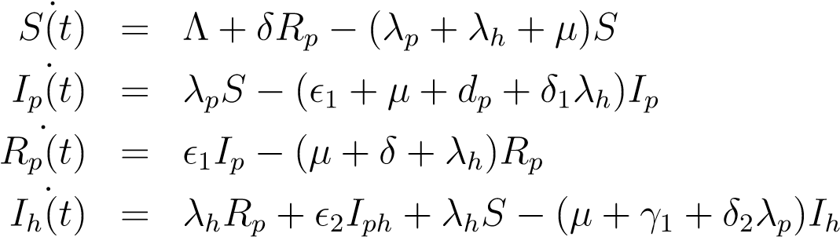
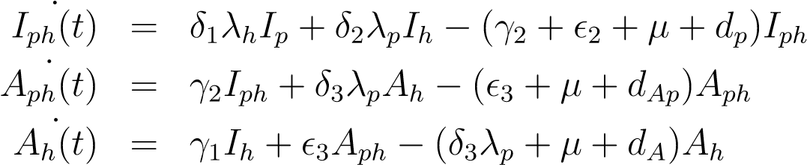 (1)
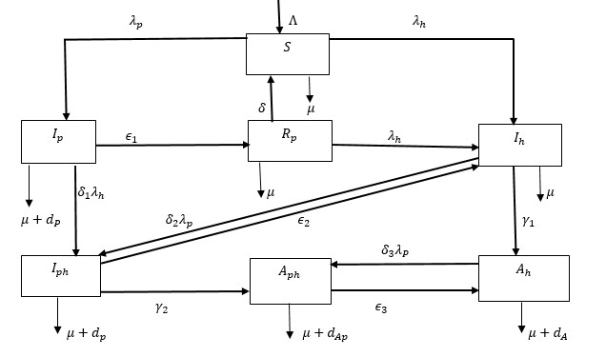
Figure 1: Flow chart diagram
The state variables descriptions are given in the table below.

Table 1: Symbols and Description of Parameter Values
Parameter Description
S(t) The number of individuals that are susceptible to both Pneumonia and HIV infections. This compartment is increased by recruits at the rate, Λ and it is increased from those individuals who have recovered from Pneumonia R_{p} after losing their temporary immunity at the rate δ. These individuals can get Pneumonia infection and move to the I_{p} at the rate λ_{p} and also can get HIV infection and move to the I_{h} class at the rate λ_{h}.
I_{p}(t) The number of individuals infected with Pneumonia. They are reduced by recoveries from Pneumonia at the rate ₁ while others get infected with HIV and progress to I_{ph} class at the rate δ₁λ_{h}. Mortality induced by Pneumonia under I_{p} class occurs at the rate d_{p}.
R_{p}(t) The number of individuals who have recovered from Pneumonia infection. These individuals lose their temporary immunity and they get to susceptible class at the rate δ while others get infection from HIV at the rate λ_{h} and progress to I_{h} class.
I_{h}(t) The number of individuals infected with HIV with no clinical symptoms of HIV and AIDS who progress to the class A_{h} by developing clinical symptoms of HIV and AIDS at the rate γ₁ while others get infected with Pneumonia and progress to I_{ph} class at the rate δ2λp.
I_{ph}(t) The number of individuals co-infected with both Pneumonia and HIV with no clinical symptoms of HIV and AIDS. These individuals recover from Pneumonia at the rate ₂ and move to I_{h} class, others develop HIV and AIDS symptoms and progress to A_{ph} class at the rate γ₂ while others die from Pneumonia induced mortality rate d_{p}.
A_{h}(t) The number of individuals infected with HIV showing clinical symptoms of HIV and AIDS. These individuals seek medication from Pneumonia and they progress to A_{h} class at a recovery rate ₃ and are increased from A_{h} class who get infection from Pneumonia at the rate δ₃λ_{p} where δ₃ > δ₂. They incur induced death from both Pneumonia and AIDS at mortality rate d_{Ap}.
A_{ph}(t) The number of individuals co-infected with both Pneumonia and HIV with clinical symptoms of HIV and AIDS. They incur AIDS induced death at the rate d_{A}. All classes are reduced by deaths from natural causes at the rate µ.

The qualitative analysis of the model system (1) were performed and the model extended into optimal control problem by introduction of controls u₁(treatment for Pneumonia using antibiotics) and u₂ (treatment for HIV using Antiretroviral Therapy - ART) by [14]. The proposed objective function J given by:
(2)
where k₁, k₂, k₃, k₄, k₅, w₁ and w₂ are positive balancing coefficients (weights)which regularize the optimal control. [6] obtained the optimal controls (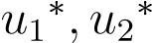) such that:
(3)
subject to the optimal control problem (4) and the control set U = {(u₁(t), u₂(t)) : 0 ≤ u₁ < 1,0 ≤ u₂ < 1,0 ≤ t ≤ T}.
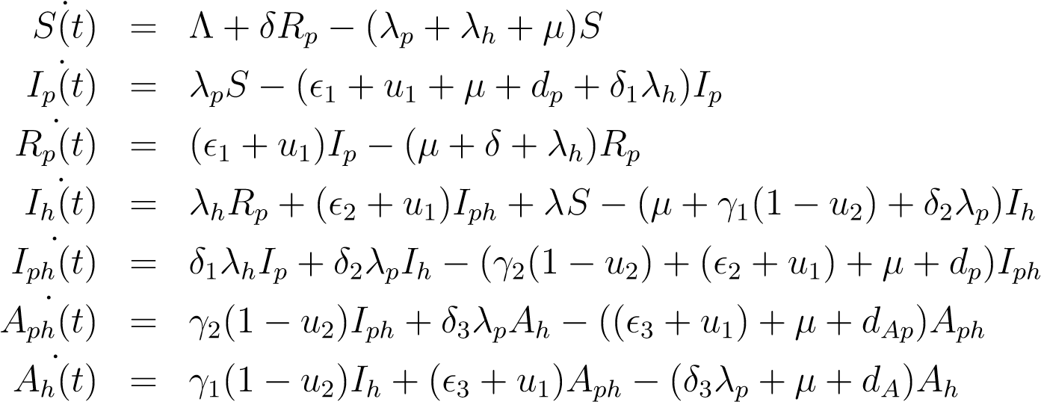 (4)
The necessary conditions for optimality were established using Pontryagin’s Maximum Principle in [8, 14], through characterization of the optimal controls using the Hamiltonian function H (which is the total energy) given as:
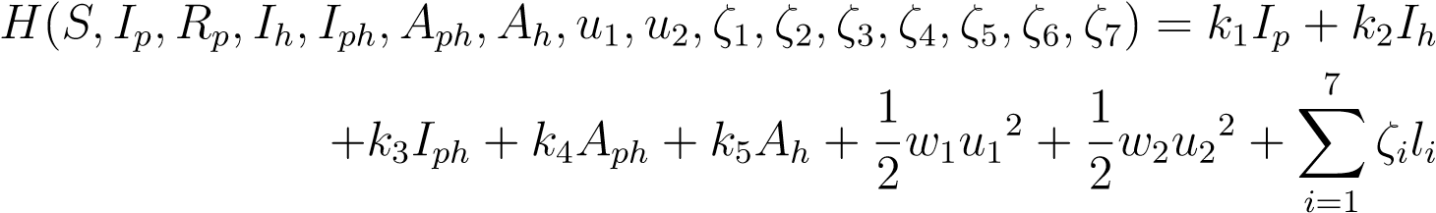 (5)
where l_{i} are the ith state variable equations on the right hand side of equation (1) and ζ₁,...,ζ₇ are the adjoint variables satisfying:
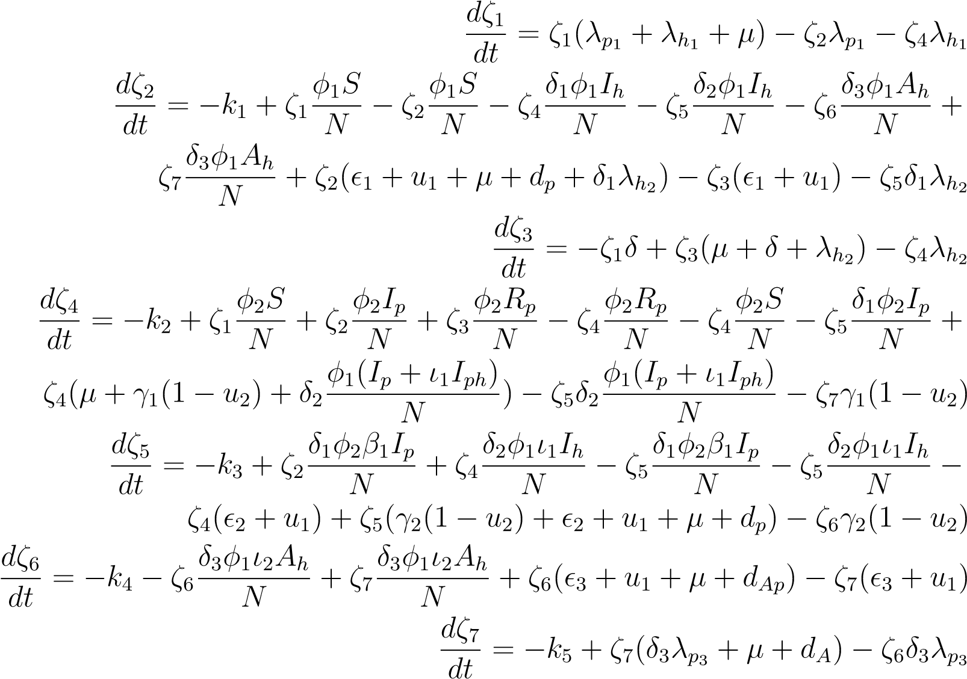 (6)
with transversality conditions; ζ₁(T) = ζ₂(T) = ζ₃(T) = ζ₄(T) = ζ₅(T) = ζ₆(T) = ζ₇(T) = 0 in which ζ₁,...,ζ₇ are adjoint variables.
The optimal controls that were determined and were given as:
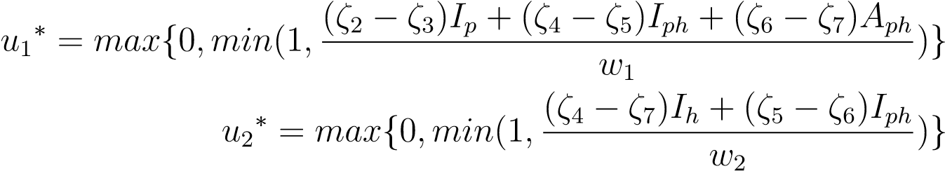 (7)
This resulted into a complex optimality system of differential equations of the form:
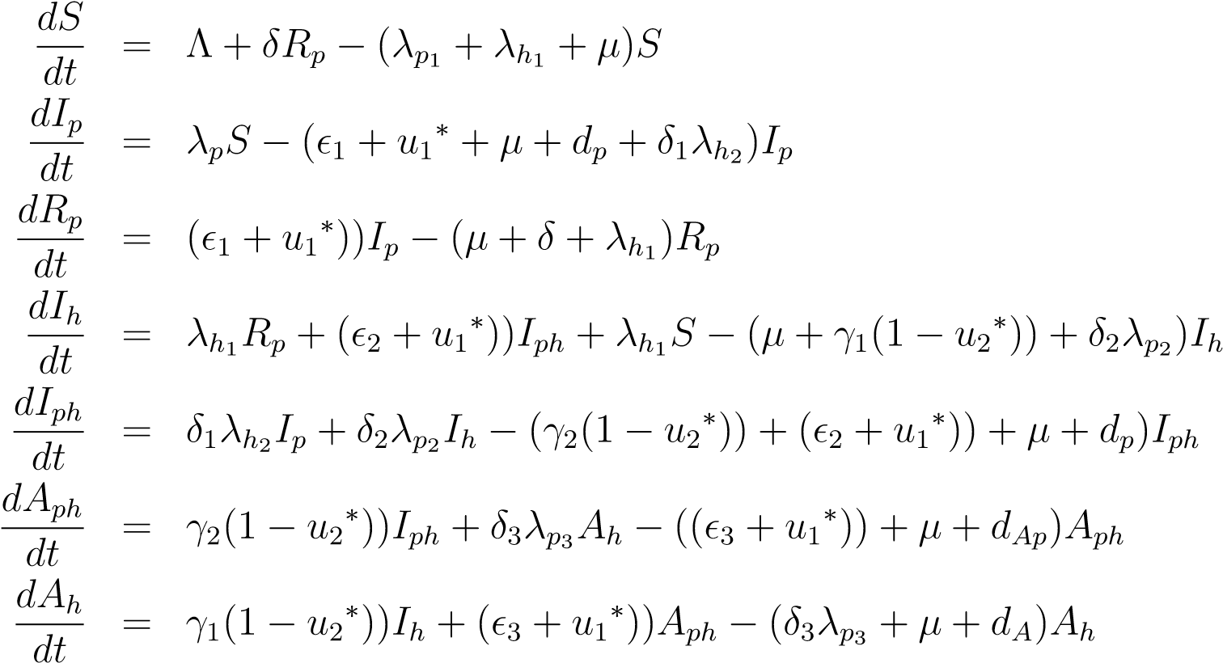 (8)
and
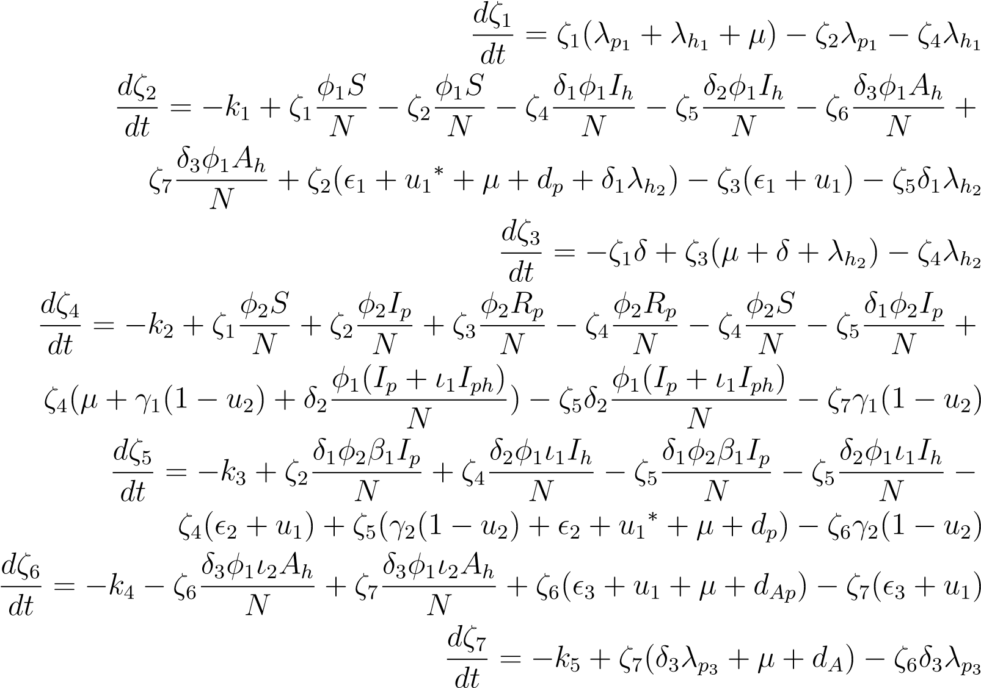 (9)
with transversality conditions; ζ₁(T) = ζ₂(T) = ζ₃(T) = ζ₄(T) = ζ₅(T) = ζ₆(T) = ζ₇(T) = 0 in which ζ₁,...,ζ₇ are adjoint variables.
The theoretical derivation of optimal controls, while crucial, must be complemented with numerical validation to assess the practical implications of different intervention strategies. Furthermore, in a world of finite health resources, determining not just the most effective, but the most cost-effective strategy is paramount for policy implementation. Therefore, this paper serves focuses on:
- The numerical solution of the optimality system.
- The simulation and comparison of different control strategies.
- A rigorous cost-effectiveness analysis to determine the best strategy for practical implementation.

2. Numerical Methods and Simulation Setup
The optimality system comprising state system (8) and adjoint equations system (9) was solved numerically using MATLAB’s forward-backward sweep method with a fourth-order Runge-Kutta scheme. This approach ensured accurate, convergent solutions through iterative multi-step computation across discretized time intervals [13], with results visualized graphically. The approach was given by the following method:
- Approximate the solutions of the optimal control state system with initial guess values on the control variables and the given into conditions of the state variable using the Runge-Kutta forward sweep method.
- Approximate the solutions for the adjoint system with final time conditions for adjoints and the given values in step (i) using Runge-Kutta backward sweep method.
- Update value of the control variables by taking the average of the previous values and new value from the control characterization.
- Repeat the process above in (i) by using the new values of the sate variables and the control values obtained in (iii), and in (ii) by using the new values of the adjoint variables until we get sufficiently close values of state, adjoints and controls are attained (converge).
In the numerical simulations, the estimated initial values of the state variables were S(0) =
1,000, I_{p}(0) = 550,R_{p} = 250, I_{h}(0) = 550, I_{ph}(0) = 400, A_{ph}(0) = 300, A_{h}(0) = 250 while for the adjoint system we used the terminal conditions at final time. The transversality conditions for the adjoint variables were ζ₁(T) = ζ₂(T) = ζ₃(T) = ζ₄(T) = ζ₅(T) = ζ₆(T) = ζ₇(T) = 0, where T = 100 days. A set of parameter values as shown in Table 2 whose sources were from literature and others were estimated were also used. The coefficients to the state variables under the objective functional were estimated to be k₁ = 1, k₂ = 1, k₃ = 5, k₄ = 1, k₅ = 1, w₁ = 80 and w₂ = 100.

Table 2: Parameter/Variable Values and Sources
Parameters/  Variables | Values Per Day | Source
Λ | 8.7 × 10⁻³ | [6]
μ | 7.0 × 10⁻³ | [6]
ε₁ | 9.0 × 10⁻¹ | [13]
δ | 0.003 - 0.1 | [13]
δ₁ | 1.8 × 10⁻¹ | [5]
γ₁ | 1.25 × 10⁻¹ | [6]
φ₁ | 8.8 × 10⁻³ | Calculated
φ₂ | 8.8 × 10⁻¹ | Calculated
δ₂ | 1.2 | Estimated
ε₂ | 8.0 × 10⁻¹ | Estimated
γ₂ | 1.2 | Estimated
ε₃ | 7.5 × 10⁻¹ | Estimated
δ₃ | 1.25 | Estimated
dₚ | 3.4 × 10⁻² | [6]
d_A | 2.3 × 10⁻⁴ | [6]
β₁ | 0.4 | Estimated
ν₂, ν₁ | 0.6, 0.1 | Estimated
d_{Ap} | 4.0 × 10⁻³ | [5]

3. Numerical Results and Discussion
In this section, the numerical results of our optimal control were presented by considering the implications of three control strategies. The graphs were plotted to show the effects of the control measures when implemented under different combination options. The three strategies were given as:
Strategy 1: Control measure against Pneumonia is implemented (u₁ $≠$0 , u₂ = 0)
Strategy 2: Control measure against HIV is implemented (u₁ = 0, u₂ $≠$0)
Strategy 3: All control measures are implemented (u₁$≠0$, u₂ $≠$ 0)

3.1 Dynamics Without Controls (Baseline Scenario) (u₁ = 0, u₂ = 0)
Figure 2 presents the baseline scenario with no controls. Over 100 days, the susceptible population sharply declined as individuals contracted both HIV and Pneumonia, causing a temporary spike in HIV infections. This was followed by a gradual decrease in infections due to disease-induced mortality. Meanwhile, the sub-population showing symptoms of HIV and AIDS decreased initially but then rose steadily, ultimately becoming the dominant group. By day 100, the number of uninfected individuals (susceptible and recovered) was surpassed by those infected with and showing symptoms of HIV and AIDS, with natural and disease induced death rates driving the decline of all other groups.
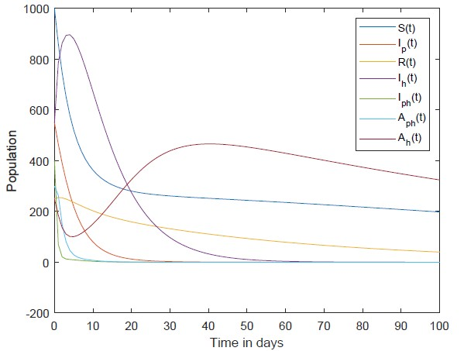
Figure 2: The Dynamics of Population with no controls

3.2 Dynamics for Strategy 1: Control measure against Pneumonia is implemented (u₁$≠$0, u₂ = 0)
Under this strategy, only the control measure against pneumonia was optimized. As shown in Figure 3, this involved intensive administration of pneumonia treatment at the optimal rate of 0.98 throughout the 100-day period. The objective was to minimize the number of infected individuals relative to the susceptible population. The model results show that, apart from the susceptible, those recovered from pneumonia, and those with symptomatic HIV, all other groups eventually declined and died out due to combined natural and disease-induced death rates.
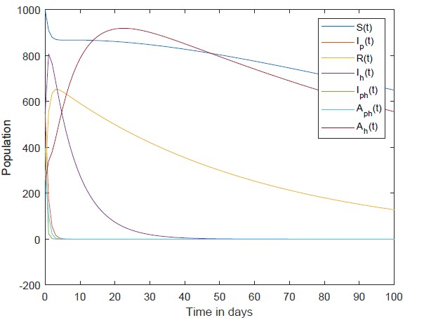
Figure 3: The Dynamics of Population with u₁ only

3.3 Dynamics for Strategy 2: Control measure against HIV is implemented
(u₁ $=$0, u₂ $≠$0)
Under this strategy, only control measure against HIV infection was used for optimization of the objective functional and the dynamics of the population was as shown in Figure 4. From Figure 4, the study noted that all individuals apart from recoveries from Pneumonia, susceptible and infected with HIV and showing symptoms of HIV decreased and died out due to induced death rates and natural death rates at the end of 100 days. To keep the number of individuals living with the infections as low as possible (as compared to susceptible individuals), HIV treatment was administered at the optimal rate of 0.12 throughout for 100 days.
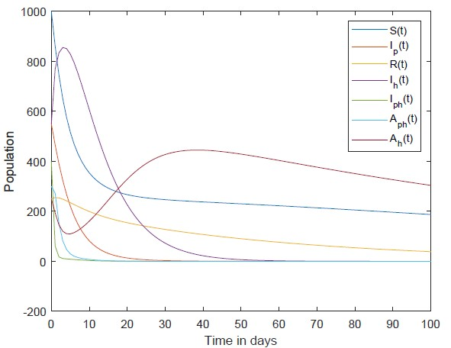
Figure 4: The Dynamics of Population with u₂ only

3.4 Dynamics for Strategy 3: All control measures are implemented (u₁$≠0$u₂ $≠$0)
This strategy involved the optimized use of all controls against HIV and Pneumonia coinfections. The resulting population dynamics are shown in Figure 5. To minimize the number of infected individuals, the model administered HIV treatment at an optimal rate of 0.41 and Pneumonia treatment at a rate of 0.98 throughout the 100-day period. The simulation revealed the following trends: the susceptible population decreased, individuals infected with HIV (but without symptoms) saw a sharp initial increase before declining to lower levels, and the symptomatic HIV group increased slowly before eventually decreasing. By the end of the simulation, all sub-populations except the susceptible, the pneumonia recovered, and the HIV infected (with and without symptoms) had been eliminated due to natural and disease-induced death rates.
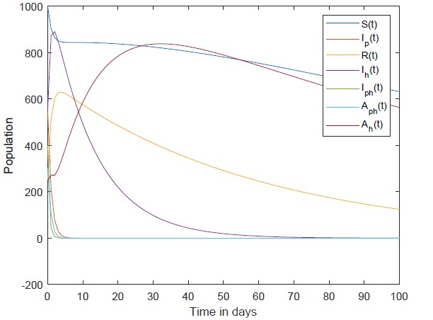
Figure 5: The Dynamics of Population with u₁ and u₂
Generally, analysis of Figures 2 through 5 revealed that the control strategies successfully kept the susceptible population above the infected populations in all cases except Figure 4. This indicates that the interventions had a positive impact, effectively reducing the overall number of infections. However, the strategy of applying only HIV treatment (Figure 4) was less effective. In this scenario, infected individuals outnumbered the susceptible population. The analysis showed that HIV treatment alone only reduced the number of symptomatic HIV and AIDS cases by a small margin-approximately 20 individuals.

4. Discussions of Cost-effectiveness Analysis
A cost-effectiveness analysis was performed to identify the optimal strategy by comparing control costs against health outcomes using the total costs, the Infections Averted Ratio (IAR) and Incremental Cost-Effectiveness Ratio (ICER), which quantifies the additional cost per additional health benefit.

The total costs for each strategy was calculated using the objective function equation (2). The difference between the total number of infections among individuals with controls and those without controls was taken to give the infections averted. The infection averted ratio (IAR) were given as;
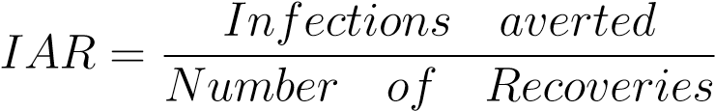 (10)

The ICER were evaluated by comparing any two competing interventions using their differences in the costs and health outcomes using the formula:
The total control costs and IAR were calculated and estimated in ($) USD over 100 as shown in table 3;
Table 3: Total infections averted and total cost
Strategies Total infections averted | Total costs J ($)
Strategy 1 1.9688 | 59,741.6
Strategy 2 0.4500 | 32,472
Strategy 3 2.02362 | 59,700.5

From the table 3, Strategy 3 was the most effective as compared to the other strategies (Strategies 1 and 2) since it had the highest IAR. We therefore embarked on determining the strategy which was cost effective.
The ICER was calculated by first ranking the control strategies in increasing order of their effectiveness which is based on the infection that is averted. Strategy 2 averts the least number of infections, followed by Strategy 1 and then Strategy 3.
The ICER were computed as follows:
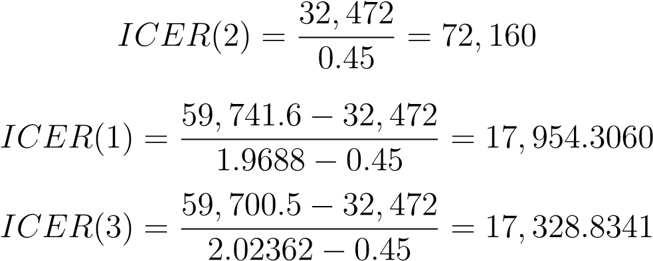
(12)
(13)
(14)
From the above calculations of ICER, Strategy 1 effectively controls Pneumonia but not HIV. Strategy 2 shows the least impact, as the modest ART rate (0.12) is insufficient to quickly alter HIV dynamics, and it does not address Pneumonia directly. But the ICER analysis revealed that Strategy 3 dominated Strategy 1, as it was both less costly and more effective. This resulted in a cost saving of 625.4719 for Strategy 3 over Strategy 1. Consequently, Strategy 1 was excluded from the set of viable options to preserve limited resources. Hence, Strategy 3 was selected as the most cost-effective strategy.

5. Conclusion and Recommendations
This study successfully implemented and numerically solved an optimal control model for Pneumonia-HIV co-infection. The simulations unequivocally demonstrate that a combined intervention strategy, simultaneously administering anti-Pneumonia drugs and ART, is the most effective for reducing disease prevalence. The cost-effectiveness analysis further solidifies this finding, identifying the combined strategy as the most efficient use of limited resources. The study recommends implementing Strategy 3, with Pneumonia treatment at
0.98 and HIV treatment at 0.41, as it simultaneously addresses both infections by boosting immunity against Pneumonia while prolonging life for HIV patients.

6. Limitations and Future Research
This research is deterministic and does not account for stochastic events or heterogeneous population mixing. Therefore, future work should consider extending the model to include age-structure or spatial heterogeneity to better reflect real-world transmission dynamics. Despite these limitations, this study provides a robust mathematical framework and a clear, data-driven recommendation for managing Pneumonia-HIV co-infection, serving as a valuable tool for epidemiologists and public health strategists.
Disclaimer (Artificial intelligence)
Option 1:
Author(s) hereby declare that NO generative AI technologies such as Large Language Models (ChatGPT, COPILOT, etc.) and text-to-image generators have been used during the writing or editing of this manuscript.
Option 2:
Author(s) hereby declare that generative AI technologies such as Large Language Models, etc. have been used during the writing or editing of manuscripts. This explanation will include the name, version, model, and source of the generative AI technology and as well as all input prompts provided to the generative AI technology
Details of the AI usage are given below:
1.
2.
3.

References
- Barbu,V. Precupanu, T. (2010).Convexity and Optimization in Banach Spaces, 4th ed.:
Springer: Dordrecht, The Netherlands.
- Fiordelisi, D., Poliseno, M., De Gennaro, N., Milano, E., Santoro, C. R., Segala, F. V., ... and Saracino, A. (2023). Varicella-zoster virus reactivation and increased vascular risk in people living with HIV: Data from a retrospective cohort study. Viruses, 15(11), 2217.
- Fleming, W. H.,and Rishel, R. W. (2012). Deterministic and stochastic optimal control.
Springer Science and Business Media.
- Khademi, F., Yousefi-Avarvand, A., Sahebkar, A., Ghanbari, F., and Vaez, H. (2018). Bacterial co-infections in HIV/AIDS-positive subjects: a systematic review and metaanalysis. Folia medica, 60(3), 339-350.
- Lutera J., Mbete D. and Wangila S. (2018) Co-infection Model of HIV/AIDS-
Pneumonia on the Effect of Treatment at Initial and Final Stages. IOSR Journal of Mathematics (IOSR-JM), volume 14. No. 5, 56-81.
- Nthiiri J.K., Lawi G. and Manyonge A. (2015). Mathematical Modelling of Pneumonia and HIV and AIDS Co-infection the Presence of Protection. International journal volume 9. No. 42, 2069-2085.
- Onyinge O. D., Omolo N., Odundo F. (2016). Mathematical Model for Co-infection of
Pneumonia and HIV/AIDS with treatment, Int. J. SCI. Eng. Appl. Sci. (IJSEAS) 2 (1)
- Pontryagin L. S., Boltyanskii V., Gramkrelidze R., and Mishchenko F. (1962). The Mathematical Theory of Optimal Processes, John Wiley and Sons Interscience. New York. London.
- Sogaard, O., Lohse, N., Gerstoft, J., Kronborg, G., Ostergaard, L., Pedersen, C., ... Obel, N. (2008). Hospitalization for Pneumonia among individuals with and without HIV infection,1995-2007: A Danish population-based, nationwide cohort. Clinical Infectious Diseases, 47(10), 1345-1353.
- Teklu, S. W., and Mekonnen, T. T. (2021). HIV/AIDS-Pneumonia Coinfection Model with Treatment at Each Infection Stage: Mathematical Analysis and Numerical Simulation. Journal of Applied Mathematics, 2021(1), 5444605.
- Teklu, S. W., and Rao, K. P. (2022). HIV/AIDS-Pneumonia Codynamics Model Analysis with Vaccination and Treatment. Computational and Mathematical Methods in Medicine, 2022(1), 3105734.
- Teklu, S. W., Abebaw, Y. F., Terefe, B. B., and Mamo, D. K. (2023). HIV/AIDS and TB co-infection deterministic model bifurcation and optimal control analysis. Informatics in Medicine Unlocked, 41, 101328.
- Tilahun, G.T., Makinde. O.D., and Malaonza D. and O. S. Obabiyi. (2017). Modelling and optimal control of pneumonia disease with cos-effective stategies. Computational and Mathematical Methodsa in Medicine, vol. 11 no. 2:400-426.
- Wafula, N. K., Kwach, B. O., and Marani, V. N. (2021). Mathematical Modelling and Optimal Controls for Controlling Pneumonia-HIV Co-Infection. International Journal of Innovative Research and Development, 10(1).
- WHO (2012). HIV/AIDS.

