Complete Pathological Response in Stage IVA Human Papillomavirus-Associated Squamous Cell Carcinoma of Bartholin’s Gland Treated with Primary Chemotherapy: A Case Report

Aims: Bartholin’s gland carcinoma (BGC) is an uncommon vulvar malignancy. We aim to describe successful treatment of stage IVA squamous cell carcinoma of Bartholin’s gland with primary chemotherapy.
Presentation of Case: A 52-year-old postmenopausal woman presented with right-sided painless vulvar mass of 6 months duration. Examination revealed a 12 cm fixed lesion involving right Bartholin’s gland extending to the rectum. MRI pelvis demonstrated tumor encroaching towards anorectal junction with possible anal sphincter involvement. Biopsy of rectal mass and Bartholin’s gland mass confirmed non-keratinizing squamous cell carcinoma of Bartholin’s gland origin, with strong p16 immunopositivity consistent with HPV association. Interim clinical assessment after 3 cycles of paclitaxel 175 mg/m² and carboplatin (AUC 6) showed marked tumor regression, with complete clinical response following completion of 6th cycle. Colonoscopy and biopsy of the rectal mucosal lesion post-treatment verified complete pathological response, characterized by absence of viable tumor cells and presence of extensive fibrosis.
Discussion and Conclusion: Primary chemotherapy is a successful treatment option in achieving complete pathological remission and allow for organ integrity preservation with sustained oncologic outcomes for stage IVA HPV-associated squamous-cell carcinoma of Bartholin’s gland.

Keywords: Bartholin’s gland carcinoma; chemotherapy; human papillomavirus; vulvar cancer

1. INTRODUCTION

Bartholin’s gland carcinoma (BGC) is an extremely rare gynecological malignancy, comprising approximately 2-5% of all vulvar neoplasms (Turetta et al., 2024). Histological spectrum of BGC is dominated by squamous cell carcinoma (85-90%), followed by adenocarcinoma (10%), and adenoid cystic carcinoma (<5%) (Addley et al., 2023). The strong association between high-risk HPV infection and squamous variant has been well-established (Topolovec et al., 2015; Wang et al., 2022). Over 60% of patients with BGC are diagnosed in stage III/IV disease (Downs et al., 2002). Clinical presentation of BGC is often indolent, with patients typically presenting with unilateral vulvar mass that may be asymptomatic or associated with mild discomfort. Differential diagnosis includes benign Bartholin’s cyst and abscess, which are significantly more prevalent, particularly in younger demographics. This clinical similarity frequently results in diagnostic delays, with up to 50% of cases initially misdiagnosed as benign pathology (Leuchter et al., 1982). Its anatomical position at the posterolateral vulva, combined with abundant lymphovascular reserves, predisposes to late-stage diagnosis and regional lymphatic spread (López-Varela et al., 2007; Olawaiye et al., 2025). Diagnostic criterion for BGC requires tumor localization to the posterolateral vulvar region with preservation of overlying epithelial integrity, distinguishing it from other vulvar malignancies (Bhalwal et al., 2016). This case report depicts successful treatment of stage IVA HPV-associated squamous cell carcinoma of Bartholin’s gland with primary chemotherapy.

2. PRESENTATION OF CASE

A 52-year-old postmenopausal woman presented with progressively enlarged right-sided vulvar mass in 6 months duration, which caused mild discomfort. She reported previous drainage of a Bartholin cyst in her 40s and denied having diabetes. Clinical examination disclosed a firm, immobile nodule measuring 10 cm at the right lower labium majus, anatomically corresponding to the Bartholin’s gland. The lesion extended posteriorly and was adherent to underlying tissues, with no fluctuations or erythema. Overlying vulvar skin was intact. Posterior vaginal wall was smooth but elevated due to presence of underlying mass. Rectal examination identified an exophytic lesion involving rectal mucosa, approximately 5 cm from the anal verge, encroaching more than 50% of the mucosal circumference. There was no inguinal lymphadenopathy.
Given the atypical presentation in a postmenopausal woman, malignancy was considered more likely than a benign cystic process. The patient subsequently underwent incisional biopsy and colonoscopy under anesthesia for further evaluation. Histopathological analysis of the Bartholin’s gland and rectal mucosa biopsy demonstrated a poorly differentiated, non-keratinizing squamous cell carcinoma (SCC), with immunohistochemical staining unveiled strong p16 positivity, consistent with HPV-associated SCC. The neoplasm involved glandular region with stromal invasion. Absence of benign residual epithelium and lack of distal squamous downgrowth supported primary origin from the Bartholin’s gland. Thorax, abdomen, and pelvis computed tomography revealed a heterogeneously enhancing lesion measuring 6 x 5 x 8 cm, centered in perineal region with right-sided predominance and superior extension involving the upper two thirds of the vagina. Bilateral inguinal lymph nodes were sub-centimeter in size, with the largest measuring 0.6 cm. No evidence of distant metastasis was observed.
Multidisciplinary tumor board meeting staged the disease as FIGO stage IVA squamous cell carcinoma, characterized as locally advanced based on tumor invasion to the rectal mucosa and CT-detected inguinal lymphadenopathy, in the absence of distant metastasis. Given posterior tumor extension involving the rectum and potential for sphincter resection, it was deemed to carry substantial morbidity. Neoadjuvant chemotherapy strategy was selected to facilitate tumor reduction prior to surgical intervention. The patient received 6 cycles of paclitaxel 175 mg/m2 and carboplatin at an area under the curve (AUC) of 6 on Day 1 of each 21-day cycle. Repeat colonoscopy was performed after completion of primary chemotherapy discovered a small, ulcerated lesion at previous site of the tumor which histology of biopsy indicated inflammatory changes without evidence of residual malignancy; this was concluded as complete pathological response to chemotherapy. Repeat CT of thorax and abdomen, and MRI pelvis reported abnormal bowel wall in anorectal region which appeared in continuation with posterior wall of vagina measuring 1 cm. However, there was no significant mass, tissue enhancement, or restricted diffusion at the previous tumor site. The report concluded that it may represent fibrosis post-chemotherapy. MDT discussed the role of surgery but given minimal visualization of the previously identified tumor and complete pathological response to chemotherapy, consensus was reached for no further treatment hence neoadjuvant chemotherapy was re-instated as primary chemotherapy. Three-monthly surveillance with CT image showed disease-free status for 9 months post-primary chemotherapy.

3. discussion

There is no consensus on the treatment option for BGC. Stage I BGC is surgically managed with wide local excision or radical vulvectomy, combined with bilateral inguinofemoral lymphadenectomy (Addley et al., 2023; Copeland et al., 1986). Literatures state that primary chemoradiation with surgical resection is the standard treatment for locally advanced disease (Gao et al., 2022; Johnson et al., 2017; López-Varela et al., 2007; Massad & De Geest, 1999; Mousa et al., 2016). However, anatomical proximity to critical structures including the urethra, rectum, and anal sphincter, may necessitate exenteration in locally advanced cases, resulting in significant functional morbidity. The decision for optimal treatment of BGC can pose a challenge to clinician due to the rarity of disease entity. Despite therapeutic approach being mainly neoadjuvant chemoradiation followed by surgery (Turetta et al., 2024), this treatment modality is not applied in our case due to scarcity of radiation service, as well as locally advanced nature of the disease and huge tumor size at diagnosis. Initial plan of neoadjuvant chemotherapy was performed to downstage and facilitate less radical surgical procedures with the goal of organ preservation. However, given complete radiological and pathological response after 6 cycles of doublet chemotherapy carboplatin-paclitaxel, surgery was deemed no longer indicated.
To our knowledge, this is the first case of BGC managed with primary chemotherapy as the sole treatment modality. The treatment was well-tolerated, with adverse effects included grade 2 alopecia and mild neutropenia. Paclitaxel-associated neuropathy was mild, presenting as grade 1 tingling by cycle 4. On top of radiation service scarcity, radiation toxicity is an under-recognized complication associated with pelvic irradiation, especially in gynecology cancer survivors (Fernandes & Andreyev, 2021). Women suffer from tissue injury resulting in damage to physiological functions of crucial pelvic organ in short- and long-term period, including progressive fibrosis of the irradiated tissue (Fernandes & Andreyev, 2021). The other consideration for primary chemotherapy for this patient is that HPV-associated cancer was found to undergo significant cell growth suppression when treated with cisplatin compared to HPV-negative counterpart (Szymonowicz & Chen, 2020). This evidence could have been the reason for excellent clinical response in our patient. Similar strategy was also implemented in HPV-associated oropharynx cancer where they employed neoadjuvant chemotherapy before surgical resection of locoregionally advanced disease as it proved to reduce dependence towards feeding tube and improved survival compared to chemoradiation group (Sadeghi et al., 2020).

4. Conclusion

This case report highlights the efficacy of primary paclitaxel-carboplatin chemotherapy in inducing a complete pathological response in a patient with stage IVA HPV-associated squamous cell carcinoma of Bartholin’s gland. This approach facilitates organ-preserving surgical management, thereby bypassing the morbidity typically associated with pelvic exenteration as well as avoiding the radiation changes due to pelvic irradiation.

5. ACKNOWLEDGEMENT

6. Competing interests

Authors have declared that no competing interests exist.

7. Authors’ Contributions

Dr. Diana M, Dr. Muhamad Faiz MJ, and Dr. Manisah MZ were involved in the clinical management of the patient. Dr. Diana drafted the manuscript. All authors contributed to the critical review of the manuscript, supervised the writing process, and approved the final version for submission.

8. CONSENT

I declare that written informed consent was obtained from the patient for publication of this case report and accompanying images. A copy of the written consent is available for review by the Editorial office/Chief Editor/Editorial Board members of this journal.

9. Ethical approval

Written informed consent for publication was obtained from the patient. Ethical approval was not required under institutional policy. All authors hereby declare that all experiments have been examined and approved by the appropriate ethics committee and have therefore been performed in accordance with the ethical standards laid down in the 1964 Declaration of Helsinki.

10. DISCLAIMER (ARTIFICIAL INTTELLIGENCE)

Authors hereby declare that NO generative AI technologies such as Large Language Models (ChatGPT, COPILOT, etc.) and text-to-image generators have been used during the writing or editing of this manuscript.

11. References

- Addley, S., Sadeghi, N., Smyth, S. L., Johnson, C., Damato, S., & Soleymani Majd, H. (2023). Bartholin's gland carcinoma-the diagnostic and management challenges of a rare malignancy-a case report and review of current literature. Transl Cancer Res, 12(1), 201-208. https://doi.org/10.21037/tcr-22-612
- Bhalwal, A. B., Nick, A. M., Dos Reis, R., Chen, C. L., Munsell, M. F., Ramalingam, P., Salcedo, M. P., Ramirez, P. T., Sood, A. K., & Schmeler, K. M. (2016). Carcinoma of the Bartholin Gland: A Review of 33 Cases. Int J Gynecol Cancer, 26(4), 785-789. https://doi.org/10.1097/igc.0000000000000656
- Copeland, L. J., Sneige, N., Gershenson, D. M., McGuffee, V. B., Abdul-Karim, F., & Rutledge, F. N. (1986). Bartholin gland carcinoma. Obstet Gynecol, 67(6), 794-801. https://doi.org/10.1097/00006250-198606000-00009
- Downs, L. S., Ghosh, K., Dusenbery, K. E., & Cosin, J. A. (2002). Stage IV carcinoma of the Bartholin gland managed with primary chemoradiation. Gynecol Oncol, 87(2), 210-212. https://doi.org/10.1006/gyno.2002.6787
- Fernandes, D. C. R., & Andreyev, H. J. N. (2021). Gastrointestinal Toxicity of Pelvic Radiotherapy: Are We Letting Women Down? Clin Oncol (R Coll Radiol), 33(9), 591-601. https://doi.org/10.1016/j.clon.2021.04.009
- Gao, Y., Li, H., & Li, C. (2022). Neoadjuvant chemotherapy followed by radical vulvectomy for adenoid cystic carcinoma of Bartholin's gland: a case report. Transl Cancer Res, 11(10), 3883-3889. https://doi.org/10.21037/tcr-21-2634
- Johnson, L. R., Nair, R. P., Sambasivan, S., Mony, R. P., Gangadharan, J., Kumar, A., & Ahamed, I. M. (2017). Adenoid Cystic Carcinoma of Vulva-11 Years' Single-Institution Experience. J Obstet Gynaecol India, 67(3), 196-201. https://doi.org/10.1007/s13224-016-0935-6
- Leuchter, R. S., Hacker, N. F., Voet, R. L., Berek, J. S., Townsend, D. E., & Lagasse, L. D. (1982). Primary carcinoma of the Bartholin gland: a report of 14 cases and review of the literature. Obstet Gynecol, 60(3), 361-368.
- López-Varela, E., Oliva, E., McIntyre, J. F., & Fuller, A. F., Jr. (2007). Primary treatment of Bartholin's gland carcinoma with radiation and chemoradiation: a report on ten consecutive cases. Int J Gynecol Cancer, 17(3), 661-667. https://doi.org/10.1111/j.1525-1438.2006.00781.x
- Massad, L. S., & De Geest, K. (1999). Multimodality therapy for carcinoma of the Bartholin gland. Gynecol Oncol, 75(2), 305-307. https://doi.org/10.1006/gyno.1999.5542
- Mousa, A., Rahimi, K., & Warkus, T. (2016). Neoadjuvant chemoradiotherapy followed by radical vulvectomy for adenoid cystic carcinoma of Bartholin's gland: a case report and review of the literature. Eur J Gynaecol Oncol, 37(1), 113-116.
- Olawaiye, A. B., Cuello, M. A., Beriwal, S., & Rogers, L. J. (2025). Cancer of the vulva: 2025 update: FIGO Cancer Report 2025. Int J Gynaecol Obstet, 171 Suppl 1(Suppl 1), 36-47. https://doi.org/10.1002/ijgo.70390
- Sadeghi, N., Mascarella, M. A., Khalife, S., Ramanakumar, A. V., Richardson, K., Joshi, A. S., Taheri, R., Fuson, A., Bouganim, N., & Siegel, R. (2020). Neoadjuvant chemotherapy followed by surgery for HPV-associated locoregionally advanced oropharynx cancer. Head Neck, 42(8), 2145-2154. https://doi.org/10.1002/hed.26147
- Szymonowicz, K. A., & Chen, J. (2020). Biological and clinical aspects of HPV-related cancers. Cancer Biol Med, 17(4), 864-878. https://doi.org/10.20892/j.issn.2095-3941.2020.0370
- Topolovec, Z., Blažičević, V., Šijanović, S., & Vidosavljević, D. (2015). Squamous cell carcinoma of Bartholin gland coexistent with human papillomavirus. Eur J Gynaecol Oncol, 36(4), 482-484.
- Turetta, C., Mazzeo, R., Capalbo, G., Miano, S., Fruscio, R., Di Donato, V., Falcone, F., Mangili, G., Pignata, S., & Palaia, I. (2024). Management of primary and recurrent Bartholin's gland carcinoma: A systematic review on behalf of MITO Rare Cancer Group. Tumori, 110(2), 96-108. https://doi.org/10.1177/03008916231208308
- Wang, K., Zheng, Y., Tong, L., Pei, K., He, X., & Zhang, J. (2022). Analysis of clinical outcomes of patients with primary rare carcinoma of Bartholin gland: six case series report and review of the literature. Transl Cancer Res, 11(6), 1483-1487. https://doi.org/10.21037/tcr-21-2591

11. FIGURES

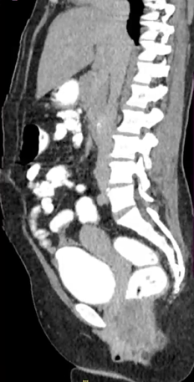
1A
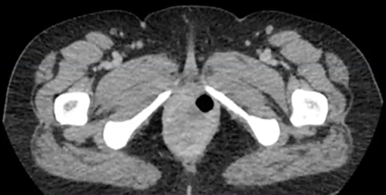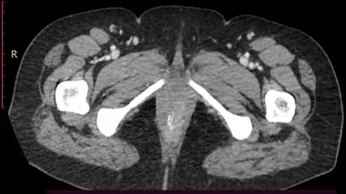
1C
1B
Figure 1A: Sagittal contrast-enhanced CT scan of the pelvis demonstrating an irregular, enhancing soft tissue mass in the posterolateral vulva region consistent with Bartholin’s gland carcinoma with features of locally advance disease.

Figure 1B: Pre-treatment axial contrast-enhance CT demonstrated an irregular, enhancing mass arising from Bartholin’s’ gland with local extension into adjacent perineal tissues, consistent with stage IVA disease.

Figure 1C: Post-treatment axial contrast-enhance CT demonstrated complete radiologic response, with disappearance of the previously noted Bartholin’ gland tumor and no evidence of residual local disease.

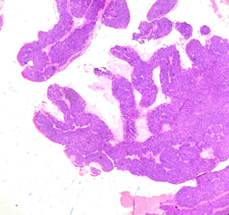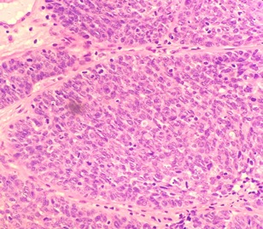
2A
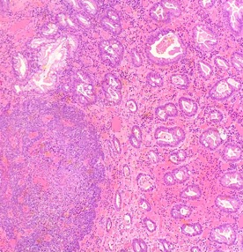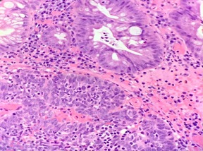
2B
Figure 2A: Low power H&E section showing an infiltrative malignant epithelial tumor composed of irregular nests and glandlike structures invading the surrounding stroma, consistent with carcinoma.

Figure 2B: Hematoxylin and eosin-stained section showing rectal mucosa with distorted glandular architecture, dense inflammatory cell infiltration in the lamina propria and areas of epithelial atypia, consistent with pathological involvement of the rectal mucosa.

