Symptomatology of Soybean Yellow Mosaic Virus (YMV) in the Marathwada Region of Maharashtra, India

ABSTRACT

Soybean (Glycine max (L.) Merr.) is an important oilseed crop cultivated widely across tropical and subtropical regions, valued for its high protein (40–42%) and oil content (18–20%). Soybean productivity in India, particularly in the Marathwada region of Maharashtra, is severely affected by Yellow Mosaic Virus Disease (YMVD), caused by Soybean Yellow Mosaic Virus (YMV), a begomovirus transmitted efficiently by the whitefly (Bemisia tabaci). The disease leads to foliar yellowing, mosaic patterns, chlorosis, puckering, shortened internodes, malformed pods, and significant yield reduction. Accurate documentation of symptom development is essential for early detection, field diagnosis, and the implementation of effective management strategies.
A study on YMV symptomatology was conducted during Kharif 2023–24 and 2024–25 at the Department of Plant Pathology, Vasantrao Naik Marathwada Krishi Vidyapeeth (VNMKV), Parbhani. Soybean plants of cv. MAUS-612 were grown in sterilized soil and inoculated at the 2–3 leaf stage using viruliferous whiteflies maintained in screen-house rearing cages. Inoculated plants were observed periodically, and symptoms were recorded with respect to colour, distribution, pattern, and severity throughout the crop growth cycle.
Initial infection appeared during the 24th Standard Meteorological Week as scattered bright yellow specks and diffused green–yellow mottling on young trifoliate leaves. Disease progression resulted in extensive yellow mosaic, chlorosis, leaf puckering, curling, blistering, and reduction in lamina size. Advanced infection stages showed stunting, shortened internodes, premature leaf drop, flower abortion, malformed pods, and shriveled or mottled seeds. Severe infections led to complete yellowing of young leaves and total failure of pod formation, indicating substantial yield losses. Symptom expression correlated with disease severity and provided early markers for field-level diagnosis.
The study provides a detailed characterization of YMV symptomatology in the Marathwada region, offering critical information for disease surveillance, epidemiological studies, varietal screening, and integrated disease management. These findings are essential for developing strategies to mitigate the impact of YMVD, supporting soybean production, and guiding resistance-breeding programs in India and other Asian soybean-growing regions.s
Keywords: Soybean, Yellow Mosaic Virus, Bemisia tabaci, Symptomatology, Disease Management, Marathwada, India.

- INTRODUCTION
Soybean (Glycine max (L.) Merr.) is a globally important oilseed and protein crop whose seed composition (≈20% oil, ≈40% protein on average) underpins food, feed and industrial supply chains and drives intensive breeding efforts for improved quality and yield (Clemente & Cahoon, 2009; Shiva et al., 2024). However, soybean productivity is frequently limited by biotic stresses, and viruses are among the most damaging pathogens because they reduce photosynthetic leaf area, stunt growth and lower pod and seed set. In Asian production zones, yellow mosaic disease (YMD) of soybean caused by begomoviruses such as Mungbean yellow mosaic virus (MYMV) and Mungbean yellow mosaic India virus (MYMIV) produces characteristic yellow-green mosaic, leaf rugosity and severe yield losses in susceptible cultivars. Recent molecular and genetic work has (1) clarified the diversity of YMD-associated begomoviruses in soybean, (2) enabled infectious-clone studies and rapid diagnostic confirmation of causal agents, and (3) identified resistant germplasm and linked resistance loci that are now being used in breeding strategies to mitigate YMD impact (Kumari et al., 2024; Rahman et al., 2023; Lin et al., 2022; Vishal et al., 2024). Together, these advances provide practical paths—marker-assisted selection, germplasm introgression and improved surveillance—for reducing viral losses and stabilizing soybean yields in affected regions.
YMV belongs to the Potyviridae family and is transmitted primarily through insect vectors, especially aphids. The virus was first documented in the United States in the mid-20th century (Pierce, 1935) and subsequently reported from India in the 1960s (Nariani, 1960). Today, YMV is widespread across the Indian subcontinent, Sri Lanka, Pakistan, Bangladesh, Thailand and parts of Southeast Asia, where it continues to cause substantial yield losses (Bhattacharyya et al., 1999). The disease has become increasingly important due to continuous soybean expansion into diverse agro-climatic zones, which favour virus survival and vector proliferation.
In soybean infected with a yellow-mosaic–causing virus, leaves often develop irregular yellow-green patches or mottling, sometimes with blotches or chlorotic spots that expand over time. As the disease progresses, these patches may enlarge or merge, causing large bright yellow-green areas; in severe infections leaves may turn almost entirely yellow while veins stay relatively green. In many cases, leaves also show deformation such as puckering or reduced size, and plants may suffer from stunted growth and reduced yield. For instance, Saket et al. (2025) reported pronounced yellow-green mottling and leaf crinkling under hot-spot conditions. Similarly,Sandra et al. (2021) observed chlorotic spots, blotches, mosaic and veinal mottling in soybean cultivars inoculated with Soybean yellow mottle mosaic virus (SYMMV).With advanced infection by SMV, soybean plants often exhibit symptoms such as mosaic, mottling, vein-clearing or chlorosis of leaves, stunted growth, pod malformation, reduced seed size and viability, and lowered seed quality all of which lead to marked yield reduction(Eid et al., 2023)Such variability in symptom severity necessitates accurate characterization of symptomatology, especially for early diagnosis and surveillance programs.
Accurate description of disease symptoms is essential for distinguishing Yellow Mosaic Disease (YMD) of soybean from other viral infections such as Soybean Mosaic Virus (SMV) or Mungbean Yellow Mosaic India Virus (MYMIV) which often co-occur in fields. Early-stage foliar symptoms of YMD typically include chlorotic or yellow-green specks and irregular mottling on young leaves; as infection progresses, these merge into conspicuous yellow-green patches or blotches, sometimes accompanied by leaf puckering, deformation or veinal mottling. These characteristic symptom patterns, which are relatively distinct from those caused by other viruses, enable field-level diagnosis, monitoring of disease onset and severity, and help guide timely management decisions (Sandra et al., 2021; Saket et al., 2025).Regional differences in symptom expression suggest various virus strains, environmental factors, and host sensitivity necessitating further investigation.
Given the increasing incidence and emerging hotspots of YMV in soybean-growing regions of India, systematic documentation of disease symptoms is crucial. A clear understanding of symptomatology forms the basis for further epidemiological studies, vector management, host resistance breeding, and integrated disease management strategies. Therefore, the present study was undertaken to document and characterize the symptomatology of Soybean Yellow Mosaic Virus disease, aiming to support accurate field diagnosis and contribute to broader research efforts on YMV epidemiology and control.
- MATERIAL AND METHODS
A study on Yellow Mosaic Virus symptomatology was conducted during Kharif 2023–24 and 2024–25 at the Department of Plant Pathology, Vasantrao Naik Marathwada Krishi Vidyapeeth (VNMKV), Parbhani.
To study the Symptomatology of yellow mosaic virus of soybean, seeds of soybean (Var.MAUS-612) were sown in earthen pots filled with steam sterilized soil and FYM (2:1) and watered regularly. After germination, seedlings at the2-3 leaf stage were inoculated with viruliferous white fly kept inarearing cage. The inoculated plants were maintained in a screen house and observed regularly for the development of symptoms. Observations were recorded on different types of symptoms and the time taken for symptom development. The description of symptoms was based on the shape, color and distribution pattern of the disease on the plot.
3. RESULTS AND DISCUSSION
Symptomatology of yellow mosaic virus disease in soybean (YMV)
Yellow mosaic disease symptoms on soybean (cv. MAUS-612) appeared first at the 24th Standard Meteorological Week (SMW) after sowing in the Kharif seasons of 2023–24 and 2024–25. Healthy control plants remained symptom-free until maturity. In contrast, virus-inoculated plants consistently developed characteristic symptoms of Yellow Mosaic Virus (YMV). Initial symptoms included bright yellow specks, irregular and diffused yellow-green dapples on the leaf surface. With progression, the leaves exhibited widespread mosaic and mottling, curling and blister-like raised areas, leaf puckering, distortion, interveinal chlorosis, and considerable reduction in leaf lamina size. As the disease advanced, premature defoliation and flower drop were frequently observed.
At later stages, older leaves displayed irregular yellow-green patches, while newly emerged leaves often turned completely yellow. In severely affected plants, growth was stunted with reduced branching, shortened internodes, and overall poor canopy development. Flowering was sparse and pod formation, when it occurred, resulted in small, deformed pods, often with visible mosaic or mottling. Seeds harvested from these pods were immature, undersized, shriveled and showed irregular mottled coloration. A substantial proportion of such seeds failed to germinate under standard germination tests, demonstrating loss of seed viability in addition to poor seed development.
Overall, infected plants produced significantly fewer and smaller pods and seeds, with clear reductions in both seed quality and quantity, compared to healthy controls.
The symptom progression observed in this study is consistent with previously documented characteristics of yellow mosaic disease in leguminous crops. Specifically, early onset of yellow-green speckling, mosaic patterning, leaf distortion, chlorosis, stunting, reduced pod and seed set are widely reported for soybeans infected by begomoviruses such as Mungbean yellow mosaic India virus (MYMIV) or related strains. (Singh et al., 2024)
In a molecular characterization study of soybean yellow mosaic disease, researchers reported similar foliar symptoms including intense mosaic and mottling, leaf curling, chlorosis and stunted growth under natural and whitefly-mediated infection. (Naveesh et al., 2023)These similarities support the conclusion that the causal agent in the present experiments likely belongs to the same begomovirus group associated with YMV in India. The involvement of begomoviruses in YMV of soybean has been well established. (Yadav et al., 2009)
Moreover, physiological studies on YMV-infected soybean have documented significant reductions in chlorophyll, total soluble protein and carbohydrate content, alongside elevated oxidative stress markers, implying compromised photosynthetic capacity and metabolic disruption that contribute to stunted growth and yield loss.(Gupta et al., 2022)These biochemical disruptions likely underlie the impaired vegetative development, poor flowering, and reduced seed formation observed in our experiments.
Furthermore, the impact on seed quality shriveling, mottling, reduced germinationmirrors reports from other legumes under begomovirus infection where seed-borne transmission and seed viability reduction have been documented. (Sivararamakrishnan et al., 2023)Given the severity and reproducibility of symptoms across two consecutive seasons, the present findings underscore the destructive potential of YMV on soybean cultivar MAUS-612 under field conditions. This highlights the urgent need for integrated disease management including breeding for resistant genotypes, vector control (e.g., management of whitefly populations), and timely disease surveillance to mitigate yield and seed-quality losses in soybean production.
In soybean (Glycine max), infection by legume-adapted yellow mosaic viruses such as Mungbeanyellowmosaic India virus (MYMIV) or other related YMV causes characteristic foliarsymptoms. Earlyin infection, young trifoliate leaves often exhibit scattered yellow specks or smallchlorotic flecks, whichlater expand and coalesce into irregular yellow-green mottled patches on the leaflamina. As the diseaseprogresses, extensive mosaic/mottling develops, with many leaves turninguniformly yellow while veinsmay remain comparatively greener. In severe cases, necrotic or rusty spotsmay appear within affectedareas, and leaf puckering or distortion may occur. This mottling andchlorosis impair photosynthesis,leading to stunting and reduced pod set. (Mishra et al.,2022; Saket et al., 2025)
Nariani (1960) reportedthe first symptoms of the disease on the young leaves in the form of
mild scattered yellow specks or spots. The next trifoliate leaf emerging from the growing apex showed
irregular yellow and green patches. The leaf size is generally not much affected but sometimes the
green areas were slightly raised and the leaves showed slight puckering and a size reduction. The size
of yellow areas increasesin the new growth and ultimately some of the apical leaves turn completely
yellow. The diseased plants usually matured late and bore very few flowers and pods. The size of the
pod was reduced and more frequently, immature and small sized seeds were obtained from such pods.
On Phaseolus mungo, symptoms were essentially similar to thosein moong bean. Bright yellow and
green patches appear on young leaves after 12-15 days and continue to appear on new growth.
Infection by Mungbean Yellow Mosaic Virus (MYMV) typically leads to onset of yellow mosaic patterns
on young leaves, often beginning as scattered chlorotic spots that coalesce into a bright yellow mosaic,
sometimes accompanied by leaf rugosity or puckering. (Mishraet al.,2020)Early or severe infection
may stunt plant growth and hamper pod formation, while later—but still significant—infection shortens
pod-filling period, delays maturity, and reduces overall yield and yield components (fewer pods per
plant, fewer seeds per pod, lower 1000-seed weight, and reduced grain yield per plant)(Khattak et al.,
2000) Previously similar symptoms of the yellow mosaic disease were reported by Nair and Nene,
(1973), Gautam (1990), Varma et al. (1992), Varma and Malathi, (2003), Qazi et al. (2007), Akhtar et
al. (2009), and Gazala et al. (2013).

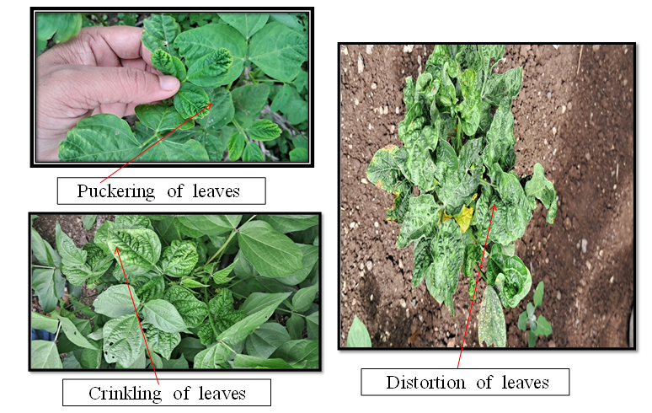

Figure 1a. Symptoms expressed especially in the early stages of infection by YMV in soybean (field condition)

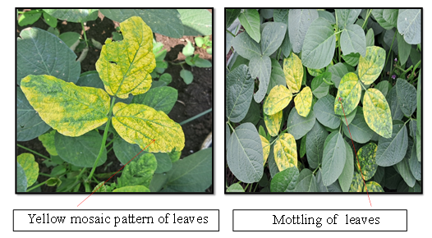

Figure 1b. Symptoms expressed especially in the early stages of infection by YMV in soybean (field condition)

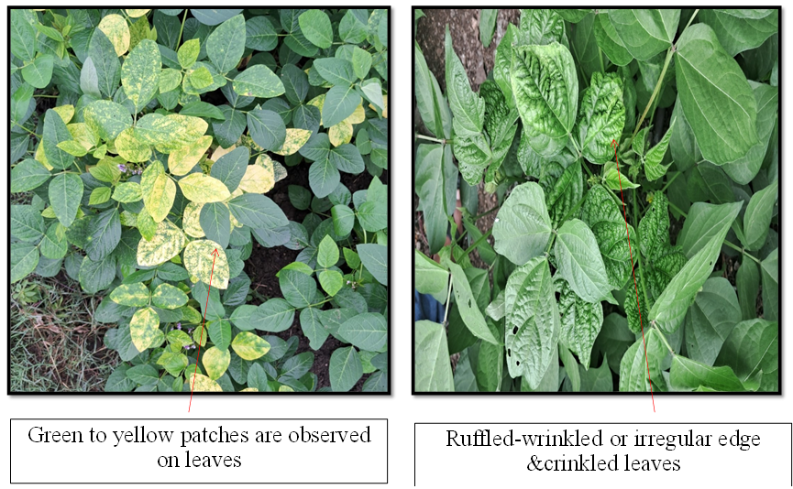
Figure1c. Symptoms expressed especially in the early stages of infection by YMV in soybean (field
condition)

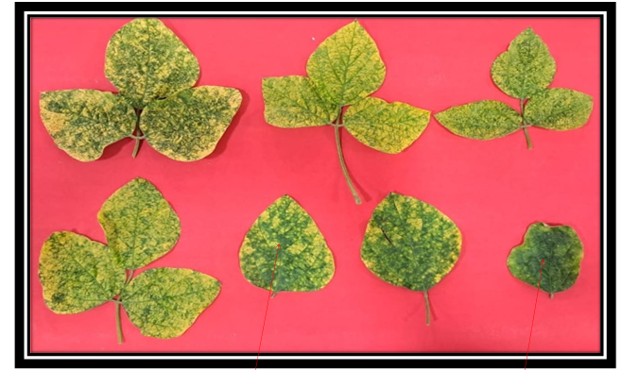

Figure1d. Affected plants showed a yellow mosaic or mottling pattern with light to dark green patches, distorted and puckering of leaves. (Suteri, 1974; Maramorosch and Muniyappa, 1981)

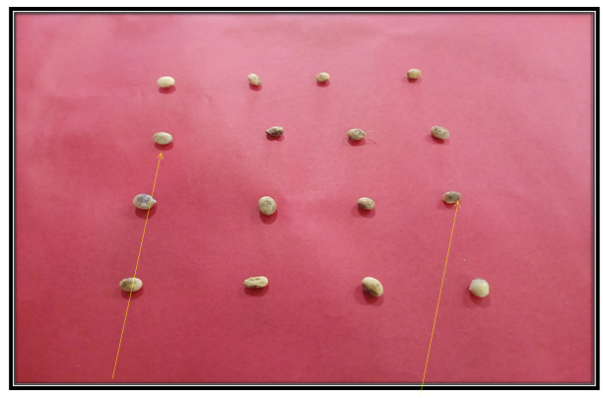

Figure 1e. Mottled soybean seeds, meaning they will have a patchy, uneven coloration.
Infected seeds may fail to germinate

4. CONCLUSIONS
The present investigation clearly demonstrated the typical symptomatology of Soybean Yellow Mosaic Virus (YMV) infecting soybean under the Marathwada conditions of Maharashtra. Symptoms first appeared around the 24th SMW after sowing and progressively intensified with plant growth. Characteristic features included bright yellow and green mosaic mottling, curling and blistering of leaves, chlorosis, reduced leaf size and premature defoliation. As the disease advanced, plants exhibited stunting, shortened internodes, poor branching and complete suppression or weakening of flowering and pod formation. Pods that did develop were deformed and contained small, immature and shrivelled seeds, many of which showed mottling and poor germination. These observations confirm that YMV infection adversely affects soybean at both vegetative and reproductive stages, ultimately reducing yield potential and seed quality. The present findings align with previous descriptions of YMV symptom expression reported by earlier workers and highlight the destructive nature of YMV in susceptible soybean cultivars grown in the region. Continued monitoring of symptom development and disease spread is essential for early detection and timely management to safeguard soybean productivity.

Disclaimer (Artificial intelligence):
Author(s) hereby declare that NO generative AI technologies such as Large Language Models (ChatGPT, COPILOT, etc.) and text-to-image generators have been used during the writing or editing of this manuscript.

REFERENCES
- Akhtar, K. P., Wasim, M., Ishaq, W., Ahmad, M., & Haq, M. A. (2009). Short communication. Deterioration of cotton fibre characteristics caused by cotton leaf curl disease. Spanish Journal of Agricultural Research, 7(4), 913-918. https://doi.org/10.5424/sjar/2009074-1110
- Bhattacharyya, P. K., Ram, H. H. and Kole, P. C. (1999). Inheritance of resistance to yellow mosaic virus in interspecific crosses of soybean. Euphytica, 108(2): 157–159. https://doi.org/10.1023/A:1003620713110
- Clemente, T. E., & Cahoon, E. B. (2009). Soybean Oil: Genetic Approaches for Modification of Functionality and Total Content. Plant Physiology, 151(3), 1030–1040. https://doi.org/10.1104/pp.109.146282
- Eid, M. A., Momeh, G. N., El-Shanshoury, A. E. R., Allam, N. G. and Gaafar, R. M. (2023). Comprehensive analysis of soybean cultivars' response to SMV infection: genotypic association, molecular characterization, and defense gene expressions. Journal, genetic engineering & biotechnology, 21(1): 102. https://doi.org/10.1186/s43141-023-00558-x
- Gautam, H. C. (1990). Identification of soybean diseases and their integrated control. Farmer and Parliament, 15–22. (As cited in Gaikwad et al. 2021; retrieved via secondary citation.)
- Gazala, I. F. S., Sahoo, R. N., Pandey, R., Mandal, B., Gupta, V. K., Singh, R., & Sinha, P. (2013). Spectral reflectance pattern in soybean for assessing yellow mosaic disease. Indian Journal of Virology, 24(2), 242–249. https://doi.org/10.1007/s13337-013-0161-0 .
- Gupta, T., Yadav, N., Dhir, S., Srivastava, A. and Raj, S. K. (2022). Biochemical alterations in soybean (Glycine max) infected with Mungbean yellow mosaic India virus in Lalitpur dist., Bundelkhand region of India. Archives of Phytopathology and Plant Protection, 55(10): 1219–1233. https://doi.org/10.1080/03235408.2022.2081773
- Khattak, G. S. S., Haq, M. A., Rana, S. A., Abass, G. and Irfag, M. (2000). Effect of Mungbean Yellow Mosaic Virus (MYMV) on yield and yield components of mungbean (Vigna radiata (L.) Wilczek). Agriculture and Natural Resources, 34(1): 12–16.
- Kumari, N., et al. (2024). Development of infectious clones of mungbean yellow mosaic virus and their use to validate resistance. PLOS ONE, 19(3), e0310003. https://doi.org/10.1371/journal.pone.0310003
- Lin, F., Chhapekar, S. S., Vieira, C. C., da Silva, M. P., Rojas, A., Lee, D., Liu, N., Pardo, E. M., Lee, Y.- C., Dong, Z., Pinheiro, J. B., Ploper, L. D., Rupe, J., Chen, P., Wang, D. and Nguyen, H. T. (2022). Breeding for disease resistance in soybean: a global perspective. Theoretical and Applied Genetics, 135(12): 3773–3872. https://doi.org/10.1007/s00122-022-04101-3 link.springer.com+1
- Mishra, G. P., Dikshit, H. K., S V, R., Tripathi, K., Kumar, R. R., Aski, M., Singh, A., Roy, A., Priti, Kumari, N., Dasgupta, U., Kumar, A., Praveen, S. and Nair, R. M. (2020). Yellow Mosaic Disease (YMD) of Mungbean (Vigna radiata (L.) Wilczek): Current Status and Management Opportunities. Frontiers in plant science, 11: 918. https://doi.org/10.3389/fpls.2020.00918
- Mishra, N., Tripathi, M. K., Tiwari, S., Tripathi, N., & Trivedi, H. K. (2022). Morphological and molecular screening of soybean genotypes against yellow mosaic virus disease. Legume Research, 45(10), 1309–1316. https://doi.org/10.18805/LR-4240 ARCC Journals+1
- Nair, N. G. and Nene, Y. L. (1973). Studies on the yellow mosaic of urdbean (Phaseolus mungo) by mungbean yellow mosaic virus — transmission studies. Indian Journal of Farm Sciences, 1: 109– 110.
- Nariani, T. K. (1960). Yellow mosaic of Mung (Phaseolus aureus L.). Indian Phytopathology, 13(1): 24–29. https://www.cabidigitallibrary.org/doi/10.5555/19610500001 .
- Naveesh, Y. B., Prameela, H. A., Sagar, N., Basavaraj, S., Nagaraju, N. and Rangaswamy, K. T. (2023) Molecular Detection and Partial Characterization of Begomovirus Associated Yellow Mosaic virus Disease of Soyabean (Glycine max L.).Biological Forum – An International Journal,15(10): 965- 969.
- Pierce, W. H. (1935).The identification of certain viruses affecting leguminous plants.Journal of Agricultural Research, 51: 1017–1039.
- Qazi, J., Ilyas, M., Mansoor, S. and Briddon, R. W. (2007). Legume yellow mosaic viruses: genetically isolated begomoviruses. Molecular Plant Pathology, 8(4): 343–348. https://doi.org/10.1111/j.1364- 3703.2007.00402.x
- Rahman, S. U., Raza, G., Naqvi, R. Z., McCoy, E., Hammad, M., LaFayette, P., Parrott, W. A., Amin, I., Mukhtar, Z., Gaafar, A.-R. Z., Hodhod, M. S. and Mansoor, S. (2023). A source of resistance against yellow mosaic disease in soybean correlates with a novel mutation in a resistance gene. Frontiers in Plant Science, 14: 1230559. https://doi.org/10.3389/fpls.2023.1230559
- Saket, J., Singh, Y., Tantwai, K., Amrate, P. K., Anand, K. J., Soni, M. and Shrivastava, M. K. (2025). Field evaluation and molecular validation of soybean genotypes for resistance to yellow mosaic disease using SSR markers. Indian Journal of Agricultural Research. https://doi.org/10.18805/IJARe.A- 6349
- Sandra, N., Tripathi, A., Lal, S. K., Mandal, B. and Jain, R. K. (2021). Molecular and biological characterization of soybean yellow mottle mosaic virus severe strain infecting soybean in India. 3 Biotech, 11(8): 381. https://doi.org/10.1007/s13205-021-02925-2
- Singh, D., Singh, P., Verma, N. and Lal, M. (2024). Begomoviruses of soybean and their management. GSCAdvanced Research and Reviews, 20(3): 42–53. https://doi.org/10.30574/gscarr.2024.20.3.0327
- Sivararamakrishnan, N. K., Vijayalakshmi, S., Kothandaraman, R. P. and Ganesan, M. V. (2023). Seed borne nature of mungbean yellow mosaic virus (MYMV) in resistant and susceptible variety of blackgram upon whitefly mediated transmission.The Pharma Innovation Journal,12(8): 69-74
- Varma, A. and Malathi, V. G. (2003). Emerging Geminivirus Problems: A Serious Threat to Crop Production. Annals of Applied Biology, 142(2), 145–164. https://doi.org/10.1111/j.1744- 7348.2003.tb00240.x
- Varma, A., Dhar, A. K. and Mandal, B. (1992). MYMV transmission and control in India. In S. K. Green & D. H. Kim (Eds.), Mungbean Yellow Mosaic Disease (pp. 8-27). Asian Vegetable Research and Development Centre. https://avrdc.org/publications/mymv-transmission-and-control-in- india/
- Yadav, R. K., Shukla, R. K. and Chattopadhyay, D. (2009). Soybean cultivar resistant to Mungbean Yellow Mosaic India Virus infection induces viral RNA degradation earlier than the susceptible cultivar. Virus research, 144(1-2): 89–95. https://doi.org/10.1016/j.virusres.2009.04.011
- Shiva Pujan Singh, Satyam Nema, Ajeet Kumar, Minnatullah & Nishant Kumar. (2024). Resource Use and Technical Efficiency of Soybean Production in Madhya Pradesh: A Data Envelopment Analysis Approach. Journal of Advances in Biology & Biotechnology, 27(5), 551–557. https://doi.org/10.9734/jabb/2024/v27i5817
- Vishal, K., Amaresh, Y. S., Gururaj, S., Aswathanarayana, D. S & Sidramappa. (2024). Management of Yellow Mosaic Disease in Soybean. International Journal of Plant & Soil Science, 36(11), 338–344. https://doi.org/10.9734/ijpss/2024/v36i115150

