ASSESSING RISK OF CARDIAC AND PULMONARY TOXICITY PROFILES IN VMAT COMPARED WITH 3DCRT FOR ESOPHAGEAL CANCER

ABSTRACT
BACKGROUND :According to multiple studies, when RT is administered to any thoracic cancer, pulmonary toxicities are far more common than cardiac toxicities. Both acute and chronic cardiac toxicities are possible; the latter can build over the course of a year and cause confusion between long-term cardiac morbidity and tumour growth. In order to predict the acute and long-term effects of thoracic radiation, such as esophageal carcinoma, our study compares the dosimetric parameters between VMAT and 3DCRT technique for combined lung and heart. It also evaluates and compares the risk profile and chances associated with radiation-induced cardiac and pulmonary toxicity.
STUDY DESIGN : prospective longitudinal observational study.
PLACE AND DURATION OF STUDY : 21 patients from Father Muller Medical College, Mangalore for a period of 18 months from 2023 to 2025 were included in this study
METHODS: Twenty-one histologically confirmed Esophageal cancer patients received final chemoradiation. The subjects were staged using TNM (AJCC Cancer Staging Manual, 8th edition). After giving informed consent, participants joined this trial. Participants received 50.4 to 54 Gy of radiation in 25 to 28 fractions of 1.8 to 2 Gy each, five times a week, using VMAT. Offline 3D conformal radiation therapy plans for the same patients were produced to evaluate dosimetry. Esophageal and gastro-oesophageal junction cancer IMRT target volumes are determined by expert consensus. All patients received Halcyon Elite Model 6 MV Linear Accelerator treatment.
RESULTS: Combined lung V20 in VMAT is 21.50 ± 6.6% and in 3DCRT is 27.75 ± 7.36%, p value is 0.001. mean lung dose was lower with VMAT (14.9 ± 2.28 Gy) compared with 3DCRT (15.78 ± 3.1 Gy) (p = 0.136). Cardiac dose was 17.51 ± 5.4 Gy, while for 3DCRT, it was 23.2 ± 6.4 Gy (p < 0.001). Also, compared to 3DCRT (42.31 ± 15.13%), heart V25 was significantly lower with VMAT (24.38 ± 11.7%), (p < 0.001).
INTERPRETATION AND CONCLUSION: With a reduced risk of potentially fatal cardiac and pulmonary toxicity as well as long-term morbidities, VMAT is a definitive treatment for non-operable locally advanced esophageal cancer.

INTRODUCTION :
Esophageal cancer (EC) ranks as the eleventh most prevalent cancer and the seventh foremost cause of cancer-related mortality globally, based on the latest GLOBOCAN 2022 estimates. It accounts for 4.6% of cancer-related deaths and 2.6% of all newly diagnosed cancer cases. This demonstrates the severity of the illness and the difficulty of treatment. Esophageal squamous cell carcinoma (ESCC), one of the two principal histological subtypes, constitutes 90% of all cases. Esophageal adenocarcinoma (EAC) is the alternative.¹
The overall 5-year survival rate for Esophageal cancer is merely 18%, which is unfortunately low and varies between 4% and 40% based on the progression of the disease. When detected early, Esophageal cancer presents a relatively favourable prognosis.²
In 2020, an estimated 544,076 cancer-related fatalities and 604,100 new cases of EC are anticipated globally. India ranks second to China in terms of the highest incidence of EC. This cancer ranks as the sixth most prevalent among women and the fifth most common among men in India. In India, 68,607 cases of Esophageal cancer were reported in 2020, including 63,180 new instances; 40,183 cases were among men and 22,997 among women. In India, the male population is 2.4 times greater than that of the female population. The predominant histological subtype in India's cancer registries is ESCC. The cancer registries of Mizoram, Kamrup Urban, Cachar, Sikkim, and Tripura exhibit the highest incidence rates of Esophageal squamous cell carcinoma (ESCC). The esophagus was the predominant site among males aged 35 to 64 in KMIO—Bangalore, AMC—Dibrugarh, BBCI—Guwahati, and PGIMER—Chandigarh, according to the hospital-based cancer registry data. The number of incidents recorded in 2020 has already exceeded the projected total for 2035, signifying a significant rise in incident rates.³
ESCC carcinoma, impacting millions globally, is associated with a dismal prognosis and low survival rates, particularly in developing nations. The swift rise in ESCC incidence demands the implementation of novel approaches for diagnosis, treatment, and disease management. The review examines modifiable risk factors such as obesity, lack of piped water, dental fluorosis, heavy metals, nutrition, socioeconomic status, and HPV, but contains minimal research from India. The report indicates that comprehensive and detailed analytical research is necessary in India to produce evidence regarding the risk factors linked to ESCC. Policymakers can mitigate such diseases and enhance public health by implementing rigorous measures against modifiable risk factors associated with ESCC.³
With a bleak prognosis and low survival rate, Esophageal squamous cell carcinoma (ESCC) impacts millions globally, especially in impoverished countries such as India. The rising incidence rate demands the creation of novel diagnostic and therapeutic strategies. The review emphasizes the insufficient research on modifiable risk factors in India, including dental fluorosis, diet, socioeconomic status, HPV, heavy metals, obesity, and unpiped water. The government is urged to tackle modifiable risks and to conduct comprehensive investigations to identify these risk factors in India to improve public health.³
Esophageal cancer is treated using various methods, including surgery, chemotherapy, and radiation therapy.
The unfavourable prognosis and the intricacy of patient management require a multidisciplinary assessment and treatment strategy. All patients must receive supportive treatment, encompassing physical and nutritional therapy, emotional support, palliative care, and additional interventions.⁴
Numerous factors, including advanced tumor stage, advanced age, significant comorbidities, and postoperative complications, may preclude many individuals from meeting the surgical criteria for Esophageal cancer treatment. Consequently, patients with Esophageal cancer derive significant advantages from non-surgical interventions.⁵
Researchers from various countries have performed multiple national studies on the application of radiation therapy for Esophageal cancer over the past few decades. Nevertheless, numerous earlier studies were performed during the era of two-dimensional radiation therapy (2DRT) and seldom addressed specific radiotherapy techniques. The precision of radiotherapy has significantly enhanced due to intensity-modulated radiation therapy (IMRT) and three-dimensional conformal radiotherapy (3DCRT), with ongoing advancements in radiotherapy techniques in recent years. Nevertheless, there is a paucity of studies focusing on patients undergoing these advanced procedures.⁵
With the increased prevalence of thoracic malignancies, radiation therapy (RT) has become an important component of full treatment. RT boosts survival in many cancers, although it has some anticipated drawbacks. Radiation-induced heart disease (RIHD) is one of the most serious outcomes. RIHD encompasses a range of heart disorders including cardiomyopathy, pericarditis, coronary artery disease, valvular heart disease and conduction system abnormalities. There are various clinical indicators of RIHD, such as chest pain, palpitation, and dyspnea, even without visible symptoms. Based on prior studies, the pathophysiology of RIHD is associated to the creation and effect of various cytokines generated by endothelial damage, inflammatory response, and oxidative stress (OS). Therefore, it is of vital importance for physicians to understand the cause and give medicines for the prevention of RIHD.⁶
Radiotherapy is provided constantly during lung cancer treatment. Radiation pneumonitis (RP) is a common result of thoracic radiation. According to the relevant studies, the incidence rate of RP is around 30%.RP occurs when normal lung tissue in the radiation field is injured by passing radiation, which produces alveolar exudation inflammation. It is generally identified by dyspnoea, dry cough, hypoxemia, and moderate fever. Pathological anatomy suggests alveolar septal oedema, endothelial cell enlargement, vascular wall thickening, and other changes . The major symptoms of CT are patchy and homogenous flocculent hazy shadows in the radiological field, accompanied by thicker blood vessels and bronchial shadows and confusing boundaries with surrounding normal lung tissue. The spots in the radiological area are solid, with a greater density than ground glass opacities, definite borders, and unambiguous boundaries with normal tissue.⁷

MATERIALS AND METHOD

SOURCE OF DATA:
Patients with histologically proven esophagus cancer receiving definitive chemoradiation, satisfying inclusion and exclusion criteria in the Department of Radiation Oncology, Father Muller Medical College, Mangalore for a period of 18 months were included in this study. Patients were counselled clearly about treatment modality, technique and toxicities. After obtaining Informed Consent patients were enrolled in this study.
INCLUSION CRITERIA:
- Patients above 18 years of age with histological diagnosis of either SCC or AC arising within the thoracic esophagus (upper, middle, or lower portion extending to the Gastro- Esophageal junction)
- No clinical evidence of distant metastasis at presentation
- Karnofsky - Performance status > 70
EXCLUSION CRITERIA:
- Patients who received previous radiotherapy for any cancer
- Pregnant women
- Synchronous secondary primary tumour
- Patients with recurrent Esophageal cancer

PRE-TREATMENT EVALUATION:
- This included history, general physical examination and complete systemic evaluation
- Upper GI Endoscopy
- CT scan of Chest.
- Assessment of haematological, renal, hepatic, serology and biochemical profile and Electrocardiogram/Echocardiogram.
- Metastatic workup as per institutional protocols that include Ultrasound abdomen and pelvis.

METHODS:
Patients with histologically proven carcinoma of esophagus. Informed consent was taken from the patients
Throughout the course of treatment, patients were be monitored on a weekly basis The effect of radiation on the irradiated site were carefully monitored and charted.

TREATMENT PROTOCOL:
In this study, 21 patients with esophageal carcinoma received radiation therapy at a dose of 50.4 to 54 Gy in 25–28 fractions, 1.8 Gy to 2 Gy per fraction, five fractions per week using the VMAT technique with IGRT (KV CT images were taken every day before treatment) and concurrent weekly injections of either cisplatin or carboplatin or paclitaxel plus carboplatin.
For the same patients, offline plans in 3DCRT were created to compare dosimetric characteristics.
The radiation therapy oncology group, which encompassed both lung and heart, served as the basis for the target volume delineation.
The HALCYON ELITE MODEL 2.06 MV Linear Accelerator was used to treat each patient.
SIMULATION AND IMMOBILIZATION:
Patient were placed in a supine posture with their arms hoisted above their heads using a thermoplastic mould to immobilize them, and they were required to retain this position throughout the length of therapy. A planned CECT was performed with a 5 mm slice thickness from the zygomatic arch to the L1 vertebral body. The treatment planning system ECLIPSE 17 then received the images for further contouring.

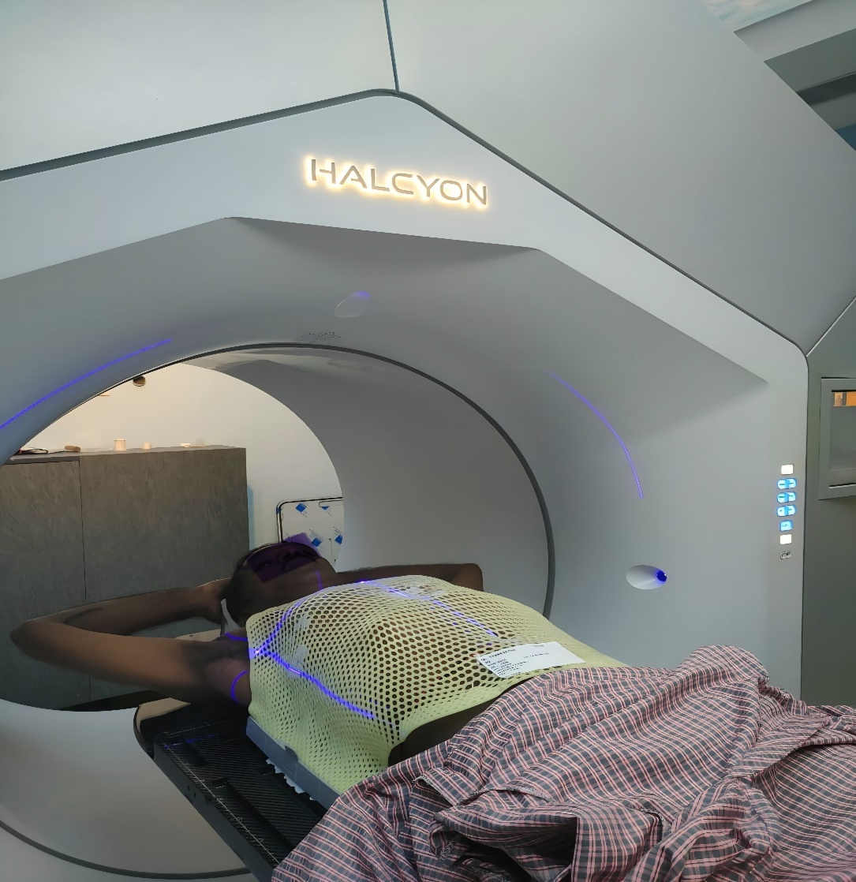
Figure 1 : Photo Of the Treatment Setup

VOLUME DELINEATION –
On the treatment planning system of Varian Eclipse VERSION 17.1.
The cranio-caudal borders of the Gross Tumour Volume (GTV) were defined by combining information from diagnostic and planning CT scans, complemented by endoscopic results. In situations where various modalities generated differing impressions, the GTV was contoured to incorporate the largest tumour extent indicated by any source. Axial tumour limits were identified largely from CT scans.
Clinical Target Volume (CTV) delineation adheres to the 2015 expert consensus recommendations for IMRT planning in Esophageal and gastroesophageal junction cancers, in combination with conventional radiation contouring concepts.⁸
SUPERIOR MARGIN: The upper CTV border extended 3–4 cm above the maximum GTV involvement or at least 1 cm above any visibly infiltrated periesophageal lymph node—whichever reached farther cranially. This expansion followed the anatomical course of the Esophageal mucosa rather than a uniform geometric border. For tumours situated near the upper esophagus, the superior boundary was not extended over the cricoid cartilage unless direct disease involvement was visible.⁸
INFERIOR MARGIN: For lesions in the proximal or mid-thoracic esophagus, the CTV extended 3–4 cm inferior to the GTV along the Esophageal mucosa. However, for distal Esophageal and gastroesophageal junction tumours, implementing this similar extension would include excessive stomach capacity at decisive dosage levels (≈50.4 Gy). Thus, a decreased inferior margin of at least 2 cm of markedly uninvolved stomach mucosa was advised. When lower, surgically targeted dosages (≤45 Gy) were recommended, a larger inferior margin (≥4 cm) might be considered, particularly when the tumour visibly expanded into the stomach. These criteria exclude Siewert type III lesions, which penetrate >5 cm into the stomach and should be contoured using gastric cancer methods.⁸

RADIAL EXPANSION: The CTV encompassed the GTV and any clinically affected nodes with a minimum circumferential margin of 1 cm. Following IASLC guidelines, station 8 peri-Esophageal lymph nodes were included inside this radial limit. growth into the heart and pericardium was restricted to ~0.5 cm unless the tumour directly abutted cardiac tissues, since myocardial microscopic spread is uncommon without gross invasion and needless growth increases cardiac dosage. Similarly, infiltration into unaffected liver tissue was confined to ~0.5 cm. When motion-control methods—such as respiratory gating or an internal target volume (ITV)—were applied, the heart and liver could be securely excluded from the CTV since their movement provided a lesser risk of compromising target coverage. The vertebral bodies were also avoided unless imaging indicated direct tumour invasion.⁸

PLANNING TARGET VOLUME (PTV): To account for setup variability and organ motion, the CTV was extended by 5 mm in the transverse plane and 10 mm in the superior–inferior direction. Centres might change these numbers depending on their own accuracy in patient positioning and internal motion evaluation.⁸

For treatment planning, the radiation dose was prescribed to the planned target volume (PTV). Target adequacy was measured using V95%, defined as the proportion of the PTV receiving at least 95% of the given dose. Organ-at-risk (OAR) dose limits were imposed and evaluated by dose–volume histogram (DVH) analysis, based on which the ideal strategy was determined. Image guiding was accomplished utilising daily cone-beam CT (CBCT) for setup verification at the start of each treatment session, after which therapy was provided accordingly. All patients got radiation on a Halcyon Elite 6 MV FFF linear accelerator.

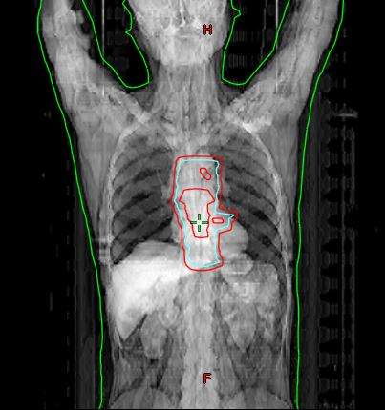
Figure 2: Target volume delineation
ORAGANS AT RISK:

Table 1: Dose Constraints for The Organs at Risk

OARS | DOSE CONSTRAINTS
COMBINED LUNG MEAN DOSE | </= 20 Gy
COMBINED LUNG V20 | </= 35%
HEART MEAN DOSE | </=26 Gy
HEART V25 Gy | </= 50%

RESULTS : Table 2 : Patient Characteristics :
PATIENT CHARACTERISTICS | DISTRIBUTION IN OUR STUDY
AGE DISTRIBUTION – Number of patients and percentage | </= 60 years - 4 (19.04 %)  60 – 65 years - 6 (28.5 %)  65-70 years - 5 (23.8 %)  >/= 70 years - 6 (28.5 %)
TUMOR EXTENT – Number OF CASES and percentage | UPPER ESOPHAGUS = 3 (14.28%)  MID ESOPHAGUS = 10 (47.61%)  LOWER ESOPHAGUS +/- EXTENSION TO GE JUNCTION = 8 (38.1 %)  TOTAL CASES = 21 (100 %)
HISTOLOGICAL TYPE – Number of cases and percentage | MDSCC = 10 (47.61 %)  WDSCC = 4 (19.04%)  PDSCC = 5 (23.8%)  ADENO CARCINOMA = 2 (9.5 %)  TOTAL = 21 (100 %)
T STAGING DISTRIBUTION -  Number of Cases and percentage | T2 = 4 (19.4)  T3 = 5 (71.42 %)  T4 = 2 (9.5 %)  TOTAL = 21 (100 %)
N STAGING DISTRIBUTION -  Number of cases and percentage | N010 = (47.61 %)  N1 = 7 (33.3%)  N2 = 1(4.76%)  N3 = 3 (14.28%)  TOTAL = 21(100 %)
DISTRIBUTION AS PER STAGE GROUPING -  Number of cases | STAGE II = 9  STAGE III = 8  STAGE IV = 4  TOTAL = 21

ORGANS AT RISK:
1.COMBINED LUNG:
The mean lung dose was lower in VMAT (14.9 ± 2.28Gy) compared to 3DCRT (15.78 ± 3.1Gy) however, this difference was not statistically significant as (p = 0.136). Similarly, the volume of the combined lung receiving at least 20Gy (V20) in VMAT is 21.50 ± 6.6% and in 3DCRT is 27.75 ± 7.36%, but and this difference was statistically significant as p value is 0.001.

Table 3: Dosimetric comparison of combined lung mean dose and V20 between VMAT & 3DCRT
VARIABLE | VMAT | 3DCRT | P value
LUNG | Mean ± sd | Mean ± sd
COMBINED LUNG MEAN | 14.9 ± 2.28 | 15.78 ± 3.1Gy | 0.136
COMBINED LUNG V20 | 21.50 ± 6.6 | 27.75 ± 7.36 | 0.001

Graph 1: Dosimetric comparison of combined lung mean dose and V20 between VMAT and 3DCRT

2.HEART:
The mean heart dose was lower in VMAT (17.51 ± 5.4Gy) compared to 3DCRT (23.2± 6.4 Gy) however, this difference was statistically significant (p = <0.001). Similarly, the volume of the heart receiving at least 25Gy (V25) in VMAT is 24.38 ± 11.7 % and in 3DCRT is 42.31± 15.13%, that too denoted a significant difference with (p = <0.001).

Table 4: Dosimetric comparison of heart mean dose and V25 between VMAT& 3DCRT
VARIABLE | VMAT | 3DCRT | P VALUE
HEART | Mean ± sd | Mean ± sd
MEAN HEART DOSE | 17.51 ± 5.4 | 23.2± 6.4 | <0.001
V25 | 24.38 ± 11.7 | 42.31± 15.13 | <0.001

Graph 2: Dosimetric comparison of heart mean dose and V25 between VMAT and 3DCRT

DISCUSSION :
Our study results showed that the volume of the combined lung receiving at least 20Gy (V20) in VMAT is 21.50 ± 6.6% and in 3DCRT is 27.75 ± 7.36%, and this difference was statistically significant as p value is 0.001. In our prospective study, the mean lung dose was lower with VMAT (14.9 ± 2.28 Gy) compared with 3DCRT (15.78 ± 3.1 Gy). Although this difference did not reach statistical significance (p = 0.136), it may be attributable to the larger tumour volumes treated, which could diminish the observable advantage of VMAT in this parameter. However, VMAT dose to mean lung was lower and is at advantage at reducing risk of RILI and other lung effects of radiation in longer term Compared to 3DCRT.
Yuxin Duan’s study published in November 2021 was comparable to ours, where in which MLD, lung V₂₀ and V₃₀ in VMAT plans were lower than other techniques such as IMRT plans (p < 0.05). V₂₀. The analysis of lung data showed that VMAT MLD and V20 as the two main predictors for lung toxicity 20 was reduced by 3.2% on VMAT compared to IMRT in his study. Similar results were also observed in MLD, where VMAT reduced MLD by 4.8% compared to IMRT.⁹ This study compares VMAT with better techniques than 3DCRT,thus establishing superiority of VMAT to 3DCRT likewise.⁹
Also , Hao Yang et al. in 2016 demonstrated that VMAT provides superior organ-at-risk (OAR) sparing compared with conventional radiotherapy techniques. Their study reported lung V20 values of 22.4%, 16.3%, and 15.4% for 3DCRT, IMRT, and VMAT, respectively (P = 0.001). Reflecting these lower lung dose–volume parameters, the IMRT and VMAT cohorts exhibited markedly fewer cases of grade 1 radiation pneumonitis on imaging than the 3DCRT group. Yang also referenced findings from Uno et al , which indicated a 14% reduction in late radiation pneumonitis with longer follow-up.¹⁰
Tsujino et al. discovered that the V20 was the lone factor related with grade ≥ 2 RP following conclusive CCRT . the 6-month cumulative incidences of grade ≥ 2 RP were 8.7, 18.3, 51, and 85% in patients with V20 s of < 20%, 21–25%, 26–30, and > 31%, respectively. The 6-month cumulative incidence of grade ≥ 2 RP among their patients was 14% in those with V20 s up to 25 and 63% in those with V20 s ≥26%. Data from a major meta-analysis of predictors of RP indicated that the rates of symptomatic RP were 18.6 and 30.3% in patients with V20 s < 20% and 20–29.99%, respectively, while the rates of fatal pneumonitis were 2.9 and 3.5% in patients with V20 s of 30–40% and ≥ 40%, respectively.¹¹Adding to the importance of V20 in reducing risk of fatal pneumonitis.¹¹
Additionally, a retrospective examination of 166 lung cancer patients was conducted to complement our prospective outcome analysis. The likely risk factors for radiation-induced lung injury were identified using the model. The frequency of RILI of grade 3 or above was 23.8% in this group. The incidence of grade 3 or higher RILI was significantly correlated with radiation dosage, volume at least received 20Gy (V20), mean lung dose, and NLR, according to univariate analysis (P = 0.012, 0.008, 0.012, and 0.039, respectively). Total radiation ≥ 60 Gy, V20 ≥ 20%, mean lung dose ≥ 12 Gy, and neutrophil to lymphocyte ratio ≥ 2.2 were shown by multivariate analysis to be independent prognostic factors for RILI (P = 0.010, 0.043, 0.028, and 0.015, respectively). Receiver operator characteristic curves were used to construct a prediction model of RILI based on the identified risk factors. The results showed that the analysis of V20, mean lung dosage, and NLR together was superior than the examination of each variable separately. They also found that individuals with higher baseline NLR levels benefited from the limitation of V20 and mean lung dose. The frequency of grade 3 or higher RILI for individuals with high NLR levels may be reduced from 63.3% to 8.7% if the V20 value and mean lung dose are below the threshold value. Radiation dosage, V20, mean lung dose, and NLR were shown to be independent predictors of RILI in this experiment; a combination study of V20, mean lung dosage, and NLR may provide a more accurate model for RILI prediction. Our study's lowered V20 and lung mean dosage also seeks to lower the risk of RILI, particularly grade 3 or higher, which is mostly dose dependant.¹²
Potential phase I research also indicated that IMRT(advanced technique like VMAT ) was linked with a worldwide decrease in normal tissue exposure compared to 3-dimensional conformal radiation, and that the former as related with a substantial reduction in V20 (21.5% vs. 26.5%, p < 0.01) and MLD (11.9 Gy vs. 14.9 Gy, p < 0.01) compared to the latter.¹³

Chun et al. undertook a secondary analysis of the RTOG 0617 study and showed that patients in the IMRT group had considerably fewer incidences of grade ≥ 3 RP than did those in the 3-dimensional conformal radiation group (7.9% vs. 3.5%, p = 0.039).¹⁴
Arriving at the cardiac mean dose in our study, it was 17.51 ± 5.4 Gy for VMAT, while for 3DCRT, it was 23.2 ± 6.4 Gy (p < 0.001). Also, compared to 3DCRT (42.31 ± 15.13%), heart V25 was significantly lower with VMAT (24.38 ± 11.7%), and this difference was very significant (p < 0.001).
2010 saw the publication of the main Quantitative Analyses of Normal Tissue Effects in the Clinic (QUANTEC), which included acute pericarditis and late cardiac death as outcomes for radiotherapy-induced cardiac problems. The QUANTEC states that in order to maintain toxicity rates under 15% for acute pericarditis, V30Gy (in 1.8-2 Gy/day) should be less than 46% and the mean heart dose should be less than 26 Gy. This is consistent with our work, which also produced reduced lung volume V25 (24.338% in VMAT) and Dmean (17.5Gy).¹⁵
Our results were on par and better than Shohei Tanaka’s study whether VMAT combining functional avoidance approaches might lower dose delivery to the myocardium in early-stage Esophageal cancer without compromising either PTV coverage or surrounding normal tissue limits. Their studies demonstrated that function-guided planning yielded mean reductions of 5.7% and 2.5% in myocardial V30 and V40, respectively, with reported heart Dmean of 26.3 ± 0.4 Gy and V30 of 28.7 ± 3.3%.13 This was the first research to utilise functional myocardial avoidance with VMAT in EC and verified that such alterations did not negatively affect overall plan quality.¹⁶

In Research by Yongkai Lu et al, according to normal tissue complication probability (NTCP) modelling, patients in the high Mean Cardiac Dose group demonstrated a substantially enhanced model-predicted risk of developing pericarditis (OR = 6.66, 95 % CI: 1.32–33.56, P = 0.046) compared to the low MCD group. The medium MCD group did not exhibit a statistically significant increase in risk (OR = 0.71, 95 % CI: 0.29–1.01). Notably, the projected risk rose considerably over a threshold MCD range. The connection remained strong across several adjusted models, including those accounting for age, BMI, comorbidities, and other factors. These data emphasise the crucial significance of MCD as a prognostic factor for radiation-induced pericarditis, underlining the necessity of rigorous dose control to prevent this adverse outcome in breast cancer patients. This research study also holds good for radiation treatment for Esophageal cancer or any other thoracic malignancy.¹⁷
Also in Aurelie Garant MD et study al 465 consecutive patients with esophageal cancer were treated with chemoradiation therapy among multiple institutions with 3DCRT , IMRT & Proton Therapy . Patients who received 3D CRT experienced higher rates of arrhythmia (P = .0001), pericardial effusion (P = .0001), pneumonia (P = .0017), pleural effusion (P ≤ .0001), and respiratory insufficiency (P ≤ .0001) compared with patients who received IMRT and PBT,which also implies VMAT technique in our study with much better results than 3DCRT.¹⁸

CONCLUSION:
Definitive radiotherapy using VMAT is dosimetrically superior to the 3DCRT plan owing to its superior conformity. VMAT with image guidance, dramatically decreases the high-dose involvement of organs at risk (OAR), mean lung dose being lower with VMAT (14.9 ± 2.28 Gy) and V20 in VMAT being 21.50 ± 6.6% which is below the threshold of risk of developing radiation pneumonitis post radiation according to multiple studies. Mean cardiac dose was 17.51 ± 5.4 Gy, while for 3DCRT, it was 23.2 ± 6.4 Gy (p < 0.001). Also, compared to 3DCRT (42.31 ± 15.13%), heart V25 was significantly lower with VMAT (24.38 ± 11.7%).These values signify as a predictive factor for risk of radiation induced pericarditis and other cardiac morbidities in the longer run also. This in turn can help improvise better methods of dose delivery and encourage more centres to adapt to newer planning techniques.

Disclaimer (Artificial intelligence)
Option 1:
Author(s) hereby declare that NO generative AI technologies such as Large Language Models (ChatGPT, COPILOT, etc.) and text-to-image generators have been used during the writing or editing of this manuscript.
Option 2:
Author(s) hereby declare that generative AI technologies such as Large Language Models, etc. have been used during the writing or editing of manuscripts. This explanation will include the name, version, model, and source of the generative AI technology and as well as all input prompts provided to the generative AI technology
Details of the AI usage are given below:
1.
2.

REFERENCES

- Jiang W, Zhang B, Xu J, Xue L, Wang L. Current status and perspectives of esophageal cancer: a comprehensive review. Cancer Communications. 2025 Mar;45(3):281-331. https://doi.org/10.1002/cac2.12645
- Morgan E, Soerjomataram I, Rumgay H, Coleman HG, Thrift AP, Vignat J, Laversanne M, Ferlay J, Arnold M. The global landscape of esophageal squamous cell carcinoma and esophageal adenocarcinoma incidence and mortality in 2020 and projections to 2040: new estimates from GLOBOCAN 2020. Gastroenterology. 2022 Sep 1;163(3):649-58.
https://doi.org/10.1053/j.gastro.2022.05.054
- Rajput N, Gholap D, Mhatre S, Dikshit R. Epidemiological review: esophagus squamous cell carcinoma in India. Indian Journal of Medical and Paediatric Oncology. 2022 Oct;43(05):393-403. https://www.thieme-connect.com/products/ejournals/html/10.1055/s-0042-1755445
- Puhr HC, Prager GW, Ilhan-Mutlu A. How we treat esophageal squamous cell carcinoma. ESMO open. 2023 Feb 1;8(1):100789. https://doi.org/10.1016/j.esmoop.2023.100789
- Li C, Wang X, Wang L, Chen J, Zhang W, Pang Q, et al. Clinical practice and outcome of radiotherapy for advanced esophageal squamous cell carcinoma between 2002 and 2018 in China: The multi-center 3JECROG survey. Acta Oncologica. 2021 Apr 1;60(5):627–34. https://doi.org/10.1080/0284186X.2021.1902564
- Wang H, Wei J, Zheng Q, Meng L, Xin Y, Yin X, Jiang X. Radiation-induced heart disease: a review of classification, mechanism and prevention. International journal of biological sciences. 2019 Aug 8;15(10):2128.https://pmc.ncbi.nlm.nih.gov/articles/PMC6775290/
- Chen F, Niu J, Wang M, Zhu H, Guo Z. Re-evaluating the risk factors for radiation pneumonitis in the era of immunotherapy. Journal of Translational Medicine. 2023 Jun 7;21(1):368. https://doi.org/10.1186/s12967-023-04212-5
- Wu AJ, Bosch WR, Chang DT, Hong TS, Jabbour SK, Kleinberg LR, Mamon HJ, Thomas Jr CR, Goodman KA. Expert consensus contouring guidelines for intensity modulated radiation therapy in esophageal and gastroesophageal junction cancer. International Journal of Radiation Oncology* Biology* Physics. 2015 Jul 15;92(4):911-20. https://doi.org/10.1016/j.ijrobp.2015.03.030
- Duan Y, Liu X, Liu Z, Zhan N, Zhu Z, Deng Z. Dosimetric and Efficiency Comparisons between Volumetric Modulated Arc Therapy and IMRT for Cervical-Thoracic Esophageal Cancers. Journal of Cancer Therapy. 2021 Nov 1;12(11):593-601
- Yang H, Feng C, Cai BN, Yang J, Liu HX, Ma L. Comparison of three-dimensional conformal radiation therapy, intensity-modulated radiation therapy, and volumetric-modulated arc therapy in the treatment of cervical esophageal carcinoma. Diseases of the Esophagus. 2017 Feb 1;30(2). https://search.ebscohost.com/login.aspx?direct=true&profile=ehost&scope=site&authtype=crawler&jrnl=11208694&AN=122603480&h=8u5gw7Vq7qzEWRIfOhQgb4ymQoZ8TT2xQ6kOvcYB0qKRPhzqJOWOXxKm5RRGHcAdTyUpHR4wMtcT8RSHMhGUiA%3D%3D&crl=c
- Palma DA, Senan S, Tsujino K, Barriger RB, Rengan R, Moreno M, Bradley JD, Kim TH, Ramella S, Marks LB, De Petris L. Predicting radiation pneumonitis after chemoradiation therapy for lung cancer: an international individual patient data meta-analysis. International Journal of Radiation Oncology* Biology* Physics. 2013 Feb 1;85(2):444-50. https://doi.org/10.1016/j.ijrobp.2012.04.043
- Pan WY, Bian C, Zou GL, Zhang CY, Hai P, Zhao R, Wang YY. Combing NLR, V20 and mean lung dose to predict radiation induced lung injury in patients with lung cancer treated with intensity modulated radiation therapy and chemotherapy. Oncotarget. 2017 Jul 6;8(46):81387.
- Boyle J, Ackerson B, Gu L, Kelsey CR. Dosimetric advantages of intensity modulated radiation therapy in locally advanced lung cancer. Advances in Radiation Oncology. 2017 Jan 1;2(1):6-11. https://www.sciencedirect.com/science/article/pii/S245210941630104X
- Chun SG, Hu C, Choy H, et al. Impact of intensity-modulated radiation therapy technique for locally advanced non–small-cell lung cancer: A secondary analysis of RTOG 0617. J Clin Oncol. 2017;35(1):56–62.
- Gagliardi G, Constine LS, Moiseenko V, Correa C, Pierce LJ, Allen AM, Marks LB. Radiation dose–volume effects in the heart. International Journal of Radiation Oncology* Biology* Physics. 2010 Mar 1;76(3):S77-85.
- Tanaka S, Kadoya N, Umezawa R, Nemoto H, Katsuta Y, Ito K, Takeda K, Jingu K. Evaluation of the dosimetric impact of heart function-based volumetric modulated arc therapy planning in patients with esophageal cancer. Radiological Physics and Technology. 2021 Sep;14(3):279-87. https://link.springer.com/article/10.1007/s12194-021-00623-5
- Lu Y, Hui B, Hu W, Zhang Y, Wang M, Xie Z, Zhang F, You J, Hu L, Zhao D, Qian A. Association of mean cardiac dose with model-predicted risk of radiation-induced pericarditis in breast cancer patients. Current Radiopharmaceuticals. 2026 Jan 1;19(1):100001. https://www.sciencedirect.com/science/article/pii/S1874471025000015
- Garant A, Spears G, Routman D, Whitaker T, Liao Z, Harmsen W, Liu A, Haddock M, Hallemeier C, Lin S, Merrell K. A multi-institutional analysis of radiation dosimetric predictors of toxicity following trimodality therapy for esophageal cancer. Practical Radiation Oncology. 2021.

