Original Research Article
Morphological and quality assessment of drought-tolerant tea clones in Bangladesh

ABSTRACT
Morphological characters and liquor quality of selected 8 tea (Camellia sinensis) clones were compared in the nurseries of Chandpore tea estate and Nalua tea estate, Habiganj district and Tea Germplasm Center of Sylhet Agricultural University, Sylhet from 2021 to 2024. Single leaf stem cuttings of 8 selected tea clones from 6 tea estates were collected and raised in two nurseries. Growth performance of cuttings was recorded with environmental parameters. The highest survivability rate was observed in C4 (78%), while the highest mortality rate was recorded in C5 (62%). Under 70% field capacity, C21 showed the best results in leaf number (93), where C7 and C11 showed the best results in leaf length (12cm). C11 showed the best results in leaf breadth (5cm). The highest number of branches was recorded in C7 (16). Survivability studies of 8 selected tea clones with 02 check varieties (BT2, BT19) were conducted at controlled conditions (screen-house) as well as at natural field conditions providing normal and supplementary watering with 03 replications. Treatment 1 was conducted with normal watering; 100% field capacity and Treatment 2 with supplementary watering; 70% field capacity. One of our main objectives was to evaluate drought tolerance of the tea clones where root performance played a vital role. Study of root was conducted from the initiation of root. C5 produced the highest root volume (132ml) where C19 had highest length of root (20.7cm). Data-logger was used to record the microclimatic data. In organoleptic taste, C7 was found as the best green tea producing clones among others.

Keywords: Tea, drought, morphology, liquor quality

1. INTRODUCTION
Tea is the number one aromatic beverage after water in the world, which is prepared from cured or fresh leaves of Camellia sinensis. The majority of tea is produced in Asia and Africa, and Bangladesh is the 11th largest tea producer in the world and the industry accounts for 2% of the global tea production.
The woody and evergreen shrub has unique morphological traits that are tailored to its tropical and subtropical growing conditions. Although the plant usually reaches a height of 3–4 m, it is frequently trimmed to make a bushy shape for easy plucking. Tea leaves are typically dark green, simple, alternate, lanceolate and have slightly serrated edges. The plant yields tiny, fragrant, five-petaled white blooms, and its fruit is a capsule that contains many seeds. Tea plants can be categorized morphologically according to the size, shape, and bud formation of their leaves; the traits of the cultivar affect the tea liquor quality. Furthermore, in areas with erratic rainfall, tea plants' deep root structure facilitates their ability to draw water from lower soil layers (Zdunek-Zastocka et al., 2019).
Tea is grown in a rain-fed perennial mono-cropping system; hence, optimal growth and development of tea plants mostly depend on macro and microclimatic conditions prevailing in the tea ecosystem. Global climatic conditions have been alarmingly changed over the past years. Notably, the global average temperature has increased by around 2ºC during the last few decades (Han et al., 2018). Climate driven drought has emerged as a big challenge for the tea growing countries (Sang, 2016). Drought has exerted a great impact on the growth and development of tea plants. Ochieng et al. (2016) predicted that tea would be one of the most adversely affected crops by global warming. Increasing temperature and drought are posing a significant threat to the resilience of the tea production system. Drought is one of the main limiting factors affecting tea yield and quality. Gupta et al. (2013) found that under drought stress, the yield of tea was reduced by up to 40% due to wilting of their leaves. Climate models indicate that drought episodes will become more frequent because of the long-term effect of global warming (Salinger et al., 2005).
The color, taste, aroma, and clarity of the brewed tea are individually considered to be a part of tea liquor quality, and these factors greatly influence the tea's market value and consumer choice. Many variables, such as the chemical makeup of the leaves, the technique of processing, and the climate in which the tea is grown, affect its quality. The astringency, bitterness, and scent of tea are influenced by the presence of polyphenols, caffeine, amino acids, and essential oils, which are the main chemicals for liquor quality (Zhao et al., 2017). For instance, teas with higher catechin content typically taste more astringent, whereas those with higher theanine content have a smoother, sweeter flavor (Ng’etich et al., 2020). The chemical profile of tea leaves is shaped by climate variables, including temperature, precipitation, and soil type, which have a direct impact on the quality of the liquor. Cooler climates tend to produce teas with lighter and more delicate flavors, whereas higher temperatures tend to produce teas with darker liquor and a more robust flavor.
Tea estates of Bangladesh are already frequently facing the negative effects of drought. For example, a reduction in tea yield of around 14–40% has been reported in the Sylhet region (Das et al. 2012). They also reported 7.72%, 11.92%, and 12.52% yield losses in 2018, 2019, and 2020, respectively, due to drought stress. The tea industry of Bangladesh significantly contributes to the economy and supports the livelihoods of a huge workforce. The negative effect of drought will not only affect the tea production but also the economy and livelihoods of this large workforce. Hence, the development of drought tolerant tea clones is of utmost importance for the sustainability of the rain-fed tea industry of Bangladesh. Prolonged dry periods can severely hinder tea production, leading to substantial yield losses and diminished tea quality. Drought-tolerant clones can ensure a more stable supply of tea, reducing economic vulnerability through maintaining tea productivity and quality in dry periods. The development and adoption of drought tolerant tea clones are therefore essential for mitigating the adverse effects of drought, safeguarding the livelihoods of tea farmers, and thereby enhancing the long-term sustainability of tea production in Bangladesh.
2. Materials and Methods
Study site: The study was carried out in tea nurseries of Chandpore tea estate and Nalua tea estate in Habiganj district and Tea Germplasm Center of Sylhet Agricultural University (SAU), Sylhet, from 2021 to 2024 (Fig. 1). We chose these tea estates because they are located in Luskerpore valley, considered the most drought prone area for tea cultivation in Bangladesh. Chandpore is a plain land tea estate with sandy to sandy-loam soil, while Nalua is low to medium high tillah (hillock land) with sandy-loam to loamy soil. Tea Germplasm Center of SAU is located in Surma valley and the land is medium tillah with loam to clay-loam soil.
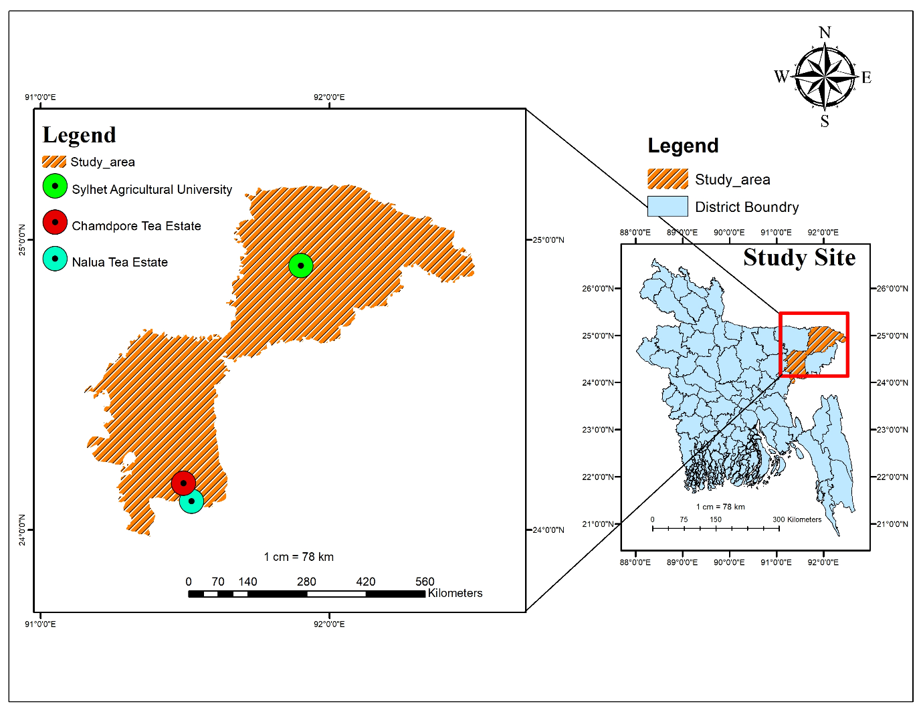
Fig. 1. Map showing the study site at Chandpore tea estate and Nalua tea estate, Habiganj district and Tea Germplasm Center at Sylhet Agricultural University, Sylhet.
Collection of cuttings and growing of tea saplings: Branches of 8 selected tea clones having morphologically different characters were collected from 6 tea estates of Sylhet, Moulvibazar and Habiganj districts. Cuttings of 8 tea clones were prepared and planted for raising saplings at the tea nurseries of Chandpore Tea Estate and Nalua Tea Estate. At the nursery, land preparation was done with the proper drainage system. Polytubes were made ready with a proper soil mixture. Cuttings were made ready with the help of a sharp knife and then soaked in fungicide solution to avoid fungal infection. Cuttings were transplanted immediately into the soil of polytubes. Proper tagging was done after transplanting the cuttings in the nurseries.
Transferring tea saplings to screen-houses: After ten months, saplings were transplanted to earthen pots under screen-house conditions. The experiment started in October 2022 in two locations, one in the experimental farm of Sylhet Agricultural University (SAU) campus and another in Chandpore Tea Estate. Two screen-houses each measuring 10.0 m (length) × 7.92 m (width) × 1.98 m (high), were constructed at the SAU campus and Chandpore Tea Estate. Transparent plastic sheets (made by RFL Bangladesh) of 4.75 m in length, 0.82 m in width and 1 mm in thickness were used at the top of screen-houses. A total of 80 saplings of 10 tea clones (8 collected clones and 2 controls) were planted in earthen pots (10 × 4 × 2 cm³) in each screen-house. Pot size was 30 cm in diameter and 25 cm in depth containing 15 kg of soil. Ten-month-old saplings were evaluated under normal watering (100% field capacity) with a supplementary watering (70% field capacity) scheme. The treatments (Soil Moisture Content) were applied at screen-house conditions. Moisture content (Field Capacity, FC) of soils inside the earthen pots was evaluated using the gravimetric method. Weather data of Chandpore Tea Estate, Chunarughat, Habiganj, during the study are shown in Appendix 1.
Treatments:
Factor A: Soil Moisture Content
T₁ = Control (normal watering; 100% field capacity)
T₂ = With supplementary watering (70% field capacity)
Factor B: Tea clones
Eight selected clones were transplanted under field conditions in October 2023. Clones were evaluated under normal watering (FC 100%) and supplementary watering (FC 70%) in the experimental plots, where BT2 and BT19 were used as the check (control) varieties. Data on the chlorophyll content was measured using a SPAD Meter at 30-day intervals and expressed in SPAD unit (μg cm⁻²).
Steps of the Green Tea Preparation:
Withering of leaves for green tea: After plucking, we took the leaves to the quality control room of Chandpore tea estate for withering. We withered the leaves at room temperature with aeration by a ceiling fan for the full time. We put the green leaf in a variety-wise separate sheet of paper for 24 hours. We turn the leaves after every 06 hours to ensure proper withering. Our green leaf was in proper, withered condition after 24 hours.
Hand rolling: After withering, one of the most important steps is hand rolling. We took the withered leaf in our palms and rolled gently until it formed a roll.
Drying: The final step of green tea preparation is drying. We took the hand-rolled green leaves into an oven to dry at 70$°$C for 3-4 minutes. We took out the oven-dried green leaves, which had become ready for liquor preparation. The brewing system of green tea is shown in Fig. 2.

Fig. 2. Brewing system of Green Tea

Organoleptic tastes of green tea: Organoleptic tastes of green tea made from 8 selected clones, along with two control varieties of tea, were performed with the help of experienced tea personnel to determine the liquor quality of tea.

3. Results and Discussion
Survival rate, root and shoot initiation of 8 selected tea clones: Significant diversity was seen in the survival percentage of ten tea clones evaluated on July 31, 2022 (Fig. 3). In C5 (ML5Y1), the survival rate was 62%, while in Check2 (BT19), it was 82%. Comparable to the standard checks (BT2 and BT19), the experimental clones C4 (ML4Y1) and C19 (RG2Y1) showed good survival rates (78% and 76%, respectively), whereas C5 (ML5Y1) showed the lowest survival (62%). While clones C11 (SAU1Y1) and C21 (BJ1Y1) recorded survival rates of 66% and 68%, respectively, clones C1 (ML1Y1) and C16 (LK2Y1) demonstrated moderate survival (74%).
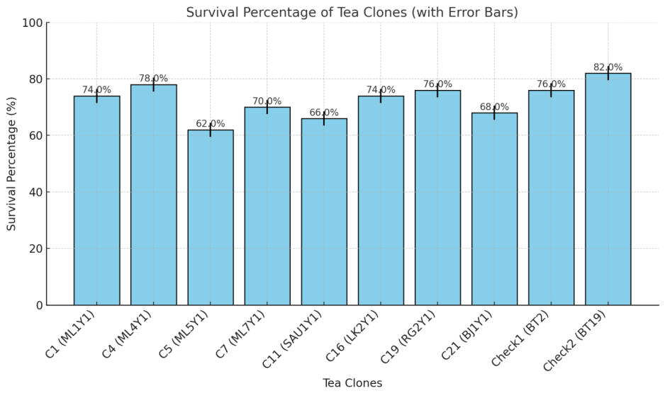
Fig. 3. Survival percentage of eight tea clones under nursery conditions
Their innate genetic heterogeneity and early establishment stage of environmental adaptation may be the root cause of the observed variations in survival rates among clones. Das et al. (2021) have found that emphasizing the considerable importance of genotype-specific physiological features, including as rooting ability and stress tolerance, on cutting survival and sapling establishment. Furthermore, clones like C4 and C19 may be suitable for large-scale planting initiatives and propagation due to their greater survival rates.
These outcomes are consistent with those reported by Han et al. (2018), who emphasized the contribution of clonal selection to enhancing plantation sustainability and propagation success in a range of climatic circumstances. In order to guarantee constant performance, clones that show satisfactory survival rates in nursery settings can be regarded as promising candidates for additional assessment in widescale field trials.
Chlorophyll content in leaves of 8 selected clones: The chlorophyll concentration (µg cm2) of various tea clones is displayed in the heatmap (Fig. 4), which clearly demonstrates genotype diversity. With darker green hues, Clone C5 (ML5) had the greatest chlorophyll concentration (82.66 µg cm²), followed by Check1 (BT2) (79.36 µg cm²) and C7 (ML7) (76.54 µg cm²). On the other hand, the lowest quantities of chlorophyll were found in C21 (BJ1) (56.78 µg cm²) and C19 (RG2) (58.93 µg cm²), as seen by their lighter green hues.
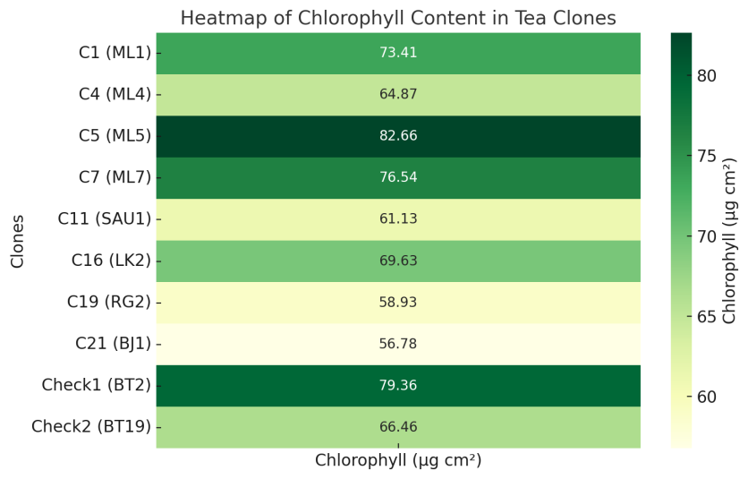
Fig. 4. Heatmap of chlorophyll content of eight tea clones under screen-house conditions
One important measure of photosynthetic efficiency and plant health under both stress and normal circumstances is the amount of chlorophyll present. Better growth and yield performance may result from clones with higher chlorophyll concentrations, such as C5 and BT2, which indicate improved photosynthetic capability and adaptability. Tea genotypes with higher amounts of chlorophyll showing improved productivity and drought tolerance.
Clone C21 and C19 may have lower chlorophyll contents, which could be a sign of decreased photosynthetic efficiency or stress sensitivity. Environmental stress is frequently associated to chlorophyll degradation, which results in reduced carbon absorption and plant performance. All factors considered, the observed variety emphasizes how crucial it is to use high-chlorophyll clones (such as C5, BT2) for breeding initiatives meant to increase tea productivity and drought tolerance.
Morphological characteristics of 8 selected tea clones: The variance in several physical characteristics across tea clones is graphically depicted in the heatmap. Superior vegetative growth is indicated by clones like C4 (ML4), C5 (ML5), and C7 (ML7), which consistently display darker hues across features including plant height, leaf number, shoot production, and root volume (Fig. 5). Clones C16 (LK2) and C21 (BJ1), on the other hand, show worse morphological performance, as seen by lighter colors in a number of criteria.

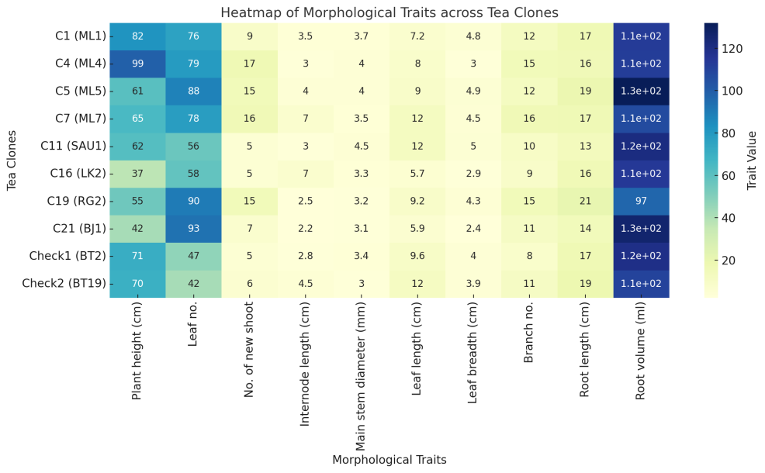
Fig. 5. Heatmap of morphological traits across eight tea clones at field conditions

Important findings include:
Plant Height & Shoots: The tallest plants, C4 (ML4) and C7 (ML7), have more shoots, which is advantageous for yield and plucking.
Leaf Characteristics: C21 (BJ1) exhibits a large number of leaves but a smaller leaf size and width, indicating a higher density.
Root Features: Strong anchoring and nutrient absorption potential are indicated by the superior root length and volume of C5 (ML5) and C19 (RG2).
The adaptability and yield potential of tea clones are greatly influenced by morphological variety. High productivity and resistance to abiotic stress are better suited for clones with vigorous shoot growth and extensive root systems (such as C5 and C7). These characteristics enhance canopy structure and maximize photosynthesis.
Han et al. (2018) found that deep-rooted tea clones maintain improved water status under stress condition, which is consistent with root features that are essential for drought tolerance. Meanwhile, photosynthetic capacity is influenced by leaf size and number, confirming that clones with more functioning leaves produce higher yields.
All factors considered, this heatmap highlights that C4, C5, and C7 have balanced root and vegetative features, which makes them attractive options for breeding initiatives that target both stress resilience and production.

Production of 2.5 years old clones under field conditions: The graph (Fig. 6) illustrates the comparative performance of ten tea clones (C1, C4, C5, C7, C11, C16, C19, C21, Cntl1, and Cntl2) across five yield-contributing characteristics: 100 fresh shoot weight, shoot length, plucking points per bush, green leaf per bush, and plucking round interval. C1 recorded the highest shoot weight (78 g), followed by C4 (69 g), while C21 and Cntl2 exhibited the lowest (51 g). This indicates C1’s superior biomass production.
C16 showed the longest shoots (7.3 cm), significantly higher than C19 (5.5 cm), suggesting better vegetative vigor. C4 (76) and C7 (73) had the most plucking points, while C19 had the lowest (54), highlighting higher shoot density in the former. C1 and C7 produced the highest green leaf weights (33 g), indicating better cumulative yield potential.
Most clones required 7–9 days between plucking rounds. Faster plucking cycles (7 days) were observed in C5, C7, and C19, which is desirable for frequent harvests.

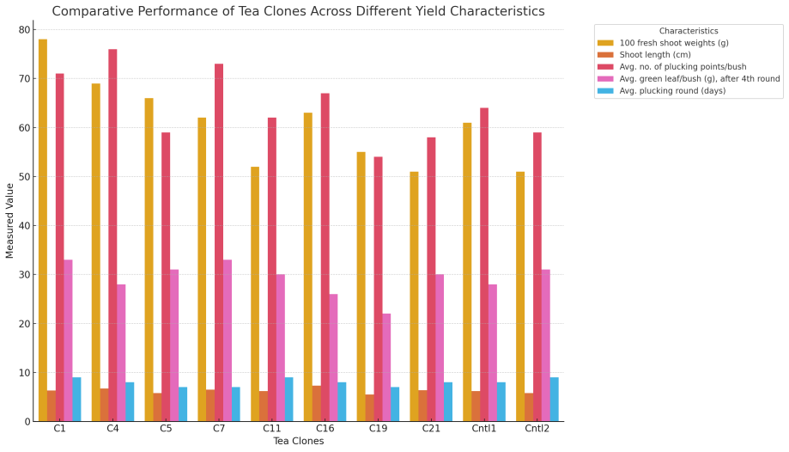
Fig. 6. Comparative performance of eight tea clones across different yield characteristics

According to the findings, C1, C4, and C7 showed outstanding yield features, which shows that they could be very productive under the evaluated conditions. While C4 and C7 had combined good shoot density and plucking intervals, C1 was superior in fresh shoot weight and green leaf output. C19, on the other hand, trailed in the majority of metrics, suggesting less appropriateness.
These results are consistent with other previous studies that highlighted the significance of shoot weight, plucking point density, and shorter plucking intervals as critical factors influencing the potential yield of tea. The output of commercial tea can be greatly increased by choosing clones with these characteristics.

Liquor quality of 8 selected tea clones: Organoleptic tastes of 8 selected clones were performed by three expert tea tasters to evaluate the liquor quality (Table 1). According to the opinions of two tasters, C7 (ML7) ranked the top (40 out of 50, indicated E- Excellent) among the ten clones while another taster gave C5 (ML5) as the top rank followed by C7 (ML7) and C11 (SAU1).

Table 1. Liquor rating of selected 8 clones by organoleptic taste

Clones | Infusion  (10) | Liquor color (10) | Briskness  (10) | Strength  (10) |  | Aroma  (10) |  | Total  (50) |  | Remarks
C1 (ML1) | 7 | 8 | 7 |  | 6 |  | 8 |  | 36 |  | AA
C4 (ML4) | 7 | 7 | 7 |  | 8 |  | 8 |  | 37 |  | AA
C5 (ML5) | 8 | 8 | 8 |  | 7 |  | 7 |  | 38 |  | AA
C7 (SHU1) | 8 | 9 | 8 |  | 7 |  | 8 |  | 40 |  | E
C11 (TP3) | 7 | 7 | 6 |  | 6 |  | 8 |  | 34 |  | AA
C16 (LK2) | 6 | 7 | 8 |  | 7 |  | 7 |  | 35 |  | AA
C19 (RG2) | 7 | 8 | 7 |  | 5 |  | 6 |  | 33 |  | AA
C21 (BJ1) | 8 | 7 | 7 |  | 6 |  | 7 |  | 35 |  | AA
Check (BT2) (Control 1) | 8 | 7 | 7 |  | 7 |  | 7 |  | 36 |  | AA
Check (BT19) (Control 2) | 7 | 7 | 8 |  | 6 |  | 7 |  | 35 |  | AA
Note: A: Average (below 30), AA: Above Average (30-39), E: Excellent (above 40)

Figure 7 illustrates the total polyphenol (%) and caffeine (%) content across 10 tea clones, highlighting biochemical diversity among genotypes.
Clone C4 (26.33%) recorded the highest polyphenol level, followed closely by C16 (25.17%) and C7 (24.65%), while C21 (19.69%) showed the lowest.
Clone C21 (2.18%) exhibited the highest caffeine concentration, whereas C7 (0.87%) was the lowest, suggesting its potential suitability for low-caffeine tea markets.
Clones like C4 and C16 combined high polyphenol content with moderate caffeine levels, desirable for both health benefits and consumer preference.

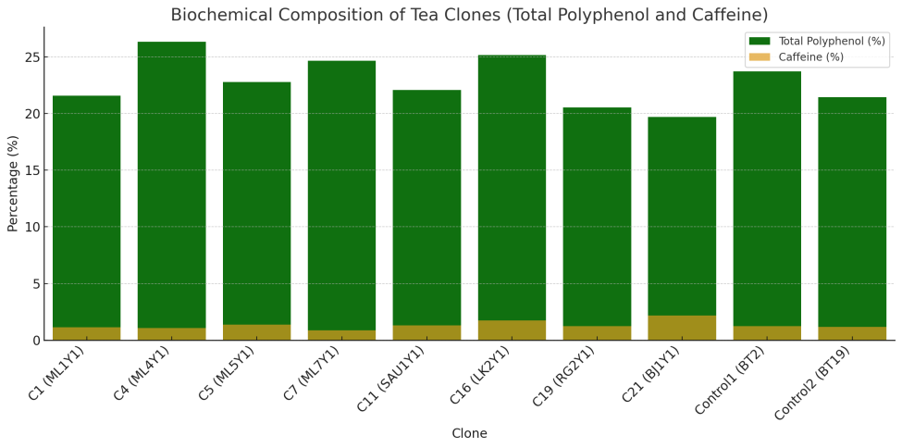
Fig. 7. Biochemical composition of eight tea clones

The quality, health advantages, and market acceptance of tea are all significantly influenced by its biochemical makeup. The observed differences in caffeine and polyphenol content between clones are consistent with earlier research showing that both characteristics are highly impacted by environment and genotype (Obanda et al., 2004; Owuor & Obanda, 2007).
The main components of tea's astringency, briskness, and antioxidant activity are polyphenols. The higher levels of polyphenols in C4 (26.33%) and C16 (25.17%) indicate that these clones have the potential to produce premium liquor with robust antioxidant properties. Yao et al. (2006) observed similar results, emphasizing that clones with greater levels of catechin (a key polyphenolic group) are preferable for processing black tea because of their significance in the synthesis of the flavin.
Caffeine affects consumer preferences by imparting bitterness and stimulatory effects. Because of their lower caffeine levels, clones C7 (0.87%) and C4 (1.07%) are appealing to markets seeking tea with less caffeine. C21's high caffeine content (2.18%) would be appropriate for special tea markets that cater to customers looking for a potent stimulant. According to earlier research, cultivars' caffeine contents vary greatly (0.5–5%) (Ashihara & Crozier, 2001).
A balance between polyphenols and caffeine is frequently required for high-quality tea. Clones C4 and C16 are excellent choices because they support quality and health claims by combining moderate caffeine with high levels of polyphenols. These clones support the findings of Han et al. (2018), who found that moderately caffeinated teas rich in polyphenols had better cup quality and were more palatable to consumers.

4. Conclusion
In order to thoroughly assess the morphological responses, drought tolerance, and liquor quality characteristics of certain tea clones, all planned tests were methodically carried out in nursery, screen-house, field, and laboratory settings. A thorough grasp of clone performance in water-deficit scenarios pertinent to Bangladesh's tea-growing regions was made possible by the integration of multi-environment studies.

According to thorough organoleptic evaluations, the clones C7 (ML7), C5 (ML5) and C11 (SAU1) consistently displayed high-quality liquor and also found better morphological characteristics. These clones showed good shoot growth patterns, attractive leaf traits and increased biochemical qualities that enhanced the cup's overall quality, color, aroma and briskness. These quality parameters environmental stability underscores their potential for usage in commercial production programs.

Overall, the results show that C4 and C5 may be useful genetic resources for creating drought-tolerant varietals whereas C7, C5 and C11 are excellent prospects for enhancing tea quality. These clones may greatly improve the sustainability of tea production, guarantee a steady supply and lessen the negative effects of drought stress brought on by climate change in Bangladesh's tea sector. They can be suggested for additional multi-location experiments.
Disclaimer (Artificial intelligence)
Option 2:
The authors hereby declare that generative AI technologies were used during the writing and editing of this manuscript. Details of the AI usage are provided below:
Name of the AI Tool: ChatGPT
Provider / Source: OpenAI (https://chat.openai.com)
Model Used: GPT-5.1
Version / Access Date: Multiple sessions between October–November 2025
Details of the AI usage are given below:
1. Refining scientific language
2. Improving clarity and coherence of paragraphs
References

- Ashihara, H., & Crozier, A. (2001). Caffeine: A well-known but little mentioned compound in plant science. Trends in Plant Science, 6(9), 407–413. https://doi.org/10.1016/s1360-1385(01)02055-6
- Bajoub, A., Medina-Rodríguez, S., Gómez-Romero, M., Ajal, E. A., Bagur-González, M. G., Fernández-Gutiérrez, A. and Carrasco-Pancorbo, A. 2017. Assessing the varietal origin of extra-virgin olive oil using liquid chromatography fingerprints of phenolic compound, data fusion and chemometrics. Food Chemistry. https://doi.org/10.1016/j.foodchem.2016.07.140
- Bangladesh's tea production in 2023 hit all-time high - Nation Thailand. (2024, January 18). Retrieved from https://www.nationthailand.com/world/asia-pacific/40034830
- Camellia sinensis - Wikipedia. (n.d.). Retrieved from https://en.wikipedia.org/wiki/Camellia_sinensis
- Lindsey, R. and Dahlman, L. Climate.gov. (2025). Climate Change: Global Temperature. NOAA Climate.gov. Retrieved from https://www.climate.gov/news-features/understanding-climate/climate-change-global-temperature
- Das A, Das S and Mondal TK. 2012. Identification of differentially expressed gene profiles in young roots of tea [Camellia sinensis (L.) O. Kuntze] subjected to drought stress using suppression subtractive hybridization. Plant Molecular Biology 30:1088–1101.
- Das AC, Noguchi R and Ahamed T. 2021.An assessment of drought stress in tea estates using optical and thermal remote sensing. Remote Sensing,13:2730. doi.org/10.3390/rs13142730
- FAO. (2015). Socio-economic implications of climate change for tea producing countries. FAO. Retrieved from https://openknowledge.fao.org/server/api/core/bitstreams/9de9d599-037c-4706-bdf6-3968ba44c3ee/content
- Gupta S, Bharalee R, Bhorali P, Das SK, Bhagawati P, Bandyopadhyay T, Gohain B, Agarwal N, Ahmed P, Borchetia S, Kalita MC, Handique A K and Das S. 2013. Molecular analysis of drought tolerance in tea by cDNA-AFLP based transcript profiling. Molecular Biotechnology,53:237–248.
- Han W, Li X, Yan P, Zhang L and Ahammed G J. 2018. Tea cultivation under changing climatic conditions. Global tea science: Current status and Future needs. Pp. 455-472. doi.org/10.19103/AS.2017.0036.19
- Ng’etich, W. K., Nyariki, J. N., Muoki, R. C., Bore, J. K., & Wachira, F. N. (2020). Combating climate change in the Kenyan tea industry. Frontiers in Plant Science, 11, 339. https://doi.org/10.3389/fpls.2020.00339
- Obanda, M., Owuor, P. O., & Mang’oka, R. (2004). Changes in chemical constituents and polyphenol oxidase activity of tea leaves with shoot maturity. Food Chemistry, 87(3), 395–404. https://doi.org/10.1016/j.foodchem.2003.11.016
- Owuor, P. O., & Obanda, M. 2007. The use of green tea (Camellia sinensis) leaf flavan-3-ol composition in predicting plain black tea quality potential. Food Chemistry, 100(3), 873–884. https://doi.org/10.1016/j.foodchem.2005.10.030
- Ochieng J, Kirimi L, Makau J. 2017. Adapting to climate variability and changes: farmer perceptions, strategies and climate trends. Natural Resources Forum. V-41, Issue-4, Pp-195-208. https://doi.org/10.1111/1477-8947.12111.
- Salinger M J, Sivakumar M V K, Motha R. 2005. Reducing vulnerability of agriculture and forestry to climate variability and change: workshop summary and recommendations. Climate Change. Pp. 341-361.
- Sang, S. (2016). Tea: Chemistry and Processing. Encyclopedia of Food and Health, 268-272. https://doi.org/10.1016/B978-0-12-384947-2.00685-1
- Tea production in Bangladesh - Wikipedia. (n.d.). Retrieved from https://en.wikipedia.org/wiki/Tea_production_in_Bangladesh
- Tea production falls amid bad weather, quality push - The Daily Star. (2023, February 25). Retrieved from https://www.thedailystar.net/business/news/tea-production-falls-amid-bad-weather-quality-push-3815571
- Yao, H., Friedman, M., Henika, P. R., & Levin, C. E. (2006). Antioxidant activity of Camellia sinensis leaves and tea from a commercial tea pilot plant. Journal of Agricultural and Food Chemistry, 54(3), 1151–1158. https://doi.org/10.1021/jf052376g
- Zdunek-Zastocka, E. and Grabowska, A. (2019). The interplay of PsABAUGT1 with other abscisic acid metabolic genes in the regulation of ABA homeostasis during the development of pea seeds and germination in the presence of H2O2. Plant Science, 78(5), 67-75. https://doi.org/10.1016/j.plantsci.2019.05.005

Months | Year
Months | 2021 |  |  | 2022 |  |  | 2023 |  |  | 2024
Months | Mean  temp (ºC) | RH (%) | Rainfall  (mm) | Mean  temp (ºC) | RH (%) | Rainfall  (mm) | Mean  temp (ºC) | RH (%) | Rainfall  (mm) | Mean  temp (ºC) | RH (%) | Rainfall  (mm)
January | 17 | 63 | 0 | 18 | 66 | 18 | 18 | 66 | 0 | 17 | 62 | 0
February | 21 | 58 | 0 | 19 | 67 | 27 | 21 | 63 | 8 | 23 | 60 | 2
March | 26 | 77 | 34 | 27 | 77 | 23 | 25 | 74 | 140 | 24 | 68 | 43
April | 29 | 81 | 147 | 28 | 78 | 83 | 29 | 81 | 149 | 27 | 79 | 188
May | 27 | 85 | 208 | 29 | 87 | 487 | 29 | 85 | 131 | 30 | 83 | 204
June | 27 | 84 | 295 | 27 | 79 | 338 | 29 | 85 | 472 | 28 | 88 | 371
July | 29 | 82 | 335 | 29 | 81 | 338 | 29 | 84 | 398 | 28 | 86 | 232
August | 26 | 81 | 296 | 29 | 77 | 252 | 29 | 82 | 320 | 30 | 84 | 167
September | 29 | 78 | 261 | 28 | 83 | 218 | 30 | 85 | 243 | 29 | 87 | 211
October | 27 | 78 | 201 | 27 | 80 | 227 | 27 | 81 | 223 | 28 | 78 | 133
November | 23 | 73 | 0 | 25 | 72 | 0 | 25 | 74 | 96 | 23 | 72 | 17
December | 20 | 66 | 40 | 17 | 66 | 0 | 21 | 76 | 40 | 18 | 68 | 0
Appendix 1. Weather data of Chandpore Tea Estate, Chunarughat, Habiganj during the period from 2021 to 2024

