Short Research Articles
Varying trends and characteristics in soil properties in transition ecosystems. A case study of the Tonle Sap riverbank to paddy fields.

.
ABSTRACT

Aims: to assess whether rural settlement areas (RSA) function as transitional zones between the temporarily flooded forests and paddy fields.
Study design: Chhnuk trou commune, Kampong Chhnang province, Cambodia was selected.
Place and Duration of Study: 101 samples were collected form the study area. Soil samples were selected with 4 types of land use (Riverbank, flooded forest, Rural settlement areas, and paddy fields). Soil samples were collected in all plots in the dry season at the same depth level (0-10cm).
Methodology: All the samples analyzed the soil physicochemical such as Bulk density, soil particle size, pH and Electrical conductivity (EC), soil organic matter and C stocks. The experiment was carried out in the soil laboratory at the Institute of Technology of Cambodia.
Results: The results revealed a fertility gradient from the riverbank to the paddy fields, with higher clay contend and carbon concentrations observed in riverbank and flooded forest. Interestingly, RSA exhibited distinct soil properties with localized enrichment in clay and carbon, most likely driven by anthropogenic factors such as waste accumulation and sediment redistribution.
Conclusion: These findings emphasize the unique pedological characteristics of RSA and underscore the importance of considering them in land-specific soil management strategies within floodplain landscapes.

Keywords: Land use gradient, Transitional zone, Rural settlement area, Carbon stock, Floodplain soil fertility.

1. INTRODUCTION

Landscapes of the Tonle Sap region are intricately shaped by the seasonal dynamics of water, creating a unique and interconnected environment (Sithirith, 2011). The Tonle Sap River, a unique and dynamic water system in Cambodia, plays a vital role in environmental conservation and supports the livelihoods of millions of people (Sithirith, 2015). Renowned for its seasonal flow reversal, the river is essential in regulating flooding, purifying water, and supporting a rich biodiversity, including one of the world’s largest inland fisheries (Uk et al., 2018). Annually, nutrient-rich sediments carried by the river’s seasonal flow reversal enrich the surrounding floodplains, boosting soil fertility and supporting agriculture, particularly rice farming (Sok, 2023). In this environment, sediments deposited by the Tonle Sap River are crucial for the region's ecological health and the livelihoods of local communities (Kummu et al., 2008). Temporary flooded forests are usually found after the floodplains. Several studies showed that these unique ecosystems have a high clay and soil organic matter contents, nutrient status, and water-holding capacity (Zhao et al., 2005) due to their tendency to promote sediment deposition during flooding(Siev et al., 2018). Flooded forests also act as natural buffers between the riverbanks of the Tonle Sap and the low-density rural settlement areas (RSA), which are inhabited and cultivated by local populations, extending to the surrounding paddy fields (Nuorteva et al., 2010). RSA are home to both land-based and floating settlements. Inhabitants do not only live in homes built on stilts or floating platforms to adapt to seasonal flooding but also engage in diverse livelihood activities. Households often cultivate small vegetable gardens for daily food consumption, grow staple crops like rice, and raise livestock such as chickens, ducks, or pigs (Chea et al., 2024). Fishing is another essential activity, with many families relying on lake and river fisheries as their primary source of income and protein (Sok et al., 2019). Moreover, the use of local natural resources, such as water plants, firewood, and wild foods from flooded forests, is widespread and deeply integrated into their way of life (Sok et al., 2019). These communities, although self-sufficient, frequently struggle with inadequate infrastructure, environmental deterioration, such unpredictable drought or flooding (Chea et al., 2024).
Located between flooded forests and paddy fields, the RSA zone is subject to human activities that are likely to confer distinct properties to its soils. Therefore, the aim of this article is to determine if RSA constitutes a transitional zone between the temporary flooded forests and paddy fields. Our hypothesis is that there is a fertility gradient from the riverbanks of the Tonle Sap to the paddy fields, with high levels of soil organic carbon and clay contents along the riverbanks and in the flooded forests, extending through the RSA zone to the rice fields, where the soils are the sandiest and poorest in soil organic carbon.

2. material and methods

2.1. Study area

Soil sampling was realized in the Chhnuk Trou commune, Baribour district, Kampong Chhnang province, Cambodia in the tail of Tonle Sap Lake (12°30'13.7"N 104°27'16.0"E), (Fig. 1). The precipitation varies between 1,000 to 1,250 mm year⁻¹, with a rainy season from May to October, followed by a dry season lasting from December to April (Uk et al., 2018). During the rainy season, the Tonle Sap River reverses its flow, carrying water from the Mekong River into Tonle Sap Lake and flooding the surrounding riverbanks and floodplains. As a result, the lake’s surface area expands from about 2,500 km² in the dry season to nearly 10,000 km² in the wet season (Lamberts, 2001). In each land use, the soils were sampled randomly from top soil, 0-10 cm depth, during the dry season in January 2023 along a topographic gradient 0.17% slope from river bank to paddy fields: (i) the riverbanks (n = 39), (ii) the flooded forests (n = 30), (iii) the RSA (n = 19), and (iv) the paddy fields (n = 13).

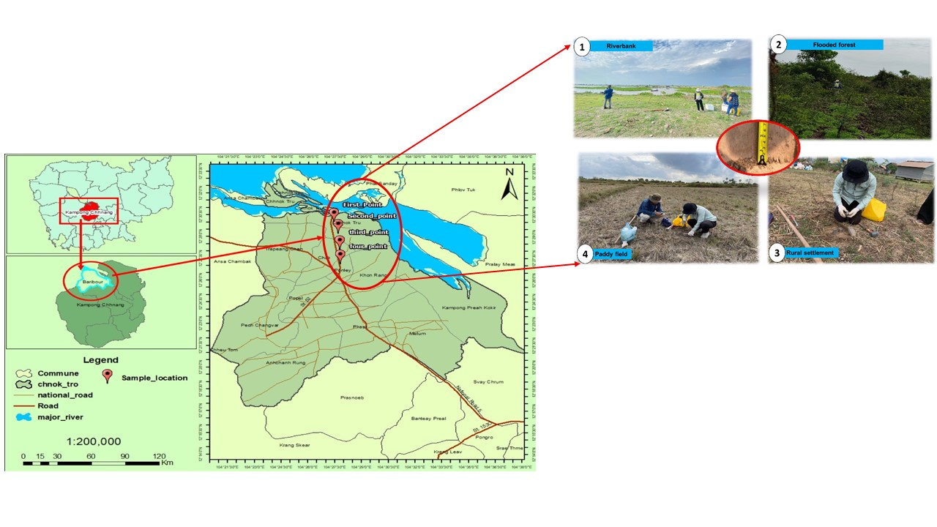
Figure 1. Map of study site. Four red points on the map represent the locations of selected land uses:(1) river banks, (2) flooded forests, (3) rural settlements, and (4) paddy field.

2.2. Analyses

Bulk density was determined by cylinder method and using 100 cm³ ring (FAO, 2023). The soil particle size distribution was measured after the destruction of organic matter by 30% hydrogen peroxide (H₂O₂) and dispersion with sodium hexametaphosphate (NaPO₃)₆. The proportion of sand (50-2,000 $μm$) was obtained by wet sieving, while the proportions of silt (2-50 $μm$) and clay (< 2 $μm$) were obtained by using ASTM 152-H hydrometers (Gee et al., 2002). The soil pH and electrical conductivity (EC) were determined in a 1:2.5 (soil: water) suspension (Mathieu, C and Pieltain, 2003) with portable pH (Hanna instrument, HI99121) and EC(Hanna instrument, HI99300 and HI99301) devices. The Loss on Ignition method was employed to analyze the soil organic matter (SOM, in g kg⁻¹) content, using a furnace set at 360°C for 2 hours (Gavlak et al., 2005). The coefficient of 1.72 was used to convert the amount of SOM to C content (Nelson et al., 1982). The C stocks (in Mg ha⁻¹) were calculated by multiplying the C content (in g kg⁻¹) by the bulk density (in g cm⁻³) and the soil depth (10 cm), then dividing the result by 1000 (Guo, L. B. and Gifford, 2002).

2.3 Statistical analyses

Data describing soil physical and chemical parameters were tested for homogeneity of variance and normality using Levene and Shapiro-Wilk tests. Moreover, differences in soil properties were calculated using one-way analysis of variance (ANOVA) and least significant difference (LSD). Prior to analysis, the homogeneity of variances was inspected using Levene’s test, and data were log-transformed if needed. Pairwise comparisons were made with Kruskal-Wallis tests with a false discovery rate correction followed by Mann-Whitney U tests when ANOVA assumptions were not met. Differences among treatments were declared significant at the P < 0.05 probability level. Principal Component Analysis (PCA) was also carried out from soil properties. All statistical analyses and visualizations were carried out with R version 4.1.1 (https://www.r-project.org/) and using “ade4”, “ggplot2” and “factoextra” packages.
3. results and discussion

This study confirms that land use significantly shapes soil properties in the floodplain, illustrating clear differences between habitats (Appling et al., 2014). Results from the PCA supports this pattern, showing that 74.9% of the variation in soil characteristics was explained by the first two dimensions (Fig. 2). These dimensions reflect the influence of both natural gradients and anthropogenic pressures: sand and pH aligned positively with the first axis, while clay and carbon stock aligned negatively, suggesting interlinked shifts in texture and fertility across land use types (Smith et al., 2002) (Fig. 2). Indeed, the distribution of particle size and carbon content followed a gradient from the riverbank to the paddy fields (excluding the RSA), with higher concentrations of clay and carbon, and higher EC in the riverbank area, followed by the flooded forest, and lowest in the paddy fields (Table 1). This aligns with the dynamic hydrological nature of these landscapes and their role in buffering changes between upland and lowland areas (Siev et al., 2018).
Obviously, proximity to the river could not be the only explanation, and the specific properties of the paddy fields could also be interpreted by agricultural intensification, which often leads to the depletion of fine particles and organic matter (Duman et al., 2023). Tillage, irrigation, and crop harvesting likely contribute to soil compaction and nutrient loss, as reflected in the relatively high bulk density values observed in these areas (Liu et al., 2021). While the pH of paddy soils was the highest among land uses in this study, it remained below the optimal range for rice cultivation (Delgoda et al., 2023)(Mandal et al., 2020), indicating possible acidification due to prolonged cultivation and chemical inputs.
The soil characteristics in the RSA area diverged from the gradient pattern observed from the riverbank to the paddy fields, indicating localized specific soil composition and properties. Indeed, RSA displayed the highest clay content, carbon stock, and EC values, suggesting a localized enrichment of soil fertility. Due to the lack of permanent vegetation and the presence of infrastructure, the RSA area is expected to have a reduced capacity to trap sediments over time (Siev et al., 2018). Therefore, the similarity in clay and carbon content between RSA soils and those of the riverbank suggests that the RSA soils likely originate from riverbank sediment deposition and waste accumulation. Indeed, the practice of exploiting riverbank soils by farmers has long been documented, particularly because this media is known to enhance the fertility and nutrient levels of cultivated soils (Marcaida et al., 2020). Another contributing factor is that bringing in soil raises the elevation above seasonally flooded areas, such as forests and riverbanks, thereby providing protection for homes, crops, and livestock.
In terms of carbon dynamics, our finding confirms that the amendment of clay-enriched sediments enhances soil carbon stocks (Lal, 2004; Post, Wilfred and Kwon, 2000). While the carbon stock in the top 10 cm of paddy field soils was relatively low (0.36 Mg ha⁻¹), it increased significantly in the RSA area, reaching 0.68 Mg ha⁻¹. This value was comparable to those observed in the riverbank and flooded forest soils, with carbon stocks of 0.64 and 0.62 Mg ha⁻¹, respectively. Therefore, the primary transition in carbon stock occurred at the level of the paddy fields, whereas human activities in the RSA area did not lead to carbon depletion but rather acted as a temporary carbon sink. However, although rural settlements exhibited localized carbon hotspots, these may be vulnerable due to their dependence on sustained human activity.

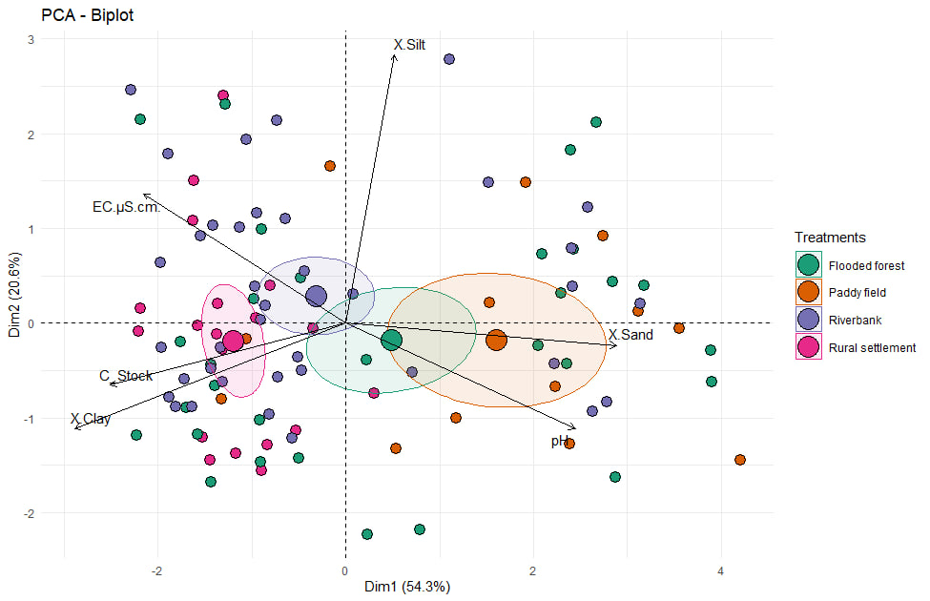
Figure 2. Graphical display of the first two axes of the Principal Component Analysis (PCA) on the soil properties (pH, EC in µS cm-1, and percentages of carbon(C), clay, silt, and sand) measured in soils from different land uses (paddy fields, rural settlement areas, flooded forests, and riverbanks) around of the Tonle Sap Lake. Components (Dim 1 and 2) are given in the figure.

 | BD (g cm-3) | pH | EC (µS cm⁻¹) | C (%) | Clay (%) | Silt (%) | Sand (%)
Paddy field | 1.28ª | 4.79 ª | 196.75 ª | 2.83 ^{c} | 45.37 ^{c} | 17.96 | 36.03 ª
Paddy field | (0.28) | (0.67) | (195.92) | (1.64) | (28.01) | (12.09) | (29.30)
Rural settlement areas | 0.91^{c} | 4.30 ^{c} | 742.82 ^{c} | 7.49 ª | 79.71ª | 16.66 | 3.26 ^{c}
Rural settlement areas | (0.25) | (0.30) | (533.51) | 1.08) | (8.91) | (9.18) | (3.31)
Flooded forest | 1.25^{ab} | 4.71 ^{ab} | 367.10 ^{ab} | 4.96 ^{bc} | 52.69^{bc} | 20.25 | 26.57 ^{ab}
Flooded forest | (0.26) | (0.50) | (519.64) | 3.38) | (26.81) | (12.53) | (22.89)
Riverbank | 1.05^{bc} | 4.37 ^{bc} | 639.40 ^{bc} | 6.13 ^{ab} | 63.37^{ab} | 21.61 | 14.37 ^{bc}
Riverbank | (0.28) | (0.47) | (491.68) | (2.52) | (22.13) | (11.67) | (20.18)
F-values | 7.15 | 5.67 | 4.06 |  |  | 0.90
Chi² |  |  |  | 21.96 | 15.121 |  | 13.62
P-values | < 0.001 | 0.001 | 0.009 | <0.001 | 0.001 | 0.443 | 0.003
Table 1. Average values of the physical and chemical properties of soils sampled in the paddy field, rural settlement areas, flooded forest and riverbank. Values in brackets correspond to standard deviations. Descriptive statistics and analysis of variance (ANOVA) of soil physicochemical properties in all land uses.

4. Conclusion

Land use strongly influences soil physicochemical properties in the Tonle Sap floodplain. Soil texture and carbon stock showed a clear gradient form riverbank to paddy fields, reflecting both natural hydrological and anthropogenic effects. Rural settlement soils deviated from this trend, indicating localized enrichment from sediment deposition and human activity. Therefore, the protection of these areas is essential for developing land-specific soil management strategies in this floodplain landscape.

Author(s) hereby declare that NO generative AI technologies such as Large Language Models (ChatGPT, COPILOT, etc.) and text-to-image generators have been used during the writing or editing of this manuscript.

References

Appling, A. P., Bernhardt, E. S., & Stanford, J. A. (2014). Floodplain biogeochemical mosaics: A multidimensional view of alluvial soils. Journal of Geophysical Research: Biogeosciences, 119(8), 1538–1553. https://doi.org/10.1002/2013JG002543
Bank, W. (2011). Climate Risk and Adaptation Country Profile: Vulnerability, Risk Reduction, and Adaptation to Climate Change, Senegal. World Bank.
Chea, M., Fraser, B. T., Nay, S., Sok, L., Strasser, H., & Tizard, R. (2024). A Survey of Changes in Grasslands within the Tonle Sap Lake Landscape from 2004 to 2023. Diversity, 16(8). https://doi.org/10.3390/d16080448
Delgoda, K. H. B. H., Sugathas, S., Neththasinghe, N. A. S. A., Chandrasekara, E. D. C. T., Dissanayaka, D. M. S. B., Ariyarathne, M., Marambe, B., Sirisena, D. N., Rathnayake, U., Kadupitiya, H. K., & Suriyagoda, L. D. B. (2023). Variability of pH and EC of Selected Rice Cultivated Soils of Sri Lanka. Tropical Agricultural Research, 34(4), 379–394. https://doi.org/10.4038/tar.v34i4.8676
Duman, A., Yildirim, C., Tufekcioglu, M., Tufekcioglu, A., & Satiral, C. (2023). Variation in Certain Soil Properties Based on Land Use Type, and Elevation in Arhavi Sub-Basin, Artvin, Turkiye. Sustainability (Switzerland), 15(11). https://doi.org/10.3390/su15119114
FAO. (2023). Standard operating procedure for soil bulk density. Cylinder Method.
Gavlak, R., Horneck, R., & Miller, R. O. (2005). Potassium Fixation Test (Incubation Method). Soil, Plant and Water Reference Methods for the Western Region, 1, 129–134.
Gee et al., 2002. (2002). 2 . 4 Particle-Size Analysis. 255–293.
Guo, L. B. and Gifford, R. M. (2002). Soil carbon stocks and land use change: A meta analysis. Global Change Biology, 8(4), 345–360. https://doi.org/10.1046/j.1354-1013.2002.00486.x
Kummu et al. (2008). Sediment: Curse or blessing for Tonle Sap Lake? Ambio, 37(3), 158–163. https://doi.org/10.1579/0044-7447(2008)37[158:SCOBFT]2.0.CO;2
Lal, R. (2004). Soil carbon sequestration to mitigate climate change. Geoderma, 123(1–2), 1–22. https://doi.org/10.1016/j.geoderma.2004.01.032
Lamberts, D. (2001). floodplain gillnet fisheries in Siem Reap. Tonle Sap Fisheries, 141.
Liu, Z., Cao, S., Sun, Z., Wang, H., Qu, S., Lei, N., He, J., & Dong, Q. (2021). Tillage effects on soil properties and crop yield after land reclamation. Scientific Reports, 11(1), 1–12. https://doi.org/10.1038/s41598-021-84191-z
Mandal, A. K., Yadav, P. K., & Dhakal, K. H. (2020). Comparative Study of Evaluation of Soil Fertility Status in Rice Zone, Morang. Tropical Agroecosystems, 2(1), 12–25. https://doi.org/10.26480/taec.01.2021.12.25
Marcaida et al. (2020). Rice Production in Tonle Sap Floodplains in Response to Anthropogenic Changes in Hydrology , Climate , and Agronomic Practices.
Mathieu, C and Pieltain, F. (2003). Analyse chimique des sols: méthodes choisies. Tec & doc. https://books.google.dz/books?id=cDmzAAAACAAJ
Nelson et al. (1982). MatterMethods of Soil Analysis. Part 2. Chemical and Microbiological Properties. Total Carbon, Organic Carbon, and Organic., 9(9), 539–579.
Nuorteva, P., Keskinen, M., & Varis, O. (2010). Water , livelihoods and climate change adaptation in the Tonle Sap Lake area , Cambodia : learning from the past to understand the future Paula Nuorteva , Marko Keskinen and Olli Varis. 87–101. https://doi.org/10.2166/wcc.2010.010
Post, Wilfred M and Kwon, K. C. (2000). Soil carbon sequestration and land‐use change: processes and potential. Global Change Biology, 6(3), 317–327.
Siev, S., Yang, H., Sok, T., Uk, S., Song, L., Kodikara, D., Oeurng, C., Hul, S., & Yoshimura, C. (2018). Sediment dynamics in a large shallow lake characterized by seasonal flood pulse in Southeast Asia. Science of the Total Environment, 631–632, 597–607. https://doi.org/10.1016/j.scitotenv.2018.03.066
Sithirith, M. (2011). Political Geographies of the Tonle Sap : Power , Space and Resources. National University of Singapore, 403 pp.
Sithirith, M. (2015). The governance of wetlands in the Tonle Sap Lake, Cambodia. Journal of Environmental Science and Engineering B, 4(6).
Smith, J. L., Halvorson, J. J., & Bolton, H. (2002). Soil properties and microbial activity across a 500 m elevation gradient in a semi-arid environment. 34, 1749–1757.
Sok, K. (2023). Dynamics of Rural household activities and poverty at diversified agro-ecosystems of Tonle Sap lake in Battambang province , Cambodia Kimchhin Sok To cite this version : HAL Id : tel-04106872 DYNAMICS OF RURAL HOUSEHOLD ACTIVITIES AND POVERTY AT DIVERSIFI. Thesis, 20, 251. https://theses.hal.science/tel-04106872
Sok, K., Méral, P., Pillot, D., & Defossez, S. (2019). Ecosystem services from tonle sap flood pulse: Spatial and economic analysis in aek phnom and Sangkae Districts of Battambang Province, Cambodia. Advances in Global Change Research, 64, 123–151. https://doi.org/10.1007/978-3-319-90400-9_8
Uk, S., Yoshimura, C., Siev, S., Try, S., Yang, H., Oeurng, C., Li, S., & Hul, S. (2018). Tonle Sap Lake: Current status and important research directions for environmental management. Lakes and Reservoirs: Research and Management, 23(3), 177–189. https://doi.org/10.1111/lre.12222
Zhao, Y., Wang, C., Wang, S., & Tibig, L. V. (2005). Impacts of present and future climate variability on agriculture and forestry in the humid and sub-humid tropics. Climatic Change, 70(1–2), 73–116.

