Assessment of soil fertility status in Palghar district of Maharashtra through Geospatial techniques

ABSTRACT
Georeferenced surface soil samples from Six (06) tehsils were delineated using stratified random soil sampling method by using (GPS) and analyze at AICRP of Micro and Secondary Nutrients and Pollutant Elements in Soils and Plant under Department of Soil Science, Dr.Panjabrao Deshmukh Krishi Vidyapeeth, Akola, Maharashtra to assess the chemical properties, major and micronutrients status in soils of Palghar district in the year 2021-2022 of one hundred and seventy nine (179) samples at the depth of (0-20 cm) were collected across the Palghar district of Maharashtra at 5 kms grid and analysed in the laboratory. The results revealed that pH, EC, CaCO₃ and organic carbon of soils collected across different tehsils of Palghar district varies from 5.49 to 8.16,0.05 to 1.29 dS m⁻¹,0.63 to 13.25 % and 2.20 to 10.7 g kg⁻¹. Whereas available S in soils ranging 7.26 to 31.89 mg Kg⁻¹. The DTPA -Zn, Fe, Cu and Mn in soil of Palghar district ranged from 0.35 to 7.14 mg Kg⁻¹ ,5.42 to 77.32 mg Kg⁻¹ ,0.88 to 14.88 mg Kg⁻¹ and 8.53 to 79.84 mg Kg⁻¹ respectively. The CaCl₂-B in soils of all tehsils ranging 0.23 to 0.69 mg Kg⁻¹. The results were clearly showed a large variation in physio-chemical properties of soil across the Palghar district with low nutrient indices to boron (1.39), medium for Sulphur (1.75) high for zinc (2.37),iron (2.81),copper (3.0) and manganese (3.0).
Key Words: Spatial Variability, Major, Micro, Nutrients, Palghar district.

INTRODUCTION
Tools made possible by information technology include the Global Positioning System (GPS), which facilitates the methodical collection of geo-referenced soil samples and the creation of geographic information about distribution in nutrients using Geographic Information Systems (GIS).
The green revolution has improved the nation's output and guaranteed nutritional security. Nonetheless, the extensive lack of all nutrients has been brought about by the high-yielding crops that have been farmed intensively, the unbalanced application of fertilizers that lack micro- and secondary nutrients, the reduce for use of organic manures, and the absence of crop residue recycling. By applying fertilizers based on soil parameters connected to fertilizer recommendations, fertilizer input can be reduced without losing output (Yadav et al., 2018). The understanding of the regional variation in the physio-chemical properties of soil a significant impact to crop selection and cropping systems, as well as to development on concepts regarding current management practices (Weindorf and Zhu, 2010 and Liu et al., 2013).
The recent surge in population in emerging nations has raised food consumption, placing severe strain on soils and resulting in a loss in land fertility. The comprehend the reasons behind soil fertility to the decline in productivity in agriculture, this work attempts to ascertain the effects of various land use systems on soil physico-chemical characteristics, nutrient status, and fertility categorization. (Kunghe et al., 2023).
To improve and execute particular to the location management, researchers have examined variations in pH, organic carbon, accessible sulphur and micronutrients under varying soil and management regimes (Li et al., 2011). Understanding the geographical variation of nutrients to the soil necessary because the lack of micronutrients is currently a key barrier to sustainable agricultural output (Katkar et al., 2018).
Growing populations and overuse of arable land result in significant issues with declining soil fertility and worsening soil quality. According to Jagtap et al., (2018), a lack of nutrients has a direct impact on the development of crops and causes poor crop response. As result, a database to soil fertility status is necessary of the management soil resources and the long-term viability to current agricultural system.
Soil properties like pH, texture, organic matter content, type of clay mineral, and elemental correlations all have a major role in controlling the availability of nutrients in soils (Malewar.,2005).
The current investigation was carried to assess the status of significant and micronutrients that in soils as well as identify and define areas of nutrient deficiencies in Palghar district of Maharashtra, India.

MATERIAL AND METHODS
The present investigation was carried out at All India Co-ordinated Research Project on Micro and Secondary Nutrients and Pollutant Elements in Soil and Plants under Department of Soil Science, Dr. Panjabrao Deshmukh Krishi Vidyapeeth, Akola, Maharashtra to assess the chemical properties, major and micronutrients status in soils of Palghar district in the year 2021-2022.GPS based one hundred and seventy-nine (179) soil samples at the depth of (0-20 cm) were collected from 06 tehsils across the Palghar district of Maharashtra at 5 kms grid were collected and analysed in the laboratory.

Description of the study area
This experimental survey results have been conducted to Palghar district. The district and tehsils were divided by grids at 5 Kms and the experimental soil samples collected from each grid square about 20-30 villages was selected to surface exterior soil samples (0-20 cm) from each block in the district.
The location of Palghar district of Maharashtra is located between 19⁰ 41' 49'' N to 72⁰ 46' 16'' E and the total geographical area of district is is divided into six tehsils the area is 5,34,400 ha and (Mokhada, Jawhar- Vikramghad, Dahanu, Talasari, Palghar and Wada).
The GPS data (Latitude, Longitude and Altitude) was recorded at each sampling site distributed over the entire district of one hundred and seventy-nine (179) samples were collected in zig -zag pattern in V shape notch by soil quadrat.
The soil samples collected from geo-referenced location at depth (0-20 cm) were dried in shade and processed. That collected soil samples used for analysis of EC, pH, organic carbon, CaCO3, Sulphur and micronutrients (Zn, Fe, Cu, Mn and B).
Analysing and testing soil:
GPS-oriented of Palghar district the total of 179 surface soil samples (0–20 cm) were gathered from 6 tehsils. Clustered random selection was used to choose the samplings. Following Jackson's (1973) instructions, the soil samples were prepared and tested for pH & EC in soil:water suspensions (1:25 w/v). Wet oxidation, which as reported Walkley & Black (Nelson & Sommers, 1982), was used for assess to amount of organic carbon; the Rapid method (Piper, 1966) was used to calculate the amount of free CaCO3, and the Turbidimetric approach (Chesnin and Yien, 1951) was used to estimate the available S. Using an atomic absorption spectrophotometer, soil samples was extracted with 0.005M DTPA to estimate the amount of accessible zinc, iron, copper, and manganese (Lindsay and Norvell, 1978). By using the Azo-methine technique with a 0.01 M CaCl2 extract, available boron was calculated (Berger and Troug, 1939). Utilizing the formula provided by Parker et al. (1951), the nutritional indices were computed and classified as low (<1.66), medium (1.66-2.33), and high (>2.33).

Per cent samples low x 1+ per cent samples medium x 2
+ per cent sample high x3
Nutrient index = ………………………………………………….
100

In the Indian state of Maharashtra, which the main and micronutrients were divided into three categories: low, medium, and high. ( Table 1).
Table 1. Categorization of soil parameters and nutrients.
Sr. No. | Parameters | Low | Medium | High
1 | pH (1:2.5) | <6.5 (Acidic) | 6.5-7.5 (Neutral) | >7.5 (Alkaline)
2 | EC (dS m-1) | <1.0 | 1-2 | >2.0
3 | O.C. (g kg-1) | <4.0 | 4-8 | >8.0
4 | CaCO3 (%) | <3.0 | 3-8 | >8.0
5 | S (mg kg-1) | <10.0 | 10-20 | >20
6 | Zn (mg kg-1) | <0.60 | 0.60-1.80 | >1.80
7 | Fe (mg kg-1) | <4.50 | 4.50-18.0 | >18.0
8 | Cu (mg kg-1) | <0.20 | 0.20-0.80 | >0.80
9 | Mn (mg kg-1) | <2.0 | 2.0-8.0 | >8.0
10 | B (mg kg-1) | <0.50 | 0.50-1.0 | >1.0

(Source: Dr. DPKV, Akola)

Chemical properties
Sr No | Name of Tehsil | No. of samples | pH (1:2.5) |  | EC (dS m⁻¹) |  | CaCO₃ (%) |  | Org. carbon  (g kg⁻¹)
Sr No | Name of Tehsil | No. of samples | Range | Mean | Range | Mean | Range | Mean | Range | Mean
1 | Mokhada | 33 | 7.38 - 7.92 | 7.59 | 0.05 - 0.80 | 0.18 | 1.13-13.25 | 5.13 | 2.20 – 10.4 | 7.38
2 | Javhar | 34 | 7.34 - 7.76 | 7.54 | 0.10 - 0.90 | 0.23 | 1.50-10.25 | 5.13 | 2.24 – 10.2 | 6.92
3 | Dahanu | 36 | 6.23 - 7.78 | 7.43 | 0.13 - 1.29 | 0.34 | 0.63 - 5.0 | 2.67 | 5.74 – 9.81 | 8.28
4 | Talasari | 16 | 6.27 - 8.14 | 7.11 | 0.13 - 0.47 | 0.25 | 2.00 - 5.50 | 3.12 | 7.20 – 10.7 | 9.12
5 | Palghar | 30 | 5.87 - 8.16 | 6.83 | 0.10 - 0.38 | 0.20 | 0.75-11.25 | 3.85 | 2.60 – 10.3 | 8.56
6 | Wada | 30 | 5.49 - 7.83 | 6.83 | 0.09 - 0.58 | 0.22 | 2.12 - 7.62 | 5.21 | 5.56 – 10.7 | 8.61
Palghar district |  | 179 | 5.49-8.16 | 7.29 | 0.05 - 1.29 | 0.24 | 0.63-13.25 | 3.98 | 2.20 – 10.7 | 8.01
Table 2. Chemical properties of soils in Palghar district

Table 3. Available Sulphur and Micronutrients status (mg kg⁻¹) of soil in Palghar district
Sr.  No | Tehsil | Available S |  | DTPA-Zn |  | DTPA-Fe |  | DTPA-Cu |  | DTPA-Mn |  | Cacl₂ ₋ B
Sr.  No | Tehsil | Range | PSD | Range | PSD | Range | PSD | Range | PSD | Range | PSD | Range | PSD
1 | Mokhada | 8.29 - 21.40 | 33.33 | 0.35 – 5.11 | 9.09 | 7.78 – 69.52 | 0 | 0.91 –10.23 | 0 | 15.28 - 79.84 | 0 | 0.35 – 0.66 | 60.61
2 | Javhar | 8.46 – 19.55 | 41.18 | 0.88 – 6.83 | 0 | 8.03 – 55.26 | 0 | 0.88 – 6.85 | 0 | 18.11 -79.60 | 0 | 0.32 – 0.57 | 55.88
3 | Dahanu | 7.26 – 31.89 | 41.67 | 0.45 – 3.00 | 11.11 | 6.30 – 66.24 | 0 | 1.26 –10.52 | 0 | 10.98 - 79.32 | 0 | 0.39 – 0.60 | 69.44
4 | Talasari | 8.03 – 14.34 | 31.25 | 0.47 – 2.11 | 6.25 | 10.81 – 49.98 | 0 | 1.55 – 7.98 | 0 | 20.28 - 54.52 | 0 | 0.39 – 0.59 | 56.25
5 | Palghar | 8.53 – 18.14 | 13.33 | 0.55 – 3.57 | 6.67 | 5.42 – 71.68 | 0 | 2.27 –14.88 | 0 | 8.53 – 18.14 | 0 | 0.35 – 0.56 | 56.67
6 | Wada | 8.74 – 23.58 | 16.67 | 1.65 – 7.14 | 0 | 22.24 – 77.32 | 0 | 2.72- 14.60 | 0 | 38.96 - 78.12 | 0 | 0.23 – 0.69 | 63.33
Palghar district |  | 7.26-31.89 | 30.17 | 0.35-7.14 | 5.59 | 5.42-77.32 | 0 | 0.88-14.88 | 0 | 9.11-79.84 | 0 | 0.23-0.69 | 60.89

Table 4. Nutrient index values of soil available nutrients in different tehsils of Palghar district
Sr.No | Name of the  Tehsils | No. of Samples | S | Zn | Fe | Cu | Mn | B
1 | Mokhada | 33 | 1.73 | 2.27 | 2.82 | 3.00 | 3.00 | 1.39
2 | Javhar | 34 | 1.59 | 2.38 | 2.85 | 3.00 | 3.00 | 1.44
3 | Dahanu | 36 | 1.67 | 2.14 | 2.58 | 3.00 | 3.00 | 1.31
4 | Talasari | 16 | 1.69 | 2.06 | 2.94 | 3.00 | 3.00 | 1.44
5 | Palghar | 30 | 1.87 | 2.37 | 2.77 | 3.00 | 3.00 | 1.43
6 | Wada | 30 | 1.97 | 2.93 | 3.00 | 3.00 | 3.00 | 1.37
Palghar district |  | 179 | 1.75 | 2.37 | 2.81 | 3.0 | 3.0 | 1.39

Table 5. Nutrient index value Fertility rating of soil available nutrients in different tehsils of Palghar district
Sr.No | Name of the  Tehsils | No. of Samples | S | Zn | Fe | Cu | Mn | B
1 | Mokhada | 33 | M | M | H | H | H | L
2 | Javhar | 34 | L | H | H | H | H | L
3 | Dahanu | 36 | M | M | H | H | H | L
4 | Talasari | 16 | M | M | H | H | H | L
5 | Palghar | 30 | M | H | H | H | H | L
6 | Wada | 30 | M | H | H | H | H | L
Palghar district |  | 179 | M | H | H | H | H | L

RESULTS AND DISCUSSION
Soil chemical properties:
Palghar district soil pH values ranged from 5.49 to 8.16, which is somewhat acidic to alkaline (Table 2). With a mean pH of 7.29, Palghar tehsil had the highest pH (8.16) and Wada the lowest (5.49). The majority of soil samples were discovered to have a mildly to moderately alkaline character. With a mean value of 0.24 dS m-1, which was within the usual range (<1 dS m-1), all the soils were non-saline (0.05-1.29 dS m-1) and appropriate for good plant growth. Soils exhibited a range of organic carbon contents from 2.20 to 10.7 g kg⁻¹.Palghar tehsil has the highest OC content (10.7), while Mokhada tehsil has the lowest (2.20).
The major number of soil samples has low to medium levels of organic carbon. The district's soils ranged in CaCo₃ content from 0.63 to 13.25 percent, suggesting to the soils are rather calcareous. Elevated calcium carbonate is detrimental because it lowers soil micronutrient cation concentrations to a point where plants with sensitivity experience micronutrient deficiencies (Deb et al. 2009). The tehsils of Javhar, Palghar, and Mokhada have the highest calcium carbonate content.
The Status of available Sulphur:
The accessible sulfur (Table 3) showed a 30.17 percent shortage and ranged from minimal to high (7.26 to 31.89). In Dahanu tehsil alone, the highest (31.89) and lowest (7.26). The depletion of sulfur from soil may be caused by the extensive farming of crops and the utilization of fertilizers lacking in sulfur. In order to retain Fertilization of soil and a long-term yield crops grown under intense agriculture must get a balanced diet.
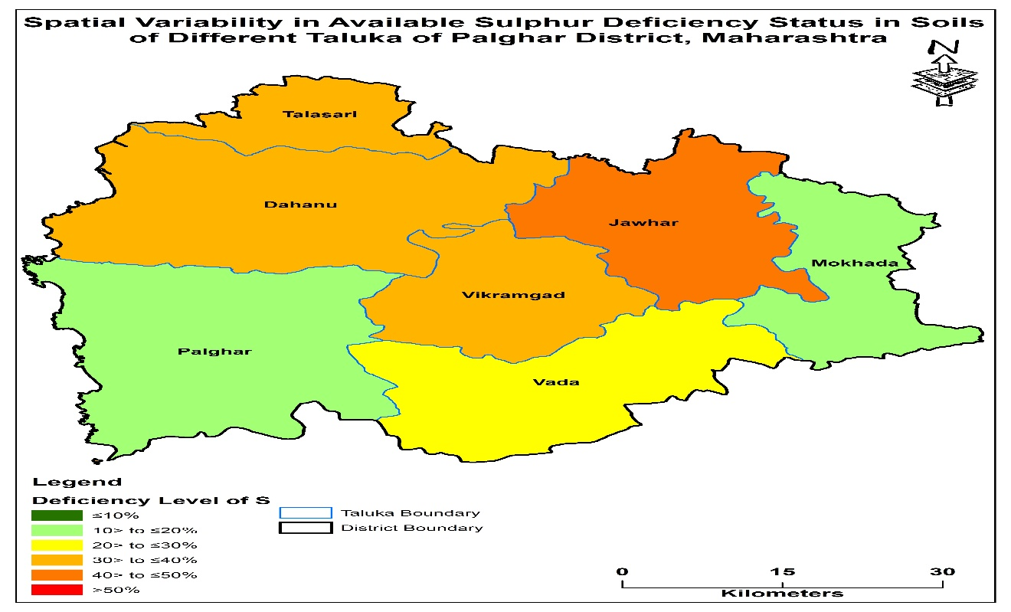
Fig 1. Spatial variability of available Sulphur in soils of Palghar district of Maharashtra.

Micronutrient status
Data on DTPA-Zn in Palghar district soils revealed in (Table 3) that the district's overall DTPA-Zn ranged from 0.35 to 7.14 mg kg-1, with Wada tehsil having highest value (7.14) and Mokhada tehsil having lowest value (0.35), signifying a 5.59 percent shortage. In contrast, 51.40 percent of the samples of Zn that were available fell into the medium group. Mokhada has the greatest deficit, followed by Dahanu. Alkaline soils typically have low levels of micronutrients and cations, which causes hidden hunger in crops cultivated on these soils (Malewar, 2005). Plants experience nutritional stress as a result it will show of soil imbalance brought on by nutrient deficiencies. high pH can fixes zinc and CaCO3 concentrations in the soil, which leads to reduction.
The micronutrient cations are extensively converted to their oxides and hydroxides in alkaline soil conditions (pH greater than 7.0), which eventually reduces their availability (Deb et al., 2012).The amount of DTPA-Fe varied greatly (5.42 to 77.32 mg kg-1) with highest value (77.32) in Wada tehsil and lowest value (5.42) in Palghar tehsil, suggesting minimal shortage.
The research area's soils had DTPA-Cu levels ranging from 0.88 to 14.88, the highest concentration in Palghar tehsil (14.88) and lowest concentration in Javhar tehsil (0.88), showing no deficit. The Palghar district's soils were all confirmed to contain an adequate amount of copper. According to Patil and Sonar (1994), in Maharashtra's swell-shrink soils.
The research region's soils exhibited DTPA-Mn values ranging from 9.11 to 79.84, with highest value found in Mokhada tehsil (79.84) the lowest range found in Palghar tehsil (8.53). This indicates there is no shortage in Mn and that all of the Palghar district's soils have enough Mn content.
In Wada tehsil alone, the available boron in CaCl2 -B ranged from 0.23 to 0.69 mg kg-1, with the maximum range (0.69) and lowest (0.23) showing a 60.89 percent shortage. (Das,2007) found that the availability of boron improved with NPK increases and that there was a positive link between boron accessibility and accessible potassium and phosphorus.
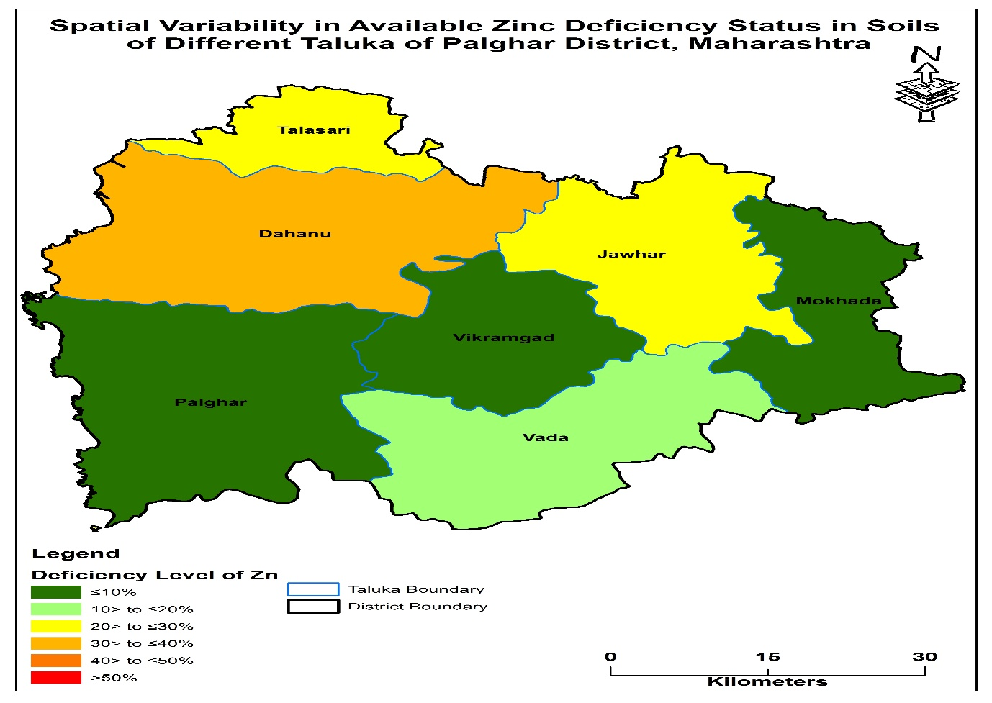
Fig 2. Spatial variability of available Zinc in soils of Palghar district of Maharashtra.

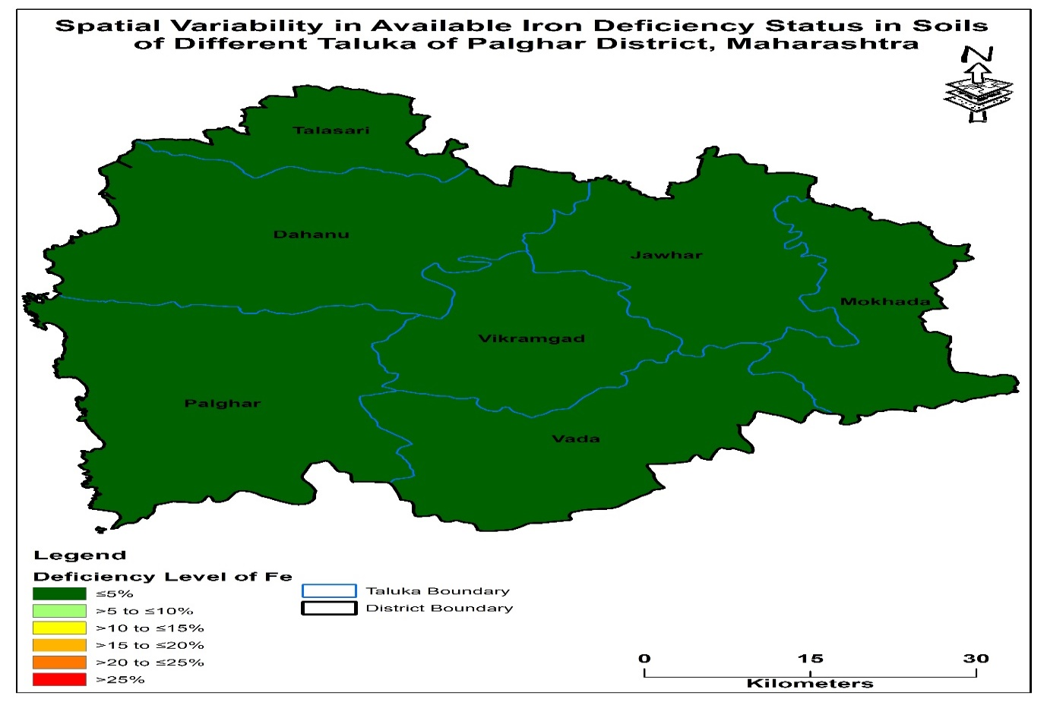
Fig 3. Spatial variability of available Fe in soils of Palghar district of Maharashtra.

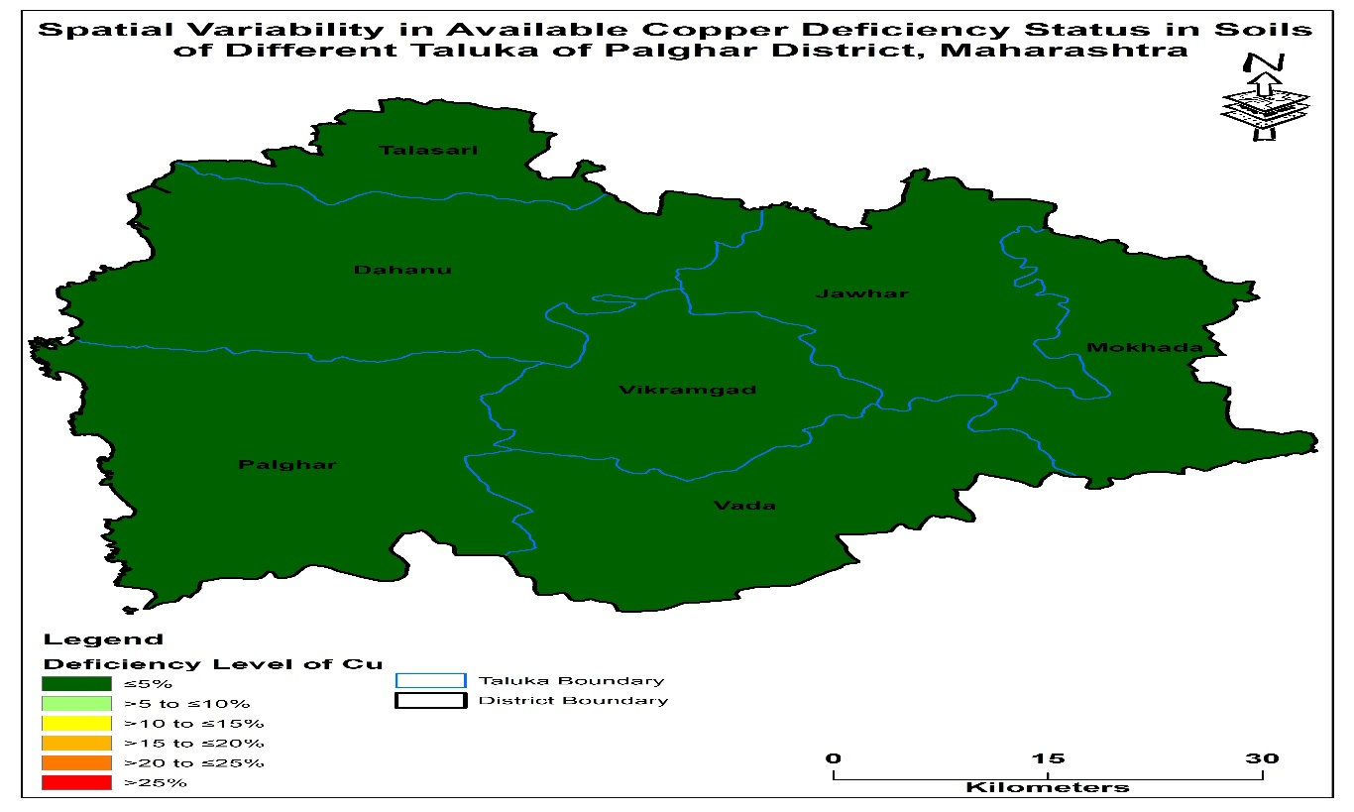
Fig.4. Spatial variability of available Cu in soils of Palghar district of Maharashtra

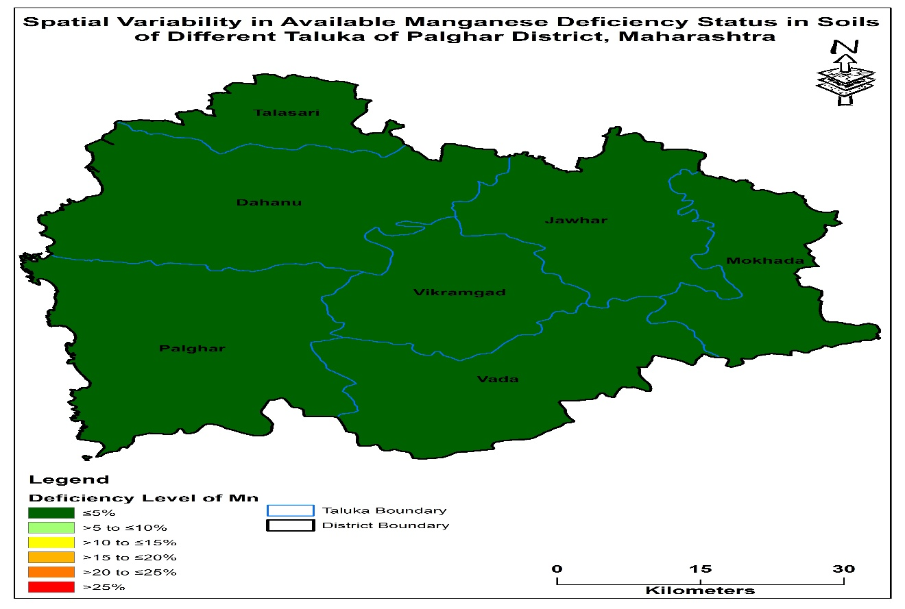
Fig.5. Spatial variability of available Mn in soils of Palghar district of Maharashtra

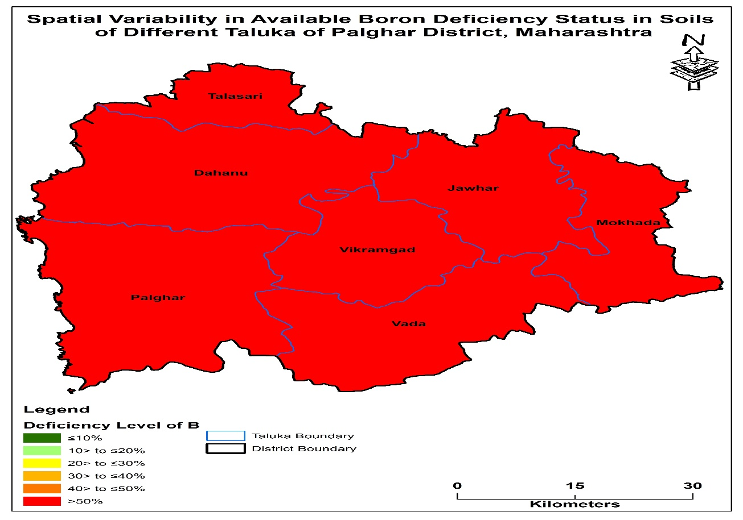
Fig.6. Spatial variability of available B in soils of Palghar district of Maharashtra

Indices of nutrients:
Nutrient values in (Table 4) for the Palghar district varied from 1.59-1.97 for S, 2.06-2.93 for Zn, 2.58-3.0 for Fe, 3.0 for Cu, 3.0 for Mn, and 1.31-1.44 for B. The fertility ratings for Zinc (Zn), ferrous (Fe), copper (Cu), manganese (Mn), and sulphur (S) were found to be high, medium, and notably low, respectively, for B. To put it succinctly, the Palghar district's soils had an overall fertility rating of low B, marginal S, and high Zn, Fe, and Cu status according to Table 5.
According to soil tests carried out by cultivators in districts where a variety of crops are grown thoroughly, if adequate attention fails to be taken for the incorporation of organic fertilizer, organic fertilizers, and micronutrient fertilizers, a region with an average amount of nutrients may soon demonstrate deficiencies (Malewar, 2005).
Conclusion:
The GPS-GIS technique, which is based on technical advancements, has been found to permit systematic tracking of the geographical variations of sulphur and micronutrient. Among the primary elements is sulphur (30.17%), micronutrient deficits in boron (60.89 percent) and zinc (5.59 percent). Rebuilding missing nutrients in the soil with chemical-based fertilizers and/or organic manures is necessary to keep the soil fertile. The Palghar district's soils' geographical variation of micronutrient status will be helpful in demonstrating effective ways and methods of Equal nutrient application to improve the yields through implementing suggested quantities of chemical fertilizers and organic fertilizer in regions of significant and micronutrient deficiency.

Disclaimer (Artificial intelligence)
Option 1:
Author(s) hereby declare that NO generative AI technologies such as Large Language Models (ChatGPT, COPILOT, etc) and text-to-image generators have been used during writing or editing of manuscripts.
Option 2:
Author(s) hereby declare that generative AI technologies such as Large Language Models, etc have been used during writing or editing of manuscripts. This explanation will include the name, version, model, and source of the generative AI technology and as well as all input prompts provided to the generative AI technology
Details of the AI usage are given below:
1.
2.
3.
Note: No AI tools used

Reference

Berger KC and Truog E.Boron determination in soils and plants. Industrial and Engineering Chemistry Analytical Edition.1939;11:540-544.
Chesnin L and Yein CH. Turbidimetric determination of available sulphates. Soil Science Society of America Proceedings.1951;15:149-157.
Das KK. Boron: In Micronutrients: Their Behavior in Soils and Plants. Kalyani Publishers, Ludhiana.2007; Pp:151-189.
Deb DL, LR Sakal and SP Datta. Micronutrients in fundamental of soil science. Journal of Indian Soc.Soil Science.2009;441-490.
Deb DL, Sakal LR and Datta SP. Micronutrients: In: Fundamental of Soil Science. Indian Society of Soil Science.2012;461-490.
Hafeez B, YM Khanif and M Saleem. Role of zinc in plant nutrition-A Review American J. Experimental Agric.2013;3(2):374-391.
Jackson ML. Soil Chemical Analysis (Eds.) Prentice Hall of India, Pvt. Ltd New Delhi.1973.

Jackson ML. Soil Chemical Analysis Prentice Hall of India, Pvt. Ltd New Delhi.1967.
Jagtap Mayuri, Chaudhari Ramesh, Thakare Ritu and Patil Tulshidas. Mapping of soil micronutrient status based on GPS-GIS and biological properties of Ajang village of Dhule tehsil of Dhule district Maharashtra. Journal of Pharmacognosy and Phytochemistry.2018;7 (5): 3270-3275.
Katkar RN, Lakhe SR, Kharche VK, Magare PN and Laharia GS. Spatial variability of major and micro nutrients in soils of Bhandara District, Maharashtra. Agropedology.2018; 27 (01):56-62.
Kunghe G, Azinwi TP, Mamdem LE, Ndzana GM, Bitom D, Tematio P. Morphology, Physico-Chemical Characteristics, Nutrient Status and Fertility Capability Classification of Andosols under Different Land Use Systems in Foumbot (Cameroon Western Highlands). Journal of Earth and Atmospheric Science. 2023: 7:041.
Li SF, ZB Chen, GB Chen and ZQ Chen. Spatial distribution of soil nutrients and their response to land use in eroded area of South China. Proc. Environmental Science.2011;10:14-19.
Lindsay WL and Norvell WA. Development of a DTPA soil test for zinc, iron, manganese and copper. Soil Science Society of America Journal.1978; 42: 421-428.
Liu ZP, MA Shao and YQ Wang.Spatial patterns of soil total nitrogen and soil total phosphorus across the entire Loess Plateau region of China. Geoderma.2013:197–198:67–78.
Malewar, G. U., 2005. Micronutrient stresses in soils and crops: Serious sickness and clinical approaches for sustainable agriculture. Journal of Indian Society of Soil Science 53 (4), 484-499
Nelson, D. W. and Sommers, L. E. 1982. In: Methods of Soil Analysis, Part II, Chemical and Microbiological Methods by Page, A. L., R. H. Miller and D. R. Keeney (eds.) Agronomy Monograph No. 9 (2nd edition) American Society of Agronomy and Soil Science Society of America, Madison, Wisconsin, USA : 570-572.
Parker, F. W., Nelson, W. L, Winters E. and Miles, I. F. 1951. The broad interpretation and application of soil test information. Agronomy Journal 43, 105-112.
Patil YM, and KR sonar. Status of major and micronutrients in swell-shrink soils of Maharashtra Agricultural Universities.1994; 19(2):169-172.
Piper, C. S. (1966). Soil and Plant Analysis, Hans. Pub. Bombay. Asian Ed. 368- 374.

Sharama VK and Anil Kumar. Characterization and classification of soil of upper Maul Khad catchment in wet temperature zone of Himachal Pradesh .2003;13:39-49.
Subbiah, B. V. and G. L. Asija, 1956. A rapid procedure for the estimation of available nitrogen in soils. Current Sci. 25: 259-260.
Watanabe, F. S. and S. R. Olsen, 1965. Test of ascorbic acid method for determining phosphorus in water and sodium bicarbonates extracts of soils. Proc. Soil. Sci. Soc. Am. 29:677-678.
Weindorf DC and Y Zhu. Spatial variability of soil properties at Capulin Volcano, New Mexico, USA: Implications for sampling strategy. Pedosphere. 2010;20(2): 185-197.

Yadav Tikam Chand, H. K. Rai, G. S. Tagore, Dayanindhi Chaubeyand R. Dhakad. (2018). Assessment of spatial variability in physio-chemical properties of soils in Alirajpur district of Madhya Pradesh using Geo-statistical approach. Journal of Soil and Water Conservation,17(4):317-324.

