A Radiological Comparison of Qualitative and Quantitative Grading Systems (Schizas Classification and Stenosis Ratio) For Lumbar Spinal Stenosis in A Low-Income Setting

ABSTRACT
Introduction: In low-resource neurosurgical settings, the choice of a reliable and efficient imaging tool for grading degenerative lumbar spinal stenosis (DLSS) is critical. The qualitative Schizas morphological classification and the quantitative Stenosis Ratio (SR) are two established methods, but their direct correlation and practical interchangeability in such environments are not well-documented. This study aimed to determine the correlation and inter-rater reliability between the Schizas grading system and the Stenosis Ratio in patients with symptomatic DLSS in a low-income country. Methods: A retrospective cross-sectional radiological analysis was conducted on 50 consecutive patients scheduled for surgery. The researcher and two neuroradiologists independently graded the most stenotic axial T2-weighted MRI level using the Schizas system (Grades A-D) and measured the SR (dural sac area / bony canal area). Inter-rater reliability was assessed using Cohen’s Kappa and Intraclass Correlation Coefficient (ICC). Correlation between the two grading systems was evaluated using Spearman’s rank correlation (ρ). Results: The cohort had a mean SR of 0.39 (SD 0.19). Schizas Grade C was the most prevalent (44%). Inter-rater reliability was excellent for both systems: SR (ICC = 0.984, p<0.001) and Schizas grade (κ = 0.90). A very strong, statistically significant negative correlation was found between the Schizas grade and the SR (ρ = -0.821, p < 0.001), indicating convergent validity. Conclusion: This study demonstrates a strong radiological correlation and excellent reliability between the Schizas classification and the Stenosis Ratio. The findings validate the Schizas system as an efficient, reliable, and software-free tool for routine anatomical grading of DLSS in low-resource settings. The quantitative SR remains a precise option for complex cases, but the high concordance supports the primary use of the simpler qualitative method to optimise workflow in constrained environments.
Keywords: Lumbar spinal stenosis, Schizas classification, Stenosis Ratio, Low-income country, Radiological correlation, Inter-rater reliability.

INTRODUCTION
In the daily practice of neurosurgery within low-income countries, we are often tasked with making definitive decisions from limited resources.^{1–3} For patients with debilitating degenerative lumbar spinal stenosis (DLSS), usually in the middle-aged to elderly population, magnetic resonance imaging (MRI) is a critical, yet frequently constrained, asset.^{4–8} Every slice of the scan must be interrogated with maximum rigour to inform our surgical strategy. In this environment, the choice of a radiological measurement tool is not merely academic; it is a practical decision with direct implications for efficiency, consistency, and ultimately, the clarity of surgical planning.^{9,10}
Two established methods for quantifying central canal stenosis dominate the literature. The Schizas morphological grading system (Grades A-D) provides a qualitative, rapid assessment based on the pattern of cerebrospinal fluid effacement within the dural sac.^{11–13} Its strength lies in its clinical adoption and simplicity, requiring no specialised software. In contrast, the Stenosis Ratio (SR) offers a precise, quantitative measure derived from the cross-sectional areas of the dural sac and the bony canal.^{14,15} While the SR is objectively numeric, its calculation demands more time, specific tools, and technical post-processing.
A clear understanding of the concordance and divergence between these two tools is foundational. However, there is a notable gap in the literature regarding their direct, detailed comparison, particularly when applied in resource-constrained settings, like Nigeria, where scanner technology and imaging protocols may vary. Many hospitals rely on commercial diagnostic centres to have an MRI done on their patients. As such, spine surgeons who work in such hospitals do not have direct access to the imaging workstation tools for characterising degenerative lumbar spine stenosis. They must depend on the printed films to make surgical decisions.
We aim to directly and systematically compare the Schizas grading system and the Stenosis Ratio in a cohort of patients with symptomatic DLSS in a low-income country. Our primary objective is to analyse the correlation and agreement between these classifications, identifying patterns of discordance and assessing the practical implications of each method for the reporting radiologist and planning neurosurgeon. By clarifying this fundamental relationship between two key diagnostic scales, we seek to provide evidence that enhances the reliability and precision of preoperative imaging assessment, forming a more robust anatomical foundation for clinical decision-making in environments where every detail counts.

METHODOLOGY
1. Study Design and Setting
This was a retrospective, observational, cross-sectional study of diagnostic imaging. It was conducted at the Memfys Hospital for Neurosurgery, a private major tertiary referral neurosurgical centre in Enugu State, Nigeria, between September 2022 and January 2023.
2. Patient Population and Selection Criteria
Consecutive patients who underwent lumbar spine MRI for symptoms suggestive of DLSS (neurogenic claudication, radicular pain) were initially identified and recruited for this study.
Inclusion Criteria:
These were patients aged ≥ 40 years, with available pre-operative T2-weighted axial MRI scan of diagnostic quality at the level of the most severe stenosis (L2-L3 to L5-S1). They had radiological diagnosis of central canal stenosis (anticipated Schizas grade A to D) at one or more levels.
Exclusion Criteria:
MRI scans with significant motion artefact or poor image quality precluding accurate measurement, stenosis secondary to non-degenerative causes (e.g., trauma, tumour, infection, significant spondylolisthesis > Grade I), and previous lumbar spine surgery at the index level.
3. Sample size calculation
The formula for calculating the required sample size for a cross-sectional study according to Habib et al.¹⁶
N = z2pq / d2
Where N is the sample size, z is the standard normal deviate (1.96 at 95% confidence level), p is the proportion of cases, q is (1-p), and d is the precision set at 10% for this study. In 2018, 264 patients were diagnosed with radiologic degenerative lumbar spine stenosis out of 297 cases with chronic low back pain. This gave a proportion (p) of 0.889 and a q of 0.111 (1-0.889). Substituting into the equation gave;
N = (1.96)2 x 0.889 x 0.111/ (0.1)2 = 38 subjects.
The final sample size for this study was 42 subjects after adding an attrition rate of 10%.
4. Imaging Protocol and Data Acquisition
All the MRI investigations were performed by a radiographer using a 16-channel 1.5T MRI scanner (GE SIGNA Explorer, USA), software version SV25 with a standard dedicated spine coil. The relevant T2-weighted axial sequences (slice thickness: 3-4 mm; inter-slice gap: 0.4-0.5 mm) were retrieved from the institutional Picture Archiving and Communication System (PACS).
5. Image Analysis Procedure:
All measurements and gradings were performed independently by two blinded assessors: the researcher and two consultant neuroradiologists. We underwent a standardised training session reviewing examples of the Schizas grading system and the Stenosis Ratio measurement protocol. After an initial training set (not included in the final cohort), we analysed the study images independently and in a random sequence, with a washout period of four weeks between the two grading sessions to mitigate recall bias.
A. Schizas Morphological Grading:^{12,13,17}
For the most stenotic axial slice at each pathological level, the dural sac was classified as follows:
Grade A: No or minor stenosis. Visible cerebrospinal fluid (CSF) space.
Grade B: Moderate stenosis. CSF space is speckled, but nerve roots can be identified.
Grade C: Severe stenosis. No CSF visible. Nerve roots appear aggregated, but individual roots can still be distinguished (grey).
Grade D: Extreme stenosis. No CSF visible. The dural sac appears uniformly grey, with no distinction between CSF and nerve roots.
For the primary analysis, grades C and D were considered "severe."

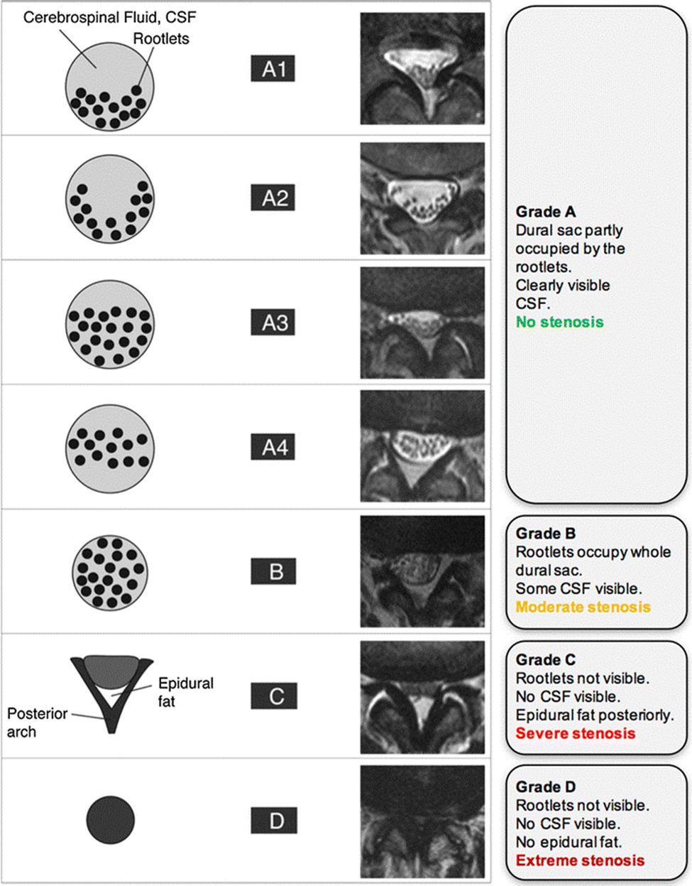
Figure 1: Schizas grading of lumbar spinal canal stenosis

B. Stenosis Ratio (SR) Calculation:¹⁴
On the same single most stenotic axial T2-weighted image, the following measurements were performed using the manual tracing/ellipse tool on the institutional PACS workstation:
Dural Sac Cross-Sectional Area (DCSAs): The area (in mm²) enclosed by the inner border of the dura mater at the critically stenotic level.
Dural Sac Cross-Sectional Area (DCSAn): The area (in mm²) enclosed by the dural sac at the inner cortical border of the vertebral laminae and pedicles without stenosis just above the stenotic area.
The Stenosis Ratio was then calculated using the formula:
SR = DCSAs / DCSAn
A lower SR indicates a greater degree of stenosis.
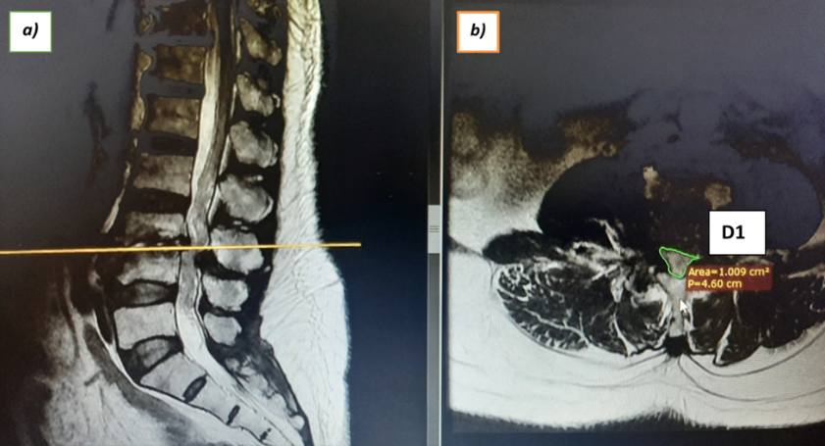
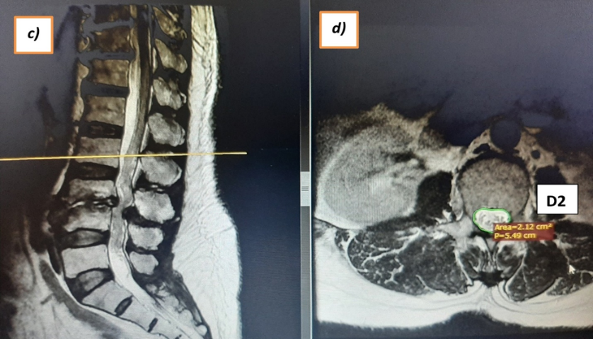
Figure2: Dural sac cross-sectional area measurements: a) & c) sagittal T2 weighted images of same patient showing L3/4 critical stenosis. b) axial T2WI at level with critical stenosis (D1) and d) axial T2WI at the level with no stenosis just above the critically stenosed area (D2)

Calculated Stenosis Ratio (SR) = D1 / D2 x 100
=100.9mm²/212mm² x 100
=47.6%
6. Data Analysis
All statistical analyses were performed using SPSS version 27.0, R Statistical Software.
Descriptive Statistics: Patient demographics and level-wise distribution of stenosis were summarised using means (± standard deviation) and frequencies (percentages) for categorical variables.
Primary Analysis - Correlation: The relationship between the ordinal Schizas grades (A-D) and the continuous Stenosis Ratio was assessed using Spearman’s rank correlation coefficient (ρ). Strength of correlation was interpreted as: very weak (0.00-0.19), weak (0.20-0.39), moderate (0.40-0.59), strong (0.60-0.79), very strong (0.80-1.00).
Agreement Analysis:
Inter-rater Reliability: Agreement between the two readers for both the Schizas grade (ordinal) and the SR (continuous) was calculated using Cohen's weighted Kappa (κ) and the Intraclass Correlation Coefficient (ICC, two-way random effects, absolute agreement model), respectively. Kappa values were interpreted as: poor (<0.20), fair (0.21-0.40), moderate (0.41-0.60), good (0.61-0.80), excellent (0.81-1.00). ICC values >0.75 indicate good reliability.
Method Agreement: To visualise the agreement between the two measurement methods across their range of values, a scatter plot of SR against Schizas' grade will be presented, with box plots overlaid to show the distribution of SR for each grade.
A p-value of <0.05 was considered statistically significant.
RESULTS and DISCUSSION

Study Population
A total of 50 subjects meeting the inclusion criteria were enrolled in the study with a mean age of 58.4±10.8 years. The cohort comprised 22 males (44.0%) and 28 females (56.0%).
Table 1: Distribution of levels of degenerative lumbar canal stenosis
RADIOLOGIC STENOTIC LEVELS | N | %
1-level | 3 | 6.0
2-levels | 14 | 28.0
Multilevel | 33 | 66.0
TOTAL | 50 | 100.0

Table 2: distribution of levels with critical stenosis
CRITICALLY STENOTIC LEVEL | N | %
L2/3 | 1 | 2.0
L3/4 | 10 | 20.0
L4/5 | 31 | 62.0
L5/S1 | 8 | 16.0
TOTAL | 50 | 100.0

Table 3: distribution of Schizas grade of patients
SCHIZA’S GRADE OF PATIENTS | N | %
A1 | 2 | 4.0
A2 | 6 | 12.0
A3 | 4 | 8.0
A4 | 1 | 2.0
B | 7 | 14.0
C | 22 | 44.0
D | 8 | 16.0
TOTAL | 50 | 100.0

Radiological Measurements and Intra-Rater Reliability
Stenosis Ratio (SR): The intra-rater reliability for the dural sac cross-sectional area measurement, assessed via the Intraclass Correlation Coefficient (ICC), was excellent (ICC = 0.999, p < 0.001). The mean dural sac area at the level of critical stenosis was 67.46 mm² (SD = 41.85), compared to 171.36 mm² (SD = 45.59) at the normal proximal segment. Consequently, the mean Stenosis Ratio for the cohort was 0.39 (SD = 0.19).
Schizas Morphological Grade: The distribution of stenosis severity according to the Schizas system was as follows: Grade A (26.0%), Grade B (14.0%), Grade C (44.0%), and Grade D (16.0%). Grade C stenosis was the most prevalent single category.

Inter-Rater Reliability
Inter-rater reliability for the quantitative Stenosis Ratio between the primary researcher and two radiologists was excellent. The ICC was 0.984 (p < 0.001) between the researcher and Radiologist 1, and 0.928 (p = 0.008) between the researcher and Radiologist 2.
For the qualitative Schizas grading system, inter-rater agreement was also excellent. Cohen’s weighted Kappa between the researcher and both radiologists was κ = 0.90.
Correlation and Agreement Analyses
Primary Analysis: SR vs. Schizas Grade
A very strong, statistically significant negative correlation was found between the quantitative Stenosis Ratio and the ordinal Schizas grade (Spearman’s ρ = -0.821, p < 0.001). This indicates that as the Schizas grade increased (denoting more severe morphological stenosis), the SR value decreased proportionally.
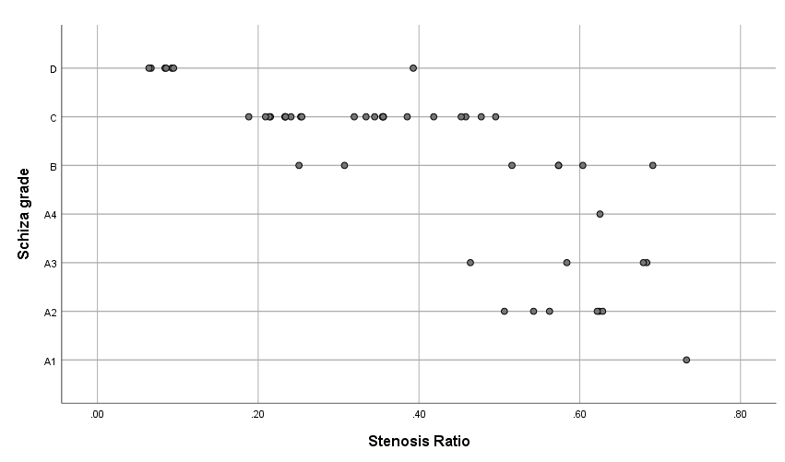
Figure 3: Scatterplot description of Schizas grade Vs Stenosis Ratio of cohort

Degenerative lumbar spine stenosis (DLSS) continues to pose an increased burden on an ageing population, and any tool beneficial in managing patients should be explored. The average age in this study corresponds to other studies in this subregion documented in the literature.^{17–20} Multilevel disease was more prevalent in this study (Table 1), with the L4/5 level most implicated (Table 2), also in tandem with other studies in the literature.^{19,21,22} Schizas grades C and D were also more prevalent in this study (Table 3), probably because patients with such degrees of stenosis were more likely to seek medical care and be investigated radiologically. Schizas et al. and Soman et al. posited that patients with Schizas grade C and D DLSS, with a higher prevalence in their study too, were candidates for surgical decompression.^{13,20}
This study provides a focused radiological comparison of two established methods for grading lumbar spinal stenosis – the qualitative Schizas morphological system and the quantitative Stenosis Ratio (SR) – within the pragmatic context of a neurosurgical practice in a low-income country. The central and most significant finding is a very strong, inverse correlation (ρ = -0.821) between the two grading systems. This robust association confirms their convergent validity in describing the anatomical severity of central canal compromise and forms the basis for a pragmatic diagnostic workflow in environments where efficiency and reliability are paramount.
Validation and Concordance of Anatomical Grading
The excellent correlation establishes that as the Schizas grade progresses from A to D, indicating increasing morphological severity, the SR decreases correspondingly and predictably. This convergence is further reinforced by the excellent inter-rater reliability demonstrated for both tools. The quantitative SR showed near-perfect intra- and inter-rater agreement (ICC up to 0.984), while the qualitative Schizas system also achieved excellent reproducibility (κ = 0.90), as demonstrated in other studies.^{12,13,23} These metrics affirm that both methods can be applied with high consistency, even with varying levels of radiological expertise – a critical factor for training and standardising reporting across departments.
Practical Synthesis for the Low-Resource Neurosurgical Workflow
The strong correlation between these systems is not merely an academic validation; it has direct and practical implications for clinical workflow in resource-constrained settings. It supports a tiered, efficient approach to imaging analysis. The Schizas classification, requiring no specialised software or time-consuming measurements, offers a rapid, visually intuitive assessment. Its high reliability makes it an ideal first-line tool for radiologists and surgeons alike, enabling efficient triage, clear communication in referrals, and initial surgical planning during high-volume clinic hours.
Conversely, the Stenosis Ratio provides an objective, continuous numerical value. While its calculation demands more time and measurement tools, its strong correlation with the Schizas grade means it is not needed for routine confirmation. Instead, its primary utility lies in specific, complex scenarios where precise quantification adds value: for detailed pre-operative mapping in revision or multilevel surgery, for objective monitoring of stenosis progression in serial scans, or as a precise metric for clinical research and audit. Researchers have suggested that quantitative measurements are more reliable than qualitative measurements.^{24,25}
In essence, the Schizas system can efficiently handle the majority of diagnostic grading, reserving the SR for cases where its quantitative precision offers a distinct advantage.

CONCLUSION
In conclusion, this study demonstrates that Schizas morphological classification and the Stenosis Ratio are highly reliable and concordant methods for anatomically grading degenerative lumbar stenosis. Their strong correlation validates the use of the simpler, cost-free Schizas system as an efficient and robust first-line grading tool for routine clinical practice. The quantitative SR remains a valuable objective measure for complex cases and research. For the neurosurgeon practising in a low-income country, this evidence supports a streamlined diagnostic approach: leveraging the speed of qualitative assessment for daily decision-making while retaining the option of precise quantification when the clinical scenario demands it.
Limitations
This study has inherent limitations. As a purely radiological correlation study, it does not address the critical and well-documented relationship between imaging findings and clinical symptoms or surgical outcomes. The sample was drawn from a surgical cohort, which may represent a more severe end of the pathological spectrum. Future research should investigate the predictive value of these combined tools for functional outcomes following decompressive surgery.
Ethical Approval and Consent:
The study protocol was reviewed and approved by the Institutional Review Board/Ethics Committee of the hospital. Written informed consent was obtained, from the patient

COMPETING INTERESTS DISCLAIMER:
Authors have declared that they have no known competing financial interests OR non-financial interests OR personal relationships that could have appeared to influence the work reported in this paper.

Disclaimer (Artificial intelligence)
Option 1:
Author(s) hereby declare that NO generative AI technologies such as Large Language Models (ChatGPT, COPILOT, etc.) and text-to-image generators have been used during the writing or editing of this manuscript.

REFERENCES
1. Weiss, H. K., Garcia, R. M., Omiye, J. A., et al. (2020). A systematic review of neurosurgical care in low-income countries. World Neurosurgery: X. https://doi.org/10.1016/j.wnsx.2019.100068
2. Iqbal, J., Naseem, A., Bashir, M. A., Yangi, K., Bozkurt, I., & Chaurasia, B. (2025). Global perspective of neurosurgery practice in lower middle-income countries: challenges, opportunities, and the path forward. Annals of Medicine and Surgery, 87(5), 2532–2536. https://doi.org/10.1097/MS9.0000000000003221
3. Punchak, M., Mukhopadhyay, S., Sachdev, S., Hung, Y. C., Peeters, S., Rattani, A., Dewan, M., Johnson, W. D., & Park, K. B. (2018). Neurosurgical Care: Availability and Access in Low-Income and Middle-Income Countries. World Neurosurgery, 112, e240–e254. https://doi.org/10.1016/j.wneu.2018.01.029
4. Abdou, A., Kades, S., Masri-Zada, T., Asim, S., Bany-Mohammed, M., & Agrawal, D. K. (2025). Lumbar Spinal Stenosis: Pathophysiology, Biomechanics, and Innovations in Diagnosis and Management. Journal of Spine Research and Surgery, 7(1), 1-17. https://doi.org/10.26502/fjsrs0082
5. Bagley, C., MacAllister, M., Dosselman, L., Moreno, J., Aoun, S. G., & El Ahmadieh, T. Y. (2019). Current concepts and recent advances in understanding and managing lumbar spine stenosis. *F1000Research*, *8*, F1000 Faculty Rev-137. https://doi.org/10.12688/f1000research.16082.1
6. Usman, B. O., Oyewole, A. A., Chom, N. D., & Umar, A. (2020). Assessment of various lumbosacral spine abnormalities on magnetic resonance imaging scans of patients with low back pain. Port Harcourt Medical Journal, 14(2), 78–85. DOI: 10.4103/phmj.phmj_7_20
7. Kitab, S., Habboub, G., Abdulkareem, S. B., Alimidhatti, M. B., & Benzel, E. (2019). Redefining lumbar spinal stenosis as a developmental syndrome: does age matter?. Journal of Neurosurgery: Spine, 31(3), 357–365. https://doi.org/10.3171/2019.2.SPINE181383
8. Abbas, J., Hamoud, K., May, H., Hay, O., Medlej, B., Masharawi, Y., Peled, N., & Hershkovitz, I. (2010). Degenerative lumbar spinal stenosis and lumbar spine configuration. European Spine Journal, 19(11), 1865–1873. https://doi.org/10.1007/s00586-010-1516-5
9. Alicioglu, B., Yilmaz, B., Bulakbasi, N., Copuroglu, C., Yalniz, E., Aykac, B., & Urut, D. U. (2012). Magnetic resonance imaging predictors of surgical outcome in degenerative lumbar spinal stenosis. Jpn J Radiol, 30(10), 811–818. https://doi.org/10.1007/s11604-012-0125-0
10. Elsig, J. P. J., & Kaech, D. L. (2006). Imaging-based planning for spine surgery. Minimally Invasive Therapy & Allied Technologies, 15(5), 260–266. https://doi.org/10.1080/13645700600958457
11. Ahsan, H., Tasra, B., & Muhammad, N. S. (2025). Comparative analysis of LEE and SCHIZAS grading systems in the MRI-based diagnosis of lumbar canal stenosis. Insights-Journal of Health and Rehabilitation, 3(1), 640–646. https://doi.org/10.71000/6zz4x825
12. Holc, F., Albani-Forneris, A., Kido, G., Beltrame, S., Petracchi, M., Gruenberg, M., Sola, C., & Camino-Willhuber, G. (2023). Independent inter and intra-observer agreement of the Schizas’s classification of degenerative lumbar stenosis: Comparison among three levels of surgical training. Revista Española de Cirugía Ortopédica y Traumatología, 67(3), 175–180. https://doi.org/10.1016/j.recot.2022.10.003
13. Schizas, C., Theumann, N., Burn, A., Tansey, R., Wardlaw, D., Smith, F. W., & Kulik, G. (2010). Qualitative grading of severity of lumbar spinal stenosis based on the morphology of the dural sac on magnetic resonance images. Spine (Phila Pa 1976), 35(21), 1919–1924. https://doi.org/10.1097/BRS.0b013e3181d359bd
14. Laurencin, C. T., Lipson, S. J., Senatus, P., Botchwey, E., Jones, T. R., Koris, M., & Hunter, J. (1999). The stenosis ratio: a new tool for the diagnosis of degenerative spinal stenosis. Int J Surg Investig, 1(2), 127–131. https://pubmed.ncbi.nlm.nih.gov/11341632/
15. Wu, A. M., Zou, F., Cao, Y., Xia, D. D., He, W., Zhu, B., Chen, D., Ni, W. F., Wang, X. Y., & Kwan, K. (2017). Lumbar spinal stenosis: an update on the epidemiology, diagnosis and treatment. AME Medical Journal, 2(63). http://doi.org/10.21037/amj.2017.04.13
16. Habib, A., Johargy, A., Mahmood, K., & Humma, H. (2014). Design and determination of the sample size in medical research. *IOSR Journal of Dental and Medical Sciences (IOSR-JDMS)*, *13*(5), 21–31. https://doi.org/10.9790/0853-13562131
17. Oyewole AF, Chom ND. Relationship between Age, Gender and Low Back Pain in Patients Referred for Magnetic Resonance Imaging of Lumbosacral Spine at Ahmadu Bello University Teaching Hospital, Zaria. Nigerian Journal of Basic and Clinical Sciences 2020;17(2):108–114. https://doi.org/10.4103/njbcs.njbcs_36_19
18. Ebubedike, U. R., Umeh, E. O., Ogbole, G. I., Ndubuisi, C. A., Mezue, W. C., & Ohaegbulam, S. C. (2016). Pattern of lumbosacral magnetic resonance imaging findings in diagnosed cases of disc degenerative disease among Nigerian adults with low back pain. West African Journal of Radiology, 24(1), 25–29. https://doi.org/10.4103/1115-3474.192752
19. Ajiboye, L. O., Oboirien, M., & Alexis, D. B. B. (2018). The incidence and clinico-radiological findings in symptomatic adult patients with lumbar degenerative disc diseases in a tertiary orthopaedic hospital, South-West, Nigeria. East African Orthopaedic Journal, 12(1), 27–32. https://scispace.com/pdf/the-incidence-and-clinico-radiological-findings-in-4lsx5xqixs.pdf
20. Soman, S. M., Chokshi, J., Chhatrala, N., Tharadara, G. H., & Prabhakar, M. (2017). Qualitative grading as a tool in the management of multilevel lumbar spine stenosis. Asian Spine Journal, 11(2), 278–284. https://doi.org/10.4184/asj.2017.11.2.278
21. Muoghalu, O. N., Nwadinigwe, C. U., Iyidobi, E. C., Duru, N. N., Anyaehie, U. E., & Okwesili, I. C. (2018). Early Functional Outcome of Posterior Spinal Decompression for Lumbar Spinal Stenosis at a Tertiary Health Institution, South East Nigeria. *Journal of Biosciences and Medicines*, *6*(7), 1–14. https://doi.org/10.4236/jbm.2018.67001
22. Sigmundsson, F. G. (2014). Determinants of outcome in lumbar spinal stenosis surgery. Acta Orthopaedica. Supplementum, 85(357), 1–45. https://doi.org/10.3109/17453674.2014.976807
23. Ko, Y.-j., Lee, E., Lee, J. W., Park, C. Y., Cho, J., Kang, Y., & Ahn, J. M. (2020). Clinical validity of two different grading systems for lumbar central canal stenosis: Schizas and Lee classification systems. PLoS ONE, 15(5), e0233633. https://doi.org/10.1371/journal.pone.0233633
24. Huber, F. A., Stutz, S., de Martini, I. V., Mannil, M., Becker, A. S., Winklhofer, S., Alkadhi, H., Benz, D. C., Distler, O., Pfirrmann, C. W. A., Sutter, R., Zanetti, M., Schwenzer, M., Frauenfelder, T., Pfirrmann, C. W., Böhm, T., Pfirrmann, C. W. A., Sutter, R., Zanetti, M., ... Böhm, T. (2019). Qualitative versus quantitative lumbar spinal stenosis grading by machine learning supported texture analysis—experience from the LSOS study cohort. *European Journal of Radiology*, *114*, 45–50. https://doi.org/10.1016/j.ejrad.2019.02.023
25. Bharadwaj, U. U., Ben-Natan, A. R., Huang, J., Pedoia, V., Chou, D., Majumdar, S., Link, T. M.,
& Chin, C. T. (2022). Evaluation of 2 novel ratio-based metrics for lumbar spinal stenosis. American Journal of Neuroradiology, 43(10), 1530–1538. https://doi.org/10.3174/ajnr.A7638.

