Cesarean Scar Endometriosis Diagnosis and Care (CSE-DxCare): A Clinical Framework for Post-Cesarean Scar Endometriosis based on a case report evaluation

Abstract:
Background: Scar endometriosis is a rare manifestation of endometriosis, occurring in less than 1% of cases, typically following obstetric or gynecologic surgeries such as cesarean section. It presents a diagnostic challenge due to its non-specific symptoms, commonly mimicking other abdominal wall pathologies.

Aim and Objectives: 1. To analyze and review the clinical presentation and treatment of a patient with cesarean scar endometriosis. 2. To evaluate differential diagnoses and provide effective symptom relief and definitive management.

Materials and Methods: A retrospective case report of a 30-year-old female who presented with chronic lower abdominal pain to the General Surgery outpatient department. Clinical evaluation, imaging (USG and MRI), diagnostic laparoscopy, and histopathological analysis were performed.

Case Summary: The patient reported progressive, cyclical pain over a previous cesarean scar for six months, aggravated during menstruation. MRI revealed a heterogeneous lesion (34×12 mm) within the anterior abdominal wall. Diagnostic laparoscopy confirmed a 5×3 cm mass invading the rectus sheath. Wide local excision was performed, and histopathology confirmed endometriosis with granulation tissue.

Results: Postoperative recovery was uneventful. Abdominal wall reconstruction with mesh was done. The patient was administered injection Leuprolide 3.75 mg monthly for three months. No recurrence was noted in the short-term follow-up.

Conclusion: Scar endometriosis should be considered in women presenting with cyclical abdominal pain and a history of uterine surgery. Surgical excision remains the gold standard treatment, and histopathological confirmation is essential. Hormonal therapy can aid in symptom control and recurrence prevention. Long-term follow-up is recommended.

Keywords: Scar endometriosis, Cesarean section, Abdominal wall mass, Surgical excision, Leuprolide, Case report

Graphical Abstract
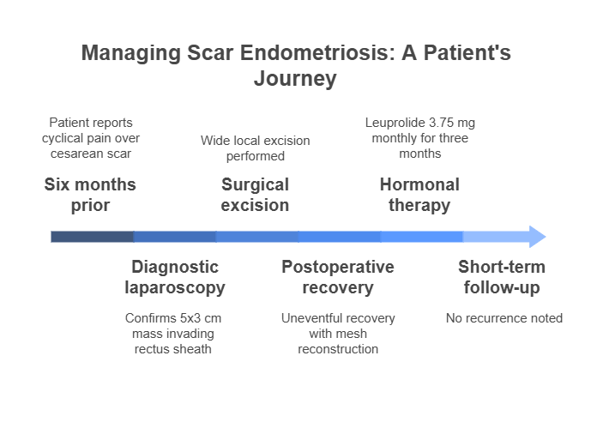

1. Introduction
Scar endometriosis is an uncommon clinical entity, representing a rare form of extrapelvic endometriosis wherein endometrial tissue is found in surgical scars, most notably following cesarean sections or other pelvic surgeries [1], [2]. It is estimated to affect less than 1% of women undergoing cesarean deliveries, yet the incidence appears to be on the rise parallel to the global increase in cesarean section rates [3], [4].
Characterized by cyclical pain, swelling, or mass near a previous surgical scar, the condition often mimics other abdominal wall pathologies such as hernias, lipomas, granulomas, or desmoid tumors [5], [6]. This diagnostic ambiguity often leads to delays in appropriate intervention, causing unnecessary distress and morbidity for the patient [7], [8].
The pathophysiology of scar endometriosis is predominantly explained by iatrogenic transplantation theory, suggesting that endometrial cells are inadvertently implanted in the surgical wound during uterine closure [9], [10]. These ectopic endometrial cells respond to hormonal changes, particularly estrogen and progesterone, resulting in inflammatory and fibrotic changes in the scar tissue [11], [12].
Imaging modalities such as ultrasound, magnetic resonance imaging (MRI), and sometimes computed tomography (CT) play a critical role in preoperative assessment, although they are often inconclusive without histopathological confirmation [13], [14]. Fine-needle aspiration cytology (FNAC) and laparoscopy may aid in diagnosis, but surgical excision remains the mainstay for definitive treatment [15], [16].
Medical therapy using gonadotropin-releasing hormone (GnRH) analogues or oral contraceptives may help in symptom management and recurrence prevention, particularly when surgery is contraindicated [17], [18]. However, recurrence following incomplete excision or in hormonally sensitive patients remains a concern [19] [20].
This case-based study introduces a structured clinical approach—CSE-DxCare (Cesarean Scar Endometriosis Diagnosis and Care)—that integrates clinical presentation, diagnostic imaging, minimally invasive exploration, surgical resection, and adjuvant medical therapy. The goal is to provide a practical, reproducible framework to aid clinicians in timely diagnosis and management of this rare but impactful condition.

1.1 Contributions
The novel contributions of this study are:
- Introduced the CSE-DxCare clinical framework for diagnosing and managing cesarean scar endometriosis.
- Highlighted the role of imaging and laparoscopy in identifying atypical scar endometriosis cases.
- Provided intraoperative and histopathological confirmation of deep abdominal wall involvement.
- Demonstrated effective postoperative management using Leuprolide to prevent recurrence.

2. Literature Review
Duncan et al. (2025) [21] emphasized the importance of a multidisciplinary approach to endometriosis management, especially in complex or extrapelvic cases like scar endometriosis. They recommended medical therapy for symptom relief but considered surgical excision superior to ablation. The study highlighted that excision offers better long-term outcomes. Coordination among gynecologists, radiologists, and surgeons was found to be crucial for optimal care.
Zahra et al. (2025) [22] conducted a study to evaluate uterine scar dehiscence and associated risk factors in women with previous cesarean sections. The prevalence of scar dehiscence was found to be 6.9%, and significant risk factors included short inter-pregnancy intervals and wound infections. They emphasized the need for careful monitoring in high-risk patients. Effective risk management strategies were recommended to minimize complications.
Ahmed et al. (2025) [23] explored the use of MRI in the preoperative diagnosis of pelvic adhesions, including endometriosis. Their study revealed that MRI offers critical insights that aid surgical planning and reduce intraoperative surprises. They proposed a standardized imaging framework for identifying adhesive disease. This can enhance diagnostic precision and improve surgical outcomes in endometriosis cases.
Kobayashi et al. (2024) [24] reevaluated the variability of cesarean scar defects (CSD) and their links to abnormal uterine bleeding. They found that CSDs often exhibit diverse morphologies, including cystic extensions and iatrogenic endometriosis. The review suggested that disruptions in myometrial layers contribute to CSD pathogenesis. A deeper understanding of histopathology was recommended for accurate diagnosis and classification.
Aljbawi et al. (2025) [25] presented a case of abdominal wall endometriosis in a young woman with cyclic pain and a mass near the cesarean scar. Despite imaging suggesting a granuloma, clinical suspicion led to surgical excision. Histopathology confirmed endometriosis with hemosiderin-laden macrophages. Postoperative recovery was smooth, reinforcing the need for early clinical suspicion in similar presentations.
Zhong et al. (2024) [26] investigated recurrence risk in cesarean scar endometriosis and found that pain severity and surgical method were significant factors. Integrated excision, which includes mass removal and scar exploration, had lower recurrence than local excision. They also identified that younger age and deeper involvement increased recurrence risk. Their study supports aggressive and comprehensive surgical strategies to reduce relapse.
Yasmin et al. (2025) [27] highlighted clinical and sonographic features of cesarean scar endometriosis in 10 patients. Cyclical pain was the most common symptom, and ultrasonography revealed solid hypoechoic masses. FNAC helped confirm diagnosis in ambiguous cases. Their study supported the use of high-resolution ultrasound as a frontline diagnostic tool in suspected cases.
Mohr-Sasson et al. (2024) [28] assessed whether endometrial closure during cesarean section reduces scar-related complications. Their randomized trial found no significant difference in uterine scar thickness or symptom rates between closure and non-closure groups. Results suggested that closure of the endometrial layer may not influence long-term scar integrity. The study contributes to ongoing debates regarding optimal cesarean techniques.
Boussif et al. (2025) [29] reported a severe case of uterine scar dehiscence post-cesarean that led to peritonitis and sepsis. The case underscored the importance of clinical vigilance and early diagnosis in postpartum patients with wound infections. Imaging played a key role in identifying the hidden dehiscence. Their findings call attention to this life-threatening complication in maternal care.
Parikh et al. (2024) [30] demonstrated the accuracy of preoperative ultrasound for detecting deep infiltrating endometriosis (DIE). Their study showed that sonographic findings correlated strongly with intraoperative observations. Structured ultrasound protocols, including the sliding sign and posterior compartment evaluation, were emphasized. This technique supports surgical planning and counseling in advanced endometriosis cases.

Table 1: Summary of Research Gaps in Post-Cesarean Scar Endometriosis Literature
Ref. No. | Author(s) | Focus Area | Key Findings | Identified Research Gap
[21] | Duncan et al. (2025) | Multidisciplinary management | Emphasized surgical excision and coordinated care | Lack of standardized multidisciplinary protocols for extrapelvic endometriosis
[22] | Zahra et al. (2025) | Uterine scar dehiscence | Identified risk factors post-LSCS | Limited studies linking uterine scar dehiscence with development of scar endometriosis
[23] | Ahmed et al. (2025) | MRI for pelvic adhesions | Proposed framework for MRI-based diagnosis | No established imaging protocol specific to scar endometriosis
[24] | Kobayashi et al. (2024) | Cesarean scar defect (CSD) pathology | CSD varies morphologically and may relate to endometriosis | Pathogenesis overlap between CSD and scar endometriosis remains underexplored
[25] | Aljbawi et al. (2025) | Case report on scar endometriosis | Confirmed diagnosis by histology post-surgery | Scar endometriosis diagnosis still relies heavily on post-operative histopathology
[26] | Zhong et al. (2024) | Recurrence risk analysis | Identified pain scale and method of excision as predictors | Insufficient long-term prospective data on recurrence prevention methods
[27] | Yasmin et al. (2025) | Sonographic features | Identified hypoechoic mass in USG and supported FNAC | Lack of diagnostic accuracy data for sonography + FNAC in early-stage cases
[28] | Mohr-Sasson et al. (2024) | Cesarean techniques | Found no effect of endometrial closure on scar defects | Scar formation versus endometrial cell implantation mechanisms unclear
[29] | Boussif et al. (2025) | Uterine scar dehiscence with infection | Linked dehiscence to postpartum sepsis | Scar infection as a precursor to endometriosis not sufficiently examined
[30] | Parikh et al. (2024) | Ultrasound for DIE | High correlation with surgical findings | Training gaps exist in DIE-focused ultrasound protocols for general practitioners

2.1 Research gaps
Despite advancements in the diagnosis and management of endometriosis, significant research gaps remain concerning cesarean scar endometriosis. There is a lack of standardized multidisciplinary care protocols specifically tailored to extrapelvic presentations, and current imaging guidelines do not adequately address scar-related manifestations. The overlap between cesarean scar defects and endometriotic lesions remains poorly understood, particularly regarding their shared pathogenesis. Additionally, most diagnoses still depend on postoperative histopathological confirmation, highlighting the need for improved non-invasive diagnostic tools. Long-term data on recurrence patterns and the effectiveness of surgical techniques, including integrated excision, are also limited. Moreover, the diagnostic accuracy and accessibility of imaging modalities like ultrasound and FNAC in early detection require further validation. These gaps underscore the need for more targeted research to establish consensus protocols, refine imaging frameworks, and enhance preoperative detection strategies.

2.2 Problem statement
Cesarean scar endometriosis is a rare and often underdiagnosed condition that poses significant diagnostic and therapeutic challenges due to its non-specific clinical presentation and overlap with other abdominal wall pathologies. The absence of standardized diagnostic protocols, limited preoperative imaging accuracy, and reliance on postoperative histopathological confirmation delay timely intervention and increase the risk of recurrence. Furthermore, there is insufficient clinical guidance on optimal surgical techniques and postoperative management strategies to prevent relapse. These challenges highlight the urgent need for a structured clinical framework that enables early identification, accurate diagnosis, and effective treatment of scar endometriosis following cesarean sections.

3. Objectives
The novel objectives of this study are:
- To analyze and review the clinical presentation and treatment of a patient with cesarean scar endometriosis.
- To evaluate differential diagnoses and provide effective symptom relief and definitive management.

4. Methodology
4.1 Study Design and Setting
This study is presented as a retrospective case report documenting the clinical course of a 30-year-old female patient diagnosed and treated for cesarean scar endometriosis. The case was evaluated and managed in the General Surgery outpatient department of a tertiary care center.

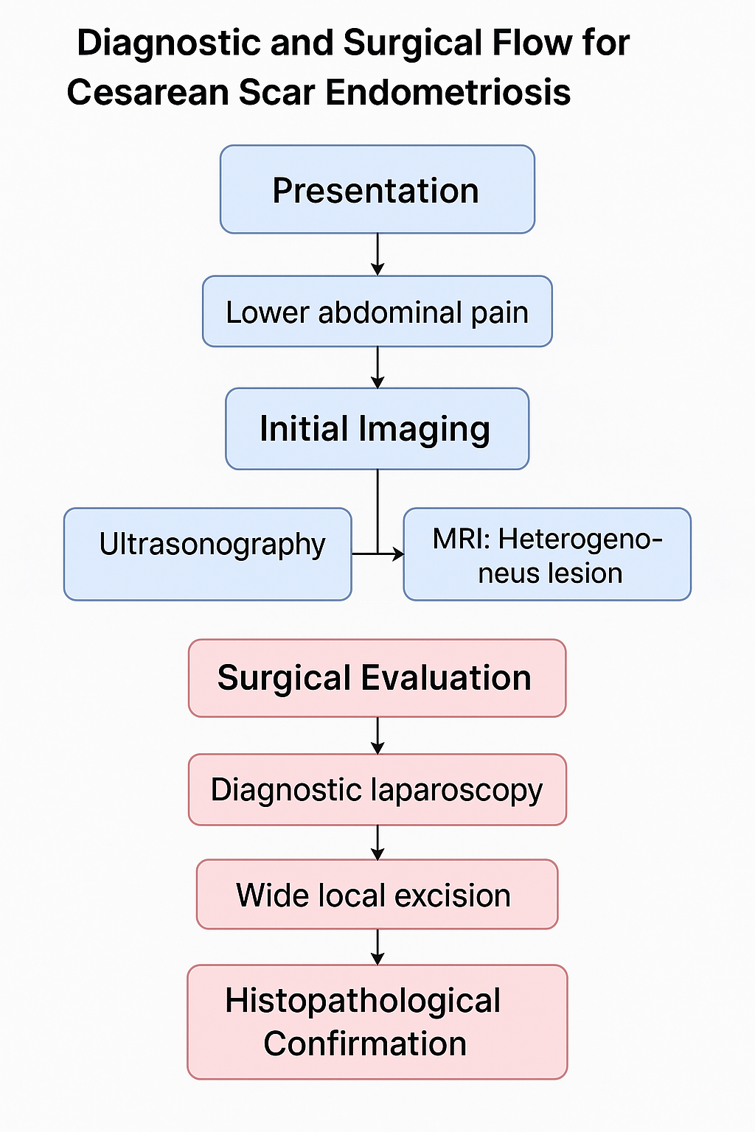
Fig. 1: Diagnostic and Surgical Flow for Cesarean Scar Endometriosis

Fig 1 illustrates the clinical pathway followed in diagnosing and treating a patient with cesarean scar endometriosis. The patient initially presented with lower abdominal pain, prompting imaging investigations. Ultrasonography and MRI revealed a heterogeneous lesion within the anterior abdominal wall. Surgical evaluation through diagnostic laparoscopy identified peritoneal invasion and a palpable mass, leading to wide local excision. The diagnosis was histopathologically confirmed, enabling appropriate postoperative management.

4.2 Patient History and Clinical Presentation
The patient presented with a six-month history of lower abdominal pain, which was insidious in onset, progressive in nature, non-radiating, and notably aggravated during menstruation. She also reported loss of appetite and weight loss. There was no history of trauma, fever, urinary complaints, or visible swelling at the scar site.

Table 2: Summary of Patient History and Clinical Findings
Parameter | Details
Chief Complaint | Lower abdominal pain (6 months), aggravated during menstruation
Associated Symptoms | Loss of appetite, weight loss
Absent Symptoms | No trauma, fever, urinary symptoms, or visible swelling
Obstetric History | P3L3A1 — 1 NVD, 2 LSCS, 1 abortion
Sterilization History | First attempt failed, second successful
Menstrual History | Regular (3/30-day cycle), painful periods
Physical Exam (Abdomen) | Soft, non-distended, tenderness over 8 cm suprapubic scar
Palpable Mass | 3×3 cm, firm, non-mobile, beneath the scar
Bowel Sounds | Normal

Obstetric history included three pregnancies (P3L3A1): one normal vaginal delivery, two lower segment cesarean sections (LSCS), and one abortion. The patient also underwent a failed sterilization procedure, followed by a successful repeat sterilization. Her menstrual cycles were regular (3/30 day cycle) but painful in nature.
On physical examination, the abdomen was soft, non-distended, and without guarding or rigidity. However, localized tenderness was present over an 8 cm suprapubic cesarean scar, beneath which a firm, non-mobile 3×3 cm mass was palpable. Bowel sounds were normal.
Table 2 shows the clinical profile and obstetric history of the patient, highlighting key features associated with cesarean scar endometriosis.

4.3 Diagnostic Imaging
Initial investigation with abdominal ultrasonography (USG) revealed a hypoechoic lesion within the anterior abdominal wall. This was followed by magnetic resonance imaging (MRI), which confirmed a heterogeneous lesion measuring 34×12 mm in the right anterior abdominal wall muscle plane. Based on these findings, scar endometriosis was suspected, and surgical exploration was planned.

Table 3: Imaging Findings Supporting Diagnosis of Scar Endometriosis
Modality | Findings | Interpretation
USG | Hypoechoic lesion in anterior abdominal wall | Suggestive of soft-tissue abnormality
MRI | Heterogeneous lesion, 34×12 mm, within right muscle plane | Indicative of scar endometriosis, warrants surgical evaluation

Fig 2 presents ultrasound and MRI images showing the lesion identified in the anterior abdominal wall. The USG shows a hypoechoic soft tissue mass, while the MRI delineates a heterogeneous lesion measuring 34×12 mm, consistent with scar endometriosis. These findings guided the decision for diagnostic laparoscopy and surgical excision.

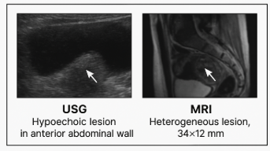

Fig. 2: Preoperative Imaging in Cesarean Scar Endometriosis

4.4 Surgical Management
The patient underwent diagnostic laparoscopy under general anesthesia due to suspicion of intraperitoneal extension of the lesion. Intraoperatively, flimsy omental adhesions were observed extending from the anterior abdominal wall. A 5×3 cm nodular mass was visualized infiltrating the rectus sheath and underlying muscle and extending to the parietal peritoneum.

Table 4: Intraoperative Findings and Surgical Procedures
Parameter | Observation/Procedure
Anesthesia | General anesthesia
Surgical approach | Diagnostic laparoscopy
Adhesions | Flimsy omental adhesions to anterior wall
Mass size | 5 × 3 cm
Infiltration | Rectus sheath, muscle, and parietal peritoneum
Surgical procedure | Wide local excision
Appearance on cut section | Chocolate-colored fluid
Reconstruction | Mesh repair of abdominal wall

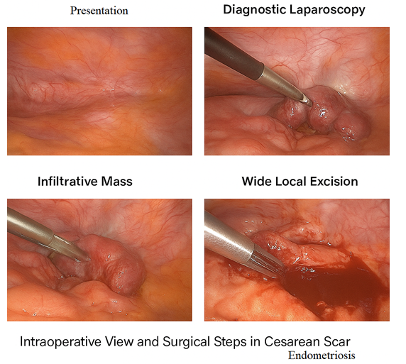
Fig. 3: Intraoperative View and Surgical Steps in Cesarean Scar Endometriosis

A wide local excision of the mass was performed. On cut section, the lesion released chocolate-colored fluid, a hallmark of endometriotic tissue. To restore abdominal wall integrity, mesh repair was carried out during the same procedure.
Table 4 presents the detailed intraoperative observations and procedural interventions undertaken during surgical management. It highlights the presence of flimsy omental adhesions, a nodular mass infiltrating the rectus sheath and parietal peritoneum, and the excision approach. The release of chocolate-colored fluid upon incision indicated endometriotic content, and abdominal wall reconstruction was successfully performed using mesh placement to restore structural integrity.
Figure 3 illustrates the intraoperative scenario, including the diagnostic laparoscopy view, identification of the infiltrative endometriotic mass, and subsequent wide local excision. The visual highlights key steps of the surgical procedure, offering insight into the complex anatomy and operative strategy required for effective treatment.

4.5 Histopathological Examination
The excised specimen was sent for histopathological analysis. Microscopy revealed fibromuscular tissue with multiple foci of endometrial glands, endometrial stroma, and hemorrhagic areas. Granulation tissue, thick-walled blood vessels, and foreign body-type multinucleated giant cells were also identified. These findings were diagnostic of scar endometriosis with granulation tissue in the right lower anterior abdominal wall.

4.6 Postoperative Care and Follow-up
The postoperative period was uneventful, and the patient was discharged in stable condition. To reduce the risk of recurrence, she was started on hormonal suppression therapy with Leuprolide acetate 3.75 mg intramuscularly once a month for three months.

During short-term follow-up, the patient reported complete resolution of symptoms. No clinical or imaging evidence of recurrence was observed, validating the surgical and hormonal strategy proposed in the CSE-DxCare clinical framework.

Table 5: Postoperative Management Plan and Patient Outcome
Time Point | Intervention / Observation | Notes
Day 0 | Wide local excision + mesh repair | Under general anesthesia
Days 1–3 | Monitoring and recovery | Discharged stable
Months 1–3 | Leuprolide 3.75 mg IM monthly | Hormonal suppression therapy
Month 4 | Follow-up with imaging and clinical exam | No recurrence, symptom resolution

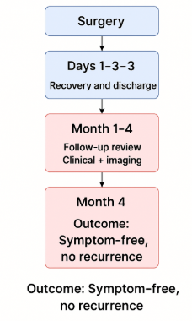
Fig. 4: Postoperative Management Timeline and Patient Outcome Following Surgical Excision of Cesarean Scar Endometriosis

Table 5 and Figure 4 present the postoperative care and follow-up outcomes for the patient diagnosed with cesarean scar endometriosis. Following wide local excision and mesh repair on Day 0, the patient was monitored for three days and discharged in stable condition. Hormonal suppression therapy with intramuscular Leuprolide acetate (3.75 mg monthly) was administered for three months to reduce recurrence risk. At the fourth-month follow-up, both imaging and clinical examination confirmed complete resolution of symptoms and no evidence of disease recurrence, indicating the effectiveness of the integrated surgical-hormonal management protocol.

4.7 Clinical Vignette: COMMON BUT NOT COMMON – A Case Snapshot
Patient Profile: A 30-year-old female presented to the General Surgery OPD with insidious, progressive lower abdominal pain for six months.
Symptoms: Non-radiating pain, aggravated during menstruation, with no visible swelling, trauma, fever, or urinary symptoms.
History: P3L3A1 with 1 NVD, 2 LSCS, and 1 abortion. Previously failed sterilization followed by successful repeat procedure.
Examination: Abdomen soft, non-distended, tenderness over suprapubic scar, 3×3 cm palpable mass, bowel sounds positive.
Imaging: USG followed by MRI showed a 34×12 mm heterogeneous lesion in the anterior abdominal wall muscle plane.
Intraoperative Findings: Diagnostic laparoscopy revealed invasion up to the parietal peritoneum, omental adhesions, and a 5×3 cm mass invading rectus sheath. Wide local excision performed; cut section showed chocolate-colored fluid.
Histopathology: Endometrial glands, hemorrhage, stroma, granulation tissue, multinucleated giant cells. Diagnosis confirmed: scar endometriosis with granulation tissue.
Management: Wide local excision, mesh repair, postoperative Leuprolide 3.75 mg monthly ×3 months.

5. Discussion

5.1 Diagnostic Summary
The patient’s diagnosis was established based on a combination of clinical examination, radiological imaging, intraoperative findings, and histopathological analysis. Imaging revealed a 34×12 mm heterogeneous lesion in the right anterior abdominal wall. Intraoperatively, a 5×3 cm mass infiltrating the rectus sheath was excised. Histopathology confirmed endometrial glands, stroma, hemorrhage, and giant cells.
Table 6 summarizes the key diagnostic modalities employed in the evaluation of the patient with suspected cesarean scar endometriosis. Ultrasonography initially detected a hypoechoic lesion measuring approximately 3×3 cm in the anterior abdominal wall. This was followed by MRI, which provided a more detailed assessment, confirming a heterogeneous lesion measuring 34×12 mm embedded within the muscle layer, raising suspicion of endometriosis. During surgical exploration, a larger nodular mass measuring 5×3 cm was found infiltrating the rectus sheath and anterior peritoneum. Histopathological examination post-excision ultimately confirmed the diagnosis of scar endometriosis by identifying definitive endometrial components within the tissue.

Table 6: Diagnostic Findings Summary
Modality | Key Finding | Dimension
Ultrasonography | Hypoechoic lesion in anterior abdominal wall | Approx. 3×3 cm
MRI | Heterogeneous lesion, infiltrating muscle | 34×12 mm
Intraoperative | Nodular mass, rectus sheath involvement | 5×3 cm
Histopathology | Endometrial glands, hemorrhage, granulation | Confirmed SE

5.2 Surgical Outcome
Wide local excision with mesh repair was successfully performed. No intraoperative complications were noted. The lesion exuded chocolate-colored fluid, consistent with old hemolyzed blood typically found in endometriotic tissue.
The patient was diagnosed with cesarean scar endometriosis, confirmed through intraoperative findings and histopathological analysis. A wide local excision of the lesion was performed, followed by abdominal wall reconstruction using mesh. Postoperatively, the patient received hormonal therapy with intramuscular injection of Leuprolide acetate 3.75 mg administered once monthly for three consecutive months.
Fig 5 displays the gross specimen of the excised mass obtained during wide local excision from the cesarean scar site. The tissue appears firm, nodular, and irregular, consistent with the clinical suspicion of endometriosis. On cut section intraoperatively, the lesion exuded characteristic chocolate-colored fluid, which is commonly observed in endometriotic cysts due to old hemolyzed blood. This gross morphology, along with the intraoperative findings, strongly supported the diagnosis, later confirmed by histopathology.

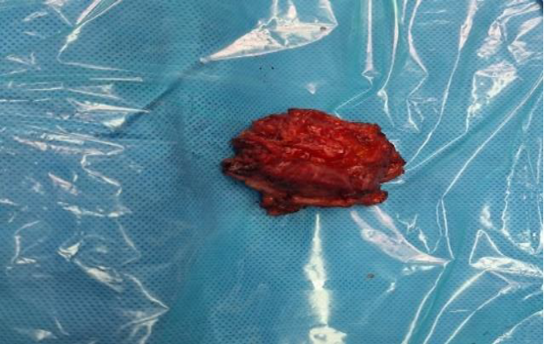
Fig. 5: Excised mass

5.3 Histopathological Confirmation
Histology revealed classical features of endometriosis—endometrial glands, stroma, hemorrhage, granulation tissue, and hemosiderin-laden macrophages.
Fig 6 presents a high-power microscopic view of the excised cesarean scar endometriosis tissue. The image clearly demonstrates areas of hemorrhage interspersed with hemosiderin-laden macrophages, which are indicative of chronic blood degradation within the ectopic endometrial tissue. The presence of these macrophages supports the diagnosis of endometriosis, as they are commonly seen in response to cyclic bleeding. These histological features reinforce the chronic inflammatory and hemorrhagic nature of the lesion.

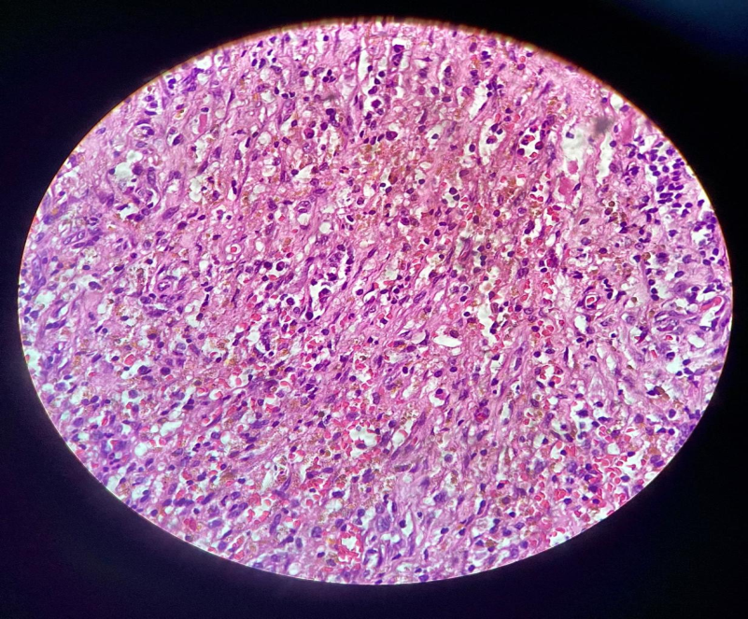
Fig. 6: High power view showing hemorrhage and hemosiderin laden macrophages

Table 7: Histopathological Features Identified
Histological Feature | Presence (✔//✖)
Endometrial glands | ✔
Endometrial stroma | ✔
Hemosiderin-laden macrophages | ✔
Granulation tissue | ✔
Multinucleated giant cells | ✔

Table 7 outlines the major histopathological features observed in the excised tissue sample. All classical hallmarks of endometriosis were present, including endometrial glands and stroma, confirming the ectopic endometrial origin of the lesion. Hemosiderin-laden macrophages were also seen, indicative of repeated internal bleeding and degradation of hemoglobin within the lesion over time. The tissue also revealed granulation tissue and foreign body-type multinucleated giant cells, consistent with chronic inflammation and tissue remodeling. These findings reinforce the chronic and reactive nature of scar endometriosis and validate the clinical suspicion raised during imaging and intraoperative assessment.

5.4 Postoperative Recovery and Follow-Up
The patient recovered uneventfully and was discharged on postoperative Day 3. She received Leuprolide 3.75 mg IM monthly for 3 months. At 4-month follow-up, she reported complete symptom resolution with no recurrence on clinical or imaging evaluation.

. Immediately following the wide local excision and mesh reconstruction performed under general anesthesia, the patient was closely monitored for three days and was discharged in stable condition. To prevent recurrence, she was started on a three-month course of Inj.Leuprolide acetate (3.75 mg IM monthly), a Gonadotropin-Releasing Hormone (GnRH) agonist, known to suppress residual ectopic endometrial tissue. At the four-month follow-up, both clinical examination and imaging confirmed the absence of recurrence. The patient reported complete symptom resolution, indicating a successful outcome following combined surgical and medical intervention.

5.5 Histopathological Features of the Excised Lesion
Histopathological examination remains the definitive modality for diagnosing cesarean scar endometriosis (CSE). In our case, microscopy confirmed the presence of endometrial glands, stroma, and chronic inflammatory changes, hallmarks of endometriotic lesions. The diagnosis was further substantiated by the presence of hemorrhage and hemosiderin-laden macrophages.

Table 8: Histopathological Features of the Excised Lesion
Histological Feature | Observation
Endometrial glands | Present, lined by columnar epithelium
Endometrial stroma | Surrounding glands, fibrocellular
Hemorrhage and hemosiderin-laden macrophages | Diffusely present, indicating chronic bleeding
Foreign body-type giant cells | Observed in response to chronic inflammation
Fibromuscular tissue | Background tissue, consistent with abdominal wall structure

Table 8 outlines the key histopathological features observed in the excised lesion. The presence of well-formed endometrial glands lined by columnar epithelium, surrounded by fibrocellular endometrial stroma, confirms the ectopic endometrial origin of the tissue. Diffuse areas of hemorrhage along with hemosiderin-laden macrophages indicate repeated cyclical bleeding within the lesion, a characteristic finding in endometriosis. Additionally, the background fibromuscular tissue supports the abdominal wall location of the lesion, further validating the diagnosis of cesarean scar endometriosis. These combined features are pathognomonic and serve as definitive evidence for the condition.
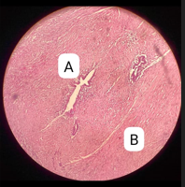
Fig. 7: Microscopic View Showing Endometrial Glands (A) Surrounded by Endometrial Stroma (B) within Fibromuscular Tissue

Fig 7 depicts a high-power microscopic view of fibromuscular tissue from the abdominal wall showing classical histopathological features diagnostic of scar endometriosis.
- Label A identifies a well-formed endometrial gland, lined by columnar epithelium, which is a defining feature of endometrial tissue. The glandular architecture is consistent with hormonally responsive endometrial origin.
- Label B points to the surrounding endometrial stroma, which appears fibrocellular and densely packed, providing supportive tissue for the gland. This stroma is essential for the cyclic activity of ectopic endometrial implants.
Together, the gland-stroma complex within the fibromuscular matrix confirms the presence of ectopic endometrial tissue in the cesarean scar—hallmark evidence of scar endometriosis. The organized arrangement of glandular epithelium surrounded by stroma supports the diagnosis and distinguishes it from other soft tissue lesions. This histological pattern is a definitive diagnostic indicator, aligning with classical criteria for endometriosis and confirming the uterine origin of the lesion.

5.6 Comparison
Table 9: Comparative Summary of Findings with Published Literature
Aspect | Present Study | Turčić et al. (2025) [1] | Chekol et al. (2024) [5] | Desai et al. (2024) [4] | Amidifar et al. (2025) [11]
Symptomatology | Cyclical pain, palpable mass | Cyclical pain, firm mass | Umbilical pain and swelling | Menstrual scar pain and lump | Recurrent inflammation
Imaging Findings | MRI: Heterogeneous mass | MRI: Hyperintense lesion | Sonography: Solid-cystic lesion | USG: Mixed echo lesion | Not specified
Histopathology | Gland-stroma, hemosiderin, fibrosis | Endometrial tissue, hemorrhage | Endometrial glands and hemosiderin | Endometrial stroma and blood | Fibrosis, giant cells, hemorrhage
Surgical Management | Wide local excision + mesh | Local excision | Local resection | Wide excision with margins | Emphasis on histological clearance
Postoperative Therapy | Leuprolide for 3 months | NA | Hormonal follow-up | Medical and surgical combination | Suggests anti-inflammatory adjuncts

Table 9 presents a comparative overview of the present study with four key literature sources focusing on cesarean scar endometriosis. Symptomatically, all cases, including the present study, share a common feature of cyclical pain and presence of a palpable mass, consistent with classical CSE presentation. Imaging findings range from heterogeneous masses observed in MRI (present study and Turčić et al. [1]) to mixed echo patterns in ultrasonography as reported by Desai et al. [4]. Histopathological findings across studies consistently emphasize gland-stroma complexes and hemorrhagic components, with Amidifar et al. [11] highlighting additional features like giant cells and fibrosis, aligning with our findings. Surgical management varied slightly, with the present case uniquely involving mesh repair post wide excision, while others emphasized local or wide resection. Postoperative therapies differ; this study employed Leuprolide for recurrence prevention, a strategy not uniformly adopted in earlier cases. Overall, the table underlines both consistency in core diagnostic criteria and the evolving approach in comprehensive management.
Cesarean scar endometriosis (CSE) remains a diagnostic challenge due to its rarity and symptom overlap with other abdominal wall pathologies. The cyclical nature of pain localized to a surgical scar, particularly coinciding with menstruation, should raise clinical suspicion. In our case, such a pattern was pivotal in guiding imaging and subsequent management. Similar patterns of cyclical scar-site pain have been identified by Aljbawi et al. (2025) [25], who emphasized the value of clinical suspicion in early recognition and surgical planning.
Imaging plays a crucial role in preoperative diagnosis and surgical mapping of CSE. While ultrasonography serves as an initial tool, MRI offers superior soft tissue resolution, especially in delineating the lesion’s depth and infiltration. This was evident in our case where MRI confirmed a well-defined heterogeneous lesion involving the rectus sheath. Zahra and Naseeb (2025) [22] support the diagnostic utility of advanced imaging modalities, particularly in patients with multiple cesarean sections, as imaging helps predict scar integrity and potential complications such as dehiscence or endometriosis.
Surgical excision with a clear margin remains the gold standard for treatment, as hormonal therapies alone have limited curative potential. In our case, a wide local excision combined with abdominal wall reconstruction using mesh was successfully performed. Gruber et al. (2024) [19] emphasized that incomplete excision can lead to recurrence, hence reinforcing the importance of complete resection and layered closure, especially in deeply infiltrating cases like ours.
Postoperative management, including hormonal suppression therapy with agents like Leuprolide acetate, aids in minimizing recurrence and managing residual microscopic disease. The integration of surgery and hormonal therapy in our case reflects the multidisciplinary approach recommended by Duncan et al. (2025) [21], who highlight the need for gynecologists, surgeons, and endocrinologists to collaborate in managing complex presentations of endometriosis.

6. Conclusion
Scar endometriosis, although an uncommon clinical entity, should be considered in women presenting with cyclical abdominal pain and a palpable mass near cesarean or surgical scars.
In certain cases Caesarean Scar Endometriosis can undergo malignant change, which is rapidly fatal and has a survival rate of only 57% [31]. Hence, it is necessary to take precautions to prevent or reduce the occurrence of Caesarean Scar Endometriosis .Accurate diagnosis begins with a detailed patient history and comprehensive physical examination. Imaging modalities such as ultrasound and MRI are valuable tools for preoperative assessment; however, the definitive diagnosis is confirmed through histopathological evaluation. The primary and most effective treatment is wide surgical excision of the lesion, often requiring mesh reinforcement for abdominal wall reconstruction in extensive cases. Postoperative management may include hormonal suppression therapy, such as Leuprolide acetate, to minimize the risk of recurrence. Long-term follow-up is essential to assess treatment success and detect any signs of recurrence. This case emphasizes the need for increased awareness and timely intervention in suspected cases of cesarean scar endometriosis.
Limitations
- The study is based on a single case report, limiting generalizability to the wider population.
- Long-term follow-up data is unavailable to assess recurrence beyond the initial postoperative period.
- Hormonal therapy outcomes may vary, and results cannot be universally applied.
- Lack of comparative imaging modalities restricts evaluation of diagnostic accuracy.

Future Work: Prospective multicentre studies are recommended to establish standardized treatment protocols and long-term outcomes.

Study Highlights
- First-line Diagnosis and Imaging: The study emphasizes the role of MRI in detecting heterogeneous lesions suggestive of scar endometriosis prior to surgical confirmation.
- Definitive Surgical Management: Wide local excision with mesh reconstruction proved effective, with no postoperative recurrence during short-term follow-up.
- Histopathological Validation: The diagnosis was confirmed through hallmark features such as endometrial glands, stroma, hemorrhage, and hemosiderin-laden macrophages.
- Integrated Postoperative Therapy: Hormonal suppression using Leuprolide acetate helped prevent recurrence, aligning with multidisciplinary treatment approaches.

Ethical Approval and Consent:
Ethical clearance and informed consent were obtained in accordance with institutional standards.

Disclaimer (Artificial intelligence)
Option 1:
The authors of this casestudy hereby declare that NO generative AI technologies such as Large Language Models (ChatGPT, COPILOT, etc.) and text-to-image generators have been used during the writing or editing of this manuscript.
References
[1] Turčić, Marijana, Koviljka Matušan Ilijaš, Koraljka Rajković Molek, and Petra Valković Zujić. "Rectus Abdominis Muscle Endometriosis: A Unique Case Report with a Literature Review." Current Issues in Molecular Biology 47, no. 1 (2025): 47. https://doi.org/10.3390/cimb47010047
[2] Razakamanantsoa, Léo, and Milan Najdawi. "Extrapelvic Location: Abdominal Wall Endometriosis. Diagnostic and Interventional Imaging." In Imaging of Endometriosis: A Comparative Guide of US, MRI and Surgery, pp. 243-259. Springer, Cham, 2025. https://doi.org/10.1007/978-3-031-82750-1
[3] Jayasundara, D. M. C. S., I. A. Jayawardane, T. D. K. M. Jayasingha, and S. D. S. Weliange. "Exploring uterine niche: a systemic review on secondary infertility rates, pathophysiological correlations, impact on assisted reproduction technology (ART), and the efficacy of surgical interventions." BMC Pregnancy and Childbirth 25, no. 1 (2025): 1-15. https://doi.org/10.1186/s12884-025-07638-5
[4] Desai, Prabha D., Nikita S. Kamashetty, Dhanesh L. Desai, and Apurva S. Gupta. "Postcesarean disasters–Isthmocele, ventrofixed uterus, and cesarean scar pregnancy: A case series." Indian Journal of Gynecological Endoscopy 1, no. 1 (2024): 47-53. https://doi.org/10.4103/IJGE.IJGE_5_24
[5] Chekol, Alemneh Mitku, Dagmawi Anteneh, Barakad Mohammed Hassen, Biniam Addis Anelay, and Kedriya Abdulkadir. "Spontaneous umbilical endometriosis: Rare occurrence in nulliparous women-Case report & literature review." International Journal of Surgery Case Reports 122 (2024): 110155. https://doi.org/10.1016/j.ijscr.2024.110155
[6] Davidson, Jennifer, Beth Shepherd, and Sunderarajan Jayaraman. Practice Long Cases for the Part B Final FRCR Examination. CRC Press, 2024. https://www.routledge.com/Practice-Long-Cases-for-the-Part-B-Final-FRCR-Examination/Davidson-Shepherd-Jayaraman/p/book/9781003579632
[7] Anchan, Megha M., Guruprasad Kalthur, Ratul Datta, Kabita Majumdar, and Rahul Dutta. "Unveiling the fibrotic puzzle of endometriosis: An overlooked concern calling for prompt action." F1000Research 13 (2024): 721. https://doi.org/10.12688/f1000research.152368.3
[8] Marano, Giuseppe, and Marianna Mazza. "Impact of gynecological cancers on women’s mental health." World Journal of Psychiatry 14, no. 9 (2024): 1294. https://doi.org/10.5498/wjp.v14.i9.1294
[9] Quddus, M. Ruhul, Sharon Liang, C. James Sung, and Wenxin Zheng. "Peritoneum and Broad Ligament." In Gynecologic and Obstetric Pathology, pp. 1489-1533. Springer, Singapore, 2025. https://doi.org/10.1007/978-981-97-4822-8_43
[10] Alaert, Julie, Mathilde Lancelle, Marie Timmermans, Panayiotis Tanos, Michelle Nisolle, and Stavros Karampelas. "Malignancy in Abdominal Wall Endometriosis: Is There a Way to Avoid It? A Systematic Review." Journal of Clinical Medicine 13, no. 8 (2024): 2282. https://doi.org/10.3390/jcm13082282
[11] Amidifar, Sima, Davood Jafari, Amir Hossein Mansourabadi, Sara Sadaghian, and Abdolreza Esmaeilzadeh. "Immunopathology of Endometriosis, Molecular Approaches." American Journal of Reproductive Immunology 93, no. 3 (2025): e70056. https://doi.org/10.1111/aji.70056
[12] Makoui, Masoud Hassanzadeh, Shiva Fekri, Reza Hassanzadeh Makoui, Negar Ansari, and Abdolreza Esmaeilzadeh. "The Role of Mast Cells in the Development and Advancement of Endometriosis." American Journal of Reproductive Immunology 93, no. 3 (2025): e70019. https://doi.org/10.1111/aji.70019
[13] Avery, Jodie C., Steven Knox, Alison Deslandes, Mathew Leonardi, Glen Lo, Hu Wang, Yuan Zhang et al. "Noninvasive diagnostic imaging for endometriosis part 2: a systematic review of recent developments in magnetic resonance imaging, nuclear medicine and computed tomography." Fertility and sterility 121, no. 2 (2024): 189-211. https://doi.org/10.1016/j.fertnstert.2023.12.017
[14] Panagiotidis, Emmanouil, and Jules Tianyu Zhang-Yin. "The Role of Positron Emission Tomography/Computed Tomography in the Management of Differentiated Thyroid Cancer: Current Applications and Future Perspectives." Journal of Clinical Medicine 13, no. 22 (2024): 6918. https://doi.org/10.3390/jcm13226918
[15] Devi, R. Sri, Arvind Kumar, Ashok Singh, Prashant Durgapal, and Sanjeev Kishore. "Ravi Hari Phulware; Department of Pathology and Laboratory Medicine, All India Institute of Medical Sciences, Rishikesh, Uttarakhand, India." Journal of Cytology 41 (2024): S39. https://doi.org/10.4103/joc.joc_145_24
[16] Nair, Nita S., Abhay Kattepur, Shraddha Patkar, Prashant Penumadu, Caleb Harris, and S. V. S. Deo. "Principles of Surgical Oncology." In Radiation Oncology–Principles, Precepts and Practice: Volume I–Technical Aspects, pp. 197-211. Singapore: Springer Nature Singapore, 2025.
[17] Piriyev, Elvin, Sven Schiermeier, and Thomas Römer. "Hormonal Treatment of Endometriosis: A Narrative Review." Pharmaceuticals 18, no. 4 (2025): 588. https://doi.org/10.3390/ph18040588
[18] Al deen Al Hussaini, Hussam, Ebtesam Saleem Eid Alatawi, Jenan Ali J. Shabani, Maryam Isa Hasan Edhrabooh, Shaikha Abduljalil Abdulla Alhawaj, Maryam Sayed Almahfoodh, Halimah Yaseen Alsamiri et al. "Management of Endometriosis-Related Pain: Comparing the Effectiveness of Hormonal Therapy, Surgical Interventions, and Complementary Therapies." Cureus 16, no. 12 (2024). https://doi.org/10.7759/cureus.75590
[19] Gruber, T. M., K. Lange, G. S. Ebeling, W. Henrich, and S. Mechsner. "Scar endometriosis, a form of abdominal wall endometriosis–a neglected obstetrical complication?" Archives of Gynecology and Obstetrics (2024): 1-8. https://doi.org/10.1007/s00404-024-07834-2
[20] Chitoran, Elena, Vlad Rotaru, Madalina-Nicoleta Mitroiu, Cristiana-Elena Durdu, Roxana-Elena Bohiltea, Sinziana-Octavia Ionescu, Aisa Gelal, Ciprian Cirimbei, Mihnea Alecu, and Laurentiu Simion. "Navigating Fertility Preservation Options in Gynecological Cancers: A Comprehensive Review." Cancers 16, no. 12 (2024): 2214. https://doi.org/10.3390/cancers16122214
[21] Duncan, Jordann-Mishael, Ritchie Delara, Gina Ranieri, and Megan Wasson. "Management of endometriosis: a call to multidisciplinary approach." Journal of Osteopathic Medicine 125, no. 6 (2025): 305-313. https://doi.org/10.1515/jom-2024-0105
[22] Zahra, Qandeel, and Shazia Naseeb. "Frequency of Uterine Scar Dehiscence and Its Associated Risk Factors in Patients with Previous Lower Segment Cesarean Section at Jinnah Post Graduate Medical Center, Karachi." Indus Journal of Bioscience Research 3, no. 2 (2025): 688-692. https://doi.org/10.70749/ijbr.v3i2.773
[23] Ahmed, Taha M., Abigail Coco, Arthur J. Vaught, and Erin N. Gomez. "MR imaging for preoperative characterization of pelvic adhesions: role in diagnosis and surgical planning." Abdominal Radiology 50, no. 2 (2025): 966-978. https://doi.org/10.1007/s00261-024-04527-x
[24] Kobayashi, Hiroshi, and Shogo Imanaka. "Reevaluating the variation of cesarean scar defect." Journal of Obstetrics and Gynaecology Research 50, no. 12 (2024): 2169-2177. https://doi.org/10.1111/jog.16137
[25] Aljbawi, Marwa, Lana Redan, Ahmad Al-Bitar, and Ebtihal Saghier. "Abdominal wall endometriosis in a cesarean scar: a case report." Journal of Medical Case Reports 19, no. 1 (2025): 1-5. https://doi.org/10.1186/s13256-025-05301-3
[26] Zhong, Qiyu, Shuhang Qin, Huiling Lai, Shuzhong Yao, and Shuqin Chen. "Risk factors for postoperative recurrence of cesarean scar endometriosis." AJOG Global Reports 4, no. 2 (2024): 100349. https://doi.org/10.1016/j.xagr.2024.100349
[27] Yasmin, Farida, Munshi Md Arif Hosen, Samira Sharmin, Afroza Naznin, Partha Pratim Saha, Md Nazmul Islam, and Rumana Parveen. "Post Caesarean Scar Endometriosis: An Uncommon Surgical Complication-Experience of a Radiologist at INMAS, Mitford." SAS J Surg 1 (2025): 16-19. https://doi.org/10.36347/sasjs.2025.v11i01.003
[29] Boussif, M., SA Oudaet Allah, Ma Nouri, Y. Bouktib, A. El Hajjami, B. Boutakioute, M. Ouali Idrissi, and N. Cherif Guennouni Idrissi. "Radiologic Insights into Post-Cesarean Uterine Scar Dehiscence: A Critical Postpartum Complication." Sch J Med Case Rep 5 (2025): 944-946. https://saspublishers.com/journal/sjmcr/archives/
[30] Parikh, S., V. Brown, R. S. Barbaresso, and R. P. Pasic. "Preoperative Sonographic Evaluation of Deep Infiltrating Endometriosis." Journal of Minimally Invasive Gynecology 31, no. 11 (2024): S16-S17.
[31.] Zhang, P., Sun, Y., Zhang, C., Yang, Y., Zhang, L., Wang, N., & Xu, H. (2019). Cesarean scar endometriosis: presentation of 198 cases and literature review. BMC women's health, 19(1),

