Case report

Management of High- Voltage Electrical Burn of the Scalp and Skull: A Case Report

Abstract
Electrical burn injuries of the scalp carry a high risk of extensive tissue destruction and neurological complications. We report the case of a 50-year-old woman who sustained a high-voltage electrical burn to the scalp following a domestic accident. The injury progressed to scalp necrosis, outer table skull bone necrosis, and secondary infection. Surgical management included excision of necrotic tissue and bone sequestrectomy, followed by coverage of the defect with local rotation flaps. The postoperative outcome was satisfactory. Deep scalp and skull burns are typically associated with high-voltage electrical injuries. Such patients should be managed in specialized burn centers capable of performing early excision and coverage of devitalized bone with well-vascularized tissue. Preventive strategies for electrical injuries are also discussed.
Keywords: Scalp; skull; high-voltage electrocution; local flaps.

Introduction
High-voltage electrical injuries to the head are uncommon but often devastating. Survivors frequently present with extensive scalp necrosis and partial or total necrosis of the underlying cranial bone. In severe cases, the dura mater and brain tissue may also be affected. Early and specialized management by a plastic surgeon is crucial, as these injuries occur in proximity to vital structures and can lead to serious complications such as osteomyelitis, brain abscess, meningitis, or hemorrhage—conditions that significantly endanger the patient’s life and neurological function.
Management of such injuries remains challenging, particularly regarding the optimal timing and extent of scalp and cranial debridement, as well as the choice of reconstruction technique for post-debridement defects. In this article, we report a case of high-voltage electrical head trauma managed surgically. A literature review was conducted.

Clinical Case Presentation
A 50-year-old woman sustained a high-voltage electrical injury to the head after accidental contact with a power line while returning home. She was transported to the hospital two hours after the incident. On admission, her vital signs were stable, and she was conscious but uncooperative and moderately disoriented. Local examination revealed an entry wound in the parieto-occipital scalp region and an exit wound on the left lower limb, both consistent with third-degree burns. Neurological assessment showed decreased muscle strength in the left upper and right lower limbs, along with brisk and hyperactive deep tendon reflexes in both lower limbs. After 48 hours of supportive care, her cooperation and orientation improved. Vital signs, urine output, and biochemical parameters remained within normal limits. A three-dimensional computed tomography (CT) scan performed on the third day revealed osteolytic changes in both the inner and outer tables of the parieto-occipital region at the site of electrical entry, while the brain parenchyma appeared normal. Over the following days, the wound evolved into extensive scalp necrosis measuring 8–10 cm along its major axis, accompanied by necrosis of the underlying cranial vault. Excision of the necrotic scalp was performed (Figure 1).

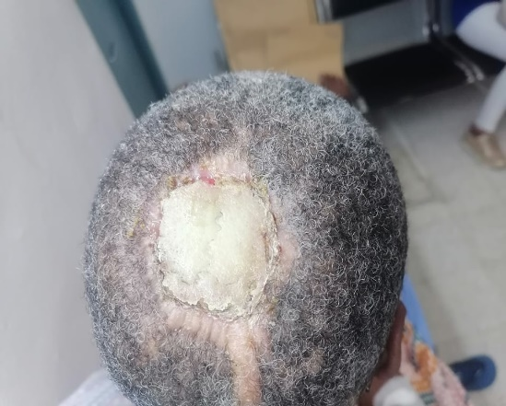
Figure 1: Clinical aspect of scalp defect and skull bone necrosis.

A follow-up CT scan two weeks later demonstrated necrosis of the outer table, necrosis of the diploë, and a 1-cm partial defect in the inner table (Figures 2 and 3).

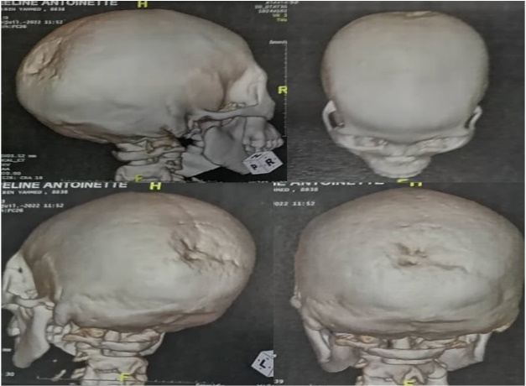

Figure 2: A three-dimensional computed tomography (CT) showing a skull lesion.

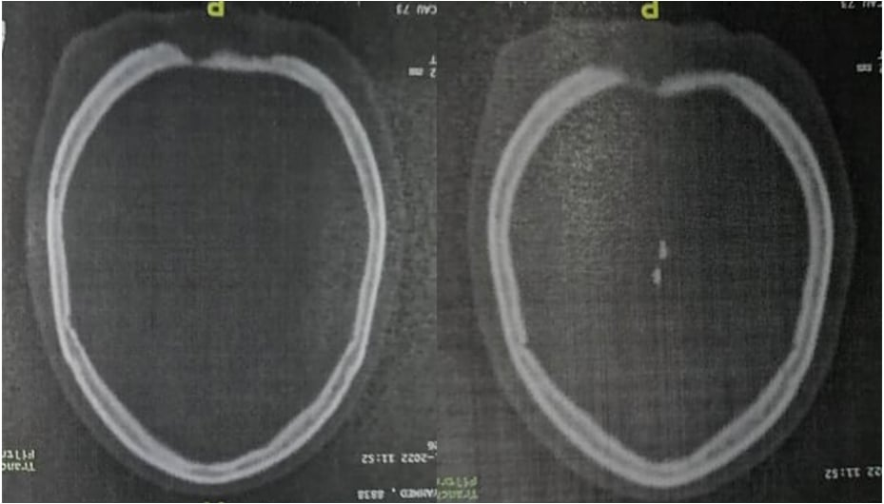
Figure 3: CT scan showing a necrosis of the skull.

Surgical management included sequestrectomy of the necrotic outer table and diploë, with refreshing of the bone margins. Given the limited extent of the inner table defect, cranioplasty was postponed. Scalp coverage was achieved using two local rotation flaps — one to cover the cranial defect and another to close the donor site (Figure 4).
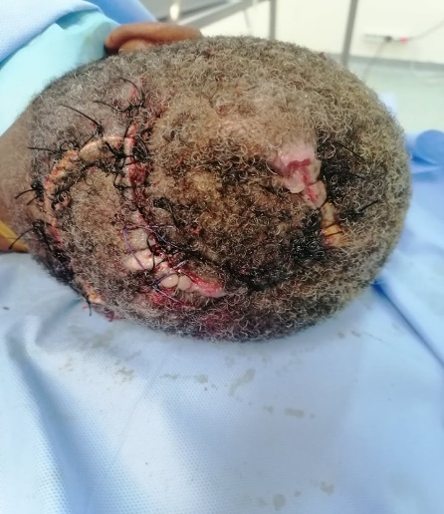
Figure 4: Coverage of the defect by local rotation flaps.

Postoperatively, there were no local complications such as parietal or subdural abscesses. Two months after surgery, the patient showed good wound healing with satisfactory cosmetic results, and her neurological examination was normal (Figure 5)

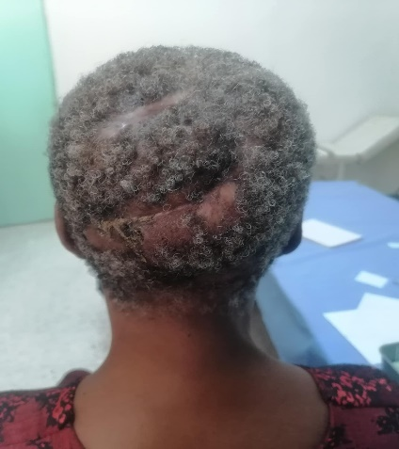

Figure 5: Clinical aspect at two-month follow-up.

Discussion
High-voltage electrical burns (>1000 volts) cause extensive tissue destruction, both immediate—due to the heat generated by the Joule effect—and delayed, as a result of progressive microvascular thrombosis [1]. When these injuries affect the scalp, they pose significant reconstructive challenges because of the need for adequate scalp coverage and repair of the charred cranial vault.
In cases of high-voltage electrical burns involving the scalp and skull, debridement of necrotic soft tissue is universally recommended. However, management of the underlying necrotic cranial bone remains controversial. The previously used conservative approach—allowing the devitalized cranial bone to heal spontaneously before covering it with a skin graft—has largely been abandoned due to the high incidence of complications such as osteomyelitis, meningitis, and epidural abscess.
For partial bone involvement limited to the outer table, some authors have proposed trephination of the necrotic area, followed by granulation and delayed skin grafting [2]. Although feasible, this method prolongs hospitalization, carries a complication rate of nearly 50%, and often results in unstable grafts. Another strategy involves early debridement of the necrotic outer bone using a high-speed burr, followed by immediate closure of the defect with local scalp flaps [3]. This approach allows complete removal of the devitalized calvarial bone when necessary and, in cases of dural involvement, the dura mater can be repaired with acellular allogeneic dermis before flap coverage [3].
Çeliköz et al. [4] reported complete excision of charred calvarial bone following a lightning strike, reconstruction of the cranial defect with a titanium plate, and coverage using a free muscle flap with a skin graft. Debridement of necrotic cranial bone is therefore essential to prevent severe complications such as injury to the dura mater or sagittal sinus, cerebrospinal fluid leakage, and hematoma formation [5–7]. Conversely, leaving necrotic bone in place and covering it with soft tissue carries risks of osteitis, bone sequestration, fluid collection, and intracranial infection. Nevertheless, these complications appear rare when early coverage with a well-vascularized local or distant flap is achieved, even if small bone sequestra persist [8].
Worthen [7] reported that when non-viable cranial bone is covered early with a vascularized flap, infectious complications do not occur. The devitalized bone may act as a scaffold for new bone formation [5–7]. Several studies have shown partial regeneration of non-viable cranial bone under well-vascularized coverage, although scintigraphic imaging often reveals incomplete bone recovery [2,5,8]. In other cases, the non-viable calvarium undergoes complete resorption over time, ultimately requiring cranioplasty [1]. Dalay et al. [9] found that early closure of cranial defects secondary to electrocution with well-vascularized local or distant flaps resulted in rapid and uncomplicated healing.
Multiple options exist for scalp reconstruction [10–14]. Local transposition or rotation flaps are often sufficient for moderate-sized defects, as illustrated in our case. The bipedicled pericranial flap, transposed adjacent to the lesion, promotes granulation over the devitalized bone and forms a barrier between it and the overlying scalp flap and sutures. This may facilitate better vascularization of pericranial tissues for subsequent procedures such as cranioplasty or tissue expansion.
Predicting the evolution of non-viable cranial bone covered early by a flap remains challenging. Reported cases of bone regeneration likely involve partial necrosis rather than complete devitalization. For extensive tissue defects, free flap transfer—particularly the latissimus dorsi or anterolateral thigh flap—has become the preferred option and yields highly satisfactory functional and aesthetic outcomes [11,12].

Conclusion
Early debridement of necrotic soft tissue while preserving the underlying devitalized bone and covering it with a well-vascularized scalp flap or free muscle transfer appears to be an effective management strategy for high-voltage electrical injuries of the scalp and skull. This approach minimizes the risk of complications associated with scalp and cranial vault necrosis and promotes stable, durable wound healing.

Consent
As per international standards or university standards, patient(s) written consent has been collected and preserved by the author(s).
Ethical Approval:
As per international standards or university standards written ethical approval has been collected and preserved by the author(s).

COMPETING INTERESTS DISCLAIMER:
Authors have declared that they have no known competing financial interests OR non-financial interests OR personal relationships that could have appeared to influence the work reported in this paper.

Disclaimer (Artificial intelligence)
Author(s) hereby declare that NO generative AI technologies such as Large Language Models (ChatGPT, COPILOT, etc.) and text-to-image generators have been used during the writing or editing of this manuscript.

References
1. Elena Blyth , Elizabeth Vujcich , Darryl Dunn . High-Voltage Electrical Burn Requiring Urgent Scalp Reconstruction after Developing a Brain Abscess. Eur Burn J. 2024 ; 3;5(3):288-295.
2. Bizhko IP, Slesarenko SV. Operative treatment of deep burns of the scalp and skull. Burns 1992;18:220-3.
3. Spies M, McCauley RL, Mudge BP, Herndon DN. Management of acute calvarial burns in children. J Trauma 2003;54:765-9.
4. J Hafidi , S El Mazouz, H El Mejatti, N Fejjal, N E Gharib, A Abbassi, A M Belmahi. Self-closing flaps in the treatment of scalp burns due to high-voltage electricity. Ann Burns Fire Disasters. 2011 Jun 30;24(2):72-6.
5. Worthen EF. Regeneration of the skull following a deep elec trical burn. Plast Reconstr Surg 1971;48:1-4.
6. Elena Blyth , Elizabeth Vujcich , Darryl Dunn . High-Voltage Electrical Burn Requiring Urgent Scalp Reconstruction after Developing a Brain Abscess. Eur Burn J. 2024 ; 3;5(3):288-295.
7. Worthen EF. Surgical treatment of electrical burns of the scalp and skull: past and present. Clin Plast Surg 1982;9:161-5.
8. Hartford CE. Preservation of devitalized calvarium follow ing high-voltage electrical injury: case reports. J Trauma 1989;29:391-4.
9. Dalay C, Kesiktas E, Yavuz M, Ozerdem G, Acarturk S. Coverage of scalp defects following contact electrical burns to the head: a clinical series. Burns 2006;32:201-7.
10.Hunt J, Purdue G, Spicer T. Management of full-thickness burns of the scalp and skull. Arch Surg 1983;118:621-5.
11.Fried M, Rosenberg B, Tuchman I, Ben-Hur N, Yardeni P, Sternberg N, et al. Electrical burn injury of the scalp-bone regrowth following application of latissimus dorsi free flap to the area. Burns 1991;17:338-9.
12. Nie GC,Zheng W,Hao XG,et al. Clinical efficacy of free anterolateral thigh tissue flap transplantation with a single-vein dual-drainage system at recipient site in repairing scalp high-voltage electrical burn wounds[J].Chin J Burns Wounds, 2025,41(10):977-985.
13. Phan Tuấn Nghĩa , Trần Thiết Sơn , Tạ Thị Hồng Thuý , Đặng Phương Nam , Hoang Tuấn Anh , Lê Anh Huy . Using tissue expanded flap for repositioning hair bearing scalp defect caused by high electrical burn: Case report. Int J Surg Case Rep. 2025 Jun:131:111419.
14. Chao Li , Wen Nie , Fujun Wang . Combined skin dilator and titanium mesh application to repair scalp and skull defects: a case report. J Surg Case Rep. 2024 Mar 15;2024(3):148.

