Giant Hydronephrosis Presenting as Abdominal Distension: An Unusual Case Presentation

ABSTRACT:
Hydronephrosis is a urological condition that most commonly occurs in the pediatric population and is not a common finding in the adult population. A study conducted in Nagpur, India, has shown that ureteric calculus is the most common cause of unilateral hydronephrosis, accounting for 2/3rd of the cases, followed by pelviureteric obstruction in 25% of the cases. A case of a left-sided giant hydronephrosis in an adult male patient was reported. A 27-year-old male patient presented to the OPD with complaints of left flank pain for 20 days. He had associated abdominal distention for 6 months but had not seen a doctor until the pain started. The patient was diagnosed with a Non-functional left kidney secondary to pelviureteric junction obstruction. The patient underwent a left open nephrectomy with a left flank incision. Intra-operatively, an obstruction at the left pelviureteric junction was noted, and 5 litres of clear fluid were drained from the left kidney. In conclusion, this case can be presented for its rarity and emphasises that a pelviureteric obstruction can also be a rare cause of an acute abdomen in adults. Early diagnosis and effective surgical treatment can help prevent complications.
Keywords: Hydronephrosis, abdominal distention, pelviureteric obstruction, acute abdomen, surgical treatment
INTRODUCTION:
“Hydronephrosis is defined as dilatation of the renal pelvis and calyces resulting from intermittent and incomplete obstruction to the flow of urine anywhere in the urinary tract” (1). Hydronephrosis is a urological condition that most commonly occurs in the pediatric population and is not a common finding in the adult population (2). The obstruction to urinary flow occurs due to various secondary causes that can be classified as intrinsic or extrinsic. There is no guideline for its early detection before it becomes “giant”. The fetal hydronephrosis guideline does not specify at what age/size pelviectasis is pathologic. So, mild dilation without extrinsic compression is often ignored (Shoyab, 2022).
Hydronephrosis produces a dull pain and irritation in the abdominal area due to increasing bladder distension (Dighade et al., 2021). Depending on the site of obstruction to the urinary flow, the hydronephrosis may be unilateral or bilateral. In unilateral hydronephrosis, the obstruction is present above the level of the bladder.
A study conducted in Nagpur, India, has shown that ureteric calculus is the most common cause of unilateral hydronephrosis, accounting for 2/3rd of the cases, followed by pelviureteric obstruction in 25% of the cases (1). The incidence of pelviureteric junction obstruction is 1 in 1000 to 1500 live births, but the incidence in adults is not well defined (3). The male-to-female ratio for a unilateral hydronephrosis is 2:1, and most commonly occurs on the right side. “Although often asymptomatic and capable of spontaneous resolution, surgical intervention is necessary for specific scenarios such as febrile urinary tract infections, deteriorating hydronephrosis, or declining renal function” (Kim, 2024).
Herein, we present a case of a left-sided giant hydronephrosis in an adult male patient.
CASE PRESENTATION:
A 27-year-old male patient presented to the OPD with complaints of left flank pain for 20 days. He had associated abdominal distention for 6 months, but had not seen a doctor until the pain started. The abdominal distention had an insidious onset and gradually progressed to the current size to occupy most of the abdomen. There was no associated fever, dysuria, discolouration of urine or other urinary symptoms. No history of constipation, nausea, vomiting, weight loss or anorexia.
He had no history of similar complaints in the past and no history of any urological problems.
On physical examination, his abdomen was non-uniformly distended involving the left lumbar, left iliac, umbilical and hypogastric area with tenderness present in the left flank.
The patient was advised a USG of the abdomen and pelvis, which shows a large multiloculated thin-walled cystic lesion with internal echogenic debris, predominantly of retroperitoneal origin, with no calcifications or definite solid components in the central and left lumbar abdominal region associated with significant mass effect.
CT abdomen and pelvis shows left kidney measurement of 22.4cm x 13.9cm. Markedly enlarged with gross hydronephrosis (renal pelvis measures 10cm) and severe thinning of cortex (3mm). Mass effect and displacement of the left adrenal gland, adjacent small bowel loops, transverse and descending colon are seen. Anteriorly, the dilated renal pelvis abuts the anterior abdominal wall, and posteriorly, there is mild compression of the abdominal aorta (figures 1 and 2).
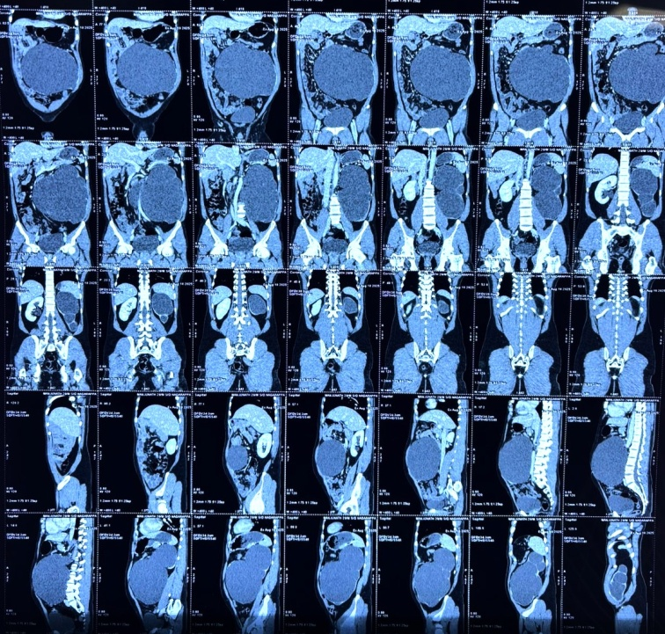
Figure 1: CT abdomen and pelvis
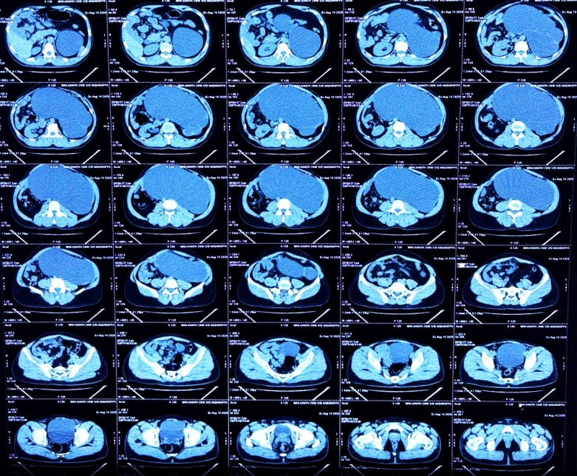
Figure 2: CT abdomen and pelvis

The patient’s blood tests were all normal, with RFT showing blood urea 17.5mg/dl (13-45mg/dl), serum creatinine 1.2 (0.70-1.40mg/dl) and serum uric acid 5.8mg/dl (3.6-8.2mg/dl).
The patient was diagnosed with a Non-functional left kidney secondary to pelviureteric junction obstruction. The patient underwent a left open nephrectomy with a left flank incision (Figure 3). Intra-operatively, an obstruction at the left pelviureteric junction was noted, and 5 litres of clear fluid were drained from the left kidney. A simple nephrectomy was done, and a drain was placed. The patient was given IV Piperacillin + Tazobactam 4.5g for 5 days postoperatively. The drain contained 15ml of serosanguinous fluid on POD1 and was clear on day 2, and was removed. The patient had a significant reduction in abdominal size and was discharged after 1 week of hospital stay.

Figure 3: Left Flank Incision with Drain Port
The left kidney specimen was sent for histopathological examination, which measured 15cmX11cm with a distorted, grey brown external surface. Microscopic examination showed renal tissue composed of a few sclerosed glomeruli with periglomerular fibrosis. Atrophy and thyroidisation of tubules were noted, and the intestitum showed fibrosis with moderate lymphoplasmacytic infiltrate (figure 4).
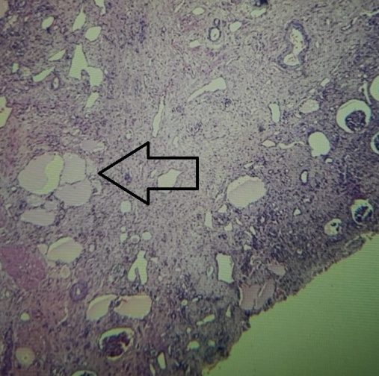
Figure 4: Histopathological Picture Showing Thyroidisation of Tubule

DISCUSSION:
This is a case of a Giant hydronephrosis. “A Giant hydronephrosis is a rare condition defined as the presence of more than 1L of fluid in the collecting system. It has been radiologically defined as the kidney occupying the hemi-abdomen along with crossing of the midline and/or that equals to height of five vertebral bodies. Uteropelvic junction obstruction is the most common cause of a giant hydornephrosis and other causes include urinary stone, renal ectopia, trauma, ureterovesical junction obstruction and rarely malignancy” (2). “The first case of GH was described in 1746; since then, more than 600 cases have been reported worldwide in the literature until now. The commonest etiological factor is congenital PUJ obstruction, and other factors are ureteric and kidney stones, aberrant vessel compression, flap-like mucosal folds and high pelvic insertion of the ureter” (Rana et al., 2025).
“GH usually manifests as asymptomatic abdominal distension or vague symptoms. However, very few published reports describe cases of GH initially presenting with respiratory and vascular manifestations” (Wirtzfeld et al., 2023). The symptoms of a giant hydronephrosis can vary from mild abdominal pain, nausea, vomiting, fever, urinary tract infection and hematuria to asymptomatic abdominal distention until later stages of life. Most of the cases are identified during childhood and infancy. If left untreated, this can lead to hypertension, renal failure, ruptured kidney or malignant transformation.
While CT is the gold standard for a patient presenting with lower back pain, USG is preferred in children and infants due to its low cost, easy administration and non-ionising radiation exposure.
“The differential diagnosis for a GH includes multicystic, dysplastic kidney, ectopic ureter, megacalycosis, simple renal cyst, urachal cyst, ovarian cyst, hydrocolops, sacrococcygeal teratoma, bowel duplication, duodenal atresia, anterior meningocele, and prune belly syndrome” (5).
The treatment options for a giant hydronephrosis depend on the functioning status and the aetiology of the hydronephrosis. Nephrectomy is the procedure of choice for a nonfunctioning kidney, and pyeloplasty is used for the management of PUJO with good differential function. a percutaneous nephrostomy can be placed as a temporary procedure. “This rare case emphasises and supports the need for close ECG monitoring in patients where kidney blowout is expected, as in this case, blowout caused therapy-resistant hyperkalaemia with cardiac arrhythmias. Therefore, clinicians should be aware of this risk, and close monitoring of heart rhythm, potassium and renal function is essential in similar cases” (van Vlijmen et al., 2021).
CONCLUSION
This case can be presented for its rarity and emphasises that a pelviureteric obstruction can also be a rare cause of an acute abdomen in adults. A differential of a giant hydronephrosis should always be kept in mind while dealing with any abdominal cystic lesion. Early diagnosis and effective surgical treatment can help prevent complications.
Consent
As per international standards or university standards, patient(s) written consent has been collected and preserved by the author(s).

Disclaimer (Artificial intelligence)
Option 1:
Author(s) hereby declare that NO generative AI technologies such as Large Language Models (ChatGPT, COPILOT, etc.) and text-to-image generators have been used during the writing or editing of this manuscript.
Option 2:
Author(s) hereby declare that generative AI technologies such as Large Language Models, etc. have been used during the writing or editing of manuscripts. This explanation will include the name, version, model, and source of the generative AI technology and as well as all input prompts provided to the generative AI technology
Details of the AI usage are given below:
1.
2.
3.

Reference
- Dare G, Akhtar M, Chaudhary S. Unilateral hydronephrosis in adults: etiology, clinical presentations and management. International Surgery Journal. 2019 May 28;6(6):2028.

- Hassen SM, Issack FH, Mummed FO, Hassen IK. Giant hydronephrosis secondary to ureteropelvic junction obstruction, a rare occurrence, case report. Urology Case Reports. 2021 Nov;39:101803.

- O’Sullivan NJ, Anderson S. Pelviureteric junction obstruction in adults: A systematic review of the literature. Current Urology. 2022 Sep 27;Publish Ahead of Print.

- H. G. V. Giant Hydronephrosis Due to Ureteropelvic Junction Obstruction in A 53-Year-Old Male: A Case Report. Journal of Clinical Surgery and Research. 2024 Dec 27;5(9):01–3.

- Joseph M, Darlington D. Acute Presentation of Giant Hydronephrosis in an Adult. Cureus [Internet]. 2020;12(6):e8702. Available from: https://pubmed.ncbi.nlm.nih.gov/32699698/

- Shoyab, M. (2022). Undetected giant hydronephrosis due to pelviureteric junction obstruction-importance of guidelines & multiphase contrast CT. European Urology Open Science, 39, S119.

- Kim, S. W. (2024). Management of hydronephrosis: a comprehensive review in pediatric urology perspective. Childhood Kidney Diseases, 28(2), 59-65.

- Dighade, A., Tivaskar, S., Luharia, A., & Christian, R. (2021). Bilateral hydrouteronephrosis dilated VUR with cystitis: A case study. Journal of Pharmaceutical Research International, 33(63A), 260–266.

- Wirtzfeld, N., Leduc, F., & Vaesen, R. (2023). Giant hydronephrosis: a rare case report and literature review. Urologia Internationalis, 107(6), 646-652.

- Rana, L., Bansal, V., Gurnal, P., & Chauhan, N. S. (2025). Giant hydronephrosis in radiology: Learning from incidental findings to improve diagnostic accuracy. Radiology Case Reports, 20(11), 5653-5655.

- van Vlijmen, N., Hoekstra, R., Aarnoudse, A. J., & van den Bersselaar, D. (2021). Acute life-threatening hyperkalaemia in a patient with giant hydronephrosis: a case report. BMJ Case Reports CP, 14(4), e240946.

